Name of Journal: World Journal of Clinical Cases
Manuscript NO: 62178
Manuscript Type: CASE REPORT

Stevens-Johnson syndrome and concurrent hand foot syndrome during treatment with capecitabine: A case report

Ahn HR et al. SJS And Concurrent HFS

Ha Rim Ahn, Sang-Kyung Lee, Hyun Jo Youn, Seok-Kweon Yun, Il-Jae Lee

Ha Rim Ahn, Hyun Jo Youn, Division of Breast and Thyroid Surgery, Department of Surgery, Jeonbuk National University, Jeonju 54907, South Korea

Ha Rim Ahn, Hyun Jo Youn, Research Institute of Clinical Medicine of Jeonbuk National University-Biomedical Research Institute of Jeonbuk National University Hospital, Jeonju 54907, South Korea

Sang-Kyung Lee, Seok-Kweon Yun, Il-Jae Lee, Department of Dermatology, Jeonbuk National University Medical School, Jeonju 54907, South Korea

Author contributions: Ahn HR and Lee SK performed the case report and wrote the manuscript; Lee IJ, Ahn HR, edited the manuscript; Yun SK, Youn HJ supervised the work and edited the manuscript; all authors have read and approve the final manuscript.

Corresponding author: Hyun Jo Youn, MD, PhD, Chief Doctor, Surgeon, Division of Breast and Thyroid Surgery, Department of Surgery, Jeonbuk National University, 20 Gunji-ro, Jeonju 54907, South Korea. yhj0903@jbnu.ac.kr

Received: January 15, 2021
Revised: February 15, 2021
Accepted: April 20, 2021
Published online: June 16, 2021

Abstract
BACKGROUND
Capecitabine is used in combination with lapatinib as palliative treatment for human epidermal growth factor receptor 2 - positive metastatic breast cancer. The most frequently reported adverse events attributed to capecitabine include diarrhea, hyperbilirubinemia, and hand-foot syndrome (HFS). A number of cutaneous adverse events have been attributed to capecitabine, including Stevens-Johnson syndrome (SJS) as a rare and potentially life-threatening mucocutaneous condition. We report the first case involving concurrent SJS and HFS after capecitabine and lapatinib treatment.

CASE SUMMARY
A 70-year-old woman with a history of breast cancer treatment visited our hospital for evaluation of painful skin lesions. Six weeks earlier, she had been prescribed capecitabine plus lapatinib as treatment for metastatic breast cancer. She subsequently developed worsening erythema and bullae on her palms and soles, as well as reddish macules on her back and chest wall. Histopathological evaluation of the chest wall lesions revealed extensive eosinophilic epidermal necrosis and separation of the epidermis from the dermis. The capecitabine plus lapatinib treatment was discontinued immediately and treatment was started using systemic steroids. This treatment resolved most lesions, although the lesions on her palms and soles required Vaseline gauze dressings, which resulted in re-epithelialization. Therefore, we determined that the patient had concurrent SJS and HFS. Although the dermatological problems resolved, the patient ultimately died because of multiple organ failure.

CONCLUSION
Oral capecitabine treatment carries a risk of both HFS and also life-threatening adverse cutaneous drug reactions, such as SJS.

Key Words: Stevens-Johnson syndrome; Hand-Foot syndrome; Palliative treatment; Capecitabine; Breast neoplasms; Case report

©The Author(s) 2021. Published by Baishideng Publishing Group Inc. All rights reserved.

Citation: Ahn HR, Lee SK, Youn HJ, Yun SK, Lee IJ. Stevens-Johnson syndrome and concurrent hand foot syndrome during treatment with capecitabine: A case report. World J Clin Cases 2021; 9(17): 4279-4284
URL: https://www.wjgnet.com/2307-8960/full/v9/i17/4279.htm
DOI: https://dx.doi.org/10.12998/wjcc.v9.i17.4279

Core Tip: Hand-foot syndrome (HFS) is a relatively well-known side effect of capecitabine treatment, although Stevens-Johnson syndrome (SJS) is not generally associated with capecitabine treatment. We report a case involving concurrent HFS and SJS. These side effects may decrease the patient's quality of life and delay chemotherapy for their primary disease. Therefore, clinicians should be aware of SJS as a rare side effect of capecitabine treatment and consider a multidisciplinary approach to treating this complication if necessary.

INTRODUCTION
Stevens-Johnson syndrome (SJS) is an acute skin reaction that is characterized by extensive necrosis and detachment of the epidermis and mucosal epithelium^{[1]}. Although SJS is rare, it is a life-threatening disease with a 30% mortality rate^{[2]}. Hand-foot syndrome (HFS), which is also known as palmoplantar erythrodysesthesia, is a well-documented adverse effect of treatment using various chemotherapeutic agents^{[3]}.
Capecitabine is a widely used oral antineoplastic agent that is effective and well-tolerated for treating numerous cancers, including breast cancer and gastrointestinal cancers^{[4]}. Common capecitabine-related toxicities include diarrhea and vomiting, which are possibly related to comorbid illness, and dermatitis^{[5]}. Reported cutaneous events have mild to moderate severity, although some patients develop grade 3-4 skin eruptions^{[5]}. Lapatinib can be combined with capecitabine for treating patients who failed trastuzumab treatment for human epidermal growth factor receptor 2 (HER2)-positive metastatic breast cancer^{[6]}, although the combination of capecitabine plus lapatinib leads to adverse events in ≥ 5% of patients. Nevertheless, a comparison of capecitabine monotherapy and lapatinib plus capecitabine revealed no differences in all-grade skin and subcutaneous tissue disorders, with the exception of rash^{[6]}, and there are only a few reports of life-threatening cutaneous eruptions, such as SJS, after capecitabine treatment^{[2,7]}. Therefore, we report what we believe is the first case involving concurrent SJS and HFS following capecitabine and lapatinib treatment.

CASE PRESENTATION
Chief complaints
A 70-year-old woman visited our outpatient clinic for subacute painful skin lesions on her trunk, palms, and soles.

History of present illness
The patient had started capecitabine plus lapatinib treatment for breast cancer with multiple metastases. Four weeks after taking capecitabine and lapatinib, erythema was developed on her hands and feet, but she did not visit the clinic. After approximately 6 wk of capecitabine plus lapatinib treatment, she complained of worsening of erythema, edema, and bullae not only her hands and feet but also on her upper arms, trunk, and buttocks. At this point, she visited our clinic for evaluation and treatment. Skin biopsies were performed at the time of admission.

History of past illness
The patient had a 22-year history of medication for treating hypertension and hyperlipidemia. Sixteen years before the current presentation, the patient have undergone modified radical mastectomy and adjuvant chemotherapy [adriamycin + cyclophosphamide (4 cycles), paclitaxel (4 cycles), and oral 5-fluorourasil] for left-breast triple-negative invasive ductal carcinoma (stage IIb). Eight years after the initial diagnosis, the patient developed recurrence in the contralateral axillary lymph node, although she rejected right modified radical mastectomy and instead underwent axillary lymph node dissection, adjuvant chemotherapy [epirubicin + cyclophosphamide (4 cycles)], and radiotherapy. One year later, she developed right-breast recurrence as stage I invasive ductal carcinoma (estrogen receptor (ER): 3+, progesterone receptor (PR): 3+, HER-2: Negative) and received adjuvant chemotherapy [cyclophosphamide + methotrexate + fluorouracil (6 cycles)]. Five years later, metastasis to the left infraclavicular lymph node, right axillary lymph node, mediastinum, lung, and bones were suspected, and metastatic adenocarcinoma was pathologically confirmed after needle biopsy of the left infraclavicular lymph node (ER: 8+, PR: 8+, HER-2: 3+). The patient started palliative treatment using anastrozole plus trastuzumab, exemestane, and trastuzumab emtansine, although that treatment failed and she was switched to treatment using capecitabine plus lapatinib.

Personal and family history
There was no family history of malignancy, allergic disease, systemic autoimmune disease, cardiovascular disease, or other diseases.

Physical examination
The physical examination revealed erythema, desquamation, and erosions on both palms and soles. We also observed reddish macules with a central non-blanching zone, as well as vesicles and erosions on the trunk and proximal extremities with Nikolsky’s sign (Figure 1). Epidermal detachment developed over approximately 10% of the patient’s body surface area. An intraoral examination revealed ulcerations of the lips and buccal mucosa. The patient had a body temperature of 37.6 °C and no other systemic signs.

Laboratory examinations
Standard laboratory tests only revealed anemia and hyponatremia.

FINAL DIAGNOSIS
The histopathological findings revealed extensive eosinophilic epidermal necrosis, focal subepidermal blisters, and separation of the epidermis from dermis (Figure 2). Based on the clinical and histopathological findings, the final diagnosis was concurrent SJS and HFS.

TREATMENT
The capecitabine plus lapatinib treatment was discontinued immediately. Intravenous high-dose methylprednisolone (250 mg/d) was administered for 2 d and then gradually tapered to a dose of 62.5 mg/d for 5 d. The treatment was then changed to oral prednisolone (30 mg/d), which was tapered slowly (50% reduction every 7 d) to reach a dose of 2.5 mg/d. Most skin lesions, with the exception of the lesions on the palms and soles, healed within 3 wk after starting systemic steroid therapy. The palms and soles were treated using daily Vaseline gauze dressing for an additional 3 wk, which resulted in re-epithelialization with residual hypopigmented scarring (Figure 3).

OUTCOME AND FOLLOW-UP
The SCORTEN system can be used to predict the prognosis of patients with epidermal necrosis, including SJS^{[1]}. The patient’s SCORTEN score was 3 points, which corresponds to a predicted mortality rate of 35.8%. The patient’s skin lesions improved after systemic steroid therapy and conservative treatment. However, her condition was not suitable for chemotherapy during SJS and HFS treatment. Her lung and liver metastasis progressed further, and her renal function decreased, and she died 2 mo later because of pulmonary and renal failure.

DISCUSSION
As an acute life-threatening mucocutaneous reaction, SJS is characterized by extensive necrosis and detachment of the epidermis and mucosal epithelium. The exact pathophysiology of SJS remains unclear, although drug treatment is considered the most important etiological factor^{[1]}. More than 100 different drugs may potentially cause SJS^{[1]}, which is histologically characterized by subepidermal vesiculation secondary to extensive vacuolar alteration and confluent necrosis of keratinocytes^{[1]}. The diagnosis of SJS in the present case was based on the patient’s clinical and histological features after treatment using oral capecitabine and lapatinib. Capecitabine is widely used for treating breast, colorectal, gastric, and pancreatic cancers^{[4]}, and the most frequently reported adverse events attributed to capecitabine include diarrhea, hyperbilirubinemia, and HFS^{[5]}. Nevertheless, our experience and other reports suggest that capecitabine may also be associated with the development of potentially life-threatening dermatological conditions, such as SJS. Jadhav et al^{[2]} and Sendur et al^{[7]} have also reported cases of SJS that were associated with oral capecitabine treatment, and these lesions were distributed on the face and trunk, with the distal extremities being relatively spared. However, our patient had more acral and atypical lesions, which were initially distributed symmetrically on the distal limbs, while the face, upper trunk, and proximal limbs were relatively spared. Thus, other etiologies might have been involved.
As a localized skin eruption, HFS (also known as palmoplantar erythrodysesthesia or acral erythema) is characterized by painful, symmetric, well-defined erythema, edema, bullae, and desquamation with burning pain^{[3]}. Furthermore, HFS occurs in approximately 50%-60% of cases with capecitabine treatment^{[3]}, and the diagnosis of HFS is made clinically^{[3]}. In the present case, the patient presented with palmoplantar erythema, blisters, and edema with burning pain approximately 6 wk after starting capecitabine and lapatinib treatment. We diagnosed concurrent HFS and SJS because of the atypical distribution of the SJS, as well as the differences in the time needed for re-epithelialization at the distal extremities and the other affected sites.
Lapatinib is a tyrosine kinase inhibitor that targets HER2 and epidermal growth factor receptor, and is used in combination with capecitabine for treating HER2-positive metastatic breast cancer^{[6]}. Rash is one of the most frequently reported adverse events related to lapatinib treatment^{[6,8]}, which generally involves mild-to-moderate rash (grade 1-2) that may resemble folliculitis or an acneiform drug eruption^{[8]}. A phase III randomized trial revealed that capecitabine plus lapatinib was associated with a higher risk of rash (vs capecitabine monotherapy), although the combination therapy was not associated with increases in the rates of serious toxic effects or treatment discontinuation related to adverse events^{[6]}. Therefore, we believe that capecitabine was the causative drug in this case, although we cannot completely exclude the possibility that lapatinib was involved in the development of SJS.
The management of SJS has three stages: Withdrawal of the causative drug(s), rapidly initiating supportive care, and specific drug therapy. Supportive care includes monitoring fluids and electrolyte levels, barrier nursing care, nutritional support, and infection control. Because SJS is rare and has a high mortality rate, there is insufficient evidence to support treatment using steroids, intravenous immunoglobulin, tumor necrosis factor, or even cyclosporine^{[1]}. However, a recent systemic review suggested that corticosteroids were useful for treating SJS^{[9]}. Thus, we treated our patient using systemic corticosteroids, which resulted in re-epithelialization at most skin lesions.

CONCLUSION
Physicians who prescribe oral capecitabine should be aware of the risks of focal HFS and other less common life-threatening adverse cutaneous drug reactions, such as SJS. Although capecitabine-induced SJS has not been frequently reported, the adverse events associated with this treatment suggest that caution is warranted when prescribing it, and that mandatory education regarding cutaneous adverse events might be beneficial.

REFERENCES
1 Maja M, Jean-Claude R. Epidermal necrolysis (Stevens-johnson Syndrome and Toxic Epidermal necrolysis). In: Kang SW, Amagai M, Anna LB, Alexander HE, David JM, Amy JM, Jeffrey SO. Fitzpatrick's dermatology in general medicine. 9th ed. New York: McGraw-Hill, 2019: 734-748
2 Jadhav P, Rogers JE, Shroff R. A Case Report-Stevens-Johnson Syndrome as an Adverse Effect of Capecitabine. J Gastrointest Cancer 2018; 49: 349-350 [PMID: 28066869 DOI: 10.1007/s12029-016-9916-3]
3 Miller KK, Gorcey L, McLellan BN. Chemotherapy-induced hand-foot syndrome and nail changes: a review of clinical presentation, etiology, pathogenesis, and management. J Am Acad Dermatol 2014; 71: 787-794 [PMID: 24795111 DOI: 10.1016/j.jaad.2014.03.019]
4 Milano G, Etienne-Grimaldi MC, Mari M, Lassalle S, Formento JL, Francoual M, Lacour JP, Hofman P. Candidate mechanisms for capecitabine-related hand-foot syndrome. Br J Clin Pharmacol 2008; 66: 88-95 [PMID: 18341672 DOI: 10.1111/j.1365-2125.2008.03159.x]
5 Blum JL, Jones SE, Buzdar AU, LoRusso PM, Kuter I, Vogel C, Osterwalder B, Burger HU, Brown CS, Griffin T. Multicenter phase II study of capecitabine in paclitaxel-refractory metastatic breast cancer. J Clin Oncol 1999; 17: 485-493 [PMID: 10080589 DOI: 10.1200/JCO.1999.17.2.485]
6 Geyer CE, Forster J, Lindquist D, Chan S, Romieu CG, Pienkowski T, Jagiello-Gruszfeld A, Crown J, Chan A, Kaufman B, Skarlos D, Campone M, Davidson N, Berger M, Oliva C, Rubin SD, Stein S, Cameron D. Lapatinib plus capecitabine for HER2-positive advanced breast cancer. N Engl J Med 2006; 355: 2733-2743 [PMID: 17192538 DOI: 10.1056/NEJMoa064320]
7 Sendur MA, Kilickap S. Stevens-Johnson syndrome after treatment with capecitabine. Clin Oncol (R Coll Radiol) 2008; 20: 202-203 [PMID: 18160271 DOI: 10.1016/j.clon.2007.11.005]
8 Moy B, Goss PE. Lapatinib-associated toxicity and practical management recommendations. Oncologist 2007; 12: 756-765 [PMID: 17673607 DOI: 10.1634/theoncologist.12-7-756]
9 Zimmermann S, Sekula P, Venhoff M, Motschall E, Knaus J, Schumacher M, Mockenhaupt M. Systemic Immunomodulating Therapies for Stevens-Johnson Syndrome and Toxic Epidermal Necrolysis: A Systematic Review and Meta-analysis. JAMA Dermatol 2017; 153: 514-522 [PMID: 28329382 DOI: 10.1001/jamadermatol.2016.5668]

Footnotes
Informed consent statement: This study was approved and reviewed by our Institutional Review Board.

Conflict-of-interest statement: The authors have no potential conflicts of interest to declare.

CARE Checklist (2016) statement: The authors have read the CARE Checklist (2016), and the manuscript was prepared and revised according to the CARE Checklist (2016).

Open-Access: This article is an open-access article that was selected by an in-house editor and fully peer-reviewed by external reviewers. It is distributed in accordance with the Creative Commons Attribution NonCommercial (CC BY-NC 4.0) license, which permits others to distribute, remix, adapt, build upon this work non-commercially, and license their derivative works on different terms, provided the original work is properly cited and the use is non-commercial. See: http://creativecommons.org/Licenses/by-nc/4.0/

Manuscript source: Unsolicited manuscript

Peer-review started: January 15, 2021
First decision: February 11, 2021
Article in press: April 20, 2021

Specialty type: Oncology
Country/Territory of origin: South Korea
Peer-review report’s scientific quality classification
Grade A (Excellent): 0
Grade B (Very good): B
Grade C (Good): C, C
Grade D (Fair): D
Grade E (Poor): 0

P-Reviewer: Han JG, Hu XS, Qiao ZG S-Editor: Liu M L-Editor: A P-Editor: Zhang YL
Figure Legends
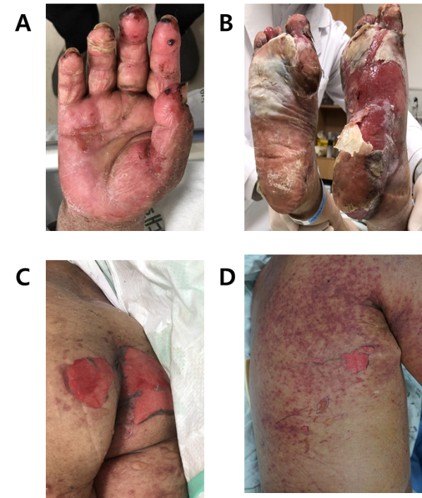
Figure 1 The patient’s gross appearance before treatment. A: A physical examination showed erythema, desquamation, and erosions on her right palm; B: Her both soles showed severe erythema, desquamation and erosions; C: Erythema and erosions were also present in her buttock; D: Vesicles and erosions were observed on the trunk with Nikolsky’s sign.

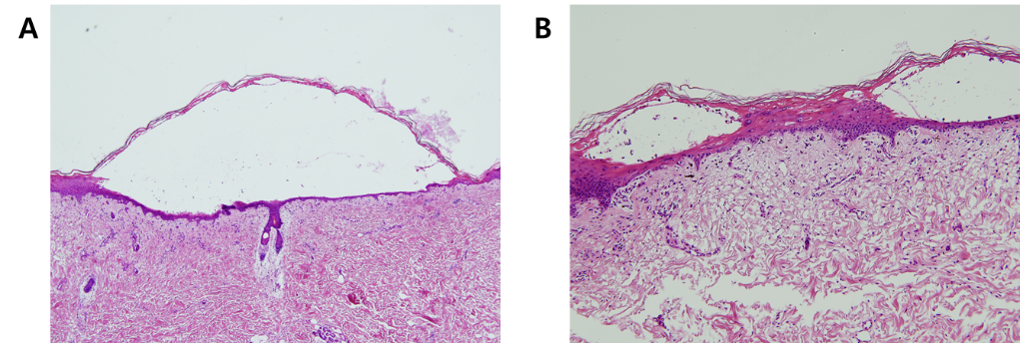
Figure 2 The histopathological findings revealed extensive eosinophilic epidermal necrosis, focal subepidermal blisters, and separation of the epidermis from dermis. A: hematoxylin and eosin, × 40; B: hematoxylin and eosin, × 200.

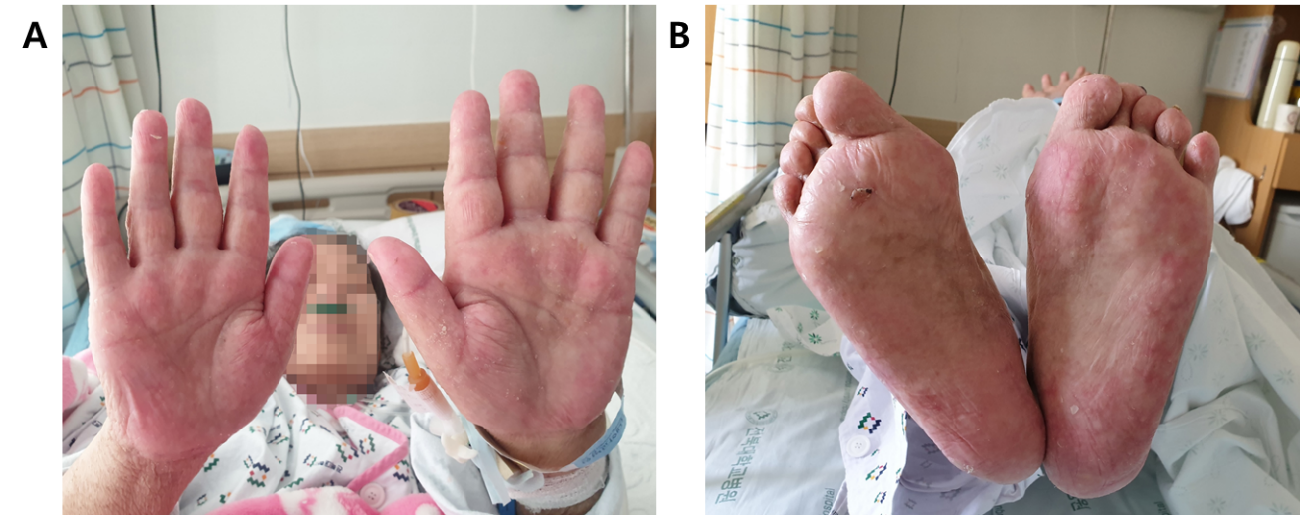
Figure 3 The patient’s gross appearance after treatment. A: Completely re-epithelialization was observed on the palms after 3 wk of Vaseline gauze dressing; B: Completely re-epithelialization was observed on the soles after 3 wk of Vaseline gauze dressing.

Published by Baishideng Publishing Group Inc
7041 Koll Center Parkway, Suite 160, Pleasanton, CA 94566, USA
Telephone: +1-925-3991568
E-mail: bpgoffice@wjgnet.com
Help Desk: https://www.f6publishing.com/helpdesk
https://www.wjgnet.com

© 2021 Baishideng Publishing Group Inc. All rights reserved.

