Name of Journal: World Journal of Gastrointestinal Surgery
Manuscript NO: 84201
Manuscript Type: ORIGINAL ARTICLE

Retrospective Study
Prognostic significance of preoperative lymphocyte to monocyte ratio in patients with signet ring gastric cancer

Liu HL et al. Preoperative LMR in SRCC GC

He-Li Liu, Xiang Feng, Mi-Mi Tang, Hai-Yan Zhou, Huan Peng, Jie Ge, Ting Liu

He-Li Liu, Xiang Feng, Jie Ge, Department of Gastrointestinal Surgery, Xiangya Hospital, Central South University, Changsha 410008, Hunan Province, China

He-Li Liu, The Hunan Provincial Key Laboratory of Precision Diagnosis and Treatment for Gastrointestinal Tumor, The Hunan Provincial Key Laboratory of Precision Diagnosis and Treatment for Gastrointestinal Tumor, Changsha 410008, Hunan Province, China

Mi-Mi Tang, Ting Liu, Institute for Rational and Safe Medication Practices National Clinical Research Center for Geriatric Disorders, Xiangya Hospital, Central South University, Changsha 410008, Hunan Province, China

Hai-Yan Zhou, Department of Pathology, Xiangya Hospital, Central South University, Changsha 410008, Hunan Province, China

Huan Peng, Clinical Nursing Teaching and Research Section, Xiangya Hospital, Central South University, Changsha 410008, Hunan Province, China

Author contributions: Liu HL, Feng X contributed equally to this work; Liu HL, Feng X and Ge J designed research; Tang MM, Zhou HY and Feng X collected and analyzed clinical data; Liu T, Peng H wrote the paper.

Supported by the Clinical Research Fund of National Geriatric Disease Clinical Medical Research Center, No. 2022LNJ22; Guangdong Yiyang Healthcare Charity Foundation, No. JZ2022014.

Corresponding author: Jie Ge, MD, Department of Gastrointestinal Surgery, Xiangya Hospital, Central South University, No. 87 Xiangya Road, Kaifu District, Changsha 410008, Hunan Province, China. gejie@csu.edu.cn

Received: May 6, 2023
Revised: May 31, 2023
Accepted: June 21, 2023
Published online:

Abstract
BACKGROUND
The ratio of lymphocytes to monocytes (LMR) has been shown to be an effective predictor of gastric cancer prognosis. However, its predictive accuracy for signet ring gastric cancer is currently not well understood.

AIM
To evaluate the prognosis predictive accuracy of preoperative LMR in signet ring gastric cancer.

METHODS
A total of 212 signet ring gastric cancer patients admitted at the Xiangya Hospital of Central South University, Department of Gastrointestinal Surgery, from January 2012 to December 2016 were enrolled in the study. The prognosis predictive accuracy of preoperative LMR was explored based on the area under the receiver operating characteristic (ROC). Factors that significantly affect the survival of patients were identified using single factor analysis, and those that were independently associated with signet ring gastric cancer were identified through multivariate analysis.

RESULTS
The results of the single factor analysis revealed a strong correlation between the survival of signet ring gastric cancer patients and several factors, including tumor invasion (χ² = 49.726; P < 0.001), lymph node metastasis (χ² = 30.269; P < 0.001), pTNM stage (χ² = 49.322; P < 0.001), surgical approach (χ² = 8.489; P = 0.004), age (t = -2.213; P < 0.028), carcinoembryonic antigen (CEA) (Z = -3.265; P = 0.001), platelet-to-lymphocyte ratio (Z = -2.196; P = 0.028), LMR (Z = -2.226; P = 0.026), ALB (t = 3.284; P = 0.001), prognostic nutritional index (t = -3.789; P < 0.001) and FIB (Z = -3.065; P = 0.002). Furthermore, the multivariate analysis further demonstrated that age (HR: 0.563, 95%CI: 0.363-0.873), tumor invasion depth (HR: 0.226, 95%CI: 0.098-0.520), pTNM stage (HR: 0.444, 95%CI: 0.255-0.771), preoperative CEA level (HR: 0.597, 95%CI: 0.386-8.790), and preoperative LMR level (HR: 1.776, 95%CI: 1.150-2.741) were independent factors influencing the prognosis of signet ring gastric cancer.

CONCLUSION
In signet ring gastric cancer patients, a low preoperative LMR level predicts poor prognosis. The death risk ratio of the low LMR group compared to the high LMR group is 1.776.

Key Words: Gastric cancer; Signet ring cell carcinoma; Inflammation indexes; Coagulation indexes; Prognosis.

Liu HL, Feng X, Tang MM, Zhou HY, Peng H, Ge J, Liu T. Prognostic significance of preoperative lymphocyte to monocyte ratio in patients with signet ring gastric cancer. World J Gastrointest Surg 2023; In press

Core Tip: Low preoperative lymphocytes to monocytes levels -predict poor prognosis of patients with signet ring gastric cancer, making it a valuable prognostic factor.

INTRODUCTION
Signet ring gastric cancer is a type of stomach cancer that is characterized by presence of cells filled with mucus, which push the nucleus to one side of the cell, giving it a ring-like appearance. This type of cancer is highly invasive, progresses rapidly, and has a high degree of malignancy. Although the incidence of gastric cancer has decreased in recent decades, cases of signet-ring cell carcinoma (SRCC) are increasingly being reported. Studies have demonstrated that SRCC accounts for 35 % to 45 % of all cases of gastric adenocarcinoma^{[1]}, and its incidence increased by tenfold from 1970 to 2000^{[2]}.
Currently, the prognosis of SRCC is not well understood. Given that SRCC is prone to lymph node and peritoneal metastasis, less responsive to chemotherapy, and most patients are diagnosed at an advanced cancer stage, patients with SRCC have a poor prognosis^{[2]}.
The occurrence and development of tumors are driven by several factors including inflammatory immune response of the host^{[3]}. Numerous studies have explored the relationship between different inflammatory markers, chemotherapeutic effects, and prognosis in gastric cancer. Among the most easily available inflammatory markers obtained from the whole blood cell count are lymphocyte-to-monocyte ratio (LMR)^{[4]}, neutrophil-to-lymphocyte ratio (NLR)^{[5]}, platelet-to-lymphocyte ratio (PLR)^{[6]}, and systemic immune inflammation (SII)^{[7]}. The prognostic nutritional index (PNI), a simple and easy detection index, has been widely used in clinical practice and shown to be associated with the prognosis of malignant gastric tumors^{[8,9]}. Moreover, the development of tumors is accompanied by changes in the blood coagulation dynamics of the host^{[10]}. Coagulation factor levels, such as platelet count, international standard ratio, fibrin degradation products, fibrinogen, and D-dimer levels, have been associated with tumor stage, metastasis, chemotherapeutic effect, and prognosis of patients with solid tumors^{[11,12]}. Although many scientists have explored the relationship between various indicators and chemotherapy response and prognosis of gastric cancer, few studies have explored the prognostic value of these indicators in SRCC.
Against this background, we explored the relationship between the common inflammatory indicators, nutritional indicators, coagulation indicators and the prognosis of SRCC to identify prognostic predictors of SRCC.

MATERIALS AND METHODS
Patients
The retrospective study included 212 patients with gastric cancer admitted to the Department of Gastroenterology at Xiangya Hospital of Central South University from January 2012 to December 2016. To be included in the study, patients had to meet the following criteria: (1) Postoperative pathology revealed SRCC components greater than 10%; (2) Accepted to undergo radical gastrectomy; and (3) With complete clinical and follow-up data. Moreover, the exclusion criteria are as follows: (1) Preoperative radiotherapy, chemotherapy, targeted therapy, immunotherapy, and other anti-tumor treatments that may affect the patient's blood routine, liver and kidney function, and coagulation routine; (2) Preoperative examination indicated the presence of distant metastases such as liver, lung, and bone metastases; (3) Intraoperative detection of metastasis; (4) Comorbidity hematological diseases and other systemic malignancies; (5) Combined with severe infections, liver disease, kidney disease, and autoimmune diseases; (6) Emergency surgery due to perforation and bleeding of gastric cancer; and (7) Gastric stump cancer. This study was approved by the Ethics Committee of Xiangya Hospital of Central South University.

Measurement of variables
Patient-related results, including demographic data, clinic characteristics, and biochemical test results such as carcinoembryonic antigen (CEA), LMR [= lymphocyte count (× 10⁹/L)/monocyte count (× 10⁹/L)], NLR [= Neutrophil count (× 10⁹/L)/Lymphocyte count (× 10⁹/L)], PLR [= platelet count (× 10⁹/L)/Lymphocyte coun (× 10⁹/L)], SII [= Neutrophil count (× 10⁹/L) × Platelet count (× 10⁹/L)/Lymphocyte count (× 10⁹/L)]^{[13]}, coagulation index [activated partial thromboplastin time (APTT), fibrinogen degradation product (FDP), fibrinogen (FIB), prothrombin time (PT), thrombin time (TT), and international normalized ratio (INR)] were obtained from the medical database of the hospital. Additionally, albumin (ALB), globulin (GLB), albumin to globulin ratio [AGR = serum albumin (g/L)/serum globulin (g/L)], and prognostic nutritional index [PNI=5 × Lymphocyte count (× 10⁹/L)+serum albumin (g/L)]^{[14]} were obtained through peripheral complete blood count and blood biochemistry before the surgery. Cut-off values for each variable were obtained from the ROC curves.

Statistical analysis
Statistical analysis was performed using SPSS 25.0 and GraphPad Prism 8.0. The normality of the data was assessed using the Shapiro-Wilk test, and the data which did not fit the normal distribution was represented by M (P25, P75) and analyzed using the Mann-Whitney U test. Single factor analysis was performed using the independent-sample t-test for normally distributed data, and the counts were presented as percentages (%). The prognostic value of inflammation, blood coagulation and other indicators was evaluated using ROC curves, and the optimal cut-off point of patient survival was determined. The patients were then divided into high and low groups based on the medium levels of the above indicators. Kaplan-Meier survival analysis and the Log-rank tests were used to compare survival rates between the high and low-risk groups. Cox proportional hazards regression analysis was conducted to identify independent predictors of the prognosis of gastric cancer with SRCC by including indicators that significantly affected the survival status. Statistical significance was set at P < 0.05.

RESULTS
Baseline data and pathological characteristics
The study included 212 patients with SRCC, of whom 87 patients (41.04 %) died, and 125 patients (58.96 %) survived for the 5-year follow-up period. The mean age of the patients was 51.42 ± 11.27 years, 117 were males (55.19 %), and 95 were females (44.81 %). The tumor location was in the upper, middle and lower third of the stomach in 5 (2.36 %), 58 (27.36 %) and 149 (70.28 %) cases, respectively. Distal gastrectomy was performed in 167 (78.78 %) cases, while total gastrectomy was performed in 45 (21.22 %) cases. The tumor infiltration depth was pT1 or pT2 in 79 cases (37.26 %) and pT3 or pT4 in 133 cases (62.74 %). Lymph node metastasis was found in 118 (55.66 %) cases with pN1, pN2 or pN3, while 94 (44.34 %) cases were classified as N0. The pTNM stage was I or II in 117 cases (55.19 %) and III in 95 (44.81 %) cases (Table 1).

ROC analysis of predictors
Table 2 shows the cut-off value and area under the curve (AUC) for each index, and Figure 1 shows the ROC curves (AUC, 95%CI) of the predictors, including age, CEA, PLR, LMR, ALB, PNI and FIB. Overall, the results indicate good predictive values of CEA (0.632, 0.556-0.708), LMR (0.590, 0.512-0.669), ALB (0.618, 0.540-0.696), PNI (0.644, 0.567-0.721), and FIB (0.624, 0.547-0.701),

Single factor analysis for prognostic factors
Table 3 displays the results of the pathological features and the 5-year survival rate of the patients. The analysis revealed that depth of tumor invasion, lymph node metastasis, pTNM stage and resection range were associated with the survival rate, while gender and tumor location showed no correlation.
As shown in Table 4, firstly, the single factor analysis demonstrated that younger patients had a better survival rate compared with older patients. The survival rate was also significantly better in the lower CEA level group compared with the higher CEA level group. In addition, SRCC patients in the higher PLR value had poorer survival rates than those in the lower PLR value group, while SRCC patients in the higher LMR value group had a better survival rate than those in the lower LMR value group. Finally, the survival rate of patients with lower FIB was significantly better in those with higher FIB, whereas patients with lower ALB had a significantly lower survival rate compared with higher ALB group.

Grouping of predictors
The predictors, including age, CEA, ALB, PNI, LMR, PLR, and FIB, were grouped as shown in Table 5.

Kaplan-Meier survival analysis
The Kaplan-Meier survival curves are shown in Figure 2. The Log-rank test indicated no significant difference in survival rate between the low PLR group and the high PLR group (P = 0.147). In contrast, significant differences were observed in survival rate between different resection groups (P < 0.001), depth of invasion (P < 0.001), lymph node metastasis (P < 0.001), pTNM stage (P < 0.001), age (P = 0.004), LMR (P = 0.003), ALB (P = 0.008), PNI (P = 0.002) and FIB (P = 0.001).

Multivariate and multiple-factor analysis
To explore the independent factors affecting the prognosis of SRCC, indicators that demonstrated statistical differences by the Log-rank test were included in a Cox proportional hazards regression model for multivariate analysis. The results (HR, 95%CI) are presented in Figure 3. The independent factors for SRCC prognosis were age (0.563, 0.363-0.873, P = 0.010), depth of tumor invasion (0.226, 0.098-0.520), pTNM stage (0.444, 0.255-0.771), preoperative CEA level (0.597, 0.386-8.790), and preoperative LMR level (1.776, 1.150-2.741). Advanced age, high CEA level before surgery, low LMR level before surgery, deep tumor invasion, and late pTNM stage were all indicative of a relatively poor prognosis. Specifically, the risk of death in low LMR group before surgery was 1.776 times higher than that of the high LMR group.

DISCUSSION
Currently, surgery is the mainstay treatment for gastric cancer patients, especially those with SRCC. However, despite radical resection or adjuvant chemotherapy, the prognosis of SRCC patients, particularly those in advanced stages, is not optimistic. Therefore, it is crucial to elucidate the mechanism of tumor progression and identify independent prognostic factors to evaluate the overall condition of tumor patients and optimize diagnosis and treatment.
The correlation between inflammation and tumors was first proposed by Rudolf Virchow^{[14]}. Research has shown that inflammation participates in tumor development^{[15,16]}. Furthermore, inflammation can influence the prognosis of tumors by altering immune response^{[17,18]}.
Lymphocytes and monocytes play a crucial role in anti-tumor immune response^{[19]}. The relationship between LMR and the prognosis of malignant tumors has been widely reported^{[20-22]}. However, few studies have investigated the relationship between inflammatory markers and SRCC. Chengcheng Tong et al^{[23]}, reported that derived monocyte-to-lymphocyte ratio (dMLR) could independently predict lymph node metastasis of SRCC. Zhu et al^{[9]} reported the relationship between SII and the prognosis of SRCC, but the relationship between LMR and SRCC has not been investigated.
Numerous studies have shown that high levels of peripheral blood lymphocyte count and TILs are associated with a good prognosis in gastric cancer^{[24-26]}. Li et al^{[27]} reported that patients with smaller tumors (< 5 cm) had higher counts of peripheral blood CD4 + T cells (P = 0.003) and CD8 + T cells (P = 0.002). In addition, patients with well-differentiated gastric cancer showed higher counts of CD4 + T cells (P = 0.029).
NK cells, which possess potent anti-tumor, anti-viral and antibacterial activity, are crucial in activating and regulating adaptive immune responses. In human peripheral blood, NK cells account for approximately 3%-5% of lymphocytes^{[28,29]}. The anti-tumor activity of NK cells is mainly determined by a group of inhibitory and activating receptors^{[30]}. Patients with gastric cancer exhibit lower expression of activating receptors such as NKG2D, NKp30, and NKp46, but higher PD-1 expression. Moreover, NK cells of patients with gastric cancer secrete lower cytokines (IFN-γ, IL-2, TNF-α, IL-12) and impaired ability to release perforin and granzyme. Meanwhile, gastric cancer cells express little MICA/B, ULBP, and B7H6, to evade NK cell-mediated innate immunity. Gastric cancer cells can also produce cytokines such as IL-10, TGF-β, and PGE2, which recruit MDSC and Treg cells to suppress NK cell function^{[31]}. The proportion of apoptotic NK cells in patients with gastric cancer is elevated when receiving gastrectomy^{[32]}. Collectively, these lines of evidence show that the number and function of NK cells decrease sharply with the progression of gastric cancer^{[31]}.
Monocytes, particularly those that differentiate into tumor-associated macrophages (TAMs), contribute to the development of gastric cancer^{[33]}. M1 TAMs have anti-tumor effects, while M2 TAMs promote tumor growth^{[34]}. Under the influence of cytokines and extracellular matrix secreted by tumour cells and lymphocytes, M1 TAMs can convert into M2 TAMs. In gastric cancer, M2 TAMs are highly expressed in SRCC, mucinous adenocarcinoma and diffuse gastric cancer^{[35]}.
Our study found that the 5-year survival rate of patients with low LMR before surgery was significantly lower than that with high LMR. In summary LMR affects the prognosis of SRCC due to reduction of lymphocytes during inflammatory response and increase of tumor-associated macrophages produced by circulating monocytes. However, this study has some limitations. First, this was a retrospective single-center study and no external validation was performed. In addition, studies have suggested that gastric cancer with different SRCC ratios may have varying biological characteristics, although we demonstrated a relationship between LMR and the prognosis of SRCC. Therefore, it is imperative to explore further the predictive value of various indicators in gastric cancer with different SRCC ratios.

CONCLUSION
In summary, this study shows that a low preoperative LMR level indicates a poor prognosis of signet ring gastric cancer. Particularly, compared with the high LMR group, the risk of mortality in the low LMR group is 1.776.

ARTICLE HIGHLIGHTS
Research background
The incidence of signet ring gastric carcinoma has increased among the past decades. Several inflammation indexes, including ratio of lymphocytes to monocytes (LMR), have been shown to be effective predictors of gastric cancer prognosis.

Research motivation
The predictive accuracy of ratio of LMR for signet ring gastric cancer is unclear now.

Research objectives
To assess the prognosis predictive accuracy of preoperative LMR for signet ring gastric cancer.

Research methods
Our research center conducted a retrospective analysis of clinical data from patients diagnosed with signet ring gastric carcinoma over the past 5 years, identifying factors that significantly affect patients’ survival by using single factor analysis, and deciding independent prognostic factors related to signet ring cell gastric cancer by using multivariate analysis.

Research results
The results of the single factor analysis indicated a strong correlation between the survival of signet ring gastric cancer patients and several factors, including tumour invasion, lymph node metastasis, pTNM stage, surgical approach, age, carcinoembryonic antigen (CEA), platelet-to-lymphocyte ratio (PLR), LMR, ALB, PNI and FIB. Furthermore, the multivariate analysis revealed that age, tumor invasion depth, pTNM stage, preoperative CEA level, and preoperative LMR level were independent factors related to the prognosis of signet ring gastric cancer.

Research conclusions
In signet ring gastric cancer patients, a low preoperative LMR level is indicative of a poor prognosis. The death risk ratio of the low LMR group compared to the high LMR group is 1.776.

Research perspectives
The study subjects were followed up for 5 years and divided into survival group and death group. Clinical data, pathological data, and prognosis of the two groups of patients were observed.

REFERENCES
1 Bamboat ZM, Tang LH, Vinuela E, Kuk D, Gonen M, Shah MA, Brennan MF, Coit DG, Strong VE. Stage-stratified prognosis of signet ring cell histology in patients undergoing curative resection for gastric adenocarcinoma. Ann Surg Oncol 2014; 21: 1678-1685 [PMID: 24394986 DOI: 10.1245/s10434-013-3466-8]
2 Henson DE, Dittus C, Younes M, Nguyen H, Albores-Saavedra J. Differential trends in the intestinal and diffuse types of gastric carcinoma in the United States, 1973-2000: increase in the signet ring cell type. Arch Pathol Lab Med 2004; 128: 765-770 [PMID: 15214826 DOI: 10.5858/2004-128-765-DTITIA]
3 Singh N, Baby D, Rajguru JP, Patil PB, Thakkannavar SS, Pujari VB. Inflammation and cancer. Ann Afr Med 2019; 18: 121-126 [PMID: 31417011 DOI: 10.4103/aam.aam_56_18]
4 Pan YC, Jia ZF, Cao DH, Wu YH, Jiang J, Wen SM, Zhao D, Zhang SL, Cao XY. Preoperative lymphocyte-to-monocyte ratio (LMR) could independently predict overall survival of resectable gastric cancer patients. Medicine (Baltimore) 2018; 97: e13896 [PMID: 30593200 DOI: 10.1097/MD.0000000000013896]
5 Miyamoto R, Inagawa S, Sano N, Tadano S, Adachi S, Yamamoto M. The neutrophil-to-lymphocyte ratio (NLR) predicts short-term and long-term outcomes in gastric cancer patients. Eur J Surg Oncol 2018; 44: 607-612 [PMID: 29478743 DOI: 10.1016/j.ejso.2018.02.003]
6 Zhang X, Zhao W, Yu Y, Qi X, Song L, Zhang C, Li G, Yang L. Clinicopathological and prognostic significance of platelet-lymphocyte ratio (PLR) in gastric cancer: an updated meta-analysis. World J Surg Oncol 2020; 18: 191 [PMID: 32731872 DOI: 10.1186/s12957-020-01952-2]
7 Cao X, Xue J, Yang H, Han X, Zu G. Association of Clinical Parameters and Prognosis with the Pretreatment Systemic Immune-inflammation Index (SII) in Patients with Gastric Cancer. J Coll Physicians Surg Pak 2021; 31: 83-88 [PMID: 33546540 DOI: 10.29271/jcpsp.2021.01.83]
8 Ma LX, Taylor K, Espin-Garcia O, Anconina R, Suzuki C, Allen MJ, Honorio M, Bach Y, Allison F, Chen EX, Brar S, Swallow CJ, Yeung J, Darling GE, Wong R, Kalimuthu SN, Jang RW, Veit-Haibach P, Elimova E. Prognostic significance of nutritional markers in metastatic gastric and esophageal adenocarcinoma. Cancer Med 2021; 10: 199-207 [PMID: 33295697 DOI: 10.1002/cam4.3604]
9 Zhu Y, Fan L, Geng X, Li J. The predictive value of the prognostic nutritional index to postoperative prognosis and nursing intervention measures for colorectal cancer. Am J Transl Res 2021; 13: 14096-14101 [PMID: 35035753]
10 Gil-Bernabé AM, Lucotti S, Muschel RJ. Coagulation and metastasis: what does the experimental literature tell us? Br J Haematol 2013; 162: 433-441 [PMID: 23691951 DOI: 10.1111/bjh.12381]
11 Kanda M, Tanaka C, Kobayashi D, Mizuno A, Tanaka Y, Takami H, Iwata N, Hayashi M, Niwa Y, Yamada S, Fujii T, Sugimoto H, Murotani K, Fujiwara M, Kodera Y. Proposal of the Coagulation Score as a Predictor for Short-Term and Long-Term Outcomes of Patients with Resectable Gastric Cancer. Ann Surg Oncol 2017; 24: 502-509 [PMID: 27600621 DOI: 10.1245/s10434-016-5544-1]
12 Jomrich G, Paireder M, Kristo I, Baierl A, Ilhan-Mutlu A, Preusser M, Asari R, Schoppmann SF. High Systemic Immune-Inflammation Index is an Adverse Prognostic Factor for Patients With Gastroesophageal Adenocarcinoma. Ann Surg 2021; 273: 532-541 [PMID: 31425286 DOI: 10.1097/SLA.0000000000003370]
13 Onodera T, Goseki N, Kosaki G. [Prognostic nutritional index in gastrointestinal surgery of malnourished cancer patients]. Nihon Geka Gakkai Zasshi 1984; 85: 1001-1005 [PMID: 6438478]
14 Balkwill F, Mantovani A. Inflammation and cancer: back to Virchow? Lancet 2001; 357: 539-545 [PMID: 11229684 DOI: 10.1016/S0140-6736(00)04046-0]
15 Mantovani A. Cancer: inflammation by remote control. Nature 2005; 435: 752-753 [PMID: 15944689 DOI: 10.1038/435752a]
16 Hanahan D, Weinberg RA. Hallmarks of cancer: the next generation. Cell 2011; 144: 646-674 [PMID: 21376230 DOI: 10.1016/j.cell.2011.02.013]
17 Iyengar NM, Hudis CA, Dannenberg AJ. Obesity and inflammation: new insights into breast cancer development and progression. Am Soc Clin Oncol Educ Book 2013; 33: 46-51 [PMID: 23714453 DOI: 10.14694/EdBook_AM.2013.33.46]
18 Moore MM, Chua W, Charles KA, Clarke SJ. Inflammation and cancer: causes and consequences. Clin Pharmacol Ther 2010; 87: 504-508 [PMID: 20147899 DOI: 10.1038/clpt.2009.254]
19 Goeppert B, Frauenschuh L, Zucknick M, Stenzinger A, Andrulis M, Klauschen F, Joehrens K, Warth A, Renner M, Mehrabi A, Hafezi M, Thelen A, Schirmacher P, Weichert W. Prognostic impact of tumour-infiltrating immune cells on biliary tract cancer. Br J Cancer 2013; 109: 2665-2674 [PMID: 24136146 DOI: 10.1038/bjc.2013.610]
20 Mandaliya H, Jones M, Oldmeadow C, Nordman II. Prognostic biomarkers in stage IV non-small cell lung cancer (NSCLC): neutrophil to lymphocyte ratio (NLR), lymphocyte to monocyte ratio (LMR), platelet to lymphocyte ratio (PLR) and advanced lung cancer inflammation index (ALI). Transl Lung Cancer Res 2019; 8: 886-894 [PMID: 32010567 DOI: 10.21037/tlcr.2019.11.16]
21 Trinh H, Dzul SP, Hyder J, Jang H, Kim S, Flowers J, Vaishampayan N, Chen J, Winer I, Miller S. Prognostic value of changes in neutrophil-to-lymphocyte ratio (NLR), platelet-to-lymphocyte ratio (PLR) and lymphocyte-to-monocyte ratio (LMR) for patients with cervical cancer undergoing definitive chemoradiotherapy (dCRT). Clin Chim Acta 2020; 510: 711-716 [PMID: 32919942 DOI: 10.1016/j.cca.2020.09.008]
22 Li C, Zhang H, Li S, Zhang D, Li J, Dionigi G, Liang N, Sun H. Prognostic Impact of Inflammatory Markers PLR, LMR, PDW, MPV in Medullary Thyroid Carcinoma. Front Endocrinol (Lausanne) 2022; 13: 861869 [PMID: 35350101 DOI: 10.3389/fendo.2022.861869]
23 Tong C, Wang W, Xia Y, He C. A potential novel biomarker in predicting lymph node metastasis of gastric signet ring cell carcinoma: A derived monocyte to lymphocyte ratio. Am J Surg 2022; 223: 1144-1150 [PMID: 34702491 DOI: 10.1016/j.amjsurg.2021.10.026]
24 Zhang D, He W, Wu C, Tan Y, He Y, Xu B, Chen L, Li Q, Jiang J. Scoring System for Tumor-Infiltrating Lymphocytes and Its Prognostic Value for Gastric Cancer. Front Immunol 2019; 10: 71 [PMID: 30761139 DOI: 10.3389/fimmu.2019.00071]
25 Feng F, Zheng G, Wang Q, Liu S, Liu Z, Xu G, Wang F, Guo M, Lian X, Zhang H. Low lymphocyte count and high monocyte count predicts poor prognosis of gastric cancer. BMC Gastroenterol 2018; 18: 148 [PMID: 30305076 DOI: 10.1186/s12876-018-0877-9]
26 Lee HE, Chae SW, Lee YJ, Kim MA, Lee HS, Lee BL, Kim WH. Prognostic implications of type and density of tumour-infiltrating lymphocytes in gastric cancer. Br J Cancer 2008; 99: 1704-1711 [PMID: 18941457 DOI: 10.1038/sj.bjc.6604738]
27 Li F, Sun Y, Huang J, Xu W, Liu J, Yuan Z. CD4/CD8 + T cells, DC subsets, Foxp3, and IDO expression are predictive indictors of gastric cancer prognosis. Cancer Med 2019; 8: 7330-7344 [PMID: 31631566 DOI: 10.1002/cam4.2596]
28 Vivier E, Tomasello E, Baratin M, Walzer T, Ugolini S. Functions of natural killer cells. Nat Immunol 2008; 9: 503-510 [PMID: 18425107 DOI: 10.1038/ni1582]
29 Vivier E, Nunès JA, Vély F. Natural killer cell signaling pathways. Science 2004; 306: 1517-1519 [PMID: 15567854 DOI: 10.1126/science.1103478]
30 Hinshaw DC, Shevde LA. The Tumor Microenvironment Innately Modulates Cancer Progression. Cancer Res 2019; 79: 4557-4566 [PMID: 31350295 DOI: 10.1158/0008-5472.CAN-18-3962]
31 Du Y, Wei Y. Therapeutic Potential of Natural Killer Cells in Gastric Cancer. Front Immunol 2018; 9: 3095 [PMID: 30719024 DOI: 10.3389/fimmu.2018.03095]
32 Wang Z, Si X, Xu A, Meng X, Gao S, Qi Y, Zhu L, Li T, Li W, Dong L. Activation of STAT3 in human gastric cancer cells via interleukin (IL)-6-type cytokine signaling correlates with clinical implications. PLoS One 2013; 8: e75788 [PMID: 24116074 DOI: 10.1371/journal.pone.0075788]
33 Rihawi K, Ricci AD, Rizzo A, Brocchi S, Marasco G, Pastore LV, Llimpe FLR, Golfieri R, Renzulli M. Tumor-Associated Macrophages and Inflammatory Microenvironment in Gastric Cancer: Novel Translational Implications. Int J Mol Sci 2021; 22 [PMID: 33916915 DOI: 10.3390/ijms22083805]
34 Biswas SK, Mantovani A. Macrophage plasticity and interaction with lymphocyte subsets: cancer as a paradigm. Nat Immunol 2010; 11: 889-896 [PMID: 20856220 DOI: 10.1038/ni.1937]
35 Räihä MR, Puolakkainen PA. Tumor-associated macrophages (TAMs) as biomarkers for gastric cancer: A review. Chronic Dis Transl Med 2018; 4: 156-163 [PMID: 30276362 DOI: 10.1016/j.cdtm.2018.07.001]
Footnotes
Institutional review board statement: Institutional review board statement: The study was reviewed and approved by the Xiangya Hospital, Central South University Institutional Review Board [Approval No. Xykyll-lx-2019030510].

Informed consent statement: All study participants, or their legal guardian, provided informed written consent prior to study enrollment.

Conflict-of-interest statement: The authors declare no conflicts of interest for this article.

Data sharing statement: No additional data are available.

Open-Access: This article is an open-access article that was selected by an in-house editor and fully peer-reviewed by external reviewers. It is distributed in accordance with the Creative Commons Attribution NonCommercial (CC BY-NC 4.0) license, which permits others to distribute, remix, adapt, build upon this work non-commercially, and license their derivative works on different terms, provided the original work is properly cited and the use is non-commercial. See: https://creativecommons.org/Licenses/by-nc/4.0/

Provenance and peer review: Unsolicited article; Externally peer reviewed.
Peer-review model: Single blind

Peer-review started: May 6, 2023
First decision: May 19, 2023
Article in press:

Specialty type: Toxicology
Country/Territory of origin: China
Peer-review report’s scientific quality classification
Grade A (Excellent): 0
Grade B (Very good): B
Grade C (Good): C
Grade D (Fair): 0
Grade E (Poor): 0

P-Reviewer: Al Zoubi M, Qatar; Kermansaravi M, Iran S-Editor: Ma YJ L-Editor: A P-Editor:
Figure Legends
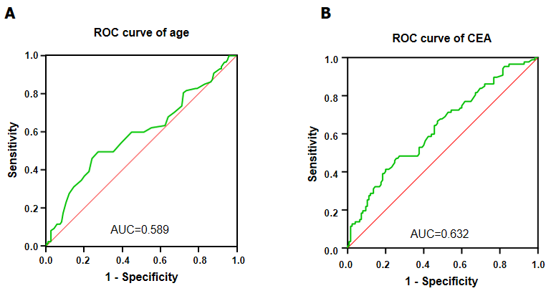
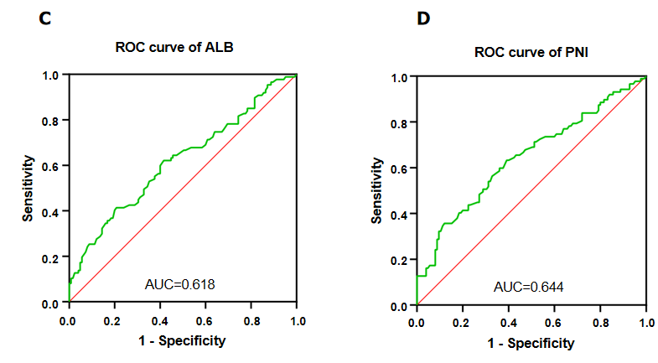
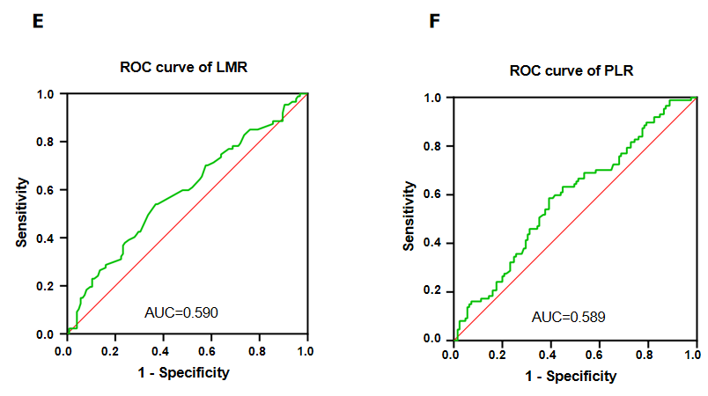
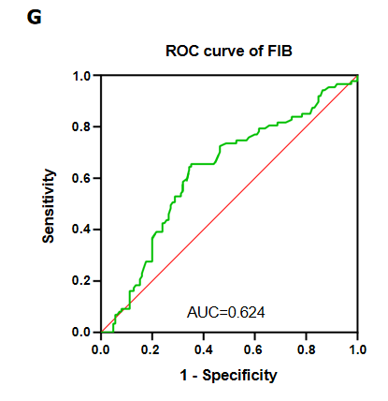
Figure 1 Receiver operating characteristic curves of all predictors. A: Age; B: Carcinoembryonic antigen; C: Albumin; D: Prognostic nutritional index; E: Lymphocyte to monocyte ratio; F: Platelet to lymphocyte ratio; G: Fibrinogen.

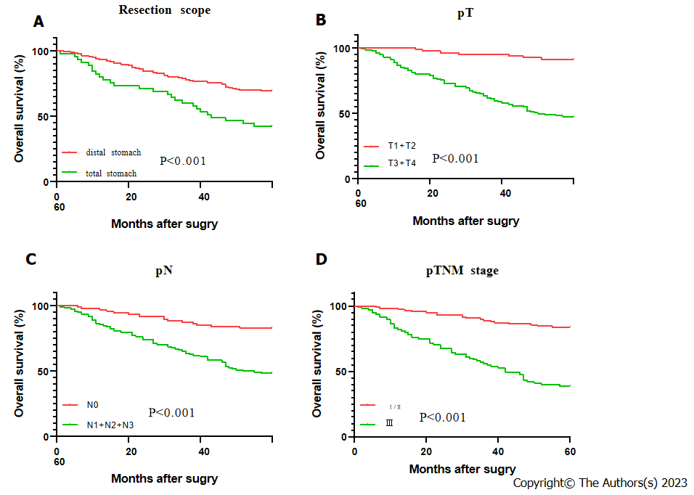
Figure 2 The survival curves of all predictors. A: Resection scope; B: Infiltration depth; C: Lymph node metastasis; D: pTNM staging;
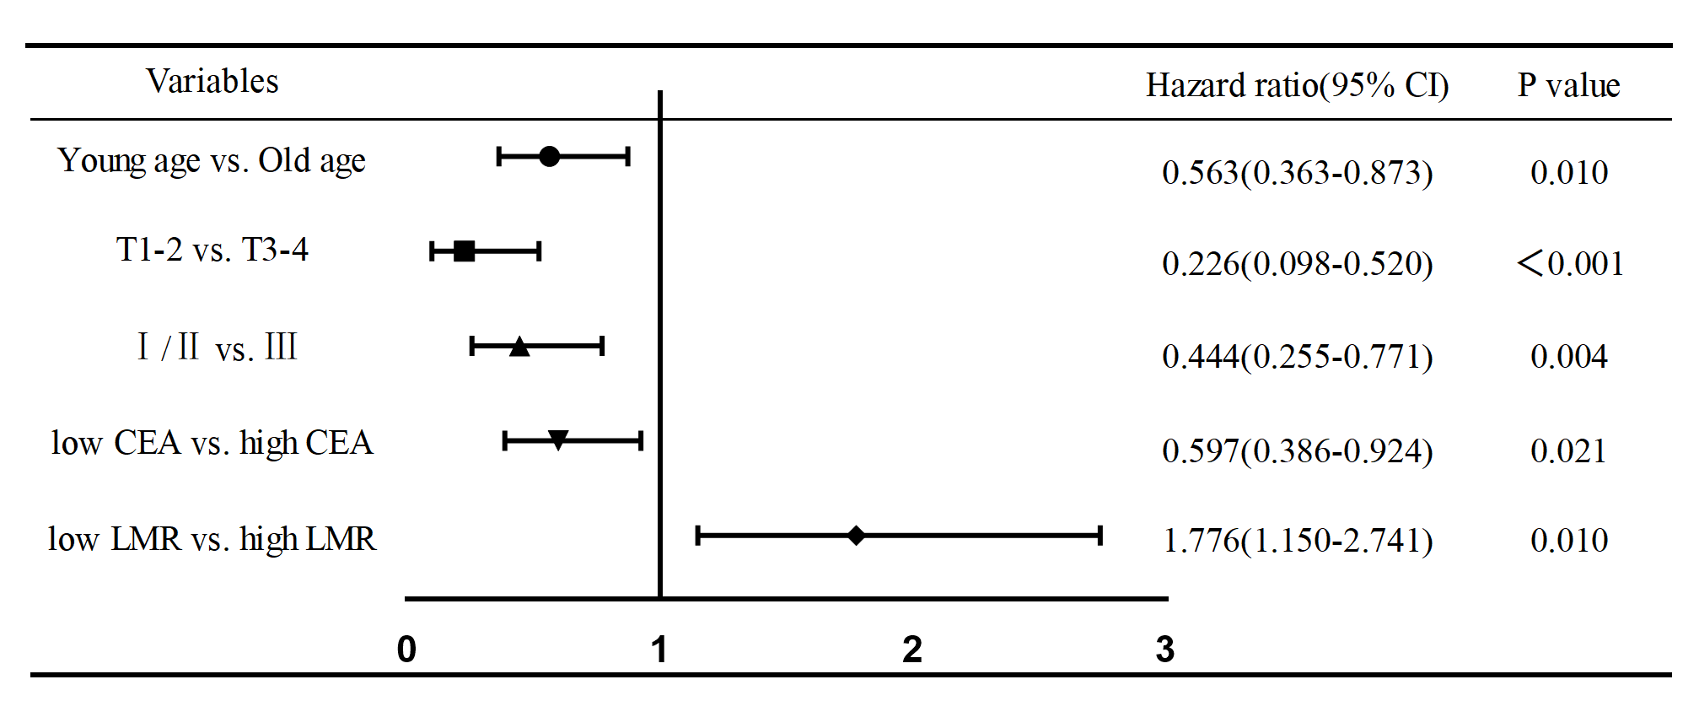
Figure 3 Survival of patients with different characteristics in Cox regression model. CEA: Carcinoembryonic antigen; LMR: Lymphocytes to monocytes.

Table 1 Baseline data and pathological features of the study participants
Characteristics | n (%)
Gender
Male | 117 (55.19)
Female | 95 (44.81)
Tumor site
Upper third | 5 (2.36)
Middle third | 58 (27.36)
Lower third | 149 (70.28)
pT
pT1-2 | 79 (37.26)
pT3-4 | 133 (62.74)
pN
pN0 | 94 (44.34)
pN1-3 | 118 (55.66)
pTNM stage
Ⅰ/Ⅱ | 117 (55.19)
Ⅲ | 95 (44.81)
Resection scope
Distal stomach | 167 (78.78)
Total stomach | 45 (21.23)
Survival status
Survival | 125 (58.96)
Dead | 87 (41.04)

Table 2 Receiver operating characteristic curve analysis results of predictors
Variables | AUC (95%CI) | P value | Cut-off value | Sensitivity | Specificity
Age | 0.589 (0.509, 0.669) | 0.028 | 55.5 | 0.494 | 0.728
PLR | 0.589 (0.511, 0.666) | 0.028 | 124.63 | 0.586 | 0.608
LMR | 0.590 (0.512, 0.669) | 0.025 | 3.83 | 0.54 | 0.632
ALB | 0.618 (0.540, 0.696) | 0.004 | 38.95 | 0.414 | 0.792
PNI | 0.644 (0.567, 0.721) | ＜ 0.001 | 49.85 | 0.632 | 0.608
FIB | 0.624 (0.547, 0.701) | 0.002 | 3.115 | 0.655 | 0.648
CEA | 0.632 (0.556, 0.708) | 0.001 | 1.455 | 0.471 | 0.744
PLR: Platelet to lymphocyte ratio; LMR: Lymphocyte to monocyte ratio; ALB: Albumin; PNI: Prognostic nutritional index; FIB: Fibrinogen; CEA: Carcinoembryonic antigen; AUC: Area under the curve.

Table 3 Relationship between baseline data, pathological features and 5-year survival rate
Group | Survival status |  | 5-OS (%) | χ² | P value
 | Survival(n) | Dead(n)
Gender |  |  |  | 1.27 | 0.26
Male | 73 | 44 | 62.39
Female | 52 | 43 | 54.74
Tumor site |  |  |  | 3.556 | 0.169
Upper third | 1 | 4 | 20
Middle third | 33 | 25 | 56.9
Lower third | 91 | 58 | 61.07
pT |  |  |  | 49.726 | ＜ 0.001
pT1-2 | 71 | 8 | 89.87
pT3-4 | 54 | 79 | 40.6
pN |  |  |  | 30.269 | ＜ 0.001
pN0 | 75 | 19 | 79.79
pN1-3 | 50 | 68 | 42.37
pTNM stage |  |  |  | 49.322 | ＜ 0.001
Ⅰ/Ⅱ | 94 | 23 | 80.34
Ⅲ | 31 | 64 | 32.63
Resection scope |  |  |  | 8.489 | 0.004
Distal stomach | 107 | 60 | 64.07
Total stomach | 18 | 27 | 40
OS: Overall survival.

Table 4 Relationship between indicators and survival status
Variables | Survival | Dead | t/Z value | P value
Age | 50 ± 10.82 | 53 ± 11.65 | -2.213 | 0.028
CEA | 0.90 (0.58, 1.48) | 1.21 (0.75, 2.35) | -3.265 | 0.001
NLR | 1.82 (1.30, 2.43) | 2.05 (1.45, 2.71) | -1.668 | 0.095
PLR | 118.33 (99.41, 150.18) | 130.59 (108.10, 162.00) | -2.196 | 0.028
LMR | 4.20 (3.40, 5.67) | 3.80 (2.80, 5.00) | -2.226 | 0.026
SII | 392.36 (275.38, 565.21) | 448.00 (311.67, 600.71) | -1.391 | 0.164
PT | 12.40 (11.96, 12.90) | 12.30 (12.00, 12.70) | -1.114 | 0.265
INR | 0.97 (0.93, 1.02) | 0.95 (0.93, 0.99) | -1.728 | 0.084
APTT | 32.71 ± 4.16 | 31.90 ± 3.98 | 1.425 | 0.156
TT | 17.55 ± 1.73 | 17.66 ± 1.85 | -0.424 | 0.672
FIB | 2.93 (2.56, 3.42) | 3.29 (2.81, 3.80) | -3.065 | 0.002
ALB (g/L) | 41.79 ± 3.83 | 40.09 ± 4.72 | 2.854 | 0.005
GLB (g/L) | 26.00 (23.80, 29.40) | 25.20 (22.80, 28.50) | -1.356 | 0.175
AGR | 1.58 (1.41, 1.80) | 1.56 (1.40, 1.75) | -0.716 | 0.474
PNI | 51.11 ± 4.95 | 48.21 ± 6.15 | 3.789 | ＜ 0.001
CEA: Carcinoembryonic antigen; NLR: Neutrophil to lymphocyte ratio; PLR: Platelet to lymphocyte ratio; LMR: Lymphocyte to monocyte ratio; SII: Systemic immune inflammation index; PT: Prothrombin time; INR: International normalized ratio; APTT: Activated partial thromboplastin time; TT: Thrombin time; FIB: Fibrinogen; ALB: Albumin; GLB: Globulin; AGR: Albumin to globulin ratio; PNI: Prognostic nutritional index.

Table 5 Grouping of predictors
 |  | Survival(n) | Dead(n) | 5-OS (%) | Total
Age | < 56 | 91 | 44 | 67.41 | 135
 | ≥ 56 | 34 | 43 | 44.16 | 77
CEA (ng/mL) | < 1.455 | 93 | 46 | 66.91 | 139
 | ≥ 1.455 | 32 | 41 | 43.84 | 73
PLR | < 124.63 | 76 | 36 | 67.86 | 112
 | ≥ 124.63 | 49 | 51 | 49 | 100
LMR | < 3.83 | 81 | 30 | 72.97 | 111
 | ≥ 3.83 | 44 | 57 | 43.56 | 101
ALB (g/L) | < 38.95 | 26 | 36 | 41.94 | 62
 | ≥ 38.95 | 99 | 51 | 66 | 150
PNI | < 49.85 | 49 | 55 | 47.12 | 104
 | ≥ 49.85 | 76 | 32 | 70.37 | 108
FIB (g/L) | < 3.115 | 46 | 47 | 49.46 | 93
 | ≥ 3.115 | 79 | 40 | 66.39 | 119
OS: Overall survival; CEA: Carcinoembryonic antigen; PLR: Platelet to lymphocyte ratio; LMR: Lymphocyte to monocyte ratio; ALB: Albumin; PNI: Prognostic nutritional index; FIB: Fibrinogen.

