Name of Journal: World Journal of Gastrointestinal Oncology
Manuscript NO: 64687
Manuscript Type: MINIREVIEWS

Novel perspective in pancreatic cancer therapy: Targeting ferroptosis pathway

Yang Y et al. Ferroptosis in pancreatic cancer

Yang Yang, Zi-Jian Zhang, Yu Wen, Li Xiong, Yun-Peng Huang, Yong-Xiang Wang, Kai Liu

Yang Yang, Zi-Jian Zhang, Yu Wen, Li Xiong, Yun-Peng Huang, Yong-Xiang Wang, Kai Liu, Department of General Surgery, The Second Xiangya Hospital, Central South University, Changsha 410011, Hunan Province, China

Author contributions: Yang Y and Zhang ZJ equally to this work; Zhang ZJ and Yang Y designed and wrote the paper; Huang YP, Liu K and Wang YX edited the work; Xiong L and Wen Y reviewed and revised the manuscript.

Supported by The National Natural Science Foundation of China, No. 81970569 and 81773293; Natural Science Foundation of Hunan Province, No. 2017SK50121.

Corresponding author: Yu Wen, MD, Chief Doctor, Professor, Department of General Surgery, The Second Xiangya Hospital, Central South University, No. 139 Renmin Road, Changsha 410011, Hunan Province, China. wenyu761507@csu.edu.cn

Received: February 22, 2021
Revised: April 20, 2021
Accepted: August 30, 2021
Published online: November 15, 2021

Abstract
Pancreatic cancer is a highly lethal malignancy with low resection and survival rates and is not sensitive to radiotherapy and chemotherapy. Ferroptosis is a novel form of nonapoptotic regulated cell death characterized by the accumulation of lipid peroxides and reactive oxygen species involved in iron metabolism. Ferroptosis has a significant role in the occurrence and development of various tumors. Previous studies have shown that regulating ferroptosis-induced cell death inhibited tumor growth in pancreatic cancer and was synergistic with other antitumor drugs to improve treatment sensitivity. Herein, we discuss the mechanism, inducers, and developments of ferroptosis in pancreatic cancer to provide new strategies for the treatment of the malignancy.

Key Words: Pancreatic cancer; Ferroptosis; Reactive oxygen species; Iron metabolism; Lipid peroxides

©The Author(s) 2021. Published by Baishideng Publishing Group Inc. All rights reserved.

Citation: Yang Y, Zhang ZJ, Wen Y, Xiong L, Huang YP, Wang YX, Liu K. Novel perspective in pancreatic cancer therapy: Targeting ferroptosis pathway. World J Gastrointest Oncol 2021; 13(11): 1668-1679
URL: https://www.wjgnet.com/1948-5204/full/v13/i11/1668.htm
DOI: https://dx.doi.org/10.4251/wjgo.v13.i11.1668

Core Tip: Many studies have confirmed that ferroptosis is closely related to the occurrence and development of pancreatic cancer, but there are few systematic reviews on the mechanism and treatment of ferroptosis in pancreatic cancer. This review focuses on the research progress of the mechanism of ferroptosis in pancreatic cancer, and summarizes feasible treatment from the perspective of the processes leading to the occurrence of ferroptosis.

INTRODUCTION
Pancreatic ductal adenocarcinoma (PDAC) accounts for approximately 90% of all pancreatic malignancies and is commonly known as pancreatic cancer. PDAC is a highly lethal malignancy, wherein the number of deaths in 2018 was almost the same as the number of new cases (432,242 and 458,918, respectively; GLOBOCAN database)^{[1]}. The clinical features of PDAC include a short course, rapid progression, and high probability of malignancy. Surgery is the only option to cure PDAC; however, most patients are diagnosed at advanced stages because of the absence of distinctive clinical symptoms, they lose the opportunity for radical surgery. The postoperative 5-year survival rate of patients with PDAC is 12%-27%^{[2]}. Currently, adjuvant gemcitabine chemotherapy is commonly performed after surgical resection; however, the 5-year survival rate is only 22.5%-26.0%^{[3-5]}. Moreover, the high resistance of PDAC cells to gemcitabine limits its efficacy. Novel adjuvant chemotherapy drugs, such as modified FOLFIRINOX and a 5-fluorouracil derivative (S-1), have been approved in recent years for patients who have undergone resection of PDAC. A study reported that the 3-year survival rate of patients was 63.4% in the modified FOLFIRINOX group; however, the outcome was associated with an increased risk of toxic effects^{[6]}. The 3-year survival rate of the patients in the S-1 group was 59.0%. However, the data were limited by the fact that all the patients were East-Asian residents of Japan^{[7]}. The global incidence of PDAC has increased over the past few decades, significantly affecting the health of the patients and causing a heavy social burden. Therefore, the need of the hour is to explore new, targeted therapies for PDAC.
Ferroptosis is a novel form of nonapoptotic regulated cell death (RCD)^{[8]} characterized by the accumulation of lipid peroxides and reactive oxygen species (ROS) involved in iron metabolism^{[9]}. ROS react with polyunsaturated fatty acids (PUFAs) in the lipid membrane to generate excessive amounts of lipid peroxides, resulting in cell membrane damage and eventually ferroptosis. Studies have shown that ferroptosis is involved in the occurrence and development of various diseases, such as neuropathy^{[10]}, ischemia-reperfusion injury^{[11]}, acute renal failure^{[12]}, and cancer. A study reported that ferroptosis might be a common and dynamic form of RCD in the treatment of cancer^{[13]}.
More than 90% of PDAC patients have mutations in the KRAS gene that promotes proliferation, alters cellular metabolism, and affects invasion and autophagy^{[14]}. Mutations in KRAS lead to a significant increase in intracellular ROS^{[15]}. To avoid cell death, cancer cells must promptly remove intracellular ROS during rapid division. A study reported that PDAC cells transport a large amount of cystine/cysteine to synthesize glutathione (GSH) as a compensatory mechanism, thereby eliminating excess intracellular ROS^{[16]}. Ferroptosis is closely related to the production of cystine/cysteine and ROS and thus can be considered a critical form of RCD in PDAC and might be selectively targeted as an anticancer therapy. In this review, we briefly describe the mechanism of ferroptosis, its research status, and prospects for use in treating PDAC.

Profile and research perspective of ferroptosis
Origin
In 2003, Dolma et al^{[17]} discovered an antitumor drug named erastin that induced cell death without causing changes in nuclear morphology, DNA fragmentation, and caspase 3 activation. Moreover, caspase inhibitors did not reverse the process. Subsequently, the group identified RAS-selective lethal small molecule 3 (RSL3), which induced cell death similar to that caused by erastin^{[18]}. In 2012, Dixon et al^{[8]} found that erastin inhibited the cystine/glutamate antiporter (system XC-), causing excessive accumulation of lipid ROS, ultimately leading to an iron-dependent oxidative death known as ferroptosis.

Characteristics
Compared with other RCDs such as necrosis, apoptosis, and autophagy^{[19]} (Table 1), ferroptosis is characterized by the maintenance of an intact nucleus, nonaggregation of chromatin, nonrupture and foaming of the protoplast membrane, condensed mitochondrial membrane densities, reduction or loss of mitochondrial crista, and outer mitochondrial membrane rupture^{[9]}. The biochemical characteristics of ferroptosis are increased concentration of lipid hydrogen peroxide (H₂O₂) and ferrous iron (Fe²⁺). Intracellular lipid oxides are abnormally metabolized by the catalysis of iron ions, and the increased lipids production affects the original redox balance. Thus, the biological macromolecules are attacked, leading to cell death manifested by the inactivation of glutathione peroxidase 4 (GPX4) and deposition of lipid peroxide^{[20]}.

Main metabolic process of ferroptosis
Currently, the metabolic mechanism of ferroptosis is known to include three processes. (1) Iron metabolism includes participation of iron ions in the formation of ROS through enzymatic or non-enzymatic reactions to mediate ferroptosis; (2) Amino acid metabolism includes GSH, which is a substrate of GPX4. GSH is the most important intracellular antilipid oxidation molecule. Cysteine is the raw material required for its synthesis, and an abundance of intracellular cysteine determines the synthesis of GSH and the process of cellular resistance to lipid oxidation, ultimately affecting ferroptosis^{[21,22]}; and (3) Lipid metabolism is involved. The accumulation of lipid peroxides, especially phospholipid peroxides, is considered a landmark of ferroptosis^{[23]}. A recent study reported that ferroptosis suppressor protein 1 exists as an independent parallel system that cooperates with GPX4 and GSH to suppress phospholipid peroxidation and ferroptosis^{[24]}. Furthermore, induction of ferroptosis occurs by regulating the tumor microenvironment (Figure 1).

Current status of ferroptosis in PDAC
In recent years, systemic treatment of PDAC has mainly relied on 5-fluorouracil and gemcitabine-based therapy. However, because of rapid and widespread development of chemical resistance, the prognosis remains poor. Recent studies have demonstrated that ferroptosis is associated with PDAC (Figure 2). Therefore, inducing ferroptosis is a new strategy to combat PDAC.

Ferroptosis regulated by iron metabolism in PDAC
Extracellular ferric ions (Fe³⁺) form a conjugate with transferrin and are transported via the transferrin receptor 1 on the surface of the cell membrane. First, the conjugate enters the cell by endocytosis. Subsequently, Fe³⁺ are reduced by the six-transmembrane epithelial antigen of prostate 3 to Fe²⁺ and enter the cytoplasm from the endosome via the divalent metal ion transporter 1^{[25]}. Fe²⁺ can be stored as ferritin or in the free form. Meanwhile, ferritin, as a downstream regulatory gene of nuclear factor erythroid 2-related factor 2 (NRF2), is regulated by the p62-KEAP1-NRF2 signaling pathway^{[26]} (Figure 2).
Excess intracellular Fe²⁺ catalyzes the Fenton reaction, in which Fe²⁺ reacts with H₂O₂ to produce Fe³⁺ and hydroxyl radicals. The hydroxyl radical is a type of ROS that can damage proteins, lipids, and DNA, affect the function of cell membranes, and lead to cell death^{[26]}. From the perspective of chemical reactions of intracellular Fe²⁺, the Fenton reaction may be considered one of the important processes involved in ferroptosis. The reaction between H₂O₂ and Fe²⁺ generates Fe³⁺ along with OH⁻ and hydroxyl radicals (Formula 1). The hydroxyl radical is one of the most active ROS. In addition, the Fenton reaction can generate peroxy free radicals^{[27]} (Formulas 2 and 3). The series of reactions suggest that iron ions act as a catalyst to promote the production of ROS in cells, especially in tumor cells^{[28]}. Therefore, the Fenton reaction not only provides Fe²⁺ but also continuously catalyzes the production of ROS, both of which are essential conditions for ferroptosis. Formulas: (1) Fe²⁺ + H₂O₂→Fe³⁺ + (OH-) + OH (Formula 1); (2) O₂⁻ + Fe³⁺→O₂ + Fe²⁺ (Formula 2); and (3) O₂ + Fe²⁺→ Fe³⁺ + O₂⁻ (Formula 3).
Ferritin is composed of two subunits, namely ferritin heavy chain (FHC) and ferritin light chain (FLC). A study reported that iron-responsive element-binding protein 2 increased the expression of FHC and FLC to inhibit ferroptosis^{[29]}. Lactotransferrin (LTF) is a member of the transferrin family that is associated with increased intracellular iron during inflammatory injury and is by neural precursor cell-expressed developmentally downregulated 4-like (NEDD4L). Wang et al^{[30]} reported that NEDD4L-mediated LTF protein degradation inhibited intracellular iron accumulation and subsequent oxidative damage-mediated ferroptosis in PDAC. Lipocalin-2 (LCN2) interacts with siderophores (iron-binding proteins) and acts as an iron carrier to intracellular and extracellular iron levels. Another study reported that LCN2 inhibited invasion and angiogenesis in PDAC^{[31]}.

Autophagy-dependent ferroptosis in PDAC
The autophagic degradation of ferritin to release Fe²⁺ is known as ferritinophagy, which is mediated by nuclear receptor coactivator 4 (NCOA4)^{[32]}. Ferritinophagy is closely associated with the physiological and pathological processes of cell growth, proliferation, differentiation, apoptosis, and carcinogenesis. Under physiological conditions, ferritinophagy is tightly regulated by the iron-dependent protein network to maintain the balance of iron in cells and perform its functions. However, excessive activation of ferritinophagy leads to intracellular iron overload and accumulation of a large amount of ROS in a short period, resulting in ferroptosis. Therefore, it has been proposed that ferroptosis is a type of autophagy-dependent cell death^{[33]}.
Overexpression of NCOA4 enhances the degradation of ferritin, increases intracellular free iron levels, and promotes ferroptosis. Knockout or knockdown of autophagy-related 5 (ATG5) and ATG7-limited erastin-induced ferroptosis are associated with decreased intracellular Fe²⁺ levels and lipid peroxidation. Hou et al^{[32]} further found that activating the ATG5/7-NCOA4 axis inhibited the expression of FHC and degraded ferritin, leading to an increase in intracellular Fe²⁺ and lipid ROS, thereby promoting ferroptosis in PDAC. Zhu et al^{[34]} reported that heat shock protein 5 (HSPA5) is closely related to the prognosis of PDAC patients treated with gemcitabine. Activation of the HSPA5-GPX4 pathway led to the resistance of PDAC cells to gemcitabine. Inhibition of HSPA5 or GPX4 gene expression reversed the resistance and ferroptosis played an important role in the process. NRF2 is a transcription factor that regulates heme and iron metabolism. Pirin (PIR), an iron-binding nuclear protein, is a nuclear redox sensor and regulator. Overexpression of PIR limits oxidative damage to DNA, subsequent cytoplasmic transport, and extracellular release of high mobility group box protein 1, which is released by ferroptotic cells and subsequently triggers an inflammatory response in peripheral macrophages. NRF2 mediates the upregulation of PIR leading to autophagy-dependent ferroptosis^{[35,36]}. In addition, the ferroptosis inducers erastin, sorafenib^{[37]}, and sulfasalazine^{[38]}, (Table 2) have been shown to activate the adenosine monophosphate-activated protein kinase/sterol regulatory element-binding protein 2 signaling pathway through iron-dependent ferritinophagy^{[39]}. Furthermore, a phase I study revealed that the combination of sorafenib and gemcitabine demonstrated promising antitumor activity in patients with advanced PDAC^{[40]}. However, the combination therapy did not improve recurrence-free and overall survival of patients with PDAC with postsurgical R1 residual status. However, a subgroup analysis revealed significantly improved disease-free and overall survival of patients who underwent more than six cycles of chemotherapy. Twelve cycles of additive chemotherapy with gemcitabine may be considered for patients in poor general health^{[41]}. Therefore, research on the relationship between autophagy and ferroptosis may provide new ideas for the treatment of PDAC.

Ferroptosis is regulated by amino acid and GSH metabolism in PDAC
Cellular entry and exit of cysteine and glutamic acid require a specific transporter, system XC-, which is a heterodimer formed by the glycosylated heavy chain CD98hc, which is also called solute carrier family 3 member 2 (SLC3A2), and nonglycosylated xCT (SLC7A11) joined by disulfide bonds^{[42]}. Cystine is reduced to cysteine to synthesize GSH and regulate downstream lipid peroxidation. As an electron donor, GSH converts toxic phospholipid peroxides into nontoxic phospholipid alcohols and oxidized glutathione under the action of GPX4^{[43]}. In addition to system XC-, cysteine can be transported directly into the cell by the alanine-serine-cysteine system, which is also known to inhibit ferroptosis^{[44]}. Furthermore, cystine can be synthesized from methionine via the transsulfuration pathway.
Many cells rely on system XC- for cystine uptake, which is the rate-limiting step for cysteine synthesis. Blocking or inhibiting this step leads to a decrease in intracellular cysteine, inhibits the lipid repair function of GPX4, and ultimately induces ferroptosis. It has been reported that erastin and its analogs (e.g., sulfasalazine and sorafenib) can block the transport function of system XC- and induce ferroptosis. Wang et al^{[39]} studied the effect of system XC- on ferroptosis and found that branched-chain amino acid transaminase 2 (BCAT2) was the key enzyme mediating the metabolism of sulfur amino acids. BCAT2 was found to regulate intracellular glutamate concentration and its activation by ectopic expression specifically antagonized the inhibition of system XC- and protected PDAC cells from ferroptosis in vitro and in vivo. Furthermore, BCAT2 participates in the synergistic mechanisms of sulfasalazine and sorafenib to induce ferroptosis. Therefore, BCAT2 may be considered a suppressor of ferroptosis, and inhibiting intracellular glutamate synthesis might be effective in inducing ferroptosis.
Another small molecule, RSL3 directly inhibits GPX4, leading to the accumulation of lipid ROS and ferroptosis. Selenium increases the antiferroptotic activity of GPX4 through a selenocysteine residue at 46. In addition, selenium is incorporated during the synthesis of selenoproteins such as thioredoxin reductase 1 (TrxR1; direct reduction of hydroperoxides). Rong et al^{[45]} reported that diaphanous homolog 3 (DIAPH3) was highly expressed in the tissues of patients with PDAC, wherein it promoted an increase of selenium content and interacted with the selenoprotein, ribosomal protein L6. DIAPH3 downregulated cellular ROS levels by upregulating the expression of TrxR1.

Ferroptosis regulated by lipid metabolism in PDAC
Fatty acids are substrates of lipid peroxidation reactions, and are esterified to form membrane phospholipids. PUFAs are more prone to oxidation than either saturated or monounsaturated fatty acids (MUFAs). Membrane phospholipids react with oxygen and adjacent lipids to generate phospholipid hydroperoxide (PL-OOH). The reaction product of Fe²⁺ and PL-OOH continues to react with lipids to generate phospholipid radicals for a new round of lipid peroxidation^{[46]}. The degradation products of PL-OOH damage the cell membrane. Extensive lipid peroxidation affects the fluidity and structure of the cell membrane, increases its permeability, and leads to cell death. Lipid peroxidation is catalyzed by long-chain acyl-CoA synthetase 4 (ACSL4), lysophosphatidylcholine acyltransferase 3 (LPCAT3), and arachidonate lipoxygenase (ALOX). ACSL4 catalyzes lipid reactions and tends to esterify the acyl group of arachidonic acid, while LPCAT3 aids in the insertion of PUFA into membrane phospholipids. Subsequently, free PUFAs are catalyzed by ALOXs to produce various lipid hydrogen peroxides^{[47,48]}.
Lipid peroxides cause cellular damage through several mechanisms. The first is by the decomposition of lipid peroxides into ROS, which further amplifies the lipid peroxidation process. Second, lipid peroxides alter the physical structure of the membrane, with changes in thickness, the degree of curvature, and pore formation that results in the release of harmful substances and disrupting intracellular metabolism. The third is via by-products such as malondialdehyde and 4-hydroxy-2-nonenal produced by lipid peroxidation, which can damage the cells^{[48]}. ADP ribosylation factor 6 (ARF6) is a member of the RAS superfamily and regulates vesicular trafficking, remodeling of membrane lipids, and signaling pathways. A study reported that ARF6 regulated the sensitivity to RSL3-induced ferroptosis and enhanced RSL3-induced lipid peroxidation by affecting the level of ACSL4 protein^{[49]}. ALOX5 is the functional subtype of the ALOX family. It catalyzes the peroxidation of PUFAs such as arachidonic acid and is a key mediator of lipid peroxidation^{[50]}. Kuang et al^{[51]} observed that NRF2 mediated the upregulation of microsomal glutathione transferase 1, which by binding to ALOX5, limited lipid peroxidation during ferroptosis in PDAC. p53 protein is a transcription factor that has an important role in preventing the development of PDAC. In addition to being regulated by a variety of cellular stressors and as a master regulator, p53 is involved in the arrest of cell growth, apoptosis, and senescence. Recently, p53 has been found to regulate a variety of cellular metabolic functions and the stress response to ROS^{[52]}. Ou et al^{[53]} discovered that p53 stimulated ferroptosis by directly activating expression of its target gene spermidine/spermine N1-acetyltransferase 1, which triggers ferroptosis upon stress from ROS. The activity of PUFAs in ferroptosis is competitively affected by MUFAs, indicating that exogenous MUFAs cause resistance to ferroptosis. The resistance depends on ACSL3 or stearoyl-CoA desaturase (SCD/SCD1), an enzyme involved in fatty acid biosynthesis, primarily the synthesis of oleic acid^{[35]}. Ye et al^{[54]} found that F-box and WD repeat domain-containing 7 promoted both ferroptosis and apoptosis in PDAC by downregulating SCD1 and inhibited the transcription of SCD1 by reducing the binding of NR4A1 to the SCD1 promoter.

Ferroptosis is regulated by the tumor microenvironment in PDAC
The tumor microenvironment, including the tumor cells, vascular system, extracellular matrix, and immune cells, is an important factor affecting the outcomes of therapy. It has been reported that nano-inducers of ferroptosis attract iron from the extracellular environment to increase the intracellular content. It has also been shown that simultaneous upregulation of FHC and downregulation of GSH that increased the levels of intracellular ROS led to ferroptosis in tumor cells^{[55]}. Another inducer is a near-infrared photosensitizer, IR780, which can be loaded into perfluorocarbon nanodroplets. The function of the inducer functions depends on differences of the microenvironments of normal and tumor tissue such as oxygen level, pH, and the immune system, among other factors. Photodynamic therapy activated oxygen enriched with perfluorocarbon generated ROS in the tumor tissue to kill the tumor cells^{[56]}. Traditionally, CD8⁺ T cells in the tumor microenvironment induce cell death through perforin, granzyme, and Fas/Fas ligand pathways. However, a recent study demonstrated that immunotherapy-activated CD8⁺ T cells enhanced ferroptosis-specific lipid peroxidation in tumor cells. Interferon-gamma released from CD8⁺ T cells was found to downregulate the expression of SLC3A2 and SLC7A11, restrain cystine uptake in tumor cells, and promote lipid peroxidation and ferroptosis^{[57]}. In addition, various macrophage subsets have different sensitivities to ferroptosis. Resting macrophages can be polarized to form antitumor M1 and procarcinogenic M2 subtypes. Dai et al^{[58]} reported that KRAS^{G12D} caused macrophages to switch to an M2-like pro-tumor phenotype via signal transducer and activator of transcription 3-dependent fatty acid oxidation, which can be considered a key mediator of cancer cell-macrophage communication in PDAC. Furthermore, oxidative stress induced the release of KRAS^{G12D} protein from cancer cells undergoing ferroptosis. Targeting the tumor microenvironment to promote ferroptosis of PDAC cells could be a new strategy for cancer therapy (Figure 3).

Inducing ferroptosis to treat PDAC
Ferroptosis has an important role in tumor cell death and inhibition of tumor growth; therefore, inducing ferroptosis in PDAC is expected to become a new therapeutic strategy. Inducers of ferroptosis can be divided into several categories based on the regulatory mechanism.

Iron metabolism
Song et al^{[59]} reported that ruscogenin induced ferroptosis by regulating the levels of transferrin and ferroportin. Ruscogenin increased the concentration of intracellular Fe²⁺ and the production of ROS, which was inhibited by deferoxamine.

Ferritinophagy
Liu et al^{[60]} observed that rapamycin caused autophagy-dependent ferroptosis by inducing the degradation of GPX4 protein but did not inhibit GPX4 gene transcription. In animal studies, the researchers observed that GPX4 depletion in PDAC cells enhanced the anticancer activity of rapamycin in vivo. Li et al^{[61]} proposed a new model of cell death, wherein mitochondrial DNA stress triggered autophagy-dependent ferroptosis. Degradation of zalcitabine-induced transcription factor A, mitochondrial triggered oxidative DNA damage, the release of mitochondrial DNA into the cytosol, and subsequent activation of the cyclic GMP-AMP synthase-stimulator of interferon genes pathway. Zalcitabine suppressed pancreatic tumor growth via the autophagy-dependent ferroptosis.

Lipid metabolism
Several key enzymes (ACSL4, LPCAT3, and ALOXs) are involved in lipid oxidation and can be regulated to induce ferroptosis. Studies have reported that erastin and RSL3 induced ferroptosis in PDAC^{[62]}, and ALOXs enhanced the sensitivity of RAS-mutated tumor cells to erastin and RSL3^{[50]}.

Amino acid metabolism
Piperlongumine (PL) is a natural product with cytotoxic properties restricted to cancer cells. PL acts by significantly increasing ROS levels in an iron-dependent manner. Yamaguchi et al^{[63]} found that PL rapidly induced the death of human PDAC cells chiefly through the inhibition of GPX4, and sulfasalazine enhanced cell death. Moreover, sulfasalazine enhanced the cancer cell-killing ability of the combination of PL and cotylenin A, which is a plant growth regulator with potent antitumor activity.

Comprehensive regulation
Bao et al^{[64]} investigated the effects of irisin on the expression of the ROS-related protein NRF2 and the autophagy-related protein, microtubule-associated protein 1A/1B-light chain 3 during ferroptosis. They observed that irisin promoted the upregulation of erastin-induced free iron, lipid ROS, and GSH depletion and positively regulated ferroptosis in PDAC. Eling et al^{[65]} reported that artesunate (ART) was a specific activator of ferroptosis in PDAC cells and that erastin and ART activated ferroptosis in PDAC cell lines in an iron- and ROS-dependent manner. ART-induced ferroptosis was most effective in mutationally-active KRAS expressing PDAC cell lines. Subsequently, Wang et al^{[66]} showed that inhibition of 78-kDa glucose-regulated protein 78 reversed the resistance of PDAC cells to ferroptosis and increased tumor sensitivity to ART.

CONCLUSION
Ferroptosis is a new model of cell death induced by small molecules such as erastin and RSL3, which are regulated at multiple levels. In this review, we briefly described the mechanism of ferroptosis, which includes iron, amino acid, and lipid metabolism, and summarized the regulatory pathways of ferroptosis in PDAC. The occurrence and development of ferroptosis are accompanied by the accumulation of ROS, resulting in lipid peroxidation of the cell membrane. Inducing ferroptosis can cause the death of PDAC cells, and can have a synergistic role with anticancer drugs to improve the sensitivity of PDAC to the existing treatment modalities. In addition, the level of ferroptosis inducer is associated with the prognosis of the disease. Therefore, induction of ferroptosis may have potential as a treatment of PDAC. However, ferroptosis has not been studied extensively in PDAC. A study reported that knockout of the GPX4 gene in B1 and marginal zone B cells triggered ferroptosis by inducing lipid peroxidation, thus affecting the immune response of B cells^{[67]}. However, there are no studies of B cells and ferroptosis in PDAC. Therefore, clarification of the molecular mechanism of ferroptosis and exploration of its role in the development and treatment of PDAC will help explain not only the mechanism of cell death and escape of PDAC cells, but also to develop novel effective therapeutic targets.

REFERENCES
1 Bray F, Ferlay J, Soerjomataram I, Siegel RL, Torre LA, Jemal A. Global cancer statistics 2018: GLOBOCAN estimates of incidence and mortality worldwide for 36 cancers in 185 countries. CA Cancer J Clin 2018; 68: 394-424 [PMID: 30207593 DOI: 10.3322/caac.21492]
2 Daamen LA, Groot VP, Intven MPW, Besselink MG, Busch OR, Koerkamp BG, Mohammad NH, Hermans JJ, van Laarhoven HWM, Nuyttens JJ, Wilmink JW, van Santvoort HC, Molenaar IQ, Stommel MWJ; Dutch Pancreatic Cancer Group. Postoperative surveillance of pancreatic cancer patients. Eur J Surg Oncol 2019; 45: 1770-1777 [PMID: 31204168 DOI: 10.1016/j.ejso.2019.05.031]
3 Skau Rasmussen L, Vittrup B, Ladekarl M, Pfeiffer P, Karen Yilmaz M, Østergaard Poulsen L, Østerlind K, Palnæs Hansen C, Bau Mortensen M, Viborg Mortensen F, Sall M, Detlefsen S, Bøgsted M, Wilki Fristrup C. The effect of postoperative gemcitabine on overall survival in patients with resected pancreatic cancer: A nationwide population-based Danish register study. Acta Oncol 2019; 58: 864-871 [PMID: 30905248 DOI: 10.1080/0284186X.2019.1581374]
4 Oettle H, Post S, Neuhaus P, Gellert K, Langrehr J, Ridwelski K, Schramm H, Fahlke J, Zuelke C, Burkart C, Gutberlet K, Kettner E, Schmalenberg H, Weigang-Koehler K, Bechstein WO, Niedergethmann M, Schmidt-Wolf I, Roll L, Doerken B, Riess H. Adjuvant chemotherapy with gemcitabine vs observation in patients undergoing curative-intent resection of pancreatic cancer: a randomized controlled trial. JAMA 2007; 297: 267-277 [PMID: 17227978 DOI: 10.1001/jama.297.3.267]
5 Murakami Y, Uemura K, Sudo T, Hayashidani Y, Hashimoto Y, Ohge H, Sueda T. Impact of adjuvant gemcitabine plus S-1 chemotherapy after surgical resection for adenocarcinoma of the body or tail of the pancreas. J Gastrointest Surg 2009; 13: 85-92 [PMID: 18704593 DOI: 10.1007/s11605-008-0650-4]
6 Conroy T, Hammel P, Hebbar M, Ben Abdelghani M, Wei AC, Raoul JL, Choné L, Francois E, Artru P, Biagi JJ, Lecomte T, Assenat E, Faroux R, Ychou M, Volet J, Sauvanet A, Breysacher G, Di Fiore F, Cripps C, Kavan P, Texereau P, Bouhier-Leporrier K, Khemissa-Akouz F, Legoux JL, Juzyna B, Gourgou S, O'Callaghan CJ, Jouffroy-Zeller C, Rat P, Malka D, Castan F, Bachet JB; Canadian Cancer Trials Group and the Unicancer-GI–PRODIGE Group. FOLFIRINOX or Gemcitabine as Adjuvant Therapy for Pancreatic Cancer. N Engl J Med 2018; 379: 2395-2406 [PMID: 30575490 DOI: 10.1056/NEJMoa1809775]
7 Uesaka K, Boku N, Fukutomi A, Okamura Y, Konishi M, Matsumoto I, Kaneoka Y, Shimizu Y, Nakamori S, Sakamoto H, Morinaga S, Kainuma O, Imai K, Sata N, Hishinuma S, Ojima H, Yamaguchi R, Hirano S, Sudo T, Ohashi Y; JASPAC 01 Study Group. Adjuvant chemotherapy of S-1 versus gemcitabine for resected pancreatic cancer: a phase 3, open-label, randomised, non-inferiority trial (JASPAC 01). Lancet 2016; 388: 248-257 [PMID: 27265347 DOI: 10.1016/S0140-6736(16)30583-9]
8 Dixon SJ, Lemberg KM, Lamprecht MR, Skouta R, Zaitsev EM, Gleason CE, Patel DN, Bauer AJ, Cantley AM, Yang WS, Morrison B 3rd, Stockwell BR. Ferroptosis: an iron-dependent form of nonapoptotic cell death. Cell 2012; 149: 1060-1072 [PMID: 22632970 DOI: 10.1016/j.cell.2012.03.042]
9 Xie Y, Hou W, Song X, Yu Y, Huang J, Sun X, Kang R, Tang D. Ferroptosis: process and function. Cell Death Differ 2016; 23: 369-379 [PMID: 26794443 DOI: 10.1038/cdd.2015.158]
10 Masaldan S, Bush AI, Devos D, Rolland AS, Moreau C. Striking while the iron is hot: Iron metabolism and ferroptosis in neurodegeneration. Free Radic Biol Med 2019; 133: 221-233 [PMID: 30266679 DOI: 10.1016/j.freeradbiomed.2018.09.033]
11 Wu X, Li Y, Zhang S, Zhou X. Ferroptosis as a novel therapeutic target for cardiovascular disease. Theranostics 2021; 11: 3052-3059 [PMID: 33537073 DOI: 10.7150/thno.54113]
12 Belavgeni A, Meyer C, Stumpf J, Hugo C, Linkermann A. Ferroptosis and Necroptosis in the Kidney. Cell Chem Biol 2020; 27: 448-462 [PMID: 32302582 DOI: 10.1016/j.chembiol.2020.03.016]
13 Mou Y, Wang J, Wu J, He D, Zhang C, Duan C, Li B. Ferroptosis, a new form of cell death: opportunities and challenges in cancer. J Hematol Oncol 2019; 12: 34 [PMID: 30925886 DOI: 10.1186/s13045-019-0720-y]
14 Mann KM, Ying H, Juan J, Jenkins NA, Copeland NG. KRAS-related proteins in pancreatic cancer. Pharmacol Ther 2016; 168: 29-42 [PMID: 27595930 DOI: 10.1016/j.pharmthera.2016.09.003]
15 Storz P. KRas, ROS and the initiation of pancreatic cancer. Small GTPases 2017; 8: 38-42 [PMID: 27215184 DOI: 10.1080/21541248.2016.1192714]
16 Badgley MA, Kremer DM, Maurer HC, DelGiorno KE, Lee HJ, Purohit V, Sagalovskiy IR, Ma A, Kapilian J, Firl CEM, Decker AR, Sastra SA, Palermo CF, Andrade LR, Sajjakulnukit P, Zhang L, Tolstyka ZP, Hirschhorn T, Lamb C, Liu T, Gu W, Seeley ES, Stone E, Georgiou G, Manor U, Iuga A, Wahl GM, Stockwell BR, Lyssiotis CA, Olive KP. Cysteine depletion induces pancreatic tumor ferroptosis in mice. Science 2020; 368: 85-89 [PMID: 32241947 DOI: 10.1126/science.aaw9872]
17 Dolma S, Lessnick SL, Hahn WC, Stockwell BR. Identification of genotype-selective antitumor agents using synthetic lethal chemical screening in engineered human tumor cells. Cancer Cell 2003; 3: 285-296 [PMID: 12676586 DOI: 10.1016/s1535-6108(03)00050-3]
18 Yang WS, Stockwell BR. Synthetic lethal screening identifies compounds activating iron-dependent, nonapoptotic cell death in oncogenic-RAS-harboring cancer cells. Chem Biol 2008; 15: 234-245 [PMID: 18355723 DOI: 10.1016/j.chembiol.2008.02.010]
19 Tang D, Kang R, Berghe TV, Vandenabeele P, Kroemer G. The molecular machinery of regulated cell death. Cell Res 2019; 29: 347-364 [PMID: 30948788 DOI: 10.1038/s41422-019-0164-5]
20 Galluzzi L, Vitale I, Aaronson SA, Abrams JM, Adam D, Agostinis P, Alnemri ES, Altucci L, Amelio I, Andrews DW, Annicchiarico-Petruzzelli M, Antonov AV, Arama E, Baehrecke EH, Barlev NA, Bazan NG, Bernassola F, Bertrand MJM, Bianchi K, Blagosklonny MV, Blomgren K, Borner C, Boya P, Brenner C, Campanella M, Candi E, Carmona-Gutierrez D, Cecconi F, Chan FK, Chandel NS, Cheng EH, Chipuk JE, Cidlowski JA, Ciechanover A, Cohen GM, Conrad M, Cubillos-Ruiz JR, Czabotar PE, D'Angiolella V, Dawson TM, Dawson VL, De Laurenzi V, De Maria R, Debatin KM, DeBerardinis RJ, Deshmukh M, Di Daniele N, Di Virgilio F, Dixit VM, Dixon SJ, Duckett CS, Dynlacht BD, El-Deiry WS, Elrod JW, Fimia GM, Fulda S, García-Sáez AJ, Garg AD, Garrido C, Gavathiotis E, Golstein P, Gottlieb E, Green DR, Greene LA, Gronemeyer H, Gross A, Hajnoczky G, Hardwick JM, Harris IS, Hengartner MO, Hetz C, Ichijo H, Jäättelä M, Joseph B, Jost PJ, Juin PP, Kaiser WJ, Karin M, Kaufmann T, Kepp O, Kimchi A, Kitsis RN, Klionsky DJ, Knight RA, Kumar S, Lee SW, Lemasters JJ, Levine B, Linkermann A, Lipton SA, Lockshin RA, López-Otín C, Lowe SW, Luedde T, Lugli E, MacFarlane M, Madeo F, Malewicz M, Malorni W, Manic G, Marine JC, Martin SJ, Martinou JC, Medema JP, Mehlen P, Meier P, Melino S, Miao EA, Molkentin JD, Moll UM, Muñoz-Pinedo C, Nagata S, Nuñez G, Oberst A, Oren M, Overholtzer M, Pagano M, Panaretakis T, Pasparakis M, Penninger JM, Pereira DM, Pervaiz S, Peter ME, Piacentini M, Pinton P, Prehn JHM, Puthalakath H, Rabinovich GA, Rehm M, Rizzuto R, Rodrigues CMP, Rubinsztein DC, Rudel T, Ryan KM, Sayan E, Scorrano L, Shao F, Shi Y, Silke J, Simon HU, Sistigu A, Stockwell BR, Strasser A, Szabadkai G, Tait SWG, Tang D, Tavernarakis N, Thorburn A, Tsujimoto Y, Turk B, Vanden Berghe T, Vandenabeele P, Vander Heiden MG, Villunger A, Virgin HW, Vousden KH, Vucic D, Wagner EF, Walczak H, Wallach D, Wang Y, Wells JA, Wood W, Yuan J, Zakeri Z, Zhivotovsky B, Zitvogel L, Melino G, Kroemer G. Molecular mechanisms of cell death: recommendations of the Nomenclature Committee on Cell Death 2018. Cell Death Differ 2018; 25: 486-541 [PMID: 29362479 DOI: 10.1038/s41418-017-0012-4]
21 Maiorino M, Conrad M, Ursini F. GPx4, Lipid Peroxidation, and Cell Death: Discoveries, Rediscoveries, and Open Issues. Antioxid Redox Signal 2018; 29: 61-74 [PMID: 28462584 DOI: 10.1089/ars.2017.7115]
22 Doll S, Conrad M. Iron and ferroptosis: A still ill-defined liaison. IUBMB Life 2017; 69: 423-434 [PMID: 28276141 DOI: 10.1002/iub.1616]
23 D'Herde K, Krysko DV. Ferroptosis: Oxidized PEs trigger death. Nat Chem Biol 2017; 13: 4-5 [PMID: 27842067 DOI: 10.1038/nchembio.2261]
24 Doll S, Freitas FP, Shah R, Aldrovandi M, da Silva MC, Ingold I, Goya Grocin A, Xavier da Silva TN, Panzilius E, Scheel CH, Mourão A, Buday K, Sato M, Wanninger J, Vignane T, Mohana V, Rehberg M, Flatley A, Schepers A, Kurz A, White D, Sauer M, Sattler M, Tate EW, Schmitz W, Schulze A, O'Donnell V, Proneth B, Popowicz GM, Pratt DA, Angeli JPF, Conrad M. FSP1 is a glutathione-independent ferroptosis suppressor. Nature 2019; 575: 693-698 [PMID: 31634899 DOI: 10.1038/s41586-019-1707-0]
25 Graham RM, Chua AC, Herbison CE, Olynyk JK, Trinder D. Liver iron transport. World J Gastroenterol 2007; 13: 4725-4736 [PMID: 17729394 DOI: 10.3748/wjg.v13.i35.4725]
26 Sun X, Ou Z, Chen R, Niu X, Chen D, Kang R, Tang D. Activation of the p62-Keap1-NRF2 pathway protects against ferroptosis in hepatocellular carcinoma cells. Hepatology 2016; 63: 173-184 [PMID: 26403645 DOI: 10.1002/hep.28251]
27 Winterbourn CC. Toxicity of iron and hydrogen peroxide: the Fenton reaction. Toxicol Lett 1995; 82-83: 969-974 [PMID: 8597169 DOI: 10.1016/0378-4274(95)03532-x]
28 Thévenod F. Iron and Its Role in Cancer Defense: A Double-Edged Sword. Met Ions Life Sci 2018; 18 [PMID: 29394034 DOI: 10.1515/9783110470734-021]
29 Song J, Liu T, Yin Y, Zhao W, Lin Z, Yin Y, Lu D, You F. The deubiquitinase OTUD1 enhances iron transport and potentiates host antitumor immunity. EMBO Rep 2021; 22: e51162 [PMID: 33393230 DOI: 10.15252/embr.202051162]
30 Wang Y, Liu Y, Liu J, Kang R, Tang D. NEDD4L-mediated LTF protein degradation limits ferroptosis. Biochem Biophys Res Commun 2020; 531: 581-587 [PMID: 32811647 DOI: 10.1016/j.bbrc.2020.07.032]
31 Chakraborty S, Kaur S, Guha S, Batra SK. The multifaceted roles of neutrophil gelatinase associated lipocalin (NGAL) in inflammation and cancer. Biochim Biophys Acta 2012; 1826: 129-169 [PMID: 22513004 DOI: 10.1016/j.bbcan.2012.03.008]
32 Hou W, Xie Y, Song X, Sun X, Lotze MT, Zeh HJ 3rd, Kang R, Tang D. Autophagy promotes ferroptosis by degradation of ferritin. Autophagy 2016; 12: 1425-1428 [PMID: 27245739 DOI: 10.1080/15548627.2016.1187366]
33 Zhou B, Liu J, Kang R, Klionsky DJ, Kroemer G, Tang D. Ferroptosis is a type of autophagy-dependent cell death. Semin Cancer Biol 2020; 66: 89-100 [PMID: 30880243 DOI: 10.1016/j.semcancer.2019.03.002]
34 Zhu S, Zhang Q, Sun X, Zeh HJ 3rd, Lotze MT, Kang R, Tang D. HSPA5 Regulates Ferroptotic Cell Death in Cancer Cells. Cancer Res 2017; 77: 2064-2077 [PMID: 28130223 DOI: 10.1158/0008-5472.CAN-16-1979]
35 Tang D, Chen X, Kang R, Kroemer G. Ferroptosis: molecular mechanisms and health implications. Cell Res 2021; 31: 107-125 [PMID: 33268902 DOI: 10.1038/s41422-020-00441-1]
36 Hu N, Bai L, Dai E, Han L, Kang R, Li H, Tang D. Pirin is a nuclear redox-sensitive modulator of autophagy-dependent ferroptosis. Biochem Biophys Res Commun 2021; 536: 100-106 [PMID: 33373853 DOI: 10.1016/j.bbrc.2020.12.066]
37 Lachaier E, Louandre C, Godin C, Saidak Z, Baert M, Diouf M, Chauffert B, Galmiche A. Sorafenib induces ferroptosis in human cancer cell lines originating from different solid tumors. Anticancer Res 2014; 34: 6417-6422 [PMID: 25368241]
38 Kim EH, Shin D, Lee J, Jung AR, Roh JL. CISD2 inhibition overcomes resistance to sulfasalazine-induced ferroptotic cell death in head and neck cancer. Cancer Lett 2018; 432: 180-190 [PMID: 29928961 DOI: 10.1016/j.canlet.2018.06.018]
39 Wang K, Zhang Z, Tsai HI, Liu Y, Gao J, Wang M, Song L, Cao X, Xu Z, Chen H, Gong A, Wang D, Cheng F, Zhu H. Branched-chain amino acid aminotransferase 2 regulates ferroptotic cell death in cancer cells. Cell Death Differ 2021; 28: 1222-1236 [PMID: 33097833 DOI: 10.1038/s41418-020-00644-4]
40 Siu LL, Awada A, Takimoto CH, Piccart M, Schwartz B, Giannaris T, Lathia C, Petrenciuc O, Moore MJ. Phase I trial of sorafenib and gemcitabine in advanced solid tumors with an expanded cohort in advanced pancreatic cancer. Clin Cancer Res 2006; 12: 144-151 [PMID: 16397036 DOI: 10.1158/1078-0432.CCR-05-1571]
41 Sinn M, Liersch T, Riess H, Gellert K, Stübs P, Waldschmidt D, Lammert F, Maschmeyer G, Bechstein W, Bitzer M, Denzlinger C, Hofheinz R, Lindig U, Ghadimi M, Hinke A, Striefler JK, Pelzer U, Bischoff S, Bahra M, Oettle H. CONKO-006: A randomised double-blinded phase IIb-study of additive therapy with gemcitabine + sorafenib/placebo in patients with R1 resection of pancreatic cancer - Final results. Eur J Cancer 2020; 138: 172-181 [PMID: 32890813 DOI: 10.1016/j.ejca.2020.06.032]
42 Liu MR, Zhu WT, Pei DS. System Xc⁻: a key regulatory target of ferroptosis in cancer. Invest New Drugs 2021; 39: 1123-1131 [PMID: 33506324 DOI: 10.1007/s10637-021-01070-0]
43 Yang WS, SriRamaratnam R, Welsch ME, Shimada K, Skouta R, Viswanathan VS, Cheah JH, Clemons PA, Shamji AF, Clish CB, Brown LM, Girotti AW, Cornish VW, Schreiber SL, Stockwell BR. Regulation of ferroptotic cancer cell death by GPX4. Cell 2014; 156: 317-331 [PMID: 24439385 DOI: 10.1016/j.cell.2013.12.010]
44 Hayano M, Yang WS, Corn CK, Pagano NC, Stockwell BR. Loss of cysteinyl-tRNA synthetase (CARS) induces the transsulfuration pathway and inhibits ferroptosis induced by cystine deprivation. Cell Death Differ 2016; 23: 270-278 [PMID: 26184909 DOI: 10.1038/cdd.2015.93]
45 Rong Y, Gao J, Kuang T, Chen J, Li JA, Huang Y, Xin H, Fang Y, Han X, Sun LQ, Deng YZ, Li Z, Lou W. DIAPH3 promotes pancreatic cancer progression by activating selenoprotein TrxR1-mediated antioxidant effects. J Cell Mol Med 2021; 25: 2163-2175 [PMID: 33345387 DOI: 10.1111/jcmm.16196]
46 Hassannia B, Vandenabeele P, Vanden Berghe T. Targeting Ferroptosis to Iron Out Cancer. Cancer Cell 2019; 35: 830-849 [PMID: 31105042 DOI: 10.1016/j.ccell.2019.04.002]
47 Dixon SJ, Winter GE, Musavi LS, Lee ED, Snijder B, Rebsamen M, Superti-Furga G, Stockwell BR. Human Haploid Cell Genetics Reveals Roles for Lipid Metabolism Genes in Nonapoptotic Cell Death. ACS Chem Biol 2015; 10: 1604-1609 [PMID: 25965523 DOI: 10.1021/acschembio.5b00245]
48 Feng H, Stockwell BR. Unsolved mysteries: How does lipid peroxidation cause ferroptosis? PLoS Biol 2018; 16: e2006203 [PMID: 29795546 DOI: 10.1371/journal.pbio.2006203]
49 Ye Z, Hu Q, Zhuo Q, Zhu Y, Fan G, Liu M, Sun Q, Zhang Z, Liu W, Xu W, Ji S, Yu X, Xu X, Qin Y. Abrogation of ARF6 promotes RSL3-induced ferroptosis and mitigates gemcitabine resistance in pancreatic cancer cells. Am J Cancer Res 2020; 10: 1182-1193 [PMID: 32368394]
50 Sun QY, Zhou HH, Mao XY. Emerging Roles of 5-Lipoxygenase Phosphorylation in Inflammation and Cell Death. Oxid Med Cell Longev 2019; 2019: 2749173 [PMID: 31871543 DOI: 10.1155/2019/2749173]
51 Kuang F, Liu J, Xie Y, Tang D, Kang R. MGST1 is a redox-sensitive repressor of ferroptosis in pancreatic cancer cells. Cell Chem Biol 2021; 28: 765-775.e5 [PMID: 33539732 DOI: 10.1016/j.chembiol.2021.01.006]
52 Fischer NW, Prodeus A, Malkin D, Gariépy J. p53 oligomerization status modulates cell fate decisions between growth, arrest and apoptosis. Cell Cycle 2016; 15: 3210-3219 [PMID: 27754743 DOI: 10.1080/15384101.2016.1241917]
53 Ou Y, Wang SJ, Li D, Chu B, Gu W. Activation of SAT1 engages polyamine metabolism with p53-mediated ferroptotic responses. Proc Natl Acad Sci U S A 2016; 113: E6806-E6812 [PMID: 27698118 DOI: 10.1073/pnas.1607152113]
54 Ye Z, Zhuo Q, Hu Q, Xu X, Mengqi Liu, Zhang Z, Xu W, Liu W, Fan G, Qin Y, Yu X, Ji S. FBW7-NRA41-SCD1 axis synchronously regulates apoptosis and ferroptosis in pancreatic cancer cells. Redox Biol 2021; 38: 101807 [PMID: 33271455 DOI: 10.1016/j.redox.2020.101807]
55 Kim SE, Zhang L, Ma K, Riegman M, Chen F, Ingold I, Conrad M, Turker MZ, Gao M, Jiang X, Monette S, Pauliah M, Gonen M, Zanzonico P, Quinn T, Wiesner U, Bradbury MS, Overholtzer M. Ultrasmall nanoparticles induce ferroptosis in nutrient-deprived cancer cells and suppress tumour growth. Nat Nanotechnol 2016; 11: 977-985 [PMID: 27668796 DOI: 10.1038/nnano.2016.164]
56 Dai Y, Xu C, Sun X, Chen X. Nanoparticle design strategies for enhanced anticancer therapy by exploiting the tumour microenvironment. Chem Soc Rev 2017; 46: 3830-3852 [PMID: 28516983 DOI: 10.1039/c6cs00592f]
57 Wang W, Green M, Choi JE, Gijón M, Kennedy PD, Johnson JK, Liao P, Lang X, Kryczek I, Sell A, Xia H, Zhou J, Li G, Li J, Li W, Wei S, Vatan L, Zhang H, Szeliga W, Gu W, Liu R, Lawrence TS, Lamb C, Tanno Y, Cieslik M, Stone E, Georgiou G, Chan TA, Chinnaiyan A, Zou W. CD8⁺ T cells regulate tumour ferroptosis during cancer immunotherapy. Nature 2019; 569: 270-274 [PMID: 31043744 DOI: 10.1038/s41586-019-1170-y]
58 Dai E, Han L, Liu J, Xie Y, Kroemer G, Klionsky DJ, Zeh HJ, Kang R, Wang J, Tang D. Autophagy-dependent ferroptosis drives tumor-associated macrophage polarization via release and uptake of oncogenic KRAS protein. Autophagy 2020; 16: 2069-2083 [PMID: 31920150 DOI: 10.1080/15548627.2020.1714209]
59 Song Z, Xiang X, Li J, Deng J, Fang Z, Zhang L, Xiong J. Ruscogenin induces ferroptosis in pancreatic cancer cells. Oncol Rep 2020; 43: 516-524 [PMID: 31894321 DOI: 10.3892/or.2019.7425]
60 Liu Y, Wang Y, Liu J, Kang R, Tang D. Interplay between MTOR and GPX4 signaling modulates autophagy-dependent ferroptotic cancer cell death. Cancer Gene Ther 2021; 28: 55-63 [PMID: 32457486 DOI: 10.1038/s41417-020-0182-y]
61 Li C, Zhang Y, Liu J, Kang R, Klionsky DJ, Tang D. Mitochondrial DNA stress triggers autophagy-dependent ferroptotic death. Autophagy 2021; 17: 948-960 [PMID: 32186434 DOI: 10.1080/15548627.2020.1739447]
62 Shintoku R, Takigawa Y, Yamada K, Kubota C, Yoshimoto Y, Takeuchi T, Koshiishi I, Torii S. Lipoxygenase-mediated generation of lipid peroxides enhances ferroptosis induced by erastin and RSL3. Cancer Sci 2017; 108: 2187-2194 [PMID: 28837253 DOI: 10.1111/cas.13380]
63 Yamaguchi Y, Kasukabe T, Kumakura S. Piperlongumine rapidly induces the death of human pancreatic cancer cells mainly through the induction of ferroptosis. Int J Oncol 2018; 52: 1011-1022 [PMID: 29393418 DOI: 10.3892/ijo.2018.4259]
64 Yang BC, Leung PS. Irisin Is a Positive Regulator for Ferroptosis in Pancreatic Cancer. Mol Ther Oncolytics 2020; 18: 457-466 [PMID: 32953980 DOI: 10.1016/j.omto.2020.08.002]
65 Eling N, Reuter L, Hazin J, Hamacher-Brady A, Brady NR. Identification of artesunate as a specific activator of ferroptosis in pancreatic cancer cells. Oncoscience 2015; 2: 517-532 [PMID: 26097885 DOI: 10.18632/oncoscience.160]
66 Wang K, Zhang Z, Wang M, Cao X, Qi J, Wang D, Gong A, Zhu H. Role of GRP78 inhibiting artesunate-induced ferroptosis in KRAS mutant pancreatic cancer cells. Drug Des Devel Ther 2019; 13: 2135-2144 [PMID: 31456633 DOI: 10.2147/DDDT.S199459]
67 Muri J, Thut H, Bornkamm GW, Kopf M. B1 and Marginal Zone B Cells but Not Follicular B2 Cells Require Gpx4 to Prevent Lipid Peroxidation and Ferroptosis. Cell Rep 2019; 29: 2731-2744.e4 [PMID: 31775041 DOI: 10.1016/j.celrep.2019.10.070]
68 Liang C, Zhang X, Yang M, Dong X. Recent Progress in Ferroptosis Inducers for Cancer Therapy. Adv Mater 2019; 31: e1904197 [PMID: 31595562 DOI: 10.1002/adma.201904197]

Footnotes
Conflict-of-interest statement: The authors declare that they do not have any conflicting interests.

Open-Access: This article is an open-access article that was selected by an in-house editor and fully peer-reviewed by external reviewers. It is distributed in accordance with the Creative Commons Attribution NonCommercial (CC BY-NC 4.0) license, which permits others to distribute, remix, adapt, build upon this work non-commercially, and license their derivative works on different terms, provided the original work is properly cited and the use is non-commercial. See: http://creativecommons.org/Licenses/by-nc/4.0/

Provenance and peer review: Invited article; Externally peer reviewed.

Peer-review started: February 22, 2021
First decision: April 19, 2021
Article in press: August 30, 2021

Specialty type: Gastroenterology and hepatology
Country/Territory of origin: China
Peer-review report’s scientific quality classification
Grade A (Excellent): 0
Grade B (Very good): B, B
Grade C (Good): 0
Grade D (Fair): 0
Grade E (Poor): 0

P-Reviewer: Sato H S-Editor: Zhang H L-Editor: Filipodia P-Editor: Yuan YY

Figure Legends
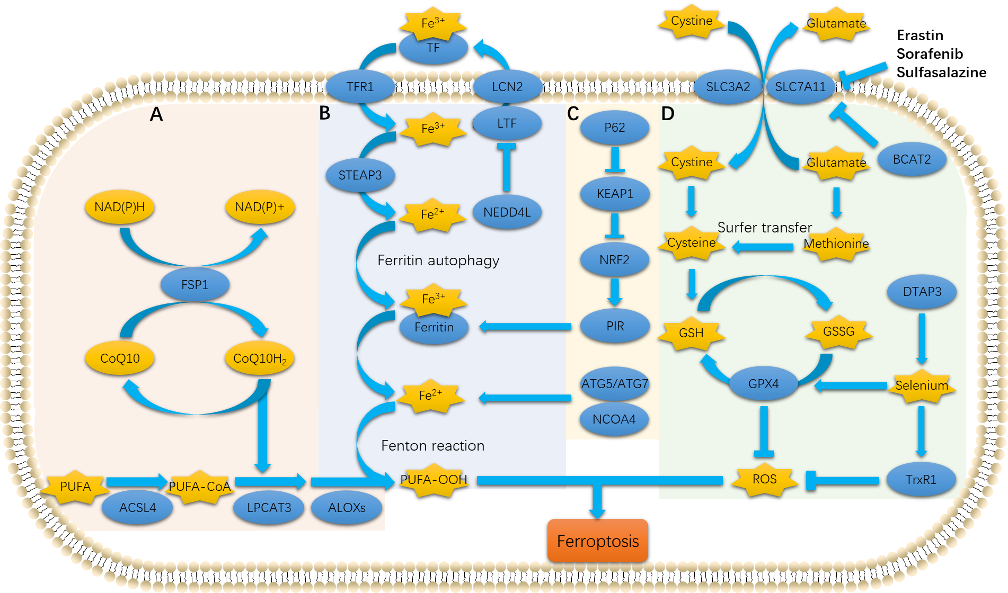
Figure 1 Metabolic mechanisms of ferroptosis in pancreatic ductal adenocarcinoma. A: Lipid metabolism; B: Iron metabolism^{[25]}; C: Autophagy^{[26-28]}; D: Amino acid metabolism^{[29-31]}. ACSL4: Long-chain acyl-CoA synthetase 4; ALOXs: Arachidonate lipoxygenases; ATG5: Autophagy-related 5; ATG7: Autophagy-related 7; CoQ10: Coenzyme Q10; CoQ10H₂: Ubiquinol-10; DIAPH3: Diaphanous homolog 3; FSP1: Ferroptosis suppressor protein 1; GPX4: Glutathione peroxidase 4; GSH/GSSG: Glutathione; KEAP1: Kelch-like ECH-associated protein 1; LPCAT3: Lysophosphatidylcholine acyltransferase 3; LTF: Lactotransferrin; NAD(P)H: Nicotinamide adenine dinucleotide phosphate; NCOA4: Nuclear receptor coactivator 4; NEDD4L: Neural precursor cell-expressed developmentally downregulated 4-like; NRF2: Nuclear factor erythroid 2-related factor 2; P62/SQSTM1: Sequestosome 1; PIR: Pirin; PUFA: Polyunsaturated fatty acids; ROS: Reactive oxygen species; SLC3A2: Solute carrier family 3 member 2; SLC7A11: Solute carrier family 7 member 11; STEAP3: Six-transmembrane epithelial antigen of prostate 3; TF: Transferrin; TrxR1: Thioredoxin reductase 1.
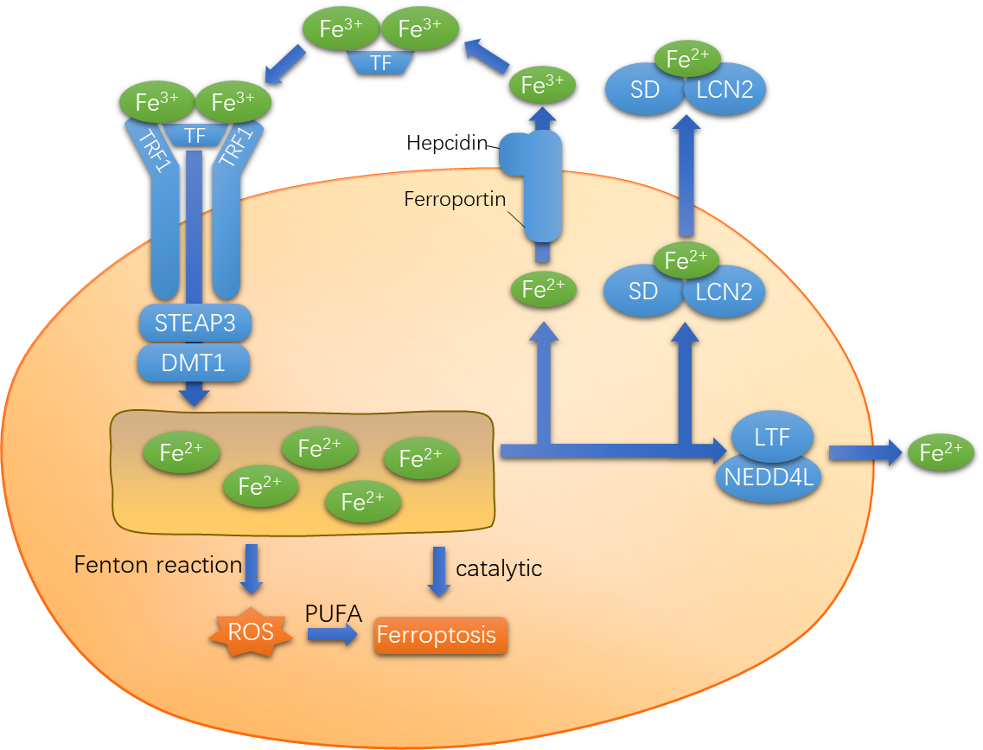
Figure 2 Iron transport. DMT1: Divalent metal transporter 1; LCN2: Lipocalin-2; LTF: Lactotransferrin; NEDD4L: Neural precursor cell-expressed developmentally downregulated 4-like. SD: Siderophore; STEAP3: Six-transmembrane epithelial antigen of the prostate 3; TFR1: Transferrin receptor 1; TFR2: Transferrin receptor 2.
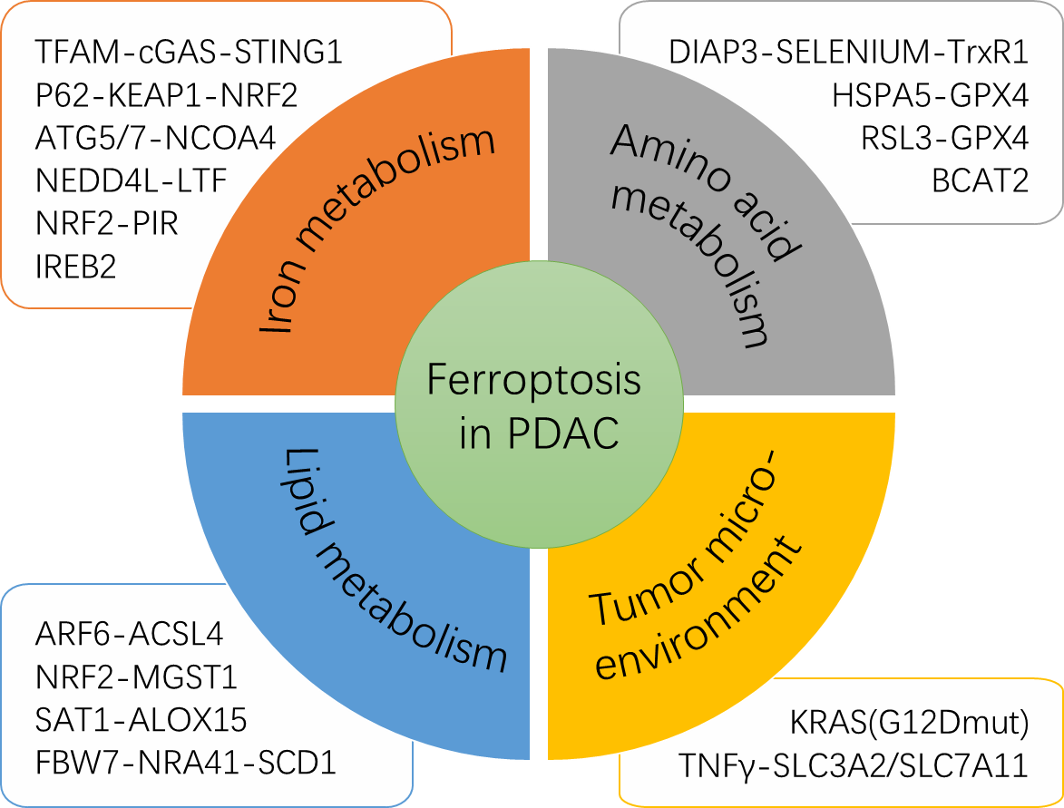

Figure 3 Regulatory molecules of ferroptosis in pancreatic ductal adenocarcinoma. ARF6: ADP ribosylation factor 6; ATG5/7: Autophagy-related 5/7; BCAT2: Branched-chain amino acid transaminase 2; cGAS: Cyclic GMP-AMP synthase; FBW7: F-box and WD repeat domain-containing 7;IREB2: Iron-responsive element-binding protein 2; HSPA5: Heat shock 70-kDa protein 5; LTF: Lactotransferrin; MGST: Microsomal glutathione transferase 1; NCOA4: Nuclear receptor coactivator 4; NEDD4L: Neural precursor cell-expressed developmentally downregulated 4-like; NR4A1: Nuclear receptor subfamily 4 group A member 1; PIR: Pirin; RSL3: RAS-selective lethal small molecule 3; SAT1: Spermidine/spermine N1-acetyltransferase 1; SCD1: Stearoyl-CoA desaturase-1. STING1: Stimulator of interferon genes; TFAM: Transcription factor A, mitochondrial.

Table 1 Features of ferroptosis and other forms of regulated cell death
 | Ferroptosis | Necrosis | Apoptosis | Autophagy
Morphological features | Condensed mitochondrial membrane densities, reduction or vanishing of mitochondria crista, and outer mitochondrial membrane rupture | Organelle swelling, plasma membrane damage, cell disruption | Cell membrane foaming, cell shrinkage and the formation of apoptotic bodies | Cytoplasm vacuolization, formation of autophagosomes and removal of substances through lysosomes
Biochemical features | Iron accumulation; lipid peroxidation; glutaminolysis | Activation of RIPK1, RIPK3, and MLKL; activation of inflammasome and release of pro-inflammatory cytokines | DNA fragmentation; Caspases cascade activation; Ca2+/mg2+ -dependent endogenous nuclease and calpain activation | MAP1LC3B-I to MAP1LC3B-II conversion; increased autophagic flux and lysosomal

Table 2 Ferroptosis inducers in pancreatic ductal adenocarcinoma
Inducers | Target | Inhibited by | Ref.
Erastin | System XC-/GPX4 | CPX | Yang et al^{[18]}
Sulfasalazine | System XC- | β-ME, CHX, DFO, Fer-1, NAC, or Trolox | Kim et al^{[38,68]}
Sorafenib | System XC- | DFO, Fer-1, Trolox, or VE | Lachaier et al^{[37]}
Artesunate | System XC- | DFO or Fer-1 | Xie et al^{[9]}
RSL3 | GPX4 | CPX, DFO, Ebs, Fer-1, Lip-1, Trolox, or U0126 | Yang et al^{[18]}
Rapamycin | GPX4 | Lip-1 | Liu et al^{[60]}
FIN56 | GPX4 | DFO, BSO and α-Toc | Liang et al^{[68]}
FINO2 | GPX4/Iron | β-ME or Fer-1 | Liang et al^{[68]}
Piperlongumine | GPX4 | Fer-1, lip-1, CPX and DFO | Yamaguchi et al^{[63]}
Ruscogenin | Iron | DFO, FAC | Song et al^{[59]}
Irisin | Iron, ROS, and glutathione depletion | Not mentioned | Yang et al^{[64]}
α-Toc: α-tocopherol; β-ME: β-mercaptoethanol; BSO: Buthionine sulfoximine; CHX: Cycloheximide; CPX: Ciclopirox olamine; DFO: Iron chelator deferoxamine; Ebs: Ebselen; FAC: Ferric ammonium citrate. Fer-1: Ferrostatin-1; Lip-1: Liproxstatin-1; NAC: N-acetylcysteine; VE: Vitamin E.

Published by Baishideng Publishing Group Inc
7041 Koll Center Parkway, Suite 160, Pleasanton, CA 94566, USA
Telephone: +1-925-3991568
E-mail: bpgoffice@wjgnet.com
Help Desk: https://www.f6publishing.com/helpdesk
https://www.wjgnet.com

© 2021 Baishideng Publishing Group Inc. All rights reserved.

