Name of Journal: World Journal of Gastrointestinal Endoscopy
Manuscript NO: 80460
Manuscript Type: CASE REPORT

Upper gastrointestinal bleeding as an unusual manifestation of localized Ménétrier’s disease with an underlying lipoma: A case report

Kmiecik M et al. Ménétrier’s disease with an underlying lipoma

Michal Kmiecik, Aleksandra Walczak, Pawel Samborski, Jacek Paszkowski, Agnieszka Dobrowolska, Ewelina Swora-Cwynar

Michal Kmiecik, Pawel Samborski, Agnieszka Dobrowolska, Ewelina Swora-Cwynar, Department of Gastroenterology, Nutrition and Internal Medicine, Poznan University of Medical Sciences, Poznan 60-355, Poland

Aleksandra Walczak, Department of Clinical Pathology, Poznan University of Medical Sciences, Poznan 60-355, Poland

Jacek Paszkowski, Department of General & Endocrine Surgery, and Gastroenterological Oncology, Poznan University of Medical Sciences, Poznan 60-355, Poland

Author contributions: Kmiecik M and Swora-Cwynar E wrote and edited the manuscript; Walczak A performed pathologic examination of the mass, wrote the paragraph on pathologic diagnosis and prepared microscopic figures; Samborski P and Paszkowski J performed endoscopic submucosal dissection and participated in editing the manuscript; Dobrowolska A reviewed the manuscript.

Corresponding author: Michal Kmiecik, HSD, Undergraduate Student, Department of Gastroenterology, Nutrition and Internal Medicine, Poznan University of Medical Sciences, 49 Przybyszewskiego Street, Poznan 60-355, Poland. 83633@student.ump.edu.pl

Received: October 15, 2022
Revised: November 16, 2022
Accepted: December 5, 2022
Published online:

Abstract
BACKGROUND
Ménétrier’s disease is a rare condition characterized by enlarged gastric folds, usually located in the whole body and fundus of the stomach. This report presents an unusual case of localized Ménétrier’s disease elevated by a submucosal lipoma and thus looking like a polypoid mass and causing an episode of upper gastrointestinal bleeding. The mass was successfully removed with endoscopic submucosal dissection.

CASE SUMMARY
Esophagogastroduodenoscopy was performed on a 76-year-old male patient after an episode of upper gastrointestinal bleeding, manifesting as fatigue and melena. A large polypoid mass (4 cm × 1 cm) with enlarged mucosal folds was found in the body of the stomach, between the lesser curvature and posterior wall. A small ulcer at the distal end of the mass was identified as the source of the bleeding. Biopsy was negative for neoplasia. Computed tomography showed a submucosal lesion beneath the affected mucosa, most likely a lipoma. The mass was removed en bloc with tunneling endoscopic submucosal dissection. Final pathology determined that the mass included Ménétrier’s disease and a submucosal lipoma. The patient was scheduled for follow-up esophagogastroduodenoscopy.

CONCLUSION
Localized Ménétrier’s disease can coexist with a submucosal lipoma creating a polypoid mass with risk of bleeding.

Key Words: Ménétrier’s disease; Submucosal lipoma; Gastrointestinal hemorrhage; Endoscopic submucosal dissection; Submucosal tunneling endoscopic resection; Case report

Kmiecik M, Walczak A, Samborski P, Paszkowski J, Dobrowolska A, Swora-Cwynar E. Upper gastrointestinal bleeding as an unusual manifestation of localized Ménétrier’s disease with an underlying lipoma: A case report. World J Gastrointest Endosc 2022; In press

Core Tip: We report the first case of localized Ménétrier’s disease coexisting with a submucosal lipoma. The elevation of the affected mucosa made it prone to mechanical damage and caused an episode of upper gastrointestinal bleeding. Tunneling endoscopic submucosal dissection proved to be an effective method of resecting such a lesion. Since the remaining mucosa seemed unaffected by the disease, we expect the resection to be curative.

INTRODUCTION
Ménétrier’s disease is rare; only a few hundred cases have been reported worldwide. Characteristic features of the disease are gastrointestinal symptoms, enlarged gastric folds (usually in the whole body and fundus of the stomach) and protein-losing gastropathy, which manifests as hypoalbuminemia and peripheral edema^{[1,2]}. The disease is associated with a higher risk of developing gastric adenocarcinoma^{[3]}.
We report an infrequent case of localized Ménétrier’s disease elevated by an underlying submucosal lipoma, making it look like a polypoid mass. The mass was successfully removed with tunneling endoscopic submucosal dissection (ESD).

CASE PRESENTATION
Chief complaints
A 76-year-old White male was referred for esophagogastroduodenoscopy (EGD) after an episode of upper gastrointestinal bleeding.

History of present illness
The patient reported recurrent epigastric pain, transient fatigue and melena.

History of past illness
The patient’s comorbidities were type 2 diabetes mellitus, arterial hypertension and benign prostatic hyperplasia. Past medical history was relevant for coronavirus disease 2019, ischemic stroke, appendectomy, viscerocranial abscess and surgically-treated cataract.

Personal and family history
The patient had a history of smoking in the past (30 pack-years). However, he had not smoked for 4 years and denied drinking alcohol. There was no relevant family history.

Physical examination
The patient’s height was 183 cm, weight was 80 kg, and body mass index was 23.89. Vitals upon admission were: heart rate, 50 beats/min; blood pressure, 118/48 mmHg; respiratory rate, 14/min; and body temperature, 36 °C. There was no abdominal tenderness and no peripheral edema.

Laboratory examinations
Laboratory results were not relevant. Serum protein or albumin levels were not tested because Ménétrier’s disease was not suspected at the time.

Endoscopic examination
EGD revealed a polypoid mass (4 cm × 1 cm) with enlarged mucosal folds in the body of the stomach between the lesser curvature and posterior wall (Figure 1A). The mass was cohesive and somewhat stiff in contact with the forceps. A small ulcer at the distal end of the mass was identified as the source of the bleeding (Figure 1B). Standard and deep biopsy were taken from the distal end of the mass, and both were negative for neoplasia. Except for the mass, the mucosa was normal, and gastric folds were not enlarged.

Imaging examinations
Computed tomography of the abdomen with contrast enhancement showed a submucosal lipoma (49 mm × 19 mm) in the body of the stomach, elevating the mucosa (Figure 2). The stomach was otherwise normal. There was no visible infiltration of surrounding tissue and no enlarged lymph nodes.

TREATMENT
The mass was removed en bloc via tunneling ESD (Figure 3).

FINAL DIAGNOSIS
The final diagnosis of Ménétrier’s disease and submucosal lipoma was determined by pathological examination of the resected specimen (Figure 4). Upon macroscopic examination, the gastric mucosa was found to be focally thickened (up to 1.5 cm in width) with tortuous folds and elevation of the surface, which gave the mucosa cobblestone or cerebriform appearance (Figure 5 and Figure 6). Histologically, the dominant feature was foveolar hyperplasia of gastric glands (Figure 7). The surface and glandular mucous cells were elongated, cystically dilated and tortuous, which can be described as a “corkscrew-like appearance” (Figure 5B, Figure 6A, and Figure 8A). Additionally, cystic dilation of the deep glands was observed (Figure 5A). Foveolar hyperplasia was accompanied by oxyntic atrophy with the loss of chief and parietal cells, especially in the area adjacent to cystically dilated deep glands. Muscularis mucosae was focally thickened and branched out to the lamina propria with vertical strands of smooth muscles (Figure 6B). Among microscopic changes of the mucosa, predominant chronic inflammatory infiltrate of low intensity with some scattered eosinophils was present in the lamina propria (Figure 6C). Moreover, a lipoma was identified in the submucosal layer (Figure 6 and Figure 8). This benign lesion was located within the submucosal border without breaching the muscularis mucosae. It simultaneously lifted the mucosal layer, described as an elevation of the surface during the macroscopic examination. The immunohistochemical tests showed no Helicobacter pylori (H. pylori) infection.

OUTCOME AND FOLLOW-UP
The patient’s symptoms subsided after the intervention, and he was scheduled for follow-up EGD.

DISCUSSION
Clinical symptoms of Ménétrier’s disease are nonspecific and include abdominal pain, nausea, vomiting, asthenia, anorexia, weight loss and peripheral edema^{[1,2]}. Among these, our patient presented only with recurrent abdominal pain. He was older than most patients at the time of diagnosis since the disease is most often diagnosed between the age of 30 and 60 years. It is diagnosed more frequently in males^{[1,2]}.
The etiology of Ménétrier’s disease in most cases is unknown. It is generally considered to be acquired, but a rare familial form has been reported in siblings. Some cases have been linked to H. pylori with regression after treatment of the infection. In our patient, the immunohistochemical test for H. pylori was negative. There is also a subtype occurring in children, associated with cytomegalovirus infection^{[1,2]}.
The definite pathophysiology of Ménétrier’s disease is still being investigated. One of the theories is linked to increased production of transforming growth factor-alpha (TGF-α) and as a consequence increased signaling of the epidermal growth factor receptor (EGFR). One consequence of TGF-α overexpression is cellular proliferation, which may trigger neoplastic transformation. Studies on mice have shown that TGF-α overexpression in the stomach mucosa showed changes characteristic of Ménétrier’s disease^{[4-6]}. Furthermore, studies on Ménétrier’s disease patients demonstrated a similar mechanism^{[7,8]}. Increased overexpression of TGF-α causes increased signaling of EGFR, a transmembrane receptor with tyrosine kinase activity that further triggers an intracellular signaling cascade, expanding the cell’s proliferation. Immunohistochemical reactions using TGF-α and EGFR are not routinely performed during the diagnostic process as they are not a requirement for the diagnosis of Ménétrier’s disease. However, in the future, it will be worth focusing on the study of the TGF-α and EGFR pathways in order to understand its pathophysiology and consequences.
Initially, Ménétrier’s disease was not suspected in our patient. His symptoms (epigastric pain, fatigue and melena) were not typical for this disease. Gastroscopic and imaging results did not indicate Ménétrier’s disease either. Gastric folds are usually enlarged in the whole body and fundus of the stomach, with antrum spared, although a localized form of the disease has been reported^{[1,3,9]}. In this case, gastric folds were enlarged only on the surface of the mass in the body of the stomach. Biopsy of the affected mucosa usually confirms the diagnosis of Ménétrier’s disease, but in our case it did not show any significant changes in the mucosa. Nevertheless, it helped differentiate the origin of the mass.
Differential diagnosis of Ménétrier’s disease involves a broad spectrum of conditions and requires analysis of clinical symptoms, gastroscopy, imaging and histological results. Ménétrier’s disease should be differentiated from hypertrophic lymphocytic gastritis, hypertrophic hypersecretory gastropathy, Zollinger-Ellison syndrome, hyperplastic or hamartomatous polyps, gastric carcinoma, lymphoma and amyloidosis^{[1,2]}.
Upper gastrointestinal bleeding has been reported as a rare manifestation of Ménétrier’s disease. The bleeding may present as hematemesis or, like in this case, as melena^{[10,11]}. One patient developed deep vein thrombosis and received anticoagulation therapy, which led to gastrointestinal bleeding^{[12]}. Iron deficiency anemia in patients with Ménétrier’s disease could be a sign of occult bleeding, but iron malabsorption should also be considered^{[13,14]}.
Hypoalbuminemia is present in the majority of patients with Ménétrier’s disease (85%), and in some cases causes peripheral edema^{[1]}. Ménétrier’s disease should be considered in differential diagnosis of protein-losing gastropathy/enteropathy, and certain interventions may be necessary to normalize albumin level, such as H. pylori eradication, proton pump inhibitors, H2-blockers, anticholinergic drugs, corticosteroids or octreotide^{[15]}. In this case, albumin level was not obtained during the diagnostic process or preoperative laboratory evaluation. It should be tested if Ménétrier’s disease is suspected or the patient presents with peripheral edema.
Treatment of Ménétrier’s disease usually includes a high-protein diet and supportive medication, but severe cases may require total gastrectomy^{[1]}. Partial gastrectomy has also been performed in selected patients^{[9,16,17]}. The discovery of the role of TGF-α and EGFR overexpression in the pathogenesis of Ménétrier’s disease resulted in experimental treatment with monoclonal antibodies, such as cetuximab^{[18-20]}. To our knowledge, localized Ménétrier’s disease with an underlying submucosal lipoma has never been reported. Tunneling ESD was used for the first time to remove localized Ménétrier’s disease.
Increased risk of gastric cancer in patients with Ménétrier’s disease contributes to increased mortality in this group. In a case-control study of 76 patients by Almazar et al^{[3]}, 8.9% of patients with Ménétrier’s disease developed gastric cancer 10 years after the diagnosis vs 3.7% in the control group. The 5-year and 10-year survival rates were 72.7% and 65.0%, respectively (vs 100% in the control group). The authors suggest annual screening for cancer with EGD. Gastrectomy remains the primary treatment option for patients who developed gastric cancer. Recently, two curative endoscopic interventions for early-stage gastric cancer in patients with Ménétrier’s disease have been reported: endoscopic mucosal resection and standard ESD^{[21,22]}.

CONCLUSION
We report a highly unusual case of localized Ménétrier’s disease coexisting with a submucosal lipoma, which created a polypoid mass in the stomach. Successful resection was achieved with tunneling ESD.

REFERENCES
1 Lambrecht NW. Ménétrier's disease of the stomach: a clinical challenge. Curr Gastroenterol Rep 2011; 13: 513-517 [PMID: 21931998 DOI: 10.1007/s11894-011-0222-8]
2 Huh WJ, Coffey RJ, Washington MK. Ménétrier's Disease: Its Mimickers and Pathogenesis. J Pathol Transl Med 2016; 50: 10-16 [PMID: 26689786 DOI: 10.4132/jptm.2015.09.15]
3 Almazar AE, Penfield JD, Saito YA, Talley NJ. Survival Times of Patients With Menetrier's Disease and Risk of Gastric Cancer. Clin Gastroenterol Hepatol 2021; 19: 707-712 [PMID: 32184187 DOI: 10.1016/j.cgh.2020.03.017]
4 Dempsey PJ, Goldenring JR, Soroka CJ, Modlin IM, McClure RW, Lind CD, Ahlquist DA, Pittelkow MR, Lee DC, Sandgren EP. Possible role of transforming growth factor alpha in the pathogenesis of Ménétrier's disease: supportive evidence form humans and transgenic mice. Gastroenterology 1992; 103: 1950-1963 [PMID: 1451986 DOI: 10.1016/0016-5085(92)91455-d]
5 Takagi H, Jhappan C, Sharp R, Merlino G. Hypertrophic gastropathy resembling Ménétrier's disease in transgenic mice overexpressing transforming growth factor alpha in the stomach. J Clin Invest 1992; 90: 1161-1167 [PMID: 1522224 DOI: 10.1172/JCI115936]
6 Takagi H, Fukusato T, Kawaharada U, Kuboyama S, Merlino G, Tsutsumi Y. Histochemical analysis of hyperplastic stomach of TGF-alpha transgenic mice. Dig Dis Sci 1997; 42: 91-98 [PMID: 9009121 DOI: 10.1023/a:1018837121947]
7 Bluth RF, Carpenter HA, Pittelkow MR, Page DL, Coffey RJ. Immunolocalization of transforming growth factor-alpha in normal and diseased human gastric mucosa. Hum Pathol 1995; 26: 1333-1340 [PMID: 8522306 DOI: 10.1016/0046-8177(95)90298-8]
8 Romano M, Meise KS, Suozzo R, Sessa G, Persico M, Coffey RJ. Regional distribution of transforming growth factor-alpha and epidermal growth factor in normal and portal hypertensive gastric mucosa in humans. Dig Dis Sci 1995; 40: 263-267 [PMID: 7851187 DOI: 10.1007/BF02065407]
9 Stamm B. Localized hyperplastic gastropathy of the mucous cell- and mixed cell-type (localized Ménétrier's disease): a report of 11 patients. Am J Surg Pathol 1997; 21: 1334-1342 [PMID: 9351571 DOI: 10.1097/00000478-199711000-00008]
10 Dickinson RJ, Axon AT. Haematemesis in Ménétrier's disease. Postgrad Med J 1979; 55: 751-752 [PMID: 537966 DOI: 10.1136/pgmj.55.648.751]
11 Kamal MU, Tariq H, Mehak V, Azam S, Kumar K, Niazi M, Dev A. A Rare Etiology of Abnormally Large Gastric Folds: Menetrier's Disease. Case Rep Gastrointest Med 2019; 2019: 7927083 [PMID: 31976093 DOI: 10.1155/2019/7927083]
12 Greenblatt HK, Nguyen BK. Ménétrier's disease presenting as recurrent unprovoked venous thrombosis: a case report. J Med Case Rep 2019; 13: 14 [PMID: 30651128 DOI: 10.1186/s13256-018-1952-0]
13 Pepa P, Uehara T, Wonaga A, Redondo A, Avagnina A, Mazzocchi O, Antelo P, Waldbaum C, Sorda J. Menetrier's disease. A diagnostic and therapeutic challenge. Medicina (B Aires) 2021; 81: 470-473 [PMID: 34137712]
14 Waisberg DR, de Mello ES, Tustumi F, Szor DJ, Charruf AZ, Fuhro FE, Waisberg J, Dias AR. A case report of diffuse hyperplastic gastropathy with multiple polypoid formations in a patient with pernicious anemia, Helicobacter pylori infection, hypergastrinemia and hypoalbuminaemia: Do not forget of Ménétrier's disease. Int J Surg Case Rep 2020; 77: 498-502 [PMID: 33395833 DOI: 10.1016/j.ijscr.2020.11.055]
15 Landzberg BR, Pochapin MB. Protein-Losing Enteropathy and Gastropathy. Curr Treat Options Gastroenterol 2001; 4: 39-49 [PMID: 11177680 DOI: 10.1007/s11938-001-0045-z]
16 Hsu CT, Ito M, Kawase Y, Sekine I, Ohmagari T, Hashimoto S. Early gastric cancer arising from localized Ménétrier's disease. Gastroenterol Jpn 1991; 26: 213-217 [PMID: 1645687 DOI: 10.1007/BF02811083]
17 Kim J, Cheong JH, Chen J, Hyung WJ, Choi SH, Noh SH. Menetrier's disease in korea: report of two cases and review of cases in a gastric cancer prevalent region. Yonsei Med J 2004; 45: 555-560 [PMID: 15227748 DOI: 10.3349/ymj.2004.45.3.555]
18 Fiske WH, Tanksley J, Nam KT, Goldenring JR, Slebos RJ, Liebler DC, Abtahi AM, La Fleur B, Ayers GD, Lind CD, Washington MK, Coffey RJ. Efficacy of cetuximab in the treatment of Menetrier's disease. Sci Transl Med 2009; 1: 8ra18 [PMID: 20368185 DOI: 10.1126/scitranslmed.3000320]
19 Parianos C, Aggeli C, Sourla A, Zografos GN. Total gastrectomy for the treatment of Menetrier's disease persistent to medical therapy: A case report. Int J Surg Case Rep 2020; 73: 95-99 [PMID: 32653837 DOI: 10.1016/j.ijscr.2020.06.033]
20 Toubia N, Schubert ML. Menetrier's Disease. Curr Treat Options Gastroenterol 2008; 11: 103-108 [PMID: 18321437 DOI: 10.1007/s11938-008-0022-x]
21 Raderer M, Oberhuber G, Templ E, Wagner L, Pötzi R, Wrba F, Hejna M, Base W. Successful symptomatic management of a patient with Ménétrier's disease with long-term antibiotic treatment. Digestion 1999; 60: 358-362 [PMID: 10394031 DOI: 10.1159/000007683]
22 Fukushi K, Goda K, Kino H, Kondo M, Kanazawa M, Kashima K, Kanamori A, Abe K, Suzuki T, Tominaga K, Yamagishi H, Irisawa A. Curative resection with endoscopic submucosal dissection of early gastric cancer in Helicobacter pylori-negative Ménétrier's disease: A case report. World J Gastroenterol 2022; 28: 594-601 [PMID: 35316958 DOI: 10.3748/wjg.v28.i5.594]

Footnotes
Informed consent statement: A written informed consent for ESD was obtained from the patient.

Conflict-of-interest statement: The authors declare that they have no conflict of interest.

CARE Checklist (2016) statement: The authors have read the CARE Checklist (2016), and the manuscript was prepared and revised according to the CARE Checklist (2016).

Open-Access: This article is an open-access article that was selected by an in-house editor and fully peer-reviewed by external reviewers. It is distributed in accordance with the Creative Commons Attribution NonCommercial (CC BY-NC 4.0) license, which permits others to distribute, remix, adapt, build upon this work non-commercially, and license their derivative works on different terms, provided the original work is properly cited and the use is non-commercial. See: https://creativecommons.org/Licenses/by-nc/4.0/

Provenance and peer review: Unsolicited article; Externally peer reviewed.
Peer-review model: Single blind

Peer-review started: October 15, 2022
First decision: October 27, 2022
Article in press:

Specialty type: Gastroenterology and Hepatology
Country/Territory of origin: Poland
Peer-review report’s scientific quality classification
Grade A (Excellent): 0
Grade B (Very good): 0
Grade C (Good): C, C
Grade D (Fair): 0
Grade E (Poor): 0

P-Reviewer: Cho JY, South Korea; Tangsuwanaruk T, Thailand S-Editor: Wang JL L-Editor: A P-Editor: Wang JL

Figure Legends
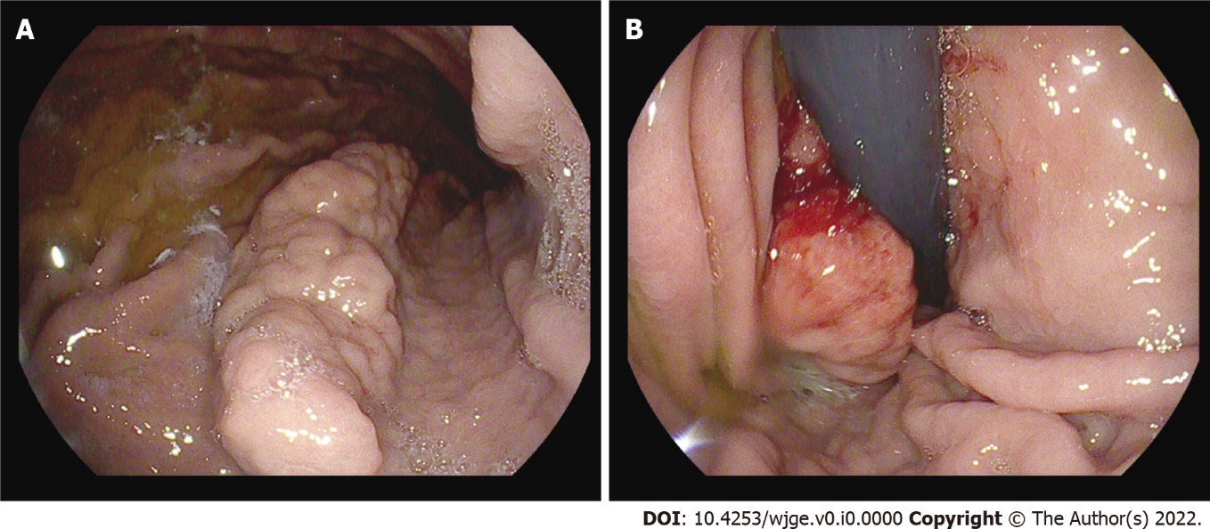
Figure 1 Polypoid mass found in the stomach during esophagogastroduodenoscopy. A: A mass (4 cm × 1 cm) with enlarged mucosal folds in the body of the stomach between the lesser curvature and posterior wall; B: A small ulcer at the distal end of the mass.

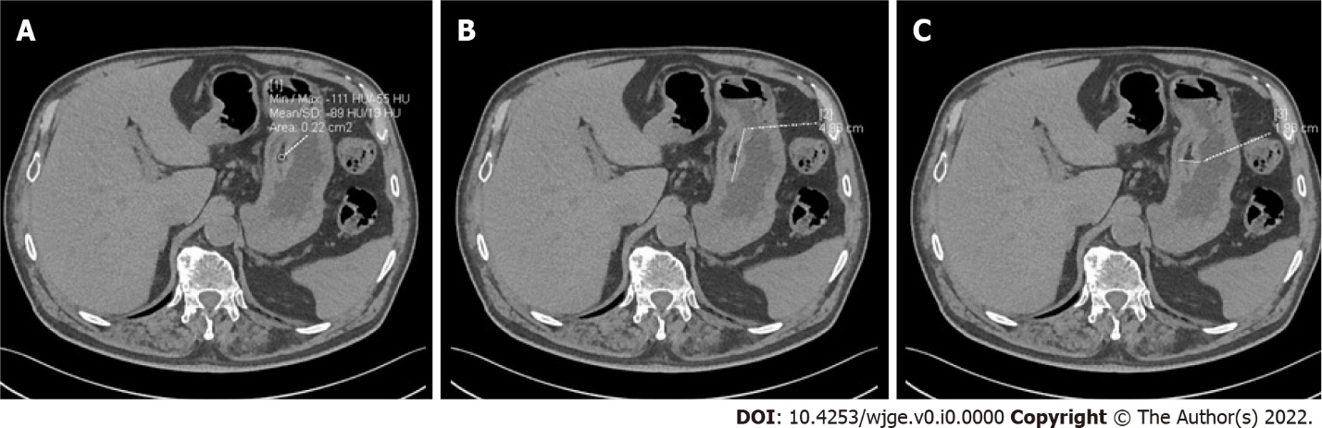
Figure 2 Computed tomography of the abdomen with contrast enhancement. A: A submucosal lesion in the stomach. Mean density of -89 HU suggested a submucosal lipoma; B: Length, 4.86 cm; C: Width, 1.96 cm.
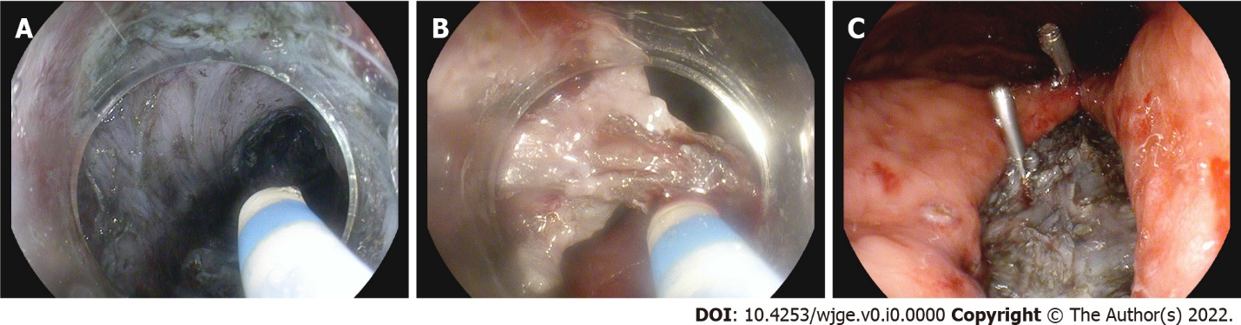
Figure 3 Resection of the mass via tunneling endoscopic submucosal dissection. A: A tunnel was created in the submucosal layer beneath the mass; B: Dissection was performed on both sides of the tunnel; C: Muscular defects were closed, and mucosal margins approximated with clips.

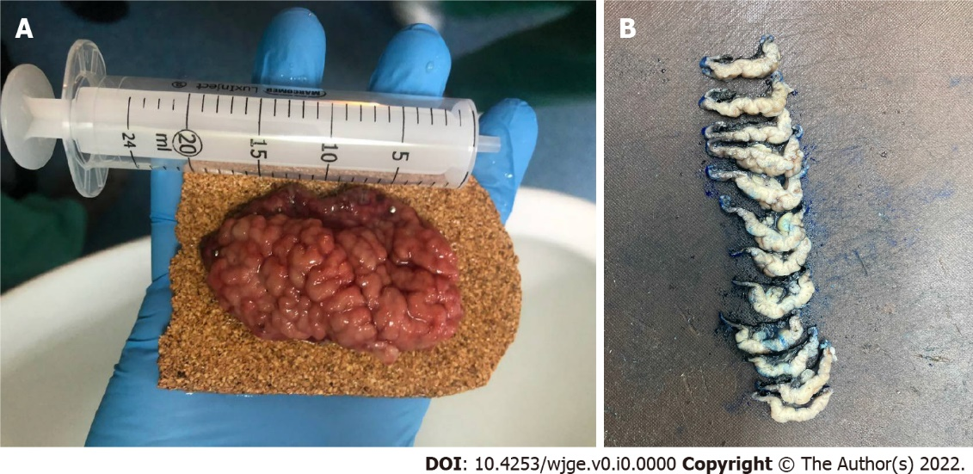
Figure 4 Resected specimen. A: Immediately after resection, enlarged gastric folds were observed on the surface; B: Intersected specimen in the Pathology Department. Yellow tissue of the submucosal lipoma was observed.

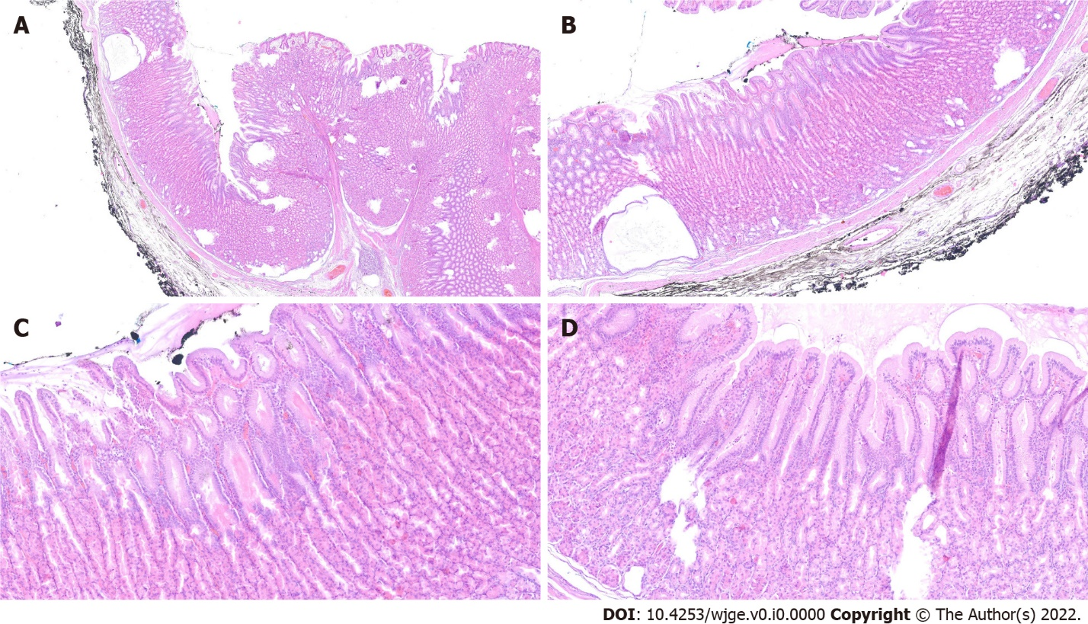
Figure 5 Histological changes in Ménétrier’s disease. A: Low magnification; B: Cystic dilation of deep glands with foveolar hyperplasia; C: Foveolar hyperplasia with tortuous glands; D: Foveolar hyperplasia with dilation of the glands and oxyntic atrophy.
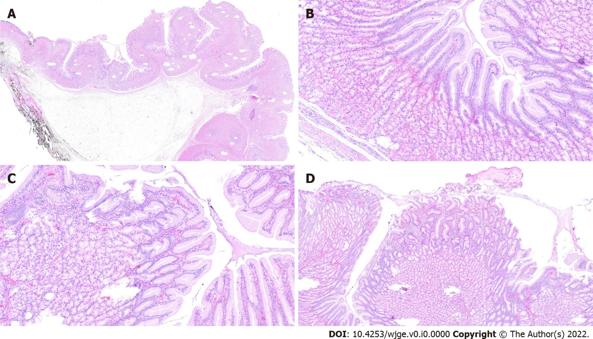
Figure 6 Submucosal lipoma and accompanying changes in the course of Ménétrier’s disease. A: Low magnification; B: Foveolar hyperplasia; C: Foveolar hyperplasia with a corkscrew morphology; D: Foveolar hyperplasia with tortuous glands and mild inflammation in lamina propria.
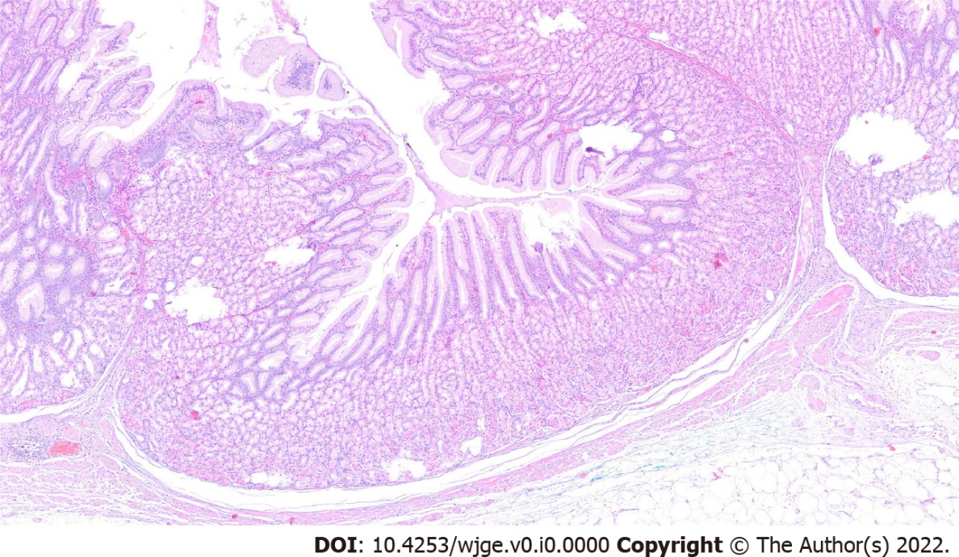
Figure 7 Histological changes in the course of Ménétrier’s disease: foveolar hyperplasia, proliferation of muscularis mucosae and mild inflammation of lamina propria.
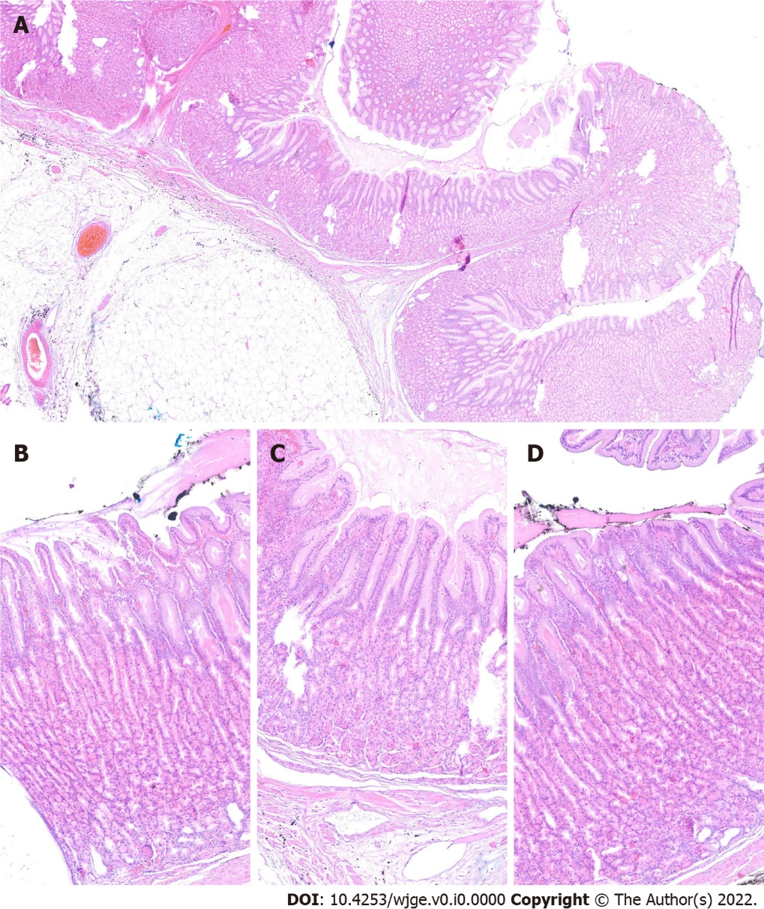
Figure 8 The mucosa with changes in the course of Ménétrier’s disease and the adjacent submucosal lipoma. The lipoma was adjacent to the mucosa without crossing its borders. A: Low magnification; B, C and D: Representative images taken at high magnification.

