Name of Journal: World Journal of Clinical Cases
Manuscript NO: 85010
Manuscript Type: ORIGINAL ARTICLE

Prospective Study
Evaluation of childhood developing via optical coherence tomography-angiography in Qamdo, Tibet, and China: A prospective cross-sectional, school-based study

Sun KX et al. Retinal microvasculature in children by OCTA

Ke-Xin Sun, Yong-Guo Xiang, Tong Zhang, Sheng-Lan Yi, Jiu-Yi Xia, Xin Yang, Shi-Jie Zheng, Yan Ji, Wen-Juan Wan, Ke Hu

Ke-Xin Sun, Yong-Guo Xiang, Sheng-Lan Yi, Jiu-Yi Xia, Xin Yang, Shi-Jie Zheng, Yan Ji, Wen-Juan Wan, Ke Hu, Department of Ophthalmology, The First Affiliated Hospital of Chongqing Medical University, Chongqing 400016, China

Tong Zhang, The First Affiliated Hospital of Chongqing Medical University, Chongqing Medical University, Chongqing 400016, China

Author contributions: Sun KX and Hu K involved in design and conduct of the study, and preparation of the manuscript; Sun KX, Xiang YG, Zhang T, Yi SL, Xia JY, Yang X, Zheng SJ, Wan WJ, Ji Y, and Shi K participated in the collection of the data; Hu K and Wan WJ participated in the management of this program; all authors review and approval of the final manuscript.

Supported by the National Natural Science Foundation of China, No. 81870650, No. 81570832, and No. 81300794; and Science and Technology Program Chongqing, China, No. 2018GDRC008.

Corresponding author: Ke Hu, MD, Adjunct Associate Professor, Department of Ophthalmology, The First Affiliated Hospital of Chongqing Medical University, No. 1 Medical College Road, Yuzhong District, Chongqing 400016, China. 42222@qq.com

Received: April 14, 2023
Revised: July 11, 2023
Accepted: July 27, 2023
Published online:

Abstract
BACKGROUND
Optical coherence tomography angiography (OCTA) is a new and reliable machine used to evaluate retinal structure and macular perfusion in children. The use of OCTA under bad condition such as high altitude, low atmospheric oxygen, and low humidity, in children is rarely.

AIM
To quantify the macular micro-vasculature in healthy children of various ages using OCTA in Qamdo.

METHODS
Design: Prospective cross-sectional, school-based study. Three hundred and forty-seven normal students from 9 schools in 4 different areas in Qamdo were included. OCTA was performed on a 3 mm × 3 mm area centered on the macular region and macular cube 512 × 128 showed details in macular. Early treatment of diabetic retinopathy study Vessel Flow Density (VD) of the macular central vascular plexus density (CVD), inner vascular plexus density (IVD), full vascular plexus density (FVD), and the size of the foveal avascular zone (FAZ) were measured. All these results corrected by t/s = 3.382 × 0.01306 × (axial length-1.82). The differences were compared among various ages, sexes and living environments.

RESULTS
The mean FAZ area in all eyes was 0.27 mm² ± 0.12 mm². The mean foveal thickness (MFT) in the macular cube was 227.64 μm ± 23.51 μm. Compared with girls, boys had a lager FAZ (P = 0.0029). Among the different age groups, MFT (P < 0.001) and FVD (P < 0.0001), IVD (P < 0.0001), and CVD (P = 0.0050) increased with age. FAZ areas were not correlated with age (P = 0.8853) or others (MFT, area).

CONCLUSION
OCTA can use to evaluate macular perfusion in children. Our data bridge the gap between structural OCT and perfusion density in children in high altitude. Even though these were not a longitudinal study, it may provide us with hints about retina development during puberty and clinical implications of OCTA in children.

Key Words: Optical coherence tomography-angiography; Qamdo; Foveal avascular zone area; Vessel flow density; Teenager

Sun KX, Xiang YG, Zhang T, Yi SL, Xia JY, Yang X, Zheng SJ, Ji Y, Wan WJ, Hu K. Evaluation of childhood developing via optical coherence tomography-angiography in Qamdo, Tibet, China: A prospective cross-sectional, school-based study. World J Clin Cases 2023; In press

Core Tip: Optical coherence tomography-angiography (OCTA) is practical as well as stable available in clinical ophthalmology. Our findings might conduce to diagnose and follow-up of children’s macular diseases. We obtain data from 5 to 18 years old children by OCTA images to describe the baseline of children retina growth and microcirculation in Qamdo, averages altitude above 3000 m. We now know the mean foveal thickness (MFT) was thinner in girls than in boys, and age effect in MFT (the macular cube), full vascular plexus density, inner vascular plexus density (linear increased). High altitude might cause difference in MFT but we don’t have enough data. Further studies will explain mechanisms and clinical significance of these changes.

INTRODUCTION
Dye leakage on fluorescein angiography (FA) remains the gold standard for diagnosing many retina diseases such as active CNV and AMD^{[1,2]}. However, the procedure is invasive and may be associated with nausea, urticaria, and rarely anaphylaxis. In children, general anesthesia is often required to acquire FA images with the contact lens-based Retcam (clarity medical systems) since few children would tolerate a needlestick while awake. Optical coherence tomography-angiography (OCTA) is a recent technological device detecting ocular blood circulation and creating en-face vascularity images without an intravenous contrast agent^{[3]}. It allows analyzing the distribution of vessels in every retinal layer and in choroid^{[4]}. It is a novel non-invasive technology that has significantly altered the understanding and management of serial ocular disorders. The technology enables in vivo quasi-histological evaluation that provides high-resolution cross-sectional images of the retina, retinal nerve-fiber layer, and the optic nerve head^{[5]}. Moreover, OCT can accurately and quantitatively measure the hierarchical structure of the retina during disease development. Being responsible for fine visual acuity, the development and maturation of the retinal macula is a compelling topic^{[6]}. Over more, OCTA as one of the combined series of screening methods that include objective and quantified measurements of visual functions and structure changes are highly significant because they have high accuracy and reliability in assessing children’s ocular health^{[7]}. Relatively little is known about the development of vascular circulation in the macular region in childhood.
The Cirrus 5000 OCT-A device (Carl Zeiss Meditec, Dublin, CA, United States) can be used to analyzed the characteristics of the superficial capillary plexus (SCP)-located between the internal limiting membrane and the internal plexiform layer-and the foveal avascular zone (FAZ) in macula^{[8]}. OCT-A is being reported as a key element in the comprehension of ocular conditions that begin in childhood, as well as further ocular conditions such as amblyopia^{[9]}, familial exudative vitreoretinopathy^{[10]} or retinopathy of prematurity^{[10-12]}. However, the use of OCTA in health children is rarely reported^{[13]}, especially teenagers in northwest China measured by Zeiss SD-OCT.
Most previous studies based on the fundus photography in vision screening programs were limited to observing only specific regions of the retina such as the optic disc or macular area^{[14]}. Several studies have shown that retina vessel density decreases while the area of the FAZ increases with age in healthy adults, which may due to the decreased demand of oxygen and nutrition^{[6,15-18]}. Some researchers reported that the superficial vascular plexus decrease in blood flow and macular vessel density with aging has been demonstrated may be caused by decreased oxygen and nutrient demands^{[18-20]}. Tibet, averages altitude above 4000 m, is called “the roof of the world”. As a consequence of its high altitude, environmental factors such as low atmospheric oxygen, low humidity, strong ultraviolet radiation, and low temperatures are prevalent^{[18,19]}. People lived there are likely to suffer from a range of symptoms prompted by oxygen deficiency, such as ocular disorders or blood disorders. These changes of macular microvasculature during childhood remain unclear. For the quantitative analysis of macular SCP vascularization, we use the software subdivided the macular area according to the early treatment of diabetic retinopathy study (ETDRS) study map, considering a central circle (cC) of 1 mm radius from the foveola and including the FAZ (no blood flow signal) and two concentric rings, one internal (inner circle, iC; from 1 mm to 3 mm radius) and one external (external circle, eC; from 3 mm to 6 mm). We report the ETDRS Vessel Flow Density (VD) of the macular central vascular plexus density (CVD), inner vascular plexus density (IVD), full vascular plexus density (FVD) and choriocapillaris and the size of the FAZ area in different children from high altitudes in vivo using commercial OCTA. In addition, we analyzed the influence of age, sex and environment. We aimed to use the OCTA device with children in order to determine the normative values in this group, and planned to obtain reference values for pediatric patients with retinal diseases such as diabetic retinopathy.

MATERIALS AND METHODS
VOS viewer
The bibliometric analysis developed in this research was based on the online database of the Web of Science (https://www.webofscience.com/wos/alldb/basic-search). This database is usually used as a source for academic and bibliometric studies. This search expressions consisted in applying the terms “Zeiss Optical coherence tomography-angiography OR OCTA”, which seeks for words on titles, abstracts, from 2002 to 2022. A total of 2123 publications were retrieved and after refinement. All analyses were performed using the “Analyzing Results” tool provided by WoS with MS Excel support (v. 2016) to perform calculations and to develop graphs (visualization of bibliometric indicators) using the following information: (1) Number of publications; (2) number of citations; (3) impact factor (for journals); and (4) h-index (for journals and authors).

Study sites
The study cohort in China was drawn from the rural and downtown Tibetan primary school children of Qamdo City. Qamdo is located in the eastern part of the Qinghai-Tibetan living. Qamdo City has 1 city and 10 townships (https://worldview.earthdata.nasa.gov/)^{[21]}. Each township has at least 1 Tibetan primary school that is supported by the government. Compared with China as a whole, the socio-economic status of the county ranks is at a low level.
According to the local government, the net enrolment of primary-school-aged children in Qamdo was 98%, this rate in middle school was 74.7% in 2014. Children start their schooling at age 6 year. Qamdo goverment provides education free of charge at the primary school and middle school level. Demographic and socio-economic data are obtained from the “Tibet Statistical Yearbook” (2006-2018) available at http://tjj.xizang.gov.cn/. There are few qualified optometrists or ophthalmologists in the county. Few children had glasses or contact lenses, less had any undergone an eye examination before this study. Even more children cannot use the eye chart.

Participant selection
The Qamdo Childhood Eye Study (QCES) was a schoolbased, observational cohort epidemiological study on childhood ocular diseases. All students from primary and middle school students in Qamdo were included. The examinations were given free of charge. After the examination, a result was presented to the teachers, and, if needed, prescriptions and suggestions were given. A few pupils were referred to the Qamdo Tibet Region People’s hospital for further treatment. Spectacles and drugs were given free of charge to the children who needed them. The survey and ethics clearances were obtained from the local government, and approval was also obtained from the ethics committee of the Health Bureau of the Qamdo Tibetan Autonomous Prefecture and the Ethics Committee of the Chongqing Medical University. The parents and pupils gave oral consent. The study protocols were in accordance with the Declaration of Helsinki.
The QCES employed the Stratified systematic sampling method to both primary and middle school students in Qamdo. This study contended from primary school to the senior high school. In Qamdo area, stratified random cluster sampling method is adopted to conduct multi-stage sampling in areas with different altitudes and economic levels (Supplementary Figure 1; Supplementary Table 1). One primary school and one middle school from towns, villages, pastoral areas and mountainous regions with relatively concentrated population and representative economic development level in Qamdo area are selected as the sampling population. In principle, men and women are equally divided. Based on local government evaluations, 9 schools from 4 different areas in Qamdo that effectively participated in the QCES were stratified into 10 levels (from Grade One to Second year of Senior High School).

Subjects and definitions
All students underwent a comprehensive eye examination that included assessment of uncorrected and best-corrected visual acuity, slit-lamp bio-microscopy evaluation (SL-3G, Topcon, Tokyo, Japan), non-contact tonometry (CT-800, Topcon, Tokyo, Japan), ocular alignment, OCTA. Myopia and hyperopia were defined as ≤ -0.50 diopters (D) SE and ≥ +2.00D SE, respectively, in one or both eyes.

OCTA measurements
Right eye of all children was subjected to OCTA examinations using the Zeiss Cirrus 5000 HD-OCT with Angioplex (Carl Zeiss Meditec, Inc, Dublin, CA, United States); all OCTA examinations were completed by the same skilled clinical staff members. Zeiss Cirrus OCTA device is a non-contact SD-OCT system that performs a fully automated “alignment, focus, and capture” procedure by capturing 50000 axials. To determine the FAZ area of the SCP, the scan protocol was the macular 3 mm × 3 mm scan pattern centered on the fovea^{[22]} (Supplementary Figure 2A). The scan included 3 repeated B-scans at the same location in the slow Y-axis (245 total B-scan locations, each separated by 12.5 μm) with 245 A-scans per B-scan in the fast X-axis. Real-time retinal tracking performed by a line scan ophthalmoscope was used to reduce motion artifacts^{[23]}. The OCTA software automatically calculated the FAZ area (Supplementary Figure 2B). The SCP was defined as the distance from the inner limiting membrane to the inner plexiform layer (Supplementary Figure 2B). Furthermore, all volunteers underwent macular scanning with a 512 × 128 scan model (128 horizontal B-scans, at 512 A-scans per B-scan) to assess the central macular thickness (center 1 mm)^{[24]} (Supplementary Figure 2C). OCTA images with a quality signal strength of > 7 were included in the data analysis. Furthermore, all images were manually checked to identify errors that may arise due to automatic analysis.

Adjustment for image magnification
For the estimation of corrected results, original OCTA images were adjusted by a scaling factor defined by the Littman and the modified Bennett formulae. According to the Littman formula, the relationship between the true size t of a retinal feature and its measured sizes on OCTA image can be expressed as t = p × q × s, where “p” is the magnification factor related to the OCT system, and q is the magnification factor related to the eye. The factor “q” can be determined by the Bennett formula: q = 0.01306 × (x-1.82), where “x” is the axial length. By using the default axial length 24.46 mm adopted by the Zeiss Cirrus 5000 HD-OCT with Angioplex syste, “p” can be calculated as 1/[0.01306 × (24.46-1.82)] = 3.382. Therefore, the scaling factor of the OCTA for adjustment of the ocular magnification can be calculated as: t/s = 3.382 × 0.01306 × (x-1.82).

Statistical analysis
Analyses were performed using IBM SPSS Statistics 25 (IBM Corp., Armonk, NY, United States) and GraphPad Prism 8 (GraphPad Software, LLC). All values are reported with their frequency distribution and their exact 95% confidence interval (95%CI), according to the binomial distribution. The Kolmogorov-Smirnov test was used to determine whether a distribution was present for systemic factors regarded as continuous variables. After confirming their normal distribution, they are presented as the means ± SD. Continuous variables are presented as means standard deviations, and categorical variables are presented as frequencies (%). Comparisons of systemic factors between female and male were performed using an independent sample t-test for variables with normal distributions. Comparisons of continuous variables were performed using one-way ANOVA and multiple comparison for trend. Analysis of the dichotomous variables was performed using the chi-square test (or Fisher’s exact test when appropriate). If premise not being satisfied Chi-square was used by judge the difference by analyzing the relative selection frequency and proportion of different types of data. Pearson’s correlation was used to determine the relationships among parameters. P values less than 0.05 were considered statistically significant.

RESULTS
Publication trend and keywords distribution
The publication trend is an indicator for reflecting and measuring the scientific activities and attention to a specific domain^{[25]}. Figures 1 and 2 shows keywords co-occurrence cluster of Zeiss OCTA researches based on bibliometric analysis in recent 20 years. A total of 2123 publications were retrieved and after refinement. We next search expressions consisted in applying the terms “students OR young adults OR teenager” and “Optical coherence tomography-angiography OR OCTA”, which seeks for words on titles, abstracts, from 2002 to 2022 (Table 1).

Local cross-validation results
Due to the inability to obtain images and information lake, 1 child was excluded. Consequently, 347 children from ten grades in four different areas were included in the study. Right eye of 347 children were examined and successfully scanned, which include 191 (52.8%) children with myopia. This myopia rate was no significant differences between this total rate in Qamdo in the present study. All study measurements provided high-quality scans. The sample included 182 girls and 165 boys; the mean age was 10.55 years ± 2.82 years (range, 5-18 years). Ocular parameters were as follows: mean vision, 4.80 diopters ± 0.30 diopters (range, 3.70 to 5.10); mean AL, 23.31 mm ± 1.01 mm (range, 20.55 mm to 26.66 mm); mean SE, -0.88 diopters ± 1.41 diopters (range, -6.50 diopters to +4.50 diopters). The AL were 23.10 mm ± 1.08 mm in male students and 23.53 mm ± 0.89 mm in female students (P < 0.0001, Figure 3A). The mean FAZ area in all eyes was 0.27 mm² ± 0.12 mm² (95%CI: 0.03-0.50 mm²), with boys (0.28 μm ± 0.13 μm; 95%CI: 0.25-0.30 mm²) having greater mean values than did girls (0.27 μm ± 0.10 μm, 95%CI, 0.28-0.32 mm²; P = 0.0029) (Figure 3B). The Mean Foveal Thickness in the macular cube (MFT) was 227.64 ± 23.51 μm (range, 193 μm to 337 μm). The mean MFT were 228.73 mm² ± 24.97 mm² in male students and 227.30 mm² ± 21.87 mm² in female students (Supplementary Figure 2); there was no significant sex-related difference (P = 0.086; Table 2). In the parafoveal region, the FVD and the IVD were larger in girls than in boys. However, most of the vascular density in the CVD and IVD had no significant differences between girls and boys (Table 2; Supplement Figure 2).

Comparison with different ages
Table 3 shows the results from OCTA images were compared between all age groups. Children under 8-year-old have better eyesight. With the age increasing, the vision of students is worse and worse. The AL is significant increased with age, 22.34 ± 0.77 in the 5 years old group to 22.54 ± 0.66 in the 6 years old group, 22.64 ± 0.67 in the 7 years old group, 23.02 ± 0.82 in the 8 years old group, 22.97 ± 0.75 in the 9 years old group, 23.11 ± 1.06 in the 10 years old group, 23.73 ± 0.77 in the 11 years old group, 23.70 ± 1.04 in the 12 years old group, 23.54 ± 0.99 in the 13 years old group, 23.98 ± 1.06 in the 14 years old group, 24.08 ± 0.76 in the 15 years old group, and 24.59 ± 1.63 older than 16 year old (P < 0.0001 by one-way ANOVA, P < 0.0001 by linear trend; Tables 3 and 4; Figure 3C) The macular vascular density and perfusion density was calculated and compared across various age groups for the full macula, central macular and para-macular areas separately from the OCTA images. Statistical significances were found for vascular density, MFT and FAZ area in all age groups (P < 0.01). Statistical significances were found for mean foveal thickness is 215.70 ± 3.46 in the 5 years old group to 216.14 ± 23.13 in the 6 years old group, 217.53 ± 22.41 in the 7 years old group, 217.45 ± 39.31 in the 8 years old group, 231.87 ± 22.93 in the 9 years old group, 233.82 ± 20.25 in the 10 years old group, 233.96 ± 18.59 in the 11 years old group, 236.02 ± 25.43 in the 12 years old group, 235.73 ± 26.33 in the 13 years old group, 219.88 ± 25.95 in the 14 years old group, 224.18 ± 30.12 in the 15 years old group, and 223.87 ± 31.33 older than 16 year old (P = 0.0012 by one-way ANOVA, P < 0.0001 by linear trend; Tables 3 and 4; Figure 3G). The CVD (P = 0.0050), IVD (P < 0.0001) and FVD (P < 0.0001) also increased significantly with age (Tables 3 and 4; Figure 3D-F).
Table 4 showing vascular density, MFT, CVD, IVD, FVD, and AL reported in linear with age. For the MFT, IVD and FVD, linear models were significantly predictive (P < 0.01 for all). For the FAZ area, the linear regression models were a poor fit for both in age (P = 0.8853), indicating that although age significantly predicted the FAZ area, most of the variation in the data was not explained by age and mean foveal growing.

Retinal changes following in a high-altitude environment
Qamdo district, located in eastern Tibet within the Hengduan Mountain region and Three-River Valley, is the second main economic and educational center in Tibet (Supplementary Table 1). Karuo District is located in the east of Qamdo, which is located near Sichuan, Yunnan and Qinghai Provience Karuo, as the capital of Qamdo, has the only one senior high school of Qamdo. We chose the 4 area which located in different four corners include Karuo (town), Dengqen (pastoral areas), Markam (village), and Chagyab (mountainous region). Due to all senior high school students gather at Karuo, and the vision has a significant decrease with age (Table 5), we just analyzed healthy students from Grade One to Grade Nine.
The FAZ and CVD were similar in each cohort. The MFT of students in Karuo (226.31 ± 20.40) is the highest, following Markam (221.81 ± 19.81), Chagyab (218.46 ± 22.06), and Dengqen (217.49 ± 18.10). The arrangment in FAZ is Chagyab (0.29 ± 0.10), Dengqen (0.28 ± 0.09) > Karuo (0.26 ± 0.11), Markam (0.24 ± 0.09) (Table 1; Figure 4). Campared with the result reported by Zhang et al^{[26]} from Wuxi, the mean FAZ area was 0.290 mm ± 0.109 mm and the MFT was 238.79 ± 20.53, we speculated that there is a correlation between altitude and retina morphology, which guides our further investigation.

DISCUSSION
Because of the availability of commercial equipment, OCTA is widely used in ophthalmic clinics nowadays^{[27,28]}. OCTA, as a non-invasive technique, was used to evaluate ocular perfusion by OCT signal amplitude reflected from non-static tissue^{[27,29]}. Moreover, the segmentation function of OCT-A enables images to be visualized in the superficial and deep layers, which allows a more thorough analysis of the chorioretinal microvasculature of an image by creating a 3D view^{[30]}. As OCT-A imaging is increasingly incorporated into daily retina practice, clinicians have tremendous opportunities to gather a large amount of microvascular data and gain deeper insight into their patients’ pathologies^{[30]}. This based on the quantification of flow that can be used to retinal and choroidal microvessels perfusion from both healthy and unhealthy person^{[31]}. Using the commercially available OCTA, many studies on healthy adults have been performed. To our knowledge, there is very little research in school-age students especially teenagers those lived in Hengduan Mountain region with high-altitude living environment^{[32-35]}. Therefore, there is a need for our study to provide detailed analysis in the present article.
To date, numerous OCTA-related studies have been reported; however, to realize factors affecting the retinal construction structures and potential correlations, most studies artificially selected only a small number of programs like gender, axial length, disease or myopia^{[9,15,28,36,37]}. Bansal et al^{[31]} study in Caucasian subjects shows that vascular density was higher in women than in men after 60 years (P < 0.01). Zhang et al^{[32]} had a research in California found that age was a predictor of SCP and DCP vessel density and FAZ area in the superficial retinal capillary plexus in adults. Many authors emphasize that factors such as age and gender are significant factors when assessing the FAZ and vessel densities in the superficial and deep retinal vascular layers^{[33]}. In this cross-sectional study, we report quantitative data of macular microvascular networks in healthy pediatric subjects using OCTA. Table 6 shows the reported FAZ areas by other authors in teenagers^{[1,6,26,38-50]}. We found a mean FAZ area of 0.290 mm², which is in agreement with other reported values in healthy eyes for FAZ area using OCT-A in China and Asia. Several studies have used OCTA to demonstrate that the FAZ size and shape in healthy adult populations increases with age^{[37,51]}. Borrelli et al^{[52]} study demonstrated that the FAZ size was increases with age and boys have larger FAZ areas, which had a same result in Li et al^{[6]}. In the other side, in Ghassemi et al^{[46]}, Kiziltoprak et al^{[43]} and İçel et al^{[41]} researches, FAZ size was greater in girls^{[26,41,43,50]}. Our results illustrated that larger FAZ area has a not significant correlated with younger age, female sex and thinner MFT (Supplementary Figures 2 and 3). We believe this difference among races and the sample size.
The evaluation the vessel density of the macula is one of the main characteristics of Zeiss OCTA^{[53,54]}. Many studies have evaluated normative data in adults^{[52]}. However, studies in children are limited. Perez-Garcia et al^{[48]} reported similar results to our study in Spanish child population using the same software and OCTA device.
Next, we analyzed age effect on retina structure and vessel flow density. Several authors analyzing OCT images have found that retinal thickness declines with age^{[16,38]}. Other studies have failed to find such a relationship between age and macular or foveal thickness^{[55]}. All these studies based on adults. In our study, we found MFT, FVD, IVD, and CVD of teenagers increasing linearly with age, which can provide guiding in prediction growth of children’s retinal structure. These changes may be caused by the increased oxygen and nutrient demands. Although the majority of the studies reported the development of macular should complete at around 4-years-old. Lee et al^{[56]} showed a continuous development of the retinal layers in adolescent and even young adult. Li et al^{[6]} showed the development of the outer retina layer could last until 10 years of age, which could be a possible basis of the continuous development of the macular microvasculature. Yao et al^{[49]} believed this continuous development of the retinal layers in adolescent and even young adult is the prolonged light exposure time which may slow the growth of the axial length thus affect the eye development in high altitude.
To date little is known about possible baseline retinal vascular differences across minority areas. The QCES was a large, a school-based, longitudinal study of eye health among all students from primary and middle schools in Qamdo, Tibet Autonomous Region, located in southwest China. To our knowledge, this is the first study evaluating the three retinal vascular plexus density in the normal eyes of students in Tibet healthy using OCTA software. Our study showed significantly lower myopia rate in villages than in Karuo. Boys had better visions than girl, which is similar with those in adult^{[57]}. Except for MFT, other data have no significant difference in each area.
Our study included a large population of healthy children in different ages distribution, analyzing a large amount of information regarding the macular microvasculature. Nevertheless, there remain several limitations. First, as a school-based study, the study may not entirely represent a normal population in Qamdo, a larger number of subjects would likely corroborate the findings reported here. Because our sample size is small, future studies will need a larger population-based study design, exploring the effects of age, sex, and important factors such as IOP. In addition, this study is solely conducted in Qamdo. As race and ethnicity could affect the foveal shape and may influence the retina development, the generalizability of these data still needs further confirmation in other races. Tian et al^{[19]} observed that high-altitude environment in Tibet might cause a significant increase in retinal nerve fiber layer (RNFL) thickness in the temporal and nasal quadrants of the optic disc, whilst a significant decrease in RNFL thickness in the inferior optic disc. We will have a further study to compared those data in Chongqing (400 m). Our term tries to build a platform about ophthalmic information in SouthWest of China. Finally, as a cross-sectional study, we showed trends of maturation in retina from different ages, a longitudinal study remains warranted to demonstrate continuous changes of macular vessel during development. Next step we will also collecting the information from same samples and make a follow-up study, and try to analysis some special samples like myopia infused in OCTA. The effects of sunlight exposure time and oxygen concentration on the thickness in Tibetan children should be observed and explored in subsequent examinations and studies.

CONCLUSION
All in all, the patients were grouped by age, gender and living area in our study. We expanded the microcirculation database in children from 5 to 18 years old using OCTA in averages altitude above 3000 m. This obtains data described the baseline of children retina growth in Qamdo as a part of our southwest eye information. We now know the MFT was thinner in girls than in boys. Age effect in MFT, FVD, IVD, and their relationship is linear increased. High altitude might cause difference in MFT but we don’t have enough data. Further studies are needed to determine the mechanisms and clinical significance of these changes. OCT-A is reproducible and widely available in ophthalmology clinics, therefore the results we report should be helpful for diagnosis and follow-up of macular diseases in children.

ARTICLE HIGHLIGHTS
Research background
In children, general fundus examination is often obtained hardly because of it required to acquire images with the contact lens-based Retcam and general anesthesia. optical coherence tomography angiography (OCTA) may provide a noninvasive and reliable approach for evaluating macular perfusion in children. Tibet, as “the roof of the world”, its environmental factors such as low atmospheric oxygen, low humidity, strong ultraviolet radiation, and low temperatures are prevalent. People lived Tibet suffered from a range of symptoms prompted by oxygen deficiency which leaded to ocular disorders or blood disorders. These changes of macular microvasculature during childhood remain unclear.

Research motivation
OCTA as one of the combined series of screening methods have high accuracy and reliability in assessing children’s ocular health. People lived in Tibet from a range of symptoms prompted by oxygen deficiency, such as ocular disorders or blood disorders. Relatively little is known about the development of vascular circulation in the macular region in childhood, especially in high altitude environment. This research helps fill data in gaps in healthy children and extreme weather.

Research objectives
To quantify the macular micro-vasculature in healthy children of various ages using OCTA in Qamdo. To compared the gender, age, environment and other influence factors in children’s retinal growthing.

Research methods
Based on local government evaluations, 9 schools from 4 different areas in Qamdo, totally 347 students were stratified into 10 levels (from Grade One to Second year of Senior High School). The Cirrus 5000 OCT-A device (Carl Zeiss Meditec, Dublin, CA, United States) was first used to performed on a 3 mm × 3 mm area centered on the macular region and macular cube 512 × 128 showed details in macular in Tibet. ETDRS Vessel Flow Density (VD) of the macular central vascular plexus density (CVD), inner vascular plexus density (IVD), full vascular plexus density (FVD), and the size of the foveal avascular zone (FAZ) were measured. The differences were compared among various ages, sexes and living environments.

Research results
The mean FAZ area in all eyes was 0.27 mm² ± 0.12 mm². The mean foveal thickness (MFT) in the macular cube was 227.64 μm ± 23.51 μm. Compared with girls, boys had a lager FAZ (P = 0.0029). Among the different age groups, MFT (P < 0.001) and FVD (P < 0.0001), IVD (P < 0.0001) and CVD (P = 0.0050) increased with age. FAZ areas were not correlated with age (P = 0.8853) or others (MFT, area).

Research conclusions
We expanded the microcirculation database in children from 5 to 18 years old using OCTA in averages altitude above 3000 m. We know the MFT was thinner in girls than in boys. Age effect in MFT, FVD, IVD, and their relationship is linear increased. High altitude might cause difference in MFT.

Research perspectives
Because our sample size is small, future studies will need a larger population-based study design, exploring the effects of age, sex, and important factors such as axial eye length, IOP, race and ethnicity. We will have a further study to compared those data in Chongqing (400 m). Next step we will also collecting the information from same samples and make a follow-up study, and try to analysis some special samples like myopia infused in OCTA. The effects of sunlight exposure time and oxygen concentration on the thickness in Tibetan children should be observed and explored in subsequent examinations and studies. Our term tries to build a platform about ophthalmic information in Southwest of China. Further studies are needed to determine the mechanisms and clinical significance of these changes.

ACKNOWLEDGEMENTS
The authors thank Dr. Xun Lei for the suggestion in statistical analysis.

REFERENCES
1 Yilmaz I, Ocak OB, Yilmaz BS, Inal A, Gokyigit B, Taskapili M. Comparison of quantitative measurement of foveal avascular zone and macular vessel density in eyes of children with amblyopia and healthy controls: an optical coherence tomography angiography study. J AAPOS 2017; 21: 224-228 [PMID: 28501447 DOI: 10.1016/j.jaapos.2017.05.002]
2 Meira J, Marques ML, Falcão-Reis F, Rebelo Gomes E, Carneiro Â. Immediate Reactions to Fluorescein and Indocyanine Green in Retinal Angiography: Review of Literature and Proposal for Patient's Evaluation. Clin Ophthalmol 2020; 14: 171-178 [PMID: 32021082 DOI: 10.2147/OPTH.S234858]
3 Bartol-Puyal FA, Isanta C, Calvo P, Ruiz-Moreno Ó, Pablo L. Relationship between vascular densities of choriocapillaris and the whole choroid using OCTA. Int Ophthalmol 2020; 40: 3135-3143 [PMID: 32621019 DOI: 10.1007/s10792-020-01500-7]
4 Jia Y, Tan O, Tokayer J, Potsaid B, Wang Y, Liu JJ, Kraus MF, Subhash H, Fujimoto JG, Hornegger J, Huang D. Split-spectrum amplitude-decorrelation angiography with optical coherence tomography. Opt Express 2012; 20: 4710-4725 [PMID: 22418228 DOI: 10.1364/OE.20.004710]
5 Guo Y, Sung MS, Park SW. Assessment of superficial retinal microvascular density in healthy myopia. Int Ophthalmol 2019; 39: 1861-1870 [PMID: 30178185 DOI: 10.1007/s10792-018-1014-z]
6 Li S, Yang X, Li M, Sun L, Zhao X, Wang Q, Huang S, Chen C, Wang Z, Luo X, Yu B, Ding X. Developmental Changes in Retinal Microvasculature in Children: A Quantitative Analysis Using Optical Coherence Tomography Angiography. Am J Ophthalmol 2020; 219: 231-239 [PMID: 32413409 DOI: 10.1016/j.ajo.2020.05.008]
7 Díez-Sotelo M, Abraldes M, Gómez-Ulla F. Multimodality Imaging Approach for Combined Central Retinal Vein and Artery Occlusion: The Role of Optical Coherence Tomography Angiography. Case Rep Ophthalmol 2019; 10: 415-423 [PMID: 31911784 DOI: 10.1159/000504127]
8 Abdolrahimzadeh S, Parisi F, Scavella V, Recupero SM. Optical coherence tomography evidence on the correlation of choroidal thickness and age with vascularized retinal layers in normal eyes. Retina 2016; 36: 2329-2338 [PMID: 27315451 DOI: 10.1097/IAE.0000000000001097]
9 Tsui CK, Yang B, Yu S, Li J, Lu X, Xu Y, Lv L, Liang X. The Relationship between Macular Vessel Density and Thickness with Light Sensitivity in Myopic Eyes. Curr Eye Res 2019; 44: 1104-1111 [PMID: 31154859 DOI: 10.1080/02713683.2019.1627461]
10 Niestrata-Ortiz M, Fichna P, Stankiewicz W, Stopa M. Enlargement of the foveal avascular zone detected by optical coherence tomography angiography in diabetic children without diabetic retinopathy. Graefes Arch Clin Exp Ophthalmol 2019; 257: 689-697 [PMID: 30824996 DOI: 10.1007/s00417-019-04264-8]
11 Lu Y, Simonett JM, Wang J, Zhang M, Hwang T, Hagag AM, Huang D, Li D, Jia Y. Evaluation of Automatically Quantified Foveal Avascular Zone Metrics for Diagnosis of Diabetic Retinopathy Using Optical Coherence Tomography Angiography. Invest Ophthalmol Vis Sci 2018; 59: 2212-2221 [PMID: 29715365 DOI: 10.1167/iovs.17-23498]
12 Oh J, Baik DJ, Ahn J. Inter-relationship between retinal and choroidal vasculatures using optical coherence tomography angiography in normal eyes. Eur J Ophthalmol 2020; 30: 48-57 [PMID: 30516077 DOI: 10.1177/1120672118816225]
13 Iafe NA, Phasukkijwatana N, Chen X, Sarraf D. Retinal Capillary Density and Foveal Avascular Zone Area Are Age-Dependent: Quantitative Analysis Using Optical Coherence Tomography Angiography. Invest Ophthalmol Vis Sci 2016; 57: 5780-5787 [PMID: 27792812 DOI: 10.1167/iovs.16-20045]
14 Wang Q, Chan S, Yang JY, You B, Wang YX, Jonas JB, Wei WB. Vascular Density in Retina and Choriocapillaris as Measured by Optical Coherence Tomography Angiography. Am J Ophthalmol 2016; 168: 95-109 [PMID: 27183862 DOI: 10.1016/j.ajo.2016.05.005]
15 Zheng F, Zhang Q, Shi Y, Russell JF, Motulsky EH, Banta JT, Chu Z, Zhou H, Patel NA, de Sisternes L, Durbin MK, Feuer W, Gregori G, Wang R, Rosenfeld PJ. Age-dependent Changes in the Macular Choriocapillaris of Normal Eyes Imaged With Swept-Source Optical Coherence Tomography Angiography. Am J Ophthalmol 2019; 200: 110-122 [PMID: 30639367 DOI: 10.1016/j.ajo.2018.12.025]
16 Wei Y, Jiang H, Shi Y, Qu D, Gregori G, Zheng F, Rundek T, Wang J. Age-Related Alterations in the Retinal Microvasculature, Microcirculation, and Microstructure. Invest Ophthalmol Vis Sci 2017; 58: 3804-3817 [PMID: 28744554 DOI: 10.1167/iovs.17-21460]
17 Pujari A, Chawla R, Markan A, Shah P, Kumar S, Hasan N, Sharma A, Kumar A. Age-related changes in macular vessels and their perfusion densities on optical coherence tomography angiography. Indian J Ophthalmol 2020; 68: 494-499 [PMID: 32057011 DOI: 10.4103/ijo.IJO_521_19]
18 Demirtaş AA, Öncül H. Solar retinopathy from sun gazing under the influence of ecstasy: A longitudinal analysis of OCT and OCTA findings. Photodiagnosis Photodyn Ther 2021; 35: 102359 [PMID: 34048970 DOI: 10.1016/j.pdpdt.2021.102359]
19 Tian X, Zhang B, Jia Y, Wang C, Li Q. Retinal changes following rapid ascent to a high-altitude environment. Eye (Lond) 2018; 32: 370-374 [PMID: 28912514 DOI: 10.1038/eye.2017.195]
20 Chen W, Fu J, Meng Z, Li L, Su H, Dai W, Yao Y. Lhasa childhood eye study: the rationale, methodology, and baseline data of a 5 year follow-up of school-based cohort study in the Tibetan plateau region of Southwest China. BMC Ophthalmol 2020; 20: 250 [PMID: 32571250 DOI: 10.1186/s12886-020-01522-w]
21 Karaküçük Y, Okudan N, Bozkurt B, Belviranlı M, Tobakçal F. Evaluation of the effect of high-intensity interval training on macular microcirculation via swept-source optical coherence tomography angiography in young football players. Indian J Ophthalmol 2021; 69: 2334-2339 [PMID: 34427215 DOI: 10.4103/ijo.IJO_3079_20]
22 Zhou L, Wang F, Wang L, Shen P, Cao Y, He Y, Yan S, Kong X, Lu X. Quantitative assessment and determinants of foveal avascular zone in healthy volunteers. J Int Med Res 2021; 49: 3000605211014994 [PMID: 33990149 DOI: 10.1177/03000605211014994]
23 Xiuyan Z, Qingmei T, Qiuxin W, Tailiang L, Jing X, Guodong T, Ting Y, Shasha L, Xi C, Chenying Q, Dongxue D, Jike S, Hongsheng B. Thickness, vessel density of retina and choroid on OCTA in young adults (18-24 years old). Microvasc Res 2021; 136: 104169 [PMID: 33839109 DOI: 10.1016/j.mvr.2021.104169]
24 Wang H, Hu H, Gregori G, Zhang J, Jiang H, Wang J. The Effect of Software Versions on the Measurement of Retinal Vascular Densities Using Optical Coherence Tomography Angiography. Curr Eye Res 2021; 46: 341-349 [PMID: 32767906 DOI: 10.1080/02713683.2020.1801756]
25 Xue J, Reniers G, Li J, Yang M, Wu C, van Gelder PHAJM. A Bibliometric and Visualized Overview for the Evolution of Process Safety and Environmental Protection. Int J Environ Res Public Health 2021; 18 [PMID: 34199608 DOI: 10.3390/ijerph18115985]
26 Zhang Z, Huang X, Meng X, Chen T, Gu Y, Wu Y, Wu Z. In vivo assessment of macula in eyes of healthy children 8 to 16 years old using optical coherence tomography angiography. Sci Rep 2017; 7: 8936 [PMID: 28827524 DOI: 10.1038/s41598-017-08174-9]
27 Serafino M, Scaramuzzi M, Bonsignore F, Vitale L, Magli A, Nucci P. Optical coherence tomography angiography for the measurement of optic disc: Macular relationship. Eur J Ophthalmol 2021; 31: 543-547 [PMID: 32019324 DOI: 10.1177/1120672120904633]
28 Zhu Q, Xing X, Wang M, Zhu M, Ma L, Yuan Y, Song E. Characterization of the Three Distinct Retinal Capillary Plexuses Using Optical Coherence Tomography Angiography in Myopic Eyes. Transl Vis Sci Technol 2020; 9: 8 [PMID: 32818096 DOI: 10.1167/tvst.9.4.8]
29 Rezar-Dreindl S, Eibenberger K, Told R, Neumayer T, Steiner I, Sacu S, Schmidt-Erfurth U, Stifter E. Retinal vessel architecture in retinopathy of prematurity and healthy controls using swept-source optical coherence tomography angiography. Acta Ophthalmol 2021; 99: e232-e239 [PMID: 32749763 DOI: 10.1111/aos.14557]
30 Lu Y, Wang JC, Cui Y, Zhu Y, Zeng R, Lu ES, Katz R, Husain D, Vavvas DG, Kim LA, Miller JW, Miller JB. A quantitative comparison of four optical coherence tomography angiography devices in healthy eyes. Graefes Arch Clin Exp Ophthalmol 2021; 259: 1493-1501 [PMID: 32975683 DOI: 10.1007/s00417-020-04945-9]
31 Bansal T, Dubey S, Rao HL, Gandhi M, Pegu J. Predictors of Peripapillary and Macular Optical Microangiography Measurements in Healthy Eyes. J Glaucoma 2021; 30: 697-702 [PMID: 33927147 DOI: 10.1097/IJG.0000000000001857]
32 Zhang X, Yang Y, Zhang S, Zhang H, Yao L, Liu L, Li H, Zhang X, Guo S, Qi L, Zhou L, She J, Zhao B, Bian X, Zhang G. TuYou-County Pediatric Eye (TYPE) study, design issues, baseline demographic characteristics, and implications: Report number 1. Medicine (Baltimore) 2021; 100: e24670 [PMID: 33725826 DOI: 10.1097/MD.0000000000024670]
33 Lu P, Chen X, Zhang W, Chen S, Shu L. Prevalence of ocular disease in Tibetan primary school children. Can J Ophthalmol 2008; 43: 95-99 [PMID: 18204497 DOI: 10.3129/i07-194]
34 Su H, Fu J, Chen W, Meng Z, Li L, Dai W, Yao Y. Prevalence of Heterophoria in Tibetan Grade-One Students: The Lhasa Childhood Eye Study. J Ophthalmol 2020; 2020: 9570908 [PMID: 33489351 DOI: 10.1155/2020/9570908]
35 He H, Fu J, Meng Z, Chen W, Li L, Zhao X. Prevalence and associated risk factors for childhood strabismus in Lhasa, Tibet, China: a cross-sectional, school-based study. BMC Ophthalmol 2020; 20: 463 [PMID: 33238929 DOI: 10.1186/s12886-020-01732-2]
36 Scherm P, Pettenkofer M, Maier M, Lohmann CP, Feucht N. Choriocapillary Blood Flow in Myopic Subjects Measured With OCT Angiography. Ophthalmic Surg Lasers Imaging Retina 2019; 50: e133-e139 [PMID: 31100167 DOI: 10.3928/23258160-20190503-13]
37 Zhou Y, Zhou M, Gao M, Liu H, Sun X. Factors Affecting the Foveal Avascular Zone Area in Healthy Eyes among Young Chinese Adults. Biomed Res Int 2020; 2020: 7361492 [PMID: 32280700 DOI: 10.1155/2020/7361492]
38 Gómez-Ulla F, Cutrin P, Santos P, Fernandez M, Abraldes M, Abalo-Lojo JM, Gonzalez F. Age and gender influence on foveal avascular zone in healthy eyes. Exp Eye Res 2019; 189: 107856 [PMID: 31654619 DOI: 10.1016/j.exer.2019.107856]
39 Hsu ST, Ngo HT, Stinnett SS, Cheung NL, House RJ, Kelly MP, Chen X, Enyedi LB, Prakalapakorn SG, Materin MA, El-Dairi MA, Jaffe GJ, Freedman SF, Toth CA, Vajzovic L. Assessment of Macular Microvasculature in Healthy Eyes of Infants and Children Using OCT Angiography. Ophthalmology 2019; 126: 1703-1711 [PMID: 31548134 DOI: 10.1016/j.ophtha.2019.06.028]
40 Jin P, Zou H, Zhu J, Xu X, Jin J, Chang TC, Lu L, Yuan H, Sun S, Yan B, He J, Wang M, He X. Choroidal and Retinal Thickness in Children With Different Refractive Status Measured by Swept-Source Optical Coherence Tomography. Am J Ophthalmol 2016; 168: 164-176 [PMID: 27189931 DOI: 10.1016/j.ajo.2016.05.008]
41 İçel E, Yılmaz H, Uçak T, Taşlı NG, Uğurlu A, Karakurt Y. Evaluation of the Optic Disc and Macula in Healthy Children Using Optical Coherence Tomography Angiography. Turk J Ophthalmol 2020; 50: 228-233 [PMID: 32854467 DOI: 10.4274/tjo.galenos.2020.85282]
42 Fujiwara A, Morizane Y, Hosokawa M, Kimura S, Shiode Y, Hirano M, Doi S, Toshima S, Takahashi K, Hosogi M, Shiraga F. Factors affecting foveal avascular zone in healthy eyes: An examination using swept-source optical coherence tomography angiography. PLoS One 2017; 12: e0188572 [PMID: 29176837 DOI: 10.1371/journal.pone.0188572]
43 Kiziltoprak H, Tekin K, Cevik S, Kocer AM, Goker YS. Normative Data Assessment of Peripapillary and Macular Vessel Density and Foveal Avascular Zone Metrics Using Optical Coherence Tomography Angiography in Children. J Pediatr Ophthalmol Strabismus 2020; 57: 388-398 [PMID: 33211897 DOI: 10.3928/01913913-20200903-01]
44 Yanni SE, Wang J, Cheng CS, Locke KI, Wen Y, Birch DG, Birch EE. Normative reference ranges for the retinal nerve fiber layer, macula, and retinal layer thicknesses in children. Am J Ophthalmol 2013; 155: 354-360.e1 [PMID: 23127751 DOI: 10.1016/j.ajo.2012.08.010]
45 Plaitano C, Periti F, Guagliano R, Bertone C, Barillà D, Arpa C, Tinelli C, Gallo FG, Bianchi A, Magli A. Optical coherence tomography angiography in healthy children: A comparison of macular structure. Eur J Ophthalmol 2022; 32: 2005-2010 [PMID: 34493114 DOI: 10.1177/11206721211043749]
46 Ghassemi F, Hatami V, Salari F, Bazvand F, Shamouli H, Mohebbi M, Sabour S. Quantification of macular perfusion in healthy children using optical coherence tomography angiography. Int J Retina Vitreous 2021; 7: 56 [PMID: 34600586 DOI: 10.1186/s40942-021-00328-2]
47 Pröbster C, Tarau IS, Berlin A, Kleefeldt N, Hillenkamp J, Nentwich MM, Sloan KR, Ach T. Quantitative Fundus Autofluorescence in the Developing and Maturing Healthy Eye. Transl Vis Sci Technol 2021; 10: 15 [PMID: 34003900 DOI: 10.1167/tvst.10.2.15]
48 Pérez-García P, Morales-Fernández L, Fernández-Vigo JI, Sáenz-Francés F, Burgos-Blasco B, Güemes-Villahoz N, Oribio-Quinto C, Garcia-Feijoo J, Martinez-de-la-Casa JM. Repeatability of Macular and Optic Nerve Head Measurements by Optical Coherence Tomography Angiography in Healthy Children. Curr Eye Res 2021; 46: 1574-1580 [PMID: 33759665 DOI: 10.1080/02713683.2021.1908568]
49 Yao Y, Fu J, Li L, Chen W, Meng Z, Su H, Dai W. Retinal and circumpapillary nerve fiber layer thickness and associated factors in children. Eye (Lond) 2021; 35: 2802-2811 [PMID: 33239762 DOI: 10.1038/s41433-020-01313-z]
50 Zhang Y, Zhang B, Fan M, Gao X, Wen X, Li Z, Zeng P, Tan W, Lan Y. The vascular densities of the macula and optic disc in normal eyes from children by optical coherence tomography angiography. Graefes Arch Clin Exp Ophthalmol 2020; 258: 437-444 [PMID: 31732811 DOI: 10.1007/s00417-019-04466-0]
51 Xiao H, Liu X, Liao L, Tan K, Ling Y, Zhong Y. Reproducibility of Foveal Avascular Zone and Superficial Macular Retinal Vasculature Measurements in Healthy Eyes Determined by Two Different Scanning Protocols of Optical Coherence Tomography Angiography. Ophthalmic Res 2020; 63: 244-251 [PMID: 31618736 DOI: 10.1159/000503071]
52 Borrelli E, Uji A, Toto L, Viggiano P, Evangelista F, Mastropasqua R. In Vivo Mapping of the Choriocapillaris in Healthy Eyes: A Widefield Swept-Source OCT Angiography Study. Ophthalmol Retina 2019; 3: 979-984 [PMID: 31371198 DOI: 10.1016/j.oret.2019.05.026]
53 Lauermann JL, Heiduschka P, Nelis P, Treder M, Alnawaiseh M, Clemens CR, Eter N, Alten F. Comparison of Choriocapillaris Flow Measurements between Two Optical Coherence Tomography Angiography Devices. Ophthalmologica 2017; 237: 238-246 [PMID: 28433988 DOI: 10.1159/000464355]
54 Pellegrini M, Cozzi M, Staurenghi G, Corvi F. Comparison of wide field optical coherence tomography angiography with extended field imaging and fluorescein angiography in retinal vascular disorders. PLoS One 2019; 14: e0214892 [PMID: 30964919 DOI: 10.1371/journal.pone.0214892]
55 Chen S, Wang B, Dong N, Ren X, Zhang T, Xiao L. Macular measurements using spectral-domain optical coherence tomography in Chinese myopic children. Invest Ophthalmol Vis Sci 2014; 55: 7410-7416 [PMID: 25316719 DOI: 10.1167/iovs.14-13894]
56 Lee H, Purohit R, Patel A, Papageorgiou E, Sheth V, Maconachie G, Pilat A, McLean RJ, Proudlock FA, Gottlob I. In Vivo Foveal Development Using Optical Coherence Tomography. Invest Ophthalmol Vis Sci 2015; 56: 4537-4545 [PMID: 26200492 DOI: 10.1167/iovs.15-16542]
57 Dong H, Feng Z, Yang Y, Li P, You Z. Dynamic assessment of ecological sustainability and the associated driving factors in Tibet and its cities. Sci Total Environ 2021; 759: 143552 [PMID: 33246714 DOI: 10.1016/j.scitotenv.2020.143552]

Footnotes
Institutional review board statement: The study was reviewed and approved by the Ethics Committee of the Chongqing Medical University Institutional Review Board (Approval No. 2020-376).

Clinical trial registration statement: This study is registered at https://www.chictr.org.cn/showproj.html?proj= 37553. The registration identification number is No. ChiCTR2000039065.

Informed consent statement: All study participants, or their legal guardian, provided informed written consent prior to study enrollment.

Conflict-of-interest statement: None of the authors have any financial/conflicting interests to disclose.

Data sharing statement: Technical appendix, statistical code, and dataset available from the corresponding author at Ke Hu (42222@qq.com).

CONSORT 2010 statement: The authors have read the CONSORT 2010 statement, and the manuscript was prepared and revised according to the CONSORT 2010 statement.

Open-Access: This article is an open-access article that was selected by an in-house editor and fully peer-reviewed by external reviewers. It is distributed in accordance with the Creative Commons Attribution NonCommercial (CC BY-NC 4.0) license, which permits others to distribute, remix, adapt, build upon this work non-commercially, and license their derivative works on different terms, provided the original work is properly cited and the use is non-commercial. See: https://creativecommons.org/Licenses/by-nc/4.0/

Provenance and peer review: Unsolicited article; Externally peer reviewed.
Peer-review model: Single blind

Peer-review started: April 14, 2023
First decision: July 3, 2023
Article in press:

Specialty type: Ophthalmology
Country/Territory of origin: China
Peer-review report’s scientific quality classification
Grade A (Excellent): A
Grade B (Very good): 0
Grade C (Good): 0
Grade D (Fair): 0
Grade E (Poor): 0

P-Reviewer: Mansour AM, Lebanon S-Editor: Chen YL L-Editor: A P-Editor:
Figure Legends
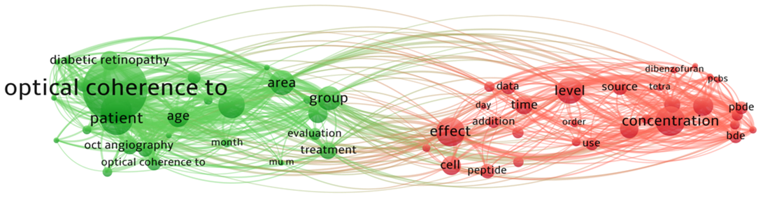
Figure 1 Keyword co-occurrence cluster of Zeiss Optical coherence tomography-angiography clinical researches based on bibliometric analysis in recent 20 years.

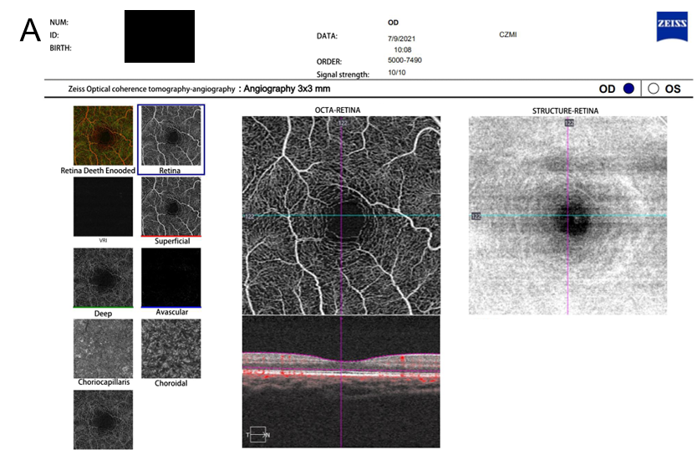
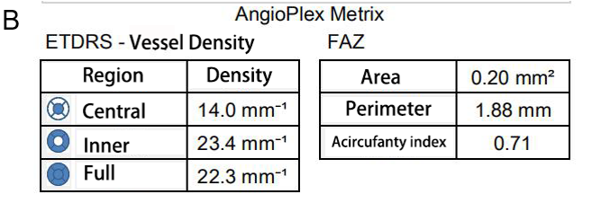
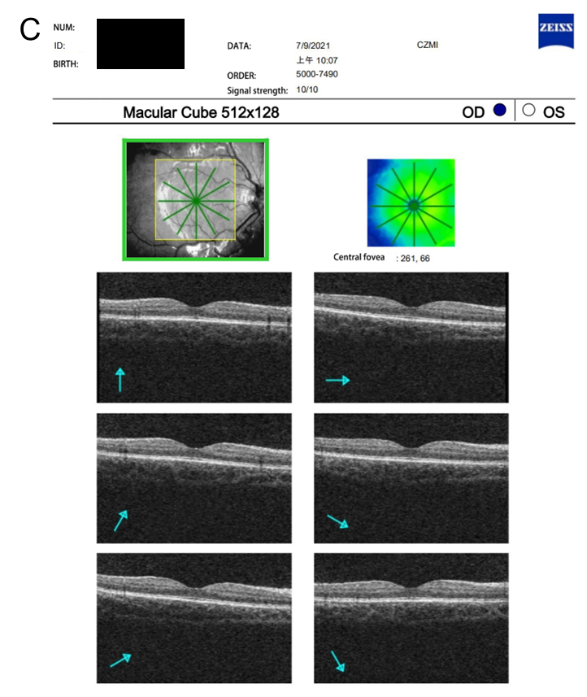
Figure 2 The optical coherence tomography angiography images obtained by participant. A: Optical coherence tomography angiography (OCTA) images of superficial capillary plexus (SCP) in the macula; B: OCTA image showing 3 mm × 3 mm scanning model in the SCP of the macula. OCTA image showing foveal avascular zone area obtained automatically by OCTA software; C: OCTA image showing 512 × 128 scanning model in the macular cube. FAZ: Foveal avascular zone.

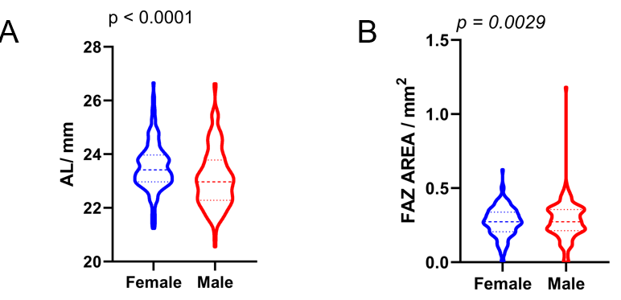
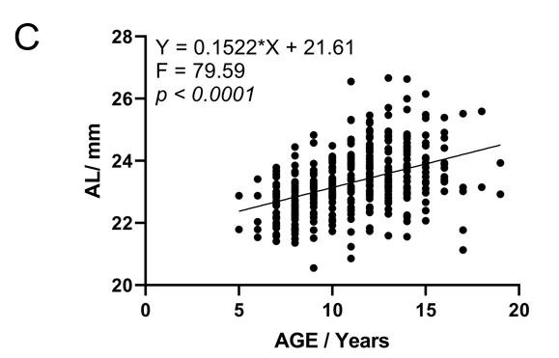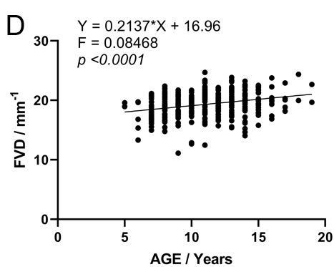
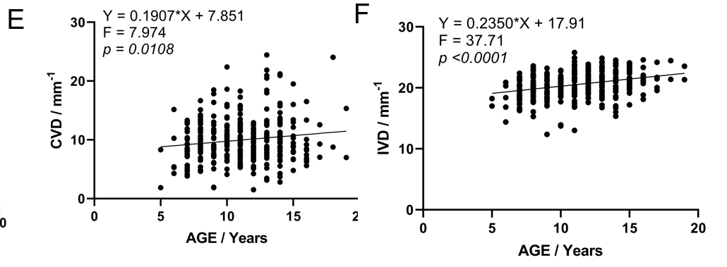
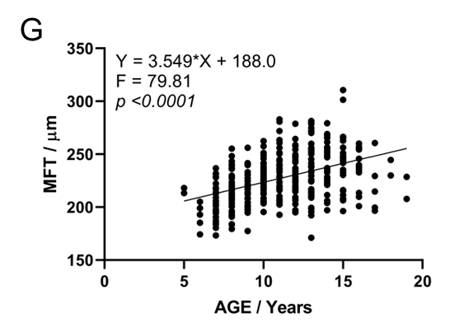
Figure 3 Graphs show vessel density and mean foveal thickness distribution. A and B: The violin mapshows comparison of the axial length (AL, A) and foveal avascular zone area (B) by gender (P < 0.001); C: Scatter plots showing positive correlation between ages and AL; D-G: Scatter plots showing positive correlation between ages and full (D) and inner macular vascular density (E) whole and deep macular vascular density (F), positive correlation between ages and the mean foveal thickness (G). P < 0.01. AL: Axial length; FAZ: Foveal avascular zone; AREA: The living environment of participant; FVD: Full vascular plexus density; CVD: Central vascular plexus density; IVD: Inner vascular plexus density; MFT: Mean foveal thickness; AGE: Age of participant.

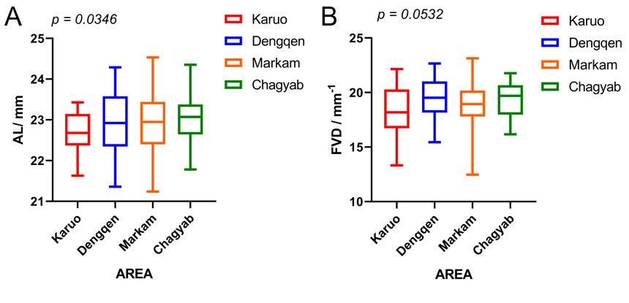
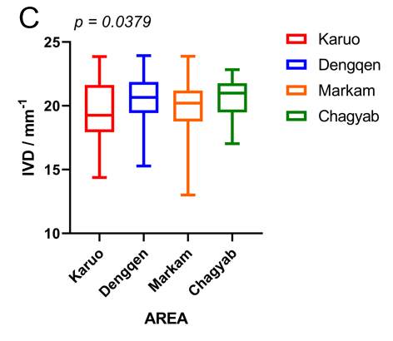
Figure 4 Box plot shows the habitat distribution of the optical coherence tomography angiography result in health students. A: Axial length, P = 0.0346; B: Full vascular plexus density, P = 0.0532; C: Inner vascular plexus density, P = 0.0379. AL: Axial length; FVD: Full vascular plexus density; IVD: Inner vascular plexus density.

Table 1 Optical coherence tomography angiography measurements of health students in Qamdo divided into habitat distribution which include mean foveal thickness, foveal avascular zone area, and vascular plexus density
 | Karuo (n = 28) | Dengqen (n = 38) | Markam (n = 48) | Chagyab (n = 48) | P value
AL, mm | 22.71 ± 0.51 | 22.94 ± 0.75 | 22.92 ± 0.78 | 23.02 ± 0.58 | 0.0346
Foveal thickness, μm | 243.00 ± 21.00 | 233.42 ± 22.31 | 235.24 ± 15.23 | 228.18 ± 17.62 | 0.0075
FAZ, mm² | 0.26 ± 0.12 | 0.32 ± 0.10 | 0.26 ± 0.10 | 0.32 ± 0.11 | 0.0211
FVD, mm⁻¹ | 20.40 ± 2.05 | 20.78 ± 1.78 | 20.24 ± 1.58 | 20.72 ± 1.45 | 0.2626
IVD, mm⁻¹ | 21.55 ± 2.16 | 22.17 ± 1.56 | 21.34 ± 1.70 | 21.66 ± 1.70 | 0.6049
CVD, mm⁻¹ | 10.07 ± 3.42 | 10.59 ± 3.69 | 10.99 ± 3.75 | 9.34 ± 3.01 | 0.1211
cFoveal thickness, μm | 226.31 ± 20.40 | 217.49 ± 18.10 | 221.81 ± 19.81 | 218.46 ± 22.06 | 0.0075
cFAZ, mm² | 0.26 ± 0.11 | 0.28 ± 0.09 | 0.24 ± 0.09 | 0.29 ± 0.10 | 0.1811
cFVD, mm⁻¹ | 18.33 ± 2.18 | 19.48 ± 1.70 | 18.89 ± 1.75 | 19.30 ± 1.57 | 0.0532
cIVD, mm⁻¹ | 19.49 ± 2.34 | 20.69 ± 1.86 | 21.34 ± 1.70 | 21.66 ± 1.70 | 0.0379
cCVD, mm⁻¹ | 9.26 ± 2.85 | 10.12 ± 3.36 | 10.13 ± 3.13 | 9.53 ± 3.23 | 0.5612
AL: Axial length; FVD: Full vascular plexus density; CVD: Central vascular plexus density; IVD: Inner vascular plexus density; FAZ: Foveal avascular zone; MFT: Mean foveal thickness.

Table 2 Clinical characteristics of the study samples and optical coherence tomography measurements of retinal and subfoveal choroidal thickness according to sex
 | ALL (n = 347) | Girls (n = 182) | Boys (n = 165) | P value
Age, yr | 10.62 ± 2.82 (range 5-18) | 10.70 ± 2.84 | 10.53 ± 2.80 | 0.0781
Vision | 4.78 ± 0.30 | 4.74 ± 0.33 | 4.83 ± 0.26 | 0.1043
AL, mm | 23.31 ± 1.01 | 23.53 ± 0.89 | 23.10 ± 1.08 | < 0.0001
SE, diopters | -0.88 ± 1.40 | -0.96 ± 1.60 | -0.79 ± 1.14 | 0.4601
Mean foveal thickness | 239.81 ± 19.13 | 238.44 ± 20.13 | 241.33 ± 17.91 | 0.0097
FAZ, mm² | 0.29 ± 0.13 | 0.30 ± 0.12 | 0.28 ± 0.14 | 0.0119
FVD, mm⁻¹ | 20.38 ± 1.88 | 20.31 ± 1.85 | 20.45 ± 1.92 | 0.0210
IVD, mm⁻¹ | 21.65 ± 1.92 | 22.50 ± 12.26 | 21.72 ± 1.91 | 0.0610
CVD, mm⁻¹ | 10.43 ± 3.79 | 10.38 ± 4.04 | 10.49 ± 3.53 | 0.7800
cMean foveal thickness | 227.64 ± 23.51 | 227.30 ± 21.87 | 228.73 ± 24.97 | 0.0863
cFAZ, mm² | 0.27 ± 0.12 | 0.27 ± 0.10 | 0.28 ± 0.13 | 0.0029
cFVD, mm⁻¹ | 19.35 ± 209 | 19.38 ± 2.09 | 19.32 ± 2.12 | 0.7931
cIVD, mm⁻¹ | 21.00 ± 8.29 | 21.49 ± 11.93 | 20.58 ± 2.15 | 0.3343
cCVD, mm⁻¹ | 9.93 ± 3.70 | 10.28 ± 3.88 | 9.49 ± 3.39 | 0.0513
AL: Axial length; FVD: Full vascular plexus density; CVD: Central vascular plexus density; IVD: Inner vascular plexus density; AL: Axial length; FAZ: Foveal avascular zone.
Table 3 Clinical characteristics of the study samples and optical coherence tomography measurements of retinal and subfoveal choroidal thickness according to ages
 | 5 (n = 2) | 6 (n = 20) | 7 (n = 40) | 8 (n = 33) | 9 (n = 35) | 10 (n = 39) | 11 (n = 36) | 12 (n = 38) | 13 (n = 43) | 14 (n = 36) | 15 (n = 15) | ≥ 16 (n = 10) | P value
F:M | 0.001389 | 0.464583 | 0.888194 | 0.760417 | 0.761806 | 0.846528 | 0.639583 | 0.927778 | 0.93125 | 0.7625 | 0.461111 | 0.252778
Vision | 4.90 ± 0.07 | 4.90 ± 0.19 | 4.90 ± 0.05 | 4.90 ± 0.08 | 4.89 ± 0.18 | 4.78 ± 0.29 | 4.72 ± 0.29 | 4.66 ± 0.34 | 4.73 ± 0.36 | 4.59 ± 0.36 | 4.60 ± 0.32 | 4.67 ± 0.37 | < 0.0001
AL, mm | 22.34 ± 0.77 | 22.54 ± 0.66 | 22.64 ± 0.67 | 23.02 ± 0.82 | 22.97 ± 0.75 | 23.11 ± 1.06 | 23.73 ± 0.77 | 23.70 ± 1.04 | 23.54 ± 0.99 | 23.98 ± 1.06 | 24.08 ± 0.76 | 24.59 ± 1.63 | < 0.0001
MFT, μm | 212.00 ± 2.83 | 216.18 ± 13.22 | 232.08 ± 15.00 | 235.77 ± 15.24 | 242.47 ± 15.36 | 248.04 ± 14.05 | 242.94 ± 14.59 | 236.35 ± 17.29 | 242.75 ± 20.62 | 249.40 ± 26.93 | 243.62 ± 16.51 | 233.67 ± 10.50 | 0.00097
FAZ, mm² | 0.64 ± 0.90 | 0.34 ± 0.13 | 0.30 ± 0.11 | 0.31 ± 0.13 | 0.30 ± 0.11 | 0.25 ± 0.10 | 0.28 ± 0.120 | 0.32 ± 0.12 | 0.26 ± 0.13 | 0.30 ± 0.08 | 0.32 ± 0.09 | 0.31 ± 0.17 | 0.008
FVD, mm⁻¹ | 15.80 ± 0.9 | 19.90 ± 1.57 | 20.51 ± 1.39 | 20.45 ± 2.19 | 20.62 ± 0.90 | 21.02 ± 1.63 | 20.40 ± 1.66 | 20.68 ± 1.50 | 20.27 ± 2.23 | 20.65 ± 1.55 | 20.62 ± 1.58 | 21.83 ± 1.18 | 0.04549
IVD, mm⁻¹ | 17.20 ± 1.27 | 21.35 ± 1.68 | 21.91 ± 1.30 | 21.84 ± 2.18 | 21.91 ± 0.99 | 22.22 ± 1.61 | 21.70 ± 1.69 | 22.18 ± 1.44 | 21.65 ± 2.22 | 22.00 ± 1.56 | 22.00 ± 1.51 | 23.23 ± 0.76 | < 0.0001
CVD, mm⁻¹ | 5.30 ± 0.99 | 8.58 ± 2.78 | 9.67 ± 3.04 | 9.44 ± 3.33 | 10.36 ± 2.61 | 11.68 ± 3.01 | 10.22 ± 2.68 | 8.95 ± 2.70 | 9.52 ± 3.51 | 10.05 ± 2.73 | 9.61 ± 3.10 | 10.83 ± 4.31 | < 0.0001
cMFT, μm | 215.700 ± 3.456 | 216.14 ± 23.13 | 217.53 ± 22.41 | 217.45 ± 39.31 | 231.87 ± 22.93 | 233.82 ± 20.25 | 233.96 ± 18.59 | 236.02 ± 25.43 | 235.73 ± 26.33 | 219.88 ± 25.95 | 224.18 ± 30.12 | 223.87 ± 31.33 | 0.0012
cFAZ, mm² | 0.46 ± 0.23 | 0.32 ± 0.08 | 0.24 ± 0.13 | 0.25 ± 0.08 | 0.24 ± 0.11 | 0.26 ± 0.11 | 0.30 ± 0.10 | 0.31 ± 0.11 | 0.26 ± 0.09 | 0.28 ± 0.09 | 0.39 ± 0.35 | 0.20 ± 0.11 | 0.0026
cFVD, mm⁻¹ | 17.62 ± 0.87 | 18.79 ± 1.47 | 18.78 ± 2.59 | 18.89 ± 1.97 | 19.45 ± 2.16 | 19.49 ± 2.14 | 19.83 ± 1.73 | 19.93 ± 2.12 | 19.74 ± 2.08 | 19.12 ± 1.89 | 18.93 ± 2.57 | 18.81 ± 2.72 | 0.01862
cIVD, mm⁻¹ | 19.26 ± 0.45 | 20.05 ± 1.46 | 19.92 ± 2.67 | 20.02 ± 3.96 | 20.57 ± 2.15 | 20.70 ± 2.21 | 21.11 ± 1.84 | 21.22 ± 2.06 | 21.02 ± 2.11 | 20.32 ± 2.05 | 20.16 ± 2.42 | 20.17 ± 2.63 | 0.01886
cCVD, mm⁻¹ | 5.08 ± 3.23 | 8.87 ± 3.18 | 9.95 ± 3.93 | 10.32 ± 3.51 | 10.77 ± 4.13 | 10.07 ± 3.73 | 9.90 ± 3.26 | 9.95 ± 4.88 | 9.71 ± 2.74 | 9.53 ± 3.15 | 9.25 ± 4.00 | 8.33 ± 4.17 | 0.02676
FVD: Full vascular plexus density; CVD: Central vascular plexus density; IVD: Inner vascular plexus density; AL: Axial length; FAZ: Foveal avascular zone; MFT: Mean foveal thickness.

Table 4 Quantitative analysis and the linear regression analyses in optical coherence tomography angiography scans according to age after correction
 | Equation | F | P value
AL | Y = 0.1522 × X + 21.61 | 79.59 | < 0.0001 | Significant
CVD | Y = 0.1907 × X + 7.851 | 7.974 | 0.005 | Significant
IVD | Y = 0.2350 × X + 17.91 | 37.71 | < 0.0001 | Significant
FVD | Y = 0.2137 × X + 16.96 | 0.08468 | < 0.0001 | Significant
FAZ | Y = 0.0003520 × X + 0.2710 | 0.02086 | 0.8853 | Not significant
MFT | Y = 3.549 × X + 188.0 | 79.81 | < 0.0001 | Significant
AL: Axial length; FVD: Full vascular plexus density; CVD: Central vascular plexus density; IVD: Inner vascular plexus density; FAZ: Foveal avascular zone; MFT: Mean foveal thickness.

Table 5 Clinical characteristics of the study samples and optical coherence tomography measurements of retinal and subfoveal choroidal thickness according to different area
 | Karuo (n = 83) | Dengqen (n = 69) | Markam (n = 67) | Chagyab (n = 76) | P value
Vision | 4.64 ± 0.33 | 4.80 ± 0.26 | 4.88 ± 0.25 | 4.84 ± 0.28 | < 0.0001
AL, mm | 23.59 ± 1.10 | 23.22 ± 0.93 | 23.15 ± 1.01 | 23.22 ± 0.93 | 0.007
Mean Foveal Thickness, μm | 248.93 ± 13.53 | 236.35 ± 21.37 | 239.24 ± 15.46 | 236.11 ± 20.23 | < 0.0001
FAZ, mm² | 0.30 ± 0.16 | 0.29 ± 0.11 | 0.27 ± 0.10 | 0.29 ± 0.11 | 0.604
FVD, mm⁻¹ | 20.40 ± 2.05 | 20.78 ± 1.79 | 20.25 ± 1.59 | 20.72 ± 1.45 | 0.21
IVD, mm⁻¹ | 21.77 ± 2.07 | 22.16 ± 1.73 | 21.54 ± 1.58 | 22.06 ± 1.40 | 0.091
CVD, mm⁻¹ | 9.65 ± 3.08 | 10.00 ± 3.44 | 10.07 ± 2.69 | 10.17 ± 2.99 | 0.1211
cMean Foveal Thickness, μm | 244.50 ± 16.60 | 221.9 ± 23.22 | 222.4 ± 21.90 | 222.7 ± 23.62 | < 0.0001
cFAZ, mm² | 0.30 ± 0.11 | 0.27 ± 0.10 | 0.25 ± 0.10 | 0.28 ± 0.15 | 0.0022
cFVD, mm⁻¹ | 20.01 ± 1.98 | 19.47 ± 1.84 | 18.66 ± 2.23 | 19.28 ± 2.14 | 0.0006
cIVD, mm⁻¹ | 21.20 ± 2.07 | 20.73 ± 1.88 | 21.74 ± 1.69 | 20.51 ± 2.13 | < 0.0001
cCVD, mm⁻¹ | 10.66 ± 4.37 | 9.66 ± 3.42 | 9.58 ± 3.25 | 9.686 ± 3.41 | 0.0256
Myopia rate, % | 77.1 | 49.4 | 27.5 | 41.8 | < 0.0001
AL: Axial length; FVD: Full vascular plexus density; CVD: Central vascular plexus density; IVD: Inner vascular plexus density; FAZ: Foveal avascular zone; MFT: Mean foveal thickness.

Table 6 Reported superficial and deep foveal avascular zone areas calculated from optical coherence tomography angiography images, mean ± SD, mm²
Ref. | Region | Number of samples | FAZ, mm² | P value
Ghassemi et al^{[46]}, 2021 | Tehran Iran | 168 eyes from 54 subjects | 0.44 ± 0.78 | < 0.001
Hsu et al^{[39]}, 2019 | North Carolina | 135 eyes from 89 subjects | 0.35 ± 0.17 | < 0.001
Enrico Borrelli et al^{[52]}, 2019 | California | 77 eyes from 52 subjects | 0.261 ± 0.149 | 0.0536
Kiziltoprak et al^{[43]}, 2020 | Turkey | 92 eyes | 0.28 ± 0.11 | 0.0278
İçel et al^{[41]}, 2020 | Turkey | 146 eyes | 0.30 ± 0.09 | < 0.001
Zhang et al^{[26]}, 2017 | China | 80 eyes | 0.290 ± 0.109 | 0.029
Zhang et al^{[50]}, 2020 | China | 71 eyes | 0.29 ± 0.10 | 0.0041
Pérez-García et al^{[48]}, 2021 | Spain | 34 eyes | 0.25 ± 0.11 | 0.1183
Plaitano et al^{[45]}, 2022 | Italy | 206 eyes from 111 subjects | 0.27 ± 0.106 | 0.0007
Fujiwara et al^{[42]}, 2017 | Japanese | 26 eyes | 0.33 ± 0.11 | 0.1533
Gómez-Ulla et al^{[38]}, 2019 | Spain | 20 eyes from 10 men | 0.298 ± 0.108 | 0.1637
Yilmaz et al^{[1]}, 2017 | Istanbul | 45 eyes of 30 subjects | 0.280 ± 0.097 | 0.0822
This report | Qamdo, China | 347 eyes | 0.27 ± 0.12 | 0.0029
FAZ: Foveal avascular zone.

