Name of Journal: World Journal of Radiology
Manuscript NO: 60798
Manuscript Type: ORIGINAL ARTICLE

Observational Study
Cone beam computed tomographic evaluation of pharyngeal airway in North Indian children with different skeletal patterns

Kochhar AS et al. Airway in different skeletal patterns

Anuraj Singh Kochhar, Maninder Singh Sidhu, Ritasha Bhasin, Gulsheen Kaur Kochhar, Himanshu Dadlani, Jagpreet Sandhu, Bobby Virk

Anuraj Singh Kochhar, Former Orthodontist, Max Hospital, Gurgaon 122001, India

Maninder Singh Sidhu, Department of Orthodontics, Faculty of Dental Sciences, SGT University, Gurugram 122001, India

Ritasha Bhasin, Faculty of Dentistry, University of Toronto, Toronto M5G 1G6, Canada

Gulsheen Kaur Kochhar, Department of Pediatric and Preventive Dentistry, National Dental College and Hospital, Derabassi 140507, Punjab, India

Himanshu Dadlani, Department of Periodontology, Kalka Dental College, Uttar Pradesh 210507, India

Himanshu Dadlani, Senior Consultant, Department of Dental Surgery, Max Hospital, Gurgaon 122001, India

Jagpreet Sandhu, Formerly at Department of Orthodontics, Genesis Institute of Dental Sciences, Punjab 152001, India

Bobby Virk, Chief Orthodontist, Smile With Braces, Puyallup, WA 98371, United States

Author contributions: Kochhar AS contributed conceptualization, data curation, and formal analysis; Sidhu MS contributed investigation and methodology; Bhasin R contributed software, supervision, and validation; Kochhar GK contributed visualization, and wrote review and edited; Dadlani H contributed data curation, and wrote original draft preparation; Sandhu J contributed Project administration and resources; Virk B contributed methodology and validation; all authors have read and approve the final manuscript.

Corresponding author: Himanshu Dadlani, MDS, Professor, Department of Periodontology, Kalka Dental College, Meerut, Uttar Pradesh 210507, India. himdent@hotmail.com

Received: November 24, 2020
Revised: December 27, 2020
Accepted: January 28, 2021
Published online:

Abstract
BACKGROUND
In growing patients with skeletal discrepancies, early assessment of functional factors can be vital for the restoration of normal craniofacial growth.

AIM
To compare airway volumes in patients with mandibular retrognathism with the normal anteroposterior skeletal relationship, thereby assessing the association between cephalometric variables and airway morphology.

METHODS
Cone-beam computed tomography volume scans, and lateral cephalograms, 3-dimensional airway volume and cross-sectional areas of 120 healthy children (54 boys and 66 girls mean age 15.19 ± 1.28) which were done for orthodontic assessment were evaluated. The subjects were divided into 2 groups based on the angle formed between point A, Nasion and point B (ANB) values and cephalometric variables (such as anterior and posterior facial height, gonial angle etc.) airway volumes, and cross-sectional measurements were compared using independent t tests. Pearson’s correlation coefficient test was used to detect any relationship of different parts of the airway and between airway volume and 2-dimensional cephalometric variables.

RESULTS
Means and standard deviations for cephalometric, cross-sectional, and volumetric variables were compared. ANB, mandibular body length and facial convexity were statistically highly significant (P < 0.01) whereas condylion to point A, nasal airway and total airway volume (P < 0.05) were statistically significant. The nasal airway volume and the superior pharyngeal airway volume had a positive correlation (P < 0.01), nasal airway was correlated to middle (P < 0.05) and total airway superior had a relation with middle (P < 0.05), inferior and total airway (P < 0.05), middle was related to all other airways; inferior was also related to all the airways except nasal. Lateral cephalometric values were positively correlated with the airway volume with Frankfurt Mandibular Plane Angle and facial convexity showed significant correlations with total airway volume (P < 0.05). Additionally, ANB angle was significantly correlated with total airway volume and superior airway (P < 0.05).

CONCLUSION
The mean total airway volume in patients with retrognathic mandible was significantly smaller than that of patients with a normal mandible.

Key Words: Pharyngeal airway; Cone beam computed tomography; Skeletal pattern; Malocclusion; Retrognathic; Airway volume

Kochhar AS, Sidhu MS, Bhasin R, Kochhar GK, Dadlani H, Sandhu J, Virk B. Cone beam computed tomographic evaluation of pharyngeal airway in North Indian children with different skeletal patterns. World J Radiol 2021; In press

Core Tip: With the advent of cone beam computed tomography, analysis of airway has become possible. Patients who present with retrognathic jaw or anterior-posterior skeletal discrepancy have been contemplated to have reduced pharyngeal airway. When comparing the airway volumes of 120 healthy individuals with mandibular retrognathism and normal anteroposterior skeletal relationship, the mean total airway volume of patients with the angle formed between point A, Nasion and point B (ANB) more than 4 was significantly smaller than that of patients with ANB less than 4. The sub-volumes in the pharyngeal airway showed a positive correlation with each other. Frankfurt Mandibular Plane Angle and facial convexity and mandibular body length also had a significant interrelationship with total volume of airway.
INTRODUCTION
Respiratory function plays a substantial role in orthodontic diagnosis and treatment planning. An association between the respiratory mode and facial morphology has been observed in various studies utilizing cephalograms^{[1]}. Furthermore, a link between Class II Division 1 malocclusion and upper pharyngeal airway obstruction as well as mouth breathing, was demonstrated by Angle^{[2]} in 1907. Various authors have presented characteristics related to obstructed breathing^{[1]}. Primary clinical features of respiratory obstruction syndrome have been identified by Ricketts^{[3]} as tonsil and adenoid enlargement, narrow nostrils, open bite, cross bite, and tongue thrusting.
The role of the upper anatomy in the craniofacial complex development is usually considered substantial^{[4]}. Impaired breathing can be a result of narrow pharyngeal airway, which can further lead to diminished levels of growth hormone in growing children or obstructive sleep apnea in mature individuals. Diminished airway associated with obstructive sleep apnea tends to be typical in patients with Angle class II malocclusion, displaying retrognathic mandible and sagittal discrepancy^{[5,6]}.
Early diagnosis and evaluation of the functional factors in growing children with skeletal discrepancy and features of adenoid hypertrophy (adenoid faces) might be pivotal to restore proper craniofacial growth and treatment outcome stability. Pharyngeal airway measurements have usually been conducted by landmark identification followed by measurements of different lengths and areas in the pharyngeal region^{[7-9]}.
Although there is an avalanche of studies regarding airway morphology and its effects on craniofacial growth, most studies have used 2-dimensional (2D) techniques, frontal or lateral cephalograms, with inadequate assessment of length and areas. A technique for 3-dimensional (3D) visualization, utilized frequently is computed tomography^{[10]}. However, a huge impediment to its use is the large radiation dose^{[11]}. The radiation dose can be minimized to one-fifth, while not compromising on quality, with modern cone beam computed tomography (CBCT), due to which it is becoming increasingly popular^{[12]}.
Volumetric measurements of the pharyngeal airway space (PAS) and, narrowing or obstruction can be localized utilizing CBCT^{[13]}. As narrowing or obstruction of the pharyngeal airway can be present in patients with altered maxillo-mandibular relationship and can be associated with sleep, as well as Obstructive Sleep Apnoea Syndrome, this analysis can be beneficial in the orthodontic diagnosis and planning orthognathic surgery^{[14]}. Therefore, the aim of the present study was to compare the pharyngeal airway volumes in children with varying anteroposterior maxillo-mandibular relationships (ANB angles that is the angle formed between point A, Nasion and Point B) and study the possible correlations between different cephalometric variables and the airway morphology in these children.

MATERIALS AND METHODS
Following the ethical clearance from the institutional review board, records of 150 children who visited the outpatient Department of Orthodontics were examined. Of this, CBCT scans of 120 healthy North Indian children (54 boys and 66 girls mean age 15.19 ± 1.28) were selected, after the following exclusion criteria was applied: history of any upper respiratory infection, pharyngeal pathology (like adenoid hypertrophy and tonsillitis) or a history of adenoid or tonsil removal (Table 1).
CBCT volume scans of all subjects were obtained by using the I-Cat CBCT unit (Imaging Sciences Hatfield, PA, United States), and the imaging protocol used a 17 cm × 21 cm field of view to include the entire craniofacial anatomy. The images were standardized with the subject seated in a chair, machine settings of 120 kV-5 mA-0.25 mm voxel, and scan time of 20 s. Patients, following the standard protocol of acquiring the scans in a natural head position, and their jaws in maximum intercuspation with the lips and tongue in resting position were used. For volume evaluation/measurement and cephalometric analysis, the axial images were transferred to InVivo Dental software (Anatomage, San Jose, CA, United States) The 3D images were reoriented using the Frankfort horizontal (FH) plane as the reference plane for uniformity and to reduce errors. A line joining the right and left portions, located in the most latero-superior point of the external auditory meatus, to the right orbitale was constructed as the FH plane (Figure 1).
2D cephalometric images were derived from the CBCT scans by using SUPER CEPH feature of the software In Vivo Dental, and the images were imported into Nemoceph® (Dental Studio NX 2006 version 6.0) (Figure 2). Landmark identifications and physical measurements were performed by the same investigator. Using the software Downs, Steiner, Jarabak, Mc Namara and Tweed Merrifield analysis were done in order to classify patients (Tables 1 and 2).
Cross-sectional views of the pharyngeal airway in the 5 planes: a, represents the length (axial slice) or height (frontal slice) of the airway defined by the greatest distance in the anteroposterior or vertical direction of the airway cross-section; b is the width of the airway defined by the greatest distance in the right and left directions of the airway cross-section and 5 volumes A, right lateral view and B, frontal view of volume rendered images. a, Anterior nasal plane; b, posterior nasal plane; c, upper pharyngeal plane; d, middle pharyngeal plane; and e, lower pharyngeal plane (Table 3 and Figures 3 and 4). Cross-sectional planes of the nasal cavity were perpendicular to the FH plane, whereas the pharyngeal cross-sections are parallel to the FH plane. Although these cross-sections are not directly perpendicular to the long axis of the airway, the FH plane was used as a reference plane to standardize the plane orientation and minimize error in identifying the studied cross-sectional planes. Cross-sectional measurements, that is width and length, were computed in frontal and axial views to provide linear accuracy.
Volumetric renderings of the subjects’ CBCT scans were acquired with the In Vivo Dental software, and we proceeded with volumetric analysis of the defined airways. 3D image inversion to convert negative image to a positive value was done, which is required as the airway is a void space. This process removes the hard and soft tissues of the image around the airway and embodies the airway spaces of the craniofacial region including the paranasal sinuses and other empty spaces. Furthermore, to isolate the required airway section and remove structures that were not necessary, sculpting was performed which was an inherent feature of the software. Threshold values were thereafter altered to remove the artifacts and enhance the selected region of airway. Lastly, designated airway volume was computed in cubic millimeters.

Statistical analysis
Descriptive statistics including the mean and standard deviation for each group were calculated by using SPSS for Windows software (version 20). Differences between groups were tested by using independent t tests. Pearson’s correlation coefficient test was used to detect any relationship of different parts of the airway and between airway volume and 2D cephalometric variables.

RESULTS
Means and standard deviations for cephalometric, cross-sectional, and volumetric variables were compared. Table 4 gives the comparison results of groups I and II. ANB, mandibular body length, facial convexity were statistically highly significant (P < 0.01) whereas condylion to point A, nasal airway and total airway volume (P < 0.05) were statistically significant. Cross-sectional and volumetric measurements at different levels when compared were statistically insignificant. However, total airway volume was significantly greater in group I (P < 0.05).
Table 3 show the correlations among the studied variables. The nasal airway volume and the superior pharyngeal airway volume had a positive correlation (P < 0.01), nasal airway was correlated to middle (P < 0.05) and total airway superior had a relation with middle (P < 0.05), inferior and total airway (P < 0.05), middle was related to all other airways, inferior was also related to all the airways except nasal (Table 5). Lateral cephalometric values were positively correlated with the airway volume with Frankfurt Mandibular Plane Angle (FMA) and facial convexity showed significant correlations with total airway volume (P < 0.05). Additionally, ANB angle was significantly correlated with total airway volume and superior airway (P < 0.05).

DISCUSSION
In the last few decades’ airway assessment has been done using nasal resistance and airflow tests, nasoendoscopy and lateral cephalograms^{[15]}. In the current study, CBCT produced anatomically precise images, sans magnification or distortion were reconstructed 3 dimensionally to completely understand the pharyngeal airway anatomy of growing children in all dimensions (sagittal, transverse and frontal)^{[11,14]}. Generally, a requisite for 3D imaging such as conventional CT or magnetic resonance imaging is for the patients to be supine. However, due to the effect of gravity on the soft tissues enveloping the oropharyngeal cavity, there are substantial anatomical changes in the airway^{[16]}.
Hsu et al^{[17]} further found that the minimum of PAS and linear distance along perpendicular changes from the most upper anterior point of the hyoid bone to mandibular plane, as the position of body is changed from upright to supine^{[17]}. Nevertheless, in recent times, advancements in CBCT have permitted axial CT images to be acquired in upright sitting posture, which is more valid for our study.
Owing to this study’s retrospective design, direct examination of the nasopharyngeal functions of the patients was not possible and previous clinical charts and diagnoses for orthodontic treatment were used to select subjects. Nonetheless, a study by Laine-Alava et al^{[18]} stated that there is no effect of a history or symptoms of upper respiratory disease on variables related to naso-respiratory function when the measurements are made during an asymptomatic period, which justifies the retrospective format of our study^{[18]}.
2D lateral cephalometric images were created from the CBCT scans to allocate the subjects to the 2 groups, and to assess correlations among the cephalometric parameters and the pharyngeal airway volumes. Linear accuracy of the CBCT-derived lateral cephalometric images has been studied in the past^{[19,20]}. The classification of the subjects based on their anteroposterior skeletal relationships, was done utilizing north Indian standards for the ANB angle^{[21]}.Additionally, previously it has been demonstrated that the prepubertal ANB angle and the angle of convexity measured have high prediction accuracy for postpubertal anteroposterior jaw relationships^{[19,22]}. In the current study, the anteroposterior analyses displayed statistically significant differences further confirming that the ANB angle, which was used to classify our subjects, was a reliable parameter^{[22]}.
Previous studies have presented excellent intra-rater reliability values of InVivo 5 software, hence in the present study the InVivo 5 software was used to analyse the pharyngeal volume^{[14,23]}. In the current study, no sexual dimorphism in any cross-sectional and volumetric measurements was observed between the two sexes. These findings were in agreement with the study by Ceylan et al^{[24]} and de Freitas et al^{[25]}. Similarly, in a study by Xu et al^{[26]} in 2019, no significant difference was observed in patient sexas well as age.
In groups I and II ANB, mandibular body length and facial convexity were statistically highly significant (P < 0.01) whereas condylion to point A, nasal airway and total airway volume (P < 0.05) were statistically significant. Although group I demonstrated greater cross-sectional areas and volumetric measurements of the sub-regions of the pharyngeal airway, this was statistically insignificant signifying lack of correlation between segmental airway capacities and mandibular deficiencies. This was in accordance with Di Carlo et al^{[27]} who did not find a direct correlation between individual skeletal patterns, and overall upper airway anatomy. Moreover, former 2D studies also asserted a lack of relationship between airway dimensions and malocclusion class^{[24,25]}. Ceylan et al^{[24]} stated that despite skeletal anteroposterior relationship changes, the airway dimensions remain constant, owing to postural changes in the pharyngeal structures. However, certain authors emphasized that upper airway dimensions vary according to different skeletal classes, developmental ages, and gender^{[1]}.
Nasal airway was positively correlated with middle and total airways. This may be justified by the location of the 2 sections, that are just superior to hard palate and not anatomically adjacent, yet there is direct correlation of their volumetric dimensions. The sections superior airway with middle, inferior and total airway and inferior airway with superior, middle and total airway display significant correlations. According to Ricketts^{[3]} and Dunn et al^{[28]}, a restricted nasopharyngeal airway width is associated with mouth breathing, because it is readily obstructed by adenoid enlargement. Total airway was positively correlated with all superior, middle and inferior airways in our study.
The negative correlation of the ANB angle and the total airway can be explained by group I (ANB less than 4) having significantly greater airway volume than group II (ANB more than 4). Mandibular body length and total airway volume were both significantly greater in group I, demonstrating a positive correlation. Total airway volume had significant association with ANB angle and mandibular body length (anterior-posterior discriminants) supporting the intergroup comparison of different anterior-posterior skeletal patterns in the study. Similar results were observed by Lopatienė et al^{[29]}, where statistically significantly narrower airways were found in patients with ANB more than 4.
Alhammadi et al^{[30]} and Xu et al^{[26]} also concluded that patients with skeletal Class II presented with reduced glossopharyngeal airway volume, larger total minimum constricted area in average faces and more nasal minimum constricted area in long faces. Hwang et al^{[31]} reported that a constricted nasopharyngeal airway is associated with retruded mandible and maxilla.
A significant correlation exists between the skeletal facial pattern and upper airway dimensions according to a study done by Shokri et al^{[32]}, who concluded that the total airway volume and the mean airway area of class III patients were larger than those in class II patients.

Limitation
In the present study we did not evaluate class III malocclusion patients, also all the patients were scanned in a sitting upright position so conclusion about obstructive sleep apnea cannot be derived. But there is strong evidence from the large sample size that mandible backward position is correlated with reduced airway.

CONCLUSION
The mean total airway volume of patients with ANB more than 4 was significantly smaller than that of patients with ANB less than 4. The sub volumes in the pharyngeal airway showed a positive correlation with each other. FMA and facial convexity and mandibular body length also had a significant interrelationship with total volume of airway.

ARTICLE HIGHLIGHTS
Research background
Diminished airway associated with obstructive sleep apnea tends to be typical in patients with Angle class II malocclusion, displaying retrognathic mandible and sagittal discrepancy. Early diagnosis and evaluation of the functional factors in growing children with skeletal discrepancy and features of adenoid hypertrophy (adenoid faces) might be pivotal to restore proper craniofacial growth and treatment outcome stability.

Research motivation
A lot of data has been published related to the identification of airway in the general population, even comparing different cone beam computed tomography machines for the same. However, there is a paucity of data on tomographic evaluation of airways in different skeletal patterns, which is often challenging due to their morphology and plays a vital role in their treatment planning.

Research objectives
Comparing the airway volumes in patients with mandibular retrognathism and those with the normal anteroposterior skeletal relationship.

Research methods
Cone-beam computed tomography volume scans, and lateral cephalograms, 3-dimensional airway volume and cross-sectional areas of 120 healthy children which were done for orthodontic assessment was evaluated. The subjects were divided into 2 groups based on the angle formed between point A, Nasion and Point B (ANB) values and cephalometric variables (such as anterior and posterior facial height, gonial angle etc.) airway volumes, and cross-sectional measurements were compared using independent t tests. Pearson’s correlation coefficient test was used to detect any relationship of different parts of the airway and between airway volume and 2-dimensional cephalometric variables.

Research results
Means and standard deviations for cephalometric, cross-sectional, and volumetric variables were compared. ANB, mandibular body length, facial convexity was statistically highly significant whereas condylion to point A, nasal airway and total airway volume were statistically significant. The nasal airway volume and the superior pharyngeal airway volume had a positive correlation, nasal airway was correlated to middle and total airway superior had a relation with middle, inferior and total airway, middle was related to all other airways, inferior was also related to all the airways except nasal. Lateral cephalometric values were positively correlated with the airway volume with Frankfurt Mandibular Plane Angle and facial convexity showed significant correlations with total airway volume. Additionally, ANB angle was significantly correlated with total airway volume and superior airway.

Research conclusions
Position of the mandible has positive correlation with the airway volume. Retrognathic mandible showed decreased overall airway in patients. Facial convexity and length of the mandible also influence the airway.

Research perspectives
The current study gives direction for future research on a larger cohort related to mandibular position and airway, linking the two for timely maxillo-facial orthopedic treatment interventions.

REFERENCES
1 Gholinia F, Habibi L, Amrollahi Boyouki M. Cephalometric Evaluation of the Upper Airway in Different Skeletal Classifications of Jaws. J Craniofac Surg 2019; 30: e469-e474 [PMID: 31299819 DOI: 10.1097/SCS.0000000000005637]
2 Angle E. Treatment of malocclusion of the teeth. Philadelphia: SS White Manufacturing Company. 1907
3 Ricketts RM. Respiratory obstruction syndrome. Am J Orthod 1968; 54: 495-507 [PMID: 5240645 DOI: 10.1016/0002-9416(68)90218-2]
4 Martin O, Muelas L, Viñas MJ. Nasopharyngeal cephalometric study of ideal occlusions. Am J Orthod Dentofacial Orthop 2006; 130: 436.e1-436.e9 [PMID: 17045141 DOI: 10.1016/j.ajodo.2006.03.022]
5 Uslu-Akcam O. Pharyngeal airway dimensions in skeletal class II: A cephalometric growth study. Imaging Sci Dent 2017; 47: 1-9 [PMID: 28361023 DOI: 10.5624/isd.2017.47.1.1]
6 Bollhalder J, Hänggi MP, Schätzle M, Markic G, Roos M, Peltomäki TA. Dentofacial and upper airway characteristics of mild and severe class II division 1 subjects. Eur J Orthod 2013; 35: 447-453 [PMID: 22427406 DOI: 10.1093/ejo/cjs010]
7 Arun T, Isik F, Sayinsu K. Vertical growth changes after adenoidectomy. Angle Orthod 2003; 73: 146-150 [PMID: 12725370]
8 Kirjavainen M, Kirjavainen T. Upper airway dimensions in Class II malocclusion. Effects of headgear treatment. Angle Orthod 2007; 77: 1046-1053 [PMID: 18004913 DOI: 10.2319/081406-332]
9 Joy A, Park J, Chambers DW, Oh H. Airway and cephalometric changes in adult orthodontic patients after premolar extractions. Angle Orthod 2020; 90: 39-46 [PMID: 31403835 DOI: 10.2319/021019-92.1]
10 Barrera JE, Pau CY, Forest VI, Holbrook AB, Popelka GR. Anatomic measures of upper airway structures in obstructive sleep apnea. World J Otorhinolaryngol Head Neck Surg 2017; 3: 85-91 [PMID: 29204584 DOI: 10.1016/j.wjorl.2017.05.002]
11 Ayoub N, Eble P, Kniha K, Peters F, Möhlhenrich SC, Goloborodko E, Hölzle F, Modabber A. Three-dimensional evaluation of the posterior airway space: differences in computed tomography and cone beam computed tomography. Clin Oral Investig 2019; 23: 603-609 [PMID: 29725852 DOI: 10.1007/s00784-018-2478-y]
12 Hofmann E, Schmid M, Lell M, Hirschfelder U. Cone beam computed tomography and low-dose multislice computed tomography in orthodontics and dentistry: a comparative evaluation on image quality and radiation exposure. J Orofac Orthop 2014; 75: 384-398 [PMID: 25158951 DOI: 10.1007/s00056-014-0232-x]
13 Kim KB. How has our interest in the airway changed over 100 years? Am J Orthod Dentofacial Orthop 2015; 148: 740-747 [PMID: 26522033 DOI: 10.1016/j.ajodo.2015.08.002]
14 Torres HM, Evangelista K, Torres EM, Estrela C, Leite AF, Valladares-Neto J, Silva MAG. Reliability and validity of two software systems used to measure the pharyngeal airway space in three-dimensional analysis. Int J Oral Maxillofac Surg 2020; 49: 602-613 [PMID: 31564477 DOI: 10.1016/j.ijom.2019.09.008]
15 Major MP, Flores-Mir C, Major PW. Assessment of lateral cephalometric diagnosis of adenoid hypertrophy and posterior upper airway obstruction: a systematic review. Am J Orthod Dentofacial Orthop 2006; 130: 700-708 [PMID: 17169731 DOI: 10.1016/j.ajodo.2005.05.050]
16 Neelapu BC, Kharbanda OP, Sardana HK, Balachandran R, Sardana V, Kapoor P, Gupta A, Vasamsetti S. Craniofacial and upper airway morphology in adult obstructive sleep apnea patients: A systematic review and meta-analysis of cephalometric studies. Sleep Med Rev 2017; 31: 79-90 [PMID: 27039222 DOI: 10.1016/j.smrv.2016.01.007]
17 Hsu WE, Wu TY. Comparison of upper airway measurement by lateral cephalogram in upright position and CBCT in supine position. J Dent Sci 2019; 14: 185-191 [PMID: 31205607 DOI: 10.1016/j.jds.2019.01.007]
18 Laine-Alava MT, Minkkinen UK. Should a history of nasal symptoms be considered when estimating nasal patency? Angle Orthod 1999; 69: 126-132 [PMID: 10227552]
19 Sam A, Currie K, Oh H, Flores-Mir C, Lagravére-Vich M. Reliability of different three-dimensional cephalometric landmarks in cone-beam computed tomography : A systematic review. Angle Orthod 2019; 89: 317-332 [PMID: 30423256 DOI: 10.2319/042018-302.1]
20 Park J, Baumrind S, Curry S, Carlson SK, Boyd RL, Oh H. Reliability of 3D dental and skeletal landmarks on CBCT images. Angle Orthod 2019; 89: 758-767 [PMID: 30883187 DOI: 10.2319/082018-612.1]
21 Grewal H, Sidhu SS, Kharbanda OP. A cephalometric appraisal of dento-facial and soft tissue pattern in Indo-Aryans. J Pierre Fauchard Acad 1994; 8: 87-96 [PMID: 9791249]
22 Li L, Liu H, Cheng H, Han Y, Wang C, Chen Y, Song J, Liu D. CBCT evaluation of the upper airway morphological changes in growing patients of class II division 1 malocclusion with mandibular retrusion using twin block appliance: a comparative research. PLoS One 2014; 9: e94378 [PMID: 24705466 DOI: 10.1371/journal.pone.0094378]
23 Kamaruddin N, Daud F, Yusof A, Aziz ME, Rajion ZA. Comparison of automatic airway analysis function of Invivo5 and Romexis software. PeerJ 2019; 7: e6319 [PMID: 30697493 DOI: 10.7717/peerj.6319]
24 Ceylan I, Oktay H. A study on the pharyngeal size in different skeletal patterns. Am J Orthod Dentofacial Orthop 1995; 108: 69-75 [PMID: 7598107 DOI: 10.1016/s0889-5406(95)70068-4]
25 de Freitas MR, Alcazar NM, Janson G, de Freitas KM, Henriques JF. Upper and lower pharyngeal airways in subjects with Class I and Class II malocclusions and different growth patterns. Am J Orthod Dentofacial Orthop 2006; 130: 742-745 [PMID: 17169736 DOI: 10.1016/j.ajodo.2005.01.033]
26 Xu J, Sun R, Wang L, Hu X. Cone-beam evaluation of pharyngeal airway space in adult skeletal Class II patients with different condylar positions. Angle Orthod 2019; 89: 312-316 [PMID: 30457352 DOI: 10.2319/040518-253.1]
27 Di Carlo G, Polimeni A, Melsen B, Cattaneo PM. The relationship between upper airways and craniofacial morphology studied in 3D. A CBCT study. Orthod Craniofac Res 2015; 18: 1-11 [PMID: 25237711 DOI: 10.1111/ocr.12053]
28 Dunn GF, Green LJ, Cunat JJ. Relationships between variation of mandibular morphology and variation of nasopharyngeal airway size in monozygotic twins. Angle Orthod 1973; 43: 129-135 [PMID: 4511991]
29 Lopatienė K, Dabkutė A, Juškevičiūtė V. Vertical and sagittal morphology of the facial skeleton and the pharyngeal airway. Stomatologija 2016; 18: 21-25 [PMID: 27649613]
30 Alhammadi MS, Almashraqi AA, Helboub E, Almahdi S, Jali T, Atafi A, Alomar F. Pharyngeal airway spaces in different skeletal malocclusions: a CBCT 3D assessment. Cranio 2019: 1-10 [PMID: 30821659 DOI: 10.1080/08869634.2019.1583301]
31 Hwang YI, Lee KH, Lee KJ, Kim SC, Cho HJ, Cheon SH, et al Effect of airway and tongue in facial morphology of prepubertal Class I, II children. Korean J Orthod 2008; 38: 74-82 [DOI: 10.4041/kjod.2008.38.2.74]
32 Shokri A, Mollabashi V, Zahedi F, Tapak L. Position of the hyoid bone and its correlation with airway dimensions in different classes of skeletal malocclusion using cone-beam computed tomography. Imaging Sci Dent 2020; 50: 105-115 [PMID: 32601585 DOI: 10.5624/isd.2020.50.2.105]

Footnotes
Institutional review board statement: The study was reviewed and approved for by our Institutional Review Board (Approval No. SGTDC/PPL/Com./E.C). Dated 14/08/2010.

Informed consent statement: All study participants, or their legal guardian, provided informed written consent prior to study enrollment.

Conflict-of-interest statement: All the authors have no conflict of interest related to the manuscript.

Data sharing statement: No additional data are available. The original anonymous dataset is available on request from the corresponding author.

STROBE statement: The authors have read the STROBE Statement-checklist of items, and the manuscript was prepared and revised according to the STROBE Statement-checklist of items.

Open-Access: This article is an open-access article that was selected by an in-house editor and fully peer-reviewed by external reviewers. It is distributed in accordance with the Creative Commons Attribution NonCommercial (CC BY-NC 4.0) license, which permits others to distribute, remix, adapt, build upon this work non-commercially, and license their derivative works on different terms, provided the original work is properly cited and the use is non-commercial. See: http://creativecommons.org/Licenses/by-nc/4.0/

Manuscript source: Invited manuscript

Peer-review started: November 24, 2020
First decision: December 21, 2020
Article in press:

Specialty type: Radiology, nuclear medicine and medical imaging
Country/Territory of origin: India
Peer-review report’s scientific quality classification
Grade A (Excellent): 0
Grade B (Very good): B, B
Grade C (Good): 0
Grade D (Fair): 0
Grade E (Poor): 0

P-Reviewer: Mani V, Xie Q S-Editor: Gao CC L-Editor: P-Editor:

Figure Legends
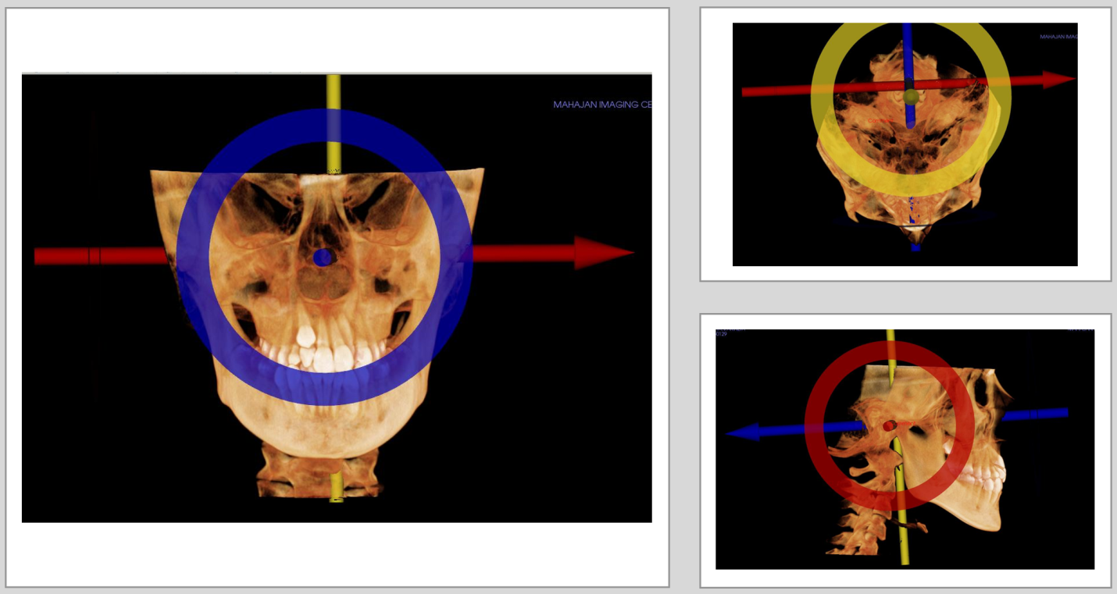
Figure 1 Standardisation of the images.
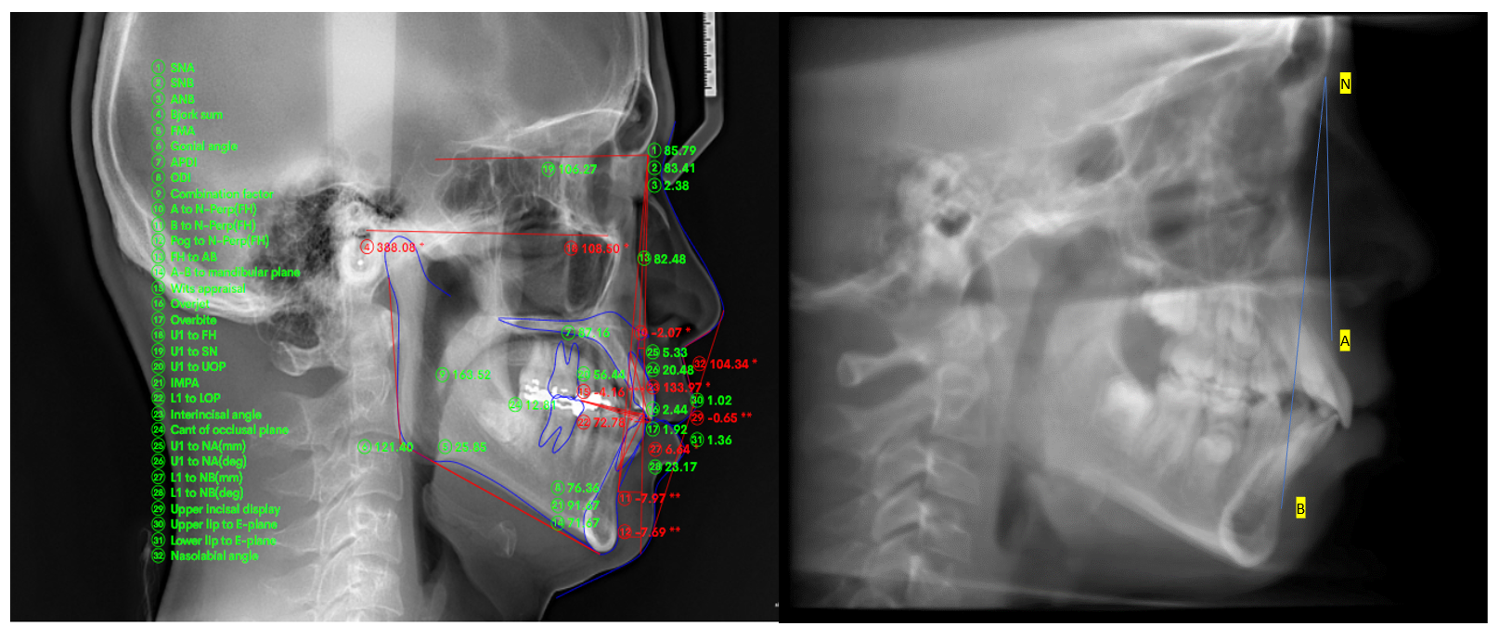
Figure 2 Cone beam computed tomography derived cephalogram and analysis.
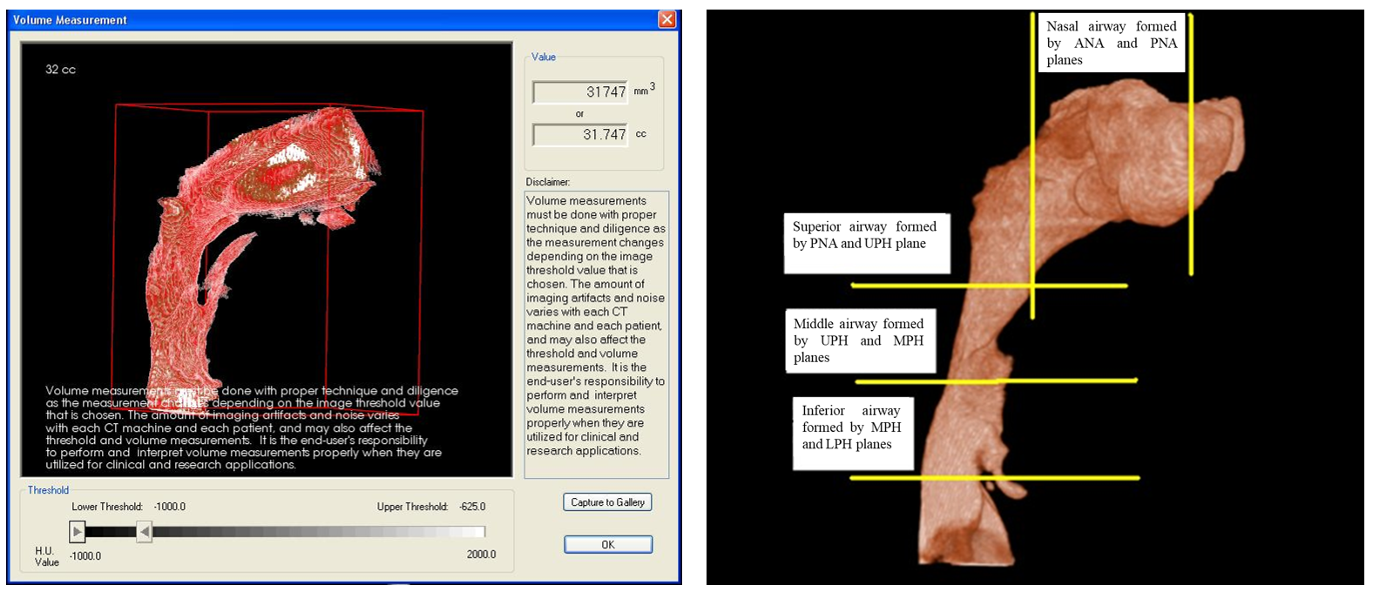
Figure 3 Airway isolated with the software and various referencing plane. ANA: Anterior nasal; PNA: Posterior nasal; UPH: Upper pharyngeal; MPH: Middle pharyngeal; LPH: Lower pharyngeal.
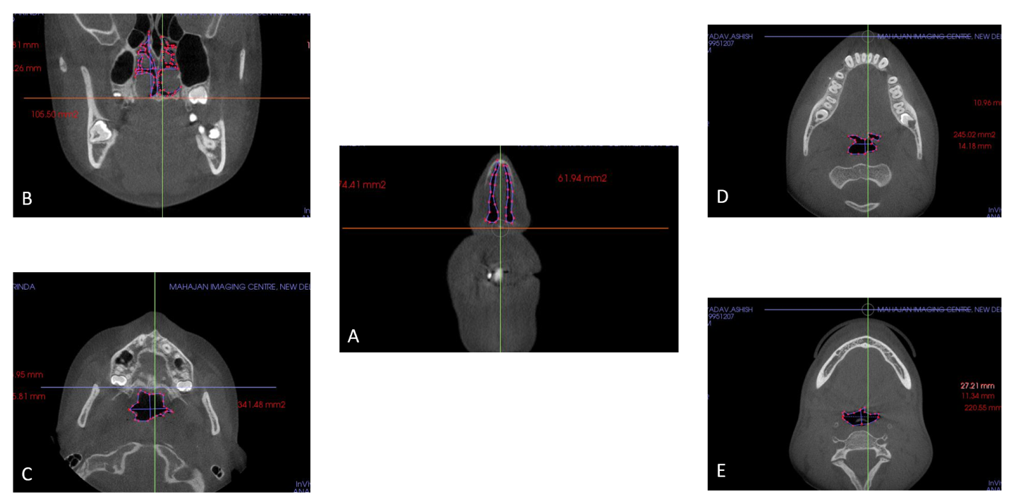
Figure 4 Horizontal section showing airway. A: Nasal; B: Superior; C: Middle; D and E: Inferior airway.
Table 1 Sample characteristics
 | Group IANB < 4 |  | Group II ANB > 4 |  | Total
 | Male | Female | Male | Female
Subjects (n) | 26 | 30 | 28 | 36 | 120
Age (yr) | 13-17 | 13-17 | 13-17 | 13-17 | 15.19 ± 1.28
ANB: The angle formed between point A, Nasion and point B.
Table 2 Two-dimensional cephalometric variables, cross-sectional planes and volumes of the 3-dimensional pharyngeal airway
Two-dimensional cephalometric variables
(1) Gonial angle: Angle formed between line drawn tangent to the lower border of the mandible and another line tangent to the distal border of the ascending ramus and the condyle on both sides; (2) Anterior facial height (AFH): Distance between the Nasion and Menton (Me); (3) Posterior facial height (PFH): Distance between Sella (S) to Gonion(Go); (4) PFH/AFH: Ratio of AFH and the PFH; (5) FMA: Frankfurt Mandibular Plane Angle formed by the intersection of the Frankfort horizontal plane and the mandibular plane; (6) ANB: The angle formed between point A, Nasion and Point B; (7) Facial convexity: Formed by the intersection of line from Nasion to point A, to point A to pogonion(Po); (8) Condylion to point A (Co-PtA); (9) Condylion to gnathion (Co-Gn); and (10) Mandibular body length (Mand-BL): Distance from gonion to pogonion
Cross-sectional planes and volumes of the 3D pharyngeal airway
Anterior nasal plane (Ana plane) | Plane passing through anterior nasal spine (ANS) and perpendicular to FH
Posterior nasal plane (Pna plane) | Plane passing through posterior nasal spine (PNS)and perpendicular to FH
Upper pharyngeal plane (Uph plane) | Plane passing through PNS parallel to FH
Middle pharyngeal plane (Mph plane) | Plane passing through lower margin of the soft palate and parallel to FH
Lower pharyngeal plane (Lph plane) | Plane passing through superior margin of the epiglottis and parallel to FH
Volume
Nasal airway | Airway formed by the planes between Ana and Pna
Superior pharyngeal airway | Airway formed by the planes between Pna and Uph
Middle pharyngeal airway | Airway formed by the planes between Uph and Mph
Inferior pharyngeal airway | Airway formed by the planes between Mph and Lph planes
Total airway | Airway extending between Ana plane to Lph plane
FH: Frankfurt horizontal; 3D: Three-dimensional.
Table 3 Correlations of sections of the airway with each other
 | Nasal airway | Superior airway | Middle airway | Inferior airway | Totalairway
Nasal airway
Pearson correlation | 1 | 0.085 | 0.471ª | 0.386 | 0.879^{b}
Sig.(2-tailed) |  | 0.722 | 0.036 | 0.093 | 0
n | 120 | 120 | 120 | 120 | 120
Superior airway
Pearson correlation | 0.85 | 1 | 0.494ª | 0.651^{b} | 0.4623ª
Sig.(2-tailed) | 0.722 | - | 0.027 | 0.002 | 0.04
n | 120 | 120 | 120 | 120 | 120
Middle airway
Pearson correlation | 0.471ª | 0.494ª | 1 | 0.763^{b} | 0.779^{b}
Sig.(2-tailed) | 0.036 | 0.027 | - | 0 | 0
n | 120 | 120 | 120 | 120 | 120
Inferior airway
Pearson correlation | 0.386 | 0.651^{b} | 0.763^{b} | 1 | 0.744^{b}
Sig.(2-tailed) | 0.093 | 0.002 | 0 | - | 0
n | 120 | 120 | 120 | 120 | 120
Totalairway
Pearson correlation | 0.879^{b} | 0.4623ª | 0.779^{b} | 0.744^{b} | 1
Sig.(2-tailed) | 0 | 0.04 | 0 | 0 | -
n | 120 | 120 | 120 | 120 | 120
ªCorrelation is significant at 0.05 level. ^{b}Correlation is significant at 0.01 level.
Table 4 Descriptive statistics of groups I and II
Group | Group I ANB < 4 |  | Group II ANB > 4 |  | P value
 | Mean | SD | Mean | SD
Ana height | 29.63 | 4.69 | 30.06 | 6.73 | 0.871
Ana width | 13.81 | 1.98 | 15.24 | 3.61 | 0.273
Ana C. area | 194.41 | 13.93 | 218.14 | 52.41 | 0.22
Pna height | 29.95 | 7.85 | 28.73 | 8.70 | 0.744
Pna width | 23.88 | 3.06 | 24.14 | 4.84 | 0.884
Pna C. area | 257.85 | 74.25 | 284.32 | 78.01 | 0.448
Uph length | 19.28 | 6.61 | 17.54 | 4.19 | 0.503
Uph width | 26.01 | 4.81 | 24.14 | 7.87 | 0.522
Uph C. area | 293.37 | 71.56 | 314.97 | 99.76 | 0.58
Mph length | 11.67 | 3.47 | 11.54 | 3.60 | 0.935
Mph width | 22.66 | 5.87 | 20.16 | 8.26 | 0.439
Mph C. area | 226.32 | 85.90 | 213.25 | 102.48 | 0.76
Lph length | 14.77 | 7.93 | 11.88 | 3.07 | 0.286
Lph width | 24.44 | 5.19 | 28.90 | 6.76 | 0.111
Lph C. area | 231.31 | 83.23 | 199.84 | 78.36 | 0.399
Gonial angle | 126.37 | 7.79 | 125.24 | 7.55 | 0.748
AFH | 108.38 | 6.08 | 112.12 | 4.86 | 0.152
PFH | 73.06 | 5.42 | 71.81 | 7.58 | 0.672
PFH/AFH, % | 67.47 | 4.49 | 64.02 | 5.83 | 0.152
FMA | 25.06 | 3.61 | 27.48 | 6.02 | 0.281
ANB | 2.85 | 1.56 | 6.14 | 1.02 | < 0.001^{b}
MAND-BL | 66.94 | 3.74 | 61.61 | 4.27 | 0.008^{b}
Facial convexity | 5.17 | 3.57 | 10.76 | 4.56 | 0.007^{b}
Co-pt A | 82.10 | 6.09 | 82.68 | 3.44 | 0.802
Co-pt GN | 109.83 | 5.54 | 103.72 | 6.42 | 0.035ª
Nasal airway | 36407.36 | 2526.59 | 30446.00 | 7060.88 | 0.037ª
Superior airway | 5563.27 | 1350.80 | 4559.67 | 1263.62 | 0.106
Middle airway | 5322.45 | 2124.81 | 4213.89 | 1291.90 | 0.188
Inferior airway | 5487.82 | 2018.25 | 5077.67 | 1521.36 | 0.621
Total airway | 52780.91 | 6435.84 | 44297.22 | 8662.49 | 0.022ª
ªCorrelation is significant at 0.05 level. ^{b}Correlation is significant at 0.01 level. ANB: The angle formed between point A, Nasion and point B; Ana: Anterior nasal; Pna: Posterior nasal; Uph: Upper pharyngeal; Mph: Middle pharyngeal; Lph: Lower pharyngeal; AFH: Anterior facial height; PFH: Posterior facial height; FMA: Frankfurt Mandibular Plane Angle; Mand-BL: Mandibular body length; Co-PtA: Condylion to point; GN: Gnathion; SD: Standard deviation.
Table 5 Correlations between the 2-dimensional cephalometric variables and the 3-dimensional volumetric measurements of the airway
 | Nasal airway | Superior airway | Middle airway | Inferior airway | Total airway
Gonial angle
Pearson correlation | -0.021 | 0.135 | 0.098 | -0.019 | 0.024
Sig.(2-tailed) | 0.928 | 0.571 | 0.681 | 0.937 | 0.918
n | 120 | 120 | 120 | 120 | 120
AFH
Pearson correlation | 0.055 | 0.201 | 0.057 | 0.342 | 0.154
Sig.(2-tailed) | 0.818 | 0.395 | 0.811 | 0.14 | 0.517
n | 120 | 120 | 120 | 120 | 120
PFH
Pearson correlation | 0.159 | 0.172 | 0.124 | 0.319 | 0.23
Sig.(2-tailed) | 0.503 | 0.47 | 0.602 | 0.171 | 0.329
n | 120 | 120 | 120 | 120 | 120
PFH/AFH, %
Pearson correlation | 0.133 | 0.057 | 0.086 | 0.113 | 0.142
Sig.(2-tailed) | 0.576 | 0.813 | 0.717 | 0.636 | 0.55
n | 120 | 120 | 120 | 120 | 120
FMA
Pearson correlation | -0.372 | -0.314 | -0.377 | -0.411 | -0.473ª
Sig.(2-tailed) | 0.106 | 0.178 | 0.102 | 0.072 | 0.035
n | 120 | 120 | 120 | 120 | 120
ANB
Pearson correlation | -0.364 | -0.408 | -0.197 | -0.152 | -0.389
Sig.(2-tailed) | 0.115 | 0.034ª | 0.405 | 0.522 | 0.22ª
n | 120 | 120 | 120 | 120 | 120
Mand-BL
Pearson correlation | 0.136 | 0.523ª | 0.038 | 0.184 | 0.225
Sig.(2-tailed) | 0.567 | 0.018 | 0.874 | 0.436 | 0.341
n | 120 | 120 | 120 | 120 | 120
Facial convexity
Pearson correlation | -0.362 | -0.306 | -0.221 | -0.22 | -0.391
Sig.(2-tailed) | 0.116 | 0.189 | 0.349 | 0.351 | 0.088
n | 120 | 120 | 120 | 120 | 120
Co-pt A
Pearson correlation | 0.127 | 0.324 | 0.289 | 0.469ª | 0.3
Sig.(2-tailed) | 0.594 | 0.163 | 0.217 | 0.037 | 0.199
n | 120 | 120 | 120 | 120 | 120
Co-pt GN
Pearson correlation | 0.301 | 0.296 | 0.012 | 0.225 | 0.303
Sig.(2-tailed) | 0.197 | 0.204 | 0.959 | 0.34 | 0.194
n | 120 | 120 | 120 | 120 | 120
ªCorrelation is significant at 0.05 level. AFH: Anterior facial height; PFH: Posterior facial height; FMA: Frankfurt Mandibular Plane Angle; Co-PtA: Condylion to point; GN: Gnathion; ANB: The angle formed between point A, Nasion and point B; Mand-BL: Mandibular body length.

