Name of Journal: World Journal of Gastrointestinal Surgery
Manuscript NO: 68738
Manuscript Type: CASE REPORT

Whole circumferential endoscopic submucosal dissection of superficial adenocarcinoma in long-segment Barrett's esophagus: A case report

Abe K et al. ESD of LSBE related superficial adenocarcinoma

Keiichiro Abe, Kenichi Goda, Akira Kanamori, Tsunehiro Suzuki, Akira Yamamiya, Yoichi Takimoto, Takahiro Arisaka, Koki Hoshi, Takeshi Sugaya, Yuichi Majima, Keiichi Tominaga, Makoto Iijima, Shinichi Hirooka, Hidetsugu Yamagishi, Atsushi Irisawa

Keiichiro Abe, Kenichi Goda, Akira Kanamori, Tsunehiro Suzuki, Akira Yamamiya, Yoichi Takimoto, Takahiro Arisaka, Koki Hoshi, Takeshi Sugaya, Yuichi Majima, Keiichi Tominaga, Makoto Iijima, Atsushi Irisawa, Department of Gastroenterology, Dokkyo Medical University, Mibu 321-0293, Tochigi, Japan

Shinichi Hirooka, Department of Pathology, The Jikei University School of Medicine, Nishishimbashi 105-8471, Tokyo, Japan

Hidetsugu Yamagishi, Academic Institutional Research Center, Dokkyo Medical University, Mibu 321-0293, Tochigi, Japan

Author contributions: Abe K and Goda K wrote the manuscript; Kanamori A, Suzuki T, Yamamiya A, Arisaka T, Sugaya T, Majima Y, Tominaga K, Iijima M, and Irisawa A contributed to the manuscript discussion and reviewed the manuscript; Hirooka S and Yamagishi H established pathological diagnosis.

Corresponding author: Kenichi Goda, MD, PhD, Professor, Department of Gastroenterology, Dokkyo Medical University, 880 Kitakobayshi, Mibu 321-0293, Tochigi, Japan. goda@dokkyomed.ac.jp

Received: June 2, 2021
Revised: July 11, 2021
Accepted: September 15, 2021
Published online: October 27, 2021

Abstract
BACKGROUND
Esophageal adenocarcinoma (EAC) derived from long-segment Barrett’s esophagus (LSBE) is extremely rare in Asia. LSBE-related EAC is often difficult to diagnose in the horizontal extent. If the tumor has spread throughout the LSBE, whole circumferential endoscopic submucosal dissection (ESD) should be performed, which is difficult to complete safely. Additionally, whole circumferential ESD can bring refractory postoperative stenosis. We hereby report a case of EAC involving the whole circumference of the LSBE, achieving complete endoscopic removal without complications.

CASE SUMMARY
An 85-year-old man with the chief complaint of dysphagia underwent esophagogastroduodenoscopy. We suspected a flat-type cancerous lesion that extended the whole circumference of the LSBE (C 3.5, M 4.0) using narrow-band imaging magnification endoscopy (NBI-M). We achieved circumferential en bloc resection of the lesion safely with special ESD techniques. Histology of the ESD specimens demonstrated that the superficial EAC extended the whole circumference of the LSBE, and papillary or well-differentiated tubular adenocarcinoma was confined in the lamina propria mucosa showing a vertical negative margin. To prevent post-ESD stenosis, we performed endoscopic local injection of steroids, followed by oral administration of steroids. There was no evidence of esophageal refractory stenosis or tumor recurrence 30 mo after ESD. In summary, we experienced a rare case of LSBE-related EAC. The horizontal tumor extent was accurately diagnosed by NBI-M. Additionally, we achieve whole circumferential ESD safely without postoperative refractory stenosis.

CONCLUSION
NBI-M, ESD, and steroid therapy enabled the curative resection of superficial full circumferential LSBE-related EAC without refractory postoperative stenosis.

Key Words: Endoscopic submucosal dissection; Long-segment Barrett's esophagus; Superficial esophageal adenocarcinoma; Steroid; Magnification endoscopy; Case report

©The Author(s) 2021. Published by Baishideng Publishing Group Inc. All rights reserved.

Citation:Abe K, Goda K, Kanamori A, Suzuki T, Yamamiya A, Takimoto Y, Arisaka T, Hoshi K, Sugaya T, Majima Y, Tominaga K, Iijima M, Hirooka S, Yamagishi H, Irisawa A. Whole circumferential endoscopic submucosal dissection of superficial adenocarcinoma in long-segment Barrett's esophagus: A case report. World J Gastrointest Surg 2021; 13(10): 1285-1292
URL: https://www.wjgnet.com/1948-9366/full/v13/i10/1285.htm
DOI: https://dx.doi.org/10.4240/wjgs.v13.i10.1285

Core Tip: Esophageal adenocarcinoma (EAC) arising from long-segment Barrett’s esophagus is rare and tends to be diffuse. Preoperative diagnosis of the horizontal tumor extent and postoperative stenosis after endoscopic submucosal dissection (ESD) could be problematic in this case. We accurately diagnosed the horizontal extent of the EAC lesion by narrow-band imaging magnification endoscopy and achieved complete en bloc R0 resection via whole circumferential ESD. We also succeeded in preventing refractory stenosis after whole circumferential ESD by prophylactic steroid therapy combing local injection and oral administration.

INTRODUCTION
The incidence of Barrett's esophagus-related adenocarcinoma has increased rapidly in western countries^{[1-3]}, and has also been gradually increasing in Asia^{[4]}. In the west, the carcinoma has been reported to develop from long-segment Barrett’s esophagus (LSBE) in more than half of cases^{[5]}, while in Asia, LSBE is extremely rare^{[6]}. LSBE-related adenocarcinomas tend to be diffuse^{[7]} and flat^{[8]}, and diagnosing the horizontal extent of the tumor can be more difficult than in short-segment Barrett’s esophagus-related adenocarcinoma, which tends to have solitary or localized carcinogenesis^{[7]}. Postoperative refractory stenosis can occur even if endoscopic submucosal dissection (ESD) can be performed for superficial esophageal adenocarcinoma (EAC) involving the whole circumference of the LSBE^{[9,10]}.
We hereby report a rare case of superficial EAC with suspected involvement of the whole circumference of the LSBE via narrow-band imaging magnification endoscopy (NBI-M). We achieved en bloc R0 resection with special ESD techniques. Additionally, we could prevent refractory postoperative stenosis by prophylactic steroid combination therapy.

CASE PRESENTATION
Chief complaints
An 85-year-old man complained of hoarseness and dysphagia. He was referred to our hospital for further medical work-up and treatment.

History of present illness
The patient underwent esophagogastroduodenoscopy; A nodular aggregated protruded lesion was found in the lower esophagus. Histological analysis of the biopsy samples obtained from the protruded lesion showed adenocarcinoma.

History of past illness
The patient had a history of left glottic cancer and prostatic cancer, which were treated with radiation therapy and hormonal therapy, respectively.

Personal and family history
He had a smoking history of 40 cigarettes per day for 40 years. There was no remarkable family medical history.

Physical examination
The patient presented in a normal nutritional state and the physical examination was unremarkable.

Laboratory examinations
Laboratory studies, including total blood count, analysis of markers of kidney and liver failure, and analysis of tumor makers did not reveal any abnormalities.

Imaging examinations
Conventional white-light endoscopy (CWE) showed a protruded lesion in the LSBE (C 3.5 M 4; Figure 1A and B). CWE and indigo carmine chromoendoscopy could not visualize a definitive lesion other than the protruded lesion (Figure 1), whereas NBI-M visualized extensive irregular mucosal/vascular patterns in the flat areas surrounding the nodular aggregated protruded lesion (Figure 2). The NBI-M findings were suggestive of a flat-type neoplastic lesion extending the whole circumference of the LSBE. The flat-type neoplastic lesion was suspected to longitudinally extend up to the esophagogastric junction. Adenocarcinoma and neoplastic glands were observed in the biopsy specimens obtained from the protruded and flat lesions, respectively. We predicted a diagnosis of superficial tumors spreading extensively along the whole circumference of the LSBE. The protruded lesion did not show poor distensibility or an expanding appearance but was semi-pedunculated. These findings suggested that the protruded tumor was confined to the mucosal layer. Contrast-enhanced computed tomography showed no metastatic lesions in the thorax and abdomen.

FINAL DIAGNOSIS
Histological analysis of the ESD specimen demonstrated that the superficial EAC extended the whole circumference of the LSBE (Figure 3). The protruding and flat extending tumors showed papillary and well-differentiated tubular adenocarcinoma, respectively (Figure 3). We achieved en bloc R0 resection with horizontal and vertical margins that were negative for cancer cells. Tumor invasion was confined to the superficial muscularis mucosa without lymphatic or vascular involvement.

TREATMENT
We achieved whole circumferential ESD with en bloc removal of the whole LSBE safely. We injected 0.4% sodium hyaluronate (MucoUp; Boston Scientific, Marlborough, MA, United States) into the submucosal layer during the ESD. We used special ESD techniques, including the submucosal tunneling method and a thread-traction method^{[11,12]}. We created three submucosal tunnels from the oral side and dissected the submucosal tissue between the tunnels (Figure 4). The ESD specimen was 98 mm × 54 mm in diameter (Figure 5).
We injected a steroid solution containing 80 mg triamcinolone into the remaining submucosal layer immediately after ESD as prophylactic therapy for postoperative stenosis. Additionally, oral prednisolone was administered at an initial dose of 20 mg/d [0.5 mg/body weight (kg)] beginning on the second day post-ESD, which was gradually tapered every 2 wk, and completed 12 wk later.

OUTCOME AND FOLLOW-UP
Although the patient had mild narrowing of the esophageal lumen and did not complain of severe dysphagia, esophagogastroduodenoscopy showed mild stenosis in the lower esophagus. We performed prophylactic endoscopic balloon dilatation with a 12-15 mm balloon diameter (CRE balloon; Boston Scientific, Boston, United States) at 3 mo, 5 mo, and 6 mo post-ESD. The patient has a regular diet and no tumor recurrence 30 mo after ESD.

DISCUSSION
LSBE is a rare disease in Asia, including in Japan, and carcinogenesis from LSBE is even rarer. In EAC derived from LSBE, the histological distribution of dysplasia and EAC tends to be multiple and diffuse^{[7]}. This often makes diagnosing the horizontal extent of the dysplasia and superficial EAC difficult. Unlike in western countries, ESD is commonly used in Japan to treat superficial EAC in the Barrett's esophagus. When the tumor has spread the whole circumference of the LSBE, as in the present case, the ESD procedure can be extremely challenging because of the high likelihood of perforation, severe hemorrhage, and refractory stenosis after whole circumferential ESD.
Using NBI-M, we were able to accurately diagnose the horizontal extent of this superficial EAC involving the w circumference of LSBE and achieved complete en bloc R0 resection. In this case, an extensive flat-type tumor lesion surrounded the protruded tumor lesion. Diagnosing the horizontal extent of the flat-type tumor can sometimes be difficult by CWE or indigo carmine chromoendoscopy. Previous studies have shown that NBI-M is useful in the diagnosis of the flat-type superficial EAC lesions^{[13-15]}. However, little is known about utility of NBI-M for LSBE-related superficial adenocarcinoma that tends to be diffuse and flat. The horizontal tumor extent of the LSBE-related superficial EAC was accurately diagnosed using NBI-M in the present case. Additionally, we utilized the following two ESD techniques and successfully completed a highly difficult procedure of whole circumferential ESD. The first ESD technique is a tunneling method^{[16,17]}, and the other is a thread-traction method^{[11]}. The tunneling method creates tunnels in the submucosal layer of a lesion, which allow for the submucosal layer to be dissected easily and safely. In this case, after creating three tunnels, the mucosa at the entrance of a tunnel was pulled towards the oral side with a thread and clip. Combining the thread-traction method with the tunneling method enable the safe completion of ESD with good traction whilst maintaining a clear the view of the operative field. Refractory postoperative stenosis commonly occurs in patients who undergo extensive endoscopic resection of ≥ 75% of the circumference, and these patients often require repeated endoscopic balloon dilation^{[18]}.
Recently, studies have shown that steroid injection therapy and oral steroid administration prevented post-operative stenosis after extensive esophageal ESD (≥ 75% circumference)^{[19,20]}. As alternative techniques for preventing post-ESD stenosis, other than steroid injection, polyglycolic acid (PGA) sheets and oral epithelial cell sheets may have the potential to prevent esophageal stricture after ESD^{[21-23]}. However, these methods have not been widely used as a prophylactic measure for preventing stenosis because the PGA has a prolonged time for endoscopic delivery and fixation, and providing oral mucosal epithelial cell sheets in every hospital would be technically and financially difficult. We considered that this case had a considerably high risk for refractory postoperative stenosis because whole circumferential ESD was performed. Consequently, we conducted combination therapy with local steroid injection and oral steroid administration, which enabled us to prevent refractory stenosis.

CONCLUSION
This case suggested that minimally invasive and radical treatment could be achieved for superficial EAC involving the whole circumference of the LSBE using ESD. NBI-M and steroid combination therapy enabled us to diagnose horizontal tumor extension accurately and prevent refractory postoperative stenosis, respectively.

REFERENCES
1 Pohl H, Sirovich B, Welch HG. Esophageal adenocarcinoma incidence: are we reaching the peak? Cancer Epidemiol Biomarkers Prev 2010; 19: 1468-1470 [PMID: 20501776 DOI: 10.1158/1055-9965.EPI-10-0012]
2 Caygill CP, Royston C, Charlett A, Wall CM, Gatenby PA, Ramus JR, Watson A, Winslet M, Bardhan KD. Mortality in Barrett's esophagus: three decades of experience at a single center. Endoscopy 2012; 44: 892-898 [PMID: 22752886 DOI: 10.1055/s-0032-1309842]
3 Everhart JE, Ruhl CE. Burden of digestive diseases in the United States part I: overall and upper gastrointestinal diseases. Gastroenterology 2009; 136: 376-386 [PMID: 19124023 DOI: 10.1053/j.gastro.2008.12.015]
4 Committee for Scientific Affairs, The Japanese Association for Thoracic Surgery. Masuda M, Endo S, Natsugoe S, Shimizu H, Doki Y, Hirata Y, Kobayashi J, Motomura N, Nakano K, Nishida H, Okada M, Saiki Y, Saito A, Sato Y, Tanemoto K, Toh Y, Tsukihara H, Wakui S, Yokomise H, Yokoi K, Okita Y. Thoracic and cardiovascular surgery in Japan during 2015 : Annual report by The Japanese Association for Thoracic Surgery. Gen Thorac Cardiovasc Surg 2018; 66: 581-615 [PMID: 30076512 DOI: 10.1007/s11748-018-0968-0]
5 American Gastroenterological Association. Spechler SJ, Sharma P, Souza RF, Inadomi JM, Shaheen NJ. American Gastroenterological Association medical position statement on the management of Barrett's esophagus. Gastroenterology 2011; 140: 1084-1091 [PMID: 21376940 DOI: 10.1053/j.gastro.2011.01.030]
6 Ogiya K, Kawano T, Ito E, Nakajima Y, Kawada K, Nishikage T, Nagai K. Lower esophageal palisade vessels and the definition of Barrett's esophagus. Dis Esophagus 2008; 21: 645-649 [PMID: 18459993 DOI: 10.1111/j.1442-2050.2008.00825.x]
7 Cameron AJ, Carpenter HA. Barrett's esophagus, high-grade dysplasia, and early adenocarcinoma: a pathological study. Am J Gastroenterol 1997; 92: 586-591 [PMID: 9128304]
8 Yamasaki A, Shimizu T, Kawachi H, Yamamoto N, Yoshimizu S, Horiuchi Y, Ishiyama A, Yoshio T, Hirasawa T, Tsuchida T, Sasaki Y, Fujisaki J. Endoscopic features of esophageal adenocarcinoma derived from short-segment vs long-segment Barrett's esophagus. J Gastroenterol Hepatol 2020; 35: 211-217 [PMID: 31396997 DOI: 10.1111/jgh.14827]
9 Kaneko M, Mitoro A, Yoshida M, Sawai M, Okura Y, Furukawa M, Namisaki T, Moriya K, Akahane T, Kawaratani H, Kitade M, Kaji K, Takaya H, Sawada Y, Seki K, Sato S, Fujii T, Yamao J, Obayashi C, Yoshiji H. Treatment of long-segment Barrett's adenocarcinoma by complete circular endoscopic submucosal dissection: a case report. BMC Gastroenterol 2018; 18: 16 [PMID: 29351773 DOI: 10.1186/s12876-018-0743-9]
10 Iizuka T, Kikuchi D, Hoteya S, Kaise M. Effectiveness of modified oral steroid administration for preventing esophageal stricture after entire circumferential endoscopic submucosal dissection. Dis Esophagus 2018; 31 [PMID: 29444278 DOI: 10.1093/dote/dox140]
11 Linghu E, Feng X, Wang X, Meng J, Du H, Wang H. Endoscopic submucosal tunnel dissection for large esophageal neoplastic lesions. Endoscopy 2013; 45: 60-62 [PMID: 23254407 DOI: 10.1055/s-0032-1325965]
12 Koike Y, Hirasawa D, Fujita N, Maeda Y, Ohira T, Harada Y, Suzuki K, Yamagata T, Tanaka M. Usefulness of the thread-traction method in esophageal endoscopic submucosal dissection: randomized controlled trial. Dig Endosc 2015; 27: 303-309 [PMID: 25357187 DOI: 10.1111/den.12396]
13 Mannath J, Subramanian V, Hawkey CJ, Ragunath K. Narrow band imaging for characterization of high grade dysplasia and specialized intestinal metaplasia in Barrett's esophagus: a meta-analysis. Endoscopy 2010; 42: 351-359 [PMID: 20200809 DOI: 10.1055/s-0029-1243949]
14 Sharma P, Bergman JJ, Goda K, Kato M, Messmann H, Alsop BR, Gupta N, Vennalaganti P, Hall M, Konda V, Koons A, Penner O, Goldblum JR, Waxman I. Development and Validation of a Classification System to Identify High-Grade Dysplasia and Esophageal Adenocarcinoma in Barrett's Esophagus Using Narrow-Band Imaging. Gastroenterology 2016; 150: 591-598 [PMID: 26627609 DOI: 10.1053/j.gastro.2015.11.037]
15 Goda K, Fujisaki J, Ishihara R, Takeuchi M, Takahashi A, Takaki Y, Hirasawa D, Momma K, Amano Y, Yagi K, Furuhashi H, Shimizu T, Kanesaka T, Hashimoto S, Ono Y, Yamagata T, Fujiwara J, Azumi T, Nishikawa M, Watanabe G, Ohkura Y, Oyama T. Newly developed magnifying endoscopic classification of the Japan Esophageal Society to identify superficial Barrett's esophagus-related neoplasms. Esophagus 2018 [PMID: 29923024 DOI: 10.1007/s10388-018-0623-y]
16 Arantes V, Albuquerque W, Freitas Dias CA, Demas Alvares Cabral MM, Yamamoto H. Standardized endoscopic submucosal tunnel dissection for management of early esophageal tumors (with video). Gastrointest Endosc 2013; 78: 946-952 [PMID: 23810327 DOI: 10.1016/j.gie.2013.05.031]
17 Gan T, Yang JL, Zhu LL, Wang YP, Yang L, Wu JC. Endoscopic submucosal multi-tunnel dissection for circumferential superficial esophageal neoplastic lesions (with videos). Gastrointest Endosc 2016; 84: 143-146 [PMID: 26828761 DOI: 10.1016/j.gie.2016.01.049]
18 Ono S, Fujishiro M, Niimi K, Goto O, Kodashima S, Yamamichi N, Omata M. Predictors of postoperative stricture after esophageal endoscopic submucosal dissection for superficial squamous cell neoplasms. Endoscopy 2009; 41: 661-665 [PMID: 19565442 DOI: 10.1055/s-0029-1214867]
19 Yamaguchi N, Isomoto H, Nakayama T, Hayashi T, Nishiyama H, Ohnita K, Takeshima F, Shikuwa S, Kohno S, Nakao K. Usefulness of oral prednisolone in the treatment of esophageal stricture after endoscopic submucosal dissection for superficial esophageal squamous cell carcinoma. Gastrointest Endosc 2011; 73: 1115-1121 [PMID: 21492854 DOI: 10.1016/j.gie.2011.02.005]
20 Hashimoto S, Kobayashi M, Takeuchi M, Sato Y, Narisawa R, Aoyagi Y. The efficacy of endoscopic triamcinolone injection for the prevention of esophageal stricture after endoscopic submucosal dissection. Gastrointest Endosc 2011; 74: 1389-1393 [PMID: 22136782 DOI: 10.1016/j.gie.2011.07.070]
21 Iizuka T, Kikuchi D, Yamada A, Hoteya S, Kajiyama Y, Kaise M. Polyglycolic acid sheet application to prevent esophageal stricture after endoscopic submucosal dissection for esophageal squamous cell carcinoma. Endoscopy 2015; 47: 341-344 [PMID: 25412087 DOI: 10.1055/s-0034-1390770]
22 Sakaguchi Y, Tsuji Y, Ono S, Saito I, Kataoka Y, Takahashi Y, Nakayama C, Shichijo S, Matsuda R, Minatsuki C, Asada-Hirayama I, Niimi K, Kodashima S, Yamamichi N, Fujishiro M, Koike K. Polyglycolic acid sheets with fibrin glue can prevent esophageal stricture after endoscopic submucosal dissection. Endoscopy 2015; 47: 336-340 [PMID: 25314328 DOI: 10.1055/s-0034-1390787]
23 Yamaguchi N, Isomoto H, Kobayashi S, Kanai N, Kanetaka K, Sakai Y, Kasai Y, Takagi R, Ohki T, Fukuda H, Kanda T, Nagai K, Asahina I, Nakao K, Yamato M, Okano T, Eguchi S. Oral epithelial cell sheets engraftment for esophageal strictures after endoscopic submucosal dissection of squamous cell carcinoma and airplane transportation. Sci Rep 2017; 7: 17460 [PMID: 29234120 DOI: 10.1038/s41598-017-17663-w]

Footnotes
Informed consent statement: Informed written consent was obtained from the patient for publication of this report.

Conflict-of-interest statement: The authors declare that there are no conflicts of interest.

CARE Checklist (2016) statement: The authors have read the CARE Checklist (2016), and the manuscript was prepared and revised according to the CARE Checklist (2016).

Open-Access: This article is an open-access article that was selected by an in-house editor and fully peer-reviewed by external reviewers. It is distributed in accordance with the Creative Commons Attribution NonCommercial (CC BY-NC 4.0) license, which permits others to distribute, remix, adapt, build upon this work non-commercially, and license their derivative works on different terms, provided the original work is properly cited and the use is non-commercial. See: http://creativecommons.org/Licenses/by-nc/4.0/

Manuscript source: Unsolicited manuscript

Peer-review started: June 2, 2021
First decision: July 1, 2021
Article in press: September 15, 2021

Specialty type: Gastroenterology and hepatology
Country/Territory of origin: Japan
Peer-review report’s scientific quality classification
Grade A (Excellent): 0
Grade B (Very good): B
Grade C (Good): C, C
Grade D (Fair): 0
Grade E (Poor): 0

P-Reviewer: Lorenzo-Zúñiga V, Samanta J, Suresh Kumar VC S-Editor: Wu YXJ L-Editor: A P-Editor: Liu JH

Figure Legends
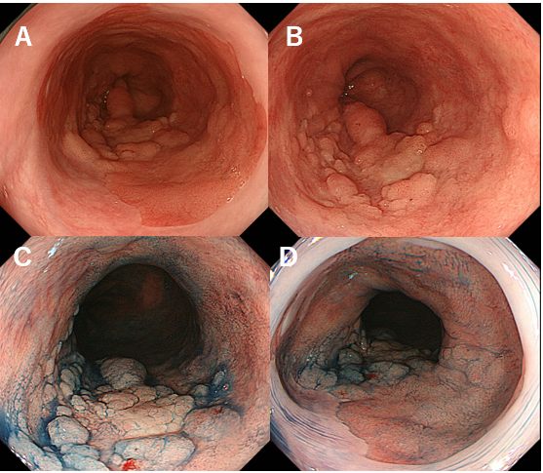
Figure 1 Images of esophagogastroduodenoscopy. A and B: Conventional white-light endoscopy shows a nodular aggregated protruded lesion in the long-segment Barrett’s esophagus (C 3.5 M 4); C and D: Chromoendoscopy with indigo carmine shows the protruded lesion with irregularly sized granules. No obvious lesion was found in the mucosal surface of Barrett's esophagus other than the nodular aggregated protruded lesion.

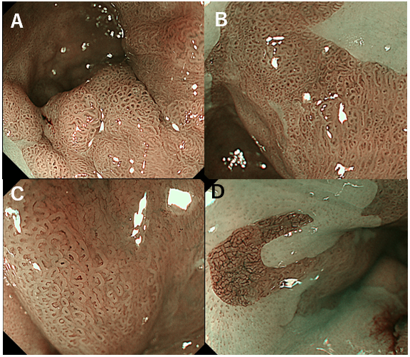
Figure 2 Images of narrow-band imaging magnification endoscopy. A: Narrow-band imaging magnification endoscopy (NBI-M) shows a visible mucosal pattern with villous structures in protruded or elevated portions, as well as in the surrounding flat portions in the long-segment Barrett’s esophagus (LSBE); B: The villous patterns were rated as irregular because they showed variety in size and existed in a high density; C: In most of surrounding areas of the LSBE, mucosal patterns showed an irregular villous pattern [similar to the image (C)], and vascular patterns were rated as irregular because they showed a variety of forms and calibers under NBI-M observation with high magnification; D: In several flat areas, NBI-M demonstrated an invisible mucosal pattern with an irregular vascular pattern forming a network-like structure with a variety in caliber.

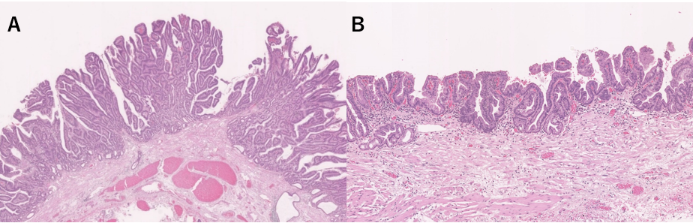
Figure 3 Pathological findings. A: Papillary adenocarcinoma with cancerous crypts exhibiting papillary proliferation accompanied by structural atypia was observed in the protruded and elevated positions (magnification: 1.5 ×); B: Well-differentiated tubular adenocarcinoma with short papillary glands accompanied by structural atypia and nuclear enlargement was extensively observed in the extensive flat portions (magnification: 2.0 ×).

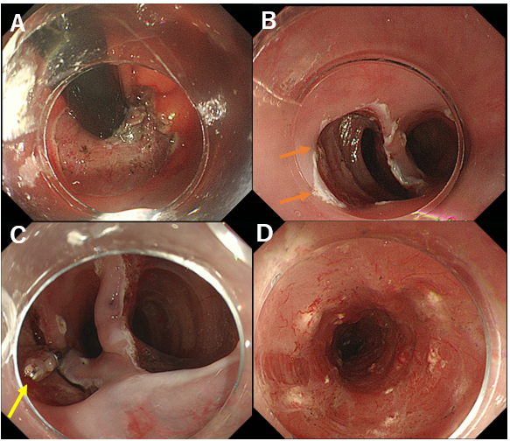
Figure 4 Images of intraoperative endoscopy. A: Barrett's esophagus-related neoplasia appears to spread up to the gastric cardia. Endoscopic submucosal dissection (ESD) was started in this cardiac area; B: After resecting and dissecting the cardiac lesion, three submucosal tunnels were created from the oral side (orange arrow is the first tunnel); C: A clip with a thread was attached to the mucosal edge of each of the three tunnels, and the dissected tissue of the tunnels was pulled toward the oral side (yellow arrow); D: Whole circumferential ESD had been completed. Steroid solution was injected into the remaining submucosa (white spots) immediately after ESD to prevent postoperative stenosis.

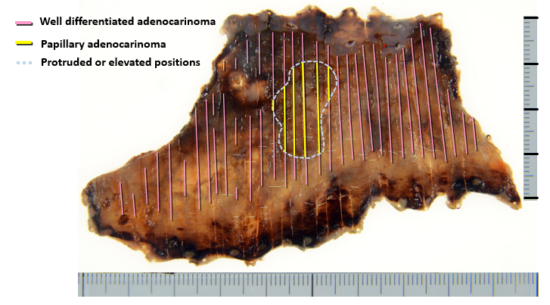
Figure 5 An endoscopic submucosal dissection en-bloc resected specimen and histological tumor distribution. The superficial carcinoma consisted of papillary and well-differentiated tubular adenocarcinoma in the protruded and elevated positions and extensive flat portions, respectively. The adenocarcinoma lesion extended the whole circumference of the long-segment Barrett’s esophagus and was confined to the superficial muscularis mucosae.

Published by Baishideng Publishing Group Inc
7041 Koll Center Parkway, Suite 160, Pleasanton, CA 94566, USA
Telephone: +1-925-3991568
E-mail: bpgoffice@wjgnet.com
Help Desk: https://www.f6publishing.com/helpdesk
https://www.wjgnet.com

© 2021 Baishideng Publishing Group Inc. All rights reserved.

