Name of Journal: World Journal of Clinical Cases
Manuscript NO: 80485
Manuscript Type: CASE REPORT

Young thoracic vertebra diffuse idiopathic skeletal hyperostosis with Scheuermann disease: A case report

Liu WZ et al. Thoracic vertebra diffuse idiopathic skeletal hyperostosis

Wen-Zheng Liu, Zheng-Qi Chang, Zhe-Ming Bao

Wen-Zheng Liu, The First Clinical Medical College, Shandong University of Traditional Chinese Medicine, Jinan 250000, Shandong Province, China

Wen-Zheng Liu, Zheng-Qi Chang, Zhe-Ming Bao, Department of Orthopedics, 960th Hospital of PLA, Jinan 250031, Shandong Province, China

Author contributions: Liu WZ and Chang ZQ conceived the research, performed clinical examinations, and wrote and revised the manuscript; Bao ZM and Chang ZQ evaluated the imaging of the patient; and all authors contributed to the article and approved the final version. Liu WZ and Bao ZM are co-first authors of the article.

Corresponding author: Zheng-Qi Chang, MD, Associate Chief Physician, Associate Professor, Department of Orthopedics, 960th Hospital of PLA, No. 25 Shifan Road, Tianqiao District, Jinan 250031, Shandong Province, China. 26766771@qq.com

Received: September 29, 2022
Revised: December 15, 2022
Accepted: January 5, 2023
Published online:

Abstract
BACKGROUND
Diffuse idiopathic skeletal hyperostosis (DISH) is a disorder characterised by the calcification and ossification of ligaments and entheses. It is a frequent occurrence in elderly males, but rarely encountered in younger individuals.

CASE SUMMARY
A 24-year-old male was admitted to the hospital due to low back pain accompanied with numbness in both lower limbs for 10 d. Upon clinical examination and imaging tests, the patient was diagnosed with DISH with Scheuermann disease and thoracic spinal stenosis. Before the operation and medical treatment, the patient had hypoesthesia of the skin below the xiphoid process. Afterward, a standard laminectomy was conducted using ultrasonic bone curette and internal fixation was applied. Subsequently, the patient was given corticosteroids, neurotrophic drugs, hyperbaric oxygen and electric stimulation. As a result of the treatment, the patient’s sensory level decreased to the navel level and there was no major change in the muscle strength of the lower limbs. During follow-up, the patient’s skin sensation has returned to normal.

CONCLUSION
This case is a rare instance of DISH co-existing with Scheuermann’s disease in a young adult. This provides a valuable reference point for spine surgeons, as DISH is more commonly observed in middle-aged and elder adults.

Key Words: Diffuse idiopathic skeletal hyperostosis; Scheuermann disease; Thoracic spinal stenosis; Case report

Liu WZ, Chang ZQ, Bao ZM. Young thoracic vertebra diffuse idiopathic skeletal hyperostosis with Scheuermann disease: A case report. World J Clin Cases 2023; In press

Core Tip: This case report presents a rare instance of diffuse idiopathic skeletal hyperostosis in a 24-year-old male patient, which is a condition that is usually seen in elderly males. The patient was also diagnosed with Scheuermann disease. By providing clinical data and treatment experience of this patient, it is hoped that it will help to improve the understanding of related diseases, and reduce the chances of misdiagnosis.

INTRODUCTION
Diffuse idiopathic skeletal hyperostosis (DISH) is an ailment caused by the calcification and ossification of the entheses that primarily affects the spine and other peripheral areas^{[1]}. Primarily, DISH affects the thoracic spine of the axial skeleton; however, other spinal regions are often affected too. Studies demonstrate that DISH is more predominant among middle-aged and elderly individuals and the rate of occurrence increases with age. Moreover, there is a higher rate of male patients than female patients^{[2]}. Scheuermann’s disease was initially described by Scheuermann^{[3]}, a Danish physician, in 1921. The main symptom of this condition is the formation of three adjacent vertebrae that are angled by at least 5 degrees, resulting in the spine’s kyphoscoliosis. Radiographic features of Scheuermann’s disease include wedged vertebrae, irregular vertebral endplates, and Schmorl’s nodes^{[4]}. In this paper, we present a case of a young patient who was eventually diagnosed with DISH in combination with Scheuermann disease and thoracic spinal stenosis (TSS) in our hospital. While DISH is usually observed in middle-aged and elderly individuals, there is a lack of reports on young DISH patients. Moreover, it is even rarer for young DISH to be associated with Scheuermann disease, thus making this case worth reporting. We have reviewed the characteristics of the case, as well as the diagnosis and treatment process, in order to expand the current knowledge on the diagnosis and treatment of related diseases.

CASE PRESENTATION
Chief complaints
The 24-year-old male patient was hospitalized for 10 d due to lower back pain and numbness in both lower limbs.

History of present illness
The 24-year-old male patient was hospitalized for 10 d due to lower back pain and numbness in both lower limbs. On physical examination, thoracodorsal kyphosis was observed and the skin below xiphoid had hypoesthesia. Furthermore, the muscle strength of the right iliopsoas, quadriceps femoris and biceps femoris was graded as III, while the right tibialis anterior and extensor dorsi were graded as IV. At admission, the patient experienced radiating pain in his waist, which had a VAS score of 8.

History of past illness
The patient reported no other medical history such as hypertension and diabetes.

Personal and family history
The patient denied any personal and family history of illness.

Physical examination
On physical examination, thoracodorsal kyphosis was observed and the skin below xiphoid had hypoesthesia. Furthermore, the muscle strength of the right iliopsoas, quadriceps femoris and biceps femoris was graded as III, while the right tibialis anterior and extensor dorsi were graded as IV. At admission, the patient experienced radiating pain in his waist, which had a VAS score of 8.

Laboratory examinations
To differentiate DISH from ankylosing spondylitis, it is necessary to test for human leukocyte antigen-B27 (HLA-B27). The patient’s HLA-B27 index is within the normal range. Additionally, the patient’s erythrocyte sedimentation rate, blood routine test and other biochemical indicators are all within the normal range.

Imaging examinations
Anterior-lateral X-ray: Kyphosis of the thoracic spine is present, with calcification of the anterior longitudinal ligament and lamellar ossification/floating bone bridge on the medial-inferior and medial-superior sides of the anterior and lateral edges of vertebral plates. Additionally, there is a local wedge-shaped deformation of the lower thoracic vertebra (Figure 1).
Thoracic computed tomography (CT) scan revealed a kyphosis in the thoracic spine and calcification of the anterior longitudinal ligament of multiple vertebral bodies. The T8-12 vertebral body was wedge-shaped with a narrow front and wide back. The T5/6, T7/8, and T8/9 intervertebral discs were observed to protrude backward, resulting in compression of the corresponding horizontal segment dural sac. Furthermore, the adequate space of the spinal canal was constricted, and the spinal cord was compressed due to hyperplasia and sclerosis of the bilateral facet joints of the T7-9 vertebral body (Figure 2).
Results of a three-dimensional reconstruction revealed calcification of the anterior longitudinal ligament of numerous vertebral bodies, which has formed a bony bridge. The T8-12 vertebral body was found to be wedge-shaped, with a narrow front and wide back, as well as hyperplasia and sclerosis of both facet joints of the T7-9 vertebral body (Figure 3).
Thoracic magnetic resonance imaging showed kyphosis in the local thoracic spine. The T8-12 vertebrae have a wedge-like shape, with a thin anterior side and a wide posterior side. The intervertebral discs between T5/6, T7/8, and T8/9 protrude posteriorly and the adjacent dural sac is compressed. Additionally, no alterations in the spinal cord signal intensity were observed (Figure 4).

FINAL DIAGNOSIS
The patient was diagnosed with DISH with Scheuermann disease and TSS.

TREATMENT
The patient’s TSS symptoms were serious, resulting in paraplegia of the lower limbs. To address this, we opted for a laminectomy with an ultrasonic bone curette and internal fixation. After the procedure, we administered corticosteroids, neurotrophic medications, hyperbaric oxygen, and electrical stimulation to the patient for further treatment.

OUTCOME AND FOLLOW-UP
After the surgery and medication, the patient’s sensory level decreased to the navel level with no noteworthy alteration in the muscle strength of the lower limbs. The VAS score was also decreased to 2 points. During the follow-up, the lumbar pain was completely gone and the patient’s skin sensation was back to normal. The patient was also capable of walking 1.5 kilometers. The postoperative reexamination revealed that the internal fixation position was successful (Figure 5).

DISCUSSION
The diagnosis of DISH is based on radiographic criteria proposed by Resnick and Niwayama^{[5]} in 1976, which include the presence of flowing calcification and ossification along the anterolateral aspects of at least four contiguous vertebral bodies, relative preservation of disc height in the problematic areas, and absence of apophyseal joint bony ankylosis and sacroiliac joint erosion, sclerosis or bony fusion. This patient fulfilled these criteria and was thus diagnosed with DISH. DISH is most commonly found in the thoracic spine, where it presents as wavy ossification in front of the thoracic centrum, forming bone bridges across the intervertebral spaces, and is most commonly located on the right side^{[6]}. It may also occur in the lower cervical spine and the upper lumbar segments^{[7]}. It is important to differentiate DISH from ankylosing spondylitis, which can be done by examining the patient’s joint space, inflammatory manifestations of the articular surface, morning stiffness, and limited joint mobility, as well as HLA-B27 values. In this case, the patient did not present with any of these features and had normal HLA-B27 values, thus excluding the possibility of ankylosing spondylitis.
Patients with DISH usually do not present with any noticeable symptoms and rarely require treatment. However, when DISH is accompanied by ossification of the ligamentum flavum and posterior longitudinal ligament, which compresses the spinal cord or nerve, surgery is necessary^{[8]}. This condition is usually discovered incidentally during imaging tests, and the prevalence rate increases with age^{[6]}. Studies have found that the incidence of DISH in males over 50 is more than 25%^{[2]}, and is associated with age, obesity, and diabetes^{[9]}. In contrast, the incidence of DISH in individuals under 40 is extremely low, with only a few cases reported in the literature^{[10]}. A Japanese study of 345 patients with spinal column diseases revealed that the youngest patient with DISH was 37 years old^{[11]}. Additionally, a study of 1479 patients undergoing chest CT scans showed that the average age of DISH was 54.7 years old, with only one patient under the age of 40^{[6]}. A cross-sectional study of 2000 subjects in China found that the mean age of DISH was 58.7 years old, and there were no cases of DISH in subjects under 40^{[10]}.
In 1964, Sorensen first proposed X-ray imaging diagnostic criteria for Scheuermann’s disease^{[12]}, which includes at least three adjacent vertebrae with a minimum of 5° wedging. Subsequent research has expanded the understanding of the condition and refined the diagnostic criteria, which include vertebral body wedging, vertebral endplate irregularity, Schmorl’s nodes, and narrowing of intervertebral disk spaces. Common symptoms in the early stages of the disease include chest and back pain. Our patient was a young individual with no prior history of spinal deformity, and they presented with the aforementioned symptoms. Scheuermann’s disease is a relatively common condition in adolescents, with an estimated prevalence of 1%-8%^{[13]}. It usually presents as mild kyphosis and does not usually cause functional impairment. However, if the kyphosis worsens and is accompanied by disc herniation or spinal stenosis, prompt surgical intervention may be necessary^{[12]}. Furthermore, a recent study reported a prevalence of syringomyelia of 5.8% in patients with Scheuermann’s disease^{[14]}, therefore, any changes in spinal cord signals should be taken seriously and prompt surgical intervention should be considered.
TSS is associated with secondary pathological factors such as ossification of ligamentum flavum and ossification of posterior longitudinal ligament secondary to ankylosing spondylitis and DISH. It is reported that the highest incidence of TSS is seen in individuals aged 50-60 years old^{[15]}. When TSS has resulted in obvious spinal cord compression and deformation (grade IV) and the patient has developed neurologic deficits, decompression surgery should be considered^{[16]}. Depending on the location of the lesion, TSS surgery mainly includes dorsal spinal canal decompression and ventral or annular spinal canal decompression^{[17]}. In the present case, spinal canal decompression and pedicle screw fixation were performed taking into account the patient’s medical history and rate of disease progression. Post-operatively, the patient’s sensory level decreased without any worsening such as spinal cord ischemia-reperfusion injury. Additionally, the physiological curvature and stability of the spine were restored.

CONCLUSION
The rarity of DISH with Scheuermann disease and TSS in a 24-year-old patient poses a challenge in terms of early detection and diagnosis. Thus, medical practitioners should strive to broaden their knowledge and differential diagnosis skills regarding related diseases in order to improve the accuracy of diagnosis. By studying the clinical data and treatment experience of similar patients, doctors can gain a better understanding of DISH in young patients and reduce the chances of misdiagnosis or delayed diagnosis.

REFERENCES
1 Mader R, Verlaan JJ, Eshed I, Bruges-Armas J, Puttini PS, Atzeni F, Buskila D, Reinshtein E, Novofastovski I, Fawaz A, Kurt V, Baraliakos X. Diffuse idiopathic skeletal hyperostosis (DISH): where we are now and where to go next. RMD Open 2017; 3: e000472 [PMID: 28955488 DOI: 10.1136/rmdopen-2017-000472]
2 Holton KF, Denard PJ, Yoo JU, Kado DM, Barrett-Connor E, Marshall LM; Osteoporotic Fractures in Men (MrOS) Study Group. Diffuse idiopathic skeletal hyperostosis and its relation to back pain among older men: the MrOS Study. Semin Arthritis Rheum 2011; 41: 131-138 [PMID: 21377195 DOI: 10.1016/j.semarthrit.2011.01.001]
3 Lowe TG, Line BG. Evidence based medicine: analysis of Scheuermann kyphosis. Spine (Phila Pa 1976) 2007; 32: S115-S119 [PMID: 17728677 DOI: 10.1097/BRS.0b013e3181354501]
4 Bezalel T, Carmeli E, Been E, Kalichman L. Scheuermann's disease: current diagnosis and treatment approach. J Back Musculoskelet Rehabil 2014; 27: 383-390 [PMID: 24898440 DOI: 10.3233/BMR-140483]
5 Resnick D, Niwayama G. Radiographic and pathologic features of spinal involvement in diffuse idiopathic skeletal hyperostosis (DISH). Radiology 1976; 119: 559-568 [PMID: 935390 DOI: 10.1148/119.3.559]
6 Hiyama A, Katoh H, Sakai D, Sato M, Tanaka M, Watanabe M. Prevalence of diffuse idiopathic skeletal hyperostosis (DISH) assessed with whole-spine computed tomography in 1479 subjects. BMC Musculoskelet Disord 2018; 19: 178 [PMID: 29848322 DOI: 10.1186/s12891-018-2108-5]
7 Mader R, Baraliakos X, Eshed I, Novofastovski I, Bieber A, Verlaan JJ, Kiefer D, Pappone N, Atzeni F. Imaging of diffuse idiopathic skeletal hyperostosis (DISH). RMD Open 2020; 6: e001151 [PMID: 32111653 DOI: 10.1136/rmdopen-2019-001151]
8 Le HV, Wick JB, Van BW, Klineberg EO. Diffuse Idiopathic Skeletal Hyperostosis of the Spine: Pathophysiology, Diagnosis, and Management. J Am Acad Orthop Surg 2021; 29: 1044-1051 [PMID: 34559699 DOI: 10.5435/JAAOS-D-20-01344]
9 Kuperus JS, Mohamed Hoesein FAA, de Jong PA, Verlaan JJ. Diffuse idiopathic skeletal hyperostosis: Etiology and clinical relevance. Best Pract Res Clin Rheumatol 2020; 34: 101527 [PMID: 32456997 DOI: 10.1016/j.berh.2020.101527]
10 Liang H, Liu G, Lu S, Chen S, Jiang D, Shi H, Fei Q. Epidemiology of ossification of the spinal ligaments and associated factors in the Chinese population: a cross-sectional study of 2000 consecutive individuals. BMC Musculoskelet Disord 2019; 20: 253 [PMID: 31128588 DOI: 10.1186/s12891-019-2569-1]
11 Toyoda H, Terai H, Yamada K, Suzuki A, Dohzono S, Matsumoto T, Nakamura H. Prevalence of Diffuse Idiopathic Skeletal Hyperostosis in Patients with Spinal Disorders. Asian Spine J 2017; 11: 63-70 [PMID: 28243371 DOI: 10.4184/asj.2017.11.1.63]
12 Diaremes P, Braun S, Meurer A. [Scheuermann's disease]. Orthopade 2022; 51: 339-348 [PMID: 35290495 DOI: 10.1007/s00132-022-04239-4]
13 Dziewulski M, Szymanik W. Epidemiology of Scheuermann's disease in children and adolescents. Ortop Traumatol Rehabil 2002; 4: 752-757 [PMID: 18034106]
14 Demiroz S, Ketenci IE, Yanik HS, Bayram S, Ur K, Erdem S. Intraspinal Anomalies in Individuals with Scheuermann's Kyphosis: Is the Routine Use of Magnetic Resonance Imaging Necessary for Preoperative Evaluation? Asian Spine J 2018; 12: 697-702 [PMID: 30060379 DOI: 10.31616/asj.2018.12.4.697]
15 Guo JJ, Luk KD, Karppinen J, Yang H, Cheung KM. Prevalence, distribution, and morphology of ossification of the ligamentum flavum: a population study of one thousand seven hundred thirty-six magnetic resonance imaging scans. Spine (Phila Pa 1976) 2010; 35: 51-56 [PMID: 20042956 DOI: 10.1097/BRS.0b013e3181b3f779]
16 Feng FB, Sun CG, Chen ZQ. Progress on clinical characteristics and identification of location of thoracic ossification of the ligamentum flavum. Orthop Surg 2015; 7: 87-96 [PMID: 26033987 DOI: 10.1111/os.12165]
17 Dützmann S, Fernandez R, Rosenthal D. [Thoracic spinal stenosis: Etiology, pathogenesis, and treatment]. Orthopade 2019; 48: 844-848 [PMID: 31041462 DOI: 10.1007/s00132-019-03731-8]

Footnotes
Informed consent statement: The patient described in this report provided verbal informed consent.

Conflict-of-interest statement: All the authors report no relevant conflicts of interest for this article.

CARE Checklist (2016) statement: The authors have read the CARE Checklist (2016), and the manuscript was prepared and revised according to the CARE Checklist (2016).

Open-Access: This article is an open-access article that was selected by an in-house editor and fully peer-reviewed by external reviewers. It is distributed in accordance with the Creative Commons Attribution NonCommercial (CC BY-NC 4.0) license, which permits others to distribute, remix, adapt, build upon this work non-commercially, and license their derivative works on different terms, provided the original work is properly cited and the use is non-commercial. See: https://creativecommons.org/Licenses/by-nc/4.0/

Provenance and peer review: Unsolicited article; Externally peer reviewed
Peer-review model: Single blind

Peer-review started: September 29, 2022
First decision: December 13, 2022
Article in press:

Specialty type: Medicine, research and experimental
Country/Territory of origin: China
Peer-review report’s scientific quality classification
Grade A (Excellent): 0
Grade B (Very good): 0
Grade C (Good): C
Grade D (Fair): 0
Grade E (Poor): 0

P-Reviewer: Bains L, India S-Editor: Wang JJ L-Editor: A P-Editor:

Figure Legends
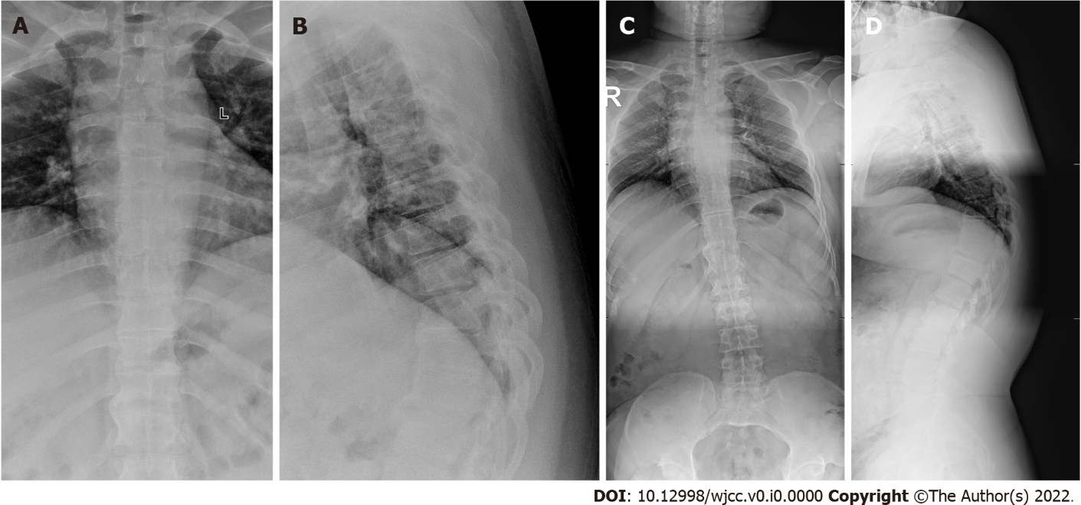
Figure 1 X-ray before treatment. A: An anterior X-ray of the thoracic vertebra before operation; B: A lateral X-ray of the thoracic vertebra before operation; C: An anterior X-ray of the full-length of the spine before operation; D: A lateral X-ray of the full-length of the spine before operation.

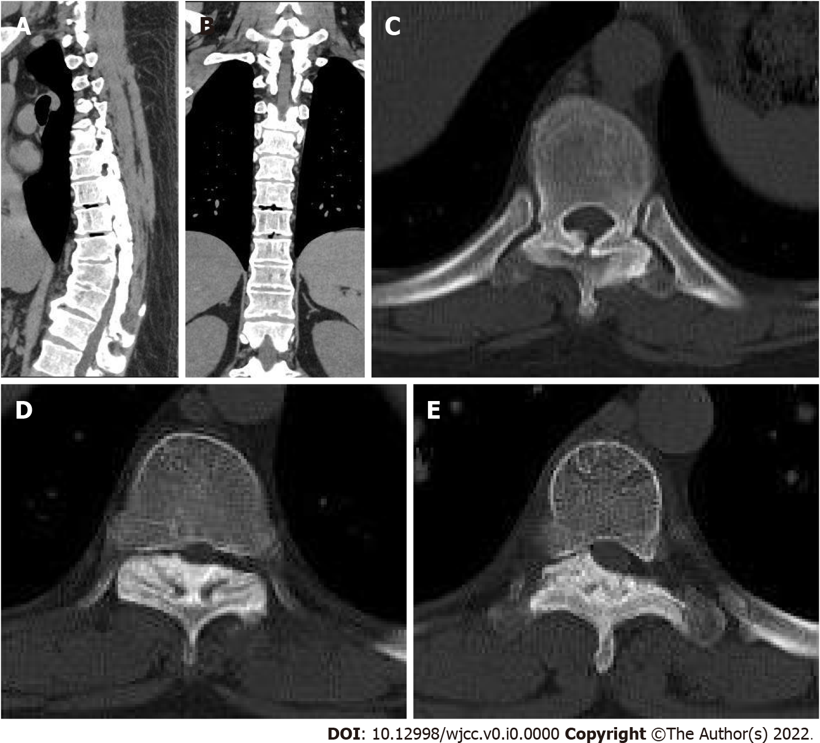
Figure 2 Thoracic computed tomography before treatment. A and B: A computed tomography scan of the anterior thorax has revealed calcification of the anterior longitudinal ligament in multiple vertebral bodies; C-E: They were the T5/6, T7/8, and T8/9 intervertebral spaces. The T5/6, T7/8, and T8/9 intervertebral discs protrude backward, and the corresponding horizontal segment of the dural sac is compressed.

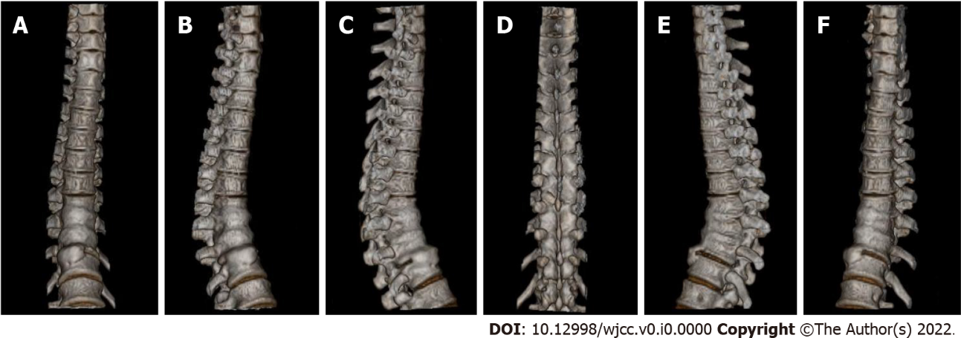
Figure 3 Three-dimensional reconstruction before treatment. A-F: Three-dimensional reconstruction.

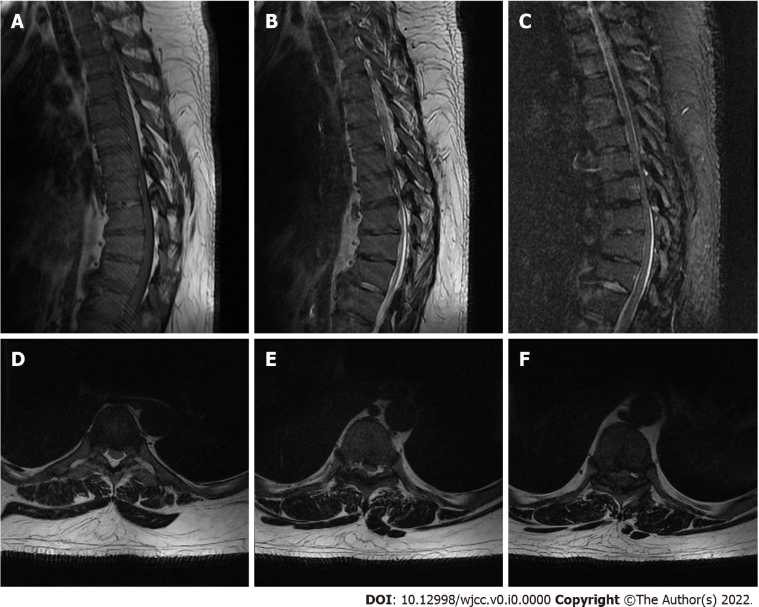
Figure 4 Thoracic magnetic resonance imaging before treatment. A-C: An magnetic resonance imaging of the thoracic spine revealed a kyphosis in the local thoracic region. The T8-12 vertebral bodies were observed to have a wedge-like shape, with a narrow front and a wide back; D-F: They were the T5/6, T7/8, and T8/9 intervertebral spaces. The T5/6, T7/8, and T8/9 intervertebral discs protrude backward, and the corresponding horizontal segment of the dural sac is compressed.

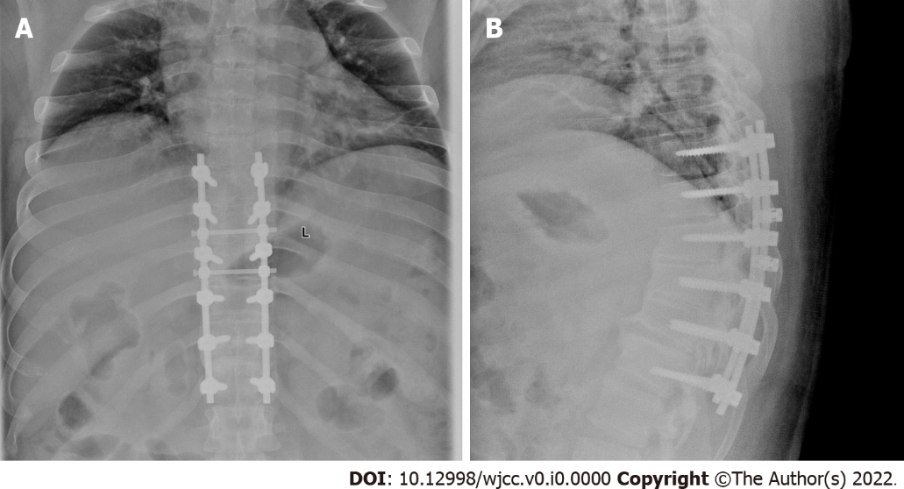
Figure 5 X-ray after treatment. A and B: Anterior X-ray of thoracic vertebra before operation. They showed that the internal fixation position was suitable.

