Name of Journal: World Journal of Gastroenterology
Manuscript NO: 86466
Manuscript Type: META-ANALYSIS

Diagnostic value of methylated branched chain amino acid transaminase 1/IKAROS family zinc finger 1 for colorectal cancer

Xu K et al. Methylated BCAT1/IKZF1 for CRC diagnosis

Ke Xu, Ai-Ru Yu, Shen-Bin Pan, Jie He

Ke Xu, Ai-Ru Yu, Shen-Bin Pan, Jie He, Clinical Medical College, Chengdu Medical College, Chengdu 610500, Sichuan Province, China

Ke Xu, Ai-Ru Yu, Shen-Bin Pan, Department of Oncology, The First Affiliated Hospital of Chengdu Medical College, Chengdu 610500, Sichuan Province, China

Jie He, Department of Pulmonary and Critical Care Medicine, The First Affiliated Hospital of Chengdu Medical College, Chengdu 610500, Sichuan Province, China

Author contributions: He J conceived and designed the study; Xu K, He J, Yu AR, and Pan SB performed the collection and assembly of data; Xu K, He J, and Yu AR performed study quality evaluation; Xu K and He J performed data analysis and interpretation; Xu K and Pan SB wrote the initial draft; All authors revised the manuscript, read and approved the final version of the manuscript.

Supported by Natural Science Foundation of Sichuan Province, No. 2023NSFSC0729; Wu Jieping Foundation Special Fund for Clinical Research, No. 320.6750.2022-19-100; Foundation of Key Clinical Specialty of Sichuan Province, No. 2022; School Foundation of Chengdu Medical College, No. CYZYB21-05.

Corresponding author: Jie He, PhD, Doctor, Department of Pulmonary and Critical Care Medicine, The First Affiliated Hospital of Chengdu Medical College, No. 278 Baoguang Street, Chengdu 610500, Sichuan Province, China. 2325@cmc.edu.cn

Received: June 20, 2023
Revised: September 1, 2023
Accepted: September 7, 2023
Published online: September 28, 2023

Abstract
BACKGROUND
The diagnostic value of combined methylated branched chain amino acid transaminase 1 (BCAT1)/IKAROS family zinc finger 1 (IKZF1) in plasma for colorectal cancer (CRC) has been explored since 2015. Recently, several related studies have published their results and showed its diagnostic efficacy.

AIM
To analyze the diagnostic value of methylated BCAT1/IKZF1 in plasma for screening and postoperative follow-up of CRC.

METHODS
The candidate studies were identified by searching the PubMed, Embase, Cochrane Library, CNKI, and Wanfang databases from May 31, 2003 to June 1, 2023. Sensitivity, specificity, and diagnostic accuracy were calculated by merging ratios or means.

RESULTS
Twelve eligible studies were included in the analysis, involving 6561 participants. The sensitivity of methylated BCAT1/IKZF1 in plasma for CRC diagnosis was 60% [95% confidence interval (CI) 53-67] and specificity was 92% (95%CI 90-94). The positive and negative likelihood ratios were 8.0 (95%CI 5.8-11.0) and 0.43 (95%CI 0.36-0.52), respectively. Diagnostic odds ratio was 19 (95%CI 11-30) and area under the curve was 0.88 (95%CI 0.85-0.91). The sensitivity and specificity for CRC screening were 64% (95%CI 59-69) and 92% (95%CI 91-93), respectively. The sensitivity and specificity for recurrence detection during follow-up were 54% (95%CI 42-67) and 93% (95%CI 88-96), respectively.

CONCLUSION
The detection of methylated BCAT1/IKZF1 in plasma, as a non-invasive detection method of circulating tumor DNA, has potential CRC diagnosis, but the clinical application prospect needs to be further explored.

Key Words: Branched chain amino acid transaminase 1; IKAROS family zinc finger 1; Methylation; Liquid biopsy; Colorectal cancer

©The Author(s) 2023. Published by Baishideng Publishing Group Inc. All rights reserved.

Citation: Xu K, Yu AR, Pan SB, He J. Diagnostic value of methylated branched chain amino acid transaminase 1/IKAROS family zinc finger 1 for colorectal cancer. World J Gastroenterol 2023; 29(36): 5240-5253
URL: https://www.wjgnet.com/1007-9327/full/v29/i36/5240.htm
DOI: https://dx.doi.org/10.3748/wjg.v29.i36.5240

Core Tip: DNA methylation, a commonly used target for detecting ctDNA in plasma, is often explored as diagnostic biomarker of cancer. Here, the present study systematically analyzed 12 studies including 6561 individuals to assess the diagnostic value of methylated branched chain amino acid transaminase 1 (BCAT1)/ IKAROS family zinc finger 1 (IKZF1) in plasma for colorectal cancer (CRC) through meta-analysis. The sensitivity and specificity of methylated BCAT1/IKZF1 in plasma for CRC diagnosis were 60% [95% confidence interval (CI) 53-67] and 92% (95%CI 90-94), respectively. The detection of methylated BCAT1/IKZF1 has potential in CRC diagnosis, but the clinical application prospect needs to be explored.

INTRODUCTION
Colorectal cancer (CRC) is the most common malignancy of the digestive system worldwide, with more than 18 million cases each year^{[1]}. During long-term follow-up, 25%-40% of patients with CRC show disease recurrence even if after receiving radical treatment^{[2,3]}. As is well known, early diagnosis and treatment are crucial for secondary cancer prevention. Both initial diagnosis and diagnosis of relapse after radical treatment have a major impact on the overall survival of patients. Currently, the diagnostic accuracy of CRC has greatly improved through the wide application of carcinoembryonic antigen (CEA) testing, colonoscopy, and imaging examination. However, the poor sensitivity of CEA detection, invasiveness of colonoscopy, high cost and radiation problems of imaging examination warrant safer, more convenient, economical, and accurate diagnostic methods in the future.
In recent years, liquid biopsy technology is being increasingly applied to disease diagnosis and treatment, owing to its characteristics such as less trauma, convenience, high speed, and cost efficiency. In the field of oncology, liquid biopsy technology has already been used for the diagnosis, prognosis, and treatment response prediction of diseases. During tumor development, because of the aggressiveness of the tumor and biological phenomena of cell necrosis and apoptosis, circulating tumor DNA (ctDNA) may enter the circulation in the early stages of disease development. Therefore, tumor markers based on ctDNA may play an important role in the early diagnosis of tumors^{[4,5]}. DNA methylation, mutation, and chromosomal copy number alteration are the most commonly used targets for detecting ctDNA in plasma, and are often explored as biomarkers^{[6]}. The identification of biomarkers can promote the development of liquid biopsy technology, and mining ctDNA-based biomarkers is considered a promising research direction.
In the field of CRC, the accumulation of genetic and epigenetic changes begins more than 10 years before the onset of the disease^{[7]}. Among these changes, genetic mutation and DNA methylation are the most commonly used biomarkers for the diagnosis and clinical prediction of CRC. As a biomarker, DNA methylation is more advantageous than genetic mutation, because DNA methylation is more common and gene mutation is more susceptible to tumor heterogeneity^{[8-12]}. In 2016, the first DNA-methylated tumor diagnostic marker, SEPT9, was approved by the United States Food and Drug Administration (FDA) for CRC screening, which promoted research in this area^{[13]}. To date, several DNA methylation diagnostic markers have been explored for CRC, including APC, BCAT1, IKZF1, ALX4, LINE-1, SDC2, MGMT, RASSF1A, and WIF1^{[14-24]}. Among them, the diagnostic value of the combination of branched chain amino acid transaminase 1 (BCAT1)/IKAROS family zinc finger 1 (IKZF1) for CRC has been explored since 2015^{[25]}. Recently, several clinical studies on the diagnostic accuracy of methylated BCAT1/IKZF1 in plasma for CRC have published their results. Methylated BCAT1/IKZF1 detection in plasma has similar or better diagnostic efficacy. In particular, a study also found that in the follow-up after radical treatment, some patients without imaging evidence have a recent recurrence event after the occurrence of BCAT1/IKZF1 hypermethylation, implying that methylated BCAT1/IKZF1 in plasma may have good timeliness in diagnosis^{[26]}. To fully understand the diagnostic value of BCAT1/IKZF1 hypermethylation in initial diagnosis and postoperative recurrence of CRC, in the present study, we systematically analyzed the sensitivity, specificity, and other diagnostic indicators of methylated BCAT1/IKZF1 detection through meta-analysis, with the aim to provide a theoretical reference for its future clinical application in CRC diagnosis.

MATERIALS AND METHODS
This meta-analysis was performed using the Preferred Reporting Items for Systematic Reviews and Meta-analysis of Diagnostic Test Accuracy Studies as the standard. Before performing this meta-analysis, a preliminary plan was developed and registered at https://www.crd.york.ac.uk/PROSPERO/.

Literature search strategy
A Computer search of PubMed, Embase, Cochrane Library, CNKI, and Wanfang databases was performed. Studies on the diagnostic accuracy of methylated BCAT1/IKZF1 in plasma for CRC were collected. The search period was from May 31, 2003, to June 1, 2023. In addition, references in the included literature were traced to supplement and obtain relevant literature. The method of free word retrieval was adopted. The search formula was (BCAT1 or IKZF1) and (methylation or methylated) and (colorectal or colon or rectal) and (cancer or tumor or carcinoma).

Inclusion and exclusion criteria
The inclusion criteria were as follows. Patients with CRC confirmed by pathological examination were included in the case group and healthy volunteers without CRC were included in the control group. Methylated BCAT1 and/or IKZF1 in plasma were used as diagnostic markers, and a positive diagnosis was defined as the presence of methylation in either BCAT1 or IKZF1. The exclusion criteria were as follows: reviews, letters, reviews, and conference papers; non-human research; lack of data or incomplete information; and data required for the four-grid statistical table could not be directly or indirectly extracted.

Literature screening and data extraction
Two researchers independently performed literature screening and data extraction, and then cross-checked the data. After removing duplicate references, the titles and abstracts of the remaining articles were screened for inclusion and exclusion criteria to exclude irrelevant studies. Eligible articles were then reviewed in full to filter again and a final inclusion was arrived. The main data extracted included the following. (1) Basic information: First author, publication time, country, design type (prospective or retrospective), detection method, and diagnostic standard; (2) Test subjects: Subject selection and number of subjects; and (3) Test indicators: number of true positive, false positive, true negative, and false negative cases. Any differences in the data extraction process were assessed independently by a third researcher.

Quality assessment
All studies were subjected to quality assessment according to the Cochrane Collaboration’s Diagnostic Accuracy Studies Quality Assessment 2 (QUADAS-2). Similarly, two researchers independently assessed the quality of each study. If there was any disagreement, it was discussed with and decided by a third researcher.

Statistical analysis
Meta-Disc 1.4 and Stata 11.0 software were used for meta-analysis. The spearman correlation coefficient was used to explore whether there was a threshold effect, and the I² statistic was used to explore whether there was heterogeneity due to non-threshold effects. If the I² was greater than 50%, it indicated obvious heterogeneity among studies, and the random effects model was used for fitting. Otherwise, the fixed effect model was used. The combined statistics were expressed by sensitivity, specificity, positive likelihood ratio, negative likelihood ratio, diagnostic odds ratio (DOR), and 95% confidence interval (CI). A summary receiver operating characteristic curve was plotted and area under the curve (AUC) was calculated. Subgroup analysis and meta-regression analysis were used to explore the sources of heterogeneity. In addition, publication bias was visually assessed using a funnel plot and quantitatively assessed using Deeks’ funnel plot asymmetric linear regression test. In full-text statistics, results with P < 0.05 were considered statistically significant.

RESULTS
Characteristics of the included studies
Among the 310 papers obtained through the search formula, 12 papers (11 prospective studies and 1 retrospective study) were included by excluding irrelevant literatures, duplicate studies, basic experimental studies, case reports, and other ineligible literatures^{[26-36]}. The specific process of inclusion and exclusion is shown in Figure 1, and the detailed information of each included study is shown in Table 1. Next, we assessed the quality of the included studies using the QUADAS-2 tool, and none of the included studies were assessed as having a high-risk bias (Figure 2) (Supplementary Table 1).

Extraction of literature data
The 12 studies involved 6561 participants. The number of true positives, false positives, true negatives, and false negatives of BCAT1/IKZF1 methylation in plasma for CRC diagnosis was clearly described by each study. Among them, 5 studies included CRC screening populations, and 7 studies included follow-up populations after radical treatment for CRC. Quantitative polymerase chain reaction (PCR) was used for assessment in all studies, but the diagnostic criteria for positive results were different among the studies. Six studies set at least one PCR replicate as positive, whereas the other 6 studies defined positive by setting a threshold of methylation rate.

Threshold effect analysis
As different thresholds can lead to different sensitivity, specificity, and DOR of diagnostic tests, resulting in threshold effects, it is necessary to first detect whether the diagnostic method has a threshold effect. Spearman correlation analysis carried out using Meta-Disc 1.4 software showed that the correlation coefficient among the included studies was r = -0.287 (P = 0.366), there was no significant threshold effect and the results were pooled for analysis.

Pooled analysis
The pooled sensitivity and specificity of the 12 studies were 60% (95%CI 53-67) and 92% (95%CI 90-94), respectively. The positive likelihood ratio and negative likelihood ratio were 8.0 (95%CI 5.8-11.0) and 0.43 (95%CI 0.36-0.52), respectively. The DOR was 19 (95%CI 11-30) and AUC was 0.88 (95%CI 0.85-0.91) (Figure 3). Furthermore, to explore the diagnostic ability of methylated BCAT1/IKZF1 detection for early CRC, we investigated the diagnostic accuracy in patients with different stages of CRC. The diagnostic sensitivity in patients with stage I, II, III, and IV disease was 32% (95%CI 22-43), 66% (95%CI 59-73), 71% (95%CI 63-78), and 91% (95%CI 81-96), respectively (Figure 4).

Subgroup analysis
To further explore the source of heterogeneity, we conducted a subgroup analysis according to the purpose of testing and positive result definition. The results of the subgroup analysis showed that when methylated BCAT1/IKZF1 in plasma was used for CRC screening, the sensitivity was 64% (95%CI 59-69), specificity was 92% (95%CI 91-93), positive likelihood ratio was 8.5 (95%CI 7.1-10.1), negative likelihood ratio was 0.39 (95%CI 0.33-0.45), DOR was 22 (95%CI 16-30) and AUC was 0.92 (95%CI 0.89-0.94). When the method was applied to postoperative follow-up and assessment of disease recurrence, the sensitivity was 54% (95%CI 42-67), specificity was 93% (95%CI 88-96), positive likelihood ratio was 7.4 (95%CI 3.9-14.2). Negative likelihood ratio was 0.49 (95%CI 0.37-0.66), DOR was 15 (95%CI 6-37) and AUC was 0.85 (95%CI 0.81-0.88). The subgroup analysis based on the purpose of testing effectively reduced heterogeneity, especially in the subgroup of CRC screening, where no significant heterogeneity was detected in both sensitivity and specificity analyses (I² = 48.58, I² = 26.75). As the method of evaluating results could directly affect the accuracy of diagnosis, the included studies were divided according to the definition of positive results. The two subgroups were defined as follows: At least one PCR replicate was positive, and exceeding the set threshold was considered positive. When at least one PCR replicate was positive, the sensitivity was 59% (95%CI 50-67), specificity was 91% (95%CI 89-93), and AUC was = 0.87 (95%CI 0.84-0.90). When result exceeding the set threshold was defined as positive, the sensitivity was 61% (95%CI 49-72), specificity was 94% (95%CI 87-96), and AUC was = 0.91 (95%CI 0.88-0.93). Combining the principle of real-time PCR and the results of the comprehensive analysis, setting a threshold to define positive result may improve the diagnostic accuracy (Table 2).

Sensitivity and publication bias analysis
To test the robustness of the results, we conducted a sensitivity analysis. The sensitivity analysis showed that after omitting each study one by one, the main results of the meta-analysis did not change significantly, indicating that there was no significant bias in the included studies, and the results were reliable and stable (Figure 5). Deeks’ funnel plot was used to assess publication bias, and no significant publication bias was observed (P = 0.604) (Figure 6).

DISCUSSION
Screening and post-treatment follow-up methods for CRC vary worldwide. Currently, the main methods include fecal sample-based testing, colonoscopy, blood sample-based testing, and computed tomography or magnetic resonance imaging colonography. The tests based on fecal samples include fecal occult blood tests, fecal immunochemical tests (FIT), gut microbe analysis, and FIT-DNA tests. Among the fecal sample-based tests, Multi-Target Stool DNA test, approved by the FDA in 2014 for CRC screening is noteworthy. In this test, CRC is diagnosed using the methylation markers NDRG4, BMP3, VIM, and TFP12, combined with mutant KRAS and fecal hemoglobin level. Its sensitivity for CRC screening was 92% and its specificity was 87%^{[37-39]}. Owing to the high diagnostic accuracy of the Multi-Target Stool DNA test, it is recommended for screening high-risk populations^{[40]}. However, its widespread application still has challenges, such as high cost and commercialization issues^{[41]}. Blood sample assay was vital for non-invasive detection, and the diagnostic markers mainly included DNA mutation, DNA methylation, cfDNA, tumor-derived circulating cells, circular RNA, P-element-induced wimpy testis, microRNA, and exosomal microRNA. Researchers have gradually realized the advantages of DNA methylation as a biomarker for tumor diagnosis. Because its changes occur even before the occurrence of tumors, it is theoretically ideal for early screening of tumors^{[10,42]}. SEPT9 methylation was the first methylated marker approved by the FDA for screening CRC using plasma samples, with a diagnostic sensitivity of 0.679 (95%CI 0.622-0.732) and specificity of 0.904 (95%CI 0.881-0.923)^{[43]}. However, it is no longer recommended by most guidelines because it is less sensitive than other current tests^{[44]}. Recently, scholars have tried to find other DNA methylation markers with better accuracy for the diagnosis of CRC, such as BCAT1, IKZF1, APC, ALX4, LINE-1, SDC2, MGMT, RASSF1A, and WIF1. They have been used to establish a variety of combinations of diagnostic panels, but there is no sufficient evidence to effectively show their application prospects^{[14-24]}. Owing to the wide application of machine learning in biomedicine, studies on multi-omics and pan-cancer screening products have gradually expanded in the exploration of tumor marker screening based on blood samples. For example, CanerSEEK was a multi-omics tool for detecting ctDNA and proteins for screening various cancers, with a diagnostic sensitivity of up to 84% for CRC^{[45]}. Another new method for pan-cancer screening is GRAIL, which has a diagnostic sensitivity of 82% for CRC, 43.3%, 85.0%, 87.9%, and 95.3% for stage I, II, III, and IV CRC, respectively^{[46]}. It is worth noting that the establishment of most pan-cancer detection methods is still based on DNA methylation as the main diagnostic marker. In the future, more new detection methods will be introduced for the initial diagnosis of CRC and post-treatment follow-up, which will further improve the overall prognosis of CRC.
Recently, multiple studies on the use of methylated BCAT1/IKZF1 in plasma for the diagnosis of CRC have been reported. Overall, its diagnostic accuracy is good, and it may be affected by fewer clinical variables. Based on the results, Clinical Genomics has already completed the commercialization of this detection method, named COLVERA®. At present, it is approved for use in postoperative follow-up detection and assessment of recurrence risk in patients with CRC in the United States and Australia^{[31]}. According to the results of this meta-analysis, methylated BCAT1/IKZF1 in plasma has a sensitivity of 60% (95%CI 53-67) and specificity of 92% (95%CI 91-93) for CRC screening. The results are better than those for CEA detection, and its accuracy is similar to that of SETP9 methylation detection. To further confirm the diagnostic value of methylated BCAT1/IKZF1 detection, a direct cross-over study with methods such as FIT and Multi-Target Stool DNA test is needed. As a postoperative follow-up diagnostic method for CRC, the sensitivity of methylated BCAT1/IKZF1 detection 54% (95%CI 42-67), specificity 93% (95%CI 88-96), and AUC was 0.85 (95%CI 0.81-0.88). A study has reported that the sensitivity of this method in the diagnosis of recurrence is as high as 75%, while the sensitivity of the CEA index commonly used in the clinical diagnosis of postoperative recurrence is just 32.1%. It can be seen that it has a major advantage in the postoperative assessment of recurrence. Additionally, some reports suggest that changes in methylated BCAT1/IKZF1 level in plasma occur before imaging changes, which also has the diagnostic timeliness of recurrence^{[26]}. Recently, it has been reported that ctDNA detection using a 15-gene mutation panel can be used to monitor the recurrence of postoperative CRC^{[47]}. Some studies have also found that mesenchymal circulating tumor cell with phosphatase of regenerating liver-3+ is associated with recurrence, which is likely to have a monitoring effect on disease recurrence^{[48]}. However, from the perspective of detection time point, methylated BCAT1/IKZF1 in plasma has major advantages in postoperative follow-up. Earlier, gene mutation indicator detection often required 4-10 wk after surgery, otherwise the sensitivity may decrease, and the method discussed here is not affected by the detection time point^{[8,49,50]}. For the stability and reliability of the results, a subgroup analysis was conducted. The Subgroup analysis based on the purpose of detection could effectively reduce the heterogeneity of the results, especially in the CRC screening group. However, there was still some heterogeneity in the postoperative follow-up group, considering this was most likely caused by different time points of monitoring and the different tumor stages. Owing to the limitations of data, further in-depth analysis could not be conducted in this group. From another perspective of grouping, there were differences in the definition of how to determine a positive result. Seven of the included studies defined at least one PCR replicate as positive. In the past two years, it has been found that setting a specific threshold based on this method could substantially improve the specificity of diagnosis without affecting the sensitivity of diagnosis. In this meta-analysis, it was also found that when at least one PCR replicate was positive, the diagnostic sensitivity was 59% (95%CI 50-67) and specificity was 91% (95%CI 89-93). When thresholds were set, diagnostic sensitivity was 61% (95%CI 49-72), specificity was 94% (95%CI 87-96), and AUC was 0.91 (95%CI 0.88-0.93). In the future application of this method, setting a threshold value may further improve the diagnostic accuracy. In terms of diagnostic sensitivity for patients with different stages of CRC, the detection of the methylated BCAT1/IKZF1 in plasma, similar to other detection methods, has a poor diagnostic sensitivity for patients with early-stage CRC, which may limit its clinical application in CRC screening. In the future, the clinical application value of methylated BCAT1/IKZF1 in plasma can be enhanced by combining it with other tests. Overall, in this meta-analysis, we systematically analyzed the diagnostic accuracy of methylated BCAT1/IKZF1 in plasma for CRC. These results can provide a basis for further research and clinical application of BCAT1/IKZF1 methylation in the diagnosis of CRC in the future.
In recent years, researchers have found that methylated BCAT1/IKZF1 in plasma may also be valuable in the prognostic prediction of CRC, suggesting that methylated BCAT1/IKZF1 in plasma is more likely to be found in patients with postoperative incisal margin deficiency, lymph node invasion or distant metastasis^{[36]}. Another study analyzed the 3-year recurrence free survival (RFS) of postoperative patients with CRC and found the RFS of patients with methylation was 56.5%, that of patients without methylation was 83.3%^{[26]}.
The multivariate analysis showed that the presence of methylated BCAT1/IKZF1 in plasma was an independent factor for poor RFS in CRC. The value of this method in prognostic prediction may be related to its role in the diagnosis of relapse. The above results suggest that patients with consistently positive BCAT1/IKZF1 methylation in plasma after surgery should be followed up cautiously, and the methylation level should be dynamically monitored. At present, some scholars believe that the cause of positive results after surgery may be related to the existence of minimal residual disease (MRD). However, as there is no gold standard for the diagnosis of MRD in CRC; further research is needed to confirm this hypothesis.
There were some limitations to this meta-analysis. As all included studies were conducted in Australia or the United States, the ability of methylated BCAT1/IKZF1 testing to diagnose CRC in other ethnic groups and regions needs to be further investigated. In addition, not all studies clearly recorded the diagnostic sensitivity for patients with different stages of disease; the diagnostic sensitivity analyzed by stratification needs to be explored. Owing to the limitation of data, the diagnostic efficacy of methylated BCAT1/IKZF1 for patients with different genotypes could not be analyzed separately. Finally, it was not possible to perform a pooled analysis of data on the prognosis, because only two studies recorded prognostic results for this approach.

CONCLUSION
The detection of methylated BCAT1/IKZF1 in plasma, as a non-invasive detection method of ctDNA, has potential CRC diagnosis, but the clinical application prospect needs to be further explored.

ARTICLE HIGHLIGHTS
Research background
Currently, DNA methylation is one of the most commonly used detection targets for circulating tumor DNA (ctDNA) in plasma, and is often explored as a diagnostic biomarker for cancer. The diagnostic value of combined methylated branched chain amino acid transaminase 1 (BCAT1)/IKAROS family zinc finger 1 (IKZF1) in plasma for colorectal cancer (CRC) has been explored since 2015. Recently, several related studies have published their results and showed its diagnostic efficacy.

Research motivation
To fully understand the diagnostic value of methylated BCAT1/IKZF1 in initial diagnosis and postoperative recurrence of CRC.

Research objectives
To evaluate the diagnostic accuracy of methylated BCAT1/IKZF1 in plasma for screening and postoperative follow-up of patients with CRC.

Research methods
We searched the PubMed, Embase, Cochrane Library, CNKI, and Wanfang databases. Studies on the diagnostic accuracy of methylated BCAT1/IKZF1 in plasma for CRC were retrieved. Data extraction, pooled analysis, subgroup analysis, sensitivity analysis, and publication bias analysis were performed.

Research results
The pooled sensitivity and specificity of methylated BCAT1/IKZF1 for CRC diagnosis were 60% [95% confidence interval (CI) 53-67] and 92% (95%CI 90-94), respectively. The positive likelihood ratio and negative likelihood ratio were 8.0 (95%CI 5.8-11.0) and 0.43 (95%CI 0.36-0.52), respectively. The diagnostic odds ratio and area under the curve were 19 (95%CI 11-30) and 0.88 (95%CI 0.85-0.91), respectively.

Research conclusions
The detection of methylated BCAT1/IKZF1 in plasma, as a non-invasive detection method of ctDNA, has potential in the diagnosis of CRC, but the clinical application value still needs to be explored.

Research perspectives
The detection of methylated BCAT1/IKZF1 in plasma, similar to other detection methods, has poor diagnostic sensitivity for early-stage disease, which may limit its clinical application in CRC screening. In the future, the clinical application of methylated BCAT1/IKZF1 in plasma can be promoted by combining it with other tests.

REFERENCES
1 Sung H, Ferlay J, Siegel RL, Laversanne M, Soerjomataram I, Jemal A, Bray F. Global Cancer Statistics 2020: GLOBOCAN Estimates of Incidence and Mortality Worldwide for 36 Cancers in 185 Countries. CA Cancer J Clin 2021; 71: 209-249 [PMID: 33538338 DOI: 10.3322/caac.21660]
2 Kunst N, Alarid-Escudero F, Aas E, Coupé VMH, Schrag D, Kuntz KM. Estimating Population-Based Recurrence Rates of Colorectal Cancer over Time in the United States. Cancer Epidemiol Biomarkers Prev 2020; 29: 2710-2718 [PMID: 32998946 DOI: 10.1158/1055-9965.EPI-20-0490]
3 Figueredo A, Rumble RB, Maroun J, Earle CC, Cummings B, McLeod R, Zuraw L, Zwaal C; Gastrointestinal Cancer Disease Site Group of Cancer Care Ontario's Program in Evidence-based Care. Follow-up of patients with curatively resected colorectal cancer: a practice guideline. BMC Cancer 2003; 3: 26 [PMID: 14529575 DOI: 10.1186/1471-2407-3-26]
4 Spindler KL, Pallisgaard N, Andersen RF, Brandslund I, Jakobsen A. Circulating free DNA as biomarker and source for mutation detection in metastatic colorectal cancer. PLoS One 2015; 10: e0108247 [PMID: 25875772 DOI: 10.1371/journal.pone.0108247]
5 Avanzini S, Kurtz DM, Chabon JJ, Moding EJ, Hori SS, Gambhir SS, Alizadeh AA, Diehn M, Reiter JG. A mathematical model of ctDNA shedding predicts tumor detection size. Sci Adv 2020; 6 [PMID: 33310847 DOI: 10.1126/sciadv.abc4308]
6 Bach S, Sluiter NR, Beagan JJ, Mekke JM, Ket JCF, van Grieken NCT, Steenbergen RDM, Ylstra B, Kazemier G, Tuynman JB. Circulating Tumor DNA Analysis: Clinical Implications for Colorectal Cancer Patients. A Systematic Review. JNCI Cancer Spectr 2019; 3: pkz042 [PMID: 32328554 DOI: 10.1093/jncics/pkz042]
7 Noffsinger AE. Serrated polyps and colorectal cancer: new pathway to malignancy. Annu Rev Pathol 2009; 4: 343-364 [PMID: 19400693 DOI: 10.1146/annurev.pathol.4.110807.092317]
8 Reinert T, Henriksen TV, Christensen E, Sharma S, Salari R, Sethi H, Knudsen M, Nordentoft I, Wu HT, Tin AS, Heilskov Rasmussen M, Vang S, Shchegrova S, Frydendahl Boll Johansen A, Srinivasan R, Assaf Z, Balcioglu M, Olson A, Dashner S, Hafez D, Navarro S, Goel S, Rabinowitz M, Billings P, Sigurjonsson S, Dyrskjøt L, Swenerton R, Aleshin A, Laurberg S, Husted Madsen A, Kannerup AS, Stribolt K, Palmelund Krag S, Iversen LH, Gotschalck Sunesen K, Lin CJ, Zimmermann BG, Lindbjerg Andersen C. Analysis of Plasma Cell-Free DNA by Ultradeep Sequencing in Patients With Stages I to III Colorectal Cancer. JAMA Oncol 2019; 5: 1124-1131 [PMID: 31070691 DOI: 10.1001/jamaoncol.2019.0528]
9 Parikh AR, Van Seventer EE, Siravegna G, Hartwig AV, Jaimovich A, He Y, Kanter K, Fish MG, Fosbenner KD, Miao B, Phillips S, Carmichael JH, Sharma N, Jarnagin J, Baiev I, Shah YS, Fetter IJ, Shahzade HA, Allen JN, Blaszkowsky LS, Clark JW, Dubois JS, Franses JW, Giantonio BJ, Goyal L, Klempner SJ, Nipp RD, Roeland EJ, Ryan DP, Weekes CD, Wo JY, Hong TS, Bordeianou L, Ferrone CR, Qadan M, Kunitake H, Berger D, Ricciardi R, Cusack JC, Raymond VM, Talasaz A, Boland GM, Corcoran RB. Minimal Residual Disease Detection using a Plasma-only Circulating Tumor DNA Assay in Patients with Colorectal Cancer. Clin Cancer Res 2021; 27: 5586-5594 [PMID: 33926918 DOI: 10.1158/1078-0432.CCR-21-0410]
10 Weisenberger DJ. Characterizing DNA methylation alterations from The Cancer Genome Atlas. J Clin Invest 2014; 124: 17-23 [PMID: 24382385 DOI: 10.1172/JCI69740]
11 Vogelstein B, Papadopoulos N, Velculescu VE, Zhou S, Diaz LA Jr, Kinzler KW. Cancer genome landscapes. Science 2013; 339: 1546-1558 [PMID: 23539594 DOI: 10.1126/science.1235122]
12 Markowitz SD, Bertagnolli MM. Molecular origins of cancer: Molecular basis of colorectal cancer. N Engl J Med 2009; 361: 2449-2460 [PMID: 20018966 DOI: 10.1056/NEJMra0804588]
13 Beltrán-García J, Osca-Verdegal R, Mena-Mollá S, García-Giménez JL. Epigenetic IVD Tests for Personalized Precision Medicine in Cancer. Front Genet 2019; 10: 621 [PMID: 31316555 DOI: 10.3389/fgene.2019.00621]
14 He Q, Chen HY, Bai EQ, Luo YX, Fu RJ, He YS, Jiang J, Wang HQ. Development of a multiplex MethyLight assay for the detection of multigene methylation in human colorectal cancer. Cancer Genet Cytogenet 2010; 202: 1-10 [PMID: 20804913 DOI: 10.1016/j.cancergencyto.2010.05.018]
15 Rasmussen SL, Krarup HB, Sunesen KG, Johansen MB, Stender MT, Pedersen IS, Madsen PH, Thorlacius-Ussing O. Hypermethylated DNA, a circulating biomarker for colorectal cancer detection. PLoS One 2017; 12: e0180809 [PMID: 28700744 DOI: 10.1371/journal.pone.0180809]
16 Ebert MP, Model F, Mooney S, Hale K, Lograsso J, Tonnes-Priddy L, Hoffmann J, Csepregi A, Röcken C, Molnar B, Schulz HU, Malfertheiner P, Lofton-Day C. Aristaless-like homeobox-4 gene methylation is a potential marker for colorectal adenocarcinomas. Gastroenterology 2006; 131: 1418-1430 [PMID: 17101318 DOI: 10.1053/j.gastro.2006.08.034]
17 Herbst A, Rahmig K, Stieber P, Philipp A, Jung A, Ofner A, Crispin A, Neumann J, Lamerz R, Kolligs FT. Methylation of NEUROG1 in serum is a sensitive marker for the detection of early colorectal cancer. Am J Gastroenterol 2011; 106: 1110-1118 [PMID: 21326223 DOI: 10.1038/ajg.2011.6]
18 Salehi R, Atapour N, Vatandoust N, Farahani N, Ahangari F, Salehi AR. Methylation pattern of ALX4 gene promoter as a potential biomarker for blood-based early detection of colorectal cancer. Adv Biomed Res 2015; 4: 252 [PMID: 26918234 DOI: 10.4103/2277-9175.170677]
19 Erdem B, Küçükyıldırım S, Sağlar E, Polat Z, Mergen H. Promoter hypermethylation of p16 and APC in gastrointestinal cancer patients. Turk J Gastroenterol 2014; 25: 512-517 [PMID: 25417611 DOI: 10.5152/tjg.2014.4791]
20 Pack SC, Kim HR, Lim SW, Kim HY, Ko JY, Lee KS, Hwang D, Park SI, Kang H, Park SW, Hong GY, Hwang SM, Shin MG, Lee S. Usefulness of plasma epigenetic changes of five major genes involved in the pathogenesis of colorectal cancer. Int J Colorectal Dis 2013; 28: 139-147 [PMID: 22990173 DOI: 10.1007/s00384-012-1566-8]
21 Matthaios D, Balgkouranidou I, Karayiannakis A, Bolanaki H, Xenidis N, Amarantidis K, Chelis L, Romanidis K, Chatzaki A, Lianidou E, Trypsianis G, Kakolyris S. Methylation status of the APC and RASSF1A promoter in cell-free circulating DNA and its prognostic role in patients with colorectal cancer. Oncol Lett 2016; 12: 748-756 [PMID: 27347211 DOI: 10.3892/ol.2016.4649]
22 Mitchell SM, Ho T, Brown GS, Baker RT, Thomas ML, McEvoy A, Xu ZZ, Ross JP, Lockett TJ, Young GP, LaPointe LC, Pedersen SK, Molloy PL. Evaluation of Methylation Biomarkers for Detection of Circulating Tumor DNA and Application to Colorectal Cancer. Genes (Basel) 2016; 7 [PMID: 27983717 DOI: 10.3390/genes7120125]
23 Shalaby SM, El-Shal AS, Abdelaziz LA, Abd-Elbary E, Khairy MM. Promoter methylation and expression of DNA repair genes MGMT and ERCC1 in tissue and blood of rectal cancer patients. Gene 2018; 644: 66-73 [PMID: 29080834 DOI: 10.1016/j.gene.2017.10.056]
24 Nagai Y, Sunami E, Yamamoto Y, Hata K, Okada S, Murono K, Yasuda K, Otani K, Nishikawa T, Tanaka T, Kiyomatsu T, Kawai K, Nozawa H, Ishihara S, Hoon DS, Watanabe T. LINE-1 hypomethylation status of circulating cell-free DNA in plasma as a biomarker for colorectal cancer. Oncotarget 2017; 8: 11906-11916 [PMID: 28060757 DOI: 10.18632/oncotarget.14439]
25 Pedersen SK, Baker RT, McEvoy A, Murray DH, Thomas M, Molloy PL, Mitchell S, Lockett T, Young GP, LaPointe LC. A two-gene blood test for methylated DNA sensitive for colorectal cancer. PLoS One 2015; 10: e0125041 [PMID: 25928810 DOI: 10.1371/journal.pone.0125041]
26 Pedersen SK, Symonds EL, Roy AC, Cornthwaite KJ, LaPointe LC, Young GP. Detection of methylated BCAT1 and IKZF1 after curative-intent treatment as a prognostic indicator for colorectal cancer recurrence. Cancer Med 2023; 12: 1319-1329 [PMID: 35822405 DOI: 10.1002/cam4.5008]
27 Symonds EL, Pedersen SK, Baker RT, Murray DH, Gaur S, Cole SR, Gopalsamy G, Mangira D, LaPointe LC, Young GP. A Blood Test for Methylated BCAT1 and IKZF1 vs. a Fecal Immunochemical Test for Detection of Colorectal Neoplasia. Clin Transl Gastroenterol 2016; 7: e137 [PMID: 26765125 DOI: 10.1038/ctg.2015.67]
28 Young GP, Pedersen SK, Mansfield S, Murray DH, Baker RT, Rabbitt P, Byrne S, Bambacas L, Hollington P, Symonds EL. A cross-sectional study comparing a blood test for methylated BCAT1 and IKZF1 tumor-derived DNA with CEA for detection of recurrent colorectal cancer. Cancer Med 2016; 5: 2763-2772 [PMID: 27726312 DOI: 10.1002/cam4.868]
29 Symonds EL, Pedersen SK, Murray D, Byrne SE, Roy A, Karapetis C, Hollington P, Rabbitt P, Jones FS, LaPointe L, Segelov E, Young GP. Circulating epigenetic biomarkers for detection of recurrent colorectal cancer. Cancer 2020; 126: 1460-1469 [PMID: 31909823 DOI: 10.1002/cncr.32695]
30 Winter JM, Sheehan-Hennessy L, Yao B, Pedersen SK, Wassie MM, Eaton M, Chong M, Young GP, Symonds EL. Detection of hypermethylated BCAT1 and IKZF1 DNA in blood and tissues of colorectal, breast and prostate cancer patients. Cancer Biomark 2022; 34: 493-503 [PMID: 35253733 DOI: 10.3233/CBM-210399]
31 Pedersen SK, Musher BL, LaPointe LC, Tuck MK, Symonds EL, Loayza N, Young GP. Detection of recurrent colorectal cancer with high specificity using a reporting threshold for circulating tumor DNA methylated in BCAT1 and IKZF1. Cancer 2022; 128: 1921-1928 [PMID: 35290664 DOI: 10.1002/cncr.34159]
32 Pedersen SK, Symonds EL, Baker RT, Murray DH, McEvoy A, Van Doorn SC, Mundt MW, Cole SR, Gopalsamy G, Mangira D, LaPointe LC, Dekker E, Young GP. Evaluation of an assay for methylated BCAT1 and IKZF1 in plasma for detection of colorectal neoplasia. BMC Cancer 2015; 15: 654 [PMID: 26445409 DOI: 10.1186/s12885-015-1674-2]
33 Musher BL, Melson JE, Amato G, Chan D, Hill M, Khan I, Kochuparambil ST, Lyons SE, Orsini J Jr, Pedersen SK, Robb B, Saltzman J, Silinsky J, Gaur S, Tuck MK, LaPointe LC, Young GP. Evaluation of Circulating Tumor DNA for Methylated BCAT1 and IKZF1 to Detect Recurrence of Stage II/Stage III Colorectal Cancer (CRC). Cancer Epidemiol Biomarkers Prev 2020; 29: 2702-2709 [PMID: 32958500 DOI: 10.1158/1055-9965.EPI-20-0574]
34 Symonds EL, Pedersen SK, Yeo B, Al Naji H, Byrne SE, Roy A, Young GP. Assessment of tumor burden and response to therapy in patients with colorectal cancer using a quantitative ctDNA test for methylated BCAT1/IKZF1. Mol Oncol 2022; 16: 2031-2041 [PMID: 35000264 DOI: 10.1002/1878-0261.13178]
35 Saluja H, Young GP, Kholmurodova F, Symonds EL. Variables Associated with Detection of Methylated BCAT1 or IKZF1 in Blood from Patients Without Colonoscopically Evident Colorectal Cancer. Cancer Epidemiol Biomarkers Prev 2021; 30: 774-781 [PMID: 33500319 DOI: 10.1158/1055-9965.EPI-20-1609]
36 Murray DH, Symonds EL, Young GP, Byrne S, Rabbitt P, Roy A, Cornthwaite K, Karapetis CS, Pedersen SK. Relationship between post-surgery detection of methylated circulating tumor DNA with risk of residual disease and recurrence-free survival. J Cancer Res Clin Oncol 2018; 144: 1741-1750 [PMID: 29992492 DOI: 10.1007/s00432-018-2701-x]
37 Ahlquist DA. Multi-target stool DNA test: a new high bar for noninvasive screening. Dig Dis Sci 2015; 60: 623-633 [PMID: 25492503 DOI: 10.1007/s10620-014-3451-5]
38 Prince M, Lester L, Chiniwala R, Berger B. Multitarget stool DNA tests increases colorectal cancer screening among previously noncompliant Medicare patients. World J Gastroenterol 2017; 23: 464-471 [PMID: 28210082 DOI: 10.3748/wjg.v23.i3.464]
39 Imperiale TF, Ransohoff DF, Itzkowitz SH, Levin TR, Lavin P, Lidgard GP, Ahlquist DA, Berger BM. Multitarget stool DNA testing for colorectal-cancer screening. N Engl J Med 2014; 370: 1287-1297 [PMID: 24645800 DOI: 10.1056/NEJMoa1311194]
40 Levin TR, Corley DA, Jensen CD, Schottinger JE, Quinn VP, Zauber AG, Lee JK, Zhao WK, Udaltsova N, Ghai NR, Lee AT, Quesenberry CP, Fireman BH, Doubeni CA. Effects of Organized Colorectal Cancer Screening on Cancer Incidence and Mortality in a Large Community-Based Population. Gastroenterology 2018; 155: 1383-1391.e5 [PMID: 30031768 DOI: 10.1053/j.gastro.2018.07.017]
41 Ladabaum U, Mannalithara A. Comparative Effectiveness and Cost Effectiveness of a Multitarget Stool DNA Test to Screen for Colorectal Neoplasia. Gastroenterology 2016; 151: 427-439.e6 [PMID: 27311556 DOI: 10.1053/j.gastro.2016.06.003]
42 Hong SN. Genetic and epigenetic alterations of colorectal cancer. Intest Res 2018; 16: 327-337 [PMID: 30090031 DOI: 10.5217/ir.2018.16.3.327]
43 Min L, Chen J, Yu M, Liu D. Using Circulating Tumor DNA as a Novel Biomarker to Screen and Diagnose Colorectal Cancer: A Meta-Analysis. J Clin Med 2023; 12 [PMID: 36675337 DOI: 10.3390/jcm12020408]
44 US Preventive Services Task Force, Davidson KW, Barry MJ, Mangione CM, Cabana M, Caughey AB, Davis EM, Donahue KE, Doubeni CA, Krist AH, Kubik M, Li L, Ogedegbe G, Owens DK, Pbert L, Silverstein M, Stevermer J, Tseng CW, Wong JB. Screening for Colorectal Cancer: US Preventive Services Task Force Recommendation Statement. JAMA 2021; 325: 1965-1977 [PMID: 34003218 DOI: 10.1001/jama.2021.6238]
45 Cohen JD, Li L, Wang Y, Thoburn C, Afsari B, Danilova L, Douville C, Javed AA, Wong F, Mattox A, Hruban RH, Wolfgang CL, Goggins MG, Dal Molin M, Wang TL, Roden R, Klein AP, Ptak J, Dobbyn L, Schaefer J, Silliman N, Popoli M, Vogelstein JT, Browne JD, Schoen RE, Brand RE, Tie J, Gibbs P, Wong HL, Mansfield AS, Jen J, Hanash SM, Falconi M, Allen PJ, Zhou S, Bettegowda C, Diaz LA Jr, Tomasetti C, Kinzler KW, Vogelstein B, Lennon AM, Papadopoulos N. Detection and localization of surgically resectable cancers with a multi-analyte blood test. Science 2018; 359: 926-930 [PMID: 29348365 DOI: 10.1126/science.aar3247]
46 Klein EA, Richards D, Cohn A, Tummala M, Lapham R, Cosgrove D, Chung G, Clement J, Gao J, Hunkapiller N, Jamshidi A, Kurtzman KN, Seiden MV, Swanton C, Liu MC. Clinical validation of a targeted methylation-based multi-cancer early detection test using an independent validation set. Ann Oncol 2021; 32: 1167-1177 [PMID: 34176681 DOI: 10.1016/j.annonc.2021.05.806]
47 Tie J, Wang Y, Cohen J, Li L, Hong W, Christie M, Wong HL, Kosmider S, Wong R, Thomson B, Choi J, Fox A, Field K, Burge M, Shannon J, Kotasek D, Tebbutt NC, Karapetis C, Underhill C, Haydon A, Schaeffer J, Ptak J, Tomasetti C, Papadopoulos N, Kinzler KW, Vogelstein B, Gibbs P. Circulating tumor DNA dynamics and recurrence risk in patients undergoing curative intent resection of colorectal cancer liver metastases: A prospective cohort study. PLoS Med 2021; 18: e1003620 [PMID: 33939694 DOI: 10.1371/journal.pmed.1003620]
48 Su P, Lai W, Liu L, Zeng Y, Xu H, Lan Q, Chu Z, Chu Z. Mesenchymal and Phosphatase of Regenerating Liver-3 Status in Circulating Tumor Cells May Serve as a Crucial Prognostic Marker for Assessing Relapse or Metastasis in Postoperative Patients With Colorectal Cancer. Clin Transl Gastroenterol 2020; 11: e00265 [PMID: 33512811 DOI: 10.14309/ctg.0000000000000265]
49 Tie J, Wang Y, Tomasetti C, Li L, Springer S, Kinde I, Silliman N, Tacey M, Wong HL, Christie M, Kosmider S, Skinner I, Wong R, Steel M, Tran B, Desai J, Jones I, Haydon A, Hayes T, Price TJ, Strausberg RL, Diaz LA Jr, Papadopoulos N, Kinzler KW, Vogelstein B, Gibbs P. Circulating tumor DNA analysis detects minimal residual disease and predicts recurrence in patients with stage II colon cancer. Sci Transl Med 2016; 8: 346ra92 [PMID: 27384348 DOI: 10.1126/scitranslmed.aaf6219]
50 Tie J, Cohen JD, Wang Y, Christie M, Simons K, Lee M, Wong R, Kosmider S, Ananda S, McKendrick J, Lee B, Cho JH, Faragher I, Jones IT, Ptak J, Schaeffer MJ, Silliman N, Dobbyn L, Li L, Tomasetti C, Papadopoulos N, Kinzler KW, Vogelstein B, Gibbs P. Circulating Tumor DNA Analyses as Markers of Recurrence Risk and Benefit of Adjuvant Therapy for Stage III Colon Cancer. JAMA Oncol 2019; 5: 1710-1717 [PMID: 31621801 DOI: 10.1001/jamaoncol.2019.3616]

Footnotes
Conflict-of-interest statement: The authors deny any conflict of interest.

PRISMA 2009 Checklist statement: The authors have read the PRISMA 2009 Checklist, and the manuscript was prepared and revised according to the PRISMA 2009 Checklist.

Open-Access: This article is an open-access article that was selected by an in-house editor and fully peer-reviewed by external reviewers. It is distributed in accordance with the Creative Commons Attribution NonCommercial (CC BY-NC 4.0) license, which permits others to distribute, remix, adapt, build upon this work non-commercially, and license their derivative works on different terms, provided the original work is properly cited and the use is non-commercial. See: https://creativecommons.org/Licenses/by-nc/4.0/

Provenance and peer review: Unsolicited article; Externally peer reviewed.

Peer-review model: Single blind

Peer-review started: June 20, 2023
First decision: August 26, 2023
Article in press: September 7, 2023

Specialty type: Gastroenterology and hepatology
Country/Territory of origin: China
Peer-review report’s scientific quality classification
Grade A (Excellent): 0
Grade B (Very good): B, B
Grade C (Good): C
Grade D (Fair): 0
Grade E (Poor): 0

P-Reviewer: Dauyey K, Kazakhstan; Fabozzi M, Italy; Ridder MD, Belgium S-Editor: Qu XL L-Editor: A P-Editor: Chen YX
Figure Legends
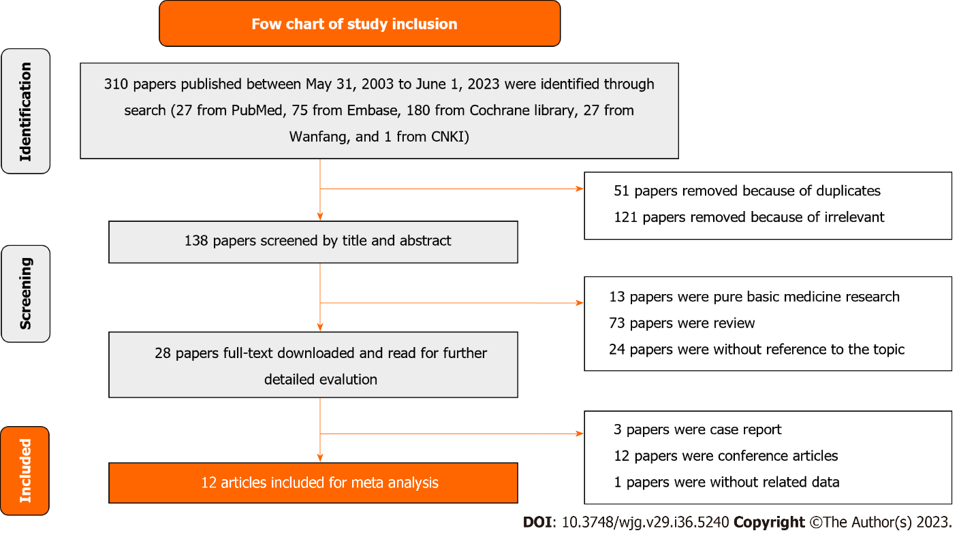
Figure 1 Detailed process of literature identification and screening.

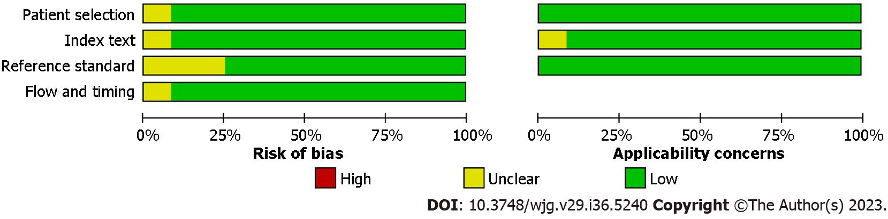
Figure 2 Overview of applicability concerns and the risk of bias of included studies according to the Cochrane Collaboration’s Diagnostic Accuracy Studies Quality Assessment 2 tool.

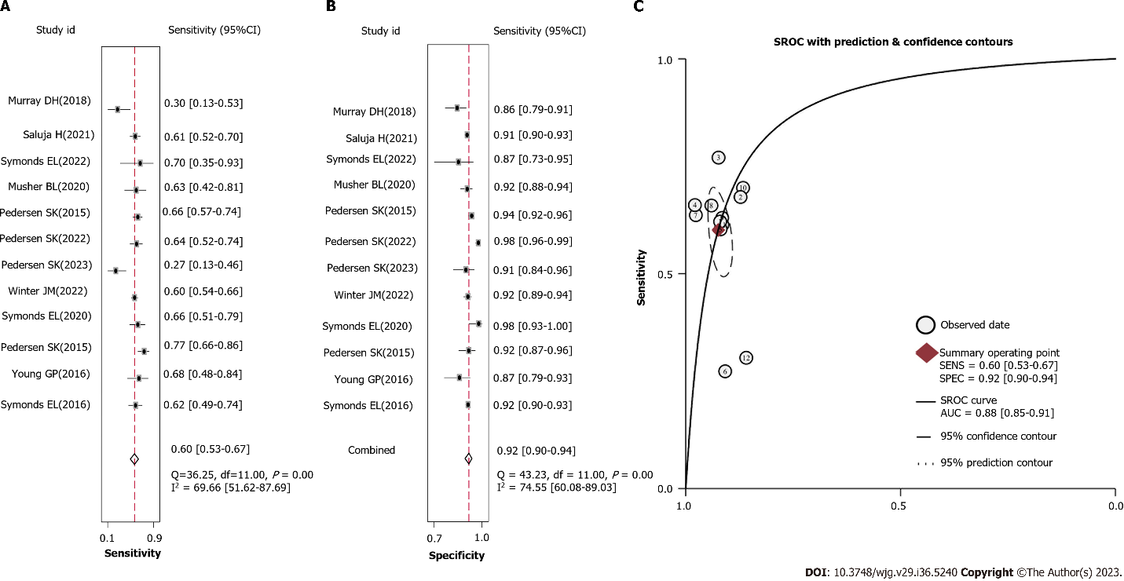
Figure 3 Pooled analysis of the diagnostic accuracy of methylated branched chain amino acid transaminase 1/IKAROS family zinc finger 1 in plasma for patients with colorectal cancer. A: Sensitivity; B: Specificity; C: Summary receiver operating characteristic curve. SROC: Summary receiver operating characteristics.
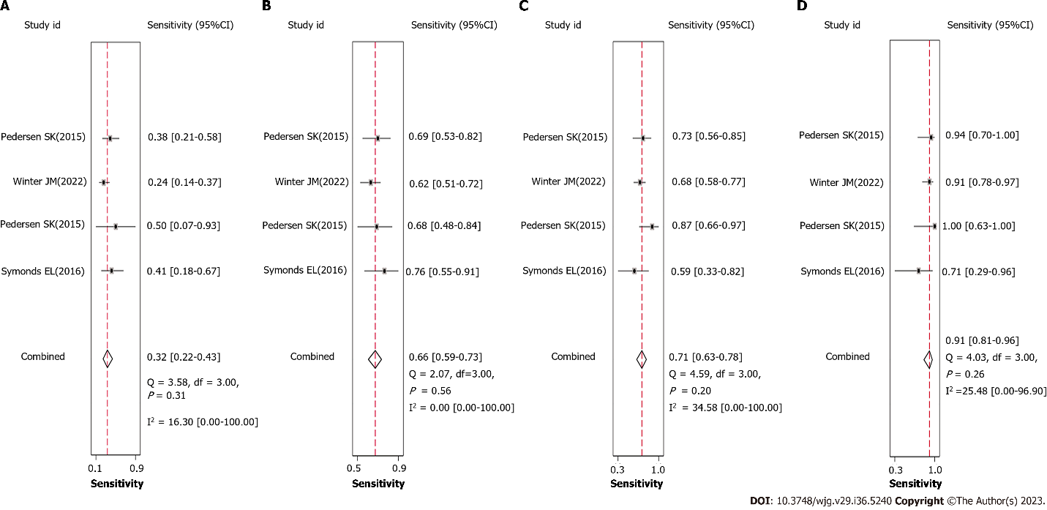
Figure 4 The Sensitivity of methylated branched chain amino acid transaminase 1/IKAROS family zinc finger 1 in plasma for patients with colorectal cancer at different stages. A: I stage; B: II stage; C: III stage; D: IV stage.

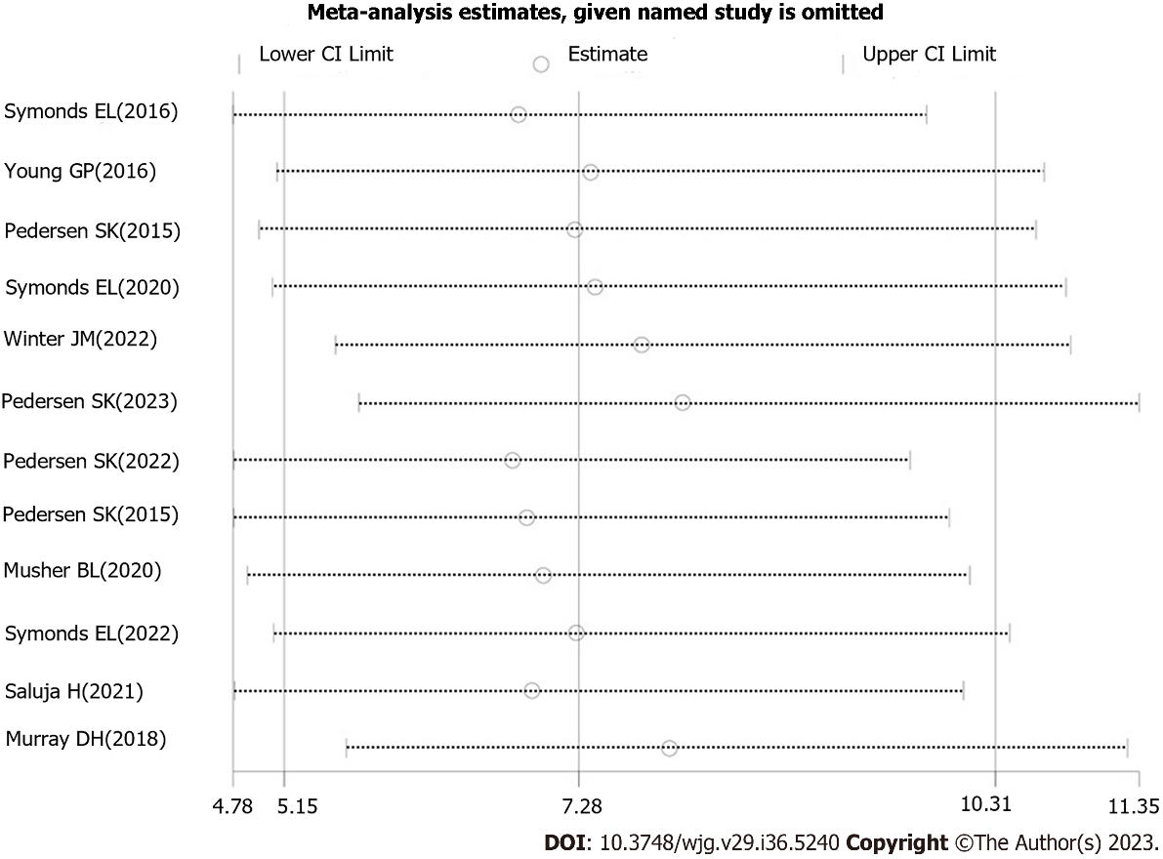
Figure 5 Sensitivity analysis of the included studies.

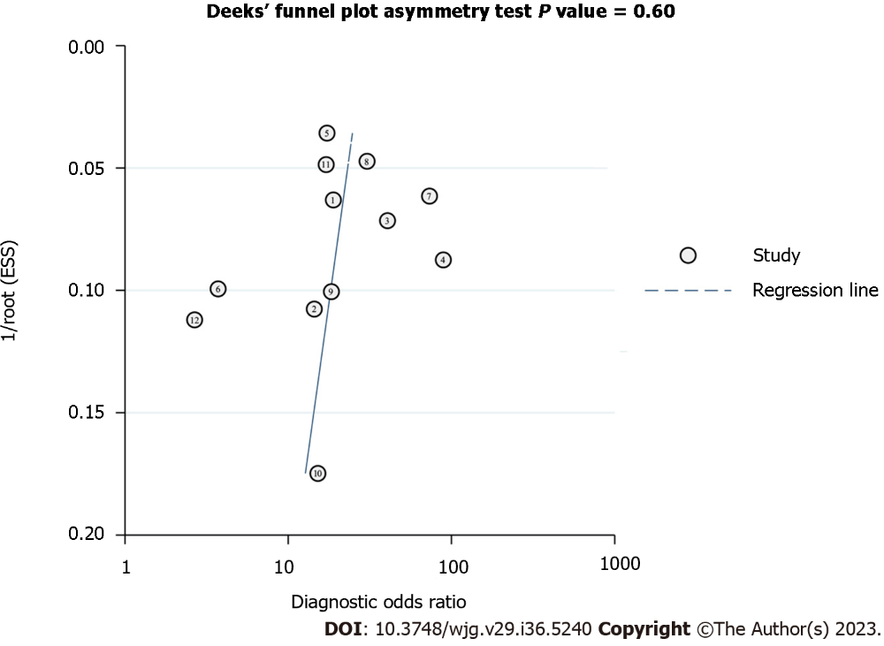
Figure 6 Publication bias analysis of the included studies by Deeks’ funnel plot asymmetric linear regression test.
Table 1 Information on the studies eligible for enrollment (%)

Ref. | Year | Country | Trial design | Disease | Detection method | Total volunteers | Cases (CRC) | Controls (non-CRC) | Sensitivity  (95% CI) | Specificity  (95% CI) | Sensitivity (95% CI) |  |  |  |  |  |  | Definition of a positive
 |  |  |  |  |  |  |  |  |  |  | Stage I | Stage II |  |  | Stage III | Stage IV
Symonds et al^{[27]} | 2016 | Australia | Prospective observational study | CRC screening | Real-time PCR | 1381 | 66 | 1315 | 62 (49–74) | 92 (90–93) | 41 (18-67) | 76 (55–91) |  |  | 59  (33–82) | 71 (29–96) |  | At least one PCR replicate was positive
Pedersen et al^{[32]} | 2015 | Australia | Prospective observational study | CRC screening | Real-time PCR | 218 | 74 | 144 | 77  (66-86) | 92  (86-96) | 50 (7-93) | 68 (48-84) |  |  | 87 (66-97) | 100 (63-100) |  | A total change in fluorescence intensity above background levels was measured within 50 PCR amplification cycles
Winter et al^{[30]} | 2022 | Australia | Prospective observational study | CRC screening | Real-time PCR | 896 | 290 | 606 | 60 (54-66) | 92  (89-94) | 24 (14-37) |  | 62 (51-72) | 68 (58-77) |  |  | 91 (78-97) | Methylation levels of 10% or more
Pedersen et al^{[32]} | 2015 | Australia | Prospective observational study | CRC screening | Real-time PCR | 967 | 129 | 838 | 66 (57-74) | 94 (92-95) | 38 (57-74) |  | 69 (53-82) | 73 (56-85) |  |  | 94 (70-100) | At least one PCR replicate was positive
Saluja et al^{[35]} | 2021 | Australia | Retrospective case–control study | CRC screening | Real-time PCR | 1593 | 114 | 1479 | 61 (52-70) | 91 (90-93) | NA |  | NA | NA |  |  | NA | At least one PCR replicate was positive
Young et al^{[28]} | 2016 | Australia | Prospective observational study | Recurrent CRC detection | Real-time PCR | 122 | 28 | 94 | 68 (48-84) | 87 (79-93) | 0/0 |  | 75 (35-97) | 71 (44-90) |  |  | 33 (1-91) | At least one PCR replicate was positive
Symonds et al^{[29]} | 2020 | Australia | Prospective observational study | Recurrent CRC detection | Real-time PCR | 144 | 50 | 94 | 66 (57-69) | 98; (93 -100) | 0/0 |  | 69 (39-91) | 70 (51-85) |  |  | 43 (10-82) | COLVERA (Clinical  Genomics Pty, Ltd, North Ryde, New South Wales,  Australia) detectability of ctDNA
Pedersen et al^{[26]} | 2023 | Australia | Prospective observational study | Recurrent CRC detection | Real-time PCR | 142 | 33 | 109 | 27 (13-46) | 91 (84-96) | NA |  | NA | NA |  |  | NA | 0.07%
Pedersen et al^{[31]} | 2022 | Australia | Prospective observational study | Recurrent CRC detection | Real-time PCR | 549 | 77 | 472 | 64 (52-74) | 98 (96-99) | NA |  | NA | NA |  |  | NA | 0.07%
Musher et al^{[33]} | 2020 | United States | Prospective observational study | Recurrent CRC detection | Real-time PCR | 322 | 27 | 295 | 63 (42-81) | 92 (88-94) | NA |  | NA | NA |  |  | NA | COLVERA (clinical Genomics Pathology Inc., NJ, United States) detectability of ctDNA
Symonds et al^{[34]} | 2022 | Australia | Prospective observational study | Recurrent CRC detection | Real-time PCR | 55 | 10 | 45 | 70 (35-93) | 87 (73-95) | NA |  | NA | NA |  |  | NA | At least one PCR replicate was positive
Murray et al^{[36]} | 2018 | Australia | Prospective observational study | recurrent CRC detection | real-time PCR | 172 | 23 | 149 | 30 (13-53) | 86 (79-91) | NA |  | NA | NA |  |  | NA | At least one PCR replicate
CRC: Colorectal cancer; CI: Confidence interval; PCR: Polymerase chain reaction; ctDNA: Circulating tumor DNA ; NA: Not available.
Table 2 Subgroup analysis of the included studies based on the differences of the purpose of testing and the positive result definition (95% CI, %)

 | Pooled sensitivity | Pooled specificity | Pooled positive likelihood ratio | Pooled negative likelihood ratio | Pooled diagnostic DOR | AUC
Overall | 60 (53-67) | 92 (90-94) | 8.0 (5.8-11.0) | 0.43 (0.36-0.52) | 19 (11-30) | 0.88 (0.85-0.91)
The purpose of testing
CRC screening | 64 (59-69) | 92 (91-93) | 8.5 (7.1-10.1) | 0.39 (0.33-0.45) | 22 (16-30) | 0.92 (0.89-0.94)
Assessment of recurrence | 54 (42-67) | 93 (88-96) | 7.4 (3.9-14.2) | 0.49 (0.37-0.66) | 15 (6-37) | 0.85 (0.81-0.88)
The definition of positive results
At least one PCR replicate | 59 (50-67) | 91 (89-93) | 6.6 (4.6-9.5) | 0.45 (0.36-0.56) | 15 (8-26) | 0.87 (0.84-0.90)
Set a specific threshold | 61 (49-72) | 94 (87-96) | 10.5 (6.1-17.9) | 0.42 (0.31-0.57) | 25 (12-55) | 0.91 (0.88-0.93)
AUC: Area under the curve; CRC: Colorectal cancer; CI: Confidence interval; PCR: Polymerase chain reaction.

Published by Baishideng Publishing Group Inc
7041 Koll Center Parkway, Suite 160, Pleasanton, CA 94566, USA
Telephone: +19253991568
Email: bpgoffice@wjgnet.com
Help Desk: https://www.f6publishing.com/helpdesk
https://www.wjgnet.com

© 2023 Baishideng Publishing Group Inc. All rights reserved.

