Name of Journal: World Journal of Clinical Cases
Manuscript NO: 62607
Manuscript Type: CASE REPORT

Pancreatic neuroendocrine carcinoma in a pregnant woman: A case report and review of the literature

Gao LP et al. Upper gastrointestinal bleeding in a pregnant woman

Li-Ping Gao, Gui-Xiang Kong, Xiang Wang, Hui-Min Ma, Fei-Fei Ding, Ting-Dong Li

Li-Ping Gao, Gui-Xiang Kong, Xiang Wang, Hui-Min Ma, Fei-Fei Ding, Department of Gastroenterology, The Second Hospital of Lanzhou University, Lanzhou 730000, Gansu Province, China

Ting-Dong Li, Department of Musculoskeletal Tumor, Gansu Provincial Cancer Hospital, Lanzhou 730000, Gansu Province, China

Author contributions: Gao LP and Wang X were attending physicians for the patient, reviewed the literature, and contributed to manuscript drafting; Ma HM and Ding FF reviewed the literature and contributed to manuscript drafting; Kong GX performed the upper gastrointestinal endoscopy and colonoscopy, and contributed to manuscript drafting; Li TD was responsible for the revision of the manuscript for important intellectual content; all authors issued final approval for the version to be submitted.

Corresponding author: Ting-Dong Li, MAMS, Doctor, Department of Musculoskeletal Tumor, Gansu Provincial Cancer Hospital, No. 2 Xiaoxihu East Street, Qilihe District, Lanzhou 730000, Gansu Province, China. ltd200998@163.com

Received: January 13, 2021
Revised: February 23, 2021
Accepted: April 6, 2021
Published online:

Abstract
BACKGROUND
Portal venous thromboembolism caused by malignant pancreatic neuroendocrine tumor metastasis, as the initial presentation of portal hypertension and upper gastrointestinal bleeding, is a rare entity. To our knowledge, there are no reports of this entity in pregnant women. We describe a case of pancreatic neuroendocrine carcinoma during pregnancy with hematemesis and hematochezia as the initial presentation and review the literature to analyze the demographic, clinical, and pathological features to provide a reference for clinical diagnosis and treatment.

CASE SUMMARY
A 40-year-old woman presented with hematemesis and hematochezia at 26-wk gestation; she had no other remarkable medical history. The physical examination revealed normal vital signs, an anemic appearance, and lower abdominal distension. Abdominal color Doppler ultrasonography showed portal vein thrombosis, splenomegaly, intrauterine pregnancy, and intrauterine fetal death. Esophagogastroduodenoscopy revealed esophageal and gastric varicose veins and portal hypertensive gastropathy. Contrast-enhanced computed tomography demonstrated multiple emboli formation in the portal and splenic veins, multiple round shadows in the liver with a slightly lower density, portal vein broadening, varicose veins in the lower esophagus and gastric fundus, splenomegaly, bilateral pleural effusion, ascites and pelvic effusion, broadening of the common bile duct, and increased uterine volume. According to the results of Positron emission tomography-computed tomography and immunohistochemical staining, the final diagnoses were that the primary lesion was a pancreatic neuroendocrine tumor and that there were secondary intrahepatic metastases and venous cancer thrombogenesis.

CONCLUSION
Upper gastrointestinal bleeding in a pregnant woman may be caused by portal hypertension due to a malignant pancreatic neuroendocrine tumor.

Key Words: Pregnancy; Portal venous thromboembolism; Pancreatic neuroendocrine carcinoma; Portal hypertension; Gastrointestinal bleeding; Case report

Gao LP, Kong GX, Wang X, Ma HM, Ding FF, Li TD. Pancreatic neuroendocrine carcinoma in a pregnant woman: A case report and review of the literature. World J Clin Cases 2021; In press

Core Tip: Upper gastrointestinal bleeding caused by portal hypertension is a rare form of advanced pancreatic neuroendocrine tumor. Our patient presented with hematemesis and hematochezia at 26-wk gestation, but no other significant medical history. Positron emission tomography-computed tomography revealed that lesions in the liver were found to be pancreatic neuroendocrine carcinoma during pregnancy. This case demonstrates that upper gastrointestinal bleeding as the initial presentation should be suspected among pregnant patients at high risk for malignancies.

INTRODUCTION
Neuroendocrine neoplasms (NENs) are a group of heterogeneous tumors originating from peptide neuroendocrine neurons and neuroendocrine cells, commonly occurring in different parts of the body, including the lung, thymus, pancreas, and gastrointestinal tract^{[1]}. The incidence of pancreatic NENs (pNENs) is 0.32/100000 person-years. According to the World Health Organization classification criteria for digestive system tumors in 2019, the gastrointestinal tract/hepatobiliary/pancreatic NEN was divided into well differentiated neuroendocrine tumor (NET) and poorly differentiated neuroendocrine carcinoma (NEC). Malignant pNENs account for approximately 1% of pancreatic malignancies, with a peak age of 40-69 years and a male-to-female ratio of 1.33:1^{[2]}. pNEN in pregnancy is a very rare condition and its diagnosis and treatment can be very challenging. Here, we report a case of pancreatic NEC (pNEC) during pregnancy with upper gastrointestinal bleeding as the initial presentation and review the related literature to analyze the demographic, clinical, and pathological features to provide a reference for clinical diagnosis and treatment.

CASE PRESENTATION
Chief complaints
A 40-year-old woman at 26-wk gestation was admitted to the hospital for hematemesis, hematochezia, and abdominal pain for 10 h.

History of present illness
Abdominal color Doppler ultrasonography showed portal vein thrombosis, splenomegaly, intrauterine pregnancy, and intrauterine fetal death.

History of past illness
The patient had no significant past medical history.

Personal and family history
The patient had no history of smoking or alcohol consumption. She had no relevant family history.

Physical examination
The physical examination revealed that the patient had normal vital signs, a body weight of 56 kg, a height of 1.58 m, a body mass index of 22.4 kg/m², an anemic appearance, and lower abdominal distension, and had no abdominal shiftiness sound.

Laboratory examinations
The laboratory examination was otherwise unremarkable. The laboratory assessment included an initial blood test of the complete blood count (hemoglobin level, 76 g/L), liver test (albumin level, 29.9 g/L), and tumor markers (alpha-fetoprotein level, 179.60 ng/mL; cancer antigen 125 level, 209.40 U/mL; and cancer antigen 199 level, 168.20 U/mL). Viral hepatitis markers were negative. Glucose and serum insulin levels were normal.

Imaging examinations
Esophagogastroduodenoscopy revealed esophageal and gastric varicose veins and portal hypertensive gastropathy (Figure 1). Contrast-enhanced computed tomography (CT) demonstrated multiple emboli formation in the portal vein and splenic vein, multiple round shadows in the liver with a slightly lower density (metastatic tumors were mostly considered), portal vein broadening, varicose veins in the lower esophagus and gastric fundus, splenomegaly, bilateral pleural effusion, ascites and pelvic effusion, broadening of the common bile duct, and increased uterine volume. Ultrasound-guided fine-needle aspiration biopsy of the liver tumor was performed. Histologically, the tumor consisted of heterogeneous cells arranged in nests, with a small cell extraction volume, short spindle or polygonal, unclear cell boundary, eosinophilic cytoplasm, increased nucleoplasmic ratio, and varying degrees of nuclear atypia. Immunohistochemical staining revealed that the tumor cells were positive for CKp, synaptophysin (Syn), chromogranin A (CgA), CD10, CD56, CDX-2, CEA, and Ki67 (40%+) (Figure 2). To identify the primary lesion, ¹⁸F-fluorodeoxyglucose Positron emission tomography/computed tomography (18F-FDG-PET-CT) was performed and showed multiple metabolic elevations in the pancreatic tail area, intrahepatic portal vein, and adjacent mesenteric and splenic veins. Considering the pathological tendency, it was considered that there was a high possibility of primary lesions of pNEC, secondary intrahepatic metastasis, venous cancer thrombogenesis, and corresponding varicose veins. No other metastatic lesions were found (Figure 3).

FINAL DIAGNOSIS
These aforementioned findings supported a diagnosis of pNEC (T2N0M2, G3) in pregnancy, secondary malignant tumor of the liver, and multiple venous thrombi.

TREATMENT
Subsequently, the patient was transferred to other hospitals for further treatment. The patient underwent transcatheter arterial chemo-embolization three times and radiofrequency ablation one time and was administered Sandostatin (octreotide acetate microsphere, 30 mg) once a month, without systemic chemotherapy or targeted drugs.

OUTCOME AND FOLLOW-UP
In February 2020, abdominal contrast-enhanced CT demonstrated the following: (1) Multiple intrahepatic tumors were present. Compared with the previous image (November 2019), the lesion volume of the hepatic hilum increased, abdominal exudation and liver injury reduced, necrosis appeared in some lesions, and little change was seen in the rest of the lesions; (2) the volume of emboli in the portal vein and inferior vena cava was increased, and multiple collateral circulations formed around the portal vein. Varicose veins were also present in the lower esophagus and gastric fundus; and (3) splenomegaly was present (Figure 4A). In June 2020, abdominal contrast-enhanced CT showed the following: (1) Multiple tumors in the liver were accompanied by accumulation of lipiodol, and the accumulation increased in the lesion compared with that in the previous lesion (February 2020). The lesion scope of the pancreatic tail was reduced. Multiple collateral circulations formed around the portal vein. Varicose veins remained present in the lower esophagus and gastric fundus; and (2) splenomegaly was still present (Figure 4B).
Even though the patient’s weight was about 10 kg less than before, she was physically active and could take care of herself.

DISCUSSION
In a review of published literature in China and abroad from 1939 to 2019, 41 cases of pNENs during pregnancy were collected, among which 29 were insulinomas in patients with an average age of 29 years^{[3-28]} (Table 1). In this study, the clinical manifestations and pathological characteristics of pNENs during gestation are summarized and analyzed. Pregnancy-associated pNENs, diagnosed during pregnancy and in the first year postpartum, may vary in type and differentiation, leading to atypical symptoms and signs and various clinical manifestations. This is an important reason why physicians and patients ignore and delay diagnosis. Functional pNENs have been observed at various stages of pregnancy, and the most common form of insulinoma is associated with hypoglycemia, including effects on the central nervous system, such as headaches, confusion, visual and behavioral abnormalities, or hypoglycemia that causes excessive catecholamine release, e.g., perspiration, tremor, and palpitations. A functional pNEN is easy to be misdiagnosed clinically because it is confused with pregnancy-associated uncomfortable symptoms^{[29]}. Symptoms of nonfunctional pNENs appear when they have local spread or distant metastases. It is challenging to perform paraclinical tests on patients with nonfunctional pNENs. In particular, invasive exploration (imaging, endoscopy, etc.) may be harmful to the fetus. Clinical diagnosis of pNENs in pregnancy is difficult because of the lack of specific clinical symptoms and CT/magnetic resonance imaging (MRI) findings^{[30]}.
Metastasis of a malignant pNEN to the liver in pregnant women is a rare entity, and little is known about the risk factors for its pathogenesis. The risk of cancer has been reported to increase with age, and the distribution of maternal age affects the incidence of pregnancy-associated cancers. The mechanisms and hormone allocation that lead to changes in maternal cancer risk are not fully understood. According to a wide range of clinical medical data, increasingly more women develop cancer during pregnancy due to delay in the age of conception. According to statistics, the incidence of malignant tumors in pregnant women during pregnancy is about 0.07% to 0.1%. Risk factors specific to pregnant women may include high estrogen levels, long-term fat intake, reduced physical activity, high blood pressure, and pre-existing chronic kidney disease; genetic and environmental sources of pregnancy-related cancers are likely to predate pregnancy. Moreover, hormones and growth factors necessary for fetal growth may accelerate tumor growth, such as estrogen, insulin-like growth factor I, and angiogenic factors, which may lead to maternal cancer and deserve further study. In addition, pregnancy is a pro-angiogenic state, and the placenta and angiogenesis required by pregnancy (placental growth factor and vascular endothelial growth factor, etc.) contribute to the occurrence or growth of tumors^{[31]}. During pregnancy, there is a higher risk of tumor complications, such as thromboembolic events and septicemia; however, physiological changes during pregnancy may delay the diagnosis of tumors and have an adverse effect on pregnancy outcomes.
CT, MRI, PET, transabdominal ultrasonography, gastrointestinal endoscopy, and endoscopic ultrasonography can be used to evaluate tumor staging and establish the diagnosis. The detection of pNENs by CT, MRI^{[32,33]}, and other imaging investigations is affected by tumor size, and establishing the diagnosis of pNENs decreases significantly when the tumor is small (< 2 cm). PET-CT seems to be useful in identifying the primary tumor site and assessing the degree of metastases at distant sites. The sensitivity of gallium 68Ga-PET-CT is higher than that of 18F-FDG-PET-CT in determining staging of pNENs^{[34,35]}. However, in pregnant women with pNENs, such tests are considered only after weighing the advantages and disadvantages.
Serological examination of pNENs during pregnancy can be performed, and serum CgA is the most widely used and valuable biomarker for diagnosis and follow-up of NENs^{[36]}, which can be used as an adjunctive diagnosis; other tumor biomarkers include neuron-specific enolase (NSE), Syn, and 5-hydroxyindoleacetic acid, and specific immunohistochemical staining markers of CgA, Syn, and NSE are the gold standard for identifying NENs.
Unlike conventional pNENs, cases of pNENs in pregnancy are scarce, and there is no standard therapeutic treatment. However, the therapy for pNENs is primarily surgical. Treatment requires a multidisciplinary approach that results in an appropriate, balanced, and optimal treatment plan, covering oncology, gynecology, surgery, psychology, anesthesiology, neonatology, and that considers ethical, family, and other relevant factors. Foreign scholars generally seem to agree that the treatment of pregnant women is the priority, followed by ensuring the healthy development of the fetus^{[37]}. The basic criteria for the treatment decision are imaging identification of the tumor location, characteristics of the tumor behavior, severity of symptoms, duration of pregnancy, and preference of the family. When the tumor is undetected, conservative treatment is warranted and surgical procedures are postponed as long as possible. This buys time for the fetus to develop more, and since pNENs grow over time, the site can be clearly diagnosed and then treated by therapeutic excision^{[38]}.
Chemotherapy is the first choice for advanced metastatic tumors, and the apparent aim is to prolong the life of the mother until safe delivery^{[39]}. Chemotherapy provides a palliative care option for pregnant women and postpartum patients if the fetus is of appropriate age. The risks to the fetus must be understood before chemotherapy is performed, and a range of moral, religious, ethical, and legal considerations must be taken into account. The extent to which the fetus receives chemotherapy and its effects depend on the progress of the pregnancy; chemotherapy must not be administered at 33 wk before birth or 3 wk after birth. The usual treatment regimen for pancreatic NETs is the use of antimetabolites (such as 5-fluorouracil) and some alkylating agents (such as streptozotocin)^{[40]}, with minimal effect on the fetus. The fetal toxicity of multi-drug chemotherapy increased from 17% to 25% compared with monotherapy^{[41]}. Molecular targeted therapies, such as mammalian target of rapamycin pathway inhibitors (e.g., iverimus) or antiangiogenic drugs (e.g., sunitinib or other isomers), have not been adequately studied to provide information on fetal side effects^{[42-44]}. For metastatic cases of pNECs during pregnancy, treatment is less likely. Surgical resection is the first treatment plan, followed by transcranial arterial chemoembolization, systemic chemotherapy, intratumoral ethanol injection, and radiofrequency ablation for liver metastasis^{[45]}. Surgical treatment is still an option, but usually after birth or, if necessary, as late as possible after the fetus has reached the appropriate age (28 wk). The prognosis of pregnancy-associated pNENS differs depending on the pathological type and stage.

CONCLUSION
In conclusion, the primary lesion of pNEC during pregnancy in this case was relatively hidden, but multiple distant metastases of the liver, portal vein, mesenteric vein, and splenic vein occurred. Additionally, acute upper gastrointestinal hemorrhage was the initial presentation, which is relatively rare. In pregnant women with pNECs, a special patient group, physicians should not only focus on the patient's own disease but also consider the safety of the fetus, family, ethics, law, and other factors. Moreover, there is no unified diagnosis and treatment standard in China and abroad. Such patients require a multidisciplinary team for comprehensive clinical management and individualized treatment based on each patient's condition and the development of the fetus.

ACKNOWLEDGEMENTS
We would like to thank the patient and her families for agreeing to publish this case report. We also acknowledge each of the authors for their contributions to this article.

REFERENCES
1 Chinese Society of Clinical Oncology Expert Committee on Neuroendocrine Oncology. The consensus of Chinese gastrointestinal and pancreatic neuroendocrine oncologists. Linchuang Zhongliu Zazhi 2016; 21: 927-946 [DOI: 1009-0460(2016)10-0927-20]
2 Yao JC, Hassan M, Phan A, Dagohoy C, Leary C, Mares JE, Abdalla EK, Fleming JB, Vauthey JN, Rashid A, Evans DB. One hundred years after "carcinoid": epidemiology of and prognostic factors for neuroendocrine tumors in 35,825 cases in the United States. J Clin Oncol 2008; 26: 3063-3072 [PMID: 18565894 DOI: 10.1200/JCO.2007.15.4377]
3 Feldman M, Weinberg T, Feldman MJ. Islet cell tumors of the pancreas. Am J Gastroenterol 1954; 22: 320-328 [PMID: 13197357]
4 Serrano-Rios M, Cifuentes I, Prieto JC. Insulinoma in a pregnant woman. Obstet Gynecol 1976; 47: 361-364 [PMID: 175325]
5 Rubens R, Carlier A, Thiery M, Vermeulen A. Pregnancy complicated by insulinoma. Case report. Br J Obstet Gynaecol 1977; 84: 543-547 [PMID: 199230 DOI: 10.1111/j.1471-0528.1977.tb12643.x]
6 Notterman RB, Jovanovic L, Peterson R, Solomon G, Druzin M, Peterson CM. Spontaneous hypoglycemic seizures in pregnancy. A manifestation of panhypopituitarism. Arch Intern Med 1984; 144: 189-191 [PMID: 6691758 DOI: 10.1001/archinte.144.1.189]
7 Osei K, Kramer DS, Malarkey WB, Falko JM. Pregnancy complicated by insulinoma. Am J Med Sci 1984; 288: 133-135 [PMID: 6091457 DOI: 10.1097/00000441-198410000-00008]
8 Shaw DL, Bernene JL, Williams JW, North CQ, Palestrant AM. Insulinoma in pregnancy. Ariz Med 1985; 42: 406-408 [PMID: 2994605]
9 Egley CC, Gutliph J, Bowes WA Jr. Severe hypoglycemia associated with HELLP syndrome. Am J Obstet Gynecol 1985; 152: 576-577 [PMID: 4014352 DOI: 10.1016/0002-9378(85)90630-1]
10 Friedman E, Moses B, Engelberg S, Levran D, Lieberman P. Malignant insulinoma with hepatic failure complicating pregnancy. South Med J 1988; 81: 86-88 [PMID: 2827322 DOI: 10.1097/00007611-198801000-00019]
11 Galun E, Ben-Yehuda A, Berlatzki J, Ben-Chetrit E, Gross DJ. Insulinoma complicating pregnancy: case report and review of the literature. Am J Obstet Gynecol 1986; 155: 64-65 [PMID: 3014882 DOI: 10.1016/0002-9378(86)90079-7]
12 Garner PR, Tsang R. Insulinoma complicating pregnancy presenting with hypoglycemic coma after delivery: a case report and review of the literature. Obstet Gynecol 1989; 73: 847-849 [PMID: 2539573]
13 Hale PJ, Hale JF, Nattrass M. Insulinoma and pregnancy. Case report. Br J Obstet Gynaecol 1988; 95: 514-517 [PMID: 2840943 DOI: 10.1111/j.1471-0528.1988.tb12808.x]
14 Liberman C, Valenzuela MA, Hernández F, Miranda C, Salazar V, Castillo J. [Insulinoma and pregnancy. Clinical case]. Rev Med Chil 1991; 119: 564-566 [PMID: 1844297]
15 Akanji AO, George AO, Olasode BJ, Osotimehin BO. Insulinoma in pregnancy presenting as a seizure disorder: a case report. East Afr Med J 1992; 69: 117-119 [PMID: 1505386]
16 Atala C, Tapia M. [Insulinoma and pregnancy. A clinical case]. Rev Chil Obstet Ginecol 1992; 57: 437-439 [PMID: 1364570]
17 Auinger M, Dudczak R, Fasching W, Leodolter S, Feinböck C, Irsigler K. [Detection of an insulinoma in pregnancy--a rare cause of hypoglycemia]. Wien Klin Wochenschr 1994; 106: 426-429 [PMID: 8091767]
18 Bardet S, Mahot P, Deumier B, Le Néel JC, Krempf M, Charbonnel B. [Discovery of an insulinoma during the first trimester of pregnancy]. Presse Med 1994; 23: 285-287 [PMID: 8208679]
19 Fredericks B, Entsch G, Lepre F, Nolan G, Davoren P. Pregnancy ameliorates symptoms of insulinoma--a case report. Aust N Z J Obstet Gynaecol 2002; 42: 564-565 [PMID: 12495117 DOI: 10.1111/j.0004-8666.2002.548_11.x]
20 Takacs CA, Krivak TC, Napolitano PG. Insulinoma in pregnancy: a case report and review of the literature. Obstet Gynecol Surv 2002; 57: 229-235 [PMID: 11961480 DOI: 10.1097/00006254-200204000-00022]
21 Gouya H, Vignaux O, Augui J, Dousset B, Palazzo L, Louvel A, Chaussade S, Legmann P. CT, endoscopic sonography, and a combined protocol for preoperative evaluation of pancreatic insulinomas. AJR Am J Roentgenol 2003; 181: 987-992 [PMID: 14500214 DOI: 10.2214/ajr.181.4.1810987]
22 Hirshberg B, Cochran C, Skarulis MC, Libutti SK, Alexander HR, Wood BJ, Chang R, Kleiner DE, Gorden P. Malignant insulinoma: spectrum of unusual clinical features. Cancer 2005; 104: 264-272 [PMID: 15937909 DOI: 10.1002/cncr.21179]
23 Lowy AJ, Chisholm DJ. Insulinoma masked by pregnancy. Intern Med J 2001; 31: 128-129 [PMID: 11480477 DOI: 10.1046/j.1445-5994.2001.00017.x]
24 Diaz AG, Herrera J, López M, Puchulu FM, Ferraina P, Bruno OD. Insulinoma associated with pregnancy. Fertil Steril 2008; 90: 199.e1-199.e4 [PMID: 17980876 DOI: 10.1016/j.fertnstert.2007.06.092]
25 Christiansen E, Vestergaard H. Insulinoma in a third-trimester pregnant woman combined with pre-eclampsia: a case report and review of the diagnostic strategies. Gynecol Endocrinol 2008; 24: 417-422 [PMID: 18645715 DOI: 10.1080/09513590802210931]
26 Rodrigues Queiróz AJ, Nazareno LS, Miranda JE, de Azevedo AEB, Teixeira da Cruz CA, Pirani Carneiro F, Florêncio da Costa AC, Lofrano-Porto A. Insulinoma diagnosed in the postpartum: clinical and immunohistochemical features. Gynecol Endocrinol 2012; 28: 633–636 [PMID: 22296647 DOI: 10.3109/09513590.2011.650756]
27 Mannelli L, Yeh MM, Wang CL. A pregnant patient with hypoglycemia. Gastroenterology 2012; 143: e3–e4 [PMID: 22921669 DOI: 10.1053/j.gastro.2012.03.051]
28 Tomazic M, Janez A, Ravnik Oblak M. Hypoglycemia identified by a continuous glucose monitoring system in a second-trimester pregnant woman with insulinoma: a case report. J Med Case Rep 2017; 11: 117 [PMID: 28427440 DOI: 10.1186/s13256-017-1265-8]
29 Massironi S, Sciola V, Peracchi M, Ciafardini C, Spampatti MP, Conte D. Neuroendocrine tumors of the gastro-entero-pancreatic system. World J Gastroenterol 2008; 14: 5377-5384 [PMID: 18803349 DOI: 10.3748/wjg.14.5377]
30 Besemer B, Müssig K. Insulinoma in pregnancy. Exp Clin Endocrinol Diabetes 2010; 118: 9-18 [PMID: 19373751 DOI: 10.1055/s-0029-1202272]
31 Troisi R, Bjørge T, Gissler M, Grotmol T, Kitahara CM, Myrtveit Sæther SM, Ording AG, Sköld C, Sørensen HT, Trabert B, Glimelius I. The Role of Pregnancy, Perinatal Factors and Hormones in Maternal Cancer Risk: a review of the evidence. J Intern Med 2018; 283: 430–445 [PMID: 29476569 DOI: 10.1111/joim.12747]
32 Goldberg-Stein S, Liu B, Hahn PF, Lee SI. Body CT during pregnancy: utilization trends, examination indications, and fetal radiation doses. AJR Am J Roentgenol 2011; 196: 146-151 [PMID: 21178060 DOI: 10.2214/AJR.10.4271]
33 Spencer JA, Tomlinson AJ, Weston MJ, Lloyd SN. Early report: comparison of breath-hold MR excretory urography, Doppler ultrasound and isotope renography in evaluation of symptomatic hydronephrosis in pregnancy. Clin Radiol 2000; 55: 446-453 [PMID: 10873690 DOI: 10.1053/crad.2000.0443]
34 Ilhan H, Fendler WP, Cyran CC, Spitzweg C, Auernhammer CJ, Gildehaus FJ, Bartenstein P, Angele MK, Haug AR. Impact of (68)Ga-DOTATATE PET/CT on the surgical management of primary neuroendocrine tumors of the pancreas or ileum. Ann Surg Oncol 2015; 22: 164-171 [PMID: 25190113 DOI: 10.1245/s10434-014-3981-2]
35 Zanotti-Fregonara P, Jan S, Taieb D, Cammilleri S, Trébossen R, Hindié E, Mundler O. Absorbed 18F-FDG dose to the fetus during early pregnancy. J Nucl Med 2010; 51: 803-805 [PMID: 20395321 DOI: 10.2967/jnumed.109.071878]
36 Panzuto F, Severi C, Cannizzaro R, Falconi M, Angeletti S, Pasquali A, Corleto VD, Annibale B, Buonadonna A, Pederzoli P, Delle Fave G. Utility of combined use of plasma levels of chromogranin A and pancreatic polypeptide in the diagnosis of gastrointestinal and pancreatic endocrine tumors. J Endocrinol Invest 2004; 27: 6-11 [PMID: 15053236 DOI: 10.1007/BF03350903]
37 Predescu D. Pancreatic Neuroendocrine Tumour in Pregnancy - Diagnosis and Treatment Management. Chirurgia (Bucur) 2019; 114: 550-563 [PMID: 31670630 DOI: 10.21614/chirurgia.114.5.550]
38 Turaga KK, Kvols LK. Recent progress in the understanding, diagnosis, and treatment of gastroenteropancreatic neuroendocrine tumors. CA Cancer J Clin 2011; 61: 113-132 [PMID: 21388967 DOI: 10.3322/caac.20097]
39 Starke A, Saddig C, Mansfeld L, Koester R, Tschahargane C, Czygan P, Goretzki P. Malignant metastatic insulinoma-postoperative treatment and follow-up. World J Surg 2005; 29: 789-793 [PMID: 15880279 DOI: 10.1007/s00268-005-7743-y]
40 Fjallskog ML, Janson ET, Falkmer UG, Vatn MH, Oberg KE, Eriksson BK. Treatment with combined streptozotocin and liposomal doxorubicin in metastatic endocrine pancreatic tumors. Neuroendocrinology 2008; 88: 53-58 [PMID: 18285678 DOI: 10.1159/000117575]
41 Leslie KK, Koil C, Rayburn WF. Chemotherapeutic drugs in pregnancy. Obstet Gynecol Clin North Am 2005; 32: 627-640 [PMID: 16310676 DOI: 10.1016/j.ogc.2005.08.009]
42 Vogl TJ, Naguib NN, Zangos S, Eichler K, Hedayati A, Nour-Eldin NE. Liver metastases of neuroendocrine carcinomas: interventional treatment via transarterial embolization, chemoembolization and thermal ablation. Eur J Radiol 2009; 72: 517-528 [PMID: 18829195 DOI: 10.1016/j.ejrad.2008.08.008]
43 Raymond E, Dahan L, Raoul JL, Bang YJ, Borbath I, Lombard-Bohas C, Valle J, Metrakos P, Smith D, Vinik A, Chen JS, Hörsch D, Hammel P, Wiedenmann B, Van Cutsem E, Patyna S, Lu DR, Blanckmeister C, Chao R, Ruszniewski P. Sunitinib malate for the treatment of pancreatic neuroendocrine tumors. N Engl J Med 2011; 364: 501-513 [PMID: 21306237 DOI: 10.1056/NEJMoa1003825]
44 Yao JC, Shah MH, Ito T, Bohas CL, Wolin EM, Van Cutsem E, Hobday TJ, Okusaka T, Capdevila J, de Vries EG, Tomassetti P, Pavel ME, Hoosen S, Haas T, Lincy J, Lebwohl D, Öberg K; RAD001 in Advanced Neuroendocrine Tumors, Third Trial (RADIANT-3) Study Group. Everolimus for advanced pancreatic neuroendocrine tumors. N Engl J Med 2011; 364: 514-523 [PMID: 21306238 DOI: 10.1056/NEJMoa1009290]
45 Pavel ME, Baudin E, Öberg KE, Hainsworth JD, Voi M, Rouyrre N, Peeters M, Gross DJ, Yao JC. Efficacy of everolimus plus octreotide LAR in patients with advanced neuroendocrine tumor and carcinoid syndrome: final overall survival from the randomized, placebo-controlled phase 3 RADIANT-2 study. Ann Oncol 2017; 28: 1569-1575 [PMID: 28444114 DOI: 10.1093/annonc/mdx193]

Footnotes
Informed consent statement: Informed written consent was obtained from the patient for publication of this report and any accompanying images.

Conflict-of-interest statement: The authors declare that they have no conflict of interest to report.

CARE Checklist (2016) statement: The authors have read the CARE Checklist (2016), and the manuscript was prepared and revised according to the CARE Checklist (2016).

Open-Access: This article is an open-access article that was selected by an in-house editor and fully peer-reviewed by external reviewers. It is distributed in accordance with the Creative Commons Attribution NonCommercial (CC BY-NC 4.0) license, which permits others to distribute, remix, adapt, build upon this work non-commercially, and license their derivative works on different terms, provided the original work is properly cited and the use is non-commercial. See: http://creativecommons.org/Licenses/by-nc/4.0/

Manuscript source: Unsolicited manuscript

Peer-review started: January 13, 2021
First decision: February 10, 2021
Article in press:

Specialty type: Gastroenterology and hepatology
Country/Territory of origin: China
Peer-review report’s scientific quality classification
Grade A (Excellent): 0
Grade B (Very good): B, B
Grade C (Good): C, C, C
Grade D (Fair): 0
Grade E (Poor): 0

P-Reviewer: Chen LW, Dehghanian M, Keikha M S-Editor: Liu M L-Editor: Wang TQ P-Editor:

Figure Legends
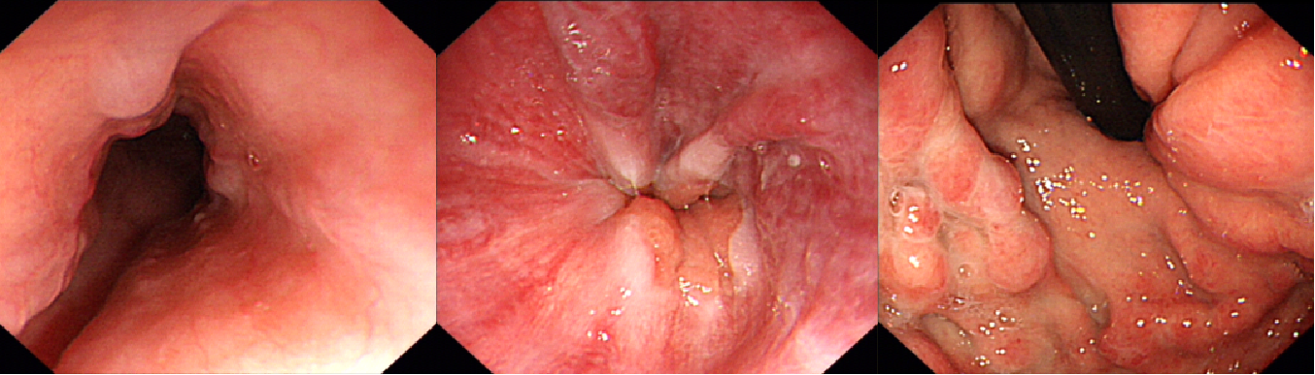
Figure 1 Esophagogastroduodenoscopy showing esophageal and gastric varicose veins.
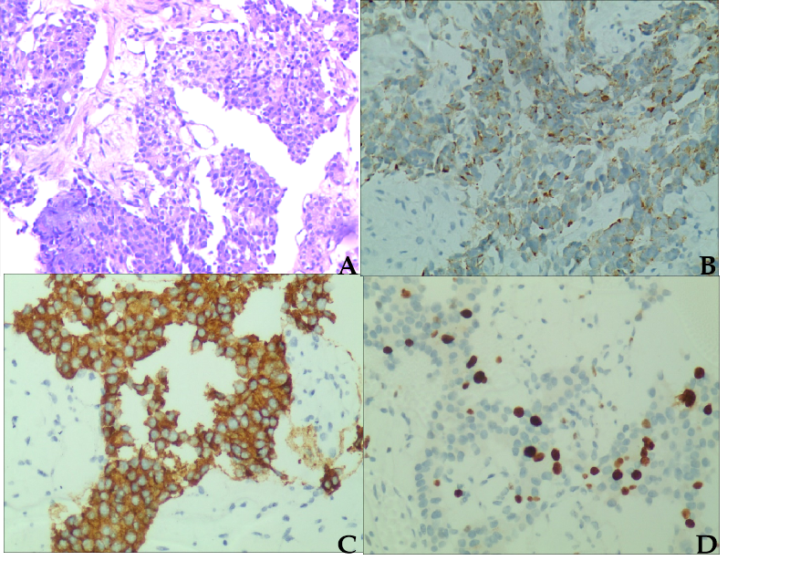
Figure 2 Ultrasound-guided fine-needle aspiration biopsy of the liver tumor. A: Hematoxylin and eosin staining (× 200); B-D: Immunohistochemical staining for (B) Chromogranin A (+), (C) Synaptophysin (+), and (D) Ki67 (40%+).
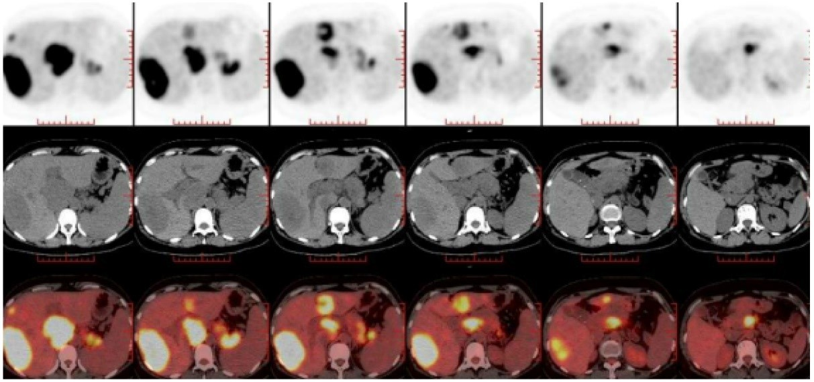
Figure 3 ¹⁸F-fluorodeoxyglucose positron emission tomography/computed tomography revealing a high possibility of a primary lesion of pancreatic neuroendocrine carcinoma, secondary intrahepatic metastasis, venous cancer thrombogenesis, and corresponding varicose veins.
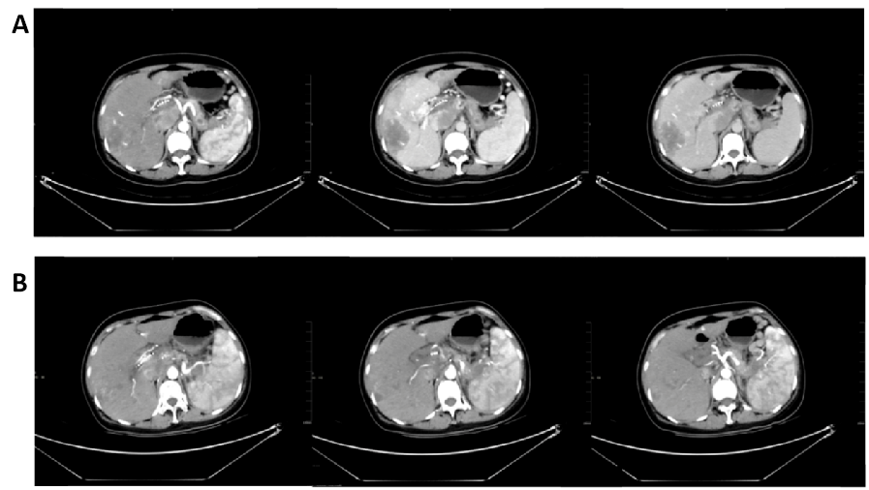
Figure 4 Imaging findings. A: Abdominal enhanced computed tomography (CT) in February 2020 demonstrated the following: (1) The presence of multiple intrahepatic tumors. Compared with the previous image (November 2019), the lesion volume of the hepatic hilar was increased, abdominal exudation and liver injury were improved, necrosis appeared in some lesions, and little change was seen in the remaining lesions; and (2) the volume of emboli in the portal vein and inferior vena cava was increased, and varicose veins were present in the lower esophagus and gastric fundus; B: Abdominal contrast-enhanced CT in June 2020 revealed multiple tumors in the liver accompanied by the accumulation of lipiodol, and increased accumulation of lipiodol in the lesion compared with the previous lesion (February 2020). The lesion scope of the pancreatic tail was reduced.
Table 1 Summary of pancreatic neuroendocrine neoplasms in pregnancy (2000-2019)
Ref. | Patient age | Onset of symptoms | Symptoms | Management | Maternal outcomes | Fatal  outcomes
Fredericks et al^{[19]} | 35-yr-old | Three weeks post-partum | Neuroglycopaenic symptoms | Laparotomy the tumor | No symptoms after removal | Live born
Takacs et al^{[20]} | 28-yr-old | At 6-wk gestation | Difficult morning arousability | Exploratory laparotomy | No residual symptoms | Cesarean delivery
 |  |  |  |  |  | Live born
Lowy and Chisholm^{[23]} | 36-yr-old | Twelve hours post-partum | Severe hypoglycaemia | Excision of the lesion | No symptoms after removal | Live born
Diaz et al^{[24]} | 35-yr-old | Three months | Loss of consciousness | Exploratory laparotomy | No residual symptoms | Live born
 |  | Post-partum
Diaz et al^{[24]} | 35-yr-old | On the 26th postpartum day | Confusion, dysarthria, and quadriplegia | Enucleation of an 8-mm tumor | No symptoms after removal | Live born
Diaz et al^{[24]} | 22-yr-old | At 2-mo gestation | Loss of consciousness | Laparoscopic distal pancreatectomy | No residual symptoms | Natural labor
 |  |  |  | Post-partum |  | Live born
Christiansen and Vestergaard^{[25]} | 29-yr-old | At 38-mo gestation | Slurred speech, weakness | Pancreaticoduodenectomy and cholecystectomy | No symptoms after removal | Natural labor
 |  |  |  | Post-partum |  | Live born
Rodrigues Queiróz et al^{[26]} | 21-yr-old | Eight days post-partum | Four limbs weahness, diffic-ult walking | Pancreatectomy | No residual symptoms | Live born
Mannelli et al^{[27]} | 29-yr-old | At 17 wk gestation | Severe hypoglycemia | Started therapy with everolimus | Died 3 yr after delivery | Cesareandelivery
 |  |  |  |  |  | Live born
Tomazic et al^{[28]} | 36-yr-old | In the second trimester of pregnancy | Hypoglycemia associated with neuroglycopenic symptoms | Distal pancreatectomy at 21 wk gestation | No symptoms after removal | Nature labor
 |  |  |  |  |  | Live born

