Name of Journal: World Journal of Stem Cells
Manuscript NO: 80209
Manuscript Type: ORIGINAL ARTICLE

Basic Study
Optimal concentration of mesenchymal stem cells for fracture healing in a rat model with long bone fracture

Kim MS et al. Optimal MSC concentration for fracture healing

Myung-Seo Kim, Hyun-Ju Chung, Kang-Il Kim

Myung-Seo Kim, Kang-Il Kim, Department of Orthopaedic Surgery, School of Medicine, Kyung Hee University and Kyung Hee University Hospital at Gangdong, Seoul 05278, South Korea

Hyun-Ju Chung, Department of Core Research Laboratory, Clinical Research Institute, Kyung Hee University Hospital at Gangdong, Seoul 05278, South Korea

Author contributions: Kim MS collected and assembled the data and performed data analysis and interpretation, manuscript writing; Chung HJ analyzed the data and performed interpretation; Kim KI provided the study material and designed the research study and performed final approval of manuscript; and all authors have read and approve the final manuscript.

Supported by the Korea Health Technology R&D Project through the Korea Health Industry Development Institute (KHIDI), funded by the Ministry of Health & Welfare, Republic of Korea, No. HI20C1405.

Corresponding author: Kang-Il Kim, MD, PhD, Professor, Department of Orthopaedic Surgery, School of Medicine, Kyung Hee University and Kyung Hee University Hospital at Gangdong, 892, Dongnam-ro, Gangdong-gu, Seoul 05278, South Korea. khuknee@gmail.com

Received: September 27, 2022
Revised: October 30, 2022
Accepted: December 7, 2022
Published online: December 26, 2022

Abstract
BACKGROUND
There is still no consensus on which concentration of mesenchymal stem cells (MSCs) to use for promoting fracture healing in a rat model of long bone fracture.

AIM
To assess the optimal concentration of MSCs for promoting fracture healing in a rat model.

METHODS
Wistar rats were divided into four groups according to MSC concentrations: Normal saline (C), 2.5 × 10⁶ (L), 5.0 × 10⁶ (M), and 10.0 × 10⁶ (H) groups. The MSCs were injected directly into the fracture site. The rats were sacrificed at 2 and 6 wk post-fracture. New bone formation [bone volume (BV) and percentage BV (PBV)] was evaluated using micro-computed tomography (CT). Histological analysis was performed to evaluate fracture healing score. The protein expression of factors related to MSC migration [stromal cell-derived factor 1 (SDF-1), transforming growth factor-beta 1 (TGF-β1)] and angiogenesis [vascular endothelial growth factor (VEGF)] was evaluated using western blot analysis. The expression of cytokines associated with osteogenesis [bone morphogenetic protein-2 (BMP-2), TGF-β1 and VEGF] was evaluated using real-time polymerase chain reaction.

RESULTS
Micro-CT showed that BV and PBV was significantly increased in groups M and H compared to that in group C at 6 wk post-fracture (P = 0.040, P = 0.009; P = 0.004, P = 0.001, respectively). Significantly more cartilaginous tissue and immature bone were formed in groups M and H than in group C at 2 and 6 wk post-fracture (P = 0.018, P = 0.010; P = 0.032, P = 0.050, respectively). At 2 wk post-fracture, SDF-1, TGF-β1 and VEGF expression were significantly higher in groups M and H than in group L (P = 0.031, P = 0.014; P < 0.001, P < 0.001; P = 0.025, P < 0.001, respectively). BMP-2 and VEGF expression were significantly higher in groups M and H than in group C at 6 wk post-fracture (P = 0.037, P = 0.038; P = 0.021, P = 0.010). Compared to group L, TGF-β1 expression was significantly higher in groups H (P = 0.016). There were no significant differences in expression levels of chemokines related to MSC migration, angiogenesis and cytokines associated with osteogenesis between M and H groups at 2 and 6 wk post-fracture.

CONCLUSION
The administration of at least 5.0 × 10⁶ MSCs was optimal to promote fracture healing in a rat model of long bone fractures.

Key Words: Rat model; Femoral shaft fracture; Mesenchymal stem cells; Direct injection; Optimal concentration; Fracture healing

©The Author(s) 2022. Published by Baishideng Publishing Group Inc. All rights reserved.

Citation: Kim MS, Chung HJ, Kim KI. Optimal concentration of mesenchymal stem cells for fracture healing in a rat model with long bone fracture. World J Stem Cells 2022; 14(12): 839-850
URL: https://www.wjgnet.com/1948-0210/full/v14/i12/839.htm
DOI: https://dx.doi.org/10.4252/wjsc.v14.i12.839

Core Tip: This study focused on the optimal concentration of mesenchymal stem cells (MSCs) that affect fracture healing in a rat model of long bone shaft fracture. Factors related to the homing effect of MSCs, osteogenesis and angiogenesis were analyzed by in vivo (radiographic and histologic evaluation) as well as in vitro (reverse transcriptase-polymerase chain reaction and western blot analysis). Among the various concentrations used, the administration of at least 5.0 × 10⁶ MSCs was optimal to promote the therapeutic effect on fracture healing.

INTRODUCTION
Long bone fractures, such as those of the femur, tibia, and humerus, occur mainly in working-age adults^{[1]} and are caused by high-energy trauma^{[2]}. Long bone fractures have a high incidence of nonunion owing to the complex and specific anatomical area of the fracture^{[3]}. Intramedullary nailing is the treatment of choice for femoral shaft fractures^{[4]}; however, the risk of nonunion in this procedure has been reported to be up to 13%, even after nailing^{[5]}. As femur has a significant weight-bearing role, the fracture nonunion can cause an increase in morbidity^{[2]}. Moreover, it may be impossible for patients to return to normal daily activities after an injury^{[6]}. Ekegren et al^{[3]} reported that among fracture healing complications, the post-operative readmission rate was highest for femoral shaft fractures, followed by tibial shaft fractures. Among these, nonunion has been reported to be the most common cause. The nonunion rate has been reported to be up to 33% after intramedullary nailing in humerus and femur shaft fractures, and a relatively high nonunion rate of approximately 5%-7% has also been reported in tibial shaft fractures^{[7]}. Thus, when nonunion occurs in long bone fractures, significant disability occurs and quality of life deteriorates, resulting in a high socioeconomic burden during treatment^{[3,7]}. Therefore, preventing nonunion during the initial surgery of shaft fractures in long bones is important for improving patient prognosis.
Autologous cells with regeneration potential have emerged as a novel method to replace the standard method of bone repair^{[8-10]}. Mesenchymal stem cells (MSCs) have the potential to promote both osteoinduction and osteogenesis^{[11]}. Stem cell therapy using this type of cell has an important effect in promoting the bone-healing process^{[8,10]}; some animal studies have reported that MSCs improve fracture healing^{[12]}. Wilson et al^{[12]} evaluated the extent of bone defect regeneration in the ramus of swine with or without MSC injection. They reported that bone healing was accelerated in a group injected with MSCs^{[12,13]}. Obermeyer et al^{[13]} reported that the administration of MSCs increased the volume and biomechanical strength of the callus in an alcohol-induced impaired fracture healing mouse model, resulting in accelerated fracture healing. Some previous studies have reported that injection of MSCs improves fracture healing; however, no studies have specifically reported the most effective concentration of MSC. Although a concentration of 5.0 × 10⁶ MSCs was mainly used in several previous studies^{[10-12]}, there was no rationale for this selection. Therefore, this study aimed to confirm the ability of MSCs and assess their optimal concentration to promote fracture healing in a rat model of long bone fracture. The authors hypothesized that administration of at least 5.0 × 10⁶ MSCs would significantly improve fracture healing.

MATERIALS AND METHODS
Animal model
Forty-eight adult male Wistar rats (8 wk old with 200-250 g weight) were obtained from the Orient Bio Institute, Seongnam City, Gyeonggi-do, Republic of Korea. All procedures and treatments involving animals in this study followed the requirements of the Institutional Animal Care and Use Committee of the Clinical Research Institute, and the final approval was obtained from the ethics committee of Kyung Hee University Hospital at Gangdong (KHNMC AP 2020-018). The rats had free access to food and water and were bred in a controlled environment at 21 ± 2 °C with a 12-h/12-h light/dark cycle.

Long bone fracture model and MSC injection
The femoral shaft, which is a representative long bone, was used as the fracture model in this study. Under general anesthesia, the right lower extremities of the rats were shaved and disinfected. First, the approach was performed using an anterior midline incision. After exposing the right knee joint by dislocating the patella medially, the intercondylar groove of the femur was exposed by flexion of the knee joint. An 18-gauge needle was retrogradely inserted into the center of the intercondylar groove to prevent significant displacement during the fracture. Since the proximal end of the needle protruding into the knee joint can affect the knee joint range of motion, we cut it and inserted the proximal end of the needle into the distal femur. Next, the femoral shaft was approached through a lateral approach, taking care to avoid damage to the periosteum. After applying an oscillating thin saw at a depth of 1 mm, a fracture was generated in the femoral shaft using the 3-point bending technique^{[14]}. Sterile saline was injected into the fracture site to minimize the periosteal damage owing to heat when applying the saw. After inserting the needle tip into the fracture site, the muscular fascia was closed, the adipose-derived (AD)-MSCs were mixed with 0.3 mL sterile normal saline, and the cells were injected once directly into the fracture site. The muscular fascia was repaired before direct injection of the cell suspension to prevent AD-MSCs from flowing out. Other weight-bearing activities were unrestricted post operatively.

Preparation of MSCs
Human AD-MSCs (Jointstem; R-Bio, Seoul, Korea) were used in this study^{[15,16]}. Three weeks before injection, human adipose tissue was collected by lipoaspiration using the tumescent technique. The aspirated tissue was digested with collagenase I to obtain AD-MSCs, and the digested tissue was centrifuged after removing cellular debris. The obtained pellet was resuspended in Dulbecco’s modified Eagle’s medium (DMEM; Invitrogen)-based medium containing 0.2 mmol/L ascorbic acid and 10% fetal bovine serum, and the cell suspension was recentrifuged. When the cells reached 90% confluence by resuspension and recentrifugation, they were passaged^{[16]}. AD-MSCs at passage 3 were used in this study. AD-MSCs were prepared under Good Manufacturing Practice conditions at the Stem Cell Research Center of RNL BIO. The expanded cells were then tested for number, viability, purity, identity, and fungal, bacterial, endotoxin, and mycoplasma contamination, as suggested by the Code of Federal Regulations Title 21, before further use. Cultured AD-MSCs showed a survival rate of over 80% between 2 and 8 °C for 72 h^{[15]}. Immediately before injection, 2.5 × 10⁶, 5.0 × 10⁶, and 10.0 × 10⁶ AD-MSCs were counted using a hemocytometer^{[17]}. The prepared AD-MSCs were injected into rats within one day of arrival at the animal laboratory.

Categorization according to the concentration of administered MSCs
After breeding for one week, the rats were randomly divided into four groups (n = 6 in each group): Rats injected with normal saline (C), 2.5 × 10⁶ (L), 5.0 × 10⁶ (M), and 10.0 × 10⁶ (H) groups. Several studies have reported the injection of 5 × 10⁶ MSCs into animal models^{[10-12]}. In particular, Wilson et al^{[12]} injected 5.0 × 10⁶ MSCs based on the study by Hou et al^{[18]} that concluded that > 3.0 × 10⁶ MSCs should be injected for bone healing. Therefore, a concentration of 5.0 × 10⁶ MSCs were used as a reference in this study. The highest concentration was set as 10.0 × 10⁶, according to a previous study that reported that the effective dose for fracture healing was between 2.0 × 10⁶ and 10.0 × 10⁶ MSCs^{[19]}. Moreover, 2.5 × 10⁶ cells, an intermediate concentration between normal saline and 5.0 × 10⁶ cells, was set as the lowest concentration.
At 2 and 6 wk post-fracture, the rats were sacrificed to harvest femur specimens, and the intramedullary needle was removed. Six weeks post-fracture has been reported as an important time point for fracture healing in previous studies^{[20-22]}; hence, 6 wk after fracture was chosen in this study to evaluate the late phase of fracture healing. Wang et al^{[20]} reported that the expression of transforming growth factor-beta 1 (TGF-β1), a chemokine that has an important effect on MSC migration, peaked at 2 wk post-fracture. Moreover, it is known that the renewal phase, in which MSCs proliferate and differentiate, usually occurs 7-10 d post-fracture^{[23]}. In this study, the expression levels of factors related to MSC migration were also analyzed. Referring to the above studies, the early phase was set at 2 wk post-fracture.

Assessment of fracture healing (in vivo studies)
Radiologic evaluation through micro-computed tomography: Micro-computed tomography (micro-CT) was used to evaluate the volume of the newly formed callus [bone volume (BV)] and the percentage of BV [(PBV), calculated as BV/tissue volume]. A 6-mm long section centered on the fracture site was analyzed. Preexisting cortical bone and medullary canal volumes were excluded according to the method described by Wang et al^{[20]}. The femur specimens were scanned using three-dimensional micro-focus micro-CT (Sky-Scan 1172TM, Skyscan, Kontich, Belgium) at 10 μm resolution, 440 ms exposure, 0.4° rotation step, 80 kV, and 167 μm with a 0.5 mm aluminum filter.

Histological evaluation: Decalcification was performed using a rapid decalcifier solution (RDO, Apex Engineering Products Corporation) at room temperature for three days. The RDO solution was replaced daily. The decalcification process and endpoint were assessed using a surgical blade and radiographic analysis, wherein in the opacity of the tissue suggested incomplete decalcification. The femur specimen was sagittally sectioned to a thickness of 3 μm and stained with hematoxylin and eosin (H&E) (Sigma-Aldrich) for histological analysis. The slides were visualized using an Olympus CX41 microscope (Olympus Co., Tokyo, Japan). Fracture healing was evaluated using a histological scoring tool for fracture healing^{[24]} (Table 1).

Assessment of fracture healing (in vitro studies)
Western blot analysis: Rat femur specimens were ground in liquid nitrogen and incubated with lysis buffer containing 140 mmol/L NaCl, 50 mmol/L NaF, 1 mmol/L EDTA, 1 mmol/L Na₃VO₄, 1 mmol/L phenylmethylsulfonyl fluoride, 10 μg/mL aprotinin, and 1% (w/v) Nonidet P-40 in 20 mmol/L Tris-HCl (pH 7.4). Protein fractions were separated by sodium dodecyl sulfate-polyacrylamide gel electrophoresis on 12% polyacrylamide gels and electrotransferred onto PVDF membranes (Bio-Rad, Hercules, CA, United States). The membranes were then blocked with Tris-buffered saline buffer consisting of 1% nonfat dry milk and 1% bovine serum albumin for 1 h. Next, membranes were then incubated overnight at 4 °C with primary antibodies against stromal cell-derived factor 1 (SDF-1) (Abcam, Cat # ab18919, 1:3000), TGF-β1 (Abcam, Cat # ab215715, 1:3000), vascular endothelial growth factor (VEGF) (Santa Cruz, SC-7269, 1:2000) and β-actin (Santa Cruz Biotechnology; 1:1000). The membranes were developed for 1 h peroxidase-conjugated anti-rabbit immunoglobulin G (Santa Cruz Biotechnology). The blots were visualized using a ChemicDoc XRS system (Bio-Rad), and protein concentrations were quantified using the Quantity One imaging software (Bio-Rad). All experiments were performed in triplicates.

Real-time quantitative polymerase chain reaction: Total RNA from the rat femur specimens was extracted using an RNeasy Mini Kit (Qiagen, Hilden, Germany), according to the manufacturer’s protocol. RNA was reverse transcribed using Superscript II reverse transcriptase (Life Technologies) at 42 °C via random hexamer priming. The quantitative polymerase chain reaction (qPCR) conditions were as follows: Pre-denaturation at 95 °C for 5 min, denaturation at 95 °C for 10 s, and annealing at 60 °C for 30 s for a total of 40 cycles, followed by fluorescence signal detection during annealing. Glyceraldehyde 3-phosphate dehydrogenase was used as an internal reference for normalization. The reactions were performed using the StepOnePlus Real-Time PCR System (Applied Biosystems, Foster City, CA, United States). The sequences of the primers used for reverse transcriptase-qPCR (RT-qPCR) are listed in Supplementary Table 1.

Statistical analysis: Based on the concentration of MSCs, one-way analysis of variance and post hoc analyses were performed to evaluate the differences in micro-CT, histological scores of fracture healing, and mRNA and protein expression (as evidenced by RT-qPCR and western blot results, respectively). Statistical significance was set P = 0.05, with 95% confidence interval. SPSS version 21.0 software (SPSS, Inc., Chicago, Illinois, United States) was used for all statistical analyses.

RESULTS
In vivo studies
Fracture healing as evaluated via micro-CT analysis: At 2 and 6 wk post-fracture, BV was significantly higher in group M and H than in group C (P = 0.048, P = 0.040 and P = 0.023, P = 0.009, respectively). There was no significant difference in BV between M and H groups (P = 0.999 and P = 0.887). There was no significant difference in PBV between four groups at 2 wk post-fracture. However, PBV was significantly increased in groups M and H compared to that in group C (P = 0.004 and P = 0.001, respectively) and group L (P = 0.026 and P = 0.003, respectively) at 6 wk post-fracture. There was no significant difference in the PBV between groups M and H (P = 0.425) (Table 2, Figures 1 and 2).

Histological scores of fracture healing evaluated using H&E staining: The formation of fibrous, cartilaginous, and immature bones was evaluated using histological scores. At 2 and 6 wk post-fracture, there was no significant difference in the fracture healing scores between groups C and L (2.8 ± 0.5 vs 3.8 ± 0.5, P = 1.000 and 5.3 ± 0.5 vs 6.5 ± 1.7, P = 1.000, respectively). Significantly more cartilaginous tissue was formed in groups M (5.5 ± 1.3) and H than in group C (P = 0.018 and P = 0.010, respectively) at 2 wk post-fracture (Figure 3). Moreover, significantly more immature bone was formed in groups M (8.8 ± 1.9) and H (8.5 ± 1.3) than in the group injected with normal saline (P = 0.032 and P = 0.050, respectively) at 6 wk post-fracture (Figure 4).

In vitro studies
Comparison of protein expression levels of chemokines related to MSC migration and angiogenesis at 2 wk post-fracture: The fold change in mRNA expression (all reported values are fold-changes relative to the comparator) of SDF-1 was significantly higher in groups L, M, and H than in group C (P < 0.001 all). Compared to group L, groups M and H showed significantly higher SDF-1 expression (P = 0.031, P = 0.014, respectively). There was no significant difference in SDF-1 expression between groups M and H (P = 0.974). TGF-β1 expression was significantly higher in groups L, M and H than in group C (P = 0.003, P < 0.001, P < 0.001, respectively). Compared to group L, groups M and H also showed significantly higher TGF-β1 expression at 2 wk post-fracture (P < 0.001, all). There was no significant difference in TGF-β1 expression between groups M and H (P = 0.997). VEGF expression was significantly higher in groups M and H than in group C (P < 0.001, all). In addition, VEGF expression was significantly higher in groups M and H than in group L (P = 0.025, P < 0.001, respectively). There was no significant difference in VEGF expression between groups M and H (P = 0.239) (Figures 5 and 6) (Supplementary Table 2).

Comparison of the mRNA expression levels of osteogenesis-related factors and chemokine related to angiogenesis at 6 wk post-fracture: Bone morphogenetic protein-2 (BMP-2) expression was significantly higher in groups L, M, and H than in group C (P < 0.001, all). Compared to group L, BMP-2 expression was significantly higher in groups M and H (P = 0.037, P = 0.038, respectively). There was no significant difference in BMP-2 expression between groups M and H (P = 1.000). TGF-β1 expression was significantly higher in groups L, M and H than in group C (P = 0.002, P < 0.001, P < 0.001, respectively). Compared to group L, TGF-β1 expression was significantly higher in groups H (P = 0.016). There was no significant difference in TGF-β1 expression between groups M and H (P = 0.824).
VEGF expression was significantly higher in groups L, M and H than in group C (P < 0.001, all). In addition, VEGF expression was significantly higher in groups M and H than in group L (P = 0.021, P = 0.010, respectively). There was no significant difference in VEGF expression between groups M and H (P = 0.943) (Figure 7) (Supplementary Table 3). The protein expression levels of BMP-2, TGF- β1 and VEGF are listed in Supplementary Table 4.

DISCUSSION
In this study, fracture healing was significantly improved in the groups injected with MSCs compared with that in the control group. In addition, after injection of MSCs at different concentrations, the mRNA and protein expression of genes related to MSC migration, angiogenesis, and osteogenesis were higher in groups injected with 5.0 × 10⁶ and 10 × 10⁶ MSCs than in the group injected with 2.5 × 10⁶ MSCs. This study is meaningful as it is the first animal study to confirm that an MSC concentration of 5.0 × 10⁶ cells, which has been used in several previous studies, maximizes fracture healing.
The nonunion of long bone fractures results in a high socioeconomic burden and long treatment duration^{[7]}. Studies aimed at enhancing fracture healing through bone regeneration^{[25,26]} and those that used MSCs as a cell therapy have been conducted^{[12,13,27]}. Obermeyer et al^{[13]} compared fracture healing after the injection of MSCs and saline in an animal model of impaired fracture healing. They reported that significantly more callus formation was observed in the group injected with MSCs and that MSCs migrated and homed to the fracture site, contributing to fracture healing. However, they evaluated only the migration of labeled MSCs to the fracture site via immunofluorescence staining; they did not quantitatively evaluate the levels of factors related to MSC homing.
The homing of MSCs to the fracture site is a key mechanism during the early stages of fracture healing. After MSCs are recruited to a fracture site, they differentiate into osteogenic cells to enhance healing^{[28]}. In addition, Caplan^{[29]} reported that directly injected MSCs did not differentiate in the injured tissue, but homed to the injury site to secrete bioactive factors, thereby resulting in therapeutic effects. Therefore, in this study, we evaluated the homing effect by quantitatively analyzing the expression of SDF-1, which is known to be an important chemokine for the recruitment of MSCs to fracture sites^{[20]}, and TGF-β1, which is known to enhance MSC proliferation^{[30]}, using western blotting at 2 wk post-fracture. The expression of factors related to MSC homing to the fracture site was higher in the groups injected with 5.0 × 10⁶ and 10.0 × 10⁶ MSCs than in the control group injected with normal saline.
Known methods of injecting MSCs for fracture healing include systemic intravenous and direct injections^{[20,31]}. Systemic MSC injection is convenient and minimally invasive^{[15]}, and repeated administration is possible^{[20]}. Therefore, it has been used in many animal studies. Ra et al^{[15]} evaluated the safety of systemic MSC injection in animals and humans and reported no serious side effects in any animal or patient. However, other than this study, no studies have analyzed the stability, toxicity, and possible adverse effects of systemic MSC injection. On the other hand, Galindo et al^{[32]} suggested that systemic injection of MSCs may be associated with a high risk of side effects, and the number of cells reaching the target area may be small. The treatment of fractures often requires opening of the fracture site to fix the injured area. Therefore, in this study, the above-mentioned disadvantage of systemic injection was reflected, and direct injection of MSCs into the fracture site was performed instead.
Hou et al^{[18]} reported that MSCs at a concentration higher than 3.0 × 10⁶ should be administered in mice. Dreger et al^{[27]} evaluated bone regeneration in a mouse femur shaft fracture model after the injection of 2.0 × 10⁶ MSCs, which was less than that reported by Hou et al^{[27]}. Dreger et al^{[27]} reported that injected MSCs significantly accumulate at the fracture site and enhance bone regeneration. However, there is still no consensus on the optimal number of MSCs to be injected to enhance fracture healing. Janko et al^{[19]} injected MSCs using scaffolds in a large-sized bone defect rat model and reported that a range of (2.0-10.0) × 10⁶ MSCs was an effective dose window for fracture healing. However, they evaluated only healing at 8 wk post-fracture and did not analyze the effect of MSC concentration on fracture healing in the early phase. In addition, they analyzed only callus formation via histological analysis, not via radiologic evaluation, such as micro-CT. Furthermore, the expression of factors related to osteogenesis and angiogenesis, which are important in evaluating fracture healing, was not analyzed. In this study, fracture healing was analyzed at 2 and 6 wk post-fracture, that is, in both the early and late phases. Histological analysis, micro-CT, and the expression of factors related to MSC migration, osteogenesis, and angiogenesis were analyzed. Our results showed that fracture healing was enhanced in the groups injected with 5.0 × 10⁶ and 10 × 10⁶ MSCs compared to the groups injected with normal saline and 2.5 × 10⁶ MSCs. There was no significant difference between the groups injected with 5.0 × 10⁶ and 10 × 10⁶ MSCs.
This study has several limitations. First, although previous reports have shown that human MSCs are safe when injected into animals^{[15]}, MSCs cultured in rats were not used in this study. However, because conventionally prepared MSCs are used, purity can be guaranteed. Second, in this study, fracture healing was compared by administering MSCs at different concentrations of 2.5 × 10⁶, 5.0 × 10⁶, and 10 × 10⁶ cells; however, the criterion for determining the concentrations was ambiguous. Third, in cases of direct injection of MSCs mixed with normal saline, it may be difficult to retain MSCs at the fracture site for the long time. Additionally, we did not evaluate retention of the implanted MSC at the fracture site using fluorescence imaging analysis. Despite these limitations, this study is meaningful because it is the first animal study to analyze the optimal concentration of MSCs that maximizes the effect on fracture healing. In addition, this study could help to set the standard concentration of MSCs for evaluating fracture healing in an rat model of long bone fracture.

CONCLUSION
Direct injection of various concentrations of MSCs enhances fracture healing in a rat model of long bone fractures. Among the various concentrations used, 5.0 × 10⁶ MSCs was optimal to promote fracture healing. Therefore, in order to evaluate the therapeutic effect on fracture healing of MSCs in a rat model of fractures, administration of at least 5.0 × 10⁶ MSCs is suggested.

ARTICLE HIGHLIGHTS
Research background
Previous studies have reported that injection of mesenchymal stem cells (MSCs) improves fracture healing. However, no studies have specifically reported the most effective concentration of MSC.

Research motivation
There is no consensus on which concentration of MSCs to use for promoting fracture healing in a rat model of long bone fracture.

Research objectives
The present study aimed to assess the optimal concentration of MSCs for promoting fracture healing in a rat model.

Research methods
Wistar rats were divided into four groups according to MSC concentrations: Normal saline (C), 2.5 × 10⁶ (L), 5.0 × 10⁶ (M), and 10.0 × 10⁶ (H) groups. New bone formation was evaluated using micro-computed tomography (micro-CT). Histological analysis was performed to evaluate fracture healing score. The protein expression of factors related to MSC migration and angiogenesis was evaluated using western blot analysis. The expression of cytokines associated with osteogenesis was evaluated using real-time polymerase chain reaction.

Research results
Micro-CT showed that new bone formation was significantly increased in groups M and H compared to that in group C at 6 wk post-fracture. Significantly more cartilaginous tissue and immature bone were formed in groups M and H than in group C at 2 and 6 wk post-fracture. At 2 post-fracture, the protein expression levels of factors related to MSC migration and angiogenesis were significantly higher in groups M and H than in group L. The mRNA levels of cytokines associated with osteogenesis and angiogenesis were significantly higher in groups M and H than in group C at 6 wk post-fracture. There were no significant differences between M and H groups.

Research conclusions
Among the various concentrations used, 5.0 × 10⁶ MSCs was the optimal concentration that promoted healing of long bone shaft fractures.

Research perspectives
This study could help to set the standard concentration of MSCs for evaluating fracture healing in an animal model of fracture.

REFERENCES
1 Bucholz RW, Jones A. Fractures of the shaft of the femur. J Bone Joint Surg Am 1991; 73: 1561-1566 [PMID: 1748704]
2 Wu KJ, Li SH, Yeh KT, Chen IH, Lee RP, Yu TC, Peng CH, Liu KL, Yao TK, Wang JH, Wu WT. The risk factors of nonunion after intramedullary nailing fixation of femur shaft fracture in middle age patients. Medicine (Baltimore) 2019; 98: e16559 [PMID: 31335740 DOI: 10.1097/MD.0000000000016559]
3 Ekegren CL, Edwards ER, de Steiger R, Gabbe BJ. Incidence, Costs and Predictors of Non-Union, Delayed Union and Mal-Union Following Long Bone Fracture. Int J Environ Res Public Health 2018; 15 [PMID: 30551632 DOI: 10.3390/ijerph15122845]
4 Ricci WM, Gallagher B, Haidukewych GJ. Intramedullary nailing of femoral shaft fractures: current concepts. J Am Acad Orthop Surg 2009; 17: 296-305 [PMID: 19411641 DOI: 10.5435/00124635-200905000-00004]
5 Song SH. Radiologic Outcomes of Intramedullary Nailing in Infraisthmal Femur-Shaft Fracture with or without Poller Screws. Biomed Res Int 2019; 2019: 9412379 [PMID: 31205948 DOI: 10.1155/2019/9412379]
6 Bell A, Templeman D, Weinlein JC. Nonunion of the Femur and Tibia: An Update. Orthop Clin North Am 2016; 47: 365-375 [PMID: 26772945 DOI: 10.1016/j.ocl.2015.09.010]
7 Rupp M, Biehl C, Budak M, Thormann U, Heiss C, Alt V. Diaphyseal long bone nonunions - types, aetiology, economics, and treatment recommendations. Int Orthop 2018; 42: 247-258 [PMID: 29273837 DOI: 10.1007/s00264-017-3734-5]
8 Henrich D. Focus on bone healing: new strategies for improvement of bone healing. Eur J Trauma Emerg Surg 2020; 46: 229-230 [PMID: 32239240 DOI: 10.1007/s00068-020-01344-x]
9 Giuliani N, Lisignoli G, Magnani M, Racano C, Bolzoni M, Dalla Palma B, Spolzino A, Manferdini C, Abati C, Toscani D, Facchini A, Aversa F. New insights into osteogenic and chondrogenic differentiation of human bone marrow mesenchymal stem cells and their potential clinical applications for bone regeneration in pediatric orthopaedics. Stem Cells Int 2013; 2013: 312501 [PMID: 23766767 DOI: 10.1155/2013/312501]
10 Oryan A, Kamali A, Moshiri A, Baghaban Eslaminejad M. Role of Mesenchymal Stem Cells in Bone Regenerative Medicine: What Is the Evidence? Cells Tissues Organs 2017; 204: 59-83 [PMID: 28647733 DOI: 10.1159/000469704]
11 Bajada S, Harrison PE, Ashton BA, Cassar-Pullicino VN, Ashammakhi N, Richardson JB. Successful treatment of refractory tibial nonunion using calcium sulphate and bone marrow stromal cell implantation. J Bone Joint Surg Br 2007; 89: 1382-1386 [PMID: 17957083 DOI: 10.1302/0301-620X.89B10.19103]
12 Wilson SM, Goldwasser MS, Clark SG, Monaco E, Bionaz M, Hurley WL, Rodriguez-Zas S, Feng L, Dymon Z, Wheeler MB. Adipose-derived mesenchymal stem cells enhance healing of mandibular defects in the ramus of swine. J Oral Maxillofac Surg 2012; 70: e193-e203 [PMID: 22374062 DOI: 10.1016/j.joms.2011.10.029]
13 Obermeyer TS, Yonick D, Lauing K, Stock SR, Nauer R, Strotman P, Shankar R, Gamelli R, Stover M, Callaci JJ. Mesenchymal stem cells facilitate fracture repair in an alcohol-induced impaired healing model. J Orthop Trauma 2012; 26: 712-718 [PMID: 23010646 DOI: 10.1097/BOT.0b013e3182724298]
14 Furuta T, Miyaki S, Ishitobi H, Ogura T, Kato Y, Kamei N, Miyado K, Higashi Y, Ochi M. Mesenchymal Stem Cell-Derived Exosomes Promote Fracture Healing in a Mouse Model. Stem Cells Transl Med 2016; 5: 1620-1630 [PMID: 27460850 DOI: 10.5966/sctm.2015-0285]
15 Ra JC, Shin IS, Kim SH, Kang SK, Kang BC, Lee HY, Kim YJ, Jo JY, Yoon EJ, Choi HJ, Kwon E. Safety of intravenous infusion of human adipose tissue-derived mesenchymal stem cells in animals and humans. Stem Cells Dev 2011; 20: 1297-1308 [PMID: 21303266 DOI: 10.1089/scd.2010.0466]
16 Lee WS, Kim HJ, Kim KI, Kim GB, Jin W. Intra-Articular Injection of Autologous Adipose Tissue-Derived Mesenchymal Stem Cells for the Treatment of Knee Osteoarthritis: A Phase IIb, Randomized, Placebo-Controlled Clinical Trial. Stem Cells Transl Med 2019; 8: 504-511 [PMID: 30835956 DOI: 10.1002/sctm.18-0122]
17 Green MR, Sambrook J. Estimation of Cell Number by Hemocytometry Counting. Cold Spring Harb Protoc 2019; 2019 [PMID: 31676576 DOI: 10.1101/pdb.prot097980]
18 Hou Z, Nguyen Q, Frenkel B, Nilsson SK, Milne M, van Wijnen AJ, Stein JL, Quesenberry P, Lian JB, Stein GS. Osteoblast-specific gene expression after transplantation of marrow cells: implications for skeletal gene therapy. Proc Natl Acad Sci U S A 1999; 96: 7294-7299 [PMID: 10377408 DOI: 10.1073/pnas.96.13.7294]
19 Janko M, Pöllinger S, Schaible A, Bellen M, Schröder K, Heilani M, Fremdling C, Marzi I, Nau C, Henrich D, Verboket RD. Determination of the effective dose of bone marrow mononuclear cell therapy for bone healing in vivo. Eur J Trauma Emerg Surg 2020; 46: 265-276 [PMID: 32112259 DOI: 10.1007/s00068-020-01331-2]
20 Wang X, Wang C, Gou W, Xu X, Wang Y, Wang A, Xu W, Guo Q, Liu S, Lu Q, Meng H, Yuan M, Peng J, Lu S. The optimal time to inject bone mesenchymal stem cells for fracture healing in a murine model. Stem Cell Res Ther 2018; 9: 272 [PMID: 30359311 DOI: 10.1186/s13287-018-1034-7]
21 Gorter EA, Hamdy NA, Appelman-Dijkstra NM, Schipper IB. The role of vitamin D in human fracture healing: a systematic review of the literature. Bone 2014; 64: 288-297 [PMID: 24792958 DOI: 10.1016/j.bone.2014.04.026]
22 Einhorn TA, Gerstenfeld LC. Fracture healing: mechanisms and interventions. Nat Rev Rheumatol 2015; 11: 45-54 [PMID: 25266456 DOI: 10.1038/nrrheum.2014.164]
23 Majidinia M, Sadeghpour A, Yousefi B. The roles of signaling pathways in bone repair and regeneration. J Cell Physiol 2018; 233: 2937-2948 [PMID: 28590066 DOI: 10.1002/jcp.26042]
24 Oetgen ME, Merrell GA, Troiano NW, Horowitz MC, Kacena MA. Development of a femoral non-union model in the mouse. Injury 2008; 39: 1119-1126 [PMID: 18656866 DOI: 10.1016/j.injury.2008.04.008]
25 Gómez-Barrena E, Rosset P, Müller I, Giordano R, Bunu C, Layrolle P, Konttinen YT, Luyten FP. Bone regeneration: stem cell therapies and clinical studies in orthopaedics and traumatology. J Cell Mol Med 2011; 15: 1266-1286 [PMID: 21251219 DOI: 10.1111/j.1582-4934.2011.01265.x]
26 Gómez-Barrena E, Padilla-Eguiluz N, Rosset P, Gebhard F, Hernigou P, Baldini N, Rouard H, Sensebé L, Gonzalo-Daganzo RM, Giordano R, García-Rey E, Cordero-Ampuero J, Rubio-Suárez JC, García-Simón MD, Stanovici J, Ehrnthaller C, Huber-Lang M, Flouzat-Lachaniette CH, Chevallier N, Donati DM, Spazzoli B, Ciapetti G, Fleury S, Fernandez MN, Cabrera JR, Avendaño-Solá C, Montemurro T, Panaitescu C, Veronesi E, Rojewski MT, Lotfi R, Dominici M, Schrezenmeier H, Layrolle P. Early efficacy evaluation of mesenchymal stromal cells (MSC) combined to biomaterials to treat long bone non-unions. Injury 2020; 51 Suppl 1: S63-S73 [PMID: 32139130 DOI: 10.1016/j.injury.2020.02.070]
27 Dreger T, Watson JT, Akers W, Molligan J, Achilefu S, Schon LC, Zhang Z. Intravenous application of CD271-selected mesenchymal stem cells during fracture healing. J Orthop Trauma 2014; 28 Suppl 1: S15-S19 [PMID: 24378433 DOI: 10.1097/BOT.0000000000000063]
28 Li WY, Xiong H. [Study on MSCs homing and its research on osteodiseases]. Zhongguo Gu Shang 2020; 33: 689-692 [PMID: 32700498 DOI: 10.12200/j.issn.1003-0034.2020.07.020]
29 Caplan AI. Mesenchymal Stem Cells: Time to Change the Name!. Stem Cells Transl Med 2017; 6: 1445-1451 [PMID: 28452204 DOI: 10.1002/sctm.17-0051]
30 Sarahrudi K, Thomas A, Mousavi M, Kaiser G, Köttstorfer J, Kecht M, Hajdu S, Aharinejad S. Elevated transforming growth factor-beta 1 (TGF-β1) levels in human fracture healing. Injury 2011; 42: 833-837 [PMID: 21529804 DOI: 10.1016/j.injury.2011.03.055]
31 Zhang Y, Hao Z, Wang P, Xia Y, Wu J, Xia D, Fang S, Xu S. Exosomes from human umbilical cord mesenchymal stem cells enhance fracture healing through HIF-1α-mediated promotion of angiogenesis in a rat model of stabilized fracture. Cell Prolif 2019; 52: e12570 [PMID: 30663158 DOI: 10.1111/cpr.12570]
32 Galindo S, de la Mata A, López-Paniagua M, Herreras JM, Pérez I, Calonge M, Nieto-Miguel T. Subconjunctival injection of mesenchymal stem cells for corneal failure due to limbal stem cell deficiency: state of the art. Stem Cell Res Ther 2021; 12: 60 [PMID: 33441175 DOI: 10.1186/s13287-020-02129-0]

Footnotes
Institutional review board statement: The study was reviewed and approved by the Institutional Review Board at Kyung Hee University Hospital at Gangdong (KHNMC 2022-11-017).

Institutional animal care and use committee statement: All procedures and treatments involving animals in this study followed the requirements of the Institutional Animal Care and Use Committee of the Clinical Research Institute, and the final approval was obtained from the ethics committee of Kyung Hee University Hospital at Gangdong (KHNMC AP 2020-018).

Conflict-of-interest statement: All the authors report no relevant conflicts of interest for this article.

Data sharing statement: Data underlying this article are available in the article and in its online supplementary material.

ARRIVE guidelines statement: The authors have read the ARRIVE guidelines, and the manuscript was prepared and revised according to the ARRIVE guidelines.

Open-Access: This article is an open-access article that was selected by an in-house editor and fully peer-reviewed by external reviewers. It is distributed in accordance with the Creative Commons Attribution NonCommercial (CC BY-NC 4.0) license, which permits others to distribute, remix, adapt, build upon this work non-commercially, and license their derivative works on different terms, provided the original work is properly cited and the use is non-commercial. See: https://creativecommons.org/Licenses/by-nc/4.0/

Provenance and peer review: Unsolicited article; Externally peer reviewed
Peer-review model: Single blind

Peer-review started: September 27, 2022
First decision: October 10, 2022
Article in press: December 7, 2022

Specialty type: Cell and tissue engineering
Country/Territory of origin: South Korea
Peer-review report’s scientific quality classification
Grade A (Excellent): 0
Grade B (Very good): B
Grade C (Good): C, C
Grade D (Fair): 0
Grade E (Poor): 0

P-Reviewer: Prasetyo EP, Indonesia; Ventura C, Italy S-Editor: Wang JJ L-Editor: A P-Editor: Wang JJ
Figure Legends
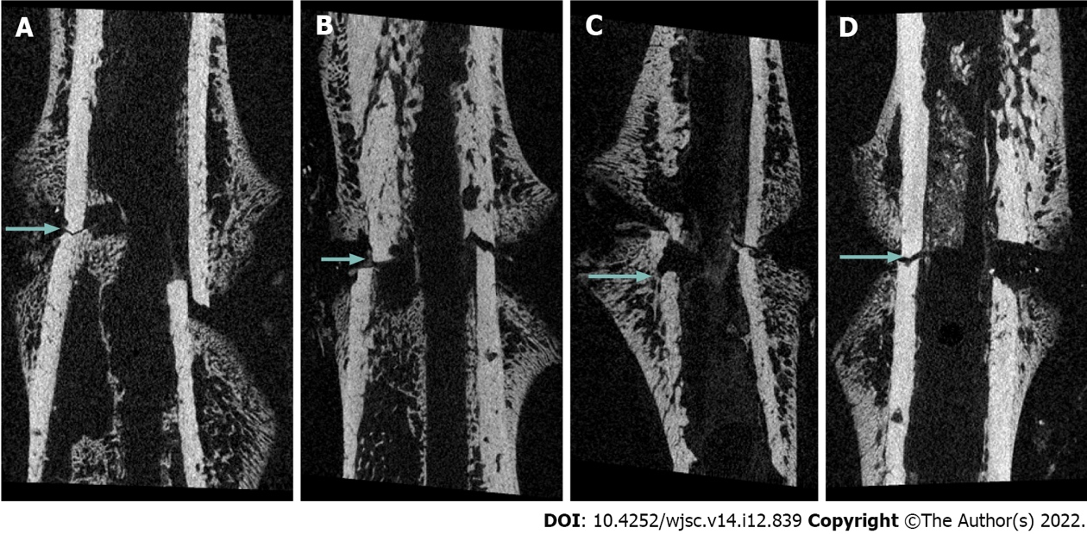
Figure 1 Micro-computed tomography imaging at 2 wk post-fracture. A: Rats were injected with normal saline; B: Rats were injected with 2.5 × 10⁶ mesenchymal stem cells (MSCs); C: Rats were injected with 5.0 × 10⁶ MSCs; D: Rats were injected with 10.0 × 10⁶ MSCs. Callus formation was observed in all groups; however, fracture lines (arrows) were clearly observed, indicating that union had not yet occurred.

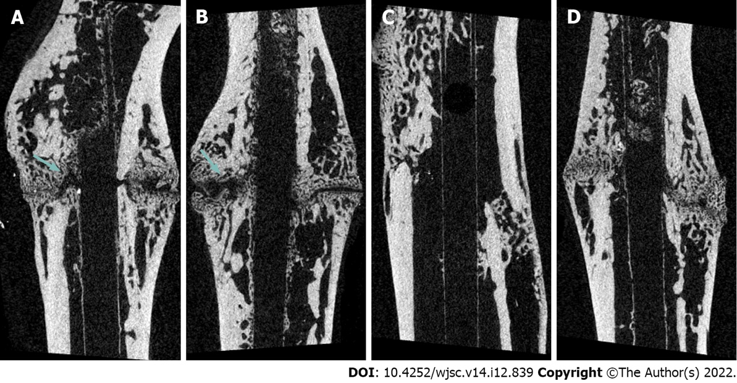
Figure 2 Micro-computed tomography imaging at 6 wk post-fracture. A: Rats were injected with normal saline; B: Rats were injected with 2.5 × 10⁶ adipose-derived-mesenchymal stem cells (AD-MSCs); C: Rats were injected with 5.0 × 10⁶ AD-MSCs; D: Rats were injected with 10.0 × 10⁶ AD-MSCs. In the group injected with normal saline and 2.5 × 10⁶ AD-MSCs, fracture lines (arrows) were clearly observed, indicating that union had not yet occurred.

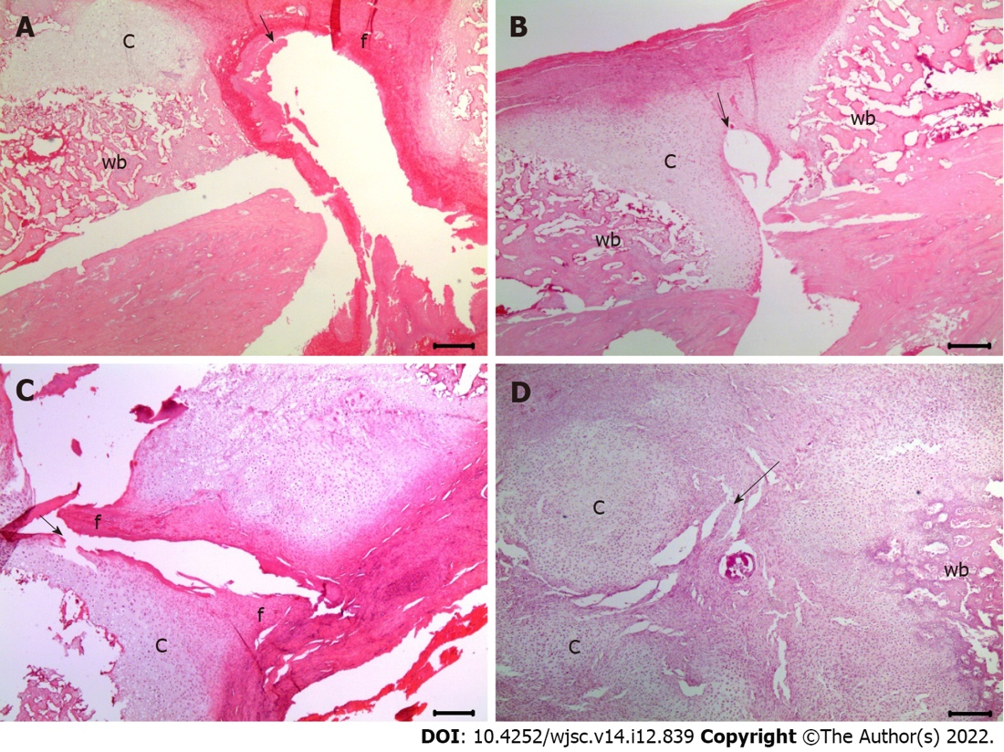
Figure 3 Assessment of histological scores for fracture healing at 2 wk post-fracture using hematoxylin and eosin staining (200 × magnification). A: The histological score was 2 in the group injected with normal saline; B: The histological score was 3 in the group injected with 2.5 × 10⁶ mesenchymal stem cells (MSCs); C: The histological score was 4 in the groups injected with 5.0 × 10⁶ MSCs; D: The histological score was 4 in the groups injected with 10.0 × 10⁶ MSCs. The black arrows indicate the fracture lines. c: Cartilage in the fracture area; f: Fibrous tissue; wb: Woven bone.

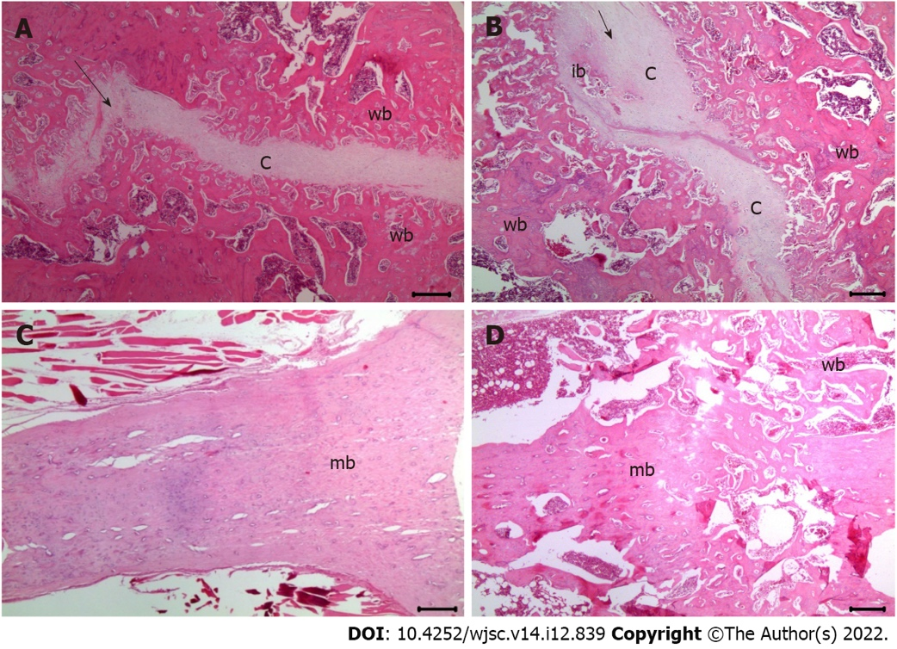
Figure 4 Assessment of histological scores for fracture healing at 6 wk post-fracture using hematoxylin and eosin staining (200 × magnification). A: The histological score was 5 in the groups injected with normal saline; B: The histological score was 5 in the groups injected with 2.5 × 10⁶ mesenchymal stem cells (MSCs); C: The histological score was 9 in the group injected with 5.0 × 10⁶ MSCs; D: The histological score was 10 in the group injected with 10.0 × 10⁶ MSCs. The black arrows indicate the fracture lines. c: Cartilage in the fracture area; wb: Woven bone; ib: Immature bone; mb: Mature bone.
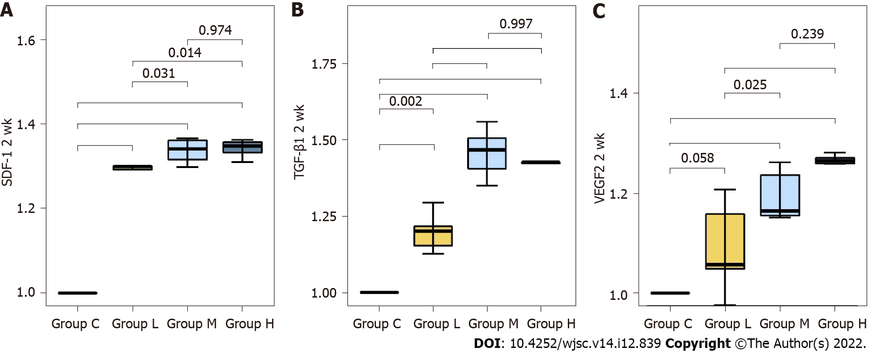
Figure 5 Relative protein expression levels of chemokines related to mesenchymal stem cell migration and angiogenesis at 2 wk post-fracture. SDF-1: Stromal cell-derived factor 1; TGF-β1: Transforming growth factor-beta 1; VEGF: Vascular endothelial growth factor.

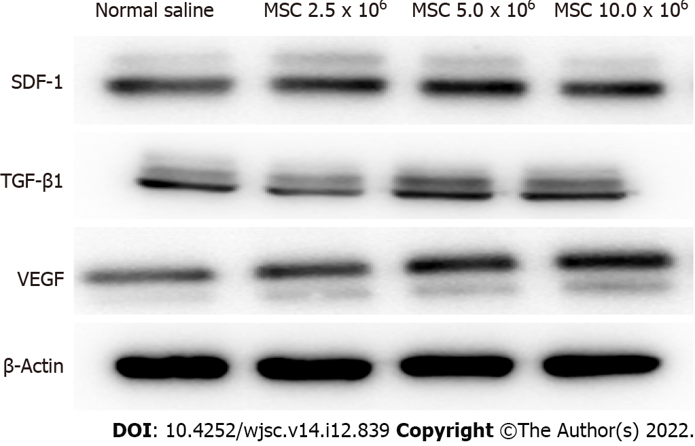
Figure 6 Western blot analysis of factors related to mesenchymal stem cell homing and angiogenesis. At 2 wk post-fracture, the protein expressions of stromal cell-derived factor 1 (SDF-1), transforming growth factor-beta 1 (TGF-β1) and vascular endothelial growth factor (VEGF) were significantly higher in the groups injected with 5.0 × 10⁶ and 10.0 × 10⁶ mesenchymal stem cells (MSCs) compared to the group injected with normal saline. No significant difference in SDF-1, TGF-β1 and VEGF protein expression was found in the groups injected with 5.0 × 10⁶ and 10.0 × 10⁶ MSCs. MSCs: Mesenchymal stem cells; SDF-1: Stromal cell-derived factor 1; TGF-β1: Transforming growth factor-beta 1; VEGF: Vascular endothelial growth factor.

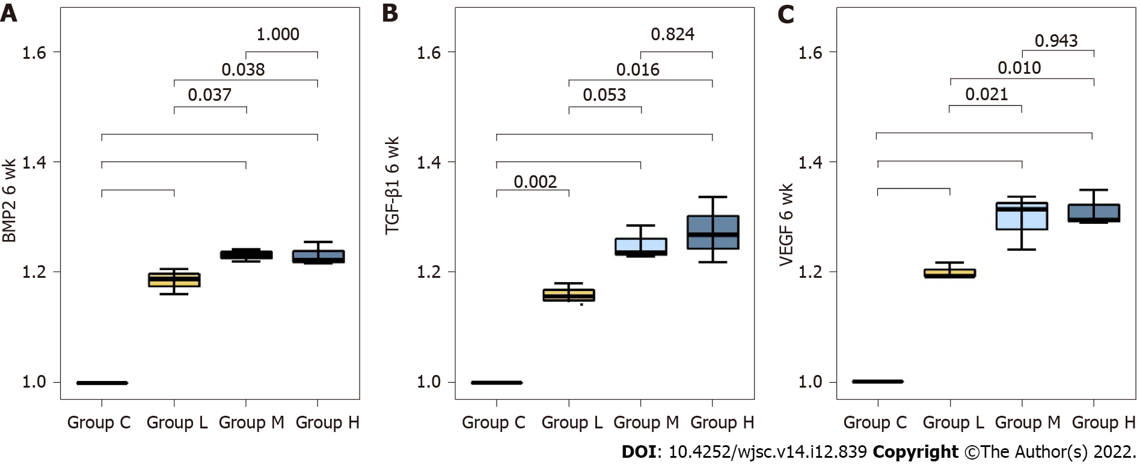
Figure 7 Relative mRNA expression levels of osteogenesis-related factors and chemokines related to angiogenesis at 6 wk post-fracture. BMP: Bone morphogenetic protein; TGF-β1: Transforming growth factor-beta 1; VEGF: Vascular endothelial growth factor.

Table 1 Fracture healing scores according to the histological findings
Score | Histological findings
1 | Fibrous tissue
2 | Predominantly fibrous tissue with small amount of cartilage
3 | Equal mixture of fibrous and cartilaginous tissue
4 | Predominantly cartilage with small amount of fibrous tissue
5 | Cartilage
6 | Predominantly cartilage with small amount of immature bone
7 | Equal mixture of cartilage and immature bone
8 | Predominantly immature bone with small amount of cartilage
9 | Union of fracture fragments by immature bone
10 | Union of fracture fragments by mature bone

Table 2 Radiologic evaluation of the fractures using micro-computed tomography analysis
 |  | Normal saline | 2.5 × 10⁶ | 5.0 × 10⁶ | 10.0 × 10⁶
Two weeks post-fracture | BV (μm³) | 34.9 ± 3.1 | 37.3 ± 4.5 | 45.3 ± 2.9 | 45.7 ± 4.9
 | Normal saline | - | 0.878 | 0.048 | 0.040
 | 2.5 × 10⁶ | 0.878 | - | 0.137 | 0.112
 | 5.0 × 10⁶ | 0.048 | 0.137 | - | 0.999
 | 10.0 × 10⁶ | 0.040 | 0.112 | 0.999 | -
 | PBV (TV/BV, %) | 7.3 ± 0.8 | 9.0 ± 0.5 | 10.8 ± 1.2 | 11.0 ± 2.6
 | Normal saline | - | 0.517 | 0.079 | 0.067
 | 2.5 × 10⁶ | 0.517 | - | 0.509 | 0.445
 | 5.0 × 10⁶ | 0.079 | 0.509 | - | 0.999
 | 10.0 × 10⁶ | 0.067 | 0.445 | 0.999 | -
Six weeks post-fracture | BV (μm³) | 71.3 ± 8.0 | 78.7 ± 8.8 | 101.4 ± 14.0 | 107.2 ± 6.9
 | Normal saline | - | 0.798 | 0.023 | 0.009
 | 2.5 × 10⁶ | 0.798 | - | 0.083 | 0.030
 | 5.0 × 10⁶ | 0.023 | 0.083 | - | 0.887
 | 10.0 × 10⁶ | 0.009 | 0.030 | 0.887 | -
 | PBV (TV/BV, %) | 13.4 ± 2.2 | 15.0 ± 3.1 | 20.5 ± 2.2 | 23.6 ± 3.3
 | Normal saline | - | 0.769 | 0.004 | 0.001
 | 2.5 × 10⁶ | 0.769 | - | 0.026 | 0.003
 | 5.0 × 10⁶ | 0.004 | 0.026 | - | 0.425
 | 10.0 × 10⁶ | 0.001 | 0.003 | 0.425 | -
CT: Computed tomography; BV: Bone volume; PBV: Percentage bone volume; TV: Tissue volume.

Published by Baishideng Publishing Group Inc
7041 Koll Center Parkway, Suite 160, Pleasanton, CA 94566, USA
Telephone: +1-925-3991568
E-mail: bpgoffice@wjgnet.com
Help Desk: https://www.f6publishing.com/helpdesk
https://www.wjgnet.com

© 2022 Baishideng Publishing Group Inc. All rights reserved.

