Name of Journal: World Journal of Clinical Cases
Manuscript NO: 79022
Manuscript Type: CASE REPORT

Pomolidomide for relapsed/refractory light chain amyloidosis after resistance to both bortezomib and daratumumab: A case report

Li X et al. Pomolidomide for relapsed/refractory AL amyloidosis

Xian Li, Xiao-Hong Pan, Qiu Fang, Yun Liang

Xian Li, Yun Liang, Department of Hematology, The Second Affiliated Hospital, College of Medicine, Zhejiang University, Hangzhou 310009, Zhejiang Province, China

Xiao-Hong Pan, Department of Cardiology, The Second Affiliated Hospital, College of Medicine, Zhejiang University, Hangzhou 310009, Zhejiang Province, China

Qiu Fang, Department of Hematology, Huzhou Central Hospital, Affiliated Huzhou Hospital, Zhejiang University School of Medicine, Huzhou 313099, Zhejiang Province, China

Author contributions: Li X, Pan XH, and Liang Y contributed to the design and conception of the study; Li X and Fang Q contributed to data collection; Li X contributed to writing the initial drafting of the manuscript; Liang Y reviewed and edited the original draft; All authors contributed to manuscript revision and read and approved the submitted version.

Corresponding author: Yun Liang, MD, Chief Physician, Department of Hematology, The Second Affiliated Hospital, College of Medicine, Zhejiang University, No. 88 Jiefang Road, Hangzhou 310009, Zhejiang Province, China. liangyun@zju.edu.cn

Received: August 9, 2022
Revised: October 13, 2022
Accepted: November 4, 2022
Published online: December 6, 2022

Abstract
BACKGROUND
Immunoglobulin light chain (AL) amyloidosis is a rare disease characterized by deposition of ALs essentially in any organ or tissue, with cardiac involvement being very frequent (61%). Early diagnosis is of high importance because early initiation of treatment in AL amyloidosis may improve outcomes. Despite the administration of immunotherapeutic agents, in particular bortezomib and daratumumab, which have improved the outcomes of AL amyloidosis, anti-plasma cell therapy remains suboptimal for some patients.

CASE SUMMARY
We report the case of a 55-year-old man presenting with heart failure who was diagnosed with cardiac AL amyloidosis by an endomyocardial biopsy. He experienced a short-term hematological remission with no organ response after being administered a bortezomib-daratumumab containing regimen. The treatment was switched to pomolidomide due to pulmonary involvement and progressive pleural effusion, in which flow cytometry analysis showed abnormal plasma cells. After two cycles of this regimen, the pleural effusion was controlled effectively with no recurrence.

CONCLUSION
This case emphasizes the crucial role of endomyocardial biopsy in early diagnosis of cardiac amyloidosis and suggests that pomolidomide may be an effective treatment for patients with AL amyloidosis that is relapsed/refractory to both bortezomib and daratumumab.

Key Words: Immunoglobulin light chain amyloidosis; Relapsed/refractory; Pleural effusion; Endo-myocardial biopsy; Immunomodulatory agent; Case report

©The Author(s) 2022. Published by Baishideng Publishing Group Inc. All rights reserved.

Citation: Li X, Pan XH, Fang Q, Liang Y. Pomolidomide for relapsed/refractory light chain amyloidosis after resistance to both bortezomib and daratumumab: A case report. World J Clin Cases 2022; 10(34):12703-12710
URL: https://www.wjgnet.com/2307-8960/full/v10/i34/12703.htm
DOI: https://dx.doi.org/10.12998/wjcc.v10.i34.12703

Core Tip: We report the case of a 55-year-old man presenting with heart failure who was diagnosed with cardiac immunoglobulin light chain (AL) amyloidosis by an endomyocardial biopsy, in whom pomolidomide corrected severe pleural effusion after resistance to both bortezomib and daratumumab. This case emphasizes the crucial role of endomyocardial biopsy in early diagnosis of cardiac amyloidosis and suggests that pomolidomide may be an effective treatment for patients with AL amyloidosis that is relapsed/refractory to both bortezomib and daratumumab.

INTRODUCTION
Immunoglobulin light chain (AL) amyloidosis is a rare monoclonal B-cell or plasma cell disorder characterized by the aggregation of misfolded monoclonal light chain kappa or lambda, which form insoluble amyloid fibrils with a beta-sheet structure^{[1]} that are deposited and accumulated in nearly any organ or tissue^{[2]}. Cardiac involvement is very frequent in AL amyloidosis (61% of patients) and can lead to heart failure because of infiltrative heart disease, which is the main prognostic factor and carries a poor prognosis^{[3]}. Early diagnosis is therefore of high importance because early initiation of treatment in AL amyloidosis may improve outcomes^{[4]}. Many diagnostic tools are included in the workup for detection of amyloidosis. However, a biopsy of a clinically affected organ is the most sensitive method^{[5]}.
Traditional conventional chemotherapy regimens are associated with a significantly lower response rate because clonal plasma cells in most AL amyloidosis patients are less chemosensitive than those in patients with multiple myeloma^{[5]}. Despite the application of novel drugs that have been developed, in particular bortezomib and daratumumab, which have improved AL amyloidosis outcomes, anti-plasma cell therapy remains suboptimal for some patients^{[6]}.
The present study describes an AL amyloidosis patient diagnosed by endomyocardial biopsy who was treated with pomolidomide after being resistant to both bortezomib and daratumumab.

CASE PRESENTATION
Chief complaints
A 55-year-old man was admitted to The Second Affiliated Hospital of Zhejiang University School of Medicine (Hangzhou, China) in October 2021 with rapidly worsening heart failure.

History of present illness
The patient had been experiencing heart failure for 3 mo, but had begun to experience chest tightness, dyspnea, edema, and fatigue after activity.

History of past illness
The patient had undergone a pulmonary resection 20 years prior to address carcinoma in situ; his current disease state was considered stable.

Personal and family history
The patient’s personal and family histories were unremarkable.

Physical examination
The patient’s blood pressure was 87/49 mmHg, pulse rate was 101 beats per minute with a regular rhythm, and O₂ saturation was 97% at room air. Physical examination revealed that he had clear lungs and normal heart sounds with no murmurs or gallops on auscultation. His lower extremities showed mild bilateral pitting edema. No enlargement of lymph nodes, liver, or spleen was found.

Laboratory examinations
Laboratory tests showed normal findings in a complete blood count and comprehensive metabolic panel. The levels of serum lactate dehydrogenase and β₂-microglobulin were within normal limits. However, the levels of brain natriuretic peptide (385.7 pg/mL; normal: < 100) and troponin T (0.058 ng/mL; normal: < 0.014) were over the normal upper limits. Creatinine was within the normal range (at 51.9 μmol/L), while urine analysis was negative for protein. Quantitation of 24-h urinary lambda light chain showed a level of 365.2 mg. Quantitative serum immunoglobulin analyses demonstrated normal levels of IgG (at 10.5 g/L), IgA (at 2.01 g/L), and IgM (at 0.28 g/L). Serum immunofixation was used to evaluate an underlying gammopathy and showed lambda light chain proteinemia. The level of serum-free lambda light chain (FLC) was normal (at 15.56 mg/L), with the difference between the involved and uninvolved serum FLC levels being 6.75 mg/L. A bone marrow aspirate smear showed 5% infiltration of plasma cells, while flow cytometry analysis showed an abnormal population of plasma cells that accounted for 5.8% of normal cells, most of which were positive for surface CD38, CD56, CD138, and cytoplasmic λ light-chain. The fluorescence in situ hybridization test was negative, which included a 1q21 amplification, 13q14 deletion, p53 deletion, and translocation of t (4; 14), t (11; 14), t (14; 16).

Imaging examinations
Positron emission tomography/computerized tomography (PET/CT) was performed and showed no abnormal metabolic lesions. An electrocardiogram showed low voltages in the limb leads. Echocardiogram revealed severe left ventricular hypertrophy, a reduced left ventricle ejection fraction of 38.1%, and an elevated left ventricular filling pressure E/A of more than 2.04. Cardiovascular magnetic resonance imaging (MRI) showed the morphologic phenotype of increased left ventricle wall thickness, while ⁹⁹technetium pyrophosphate (⁹⁹mTc-PYP) planar scintigraphy showed a heart-to-contralateral ratio of 1.31.

Further diagnostic workup
Cardiac amyloidosis was considered as a possible etiology of the cardiomyopathy due to the left ventricle thickness on echocardiogram and the heart-to-contralateral ratio of 1.31 on ⁹⁹mTc-PYP. An endomyocardial biopsy was performed with electron microscopy, revealing fibroid deposits in the myocardium and after Congo-red staining, fibrous tissue with apple green birefringence visualized by polarized light microscopy (Figure 1). Immunohistochemistry analysis showed dominant positivity for monoclonal lambda light chains.

FINAL DIAGNOSIS
Taken together, these findings established a diagnosis of cardiac AL amyloidosis (stage 2, Mayo 2012 model).

TREATMENT
The patient then underwent four courses of chemotherapy including bortezomib, daratumumab, and dexamethasone, which achieved a partial hematologic response without a cardiac response. Remarkably, despite there no longer being a detectable monoclonal component on serum immunofixation or monoclonal plasma cells in a bone marrow aspirate, the patient’s troponin T level remained at 0.140 ng/mL with the brain natriuretic peptide level of 399.6 pg/mL. Moreover, the symptom of chest tightness rapidly exacerbated. Computed tomography showed bilateral pleural effusions, while PET/CT revealed multiple pulmonary nodules with an increased metabolism of fluorodeoxyglucose (Figure 2). Thoracocentesis was performed with flow cytometry analysis, revealing 10.754% abnormal plasma cells with CD38 and CD56 positivity in the pleural effusion (Figure 3). With the clinical and biochemical evidence of disease progression, the patient was started on a pomolidomide-cyclophosphamide-dexamethasone regimen.

OUTCOME AND FOLLOW-UP
After two cycles, the patient showed good tolerance of the regimen without any notable side effects, and his brain natriuretic peptide and troponin T levels had reduced slightly to 304.1 pg/mL and 0.114 ng/mL, respectively. The results of echocardiography after treatment were as follows: Left ventricular hypertrophy; left ventricle ejection fraction of 37.4%; and E/A ratio of 1.94. These findings were similar to those at diagnosis, although the pleural effusion was eliminated with no recurrence (Figure 4).

DISCUSSION
This brief report describes a patient with AL amyloidosis diagnosed by an endomyocardial biopsy, in whom pomolidomide corrected severe pleural effusion after resistance to both bortezomib and daratumumab. The main points of this interesting case are as follows. First, the case emphasizes the crucial role of endomyocardial biopsy in the diagnosis of cardiac amyloidosis. Second, it shows the possibility that some patients may have progression of disease despite there no longer being a detectable monoclonal component on serum immunofixation or monoclonal plasma cells in a bone marrow aspirate. Third and last, the case demonstrates the efficacy of pomolidomide in treating relapsed/refractory AL amyloidosis and offers an opportunity for remission.
AL amyloidosis is a systemic disease characterized by deposition of ALs essentially in any organ or tissue, resulting in dysfunction of the affected organs. Because of the rapid progress and poor prognosis of AL amyloidosis, early detection and treatment are necessary. The diagnostic criteria for AL amyloidosis include clinical presentation of organ dysfunction, evidence of amyloid deposition, and dominant monoclonal immunoglobulin or free light chains. Histopathological detection of these changes remains the diagnostic gold standard^{[7]}.
To establish the diagnosis, detection of amyloidosis is required using a biopsy of subcutaneous fat, bone marrow, or salivary glands. However, biopsy of a clinically affected organ is the most sensitive method, in particular a heart biopsy, despite this procedure being associated with a risk of an adverse event^{[8]}. In AL amyloidosis, positive staining for Congo red, an 8-14 nm wide fibrillar appearance by electron microscopy, and apple-green birefringence under polarized light microscopy are the common histopathologic features. Dominant positivity for monoclonal light chain kappa or lambda can be seen by immunohistochemistry, although in some cases identification of the amyloid subunit may be equivocal^{[5]}.
Mass spectrometry is therefore the standard for confirming protein composition in amyloid deposits and is superior to immunohistochemistry in typing the protein subunit^{[9]}. In addition to histopathologic confirmation of amyloid deposits in tissue, cardiovascular imaging has taken on an increasingly important role in the diagnosis of cardiac amyloidosis. ⁹⁹mTc-PYP has been found useful in distinguishing between AL cardiac amyloidosis and transthyretin amyloidosis (heart-to-contralateral ratio ≥ 1.5)^{[8]}. Echocardiogram and cardiac MRI have also shown the ability to evaluate cardiac function and provide prognostic information to predict mortality. The potential utility of PET/CT is to identify cardiac amyloidosis and quantify the burden of amyloid deposition^{[10]}.
The major determinants of outcome in amyloidosis include the extent of cardiac involvement, response durability^{[11]}, and the burden of light chain deposition. Meanwhile, bone marrow plasma cell infiltration and cytogenetic risk have been shown to predict relapse and long-term survival^{[12]}. According to previous clinical studies, AL amyloidosis patients with an initial difference between the involved and uninvolved serum FLC < 50 mg/L have a meaningful advantage in clinical outcome, in whom an early hematologic response within 3 mo indicates a favorable prognosis^{[13]}. In our case, the patient had normal cytogenetics with low initial amyloidogenic FLC levels and had an early hematological remission without cardiac response. Although serum monoclonal immunoglobulin and bone marrow clonal plasma cells were negative following first-line treatment, the patient developed rapid progression of extra-cardiac infiltration including the pleura and pulmonary region. This imbalance between normal monoclonal light chain burden and apparent organ involvement could potentially be explained by distinctive selective and toxic monoclonal light chains in tissues^{[14]}. However, the detailed mechanisms still remain unclear.
During the last two decades, application of novel drugs that have been developed have optimized the overall prognosis of AL amyloidosis. Bortezomib, a proteasome inhibitor, is an attractive option for AL amyloidosis patients, as there is evidence that it significantly improves overall response rate^{[15]}. Bortezomib-based regimens have been used to initiate treatment for newly diagnosed patients with AL amyloidosis, in particular in combination with the anti-CD38 antibody daratumumab. In the ANDROMEDA study, daratumumab plus CyBorD (bortezomib-cyclophosphamide-dexamethasone) had a higher overall hematologic response rate (96%) and organ response rate (64%) compared to that of controls without daratumumab therapy^{[6]}. However, these immunotherapeutic agents remain suboptimal for some patients. Immunomodulatory drugs such as thalidomide, lenalidomide, and pomalidomide exert direct and indirect anti-plasma cell activity by regulating the immune response, enhancing natural killer cell cytotoxicity directly or through T cell stimulation, and modulating the microenvironment^{[16]}.
Currently, most patients receive immunomodulatory drug-based rescue therapy, which can overcome resistance to daratumumab and bortezomib^{[8,16]}. Because AL amyloidosis is commonly accompanied by significant organ dysfunction, treatment must be minimally toxic to avoid clinical deterioration. Thalidomide and lenalidomide have poor tolerance in patients with cardiac amyloidosis, with the efficacy of thalidomide also being limited. Pomalidomide, a next-generation immunomodulatory agent, induces a rapid hematologic response rate ranging from 44%-66%, associated with a renal response in 17%-44% of cases^{[17-19]}. Even in heavily pretreated refractory patients, who previously received bortezomib (93%) and lenalidomide (81%), pomalidomide was an effective treatment, eliciting a hematologic response rate ranging from 37%-49%^{[17]}. Moreover, pomalidomide toxicity is manageable, even in the fragile population of patients with cardiac or renal dysfunction. Pomalidomide will also most likely further improve the outcome of relapsed/refractory AL amyloidosis patients.

CONCLUSION
We report an AL amyloidosis patient diagnosed by an endomyocardial biopsy, to whom pomolidomide was effective after resistance to both bortezomib and daratumumab. We hope that our experience will provide a reference for physicians to improve early diagnosis and appropriate management for AL amyloidosis.

REFERENCES
1 Bianchi G, Kumar S. Systemic Amyloidosis Due to Clonal Plasma Cell Diseases. Hematol Oncol Clin North Am 2020; 34: 1009-1026 [PMID: 33099420 DOI: 10.1016/j.hoc.2020.08.001]
2 Martinez-Naharro A, Hawkins PN, Fontana M. Cardiac amyloidosis. Clin Med (Lond) 2018; 18: s30-s35 [PMID: 29700090 DOI: 10.7861/clinmedicine.18-2-s30]
3 Quock TP, Yan T, Chang E, Guthrie S, Broder MS. Epidemiology of AL amyloidosis: a real-world study using US claims data. Blood Adv 2018; 2: 1046-1053 [PMID: 29748430 DOI: 10.1182/bloodadvances.2018016402]
4 Sperry BW, Ikram A, Hachamovitch R, Valent J, Vranian MN, Phelan D, Hanna M. Efficacy of Chemotherapy for Light-Chain Amyloidosis in Patients Presenting With Symptomatic Heart Failure. J Am Coll Cardiol 2016; 67: 2941-2948 [PMID: 27339491 DOI: 10.1016/j.jacc.2016.03.593]
5 Ryšavá R. AL amyloidosis: advances in diagnostics and treatment. Nephrol Dial Transplant 2019; 34: 1460-1466 [PMID: 30299492 DOI: 10.1093/ndt/gfy291]
6 Palladini G, Kastritis E, Maurer MS, Zonder J, Minnema MC, Wechalekar AD, Jaccard A, Lee HC, Bumma N, Kaufman JL, Medvedova E, Kovacsovics T, Rosenzweig M, Sanchorawala V, Qin X, Vasey SY, Weiss BM, Vermeulen J, Merlini G, Comenzo RL. Daratumumab plus CyBorD for patients with newly diagnosed AL amyloidosis: safety run-in results of ANDROMEDA. Blood 2020; 136: 71-80 [PMID: 32244252 DOI: 10.1182/blood.2019004460]
7 Siddiqi OK, Ruberg FL. Cardiac amyloidosis: An update on pathophysiology, diagnosis, and treatment. Trends Cardiovasc Med 2018; 28: 10-21 [PMID: 28739313 DOI: 10.1016/j.tcm.2017.07.004]
8 Gertz MA. Immunoglobulin light chain amyloidosis: 2022 update on diagnosis, prognosis, and treatment. Am J Hematol 2022; 97: 818-829 [PMID: 35429180 DOI: 10.1002/ajh.26569]
9 Barreca A, Bottasso E, Veneziano F, Giarin M, Nocifora A, Martinetti N, Attanasio A, Biancone L, Benevolo G, Roccatello D, Cassoni P, Papotti MG; Amyloidosis Group of the “Rete Interregionale Piemonte e Valle d’Aosta per le Malattie Rare”. Immunohistochemical typing of amyloid in fixed paraffin-embedded samples by an automatic procedure: Comparison with immunofluorescence data on fresh-frozen tissue. PLoS One 2021; 16: e0256306 [PMID: 34428239 DOI: 10.1371/journal.pone.0256306]
10 Taiwo AA, Alapati L, Movahed A. Cardiac amyloidosis: A case report and review of literature. World J Clin Cases 2019; 7: 742-752 [PMID: 30968039 DOI: 10.12998/wjcc.v7.i6.742]
11 Ravichandran S, Law S, Mahmood S, Wisniowski B, Foard D, Fontana M, Martinez-Naharro A, Whelan C, Gillmore JD, Lachmann HJ, Hawkins PN, Wechalekar AD. Early relapse is an adverse prognostic marker in systemic immunoglobulin light chain (AL) Amyloidosis. Leukemia 2022; 36: 1180-1184 [PMID: 34987193 DOI: 10.1038/s41375-021-01497-7]
12 Palladini G, Milani P, Merlini G. Predicting survival in light chain amyloidosis. Haematologica 2019; 104: 1294-1296 [PMID: 31257205 DOI: 10.3324/haematol.2019.218859]
13 Dittrich T, Bochtler T, Kimmich C, Becker N, Jauch A, Goldschmidt H, Ho AD, Hegenbart U, Schönland SO. AL amyloidosis patients with low amyloidogenic free light chain levels at first diagnosis have an excellent prognosis. Blood 2017; 130: 632-642 [PMID: 28550043 DOI: 10.1182/blood-2017-02-767475]
14 Merlini G, Palladini G. Light chain amyloidosis: the heart of the problem. Haematologica 2013; 98: 1492-1495 [PMID: 24091927 DOI: 10.3324/haematol.2013.094482]
15 Manwani R, Cohen O, Sharpley F, Mahmood S, Sachchithanantham S, Foard D, Lachmann HJ, Quarta C, Fontana M, Gillmore JD, Whelan C, Hawkins PN, Wechalekar AD. A prospective observational study of 915 patients with systemic AL amyloidosis treated with upfront bortezomib. Blood 2019; 134: 2271-2280 [PMID: 31578202 DOI: 10.1182/blood.2019000834]
16 Gavriatopoulou M, Kastritis E, Ntanasis-Stathopoulos I, Fotiou D, Roussou M, Migkou M, Ziogas DC, Kanellias N, Terpos E, Dimopoulos MA. The addition of IMiDs for patients with daratumumab-refractory multiple myeloma can overcome refractoriness to both agents. Blood 2018; 131: 464-467 [PMID: 29167176 DOI: 10.1182/blood-2017-10-809293]
17 Milani P, Sharpley F, Schönland SO, Basset M, Mahmood S, Nuvolone M, Kimmich C, Foli A, Sachchithanantham S, Merlini G, Wechalekar A, Palladini G, Hegenbart U. Pomalidomide and dexamethasone grant rapid haematologic responses in patients with relapsed and refractory AL amyloidosis: a European retrospective series of 153 patients. Amyloid 2020; 27: 231-236 [PMID: 32449385 DOI: 10.1080/13506129.2020.1767566]
18 Sharpley FA, Manwani R, Mahmood S, Sachchithanantham S, Lachmann H, Gilmore J, Whelan C, Hawkins P, Wechalekar A. Real world outcomes of pomalidomide for treatment of relapsed light chain amyloidosis. Br J Haematol 2018; 183: 557-563 [PMID: 30095161 DOI: 10.1111/bjh.15541]
19 Palladini G, Milani P, Foli A, Basset M, Russo F, Perlini S, Merlini G. A phase 2 trial of pomalidomide and dexamethasone rescue treatment in patients with AL amyloidosis. Blood 2017; 129: 2120-2123 [PMID: 28130212 DOI: 10.1182/blood-2016-12-756528]

Footnotes
Informed consent statement: All study participants or their legal guardian provided informed written consent about personal and medical data collection prior to study enrolment.

Conflict-of-interest statement: All the authors report having no relevant conflicts of interest for this article.

CARE Checklist (2016) statement: The authors have read the CARE Checklist (2016), and the manuscript was prepared and revised according to the CARE Checklist (2016).

Open-Access: This article is an open-access article that was selected by an in-house editor and fully peer-reviewed by external reviewers. It is distributed in accordance with the Creative Commons Attribution NonCommercial (CC BY-NC 4.0) license, which permits others to distribute, remix, adapt, build upon this work non-commercially, and license their derivative works on different terms, provided the original work is properly cited and the use is non-commercial. See: https://creativecommons.org/Licenses/by-nc/4.0/

Provenance and peer review: Unsolicited article; Externally peer reviewed.
Peer-review model: Single blind

Peer-review started: August 9, 2022
First decision: October 12, 2022
Article in press: November 4, 2022

Specialty type: Medicine, research and experimental
Country/Territory of origin: China
Peer-review report’s scientific quality classification
Grade A (Excellent): 0
Grade B (Very good): B
Grade C (Good): C
Grade D (Fair): 0
Grade E (Poor): 0

P-Reviewer: Charach L, Israel; Paydas S, Turkey S-Editor: Liu GL L-Editor: A P-Editor: Liu GL
Figure Legends
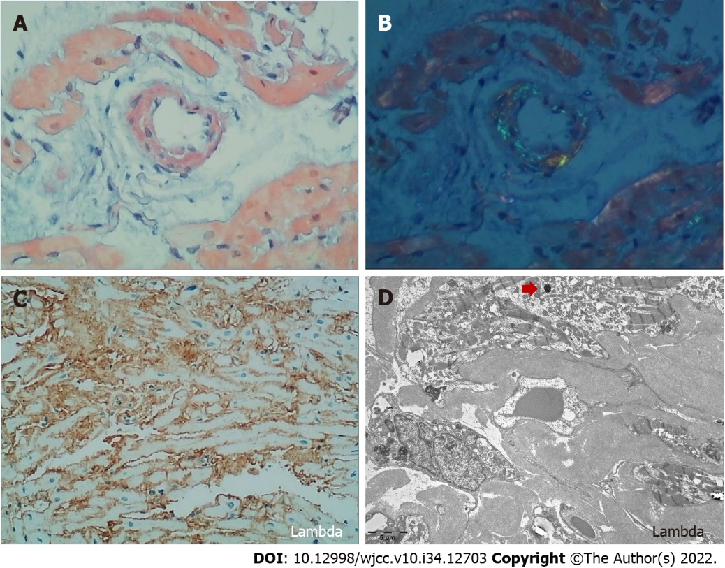
Figure 1 Endomyocardial biopsy. A: Light microscopy showed amyloid deposits-stained pink to red by Congo red; B: The amyloid showed an apple-green birefringence under polarized light; C: Monoclonal lambda light chains were visualized by immunohistochemistry; D: Electron microscopy showed an 8-12 nm wide fibrillar appearance (400 ×). The red arrow indicates protein colloids in the amyloid fiber.
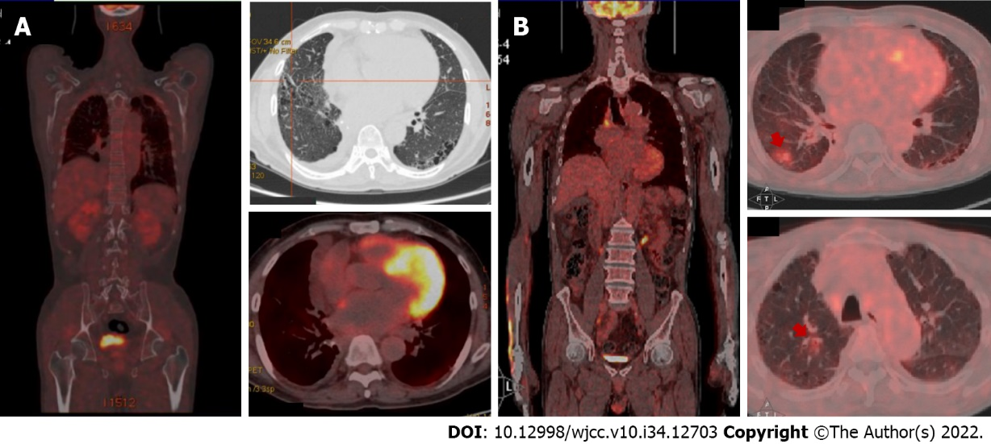
Figure 2 Positron emission tomography/computerized tomography evaluations. A: Positron emission tomography/computerized tomography (PET/CT) showed no abnormal metabolism lesions at diagnosis; B: PET/CT examination showed significantly positive lesions and confirmed refractory/relapse after first-line therapy. The red arrows indicate increased-fluorodeoxyglucose metabolism lesions.
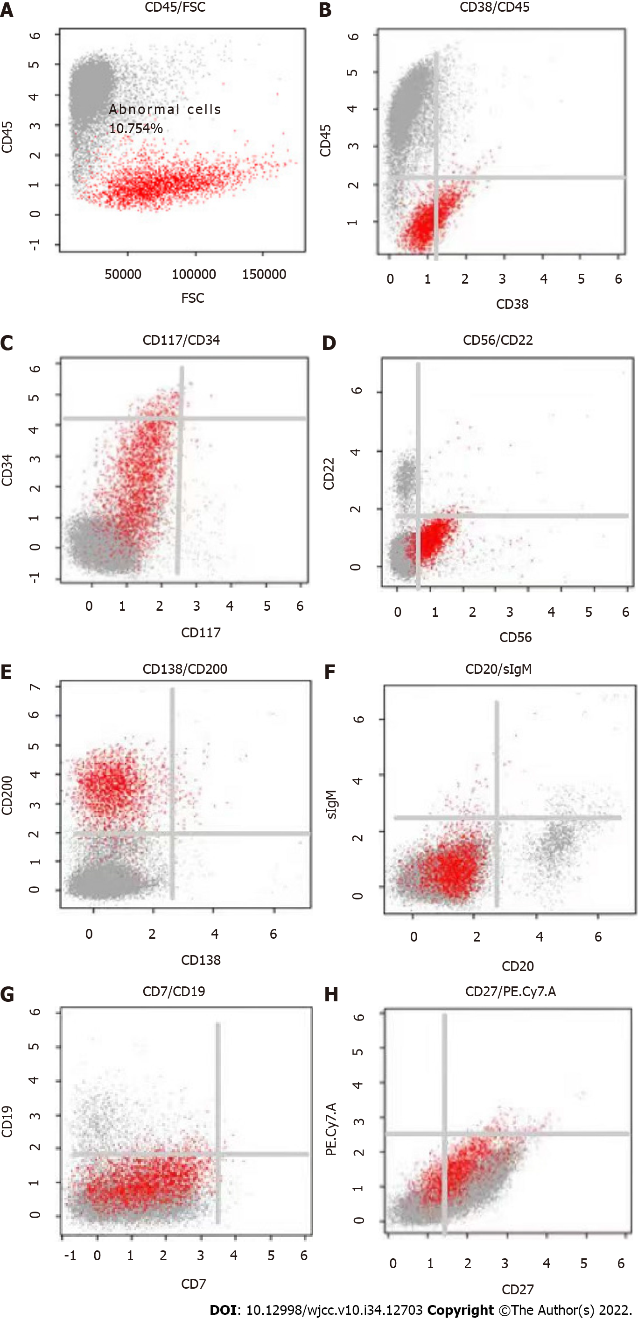
Figure 3 Flow cytometry analysis of a pleural effusion. A: The result showed abnormal plasma cells accounted for 10.754% (2804/26075) of the nucleated cells; B: These cells were weakly positive for CD38; C: These cells were positive for CD34 and negative for CD117; D: These cells were positive for CD56 and negative for CD22; E: These cells were positive for CD200 and negative for CD138; F: These cells were negative for CD20 and secretory immunoglobulin M; G: These cells were negative for CD19 and CD7; H: These cells were weakly positive for CD27. sIgM: Secretory immunoglobulin M.
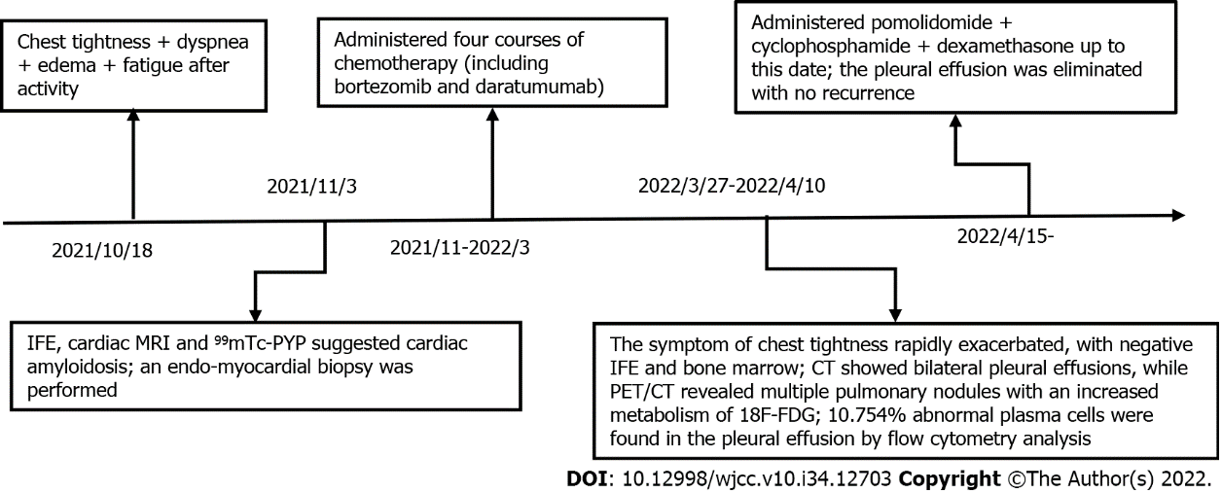
Figure 4 Timeline of reported events. The most relevant symptoms, diagnostics, and treatment of the patient are presented in chronological order. CT: Computed tomography; IFE: Serum immunofixation; MRI: Magnetic resonance imaging; PET/CT: Positron emission tomography/computerized tomography; 18F-FDG: Fluorodeoxyglucose; ⁹⁹mTc-PYP: ⁹⁹Technetium pyrophosphate.

Published by Baishideng Publishing Group Inc
7041 Koll Center Parkway, Suite 160, Pleasanton, CA 94566, USA
Telephone: +1-925-3991568
E-mail: bpgoffice@wjgnet.com
Help Desk: https://www.f6publishing.com/helpdesk
https://www.wjgnet.com

© 2022 Baishideng Publishing Group Inc. All rights reserved.

