Name of journal: World Journal of Gastrointestinal Oncology
ESPS Manuscript NO: 9917
Columns: Observational Study

Single nucleotide polymorphisms of GNAS1 T393C TT predicts better outcome of advanced non-small cell lung cancer patients

Gong HY et al. Single nucleotide polymorphisms of GNAS1 T393C TT

Hong-Yun Gong, Wei-Guo Hu, Xiu-Ling Wang, Fan Zhu, Qin-Bin Song

Hong-Yun Gong, Wei-Guo Hu, Qin-Bin Song, Department of Oncology, Renmin Hospital of Wuhan University, Wuhan 430060, Hebei Province, China

Xiu-Ling Wang, Fan Zhu, Department of Medical Microbiology, School of Medicine, Wuhan University, Wuhan 430060, Hebei Province, China

Author contributions: Gong HY searched out the GNAS1 T393C polymorphism from a large number of literature and isolated genomic DNA from peripheral blood leucocytes; Hu WG collected blood samples of patients; Wang XL finished the genotyping of gemomic DNA; Zhu F gave suggtions in writing introdution and discussion of this article; Song QB directed and coordinated the accomplish of this reseach; all authors were involved in organizing and refining the article.

Correspondence to: Dr. Qin-Bin Song, Department of Oncology, Renmin Hospital of Wuhan University, No.238 JieFang Road, Wuhan 430060, Hebei Province, China. baxinfangkaihao@sina.com

Telephone: +86-131-63347213 Fax: +86-131-63347213

Received: March 3, 2014 Revised: October 28, 2014
Accepted: October 31, 2014

Published online:

Abstract
AIM: To evaluate the potential prognostic value of GNAS1 T393C polymorphism in advanced non-small cell lung cancer.

METHODS: We extracted genomic DNA from the peripheral blood leucocytes of 94 patients with advanced non-small cell lung cancer. Quantitative real-time polymerase chain reaction was used to determine the allelic discrimination. The correlation between genotype and overall survival was evaluated according to the multivariate analysis and Kaplan-Meier approach.

RESULTS: Thirty-eight out of 94 (40%) patients displayed a TT genotype, 29 out of 94 (31%) a CT genotype and 27 out of 94 (29%) a CC genotype. The median survival of TT (25 mo) genotype was longer than CT (12 mo) or CC (8 mo) genotype. The favorable TT genotype predict better overall survival (OS) (2-year OS: 48%; P =0.01) compared with CT (2-year OS: 18%) or CC (2-year OS: 15%) genotype. However, dichotomization between C-genotypes (CC+CT) and T-genotypes (TT) revealed signiﬁcantly lower survival rates (2-year OS: 16%; P = 0.01) for C allele carriers.

CONCLUSION: Our data provided strong evidence that genetic polymorphism in the GNAS1 T393C inﬂuenced the prognosis in advanced non-small lung cancer with a worse outcome for C allele carriers.

© 2014 Baishideng Publishing Group Inc. All rights reserved.

Key words: GNAS1; Polymorphism; Advanced non-small cell lung cancer; Prognosis

Core tip: We evaluated T393C-SNP in a homogenous (Han) study population of patients to evaluate the effect of this polymorphism on survival in non-small-cell lung cancer (NSCLC). Our study indicated that genetic polymorphism in the GNAS1 T393C affected the overall survival in advanced NSCLC with a worse outcome for C allele carriers.

Gong HY, Hu WG, Wang XL, Zhu F, Song QB. Single nucleotide polymorphisms of GNAS1 T393C TT predicts better outcome of advanced non-small cell lung cancer patients. World J Gastrointest Oncol 2014; In press

INTRODUCTION
Lung cancer has increased substantially over the past ten years^{[1]}. Non-small-cell lung cancer (NSCLC) constitutes about 85% of all lung cancer patients^{[2]} with only 16.6% can live 5 years or more after diagnosis^{[3]}. To date, the most feasible treatment for advanced NSCLC patients is the platinum-based combination chemotherapy and it turns out to have better overall survival rates^{[4]}. TNM stages normally correlate with the clinical outcome of a large population of patients, but patients with similar clinical characteristics have different outcomes, which may be affected by their individual genes. The identification of patients with high-risk lung cancer could thus help to set up novel treatment strategies and could theoretically improve the outcome of anti-cancer therapy. Therefore, it is desirable to characterize more reliable and accurate molecular markers to identify more aggressive lung cancer phenotypes in order to individually tailor the therapy.
Actually, previous studies have implied that biomarkers could help define the subgroups of patients. However, there is no standard way to immunohistochemically detect these biomarkers, which prevents their application as prognostic factors. Nowadays, people choose to study single nucleotide polymorphisms (SNPs) as prognostic markers because these SNPs can be easily evaluated from patients’ blood, which can avoid issues such as the availability and the quality of materials. One typical example is the gene GNAS1 T393C polymorphism.
The gene, GNAS1, has been mapped to chromosome 20q13 and has 13 exons located in exon 5, which encodes the α-subunit of the stimulatoryG protein, namely Gαs. Somatic mutations of GNAS1 has been reported to be involved in the etiology of McCune Albright Syndrome and sporadic, isolated endocrine tumors^{[5-7]}, suggesting that GNAS1 could participate in cancer initiation and progression. What’s more, previous studies have demonstrated that the T393C polymorphism was significantly correlated with the prognosis of patients with various cancers, such as breast carcinoma, squamous cell carcinoma of the larynx, bladder cancer, cholangiocarcinoma, colorectal cancer, clear cell renal carcinoma, oropharynx and hypopharynx^{[8-20]}.
In this study, we evaluated the T393C-SNP polymorphism in Han population to evaluate the effect of this polymorphism on lung cancer prognosis. Our purpose was to determine whether the common GNAS1 T393C polymorphismcan be used as a prediction factor for survival in NSCLC patients.

MATERIALS AND METHODS
Patients and clinical samples
Two mL peripheral blood samples were collected from patients diagnosed with advanced NSCLC pathologically before any antineoplastic treatment at Renmin Hospital of Wuhan University (China) between March 2010 and March 2012. Patients were chosen based on the following criteria: (1) UICC(2009) stage IIIB or IV histologically confirmed NSCLC;(2) Eastern Cooperative Oncology Group PS of 2 or less; (3) life expectancy of more than 3 months. Patients were not included if they had taken any anti-tumor therapy previously. All patients were asked to sign the informed consent before including them in the database. The study cohort (94 patients; for clinicopathological data, Table 1) composed exclusively of patients with a meticulously complete follow-up record. This study was performed following the guidelines of the local Research Ethics Commission.

DNA extraction and genotyping
The patient DNA was isolated from whole blood samples using the QIAamp kit (Qiagen, Germany). T393C-SNP (dbSNP rs7121) amplified by PCR with the following primers: Forward primer 5’-CAGCCCACATTAGGGAGCATAT-3’ and Reverse primer 5’-TAATCCCTGCCTATGCTCACGA-3’. After denaturation at 95°C, 50 cycles of DNA amplification were done using (NH4)₂SO₄ containing buffer (Bioron, Germany) at 95°C for 60 s, 60°C for 30 s, and 70°C for 60 s. The 807-bp PCR products were genotyped by their sequences.

Statistical analysis
The software SPSS 17.0 was used in the statistical analysis in this study. Descriptive statistics were applied to describe patient baseline characteristics. The correlation between T393C genotypes and the clinical outcome were evaluated by Kaplan-Meier plots and the log-rank test. The survival time were calculated from the date of the primary diagnosis to the end of follow-up or date of death, whichever occurred first. The independent influence of T393C-SNP and other covariates on survival rates was assessed in multivariate analysis by cox regression hazard model .Only when the P value is less than 0.05, it is considered as statistical significant in the presentation of results. The compatibility with the Hardy-Weinberg equilibrium was calculated with HWE (http:// linkage.rockefeller.edu/ott/linkutil.htm).

RESULTS
Analysis of GNAS1 T393C genotypes and associated clinicopathological features
The clinicopathological characteristics of patients with genotype distribution were shown in Table 1. In sum, there were 94 advanced NSCLC patients participating in this study with 23 women and 71 men . The average age of participants was 58.6 years old, which ranges from 31 to 80 years old.
Among 94 patients, 38 (40%) patients displayed a TT genotype, 29 (31%) with a CT genotype and 27 (29%) with a CC genotype. In the entire patient group, the frequency of the C allele (fC) was 0.55. The distribution was compatible with the Hardy-Weinberg equilibrium. There was no significant correlation between the GNAS1 T393C genotypes and clinicopathological parameters, such as age (P = 0.48), gender (P = 0.42), performance status (PS) (P = 0.30), smoking status (P = 0.44) or pathology (P = 0.59) (Table 2). Further analysis showed that there was no signiﬁcant correlation of overall survival (OS) with age (P = 0.135), gender (P = 0.0580), PS (P = 0.658), smoking (P = 0.473), pathology (P = 0.559), or treatment mode (P = 0.116).

GNAS1 T393C TT type predicts favorable survival
The median survival of TT, CT, and CC genotypes was 25, 12, and 8 mo, respectively. We analyzed the relationship between overall survival rate verall survival and T393C genotypes by Kaplan-Meier survival curves. Our data showed that the favorable TT genotype was significantly associated with better OS (2-year OS: 48%; P = 0.01) when compared with the other genotypes. For example, the 2-year OS for CT genotype is 18%and 15% for CC genotype (Figure 1). By applying the multivariate Cox proportional hazards model, we found that GNAS1 T393C polymorphism was independently associated with OS after adjusting the clinicopathological factors (P < 0.05). However, the dichotomization between C-genotypes (CC+CT) and T-genotypes (TT), indicates signiﬁcant lower survival rates for C allele patients (P = 0.01), which have a 2-year OS of 16% (Figure 2).

DISCUSSION
Lung cancer is the major cause of cancer death in the world and there is an urgent need to accurately and individually treat patient with lung cancer. Although clinicopathological parameters such as UICC stages may serve as prognostic markers in lung cancer, it is still desirable to develop more reliable and accurate biomarkers to more precisely predict the clinical outcome of individual patients. Most prognostic biomarkers are developed according to the features of the tumor tissue itself. GNAS1 gene encodes the Gαs subunit of G proteins and it has been shown that the GNAS1 T393C polymorphism correlates with lung cancer^{[20]}. Hence, we investigated whether GNAS1 T393C polymorphism can be used to predict the clinical outcome in patients with NSCLC. Our study clearly indicated that the homozygous TT patients had a much longer survival rate than patients with either homozygous CC or heterozygous CT. If we could identify patients with poor clinical outcome, then we might develop novel treatment strategies accordingly at the initial stage of management, which could lead to improved individual therapy strategies with higher survival rates. Meanwhile, our results also indicated the potential role of GNAS1 T393C polymorphism as a possible general genetic marker for tumor progression and survival since T-allele carriers demonstrated better clinical outcome than C-allele carriers (TC and CC genotypes). However, it should be noted that the connection between GNAS1 T393C polymorphism and survival was different in different types of tumors. For some tumors, TT genotype was significantly correlated with better OS compared with CT or CC genotypes. For example, In advanced squamous cell carcinoma of the larynx, the five-year survival rate for TT genotype patients were 76%, 49% for TC genotype, and 43.5% for CC genotype^{[10]}. Also, it had been reported that the five-year survival rate of sporadic colorectal cancer patients with a TT genotype (87.8%) is much higher than patients with TC (71.0%) and CC genotypes (50.0%)^{[15]}. On the other hand, in intrahepatic cholangio-carcinoma^{[9]}, esophageal cancer^{[12]} and breast cancer^{[16]}, the patients of CC genotype had a more favorable clinical outcome (Table 3). Thus, it was conceivable that the GNAS1 T393C polymorphism in various tumor type played different biological effects. In order to underly the significance of the T393C genotypes in different tumor types, further more studies were needed to find out the molecular mechanisms.
The in vitro studies demonstrated that increased Gαs expression promotes apoptosis^{[21]}. Therefore, it is highly likely that increased Gαs expression and the subsequently increased apoptosis could be associated with better survival rate in patients with GANS1 TT genotype. The in vitro experiments also suggest that the product of Gαs, cyclic AMP, could play a crucial role in the proapoptotic process. It has been reported that increasing the intracellular concentration of cyclic AMP leads to enhanced apoptosis in several cell lines including lymphoma cells^{[5]}, leukemic^{[22]} and ovarian cancer^{[23]}. And Gαs was also found to differentially express between various GNAS1 T393C genotypes. Previous studies have suggested that the Gαs transcription level is increased in individuals with GNAS1 393 TT genotype^{[13]}. Intriguingly, the mRNA stability has been shown to be determined by the coding region of some genes^{[24-26]}. Using the MFOLD (the software for the prediction of the secondary structure of single stranded nucleic acids), Alakus et al has been reported that the substitution of T393 to C affects the structure of mRNA, most likely the mRNA folding^{[8]}.
Several biomarkers have been used as predictive and prognostic markers for NSCLC patients. A prognostic biomarker is a molecule that can be used to indicate the patient survival independent of the treatment received. In other words, it is an indicator of the innate tumor aggressiveness. For example, KRAS mutations can be served as a good prognostic biomarker indicating the poor survival for NSCLC patients when compared with the patients without KRAS mutations, independent of therapy. Xie et al^{[20]} has reported that the GNAS1 T393C polymorphism can somehow predict the chemotherapy sensitivity and overall survival rate in advanced NSCLC patients treated with gemcitabine and platinum^{[20]}. Here, our data clearly showed that the GNAS1 T393C TT genotype was prognostic of better overall survival for NSCLC patients, independent of therapy.
Nevertheless, it should be emphasized that in this study, we only investigated a small population of patients. Although our study indicated that genetic host factors play a role in tumor progression, which was consistent with the previously published data^{[20]}, further independent studies of large cohorts were necessary to confirm their validity. Furthermore, the molecular mechanisms underlying the significance of the GNAS1 T393C genotype associated with potentially surrogate SNPs remained to be explored.

COMMENTS
Background
Lung cancer is major cause of cancer death around the world. Although some clinicopathological parameters like UICC stages may be used as prognostic biomarkers in lung cancer, other reliable markers that can help precisely predict the clinical outcome of individual patients are still desirable. Most prognostic biomarkers are based on features of the tumor tissue itself.

Research frontiers
Characterization of single nucleotide polymorphisms (SNPs) as a prognostic biomarker in cancer has become the hotspot of recent research. The T393C polymorphism of the gene GNAS1 is one such polymorphism.
Innovations and breakthroughs
Several molecular markers have been used as predictive and prognostic markers for non-small-cell lung cancer (NSCLC). A prognostic biomarker is a biomolecule that can be used to indicate the patient survival independent of the treatment received. It can also indicate for the innate tumor aggressiveness. For example, the KRAS mutations was prognostic of poor survival for NSCLC patients when compared to the absence of KRAS mutations, independent of therapy. Xie et al. reported that the GNAS1 T393C polymorphism can be used topredict the chemotherapy sensitivity as well as the survival rates in advanced NSCLC patients treated with gemcitabine and platinum. Here, our data clearly indicate that the GNAS1 T393C TT genotype was prognostic of better survival rates for NSCLC patients, independent of therapy.
Applications
The identification of patients with high-risk lung cancer could help develop novel and individual treatment strategies and could improve the clinical outcome. Our data clearly indicate that genetic polymorphism in the GNAS1 T393C inﬂuenced survival in advanced non-small lung cancer with a worse clinical outcome for C allele patients.
Terminology
Single nucleotide polymorphisms (SNPs): SNPs refer to a DNA sequence variation occurring commonly within a population (e.g., 1%) in which a Single Nucleotide -A, T, C or G - in the genome (or other shared sequence) differs between members of a biological species or paired chromosomes.
Peer review
The manuscript is comprehensive and important.

REFERENCES
1 Jemal A, Bray F, Center MM, Ferlay J, Ward E, Forman D. Global cancer statistics. CA Cancer J Clin 2011; 61: 69-90 [PMID: 21296855 DOI: 10.3322/caac.20107]
2 Molina JR, Yang P, Cassivi SD, Schild SE, Adjei AA. Non-small cell lung cancer: epidemiology, risk factors, treatment, and survivorship. Mayo Clin Proc 2008; 83: 584-594 [PMID: 18452692 DOI: 10.1016/S0025-6196(11)60735-0]
3 Forde PM, Ettinger DS. Targeted therapy for non-small-cell lung cancer: past, present and future. Expert Rev Anticancer Ther 2013; 13: 745-758 [PMID: 23773106 DOI: 10.1586/era.13.47]
4 Schiller JH, Harrington D, Belani CP, Langer C, Sandler A, Krook J, Zhu J, Johnson DH. Comparison of four chemotherapy regimens for advanced non-small-cell lung cancer. N Engl J Med 2002; 346: 92-98 [PMID: 11784875 DOI: 10.1056/NEJMoa011954]
5 Yan L, Herrmann V, Hofer JK, Insel PA. beta-adrenergic receptor/cAMP-mediated signaling and apoptosis of S49 lymphoma cells. Am J Physiol Cell Physiol 2000; 279: C1665-C1674 [PMID: 11029315]
6 Collins MT, Sarlis NJ, Merino MJ, Monroe J, Crawford SE, Krakoff JA, Guthrie LC, Bonat S, Robey PG, Shenker A. Thyroid carcinoma in the McCune-Albright syndrome: contributory role of activating Gs alpha mutations. J Clin Endocrinol Metab 2003; 88: 4413-4417 [PMID: 12970318 DOI: 10.1210/jc.2002-021642]
7 Lyons J, Landis CA, Harsh G, Vallar L, Grünewald K, Feichtinger H, Duh QY, Clark OH, Kawasaki E, Bourne HR. Two G protein oncogenes in human endocrine tumors. Science 1990; 249: 655-659 [PMID: 2116665 DOI: 10.1126/science.2116665]
8 Alakus H, Mönig SP, Warnecke-Eberz U, Alakus G, Winde G, Drebber U, Schmitz KJ, Schmid KW, Riemann K, Siffert W, Bollschweiler E, Hölscher AH, Metzger R. Association of the GNAS1 T393C polymorphism with tumor stage and survival in gastric cancer. World J Gastroenterol 2009; 15: 6061-6067 [PMID: 20027678 DOI: 10.3748/wjg.15.6061]
9 Schmitz KJ, Lang H, Frey UH, Sotiropoulos GC, Wohlschlaeger J, Reis H, Takeda A, Siffert W, Schmid KW, Baba HA. GNAS1 T393C polymorphism is associated with clinical course in patients with intrahepatic cholangiocarcinoma. Neoplasia 2007; 9: 159-165 [PMID: 17356712 DOI: 10.1593/neo.06796]
10 Lehnerdt GF, Franz P, Winterhoff S, Bankfalvi A, Grehl S, Lang S, Schmid KW, Siffert W, Jahnke K, Frey UH. The GNAS1 T393C polymorphism predicts survival in patients with advanced squamous cell carcinoma of the larynx. Laryngoscope 2008; 118: 2172-2176 [PMID: 19029852]
11 Frey UH, Nückel H, Sellmann L, Siemer D, Küppers R, Dürig J, Dührsen U, Siffert W. The GNAS1 T393C polymorphism is associated with disease progression and survival in chronic lymphocytic leukemia. Clin Cancer Res 2006; 12: 5686-5692 [PMID: 17020971 DOI: 10.1158/1078-0432.CCR-06-0288]
12 Vashist YK, Kutup A, Musici S, Yekebas EF, Mina S, Uzunoglu G, Zehler O, Koenig A, Cataldegirmen G, Bockhorn M, Effenberger K, Kalinin V, Pantel K, Izbicki JR. The GNAS1 T393C single nucleotide polymorphism predicts the natural postoperative course of complete resected esophageal cancer. Cell Oncol (Dordr) 2011; 34: 281-288 [PMID: 21340746 DOI: 10.1007/s13402-011-0016-x]
13 Frey UH, Eisenhardt A, Lümmen G, Rübben H, Jöckel KH, Schmid KW, Siffert W. The T393C polymorphism of the G alpha s gene (GNAS1) is a novel prognostic marker in bladder cancer. Cancer Epidemiol Biomarkers Prev 2005; 14: 871-877 [PMID: 15824158 DOI: 10.1158/1055-9965.EPI-04-0720]
14 Frey UH, Lümmen G, Jäger T, Jöckel KH, Schmid KW, Rübben H, Müller N, Siffert W, Eisenhardt A. The GNAS1 T393C polymorphism predicts survival in patients with clear cell renal cell carcinoma. Clin Cancer Res 2006; 12: 759-763 [PMID: 16467086 DOI: 10.1158/1078-0432.CCR-05-1722]
15 Frey UH, Alakus H, Wohlschlaeger J, Schmitz KJ, Winde G, van Calker HG, Jöckel KH, Siffert W, Schmid KW. GNAS1 T393C polymorphism and survival in patients with sporadic colorectal cancer. Clin Cancer Res 2005; 11: 5071-5077 [PMID: 16033819 DOI: 10.1158/1078-0432.CCR-05-0472]
16 Otterbach F, Callies R, Frey UH, Schmitz KJ, Wreczycki C, Kimmig R, Siffert W, Schmid KW. The T393C polymorphism in the gene GNAS1 of G protein is associated with survival of patients with invasive breast carcinoma. Breast Cancer Res Treat 2007; 105: 311-317 [PMID: 17186357 DOI: 10.1007/s10549-006-9462-y]
17 Lehnerdt GF, Franz P, Zaqoul A, Schmitz KJ, Grehl S, Lang S, Schmid KW, Siffert W, Jahnke K, Frey UH. Overall and relapse-free survival in oropharyngeal and hypopharyngeal squamous cell carcinoma are associated with genotypes of T393C polymorphism of the GNAS1 gene. Clin Cancer Res 2008; 14: 1753-1758 [PMID: 18347176 DOI: 10.1158/1078-0432.CCR-07-1605]
18 Frey UH, Fritz A, Rotterdam S, Schmid KW, Potthoff A, Altmeyer P, Siffert W, Brockmeyer NH. GNAS1 T393C polymorphism and disease progression in patients with malignant melanoma. Eur J Med Res 2010; 15: 422-427 [PMID: 21156401 DOI: 10.1186/2047-783X-15-10-422]
19 Kaderi MA, Murray F, Jansson M, Merup M, Karlsson K, Roos G, Aleskog A, Tobin G. The GNAS1 T393C polymorphism and lack of clinical prognostic value in chronic lymphocytic leukemia. Leuk Res 2008; 32: 984-987 [PMID: 18006055 DOI: 10.1016/j.leukres.2007.10.003]
20 Xie FJ, Zhao P, Kou JY, Hong W, Fu L, Hu L, Hong D, Su D, Gao Y, Zhang YP. The T393C polymorphism of GNAS1 as a predictor for chemotherapy sensitivity and survival in advanced non-small-cell lung cancer patients treated with gemcitabine plus platinum. Cancer Chemother Pharmacol 2012; 69: 1443-1448 [PMID: 22371153]
21 Yang X, Lee FY, Wand GS. Increased expression of Gs(alpha) enhances activation of the adenylyl cyclase signal transduction cascade. Mol Endocrinol 1997; 11: 1053-1061 [PMID: 9212053]
22 Myklebust JH, Josefsen D, Blomhoff HK, Levy FO, Naderi S, Reed JC, Smeland EB. Activation of the cAMP signaling pathway increases apoptosis in human B-precursor cells and is associated with downregulation of Mcl-1 expression. J Cell Physiol 1999; 180: 71-80 [PMID: 10362019 DOI: 10.1002/(SICI)1097-4652(199907)180: 1<71: : AID-JCP8>3.0.CO; 2-N]
23 Srivastava RK, Srivastava AR, Cho-Chung YS, Longo DL. Synergistic effects of retinoic acid and 8-Cl-cAMP on apoptosis require caspase-3 activation in human ovarian cancer cells. Oncogene 1999; 18: 1755-1763 [PMID: 10208436 DOI: 10.1038/sj.onc.1202464]
24 Duan J, Wainwright MS, Comeron JM, Saitou N, Sanders AR, Gelernter J, Gejman PV. Synonymous mutations in the human dopamine receptor D2 (DRD2) affect mRNA stability and synthesis of the receptor. Hum Mol Genet 2003; 12: 205-216 [PMID: 12554675 DOI: 10.1093/hmg/ddg055]
25 Capon F, Allen MH, Ameen M, Burden AD, Tillman D, Barker JN, Trembath RC. A synonymous SNP of the corneodesmosin gene leads to increased mRNA stability and demonstrates association with psoriasis across diverse ethnic groups. Hum Mol Genet 2004; 13: 2361-2368 [PMID: 15333584 DOI: 10.1093/hmg/ddh273]
26 Tierney MJ, Medcalf RL. Plasminogen activator inhibitor type 2 contains mRNA instability elements within exon 4 of the coding region. Sequence homology to coding region instability determinants in other mRNAs. J Biol Chem 2001; 276: 13675-13684 [PMID: 11278713]

P-Reviewer: Garfield D, Kermanizadeh A, Nacak M, Zhang YJ S-Editor: Ji FF L-Editor: E-Editor:
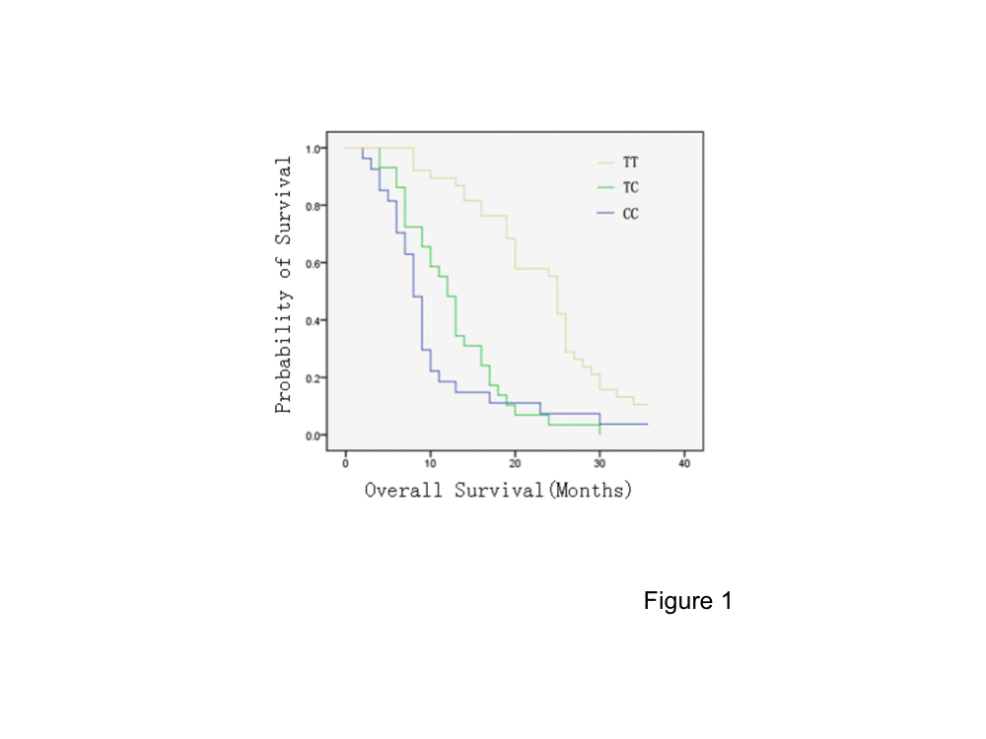
Figure 1 The overall survival of 94 lung cancer patients according to GNAS1 T393C genotypes. The data were analyzed by Kaplan-Meier analysis, P < 0.01, TT genotype vs other genotypes.
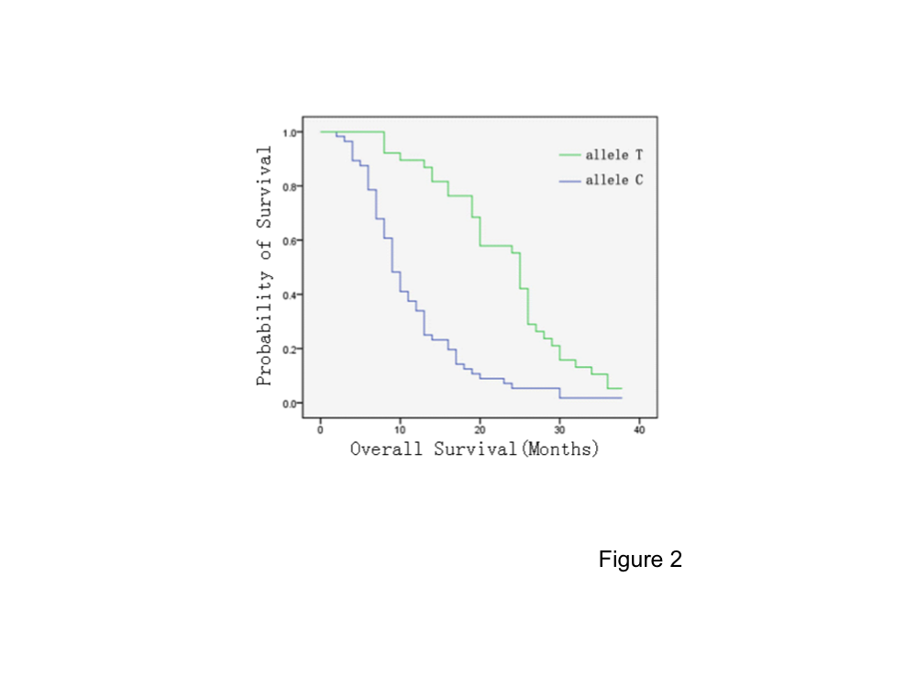
Figure 2 The overall survival of 94 lung cancer patients according to GNAS1 T393C genotype with dichotomization between C+ and C- genotypes, P < 0.01.

Table 1 Clinicopathological characteristics of 94 patients with non-small cell lung cancer
 | Subgroup | n | MST | 1-yr-OS (%) | 2-yr-OS (%) | P
Gender | Male | 71 | 14 | 59 | 36 | 0.058
 | Female | 23 | 13 | 53 | 28
Age | ≥ 60 yr | 51 | 13 | 61 | 26 | 0.135
 | ＜ 60 yr | 43 | 16 | 52 | 36
PS | ≥ 2 | 25 | 13 | 51 | 25 | 0.658
 | ＜ 2 | 69 | 17 | 64 | 32
Smoking | Yes | 23 | 13 | 55 | 29 | 0.473
 | No | 71 | 14 | 58 | 32
Pathology | Adeno- | 48 | 13 | 54 | 36 | 0.559
 | Squar- | 46 | 14 | 63 | 29
Treatment | Supportive only | 12 | 10 | 49 | 25 | 0.116
 | Chemotherapy | 14 | 13 | 56 | 32
 | Radiotherapy | 11 | 13 | 60 | 30
 | Chemoradiotherapy | 57 | 16 | 64 | 35
GNAS1 T393C | TT | 38 | 25 | 76 | 48 | 0.01
 | TC | 29 | 12 | 54 | 18
 | CC | 27 | 8 | 23 | 15
 | TC+ CC | 56 | 11.5 | 25 | 16 | 0.01
OS: Overall survival.
Table 2 Association between GNAS1 single nucleotide polymorphism and clinical parameter
 | Subgroup | All (n = 94) | TT (n = 38; 40%) | TC (n = 29; 31%) | CC (n =27; 29%) | P
Gender | Male | 71 | 31（43.6） | 22（30.9） | 18（25.5） | 0.42
 | Female | 23 | 7（30.4） | 7（30.4） | 9（39.2）
Age | ≥ 60 yr | 51 | 22（43.1） | 13（25.5） | 16（31.4） | 0.48
 | ＜ 60 yr | 43 | 16（37.2） | 16（37.2） | 11（25.6）
PS | ≥ 2 | 25 | 13（52.0） | 5（20.0） | 7（28.0） | 0.30
 | ＜ 2 | 69 | 25（36.2） | 24（34.8） | 20（29.0）
Smoking | Yes | 23 | 12（52.2） | 6（26.1） | 5（21.7） | 0.44
 | No | 71 | 26（36.6） | 23（32.4） | 22（31.0）
Pathology | Adeno- | 48 | 19（39.6） | 17（35.4） | 12（25.0） | 0.59
 | Squar- | 46 | 19（41.3） | 12（26.1） | 15（32.6）

Table 3 The effect of GNAS1 T393C on distinct carcinomas

Author | Year | Cancer type | All | Genotype | n | OS | Benefit | P
Alakus | 2009 | Gastric cancer | 122 | TT | 26 | 56.9% | TT | 0.043
 |  |  |  | TC | 57 | 32.7%
 |  |  |  | CC | 39 | 42.6%
Schmitz | 2007 | Cholangiocarcinoma | 87 | TT | 15 | 10% | C+ | 0.04
 |  |  |  | TC | 41 | 17%
 |  |  |  | CC | 31 | 18%
Lehnerdt | 2008 | Laryngocarcinoma | 157 | TT | 40 | 76% | TT | 0.037
 |  |  |  | TC | 75 | 49%
 |  |  |  | CC | 42 | 43.5%
Frey | 2006 | Chronic lymphocytic leukemia | 144 | TT | 27 | 73% | T+ | 0.013
 |  |  |  | TC | 72 | 63.3%
 |  |  |  | CC | 45 | 33.2%
Vashist | 2011 | Esophageal cancer | 190 | TT | 38 | 19% | CC | 0.001
 |  |  |  | TC | 96 | 15%
 |  |  |  | CC | 56 | 51%
Frey | 2005 | Bladder cancer | 254 | TT | 49 | 82% | TT | 0.015
 |  |  |  | TC | 121 | 60%
 |  |  |  | CC | 84 | 58%
Frey | 2006 | Renal cancer | 150 | TT | 34 | 91% | TT | 0.01
 |  |  |  | TC | 79 | 81%
 |  |  |  | CC | 37 | 69%
Frey | 2005 | Colorectal cancer | 151 | TT | 36 | 87.8% | TT | 0.009
 |  |  |  | TC | 72 | 71%
 |  |  |  | CC | 43 | 50%
Otterbach | 2007 | Breast cancer | 279 | TT | 64 | 23% | CC | 0.01
 |  |  |  | TC | 162 | 40%
 |  |  |  | CC | 53 | 63%
Lehnerdt | 2008 | Oral carcinoma | 202 | TT | 48 | 51.3% | TT | 0.015
 |  |  |  | TC | 89 | 44.7%
 |  |  |  | CC | 65 | 36.8%
Kaderi | 2008 | Chronic lymphocytic leukemia | 279 | TT | 80 | 65% | NS | 0.802
 |  |  |  | TC | 115 | 70%
 |  |  |  | CC | 84 | 64%
Frey | 2010 | Malignant melanoma | 328 | TT | 69 | 87.1% | TT | 0.017
 |  |  |  | TC | 149 | NS
 |  |  |  | CC | 110 | 66%
Xie | 2013 | Non-small cell  lung cancer |  | TT | 33 | NS | TT | 0.02
 |  |  |  | TC | 63 | NS
 |  |  |  | CC | 35 | NS
OS: Overall survival.

