Name of Journal: World Journal of Clinical Cases
Manuscript NO: 47749
Manuscript Type: CASE REPORT

Malignant syphilis accompanied with neurosyphilis in a malnourished patient: A case report

Ge G et al. Malignant syphilis accompanied with neurosyphilis in a malnourished patient

Gai Ge, Dongmei Li, Ying Qiu, Hongjun Fu, Xiangyu Zhang, Dongmei Shi

Gai Ge, Jining Medical University, Jining 272067, Shandong Province, China

Dongmei Li, Georgetown University Medical Center, Washington, DC 20057, United States

Ying Qiu, Hong-Jun Fu, Department of Dermatology, Jining No. 1 People’s Hospital, Jining 272067, Shandong Province, China

Xiangyu Zhang, Department of Pathology, Jining No. 1 People’s Hospital, Jining 272067, Shandong Province, China

Dongmei Shi, Department of Dermatology and Laboratory of Medical Mycology, Jining No. 1 People’s Hospital, Jining 272067, Shandong Province, China

ORCID number: Gai Ge (0000-0002-9548-0785); Dong-Mei Li (0000-0002-1550-9526); Ying Qiu (0000-0001-7012-4840); Hongjun Fu (0000-0003-2075-9754); Xiangyu Zhang (0000-0003-0170-0837); Dongmei Shi (0000-0002-0886-4191).

Author contributions: Shi D designed the case report; Ge G, Shi DM, and Li DM analyzed all the data and wrote the manuscript; Qiu Y, Fu HJ, and Zhang XY collected the information; Li DM made some modifications to the manuscript. All authors read and approved the final manuscript.

Supported by the National Natural Science Foundation of China, No. 81773337; the Shandong Traditional Chinese Medicine Science and Technology Development Plans, China, No. 2017-415; the Medical and Health Science Technology Project of Shandong Province, China, No. 2017WS345; and the Natural Science Foundation of Shandong Province, China, No. ZR2015HL127.

Informed consent statement: Institutional ethics review board at Jining No. 1 People’s Hospital approved this study. The patient gave written consent for the publication of the figures as well as this case report.

Conflict-of-interest statement: The authors declare that they have no conflict of interest.

CARE Checklist (2016) statement: The authors have read the CARE Checklist (2016), and the manuscript was prepared and revised according to the CARE Checklist (2016).

Open-Access: This article is an open-access article which was selected by an in-house editor and fully peer-reviewed by external reviewers. It is distributed in accordance with the Creative Commons Attribution Non Commercial (CC BY-NC 4.0) license, which permits others to distribute, remix, adapt, build upon this work non-commercially, and license their derivative works on different terms, provided the original work is properly cited and the use is non-commercial. See: http://creativecommons.org/licenses/by-nc/4.0/

Manuscript source: Unsolicited manuscript

Corresponding author: Dongmei Shi, MD, PhD, Doctor, Department of Dermatology and Laboratory of Medical Mycology, Jining No. 1 People's Hospital, No. 6, Jiankang Road, Jining 272067, Shandong Province, China. shidongmei28@163.com
Telephone: +86-537-6050108
Fax: +86-537-2256374

Received: March 25, 2019
Peer-review started: March 26, 2019
First decision: May 31, 2019
Revised: July 9, 2019
Accepted: July 20, 2019
Article in press:
Published online:

Abstract
BACKGROUND
Syphilis is a common sexually transmitted disease caused by the Treponema pallidum (T. pallidum). Malignant syphilis is a rare presentation of secondary syphilis. Here, we present a case diagnosed with malignant syphilis accompanied with neurosyphilis.

CASE SUMMARY
A 56-year-old man present with a 2-mo history of spreading ulcerous and necrotic papules and nodules covered with thick crusts over the face, trunk, extremities, and genitalia. The patient was diagnosed with malignant syphilis accompanied by neurosyphilis based on the characteristic morphology of the lesions, positive serological and cerebrospinal fluid tests for syphilis, brain magnetic resonance imaging, and histopathology, along with resolution of the lesions following the institution of penicillin therapy. The lesions and neurological condition successfully resolved after a course of treatment with penicillin.

CONCLUSION
We suggest that neurosyphilis should be considered whenever people have psychiatric symptoms without cutaneous lesions or human immunodeficiency virus.

Key words: Malignant syphilis; Secondary syphilis; Neurosyphilis; Jarisch-Herxheimer reaction; Case report

© The Author(s) 2019. Published by Baishideng Publishing Group Inc. All rights reserved.

Core tip: We present a 53-year-old malnourished man with a two-month history of spreading ulcerative and necrotic cutaneous lesions with psychiatric symptoms. The patient was diagnosed with malignant syphilis accompanied by neurosyphilis based on the characteristic morphology, positive serological and cerebrospinal fluid tests, and histopathology, with resolution of the lesions following penicillin therapy. We report the case to emphasize the diagnosis of the disease, and its association not only with human immunodeficiency virus (HIV), but also with other poor health conditions, specifically malnutrition. We suggest that neurosyphilis should be considered whenever people have psychiatric symptoms even in case of no cutaneous lesions or HIV infection.

Ge G, Li DM, Qiu Y, Fu HJ, Zhang XY, Shi DM. Malignant syphilis accompanied with neurosyphilis in a malnourished patient: A case report. World J Clin Cases 2019; In press

INTRODUCTION
Syphilis is a common sexually transmitted disease caused by Treponema pallidum (T. pallidum). The course of the disease normally comprises primary, secondary, latent, tertiary, and neurosyphilis stages. Malignant syphilis, also known as Lues malign or ulceronodular syphilis, an uncommon ulcerative variety of secondary syphilis, is an explosive form of syphilis that was first described in the 19th century. This rare form of syphilis is characterized by a prodrome of fever, headache, and muscle pain followed by a papulopustular eruption that soon becomes necrotic, resulting in sharply demarcated ulcers with a thick, rupioid crust^{[1,2]}. Malignant syphilis most commonly affects individuals with human immunodeficiency virus (HIV) infection^{[3-5]}. However, malignant syphilis has also been noted and described in immunocompetent patients^{[6-8]} and is then commonly associated with alcoholism, malnutrition, hepatitis, pregnancy, and diabetes^{[9]}. When untreated, syphilis can spread to the brain and nervous system (neurosyphilis) during any of the stages described above. Patients co-infected with T. pallidum and HIV are at significantly higher risk for developing neurosyphilis^{[3,5-6]}.
Because its range of manifestations is so vast, syphilis has earned the nickname “The Great Imitator”^{[10]}, making its diagnosis in the emergency room notoriously difficult. The clinical manifestations of malignant syphilis are different from classical secondary syphilis in that the former is characterized by pleomorphic pustules, nodules, and deep ulcers with thick crusts. This diagnosis is often forgotten or misdiagnosed, especially when an immunocompetent patient presents with spread skin lesions and cerebral manifestations^{[11]}. Here, we present a case diagnosed as malignant syphilis accompanied with neurosyphilis, but first misdiagnosed as psoriasis/pyoderma gangrenosum and cerebral fracture. On the basis of clinical examination, serum and cerebrospinal fluid (CSF) T. pallidum particle agglutination (TPPA), rapid plasma regain (RPR), histological examination, and cerebral magnetic resonance imaging (MRI), the patient was re-diagnosed to be suffering from malignant syphilis and neurosyphilis. The patient recovered following a course of treatment with penicillin.

CASE PRESENTATION
Clinical summary
A 56-year-old male present with a 2-mo history of spreading ulcerous and necrotic papules and nodules covered with thick crusts over the face, trunk, extremities, and genitalia on March 20, 2018 (day 0). The skin lesions initially appeared as small erythematous papules over his back and gradually spread to the chest, face, extremities, and genitals. The lesions progressed to ulcerous/necrotic lesions covered with thick yellowish and blackish crusts. There was no association with systemic manifestations such as fever, weight loss, or headache; however, the patient also suffered from a loss of coordination of movement, personality changes, and changes in speech. The patient was initially diagnosed with pyoderma gangrenosum and treated for 7 d (days -8 to 1) at a local hospital, but his loss of coordination and speech impairment worsened. The patient reported having unprotected sexual activity within the past 2 mo but denied ever having had sex with men. The patient had no other apparent underlying disease. Other possibly relevant habits included smoking 20-40 cigarettes each day for more than 30 years, but the patient denied ever drinking alcohol.

Pathological findings
His height and body mass index (BMI) of 18.36 kg/m² together indicated mild malnutrition. Examination revealed pleomorphic ulcers of varying sizes ranging from 1 to 6 cm, circular and oval in shape with sharp borders, covered by yellowish and blackish thick crusts. The lesions were distributed over the face, front and back of the trunk, extremities, and genitals (Figure 1). Neurological examination showed mental confusion, mania, paranoia, and mild motor dysphasia.

Laboratory examinations
Full blood cell count, CD4+ cell count, CD8+ cell count, HIV serotest, hepatitis B and hepatitis C, antineutrophil cytoplasmic antibody and anti-nuclear antibodies, and cultures for fungi and bacteria (including Mycobacterium tuberculosis and Neisseria gonorrhoeae) were all normal or negative. Other laboratory analyses showed slightly attenuated albumin (31.3 g/L), anemia (hemoglobin 117 g/L), and elevated C reactive protein (35.00 mg/L), with no other abnormalities. Serum TPPA was positive and RPR test was at a titer of 1:16 (at +1 d).

Imaging examinations
MRI revealed abnormal hyperintense lesions in the bilateral insular cortex and radial crown, and lateral anterior horn (at +1 d) (Figure 2). Histological examination of a biopsy sample from an ulcer on his abdomen indicated obliterative vasculitis as well as infiltration of cells (predominantly lymphocytes and plasma cells) in the dermis (Figure 3A). Staining for fungi, mycobacteria, and spirochetes was all negative. Immunohistochemical staining with a polyclonal antibody against T. pallidum was positive (Figure 3B).
Because the patient was suspected to have neurosyphilis, he was arranged to undergo a lumbar puncture, but at first he refused. After treatment with penicillin (at +11 d), the patient received a lumbar puncture, which showed elevated protein (5.9 mg/dL) and high white blood cell count (16 cells/µL; predominantly lymphocytes) in CSF. TPPA was positive and RPR was negative.

FINAL DIAGNOSIS
Based on the clinical findings, along with serum TPPA, RPR, histological examination, and MRI, the patient was diagnosed with malignant syphilis with neurosyphilis.

TREATMENT
The patient was initially treated with 60 million units of penicillin three times daily for 10 d (from +1 d to +11 d). He did not present with Jarisch-Herxhiemer reaction (JHR) possibly due to the corticosteroids prescribed earlier. The lesions regressed remarkably and quickly and he was discharged from the hospital. The patient continued to respond positively to treatment with 240 million units of penicillin intramuscularly once a week for three weeks, with a complete remission of lesions and neurotic systems.

OUTCOME AND FOLLOW-UP
In next follow-up, the ulcers had healed completely, although atrophic scars remained (Figure 4); the RPR titer dropped to 1:2 and HIV serotest remained negative.

DISCUSSION
Malignant syphilis is a rare presentation of secondary syphilis, originally described by Bazin in 1859 as a nodular variant of syphilis. With the increase in the incidence of HIV infection, the morbidity as well as the frequency of this disease has increased^{[12]}. It usually occurs from 6 weeks to 1 year after the primary symptoms manifest, or even earlier in people with HIV infection^{[13,14]}. A few cases of malignant syphilis have been described, mostly associated with HIV infection, and it is rarely seen otherwise in patients with poor health conditions, diabetes, or malnutrition^{[9]}.
The occurrence of malignant syphilis together with neurosyphilis and malnutrition, as shown in the present case, is extremely rare. A few cases of malignant syphilis have been reported in the literature, most of which had no neurosyphilis or HIV infection^{[3,15]}. In the present case, the patient was not HIV positive, and therefore one of the main risk factors for the development of both malignant syphilis and neurosyphilis was absent.
Typical lesions of malignant syphilis are initially papules that rapidly evolve into pustules and finally form ulcers with an elevated border and necrotic center^{[16]}. The skin lesion mainly affects the trunk and extremities, although the face, scalp, mucous membranes, palms, soles, and genitals can also be involved. Because of the varied clinical manifestations and mimicking of several more common dermatoses, malignant syphilis is almost always misdiagnosed as another disease. In our case, at first the patient was misdiagnosed with pyoderma gangrenosum. When there is clinical suspicion of malignant syphilis, confirmation of the diagnosis will be supported by three criteria: clinical and histopathological characteristics; presence of high-titer antibodies from Venereal Diseases Research Laboratory (VDRL) or a similar test; and intense and severe JHR and rapid resolution of lesions with adequate therapy. The diagnosis is typically established by strongly positive serological tests, a severe JHR, and an excellent response to antibiotic therapy^{[17]}. In our case, the patient was prescribed with glucocorticoids prior to antibiotic therapy, in which case JHR might have been inhibited. Based on the circumstances of the present case, we believe that severe JHR should not be included as one of the mandatory criteria.
Syphilis can spread to the brain and nervous system (neurosyphilis) during any stage of the course of the disease. Neurosyphilis should be considered for any patients with syphilis accompanied by tabes dorsalis, general paresis, meningovascular neurosyphilis, or other unexplained neurological conditions. Early diagnosis and treatment are crucial due to potential persistent disabilities that can be easily treated or prevented if detected early. Brain MRI and CSF analyses are essential for treatment planning and management. In patients with a known syphilis infection who present with neurologic, ophthalmic, or tertiary syphilis symptoms, the United States Centers for Disease Control and Prevention (CDC) recommends a lumbar puncture with a CSF examination^{[18]}. The possibility of neurosyphilis should be promptly investigated, followed by empiric treatment. In the present case, widespread lesions, tabes dorsalis, serum RPR test along with MRI all suggest neurosyphilis, even without brain fluid TPPA and RPR. In addition, CSF showed elevated protein and high white blood cell count with lymphocyte predominance. Also, CSF TPPA was positive and RPR was negative. We considered that RPR was negative due to the initial treatment with penicillin. After these considerations, the patient was diagnosed with malignant syphilis with neurosyphilis.
Pathological studies show that obliterative medium-sized vessel vasculitis and plasma cell infiltrates in the dermis can be valuable tools in a challenging diagnosis^{[19]}. In the classical definition of malignant syphilis, the absence of spirochetes in tissue samples was cited as one diagnostic criterion. However, treponema can occasionally be identified by silver staining such as Steiner or Whartin-Starry techniques. Immunohistochemical staining using monoclonal antibodies against T. pallidum is sometimes helpful to identify microorganisms, especially in secondary syphilis, and has demonstrated a high sensitivity and specificity^{[2]}. In the present case, treponema was not identified using silver staining, however, in agreement with other reports, spirochetes were detected using antibodies against T. pallidum. Therefore, we propose that immunohistochemical staining can be a useful tool for confirming the diagnosis along with the clinical and serologic findings.
Although penicillin is the treatment of choice, there is no special recommended treatment for malignant syphilis. Some authors recommend increasing the dose in cases of poor general health conditions. For resistant cases or relapses, prolonged therapy with high doses of penicillin is suggested^{[20]}. In the present case, the patient was diagnosed with malignant syphilis accompanied with neurosyphilis, and he was initially treated with 60 million units of penicillin daily for 10 d, in view of the fact that crystalline penicillin was able to cross the blood-brain barrier. After he was discharged from the hospital, we chose a total dose of penicillin G benzathine (7.2 million units) for next three weeks. The lesions and neurological condition successfully resolved after the treatment, along with a fourfold decline in serum RPR.

CONCLUSION
The titers of VDRL or RPR were high in most published malignant syphilis cases, however, in our case the titer of RPR was not remarkably high, which suggests that the high titer of RPR is not always correlated to the occurrence of malignant syphilis. By presenting a variety of clinical manifestations and mimicking several common dermatoses, malignant syphilis should always be included in differential diagnoses, even though it might be rare in the absence of HIV infection. When accompanied by psychological or neurological symptoms, the physician should be alert for the possibility of neurosyphilis, and serological screening for syphilis should be routine for such patients.

REFERENCES
1 Sharma VK, Kumar B. Malignant syphilis or syphilis simulating malignancy. Int J Dermatol 1991; 30: 676 [PMID: 1938091 DOI: 10.1111/j.1365-4362.1991.tb03506.x]
2 Cid PM, Cudós ES, Zamora Vargas FX, Merino MJ, Pinto PH. Pathologically confirmed malignant syphilis using immunohistochemical staining: report of 3 cases and review of the literature. Sex Transm Dis 2014; 41: 94-97 [PMID: 24413487 DOI: 10.1097/OLQ.0000000000000084]
3 Don PC, Rubinstein R, Christie S. Malignant syphilis (lues maligna) and concurrent infection with HIV. Int J Dermatol 1995; 34: 403-407 [PMID: 7657439 DOI: 10.1111/j.1365-4362.1995.tb04441.x]
4 Delgado S, Caceres J. Malignant Syphilis in a Human Immunodeficient Virus-Infected Patient. Am J Trop Med Hyg 2017; 96: 523-524 [PMID: 28471744 DOI: 10.4269/ajtmh.16-0755]
5 Sun JR, Tu P, Wang Y. Image Gallery: Malignant syphilis in a young man with HIV infection. Br J Dermatol 2018; 178: e392 [PMID: 29897123 DOI: 10.1111/bjd.16566]
6 Requena CB, Orasmo CR, Ocanha JP, Barraviera SR, Marques ME, Marques SA. Malignant syphilis in an immunocompetent female patient. An Bras Dermatol 2014; 89: 970-972 [PMID: 25387504 DOI: 10.1590/abd1806-4841.20143155]
7 Rao AG, Swathi T, Hari S, Kolli A, Reddy UD. Malignant Syphilis in an Immunocompetent Adult Male. Indian J Dermatol 2017; 62: 524-527 [PMID: 28979018]
8 González-Lara L, Vázquez-López F, Eiris-Salvado N, Pérez-Oliva N. [Malignant syphilis in an immunocompetent patient]. Med Clin (Barc) 2013; 140: e13 [PMID: 23481872 DOI: 10.1016/j.medcli.2013.01.001]
9 Li JH, Guo H, Zheng S, Li B, Gao XH, Chen HD. Widespread Crusted Skin Ulcerations in a Man with Type II Diabetes: A Quiz. Diagnosis: Malignant syphilis. Acta Derm Venereol 2015; 95: 632-633 [PMID: 25365992 DOI: 10.2340/00015555-1999]
10 Park SY, Kang JH, Roh JH, Huh HJ, Yeo JS, Kim DY. Secondary syphilis presenting as a generalized lymphadenopathy: clinical mimicry of malignant lymphoma. Sex Transm Dis 2013; 40: 490-492 [PMID: 23680905 DOI: 10.1097/OLQ.0b013e3182897eb0]
11 Muylaert B, Almeidinha Y, Borelli N, Esteves E, Oliveira AR, Cestari CM, Garbelini GL, Eid R, Michalany A, De Oliveira Filho J. Malignant syphilis and neurosyphilis in an immunocompetent patient. J Am Acad Dermatol 2016; 74: AB152 [DOI: 10.1016/j.jaad.2016.02.599]
12 Schöfer H, Imhof M, Thoma-Greber E, Brockmeyer NH, Hartmann M, Gerken G, Pees HW, Rasokat H, Hartmann H, Sadri I, Emminger C, Stellbrink HJ, Baumgarten R, Plettenberg A. Active syphilis in HIV infection: a multicentre retrospective survey. The German AIDS Study Group (GASG). Genitourin Med 1996; 72: 176-181 [PMID: 8707318 DOI: 10.1136/sti.72.3.176]
13 de Carvalho NS, Mello GR, Castro GR, Telles FQ, Reggiani C, Piazza MJ. Malignant syphilis in an HIV seropositive woman. Int J Gynaecol Obstet 2008; 102: 297-298 [PMID: 18457838 DOI: 10.1016/j.ijgo.2008.03.015]
14 Corti M, Solari R, De Carolis L, Figueiras O, Vittar N, Maronna E. [Malignant syphilis in a patient infected by human immunodeficiency virus. Case report and literature review]. Rev Chilena Infectol 2012; 29: 678-681 [PMID: 23412041 DOI: 10.4067/S0716-10182012000700017]
15 dos Santos TR, de Castro IJ, Dahia MM, de Azevedo MC, da Silva GA, Motta RN, da Cunha Pinto J, de Almeida Ferry FR. Malignant syphilis in an AIDS patient. Infection 2015; 43: 231-236 [PMID: 25408098 DOI: 10.1007/s15010-014-0698-x]
16 Vinay K, Kanwar AJ, Narang T, Saikia UN. Malignant syphilis. Int J Infect Dis 2013; 17: e930-e931 [PMID: 23688548 DOI: 10.1016/j.ijid.2013.03.020]
17 Kingston M, French P, Higgins S, McQuillan O, Sukthankar A, Stott C, McBrien B, Tipple C, Turner A, Sullivan AK; Members of the Syphilis guidelines revision group 2015, Radcliffe K, Cousins D, FitzGerald M, Fisher M, Grover D, Higgins S, Kingston M, Rayment M, Sullivan A. UK national guidelines on the management of syphilis 2015. Int J STD AIDS 2016; 27: 421-446 [PMID: 26721608 DOI: 10.1177/0956462415624059]
18 Pastuszczak M, Wojas-Pelc A. Current standards for diagnosis and treatment of syphilis: selection of some practical issues, based on the European (IUSTI) and U.S. (CDC) guidelines. Postepy Dermatol Alergol 2013; 30: 203-210 [PMID: 24278076 DOI: 10.5114/pdia.2013.37029]
19 Rajan J, Prasad PV, Chockalingam K, Kaviarasan PK. Malignant syphilis with human immunodeficiency virus infection. Indian Dermatol Online J 2011; 2: 19-22 [PMID: 23130209 DOI: 10.4103/2229-5178.79864]
20 Shao LL, Guo R, Shi WJ, Liu YJ, Feng B, Han L, Liu QZ. Could lengthening minocycline therapy better treat early syphilis? Medicine (Baltimore) 2016; 95: e5773 [PMID: 28033297 DOI: 10.1097/MD.0000000000005773]

P-Reviewer: Maher J S-Editor: Dou Y L-Editor: Wang TQ E-Editor:
Specialty type: Medicine, research and experimental
Country of origin: China
Peer-review report classification
Grade A (Excellent): 0
Grade B (Very good): 0
Grade C (Good): C
Grade D (Fair): 0
Grade E (Poor): 0

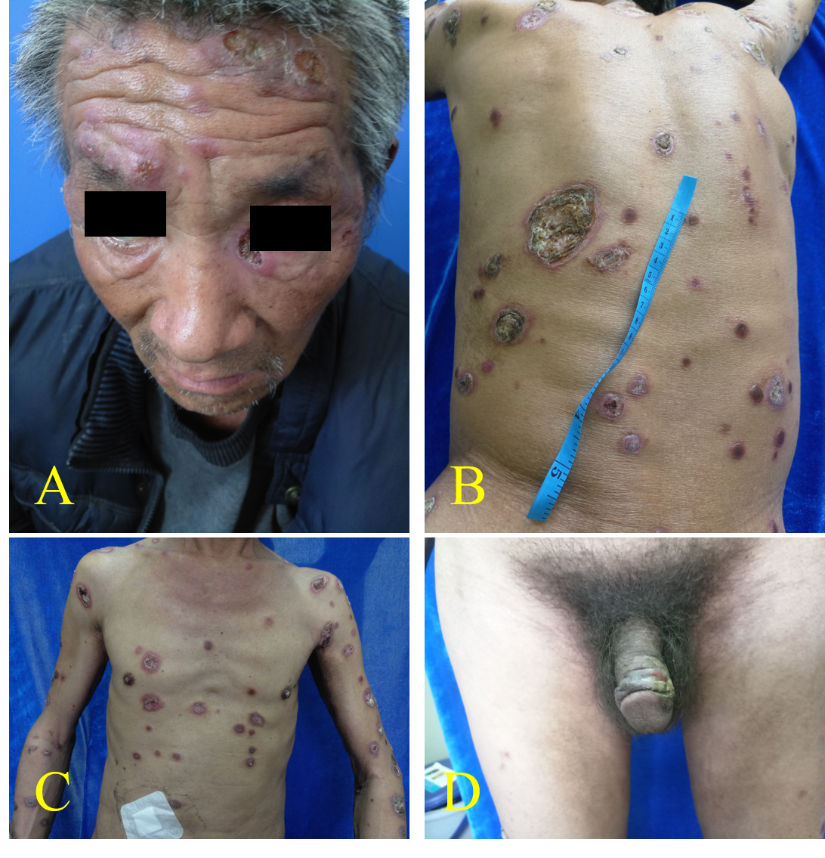
Figure 1 Widespread crusted skin ulceration. A: Face; B: Back; C: Chest; D: Genitals.

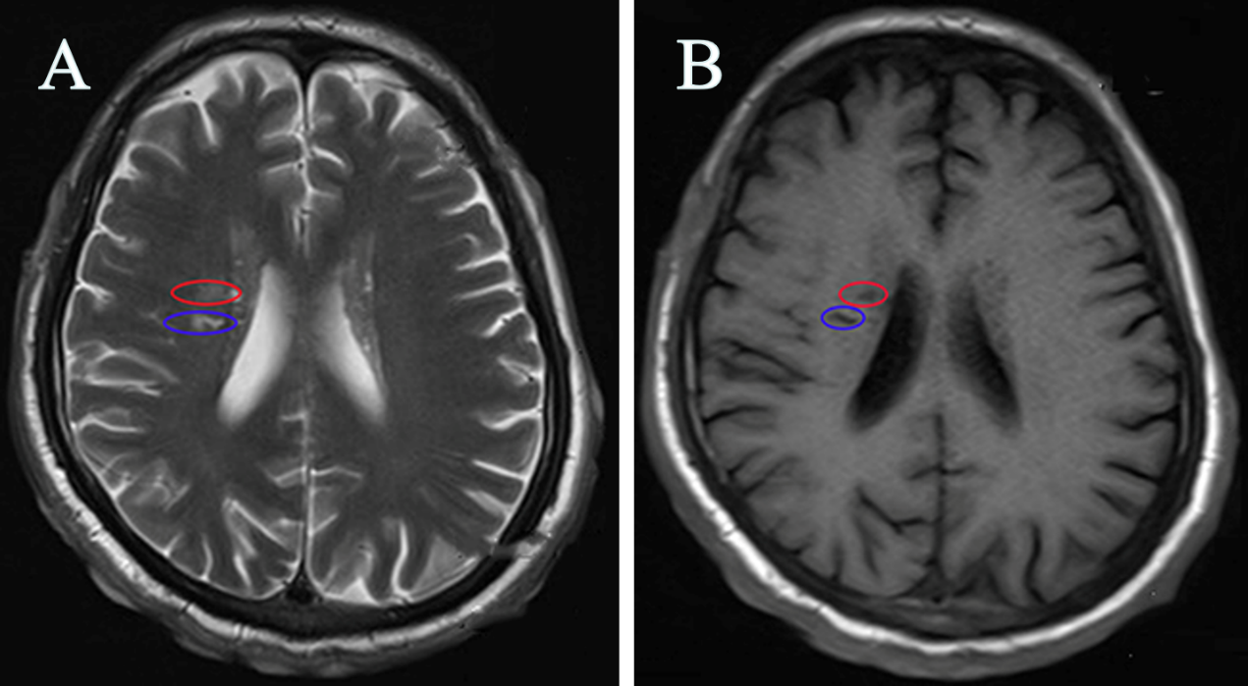
Figure 2 Magnetic resonance imaging revealing abnormal hyperintense lesions in the bilateral insular cortex and radial crown, and lateral anterior horn. The circles in blue and in red indicate lesions. A: T2 weighted imaging; B: T1 weighted imaging.
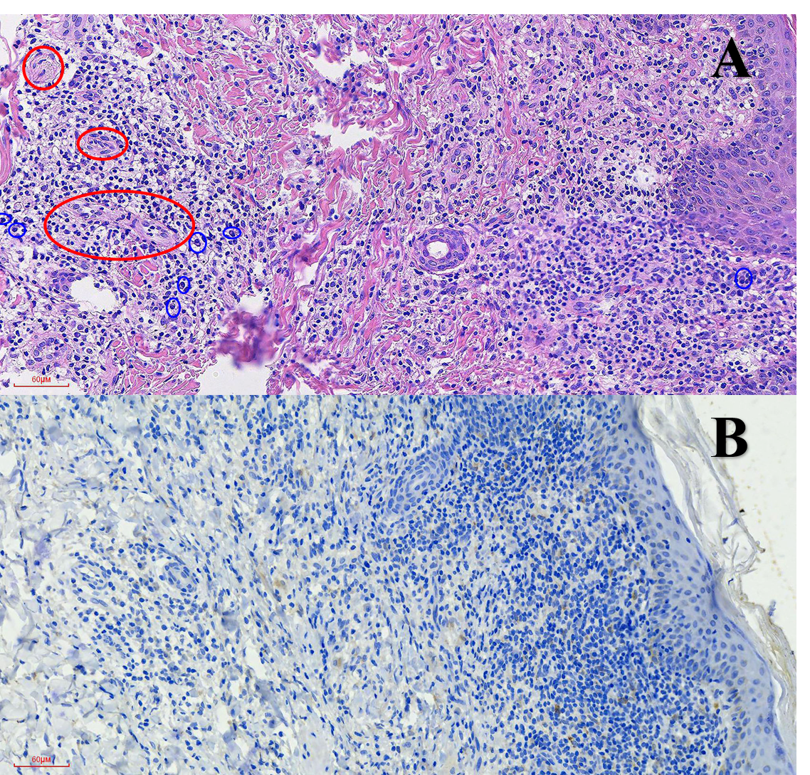
Figure 3 Photomicrograph of section of the skin biopsy from the abdomen lesion. A: The mixed infiltrate of lymphocytes, histocytes, and plasma cells (blue circle) accompanied by obliterative vasculitis in the dermis (red circle). (Hematoxylin-eosin staining, original magnification, ×200); B: Spiral and thread-like organisms, highlighted by the brown chromogen in the dermis, represent the spirochetes. (Immunohistochemical staining with anti-spirochetes, original magnification, ×200).
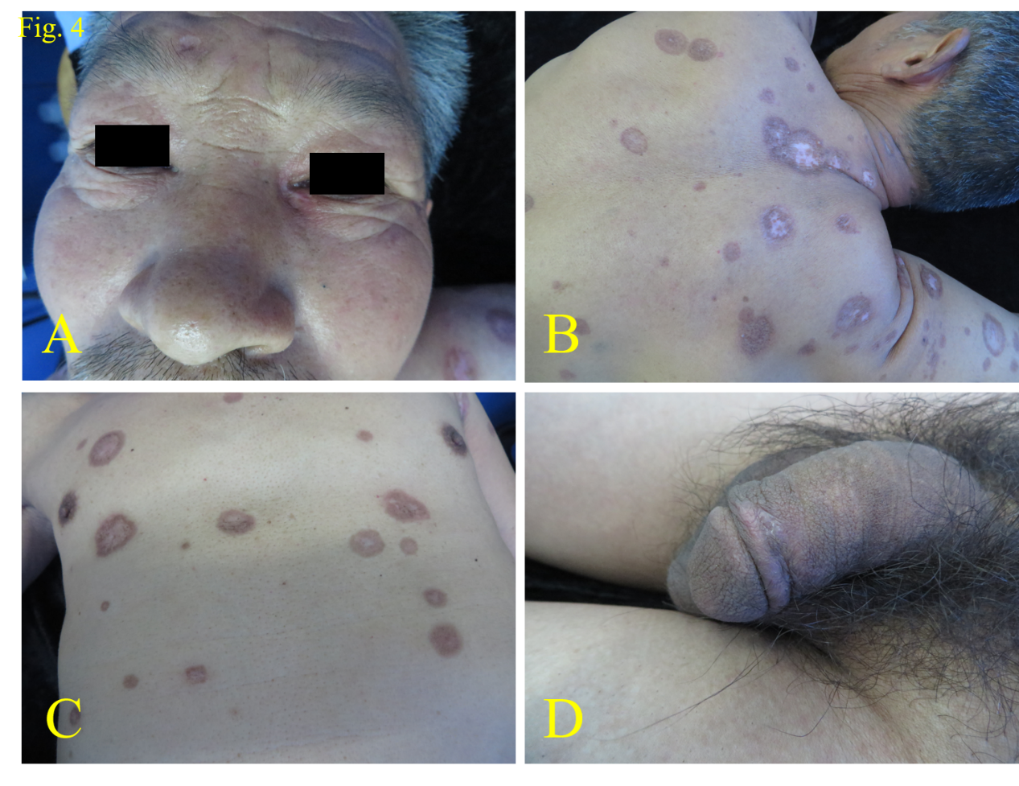
Figure 4 Pigmented and depigmented macules and atrophic scars 4 months after treatment. A: Face; B: Back; C: Chest; D: Genitals.

