Name of Journal: World Journal of Clinical Cases
Manuscript NO: 62930
Manuscript Type: CASE REPORT

Rapid response to radiotherapy in unresectable tracheal adenoid cystic carcinoma: A case report

Wu Q et al. Radiotherapy for tracheal adenoid cystic carcinoma

Qiang Wu, Feng Xu

Qiang Wu, Feng Xu, Lung Cancer Center and Institute, West China Hospital, Sichuan University, Chengdu 610041, Sichuan Province, China

Author contributions: Wu Q and Xu F conducted data curation and project management; Wu Q reviewed and analyzed data; Xu F designed the concept and methodology and supervised the entire study; Wu Q and Xu F wrote the manuscript and all authors read and approved the final manuscript; all authors contributed to the article and approved the submitted version.

Supported by National Natural Science Foundation of China, No.81573024.

Corresponding author: Feng Xu, MD, Professor, Lung Cancer Center and Institute, West China Hospital, Sichuan University, No. 37 Guoxue Lane, Wuhou District, Chengdu 610041, Sichuan Province, China. fengxuster@163.com

Received: January 21, 2021
Revised: February 24, 2021
Accepted: September 22, 2021
Published online: November 6, 2021

Abstract
BACKGROUND
Adenoid cystic carcinoma (ACC) occurs mainly in the head and neck. Tracheal ACC (TACC) is uncommon. Primary resection is recommended as the main treatment of choice, and radiotherapy is considered for residual disease in the postoperative setting. Definitive radiotherapy is an alternative approach to cure unresectable TACC. As the status of radiosensitivity in TACC is uncertain, the evidence for radiotherapy in unresectable TACC is not well established, especially in terms of the optimal dosage and its response evaluation. Herein, we report a case of locally advanced TACC.

CASE SUMMARY
A 49-year-old woman was diagnosed with TACC, which included a range of lesions arising in the upper trachea extending caudally 2 cm to 7 cm of the glottis. She was treated with definitive radiotherapy, given the low likelihood of complete resection of the disease. Due to the indolent growth and the propensity for infiltration along the airways, the scheduled radiation dose of 76 Gy in 38 fractions with 6-MV X-ray delivered by intensity-modulated radiotherapy was conducted to the primary tumor volume. After irradiation of 40 Gy, the patient’s dyspnea on exertion was dramatically relieved and bronchoscopy revealed that the previous large polypoid intra-luminal mass was significantly eliminated, with near-complete response. The patient completed two phases of scheduled radiotherapy, and acute reactions to treatment included subjective chest tightness and grade 2 esophagitis, managed medically. After 5 years of treatment, the patient is alive without recurrent disease, and there were no serious late radiation esophagus and lung damage, with only slight dysphagia without perforation and fistula.

CONCLUSION
Taken together, TACC is uncommon and the treatment of unresectable TACC is challenging. This case indicated that patients with unresectable TACC who rapidly respond to radiation may benefit from primary radical radiotherapy. Radiotherapy may be considered an effective alternative treatment modality.

Key Words: Adenoid cystic carcinoma; Tracheal cancer; Radiotherapy; Tracheal adenoid cystic carcinoma; Case report

©The Author(s) 2021. Published by Baishideng Publishing Group Inc. All rights reserved.

Citation: Wu Q, Xu F. Rapid response to radiotherapy in unresectable tracheal adenoid cystic carcinoma: A case report. World J Clin Cases 2021; 9(31): 9535-9541 URL: https://www.wjgnet.com/2307-8960/full/v9/i31/9535.htm DOI:https://dx.doi.org/10.12998/wjcc.v9.i31.9535

Core Tip: Tracheal adenoid cystic carcinoma (TACC) is uncommon. Primary resection is recommended as the main treatment of choice, and radiotherapy is considered for residual disease in the postoperative setting. Definitive radiotherapy is an alternative approach to cure unresectable TACC. As the status of radiosensitivity in TACC is uncertain, the evidence for radiotherapy in unresectable TACC is not well established, especially in terms of the optimal dosage and its response evaluation. Herein, we report a case of locally advanced TACC who rapidly responded to radiotherapy.
INTRODUCTION
Adenoid cystic carcinoma (ACC) is a rare tumor, which is most commonly found in salivary glands of the head and neck^{[1]}. Tracheal ACC (TACC), originating from the submucosal glands of the trachea, is much less common, accounting for approximately 10%-20% of malignant tracheal tumors^{[2]}. The standard treatment of TACC includes primary resection and postoperative radiotherapy for residual disease. Most patients, however, present with locally advanced disease, due to the slow and indolent growth of the tumor and the propensity for invasion into adjacent structures^{[3]}. Primary radiotherapy is the main approach for unresectable TACC. As ACC is prone to indolent growth and the radiosensitivity status is uncertain, most tumors respond poorly to radiotherapy and local progression often occurs shortly after completion of treatment. Herein, we present a case of inoperable TACC, who rapidly responded to radiotherapy. This study was approved by the ethical review committee of West China Hospital of Sichuan University.

CASE PRESENTATION
Chief complaints
A 49-year-old woman presented with increasing dyspnea on exertion for 3 wk, occasionally accompanied by chest pain and cough.

History of past illness
No special history of past illness.

Physical examination
Physical examination was notable for stridor at rest.

Imaging examinations
After she was admitted to the local hospital in March 2015, a chest computed tomography (CT) scan showed a soft tissue mass surrounding the inner surface of the upper trachea, leading to irregular lumen stenosis of the trachea (Figure 1A and B). Thus, she was referred to our hospital, in order to initially undergo resection, which is considered the most effective treatment for tracheal tumor. The patient experienced stridor at rest. Bronchoscopy revealed that a large polypoid intra-luminal mass, with its surface presenting rich vascular networks and nodular protrusions, was present in the upper trachea extending caudally 2 cm to 7 cm of the glottis (Figure 2A).

FINAL DIAGNOSIS
Bronchoscopic biopsy confirmed an ACC, with immunohistochemistry of AE1/AE3 (+), CEA (-), GFAP (-), S-100 (+).

TREATMENT
Radioisotope bone scans, brain magnetic resonance imaging, and abdominal CT did not reveal enlarged lymph nodes or metastatic disease. After a discussion of this case in our daily multidisciplinary tumor board, she was treated with definitive radiotherapy given the low likelihood of complete resection of disease.
According to the suggestion from the QUANTEC (quantitative analysis of normal tissue effects in the clinic) report^{[4]}, the total irradiated dose in our case did not exceed 80 Gy in order to reduce the risk of central airway stenosis. In view of large volume lesions, the therapeutic regimen, which was planned to deliver 76 Gy to the gross tumor volume (GTV) with an additional margin to account for microscopic extension of disease, respiratory motion, and daily variance in patient positioning, was divided into two phases. In the first treatment phase, she received 60 Gy in 30 fractions, using 6-MV X-ray delivered by an intensity-modulated radiotherapy (IMRT) technique. Astonishingly, the patient’s dyspnea on exertion was dramatically relieved after 40 Gy of irradiation. Bronchoscopy was conducted which revealed that the previous large polypoid intra-luminal mass was significantly eliminated and the narrow trachea was freed (Figure 2B). However, considering the probable low inherent radiosensitivity of ACC, a prophylactic dose of 60 Gy to the low-risk clinical target volume (CTV_{low}), referring to the region for low-risk lymphatic metastasis, was delivered as planned. In the second CT scan of radiotherapy simulation, there was evident regression of the tumor with increased luminal opening of the trachea (Figure 1C and D). The patient received an additional 10 Gy for the high-risk clinical target volume (CTV_{high}), referring to the region for high-risk lymphatic metastasis, and an another 6 Gy for the GTV at 2 Gy/d in the second phase of radiotherapy with 6-MV X-ray delivered by IMRT (Figure 3). Thus, the GTV received the prescribed dosage of 76 Gy per 2 Gy in total. The radiotherapy plan beam arrangement consisted of anterior, left, and right anterior oblique, posterior, and left and right posterior oblique fields. The weights of the three posterior fields were reduced compared to the others, in order to minimize the irradiated dose and volume to the esophagus and spinal cord. Due to longitudinal invasion along the trachea, margins of 4-5 cm in the craniocaudal axis were included as suggested by Kaminski^{[5]}. Considering the high-risk of local-regional recurrence, the CTV_{high} encompassed the entire GTV with a 2-cm margin of adjacent superior and inferior structures, and with a 0.5-cm margin of adjacent anterior, posterior, and bilateral structures. Given the tumor’s propensity for invasion into local nerves, the CTV_{low} covered the entire CTV_{high} with a 3-cm margin of adjacent superior and inferior structures, and with a 0.5-cm margin of adjacent anterior, posterior and bilateral structures (Figure 3).

OUTCOME AND FOLLOW-UP
The patient successfully completed the scheduled two phases of radiotherapy, and acute reactions to treatment included subjective chest tightness and grade 2 esophagitis, managed medically. After 5 years of treatment, the patient is alive without recurrent disease, and no serious late radiation esophagus and lung damage, only slight dysphagia without perforation and fistula.

DISCUSSION
ACC, formerly known as “cylindroma” and “adenocystic carcinoma,” occurs mainly in the head and neck. However, its presence in the pulmonary system is uncommon. Most tumors occur in the trachea and mainstem bronchi, but peripheral tumors from glands of small bronchi have occasionally been reported^{[6-8]}. Women are more often affected than men, and the peak age of incidence occurs between the 4th and 5th decades of life, which is earlier than lung cancer^{[9,10]}. Smoking does not affect the incidence. ACC is well known for its prolonged clinical course, its propensity for peritracheal soft tissue and perineural invasion, and delayed onset of distant metastases^{[3]}. The most common site of distant metastasis is the lung, followed by bone, liver, and brain^{[11]}.
Owing to its slow and indolent growth, the clinical course of TACC is prolonged and asymptomatic. When the tumor invades local nerves and structures, patients will present varying symptoms, which are related to airway obstruction. Cough, dyspnea, and hemoptysis are the most common complaints. However, those symptoms often lead to a misdiagnosis of asthma or bronchitis. Chest CT and bronchoscopy are the main diagnostic methods for the diagnosis of TACC. On CT, this tumor usually has a marked tendency toward submucosal extension that manifests as an intraluminal mass with longitudinal extension^{[12]}, as seen in our case.
Once diagnosed, the tumor should be assessed for surgical resection. Several relatively large studies showed that surgery can lead to a significantly better survival than non-surgical management. Two large studies^{[13,14]} reported that the overall 5-year and 10-year survival rates of resected TACC, regardless of complete or incomplete resection, were 52%-88.7% and 29%-43.2%, compared with 33% and 10% in the non-resected group, respectively. Compared with incomplete resection, complete resection with negative airway margins resulted in higher survival with 5-year and 10-year survival rates of 75%-90% and 45%-75%, respectively. It was noted that the incomplete resection of TACC was quite high, with 59%-84.4% R₁ resection rates, probably because it tends to infiltrate along the airways and invade peritracheal soft tissue and perineural tissue. However, the 15-year long-term follow-up results showed that surgery still benefits patients with incomplete resected TACC, compared with the unresectable group (15-year overall survival: 14.5% vs 0%)^{[13]}. For TACC patients with incomplete resection (R1), postoperative radiotherapy significantly reduces local-regional failure and improves overall survival. This evidence suggests that a pathologically negative margin might not always be required, and adjuvant radiotherapy is needed in the postoperative setting in such cases. The benefit of adjuvant radiotherapy in R0 resection remains uncertain.
If patients have technically or medically inoperable tumors, radiotherapy should be considered as an alternative local treatment. Nevertheless, the optimal dosage of radical radiotherapy for TACC is not well known, due to the uncertain status of radiosensitivity in TACC. ACC is deemed to be a relatively radioresistant tumor, due to its indolent growth and low inherent radiosensitivity. Lee et al^{[2]} assessed the efficacy of irradiation in patients with unresectable TACC, after immediately completing primary radiotherapy. The results showed that among 13 inoperable patients treated with primary radiation of 60 Gy, the objective response rate was only 1/13 (one had a partial response), while four had stable disease, and eight had progressive disease. A Chinese study^{[9]} revealed that two patients with locally advanced disease and invasion of the pulmonary artery received primary radiotherapy with 40 Gy of the scheduled dose, and response to radiation was poor. The lesions remained unchanged following radiotherapy. However, our case showed a significant reduction in tumor size after 40 Gy of irradiation. In contrast, some studies have also indicated that TACC seems to have high radiosensitivity. Bhandari et al^{[15]} reported a 51-year-old female with unresectable TACC, who received a dose of 54 Gy/30 fractions IMRT. At 8 mo post-radiotherapy, her CT scan showed a near complete response. Kanematsu et al^{[16]} reported that 5 inoperable patients treated with primary radiation with a median dosage of 60 Gy (50 Gy to 70 Gy), showed a remarkable radiosensitivity including 1 complete response and 4 partial responses, and the 5-year survival rate was 40%. Maziak et al^{[11]} also reported that 6 inoperable patients treated with primary radiation with a given dosage varying between 50 and 75 Gy, had a mean survival of 6.2 years. However, most of the irradiated patients harbored high rates of local recurrence, compared with patients treated by primary resection. This may indicate that a higher dosage of irradiation is needed for TACC to improve local control. Bonner Millar et al^{[17]} reported a patient with inoperable TACC with a 2.2 cm × 1.9 cm soft tissue mass located posterior to the carina, who received 80 Gy of radiation with 6-MV photons. It was observed that the tumor completely responded to radiation as shown by chest CT scan one month after treatment. There was no evidence of recurrent disease over six years follow-up, and some tolerated side-effects of radiotherapy were noted including chest tightness and pain, diminished force of cough, atrophy of chest wall musculature, and gastroesophageal reflux disease, but not tracheal or esophageal ulcer and fistula. Similarly, our case received 76 Gy of radiation and did not suffer a severe adverse radiation reaction. Higher doses may improve tumor control, but there is also the potential for increased complications using photons (dose > 66 Gy)^{[18]}. Compared to photons, high linear energy transfer (LET) radiation, such as neutrons, harbors a unique physical property of the Bragg peak for sharp dose distribution to significantly diminish irradiated dose and volume of normal tissues around the irradiated target. Bittner et al^{[19]} described the effectiveness of fast neutron radiotherapy in 19 unresectable ACC patients, and reported a 5-year actuarial locoregional control rate of 54.1%, with tolerable side-effects (only 2 cases experienced grade 3/4 chronic toxicity).

CONCLUSION
TACC is uncommon and the treatment of unresectable TACC is challenging. This case indicates that patients with unresectable TACC who rapidly respond to radiation may persistently benefit from primary radical radiotherapy. Radiotherapy may be considered an effective alternative treatment modality. Future research in the form of more case reports, case series, or small-scale clinical trials could add evidence on this phenomenon.

REFERENCES
1 Dodd RL, Slevin NJ. Salivary gland adenoid cystic carcinoma: a review of chemotherapy and molecular therapies. Oral Oncol 2006; 42: 759-769 [PMID: 16757203 DOI: 10.1016/j.oraloncology.2006.01.001]
2 Lee JH, Jung EJ, Jeon K, Koh WJ, Suh GY, Chung MP, Kim H, Kwon OJ, Shim YM, Kim J, Han J, Um SW. Treatment outcomes of patients with adenoid cystic carcinoma of the airway. Lung Cancer 2011; 72: 244-249 [PMID: 20828861 DOI: 10.1016/j.lungcan.2010.08.011]
3 Jaso J, Malhotra R. Adenoid cystic carcinoma. Arch Pathol Lab Med 2011; 135: 511-515 [PMID: 21466371 DOI: 10.5858/2009-0527-RS.1]
4 Marks LB, Bentzen SM, Deasy JO, Kong FM, Bradley JD, Vogelius IS, El Naqa I, Hubbs JL, Lebesque JV, Timmerman RD, Martel MK, Jackson A. Radiation dose-volume effects in the lung. Int J Radiat Oncol Biol Phys 2010; 76: S70-S76 [PMID: 20171521 DOI: 10.1016/j.ijrobp.2009.06.091]
5 Kaminski JM, Langer CJ, Movsas B. The role of radiation therapy and chemotherapy in the management of airway tumors other than small-cell carcinoma and non-small-cell carcinoma. Chest Surg Clin N Am 2003; 13: 149-167 [PMID: 12698643 DOI: 10.1016/s1052-3359(02)00040-6]
6 Gallagher CG, Stark R, Teskey J, Kryger M. Atypical manifestations of pulmonary adenoid cystic carcinoma. Br J Dis Chest 1986; 80: 396-399 [PMID: 3040062 DOI: 10.1016/0007-0971(86)90094-x]
7 Vallonthaiel AG, Jain D, Singh V, Kaur K, Madan K, Kumar V, Iyer VK, Sharma MC. c-Myb Overexpression in Cytology Smears of Tracheobronchial and Pulmonary Adenoid Cystic Carcinomas. Acta Cytol 2017; 61: 77-83 [PMID: 27974718 DOI: 10.1159/000453103]
8 Shinohara S, Hanagiri T, Takenaka M, Oka S, Chikaishi Y, Shimokawa H, Nakagawa M, Uramoto H, So T, Tanaka F. Primary Adenoid Cystic Carcinoma of the Peripheral Lungs. J UOEH 2015; 37: 121-125 [PMID: 26073501 DOI: 10.7888/juoeh.37.121]
9 Hu MM, Hu Y, He JB, Li BL. Primary adenoid cystic carcinoma of the lung: Clinicopathological features, treatment and results. Oncol Lett 2015; 9: 1475-1481 [PMID: 25663934 DOI: 10.3892/ol.2015.2859]
10 Chen F, Huang M, Xu Y, Li T, Xie K, Zhang L, Cheng D, Liu L, Che G, Hou M, Wang J, Luo Z, Lu Y. Primary tracheal adenoid cystic carcinoma: adjuvant treatment outcome. Int J Clin Oncol 2015; 20: 686-692 [PMID: 25412605 DOI: 10.1007/s10147-014-0771-6]
11 Maziak DE, Todd TR, Keshavjee SH, Winton TL, Van Nostrand P, Pearson FG. Adenoid cystic carcinoma of the airway: thirty-two-year experience. J Thorac Cardiovasc Surg 1996; 112: 1522-31; discussion 1531-2 [PMID: 8975844 DOI: 10.1016/S0022-5223(96)70011-9]
12 Kwak SH, Lee KS, Chung MJ, Jeong YJ, Kim GY, Kwon OJ. Adenoid cystic carcinoma of the airways: helical CT and histopathologic correlation. AJR Am J Roentgenol 2004; 183: 277-281 [PMID: 15269011 DOI: 10.2214/ajr.183.2.1830277]
13 Gaissert HA, Grillo HC, Shadmehr MB, Wright CD, Gokhale M, Wain JC, Mathisen DJ. Long-term survival after resection of primary adenoid cystic and squamous cell carcinoma of the trachea and carina. Ann Thorac Surg 2004; 78: 1889-96; discussion 1896-7 [PMID: 15560996 DOI: 10.1016/j.athoracsur.2004.05.064]
14 Yang H, Yao F, Tantai J, Zhao Y, Tan Q, Zhao H. Resected Tracheal Adenoid Cystic Carcinoma: Improvements in Outcome at a Single Institution. Ann Thorac Surg 2016; 101: 294-300 [PMID: 26431923 DOI: 10.1016/j.athoracsur.2015.06.073]
15 Bhandari V, Ladia DD, Kausar M, Varma A. Definitive radiotherapy for inoperable adenoid cystic carcinoma of the trachea: A rare case report. Lung India 2017; 34: 73-75 [PMID: 28144065 DOI: 10.4103/0970-2113.197117]
16 Kanematsu T, Yohena T, Uehara T, Ushijima C, Asoh H, Yoshino I, Ichinose Y. Treatment outcome of resected and nonresected primary adenoid cystic carcinoma of the lung. Ann Thorac Cardiovasc Surg 2002; 8: 74-77 [PMID: 12027791]
17 Bonner Millar LP, Stripp D, Cooper JD, Both S, James P, Rengan R. Definitive radiotherapy for unresected adenoid cystic carcinoma of the trachea. Chest 2012; 141: 1323-1326 [PMID: 22553266 DOI: 10.1378/chest.11-0925]
18 Eom JS, Kim B, Kim H, Jeon K, Um SW, Koh WJ, Suh GY, Chung MP, Kwon OJ. Fibrotic airway stenosis following radiotherapy in patients with adenoid cystic carcinoma. Respirology 2014; 19: 914-920 [PMID: 24935759 DOI: 10.1111/resp.12336]
19 Bittner N, Koh WJ, Laramore GE, Patel S, Mulligan MS, Douglas JG. Treatment of locally advanced adenoid cystic carcinoma of the trachea with neutron radiotherapy. Int J Radiat Oncol Biol Phys 2008; 72: 410-414 [PMID: 18374509 DOI: 10.1016/j.ijrobp.2008.01.016]

Footnotes
Informed consent statement: The patient provided written informed consent to participate in this study. Written informed consent was obtained for the publication of any potentially identifiable images or data included in this article.

Conflict-of-interest statement: The authors declare that they have no conflict of interest.

CARE Checklist (2016) statement: The authors have read the CARE Checklist (2016), and the manuscript was prepared and revised according to the CARE Checklist (2016).

Open-Access: This article is an open-access article that was selected by an in-house editor and fully peer-reviewed by external reviewers. It is distributed in accordance with the Creative Commons Attribution NonCommercial (CC BY-NC 4.0) license, which permits others to distribute, remix, adapt, build upon this work non-commercially, and license their derivative works on different terms, provided the original work is properly cited and the use is non-commercial. See: http://creativecommons.org/Licenses/by-nc/4.0/

Manuscript source: Unsolicited manuscript

Peer-review started: January 21, 2021
First decision: February 11, 2021
Article in press: September 22, 2021

Specialty type: Medicine, research and experimental
Country/Territory of origin: China
Peer-review report’s scientific quality classification
Grade A (Excellent): 0
Grade B (Very good): B, B
Grade C (Good): C
Grade D (Fair): 0
Grade E (Poor): 0

P-Reviewer: Arias F, Dubinsky P S-Editor: Gao CC L-Editor: Webster JR P-Editor: Wu RR

Figure Legends
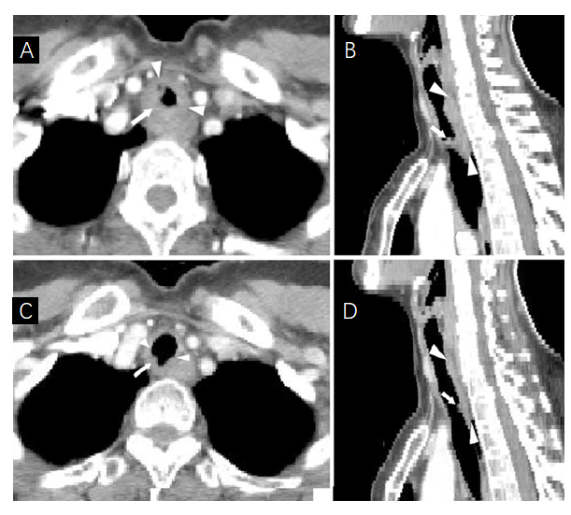
Figure 1 Imaging of the case. A and B: Chest computed tomography pre-treatment revealed a soft tissue mass surrounding the inner surface of the upper trachea; C and D: Chest computed tomography after 60 Gy indicated dramatic regression of the tumor.
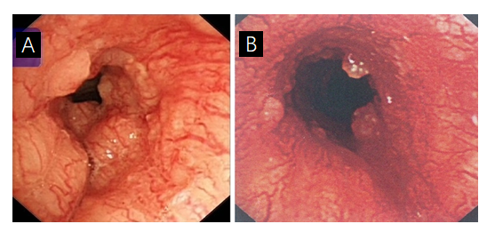
Figure 2 Bronchoscopic findings. A: Pre-treatment revealed that a large polypoid intra-luminal mass, with its surface presenting rich vascular networks and nodular protrusions; B: After receiving 40 Gy, bronchoscopy indicated that the previous large polypoid intra-luminal mass was significantly eliminated.
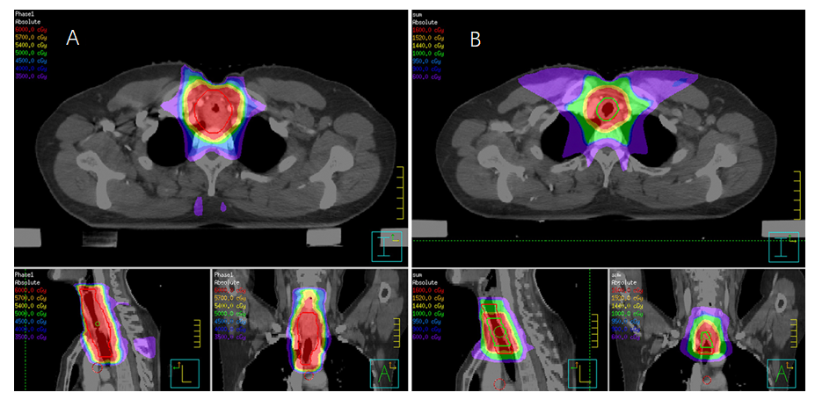
Figure 3 Dose distribution of the first and second treatment plan using intensity-modulated radiotherapy. A: The first radiotherapy plan (30 × 2 Gy) with an irradiated high dose zone for CTV_{low}, surrounded by a red line; B: The second radiotherapy plan, where CTV_{high} (red line) received an additional 10 Gy in 5 fractions and the GTV (green line) received another 6 Gy in 3 fractions. IMRT: Intensity modulated radiation therapy; CTV: Clinical target volume; GTV: Gross tumor volume.

Published by Baishideng Publishing Group Inc
7041 Koll Center Parkway, Suite 160, Pleasanton, CA 94566, USA
Telephone: +1-925-3991568
E-mail: bpgoffice@wjgnet.com
Help Desk: https://www.f6publishing.com/helpdesk
https://www.wjgnet.com

© 2021 Baishideng Publishing Group Inc. All rights reserved.

