Name of journal: World Journal of Gastroenterology
ESPS Manuscript NO: 28961
Manuscript Type: ORIGINAL ARTICLE

Basic Study
Construct of Gpm6a/Reelin^{GFPCreERT2} by BAC recombineering using specific gene in hepatic mesothelial or stellate cells

Shi HB et al. Gpm6a/Reelin^{GFPCreERT2} construct

Hong-Bo Shi, Jin-Li Lou, Hong-Lin Shi, Feng Ren, Yu Chen, Zhong-Ping Duan

Hong-Bo Shi, Hong-Lin Shi, Feng Ren, Zhong-Ping Duan, Beijing Institute of Hepatology, Beijing Youan Hospital, Capital Medical University, Beijing 100069, China

Jin-Li Lou, Clinical Laboratory Center, Beijing Youan Hospital, Capital Medical University, Beijing 100069, China

Yu Chen, Zhong-Ping Duan, Artifical Liver Center, Beijing Youan Hospital, Capital Medical University, Beijing 100069, China

Author contributions: Shi HB and Lou JL contribute equally to this work; Shi HB and Shi HL carried out most of the experiments; Ren F purified the strain and performed PCR; Chen Y analyzed the pattern of restriction enzyme digestion; Shi HB drafted the manuscript and Lou JL analyzed the experimental data; Duan ZP and Lou JL conceived and supervised the study; Duan ZP was involved in editing the manuscript; all authors read and approved the final manuscript.

Supported by the National Natural Science Foundation of China, No. 81300349 and No. 81270532; the Beijing Natural Science Foundation No. 7144216; the Beijing Nova Program No. Z131107000413016; the Project of Science and Technology Activities of preferred overseas personnel of Beijing (2014); the Project of Cultivation of High Level Medical Technical Personnel in Health System of Beijing No. 2014-3-090 and No. 2013-3-071.

Institutional review board statement: No human objectives were used in this study.

Institutional animal care and use committee: No animals were used in this study.

Conflict-of-interest statement: Shi HB Lou JL Shi HL Ren F, Chen Y and Duan ZP re employees of Beijing Youan Hospital, Capital Medical University. The authors declare no conflicts of interest.

Data sharing statement: Technical appendices, statistical codes, and datasets are available from the corresponding author at duan2517@163.com. Participants provided informed consent for data sharing. No additional data are available.

Open-Access: This article is an open-access article which was selected by an in-house editor and fully peer-reviewed by external reviewers. It is distributed in accordance with the Creative Commons Attribution Non Commercial (CC BY-NC 4.0) license, which permits others to distribute, remix, adapt, build upon this work non-commercially, and license their derivative works on different terms, provided the original work is properly cited and the use is non-commercial. See: http://creativecommons.org/licenses/by-nc/4.0/

Manuscript source: Unsolicited manuscript

Correspondence to: Zhong-Ping Duan, MD, PhD, Professor, Beijing Youan Hospital, Capital Medical University, 10 Xitoutiao, Beijing 100069, China. duan2517@163.com
Telephone: +86-10-63291007
Fax: +86-10-63295258

Received: August 2, 2016
Peer-review started: August 3, 2016
First decision: September 21, 2016
Revised: October 5, 2016
Accepted: October 30, 2016
Article in press:
Published online:

Abstract
AIM
To prepare Gpm6a/Reelin^{GFPCreERT2} construct by a rapid and reliable strategy using bacterial artificial chromosome (BAC).

METHODS
Gpm6a and Reelin BAC were purified and transformed into SW102 E.coli by electroporation. GFPCreERT2 fragment was prepared from shuttle vector and transformed into SW102 E.coli carrying BAC. Homologous recombination was induced in SW102 E.coli. Recombinant clones were screened and confirmed by PCR and restriction enzyme digestion. Recombinant clones were transformed into SW102 E.coli to remove Kanamycin unit.

RESULTS
Complete BAC was transformed into SW102 E.coli by electroporation successfully, because BAC purified from SW102 E.coli showed the same pattern as original BAC with BamHI digestion. GFPCreERT2 fragment was prepared successfully because we obtained the same size fragment as expected. Homologous recombination was induced and GFPCreERT2 was inserted into the correct site of BAC, because we found the band change was same as the expected pattern after restriction enzyme digestion. Kanamycin unit was removed because we got different sizes of bands consistent with expected by PCR with different primers.

CONCLUSION
The construct of Gpm6a ^{GFPCreERT2} or Reelin^{GFPCreERT2} was prepared successfully, which will establish foundation for tracing the hepatic stellate cells lineage and studying its function.

Key words: Bacterial artificial chromosome; Homologous recombination; Glycoprotein M6a; Reelin

© The Author(s) 2016. Published by Baishideng Publishing Group Inc. All rights reserved.

Core tip: Up to now, there are few specific mouse lines which can cause recombination for tracing hepatic mesothelial cells or hepatic stellate cells. Here, we describe a rapid and reliable strategy for construct preparation using bacterial artificial chromosome. This study prepared for the first time Gpm6a/Reelin^{GFPCreERT2} construct, which is the first step for the preparation of Gpm6a ^{GFPCreERT2} or Reelin^{GFPCreERT2} mouse line.

Shi HB, Lou JL, Shi HL, Ren F, Chen Y, Duan ZP. Preparation and identification of Gpm6a/ReelinGFPCreERT2 construct. World J Gastroenterol 2016; In press

INTRODUCTION
Excessive extracellular matrix (ECM) of the liver results in cirrhosis, the end stage liver disease of high mortality for which efficacious medical treatments are not currently available except for liver transplantation. Hepatic stellate cells (HSCs) activation is considered a major mechanism in the formation of fibrosis and cirrhosis. However fundamental questions concerning cell fate regulation of HSCs remain largely underexplored. Recent study reported that hepatic mesothelial cells are the potential precursors for HSCs in the development of liver and can transdifferentiate into myofibroblast cells in mouse liver fibrosis ^{[1-3]}.
Up to now, there are few specific mouse lines which can cause recombination (Cre) for tracing hepatic mesothelial cells or hepatic stellate cells (HSCs). The Wt1^{CreERT2} mice are useful to trace hepatic mesothelial cells, but the labeling efficiency and specificity is low ^{[4-6]}. Specific genes have been identified in hepatic mesothelial cells and HSCs by microarray ^{[7,8]}. We will make Cre mouse lines with the specific markers for the study of HSCs or hepatic mesothelial cells. Based on the previous study, glycoprotein M6a (Gpm6a) has been identified as a specific surface marker of hepatic mesothelial cell. It covers on the surface of liver and migrates from surface into the center ^{[4]}. Reelin is extracellular matrix glycoprotein, which is a specific HSCs marker in mouse liver and has similar amounts in resting and activated HSCs ^{[9]}.
Gpm6a ^{GFPCreERT2} or Reelin^{GFPCreERT2} mouse line will express a fusion protein of green fluorescent protein (GFP), Cre recombinase (Cre), and estrogen receptor induced by tamoxifen (ERT2) under the control of the Gpm6a or Reelin promoter. GFP is used to trace the labeled protein as a marker. Cre recombinase is used to delete a segment of DNA flanked by LoxP sites (flox). ERT2 system is used to activate Cre activity by tamoxifen treatment ^{[10,11]}.
Cre mouse lines are very useful tools, which can generate knockout mice through the crossover between Cre and flox mouse lines. We need a mouse line to trace the hepatic stellate cells lineage and study its function through knockout of specific gene in specific cells, so it is very necessary to prepare the Gpm6a ^{GFPCreERT2} or Reelin^{GFPCreERT2} mouse line. In this study, we will investigate the preparation and identification of Gpm6a/Reelin^{GFPCreERT2} construct, which is the first step for the preparation of Gpm6a ^{GFPCreERT2} or Reelin^{GFPCreERT2} mouse line.

MATERIALS AND METHODS
BAC DNA clones and shuttle vector
Gpm6a BAC (RP23-410D17) and Reelin BAC (RP23-143M9) were purchased from BACPAC Resource Center (BPRC) located at the Children's Hospital Oakland Research Institute in Oakland, California, United States. Female (C57BL/6J) mouse BAC library is made from kidney and brain DNA, cloned into the pBACe3.6 vector in the EcoRI site and transformed into DH10B E.coli. The reporter gene GFPCreERT2 is in the shuttle vector which was developed by Biomed Company. 5arm and 3arm were inserted into both sites of the reporter gene. The arm sequences were amplified according to the BAC template by polymerase chain reaction (PCR).

Purification of BAC DNA
Streak DH10B E.coli onto LB plates with 25 mg/mL Chloramphenicol (Cmr, Sigma, United States) at 32 ºC. Pick up single colony and culture in 25 mL LB medium with Cmr. Purify BAC DNA with large construct kit (QIAGEN, Germany). Confirm BAC DNA with restriction enzymes BamHI (Biolabs, New England).

Electroporation of BAC DNA into SW102 E. coli
Streak SW102 E.coli (NCI at Frederick, United States) onto plates with 50 mg/mL Tetracycline (Tc, Sigma, United States) at 32 ºC. Pick up single colony and inoculate in LB medium with Tc for 4-6 h. Place on ice and make competent cells from SW102 E. coli. Wash with ice-cold water and Add 5 mL BAC DNA into 85 mL competent cells. Electroporate by Gene Pulser Xcell (Biorad, United States) at 1.75 KV, 25 mF (time constant: 4.5-5.0). Add 1 m LB and incubate at 32 ºC for 1 h. Plate onto LB plates with Cmr and purify BAC using QIAGEN kit. Confirm BAC DNA with restriction enzymes BamHI.

Preparation of reporter gene GFPCreERT2
Streak SW102 E.coli onto 50 mg/mL kanamycin (Kam, Sigma, USA) plates at 32 ºC. Pick up single colony and inoculate in LB medium with Kam for 4-6 h. Purify the shuttle vector with Endofree plasmid maxi kit (QIAGEN, Germany). Digest the vector with NotI and FseI (Biolabs, New England) and make electrophoresis with agarose gel (Takara, Japan). Recover the big fragment of GFPCreERT2 from the gel according to quick gel extraction kit (QIAGEN, Germany).

Homologous DNA recombination
Streak SW102 E.coli carrying BAC onto LB plates with 50 mg/mL Tc and 25 mg/mL Cmr. Induce SW102 E.coli carrying BAC and make competent cells as mentioned above. Add 200 ng of fragment of GFPCreERT2 into 85 mL competent cells. Electroporate at 1.75 KV, 25 mF (time constant: 4.5-5.0). Add 0.6 ml LB and culture at 32 ºC for 1 h. Plate onto LB plates with 25 mg/ml Cmr and 12.5 mg/mL Kam. Confirm recombinant BAC DNA by PCR with platinum Taq DNA Polymerase (Invitrogen, United States) and restriction enzymes digestion.

Removal of Kam unit and selection of deleted Kam clone
Streak SW105 E.coli (NCI at Frederick, United States) without antibiotics. Pick up single colony and make competent cells. Transform recombinant BAC DNA into competent cells with electroporation. Inoculate in LB medium with L-arabinose (Sigma, United States) for removal of Kam unit. Plate onto LB plates with Cmr only. Check no colonies in LB plate with Cmr and Kam. Pick up 16 colonies and check by PCR using 5 arm primer. Confirm one colony by PCR using different primers. Digest the PCR product with BamHI and AflII (Biolabs, New England) for further confirmation.

RESULTS
Conformation of BAC with restriction enzyme BamHI digestion
As we mentioned before, we purchased BAC from BPRC. We confirmed the BAC sequence at the first. From Figure 1, we can see that after digestion with BamHI, Gpm6a BAC had 11 bands, which was same as expected pattern. For Reelin BAC, the same results were got. So we thought the BAC clone we purchased was what we want.

Confirmation of BAC DNA transformed into SW102 E.coli
BAC DNA is so long that it is impossible to transform BAC into SW102 E.coli by chemical transduction ^{[12]}. We transformed purified BAC into SW102 E.coli by electroporation. After electroporation, we purified BAC from SW102 E.coli and indentified BAC with restriction enzyme BamHI digestion. For Gpm6a BAC, after BamHI digestion, selected clones did not show the same digestion pattern with original BAC as Figure 2, which suggested original BAC DNA may be fragmented during purification step. For Reelin BAC, we got two positive clones which showed the same pattern as original BAC after BamHI digestion. We improved the purification methods and finally we succeeded in transforming complete Gpm6a BAC to SW102 E.coli (Figure 2B).

Preparation of reporter gene GFPCreERT2
The reporter gene GFPCreERT2 is in the shuttle vector which contains some genes encoding 5arm, flp recombinase target (FRT), kanamycin, FRT, GFPCreERT2, 3arm and ampicillin. We used NotI and FseI to digest the shuttle vector and got the fragment of GFPCreERT2 flanked by 5arm and 3arm. As shown in Figure 3, after digestion with NotI and FseI, we got two bands in which one was about 7600bp and the other was about 2800bp. We recovered the long band containing GFPCreERT2 from agarose gel for transformation.

Screening and confirmation of recombinant clones
We induced the SW102 E.colicarrying BAC to be competent cells and transformed the fragment of GFPCreERT2 into the SW102 E.coli carrying BAC. After homologous recombination between BAC and GFPCreERT2, GFPCreERT2 replaced the first extron in BAC vector. Then we purified the recombinant BAC for screening and confirmation. As shown in Figure 4B, we got 14 positive clones for Gpm6a (14/25, 56%) by PCR screening. For Reelin, we got 22 positive clones (22/25, 88%). We further confirmed the positive clones by restriction enzyme digestion. For Gpm6a, we found the band change was same as the expected pattern after BamHI or KpnI digestion (Figure 4C). Reelin had the same results (Figure 4D). It suggested that GFPCreERT2 was inserted into the correct site in BAC and we got the recombinant BAC.

Screening and confirmation of recombinant clones without kanamycin gene
Finally, we must remove the kanamycin unit which may interfere with the expression of reporter gene. We purified the recombinant BAC carrying GFPCreERT2 and transformed it to SW105 E. coli. Kanamycin unit was removed by homologous recombination. As shown in Figure 5B, we got 16 positive clones for Gpm6a (16/16, 100%) by PCR screening. We further confirmed the positive clones by PCR with different primers. We got different sizes of bands which were consistent with expected (Figure 5C). We digested the PCR product of 4527bp with BamHI or AflII, and the bands we got were the same as expected (Figure 5D). It suggested that kanamycin unit was removed and we got the deleted kanamycin BAC carrying GFPCreERT2.

Conclusion
First of all, we need to choose a vector to prepare the construct of Gpm6a/Reelin^{GFPCreERT2}. For conventional vector, its advantage is easy to handle, but it has low expression of the reporter genes and low specificity because DNA size is about 3-5kb containing only promoter. For bacterial artificial chromosome (BAC) vector, its advantages include relatively high efficiency and relatively high specificity, but BAC DNA is fragile and can break easily because BAC DNA is about 200kb containing all regulatory sequences upstream and downstream of the encoding sequence^{[13, 14]}. Thus we choose BAC vector to prepare the construct of Gpm6a ^{GFPCreERT2} and Reelin^{GFPCreERT2}.
Secondly, how to insert reporter genes into BAC DNA? In 200 kb BAC DNA, there would be 49 recognition sites for 6 nucleotide cutters such as EcoRI and BamHI, so it is impossible to use restriction enzymes digestion and ligation. We use homologous DNA recombination for gene insertion ^{[15-18]}. In BAC DNA, we design the primers in upstream or downstream of the first extron and get 5arm and 3arm fragment by PCR amplification. In the shuttle vector, 5arm fragment is inserted into the upstream of the reporter gene and 3arm fragment is inserted the downstream of the reporter gene. In SW102 E. coli, the reporter gene that is GFPCreERT2 will replace the first extron in BAC vector by homologous recombination. The expression of GFPCreERT2 is regulated by Gpm6a or Reelin promoter.
Finally, we removed kanamycin unit by homologous recombination of flp recombinase target (FRT) using SW105 E. coli. The FRT is similar to LoxP which is used to delete a segment of DNA flanked by LoxP sites ^{[19]}. The FRT cassette is excised with high frequency which is close to 100% ^{[20]}. Then we got the construct of Gpm6a ^{GFPCreERT2} and Reelin^{GFPCreERT2} successfully. After microinjection, we can get the mouse line with Gpm6a ^{GFPCreERT2} and Reelin^{GFPCreERT2}.
Homologous recombination was performed by modified E.coli bacteria strain: SW102 and SW105. SW102 E.coli carries some genes such exo, bet and gam and so on. Exo encodes 5'-3' exonuclease, bet encodes overhang binding protein which enables annealing and recombination with complementary DNA, and gam encodes inhibitor of E.coli exonuclease to protect introduced DNA. SW105 E.colicarries L-arabinose inducible flp gene, which encodes recombinase allow DNA modification without restriction enzyme and DNA ligase ^{[21]}.
Cre-Lox recombination is a site-specific recombinase technology widely used to carry out deletions, insertions, translocations and inversions in the DNA of cells. It allows the DNA modification to be targeted to a specific cell type or be triggered by a specific external stimulus ^{[22, 23]}. For mouse line with Gpm6a ^{GFPCreERT2} and Reelin^{GFPCreERT2}, once the specific genes such as Gpm6a or Reelin begin to express, the GFPCreERT2 will express in the specific cell. Using GFP as a marker, we can trace the specific cells. Using CreERT2 system, we can knock out the specific gene in specific cell, which is conditional knockout ^{[24]}.
For the next plan, we will Label hepatic mesothelial and hepatic stellate cells in the Gpm6a/Reelin^{GFPCreERT2} transgenic mouse, to trace the lineage of hepatic stellate cells. We also will make conditional TGFβ-KO mouse through crossover between TGF^{flox/flox} mouse and Gpm6a/Reelin^{GFPCreERT2} mouse, to explore the function of hepatic stellate cells during the development.

comments
Background
Hepatic stellate cells (HSCs) activation is considered a major mechanism in the formation of fibrosis and cirrhosis. However fundamental questions concerning cell fate regulation of HSCs remain largely underexplored. Recent study reported that hepatic mesothelial cells are the potential precursors for HSCs in the development of liver and can transdifferentiate into myofibroblast cells in mouse liver fibrosis. Up to now, there are few specific mouse lines which can cause recombination (Cre) for tracing hepatic mesothelial cells or hepatic stellate cells (HSCs). Here, we describe a rapid and reliable strategy for construct preparation using bacterial artificial chromosome (BAC).

Research frontiers
Recent study reported that hepatic mesothelial cells are the potential precursors for HSCs in the development of liver and can transdifferentiate into myofibroblast cells in mouse liver fibrosis. Glycoprotein M6a (Gpm6a) has been identified as a specific surface marker of hepatic mesothelial cell, which covers on the surface of liver and migrates from surface into the center. Reelin is extracellular matrix glycoprotein, which is a specific HSCs marker in mouse liver and has similar amounts in resting and activated HSCs.

Innovations and breakthroughs
Up to now, there are few specific mouse lines which can cause recombination (Cre) for tracing hepatic mesothelial cells or hepatic stellate cells (HSCs). Here, the authors describe a rapid and reliable strategy for construct preparation using bacterial artificial chromosome (BAC). This study prepared for the first time Gpm6a/Reelin^{GFPCreERT2} construct, which is the first step for the preparation of Gpm6a ^{GFPCreERT2} or Reelin^{GFPCreERT2} mouse line.

Applications
In this study, the construct of Gpm6a ^{GFPCreERT2} or Reelin^{GFPCreERT2} was prepared successfully, which will establish foundation for tracing the hepatic stellate cells lineage and studying its function.

Terminology
Cre-Lox recombination is a site-specific recombinase technology widely used to carry out deletions, insertions, translocations and inversions in the DNA of cells. It allows the DNA modification to be targeted to a specific cell type or be triggered by a specific external stimulus. For mouse line with Gpm6a ^{GFPCreERT2} and Reelin^{GFPCreERT2}, once the specific genes such as Gpm6a or Reelin begin to express, the GFPCreERT2 will express in the specific cell. Using GFP as a marker, we can trace the specific cells. Using CreERT2 system, we can knock out the specific gene in specific cell, which is conditional knockout.

Peer-review
This is a good study in which the author prepared the construct of Gpm6a ^{GFPCreERT2} or Reelin^{GFPCreERT2} successfully, which is the first step for the preparation of Gpm6a ^{GFPCreERT2} or Reelin^{GFPCreERT2} mouse line. Cre mouse lines are very useful tools, which can generate knockout mice through the crossover between Cre and flox mouse lines.

REFERENCES
1 Lua I, Asahina K. The Role of Mesothelial Cells in Liver Development, Injury, and Regeneration. Gut Liver 2016; 10: 166-176 [PMID: 26934883 DOI: 10.5009/gnl15226]
2 Lua I, James D, Wang J, Wang KS, Asahina K. Mesodermal mesenchymal cells give rise to myofibroblasts, but not epithelial cells, in mouse liver injury. Hepatology 2014; 60: 311-322 [PMID: 24488807 DOI: 10.1002/hep.27035]
3 Li Y, Lua I, French SW, Asahina K. Role of TGF-β signaling in differentiation of mesothelial cells to vitamin A-poor hepatic stellate cells in liver fibrosis. Am J Physiol Gastrointest Liver Physiol 2016; 310: G262-G272 [PMID: 26702136 DOI: 10.1152/ajpgi.00257.2015]
4 Vicente-Steijn R, Scherptong RW, Kruithof BP, Duim SN, Goumans MJ, Wisse LJ, Zhou B, Pu WT, Poelmann RE, Schalij MJ, Tallquist MD, Gittenberger-de Groot AC, Jongbloed MR. Regional differences in WT-1 and Tcf21 expression during ventricular development: implications for myocardial compaction. PLoS One 2015; 10: e0136025 [PMID: 26390289 DOI: 10.1371/journal.pone.0136025]
5 Li Y, Wang J, Asahina K. Mesothelial cells give rise to hepatic stellate cells and myofibroblasts via mesothelial-mesenchymal transition in liver injury. Proc Natl Acad Sci USA 2013; 110: 2324-2329 [PMID: 23345421 DOI: 10.1073/pnas.1214136110]
6 Asahina K, Zhou B, Pu WT, Tsukamoto H. Septum transversum-derived mesothelium gives rise to hepatic stellate cells and perivascular mesenchymal cells in developing mouse liver. Hepatology 2011; 53: 983-995 [PMID: 21294146 DOI: 10.1002/hep.24119]
7 Lua I, Li Y, Zagory JA, Wang KS, French SW, Sévigny J, Asahina K. Characterization of hepatic stellate cells, portal fibroblasts, and mesothelial cells in normal and fibrotic livers. J Hepatol 2016; 64: 1137-1146 [PMID: 26806818 DOI: 10.1016/j.jhep.2016.01.010]
8 Mansy SS, Nosseir MM, Zoheiry MA, Hassanein MH, Guda MF, Othman MM, AbuTalab H. Value of reelin for assessing hepatic fibrogenesis in a group of Egyptian HCV infected patients. Clin Chem Lab Med 2014; 52: 1319-1328 [PMID: 24803609 DOI: 10.1515/cclm-2014-0030]
9 Kobold D, Grundmann A, Piscaglia F, Eisenbach C, Neubauer K, Steffgen J, Ramadori G, Knittel T. Expression of reelin in hepatic stellate cells and during hepatic tissue repair: a novel marker for the differentiation of HSC from other liver myofibroblasts. J Hepatol 2002; 36: 607-613 [PMID: 11983443]
10 Lizen B, Claus M, Jeannotte L, Rijli FM, Gofflot F. Perinatal induction of Cre recombination with tamoxifen. Transgenic Res 2015; 24: 1065-1077 [PMID: 26395370 DOI: 10.1007/s11248-015-9905-5]
11 Miwa H, Era T. Generation and characterization of PDGFRα-GFPCreERT2 knock-In mouse line. Genesis 2015; 53: 329-336 [PMID: 25884589 DOI: 10.1002/dvg.22853]
12 Cui B, Smooker PM, Rouch DA, Deighton MA. Enhancing DNA electro-transformation efficiency on a clinical Staphylococcus capitis isolate. J Microbiol Methods 2015; 109: 25-30 [PMID: 25477024 DOI: 10.1016/j.mimet.2014.11.012]
13 Hasse S, Hyman AA, Sarov M. TransgeneOmics--A transgenic platform for protein localization based function exploration. Methods 2016; 96: 69-74 [PMID: 26475212 DOI: 10.1016/j.ymeth.2015.10.005]
14 Hall RN, Meers J, Fowler E, Mahony T. Back to BAC: the use of infectious clone technologies for viral mutagenesis. Viruses 2012; 4: 211-235 [PMID: 22470833 DOI: 10.3390/v4020211]
15 Zhou F, Li Q, Wong SW, Gao SJ. Autoexcision of bacterial artificial chromosome facilitated by terminal repeat-mediated homologous recombination: a novel approach for generating traceless genetic mutants of herpesviruses. J Virol 2010; 84: 2871-2880 [PMID: 20071577 DOI: 10.1128/JVI.01734-09]
16 Narayanan K, Williamson R, Zhang Y, Stewart AF, Ioannou PA. Efficient and precise engineering of a 200 kb beta-globin human/bacterial artificial chromosome in E. coli DH10B using an inducible homologous recombination system. Gene Ther 1999; 6: 442-447 [PMID: 10435094 DOI: 10.1038/sj.gt.3300901]
17 Yang XW, Model P, Heintz N. Homologous recombination based modification in Escherichia coli and germline transmission in transgenic mice of a bacterial artificial chromosome. Nat Biotechnol 1997; 15: 859-865 [PMID: 9306400 DOI: 10.1038/nbt0997-859]
18 Wang S, Zhao Y, Leiby M, Zhu J. A new positive/negative selection scheme for precise BAC recombineering. Mol Biotechnol 2009; 42: 110-116 [PMID: 19160076 DOI: 10.1007/s12033-009-9142-3]
19 Shah R, Li F, Voziyanova E, Voziyanov Y. Target-specific variants of Flp recombinase mediate genome engineering reactions in mammalian cells. FEBS J 2015; 282: 3323-3333 [PMID: 26077105 DOI: 10.1111/febs.13345]
20 Fan HF, Cheng YS, Ma CH, Jayaram M. Single molecule TPM analysis of the catalytic pentad mutants of Cre and Flp site-specific recombinases: contributions of the pentad residues to the pre-chemical steps of recombination. Nucleic Acids Res 2015; 43: 3237-3255 [PMID: 25765648 DOI: 10.1093/nar/gkv114]
21 Warming S, Costantino N, Court DL, Jenkins NA, Copeland NG. Simple and highly efficient BAC recombineering using galK selection. Nucleic Acids Res 2005; 33: e36 [PMID: 15731329 DOI: 10.1093/nar/gni035]
22 Hubbard EJ. FLP/FRT and Cre/lox recombination technology in C. elegans. Methods 2014; 68: 417-424 [PMID: 24874786 DOI: 10.1016/j.ymeth.2014.05.007]
23 Yarmolinsky M, Hoess R. The Legacy of Nat Sternberg: The Genesis of Cre-lox Technology. Annu Rev Virol 2015; 2: 25-40 [PMID: 26958905 DOI: 10.1146/annurev-virology-100114-054930]
24 Hu MW, Wang ZB, Schatten H, Sun QY. New understandings on folliculogenesis/oogenesis regulation in mouse as revealed by conditional knockout. J Genet Genomics 2012; 39: 61-68 [PMID: 22361505 DOI: 10.1016/j.jgg.2012.01.004]

P-Reviewer: Chan WK S-Editor: Qi Y L-Editor: E-Editor:

Specialty type: Gastroenterology and hepatology
Country of origin: China
Peer-review report classification
Grade A (Excellent): 0
Grade B (Very good): 0
Grade C (Good): C
Grade D (Fair): 0
Grade E (Poor): 0

Table 1 Primer sequence of Gpm6a and Reelin

 | Forward (F) | Reverse (R)
Gpm6a 3arm | CGG TAC CTT TCA TGT TTT CAT GGT TGT CA | AGG TAC CGG CCG GCC ATG ACA GCA AAC ACT GCC TCT A
Gpm6a 5arm | ACC CAA TCT CCC TTT CAG | TGA ACT TGT GGC TTT AGA TC
Gpm6a Cre | ACC TGA AGA TGT TCG CGA TTA TCT | ACC GTC AGT ACG TGA GAT ATC TT
Reelin 3arm | AGG TAC CAC GGC ATC CCT ACG GCG C | AGG TAC CGG CCG GCC ACA GCC GCT CTG TTT CTT GAG G
Reelin 5arm | ACC CAA TCT CCC TTT CAG | TGA ACT TGT GGC TTT ACG TC
Reelin Cre | ACT TAA GCT CGT TCG CGC AGC G | AGT CGA CGC CGC CGC GCT CCG T

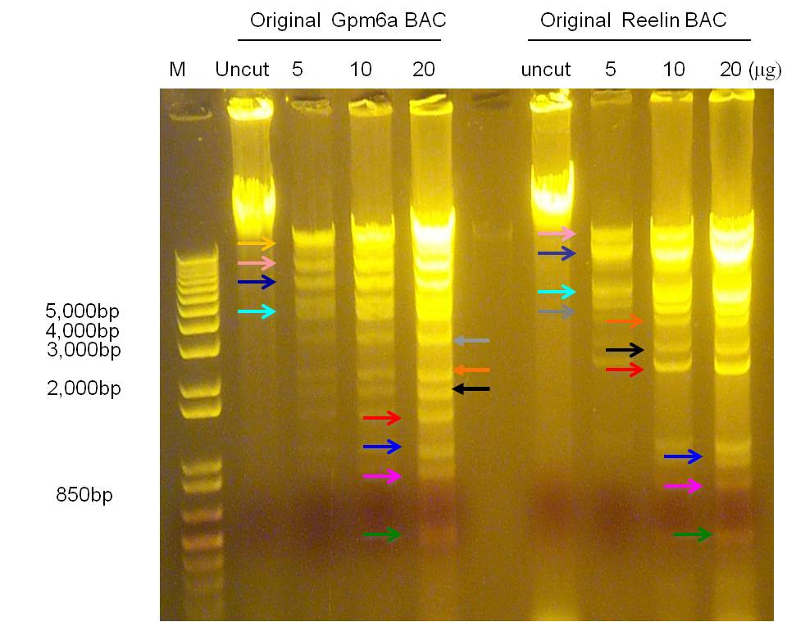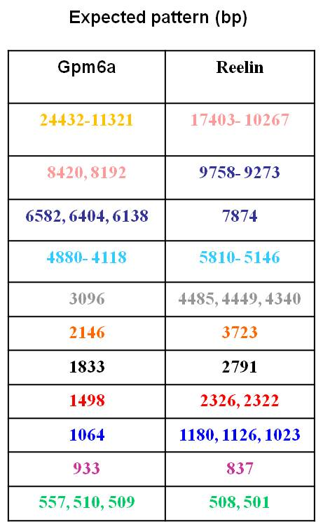
B
A

Figure 1 Confirmation of BAC DNA with restriction enzyme digestion. A: The electrophoretogram of original BAC with BamHI digestion; B: The expected bands of original BAC with BamHI digestion. The color of number is same as the arrow. M: Maker; Uncut: original BAC without digestion; 5, 10, 20: 5 μg, 10 μg, 20 μg of original BAC with BamHI digestion.

B
A
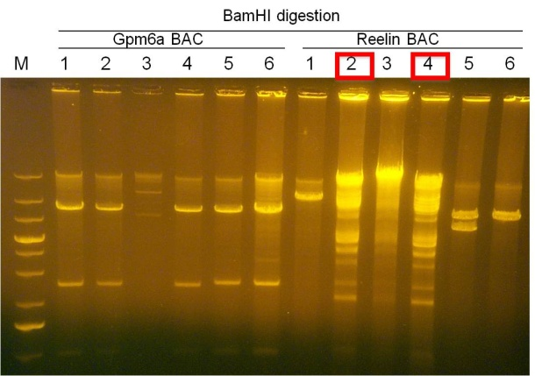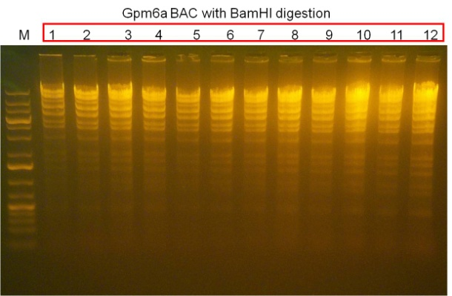
Figure 2 Confirmation of BAC DNA transformed into SW102 E.coli. A: The electrophoretogram of Gpm6a and Reelin BAC purified from SW102 E.coli with BamHI digestion; B: The electrophoretogram of Gpm6a BAC with BamHI digestion. The positive clones were emphasized by red pane.

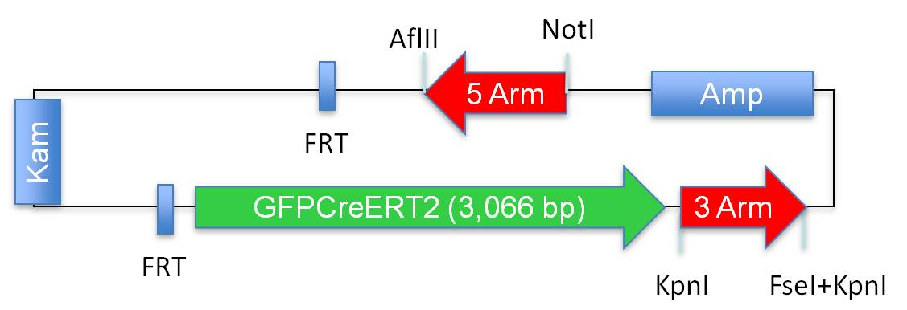
A
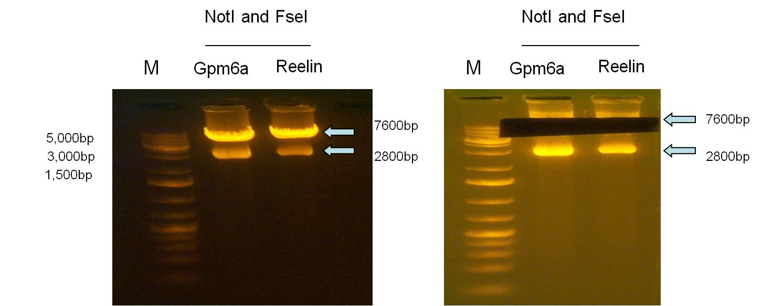
C
B
Figure 3 Preparation of reporter gene GFPCreERT2. A: The diagram of shuttle vector carrying GFPCreERT2; B: The electrophoretogram of the shuttle vector cut by NotI and FseI; C: The electrophoretogram after GFPCreERT2 fragment was cut from gel. M: Maker; Gpm6a: Shuttle vector inserted by 5 arm and 3 arm from Gpm6a BAC; Reelin: shuttle vector inserted by 5 arm and 3 arm from Reelin BAC.

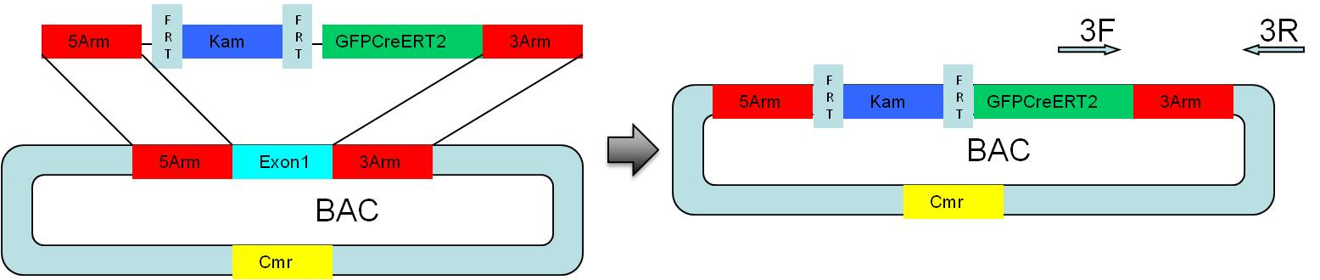
B
A
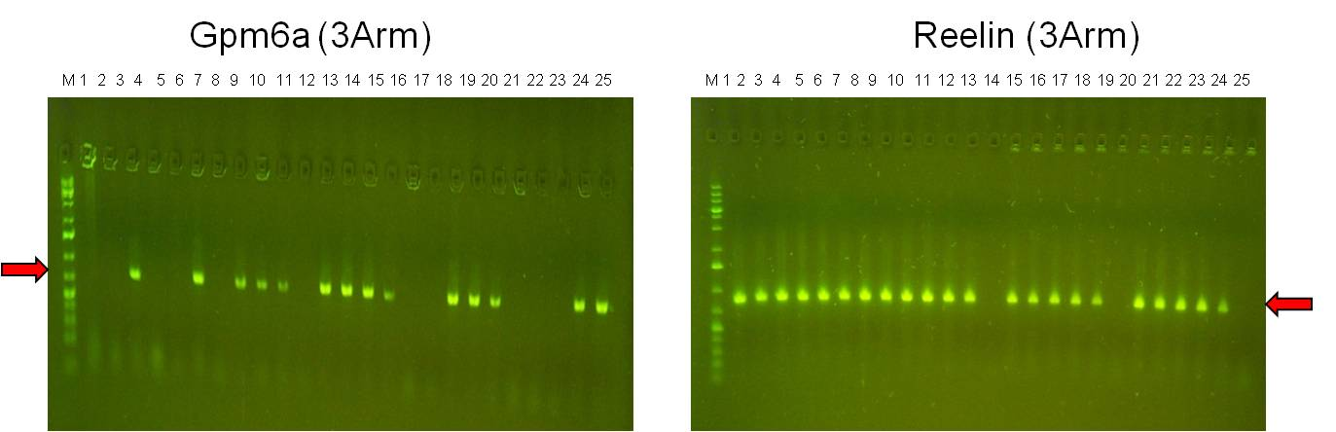
C
D
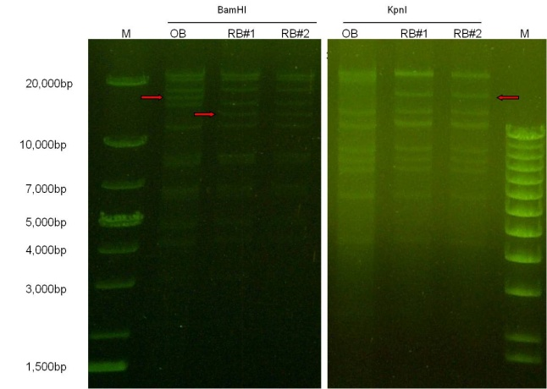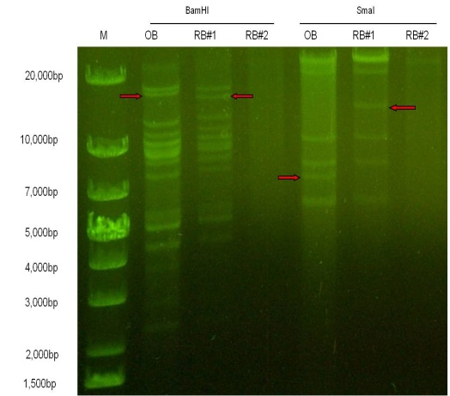
Figure 4 Screening and confirmation of recombinant clones. A: The diagram of Homologous recombination between BAC and GFPCreERT2; B: The electrophoretogram of PCR product according to the recombinant BAC template with 3arm primer; C: The electrophoretogram of recombinant Gpm6a BAC digested by BamHI and KpnI. D: The electrophoretogram of recombinant Reelin BAC digested by BamHI and SmaI. M: Maker; OB: Original BAC; RB: Recombinant BAC.

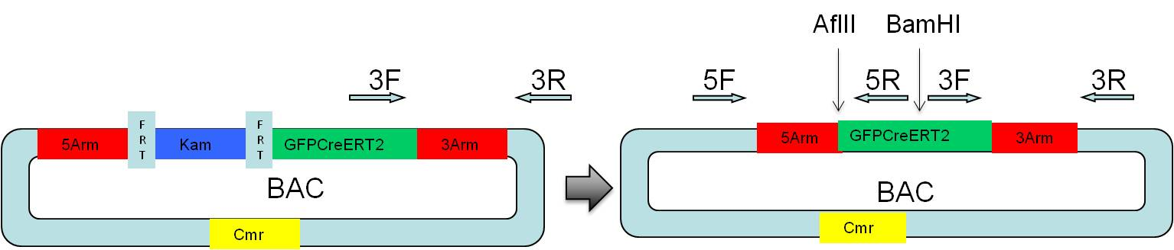
A

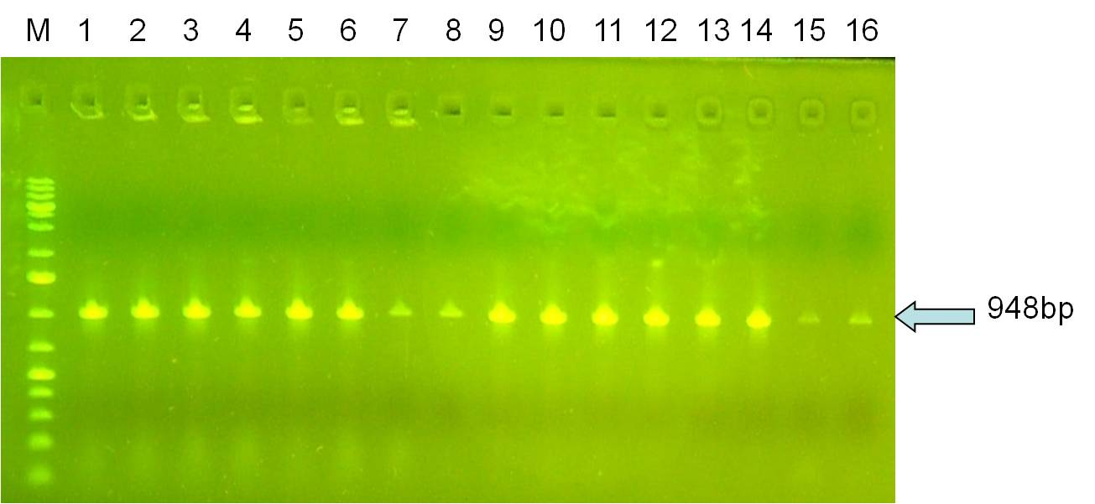
B

D
C
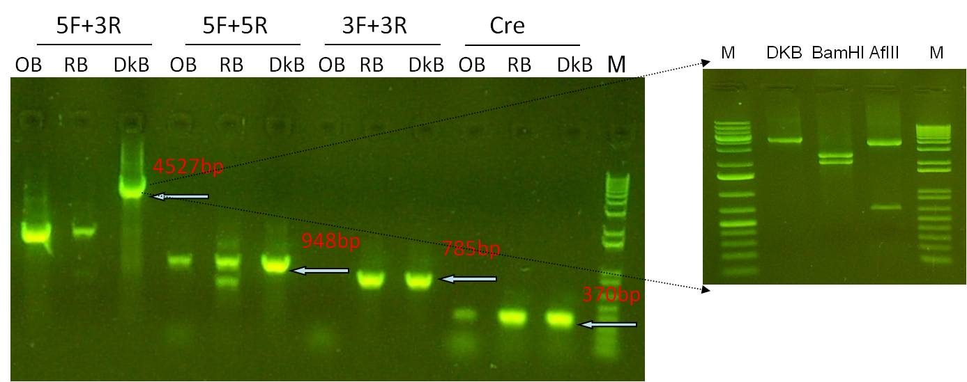
Figure 5 Screening and confirmation of recombinant clones without kanamycin unit. A: The diagram of Removal of Kam unit in SW105 E.coli; B: The electrophoretogram of PCR product according to the recombinant BAC template with 5arm primer; C: The electrophoretogram of PCR product according to the recombinant BAC template with different primers; D: The electrophoretogram of PCR product with BamHI or AflII digestion. M: Maker; OB: Original BAC; RB: Recombinant BAC; DkB: Deleted kanamycin BAC; 5F: Forward primer of 5arm; 5R: Reverse primer of 5arm; 3F: Forward primer of 3arm; 3R: Reverse primer of 3arm; Cre: Cre primer.

