Name of Journal: World Journal of Gastroenterology
Manuscript NO: 60827
Manuscript Type: ORIGINAL ARTICLE

Basic Study
S100 calcium binding protein A6 and associated long noncoding ribonucleic acids as biomarkers in the diagnosis and staging of primary biliary cholangitis

Dong XH et al. Biomarkers for the diagnosis and staging of PBC

Xi-Hua Dong, Di Dai, Zhi-Dong Yang, Xiao-Ou Yu, Hua Li, Hui Kang

Xi-Hua Dong, Di Dai, Zhi-Dong Yang, Xiao-Ou Yu, Hua Li, Hui Kang, Department of Laboratory Medicine, The First Affiliated Hospital of China Medical University, Shenyang 110001, Liaoning Province, China

Author contributions: All authors participated in the design, interpretation of the studies, analysis of the data and review of the manuscript; Dong XH wrote the manuscript; Dong XH, Dai D and Yang ZD conducted the experiment; Yu XO and Li H collected data; Dong XH, Yu XO and Li H analyzed the data; the article was approved by Kang H; The final version of the article was approved by all authors.

Supported by National Natural Science Foundation of China, No. 81871723.

Corresponding author: Hui Kang, PhD, Professor, Department of Laboratory Medicine, The First Affiliated Hospital of China Medical University, No. 155 Nanjing North Street, Shenyang 110001, Liaoning Province, China. kanghui65@sina.com

Received: December 7, 2020
Revised: January 23, 2021
Accepted: March 10, 2021
Published online:

Abstract
BACKGROUND
Primary biliary cholangitis (PBC) is a chronic and slowly progressing cholestatic disease, which causes damage to the small intrahepatic bile duct by immunoregulation, and may lead to cholestasis, liver fibrosis, cirrhosis and, eventually, liver failure.

AIM
To explore the potential diagnosis and staging value of plasma S100 calcium binding protein A6 (S100A6) messenger ribonucleic acid (mRNA), LINC00312, LINC00472, and LINC01257 in primary biliary cholangitis.

METHODS
A total of 145 PBC patients and 110 healthy controls (HCs) were enrolled. Among them, 80 PBC patients and 60 HCs were used as the training set, and 65 PBC patients and 50 HCs were used as the validation set. The relative expression levels of plasma S100A6 mRNA, long noncoding ribonucleic acids LINC00312, LINC00472 and LINC01257 were analyzed using quantitative reverse transcription-polymerase chain reaction. The bile duct ligation (BDL) mouse model was used to simulate PBC. Then double immunofluorescence was conducted to verify the overexpression of S100A6 protein in intrahepatic bile duct cells of BDL mice. Human intrahepatic biliary epithelial cells were treated with glycochenodeoxycholate to simulate the cholestatic environment of intrahepatic biliary epithelial cells in PBC.

RESULTS
The expression of S100A6 protein in intrahepatic bile duct cells was up-regulated in the BDL mouse model compared with sham mice. The relative expression levels of plasma S100A6 mRNA, log10 LINC00472 and LINC01257 were up-regulated while LINC00312 was down-regulated in plasma of PBC patients compared with HCs (3.01 ± 1.04 vs 2.09 ± 0.87, P < 0.0001; 2.46 ± 1.03 vs 1.77 ± 0.84, P < 0.0001; 3.49 ± 1.64 vs 2.37 ± 0.96, P < 0.0001; 1.70 ± 0.33 vs 2.07 ± 0.53, P < 0.0001, respectively). The relative expression levels of S100A6 mRNA, LINC00472 and LINC01257 were up-regulated and LINC00312 was down-regulated in human intrahepatic biliary epithelial cells treated with glycochenodeoxycholate compared with control (2.97 ± 0.43 vs 1.09 ± 0.08, P = 0.0018; 2.70 ± 0.26 vs 1.10 ± 0.10, P = 0.0006; 2.23 ± 0.21 vs 1.10 ± 0.10, P = 0.0011; 1.20 ± 0.04 vs 3.03 ± 0.15, P < 0.0001, respectively). The mean expression of S100A6 in the advanced stage (III and IV) of PBC was up-regulated compared to that in HCs and the early stage (II) (3.38 ± 0.71 vs 2.09 ± 0.87, P < 0.0001; 3.38 ± 0.71 vs 2.57 ± 1.21, P = 0.0003, respectively); and in the early stage (II), it was higher than that in HCs (2.57 ± 1.21 vs 2.09 ± 0.87, P = 0.03). The mean expression of LINC00312 in the advanced stage was lower than that in the early stage and HCs (1.39 ± 0.29 vs 1.56 ± 0.33, P = 0.01; 1.39 ± 0.29 vs 2.07 ± 0.53, P < 0.0001, respectively); in addition, the mean expression of LINC00312 in the early stage was lower than that in HCs (1.56 ± 0.33 vs 2.07 ± 0.53, P < 0.0001). The mean expression of log10 LINC00472 in the advanced stage was higher than those in the early stage and HCs (2.99 ± 0.87 vs 1.81 ± 0.83, P < 0.0001; 2.99 ± 0.87 vs 1.77 ± 0.84, P < 0.0001, respectively). The mean expression of LINC01257 in both the early stage and advanced stage were up-regulated compared with HCs (3.88 ± 1.55 vs 2.37 ± 0.96, P < 0.0001; 3.57 ± 1.79 vs 2.37 ± 0.96, P < 0.0001, respectively). The areas under the curves (AUC) for S100A6, LINC00312, log10 LINC00472 and LINC01257 in PBC diagnosis were 0.759, 0.7292, 0.6942 and 0.7158, respectively. Furthermore, the AUC for these four genes in PBC staging were 0.666, 0.661, 0.839 and 0.5549, respectively. The expression levels of S100A6 mRNA, log10 LINC00472, and LINC01257 in plasma of PBC patients were decreased (2.35 ± 1.02 vs 3.06 ± 1.04, P = 0.0018; 1.99 ± 0.83 vs 2.33 ± 0.96, P = 0.036; 2.84 ± 0.92 vs 3.69 ± 1.54, P = 0.0006), and the expression level of LINC00312 was increased (1.95 ± 0.35 vs 1.73 ± 0.32, P = 0.0007) after treatment compared with before treatment using the paired t-test. Relative expression of S100A6 mRNA was positively correlated with log10 LINC00472 (r = 0.683, P < 0.0001); serum level of collagen type IV was positively correlated with the relative expression of log10 LINC00472 (r = 0.482, P < 0.0001); relative expression of S100A6 mRNA was positively correlated with the serum level of collagen type IV (r = 0.732, P < 0.0001). The AUC for the four biomarkers obtained in the validation set were close to the training set.

CONCLUSION
These four genes may potentially act as novel biomarkers for the diagnosis of PBC. Moreover, LINC00472 acts as a potential biomarker for staging in PBC.

Key Words: S100 calcium binding protein A6; Long noncoding ribonucleic acids; Primary biliary cholangitis; Biomarker; Diagnosis; Staging

Dong XH, Dai D, Yang ZD, Yu XO, Li H, Kang H. S100 calcium binding protein A6 and associated long noncoding ribonucleic acids as biomarkers in the diagnosis and staging of primary biliary cholangitis. World J Gastroenterol 2021; In press

Core Tip: Primary biliary cholangitis (PBC) is an autoimmune liver disease which is characterized by intrahepatic cholestasis. The expression of S100 calcium binding protein A6 (S100A6) was up-regulated in a bile duct ligation mouse model compared with sham mice. The relative expression levels of plasma S100A6 messenger ribonucleic acid, LINC00472 and LINC01257 were up-regulated and the relative expression of LINC00312 was down-regulated in PBC patients. S100A6 and the three long noncoding ribonucleic acids can be used as biomarkers for PBC diagnosis and staging using receiver operating characteristic curve analysis. The results were further verified in vitro using intrahepatic biliary epithelial cells.

INTRODUCTION
Primary biliary cholangitis (PBC) is a chronic and slowly progressing cholestatic disease, which causes damage to the small intrahepatic bile duct by immunoregulation, and may lead to cholestasis, liver fibrosis, cirrhosis and, eventually, liver failure. The injury mechanism of intrahepatic biliary epithelial cells (iBECs) is the key to investigate the pathogenesis of PBC, but the accurate relationship between cholestasis and liver fibrosis is still indistinct. Currently, liver injury caused by cholestasis is mainly studied using liver cell lines or liver cancer cell lines treated with hydrophobic bile acids^{[1]}, while iBECs, the main target cells of PBC, have rarely been studied.
S100 calcium binding protein A6 (S100A6), also known as calcyclin, is a Ca²⁺ binding protein and is a member of the S100 family. Its distribution in the body is specific to cells and tissues, having a high expression in normal epithelial cells and fibroblasts, as well as in some tumor cells^{[2]}. As an intracellular protein, S100A6 is involved in the regulation of various cellular functions, such as proliferation, apoptosis, cytoskeletal dynamics, and cell response to different stressors. It is believed that S100A6 may be involved in the ubiquitination of beta catenin and play an important role in controlling the cell cycle process^{[3]}. S100A6 can interact with the calcyclin-binding protein/Siah-1-interacting protein, which is a component of the ubiquitin ligase complex^{[4]}.
Long non-coding ribonucleic acids (lncRNAs) are involved in the regulation of a variety of intracellular processes^{[5]}. As a structural component, lncRNAs can form a nucleic acid protein complex with gene regulatory transcription factors^{[6]}. LncRNAs can also bind to specific transcription factors and change their cellular localization, thus affecting the transcription of target genes. Abnormal expression of lncRNAs in plasma has been shown to accurately predict several human diseases^{[7,8]}.
As a general rule, PBC diagnosis depends on titers of antimitochondrial antibody (AMA), serum level of alkaline phosphatase (ALP) and liver biopsy^{[9-11]}. However, it is difficult to achieve an early diagnosis in AMA-negative patients, or to differentiate from other autoimmune liver diseases; thus, an invasive liver biopsy is required to make a definitive diagnosis, and this not only increases the financial burden of patients, but also brings mental and physical trauma to patients, often delaying the best time for treatment. However, after definite diagnosis, some patients fail to respond to ursodeoxycholic acid treatment and often have a poor prognosis or even progress to liver failure. The majority of PBC cases are diagnosed mostly at an advanced stage, so diagnosis and staging biomarkers of PBC are urgently needed.
In this study, we explored the value of S100A6 and its associated lncRNAs as potential biomarkers for the diagnosis and staging of PBC.

MATERIALS AND METHODS
Study design
This study included three phases (Figure 1): (1) The discovery phase, in which candidate genes and lncRNAs were searched using bioinformatics methods, and were then verified by a mouse model and cell model; (2) The training phase, in which quantitative reverse transcription-polymerase chain reaction (qRT-PCR) was used to evaluate the relative expression levels of target gene and lncRNAs in the plasma of PBC patients and healthy controls, as well as to estimate their diagnosis and staging value; and (3) the validation phase, in which the diagnosis and staging value of target genes and lncRNAs was verified in another independent PBC cohort.

Identification of differentially expressed genes from the gene expression omnibus dataset
The GSE29776 array dataset was analyzed on the gene expression omnibus (GEO) database (https://www.ncbi.nlm.nih.gov/geo/)^{[12]}. The dataset contains 6 mouse liver tissue samples, including 3 bile duct ligation (BDL) mouse samples and 3 sham mouse samples. “GEO2R” in the webpage was used to analyze the array database.

LncRNAs selection
The PROMO usage database (http://alggen.lsi.upc.es/cgi-bin/promo_v3/promo/promoinit.cgi?dirDB=TF_8.3) was used to predict the transcription factors of the S100A6 promoter^{[13]}. There were multiple binding sites between the transcription factor estrogen receptor alpha (also known as ESR1) and the promoter of S100A6. Experiments with BDL mice and PBC patients suggested that the expression of estrogen receptor in bile duct epithelial cells was associated with cholestasis or bile duct epithelial cells in PBC^{[14]}. We hypothesized that ESR1 could regulate the transcription of S100A6 as a transcription factor and thus play an important role in the injury of bile duct cells in PBC. The Gene-Cloud of Biotechnology Information database (https://www.gcbi.com.cn/gcanalyze/html/generadar/index) was used to screen lncRNAs associated with ESR1^{[15]}. The binding force between lncRNAs and ESR1 was calculated by RNA-Protein Interaction Prediction (http://pridb.gdcb.iastate.edu/RPISeq/)^{[16]}. As RF and SVM scores of LINC00312, LINC00472, and LINC01257 were all found to be close to 1.0, these three lncRNAs were selected as candidate lncRNAs in this study.

Animal studies, bile duct ligation model
Male C57BL/6J mice (aged 6-8 wk) were purchased from the Animal Experiment Department of China Medical University (Shenyang, Liaoning Province, China). All mice were weighed and randomly grouped with an average weight of 20-25 g into the BDL group and the sham group. To simulate cholestasis, 9 mice underwent BDL^{[17]}. The animal protocol was designed to minimize pain or discomfort to the mice. The animals were acclimatized to laboratory conditions (24°C, 12 h/12 h light/dark, 50% humidity, ad libitum access to food and water) for 2 wk prior to experimentation. The BDL procedure was performed with the common bile duct doubly ligated under anesthesia via laparotomy^{[18]}. The sham procedure was performed via a similar laparotomy without BDL. Animal experiments were approved by the Ethics Committee of the Animal Experiment Department of China Medical University.
A portion of the liver tissue was placed in a 4% p-formaldehyde solution and routinely processed for histological assessment, while the remaining tissue was snap frozen and stored at -80°C.

Histological analysis
The mice were sacrificed by cervical dislocation and the liver was immediately removed by laparotomy. Part of the right lobe of the liver was fixed in 4% formaldehyde. The liver tissues were embedded in paraffin and sliced. Hematoxylin and eosin stained liver sections were observed under a light microscope at x 400 magnification to evaluate whether the cholestasis model was successfully established^{[19]}.

Double immunofluorescence
To identify whether the expression of S100A6 protein was up-regulated in bile duct epithelial cells in BDL mice, we performed double immunofluorescence^{[20]} for S100A6 antibodies (Abcam, USA, Cat. No. ab181975) with cytokeratin 19 (CK19) antibodies (Abcam, USA, Cat. No. ab52625) which was specifically expressed in epithelial cells^{[21]}. The primary antibody was replaced by rabbit or mouse IgG for negative controls. The working concentration of fluorescein isothiocyanate and tetraethyl rhodamine isothiocyanate was 1:50. Nuclei were counterstained with DAPI. The empirical procedure was performed according to the manufacturer’s instructions. The sections were counterstained with DAPI and evaluated under a conventional fluorescence microscope.

Cells culture and treatments
Human intrahepatic biliary epithelial cells (HiBECs) were purchased from Guangzhou Jennio Biotech Company Limited (Guangzhou, Guangdong Province, China). Cells were cultured in RPMI-1640 supplemented with 10% fetal bovine serum (GEMINI, USA), 100 U/mL penicillin, and 100 mg/mL streptomycin in incubators at 37°C with 5% CO₂. HiBECs were treated with 1000 mmol/L glycochenodeoxycholate (GCDC)^{[22]} for 24 h to mimic cholestasis in PBC patients.

Patients
A total of 80 untreated PBC patients and 60 healthy controls as the training set were enrolled in order to differentially evaluate S100A6 and lncRNAs. In addition, another cohort consisting of 65 PBC patients and 50 healthy controls was used as the validation set. PBC patients were diagnosed by the Department of Gastroenterology or Rheumatology of The First Affiliated Hospital of China Medical University between January 2017 and November 2020. The diagnosis of PBC needed to meet two of the following three criteria^{[9-11]}: (1) AMA titer > 1:40; (2) ALP level 1.5-times higher than the normal upper limit for more than 24 wk; and (3) liver biopsy revealing non-suppurative cholangitis and interlobular bile duct damage. Written informed consent was obtained from all patients who participated in the study. This study was approved by the Ethics Committee of The First Affiliated Hospital of China Medical University and was carried out in accordance with the Declaration of Helsinki.
Percutaneous ultrasound-guided puncture biopsy of the right liver was performed in all PBC patients, followed by histopathological examination and pathological stage identification^{[23]}. Four stages were defined based on intrahepatic bile duct injury^{[24]}: Stage Ι: Cholangitis stage, chronic inflammation in the interlobular and septal bile duct. Lymphocytes and plasma cells around the damaged bile ducts infiltrate or form granuloma, but the inflammation in the portal area does not involve the liver parenchyma and there is no cholestasis; stage II: Periportal inflammation stage, with a continuous reduction in the number of interlobular bile ducts, reactive hyperplasia of bile ducts around the portal area, inflammation involving adjacent liver parenchyma and destruction of liver cells, and common focal necrosis, cholestasis also occurs; stage III: Progressive fibrosis stage, the portal area is continuously enlarged by inflammation and fibrosis progression, the fibrous septa formed gradually widens, and cholestasis is aggravated; stage IV: Liver cirrhosis stage, fibrous septa divides the liver parenchyma into patchy nodules, regenerating nodules, and forming pseudo lobules.

Extraction of total RNA from plasma samples and cells
The relative expression levels of S100A6 and lncRNAs in plasma were measured in PBC patients, as well as human intrahepatic biliary epithelial cell lines. Total RNA was extracted from plasma and HiBECs by an RNA extraction kit (Bioteke, China), according to the manufacturer’s instructions.

Reverse transcription and quantitative PCR for S100A6 and lncRNAs
Total RNA was amplified by reverse transcription using a reverse transcription kit (PrimeScriptTM RT Master Mix, TaKaRa, China)^{[25]}. All reactions were completed in a Themocycler (Mastercycler nexus, Eppendorf, Germany). Then, quantitative PCR was performed using SYBR® Premix Ex TaqTM II kit (Takara, China) on the LightCycler 480 (Roche, Germany). GAPDH was used as an internal reference, and served as an internal control for plasma RNA quality. S100A6 and lncRNAs expression were calculated by the 2^{−ΔΔCt} method {2[(Mean ct of RNA–mean ct of GAPDH) – (mean ct of control–mean ct of GAPDH)]}^{[26]}. The calculated result was the relative quantitative expression value of S100A6 and lncRNAs compared with the internal reference. Primers for reactions were designed by Primer Premier 6.0 (Canada) software (Table 1)^{[27]}.

Statistical analysis
Statistical Package for Social Science 23.0 software (IBM Solutions Statistical Package for the Social Sciences Incorporated, USA) and GraphPad Prism 8 (GraphPad Software, Incorporated, San Diego, CA, USA) were used for all statistical analyses. The normal distribution data were recorded (mean ± SD), and comparisons between the two groups were performed using the unpaired t-test. The paired t-test was used to compare the expression levels before and after treatment. Non-normal distribution data were analyzed using the non-parametric Mann-Whitney U test^{[28]}. Categorical data were analyzed using the χ² test. The correlation between the plasma level of S100A6 mRNA and lncRNAs was analyzed using Pearson or Spearman correlation analysis. Receiver operating characteristic (ROC) curves were constructed and the areas under the curves (AUC) were used to evaluate the value of plasma S100A6 mRNA and lncRNAs as biomarkers for the diagnosis and staging of PBC^{[29]}. P < 0.05 was considered statistically significant.

RESULTS
Identification of the target gene
“GEO2R” was used to analyze the differentially expressed genes in liver tissues of BDL and sham mice of GSE29776. The top 10 up- and down-regulated genes of GSE29776 in the BDL and sham group are listed in Table 2. To identify potential biomarkers for PBC diagnosis and staging, we used qRT-PCR to validate the analysis of bioinformatics up-regulated genes in plasma of 30 PBC patients and 30 healthy controls. It was found that S100A6 showed the greatest change in the plasma of PBC patients (t = 20.28, P < 0.0001) (Figure 2). Therefore, S100A6 was selected as the target gene in this study.

Expression of S100A6 protein in the BDL mouse model
HE staining revealed histological changes in liver tissues, with the BDL group showing liver cell swelling, vacuolar degeneration, and coagulative necrosis. Inflammatory cell infiltration was observed in the portal area and around the bile duct, and fibrosis around the bile duct (Figure 3A-C). In the sham group, there was no or minimal inflammatory cell infiltration around the portal area and bile duct (Figure 3D-F).
Double immunofluorescence staining was used to label CK19 and S100A6 proteins. A fluorescence microscope was used for observation and Image J software was used for graph analysis. The results showed that S100A6 labeled with fluorescein isothiocyanate showed emerald green fluorescence and CK19 labeled with tetraethyl rhodamine isothiocyanate showed red fluorescence. Red and green fluorescent overlapping images showed that CK19 and S100A6 proteins were positively expressed in the iBECs of BDL mice (Figure 4A-C), while these two proteins were weakly expressed in the iBECs of mice in the sham group (Figure 4D-F).

The expression of S100A6 and lncRNAs analyzed in HiBECs
To investigate the mechanism of S100A6 and lncRNAs, the expression of S100A6 and lncRNAs was studied in HiBECs. Normal and HiBECs treated with GCDC were detected by qRT-PCR. The relative expression levels of S100A6 mRNA, LINC00472 and LINC01257 were up-regulated and LINC00312 was down-regulated in HiBECs treated with GCDC compared with controls (2.97 ± 0.43 vs 1.09 ± 0.08, P = 0.0018; 2.70 ± 0.26 vs 1.10 ± 0.10, P = 0.0006; 2.23 ± 0.21 vs 1.10 ± 0.10, P = 0.0011; 1.20 ± 0.04 vs 3.03 ± 0.15, P < 0.0001, respectively) (Figure 5).

Demographics and clinical features of PBC patients compared with healthy controls
There were no differences in age and gender between the training set and validation set (P = 0.504 and P = 1.0, respectively, Table 3). Moreover, there were no differences in age and gender between PBC patients and healthy controls (P = 0.58 and P = 1.0, respectively). Clinical serological data including alanine aminotransferase, aspartate aminotransferase, ALP, gamma-glutamyl transpeptidase, total bilirubin, direct bilirubin, total bile acid, hyaluronic acid, laminin, collagen type IV (C-IV) and procollagen III were all significantly higher in PBC patients than in healthy controls (P < 0.0001, Table 4).

Differential expression of S100A6 and lncRNAs in PBC patients compared with HCs
To compare the mean expression levels of S100A6 mRNA, LINC00312, and LINC01257 in PBC patients and healthy controls, the Kolmogorov–Smirnov test was used to check normality. The results showed that these variables had a normal distribution (P > 0.05), and the t-test was used for analysis, as the relative expression of LINC00472 showed a skewed distribution, and was normally distributed after logarithmic conversion based on 10. The results showed that the expression levels of S100A6 mRNA, log10 LINC00472 and LINC1257 in PBC patients were significantly up-regulated compared to the healthy controls (3.01 ± 1.04 vs 2.09 ± 0.87; 2.46 ± 1.03 vs 1.77 ± 0.84; 3.49 ± 1.64 vs 2.37 ± 0.96, P values were all less than 0.0001, Figure 6A, C and D). The mean expression level of LINC00312 was significantly lower in PBC plasma samples compared with HCs (1.70 ± 0.33 vs 2.07 ± 0.53, P < 0.0001, Figure 6B).

Distribution of S100A6 and lncRNAs expression levels in different stages of PBC
The unpaired t-test analysis of variance was performed to evaluate differences in the expression of S100A6 and lncRNAs among different PBC stages and healthy controls (Figure 7). The results showed that the mean expression of S100A6 in the advanced stage (III and IV) of PBC was up-regulated compared to that in HCs and the early stage (II) (3.38 ± 0.71 vs 2.09 ± 0.87, P < 0.0001; 3.38 ± 0.71 vs 2.57 ± 1.21, P = 0.0003, respectively); and in the early stage (II), it was higher than that in HCs (2.57 ± 1.21 vs 2.09 ± 0.87, P = 0.03) (Figure 7A). The mean expression of LINC00312 in the advanced stage was lower than that in the early stage and HCs (1.39 ± 0.29 vs 1.56 ± 0.33, P = 0.01; 1.39 ± 0.29 vs 2.07 ± 0.53, P < 0.0001, respectively) (Figure 7B); in addition, the mean expression of LINC00312 in the early stage was lower than that in HCs (1.56 ± 0.33 vs 2.07 ± 0.53, P < 0.0001) (Figure 7B). The mean expression of log10 LINC00472 in the advanced stage was higher than that in the early stage and HCs (2.99 ± 0.87 vs 1.81 ± 0.83, P < 0.0001; 2.99 ± 0.87 vs 1.77 ± 0.84, P < 0.0001, respectively) (Figure 7C). The mean expression of LINC01257 in both the early stage and advanced stage were up-regulated compared with HCs (3.88 ± 1.55 vs 2.37 ± 0.96, P < 0.0001; 3.57 ± 1.79 vs 2.37 ± 0.96, P < 0.0001, respectively) (Figure 7D).

Diagnosis and staging value of plasma S100A6 and lncRNAs for PBC patients
ROC curves were used to evaluate the potential diagnostic value of each biomarker for PBC. The AUC for S100A6, LINC00312, log10 LINC00472 and LINC01257 in PBC diagnosis were 0.759, 0.7292, 0.6942 and 0.7158, respectively (Figure 8A-D). Furthermore, AUC for these four genes in PBC staging were 0.666, 0.661, 0.839 and 0.5549, respectively (Figure 8E-H).
Pearson or Spearman correlation analysis was performed to evaluate the correlation between relative expression of S100A6 mRNA and lncRNAs, as well as relative expression of S100A6 mRNA or lncRNAs and clinical serological data in PBC patients. Relative expression of S100A6 mRNA was positively correlated with log10 LINC00472 (r = 0.683, P < 0.0001); serum level of C-IV was positively correlated with relative expression of log10 LINC00472 (r = 0.482, P < 0.0001); relative expression of S100A6 mRNA was positively correlated with serum level of C-IV (r = 0.732, P < 0.0001) (Figure 9).

Comparison of expression levels of biomarkers before and after treatment
A total of 58 PBC patients were followed up after their treatment for one year. Paired t-test analysis was used to compare the expression levels of these four genes before and after treatment. The relative expression of S100A6 mRNA, log10 LINC00472, and LINC01257 were significantly decreased after treatment (2.35 ± 1.02 vs 3.06 ±1.04, P = 0.0018; 1.99 ± 0.83 vs 2.33 ± 0.96, P = 0.036; 2.84 ± 0.92 vs 3.69 ± 1.54, P = 0.0006, respectively); in addition, the relative expression of LINC00312 increased significantly after treatment compared with before treatment (1.95 ± 0.35 vs 1.73 ± 0.32, P = 0.0007) (Figure 10).

Differences between PBC patients with high and low levels of LINC00472
According to ROC curves analysis, the AUC of log10 LINC00472 was 0.839 (P < 0.0001) and the Youden index was 1.551. Accordingly, the patients in the PBC group were divided into L1 (log10 LINC00472 < 2.33) and L2 (log10 LINC00472 ≥ 2.33) subgroups. The baseline characteristics of PBC patients classified by the relative expression of the log10 LINC00472 cutoff value (2.33) is shown in Table 5. The relative expression of S100A6 mRNA and serum level of C-IV were lower in the L1 subgroup (P < 0.0001, Table 5); in addition, the relative expression of LINC01257 was higher in the L1 subgroup compared to the L2 subgroup (P = 0.005, Table 5).

Validation of diagnosis and staging value
The parameters estimated from the training data set were used to predict the probability of being diagnosed with PBC and staging of PBC for the independent validation data set. ROC curves were also constructed to predict the probability of diagnosis and staging. The AUC of S100A6 mRNA, LINC00312, log10 LINC00472 and LINC01257 in PBC diagnosis were 0.769, 0.772, 0.755 and 0.695, respectively (Figure 11A-D). Moreover, the AUC for log10 LINC00472 in PBC staging was 0.835 (Figure 11E).

DISCUSSION
PBC is a type of cholestatic liver disease which is a pathophysiological process caused by the obstruction of bile secretion and excretion. After analyzing the expression levels of the top 10 up-regulated genes of GSE29776 in the plasma of PBC patients, it was found that the difference in S100A6 mRNA expression levels between PBC patients and healthy controls was greatest (t = 20.28, P < 0.0001). Therefore, S100A6 was selected as the target gene. BDL is a common procedure for biliary obstruction widely used in rodent models of cholestasis and liver damage^{[30]}. Immunofluorescence double labeling analysis was performed to identify the overexpression of S100A6 protein in the intrahepatic bile duct epithelial cells of BDL mice compared with sham mice, which verified the results predicted by bioinformatics analysis. In this study, the bile duct cells proliferated greatly in the liver tissue 10 d after the operation in the BDL group^{[31,32]}, and S100A6 protein was expressed in large quantities during the corresponding period. However, the number of bile duct cells in the sham group was relatively low, and the expression of S100A6 protein was also relatively low. Therefore, it can be seen that proliferation of bile duct cells was specifically enhanced when cholestatic liver injury occurred; thus, there was a difference in S100A6 between the two groups. S100A6 is expressed as a 89-amino acid protein in mice and rats, a 90-amino acid protein in humans and rabbits, and subtypes A (92 amino acids) and B (91 amino acids) in chickens, which may be produced by mRNA selective splicing^{[33]}. In this study, the S100A6 antibodies used were universal in humans and mice, so the results of the BDL mouse model could indirectly reflect the up-regulation of S100A6 expression in human intrahepatic cholestasis.
In this study, S100A6 mRNA was overexpressed in the plasma of PBC patients compared with healthy controls. S100A6 expression is up-regulated in breast cancer, thyroid cancer, colorectal cancer, various types of skin tumors, acute myelogenous leukemia, epithelial tissues and other highly proliferating cell lines^{[34]}. Apoptosis in PBC is considered to be the cell effector injury mediated by T cells. Changes in apoptosis and apoptosis-related molecular expression of bile duct cells have been reported in bile duct lesions, but immune-mediated injury of bile duct epithelial cells has not been fully elucidated^{[35]}. Joo et al^{[36]} found that S100A6 may be involved in the process of apoptosis by regulating the transcriptional regulation of caspase-3. Therefore, it seems that S100A6 may play an important role in the pathogenesis of PBC.
The expression of lncRNAs is not only closely related to the occurrence and development of tumors^{[37]}, but also associated with autoimmune diseases^{[38]}. In this study, the expression of lncRNAs selected by bioinformatics analysis was differentially expressed in the plasma of PBC patients compared with healthy controls. The levels of plasma LINC00312 was significantly down-regulated in PBC patients, while LINC00472 and LINC01257 were up-regulated in PBC patients, indicating that these lncRNAs might be valuable for PBC diagnosis. ROC curves were used to evaluate the diagnostic value of each marker. The differential expression in plasma between PBC patients and heathy controls indicated that S100A6 mRNA (AUC = 0.76, P < 0.0001), LINC00312 (AUC = 0.73, P < 0.0001), log10 LINC00472 (AUC = 0.69, P < 0.0001) and LINC01257 (AUC = 0.72, P < 0.0001) may be potential biomarkers for the diagnosis of PBC.
Furthermore, the ROC curves analysis also showed that plasma S100A6 mRNA (AUC = 0.67, P = 0.01), LINC00312 (AUC = 0.66, P = 0.01) and log10 LINC00472 (AUC = 0.84, P < 0.0001) could also be used to predict disease progression in PBC. In particular, LINC00472 had high diagnostic value for PBC staging (sensitivity was 77.27%, specificity was 77.78%). According to the cutoff value (2.33) of log10 LINC00472, the relative expression of S100A6 mRNA and serum level of C-IV in the high-level group were higher than those in the low-level group.
LINC00312, also known as NAG7, was found to inhibit proliferation and induce apoptosis in nasopharyngeal carcinoma (NPC) cells but also stimulate NPC cell invasion. LINC00312 was significantly down-regulated in NPC tissues compared with non-cancerous nasopharyngeal epithelium tissues. Positive expression of LINC00312 was negatively correlated with tumor size but positively correlated with lymph node metastasis^{[39]}. High expression of LINC00472 was associated with less aggressive breast tumors and better prognosis. Patients with high expression of LINC00472 had a significantly reduced risk of recurrence and death compared to those with low expression. Patients with high expression of LINC00472 also responded better to adjuvant chemotherapy or hormone therapy than those with low expression^{[40]}. Therefore, studies on S100A6, LINC00312 and LINC00472 have all been related to tumors. This study is the first to explore the relationship between these three genes and autoimmune diseases. In addition, we investigated the relationship between the expression of LINC01257 and diseases for the first time.
The expression levels of plasma S100A6, LINC00312, LINC00472 and LINC01257 in PBC patients before and after treatment were analyzed by the paired t-test. It was found that the elevated biomarkers decreased after treatment, while the reduced biomarker increased. This provides further evidence that these four genes are biomarkers for PBC diagnosis.
The correlation analysis showed that relative expression of S100A6 mRNA was positively correlated with log10 LINC00472 (r = 0.683, P < 0.0001) and the serum level of C-IV (r = 0.732, P < 0.0001). C-IV serves as a histochemical marker of perisinusoidal basement membrane formation in liver disease^{[41]}. It was further illustrated that S100A6 may be associated with PBC liver injury. The relative expression of log10 LINC00472 was positively correlated with the serum level of C-IV (r = 0.482, P < 0.0001), indicating that it was related to the disease severity of PBC. It was suggested that LINC00472 can be used as a marker of PBC staging. However, in our study, the four biomarkers did not correlate with the cholestasis indicator ALP, and we think this may be due to the following reasons: (1) The S100A6 protein was expressed in large quantities during the early period of cholestasis. This process may precede the increase in serum ALP level; (2) Proliferation of bile duct cells is characterized by irregular proliferation of intrahepatic bile ducts not only confined to portal areas, but also sprouting into periportal and parenchymal regions. This implies that the newly formed bile ducts are functionally ineffective^{[42,43]}; and (3) In the late stage of liver fibrosis, considerable hepatocyte necrosis occurs.
Hepatocytes exposed to bile acids have been used in many studies on PBC. The most commonly used bile acid is GCDC, which is a type of toxic hydrophobic bile acid and can induce apoptosis of iBECs, form apoptotic bodies, and can lead to the pyruvate dehydrogenase complex E2 subunit as an autoimmune antigen to be exposed. A series of immune responses are then activated^{[44]}. Hisamoto et al^{[45]} studied the effects of hydrophobic bile acid on human BECs and autologous spleen mononuclear cells, especially the effects of GCDC on anion exchange protein expression of BECs and on the phenotype of BECs and local inflammatory response. It was proved that GCDC reduced the expression of anion exchange in BECs and accelerated the aging of BECs by inducing reactive oxygen species. Therefore, this study used GCDC to treat HiBECs to simulate a cholestatic environment and assess its damage to HiBECs. In this study, the expression levels of S100A6 mRNA, LINC00472 and LINC01257 were up-regulated while LINC00312 was down-regulated in GCDC-treated HiBECs compared with controls, consistent with the expression in plasma of PBC patients. It was further proved that these four indicators are related to PBC diagnosis and staging.
The value of the above four biomarkers should be validated in an additional cohort of PBC patients and their specificity needs to be examined in other patient populations^{[46]}. We chose another PBC cohort as the validation set. The AUC of the four genes were close to those in the training set. Therefore, the value of these four biomarkers in the diagnosis and staging of PCB was validated. However, in China, the vast majority are Han Chinese; therefore, it is difficult to verify these findings in other ethnic groups.

CONCLUSION
In conclusion, the expression of S100A6 protein in BDL mice was up-regulated, the expression of S100A6 mRNA, LINC00472 and LINC01257 were up-regulated, while LINC00312 was down-regulated both in the plasma of PBC patients and HiBECs treated with GCDC compared with controls. Although our study was confined to the expression analysis of S100A6 mRNA, LINC00312, LINC00472 and LINC01257, warranting further studies to investigate the mechanisms underlying the functional role of these four markers, nevertheless their potential as biomarkers for diagnosis and staging of PBC was elucidated by multiple evaluations in this study.

ARTICLE HIGHLIGHTS
Research background
Primary biliary cholangitis (PBC) is an autoimmune liver disease that mostly affects women. Fatigue and persistent pruritus are the most obvious symptoms. PBC may lead to cholestasis, liver fibrosis, cirrhosis and, eventually, liver failure. The injury mechanism of intrahepatic biliary epithelial cells is the key to investigating the pathogenesis of PBC, but the accurate relationship between cholestasis and liver fibrosis is still indistinct.

Research motivation
To explore the target genes of intrahepatic biliary epithelial cell injury in PBC. To search for plasma biomarkers for early diagnosis and staging of PBC. To lay a foundation for further study on the pathogenesis of PBC.

Research objectives
To explore the potential diagnosis and staging value of plasma S100 calcium binding protein A6 (S100A6) messenger ribonucleic acid (mRNA), LINC00312, LINC00472, and LINC01257 in primary biliary cholangitis.

Research methods
The up-regulation of S100A6 was identified by double immunofluorescence in a bile duct ligation mouse model. We used quantitative reverse transcription-polymerase chain reaction to analyze the relative expression levels of S100A6 mRNA, long noncoding ribonucleic acids (lncRNAs) LINC00312, LINC00472 and LINC01257 both in patients with PBC and in human intrahepatic biliary epithelial cells treated with glycochenodeoxycholate.

Research results
The relative expression levels of S100A6 mRNA, LINC00472 and LINC01257 were up-regulated while LINC00312 was down-regulated in both the plasma of patients with PBC and in human intrahepatic biliary epithelial cells treated with glycochenodeoxycholate.

Research conclusions
These four genes may potentially act as novel biomarkers for the diagnosis of PBC. Moreover, LINC00472 acts as a biomarker for staging in PBC.

Research perspectives
Although we have demonstrated that S100A6 and related lncRNAs may be biomarkers for the diagnosis and staging of PBC, their detailed value needs to be analyzed in a large sample. The specific mechanisms of S100A6 and lncRNAs require further investigation.

REFERENCES
1 Woolbright BL, McGill MR, Yan H, Jaeschke H. Bile Acid-Induced Toxicity in HepaRG Cells Recapitulates the Response in Primary Human Hepatocytes. Basic Clin Pharmacol Toxicol 2016; 118: 160-167 [PMID: 26176423 DOI: 10.1111/bcpt.12449]
2 Salama I, Malone PS, Mihaimeed F, Jones JL. A review of the S100 proteins in cancer. Eur J Surg Oncol 2008; 34: 357-364 [PMID: 17566693 DOI: 10.1016/j.ejso.2007.04.009]
3 Matsuzawa SI, Reed JC. Siah-1, SIP, and Ebi collaborate in a novel pathway for beta-catenin degradation linked to p53 responses. Mol Cell 2001; 7: 915-926 [PMID: 11389839 DOI: 10.1016/s1097-2765(01)00242-8]
4 Filipek A, Kuźnicki J. Molecular cloning and expression of a mouse brain cDNA encoding a novel protein target of calcyclin. J Neurochem 1998; 70: 1793-1798 [PMID: 9572262 DOI: 10.1046/j.1471-4159.1998.70051793.x]
5 Veneziano D, Di Bella S, Nigita G, Laganà A, Ferro A, Croce CM. Noncoding RNA: Current Deep Sequencing Data Analysis Approaches and Challenges. Hum Mutat 2016; 37: 1283-1298 [PMID: 27516218 DOI: 10.1002/humu.23066]
6 Geisler S, Coller J. RNA in unexpected places: long non-coding RNA functions in diverse cellular contexts. Nat Rev Mol Cell Biol 2013; 14: 699-712 [PMID: 24105322 DOI: 10.1038/nrm³679]
7 Yang Y, Cai Y, Wu G, Chen X, Liu Y, Wang X, Yu J, Li C, Chen X, Jose PA, Zhou L, Zeng C. Plasma long non-coding RNA, CoroMarker, a novel biomarker for diagnosis of coronary artery disease. Clin Sci (Lond) 2015; 129: 675-685 [PMID: 26201019 DOI: 10.1042/CS20150121]
8 Tang J, Jiang R, Deng L, Zhang X, Wang K, Sun B. Circulation long non-coding RNAs act as biomarkers for predicting tumorigenesis and metastasis in hepatocellular carcinoma. Oncotarget 2015; 6: 4505-4515 [PMID: 25714016 DOI: 10.18632/oncotarget.2934]
9 Bowlus CL, Gershwin ME. The diagnosis of primary biliary cirrhosis. Autoimmun Rev 2014; 13: 441-444 [PMID: 24424173 DOI: 10.1016/j.autrev.2014.01.041]
10 European Association for the Study of the Liver. EASL Clinical Practice Guidelines: management of cholestatic liver diseases. J Hepatol 2009; 51: 237-267 [PMID: 19501929 DOI: 10.1016/j.jhep.2009.04.009]
11 Zweers SJ, de Vries EM, Lenicek M, Tolenaars D, de Waart DR, Koelfat KV, Groen AK, Olde Damink SW, Beuers U, Ponsioen C, Jansen PL, Schaap FG. Prolonged fibroblast growth factor 19 response in patients with primary sclerosing cholangitis after an oral chenodeoxycholic acid challenge. Hepatol Int 2017; 11: 132-140 [PMID: 27696157 DOI: 10.1007/s12072-016-9769-7]
12 Barrett T, Wilhite SE, Ledoux P, Evangelista C, Kim IF, Tomashevsky M, Marshall KA, Phillippy KH, Sherman PM, Holko M, Yefanov A, Lee H, Zhang N, Robertson CL, Serova N, Davis S, Soboleva A. NCBI GEO: archive for functional genomics data sets--update. Nucleic Acids Res 2013; 41: D991-D995 [PMID: 23193258 DOI: 10.1093/nar/gks1193]
13 Messeguer X, Escudero R, Farré D, Núñez O, Martínez J, Albà MM. PROMO: detection of known transcription regulatory elements using species-tailored searches. Bioinformatics 2002; 18: 333-334 [PMID: 11847087 DOI: 10.1093/bioinformatics/18.2.333]
14 Alvaro D, Alpini G, Onori P, Franchitto A, Glaser S, Le Sage G, Gigliozzi A, Vetuschi A, Morini S, Attili AF, Gaudio E. Effect of ovariectomy on the proliferative capacity of intrahepatic rat cholangiocytes. Gastroenterology 2002; 123: 336-344 [PMID: 12105861 DOI: 10.1053/gast.2002.34169]
15 Xiao J, Liu A, Lu X, Chen X, Li W, He S, He B, Chen Q. Prognostic significance of TCF21 mRNA expression in patients with lung adenocarcinoma. Sci Rep 2017; 7: 2027 [PMID: 28515486 DOI: 10.1038/s41598-017-02290-2]
16 Wang L, Yan X, Liu ML, Song KJ, Sun XF, Pan WW. Prediction of RNA-protein interactions by combining deep convolutional neural network with feature selection ensemble method. J Theor Biol 2019; 461: 230-238 [PMID: 30321541 DOI: 10.1016/j.jtbi.2018.10.029]
17 Grattagliano I, Portincasa P, Palmieri VO, Palasciano G. Mutual changes of thioredoxin and nitrosothiols during biliary cirrhosis: results from humans and cholestatic rats. Hepatology 2007; 45: 331-339 [PMID: 17256724 DOI: 10.1002/hep.21519]
18 Soroka CJ, Lee JM, Azzaroli F, Boyer JL. Cellular localization and up-regulation of multidrug resistance-associated protein 3 in hepatocytes and cholangiocytes during obstructive cholestasis in rat liver. Hepatology 2001; 33: 783-791 [PMID: 11283840 DOI: 10.1053/jhep.2001.23501]
19 Wen YA, Liu D, Zhou QY, Huang SF, Luo P, Xiang Y, Sun S, Luo D, Dong YF, Zhang LP. Biliary intervention aggravates cholestatic liver injury, and induces hepatic inflammation, proliferation and fibrogenesis in BDL mice. Exp Toxicol Pathol 2011; 63: 277-284 [PMID: 20149605 DOI: 10.1016/j.etp.2010.01.006]
20 Bouter Y, Meller B, Sahlmann CO, Wolf BJ, Langer L, Bankstahl JP, Wester HJ, Kropf S, Meller J, Bouter C. Immunohistochemical detection of chemokine receptor 4 expression in chronic osteomyelitis confirms specific uptake in 68Ga-Pentixafor-PET/CT. Nuklearmedizin 2018; 57: 198-203 [PMID: 30267402 DOI: 10.3413/Nukmed-0971-18-04]
21 Gurung A, Yoshida EM, Scudamore CH, Hashim A, Erb SR, Webber DL. Primary hepatic neuroendocrine tumour requiring live donor liver transplantation: case report and concise review. Ann Hepatol 2012; 11: 715-720 [PMID: 22947536]
22 Woolbright BL, Dorko K, Antoine DJ, Clarke JI, Gholami P, Li F, Kumer SC, Schmitt TM, Forster J, Fan F, Jenkins RE, Park BK, Hagenbuch B, Olyaee M, Jaeschke H. Bile acid-induced necrosis in primary human hepatocytes and in patients with obstructive cholestasis. Toxicol Appl Pharmacol 2015; 283: 168-177 [PMID: 25636263 DOI: 10.1016/j.taap.2015.01.015]
23 Czul F, Levy C. Novel Therapies on Primary Biliary Cirrhosis. Clin Liver Dis 2016; 20: 113-130 [PMID: 26593294 DOI: 10.1016/j.cld.2015.08.006]
24 Trivedi PJ, Hirschfield GM. Primary biliary cirrhosis: Renaming primary biliary cirrhosis-clarity or confusion? Nat Rev Gastroenterol Hepatol 2015; 12: 678-679 [PMID: 26553417 DOI: 10.1038/nrgastro.2015.187]
25 Li J, Zhang M, An G, Ma Q. LncRNA TUG1 acts as a tumor suppressor in human glioma by promoting cell apoptosis. Exp Biol Med (Maywood) 2016; 241: 644-649 [PMID: 26748401 DOI: 10.1177/1535370215622708]
26 Livak KJ, Schmittgen TD. Analysis of relative gene expression data using real-time quantitative PCR and the 2(-Delta Delta C(T)) Method. Methods 2001; 25: 402-408 [PMID: 11846609 DOI: 10.1006/meth.2001.1262]
27 Xu L, Bao L, Gu S, Qin C. [Real-time PCR Detection Method for the Reston Subtype of the Ebola Virus]. Bing Du Xue Bao 2015; 31: 276-281 [PMID: 26470534]
28 Zimmerman DW, Zumbo BD. The Relative Power of the Wilcoxon-Mann-Whitney Test and Student t Test Under Simple Bounded Transformations. J Gen Psychol 1990; 117: 425-436 [PMID: 28142339 DOI: 10.1080/00221309.1990.9921148]
29 Lorbeer R, Ittermann T, Völzke H, Gläser S, Ewert R, Felix SB, Dörr M. Assessing cutoff values for increased exercise blood pressure to predict incident hypertension in a general population. J Hypertens 2015; 33: 1386-1393 [PMID: 25807218 DOI: 10.1097/HJH.0000000000000568]
30 Tag CG, Sauer-Lehnen S, Weiskirchen S, Borkham-Kamphorst E, Tolba RH, Tacke F, Weiskirchen R. Bile duct ligation in mice: induction of inflammatory liver injury and fibrosis by obstructive cholestasis. J Vis Exp 2015 [PMID: 25741630 DOI: 10.3791/52438]
31 Afroze SH, Munshi MK, Martínez AK, Uddin M, Gergely M, Szynkarski C, Guerrier M, Nizamutdinov D, Dostal D, Glaser S. Activation of the renin-angiotensin system stimulates biliary hyperplasia during cholestasis induced by extrahepatic bile duct ligation. Am J Physiol Gastrointest Liver Physiol 2015; 308: G691-G701 [PMID: 25678505 DOI: 10.1152/ajpgi.00116.2014]
32 Graf A, Meng F, Hargrove L, Kennedy L, Han Y, Francis T, Hodges K, Ueno Y, Nguyen Q, Greene JF, Francis H. Knockout of histidine decarboxylase decreases bile duct ligation-induced biliary hyperplasia via downregulation of the histidine decarboxylase/VEGF axis through PKA-ERK1/2 signaling. Am J Physiol Gastrointest Liver Physiol 2014; 307: G813-G823 [PMID: 25169977 DOI: 10.1152/ajpgi.00188.2014]
33 Allen BG, Andrea JE, Sutherland C, Schönekess BO, Walsh MP. Molecular cloning of chicken calcyclin (S100A6) and identification of putative isoforms. Biochem Cell Biol 1997; 75: 733-738 [PMID: 9599662]
34 Ilg EC, Schäfer BW, Heizmann CW. Expression pattern of S100 calcium-binding proteins in human tumors. Int J Cancer 1996; 68: 325-332 [PMID: 8903474 DOI: 10.1002/(SICI)1097-0215(19961104)68:3<325::AID-IJC10>3.0.CO;2-7]
35 Koga H, Sakisaka S, Ohishi M, Sata M, Tanikawa K. Nuclear DNA fragmentation and expression of Bcl-2 in primary biliary cirrhosis. Hepatology 1997; 25: 1077-1084 [PMID: 9141420 DOI: 10.1002/hep.510250505]
36 Joo JH, Yoon SY, Kim JH, Paik SG, Min SR, Lim JS, Choe IS, Choi I, Kim JW. S100A6 (calcyclin) enhances the sensitivity to apoptosis via the upregulation of caspase-3 activity in Hep3B cells. J Cell Biochem 2008; 103: 1183-1197 [PMID: 17721932 DOI: 10.1002/jcb.21496]
37 Hauptman N, Glavač D. Long non-coding RNA in cancer. Int J Mol Sci 2013; 14: 4655-4669 [PMID: 23443164 DOI: 10.3390/ijms14034655]
38 Taghizadeh E, Taheri F, Samadian MM, Soudyab M, Abi A, Gheibi Hayat SM. Role of long non-coding RNAs (LncRNAs) in multiple sclerosis: a brief review. Neurol Sci 2020; 41: 2443-2451 [PMID: 32350675 DOI: 10.1007/s10072-020-04425-2]
39 Zhang W, Huang C, Gong Z, Zhao Y, Tang K, Li X, Fan S, Shi L, Li X, Zhang P, Zhou Y, Huang D, Liang F, Zhang X, Wu M, Cao L, Wang J, Li Y, Xiong W, Zeng Z, Li G. Expression of LINC00312, a long intergenic non-coding RNA, is negatively correlated with tumor size but positively correlated with lymph node metastasis in nasopharyngeal carcinoma. J Mol Histol 2013; 44: 545-554 [PMID: 23529758 DOI: 10.1007/s10735-013-9503-x]
40 Shen Y, Katsaros D, Loo LW, Hernandez BY, Chong C, Canuto EM, Biglia N, Lu L, Risch H, Chu WM, Yu H. Prognostic and predictive values of long non-coding RNA LINC00472 in breast cancer. Oncotarget 2015; 6: 8579-8592 [PMID: 25865225 DOI: 10.18632/oncotarget.3287]
41 Mak KM, Mei R. Basement Membrane Type IV Collagen and Laminin: An Overview of Their Biology and Value as Fibrosis Biomarkers of Liver Disease. Anat Rec (Hoboken) 2017; 300: 1371-1390 [PMID: 28187500 DOI: 10.1002/ar.23567]
42 Alvaro D, Gigliozzi A, Attili AF. Regulation and deregulation of cholangiocyte proliferation. J Hepatol 2000; 33: 333-340 [PMID: 10952254 DOI: 10.1016/s0168-8278(00)80377-3]
43 Priester S, Wise C, Glaser SS. Involvement of cholangiocyte proliferation in biliary fibrosis. World J Gastrointest Pathophysiol 2010; 1: 30-37 [PMID: 21607140 DOI: 10.4291/wjgp.v1.i2.30]
44 Lleo A, Selmi C, Invernizzi P, Podda M, Coppel RL, Mackay IR, Gores GJ, Ansari AA, Van de Water J, Gershwin ME. Apotopes and the biliary specificity of primary biliary cirrhosis. Hepatology 2009; 49: 871-879 [PMID: 19185000 DOI: 10.1002/hep.22736]
45 Hisamoto S, Shimoda S, Harada K, Iwasaka S, Onohara S, Chong Y, Nakamura M, Bekki Y, Yoshizumi T, Ikegami T, Maehara Y, He XS, Gershwin ME, Akashi K. Hydrophobic bile acids suppress expression of AE2 in biliary epithelial cells and induce bile duct inflammation in primary biliary cholangitis. J Autoimmun 2016; 75: 150-160 [PMID: 27592379 DOI: 10.1016/j.jaut.2016.08.006]
46 Wilson JL, Altman RB. Biomarkers: Delivering on the expectation of molecularly driven, quantitative health. Exp Biol Med (Maywood) 2018; 243: 313-322 [PMID: 29199461 DOI: 10.1177/1535370217744775]

Footnotes
Institutional review board statement: The study was reviewed and approved by the Ethics Committee of The First Affiliated Hospital of China Medical University (Approval No. 2018-89-2).

Institutional animal care and use committee statement: All animal experiments conformed to the internationally accepted principles for the care and use of laboratory animals [China Medical University Application for Laboratory Animal Welfare and Ethical review (201702 Edition)].

Conflict-of-interest statement: The authors declare that there are no conflicts of interest.

Data sharing statement: No additional data are available.

ARRIVE guidelines statement: The authors have read the ARRIVE guidelines, and the manuscript was prepared and revised according to the ARRIVE guidelines.

Open-Access: This article is an open-access article that was selected by an in-house editor and fully peer-reviewed by external reviewers. It is distributed in accordance with the Creative Commons Attribution NonCommercial (CC BY-NC 4.0) license, which permits others to distribute, remix, adapt, build upon this work non-commercially, and license their derivative works on different terms, provided the original work is properly cited and the use is non-commercial. See: http://creativecommons.org/Licenses/by-nc/4.0/

Manuscript source: Unsolicited manuscript

Peer-review started: December 7, 2020
First decision: January 10, 2021
Article in press:

Specialty type: Gastroenterology and hepatology
Country/Territory of origin: China
Peer-review report’s scientific quality classification
Grade A (Excellent): 0
Grade B (Very good): 0
Grade C (Good): C, C
Grade D (Fair): 0
Grade E (Poor): 0

P-Reviewer: Hitomi Y S-Editor: Zhang L L-Editor: Webster JR P-Editor:

Figure Legends
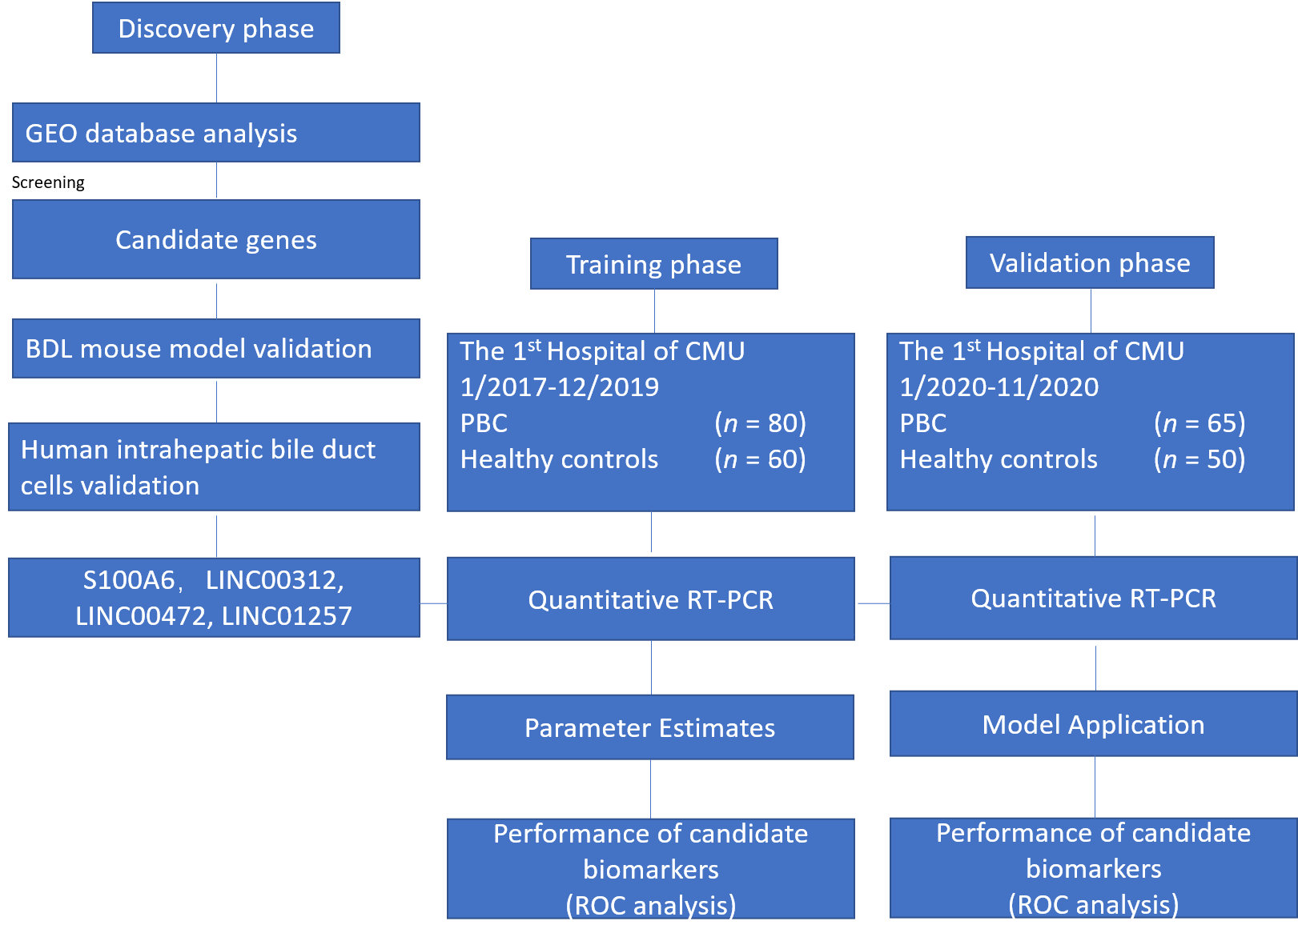
Figure 1 Study design. BDL: Bile duct ligation; GEO: Gene Expression Omnibus; PBC: Primary biliary cholangitis; ROC: Receiver operating characteristic curve; RT-PCR: Reverse transcriptase polymerase chain reaction.
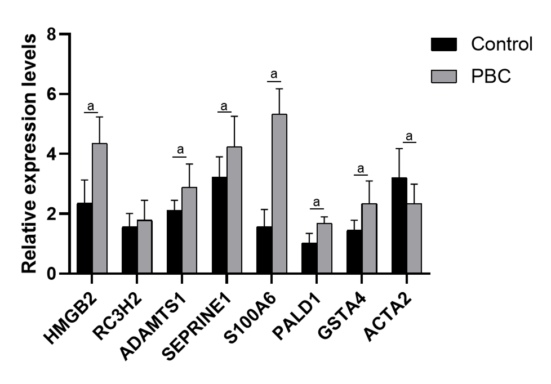
Figure 2 Validation of top 10 up-regulated genes in the plasma of primary biliary cholangitis patients and healthy controls by reverse transcriptase polymerase chain reaction. ªP < 0.0001. ACTA2: Actin alpha 2, smooth muscle; ADAMTS1: ADAM metallopeptidase with thrombospondin type 1 motif 1; GSTA4: Glutathione S-transferase alpha 4; HMGB2: High mobility group box 2; PALD1: Phosphatase domain containing paladin 1; RC3H2: Ring finger and CCCH-type domains 2; S100A6: S100 calcium binding protein A6; SERPINE1: Serpin family E member 1; PBC: Primary biliary cholangitis.
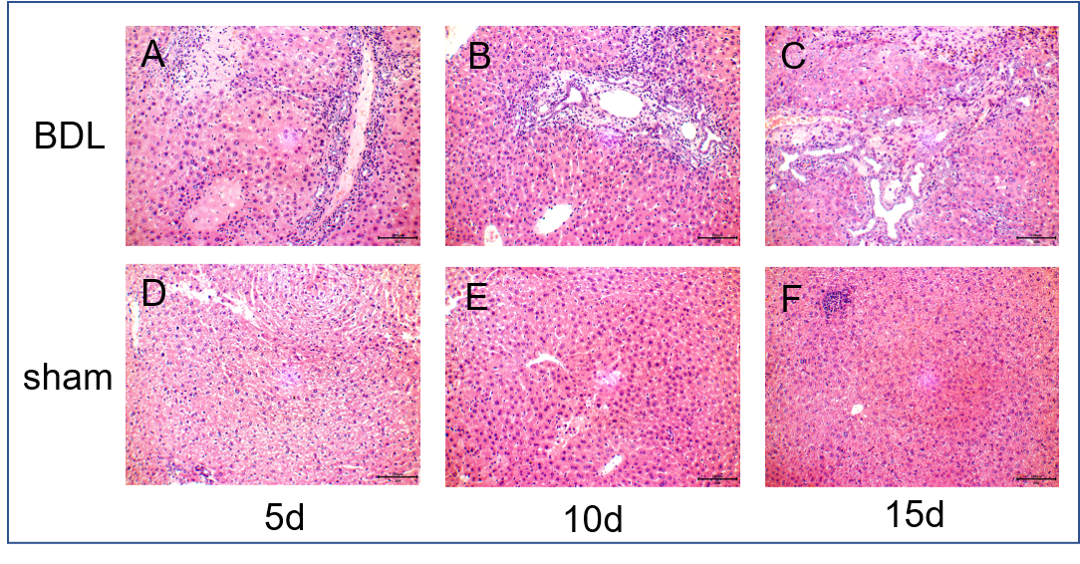
Figure 3 Liver tissues of mice in the bile duct ligation group and sham group were observed under an optical microscope (hematoxylin-eosin stain, × 400). A-C: 5, 10 and 15 d after surgery in the bile duct ligation group, respectively; D-F: 5, 10 and 15 d after surgery in the sham group, respectively. BDL: Bile duct ligation.
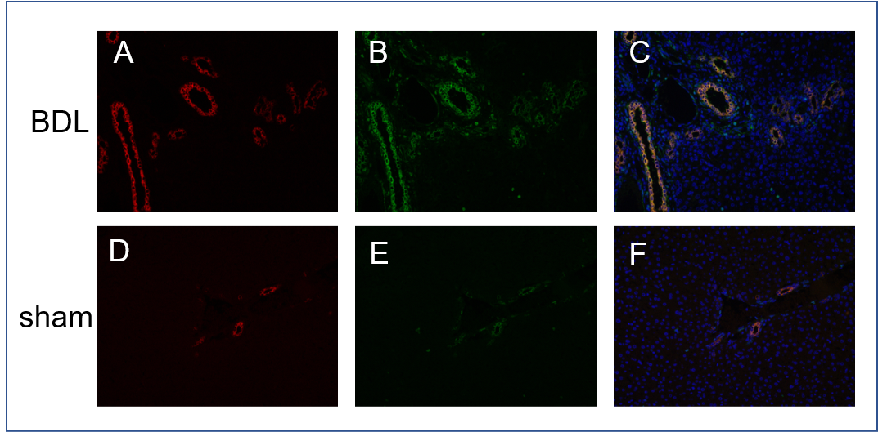
Figure 4 C57BL/6J mouse liver tissue double immunofluorescence (red light: Cytokeratin 19 protein, green light: S100 calcium binding protein A6 protein, × 200). A: Cytokeratin 19 (CK19) protein in bile duct ligation (BDL) mouse; B: S100 calcium binding protein A6 protein (S100A6) protein in BDL mouse; C: CK19 and S100A6 proteins merge in BDL mouse; D: CK19 protein in sham mouse; E: S100A6 protein in sham mouse; F: CK19 and S100A6 proteins merge in sham mouse. BDL: Bile duct ligation.
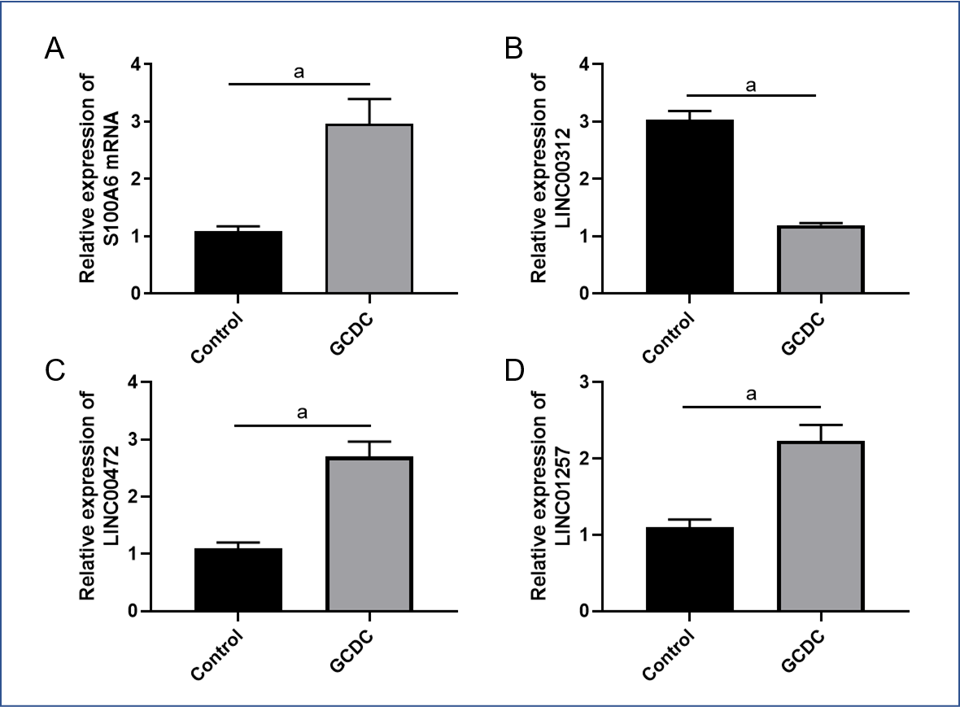
Figure 5 The expression of S100 calcium binding protein A6 protein messenger ribonucleic acid, LINC00312, LINC00472 and LINC01257 in human intrahepatic biliary epithelial cells (control and treated with glycochenodeoxycholate) analyzed by quantitative reverse transcription-polymerase chain reaction. A: S100 calcium binding protein A6 protein messenger ribonucleic acid; B: LINC00312; C: LINC00472; D: LINC01257. ªP < 0.005. GCDC: Glycochenodeoxycholate.
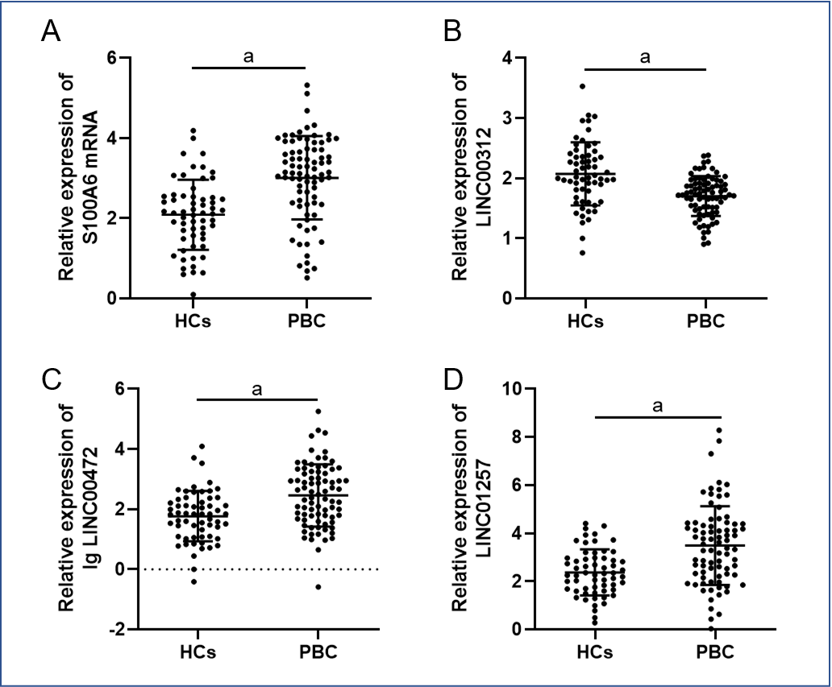
Figure 6 Differential expression of plasma s100 calcium binding protein A6 protein messenger ribonucleic acid and long non-coding ribonucleic acids in primary biliary cholangitis plasma samples compared with healthy controls. A: S100 calcium binding protein A6 protein messenger ribonucleic acid; B: LINC00312; C: log10 LINC00472; D: LINC01257. ªP < 0.0001. HCs: Healthy controls; PBC: Primary biliary cholangitis.
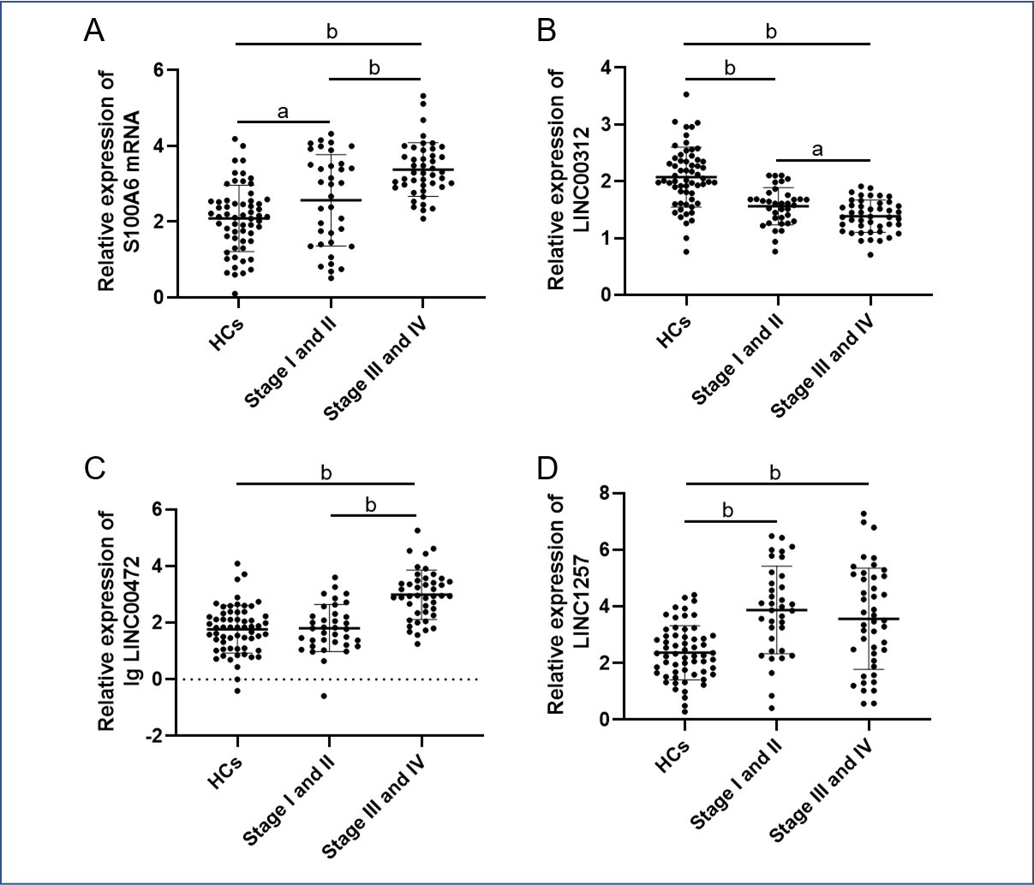
Figure 7 Scatter plot and distribution of expression levels of s100 calcium binding protein A6 protein messenger ribonucleic acid and long non-coding ribonucleic acids in different stages of primary biliary cholangitis compared with healthy controls. The unpaired t-test analysis of variance was performed to examine differences in S100 calcium binding protein A6 protein messenger ribonucleic acid and long non-coding ribonucleic acids expression levels between various groups. A: S100 calcium binding protein A6 protein messenger ribonucleic acid; B: LINC00312; C: log10 LINC00472; D: LINC01257. ªP < 0.05, ^{b}P < 0.0001. HCs: Healthy controls.
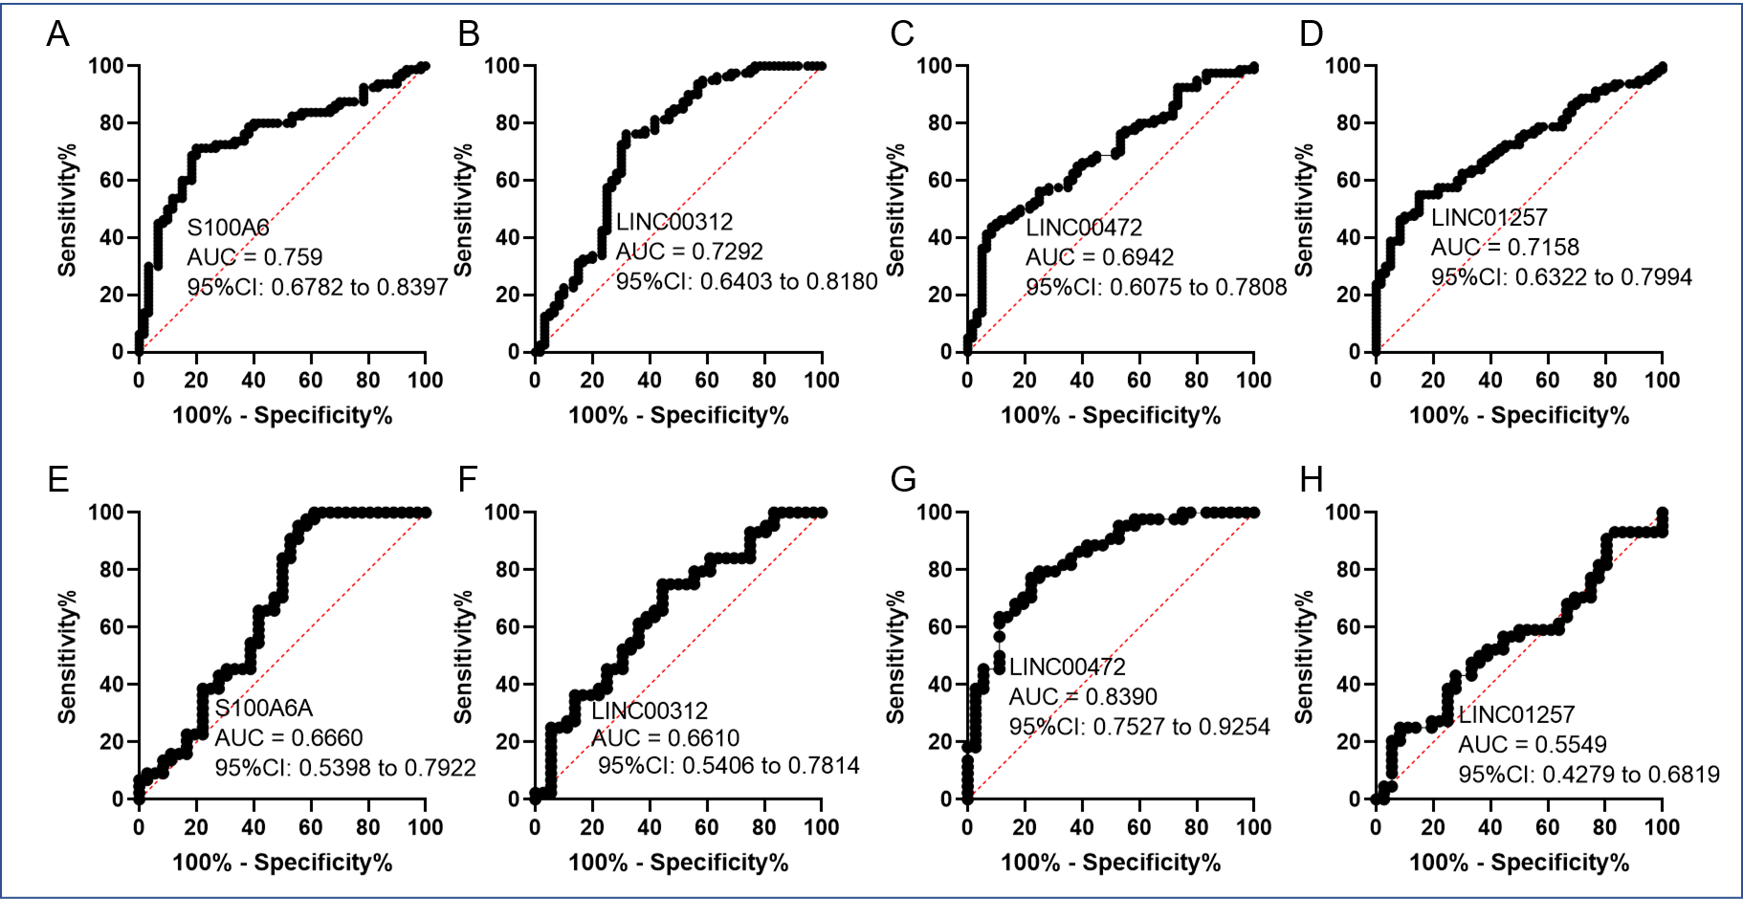
Figure 8 Receiver operating characteristic curves of s100 calcium binding protein A6 protein, LINC00312, LINC00472 and LINC01257 for primary biliary cholangitis diagnosis and staging in the training set. A-D: Receiver operating characteristic curves of s100 calcium binding protein A6 protein, LINC00312, LINC00472 and LINC01257 for primary biliary cholangitis diagnosis in the training set; E-H: Receiver operating characteristic curves of s100 calcium binding protein A6 protein, LINC00312, LINC00472 and LINC01257 for primary biliary cholangitis staging in the training set. AUC: Area under the curve; CI: Confidence interval.

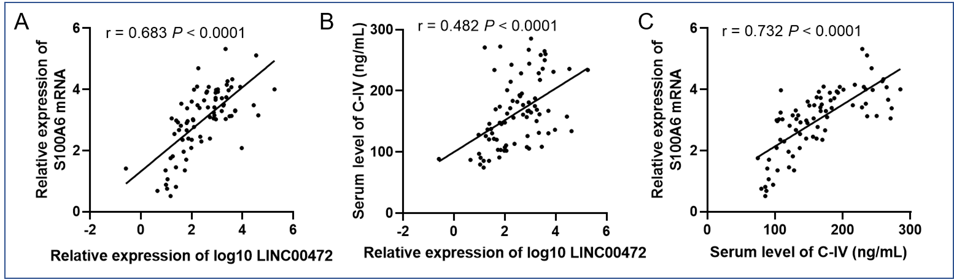
Figure 9 Correlation analysis of biomarkers and clinical serological indices. A: The positive correlation between relative expression of s100 calcium binding protein A6 protein messenger ribonucleic acid and log10 LINC00472, r = 0.683, P < 0.0001; B: The positive correlation between relative expression of log10 LINC00472 and serum level of collagen type IV, r = 0.482, P < 0.0001; C: The positive correlation between serum level of collagen type IV and relative expression of s100 calcium binding protein A6 protein messenger ribonucleic acid, r = 0.732, P < 0.0001.
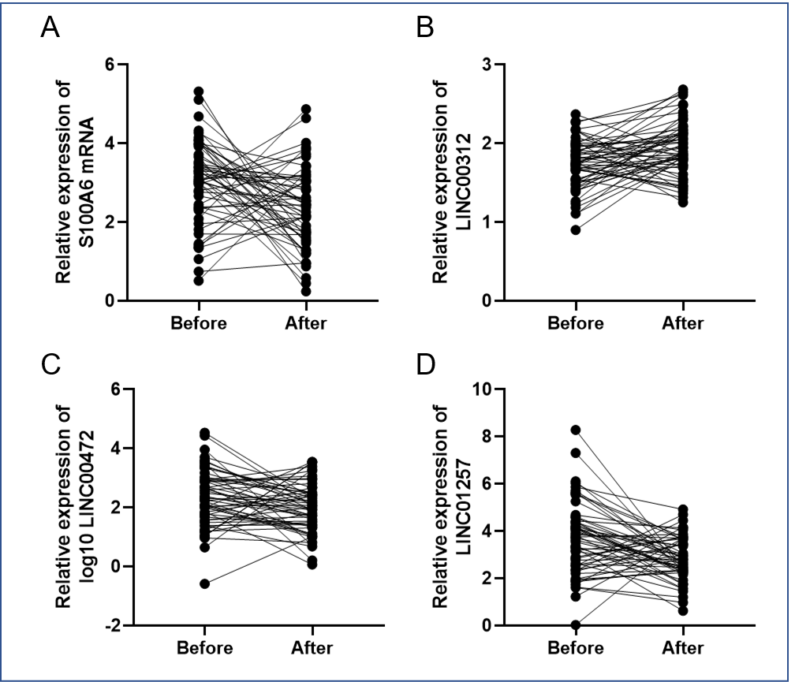
Figure 10 Comparison and analysis of s100 calcium binding protein A6 protein messenger ribonucleic acid, LINC00312, log10 LINC00472, LINC01257 expression levels in primary biliary cholangitis patients before and after treatment using the paired t-test. A: S100 calcium binding protein A6 protein messenger ribonucleic acid; B: LINC00312; C: log10 LINC00472; D: LINC01257.
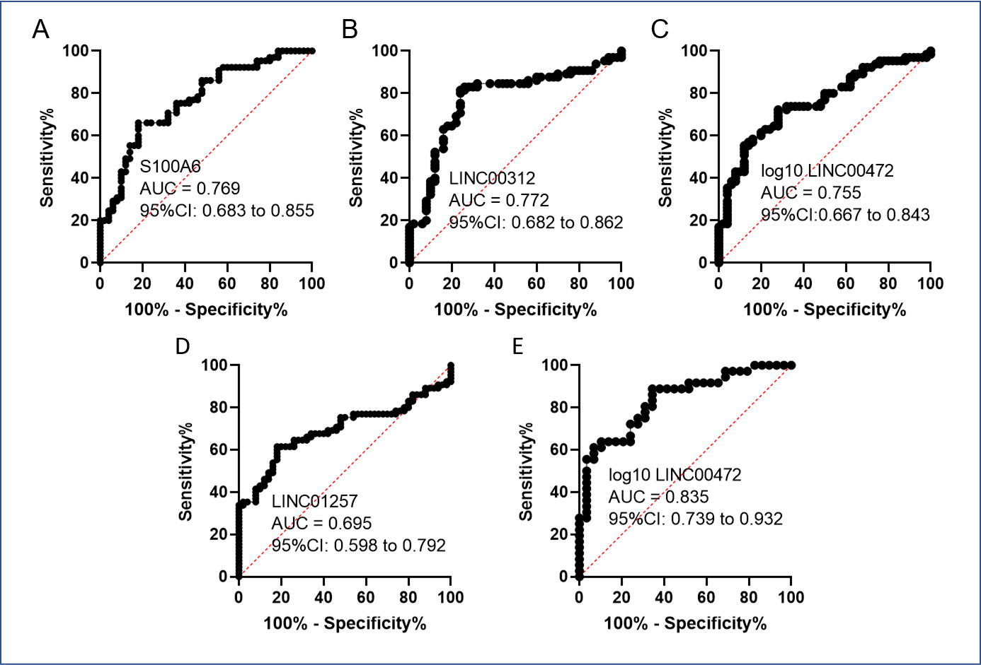
Figure 11 Receiver operating characteristic curves of s100 calcium binding protein A6 protein, LINC00312, LINC00472 and LINC01257 for primary biliary cholangitis diagnosis and staging in the validation set. A-D: Receiver operating characteristic curves of s100 calcium binding protein A6 protein, LINC00312, LINC00472 and LINC01257 for primary biliary cholangitis diagnosis in the validation set; E: Receiver operating characteristic curves of LINC00472 for primary biliary cholangitis staging in the validation set. AUC: Area under the curve; CI: Confidence interval.
Table 1 Primer sequences used in this study
Target gene | Forward sequence (5’→3’) | Reverse sequence (5’→3’)
S100A6  LINC00312  LINC00472  LINC01257 | AATGTGCGTTGTGTAAGC  GGAAGGAATACCACAGAAGT  AGAGTTGCTGTAGAAGAAGG  TGCTGCGAATGATGACTT | CGGTCCAAGTCTTCCATC  TGAAGAACAGGACATTGACA  AGGAGGAGAGTAGAAGAGAC  AGGACTTGAATCTGCTACTG
HMGB2 | TTACGTTCCTCCCAAAGGTG | TCTTTGGCTGACTGCTCAGA
RC3H2 | TTGCAAAGAAATGCGTTGAG | GATTGGCAGACAACTGCTGA
ADAMTS1 | CCTCTGTCTGTGTGCAAGGA | GTGGCTCCAGTTGGAATTGT
SERPINE1 | CTCTCTCTGCCCTCACCAAC | GTGGAGAGGCTCTTGGTCTG
PALD1 | GCCGAAGTTGTTCCCATTTA | GCTGAAAGTCAGAGCCAACC
GSTA4 | TCCGTGAGATGGGTTTTAGC | TGCCAAAGAGATTGTGCTTG
ACTA2 | TTCAATGTCCCAGCCATGTA | GAAGGAATAGCCACGCTCAG
GAPDH | GCACCGTCAAGGCTGAGAAC | TGGTGAAGACGCCAGTGGA
ACTA2: Actin alpha 2, smooth muscle; ADAMTS1: ADAM metallopeptidase with thrombospondin type 1 motif 1; GAPDH: Glyceraldehyde-3-phosphate dehydrogenase; GSTA4: Glutathione S-transferase alpha 4; HMGB2: High mobility group box 2; PALD1: Phosphatase domain containing paladin 1; RC3H2: Ring finger and CCCH-type domains 2; S100A6: S100 calcium binding protein A6; SERPINE1: Serpin family E member 1.
Table 2 Top 10 dysregulated genes in bile duct ligation and sham mice
Gene name | Transcript | Lg fold change
Up-regulated
Hmgb2 | ENSMUSG00000054717 | 3.53
Rc3h2 | ENSMUSG00000075376 | 3.33
Adamts1 | ENSMUSG00000022893 | 3.15
Serpine1 | ENSMUSG00000037411 | 3.08
S100a6 | ENSMUSG00000001025 | 2.98
Pald1 | ENSMUSG00000020092 | 2.67
Gsta4 | ENSMUSG00000032348 | 2.50
D17H6S56E-5 | NM_033075 | 2.46
Acta2 | ENSMUSG00000035783 | 2.39
Ifi204 | ENSMUSG00000073489 | 2.33
Down-regulated
Mcm10  Upp2  2810043O03Rik  Dnaaf5  Sva  Naca  Dhps  Cdh15  Gzmm  Alox12 | ENSMUSG00000026669  ENSMUSG00000026839  AK012901.1  ENSMUSG00000025857  ENSMUSG00000023289  ENSMUSG00000061315  ENSMUSG00000060038  ENSMUSG00000031962  ENSMUSG00000054206  ENSMUSG00000000320 | 3.23  2.85  2.59  2.41  2.40  2.35  2.33  2.26  2.20  2.15
2810043O03Rik: RIKEN complementary deoxyribonucleic acid 2810043O03 gene; Acta2: Actin alpha 2, smooth muscle; Adamts1: A disintegrin-like and metallopeptidase (reprolysin type) with thrombospondin type 1 motif, 1; Alox12: Arachidonate 12-lipoxygenase; Cdh15: Cadherin 15; D17H6S56E-5: Deoxyribonucleic acid segment, Chr 17, human D6S56E 5; Dhps: Deoxyhypusine synthase; Dnaaf5: Dynein, axonemal assembly factor 5; Gsta4: Glutathione S-transferase alpha 4; Gzmm: Granzyme M (lymphocyte met-ase 1); Hmgb2: High mobility group box 2; Ifi204: Interferon activated gene 204; Mcm10: Minichromosome maintenance 10 replication initiation factor; Naca: Nascent polypeptide-associated complex alpha polypeptide; Pald1: Phosphatase domain containing paladin 1; Rc3h2: Ring finger and CCCH-type domains 2; S100A6: S100 calcium binding protein A6; Serpine1: Serpin family E member 1; Sva: Seminal vesicle antigen; Upp2: Uridine phosphorylase 2.
Table 3 Demographics and clinical characteristics in the training and validation datasets
Characteristics | Training | Validation | P value
No. | 140 | 115 | -
Age, mean ± SD, yr | 56.0 ± 13.9 | 57.2 ± 13.2 | 0.504
Gender, n (%)
Male | 17 (12.1) | 13 (11.3)
Female | 123 (87.9) | 102 (88.7) | 1.0
Pathological stage
Ι and II | 36 (45.0) | 26 (40.0)
III and IV | 44 (55.0) | 39 (60.0) | 0.614
Normally distributed data are expressed as mean ± SD. Categorical variable values are described as n (%). SD: Standard deviation.
Table 4 Demographics and clinical characteristics of primary biliary cholangitis patients and healthy controls¹
Characteristics | PBC (n = 145) | HCs (n = 110) | P value
Age, mean ± SD, yr | 56.1 ± 13.4 | 55.3 ± 11.8 | 0.58
Gender, n (%)
Male | 17 (12.5) | 13 (16.7)
Female | 128 (87.5) | 97 (83.3) | 1.00
ALT, U/L | 78.6 ± 35.7 | 18.4 ± 6.5 | < 0.001
AST, U/L | 104.8 ± 43.5 | 20.2 ± 4.3 | < 0.001
ALP, U/L | 257.4 ± 79.9 | 64.7 ± 14.5 | < 0.001
γGT, U/L | 416.7 ± 209.2 | 26.3 ± 10.4 | < 0.001
TBIL, μmol/L | 66.8 ± 10.6 | 11.8 ± 4.0 | < 0.001
DBIL, μmol/L | 51.9 ± 11.4 | 6.4 ± 0.5 | < 0.001
TBA, μmol/L | 71.3 ± 11.6 | 2.8 ± 0.4 | < 0.001
HA, ng/mL | 146.9 (104.6-190.1) | 67.0 (53.9-79.7) | < 0.001
LN, ng/mL | 148.9 (76.7-182.8) | 70.4 (58.7-82.9) | < 0.001
C-IV, ng/mL | 154.8 (121.1-192.0) | 60.1 (55.2-66.7) | < 0.001
PC-III, ng/mL | 161.0 (135.1-184.5) | 57.3 (49.9-63.5) | < 0.001
Pathological stage
Ι and II | 62 (42.8) | -
III and IV | 83 (57.2) | -
¹Normally distributed data are expressed as means ± SD, variables with a skewed distribution are presented as median (interquartile range). Categorical variable values are described as n (%). γGT: Gamma-glutamyl transpeptidase; ALT: Alanine aminotransferase; ALP: Alkaline phosphatase; AST: Aspartate aminotransferase; C-IV: Collagen type IV; DBIL: Direct bilirubin; HA: Hyaluronic acid; LN, Laminin; PC-III: Procollagen III; TBA: Total bile acid; TBIL: Total bilirubin; SD: Standard deviation; PBC: Primary biliary cholangitis; HCs: Healthy controls.
Table 5 Characteristics of primary biliary cholangitis patients based on the expression of log10 LINC00472 cutoff value
 | Relative Expression of log10 LINC00472
 | L1 (< 2.33) (n = 38) | L2 (≥ 2.33) (n = 42) | P value
Age, mean ± SD, years | 60.3 ± 14.9 | 55.1 ± 14.0 | 0.109
Gender, n (%)
Male | 5 (13.2) | 5 (11.9)
Female | 33 (86.8) | 37 (88.1) | 0.886
ALT, U/L | 73.2 (52.7-100.1) | 73.2 (46.2-100.7) | 0.985
AST, U/L | 109.2 ± 45.9 | 103.0 ± 44.6 | 0.543
ALP, U/L | 264.0 ± 89.4 | 252.2 ± 78.3 | 0.532
γGT, U/L | 420.2 ± 197.9 | 413.2 ± 237.1 | 0.887
TBA, μmol/L | 73.2 ± 12.4 | 70.9 ± 13.3 | 0.438
TBiL, μmol/L | 68.0 (63.0-73.0) | 63.0 (58.0-73.0) | 0.166
DBiL, μmol/L | 50.6 ± 9.8 | 52.2 ± 11.4 | 0.505
LINC00312 | 1.51 ± 0.32 | 1.43 ± 0.31 | 0.261
S100A6 | 2.40 ± 1.05 | 3.57 ± 0.66 | < 0.0001
LINC01257 | 4.25 ± 1.39 | 3.22 ± 1.78 | 0.005
HA, ng/mL | 144.8 (101.6-208.8) | 135.5 (95.4-195.4) | 0.537
LN, ng/mL | 126.1 (48.4-178.4) | 156.1 (57.6-175.8) | 0.780
C-IV, ng/mL | 127.2 (100.9-170.4) | 176.0 (154.7-232.0) | < 0.0001
PC-III, ng/mL | 156.6 (125.8-190.1) | 161.6 (128.0-184.5) | 0.916
SD: Standard deviation; γGT: Gamma-glutamyl transpeptidase; ALT: Alanine aminotransferase; ALP: Alkaline phosphatase; AST: Aspartate aminotransferase; C-IV: Collagen type IV; DBIL: Direct bilirubin; HA: Hyaluronic acid; LN: Laminin; PC-III: Procollagen III; S100A6: S100 calcium binding protein A6; TBA: Total bile acid; TBIL: Total bilirubin.

