Name of Journal: World Journal of Clinical Cases
Manuscript NO: 76862
Manuscript Type: CASE REPORT

Cardiac myxoma shedding leads to lower extremity arterial embolism: A case report

Meng XH et al. Cardiac myxoma leading lower extremity arterial embolism

Xiao-Hu Meng, Le-Si Xie, Xu-Pin Xie, Yong-Chang Liu, Chang-Pin Huang, Lin-Jun Wang, Guo-Hui Zhang, Dong Xu, Xu-Chao Cai, Xin Fang

Xiao-Hu Meng, Xu-Pin Xie, Yong-Chang Liu, Lin-Jun Wang, Dong Xu, Xin Fang, Department of Vascular Surgery, The Affiliated Hangzhou First People's Hospital, Zhejiang University School of Medicine, Hangzhou 310006, Zhejiang Province, China

Le-Si Xie, Department of Pathology, The Affiliated Hangzhou First People's Hospital, Zhejiang University School of Medicine, Hangzhou 310006, Zhejiang Province, China

Chang-Pin Huang, Guo-Hui Zhang, Xu-Chao Cai, Department of General Surgery, Hangzhou Geriatrics Hospital, Hangzhou 310006, Zhejiang Province, China

Author contributions: Meng XH contributed to the study conception and writing; Meng XH and Fang X contributed to the data collection and investigation; Meng XH and Xie LS contributed to the analysis; all authors contributed to the critical review and revision, final approval of the article and accountability for all aspects of the work.

Corresponding author: Xin Fang, MAMS, Chief Physician, Department of Vascular Surgery, The Affiliated Hangzhou First People's Hospital, Zhejiang University School of Medicine, No. 261 Huansha Road, Hangzhou 310006, Zhejiang Province, China. fangxin19800324@163.com

Received: April 13, 2022
Revised: July 7, 2022
Accepted: September 7, 2022
Published online:

Abstract
BACKGROUND
Left cardiac myxoma (CM) is the most common benign tumor of primary cardiac tumors, but because of its special position caused by pathological physiology change, caused by the complications of the heavier, the surface is often accompanied by blood clots, once fall out, it causes peripheral vascular embolization, such as acute lower limb artery embolization, harmfulness is large, high morbidity, and easy to occur repeatedly.

CASE SUMMARY
A 67-year-old male patient suddenly appeared numbness and weakness of the left lower limb and could not walk without obvious incentive. The patient was finally diagnosed as left CM complicated with acute lower limb arterial embolism after completing cardiac ultrasound, computer tomography angiography, and histopathological analysis, such as hematoxylin-eosin stain staining, immunohistochemistry and special staining including alcian blue staining and periodic acid schiff staining. Arterial thrombosis was removed successfully by femoral artery thrombectomy, postoperative numbness and weakness of the patient's left lower limb disappeared, skin temperature became warm, and dorsal foot artery pulsation was accessible. The patient was readmitted to the hospital 8 mo after discharge for left atrial mass resection, and was diagnosed as CM by postoperative histopathological examination.

CONCLUSION
Although CM is rare, it may be considered as the source of embolism in patients with acute limb ischemia. Repeated loss of thrombus on the tumor and its surface may lead to repeated embolism of peripheral vessels. Cardiac ultrasound is helpful for early diagnosis. Here, we use this case report to highlight left CM as an important cause of acute limb ischemia and to report our experience in the diagnosis and treatment of lower limb arterial embolism caused by CM detachment.

Key Words: Left cardiac myxoma; Benign tumor; Acute lower limb artery embolization; Femoral artery embolization; Case report

Meng XH, Xie LS, Xie XP, Liu YC, Huang CP, Wang LJ, Zhang GH, Xu D, Cai XC, Fang X. Cardiac myxoma shedding leads to lower extremity arterial embolism: A case report. World J Clin Cases 2022; In press

Core Tip: Cardiac myxoma (CM), although rare, is a unique cause of acute arterial embolism, we report a rare case of this type and provide insights into the diagnosis and treatment of acute lower extremity arterial embolism caused by shedding of left CM. We hope that by improving the recognition of the disease, we can reduce intervention time and thus avoid delays in diagnosis and treatment.

INTRODUCTION
The most common primary tumor of the heart is left cardiac myxoma (CM). CM is rare and benign and has an incidence of approximately 0.5 per 1 million people per year^{[1]}. There are thrombi of different sizes, and once they fall off, they can easily cause embolisms in the peripheral blood vessels, thus causing serious complications. The clinical manifestations of left atrial myxoma vary from asymptomatic to fever, multiple arterial embolisms, syncope, and sudden death. Arterial embolism is a common serious complication of myxoma, and the condition is dangerous and life-threatening^{[2]}. The repeated shedding of CMs can easily lead to the recurrence of arterial embolism, so early diagnosis of myxoma is very important for the early treatment of arterial embolism. Cardiac ultrasound and vascular computed tomography angiography play a key role in the rapid diagnosis of myxoma and arterial embolism^{[3]}. CM is a benign tumor that grows slowly in the heart cavity and originates from mesenchymal cells of the septal endocardium. Systemic embolic events have been reported in 30% to 50% of patients with left atrial myxoma, half of which have cerebrovascular involvement^{[4]}, and the recurrence of acute lower extremity arterial embolism caused by left atrial myxoma is rarely reported in China. This study reports a patient with an acute lower extremity arterial embolism caused by CM shedding, discusses the clinicopathological features, clinical diagnosis and treatment, and includes a literature review to improve the understanding of the rare disease and to avoid misdiagnosis and delayed treatment.

CASE PRESENTATION
Chief complaints
A 67-year-old male patient suddenly developed numbness and weakness of the left lower extremity without an obvious origin 6 h ago, and he could not walk.

History of present illness
Six hours prior to admission, the patient suddenly developed numbness and weakness of the left lower extremity without an obvious origin, so he went to the emergency department of our hospital.

History of past illness
Although he had a history of hypertension and was treated with oral antihypertensive drugs, his blood pressure was well controlled. He denied a history of atrial fibrillation. In 2016, he had an arterial embolism in both lower extremities; he also had a history of bilateral femoral artery thrombectomy, and long-term treatment with oral Bayer aspirin.

Personal and family history
The patient was not a descendant of a consanguineous marriage, and there was no family history of a similar disease.

Physical examination
During physical examination, the bilateral femoral artery and the right popliteal, posterior tibial, and dorsal pedis arteries were palpable, but the left popliteal, posterior tibial, and dorsal pedis arteries were not palpable. The skin temperature of the right lower extremity was normal, but the left lower extremity was cool and pale.

Laboratory examinations
The laboratory results at admission were normal, including routine blood tests, coagulation function, liver and kidney function, tumor markers, and urine and stool tests, but the d-dimer results (670 µg/L) were not normal (0-500 µg/L).

Imaging examinations
Bedside echocardiography showed two abnormal echo groups in the left atrium (shown by the red arrow), which were 3.1 cm × 1.8 cm and 1.0 cm × 0.8 cm in size, and there was an acceptable range of motion (Figure 1). Computer tomography angiography (CTA) of the lower extremity vessels showed that the left popliteal artery was not visualized shown by the red arrow, so a lumen embolism was considered (Figure 2). The patient’s left lower extremity ischemic symptoms were severe, and there was a risk of lower extremity necrosis. The surgical indications were clear. After completing the preoperative examination and excluding surgical contraindications, an emergency left femoral artery incision was made, and a thrombectomy was performed.
The patient recovered well after the operation. The numbness and weakness of the left lower extremity disappeared, the skin temperature became warmer, and the left popliteal, posterior tibial and dorsal foot arteries were palpable.
Assessment of the pathological specimen was based on microscopic examination. Hematoxylin-eosin staining showed thrombi and many myxoid materials, and free clusters of round and polygonal cells were seen inside, which was consistent with the pathological characteristics of myxoma (Figure 3). Immunohistochemical studies showed that vimentin, calretinin, CD31, and CD34 were positive, while CD68, cytokeratin (CK), CK5/6, and factor 8-related antigen (F8) were negative. Alcian blue staining (AB) and periodic acid Schiff staining (PAS) were also positive (Figure 4). The above pathological findings were consistent with the pathological features of myxoma^{[5-7]}. Combined with the results of preoperative echocardiography and postoperative pathological examination, it can be inferred that the acute lower extremity arterial embolism was caused by shedding of a left CM.

FINAL DIAGNOSIS
Acute lower limb arterial embolism secondary to CM.

TREATMENT
A 10-cm incision was made along the surface of the left common femoral artery under the inguinal ligament, and the common femoral artery, deep femoral artery and superficial femoral artery were dissociated and exposed. After an intravenous injection of 5000 units of heparin, the common femoral artery and deep femoral artery were blocked. The superficial femoral artery and the common femoral artery were longitudinally incised to the origin of the deep femoral artery; the incision was approximately 1 cm long, and the left superficial femoral artery had smooth, unrestricted blood flow and mild stenosis. The lateral popliteal artery was not visualized; thus, a lumen embolism was considered, and the peroneal artery, posterior tibial artery, and proximal tibial artery occlusion were observed (Figure 5A). The guide wire catheter passed through the diseased section and continued to the distal ends of the anterior tibial artery and posterior tibial artery. The guide wire passed through without resistance, and the 4F Fogarty thrombectomy catheter reached the popliteal artery. After multiple thrombectomies, the thrombus had a total length of approximately 10 cm and was dark red and transparent at the head end. The final angiography showed that the blood flow of the superficial femoral artery, popliteal artery, tibiofibular trunk, anterior tibial artery, peroneal artery and dorsal pedis artery was smooth (Figure 5B), and the blood supply to the foot was significantly improved compared with the previous angiography. Blood vessels and various layers of tissue were sutured, and the operation ended. After the operation, the left dorsal artery pulse was increased, the skin temperature of the foot was significantly higher, and the thrombus was examined by histopathology. After the operation, 4100 units of low molecular weight heparin were administered, and anticoagulants were subcutaneously injected every 12 h.

OUTCOME AND FOLLOW-UP
The patient had no postoperative complications, such as incision infection, hemorrhage, hematoma, pseudoaneurysm or lower extremity ischemia–reperfusion injury, and was discharged 6 d after the operation. One month after discharge, there were no obvious ischemic symptoms in the left lower extremity, and the left popliteal artery and dorsal pedis artery pulse were accessible; at the 6th months after discharge, CTA of the lower extremity blood vessels showed that the blood flow of the left popliteal artery, anterior tibial artery and peroneal artery was still unobstructed (Figure 6). We recommend early CM removal. Due to physical and economic factors, the patient underwent left atrial tumor resection in another hospital 8 mo after discharge, and the postoperative pathological diagnosis was atrial myxoma. There were no obvious ischemic symptoms in the left lower extremity during the 1-year follow-up by telephone.

DISCUSSION
Most CMs occur at the edge of the fossa ovalis, and approximately 10% occur at other sites^{[8]}. The clinical manifestations and signs of CM depend on the location and activity of the tumor. Most left CMs have atypical symptoms, including hemodynamic changes, systemic symptoms, and the triad of peripheral vascular embolism^{[9]}. However, approximately 3.2%-46.4% of patients with CM are asymptomatic^{[1,10]}. CM occurs in all age groups, with an average age of 42-66 years^{[11]}. Familial CM is less frequently reported in younger patients than in older patients. CM is most commonly found in the left atrium; however, unusual locations of CM include the right atrium (0.7% to 7.5%), right ventricle (0.7% to 2.5%), left ventricle (0.7% to 3.6%), and heart valves (less than 1%)^{[12]}. Approximately 72% to 92% of patients have been reported that CM is located in the left atrium by most studies^{[5]}.
The diagnosis of CM is based on clinical examination, electrocardiogram, transthoracic echocardiography (TTE), transesophageal echocardiography (TEE), chest computed tomography, and chest or cardiac magnetic resonance imaging, and there is no evidence that a specific blood test is useful in diagnosis. The clinical examination of the patient includes auscultation for possible systolic or diastolic murmurs, which may be heard if the myxoma prolapses or blocks the valve orifice of the heart. Heart murmurs are not specific to CM. Furthermore, concomitant organic heart disease may be confused with CM. There is no standard electrocardiograph diagnosis for CM because arrhythmias are common in other heart diseases^{[13]}. Nevertheless, the accuracy of TTE and TEE in diagnosing CM is as high as 90% to 96%. TTE is the most convenient and useful examination for patients with heart disease, especially cardiac tumors^{[2]}. Echocardiography is the most reliable method for diagnosing left atrial myxoma in every hospital. In conventional clinical practice, it can quickly and safely analyze the structure and location of cardiac tumors. If TTE is unable to identify the nature, structure, and activity of CM, TEE can accurately assess tumor characteristics. The diagnostic test for CM has a high sensitivity of more than 90%^{[14]}. Systemic embolic events have been reported in 30% to 50% of patients with left atrial myxoma, half of which have cerebrovascular involvement. In addition, left atrial myxoma can be repeatedly shed, resulting in recurrent acute lower extremity arterial embolism^{[4]}. Acute limb ischemia is caused by a sudden decrease in limb perfusion that threatens limb vitality, which can lead to loss of sensation, movement, or even a limb, and requires urgent intervention. Of peripheral arterial emboli, 80% have a cardiac origin (rheumatic valve disease, atrial fibrillation, appendicitis, wall thrombus, infective endocarditis, prosthetic valve thrombus, or tumor), and only 1.5% are cardiac tumors that require surgery to save a limb^{[4,15]}. Therefore, accurate and timely diagnosis and treatment are essential to restore normal blood flow. Lower extremity arterial ultrasound and CTA are crucial for the timely diagnosis and assessment of acute lower extremity arterial embolism. Lower extremity arteriotomy, thrombectomy with a Fogarty catheter, and catheter thrombolysis are the first-line interventions for acute lower extremity ischemia^{[16]}. The lower extremity vascular CTA showed mild stenosis of the left superficial femoral artery; the left popliteal artery was not visualized; and the peroneal artery, posterior tibial artery, and proximal end of the anterior tibial artery were occluded. Considering the patient's medical history, it was determined that it was caused by shedding of the emboli of the left atrial myxoma. Echocardiography showed multiple abnormal echo groups in the left atrium, and the intraoperative findings and postoperative pathology were essentially consistent with the preoperative examination. Pathological immunohistochemical results showed that the emboli stained positive for vimentin, calretinin, CD31 and CD34 but were negative for CD68, CK, CK5/6 and F8. In addition, AB and PAS were positive, and the above results are consistent with the pathological characteristics of CM^{[5-7]}.
Although rare, myxoma is a unique cause of acute arterial embolism that needs to be fully recognized. Systemic anticoagulation and immediate surgical thrombectomy are first-choice treatments for acute lower extremity arterial embolism. Early surgical tumor resection is the main treatment method to prevent further cardiovascular complications^{[4]}. CM is an identifying indicator in patients with acute limb ischemia presenting to the emergency department, and the timely use of bedside echocardiography can aid in diagnosis and reduce intervention time, which is crucial for a good prognosis in such cases.

CONCLUSION
CM, although rare, is a unique cause of acute arterial embolism, and echocardiography and arterial CTA are critical for the timely diagnosis of this disease. We report a rare case of this type and provide insights into the diagnosis and treatment of acute lower extremity arterial embolism caused by shedding of the left CM. We hope that by improving the recognition of the disease, we can reduce intervention time and thus avoid delays in diagnosis and treatment.

ACKNOWLEDGEMENTS
We thank all the histology technologists at the Department of Pathology, Hangzhou First People’s Hospital for their technical support.

REFERENCES
1 Samanidis G, Khoury M, Balanika M, Perrea DN. Current challenges in the diagnosis and treatment of cardiac myxoma. Kardiol Pol 2020; 78: 269-277 [PMID: 32207702 DOI: 10.33963/KP.15254]
2 Mahavar RK, Arora D, Singh A, Mishra M. Recurrent cardiac myxoma: A case report. Ann Card Anaesth 2021; 24: 490-492 [PMID: 34747762 DOI: 10.4103/aca.ACA_7_20]
3 Ho KKF, Barsoum R, Shepherd B, McGahan T. Bilateral acute lower limb ischemia secondary to complete embolization of cardiac myxoma. J Vasc Surg 2020; 71: 1759-1761 [PMID: 31708301 DOI: 10.1016/j.jvs.2019.08.264]
4 Mathew R, Agrawal N, Aggarwal P, Jamshed N. Atrial Myxoma Presenting as Acute Bilateral Limb Ischemia. J Emerg Med 2019; 57: 710-712 [PMID: 31492590 DOI: 10.1016/j.jemermed.2019.06.006]
5 Jantuan E, Chiu B, Chiu B, Shen F, Oudit GY, Sergi C. The tumor microenvironment may trigger lymphoproliferation in cardiac myxoma. Transl Oncol 2021; 14: 100911 [PMID: 33129111 DOI: 10.1016/j.tranon.2020.100911]
6 Sussman MA. Atrial myxoma: the cardiac chameleon. Eur Heart J 2020; 41: 4346-4348 [PMID: 32330936 DOI: 10.1093/eurheartj/ehaa208]
7 Ma H, Niu Y, Tian M, Liu L, Gong W, Zheng M. A study of 399 cardiac tumors: Characteristics of echocardiography and pathological features. Echocardiography 2022; 39: 37-45 [PMID: 34913194 DOI: 10.1111/echo.15249]
8 Chang WS, Li N, Liu H, Yin JJ, Zhang HQ. Thrombolysis and embolectomy in treatment of acute stroke as a bridge to open-heart resection of giant cardiac myxoma: A case report. World J Clin Cases 2021; 9: 7572-7578 [PMID: 34616828 DOI: 10.12998/wjcc.v9.i25.7572]
9 Liu SZ, Hong Y, Huang KL, Li XP. Multiple left ventricular myxomas combined with severe rheumatic valvular lesions: A case report. World J Clin Cases 2021; 9: 5535-5539 [PMID: 34307606 DOI: 10.12998/wjcc.v9.i20.5535]
10 Cianciulli TF, Cozzarin A, Soumoulou JB, Saccheri MC, Méndez RJ, Beck MA, Gagliardi JA, Lax JA. Twenty Years of Clinical Experience with Cardiac Myxomas: Diagnosis, Treatment, and Follow Up. J Cardiovasc Imaging 2019; 27: 37-47 [PMID: 30701715 DOI: 10.4250/jcvi.2019.27.e7]
11 Bianchi G, Margaryan R, Kallushi E, Cerillo AG, Farneti PA, Pucci A, Solinas M. Outcomes of Video-assisted Minimally Invasive Cardiac Myxoma Resection. Heart Lung Circ 2019; 28: 327-333 [PMID: 29277548 DOI: 10.1016/j.hlc.2017.11.010]
12 Karabinis A, Samanidis G, Khoury M, Stavridis G, Perreas K. Clinical presentation and treatment of cardiac myxoma in 153 patients. Medicine (Baltimore) 2018; 97: e12397 [PMID: 30213011 DOI: 10.1097/MD.0000000000012397]
13 Nehaj F, Sokol J, Mokan M, Jankovicova V, Kovar F, Kubaskova M, Mizera S, Mokan M. Outcomes of Patients with Newly Diagnosed Cardiac Myxoma: A Retrospective Multicentric Study. Biomed Res Int 2018; 2018: 8320793 [PMID: 29546068 DOI: 10.1155/2018/8320793]
14 Jiang CX, Wang JG, Qi RD, Wang W, Gao LJ, Zhao JH, Zhang CX, Zhou MC, Tu X, Shang MS, Yao Y. Long-term outcome of patients with atrial myxoma after surgical intervention: analysis of 403 cases. J Geriatr Cardiol 2019; 16: 338-343 [PMID: 31105754 DOI: 10.11909/j.issn.1671-5411.2019.04.003]
15 Liu L, Zhang X, Huang M, Li J, Zhao Z, Huang J. The effectiveness of percutaneous mechanical thrombectomy in the treatment of acute thromboembolic occlusions of lower extremity. Vascular 2021; 29: 945-951 [PMID: 33349197 DOI: 10.1177/1708538120981226]
16 Teodoro C, Bertanha M, Girard FPCM, Sobreira ML, Yoshida RA, Moura R, Jaldin RG, Yoshida WB. Results of treatment of acute occlusions of limb arteries at a university hospital - retrospective study. J Vasc Bras 2020; 19: e20200031 [PMID: 34211514 DOI: 10.1590/1677-5449.200031]

Footnotes
Informed consent statement: Written informed consent was obtained from the patient for publication of this case report. A copy of the written consent is available for review from the Editor-in-Chief of this journal.

Conflict-of-interest statement: All authors have no conflict of interest.

CARE Checklist (2016) statement: The authors have read the CARE Checklist (2016), and the manuscript was prepared and revised according to the CARE Checklist (2016).

Open-Access: This article is an open-access article that was selected by an in-house editor and fully peer-reviewed by external reviewers. It is distributed in accordance with the Creative Commons Attribution NonCommercial (CC BY-NC 4.0) license, which permits others to distribute, remix, adapt, build upon this work non-commercially, and license their derivative works on different terms, provided the original work is properly cited and the use is non-commercial. See: https://creativecommons.org/Licenses/by-nc/4.0/

Provenance and peer review: Unsolicited article; Externally peer reviewed.
Peer-review model: Single blind

Peer-review started: April 13, 2022
First decision: June 27, 2022
Article in press:

Specialty type: Surgery
Country/Territory of origin: China
Peer-review report’s scientific quality classification
Grade A (Excellent): 0
Grade B (Very good): B
Grade C (Good): C
Grade D (Fair): 0
Grade E (Poor): 0

P-Reviewer: Hashimoto K, Japan; Ito S, Japan S-Editor: Chang KL L-Editor: A P-Editor:

Figure Legends
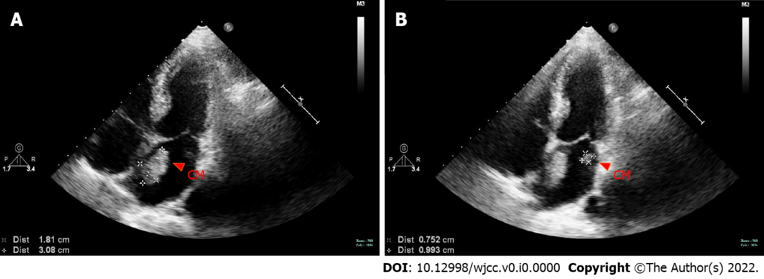
Figure 1 Cardiac ultrasound. Two abnormal psychogenic masses were seen in the left atrium, 3.1 cm × 1.8cm and 1.0 cm × 0.8cm respectively. CM: Cardiac myxoma.

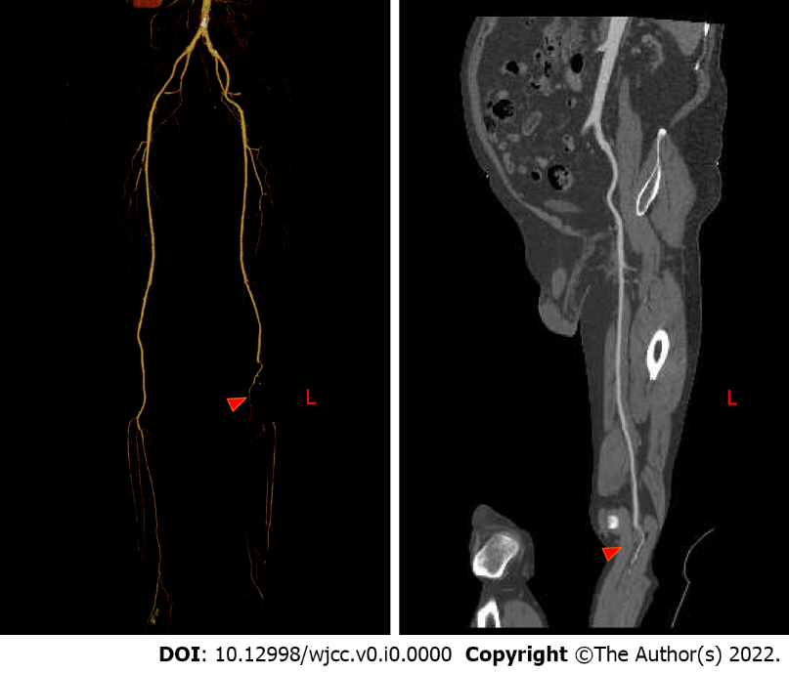
Figure 2 Computer tomography angiography of lower extremity blood vessels before operation. The left popliteal artery was not visualized, the lumen embolism was considered, the peroneal artery and the posterior tibial artery were occluded, and the proximal end of the anterior tibial artery was occluded.

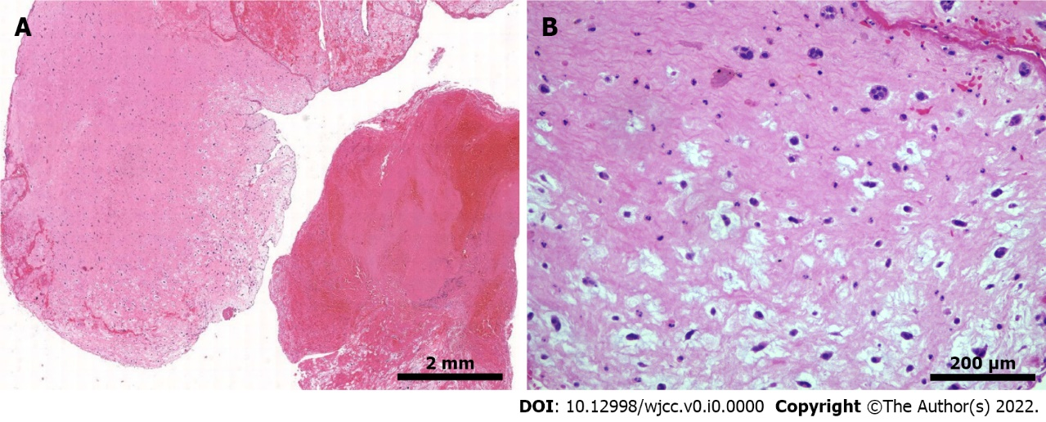
Figure 3 Hematoxylin-eosin staining. A: Histological section shows embolism with thrombus components and mucous background, with scattered sparse cell clusters and multiple villi-like protrusions, which are consistent with the characteristics of soft and brittle taxonomy (1 ×); B: High magnification microscope shows scattered free clusters on a mucus background with nested round, polygonal cells (squamous cells) arranged in short cords, with round nuclei and fine chromatin, and no atypical (10 ×).

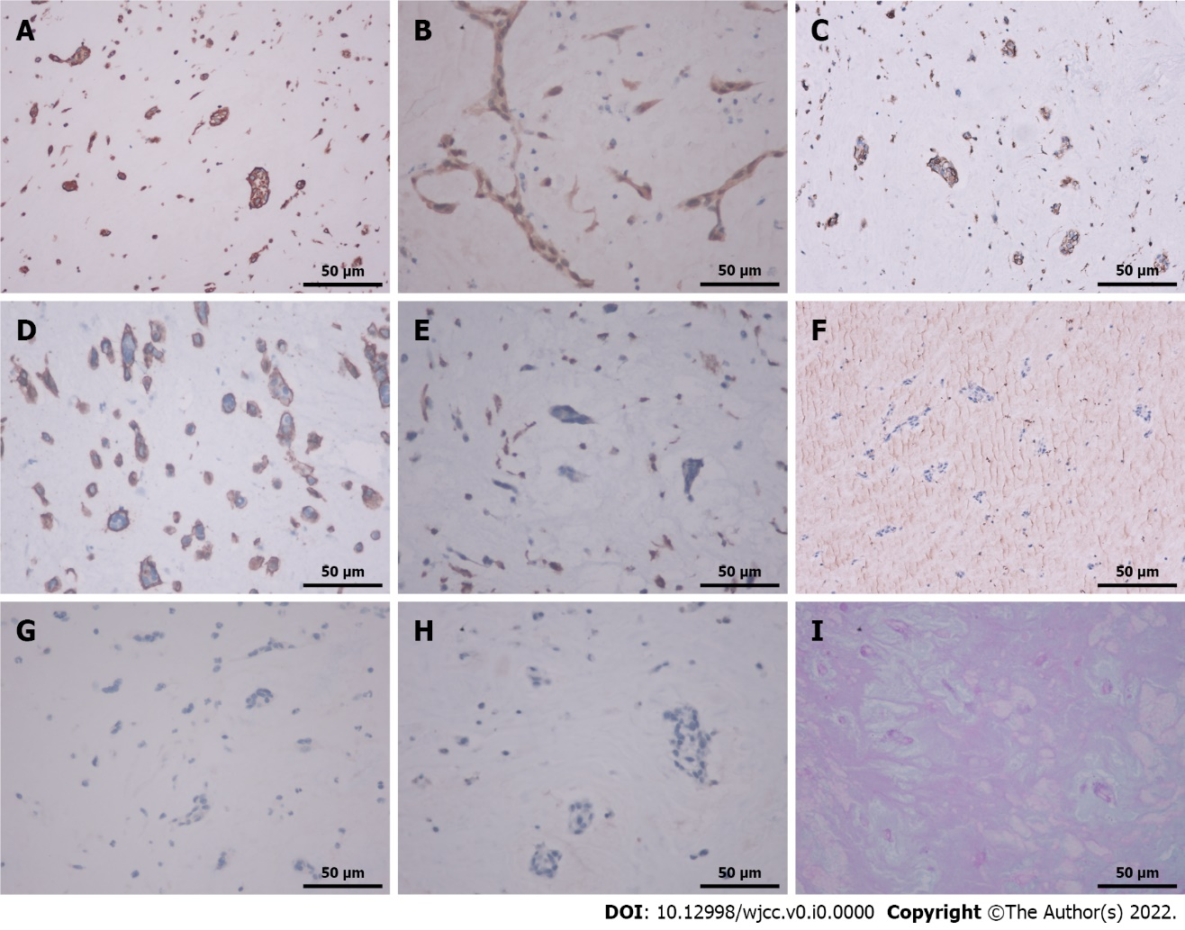
Figure 4 Immunohistochemistry, alcian blue staining and periodic acid schiff staining (40 ×). A: Cytoplasmic vimentin positive; B: Cytoplasmic and nuclear calretinin positive; C: Cytoplasmic CD31 positive; D: Cytoplasmic CD34 positive; E: Cytoplasmic CD68 negative; F: Cytoplasmic Factor 8 related antigen negative; G: Cytoplasmic cytokines protein was negative; H: Cytoplasmic cytokines 5/6 was negative; I: Cytoplasmic alcian blue staining and periodic acid schiff staining was positive.

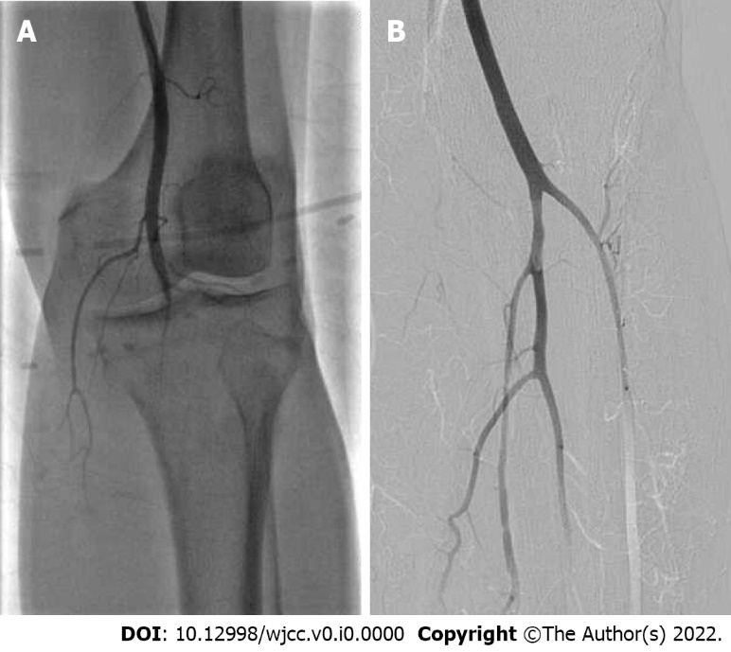
Figure 5 Angiography results. A: Lower extremity historiography before thrombolytic showed that the popliteal artery was occluded, and the infra-knee artery was not visualized; B: Lower extremity historiography after thrombolytic showed that the blood flow of the popliteal artery, tibiofibular trunk, anterior tibial artery and peroneal artery was unobstructed.

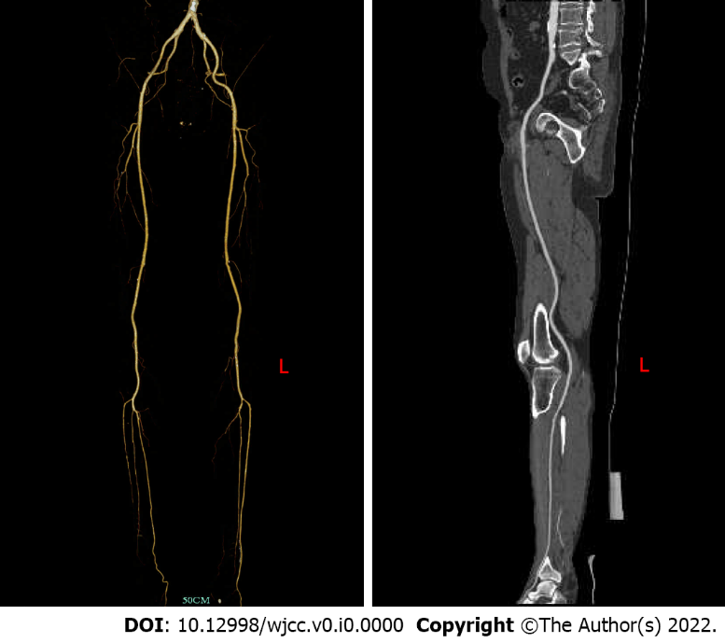
Figure 6 Postoperative re-examination of lower extremity vascular computer tomography angiography showed that the left popliteal artery, anterior tibial artery and peroneal artery were still unobstructed.

