Name of Journal: World Journal of Clinical Cases
Manuscript NO: 69683
Manuscript Type: META-ANALYSIS

Effectiveness of Maitland and Mulligan mobilization methods for adults with knee osteoarthritis: A systematic review and meta-analysis

Li LL et al. Effectiveness of Maitland vs Mulligan’s mobilization

Ling-Ling Li, Xin-Jie Hu, Yong-Hui Di, Wei Jiao

Ling-Ling Li, Xin-Jie Hu, Yong-Hui Di, Wei Jiao, Sport Medicine and Rehabilitation College, Beijing Sport University, Beijing 100084, China

Author contributions: Li LL and Hu XJ designed the research; Li LL, Hu XJ and Di YH performed the research; Li LL and Hu XJ contributed new reagents/analytic tools; Li LL and Di YH analyzed the data; Li LL and Hu XJ wrote the paper.

Supported by the National Key Research and Development Program of China, No. 2018YFF0301104.

Corresponding author: Wei Jiao, PhD, Academic Fellow, Sport Medicine and Rehabilitation College, Beijing Sport University, No. 48 Xinxi Road, Haidian District, Beijing 100084, China. jiaowei01@vip.sina.com

Received: July 9, 2021
Revised: November 4, 2021
Accepted: December 22, 2021
Published online:

Abstract
BACKGROUND
As a serious global problem, knee osteoarthritis (KOA) often leads to pain and disability. Manual therapy is widely used as a kind of physical treatment for KOA.

AIM
To explore further the efficacy of Maitland and Mulligan mobilization methods for adults with KOA.

METHODS
We searched PubMed, the Cochrane Library, EMbase, Web of Science and Google Scholar from inception to September 20, 2020 to collect studies comparing Maitland and Mulligan mobilization methods in adults with KOA. The quality of the studies was assessed using the Physiotherapy Evidence Database Scale for randomized controlled trials. Data analyses were performed using Review Manager 5.0 software.

RESULTS
A total of 341 articles were screened from five electronic databases (PubMed, the Cochrane Library, EMbase, Web of Science and Google Scholar) after excluding duplicates. Ultimately, eight trials involving 471 subjects were included in present systematic review and meta-analysis. The mean PEDro scale score was 6.6. Mulligan mobilization was more effective in alleviating pain [standardized mean difference (SMD) = 0.60; 95% confidence interval (CI): 0.17 to 1.03, P = 0.007; I² = 60%, P = 0.020) and improving Western Ontario and McMaster Universities function score (SMD = 7.41; 95%CI: 2.36 to 12.47, P = 0.004; I² = 92%, P = 0.000). There was no difference in the effect of the two kinds of mobilization on improving the range of motion (SMD = 9.63; 95%CI: -1.23 to 20.48, P = 0.080; I² = 97%, P = 0.000).

CONCLUSION
Mulligan mobilization technique is a promising intervention in alleviating pain and improving function score in KOA patients.

Key Words: Mulligan mobilization; Maitland mobilization; Manipulation; Manual therapy; Knee osteoarthritis; Meta-analysis

Li L, Hu X, Di Y, Jiao W. Effectiveness of Maitland and Mulligan mobilization methods for adults with knee osteoarthritis: A systematic review and meta-analysis. World J Clin Cases 2021; In press

Core Tip: Manual therapy is widely used as a kind of physical treatment for knee osteoarthritis. Maitland and Mulligan mobilization are two types of manual therapy used in osteoarthritis treatment. There still was no systematic reviews and meta-analyses to compare the efficacy of different mobilization techniques, such as Maitland vs Mulligan mobilization. This study aims to explore further the efficacy of Maitland and Mulligan mobilization and fill the research gaps. Mulligan mobilization was found to be a promising alternative option for knee osteoarthritis treatment. Particularly, the Mulligan mobilization has been recommended to be applied in alleviating pain and improving Western Ontario and McMaster Universities function scores.

INTRODUCTION
Osteoarthritis (OA) is the most common type of arthritis, with 1 in 3 people over age 65 affected and a higher prevalence in women^{[1,2]}. The knees are among the most commonly affected joints in OA^{[3,4]}. Knee osteoarthritis (KOA) is characterized as pain, joint stiffness, functional impairment and even disability, contributing to a heavy burden on healthcare service^{[5,6]}. Considering the severe socioeconomic burden, non-pharmacological, pharmacological and surgical approaches were applied^{[7]}. Physical therapy has been known to play a vital role in pain relief and restoration of mobility and function in KOA patients^{[8]}. Manual therapy is a widely used physical treatment for KOA^{[9]}. Several studies have reported positive effects of manual physical therapy on KOA^{[9-11]}. The American College of Rheumatology recommends the combination of manual therapy with exercise for KOA patients under the supervision of a physiotherapist^{[12]}. Besides, for the patients with deficits in range of motion (ROM), manual therapy plays a role to restore or maximize ROM improvement before surgeries^{[13]}.
Maitland and Mulligan mobilization are two types of manual therapy used in OA treatment^{[14]}. Mulligan mobilization allows the patients to perform the offending movements in a functional position, hence, leading to a rewarding outcome^{[15]}. Maitland mobilization aims to reestablish the spinning, gliding and rolling motions of the two joints^{[14]}. In clinical practice, movement quality can be increased via improving joint stability of weak muscles by applying Maitland mobilization combined with psychological effects (self-confidence and motivating factors) and corrected mechanical loading. Maitland and Mulligan mobilization therapies have been used to treat multiple diseases, such as primary adhesive capsulitis of the shoulder^{[16]}, hip osteoarthritis^{[17]} and knee osteoarthritis^{[18]}. As reported by previous studies, Maitland or Mulligan mobilizations were used by 99.8% of physical therapists to treat cervicogenic dizziness^{[19]}.
Recently, some reviews have found that the manual therapies might be effective and safe in ameliorating osteoarthritis symptoms^{[16,18,20]}. A meta-analysis by Qinguang Xu et al^{[18]} demonstrated that manual therapy effectively and safely alleviated pain, reduced stiffness and restored physical function in KOA patients, and thus it could be considered as a complementary and alternative option. In the studies on primary adhesive capsulitis of the shoulder, Noten et al^{[16]} identified the efficacy of mobilization techniques. Although Maitland mobilization was recommended in these studies^{[16,20]}, there still was no systematic review and meta-analysis to compare the efficacy of different mobilization techniques, such as Maitland vs Mulligan mobilization. Therefore, this study used an evidence-based method to determine the efficacy of Maitland and Mulligan mobilization methods in adults with KOA.

MATERIALS AND METHODS
This systematic review was conducted according to the Preferred Reporting Items for Systematic Review and Meta-Analyses (PRISMA)^{[21]} and the Cochrane Collaboration Handbook^{[22]}. The protocol of this systematic review and meta-analysis was registered on the International Prospective Register of Systematic Reviews (PROSPERO: CRD42020182532) on April 28, 2020.

Information sources
Two reviewers performed literature search individually in the following electronic databases: PubMed, The Cochrane Library, Web of Science, Embase and Google Scholar, from the time of inception to September 20, 2020. We also reviewed the reference lists of relevant reviews and meta-analyses^{[23,24]}.

Search strategy
The search terms included related text words and medical subject headings regarding ‘Mulligan’ or ‘Maitland’ or ‘Mobilization with Movement’ or ‘MWM’ or ‘Passive joint mobilization’ or ‘PJM’ or ‘musculoskeletal manipulations’ or ‘mobilization’ or “manual therapy” and “Knee Osteoarthritis” or “knee osteo-arthritis” or “Knee Osteoarthritides” or “Osteoarthritis of Knee” or “Osteoarthritis of the Knee”. We had tailored search strategy for each database, and details of the predefined search criteria are provided in Table S1 (see Supplementary Material).

Eligibility criteria
Trials were considered eligible if the following items were met: (1) Adult patients with KOA at any stage according to Kellgren and Lawrence grading system; (2) Containing data about Maitland joint mobilization or mobilization with movement technique with or without other interventions; (3) Reporting pain, range of motion, functional performance/ability or other relevant outcomes; and (4) Controlled clinical trials.
Since our aim was to explore the different efficacy of these two techniques in ROM, pain and functional performance in KOA, some experiments containing the combination of joint mobilization (Maitland or Mulligan) with other common treatments were also included, as long as they mainly focused on assessing the effect of these two types of joint mobilization methods.

Study selection
Two independent reviewers (Li LL, Hu XJ) removed duplication, screened titles, abstracts and full texts and agreed on the final eligibility. Negotiation was required when there was disagreement^{[25]}. We recorded the reasons for exclusion of full texts.

Data collection process and data items
Two independent reviewers (Li LL, Di YH) extracted the data from included articles using a pre-designed form, including the following parameters: Author’s name, publication year, sample size, study design, type/frequency/duration of the intervention and outcome assessment. Any disagreements were discussed and resolved by the two authors.

Risk of bias in individual studies
The quality of the included articles was assessed by two reviewers individually using PEDro scale. The results given by the two reviewers were compared and any disagreements were resolved by all three authors. The PEDro scale is based on the Delphi list and reported to be reliable for randomized controlled trials (RCTs) of physical therapy in systematic reviews. The PEDro scale consists of 11 items, including: (1) Specified eligibility criteria of studies; (2) Random allocation of studies; (3) Concealed allocation; (4) Similarity between groups at baseline; (5) Blinding of all subjects; (6) Blinding of all therapists; (7) blinding of all assessors; (8) Less than 15% dropouts; (9) Intention-to-treat analysis; (10) statistical comparisons between groups; and (11) Point measures and variability data. PEDro score was calculated by assessing the items 2-11. Each item was scored as either 1 or 0 according to whether the item was met or not, respectively. The total score of the scale is 10. Articles were classified into three distinct categories, including high (7-10), moderate (4-6) and low (0-3) quality.

Statistical analysis
All data were analyzed by using Cochrane Collaboration software (Review Manager Version 5.2 for Windows). Only continuous variables (range of motion, pain, function scale) were identified, therefore, the difference in means between the intervention groups with 95% confidence intervals (CI) was used as the main summary measures to determine the effect size of the results^{[26]}. The final value and the standard deviation of the results were recorded as well as the number of patients in each treatment group at the last time of the follow-up. To evaluate the heterogeneity of the included studies, the chi² statistical test and I² statistic were performed. The extent of heterogeneity was measured by the I² statistical test and presented as the total percentage of variation between the studies. The I² value was considered low if I² was 0%-25%, moderate if I² was 25%-50% and high if I² was 50%-90%. A random effect model was employed if the heterogeneity was relatively high. Conversely, in case of low heterogeneity, a fixed effect model was used to analyze the data with inverse variance weighting^{[27]}. Sensitivity analysis was conducted to identify the potential sources of high heterogeneity^{[28]}. The statistical significance was assessed by using the Z index of overall effects^{[27]}. Funnel plots was used to assess potential publication biases. If the included trials were < 10, we did not test for publication bias^{[29]}.

RESULTS
A total of 341 articles were screened from five electronic databases. After removing 333 articles, of which 125 were duplicates, 206 articles were screened out through title and abstract review, 10 articles were still for further consideration. After excluding two studies, eight trials involving 471 subjects were included in the present systematic review and meta-analysis (the reasons for their exclusion were given in Figure 1).

Characteristics of included studies
The characteristics regarding the study population, intervention, follow-up period and main results of the studies are presented in Table 1.

Risk of bias
All the articles included were assessed with the PEDro Scale (Table 2). The total score of methodological quality varied from 5 to 10 out of 11. The score of most studies exceeded the cut-off point 6, but only two studies scored 9. Many studies missed points on blinding of patients^{[14,15,30-32]}, therapists^{[14,15,30-34]} and assessors^{[14,15,30,32]}. In addition, there was often a lack of the concealment of allocation. These are shortcomings for RCTs.

Pain
Seven studies^{[14,15,30-34]} with continuous data on pain degree were included in the meta-analysis, with a total of 354 participants. Five studies^{[14,15,30,31,33]} reported the severity of pain using visual analogue scale, while the other two studies^{[32,34]} adopted another Numeric Pain Rating Scale. The Numeric Pain Rating Scale is a segmented numeric version of the visual analogue scale, and both scales use a horizontal bar or line to rate the degree of pain. Thus, these two scales could be considered as the same. According to the forest plot (Figure 2), the pooled standardized mean difference (SMD) was 0.60 (SMD = 0.60; 95%CI: 0.17 to 1.03; P = 0.007).

ROM
Data were collected from five studies^{[14,30,31,33,35]} with continuous data containing a total population of 204 participants. According to the forest plot (Figure 3), random effect model showed that there was no difference in the effect of the two mobilization methods on improving ROM (SMD = 9.63; 95%CI: -1.23 to 20.48; P = 0.08).

Western Ontario and McMaster Universities (WOMAC) function score
Six studies, with 297 participants, reported WOMAC function score^{[14,15,31-33,35]}, and one study^{[14]} reported WOMAC function and pain score. According to the forest plot (Figure 4), Mulligan dynamic joint mobilization was more effective in improving the WOMAC function score of patients with knee arthritis. (SMD = 7.41; 95%CI: 2.36 to 12.47; P = 0.004).

Publication bias
The analysis of the funnel plot for publication bias suggested the absence of bias because of plot symmetry (Figure 5).

DISCUSSION
Summary of evidence
In this systematic review and meta-analysis of eight randomized controlled trials including 471 KOA patients, Mulligan mobilization was found to be a promising alternative option for KOA treatment. Particularly, the Mulligan mobilization has been recommended to be applied in alleviating pain and improving WOMAC function score. Because of the poor methodological quality of included studies, more studies are needed to assess the effect of manual therapies on pain, WOMAC function score and ROM.
Limited preliminary evidence showed that Mulligan mobilization could reduce pain and improve WOMAC function compared with Maitland mobilization. This conclusion was consistent with that in previous studies. Gomes et al^{[36]} found that pain was significantly improved in KOA patients who received a course of Mulligan mobilization. Besides, Bhagat et al^{[37]} showed that Mulligan technique was effective in alleviating pain and improving functional mobility in KOA patients. However, in these studies^{[36,37]}, the intervention periods were not analyzed and the sample size was small. In the previous meta-analysis, Stathopoulos et al^{[17]} found that the efficacy of Mulligan mobilization method on KOA was unclear due to the high heterogeneity. We speculated that shorter intervention periods or the small sample size might contribute to this heterogeneity. Therefore, further studies will be required to identify the biomechanical rationale behind the effect of mobilization in a longer treatment period.
For ROM, Mulligan mobilization might have the same efficacy as Maitland mobilization. Mulligan and Maitland mobilization, as two kinds of manual therapies, have been found to improve the mechanical loading, joint stability and strength of weak muscles through mechanical, self-confidence and motivating factors. In a cohort study, KOA patients received a manual physical therapy program focusing on passive extension mobilization of the knee, and the restoration effects in Mulligan mobilization group was not better than that in the exercise group^{[38]}. In another study, ROM in Mulligan mobilization was improved in the long term^{[33]}. According to the studies by Stathopoulos et al^{[17]}, Mulligan mobilization could only ameliorate joint dysfunctions of the upper and lower extremities and facilitated the immediate recovery of full and pain-free ROM. However, no studies have focused on the treatment period and the site of arthritis. In our study, we focused on the ROM of knees and included studies with various treatment periods. Besides, the high heterogeneity might decrease the reliabilities of the results. Further study and follow-ups will be needed to validate the conclusion.
Overall, KOA is regarded as a complex disorder with multiple risk factors, such as generalized constitutional factors (age, female sex, etc.)^{[39]} and local adverse mechanical factors (trauma, malalignment, etc.)^{[40]}. Confined to the current evidence, we did not limit sex, age, body weight or even history, which may influence the representativeness and application of conclusions. In addition, it was found that the heterogeneity of most included RCTs was high. Thus, the positive effects of the Mulligan mobilization should be interpreted with caution. Finally, because manual therapies require hands-on treatments, it is not possible to perform the study in a blinded way, resulting in the poor score on the PEDro Scale. In the future clinical trials, attention should be paid to all the points above in study design.

Strengths and limitations
Our research has several strengths. First, as far as we are aware, this is the first systematic review and meta-analysis aiming to determine the efficacy of Maitland vs Mulligan mobilization with movement in KOA patients. Secondly, this meta-analysis included as many relevant outcomes as possible and was completed according to the accepted guideline^{[41]}. Thus, the results were relatively comprehensive.
However, similar to other meta-analyses, there were also limitations^{[42]}. Firstly, since not all the grey literature could be searched, some studies might have been missed^{[43]}. This may be negligible with comprehensive and reliable research strategy. Secondly, the sample size in this review might not be enough, which could affect the quality of evidence. Thirdly, due to less than 10 included studies, interpretation of publication bias assessment should be done with caution^{[29]}. Finally, we did not report the cost due to the lack of data. Thus, more RCTs should be conducted, including novel interventions, and more data on adverse effects (AEs) safety will be of necessity.

CONCLUSION
Mulligan joint mobilization is a promising intervention with the potential to improve the pain and joint function for patients with KOA. Based on real-world and other epidemiological settings, more data and surveillance will be necessary to identify the efficacy. Also, further studies are necessary to explore the cost of KOA in other ethnicities.

ARTICLE HIGHLIGHTS
Research background
Knee osteoarthritis (KOA) is the most common type of arthritis, with heavy burden on healthcare service. Manual therapy is an effective method for the treatment of KOA, but the efficacy of Maitland vs Mulligan mobilization techniques is still controversial.

Research motivation
Some reviews have found that the manual therapies might be effective and safe in ameliorating osteoarthritis symptoms, and Maitland mobilization was recommended in these studies. However, there still was no systematic review and meta-analysis to compare the efficacy of different mobilization techniques, such as Maitland vs Mulligan mobilization. Therefore, it is necessary to conduct a meta-analysis to fill this gap in our understanding.

Research objectives
To determine the efficacy of Maitland and Mulligan mobilization methods in adults with KOA.

Research methods
We searched PubMed, Embase, Web of Science, the Cochrane Library and Google Scholar from inception to September 20, 2020 to collect studies comparing Maitland and Mulligan mobilization methods in adults with KOA. Data processing and statistical analyses were performed using Cochrane Collaboration software (Review Manager Version 5.2 for Windows). The odds ratio and 95% confidence interval (CI) were employed to analyze the dichotomous variables. Meanwhile, the standardized mean difference (SMD) with a 95%CI was used to analyze the continuous variables.

Research results
A total of 341 articles were screened from five electronic databases (PubMed, the Cochrane Library, EMbase, Web of Science and Google Scholar) after excluding duplicates. Ultimately, eight trials involving 471 subjects were included in present systematic review and meta-analysis. Mulligan mobilization is more effective in alleviating pain (SMD = 0.60; 95%CI: 0.17 to 1.03, P = 0.007; I² = 60%, P = 0.020) and improving Western Ontario and McMaster Universities function score (standardized mean difference = 7.41; 95%CI: 2.36 to 12.47, P = 0.004; I² = 92%, P = 0.000). There was no difference in the effect of the two kinds of mobilization on improving the range of motion (standardized mean difference = 9.63; 95%CI: -1.23 to 20.48, P = 0.080; I² = 97%, P = 0.000).

Research conclusions
The Mulligan mobilization has been recommended to be applied in alleviating pain and improving Western Ontario and McMaster Universities function score.

Research perspectives
Our meta-analysis revealed that Mulligan mobilization will be a promising alternative option for KOA treatment. Unfortunately, because of the poor methodological quality of included studies, more data and surveillance will be necessary to identify the efficacy. Also, further studies are needed to explore the cost of KOA in other ethnicities.

ACKNOWLEDGEMENTS
We would like to thank all authors of the included primary studies.

REFERENCES
1 Bijlsma JW, Berenbaum F, Lafeber FP. Osteoarthritis: an update with relevance for clinical practice. Lancet 2011; 377: 2115-2126 [PMID: 21684382 DOI: 10.1016/s0140-6736(11)60243-2]
2 Glyn-Jones S, Palmer AJ, Agricola R, Price AJ, Vincent TL, Weinans H, Carr AJ. Osteoarthritis. Lancet 2015; 386: 376-387 [PMID: 25748615 DOI: 10.1016/s0140-6736(14)60802-3]
3 Burn E, Murray DW, Hawker GA, Pinedo-Villanueva R, Prieto-Alhambra D. Lifetime risk of knee and hip replacement following a GP diagnosis of osteoarthritis: a real-world cohort study. Osteoarthritis Cartilage 2019; 27: 1627-1635 [PMID: 31220608 DOI: 10.1016/j.joca.2019.06.004]
4 Sit RWS, Chan DCC, Wong W, Yip BHK, Chow LLY, Wong SYS. Translation, cross-cultural adaptation and validation of the traditional Chinese intermittent and constant osteoarthritis pain (ICOAP) questionnaire for knee osteoarthritis. BMJ Open 2019; 9: e026006 [PMID: 30928946 DOI: 10.1136/bmjopen-2018-026006]
5 Abbasi J. Can Exercise Prevent Knee Osteoarthritis? JAMA 2017; 318: 2169-2171 [PMID: 29167894 DOI: 10.1001/jama.2017.16144]
6 Sharma L. Osteoarthritis of the Knee. N Engl J Med 2021; 384: 51-59 [PMID: 33406330 DOI: 10.1056/NEJMcp1903768]
7 Hussain SM, Neilly DW, Baliga S, Patil S, Meek R. Knee osteoarthritis: a review of management options. Scott Med J 2016; 61: 7-16 [PMID: 27330013 DOI: 10.1177/0036933015619588]
8 Dunning J, Butts R, Young I, Mourad F, Galante V, Bliton P, Tanner M, Fernández-de-Las-Peñas C. Periosteal Electrical Dry Needling as an Adjunct to Exercise and Manual Therapy for Knee Osteoarthritis: A Multicenter Randomized Clinical Trial. Clin J Pain 2018; 34: 1149-1158 [PMID: 29864043 DOI: 10.1097/ajp.0000000000000634]
9 French HP, Galvin R, Cusack T, McCarthy GM. Predictors of short-term outcome to exercise and manual therapy for people with hip osteoarthritis. Phys Ther 2014; 94: 31-39 [PMID: 23929827 DOI: 10.2522/ptj.20130173]
10 Abbott JH, Wilson R, Pinto D, Chapple CM, Wright AA; MOA Trial team. Incremental clinical effectiveness and cost effectiveness of providing supervised physiotherapy in addition to usual medical care in patients with osteoarthritis of the hip or knee: 2-year results of the MOA randomised controlled trial. Osteoarthritis Cartilage 2019; 27: 424-434 [PMID: 30553932 DOI: 10.1016/j.joca.2018.12.004]
11 Deyle GD, Allen CS, Allison SC, Gill NW, Hando BR, Petersen EJ, Dusenberry DI, Rhon DI. Physical Therapy vs Glucocorticoid Injection for Osteoarthritis of the Knee. N Engl J Med 2020; 382: 1420-1429 [PMID: 32268027 DOI: 10.1056/NEJMoa1905877]
12 Pizac DA, Savin DN, Orwig D, Gruber-Baldini A, Creath R, Conroy V, Hochberg M, Beamer BA, Magaziner J, Rogers MW. Neurocognitive measures predict voluntary stepping performance in older adults post-hip fracture. Clin Biomech (Bristol, Avon) 2021; 81: 105234 [PMID: 33213932 DOI: 10.1016/j.clinbiomech.2020.105234]
13 Bloemen MAT, de Groot JF, Backx FJG, Benner J, Kruitwagen CLJJ, Takken T. Wheelchair Shuttle Test for Assessing Aerobic Fitness in Youth With Spina Bifida: Validity and Reliability. Phys Ther 2017; 97: 1020-1029 [PMID: 29029556 DOI: 10.1093/ptj/pzx075]
14 Kiran A, Ijaz MJ, Qamar MM, Basharat A, Rasul A, Ahmed W. Comparison of Efficacy of Mulligan’s Mobilization with Movement with Maitland Mobilization along with Conventional Therapy in the Patients with Knee Osteoarthritis: A Randomized Clinical Trial. Libyan Int Med Univ J 2018; 3: 26-30 [cited 20 February 2021]. Available from: http://journal.limu.edu.ly/text.asp?2018/3/1/26/229382
15 Lalit SY, Suhas MB, Amita M. Effect of Manual Therapy Techniques on Knee Proprioception in Patients with Osteo-arthritis of Knee. Indian J Physiotherapy and Occupational Therapy 2012. [cited 20 February 2021]. Available from: https://scholar.cu.edu.eg/sites/default/files/salma/files/ijpot_letter_journal_revisenn_1_for_germany.pdf#page = 291
16 Noten S, Meeus M, Stassijns G, Van Glabbeek F, Verborgt O, Struyf F. Efficacy of Different Types of Mobilization Techniques in Patients With Primary Adhesive Capsulitis of the Shoulder: A Systematic Review. Arch Phys Med Rehabil 2016; 97: 815-825 [PMID: 26284892 DOI: 10.1016/j.apmr.2015.07.025]
17 Stathopoulos N, Dimitriadis Z, Koumantakis GA. Effectiveness of Mulligan's Mobilization With Movement Techniques on Range of Motion in Peripheral Joint Pathologies: A Systematic Review With Meta-analysis Between 2008 and 2018. J Manipulative Physiol Ther 2019; 42: 439-449 [PMID: 31324377 DOI: 10.1016/j.jmpt.2019.04.001]
18 Xu Q, Chen B, Wang Y, Wang X, Han D, Ding D, Zheng Y, Cao Y, Zhan H, Zhou Y. The Effectiveness of Manual Therapy for Relieving Pain, Stiffness, and Dysfunction in Knee Osteoarthritis: A Systematic Review and Meta-Analysis. Pain Physician 2017; 20: 229-243 [PMID: 28535547]
19 Reid SA, Rivett DA, Katekar MG, Callister R. Comparison of mulligan sustained natural apophyseal glides and maitland mobilizations for treatment of cervicogenic dizziness: a randomized controlled trial. Phys Ther 2014; 94: 466-476 [PMID: 24336477 DOI: 10.2522/ptj.20120483]
20 Salamh P, Cook C, Reiman MP, Sheets C. Treatment effectiveness and fidelity of manual therapy to the knee: A systematic review and meta-analysis. Musculoskeletal Care 2017; 15: 238-248 [PMID: 27860218 DOI: 10.1002/msc.1166]
21 Liberati A, Altman DG, Tetzlaff J, Mulrow C, Gøtzsche PC, Ioannidis JP, Clarke M, Devereaux PJ, Kleijnen J, Moher D. The PRISMA statement for reporting systematic reviews and meta-analyses of studies that evaluate healthcare interventions: explanation and elaboration. BMJ 2009; 339: b2700 [PMID: 19622552 DOI: 10.1136/bmj.b2700]
22 Higgins JP, Thomas J, Chandler J, Cumpston M, Li T, Page MJ, Welch VA. Cochrane Handbook for Systematic Reviews of Interventions version 6.1. [cited 20 February 2021]. Available from: https://books.google.com.hk/books?hl = zh-CN and lr = and id = cTqyDwAAQBAJ and oi = fnd and pg = PR3 and dq = Cochrane+Handbook+for+Systematic+Reviews+of+Interventions+version+6.1 and ots = tviMB8tFlh and sig = _I8kfXIJd7zTMz4Z0SKy1WG0LJE and redir_esc = y#v = onepage and q = Cochrane%20Handbook%20for%20Systematic%20Reviews%20of%20Interventions%20version%206.1 and f = false
23 Shreberk-Hassidim R, Ramot Y, Zlotogorski A. Janus kinase inhibitors in dermatology: A systematic review. J Am Acad Dermatol 2017; 76: 745-753.e19 [PMID: 28169015 DOI: 10.1016/j.jaad.2016.12.004]
24 Arora CJ, Khattak FA, Yousafzai MT, Ibitoye BM, Shumack S. The effectiveness of Janus kinase inhibitors in treating atopic dermatitis: A systematic review and meta-analysis. Dermatol Ther 2020; 33: e13685 [PMID: 32463149 DOI: 10.1111/dth.13685]
25 Li L, Tian J, Tian H, Moher D, Liang F, Jiang T, Yao L, Yang K. Network meta-analyses could be improved by searching more sources and by involving a librarian. J Clin Epidemiol 2014; 67: 1001-1007 [PMID: 24841794 DOI: 10.1016/j.jclinepi.2014.04.003]
26 Ge L, Tian JH, Li YN, Pan JX, Li G, Wei D, Xing X, Pan B, Chen YL, Song FJ, Yang KH. Association between prospective registration and overall reporting and methodological quality of systematic reviews: a meta-epidemiological study. J Clin Epidemiol 2018; 93: 45-55 [PMID: 29111471 DOI: 10.1016/j.jclinepi.2017.10.012]
27 Gil-Betancur A, Mantilla-Gutierrez CY, Cardona-Arias JA. Effect of plateletpheresis on total platelet count and mean platelet volume: A meta-analysis. J Evid Based Med 2020; 13: 206-214 [PMID: 32615026 DOI: 10.1111/jebm.12403]
28 Jia WQ, Tian JH, Yang KH, Ma B, Liu Y-L, Zhang P, Li R-J, Jia R-H. Open vs laparoscopic pyloromyotomy for pyloric stenosis: a meta-analysis of randomized controlled trials. European J Pediatric Surgery 2011; 21: 77-81 [cited 20 February 2021]. Available from: https://www.thieme-connect.com/products/ejournals/abstract/10.1055/s-0030-1261926
29 Pan B, Ge L, Xun YQ, Chen YJ, Gao CY, Han X, Zuo LQ, Shan HQ, Yang KH, Ding GW, Tian JH. Exercise training modalities in patients with type 2 diabetes mellitus: a systematic review and network meta-analysis. International J Behavioral Nutrition and Physical Activity 2018; 15: 72 [cited 20 February 2021]. Available from: https://ijbnpa.biomedcentral.com/articles/10.1186/s12966-018-0703-3
30 Jeyakumar S, Alagesan J, Ramachandran A. A Comparative Study on the Efficacy of Maitland's Mobilisation and Mulligan's Mobilisation in Sub-Acute Osteoarthritis Knee, 2017 [cited 20 February 2021]. Available from: https://www.researchgate.net/publication/323027510
31 Sambandam C, Sailor SN, Alagesan J. Effect of Mulligan Mobilization and Maitland Mobilization in Subjects with Unilateral Tibiofemoral Osteoarthritis - Randomized Controlled Trial, 2011 [cited 20 February 2021]. Available from: https://www.researchgate.net/profile/Jagatheesan-Alagesan/publication/52005331_Effect_of_Mulligan_Mobilization_and_Maitland_Mobilization_in_Subjects_with_Unilateral_Tibiofemoral_Osteoarthritis_-_Randomized_Controlled_Trial/links/54cf40a30cf29ca810fdc8be/Effect-of-Mulligan-Mobilization-and-Maitland-Mobilization-in-Subjects-with-Unilateral-Tibiofemoral-Osteoarthritis-Randomized-Controlled-Trial.pdf
32 Giri P. The effect of mulligan technique in comparison with maitland mobilization and kinesio taping in patients with osteoarthritis of knee joint. miraj Medical Centre's Journal of Physiotherapy 2019; 1: 42-59 [cited 20 February 2021]. Available from: https://www.semanticscholar.org/paper/%E2%80%9CTHE-EFFECT-OF-MULLIGAN-TECHNIQUE-IN-COMPARISON-AND-Giri/ab8b5fdcc9f68a911082f6497433b2fedaf8c0c8
33 Mutlu EK, Ercin E, Ozd?Ncler AR, Ones N. A comparison of two manual physical therapy approaches and electrotherapy modalities for patients with knee osteoarthritis: A randomized three arm clinical trial. Physiotherapy Theory and Practice 2018: 1 [PMID: 29308949 DOI: 10.1080/09593985.2018.1423591]
34 Rao RV, Balthillaya G, Prabhu A, Kamath A. Immediate effects of Maitland mobilization vs Mulligan Mobilization with Movement in Osteoarthritis knee- A Randomized Crossover trial. Journal of Bodywork and Movement Therapies 2017: S1360859217302413 [PMID: 30100279 DOI: 10.1016/j.jbmt.2017.09.017]
35 Lalnunpuii, Angie, Sarkar, Bibhuti, Alam, Sarfaraz, Equebal, Ameed, Biswas, Abhishek. Efficacy Of Mulligan Mobilisation As Compared To Maitland Mobilisation In Females With Knee Osteoarthritis: A Double Blind Randomized Controlled Trial. International Journal of Therapies and Rehabilitation Research 2017; 6: 37-44 [cited 20 February 2021]. Available from: https://www.researchgate.net/profile/Bibhuti-Sarkar/publication/314126630_EFFICACY_OF_MULLIGAN_MOBILISATION_AS_COMPARED_TO_MAITLAND_MOBILISATION_IN_FEMALES_WITH_KNEE_OSTEOARTHRITISA_DOUBLE_BLIND_RANDOMIZED_CONTROLLED_TRIAL/links/59df7d3d0f7e9b2dba833c9e/EFFICACY-OF-MULLIGAN-MOBILISATION-AS-COMPARED-TO-MAITLAND-MOBILISATION-IN-FEMALES-WITH-KNEE-OSTEOARTHRITISA-DOUBLE-BLIND-RANDOMIZED-CONTROLLED-TRIAL.pdf
36 Gomes MG, Primo AF, De Jesus LLJR, Dionisio VC. Short-term Effects of Mulligan's Mobilization With Movement on Pain, Function, and Emotional Aspects in Individuals With Knee Osteoarthritis: A Prospective Case Series. J Manipulative Physiol Ther 2020; 43: 437-445 [PMID: 32839020 DOI: 10.1016/j.jmpt.2019.04.011]
37 Bhagat M, Neelapala YVR, Gangavelli R. Immediate effects of Mulligan's techniques on pain and functional mobility in individuals with knee osteoarthritis: A randomized control trial. Physiother Res Int 2020; 25: e1812 [PMID: 31502354 DOI: 10.1002/pri.1812]
38 Kappetijn O, van Trijffel E, Lucas C. Efficacy of passive extension mobilization in addition to exercise in the osteoarthritic knee: an observational parallel-group study. Knee 2014; 21: 703-709 [PMID: 24746916 DOI: 10.1016/j.knee.2014.03.003]
39 Radin EL, Yang KH, Riegger C, Kish VL, O'Connor JJ. Relationship between lower limb dynamics and knee joint pain. J Orthop Res 1991; 9: 398-405 [PMID: 2010844 DOI: 10.1002/jor.1100090312]
40 Radin EL, Paul IL, Pollock D. Animal joint behaviour under excessive loading. Nature 1970; 226: 554-555 [PMID: 5442356 DOI: 10.1038/226554a0]
41 Tian J, Zhang J, Ge L, Yang K, Song F. The methodological and reporting quality of systematic reviews from China and the USA are similar. J Clin Epidemiol 2017; 85: 50-58 [PMID: 28063911 DOI: 10.1016/j.jclinepi.2016.12.004]
42 Yang K. Evidence-based social science: the origin, development and prospects. J Librarianship Information Science 2018 [cited 20 February 2021]. Available from: https://en.cnki.com.cn/Article_en/CJFDTotal-BOOK201803001.htm
43 Yang K, Chen Y, Li Y, Schünemann HJ. can China master the guideline challenge? Health research policy and systems 2013; 11: 1 [PMID: 23302417 DOI: 10.1186/1478-4505-11-1]

Footnotes
Conflict-of-interest statement: Dr. Jiao reports grants from National Key Research and Development Program of China, during the conduct of the study.

PRISMA 2009 Checklist statement: The authors have read the PRISMA 2009 Checklist, and the manuscript was prepared and revised according to the PRISMA 2009 Checklist.

Open-Access: This article is an open-access article that was selected by an in-house editor and fully peer-reviewed by external reviewers. It is distributed in accordance with the Creative Commons Attribution NonCommercial (CC BY-NC 4.0) license, which permits others to distribute, remix, adapt, build upon this work non-commercially, and license their derivative works on different terms, provided the original work is properly cited and the use is non-commercial. See: https://creativecommons.org/Licenses/by-nc/4.0/

Provenance and peer review: Unsolicited Manuscript; Externally peer reviewed.
Peer-review model: Single blind

Peer-review started: July 9, 2021
First decision: October 22, 2021
Article in press:

Specialty type: Medicine, research and experimental
Country/Territory of origin: China
Peer-review report’s scientific quality classification
Grade A (Excellent): 0
Grade B (Very good): B
Grade C (Good): C
Grade D (Fair): 0
Grade E (Poor): 0

P-Reviewer: Labusca L, Sun C S-Editor: Wang LL L-Editor: Filipodia P-Editor: Wang LL

Figure Legends
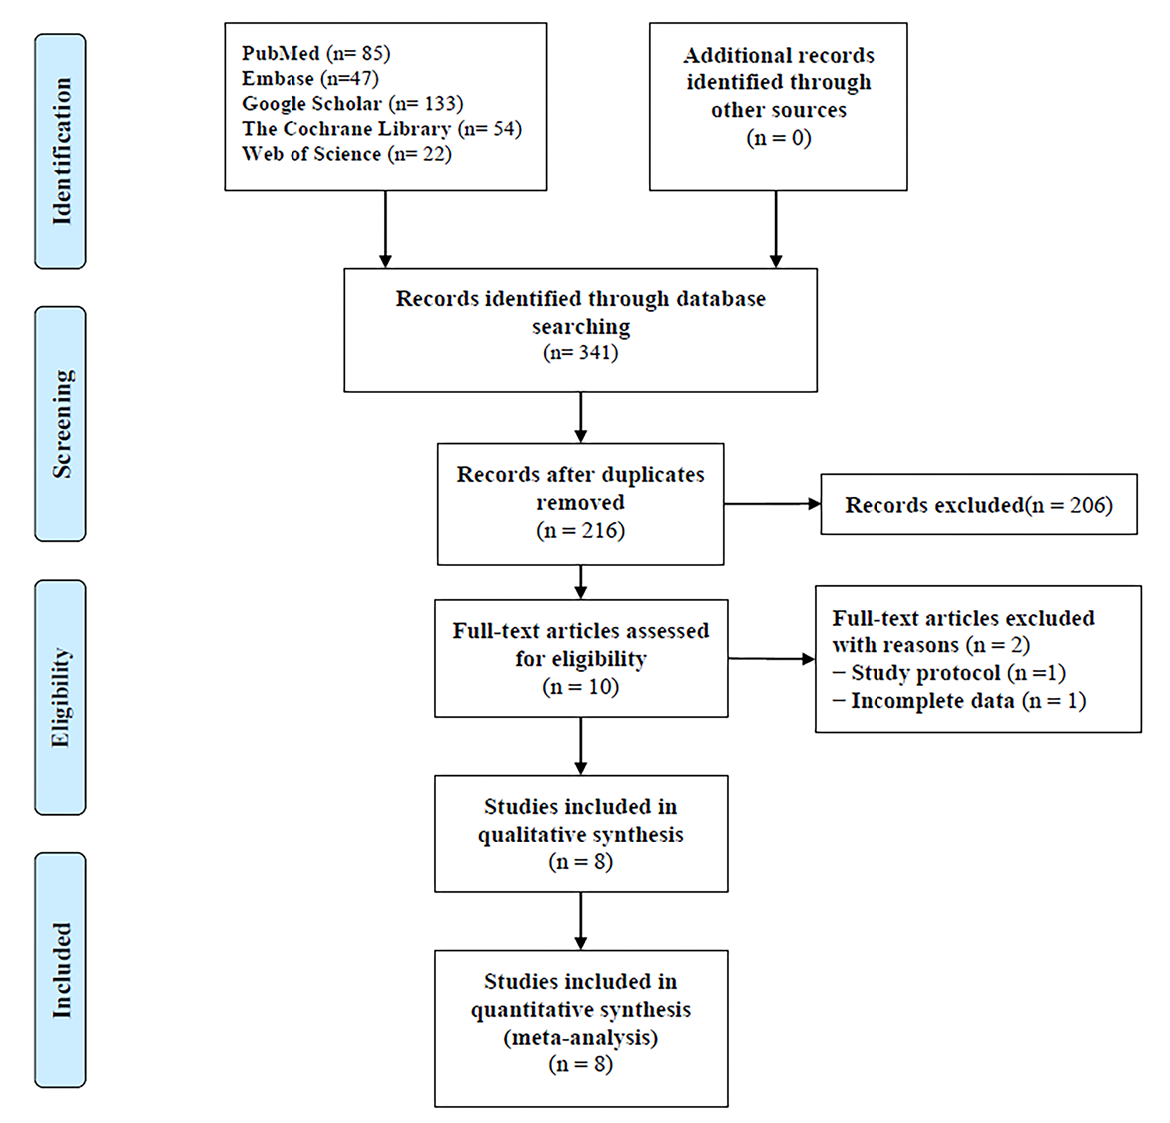
Figure 1 Preferred reporting items for systematic review and meta-analyses flow diagram.
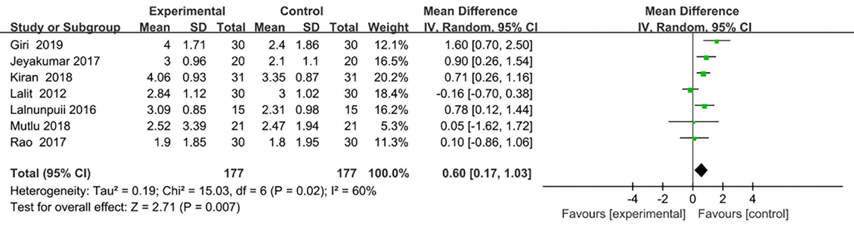
Figure 2 Forest plot of the pain. SD: Standard deviation; CI: Confidence interval.
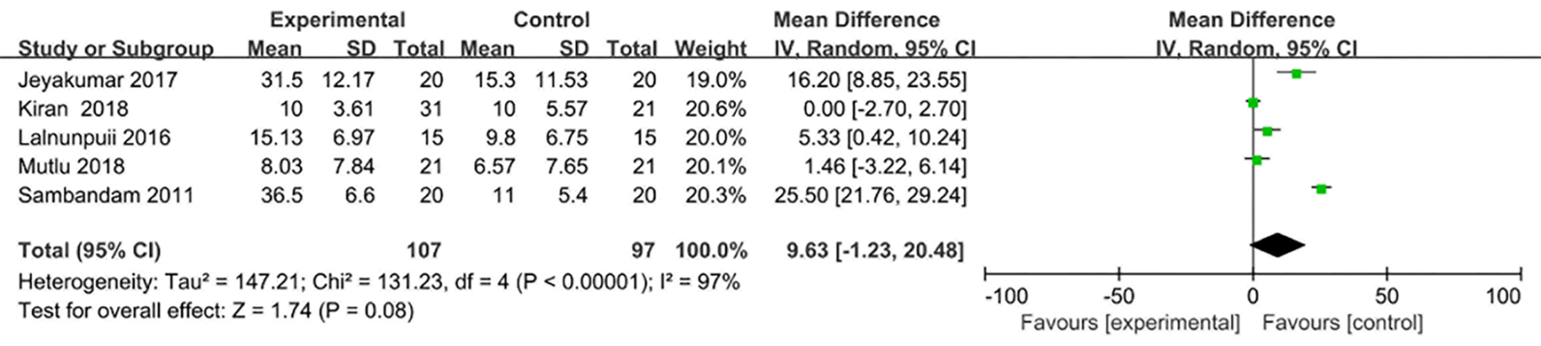
Figure 3 Forest plot of the range of motion. SD: Standard deviation; CI: Confidence interval.
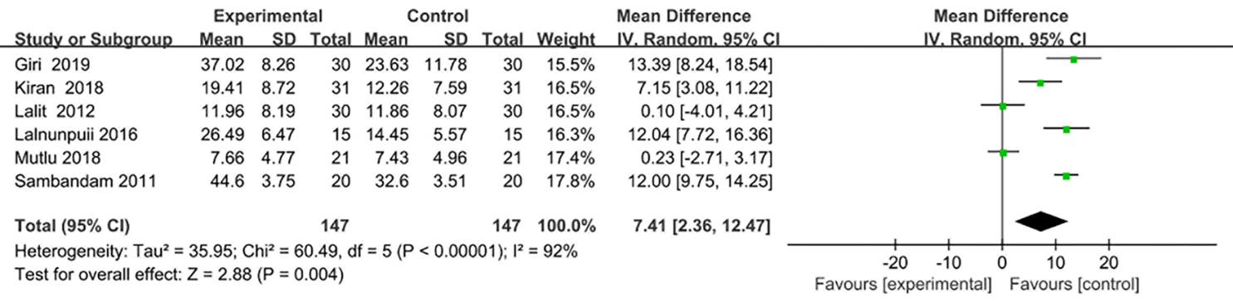
Figure 4 Forest plot of Western Ontario and McMaster Universities function score. SD: Standard deviation; CI: Confidence interval.
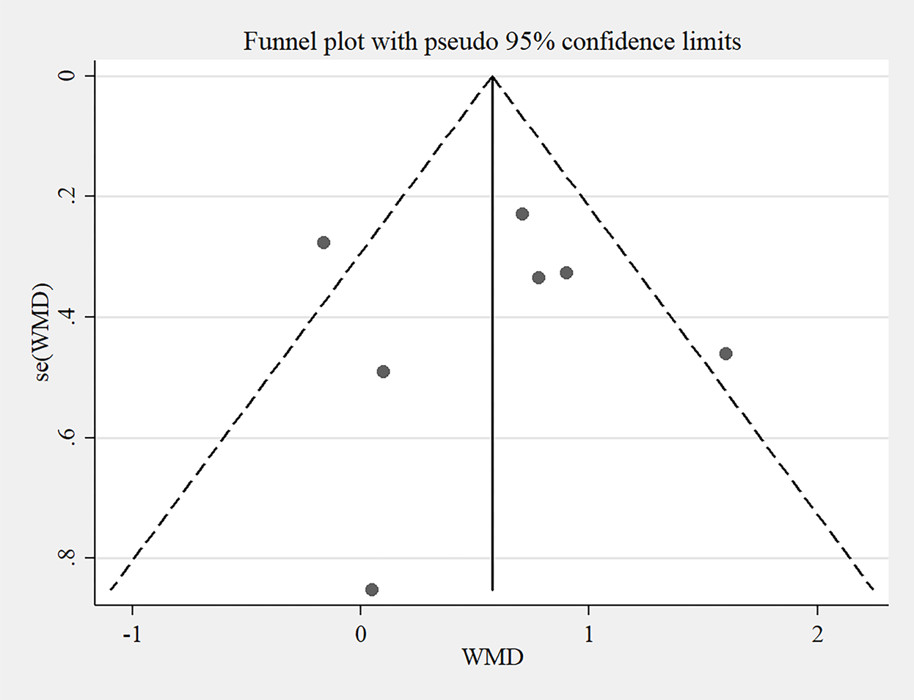
Figure 5 Publication bias.
Table 1 Characteristics of the included studies
Study | Comparators | Sample size | Age (yr) | Interventional type | Interval | Treatment period | Outcomes
Sambandam et al^{[31]}, 2011 | Mulligan | 20 | 61.0 ± 5.8¹ | Unspecific; CT: 10 min hot pack and quad isometrics, 10 rep; HE: 10 rep isometric quadriceps | Once per day | 2 wk | 1, 2, 3
 | Maitland | 20 | 60.0 ± 5.1¹
Kiran et al^{[14]}, 2018 | Mulligan | 31 | 47.5 ± 0.6¹ | Depending on pain; CT: 10 min hot pack and quad isometrics | 3 times per week | 2 wk | 1, 2, 3
 | Maitland | 31 |  | Grade 1, 2 for pain; Grade 3 for ROM; CT: 10 min hot pack and quad isometrics
Jeyakumar et al^{[30]}, 2017 | Mulligan | 20 | 51.0 ± 1.5¹ | Medial, lateral, and rotational Mulligan without a belt; one glide per sec for 30 sec; 3 sets per treatment session; CT: hot pack, quad isometrics and SLR | Once per day | 3 wk | 1, 2
 | Maitland | 20 | 50.0 ± 2.7¹ | Medial, lateral, posterior glide; one glide per seconds for 30 seconds; 3 sets per treatment session; CT: hot pack, quad isometric and SLR
Multu et al^{[33]}, 2018 | Mulligan | 21 | 54.2 ± 7.3¹ | A sustained manual glide of the tibia (medial, lateral, or rotation) during active; knee flexion and extension, 3 sets of 10 rep; EP: aerobic, active ROM, strength, stretching exercises | 3 times per week | 4 wk | 1, 2, 3
 | Maitland | 21 | 56.3 ± 6.6¹ | Knee distraction and dorsal glides, ventral glides and patellar glides in all direction; 2-3 oscillations per seconds for 1-2 min; 3-6 rep; EP: aerobic, active ROM, strength, stretching exercises
Lalnunpuii et al^{[35]}, 2016 | Mulligan | 15 | 49.5 ± 5.5¹ | Medial, lateral, rotation and dorsal mobilization with active knee flexion; 3 sets of 10 rep; EP: isometric strengthening (quad, hamstring, VMO), Stretch (quad, hamstring), ROM | 3 sessions per week | 4 wk | 2, 3
 | Maitland | 15 | 48.5 ± 6.9¹ | Tibia-femoral anterior-posterior glide, Tibia-femoral posterior-anterior glide, Patella-femoral caudal-cephaloid glide, 2-3 oscillations per sec for 1-2 min. EP: isometric strengthening (quad, hamstring, VMO), Stretch (quad, hamstring), ROM
Giri ^{[32]}, 2019 | Mulligan | 30 | 61-70² | A sustained manual glide of the tibia (either medial, lateral, anterior, posterior or rotation) during active knee flexion and extension; 3 sets of 10 rep. Mulligan taping: tape with brown rigid tape | 3 times per week | 2 wk | 1, 3
 | Maitland | 30 |  | Tibia-femoral anterior and posterior glided. Kinesio taping: superior "Y" technique
Rao et al^{[34]}, 2017 | Mulligan | 30 | 51.2 ± 9.2¹ | According to individual condition | - | - | 1
 | Maitland |  |  | AP, PA, medial, lateral, compression and distraction glides; rotation
Lalit et al^{[15]}, 2012 | Mulligan | 30 | 51.7² | internal rotation the tibia, 3 reps for 3 sets; EP: multiple angle isometrics, terminal arc knee extension, mini-squats, partial lunges one-leg balances, cross-body leg swings, 10 rep per session, 3 sessions per day | 3 sessions per day | 5 d | 1, 3
 | Maitland | 30 | 54.7³ | Anterior and posterior glide for tibial-femoral joint, superior-inferior and medio-lateral glides for patellar femoral joint, 10 rep per session, 3 sessions per day; EP: multiple angle isometrics, terminal arc knee extension, mini squats, partial lunges one-leg balances, cross-body leg swings (10 rep per session, 3 sessions per day)
¹mean ± SD.
²Range.
³mean. 1: Pain; 2: ROM: Range of motion; 3: WOMAC function score: Western Ontario and McMaster Universities function score. Rep: Repetition; CT: Conventional treatment; HE: Home exercise; SLR: Straight leg raise; EP: Exercise program; VMO: Vastus medialis oblique; AP: Anterior to posterior; PA: Posterior to anterior.

Table 2 Quality of included studies by PEDro Scale
Author | C1 | C2 | C3 | C4 | C5 | C6 | C7 | C8 | C9 | C10 | C11 | TS | Level of evidence
Lalnunpuii et al^{[31]}, 2016 | 1 | 1 | 0 | 1 | 1 | 1 | 1 | 1 | 1 | 1 | 1 | 10 | A2
Rao et al^{[34]}, 2017 | 1 | 1 | 0 | 1 | 1 | 0 | 1 | 1 | 0 | 1 | 1 | 8 | B
Kiran et al^{[14]}, 2018 | 1 | 1 | 0 | 1 | 0 | 0 | 0 | 1 | 1 | 1 | 1 | 7 | B
Mutlu et al^{[33]}, 2018 | 1 | 1 | 1 | 1 | 1 | 0 | 1 | 1 | 0 | 1 | 1 | 9 | B
Giri et al^{[32]}, 2019 | 1 | 1 | 0 | 1 | 0 | 0 | 0 | 1 | 1 | 1 | 1 | 7 | B
Jeyakumar et al^{[30]}, 2017 | 1 | 1 | 1 | 1 | 0 | 0 | 0 | 1 | 1 | 1 | 1 | 8 | B
Sambandam et al^{[31]}, 2011 | 0 | 1 | 0 | 1 | 0 | 0 | 1 | 1 | 1 | 1 | 1 | 7 | B
Lalit et al^{[15]}, 2012 | 1 | 0 | 0 | 0 | 0 | 0 | 0 | 1 | 1 | 1 | 1 | 5 | B
C1: Eligibility criteria were specified; C2: Subjects were randomly allocated to groups (in a crossover study, subjects were randomly allocated an order in which treatments were received); C3: Allocation was concealed; C4: The groups were similar at baseline regarding the most important prognogstic indicators; C5: There was blinding of all subjects; C6: There was blinding of all therapists who administered the therapy; C7: There was blinding of all assessors who measured at least one key outcome; C8: Measurements of at least one key outcome were obtained from more than 85% of the subjects initially allocated to groups; C9: All subjects for whom outcome measurements were available received the treatment or control condition as allocated, or where this was not the case, data for at least one key outcome were analyzed by "Intention to treat"; C10: The result of between-group statistical comparisons were reported for at least one key outcome; C11: The study provided both point measurements and measurements of variability for at least one key outcome; 0: Does not meet the included criteria; 1: Meets the included criteria. TS: Total score.

