Name of Journal: World Journal of Clinical Cases
Manuscript NO: 57484
Manuscript Type: CASE REPORT

Acute amnesia during pregnancy due to bilateral fornix infarction: A case report

Cho MJ et al. Acute isolated amnesia due to BFI

Min Jai Cho, Dong-Ick Shin, Moon-Ku Han, Kyu Sun Yum

Min Jai Cho, Department of Neurosurgery, Chungbuk National University Hospital, Cheongju-si 28644, South Korea

Dong-Ick Shin, Kyu Sun Yum, Department of Neurology, Chungbuk National University Hospital, Cheongju-si 28644, South Korea

Moon-Ku Han, Department of Neurology, Seoul National University Bundang Hospital, Seongnam-si 463-707, South Korea

Author contributions: Yum KS was the patient’s neurologist; Yum KS and Cho MJ reviewed the literature and contributed to manuscript drafting; Shin DI and Han MK were responsible for the revision of the manuscript for important intellectual content; all authors issued final approval of the version to be submitted.

Corresponding author: Kyu Sun Yum, MD, Assistant Professor, Department of Neurology, Chungbuk National University Hospital, 776, 1 Sunhwan-ro, Seowon-gu, Cheongju-si 28644, Korea. alcest@gmail.com

Received: June 25, 2020
Revised: August 12, 2020
Accepted: September 4, 2020
Published online: October 6, 2020

Abstract
BACKGROUND
Stroke is an important cause of maternal morbidity and mortality during pregnancy and puerperium. Isolated amnesia is a rare clinical symptom caused by ischemic stroke during pregnancy. We present the first documented case of acute amnesia during pregnancy due to bilateral fornix infarction.

CASE SUMMARY
A 32-year-old nullipara presented at 35 wk of gestation with acute amnesia and headache. Brain magnetic resonance imaging and angiography revealed acute infarction in the bilateral anterior fornix. There was no evidence of causative abnormality after extensive work-up, including for vascular abnormality, cardiac disease, coagulopathy, and pregnancy-related conditions. The patient was diagnosed with cryptogenic stroke. Aspirin was administered immediately, and the patient recovered fully without recurrence.

CONCLUSION
Acute isolated amnesia due to stroke is rare during pregnancy. Early diagnosis of stroke and immediate treatment prevent neurologic sequelae.

Key words: Fornix; Brain; Amnesia; Cerebral infarction; Pregnancy; Stroke; Case report

Cho MJ, Shin DI, Han MK, Yum KS. Acute amnesia during pregnancy due to bilateral fornix infarction: A case report. World J Clin Cases 2020; 8(19): 4494-4498 URL: https://www.wjgnet.com/2307-8960/full/v8/i19/4494.htm DOI: https://dx.doi.org/10.12998/wjcc.v8.i19.4494

Core Tip: Pregnancy-related cerebrovascular disorder is one of the major causes of maternal mortality. Arterial ischemic infarction is a less common complication, however, more critical and disabling. Isolated amnesia is a rare clinical symptom caused by ischemic stroke in pregnancy. We present a rare case of acute amnesia due to bilateral fornix infarction in healthy young nullipara. Extensive work up for stroke revealed no causative abnormality. The patient was diagnosed as cryptogenic stroke. This case highlights the early diagnosis and treatment for stroke in pregnancy with acute amnesia without another neurologic deficit.

INTRODUCTION
Cerebrovascular disease during pregnancy is rare, but it is one of the major causes of maternal mortality and serious long-term disability^{[1]}. Pregnancy is associated with an increased risk of ischemic stroke (including arterial and venous infarction) and hemorrhagic stroke (including intracerebral and subarachnoid hemorrhage). The incidence of stroke during pregnancy varies depending on gestational age. The greatest risk is observed during the third trimester and early postpartum. Risk factors for cerebrovascular complication during pregnancy are underlying diseases and conditions related to pregnancy^{[2]}. Ischemic stroke during pregnancy is less common than hemorrhagic stroke and is higher during puerperium than during pregnancy^{[2-4]}. Isolated amnestic syndrome due to vascular disease (especially acute infarction in the bilateral fornix) is a rare situation^{[5]}. Herein, we report the first documented case of acute amnesia during the third trimester of pregnancy due to arterial infarction of the bilateral fornix.

CASE PRESENTATION
Chief complaints
A 32-year-old nullipara at 35 wk gestation presented with headache and sudden memory impairment. She could not recall any of the events that happened for 5 d.

History of present illness
Amnesia and headache occurred abruptly. Symptoms did not improve for 5 d.

History of past illness
The patient had no remarkable medical history, including for hypertension, diabetes mellitus, dyslipidemia or migraine.

Physical examination
Upon arrival at the hospital, the patient’s blood pressure was 120/80 mmHg, and her heart rate was 68 bpm and regular. She was alert and oriented to time, person and place. Neurological examination was normal except anterograde and retrograde amnesia. The Mini-Mental State Examination score was 28 and the Montreal Cognitive Assessment score was 26 points with delayed recall impairment.

Laboratory examinations
Laboratory testing was unremarkable, including findings for thrombophilia, autoimmune diseases, diabetes mellitus, dyslipidemia, erythrocyte sedimentation rate, C-reactive protein, thiamine level, and human immunodeficiency virus.

Imaging examinations
Magnetic resonance imaging of the brain revealed acute infarction in the bilateral anterior fornix. No significant steno-occlusive lesions in the intracranial and proximal neck vessels were found in magnetic resonance angiography (Figure 1).

Further diagnostic work-up
Findings from electrocardiography, Holter monitoring, transthoracic echocardiography and transesophageal echocardiography, including a test for patent foramen ovale, were also normal. Findings from obstetric ultrasonography were unremarkable.

FINAL DIAGNOSIS
Cryptogenic infarction of bilateral fornix.

TREATMENT
The patient was immediately treated with 100 mg of aspirin, which was continued until 5 d prior to delivery.

OUTCOME AND FOLLOW-UP
The patient’s symptoms gradually improved. She was discharged to home and completely recovered after 2 wk. She gave birth to a healthy baby by Cesarean section at 4 wk after the stroke.

DISCUSSION
Cerebrovascular disease during pregnancy, especially arterial ischemic stroke, is rare, but it is a critical condition and disabling to the patient^{[3,6]}. The risk of ischemic stroke is higher during puerperium than during pregnancy^{[3]}. However, hemorrhagic stroke (including intracerebral hemorrhage and subarachnoid hemorrhage) occur more frequently during the second or early third trimesters and in the early postpartum period. Risk factors for cerebrovascular complication during pregnancy are underlying diseases such as prothrombotic conditions, heart disease, anomalies of cerebral vasculature and conditions related to pregnancy, including Cesarean delivery, pregnancy-induced hypertension, peripartum infection, multiple gestation, and the result of hemodynamic and coagulation system changes^{[2,7]}. In the case of ischemic stroke, there are many causes of stroke during pregnancy, with common etiologies being hypertension, smoking, diabetes mellitus, dyslipidemia, thrombophilia, paradoxical emboli, heart disease, and anomalies of cerebral vasculature. However, pregnancy-specific causes include preeclampsia/eclampsia, cerebral venous thrombosis, amniotic fluid embolism, posterior reversible encephalopathy syndrome, peripartum infection, Cesarean delivery, postpartum cerebral angiopathy, and gestational trophoblastic disease^{[2,8]}. The management of stroke during pregnancy is guided by the stroke etiology and subtype. In the case of arterial stroke, early antiplatelet agent therapy (i.e., aspirin) is recommended for cases without intracranial bleeding and as secondary prevention. In the case of symptomatic cerebral venous sinus thrombosis, with or without hemorrhagic venous infarction, anticoagulation should be continued throughout the pregnancy^{[9,10]}.
Several cases of memory impairment during pregnancy due to cerebral dysfunction have been reported previously. Wernicke encephalopathy is a clinical syndrome characterized by acute amnesia following hyperemesis gravidarum. This typically occurs at 14-16 wk of gestation and is caused by thiamine deficiency^{[11]}. Sudden onset of amnesia due to a vascular lesion in a healthy young woman is an uncommon situation. Acute amnestic syndrome due to infarction of bilateral fornix, an important anatomical structure of the Papez circuit, is a rare condition and only a few cases have been reported. Small vessel disease, cardioembolic disease and giant cell arteritis have been proposed as the etiology. The subcallosal artery, a perforator of anterior communicating artery, supply the bilateral column of fornix (Figure 2). Iatrogenic subcallosal artery occlusion after clipping or surgery of the anterior communicating artery can also cause acute amnestic syndrome. However, the patients in the previous reports^{[5,11-15]} did not represent young-age pregnancies without risk factors of ischemic stroke or cerebral vascular abnormality.
Our patient was diagnosed with an acute infarction of the bilateral fornix during the third trimester of pregnancy. She had no conventional risk factors of ischemic stroke. Extensive diagnostic workup for ischemic stroke, including cardioembolism, paradoxical emboli, autoimmune disease and coagulation disorder, were performed and there were no remarkable findings. Patent foramen ovale is an important cause of cryptogenic stroke in healthy young adults, especially during pregnancy. However, transesophageal echocardiogram showed no evidence of patent foramen ovale. There was no evidence of pregnancy-related risk factors such as gestational hypertension, preeclampsia/eclampsia and coagulopathy. Brain magnetic resonance imaging and magnetic resonance angiography revealed acute infarction in the bilateral fornix without significant steno-occlusive lesion of the anterior communicating artery. We diagnosed the patient with cryptogenic stroke, and aspirin was administered immediately. The amnesia was completely resolved. There was no recurrence at the 1-year follow-up.
This case is the first report of acute amnesia due to infarction of the bilateral fornix during pregnancy. Bilateral fornix infarction is a very rare situation during pregnancy. Brain imaging should be considered for acute onset amnesia, especially if symptoms persist more than 24 h. Early detection of stroke and immediate treatment are important for good recovery.

CONCLUSION
Acute isolated amnesia due to cerebral infarction during a healthy young pregnancy is extremely rare. All previously documented cases of pure amnestic syndrome due to bilateral fornix infarction found a presumed pathophysiology including microangiopathy, cardioembolism, vasculitis and iatrogenic injury after aneurysmal procedure of the relevant artery. Early diagnosis and immediate treatment are important for good recovery in cryptogenic stroke.

ACKNOWLEDGEMENTS
The authors are grateful to the patient and her parents for allowing publication of this rare case report.

REFERENCES
1 Say L, Chou D, Gemmill A, Tunçalp Ö, Moller AB, Daniels J, Gülmezoglu AM, Temmerman M, Alkema L. Global causes of maternal death: a WHO systematic analysis. Lancet Glob Health 2014; 2: e323-e333 [PMID: 25103301 DOI: 10.1016/S2214-109X(14)70227-X]
2 James AH, Bushnell CD, Jamison MG, Myers ER. Incidence and risk factors for stroke in pregnancy and the puerperium. Obstet Gynecol 2005; 106: 509-516 [PMID: 16135580 DOI: 10.1097/01.AOG.0000172428.78411.b0]
3 Kittner SJ, Stern BJ, Feeser BR, Hebel R, Nagey DA, Buchholz DW, Earley CJ, Johnson CJ, Macko RF, Sloan MA, Wityk RJ, Wozniak MA. Pregnancy and the risk of stroke. N Engl J Med 1996; 335: 768-774 [PMID: 8703181 DOI: 10.1056/NEJM199609123351102]
4 Liu S, Chan WS, Ray JG, Kramer MS, Joseph KS; for the Canadian Perinatal Surveillance System (Public Health Agency of Canada). Stroke and cerebrovascular disease in pregnancy. Stroke 2019; 50: 13-20 [DOI: 10.1161/STROKEAHA.118.023118]
5 Meila D, Saliou G, Krings T. Subcallosal artery stroke: infarction of the fornix and the genu of the corpus callosum. The importance of the anterior communicating artery complex. Case series and review of the literature. Neuroradiology 2015; 57: 41-47 [PMID: 25280444 DOI: 10.1007/s00234-014-1438-8]
6 Razmara A, Bakhadirov K, Batra A, Feske SK. Cerebrovascular complications of pregnancy and the postpartum period. Curr Cardiol Rep 2014; 16: 532 [PMID: 25239155 DOI: 10.1007/s11886-014-0532-1]
7 Ros HS, Lichtenstein P, Bellocco R, Petersson G, Cnattingius S. Pulmonary embolism and stroke in relation to pregnancy: how can high-risk women be identified? Am J Obstet Gynecol 2002; 186: 198-203 [PMID: 11854635 DOI: 10.1067/mob.2002.119177]
8 Mas JL, Lamy C. Stroke in pregnancy and the puerperium. J Neurol 1998; 245: 305-313 [PMID: 9669480 DOI: 10.1007/s004150050224]
9 Treadwell SD, Thanvi B, Robinson TG. Stroke in pregnancy and the puerperium. Postgrad Med J 2008; 84: 238-245 [PMID: 18508980 DOI: 10.1136/pgmj.2007.066167]
10 Saposnik G, Barinagarrementeria F, Brown RD Jr, Bushnell CD, Cucchiara B, Cushman M, deVeber G, Ferro JM, Tsai FY; American Heart Association Stroke Council and the Council on Epidemiology and Prevention. Diagnosis and management of cerebral venous thrombosis: a statement for healthcare professionals from the American Heart Association/American Stroke Association. Stroke 2011; 42: 1158-1192 [PMID: 21293023 DOI: 10.1161/STR.0b013e31820a8364]
11 Kotha VK, De Souza A. Wernicke's encephalopathy following Hyperemesis gravidarum. A report of three cases. Neuroradiol J 2013; 26: 35-40 [PMID: 23859165 DOI: 10.1177/197140091302600106]
12 Moudgil SS, Azzouz M, Al-Azzaz A, Haut M, Gutmann L. Amnesia due to fornix infarction. Stroke 2000; 31: 1418-1419 [PMID: 10835465 DOI: 10.1161/01.str.31.6.1418]
13 Park SA, Hahn JH, Kim JI, Na DL, Huh K. Memory deficits after bilateral anterior fornix infarction. Neurology 2000; 54: 1379-1382 [PMID: 10746616 DOI: 10.1212/wnl.54.6.1379]
14 Moussouttas M, Giacino J, Papamitsakis N. Amnestic syndrome of the subcallosal artery: a novel infarct syndrome. Cerebrovasc Dis 2005; 19: 410-414 [PMID: 15925871 DOI: 10.1159/000086104]
15 Murr N, Thaisetthawatkul P, Helvey J, Fayad P. Selective infarction of the anterior genu fornices associated with giant cell arteritis. J Stroke Cerebrovasc Dis 2012; 21: 327-329 [PMID: 20884244 DOI: 10.1016/j.jstrokecerebrovasdis.2010.08.006]

Footnotes
Informed consent statement: Informed written consent was obtained from the patient for publication of this report and any accompanying images.

Conflict-of-interest statement: The authors declare that they have no conflicts of interest.

CARE Checklist (2016) statement: The authors have read the CARE Checklist (2016), and the manuscript was prepared and revised according to the CARE Checklist (2016).

Open-Access: This article is an open-access article that was selected by an in-house editor and fully peer-reviewed by external reviewers. It is distributed in accordance with the Creative Commons Attribution NonCommercial (CC BY-NC 4.0) license, which permits others to distribute, remix, adapt, build upon this work non-commercially, and license their derivative works on different terms, provided the original work is properly cited and the use is non-commercial. See: http://creativecommons.org/Licenses/by-nc/4.0/

Manuscript source: Unsolicited manuscript

Peer-review started: June 25, 2020
First decision: August 8, 2020
Article in press: September 4, 2020

Specialty type: Medicine, research and experimental
Country/Territory of origin: South Korea
Peer-review report’s scientific quality classification
Grade A (Excellent): 0
Grade B (Very good): B
Grade C (Good): C
Grade D (Fair): 0
Grade E (Poor): 0

P-Reviewer: Zhang S S-Editor: Yan JP L-Editor: A P-Editor: Xing YX
Figure Legends
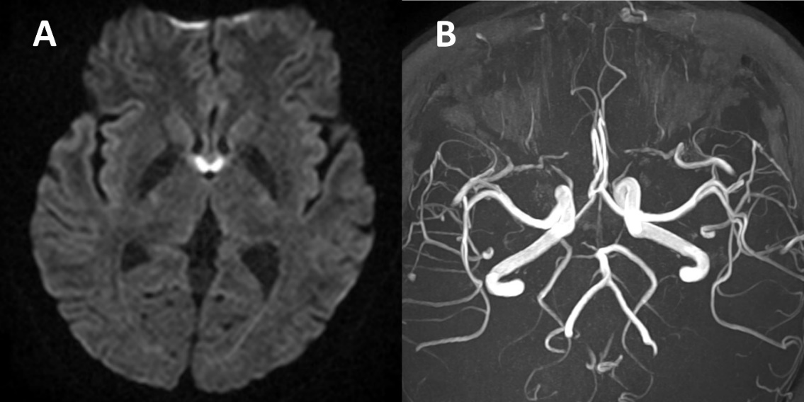
Figure 1 Diffusion weighted image and angiography of patient. A: Diffusion weighted image revealed acute infarction in the bilateral fornix; B: Magnetic resonance angiography showed normal vasculature of the anterior communicating artery.

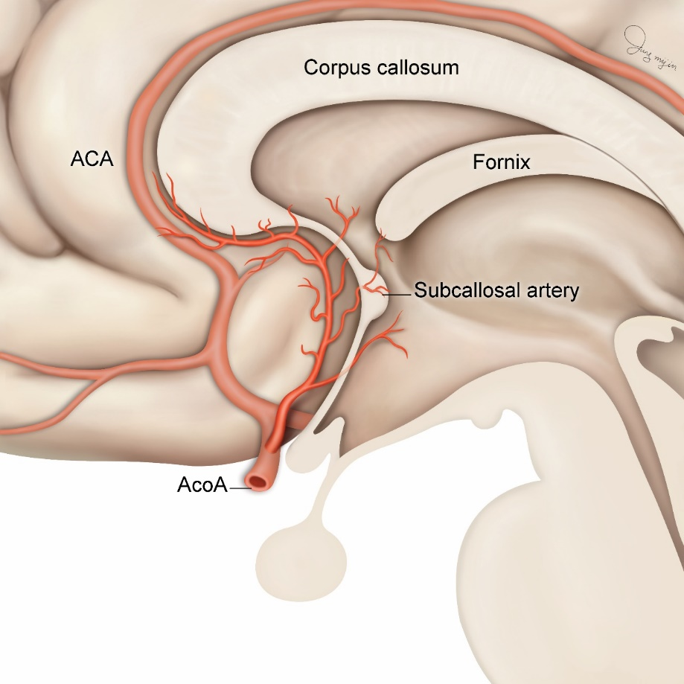
Figure 2 Vascular supply of the fornix. The vascular supply of the column of fornix is the subcallosal artery which is a small perforating branch arising from the anterior communicating artery. ACA: Anterior cerebral artery; AcoA: Anterior communicating artery.

