Name of Journal: World Journal of Gastroenterology
Manuscript NO: 62643
Manuscript Type: CASE REPORT

Gastrointestinal cytomegalovirus disease secondary to measles in an immunocompetent infant: A case report

Yang QH et al. An infant with prolonged fever and bloody diarrhea

Qing-Hua Yang, Xiao-Peng Ma, Dong-Ling Dai, Da-Ming Bai, Yu Zou, Si-Xi Liu, Jian-Ming Song

Qing-Hua Yang, Xiao-Peng Ma, Dong-Ling Dai, Da-Ming Bai, Yu Zou, Si-Xi Liu, Endoscopy Center and Gastroenterology Department, Shenzhen Children's Hospital, Shenzhen 518036, Guangdong Province, China

Jian-Ming Song, Department of Pathology, Shenzhen Children's Hospital, Shenzhen 518036, Guangdong Province, China

Author contributions: Yang QH drafted the manuscript and analyzed the data; Liu SX, Bai DM, and Zou Y were involved in patient management and follow-up; Dai DL and Ma XP designed and supervised the study; Song JM contributed to data acquisition, analysis, and interpretation; Dai DL and Ma XP contributed equally to this manuscript; all of the authors approved the submission of this manuscript.

Supported by Shenzhen Innovation and Technology Committee, No. JCYJ20180228175150018.

Corresponding author: Dong-Ling Dai, MD, PhD, Chief Doctor, Professor, Endoscopy Center and Gastroenterology Department, Shenzhen Children's Hospital, No. 7019 Yitian Road, Futian District, Shenzhen 518036, Guangdong Province, China. daidong3529@sina.com

Received: January 14, 2021
Revised: February 19, 2021
Accepted: March 25, 2021
Published online: April 21, 2021

Abstract
BACKGROUND
Gastrointestinal cytomegalovirus (CMV) disease occurs commonly in immunocompromised/immunodeficient patients with advanced human immunodeficiency virus infection, neoplasm, solid organ transplantation, hematopoietic stem cell transplantation, or treatment with immunosuppressants, but is rarely reported in association with measles infection.

CASE SUMMARY
We describe a case of extensive gastrointestinal CMV disease secondary to measles infection in a 9-mo-old boy who presented with persistent fever and bloody diarrhea. His condition was improved after ganciclovir treatment. Serological analysis of CMV showed negative immunoglobulin (Ig) M and positive IgG. Blood CMV-DNA was 9.26 × 10³ copies/mL. The diagnosis of gastrointestinal CMV disease was confirmed by histopathological findings of intranuclear and intracytoplasmic inclusions and Owl’s eye inclusion. This case highlights the differential diagnosis and histopathological characteristics of gastrointestinal CMV infection and laboratory tests.

CONCLUSION
Extensive gastrointestinal CMV lesions can be induced by the immune suppression secondary to measles infection. Rational, fast, and effective laboratory examinations are essential for suspected patients.

Key Words: Cytomegalovirus; Diarrhea; Gastrointestinal; Infant; Measles; Case report

©The Author(s) 2021. Published by Baishideng Publishing Group Inc. All rights reserved.

Citation: Yang QH, Ma XP, Dai DL, Bai DM, Zou Y, Liu SX, Song JM. Gastrointestinal cytomegalovirus disease secondary to measles in an immunocompetent infant: A case report. World J Gastroenterol 2021; 27(15): 1655-1663
URL: https://www.wjgnet.com/1007-9327/full/v27/i15/1655.htm
DOI: https://dx.doi.org/10.3748/wjg.v27.i15.1655

Core Tip: We report a case of gastrointestinal cytomegalovirus (CMV) disease secondary to measles infection in a 9-mo-old Chinese boy who had extensive gastrointestinal lesions; the diagnosis was confirmed by histopathological analysis. His condition was improved by ganciclovir treatment. This case highlights the differential diagnosis and histopathological characteristics of gastrointestinal CMV infection and laboratory tests and sheds light on the difficulty in diagnosing gastrointestinal CMV disease due to its nonspecific clinical presentation and the weak diagnostic value of serologic antibody detection.
INTRODUCTION
Cytomegalovirus (CMV) is an intracellular virus, and CMV infection of the gastrointestinal tract is commonly documented in immunocompromised/immunodeficient patients. Measles infection induces immune suppression and is associated with an increased susceptibility to secondary infections^{[1]}, and this effect has typically been thought to last from a few weeks to a few months^{[2]}. The Th2 response during convalescence of measles might inhibit Th1 responses, increasing susceptibility to other infections in children with measles^{[3]}. The morbidity from diarrhea, one of the most common complications of measles, is reported to increase in the acute phase of measles^{[4]}; however, gastrointestinal CMV infection is rarely reported as a causative etiology of persistent diarrhea secondary to measles infection.
CMV disease of the gastrointestinal tract is associated with significant mortality, mostly resulting from considerable bleeding and perforation when the patient is in an immunodepressed status^{[5]}. However, it is not so common for the lesions to be very large. Limitations of the serologic assay of CMV and nonspecific clinical manifestations that mimic many other infectious diseases present a significant challenge to early and accurate diagnosis in clinical practice. Clinicians should consider CMV infection as a differential diagnosis even in immunocompetent patients with common alimentary symptoms, particularly intractable diarrhea, hematochezia, or vomiting in conjunction with fever. Here, we describe a case of gastrointestinal CMV disease secondary to measles infection that involved vast lesions, and we review the differential diagnosis, histopathological diagnosis, and treatment of gastrointestinal CMV infection.

CASE PRESENTATION
Chief complaints
A 9-mo-old Chinese boy was admitted to Shenzhen Children’s hospital because of a persistent high fever and diarrhea that lasted for 17 d.

History of present illness
After 3 d of fever, he had a rash extending from his face to his trunk and limbs, and 5 d later, he suffered watery and bloody diarrhea. Positive immunoglobulin (Ig) M on the 10th day of fever confirmed a diagnosis of measles. Peripheral white blood cells, neutrophils, and C-reactive protein were elevated. Many leukocytes were found in his stool. Cefoperazone-sulbactam was administered intravenously for 4 d before admission, but the frequency of diarrhea increased, along with abdominal distension.

History of past illness
The patient had two episodes of pneumonia 40 d before this admission.

Personal and family history
The patient was born by cesarean section after full-term gestation, without complications during gestation or delivery. He had met physical and developmental milestones. Routine childhood immunizations were administered except for the measles vaccine.

Physical examination
On admission, the patient was weak but alert with a dehydrated appearance and typical measles skin (pigmentation and desquamation all over his body). The abdomen was soft and distended, with no tenderness or masses. The remainder of the physical examination was normal. Rapid intravenous rehydration was applied before further evaluation.

Laboratory examinations
Serological analysis for CMV showed negative IgM and positive IgG. PCR blood assay showed an elevation of CMV-DNA. The other laboratory results are shown in Tables 1 and 2.

Imaging examinations
Abdominal radiography (Figure 1) revealed upper gastrointestinal obstruction, while abdominal ultrasonography showed no obvious dilatation of the intestine or free effusion. Enhanced computed tomography demonstrated obstruction in the horizontal duodenum.

Further diagnostic work-up
On the 23rd day, gastroscopy (EG-99WR; Fujinon, Tokyo, Japan) and colonoscopy (GIF-XQ240; Olympus, Tokyo, Japan) were performed. Gastroscopy (Figure 2) revealed gastroduodenal mucosal edema and hyperemia, lymphoid hyperplasia, focal ulceration, pseudotumor formation, and stenosis in the horizontal duodenum. Incomplete colonoscopy (Figure 3) displayed diffuse mucosal edema and roughness, stiffness, friability, and white membranoid substances in the descending colon, sigmoid colon, and rectum. The histopathological examination revealed characteristic inclusions suggestive of CMV.

FINAL DIAGNOSIS
The final diagnosis of the presented case was gastrointestinal CMV disease.

TREATMENT
After admission to the hospital, suspected bacterial infection was treated with intravenous vancomycin and meropenem without improvement. On hospital day 12, diarrhea was aggravated with persistent high fever and episodes of vomiting and abdominal distension. Fasting and gastrointestinal decompression did not improve his condition. After the diagnosis of gastrointestinal CMV disease was made, intravenous ganciclovir was administered at 5 mg/kg every 12 h on the 30th hospital day for 2 wk and then reduced to 5 mg/kg each day for 1 wk.

OUTCOME AND FOLLOW-UP
The patient’s condition improved after treatment with IV ganciclovir and he was discharged on the 54th hospital day. He was followed regularly to 4.5 years old, and he is doing well.

DISCUSSION
This 9-mo-old Chinese boy had persistent fever and diarrhea after measles infection; ensuing vomiting, abdominal distension, and hematochezia presented at a later stage. All of these symptoms are indicative of digestive system diseases. Fever and diarrhea are common signs of different diagnoses in infants and children, including gastrointestinal infectious and noninfectious causes. In complicated cases with a prolonged course, there are difficulties in distinguishing pathogens; thus, detailed clinical data, exposure history, and pertinent laboratory tests can provide valuable assessment information.
Bacteria are reported as predominant pathogens of measles associated with diarrhea. However, this patient failed to respond to various antibiotics. Some distinct pathogens were considered. Enteroaggregative Escherichia coli (E. coli) and enteropathogenic E. coli are the most commonly implicated bacterial pathogens in persistent infections in developing countries, especially among children^{[6]}. The patient was a breastfed infant who had no ingestion of contaminated food, water, or unpasteurized milk, no exposure to sick contacts, no contact with infected pets or fowl, no travel history, and a negative result from stool culture, all of which indicated a low possibility of shigella, salmonella, campylobacter or other enteric infections^{[7]}.
While asymptomatic colonization of Clostridium difficile (C. difficile) is prevalent in infants, for patients with recent exposure to hospitals and antibiotics, microbiological evaluation should focus on the diagnosis of C. difficile infection^{[8]}; however, C. difficile should be sensitive to vancomycin, together with repeated negative bacterial separation and culture and enzyme immunoassay tests for toxins A and B and glutamate dehydrogenase. There was no support for the diagnosis of C. difficile infection in this patient.
The patient lives in China, a country that ranks 3rd in the world for high tuberculosis (TB) morbidity; thus, intestinal TB (ITB) should be considered even though it is more likely to cause miliary TB in infants. ITB is characterized by low-grade fever, abdominal pain, loss of weight, altered bowel habits, and night sweats^{[9]}. The absence of exposure to Mycobacterium tuberculosis and negative chest X-ray and interferon-γ release assay for TB revealed no direct evidence of TB in this patient.
As a noninfectious disease, inflammatory bowel disease (IBD) should be included in the differential diagnosis when lacking evidence of clear pathogenic microorganism infection^{[7]}. The typical clinical presentations of infantile-onset IBD are intermittent fever and bloody diarrhea^{[10]}; some cases are also associated with oral ulcers and perianal abscess and fistula. The diagnosis relies on endoscopic evaluation and histopathological findings of mucosal biopsy other than on clinical characteristics and history. Macroscopic features revealed no contiguous or skip linear ulceration, aphtha ulceration, cobblestoning, fistula, abscesses, or other changes, and microscopic features showed no crypt architectural changes or noncaseating granuloma, so the evidence supporting IBD was insufficient^{[11]}. Granting that very-early onset IBD may have heterogeneous or atypical symptoms and signs, endoscopy and mucosal biopsy were of great benefit to exclude IBD in this patient. There was no evidence of indigestion, malabsorption, autoimmune enteropathy, hemolytic uremic syndrome, allergic or neoplastic disorders, drug- or poison-induced diarrhea, structural diseases, or functional enteropathy in this case (Table 3).
Multiple factors may contribute to several weeks of measles-induced immune suppression^{[1]}. There is an epidemiologically detectable long-term increase in susceptibility to infectious diseases in those who survive measles^{[12]}. Measles infection contributes to transient lymphopenia with decreased numbers of T cells and B cells in circulation during the acute phase of infection. As viral RNA persists, suppression of lymphocyte proliferation is induced. During recovery, the later Th 2 CD4+ T-cell response may suppress macrophage activation and Th 1 responses to new infections. Moreover, measles-infected dendritic cells induce lymphocyte unresponsiveness. The suppression of interleukin (IL)-12 production, lymphocyte expression of CD30, and elevation of IL-4, IL-10, and IL-13 might contribute to immune suppression. Deficiencies of both innate and adaptive immune responses can render individuals with measles more susceptible to secondary bacterial and viral infections^{[13]}. The susceptibility to CMV is considered to be due to impaired cell-mediated immunity and a reduction in the levels of IgM^{[14]}.
Any part of the alimentary tract can be impacted by CMV infection but the typical CMV lesions are limited to either the upper or the lower gastrointestinal tract, while both the upper and the lower gastrointestinal tracts are rarely involved simultaneously^{[15]}. Gastrointestinal CMV disease with complex and diverse but nonspecific symptoms is a remediable disease with a high mortality; delayed diagnosis, misdiagnosis, and missed diagnosis greatly increase fatality. To the best of our knowledge, in both immunocompetent and immunodeficient patients, intractable diarrhea and fever seem to be the most common presentations of gastrointestinal CMV disease, so differentiating CMV infection from infectious diarrhea as early as possible is vital in clinical practice.
In addition to broad clinical presentations and signs, confirmation of the virus via laboratory methods is indispensable in diagnosing CMV disease. In this patient, CMV-IgM was negative, and the absence of evidence of active infection led to an uncertain causal relationship between CMV infection and various symptoms, which demanded histopathology detection for further verification. Nonetheless, the positive CMV-IgG titre was more than 4-fold in 2 wk, and elevated CMV DNA copies provided clues for diagnosis. Nevertheless, false negative IgM results can be obtained in immunocompromised patients and infants. Positive measles IgM was detected in this patient because the immune status was not affected by measles infection at the early stage. However, due to an immunocompromised status secondary to measles infection later, the negative IgM significantly limits its clinical application in the early diagnosis of CMV infection, which may delay diagnosis and treatment^{[16]}.
Negative results of CMV PCR do not rule out CMV disease^{[17]}. As a marker of early diagnosis, CMV pp65 antigen is not able to differentiate between latent infection and active disease. Viral culture is the diagnostic gold standard, but its poor sensitivity and slow turn-around time limit its clinical utility, while histopathology assays can provide confirmatory information for invasive disease which is highly specific^{[18]} (Figure 4). Therefore, when gastrointestinal CMV infection is suspected, endoscopy and biopsy must be performed to obtain positive evidence for diagnosis.
The macroscopic features of gastrointestinal CMV disease vary from normal mucosa, focal erythematous, erosion, and pseudotumor formation to deep ulceration, lacking specificity^{[19]}. Based on the patchy distributions and diverse endoscopic findings, biopsy location and number are important to assess CMV^{[20]}. Gastroduodenoscopy and incomplete colonoscopy were performed in this patient due to the risk of intestinal perforation and massive hemorrhage. The outcome of the histopathology assay confirmed invasive CMV disease.
CMV disease requires evidence of parenchymal organ damage before it can be diagnosed and treated with antiviral therapy. Anti-CMV treatment in immunocompromised patients is of vital importance to improve prognosis. Ganciclovir is recommended as the first-line pharmacological treatment for CMV infection, which comprises induction and maintenance. The initial dose must be adjusted for renal function and it is commonly advised to be 5 mg/kg every 12 h for at least 2 wk to 3 wk in the induction stage^{[21]}. The course of treatment varies with therapeutic reactions, including symptoms, quantitative detection of viral load, whole blood counts, hepatic function and renal function. When patients cannot tolerate side effects or diseases worsen with the use of ganciclovir, foscarnet is generally used as a substitution drug, whereas which can result in renal toxicity and electrolyte disturbances^{[22]}. After the diagnosis of CMV disease, the auditory, ophthalmic, and neurodevelopmental assessments of the patient were normal. His temperature decreased, vomiting disappeared, and the bowls recovered after intravenous ganciclovir administration. Inflammation biomarkers and CMV DNA copies decreased. An obvious improvement in imaging was shown on re-examination (Figure 1). The amelioration after antiviral therapy helped exclude IBD completely. Undoubtedly, this patient was fortunate. For immunocompromised patients with severe CMV infection, surgical treatment is required when medical treatment is ineffective.
In conclusion, we sought to review the differential diagnosis for similar clinical outcomes in a young child with diarrhea, hematochezia, and fevers, and to clarify endoscopic and histopathological findings as well as outline treatment options for CMV colitis. We highlighted the diagnostic challenges of gastrointestinal CMV disease due to its nonspecific clinical presentation and the weak diagnostic value of serologic antibody detection. We hope to help clinicians improve the understanding of the importance of considering this disease in immunocompromised patients, as well as to consider it in otherwise healthy patients with a prolonged course characterized by fever, diarrhea, and hematochezia who may become immunocompromised due to measles infection.

CONCLUSION
This is the first case of gastrointestinal CMV infection due to transient immunosuppression secondary to measles infection in a presumably immunocompetent child. Gastrointestinal CMV disease should be taken into consideration in patients with persistent fever and diarrhea followed by measles infection. Rational, fast, and effective laboratory examinations are essential for a timely diagnosis, avoiding inappropriate treatment and reducing mortality in suspected patients.

ACKNOWLEDGEMENTS
We thank the patient’s family for providing background information and allowing us to publish this manuscript. We wish to thank Dr. Cao WG and Gan YG (MD, Radiologist, Radiology Department of Shenzhen Children's Hospital) for their imaging technical assistance.

REFERENCES
1 Griffin DE. Measles virus-induced suppression of immune responses. Immunol Rev 2010; 236: 176-189 [PMID: 20636817 DOI: 10.1111/j.1600-065X.2010.00925.x]
2 Bester JC. Measles and Measles Vaccination: A Review. JAMA Pediatr 2016; 170: 1209-1215 [PMID: 27695849 DOI: 10.1001/jamapediatrics.2016.1787]
3 Moss WJ, Griffin DE. Measles. Lancet 2012; 379: 153-164 [PMID: 21855993 DOI: 10.1016/S0140-6736(10)62352-5]
4 Jackson BD, Black RE. Available studies fail to provide strong evidence of increased risk of diarrhea mortality due to measles in the period 4-26 weeks after measles rash onset. BMC Public Health 2017; 17: 783 [PMID: 29143685 DOI: 10.1186/s12889-017-4745-2]
5 Arnold M, Itzikowitz R, Young B, Machoki SM, Hsiao NY, Pillay K, Alexander A. Surgical manifestations of gastrointestinal cytomegalovirus infection in children: Clinical audit and literature review. J Pediatr Surg 2015; 50: 1874-1879 [PMID: 26265193 DOI: 10.1016/j.jpedsurg.2015.06.018]
6 Pawlowski SW, Warren CA, Guerrant R. Diagnosis and treatment of acute or persistent diarrhea. Gastroenterology 2009; 136: 1874-1886 [PMID: 19457416 DOI: 10.1053/j.gastro.2009.02.072]
7 DuPont HL. Persistent Diarrhea: A Clinical Review. JAMA 2016; 315: 2712-2723 [PMID: 27357241 DOI: 10.1001/jama.2016.7833]
8 McDonald LC, Gerding DN, Johnson S, Bakken JS, Carroll KC, Coffin SE, Dubberke ER, Garey KW, Gould CV, Kelly C, Loo V, Shaklee Sammons J, Sandora TJ, Wilcox MH. Clinical Practice Guidelines for Clostridium difficile Infection in Adults and Children: 2017 Update by the Infectious Diseases Society of America (IDSA) and Society for Healthcare Epidemiology of America (SHEA). Clin Infect Dis 2018; 66: 987-994 [PMID: 29562266 DOI: 10.1093/cid/ciy149]
9 Donoghue HD, Holton J. Intestinal tuberculosis. Curr Opin Infect Dis 2009; 22: 490-496 [PMID: 19623062 DOI: 10.1097/QCO.0b013e3283306712]
10 Ye Z, Zhou Y, Huang Y, Wang Y, Lu J, Tang Z, Miao S, Dong K, Jiang Z. Phenotype and Management of Infantile-onset Inflammatory Bowel Disease: Experience from a Tertiary Care Center in China. Inflamm Bowel Dis 2017; 23: 2154-2164 [PMID: 29140941 DOI: 10.1097/MIB.0000000000001269]
11 Levine A, Koletzko S, Turner D, Escher JC, Cucchiara S, de Ridder L, Kolho KL, Veres G, Russell RK, Paerregaard A, Buderus S, Greer ML, Dias JA, Veereman-Wauters G, Lionetti P, Sladek M, Martin de Carpi J, Staiano A, Ruemmele FM, Wilson DC; European Society of Pediatric Gastroenterology, Hepatology, and Nutrition. ESPGHAN revised porto criteria for the diagnosis of inflammatory bowel disease in children and adolescents. J Pediatr Gastroenterol Nutr 2014; 58: 795-806 [PMID: 24231644 DOI: 10.1097/MPG.0000000000000239]
12 Griffin DE. Measles immunity and immunosuppression. Curr Opin Virol 2021; 46: 9-14 [PMID: 32891958 DOI: 10.1016/j.coviro.2020.08.002]
13 Moss WJ. Measles. Lancet 2017; 390: 2490-2502 [PMID: 28673424 DOI: 10.1016/S0140-6736(17)31463-0]
14 Baumgartner JD, Glauser MP, Burgo-Black AL, Black RD, Pyndiah N, Chiolero R. Severe cytomegalovirus infection in multiply transfused, splenectomized, trauma patients. Lancet 1982; 2: 63-66 [PMID: 6123807 DOI: 10.1016/s0140-6736(82)91688-9]
15 de Andrade LG, Rodrigues MA, Romeiro FG, Carvalho MF. Gastrointestinal cytomegalovirus disease in renal transplant recipients: a case series. Clin Transplant 2012; 26: 345-350 [PMID: 22017269 DOI: 10.1111/j.1399-0012.2011.01514.x]
16 Razonable RR, Paya CV, Smith TF. Role of the laboratory in diagnosis and management of cytomegalovirus infection in hematopoietic stem cell and solid-organ transplant recipients. J Clin Microbiol 2002; 40: 746-752 [PMID: 11880387 DOI: 10.1128/jcm.40.3.746-752.2002]
17 Ruell J, Barnes C, Mutton K, Foulkes B, Chang J, Cavet J, Guiver M, Menasce L, Dougal M, Chopra R. Active CMV disease does not always correlate with viral load detection. Bone Marrow Transplant 2007; 40: 55-61 [PMID: 17468776 DOI: 10.1038/sj.bmt.1705671]
18 Pillet S, Pozzetto B, Roblin X. Cytomegalovirus and ulcerative colitis: Place of antiviral therapy. World J Gastroenterol 2016; 22: 2030-2045 [PMID: 26877608 DOI: 10.3748/wjg.v22.i6.2030]
19 Goodgame RW. Gastrointestinal cytomegalovirus disease. Ann Intern Med 1993; 119: 924-935 [PMID: 8215005 DOI: 10.7326/0003-4819-119-9-199311010-00010]
20 Juric-Sekhar G, Upton MP, Swanson PE, Westerhoff M. Cytomegalovirus (CMV) in gastrointestinal mucosal biopsies: should a pathologist perform CMV immunohistochemistry if the clinician requests it? Hum Pathol 2017; 60: 11-15 [PMID: 27666768 DOI: 10.1016/j.humpath.2016.09.009]
21 You DM, Johnson MD. Cytomegalovirus infection and the gastrointestinal tract. Curr Gastroenterol Rep 2012; 14: 334-342 [PMID: 22588614 DOI: 10.1007/s11894-012-0266-4]
22 Kotton CN, Kumar D, Caliendo AM, Huprikar S, Chou S, Danziger-Isakov L, Humar A; The Transplantation Society International CMV Consensus Group. The Third International Consensus Guidelines on the Management of Cytomegalovirus in Solid-organ Transplantation. Transplantation 2018; 102: 900-931 [PMID: 29596116 DOI: 10.1097/TP.0000000000002191]

Footnotes
Informed consent statement: Consent was obtained from the parents of the patient for publication of the case report and any accompanying images.

Conflict-of-interest statement: The authors who took part in this study declare that they do not have anything to disclose regarding funding or a conflict of interest with respect to this manuscript.

CARE Checklist (2016) statement: The authors have read the CARE Checklist (2016), and the manuscript was prepared and revised according to the CARE Checklist (2016).

Open-Access: This article is an open-access article that was selected by an in-house editor and fully peer-reviewed by external reviewers. It is distributed in accordance with the Creative Commons Attribution NonCommercial (CC BY-NC 4.0) license, which permits others to distribute, remix, adapt, build upon this work non-commercially, and license their derivative works on different terms, provided the original work is properly cited and the use is non-commercial. See: http://creativecommons.org/Licenses/by-nc/4.0/

Manuscript source: Unsolicited manuscript

Peer-review started: January 14, 2021
First decision: February 10, 2021
Article in press: March 25, 2021

Specialty type: Gastroenterology and hepatology
Country/Territory of origin: China
Peer-review report’s scientific quality classification
Grade A (Excellent): 0
Grade B (Very good): B, B
Grade C (Good): C
Grade D (Fair): 0
Grade E (Poor): 0

P-Reviewer: Ilic K, Komatsu H, Liatsos GD S-Editor: Gao CC L-Editor: Wang TQ P-Editor: Ma YJ
Figure Legends
A
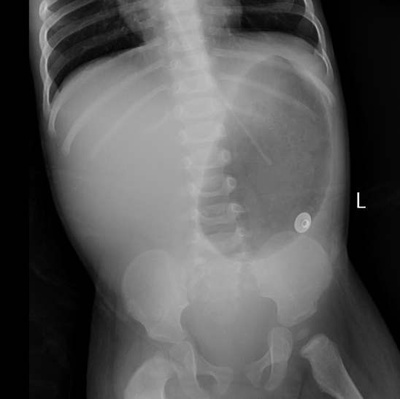
B
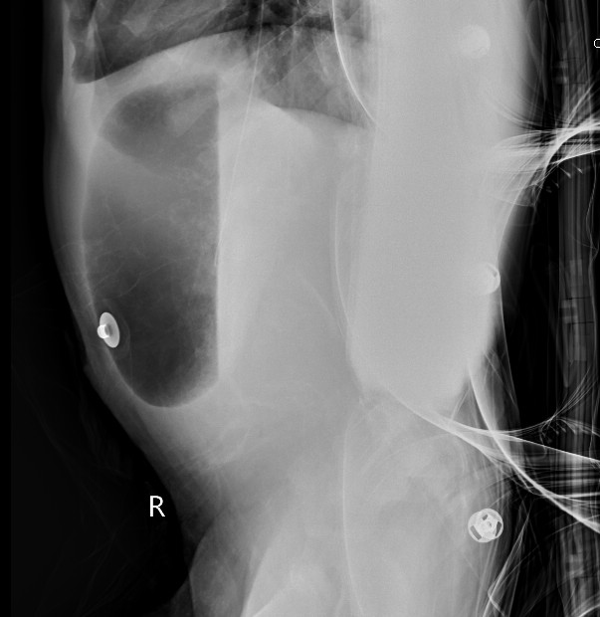
C
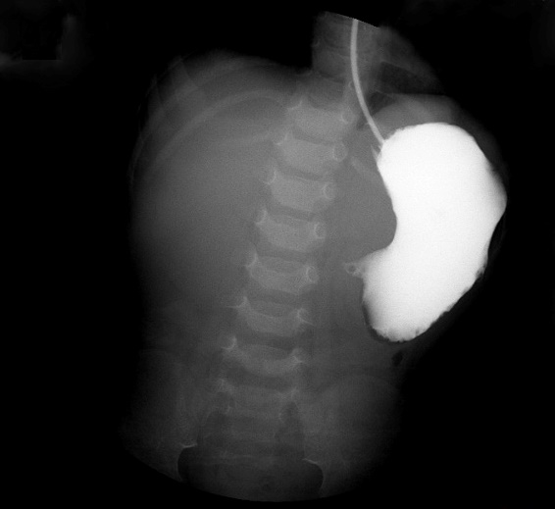
D
Figure 1 Abdominal plain. A and B: Supine (A) and lateral (B) abdominal plain films showed a large stomach, and no free gas was found in the small intestine, colon, or rectum. A nasogastric tube was coiled in the stomach; C: The iopromide administered by gastric tube did not enter the duodenum; D: Re-examination of abdominal film revealed decreased gas in the stomach and a few inflatable intestines.
A
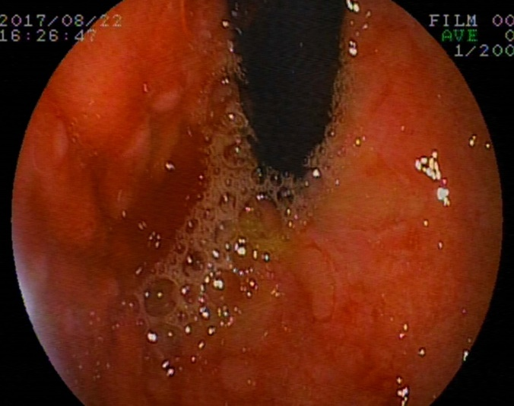
B
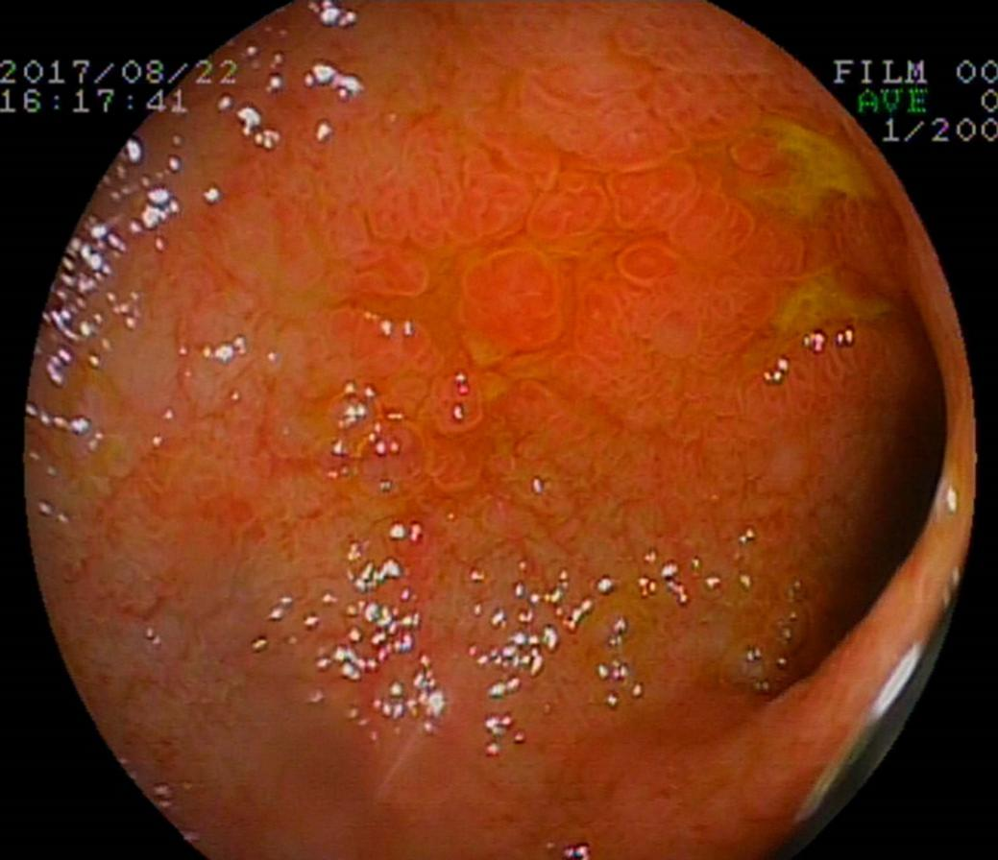
C
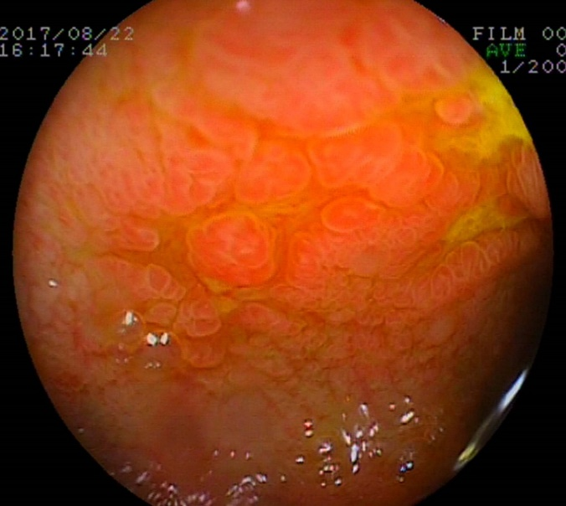
D
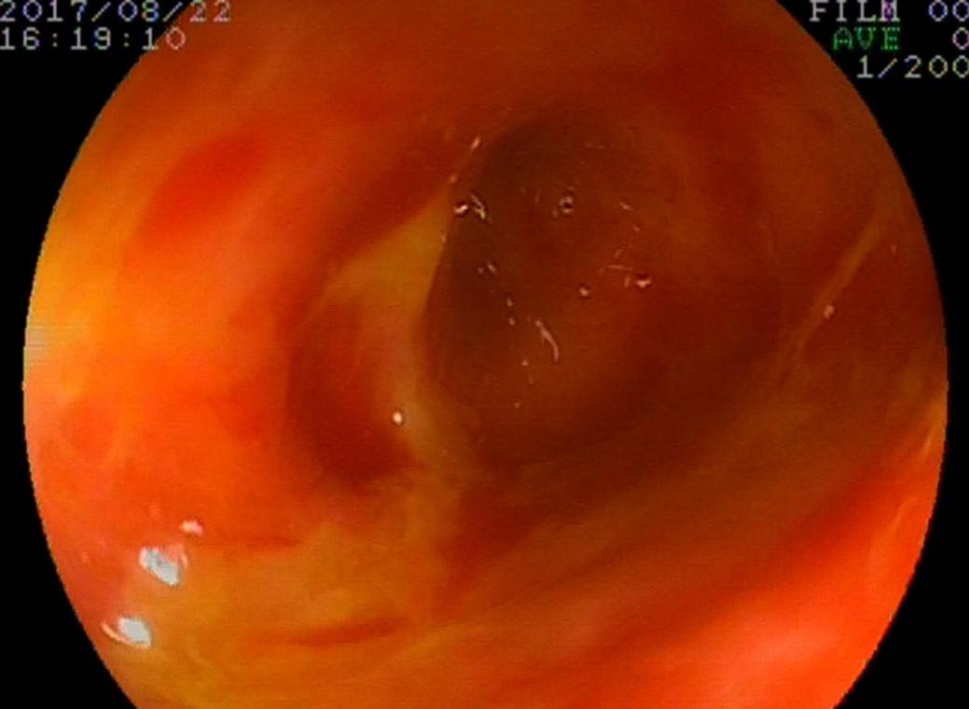
Figure 2 Gastroscopic findings. A gastroscope was inserted into the horizontal part of the duodenum. Hyperemia, edema, lymphoid hyperplasia, focal ulceration, and pseudotumor formation were seen in the stomach and duodenum. A: Gastric fundus; B and C: Duodenal bulb; D: Dilatation of proximal duodenum.
A
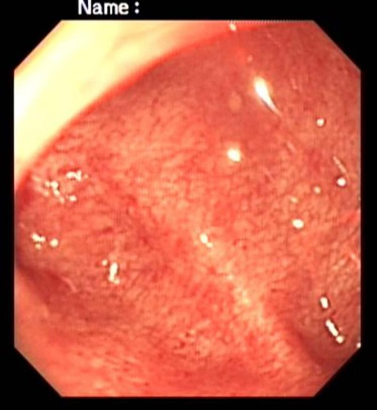
B
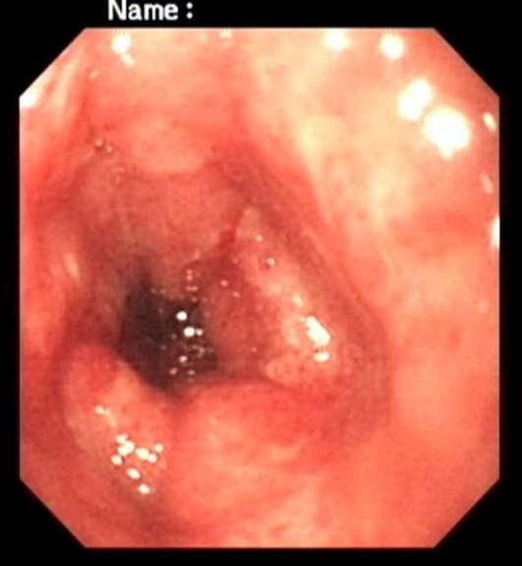
C
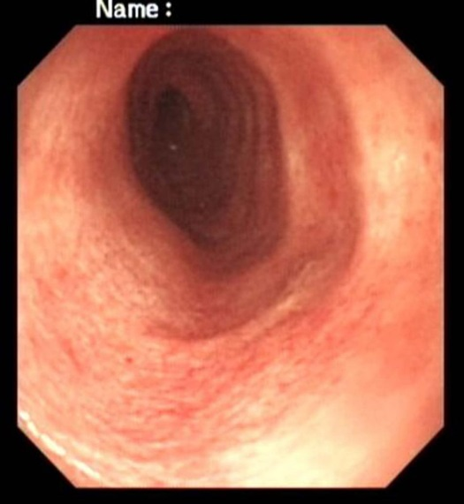
Figure 3 Colonoscopic findings. A colonoscope reached the splenic flexure of the colon. It showed hyperemia, roughness, stiffness, friability, and easy bleeding of the mucosa. A: Rectum; B: Sigmoid colon; C: Descending colon.
A
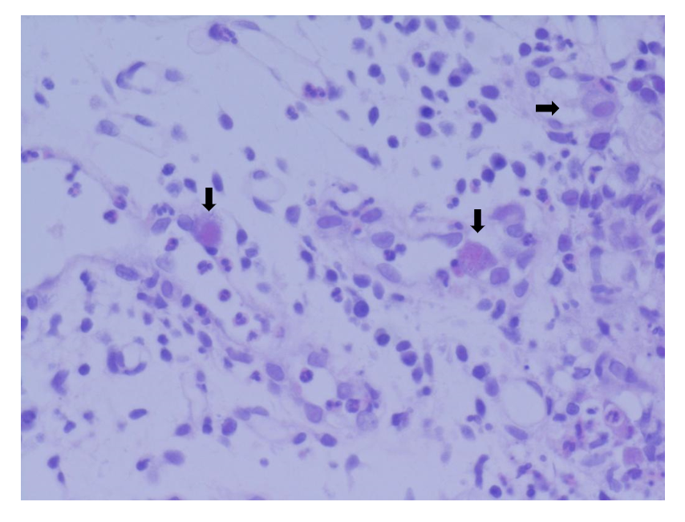
B
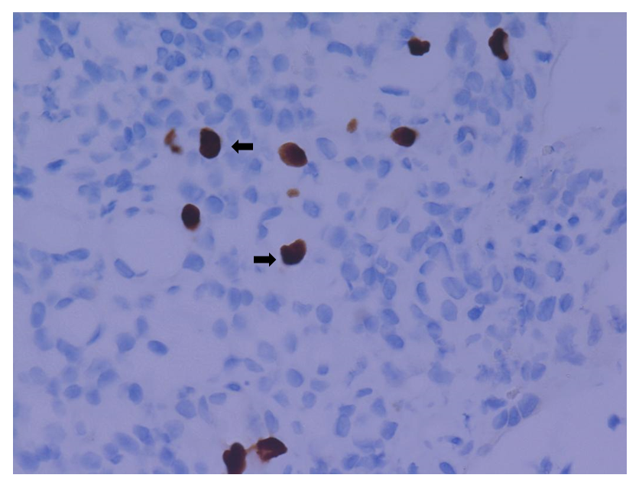
Figure 4 Gastrointestinal histopathologic findings. Histopathologic photomicrographs of gastric, duodenal, descending colony-like, sigmoid colony-like, and rectal specimens. A: Inflammatory cell infiltration and characterized cytomegalic cells (arrows) containing eosinophilic intranuclear inclusions (hematoxylin and eosin: × 400); B: Owl’s eye inclusions (arrows) in cytomegalovirus-infected cells (immunohistochemical staining: × 400).

Table 1 Laboratory results (international system of units)
Parameter | Reference range | 5 d before admission | 1 d before admission | On admission | Day 6 | Day 12 | Day 23 | Day 37
Hemoglobin (g/L) | 110-160 | 120 | 115 | 79 | 91 | 73 | 126 | 69
Erythrocytes (× 10¹²/L) | 3.5-5.5 | 4.70 | 4.56 | 2.93 | 3.21 | 2.50 | 3.93 | 2.34
Leucocytes (× 10⁹/L) | 5-12 | 14.96 | 9.36 | 17.87 | 8.37 | 20.42 | 38.68 | 10.35
Neutrophils (%) | 50-70 | 54.9 | 32.6 | 55.1 | 62.7 | 61.6 | 80.4 | 59.9
Lymphocytes (%) | 20-40 | 36.9 | 56.7 | 27 | 29.3 | 28.3 | 15.4 | 33.4
Atypical lymphocytes (%) | 0-2 |  |  | 9 | 7 | 0 | 0 | 0
Eosinophils (%) | 0.02-0.5 | 1.3 | 1.4 | 0.9 | 0.4 | 0 | 0 | 0
Platelets (× 10⁹/L) | 100-300 | 234 | 226 | 769 | 200 | 276 | 165 | 110
Sedimentation rate (mm/h) | 0-15 |  |  | 78 |  | 1
C-reactive protein (mg/L) | 0-10 | 39.7 |  | 176 | 80 | 114 | 3.7 | 4.7
Procalcitonin (ng/L) | 0-0.5 |  |  | 31.87 | 0.77 |  | 0.31
Sodium (mmol/L) | 135-146 |  |  | 116.3 | 138.4 | 131.2 | 139.4 | 135
Potassium (mmol/L) | 3.5-5.5 |  |  | 6.15 | 4.53 | 3.9 | 4.2 | 3.61
Chloride (mmol/L) | 101-111 |  |  | 91.1 | 102.7 | 97.8 | 116.9 | 110.5
Calcium (mmol/L) | 2.25-2.75 |  |  | 1.79 | 2.46 | 1.87 | 2.04 | 1.66
Magnesium (mmol/L) | 0.7-1.15 |  |  | 0.96 | 0.61 | 0.53 | 0.35 | 0.38
Albumin (g/L) | 35-55 |  |  | 25.8 | 37.3 | 25.9 | 15.5 | 20.6
Globulin (g/L) | 20-30 |  |  | 28.1 | 17.6 | 19.3 | 13.2 | 5.9
Aspartate amino transferase (IU/L) | 0-40 |  |  | 70 | 28 | 48 | 85 | 22
Alanine amino transferase (IU/L) | 0-40 |  |  | 61 | 12 | 41 | 53 | 6
Prothrombin time (s) | 9.3-12.9 |  |  | 17.4 | 19.6 | 12.5 | 11.4 | 16.2
Activated partial thromboplastin time (s) | 26.1-40.7 |  |  | 34.5 | 57.8 | 38 | 39.5 | 55.2
Fecal occult blood test | - |  |  | - | + | + | + | +
Fecal white blood cell | - | ++ | - | - | ++ | ++++ | ++ | -

Table 2 Microbiology results
 | Peripheral blood | Feces
Day 1 | HBsAg (-); HBsAb (+); HBeAg (-); HBeAb (-); HBcAb (-); TP antibody (-); HIV antibody (-); HCV antibody (-); EBNA IgG (+); EBV-CA IgG (+); EBV-CA IgM (±); EBV-EA IgM (-); EBV DNA < 5.00 × 10² copies/mL (LD) | Norovirus (-); Rotavirus (-); Astrovirus (-); Enteral adenovirus (-); Shigella NA (-); Salmonella NA (-); Widal's test (-)
Day 6 | G test (-); EBV DNA < 5.00 × 10² copies/mL (LD) | Norovirus (-); Rotavirus (-); Astrovirus (-); Enteral adenovirus (-)
Day 12 | G test (-); Interferon-γ release assay of tuberculosis (-) | Clostridium difficile GDH (-); Clostridium difficile toxin A/B (-)
Day 16 | CMV-IgM 11.5 U/mL (ref 0-22); CMV-IgG 18.3 U/mL (ref 0-14); CMV DNA quantitation 9.26 × 10³ copies/mL | Clostridium difficile GDH (-); Clostridium difficile toxin A/B (-)
Day 36 | CMV DNA quantitation < 5.00 × 10² copies/mL (LD); CMV-IgG 82.2 U/mL (ref 0-14)
HBsAg: Hepatitis B virus surface antigen; HBsAb: Hepatitis B virus surface antibody; HBcAg: Hepatitis B virus core antigen; HBcAb: Hepatitis B virus core antibody; HBeAg: Hepatitis B virus e antigen; TP: Treponemal; HIV: Human immunodeficiency virus; HCV: Hepatitis C virus; EBV-CA: Epstein-Barr virus capsid antigen; EBNA: Epstein-Barr nuclear antigen; EBV-EA: Epstein-Barr virus early antigen; MV: Measles virus; RV: Rubella virus; GDH: Glutamic acid dehydrogenase; LD: Limit of detection; NA: Nucleic acid.
Table 3 Some noninfectious factors in diarrhea
Gastrointestinal diseases | Digestion and absorption disorder
(1) Inflammatory bowel disease; (2) Gastroenteric tumor; (3) Intussusception; (4) Enteric cyst; (5) Duplication of digestive tract; (6) Diverticulosis; (7) Polyposis coli; and (8) Ischemic enteropathy | (1) Short bowel syndrome; (2) Exocrine pancreatic insufficiency; (3) Bile acid-losing syndrome; and (4) Lactose intolerance
Systemic disease: (1) Anaphylactoid purpura; (2) Hyperthyroidism; and (3) Primary chronic adrenocortical hypofunction | Neoplastic diseases: (1) Gastrin adenoma; (2) Carcinoid syndrome; (3) Vasoactive intestinal peptide tumor; and (4) Pheochromocytoma
Allergic diarrhea: (1) Food protein-induced enterocolitis syndrome; (2) food protein-induced proctocolitis; and (3) eosinophilic gastroenteritis | Primary immunodeficiency diseases: (1) Chronic granulomatous disease; (2) Common variable immunodeficiency; and (3) X linked agammaglobulinemia
 | Secondary immunodeficiency diseases
 | Functional diarrhea
 | Drugs/toxicants factor

Published by Baishideng Publishing Group Inc
7041 Koll Center Parkway, Suite 160, Pleasanton, CA 94566, USA
Telephone: +1-925-3991568
E-mail: bpgoffice@wjgnet.com
Help Desk: https://www.f6publishing.com/helpdesk
https://www.wjgnet.com

© 2021 Baishideng Publishing Group Inc. All rights reserved.

