Name of Journal: World Journal of Clinical Cases
Manuscript NO: 70892
Manuscript Type: CASE REPORT

Cavernous hemangioma of an intrapancreatic accessory spleen mimicking a pancreatic tumor: A case report

Huang JY et al. Hemangioma of IPAS: A diagnosis challenge

Jia-Yan Huang, Rui Yang, Jia-Wu Li, Qiang Lu, Yan Luo

Jia-Yan Huang, Rui Yang, Jia-Wu Li, Qiang Lu, Yan Luo, Department of Medical Ultrasound, West China Hospital of Sichuan University, Chengdu 610041, Sichuan Province, China

Author contributions: Luo Y performed the contrast-enhanced ultrasound examination for the patient and proposed writing it up as a case report; Huang JY collected the clinical information of the patient, reviewed the literature and contributed to manuscript drafting; Yang R provided the pathological data and helped with creating the figures; Li JW contributed to revising the grammar of the manuscript; Luo Y and Lu Q were responsible for the revision of the manuscript for important intellectual content. All of the authors issued final approval for this version of the manuscript to be submitted.

Supported by the National Natural Science Foundation of China, No. 81571697.

Corresponding author: Yan Luo, MD, Full Professor, Department of Medical Ultrasound, West China Hospital of Sichuan University, No. 37 Guo Xue Xiang, Chengdu 610041, Sichuan Province, China. luoyan15957@126.com

Received: August 25, 2021
Revised: November 2, 2021
Accepted: January 11, 2022
Published online:

Abstract
BACKGROUND
Intrapancreatic accessory spleen (IPAS) is an uncommon condition, with the majority of cases presenting as solid lesions. Thus, this condition is frequently misdiagnosed as pancreatic solid neoplasm. Moreover, splenic cavernous hemangioma is a rare disorder, whereas lesions with a cystic appearance arising from IPAS have not been reported.

CASE SUMMARY
Herein, we present a case involving a 32-year-old male who had a complex cystic lesion in the tail of the pancreas revealed by conventional ultrasound. The lesion was misdiagnosed as a pancreatic cystadenoma because of its confusing anatomic location, as well as due to its peripheral nodular and internal septal enhancement patterns on contrast-enhanced ultrasound. After multidisciplinary discussion, the patient finally underwent laparoscopic pancreatic body and tail resections. Postoperative pathology demonstrated the lesion to be a cavernous hemangioma arising from the IPAS.

CONCLUSION
Cavernous hemangioma in the intrapancreatic accessory spleen may mimic pancreatic cystadenoma, which is a condition with the potential to be malignant. Imaging follow-ups or surgical interventions may be helpful for the exclusion of malignant risks in complicated cystic lesions, especially those with parietal and septal enhancements.

Key Words: Intrapancreatic accessary spleen; Pancreas; Diagnosis; Contrast enhanced ultrasound; Case report

Huang JY, Yang R, Li JW, Lu Q, Luo Y. Cavernous hemangioma of an intrapancreatic accessory spleen mimicking a pancreatic tumor: A case report. World J Clin Cases 2021; In press

Core Tip: Intrapancreatic accessory spleen (IPAS) is an uncommon condition; however, overlapping imaging manifestations of IPAS and pancreatic tumors may lead to unnecessary surgery. Cystic splenic cavernous hemangioma is a rare disorder, whereas lesions with a cystic appearance arising from IPAS have not been reported. Herein, we report a cavernous hemangioma in the IPAS that was misdiagnosed as being a pancreatic cystadenoma via contrast-enhanced modalities. The diagnosis of cystic lesions in IPAS can be challenging. Imaging follow-ups or surgical interventions may be needed for the possible malignancy risk of a complicated cystic lesion, especially those with parietal and septal enhancements.

INTRODUCTION
An intrapancreatic accessory spleen (IPAS) is an uncommon condition, with a prevalence ranging from 1.1%-3.4% in individuals^{[1,2]}. An IPAS is typically asymptomatic and has an innocuous nature. However, overlapping imaging manifestations of an IPAS and primary pancreatic tumors may lead to unnecessary surgery^{[3]}. A typical IPAS demonstrates a solid lesion with a round, oval or triangular shape, which is similar to the spleen on both precontrast and contrast-enhanced images. Therefore, this disorder is frequently confused with adenocarcinomas, neuroendocrine tumors or other solid pancreatic entities. When compared with a solid IPAS, cystic lesions arising from an IPAS are rare but necessitate a differential diagnosis with pancreatic cystic neoplasms, especially those possessing the potential to be malignant. Moreover, when considering the high likelihood of false-negative results, biopsy of cystic pancreatic lesions is seldom performed, and surgery is ultimately performed in most patients.
Herein, we report such a case involving a patient who underwent laparoscopic pancreatic body and tail resections because of an indeterminate pancreatic cystic lesion. Postoperative pathology confirmed this lesion as being a cavernous hemangioma arising from an IPAS. Furthermore, the clinical and imaging characteristics of IPAS and pancreatic cystic neoplasms (according to the previous literature) were also reviewed (Table 1).

CASE PRESENTATION
Chief complaints
A 32-year-old male was referred to our hospital because of a suspicious lesion neighboring the hilum of the spleen, which was detected via conventional grayscale ultrasound in a local community hospital. The patient did not complain of obvious discomfort.

History of past illness
The patient had a history of chronic hepatitis B.

Physical examination
The patient did not complain of abdominal pain or any remarkable discomfort during the physical examination.

Laboratory examinations
In addition to a slightly increased albumin-globulin ratio (2.96) and glutamine transpeptidase level (63 IU/L), no abnormal laboratory test results, including those of related tumor markers, were found.

Imaging examinations
The patient underwent contrast-enhanced ultrasound (CEUS) in our department. Before the CEUS, a baseline ultrasound illustrated a complicated cystic nodule measuring 2 cm, with a well-defined border in the tail of the pancreas without salient blood supply on color Doppler ultrasound (Figure 1). For the CEUS, a bolus injection of the US contrast agent SonoVue (Bracco, Milan, Italy) was administered through the antecubital vein, followed by a flush of 5 mL of 0.9% normal saline. The lesion demonstrated peripheral nodular and internal septal isoenhancement in the arterial phase, followed by slight hyperenhancement of the enhanced area in the venous phase. The predominant cystic area of the lesion did not show any enhancement in either phase. According to the aforementioned enhancing pattern in the CEUS, the lesion was suspected to be a pancreatic cystadenoma via CEUS (Figure 1).
Contrast-enhanced computed tomography (CECT) was performed to further examine the lesion. On the unenhanced CT, a nodule with a diameter of 2.2 cm and slightly low density was identified in the tail of the pancreas. Septa were observed, whereas no significant enhancement was presented within the lesion (Figure 2). The nodule was diagnosed as being a pancreatic cystic lesion via the CECT. Moreover, no salient abnormalities were found in the liver, kidney, spleen or biliary system via imaging evaluations.

FINAL DIAGNOSIS
The lesion was misdiagnosed as pancreatic cystadenoma by CEUS and CECT.

TREATMENT
After multidisciplinary discussion and communication with the patient, as well as with his family, laparoscopic pancreatic body and tail resections were performed.

OUTCOME AND FOLLOW-UP
Postoperative pathology demonstrated that the lesion was a splenic cavernous hemangioma in the pancreas (Figure 3). After an uneventful postoperative course, the patient was discharged on postoperative day 5. No obvious abnormality was found in a follow-up abdominal US one month later (Timeline of diagnosis and treatment of the pancreatic lesion is presented in Supplementary Figure 1).

DISCUSSION
Intrapancreatic accessory spleen is a rare congenital condition, compared with an accessory spleen located at the hilum of the spleen^{[2,4]}. Due to its innocuous nature and infrequent induction of symptoms, IPAS seldom requires therapy unless they cause symptoms as a result of the compression, torsion or spontaneous rupture of a hemorrhage^{[5,6]}.
Typical IPAS presents as a solid lesion and demonstrates similar manifestations to the spleen on both precontrast and contrast-enhanced ultrasound^{[7,8]}. However, cystic neoplasm development in IPASs is rare. Sporadic cases of epidermoid cysts in IPASs (known as ECIPASs) have been reported^{[6,9-11]}. The walls of ECIPASs are irregularly thickened and thicker than those of mucinous cystic neoplasms (MCNs) and intraductal papillary mucinous neoplasms (IPMNs)^{[9]}. Moreover, the evident contrast enhancement of the partially thickened wall of ECIPAS (which is similar to that of the spleen) makes it possible to distinguish ECIPASs from MCNs or IPMNs.
The differential diagnosis was even more considerable in our case. The cystic cavernous hemangioma in the IPAS (known as CHIPAS) presented peripheral nodular and internal septal enhancements, which are frequently observed in pancreatic mucinous cystadenomas (MCAs). Furthermore, the majority of MCAs are located in the tail of the pancreas, where IPASs are also frequently discovered^{[12]}. Therefore, this increases the difficulty of an accurate diagnosis. However, the ancillary features of a fibrous pseudocapsule or calcified contents inside of the MCNs have also been reported^{[13]}. Another pancreatic cystic lesion that warrants vigilant discrimination from the CHIPAS is an IPMN. An IPMN in the main duct possesses a high risk of malignancy, with 38%–68% being confirmed as high-grade dysplasia or pancreatic cancer in postoperative specimens^{[14]}. Fortunately, CEUS is sensitive in being demonstrated in the dilated main pancreatic duct and the polycystic lesion connecting to the pancreatic duct or in developing within the duct in cases of IPMNs^{[15]}.
To our knowledge, there is only one case report of solid cavernous hemangioma detected in both the spleen and the IPAS^{[16]}. In this case, the CHIPAS was accurately identified by the investigators because of a similar enhancement pattern of the pancreatic lesion and the splenic lesions on CECT and contrast-enhanced magnetic resonance imaging. An accurate diagnosis was more difficult, as in our patient, because there was no lesion in the spleen for comparison. Moreover, a splenic hemangioma typically shows a hyperechoic and solid appearance. The atypical cystic appearance in our patient increased the difficulty of making an accurate diagnosis.
Herein, we presented on an extremely rare case of a cystic cavernous hemangioma arising from an IPAS. Contrast-enhanced ultrasound is sensitive in demonstrating the enhancements of the septa and the parietal nodule. However, an accurate diagnosis of cystic cavernous hemangioma arising from an IPAS via imaging tools is challenging. Imaging follow-ups or surgical interventions may be needed, due to the possible malignancy risk of a complicated cystic lesion with parietal and septal enhancements.

CONCLUSION
Cavernous hemangioma in the intrapancreatic accessory spleen may mimic pancreatic cystadenoma, which is a condition with the potential for malignancy. Imaging follow-ups or surgical interventions may be helpful for the exclusion of malignant risks in complicated cystic lesions, especially those with parietal and septal enhancements.

ACKNOWLEDGEMENTS
The authors would like to express their gratitude to the patient and his family.

REFERENCES
1 Li BQ, Xu XQ, Guo JC. Intrapancreatic accessory spleen: a diagnostic dilemma. HPB (Oxford) 2018; 20: 1004-1011 [PMID: 29843985 DOI: 10.1016/j.hpb.2018.04.004]
2 Halpert B, Gyorkey F. Lesions observed in accessory spleens of 311 patients. Am J Clin Pathol 1959; 32: 165-168 [PMID: 13670140 DOI: 10.1093/ajcp/32.2.165]
3 Sica GT, Reed MF. Case 27: intrapancreatic accessory spleen. Radiology 2000; 217: 134-137 [PMID: 11012435 DOI: 10.1148/radiology.217.1.r00oc30134]
4 Jang KM, Kim SH, Lee SJ, Park MJ, Lee MH, Choi D. Differentiation of an intrapancreatic accessory spleen from a small (<3-cm) solid pancreatic tumor: value of diffusion-weighted MR imaging. Radiology 2013; 266: 159-167 [PMID: 23093681 DOI: 10.1148/radiol.12112765]
5 Obuchi T, Takagane A, Sato K, Yonezawa H, Funato O, Kobayashi M. Single-incision laparoscopic excision of symptomatic accessory spleen in the pelvis: An initial report. J Minim Access Surg 2017; 13: 321-322 [PMID: 28872102 DOI: 10.4103/0972-9941.199212]
6 Davidson ED, Campbell WG, Hersh T. Epidermoid splenic cyst occurring in an intrapancreatic accessory spleen. Dig Dis Sci 1980; 25: 964-967 [PMID: 7449592 DOI: 10.1007/BF01308048]
7 Kim SH, Lee JM, Han JK, Lee JY, Kim KW, Cho KC, Choi BI. Intrapancreatic accessory spleen: findings on MR Imaging, CT, US and scintigraphy, and the pathologic analysis. Korean J Radiol 2008; 9: 162-174 [PMID: 18385564 DOI: 10.3348/kjr.2008.9.2.162]
8 Kim SH, Lee JM, Lee JY, Han JK, Choi BI. Contrast-enhanced sonography of intrapancreatic accessory spleen in six patients. AJR Am J Roentgenol 2007; 188: 422-428 [PMID: 17242251 DOI: 10.2214/AJR.05.1252]
9 Hwang HS, Lee SS, Kim SC, Seo DW, Kim J. Intrapancreatic accessory spleen: clinicopathologic analysis of 12 cases. Pancreas 2011; 40: 956-965 [PMID: 21562442 DOI: 10.1097/MPA.0b013e318216815b]
10 Yamanishi H, Kumagi T, Yokota T, Koizumi M, Azemoto N, Watanabe J, Mizuno Y, Sugita A, Abe M, Ikeda Y, Matsuura B, Hiasa Y, Onji M. Epithelial cyst arising in an intrapancreatic accessory spleen: a diagnostic dilemma. Intern Med 2011; 50: 1947-1952 [PMID: 21921374 DOI: 10.2169/internalmedicine.50.5340]
11 Kato T, Matsuo Y, Ueda G, Aoyama Y, Omi K, Hayashi Y, Imafuji H, Saito K, Tsuboi K, Morimoto M, Ogawa R, Takahashi H, Kato H, Yoshida M, Naitoh I, Hayashi K, Takahashi S, Takiguchi S. Epithelial cyst arising in an intrapancreatic accessory spleen: a case report of robotic surgery and review of minimally invasive treatment. BMC Surg 2020; 20: 263 [PMID: 33129283 DOI: 10.1186/s12893-020-00927-0]
12 Crippa S, Salvia R, Warshaw AL, Domínguez I, Bassi C, Falconi M, Thayer SP, Zamboni G, Lauwers GY, Mino-Kenudson M, Capelli P, Pederzoli P, Castillo CF. Mucinous cystic neoplasm of the pancreas is not an aggressive entity: lessons from 163 resected patients. Ann Surg 2008; 247: 571-579 [PMID: 18362619 DOI: 10.1097/SLA.0b013e31811f4449]
13 De Robertis R, D'Onofrio M, Crosara S, Dal Corso F, Barbi E, Canestrini S, Mucelli RP. Contrast-enhanced ultrasound of pancreatic tumours. Australas J Ultrasound Med 2014; 17: 96-109 [PMID: 28191218 DOI: 10.1002/j.2205-0140.2014.tb00032.x]
14 Stark A, Donahue TR, Reber HA, Hines OJ. Pancreatic Cyst Disease: A Review. JAMA 2016; 315: 1882-1893 [PMID: 27139061 DOI: 10.1001/jama.2016.4690]
15 Wang Y, Wang Y, Fan Z, Shan J, Yan K. The Value of Contrast-Enhanced Ultrasound Classification in Diagnosis of Pancreatic Cystic Lesions. Biomed Res Int 2019; 2019: 5698140 [PMID: 31737668 DOI: 10.1155/2019/5698140]
16 Makino I, Tajima H, Kitagawa H, Nakagawara H, Ohta T. A rare case of hemangiomatosis of the spleen and intrapancreatic accessory spleen. Abdom Imaging 2014; 39: 1169-1174 [PMID: 24811762 DOI: 10.1007/s00261-014-0149-2]
17 Choi JY, Kim MJ, Lee JY, Lim JS, Chung JJ, Kim KW, Yoo HS. Typical and atypical manifestations of serous cystadenoma of the pancreas: imaging findings with pathologic correlation. AJR Am J Roentgenol 2009; 193: 136-142 [PMID: 19542405 DOI: 10.2214/AJR.08.1309]
18 Garcea G, Ong SL, Rajesh A, Neal CP, Pollard CA, Berry DP, Dennison AR. Cystic lesions of the pancreas. A diagnostic and management dilemma. Pancreatology 2008; 8: 236-251 [PMID: 18497542 DOI: 10.1159/000134279]
19 Vasile TA, Socaciu M, Stan Iuga R, Seicean A, Iancu C, al Hajjar N, Zaharie T, Badea R. Added value of intravenous contrast-enhanced ultrasound for characterization of cystic pancreatic masses: a prospective study on 37 patients. Med Ultrason 2012; 14: 108-114 [PMID: 22675710]
20 Misra AP, Misra R, Kumar A. Giant cavernous haemangioma of the wandering spleen. Indian J Surg 2013; 75: 54-55 [PMID: 24426387 DOI: 10.1007/s12262-012-0546-0]
21 Yamashita Y, Ueda K, Itonaga M, Yoshida T, Maeda H, Maekita T, Iguchi M, Tamai H, Ichinose M, Kato J. Usefulness of contrast-enhanced endoscopic sonography for discriminating mural nodules from mucous clots in intraductal papillary mucinous neoplasms: a single-center prospective study. J Ultrasound Med 2013; 32: 61-68 [PMID: 23269711 DOI: 10.7863/jum.2013.32.1.61]
22 Lee JE, Choi SY, Min JH, Yi BH, Lee MH, Kim SS, Hwang JA, Kim JH. Determining Malignant Potential of Intraductal Papillary Mucinous Neoplasm of the Pancreas: CT versus MRI by Using Revised 2017 International Consensus Guidelines. Radiology 2019; 293: 134-143 [PMID: 31478800 DOI: 10.1148/radiol.2019190144]
23 Tang JY, Chen J, Pan C, Yin MZ, Zhu M. Diffuse cavernous hemangioma of the spleen with Kasabach-Merritt syndrome misdiagnosed as idiopathic thrombocytopenia in a child. World J Pediatr 2008; 4: 227-230 [PMID: 18822934 DOI: 10.1007/s12519-008-0042-6]
24 Kang BK, Kim JH, Byun JH, Lee SS, Kim HJ, Kim SY, Lee MG. Diffusion-weighted MRI: usefulness for differentiating intrapancreatic accessory spleen and small hypervascular neuroendocrine tumor of the pancreas. Acta Radiol 2014; 55: 1157-1165 [PMID: 24259300 DOI: 10.1177/0284185113513760]

Footnotes
Informed consent statement: Informed consent was obtained from the patient for the publication of any potentially identifiable images or data included in this article.

Conflict-of-interest statement: The authors declare that they have no conflicts of interest.

CARE Checklist (2016) statement: The authors have read the CARE Checklist (2016), and the manuscript was prepared and revised according to the CARE Checklist (2016).

Open-Access: This article is an open-access article that was selected by an in-house editor and fully peer-reviewed by external reviewers. It is distributed in accordance with the Creative Commons Attribution NonCommercial (CC BY-NC 4.0) license, which permits others to distribute, remix, adapt, build upon this work non-commercially, and license their derivative works on different terms, provided the original work is properly cited and the use is non-commercial. See: http://creativecommons.org/Licenses/by-nc/4.0/

Provenance and peer review: Unsolicited article; Externally peer reviewed
Peer-review model: Single blind

Peer-review started: August 25, 2021
First decision: October 27, 2021
Article in press:

Specialty type: Gastroenterology and hepatology
Country/Territory of origin: China
Peer-review report’s scientific quality classification
Grade A (Excellent): 0
Grade B (Very good): B, B
Grade C (Good): 0
Grade D (Fair): 0
Grade E (Poor): 0

P-Reviewer: Khuroo S, Zharikov YO S-Editor: Zhang H L-Editor: A P-Editor: Zhang H

Figure Legends
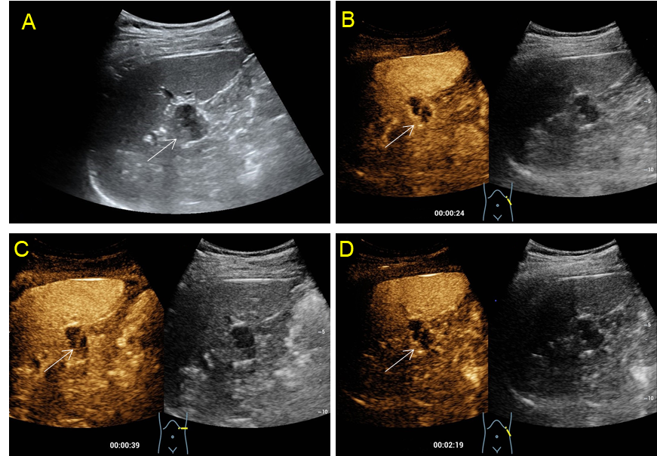
Figure 1 Pre-contrast and contrast enhanced ultrasound of the pancreatic lesion. A: A complicated cystic lesion (arrow) measuring 2 cm was detected in the tail of the pancreas by grayscale ultrasound in a 32-year-old male patient; B: Peripheral nodular and internal septal isoenhancement (arrow) in the arterial phase was shown on contrast-enhanced ultrasound; C and D: The enhanced part of the lesion exhibited mild hyperenhancement in the early venous phase without definite washout in the late venous phase. The cystic component did not show any enhancement through either phase.
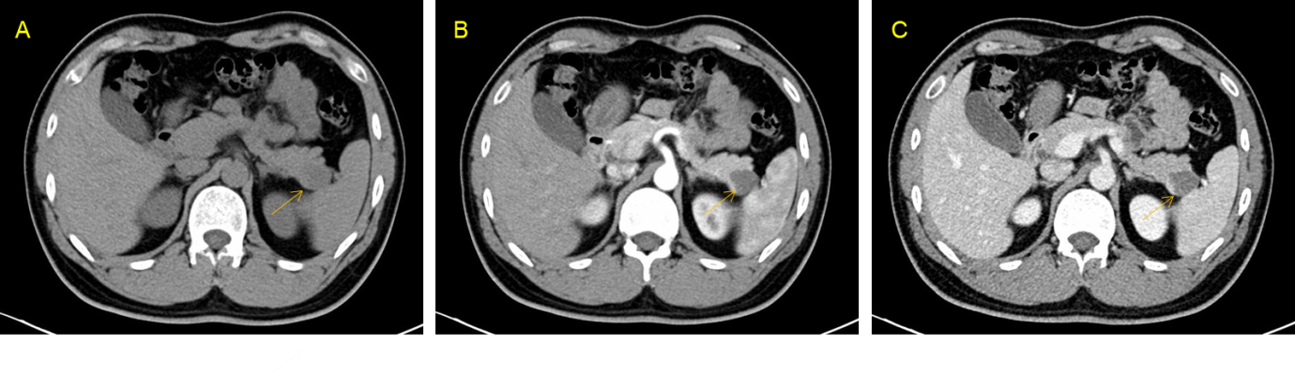
Figure 2 Pre-operative computed tomography scan of the pancreatic lesion. A: A slightly low-density nodule measuring 2.2 cm (arrow) was found in the tail of the pancreas on unenhanced computed tomography (CT); B and C: Septa were faintly visible whereas no salient enhancement was presented within the lesion (arrows) in either the arterial or the venous phases on axial contrast-enhanced CT.
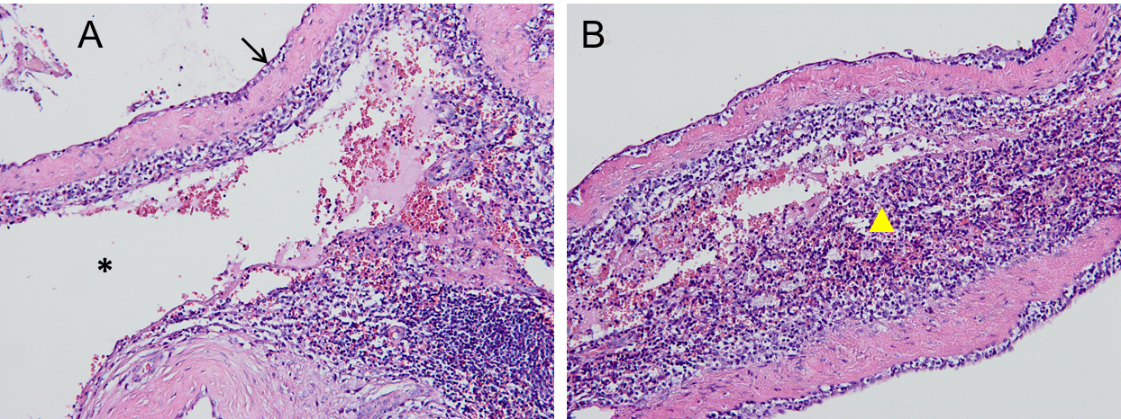
Figure 3 Hematoxylin-eosin staining of the cavernous hemangioma arising from the intrapancreatic accessory spleen. A: Large dilated vascular spaces (asterisk) separated by fibrous septa and endothelial cells (arrows) lining on the surface of the vascular spaces were observed in the intermediate-power view (original magnification, 200×); B: A high-powered photomicrograph (original magnification, 400×) illustrated splenic tissues (triangles) adjacent to the vascular spaces.

Table 1 Clinical and radiological characteristics of intrapancreatic accessory spleen and pancreatic cystic neoplasms
 |  | Pancreatic cystic neoplasms
 | IPAS | Pseudocyst | SCA | MCA | SPN | IPMN
Clinical features^{[1,17,18]}
Age (mean: year) | 40 to 65 | At any age | 60 | 40 to 50 | 30 | 65
Gender | Slightly higher in males | Males > females | Older females | Females > males | Young females | Males > females
Incidence | 11%–17% of AS | 5%-40% after pancreatitis | 16% of PCN | 29% of PCN | 2% and 3% of PCN | 20%-50% of PCN
Benign/malignant | Benign | Benign | Benign | Low malignant potential | Low malignant potential | Malignant potential
Anatomic location | Tail > head/body | 1/3 near the head | Head > body/tail | Body/tail > head | Body/tail > head | Arising from the pancreatic ducts
Size (mean: cm) | ≤ 2 | Depending on the duration of disease | 5-8 | 7-10 | 6 | 0.8
Potential mimickers | NET and PDAC | MCA | MCA and IPMN | MCA: IPMN and MCAC | MCA: IPMN and MCAC | SCA: MCA and MCAC
Radiological diagnosis
Ultrasound^{[7,17,19-21]}
Baseline US | Hypoechoic lesion with well-defined border | Transonic: net separation: irregular internal outline: fluid-containing lesion | Small transonic lesions with thin septa inside | Unilocular or septated cystic lesions with thickened walls and well-defined margins | Encapsulated mixed mass (solid and cystic) | Lesions developed inside the main/branch pancreatic ducts: parietal nodules and septa can be seen in the cysts
Doppler US | Blood supply may from the splenic vessels | No obvious blood flow encompass or inside the lesion | No obvious blood flow encompass or inside the lesion | No obvious blood flow encompass or inside the lesion | Blood flow signal around the tumor | No obvious blood flow encompass or inside the lesion
CEUS^{[19,21]} | Inhomogeneous hyperenhancement followed by homogeneous hyperenhancement | Iso- or hyperenhancement of the cystic wall: without definite washout | Isoenhancement of the cystic walls and septa: without definite washout | Iso-enhancement of the cystic walls and nodules: without definite washout | Rim hyperenhancement in the capsule:centripetal hyperenhancement followed by mild washout in the solid part: no enhancement in the cystic components | Iso-enhancement in the cystic wall and nodules
CECT^{[18,21-23]} | Inhomogeneous hyperenhancement followed by homogeneous hyperenhancement | Round or oval fluid collection with a thin: hardly perceptible wall or enhancing thick wall | Well-defined: polycystic or honeycomb lesions showing enhancing internal septa and cyst walls | Well-circumscribed round/oval macrocystic lesions with enhancement of the walls | Hypo-attenuating on pancreatic phase followed by homogeneous gradual enhancement to iso-attenuating on the hepatic venous phase | Dilated main/side pancreatic ducts: nodules arising from the ducts manifest hyperattenuating at contrast-enhanced CT
CEMRI^{[22,24]}
T1-W | Inhomogeneous hypointensity | Blood products and necrotic components commonly present intrinsically increased t1 signal intensity: the thickend wall shows a rim hyperintensity | High intensity fluid in the cysts | Homogeneous low t1 signal intensity | Low signal intensity: SPN with hemorrhage presents t1 hyperintensity | Loss of t1 signal and delayed uptake of contrast material
T2-W | Homogeneous hyperintensity | The hyperintensity in tissues surrounding the pseudocyst represents the inflammation on t2 fat-suppressed images | Honeycomb pattern (microcysts) or macrocysts manifest signal intensity of simple fluid | Homogeneous high t2 signal intensity | Predominantly solid show mildly increased t2 signal intensity: cystic-dominated present t2 signal intensity closer to that of fluid | Papillary excrescences or nodules in the walls of the dilated ducts present hypointense on t2-weighted images
Management | Usually require no treatment | Serial imaging follow-up | Follow-up or resection depending on the size of the tumor | Surgical resection | Surgical resection | Recommended to be surgically resected
AS: Accessory spleen; IPAS: Intrapancreatic accessory spleen; PCN: Pancreatic cystic neoplasm; SCA: Serous cystadenoma; MCA: Mucinous cystadenoma; SPN: Solid pseudopapillary neoplasm; IPMN: Intraductal papillary mucinous neoplasm; MCAC: Mucinous cystadenocarcinoma; US: Ultrasound; CEUS: Contrast enhanced ultrasound; CECT: Contrast enhanced computerized tomography; CEMRI: Contrast enhanced magnetic resonance imaging; T1-W: T1-weighted; T2-W: T2-weighted.

