Name of Journal: World Journal of Clinical Cases
Manuscript NO: 59450
Manuscript Type: CASE REPORT

Endoscopic salvage treatment of histoacryl after stent application on the anastomotic leak after gastrectomy: A case report

Kim HS et al. Endoscopic treatment of add-on histoacryl sealin

Hee-Sung Kim, Yook Kim, Joung-Ho Han

Hee-Sung Kim, Joung-Ho Han, Department of Internal Medicine, Chungbuk National University Hospital, Chungbuk National University College of Medicine, Cheongju-si 28644, South Korea

Yook Kim, Department of Radiology, Chungbuk National University Hospital, Cheongju-si 28644, South Korea

Author contributions: Kim HS and Kim Y contributed equally to this work; Kim HS and Kim Y collected the patient’s clinical data and wrote the paper; Han JH designed the report; all authors read and approved the final version of the manuscript.

Supported by 2020 Research Fund of the Chungbuk National University.

Corresponding author: Joung-Ho Han, MD, PhD, Professor, Department of Internal Medicine, Chungbuk National University Hospital, Chungbuk National University College of Medicine, Chungdae-ro 1, Seowon-gu, Cheongju-si 28644, South Korea. joungho@cbnu.ac.kr

Received: September 21, 2020
Revised: October 9, 2020
Accepted: November 21, 2020
Published online:

Abstract
BACKGROUND
Endoscopic approach could effectively manage postoperative anastomotic leakage. Various endoscopic methods have been developed for the treatment of anastomotic leakage.

CASE SUMMARY
A 53-year-old woman developed anastomotic leak after laparoscopic proximal gastrectomy. Endoscopic clip closure failed due to strong wall tension; therefore, a fully covered self-expandable esophageal metal stent (fc-SEMS) was placed to cover the leak after it was filled with a mixture of fibrin glue and histoacryl. However, fluoroscopy with gastrograffin showed dye leaking out of the fc-SEMS. Using the previous fluoroscopic image for guidance, a catheter was inserted at the leakage site. The radiocontrast dye was injected and was seen spreading along the sinus tract. Thereafter, histoacryl was injected. Seven days after the last procedure, upper gastrointestinal contrast studies showed no leaks. The patient was subsequently discharged 9 d after histoacryl injection without any complications.

CONCLUSION
To seal an anastomosis leak after stent application, salvage technique using histoacryl injection at the leakage site with fluoroscopy guidance could be considered cautiously.

Key Words: Anastomotic leak; Stent; Histoacryl; Endoscopy; Gastrectomy; Gastric cancer; Case report

Kim HS, Kim Y, Han JH. Endoscopic salvage treatment of histoacryl after stent application on the anastomotic leak after gastrectomy: A case report. World J Clin Cases 2020; In press

Core Tip: Endoscopic treatment including stent deployment, clipping or fibrin glue is considered as a safe and effective treatment options for anastomotic leakage after gastrectomy. We successfully treated esophago-gastric anastomotic leakage with endoscopic salvage treatment of add-on histoacryl after fully covered self-expandable esophageal metal stent (fc-SEMS). Histoacryl injection after fc-SEMS application on the anastomotic leak should be considered as treatment option.

INTRODUCTION
Laparoscopic approach for treating gastric cancer has fewer complications than open approach^{[1]}. Aside from Intra-abdominal bleeding, anastomotic leakage was the most common complication^{[2]}. Treatment options include surgery, conservative approaches, or endoscopic interventions^{[3]}. Being as high mortality following revisional surgery for anastomotic leakage, conservative endoscopic method developed to decrease complication. Endoscopic clip, fibrin glue, endoscopic placement of stents has a crucial role in the management of anastomotic leakage. Depending on the size and location of defect, a variety of endoscopic procedures can be selected^{[4]}. There have been several reports of endoscopic treatment for anastomotic leak. However there have been no reports of combining endoscopic management with injection of histoacryl after stent application on anastomotic leak. Herein, we present a case of anastomotic leak treated with combining endoscopic management with stent and histoacryl.

CASE PRESENTATION
Chief complaints
A 53-year-old women consulted gastroenterology for anastomotic leak after proximal gastrectomy for gastric cancer.

History of present illness
A 53-year-old woman underwent a laparoscopic proximal gastrectomy for early gastric cancer. Daily drainage via Jackson-Pratt (JP) drain was not decreased until the fourth postoperative day. Fluoroscopy with gastrograffin revealed leakage from the anastomotic site.

History of past illness
Apart from present illness, she has had no previous significant medical history.

Personal and family history
Her family history had any relevance to this present illness.

Physical examination
On the fourth postoperative day, the patient developed abdominal pain. Physical examination revealed a temperature of 37.3 ℃, a blood pressure of 110/60 mmHg, a pulse of 118/min, a respiratory rate of 22/min, and a diffusely tender abdomen without rebound or guarding.

Laboratory examinations
A complete blood count showed that the white blood cell count of 11.6 × 10⁶, hemoglobin 11.2 g/dL, and a platelet count of 164 × 10⁹/L. Other blood biochemical tests were normal.

Imaging examinations
On the fourth postoperative days, upper gastrointestinal (UGI) contrast studies revealed a leakage from anastomotic site, and endoscopy showed a lesion (Figure 1A). A fully covered self-expandable esophageal metal stent (fc-SEMS) (12 cm length, outer diameter 2.2 cm, Hanaro, Seoul, Korea) was placed to cover the leak. Subsequently, drainage was diminished to 15-20 mL/d. However, fluoroscopy with gastrograffin showed dye leaking out of the fc-SEMS. (Figure 1B)

FINAL DIAGNOSIS
Unsuccessful sealing anastomotic leak with fc-SEMS after laparoscopic proximal gastrectomy.

TREATMENT
Using the previous fluoroscopic image (Figure 1B) for guidance, a catheter (MTW Endoskpie, Dusseldorf, Germany) was inserted at the leakage site after puncturing the stent membrane. The radiocontrast dye was injected and was seen spreading along the sinus tract. Thereafter, 8 mm of histoacryl was injected into the sinus tract as the catheter was withdrawn (Figure 1C).

OUTCOME AND FOLLOW-UP
Seven days after the last endoscopic procedure, UGI contrast studies showed no leaks (Figure 2A). One month later, endoscopy was performed to remove the stent and remnant histoacryl (Figure 2B arrow) was observed covering the site without leakage (Figure 2B).

DISCUSSION
Anastomotic leakage following gastrectomy for gastric cancer is a life-threatening complication, and revisional surgery has a high mortality rate. The treatment includes conservative management, endoscopic treatment, and surgery^{[5]}. Surgery is generally recommended for patients in critical condition. Otherwise, conservative management with endoscopic management is sufficient for minimal anastomotic leakage. Endoscopic management including stent deployment, clipping or tissue sealant had been considered safe and effective for anastomotic leak^{[6-9]}. Stent implantation achieved 70% complete healing in 115 patients with anastomotic leakage^{[10]}. However stent migration often occur and stent-related pain, stricture were reported following repeated stent placement^{[11,12]}. Endoscopic repair using clips proven to be effective for only small defect^{[13,14]}. The use of tissue sealants may be effective in small leaks with long tracts. Histoacryl occludes leak instantly after contact with liquid and it also promote inflammatory reaction which improve vascularity and healing^{[15]}. High-output gastrointestinal fistula are less likely to close with the tissue sealant alone^{[16]}. In case series, the reported outcomes showed that combination therapy by using clips and stents along with glue are more successful^{[17]}. To achieve best result, the quality of the tissue surrounding the defects, interrupting flow across defect, confirmation of continued integrity need to be considered^{[16]}.
Depending on the size and location of the defect, a variety of endoscopic procedures can be selected^{[4]}. In failure to seal an anastomosis leak with a stent after gastrectomy, salvage technique using histoacryl injection at the leakage site, with fluoroscopy guidance could be considered cautiously.

CONCLUSION
Postgastrectomy esophago-gastric leak is a serious complication. The endoscopic placement of fc-SEMS has become preferred treatment for esophageal anastomotic leakage. However, in failure to control leakage with fc-SEMS, salvage treatment with add-on histoacryl injection should be considered as a treatment option.

REFERENCES
1 Lee JH, Park DJ, Kim HH, Lee HJ, Yang HK. Comparison of complications after laparoscopy-assisted distal gastrectomy and open distal gastrectomy for gastric cancer using the Clavien-Dindo classification. Surg Endosc 2012; 26: 1287-1295 [PMID: 22044981 DOI: 10.1007/s00464-011-2027-0]
2 Kim MC, Kim W, Kim HH, Ryu SW, Ryu SY, Song KY, Lee HJ, Cho GS, Han SU, Hyung WJ; Korean Laparoscopic Gastrointestinal Surgery Study (KLASS) Group. Risk factors associated with complication following laparoscopy-assisted gastrectomy for gastric cancer: a large-scale korean multicenter study. Ann Surg Oncol 2008; 15: 2692-2700 [PMID: 18663532 DOI: 10.1245/s10434-008-0075-z]
3 Truong S, Böhm G, Klinge U, Stumpf M, Schumpelick V. Results after endoscopic treatment of postoperative upper gastrointestinal fistulas and leaks using combined Vicryl plug and fibrin glue. Surg Endosc 2004; 18: 1105-1108 [PMID: 15156390 DOI: 10.1007/s00464-003-8286-7]
4 Kim YJ, Shin SK, Lee HJ, Chung HS, Lee YC, Park JC, Hyung WJ, Noh SH, Kim CB, Lee SK. Endoscopic management of anastomotic leakage after gastrectomy for gastric cancer: how efficacious is it? Scand J Gastroenterol 2013; 48: 111-118 [PMID: 23116156 DOI: 10.3109/00365521.2012.737362]
5 Yu B, Ding Y, Liao X, Wang C, Wang B, Chen X. Radiofrequency ablation versus surgical resection in elderly patients with early-stage hepatocellular carcinoma in the era of organ shortage. Saudi J Gastroenterol 2018; 24: 317-325 [PMID: 30117492 DOI: 10.4103/sjg.SJG_261_18]
6 Nguyen NT, Nguyen CT, Stevens CM, Steward E, Paya M. The efficacy of fibrin sealant in prevention of anastomotic leak after laparoscopic gastric bypass. J Surg Res 2004; 122: 218-224 [PMID: 15555621 DOI: 10.1016/j.jss.2004.05.005]
7 Merrifield BF, Lautz D, Thompson CC. Endoscopic repair of gastric leaks after Roux-en-Y gastric bypass: a less invasive approach. Gastrointest Endosc 2006; 63: 710-714 [PMID: 16564884 DOI: 10.1016/j.gie.2005.11.018]
8 Evans JA, Branch MS, Pryor AD, Demaria EJ. Endoscopic closure of a gastrojejunal anastomotic leak (with video). Gastrointest Endosc 2007; 66: 1225-1226 [PMID: 18061723 DOI: 10.1016/j.gie.2007.06.037]
9 Groce JR, Raju GS, Hewlett A, Zwischenberger JB. Endoscopic clip closure of a gastric staple-line dehiscence (with video). Gastrointest Endosc 2007; 65: 321-322 [PMID: 17258993 DOI: 10.1016/j.gie.2006.06.028]
10 Feith M, Gillen S, Schuster T, Theisen J, Friess H, Gertler R. Healing occurs in most patients that receive endoscopic stents for anastomotic leakage; dislocation remains a problem. Clin Gastroenterol Hepatol 2011; 9: 202-210 [PMID: 21172455 DOI: 10.1016/j.cgh.2010.12.010]
11 Fernández A, Vila JJ, Vázquez S, González-Portela C, de la Iglesia M, Lozano M, Toscano E. Self-expanding plastic stents for the treatment of post-operative esophago-jejuno anastomosis leak. A case series study. Rev Esp Enferm Dig 2010; 102: 704-710 [PMID: 21198312 DOI: 10.4321/s1130-01082010001200005]
12 Aurello P, Magistri P, D'Angelo F, Valabrega S, Sirimarco D, Tierno SM, Nava AK, Ramacciato G. Treatment of esophagojejunal anastomosis leakage: a systematic review from the last two decades. Am Surg 2015; 81: 450-453 [PMID: 25975326]
13 Gelbmann CM, Ratiu NL, Rath HC, Rogler G, Lock G, Schölmerich J, Kullmann F. Use of self-expandable plastic stents for the treatment of esophageal perforations and symptomatic anastomotic leaks. Endoscopy 2004; 36: 695-699 [PMID: 15280974 DOI: 10.1055/s-2004-825656]
14 Hünerbein M, Stroszczynski C, Moesta KT, Schlag PM. Treatment of thoracic anastomotic leaks after esophagectomy with self-expanding plastic stents. Ann Surg 2004; 240: 801-807 [PMID: 15492561 DOI: 10.1097/01.sla.0000143122.76666.ae]
15 Pramateftakis MG, Vrakas G, Kanellos I, Mantzoros I, Angelopoulos S, Eleftheriades E, Lazarides C. Endoscopic application of n-butyl-2-cyanoacrylate on esophagojejunal anastomotic leak: a case report. J Med Case Rep 2011; 5: 96 [PMID: 21392389 DOI: 10.1186/1752-1947-5-96]
16 Rábago LR, Ventosa N, Castro JL, Marco J, Herrera N, Gea F. Endoscopic treatment of postoperative fistulas resistant to conservative management using biological fibrin glue. Endoscopy 2002; 34: 632-638 [PMID: 12173084 DOI: 10.1055/s-2002-33237]
17 Victorzon M, Victorzon S, Peromaa-Haavisto P. Fibrin glue and stents in the treatment of gastrojejunal leaks after laparoscopic gastric bypass: a case series and review of the literature. Obes Surg 2013; 23: 1692-1697 [PMID: 23912265 DOI: 10.1007/s11695-013-1048-2]

Footnotes
Informed consent statement: Informed written consent was obtained from the patient for publication of this report and any accompanying images.

Conflict-of-interest statement: The authors have no conflicts of interest to declare.

CARE Checklist (2016) statement: The authors have read the CARE Checklist (2016), and the manuscript was prepared and revised according to the CARE Checklist (2016).

Open-Access: This article is an open-access article that was selected by an in-house editor and fully peer-reviewed by external reviewers. It is distributed in accordance with the Creative Commons Attribution NonCommercial (CC BY-NC 4.0) license, which permits others to distribute, remix, adapt, build upon this work non-commercially, and license their derivative works on different terms, provided the original work is properly cited and the use is non-commercial. See: http://creativecommons.org/Licenses/by-nc/4.0/

Manuscript source: Unsolicited manuscript

Peer-review started: September 11, 2020
First decision: September 29, 2020
Article in press:

Specialty type: Medicine, research and experimental
Country/Territory of origin: South Korea
Peer-review report’s scientific quality classification
Grade A (Excellent): 0
Grade B (Very good): B
Grade C (Good): 0
Grade D (Fair): 0
Grade E (Poor): 0

P-Reviewer: Wu W S-Editor: Fan JR L-Editor: P-Editor:
Figure Legends
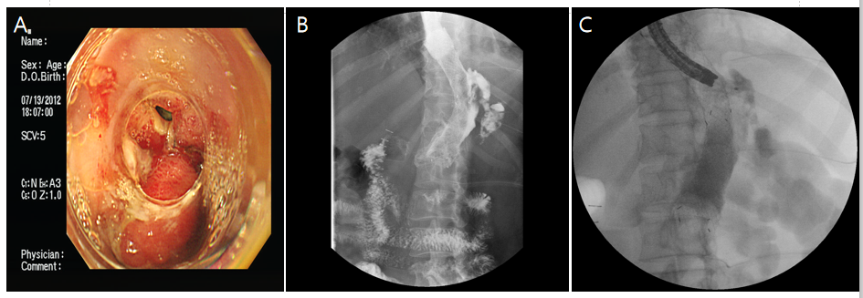
Figure 1 Anastomotic leak after gastrectomy and subsequent histoacryl injection using fluoroscopy and catheter after failed stent application. A: A 4 mm diameter leak was identified at the esophago-gastric anastomotic site; B: A leak (arrow) still existed 3 d after stent application; C: Estimating the location using previous radiocontrast study, the catheter was introduced into sinus tract after puncturing stent membrane (arrow), then it was filled with histoacryl.

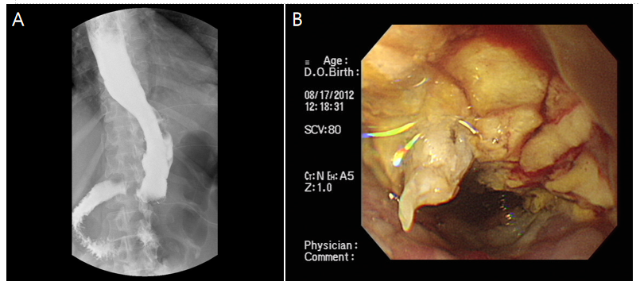
Figure 2 Contrast examinations finding after 1 mo after injection of histoacryl to the leak after puncture the stent membrane. A: The leak was obliterated with histoacryl; B: Endoscopy after stent removal showed remnant histoacryl (arrow) and complete closure.

