Name of Journal: World Journal of Radiology
ESPS Manuscript NO: 30316
Manuscript Type: Original Article

Basic Study

Cystic lesions of peripheral nerves: Are we missing the diagnosis of the intraneural ganglion cyst?

Panwar J et al. Intraneural ganglion cyst of peripheral nerves

Jyoti Panwar, Anil Mathew, Binu P Thomas

Jyoti Panwar, Department of Radiology, Christian Medical College, Vellore 632004, India

Jyoti Panwar, Joint Department of Medical Imaging, University Health Network, University of Toronto, Toronto, M5G 2N2, Ontario, Canada

Anil Mathew, Binu P Thomas, Department of Hand Surgery and Leprosy Reconstructive Surgery, Christian Medical College, Vellore 632004, India

Author contributions: Panwar J and Mathew A participated in the conception, acquisition, analysis, interpretation of the data and drafted the initial manuscript; Panwar J was the guarantor and designed the study; Thomas BP revised the article critically for important intellectual content; Language revision and final approval of the version of the article was done by Mathew A and Thomas BP.

Institutional review board statement: The study was reviewed and approved by the Institutional review board, Christian Medical College, Vellore, India.

Informed consent statement: Not applicable given the retrospective design of our study.

Conflict-of-interest statement: There are no conflicts of interest to report.

Data sharing statement: No additional data are available.

Open-Access: This article is an open-access article which was selected by an in-house editor and fully peer-reviewed by external reviewers. It is distributed in accordance with the Creative Commons Attribution Non Commercial (CC BY-NC 4.0) license, which permits others to distribute, remix, adapt, build upon this work non-commercially, and license their derivative works on different terms, provided the original work is properly cited and the use is non-commercial. See: http://creativecommons.org/licenses/by-nc/4.0/

Manuscript source: Invited manuscript

Correspondence to: Jyoti Panwar, MD, FRCR, Musculoskeletal Radiology Fellow, Joint Department of Medical Imaging, University Health Network, University of Toronto, 585 University Avenue, Toronto, M5G 2N2, Ontario, Canada. drjyoticmch@gmail.com
Telephone: +1-416-3403372

Received: September 26, 2016
Peer-review started: September 28, 2016
First decision: October 20, 2016
Revised: January 17, 2017
Accepted: March 16, 2017
Article in press:
Published online:

Abstract
AIM
To highlight the salient magnetic resonance imaging (MRI) features of the intraneural ganglion cyst (INGC) of various peripheral nerves for their precise diagnosis and to differentiate them from other intra and extra-neural cystic lesions.

METHODS
A retrospective analysis of the magnetic resonance (MR) images of a cohort of 245 patients presenting with nerve palsy involving different peripheral nerves was done. MR images were analyzed for the presence of a nerve lesion, and if found, it was further characterized as solid or cystic. The serial axial, coronal and sagittal MR images of the lesions diagnosed as INGC were studied for their pattern and the anatomical extent along the course of the affected nerve and its branches. Its relation to identifiable anatomical landmarks, intra-articular communication and presence of denervation changes in the muscles supplied by involved nerve was also studied.

RESULTS
A total of 45 cystic lesions in the intra or extraneural locations of the nerves were identified from the 245 MR scans done for patients presenting with nerve palsy. Out of these 45 cystic lesions, 13 were diagnosed to have INGC of a peripheral nerve on MRI. The other cystic lesions included extraneural ganglion cyst, paralabral cyst impinging upon the suprascapular nerve, cystic schwannoma and nerve abscesses related to Hansen’s disease involving various peripheral nerves. Thirteen lesions of INGC were identified in 12 patients. Seven of these affected the common peroneal nerve with one patient having a bilateral involvement. Two lesions each were noted in the tibial and suprascapular nerves, and one each in the obturator and proximal sciatic nerve. An intra-articular connection along the articular branch was demonstrated in 12 out of 13 lesions. Varying stages of denervation atrophy of the supplied muscles of the affected nerves were seen in 7 cases. Out of these 13 lesions in 12 patients, 6 underwent surgery.

CONCLUSION
INGC is an important cause of reversible mono-neuropathy if diagnosed early and surgically treated. Its classic MRI pattern differentiates it from other lesions of the peripheral nerve and aid in its therapeutic planning. In each case, the joint connection has to be identified preoperatively, and the same should be excised during surgery to prevent further cyst recurrence.

Key words: Ganglion cyst; Intra-neural; Magnetic resonance imaging; Peripheral nerves; Extra-neural

© The Author(s) 2017. Published by Baishideng Publishing Group Inc. All rights reserved.

Core tip: This is a retrospective study to emphasize the characteristic magnetic resonance imaging (MRI) features of the intraneural ganglion cyst (INGC) of the peripheral nerves. The radiologist should recognize the classic MRI pattern of the INGC, its joint connection and imaging anatomy of the involved nerve. This would be helpful to surgeons and will aid complete removal of the cyst, prevention of recurrence and improved patient outcomes. Both the radiologists and surgeons should also be able to differentiate this entity from a neurogenic lesion and extra-neural ganglion cyst which can also have joint connection.

Panwar J, Mathew A, Thomas BP. Cystic lesions of peripheral nerves: Are we missing the diagnosis of the intraneural ganglion cyst? World J Radiol 2017; In press

INTRODUCTION
Patients presenting with thickened peripheral nerves and nerve palsy are often diagnosed as Hansen’s disease (HD) in endemic areas when other diagnostic tests come back inconclusive^{[1-4]}. These patients may be thus treated with long term empirical multi-drug therapy (MDT) for the same^{[3-6]}. An intraneural ganglion cyst (INGC) is a non-neoplastic mucinous cyst within the epineurium of a nerve and commences from an adjoining joint^{[7–13]}. These cysts are filled with a mucinous material which is walled off by a fibrous layer^{[7–9]}. As these cysts expand within the epineurium, they displace and compress the adjacent nerve fascicles leading to pain, paresthesia, tingling and muscle paralysis in the distribution of the involved nerve^{[14,15]}. It may follow trivial trauma to the joint^{[7]}. The clinical evaluation of an involved nerve will show thickening if superficial and a variable degree of sensory-motor disturbance along its distribution^{[13-15]}. This presentation of variable motor palsy and sensory symptoms of acute onset may mimic other conditions like lumbosacral disc disease, pelvic or shoulder pathologies and may delay early detection^{[14,16]}. The diagnosis of INGC can be confirmed by imaging techniques like magnetic resonance imaging (MRI) and high resolution ultrasonography (HRUS)^{[14–19]}. The nerve paralysis is usually reversible if the nerve is surgically decompressed early. Its articular connection should be identified and disconnected during surgery to prevent recurrence^{[14,15,20]}.

MATERIALS AND METHODS
This study was approved by the institutional review board, and consent from all patients was waived. This research did not receive any specific grant from funding agencies in the public, commercial, or not-for-profit sectors.

Patient selection
All MR images of the patients presenting with peripheral nerve palsy from July 2005 to December 2015 were selected from our radiology database. A computer search was also performed for the term “ganglion cyst” of proximal tibiofibular (PTF) joint, “paralabral cyst”, “intraneural ganglion cyst”, ganglion cyst of knee, shoulder, elbow and hip joints in the radiology information system (RIS) database. From this cohort of images, all nerves with solid and cystic lesions were first identified. Among the cystic lesions thus identified the images showing elongated cystic lesions of the peripheral nerve along its course and those that fulfilled one or more of the inclusion criteria for INGC (Table 1) were selected. Thirteen such lesions were identified and their MR images, available clinical details, follow-up information and histopathology were reviewed by a musculoskeletal radiologist.

Image acquisition
Images were obtained with by a variety of MRI scanners, including 0.5-T units (n = 1; NT Intera, Philips Healthcare, Netherland), 1.5-T units (n = 2; Magnetom Avanto, Siemens Healthcare, Erlangen, Germany), and 3-T units (n = 6; Intera Achieva, Philips Healthcare, Best, Netherland). The imaging protocol and parameters also varied from case to case. The images were acquired in all three orthogonal planes including axial, coronal and sagittal in all patients. Fast spin echo (FSE) T2-weighted axial, coronal and sagittal images with or without fat suppression and T1-weighted axial images were done in all patients scanned in the 0.5-T and 1.5-T MR scanner. Proton density (PD) fat suppressed axial, coronal and sagittal images along with T1-weighted axial images were available for all cases done in the 3-T MR scanner.

Image analysis
The MR images of all cystic lesions were reviewed by a musculoskeletal radiologist on a General Electric® (GE) picture archiving and communication system (PACS) workstation. The images were evaluated, specifically looking for the presence of the following features: (1) the presence of T2/fat suppressed (T2 or proton density) hyperintense cystic lesion, along the nerve or its branches; (2) the exact anatomical site, intra or extra-neural location; (3) any communication to the adjacent joint along an articular branch; (4) the morphology of the cyst in terms of shape and pattern; and (5) denervation changes of the affected muscle compartment was also assessed.

RESULTS
Clinical findings
The mean age of the patients was 38.2 years (range 9-67 years). There were ten males and two females in this series. Pain along the distribution of the involved nerve and weakness of muscles supplied by the same were the most common presenting symptoms and was present in all 12 patients. One lesion was asymptomatic. The same was discovered incidentally on the contralateral side during routine imaging. Four cases of INGCs involving the common peroneal nerve (CPN) were primarily diagnosed as cystic schwannoma and one suprascapular and obturator nerves lesion were labeled as a paralabral and obturator foramen ganglion cysts respectively. However, no labral tear was seen on MR imaging in either case. Of the 13 lesions, 6 cysts were excised or decompressed by surgery. The articular connection was excised during surgery in 4 out of 5 patients with CPN (PTF joint connection) and in one patient with suprascapular nerve (AC joint connection) involvement.
The other cystic lesions included: 9 cases of extraneural ganglion cyst (ENGC) of PTF joint in close relation with CPN, one ENGC of radio-humeral (elbow) joint impinging upon the deep branch of radial nerve, 6 cases of paralabral cyst impinging upon the suprascapular nerve, 8 cases of cystic schwannoma and 8 cases of nerve abscesses related to HD involving various peripheral nerves. Table 2 summarizes the clinical details of patients with cystic lesions related to and of the nerve.

MRI findings
INGSs: An elongated multi-lobulated cystic lesion, oriented longitudinally along the course of the nerve was seen in all 13 INGC lesions. An extension of the cyst along the articular branch with intra-articular communication was demonstrated in 12 of these lesions (Figures 1 and 2).
Out of the 13 lesions, 7 involved the peroneal nerve with one patient having bilateral lesions of which one side was asymptomatic. The Tibial (Figures 3-5) and suprascapular nerves (Figure 6) was involved in 2 patients each.
One case each of the obturator (Figures 7, 8) and proximal sciatic nerves (Figures 9 and 10) were also identified.
A variable extension of cysts along the branches of the parent nerve is also seen in 12 cases (Figures 1-5, 8 and 11). Varying stages of denervation of the supplied muscles are seen in 7 cases (Figures 3-5, 8 and 11).
Six patients underwent surgical intervention and the diagnosis was histo-pathologically confirmed in them. The intraoperative images of one of these patients are shown in Figure 12.
In one tibial nerve INGC, in addition to PTF joint connection, a second posterior knee joint connection was also noted (Figure 4). In four cases with CPN involvement, the INGC could also be seen extending distally for a variable length along the deep (Figures 2) and superficial peroneal (Figure 11) nerve branches. The obturator nerve cyst also extended along it’s anterior branch (Figure 8) the tibial nerve lesions extended along the branch to the popliteus and tibialis posterior muscles (Figure 3-5). Table 3 summarizes the MRI findings of INGC of the peripheral nerves in this series.

Other cystic lesions
ENGC: These are most commonly seen around the PTF joint in close relation with CPN and its branches. Its characteristic MR features are described in Figure 13 and its differentiation from INGC on imaging is illustrated in Figure 14 and summarized in Table 4.

Cystic schwannoma: Schwannomas are the most common peripheral nerve sheath tumors^{[21]}, mostly solid or heterogeneous solid tumors. However, cystic schwannomas of the peripheral nerve are uncommon^{[22,23]} and may mimic other extra or intraneural cystic lesions. MR features of cystic schwannoma of CPN are illustrated in Figure 15.

Paralabral cyst: Paralabral cysts of the shoulder joint are commonly seen in the middle age men and cause impingement of the suprascapular nerve. They are commonly located at the posterosuperior glenoid region, secondary to a labral tear. They can extend into the spinoglenoid notch and can cause compression of the suprascapular nerve (Figure 16).

Nerve abscess related to HD: Granulomatous nerve lesions of HD may show central breakdown and abscess formation. These are relatively uncommon and are seen in the tuberculoid form of the leprosy (Figure 17).

DISCUSSION
INGC is often referred to as a rare non-neoplastic mucinous cyst located within the epineurium of peripheral nerves and is closely related to an adjoining joint ^{[7–11,20,24,25]}. These lesions commonly affect the peroneal nerve at the knee but can involve the other peripheral nerves^{[7,26,27]} as shown in this series. They usually present with mild symptoms and remain undiagnosed initially^{[27]}. MRI plays an important role in diagnosing this condition and can reliably demonstrate the presence and the pattern of the cystic lesion and the exact level of communication of the cyst to the adjacent joint^{[8,20,28,29]}. This typical imaging pattern and the appearance of this lesion with a consistent anatomic site within the nerves and its communication with the adjoining joints, distinguish the intraneural cyst from the other neurogenic or extra neural cystic lesions^{[8,28,29]}. Recognition of its articular connection on MR further helps in complete removal of the cyst, thus avoiding cyst recurrences^{[20,29]}.
The exact pathogenesis of INGC is still not known. There are numerous hypotheses for its pathogenesis ranging from recurrent trauma, intra-neural hemorrhage, mucoid degeneration, de novo formation from haemartomatous cell rests^{[7,11,30–32]} and the more recent “unified articular theory^{[20,29,33,34]}. According to the latter, the INGC originates from an adjoining joint and dissects along the articular branch into the parent nerve. The cyst dissects along the path of least resistance, namely the perineural tissue of the nerve^{[11,30,31]}.
The diagnostic work-up includes clinical examination, electrophysiological studies and imaging. The ganglion cyst usually presents with pain, motor weakness and paraesthesia along the distribution of involved nerve^{[13-15,35]}. Electrophysiological studies including electromyography and nerve conduction studies may indicate muscle denervation and conduction latency, respectively^{[35-38]}. MRI is the imaging of choice for the nerve and its surrounding soft tissues^{[37,39–41]}. It helps in defining the lesion along the course of the nerve.
On MR, these cysts are small in size and demonstrate the typical, tubular beaded configuration oriented longitudinally along the course of the involved nerve and its branches^{[8,9,19,38,40]}. They appear as low signal on T1-weighted and high signal on T2-weighted images^{[42,43]}. The joint connection and the extension of the cyst along the articular branch of nerve when present, can be well demonstrated^{[20,29,30,36,38,39]}. Further denervation muscle edema as T2 hyperintensity and muscle atrophy as T1 hyperintensity can be seen^{[8,10,38]}. In the peroneal intraneural cyst, the PTF joint connection and a cyst along the descending and ascending limb of articular branch of CPN can be seen in all the three orthogonal planes^{[20,24,29,38,39]}. As described by Spinner et al^{[24,29,31]} in 2008, on serial axial sections, the joint connection is interpreted as the “tail sign” (Figures 1-5, 14) and the extension of the cyst in the ascending limb of the articular branch as the “transverse limb sign” (Figures 1, 2, 14). An eccentric cyst within the outer epineurium of the CPN is interpreted as the “signet ring sign” (Figures 3-5, 14). In all our seven CPN lesions, we found that they had evidence of joint connection; presence of cysts along the articular branch; variable proximal ascent of the intra-neural cyst along the CPN and distal descent along its branches. On coronal images this extension of the cyst along the descending and ascending portions of the articular branch is interpreted as “u-sign” (Figures 1, 2, 11).
In the lower extremity, less commonly, they can involve the lumbosacral plexus, sciatic, obturator and tibial nerves^{[9,12,28,,44]}. The sciatic nerve can be involved in its proximal or distal portion. We have seen in our case, the presence of intra-neural sciatic ganglion cyst at the sacral notch, with characteristic tubular connection to the posteromedial hip joint on MR. There were no obvious degenerative changes in the joint, labral tears or other structural problems on both the conventional MR and radiographs in the case reported herein. However, intra-articular contrast was not given and hence, the common underlying pathology of labral tear or capsular rent with intra-neural extension from a paralabral or para-articular cyst cannot be completely excluded. In Spinner’s series of INGC around the hip and pelvic region^{[44]}, four out of five cases showed a cyst at the sciatic notch with an articular communication with the ipsilateral hip joint and further extension of the same into the sciatic nerve. Likewise, the obturator INGC also has a known joint connection with the anteromedial hip joint^{[44,45]} as seen in our case. The propagation of the cyst along the articular branch and further dissection of the cyst along the parent nerve and its anterior and posterior branches has been described^{[45]} and is demonstrated in the current case. Variable atrophy and denervation hyperintensity of ipsilateral adductor brevis and magnus muscles was also seen in our case.
Various case reports have described the involvement of tibial nerve in the popliteal fossa by the INGC^{[7,12,36,40,46,47]}. These tibial INGCs are the posterior counterpart of the peroneal INGCs and demonstrate an intraneural cyst and its connection to the adjacent joint via the articular branch to the PTF joint^{[40,47,48]}. In one of our cases there was evidence of dual communication of the tibial intraneural cyst to both the knee and PTF joint through its corresponding articular branches (Figures 3-5) and further extension of cyst into the popliteus and tibialis posterior nerve branches (Figures 3-5). Denervation edema was noted in both popliteus and tibialis posterior muscles (Figures 3-5).
In the upper extremity, less commonly, they can involve the suprascapular, ulnar or median nerves^{[8,49]}. INGC is a common cause of suprascapular nerve impingement at the suprascapular and more commonly at the spino-glenoid notch originating from gleno-humeral joint and often associated with tears of the glenoid labrum^{[50,51]}. It may also arise from the acromioclavicular (AC) joint as articular branch of the suprascapular nerve innervate the AC joint^{[52]}. They track along the articular branch into the parent nerve and can be associated with a labral tear or capsular rent^{[53]}. However, in one of our cases, the joint connection could not be demonstrated. In the other case there was an AC joint connection (Figure 6). In contrast to this extra neural paralabral cyst where the nerve is seen separately from the cyst with a preserved fat plane in between, an INGC affecting the suprascapular nerve evolves within the epineurium of the nerve as seen in other peripheral nerve INGCs^{[53–55]}.
In our series of 245 cases of peripheral nerve palsy for which imaging was done, 45 cases of cystic lesions were identified. Of these 45 cystic lesions, more than a fourth (13 cases), were diagnosed to be INGC retrospectively. Although the exact incidence of INGC is not known, in our series it was the commonest cause for the cystic nerve lesions. The fact that these lesions are reported as rare^{[7–11]} may be incorrect since they are often underdiagnosed as shown in our series. The primary radiological diagnosis of INGC in our series was correct in only 60 percent of the cases, i.e., the last 7 cases in this series. Lack of knowledge of this pathological entity and absence of this entity in standard radiological textbooks were probable reasons for its under-diagnosis among the early cases in this series. INGC as an entity was little known before the 90s even in western literature, being reported as rare case reports or case series prior to that^{[14,56,57]}. The others cystic lesions in this series varied from cystic schwannoma, extra-neural ganglion cysts, paralabral cysts and nerve abscesses. All of these cystic lesions were correctly diagnosed primarily except two ENGCs which were mistaken as cystic schwannoma.
This article endeavors to describe different INGCs at varying anatomical locations, to emphasize the fact that it is the single largest cause of surgically treatable mono-neuropathy due to a cystic nerve lesion. These lesions have a classic configuration, anatomical location within the nerve and extensions along its branches. Most have defined communications to the nearby joint and the innervated muscles show signs of denervation. Identification of the articular branch and disconnecting it is important to prevent recurrence. The youngest patient in this series had surgery, 7 mo after the onset of nerve palsy due to the late presentation at the hospital. The cysts were decompressed and the articular branch disconnected during the surgery. The innervated muscles showed MRC grade 4 recovery about one year after surgery, in spite of the late intervention.
In conclusion, over the past years, INGC has been increasingly recognized as a radio-pathologic entity. It is a cause of peripheral neuropathy that can be treated by surgery, but is often under-diagnosed. This research looked at a historic cohort of patients that were imaged for mono-neuropathy and within that the subsets of patients with cystic lesions were looked at, in greater detail. We were certainly missing the diagnosis of the INGC until recently. The surgical treatment of a cystic schwannoma is enucleation as opposed to the INGC where the nerve is decompressed and the articular branch is excised. This study re- emphasizes that any elongated cystic lesion along the course of a peripheral nerve and in the vicinity of a joint should be considered as an INGC unless proved otherwise. This will ensure that both the radiologist and the surgeon would diligently search for the articular (branch) connection and hence prevent a misdiagnosis and a possible recurrence.

COMMENTS
Background
intraneural ganglion cysts (INGCs) of peripheral nerves occur within the epineurium and related to the adjoining joint are relatively uncommon entity. They generally formed when joint fluid track in the epineural sheath of the articular branch of the nerve and further along the path of least resistance. They commonly present with sensory-motor symptoms along the distribution of the involved nerve. If these are identified and treated early, symptoms are reversible. The articular branch disconnection of the cyst will avoid the recurrence of the cyst. In this study, we evaluated 13 such cases involving the different peripheral nerves.

Research frontiers
Magnetic resonance imaging (MRI) is the most important modality to diagnose this condition. It also allows differentiating it from other intra or juxtra-neural lesions like neurogenic tumors and the extra-neural ganglion cyst. Though it has been described as a rare disease in literature, the results of this study showed that it is the single largest cause of surgically treatable mono-neuropathy caused by a cystic nerve lesion.

Innovations and breakthroughs
In this study, the classic MRI pattern of the INGC was a useful tool in diagnosing this condition and to differentiate it from other intra or extraneural cystic lesions. These results agree with prior literature. However, in this study, 40% of cases representing the initial cases in this series were misdiagnosed preoperatively and were mistaken for neurogenic tumor. This emphasizes the diagnostic knowledge of this condition. An early diagnosis and surgical intervention will improve patient outcomes.

Applications
In the order of differential diagnosis of cystic nerve lesions arising in the vicinity of a joint, the INGC comes first. This research re-emphasizes that the knowledge of the classic MRI pattern is paramount in diagnosing the INGC. An early surgical intervention will cause significant reversal of neurologic symptoms.

Terminology
INGC: Intraneural ganglion cyst, cyst occurring within the epineurium of nerve; ENGC: Extraneural ganglion cyst, cyst adjacent to nerve but outside the epineural sheath; CPN: Common peroneal nerve, a nerve in the lower leg that provides sensation and motor function to parts of the lower leg.

Peer-review
This review article has well described the use and dose optimisation of computed tomography in patients with cystic. It is well-organized and useful for clinical practice, especially for western radiology society.

REFERENCES
1 van Brakel WH, Nicholls PG, Das L, Barkataki P, Suneetha SK, Jadhav RS, Maddali P, Lockwood DN, Wilder-Smith E, Desikan KV. The INFIR Cohort Study: investigating prediction, detection and pathogenesis of neuropathy and reactions in leprosy. Methods and baseline results of a cohort of multibacillary leprosy patients in north India. Lepr Rev 2005; 76: 14-34 [PMID: 15881033]
2 de Freitas MR, Nascimento OJ, Quaglino EA, Oliveira A, Hahn MD. Small-fiber polyneuropathy in leprosy without skin changes: study of 17 cases. Arq Neuropsiquiatr 2003; 61: 542-546 [PMID: 14513154 DOI: 10.1590/S0004-282X2003000400003]
3 World Health Organization, Global leprosy situation, Relevé Épidémiologique Hebd. Sect. Hygiène Secrétariat Société Nations Wkly Epidemiol Rec Health Sect Secr Leag Nation 2005; 80: 289-295
4 Scollard DM, Adams LB, Gillis TP, Krahenbuhl JL, Truman RW, Williams DL. The continuing challenges of leprosy. Clin Microbiol Rev 2006; 19: 338-381 [DOI: 10.1128/CMR.19.2.338-381.2006]
5 Joyce M, Scollard D. Lepr. Hansens Dis. Conns Curr. Ther., edition 1, Saunders, Philadelphia, 2004: 100-105
6 Ustianowski AP, Lockwood DN. Leprosy: current diagnostic and treatment approaches. Curr Opin Infect Dis 2003; 16: 421-427 [PMID: 14501994 DOI: 10.1097/01.qco.0000092813.64370.be]
7 Patel P, Schucany WG. A rare case of intraneural ganglion cyst involving the tibial nerve. Proc (Bayl Univ Med Cent) 2012; 25: 132-135 [PMID: 22481843]
8 Uetani M, Hashmi R, Hayashi K, Nagatani Y, Narabayashi Y, Imamura K. Peripheral nerve intraneural ganglion cyst: MR findings in three cases. J Comput Assist Tomogr 1998; 22: 629-632 [PMID: 9676458 DOI: 10.1097/00004728-199807000-00023]
9 Harbaugh KS, Tiel RL, Kline DG. Ganglion cyst involvement of peripheral nerves. J Neurosurg 1997; 87: 403-408 [PMID: 9285606 DOI: 10.3171/jns.1997.87.3.0403]
10 Spinner RJ, Desy NM, Rock MG, Amrami KK. Peroneal intraneural ganglia. Part I. Techniques for successful diagnosis and treatment. Neurosurg Focus 2007; 22: E16 [PMID: 17613207 DOI: 10.3171/foc.2007.22.6.17]
11 Jacobs RR, Maxwell JA, Kepes J. Ganglia of the nerve. Presentation of two unusual cases, a review of the literature, and a discussion of pathogenesis. Clin Orthop Relat Res 1975: 135-144 [PMID: 172271 DOI: 10.1097/00003086-197511000-00020]
12 Adn M, Hamlat A, Morandi X, Guegan Y. Intraneural ganglion cyst of the tibial nerve. Acta Neurochir (Wien) 2006; 148: 885-89; discussion 885-89; [PMID: 16775659 DOI: 10.1007/s00701-006-0803-8]
13 Johnston JA, Lyne DE. Intraneural ganglion cyst of the peroneal nerve in a four-year-old girl: a case report. J Pediatr Orthop 2007; 27: 944-946 [PMID: 18209620 DOI: 10.1097/BPO.0b013e3181558c05]
14 Tehli O, Celikmez RC, Birgili B, Solmaz I, Celik E. Pure peroneal intraneural ganglion cyst ascending along the sciatic nerve. Turk Neurosurg 2011; 21: 254-258 [PMID: 21534214 DOI: 10.5137/1019-5149.JTN.2660-09.1]
15 Liang T, Panu A, Crowther S, Low G, Lambert R. Ultrasound-guided aspiration and injection of an intraneural ganglion cyst of the common peroneal nerve. HSS J 2013; 9: 270-274 [PMID: 24426879 DOI: 10.1007/s11420-013-9345-9]
16 Lang CJ, Neubauer U, Qaiyumi S, Fahlbusch R. Intraneural ganglion of the sciatic nerve: detection by ultrasound. J Neurol Neurosurg Psychiatry 1994; 57: 870-871 [PMID: 8021688 DOI: 10.1136/jnnp.57.7.870-a]
17 Leijten FS, Arts WF, Puylaert JB. Ultrasound diagnosis of an intraneural ganglion cyst of the peroneal nerve. Case report. J Neurosurg 1992; 76: 538-540 [PMID: 1310730 DOI: 10.3171/jns.1992.76.3.0538]
18 Masciocchi C, Innacoli M, Cisternino S, Barile A, Rossi F, Passariello R. Myxoid intraneural cysts of external popliteal ischiadic nerve. Report of 2 cases studied with ultrasound, computed tomography and magnetic resonance imaging. Eur J Radiol 1992; 14: 52-55 [PMID: 1314178 DOI: 10.1016/0720-048X(92)90062-E]
19 McCarthy CL, McNally EG. The MRI appearance of cystic lesions around the knee. Skeletal Radiol 2004; 33: 187-209 [PMID: 14991250 DOI: 10.1007/s00256-003-0741-y]
20 Spinner RJ, Atkinson JL, Scheithauer BW, Rock MG, Birch R, Kim TA, Kliot M, Kline DG, Tiel RL. Peroneal intraneural ganglia: the importance of the articular branch. Clinical series. J Neurosurg 2003; 99: 319-329 [PMID: 12924707 DOI: 10.3171/jns.2003.99.2.0319]
21 Martinez Algarra JC, Gastaldi Rodrigo P, Palomares Talens E. [Multiple schwannoma of the sciatic nerve. Apropos of a case]. Rev Chir Orthop Reparatrice Appar Mot 1999; 85: 632-635 [PMID: 10575727]
22 Parmar H, Patkar D, Gadani S, Shah J. Cystic lumbar nerve sheath tumours: MRI features in five patients. Australas Radiol 2001; 45: 123-127 [PMID: 11380354 DOI: 10.1046/j.1440-1673.2001.00891.x]
23 Wu D, Ba Z, Huang Y, Zhao W, Shen B, Kan H. Totally cystic schwannoma of the lumbar spine. Orthopedics 2013; 36: e679-e682 [PMID: 23672923 DOI: 10.3928/01477447-20130426-36]
24 Spinner RJ, Carmichael SW, Wang H, Parisi TJ, Skinner JA, Amrami KK. Patterns of intraneural ganglion cyst descent. Clin Anat 2008; 21: 233-245 [PMID: 18330922 DOI: 10.1002/ca.20614]
25 Nicholson TR, Cohen RC, Grattan-Smith PJ. Intraneural ganglion of the common peroneal nerve in a 4-year-old boy. J Child Neurol 1995; 10: 213-215 [PMID: 7642891 DOI: 10.1177/088307389501000310]
26 Kim TS, Jo YH, Paik SS, Kim SJ. Intraneural Ganglion Cyst of the Peripheral Nerve: Two Cases Report. J Korean Bone Jt Tumor Soc 2013; 19: 83 DOI: 10.5292/jkbjts.2013.19.2.83]
27 Haller JM, Potter MQ, Sinclair M, Hutchinson DT. Intraneural ganglion in superficial radial nerve mimics de quervain tenosynovitis. J Wrist Surg 2014; 3: 262-264 [PMID: 25364639 DOI: 10.1055/s-0034-1384746]
28 Swartz KR, Wilson D, Boland M, Fee DB. Proximal sciatic nerve intraneural ganglion cyst. Case Rep Med 2009; 2009: 810973 [PMID: 20069041 DOI: 10.1155/2009/810973]
29 Spinner RJ, Luthra G, Desy NM, Anderson ML, Amrami KK. The clock face guide to peroneal intraneural ganglia: critical "times" and sites for accurate diagnosis. Skeletal Radiol 2008; 37: 1091-1099 [PMID: 18641980 DOI: 10.1007/s00256-008-0545-1]
30 Spinner RJ, Amrami KK, Wang H, Kliot M, Carmichael SW. Cross-over: a generalizable phenomenon necessary for secondary intraneural ganglion cyst formation. Clin Anat 2008; 21: 111-118 [PMID: 18220283 DOI: 10.1002/ca.20590]
31 Krishnan KG, Schackert G. Intraneural ganglion cysts: a case of sciatic nerve involvement. Br J Plast Surg 2003; 56: 183-186 [PMID: 12791372 DOI: 10.1016/S0007-1226(03)00036-5]
32 Colbert SH, Le MH. Case report: intraneural ganglion cyst of the ulnar nerve at the wrist. Hand (N Y) 2011; 6: 317-320 [PMID: 22942857 DOI: 10.1007/s11552-011-9329-5]
33 Spinner RJ, Amrami KK, Wolanskyj AP, Desy NM, Wang H, Benarroch EE, Skinner JA, Rock MG, Scheithauer BW. Dynamic phases of peroneal and tibial intraneural ganglia formation: a new dimension added to the unifying articular theory. J Neurosurg 2007; 107: 296-307 [PMID: 17695383 DOI: 10.3171/JNS-07/08/0296]
34 Elangovan S, Odegard GM, Morrow DA, Wang H, Hébert-Blouin MN, Spinner RJ. Intraneural ganglia: a clinical problem deserving a mechanistic explanation and model. Neurosurg Focus 2009; 26: E11 [PMID: 19435441 DOI: 10.3171/FOC.2009.26.2.E11]
35 Greer-Bayramoglu RJ, Nimigan AS, Gan BS. Compression neuropathy of the peroneal nerve secondary to a ganglion cyst. Can J Plast Surg 2008; 16: 181-183 [PMID: 19721802 DOI: 10.4172/plastic-surgery.1000570]
36 Spinner RJ, Desy NM, Amrami KK. Sequential tibial and peroneal intraneural ganglia arising from the superior tibiofibular joint. Skeletal Radiol 2008; 37: 79-84 [PMID: 17968541 DOI: 10.1007/s00256-007-0400-9]
37 Kukreja MM, Telang VG. Common Peroneal Nerve Palsy Secondary to a Proximal Tibiofibular Joint "Ganglion Cyst"—A Case Report and Review of Literature. [accessed 2016 June 19]. Available from: URL: http://file.scirp.org/pdf/OJO_2015112014185133.pdf
38 Coakley FV, Finlay DB, Harper WM, Allen MJ. Direct and indirect MRI findings in ganglion cysts of the common peroneal nerve. Clin Radiol 1995; 50: 168-169 [PMID: 7889707 DOI: 10.1016/S0009-9260(05)82993-9]
39 Spinner RJ, Amrami KK, Rock MG. The use of MR arthrography to document an occult joint communication in a recurrent peroneal intraneural ganglion. Skeletal Radiol 2006; 35: 172-179 [PMID: 16333654 DOI: 10.1007/s00256-005-0036-6]
40 Spinner RJ, Atkinson JL, Harper CM, Wenger DE. Recurrent intraneural ganglion cyst of the tibial nerve. Case report. J Neurosurg 2000; 92: 334-337 [PMID: 10659022 DOI: 10.3171/jns.2000.92.2.0334]
41 Leon J, Marano G. MRI of peroneal nerve entrapment due to a ganglion cyst. Magn Reson Imaging 1987; 5: 307-309 [PMID: 3657403 DOI: 10.1016/0730-725X(87)90009-9]
42 Dubuisson AS, Stevenaert A. Recurrent ganglion cyst of the peroneal nerve: radiological and operative observations. Case report. J Neurosurg 1996; 84: 280-283 [PMID: 8592235 DOI: 10.3171/jns.1996.84.2.0280]
43 Iverson DJ. MRI detection of cysts of the knee causing common peroneal neuropathy. Neurology 2005; 65: 1829-1831 [PMID: 16344535 DOI: 10.1212/01.wnl.0000187098.42938.b6]
44 Spinner RJ, Hébert-Blouin MN, Trousdale RT, Midha R, Russell SM, Yamauchi T, Sasaki S, Amrami KK. Intraneural ganglia in the hip and pelvic region. Clinical article. J Neurosurg 2009; 111: 317-325 [PMID: 19374493 DOI: 10.3171/2009.2.JNS081720]
45 Sureka J, Panwar S, Mullapudi I. Intraneural ganglion cysts of obturator nerve causing obturator neuropathy. Acta Neurol Belg 2012; 112: 229-230 [PMID: 22426671 DOI: 10.1007/s13760-012-0041-1]
46 Spinner RJ, Hébert-Blouin MN, Amrami KK, Rock MG. Peroneal and tibial intraneural ganglion cysts in the knee region: a technical note. Neurosurgery 2010; 67: ons71-ons8; discussion ons78 [PMID: 20679946 DOI: 10.1227/01.NEU.0000374683.91933.0E]
47 Davis GA, Cox IH. Tibial intraneural ganglia at the ankle and knee: incorporating the unified (articular) theory in adults and children. J Neurosurg 2011; 114: 236-239 [PMID: 20415523 DOI: 10.3171/2010.3.JNS10427]
48 Jerath NU, Chen JJ, Miller BJ, Reddy CG. Teaching NeuroImages: intraneural ganglion cyst of the tibial nerve. Neurology 2014; 82: e174-e175 [PMID: 24843041 DOI: 10.1212/WNL.0000000000000429]
49 Wang H, Terrill RQ, Tanaka S, Amrami KK, Spinner RJ. Adherence of intraneural ganglia of the upper extremity to the principles of the unifying articular (synovial) theory. Neurosurg Focus 2009; 26: E10 [PMID: 19435440 DOI: 10.3171/FOC.2009.26.2.E10]
50 Lee BC, Yegappan M, Thiagarajan P. Suprascapular nerve neuropathy secondary to spinoglenoid notch ganglion cyst: case reports and review of literature. Ann Acad Med Singapore 2007; 36: 1032-1035 [PMID: 18185886]
51 Limbucci N, Rossi F, Salvati F, Pistoia LM, Barile A, Masciocchi C. Bilateral suprascapular nerve entrapment by glenoid labral cysts associated with rotator cuff damage and posterior instability in an amateur weightlifter. J Sports Med Phys Fitness 2010; 50: 64-67 [PMID: 20308974]
52 Ebraheim NA, Whitehead JL, Alla SR, Moral MZ, Castillo S, McCollough AL, Yeasting RA, Liu J. The suprascapular nerve and its articular branch to the acromioclavicular joint: an anatomic study. J Shoulder Elbow Surg 2011; 20: e13-e17 [PMID: 21194975 DOI: 10.1016/j.jse.2010.09.004]
53 Spinner RJ, Amrami KK, Kliot M, Johnston SP, Casañas J. Suprascapular intraneural ganglia and glenohumeral joint connections. J Neurosurg 2006; 104: 551-557 [PMID: 16619659 DOI: 10.3171/jns.2006.104.4.551]
54 Spinner RJ, Amrami KK. Intraneural ganglion of the suprascapular nerve: Case report. J Hand Surg Am 2006; 31: 1698-1699 [PMID: 17145396 DOI: 10.1016/j.jhsa.2006.09.015]
55 Sanger J, Cortes W, Yan JG. Intraneural ganglion of the suprascapular nerve: case report. J Hand Surg Am 2006; 31: 40-44 [PMID: 16443102 DOI: 10.1016/j.jhsa.2005.08.010]
56 Parkes A. Intraneural ganglion of the lateral popliteal nerve. J Bone Joint Surg Br 1961; 43-B: 784-790 [PMID: 14038186]
57 Bacigalupo LE, Damasio MB, Zuccarino F, Succio G, Silversti E, Bianchi S, Martinoli C. US and MR imaging of peroneal intraneural ganglia: Emphasis on the articular branch. Skeletal Radiol 2005; 34: 588 [DOI: 10.1007/s00256-005-0959-y.

P- Reviewer: Ju CI, Reddy CG, Squires JH S- Editor: Song XX L- Editor: E- Editor:

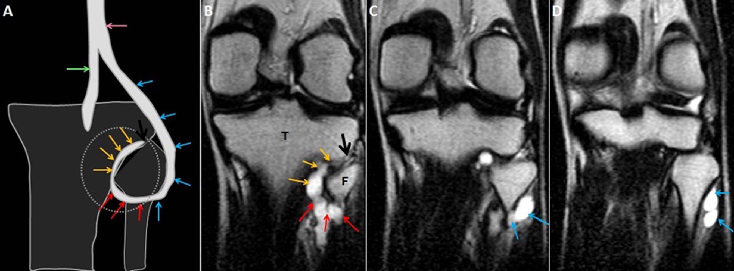
Figure 1 A shows a diagrammatic representation of the intraneural ganglion cyst associated with the proximal tibiofibular joint in the coronal plane; B-D are serial, coronal, T2-weighted, fast spin echo images of the knee show the origin of the lobulated tubular cyst from the proximal tibiofibular joint also called the “tail sign” demonstrated by the black arrows. The further extension along the descending limb (yellow arrows) of the articular branch represents the “vertical limb sign”. The ascending limb of the articular branch (red arrows) demonstrates the “transverse limb sign” which continues to the CPN (blue arrows). Extension of the cyst into the two limbs of the articular branch and further ascent into the parent nerve represents the “u-sign”. T: Tibia; F: Fibula; CPN: Common peroneal nerve.

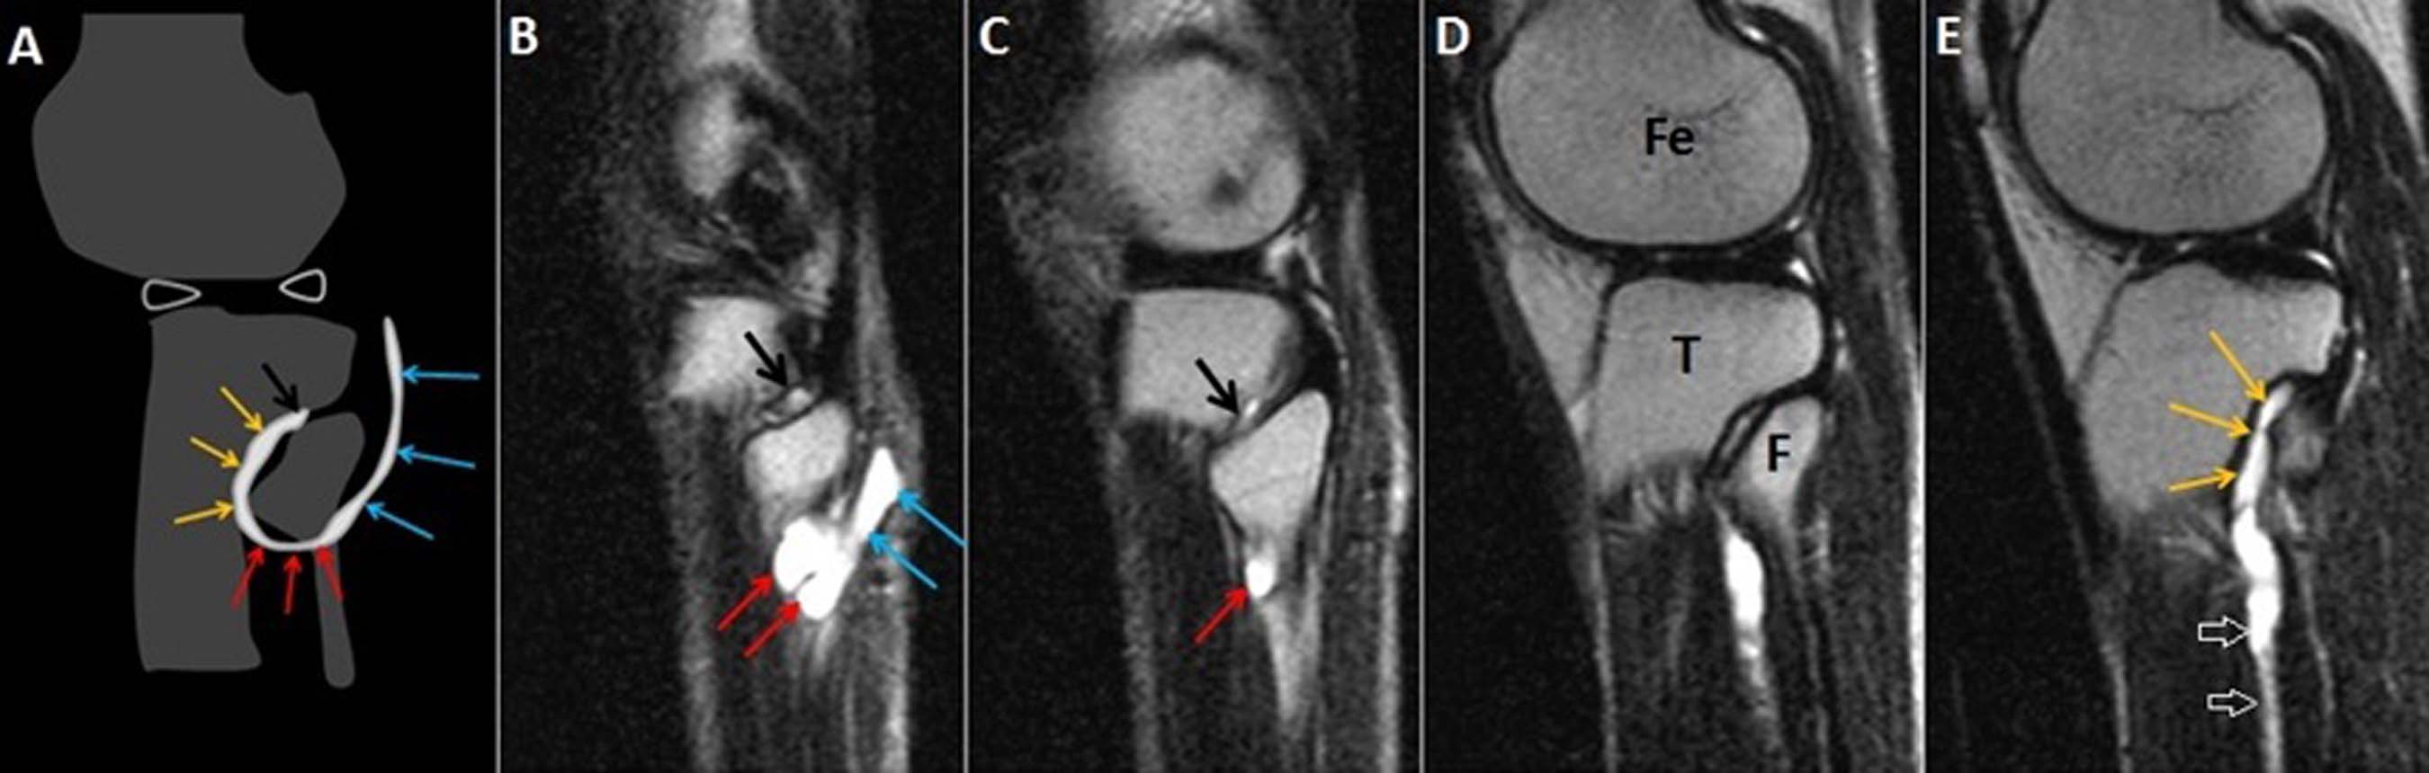
Figure 2 A shows a diagrammatic representation of the intraneural ganglion cyst associated with the proximal tibiofibular joint in the sagittal plane; B-E serial, sagittal, T2-weighted, fast spin echo images of the knee show the origin of the lobulated tubular cyst from the proximal tibiofibular joint represents the “tail sign” (black arrows). The further extension along the descending limb (yellow arrows) represents the “vertical limb sign” and ascending limb (red arrows) of the articular branch demonstrates the “transverse limb sign”; which continues to the CPN (blue arrows). The cyst also extends along the deep peroneal nerve (open arrows) in image E. T: Tibia; F: Fibula; CPN: Common peroneal nerve.

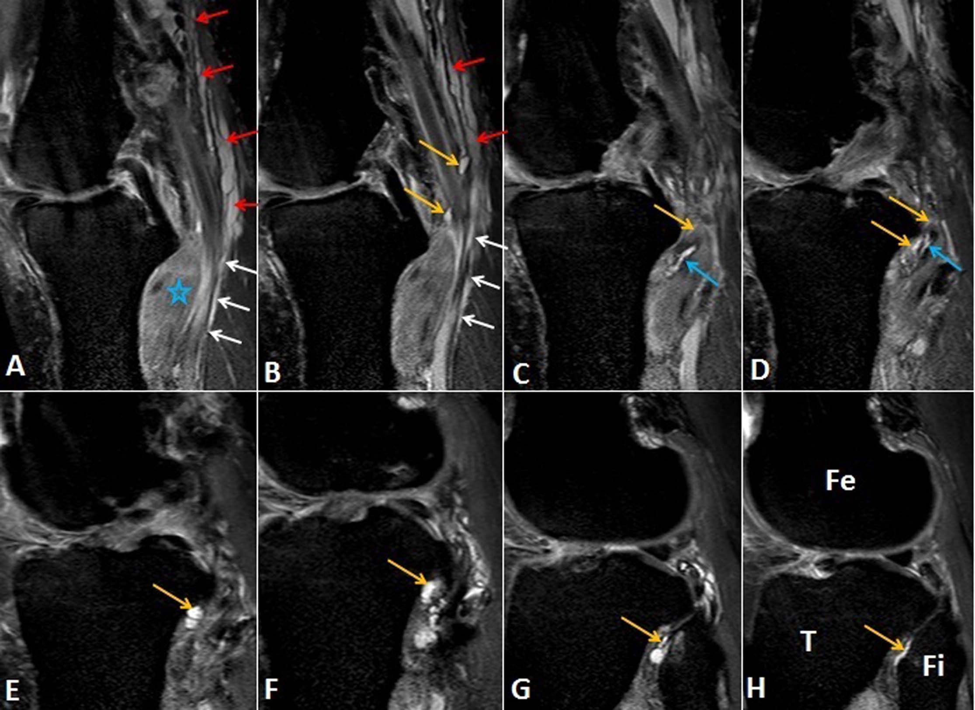
Figure 3 Images A-H show serial, proton density-weighted fat suppressed sagittal sections of the knee demonstrate the longitudinally oriented cystic lesion in the tibial nerve (red arrows) with extension along the articular branch to proximal tibiofibular joint (yellow arrows), branch to popliteus (blue arrows) and tibialis posterior muscles (white arrows). Note the denervation edema in the popliteus muscle (star). T: Tibia; Fi: Fibula; Fe: Femur.

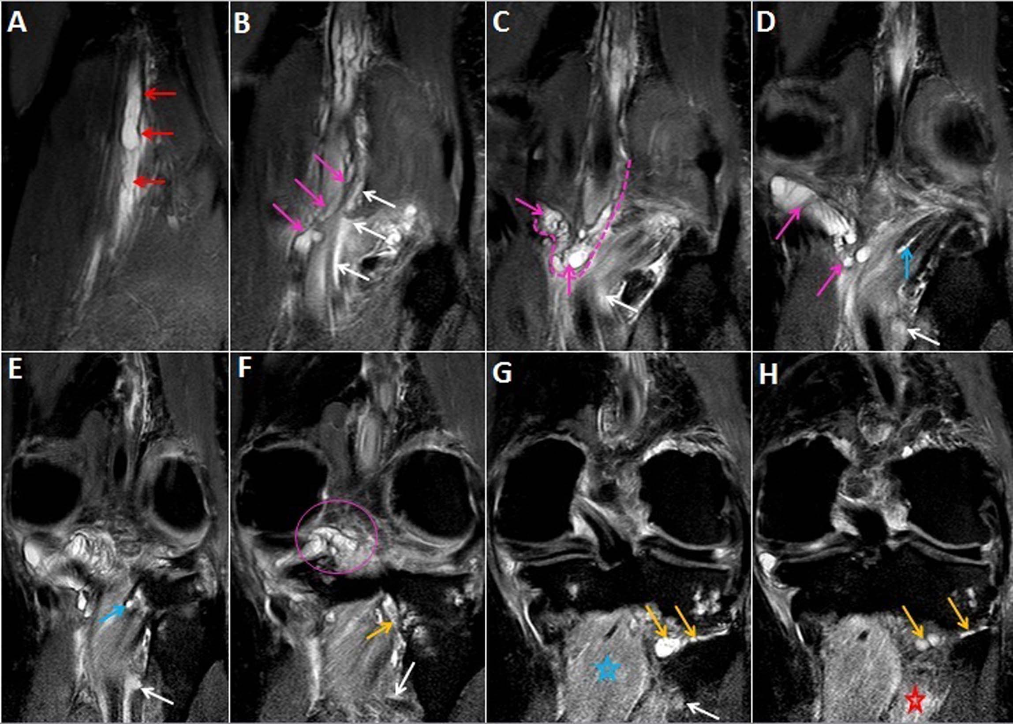
Figure 4 Images A-H show serial, proton density -weighted fat suppressed coronal sections of the knee demonstrate the longitudinal extent of intraneural cyst in the tibial nerve (red arrows), with propagation of cyst along the articular branches that communicate with the posterior aspect of knee joint (pink arrows, dashed line and circle) and to the postero-inferior part of proximal tibiofibular joint (yellow arrows). This represents a dual joint connection (knee and proximal tibiofibular) from the same intraneural ganglion cyst. The cyst also extends along the branch to the popliteus (blue arrows) and tibialis posterior muscles (white arrows). Note the denervation edema in the popliteus (blue star) and tibialis posterior (red star) muscles. Superiorly, the cyst extends up to the bifurcation of the sciatic nerve in the distal third of the thigh.

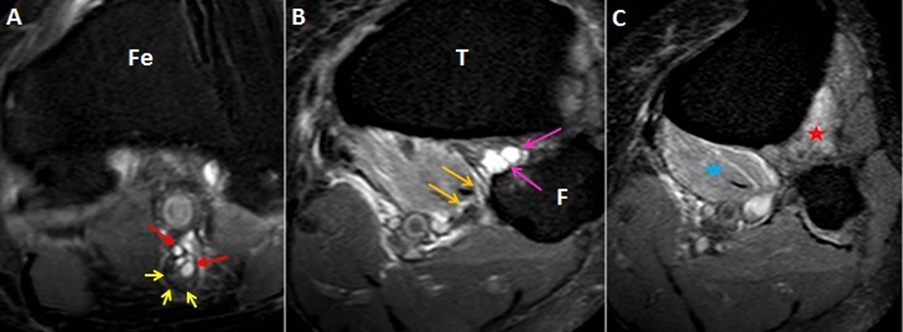
Figure 5 Images A-C show serial, proton density-weighted fat suppressed axial images of the knee demonstrate the eccentric cyst (red arrows) within the epineurium of tibial nerve displacing the nerve fascicles (yellow arrows) which represents the “signet ring sign” (A). The joint connection (pink arrows) is well appreciated where the cyst arises from the posterior aspect of the PTF joint. This represents the “tail sign” (B). The cyst (yellow arrows) extends along the posterior surface of the popliteus muscle into the branch to popliteus muscle. Denervation edema is seen in the popliteus (blue star) and tibialis posterior (red star) muscles. T: Tibia; F: Fibula; Fe: Femur; PTF: Proximal tibiofibular.

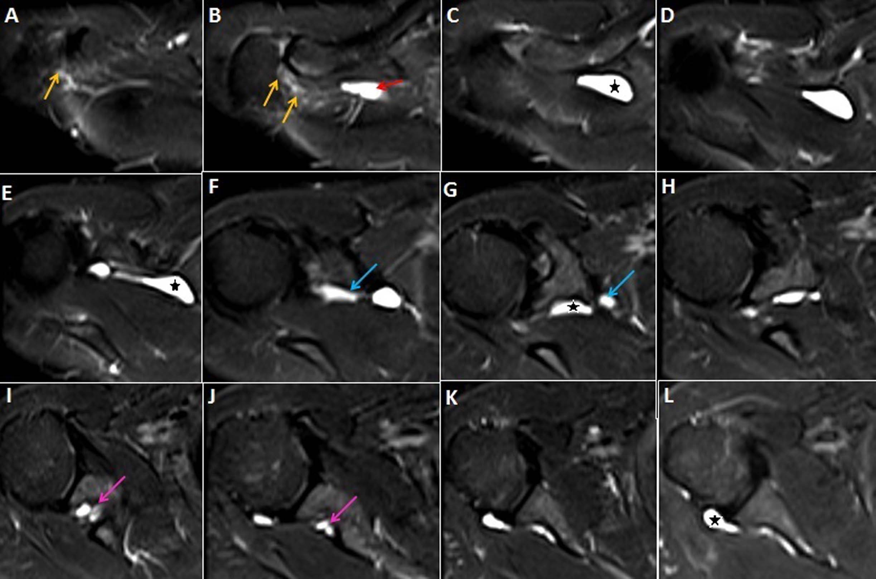
Figure 6 Images A-L show serial T2-weighted fat suppressed axial sections of the right shoulder, outlines the longitudinally oriented cyst (stars) along the course of the suprascapular nerve. The cyst extends from the level of the acromioclavicular joint (B) to the posterior aspect of glenohumeral joint (L). A narrow joint connection extends along the expected course of the articular branch of the suprascapular nerve to the acromioclavicular joint (yellow arrows). Further descend of the intraneural cyst through the posterior triangle into the suprascapular and spinoglenoid notches are demonstrated by red, blue and pink arrows respectively. No obvious labral or capsular tear or degeneration of joint is noted on magnetic resonance imaging.

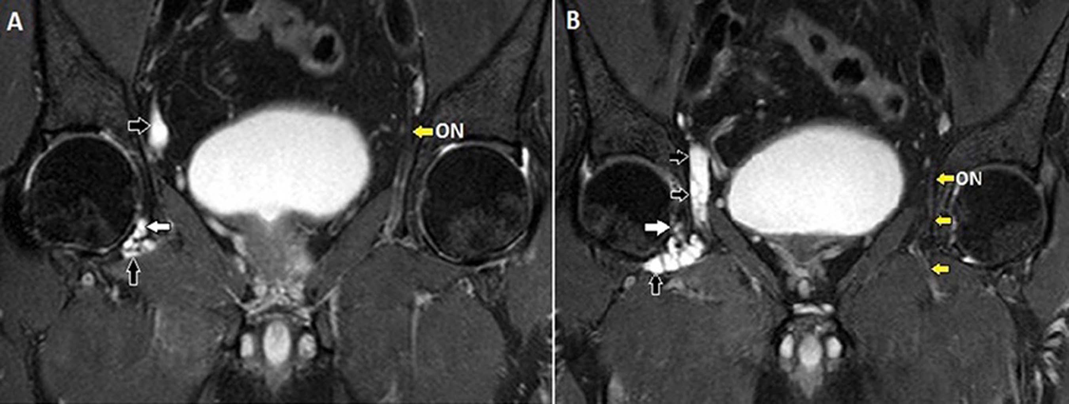
Figure 7 Images A, B show serial, T2-weighted fat suppressed coronal sections of the pelvis that demonstrates the longitudinally oriented intraneural cyst in the right obturator nerve (black arrows). The extension along the articular branch to the anteromedial aspect of right hip joint (white arrows) is also seen. Note the normal left obturator nerve (ON, yellow arrows). Reprinted with permission from Acta Neurologica Belgica.

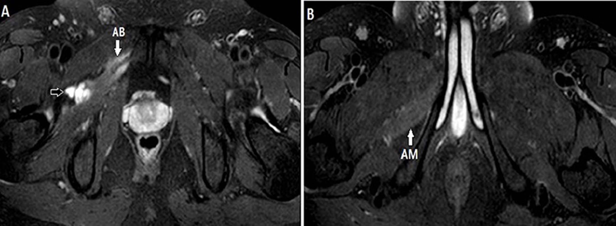
Figure 8 Image A, B show serial, T2-weighted fat suppressed axial images of the pelvis that demonstrates the further inferior extension of the cyst along the anterior branch of the obturator nerve (black arrow). Note the denervation atrophy of adductor brevis (AB) and magnus (AM) muscles. Reprinted with permission from Acta Neurologica Belgica.

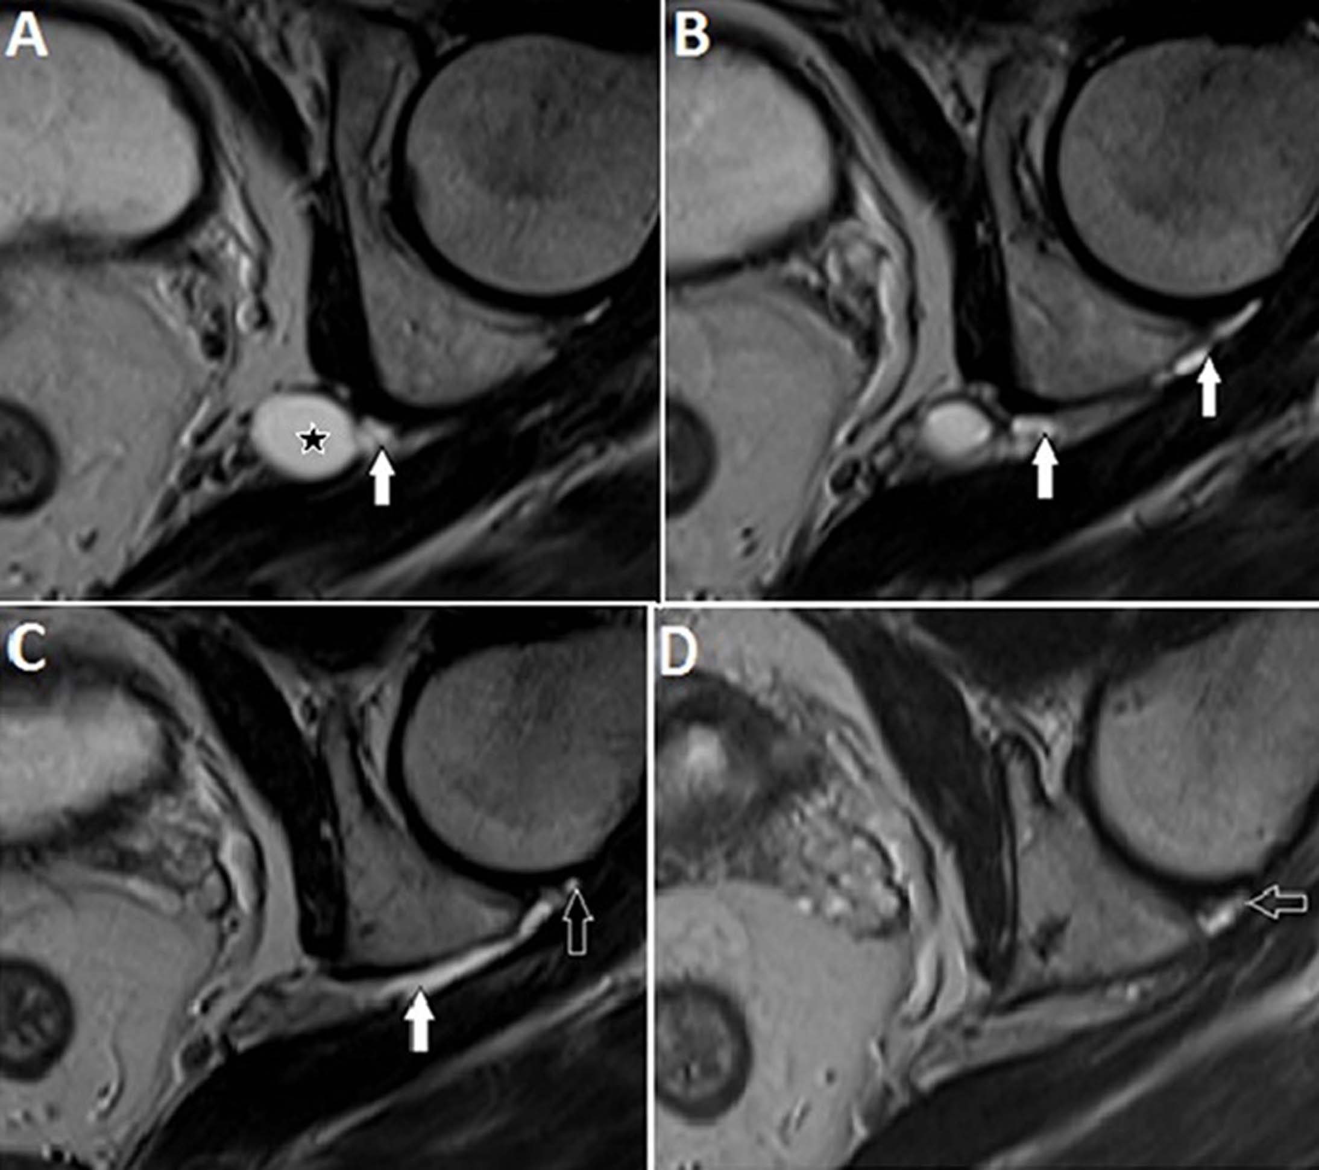
Figure 9 Image A-D show serial, T2-weighted, FSE axial sections of the left hip joint highlighting a cyst (star) at the level of the left sciatic notch. An extension along the expected course of the articular branch of the sciatic nerve (white arrows) communicating with the posteromedial aspect of the ipsilateral hip joint (open arrows) is also seen.

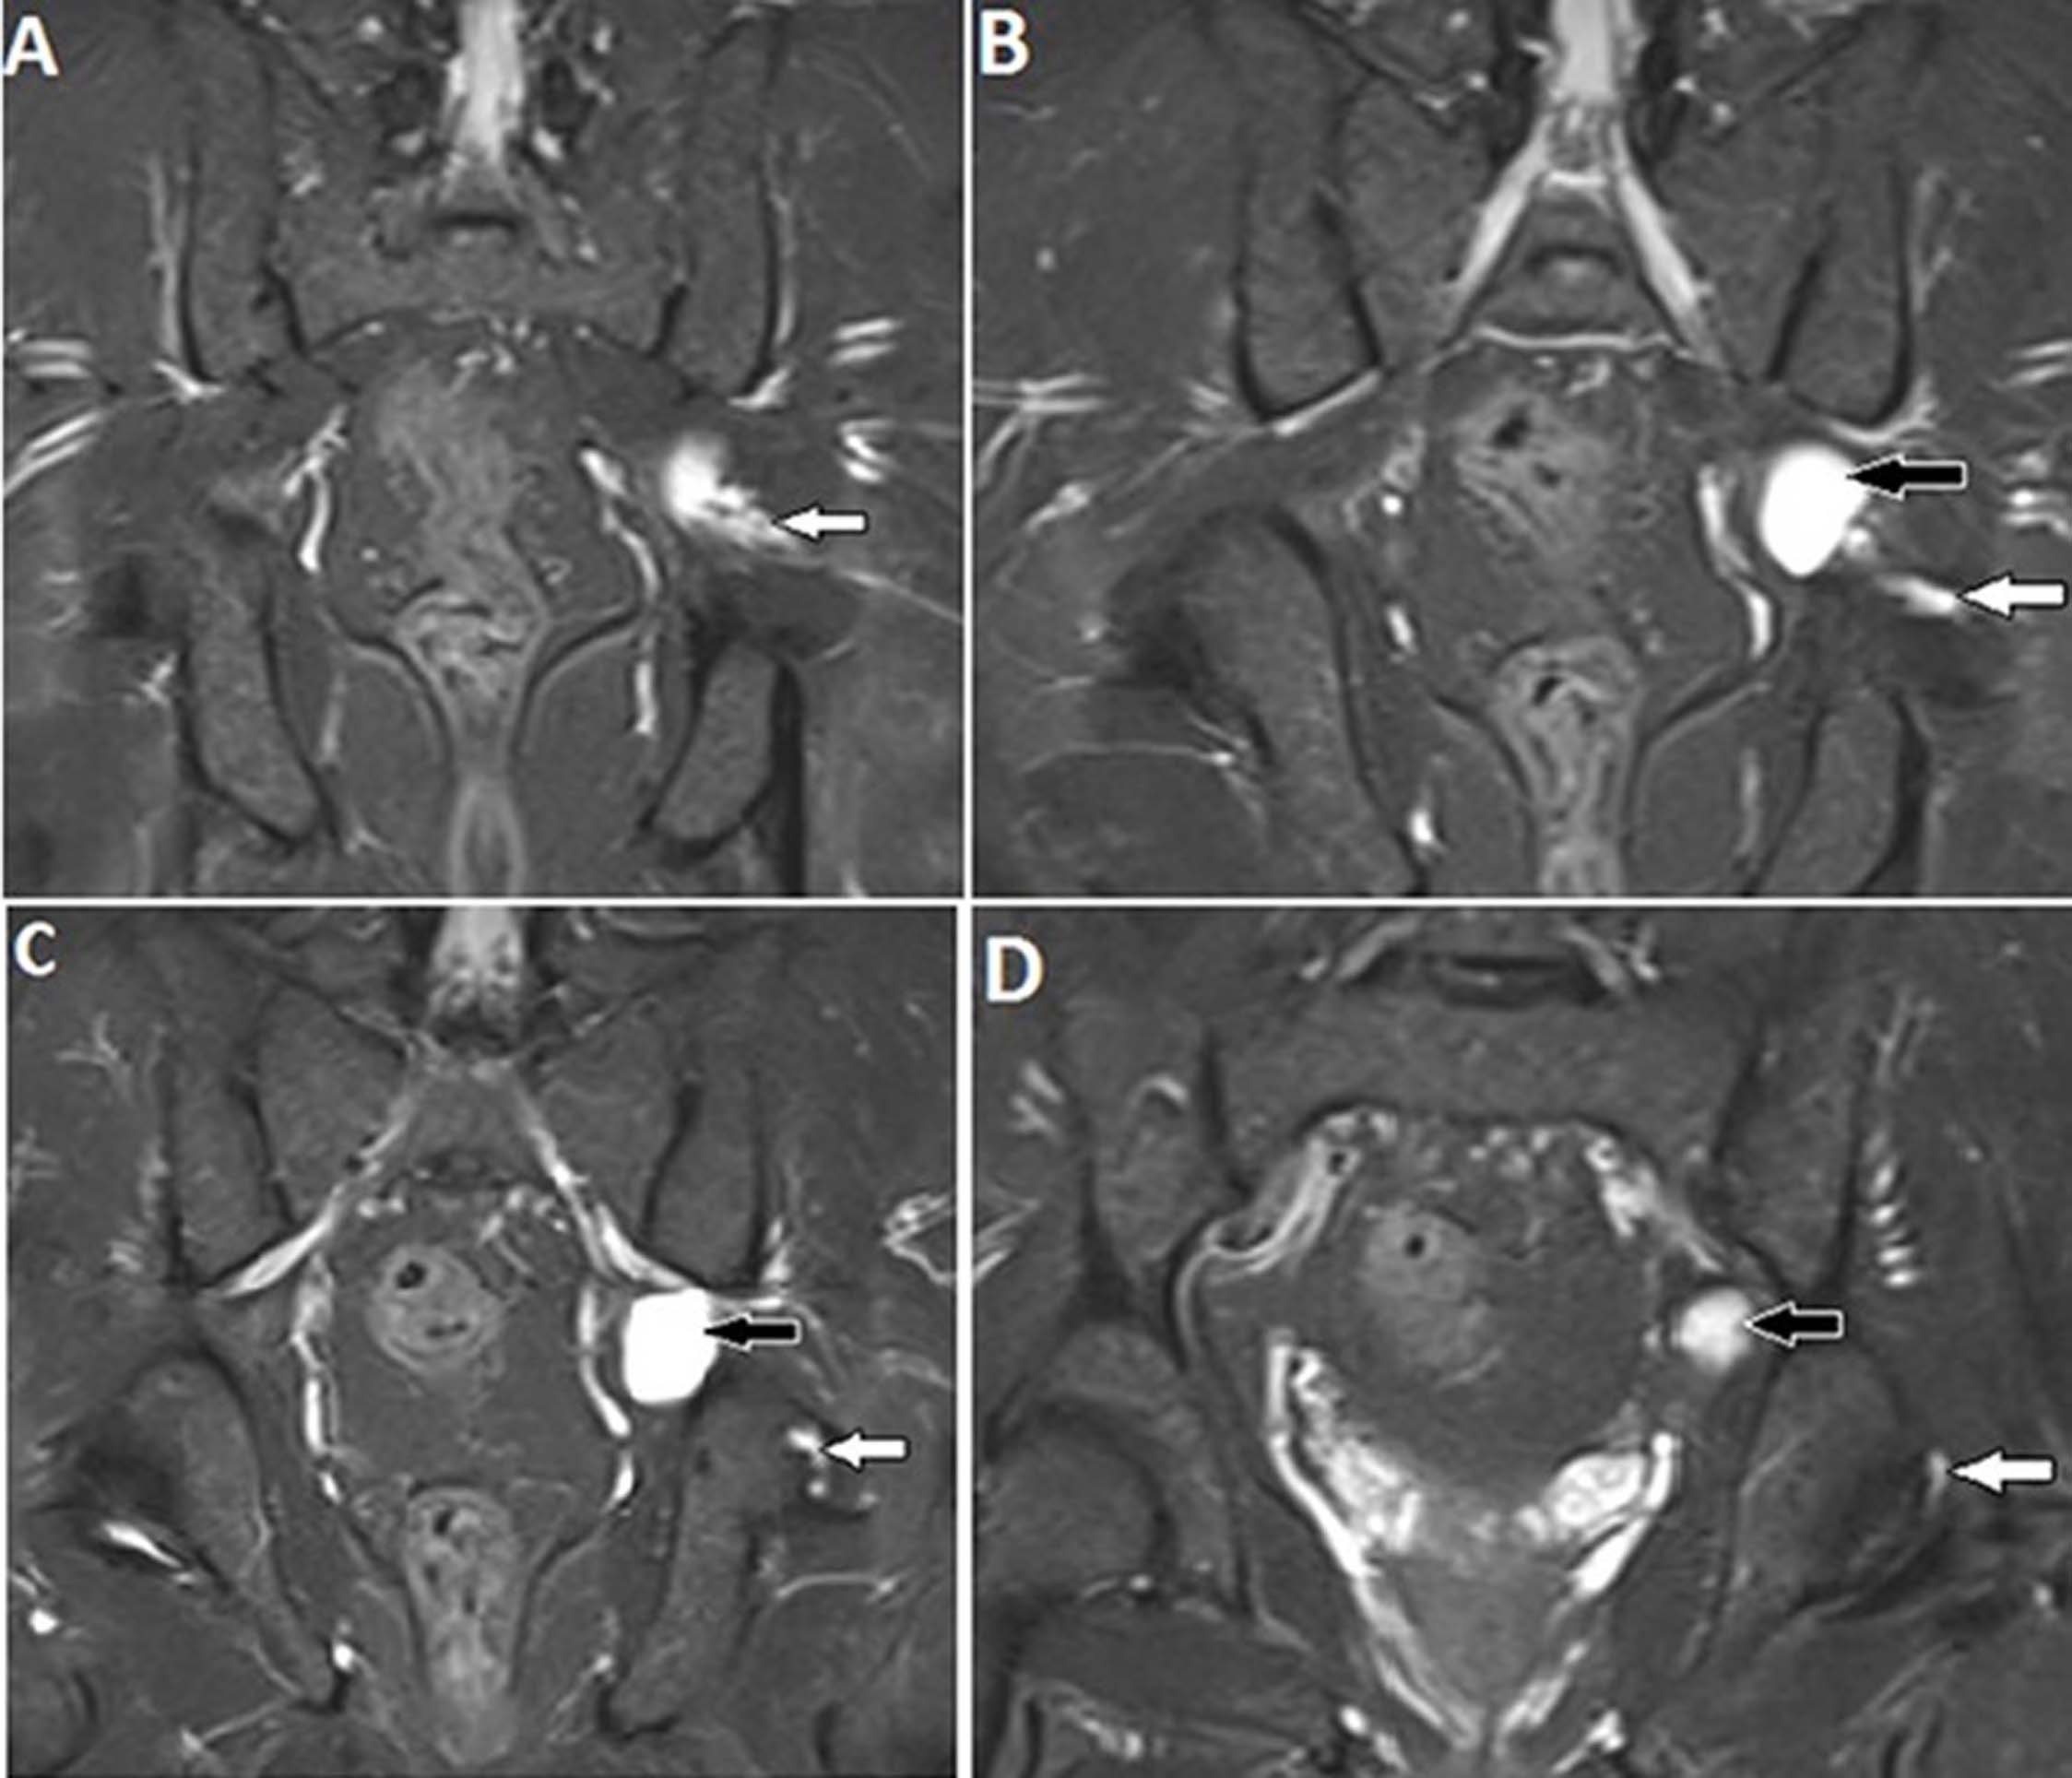
Figure 10 Images A-D show serial, T2- weighted fat suppressed coronal sections of the pelvis, demonstrate a cyst (black arrows) at the level of the left sciatic notch. The cyst extends along the articular branch of the sciatic nerve (white arrows) and communicates with the posteromedial aspect of the ipsilateral hip joint (D). No obvious labral or capsular tear or degeneration of joint is noted.

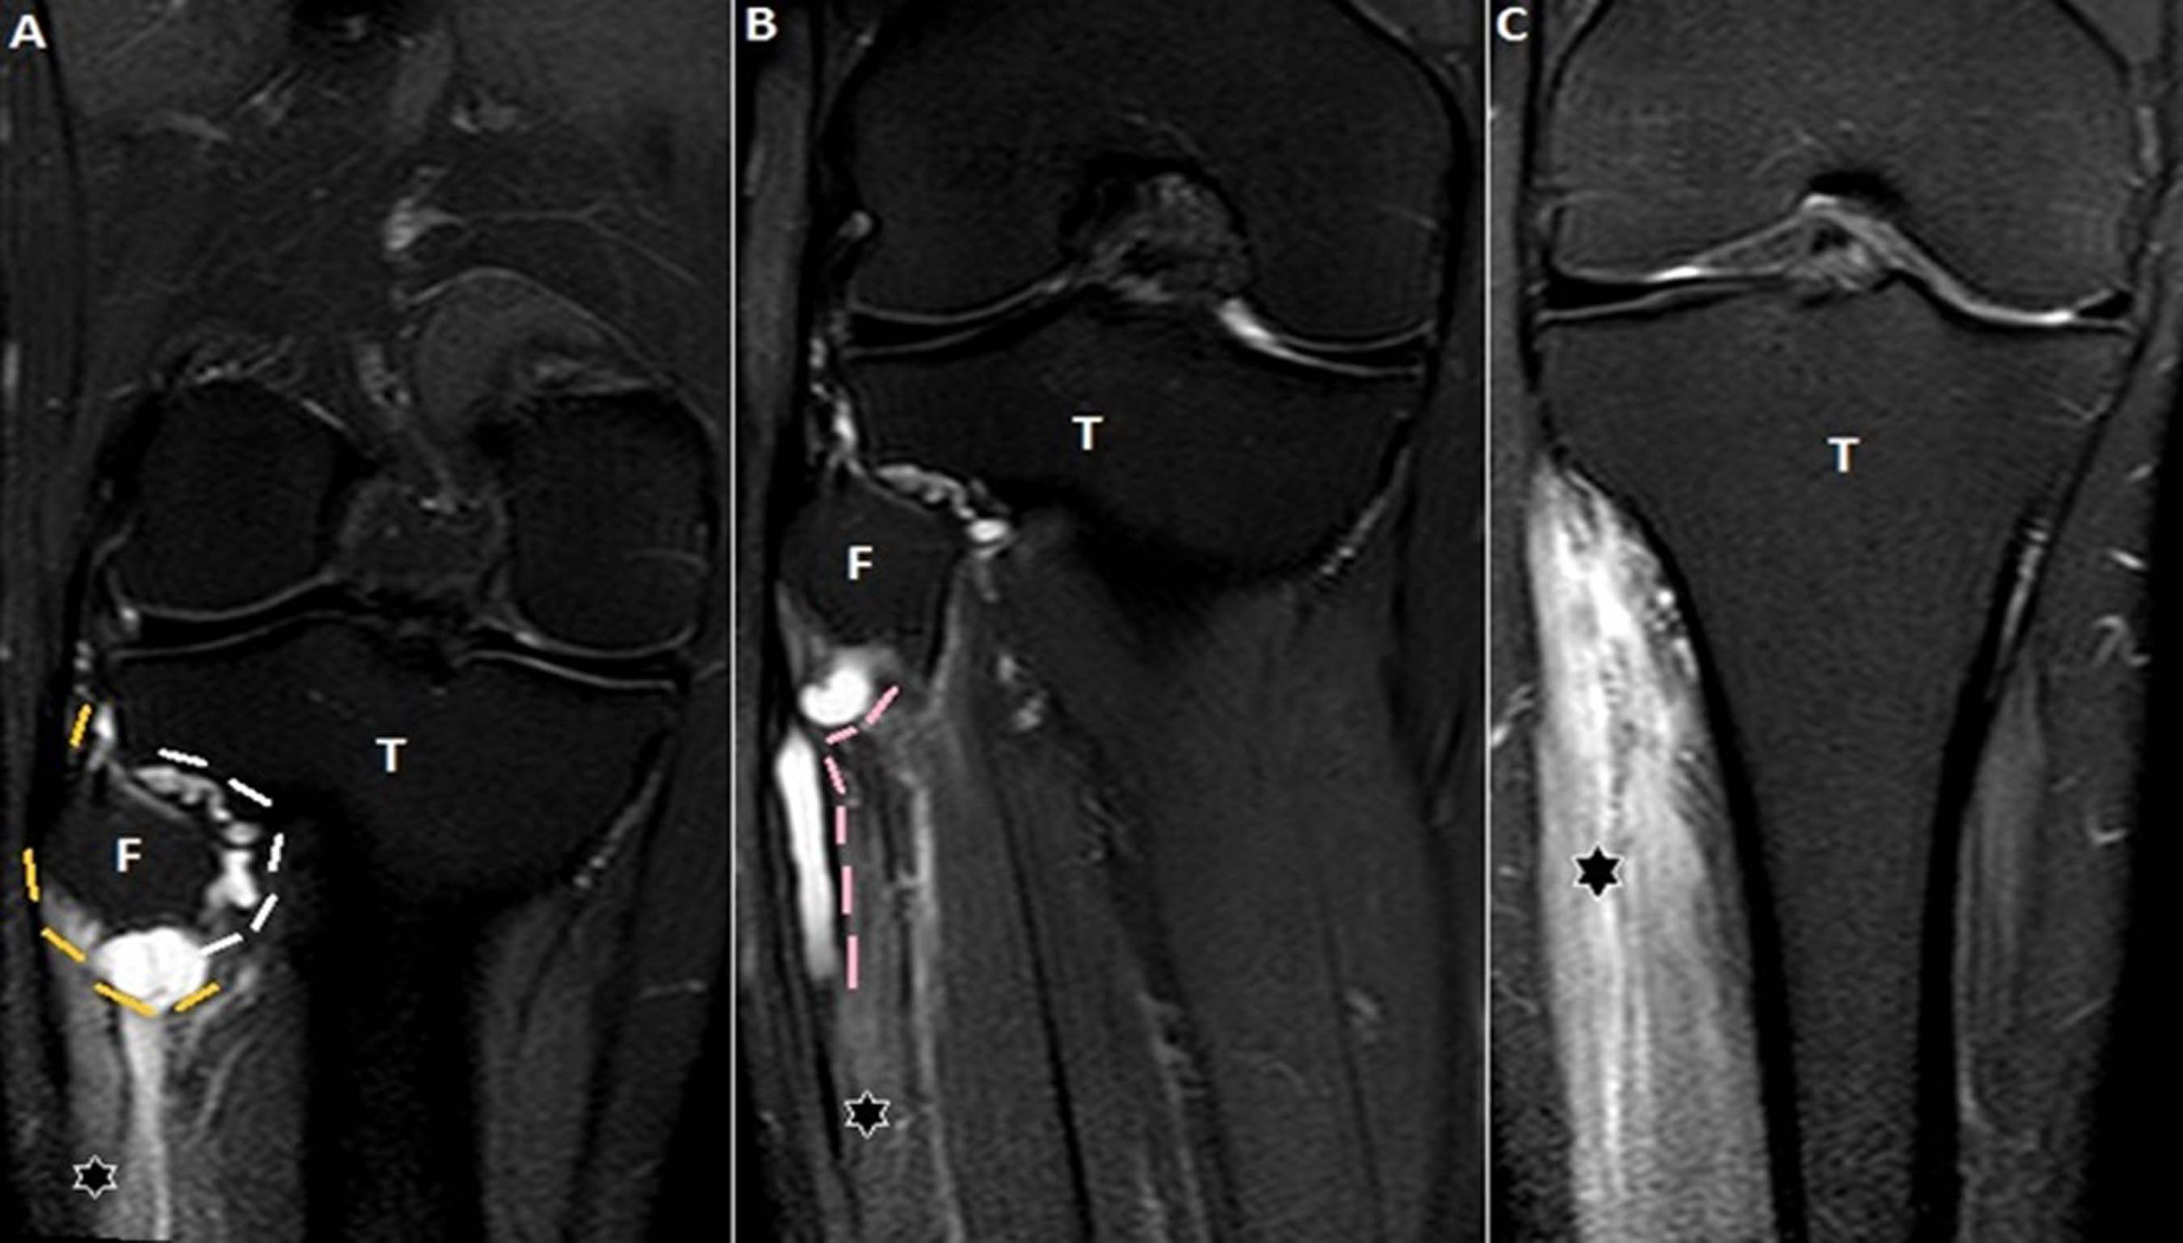
Figure 11 Images A-C show serial, coronal, proton density fat suppressed sections of the knee and proximal leg. The entire extent of the cyst within the articular branch (white dashes) to the PTF joint extending to the CPN (yellow dashes) at the posterolateral fibular neck is seen, demonstrating the “u-sign” (A). The cyst extends into the proximal portion of the superficial peroneal nerve (pink dashes) for a length of approximately 5 cm (B). Denervation hyperintensity of the muscles (stars) of anterior and peroneal compartments of the leg is also seen. T: Tibial; F: Fibula; PTF: Proximal tibiofibular; CPN: Common peroneal nerve.

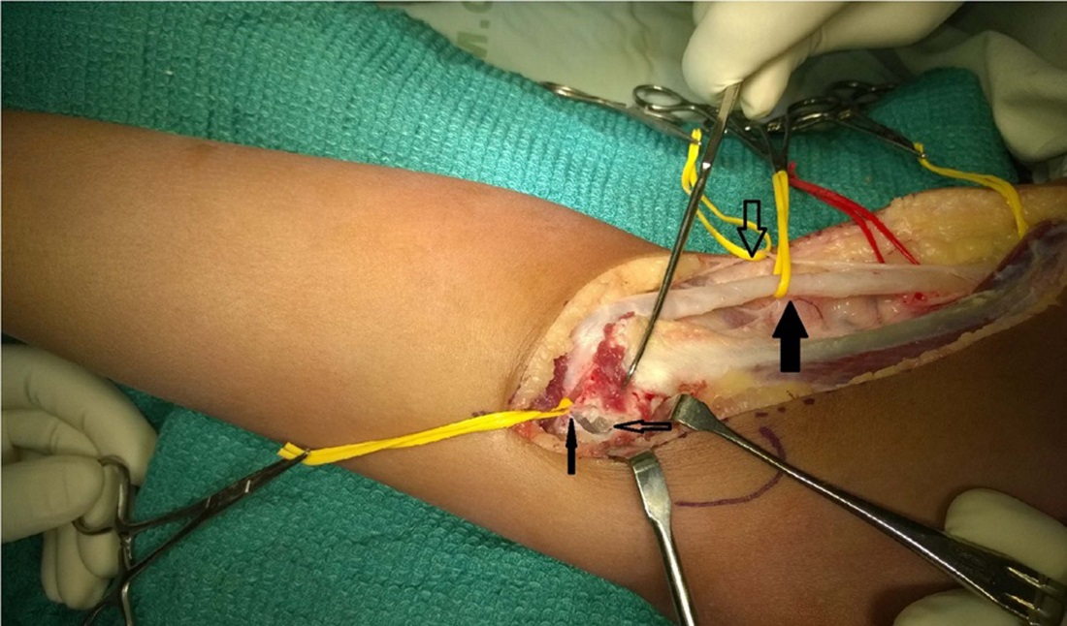
A

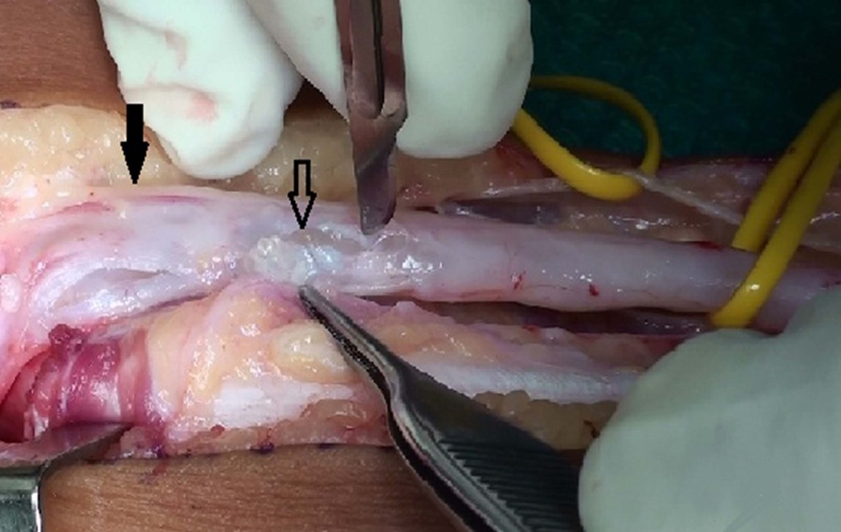
B
Figure 12 The intraoperative images of one of these patients. A: Surgical exposure and decompression of the CPN in a 9-year-old girl presenting with foot drop. The intraoperative picture shows a thickened CPN (thick block arrow); the sural communicating branch of the CPN (thick hollow arrow); the articular branch of the CPN (thin block arrow) and the arthrotomy of the PTF joint and a mucinous cyst within it (thin hollow arrow); B: Close up of the CPN, being decompressed with multiple stab incisions with mucin (hollow arrow) within the substance of the nerve. The superficial peroneal branch of the nerve (block arrow) appeared unaffected which correlated clinically. PTF: Proximal tibiofibular; CPN: Common peroneal nerve.

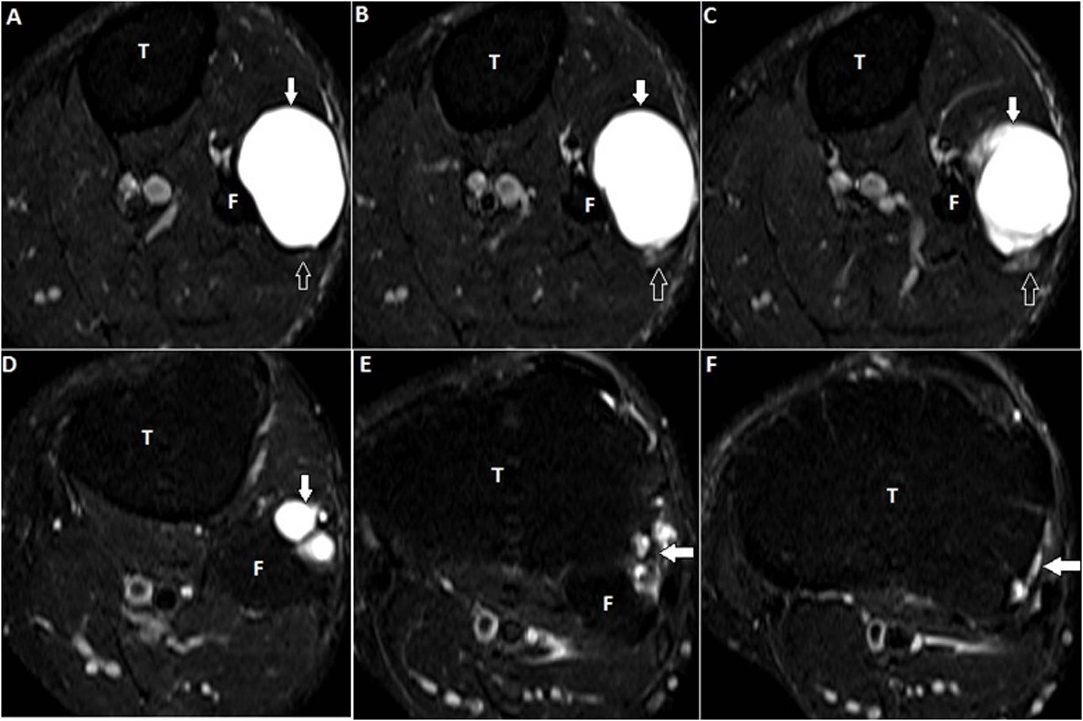
Figure 13 Images A-F show serial, T2-weighted fat suppressed axial sections of the proximal leg and demonstrate a large multilobulated globular extra-neural ganglion cyst (block arrows). The ENGC is antero-lateral to the proximal fibula and indenting the peroneus longus muscle anteriorly (A-C). The CPN (open arrows) lies posterior to the cyst but is seen separate from it. The tail of the cyst (arrows in D-F) extends superiorly and communicates with the superior aspect of the PTF joint. PTF: Proximal tibiofibular; CPN: Common peroneal nerve; ENGC: Extraneural ganglion cyst.

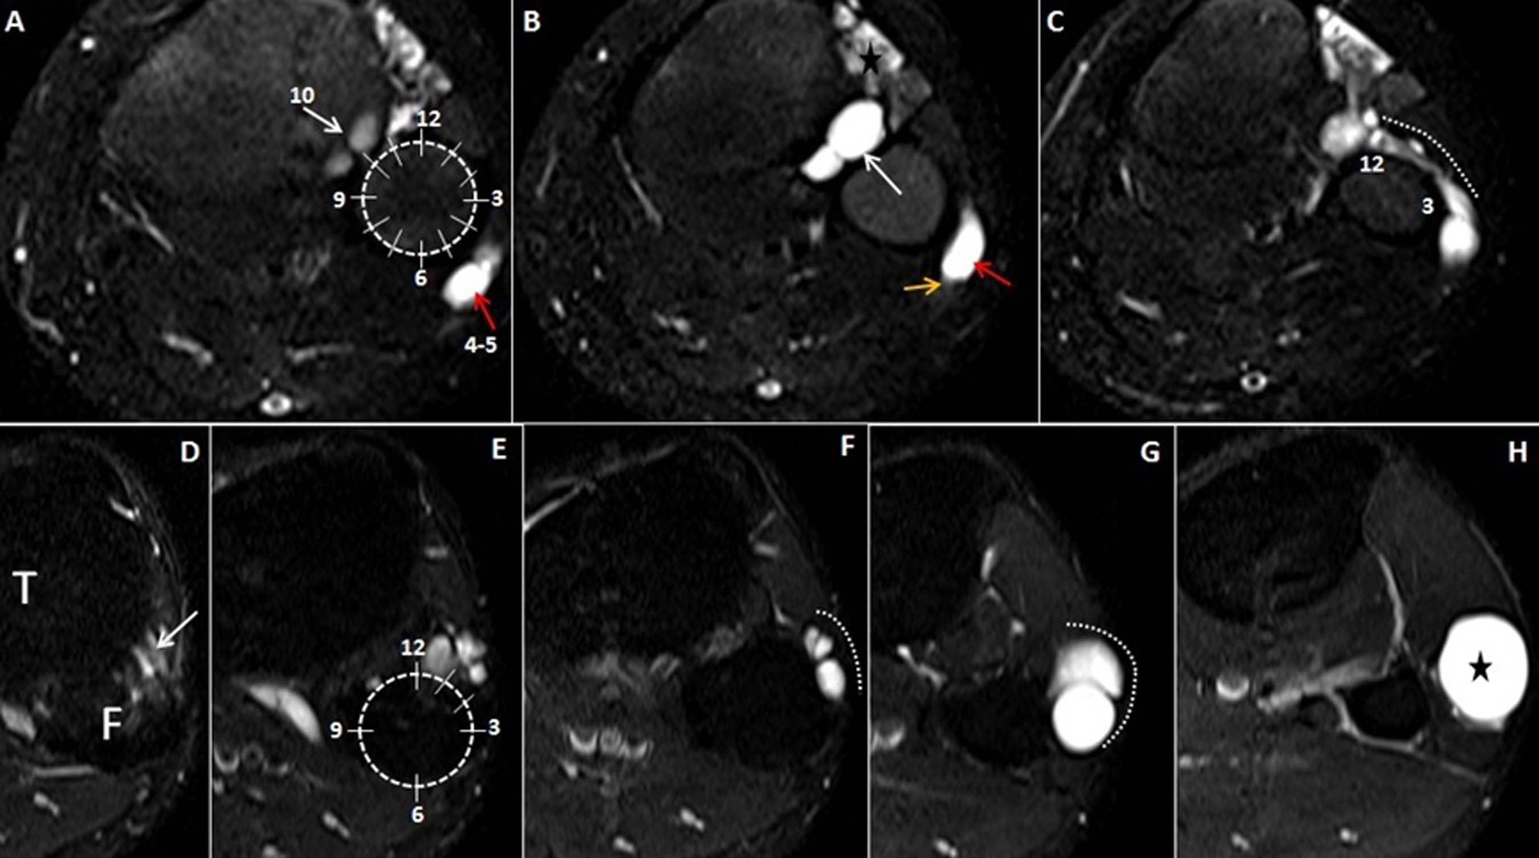
Figure 14 Axial, T2-weighted fat suppressed images A-H of the proximal leg show the left clock face model to differentiate intraneural ganglion cyst from extraneural ganglion cyst. A-C represent INGC where images A, B (at the upper-mid fibular head level) depict the joint connection of the cyst at the 10 o’clock (white arrows) which signifies the “tail sign”. The cyst (red arrows) within the outer epineurium of the CPN (yellow arrow), between the 4 and 5 o’clock position represents the “signet ring sign”. Image C, (at the level of fibular neck) shows the extension of the cyst along the ascending limb of the articular branch (dotted white line) depicting the “transverse limb sign”. It crosses the anterior surface of fibula from the PTF joint and progresses clockwise from 12-3 o’clock position around the fibular head. On the other hand, images D-H, depicting ENGC show a more superiorly located joint connection (white arrow) in between 12-2 o’clock position in images D, E. It lies anterolateral to the fibula (dotted white line) and never crosses it as seen in images F, G. The cyst (star) is more globular and lying in the intermuscular plane as seen in the image H. INGC: Intraneural ganglion cyst; CPN: Common peroneal nerve; ENGC: Extraneural ganglion cyst.

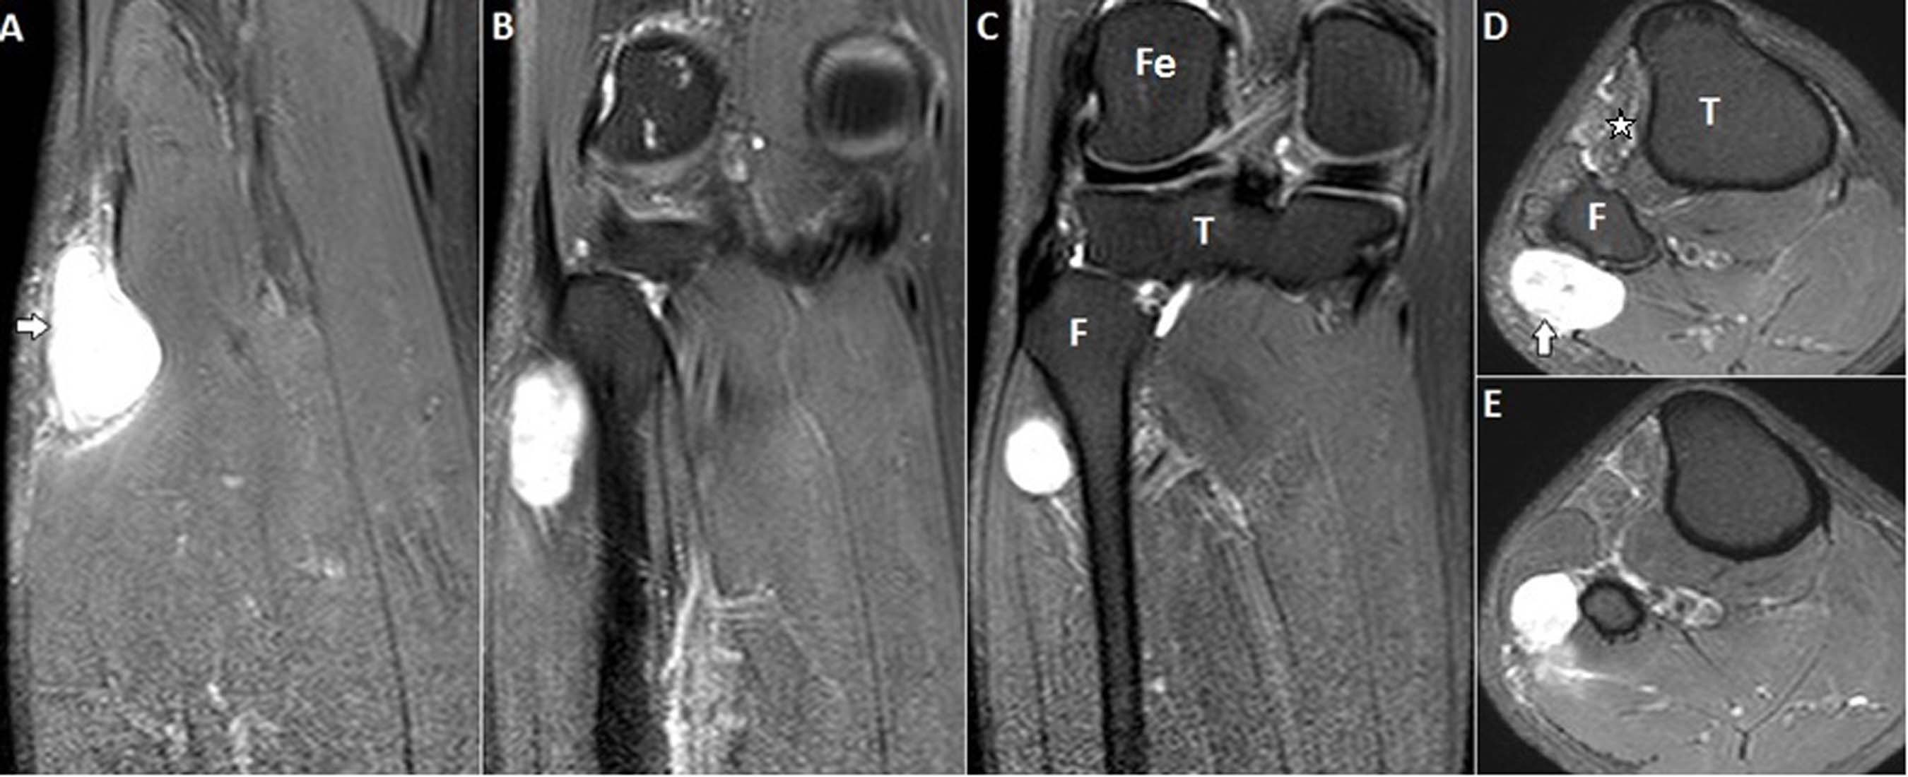
Figure 15 Serial, coronal, (images A-C), and axial, (images D-E), proton density fat suppressed sections show a well-defined oval cystic lesion at the posterolateral aspect of upper fibula along the expected course of common peroneal nerve which does not communicate within the proximal tibiofibular joint. Mild denervation edema is seen in the anterior compartment muscles (star). This is a case of cystic schwannoma involving the CPN. T: Tibia; F: Fibula; Fe: Femur; CPN: Common peroneal nerve.

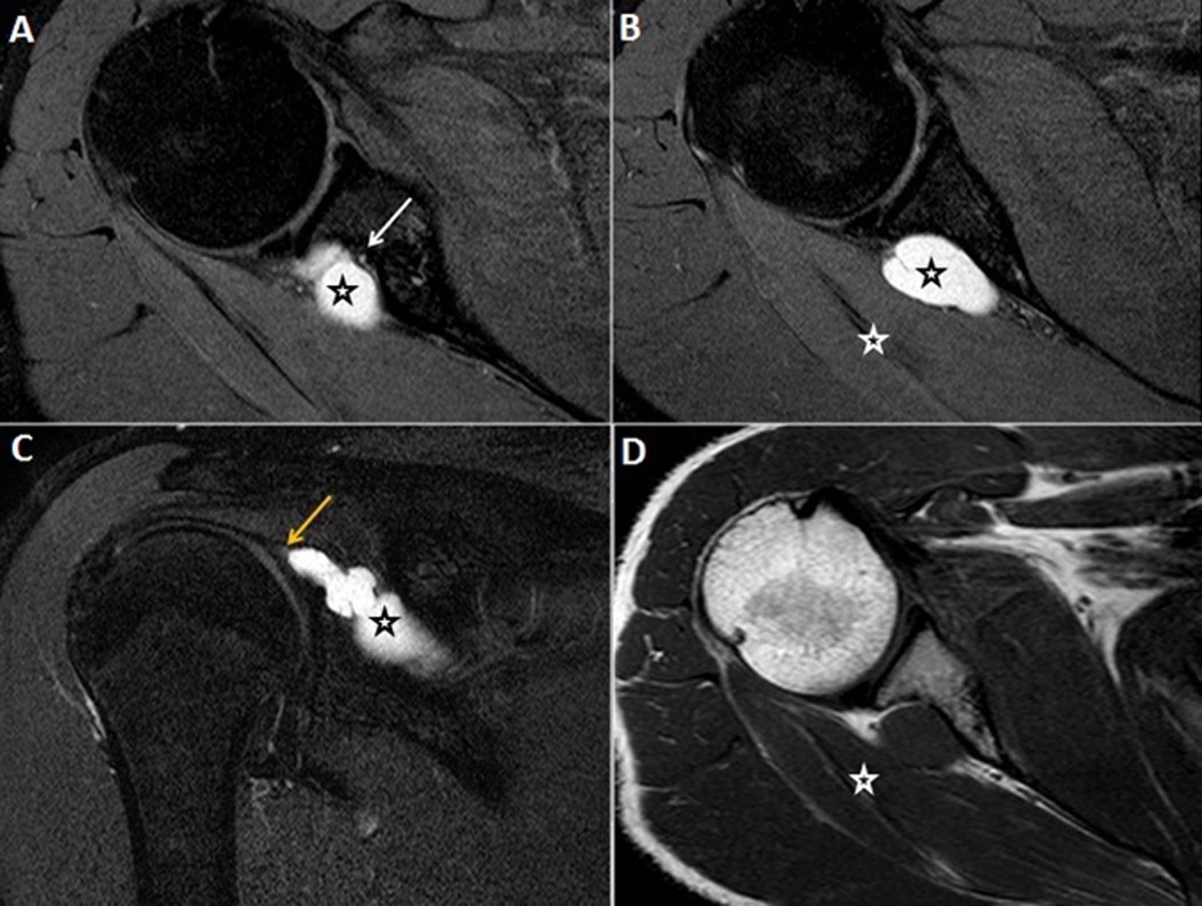
Figure 16 Proton density fat suppressed, serial axial (A, B); coronal (C) and T1-weighted, axial (D) show a well-defined lobulated slightly elongated cystic lesion (black stars) at the spinoglenoid notch compressing upon the suprascapular nerve (white arrow), which is seen separately from the cyst with preserved fat plane. There is a tail like communication (yellow arrow) of the cyst with the posterior labrum. This suggests labral tear with paralabral cyst formation. Denervation edema and mild volume loss in the infraspinatus muscle (white stars) is seen.

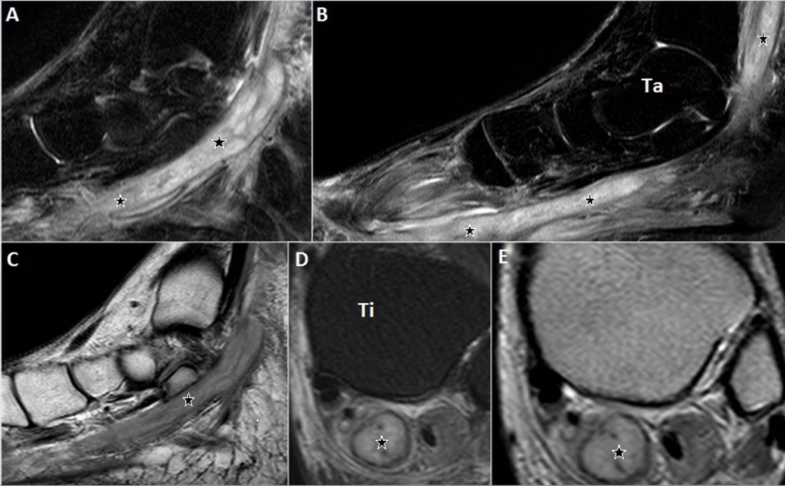
Figure 17 T2-weighted fat suppressed, serial sagittal (A, B); T1-weighted, sagittal (C); T2-weighted fat suppressed, axial (D) and proton density-weighted, axial (E) show an elongated tubular cystic lesion (stars) along the posterior tibial nerve at the lower leg, ankle and foot. The lesion is seen within the substance of the nerve and has a central cystic component (stars) and a peripheral thin wall consistent with an abscess (D, E). This is a case of Hansen’s disease with posterior tibial nerve abscess.

Table 1 Inclusion criteria for intraneural ganglion cyst
Multilocular elongated hyperintense cystic mass on T2 weighted imaging
Distributed along the course of a peripheral nerve and its branches
Extension along the articular branch to the adjacent joint
Denervation changes of the muscles supplied by involved nerve

Table 2 Epidemiological data of patients diagnosed with cystic lesions related to the nerve
Patient data | Intraneural ganglion cyst | Extraneural ganglion cyst | Para-labral cyst | Cystic schwannoma | Nerve abscess
Total number of lesions | 13 | 10 | 6 | 8 | 8
Mean age (yr)  SD | 38.2  14.66 | 30.5  16.42 | 32  3.94 | 42.6  10.79 | 28.2  12.84
Common symptoms | Pain along distribution of nerve, motor weakness | Pain and swelling | Pain and weakness of external rotators | Parasthesia, pain along distribution of nerve | Parasthesia and weakness
Male:female ratio | 10:2 | 6:4 | 6:0 | 5:3 | 8:0
Nerves involved | CPN 7  Tibial 2  Suprascapular 2  Prox. Sciatic 1  Obturator 1 | Near  CPN 9  Radial 1 | Near  SSN 6 | CPN 3  Median 2  Sciatic 1  Tibial 1  Radial 1 | Ulnar 5¹  CPN 2¹  Median 3¹  Radial 3¹
Number who underwent surgery | 6/13 | 10/10 | 6/6 | 8/8 | 3/8
Correct diagnosis on MRI | 7/13 | 8/10 | 6/6 | 8/8 | 8/8
¹Combined involvement of multiple nerves. MRI: Magnetic resonance imaging.

Table 3 Summery of magnetic resonance imaging findings of intraneural ganglion cyst of peripheral nerves
SN | Involved Nerve | Extension |  |  | Labral or Capsular Tear | Joint abnormality | Muscle  denervation
 |  | Anatomical extent along the parent nerve | Branches | Intra-articular extension
1. | Rt CPN | Upto sciatic bifurcation | Recurrent articular | Anterior aspect of PTF joint | Negative | - | Muscles of anterolateral compartment of leg
2. | Lt CPN | Upto posterolateral fibular head | Recurrent articular, deep peroneal | Anterior aspect of PTF joint | Negative | - | -
3. | Rt CPN | Upto sciatic bifurcation | Recurrent articular, superficial and deep peroneal | Anterior aspect of PTF joint | Negative | - | Muscles of anterolateral compartment of leg
4. | Lt CPN | Upto posterolateral fibular head | Recurrent articular, deep peroneal | Anterior aspect of PTF joint | Negative | - | -
5. | Lt CPN | Upto posterolateral fibular head | Recurrent articular, deep peroneal | Anterior aspect of PTF joint | Negative | - | Muscles of anterolateral compartment of leg
6. | Rt CPN | Upto posterolateral fibular head | Recurrent articular | Anterior aspect of PTF joint | Negative | - | Muscles of anterolateral compartment of leg
7. | Rt CPN | Upto neck of fibula | Recurrent articular | Anterior aspect of PTF | Negative |  | -
8. | Rt obturator | Along the lateral pelvic wall to pelvic brim | Anterior division | Anteromedial aspect of hip joint | Negative | - | Adductor brevis and magnus
9. | Rt suprascapular | Suprascapular to spinoglenoid notch | - | - | Negative | - | Supra and infraspinatus
10. | Lt proximal sciatic | At sciatic notch | Articular | Posteromedial aspect of hip joint | Negative | - | -
11. | Rt tibial | Upto tibial nerve | Articular, branch to popliteus muscle | Posterior aspect of PTF joint | Negative | - | -
12. | Lt tibial | Upto sciatic bifurcation | Articular, branch to popliteus muscle, branch to tibialis posterior muscle | Posterior aspect of PTF and knee joints | Negative | - | Popliteus and tibialis posterior
13. | Rt suprascapular | From the level of AC joint to below the spinoglenoid notch | Articular branch to AC joint | AC joint | Negative | - | -
PTF: Proximal tibiofibular.

Table 4 Magnetic resonance features differentiating intraneural ganglion cyst from extraneural ganglion cyst
 | Intraneural ganglion cyst | Extraneural ganglion cyst
Cyst size | Small | Large
Cyst shape | Tubular beaded configuration | Globular
Cyst pattern and location | It is along the course of the nerve and its branches with no fat plane between the cyst and the nerve | It does not follow the course of the nerve; the nerve is seen separately from the cyst with an intervening preserved fat plane; usually located in between the fibula and peroneus longus muscle, with or without an intramuscular extension
PTF joint connection | Is present and the tail lies anteromedial to proximal fibula between 10-12 o’clock position on axial MR images | Is present but located more superiorly and anterolateral to the proximal fibula at 12–2 o’clock position on axial MR images
Relation with fibula | The extension of the cyst along the articular branch appears to cross the fibula from medial to lateral (“Transverse limb sign”) | The cyst never crosses the fibula and always lies anterior, anterolateral or lateral to the fibula (Absent “Transverse limb sign”)
Muscle denervation | Common | Uncommon
MR: Magnetic resonance.

