Name of Journal: World Journal of Meta-Analysis
Manuscript NO: 70592
Manuscript Type: META-ANALYSIS

MicroRNAs as prognostic biomarkers for survival outcome in osteosarcoma: A meta-analysis

Gao SS et al. MicroRNAs’ prognostic function in osteosarcoma

Shuai-Shuai Gao, Guo-Xun Zhang, Wen-Ting Zhang

Shuai-Shuai Gao, Guo-Xun Zhang, Wen-Ting Zhang, International Doctoral School, University of Seville, Seville 41004, Spain

Shuai-Shuai Gao, Department of Traumatology and Orthopedic Surgery, Xi'an Daxing Hospital, Xi'an 710016, Shaanxi Province, China

Author contributions: Gao SS drafting the article; Gao SS and Zhang GX searching of literature, acquisition of data; Gao SS and Zhang WT analysis and interpretation of data; Gao SS, Zhang GX and Zhang WT did final approval; Zhang GX revising the article; Zhang WT conception and design of the study, critical revision.

Corresponding author: Wen-Ting Zhang, PhD, Doctor, International Doctoral School, University of Seville, Calle San Fernando, 4, Seville 41004, Spain. 724521882@qq.com

Received: August 7, 2021
Revised: October 8, 2021
Accepted: December 24, 2021
Published online: December 28, 2021

Abstract
BACKGROUND
Osteosarcoma was considered to be one of the most prevalent malignant bone tumors in adolescents.

AIM
To explore the prognostic significance of microRNA (miRNA) in osteosarcoma.

METHODS
The literature was selected by searching online in PubMed, Embase, Web of Science, Cochrane Library, China National Knowledge Infrastructure, and Wanfang Database until July 1, 2021. The pooled hazard ratio (HR) with corresponding 95% confidence interval (CI) for the outcomes of overall survival (OS), disease-free survival (DFS), progression-free survival (PFS) and recurrence-free survival were calculated. Subgroup analyses were carried out to identify potential sources of heterogeneity. Publication bias was assessed by Egger’s bias indicator test.

RESULTS
A total of 60 studies from 54 articles with 5824 osteosarcoma patients were included for this meta-analysis. The pooled HR for OS, DFS, PFS were 2.92 (95%CI: 2.43-3.41, P = 0.000), 3.70 (95%CI: 2.80-4.61, P = 0.000), and 3.57 (95%CI: 1.60-5.54, P = 0.000), respectively. The high miR-21 expression levels were related to poor OS in osteosarcoma (HR = 2.86, 95%CI: 1.20-4.53, P = 0.001). Subgroup analysis demonstrated that a high expression level of miRNA correlated with worse OS (HR: 3.56, 95%CI: 2.59-4.54, P = 0.000). In addition, miRNA from tissue (HR: 3.20, 95%CI: 2.16-4.23, P = 0.000) may be a stronger prognostic biomarker in comparison with that from serum and plasma.

CONCLUSION
miRNA (especially miR-21) could be served as a potential prognostic biomarker for osteosarcoma. A high expression level of miRNA in tumor tissue correlated with worse OS of osteosarcoma.

Key Words: Osteosarcoma; MicroRNA; Prognosis; Biomarker; Meta-analysis

©The Author(s) 2021. Published by Baishideng Publishing Group Inc. All rights reserved.

Citation: Gao SS, Zhang GX, Zhang WT. MicroRNAs as prognostic biomarkers for survival outcome in osteosarcoma: A meta-analysis. World J Meta-Anal 2021; 9(6): 568-584
URL: https://www.wjgnet.com/2308-3840/full/v9/i6/568.htm
DOI: https://dx.doi.org/10.13105/wjma.v9.i6.568

Core Tip: Osteosarcoma is a common primary malignant bone tumor with a high degree of malignancy and poor prognosis. MicroRNA can be used as a valuable biomarker for the prognosis of osteosarcoma.

INTRODUCTION
Osteosarcoma was considered to be one of the most prevalent malignant bone tumors in adolescents. These kind of tumors have an insidious onset, rapid progress, and a high degree of malignancy^{[1]}. The global incidence of osteosarcoma is 4.4 cases per million people^{[2]}. The most common locations of this tumor were the distal femur and proximal tibia, they may also involve the shoulders, mandible, skull and pelvis^{[3]}. The main treatment therapies currently for patients with osteosarcoma are extensive tumor resection, neoadjuvant chemotherapy, and radiotherapy. However, it is well known that patients with osteosarcoma are prone to local relapse and distant metastasis (the most common being lung metastasis), and so the prognosis of osteosarcoma is still unfavorable^{[4]}. The 5-year survival rate of patients with osteosarcoma without metastatic disease is 70%, but for patients with metastasis or relapse it is only 27.4%^{[5]}. At present it is difficult to determine the early stage of treatable osteosarcoma, as a result, it is urgent to determine potential biomarkers that can be used to accurately assess the prognosis of osteosarcoma.
MicroRNA (miRNA) is a group of small non-coding single-stranded RNA that can interfere with the translation of many proteins after gene transcription^{[6]}. MiRNAs participates in diverse biological processes^{[7]}, and can act as tumor suppressor genes as well as oncogenes^{[8]}. Therefore, miRNAs may be capable of offering a sensitive method for the diagnosis, monitoring and prognosis of osteosarcoma. Previous studies have shown that miRNAs have been proposed as a valuable biomarkers for the diagnosis^{[9]} and prognosis of osteosarcoma^{[10]}. Although numerous studies have reported the correlation between the prognosis of osteosarcoma and miRNA expression, the results were inconsistent^{[11-14]}.

MATERIALS AND METHODS
Literature search strategy
This meta-analysis was performed according to the guidelines of the Meta-analysis of Observational Studies in Epidemiology^{[15]}. To identify relevant studies, two investigators independently and systematically searched online in PubMed, Embase, Web of Science, Cochrane Library, China National Knowledge Infrastructure, and Wanfang Database until July 1, 2021. The combination of keywords used were (“osteosarcoma” or “osteosarcoma tumor”) and (“microRNA” or “miRNA” or “miR”) and (“prognosis” or “prognostic” or “survival” or “outcome”). Although this online search had no language restrictions, it was limited to publications with human subjects.

Inclusion and exclusion criteria
Included studies met the following criteria: (1) Studies that investigated the prognostic value of miRNAs in osteosarcoma; (2) Assayed type either blood or tissue samples; (3) Studies that presented sufficient data to allow calculation of hazard ratio (HR) and 95% confidence interval (CI); and (4) Studies that clearly defined the cut-off and described the miRNA measurement method. Studies were excluded if they had one or more of the following criteria: (1) Duplicated or retracted studies; (2) Case reports, comments, letters, review articles or meta-analysis; (3) The obtained miRNAs were from animals or cell lines; and (4) Studies that did not have survival outcomes report or where the data presented was not sufficient to estimate HR.

Data extraction and quality assessment
All data were extracted independently by two investigators. The extracted data were as follows: first author, publication year, country, miRNA type, miRNA expression with poor prognosis (high or low), sample size, specimen type (serum, plasma, or tissue), cut off value, follow-up time (basic unit: month), clinical outcomes, detection method, survival analysis methods, and HR values of miRNAs for predicting overall survival (OS), disease-free survival (DFS), progression-free survival (PFS), and recurrence-free survival (RFS), as well as their 95%CI and P values. For studies that did not directly report HR values and 95%CI, we calculated those from the given Kaplan-Meier (K-M) curves by using Engauge Digitizer^{[16,17]}. In case of different publications that investigated the same cohort patients, we selected the most complete research. Also, when univariate and multivariate analysis were carried out at the same time, we chose the last as the more precise result. The quality of all the selected studies was assessed independently by two investigators according to the guidelines of the Newcastle-Ottawa scale (NOS)^{[18]}. The total score of NOS ranged from 0 to 9, studies with a score ≥ 6 were considered as high quality.

Statistical analysis
All statistical analyses were carried out using STATA package version 13.0. The pooled HR with 95%CI was calculated to evaluate the correlation between miRNA expression and the clinical outcome (OS, DFS, PFS, and RFS) of osteosarcoma patients. A pooled HR < 1 implied a more favorable prognosis in patients with aberrant miRNA, and a pooled HR > 1 implied a poor prognosis. Heterogeneity among the studies was assessed using Cochran’s Q test and Higgins’s I² statistics. A random effect model was applied if heterogeneity was observed (P < 0.10 or I² > 50%), while a fixed effect model was applied in the absence of heterogeneity (P ≥ 0.10 or I² ≤ 50%). Subsequently, subgroup analyses for OS were carried out to identify potential sources of heterogeneity and to assess the prognostic value of different subgroups. In addition, sensitivity analysis was carried out to explore the impact of one single study on the pooled HR. Publication bias was evaluated using the Egger's bias plot^{[19]}, where P < 0.05 indicates significant publication bias.

RESULTS
Literature search results
The detailed literature search results are presented in Figure 1. The primary search identified 6327 articles. After excluding 2486 duplicate studies, 3841 articles remained. Secondly, 3698 studies were excluded after screening titles and abstracts, among which 2674 irrelevant research, 736 not human research, and 288 case report, letters or reviews. Subsequently, through careful reading and screening of the full text of 143 studies, 89 studies were excluded due to insufficient data. Finally, 60 studies from 54 articles were included in our meta-analysis.

Characteristics of studies
In Table 1 and Table 2, we summarized the basic information of included studies. A total of 5824 osteosarcoma patients across the 60 studies were included in this meta-analysis, among them 58 studies were conducted in China, 1 in United States and 1 in Japan. These studies have reported 51 miRNAs with different prognostic values. Among the articles included in this meta-analysis, 27 studies showed high miRNA expression and 33 studies showed low miRNA expression, indicating poor prognosis of osteosarcoma. The expression levels of miRNAs from 28 serum specimens, 6 plasmas specimens, and 26 tissue specimens were analyzed using PCR. In most of the studies, the mean/median were considered as the critical cut-off values. The follow-up time of all the studies ranged from 30 mo to 150 mo, of which 40 studies had a follow-up time of less than 5 years, and 20 studies had more than 5 years of follow-up. All of the articles were analyzed to evaluate the correlation between miRNAs and survival outcomes: 60 studies for OS, 25 studies for DFS, 4 studies for PFS, and 2 studies for RFS. The HRs and 95%CIs were directly reported in 35 studies, and the values of HRs and 95%CI in the remaining 25 studies were extracted by K-M curve. Furthermore, we assessed the quality for each study that was included in this meta-analysis and found that the NOS score varied from 6 to 8, which means the quality of each study was high.

Meta-analysis in clinical outcome of osteosarcoma
This meta-analysis was conducted based on the survival endpoint used by each study. There were 60 studies evaluated OS of osteosarcoma, the pooled HR for OS was 2.92 (95%CI: 2.43-3.41, P = 0.000). For the 25 studies that evaluated DFS of patients, the pooled HR was 3.70 (95%CI: 2.80-4.61, P = 0.000). For the studies that tested PFS (n = 4) and RFS (n = 2) as their outcome assessments, the pooled HR were 3.57 (95%CI: 1.60-5.54, P = 0.000) and 3.71 (95%CI: 0.09-7.51, P = 0.056), respectively. The pooled HR of OS studies as well as that of DFS and PFS (P < 0.05) were found to be statistically significant; however, the effect of RFS studies did not reach the level of statistical significance. The forest plots of OS are presented in Figure 2A, and the forest plots of DFS, PFS and RFS are presented in Figure 2B.

Prognostic value of miR-21 in osteosarcoma
In our meta-analysis, there were three studies that assessed miR-21 as a predictor of OS in osteosarcoma. We calculated the pooled HRs for these studies by using the random-effects model. The results suggested that high expression levels of miR-21 are correlated with poor OS (HR = 2.86, 95%CI: 1.20-4.53, P = 0.001). In addition, there was only one study that accessed the correlation between miR-21 expression and DFS, which indicates that the high expression levels of miR-21 are correlated with poor DFS. Therefore, miR-21 may be used as a biomarker of poor prognosis in osteosarcoma.

Subgroup analyses
As shown in Table 3, six subgroup analyses of OS in osteosarcoma patients were done depending on miRNA expression, specimen, survival analysis, source of HR, follow-up, and country of publication. To analyze the prognostic value of miRNA expression in osteosarcoma, we assessed the subgroups for high expression and low expression levels of miRNA for OS. The high expression levels of miRNA showed a pooled HR of 3.56 (95%CI: 2.59-4.54, P = 0.000), while the low expression levels of miRNA showed a pooled HR of 2.23 (95%CI:1.74-2.72, P = 0.000) (Figure 3A). The results were found to be statistically significant for both high expression and low expression levels of miRNA; however, the high expression levels of miRNA were significantly correlated with poor prognosis in osteosarcoma. The pooled HR of different specimen of miRNAs are as follows: tissue, 3.20 (95%CI: 2.16-4.23, P = 0.000); serum, 3.04 (95%CI: 2.37-3.71, P = 0.000); plasma, 0.94 (95%CI: 0.36-1.51, P = 0.001) (Figure 3B). The result show that pooled HR for univariate analysis was 2.36 (95%CI: 1.67-3.04, P = 0.000) and for multivariate analysis was 3.29 (95%CI: 2.52-4.07, P = 0.000), and the pooled HR for univariate analysis and multivariate analysis was 2.73 (95%CI: 1.95-3.50, P = 0.000) (Figure 3C). As shown in Figure 3D, the pooled HR calculated directly from the original reported studies was 3.00 (95%CI: 2.21-3.79, P = 0.000), and the pooled HR calculated from K-M curve was 2.48 (95%CI: 1.92-3.04, P = 0.000). In addition, we found that miRNAs contributed to a different OS when the follow-up time for patients was different, the pooled HR for less than 5 years of follow-up time was 3.08 (95%CI: 2.44-3.71, P = 0.000), and the pooled HR for more than 5 years of follow-up time was 2.75 (95%CI: 1.88-3.63, P = 0.000) (Figure 3E). Furthermore, the pooled HR for OS was 3.05 in China (95%CI: 2.52-3.57, P = 0.000) (Figure 3F).

Sensitivity analysis and publication bias
We conducted a sensitivity analysis using pooled HR and by omitting single studies, and none of these studies exceeded the outliers, which indicates that the pooled results of this meta-analysis are credible. The publication bias of included studies was assessed using Egger’s graphical tests, and the P values of Egger’s tests were 0.987, which indicates that there was no publication bias in our meta-analysis (Figure 4).

DISCUSSION
Osteosarcoma is a malignant bone tumor occurring in teenagers. It is a mesenchymal tumor with histological features such as the presence of malignant mesenchymal cells and the production of bone stroma^{[70]}. As one of the most destructive malignant tumors, osteosarcoma has a 5-year survival rate of less than 60% due to its high aggressiveness and the tendency to metastasize early^{[71]}. It is well known that the key to the successful treatment of osteosarcoma is its accurate and timely diagnosis, and is also an important guarantee for improving prognosis and survival. This motivated us to explore more effective and/or more accurate biological biomarkers for clinical applications of osteosarcoma. MiRNAs have been used as biomarkers for the diagnosis, metastasis, and prognosis of many cancers. A large number of studies have reported the prognostic value of miRNA for osteosarcoma. However, the results are still controversial and no consensus has been reached. Therefore, we performed this meta-analysis to explore the prognostic function of miRNA in patients with osteosarcoma.
We collected all the literature on the prognostic value of miRNAs in osteosarcoma. First, we calculated the pooled HR according to the survival endpoint used in each study: the pooled HR for overall OS was 2.92 (95%CI: 2.43-3.41, P = 0.000), for DFS was 3.70 (95%CI: 2.80-4.61, P = 0.000), for PFS was 3.57 (95%CI: 1.60-5.54, P = 0.000), and for RFS was 3.71 (95%CI: 0.09-7.51, P = 0.056). It was found that the pooled HR were statistically related to the clinical outcome (OS, DFS, and PFS) of osteosarcoma (P < 0.05), but the impact of RFS did not reach a statistically significant level. We also evaluated the prognostic value of miR-21 in osteosarcoma. The result showed that high expression levels of miR-21 were associated with poor OS in osteosarcoma (HR = 2.86, 95%CI: 1.20-4.53, P = 0.001), which may be used as a marker of poor prognosis in patients with osteosarcoma. MiR-21 has been demonstrated to be a tumor oncogene and plays an important role in the progression of various types of tumors^{[72]}. A recent study suggested that, LncRNA neuroblastoma-associated transcript 1 suppresses the expression of miR-21 and also targets the miR-21-associated genes in osteosarcoma^{[73]}. MiR-21 modulates cell invasion and migration by directly targeting reversion-inducing-cysteine-rich protein with kazal motifs and phosphatase and tensin homologue gene in osteosarcoma^{[74,75]}, it is also reduces the anti-tumor effect of cisplatin in osteosarcoma by regulating Bcl-2 expression^{[76]}.
Subsequently, due to heterogeneity of studies, we conducted a subgroup analysis of OS in patients with osteosarcoma on the basis of miRNA expression, specimens, survival rate analysis, HR source, follow-up status, and publishing country. The high expression level of miRNA shows that the combined HR is 3.56 (95%CI: 2.59-4.54, P = 0.000), while the low expression level of miRNA shows that the combined HR is 2.23 (95%CI: 1.74-2.72, P = 0.000). This indicates that the altered miRNA is related to the poor prognosis of osteosarcoma, and the high expression level of miRNA indicates a higher risk of poor prognosis of osteosarcoma. Different miRNA specimen sources may lead to different clinical outcomes. We found that miRNA from tissues (HR: 3.20, 95%CI: 2.16-4.23, P = 0.000) may be a stronger prognostic biomarker for patients with osteosarcoma. As regards the source of HR, there is no big difference between the HR directly reported in the original article and the HR extracted in the K-M survival curve, which indicates that the data extracted from the K-M survival curve according to the previous methods were reliable^{[17]}. The length of follow-up time has different prognosis in osteosarcoma, and we found that patients with less than 5 years of follow-up have a higher risk of poor prognosis than those with more than 5 years of follow-up. This may be related to tumor aggressiveness and metastasis of osteosarcoma. The survival time of orthotopic osteosarcoma is significantly longer than that of patients with metastasis^{[71]}. Moreover, the country of publication has no significant impact on the prognosis of patients with osteosarcoma. Finally, we conducted sensitivity analysis and publication bias and found that the combined results of the study are credible without publication bias.
This is a comprehensive meta-analysis to evaluate the prognostic function of miRNAs for osteosarcoma. Two investigators independently conducted literature screening and data extraction based on strict inclusion and exclusion criteria. We make every effort to avoid publishing biases, but we acknowledge that this meta-analysis still has some limitations. First, we excluded a small number of studies that lacked original data or could not calculate HR, which may relatively reduce the convincing power of the results. Secondly, some HR data are extracted from the survival curve, which may bring small errors. Future research should be based on data obtained directly from the original article if possible. Third, although there is no obvious publication bias in this meta-analysis, positive results are more likely to be published than negative results, which may lead to an overestimation of the association between miRNAs and poor prognosis of osteosarcoma. Fourth, almost all of the 54 articles included are from China, except for one from the United States and one from Japan. Therefore, the applicability of miRNA as a prognostic indicator of osteosarcoma in other countries and regions is unclear, and our results need to be proved by more studies from other regions.

CONCLUSION
In summary, miRNA (especially miR-21), could be used as a potential prognostic biomarker for osteosarcoma. A high expression level of miRNA in tumor tissue correlated with worse OS of osteosarcoma. However, we should also focus on the low expression level of several special miRNAs. Furthermore, a large number of samples, particularly multi-center, multi-country prospective studies, will be required in the future to enhance the persuasiveness of the prognostic role of miRNA in osteosarcoma.

ARTICLE HIGHLIGHTS
Research background
Osteosarcoma is one of the most common primary malignant bone tumors in children, with rapid progress and poor prognosis. microRNA (miRNA) has been proposed as a valuable biomarker for the prognosis of osteosarcoma, but the results are not consistent.

Research motivation
We wished to gain a detailed insight into the effect of circulating miRNA on the prognosis of patients with osteosarcoma.

Research objectives
The aim of this meta-analysis was to study the prognostic value of miRNA expression in patients with osteosarcoma.

Research methods
A literature search was conducted to identify studies published through July 1, 2021. Random-effects meta-analyses were conducted for combinations of the outcomes of overall survival (OS), disease-free survival (DFS), progression-free survival (PFS), and recurrence-free survival in osteosarcoma patients. Subgroup analyses were conducted to identify sources of heterogeneity. Publication bias was assessed by Egger’s bias indicator test.

Research results
A total of 60 studies were included for this meta-analysis. The pooled HR for OS, DFS, PFS were 2.92 (95%CI: 2.43-3.41, P = 0.000), 3.70 (95%CI: 2.80-4.61, P = 0.000), and 3.57 (95%CI: 1.60-5.54, P = 0.000), respectively. The high expression levels of miR-21 were associated with poor OS in osteosarcoma (HR = 2.86, 95%CI: 1.20-4.53, P = 0.001).

Research conclusions
Circulating miRNA could be used as a potential prognostic biomarker for osteosarcoma.

Research perspectives
Evidence from later studies could consolidate these conclusions. A large number of samples prospective studies are needed in the future to enhance the persuasiveness of our conclusion.

REFERENCES
1 Meyers PA, Gorlick R. Osteosarcoma. Pediatr Clin North Am 1997; 44: 973-989 [PMID: 9286295 DOI: 10.1016/s0031-3955(05)70540-x]
2 Zhu K, Liu L, Zhang J, Wang Y, Liang H, Fan G, Jiang Z, Zhang CY, Chen X, Zhou G. MiR-29b suppresses the proliferation and migration of osteosarcoma cells by targeting CDK6. Protein Cell 2016; 7: 434-444 [PMID: 27230400 DOI: 10.1007/s13238-016-0277-2]
3 VandenBussche CJ, Sathiyamoorthy S, Wakely PE Jr, Ali SZ. Chondroblastic osteosarcoma: Cytomorphologic characteristics and differential diagnosis on FNA. Cancer Cytopathol 2016; 124: 493-500 [PMID: 26999748 DOI: 10.1002/cncy.21715]
4 Bishop MW, Janeway KA, Gorlick R. Future directions in the treatment of osteosarcoma. Curr Opin Pediatr 2016; 28: 26-33 [PMID: 26626558 DOI: 10.1097/MOP.0000000000000298]
5 Simpson S, Dunning MD, de Brot S, Grau-Roma L, Mongan NP, Rutland CS. Comparative review of human and canine osteosarcoma: morphology, epidemiology, prognosis, treatment and genetics. Acta Vet Scand 2017; 59: 71 [PMID: 29065898 DOI: 10.1186/s13028-017-0341-9]
6 Yates LA, Norbury CJ, Gilbert RJ. The long and short of microRNA. Cell 2013; 153: 516-519 [PMID: 23622238 DOI: 10.1016/j.cell.2013.04.003]
7 Chen CZ. MicroRNAs as oncogenes and tumor suppressors. N Engl J Med 2005; 353: 1768-1771 [PMID: 16251533 DOI: 10.1056/NEJMp058190]
8 Macfarlane LA, Murphy PR. MicroRNA: Biogenesis, Function and Role in Cancer. Curr Genomics 2010; 11: 537-561 [PMID: 21532838 DOI: 10.2174/138920210793175895]
9 Gao SS, Wang YJ, Zhang GX, Zhang WT. Potential diagnostic value of miRNAs in peripheral blood for osteosarcoma: A meta-analysis. J Bone Oncol 2020; 23: 100307 [PMID: 32742918 DOI: 10.1016/j.jbo.2020.100307]
10 Kim YH, Goh TS, Lee CS, Oh SO, Kim JI, Jeung SH, Pak K. Prognostic value of microRNAs in osteosarcoma: A meta-analysis. Oncotarget 2017; 8: 8726-8737 [PMID: 28060730 DOI: 10.18632/oncotarget.14429]
11 Zhu H, Liao Q, Yin K, Zhong D, Wang C. Circulating miR-17-5p as a potential biomarker for diagnosis and prognosis in osteosarcoma. Int J Clin Exp Pathol 2017; 10: 3409-3416
12 Liang W, Li C, Li M, Wang D, Zhong Z. MicroRNA-765 sensitizes osteosarcoma cells to cisplatin via downregulating APE1 expression. Onco Targets Ther 2019; 12: 7203-7214 [PMID: 31564904 DOI: 10.2147/OTT.S194800]
13 Zhang C, Yao C, Li H, Wang G, He X. Combined elevation of microRNA-196a and microRNA-196b in sera predicts unfavorable prognosis in patients with osteosarcomas. Int J Mol Sci 2014; 15: 6544-6555 [PMID: 24747591 DOI: 10.3390/ijms15046544]
14 Luo Z, Liu M, Zhang H, Xia Y. Association of circulating miR-125b and survival in patients with osteosarcoma-A single center experience. J Bone Oncol 2016; 5: 167-172 [PMID: 28008378 DOI: 10.1016/j.jbo.2016.06.002]
15 Stroup DF, Berlin JA, Morton SC, Olkin I, Williamson GD, Rennie D, Moher D, Becker BJ, Sipe TA, Thacker SB. Meta-analysis of observational studies in epidemiology: a proposal for reporting. Meta-analysis Of Observational Studies in Epidemiology (MOOSE) group. JAMA 2000; 283: 2008-2012 [PMID: 10789670 DOI: 10.1001/jama.283.15.2008]
16 Tierney JF, Stewart LA, Ghersi D, Burdett S, Sydes MR. Practical methods for incorporating summary time-to-event data into meta-analysis. Trials 2007; 8: 16 [PMID: 17555582 DOI: 10.1186/1745-6215-8-16]
17 Guyot P, Ades AE, Ouwens MJ, Welton NJ. Enhanced secondary analysis of survival data: reconstructing the data from published Kaplan-Meier survival curves. BMC Med Res Methodol 2012; 12: 9 [PMID: 22297116 DOI: 10.1186/1471-2288-12-9]
18 Stang A. Critical evaluation of the Newcastle-Ottawa scale for the assessment of the quality of nonrandomized studies in meta-analyses. Eur J Epidemiol 2010; 25: 603-605 [PMID: 20652370 DOI: 10.1007/s10654-010-9491-z]
19 Egger M, Davey Smith G, Schneider M, Minder C. Bias in meta-analysis detected by a simple, graphical test. BMJ 1997; 315: 629-634 [PMID: 9310563 DOI: 10.1136/bmj.315.7109.629]
20 Yuan J, Chen L, Chen X, Sun W, Zhou X. Identification of serum microRNA-21 as a biomarker for chemosensitivity and prognosis in human osteosarcoma. J Int Med Res 2012; 40: 2090-2097 [PMID: 23321165 DOI: 10.1177/030006051204000606]
21 Ji F, Zhang H, Wang Y, Li M, Xu W, Kang Y, Wang Z, Wang Z, Cheng P, Tong D, Li C, Tang H. MicroRNA-133a, downregulated in osteosarcoma, suppresses proliferation and promotes apoptosis by targeting Bcl-xL and Mcl-1. Bone 2013; 56: 220-226 [PMID: 23756231 DOI: 10.1016/j.bone.2013.05.020]
22 Cai H, Lin L, Cai H, Tang M, Wang Z. Prognostic evaluation of microRNA-210 expression in pediatric osteosarcoma. Med Oncol 2013; 30: 499 [PMID: 23430441 DOI: 10.1007/s12032-013-0499-6]
23 Yang J, Gao T, Tang J, Cai H, Lin L, Fu S. Loss of microRNA-132 predicts poor prognosis in patients with primary osteosarcoma. Mol Cell Biochem 2013; 381: 9-15 [PMID: 23801049 DOI: 10.1007/s11010-013-1677-8]
24 Li X, Yang H, Tian Q, Liu Y, Weng Y. Upregulation of microRNA-17-92 cluster associates with tumor progression and prognosis in osteosarcoma. Neoplasma 2014; 61: 453-460 [PMID: 24645838 DOI: 10.4149/neo_2014_056]
25 Xu SH, Yang YL, Han SM, Wu ZH. MicroRNA-9 expression is a prognostic biomarker in patients with osteosarcoma. World J Surg Oncol 2014; 12: 195 [PMID: 24969351 DOI: 10.1186/1477-7819-12-195]
26 Zhang C, Yao C, Li H, Wang G, He X. Serum levels of microRNA-133b and microRNA-206 expression predict prognosis in patients with osteosarcoma. Int J Clin Exp Pathol 2014; 7: 4194-4203 [PMID: 25120799]
27 Cai H, Lin L, Cai H, Tang M, Wang Z. Combined microRNA-340 and ROCK1 mRNA profiling predicts tumor progression and prognosis in pediatric osteosarcoma. Int J Mol Sci 2014; 15: 560-573 [PMID: 24398981 DOI: 10.3390/ijms15010560]
28 Fei D, Li Y, Zhao D, Zhao K, Dai L, Gao Z. Serum miR-9 as a prognostic biomarker in patients with osteosarcoma. J Int Med Res 2014; 42: 932-937 [PMID: 24962996 DOI: 10.1177/0300060514534643]
29 Ma W, Zhang X, Chai J, Chen P, Ren P, Gong M. Circulating miR-148a is a significant diagnostic and prognostic biomarker for patients with osteosarcoma. Tumour Biol 2014; 35: 12467-12472 [PMID: 25185654 DOI: 10.1007/s13277-014-2565-x]
30 Lin JL, Wang FS, Ye JJ, Wu ZY, Li X, Lin JH. Expression of miR-17-92 cluster in osteosarcoma and its clinical significance. Zhongguo Zhongliu Linchuan 2014; 41: 1532-1535 [DOI: 10.3969/j.issn.1000-8179.20141243]
31 Song QC, Shi ZB, Zhang YT, Ji L, Wang KZ, Duan DP, Dang XQ. Downregulation of microRNA-26a is associated with metastatic potential and the poor prognosis of osteosarcoma patients. Oncol Rep 2014; 31: 1263-1270 [PMID: 24452597 DOI: 10.3892/or.2014.2989]
32 Wang Z, Cai H, Lin L, Tang M, Cai H. Upregulated expression of microRNA-214 is linked to tumor progression and adverse prognosis in pediatric osteosarcoma. Pediatr Blood Cancer 2014; 61: 206-210 [PMID: 24038809 DOI: 10.1002/pbc.24763]
33 Cai H, Zhao H, Tang J, Wu H. Serum miR-195 is a diagnostic and prognostic marker for osteosarcoma. J Surg Res 2015; 194: 505-510 [PMID: 25498513 DOI: 10.1016/j.jss.2014.11.025]
34 Liu W, Zhao ZY, Shi L, Yuan WD. Tissue microRNA-126 expression level predicts outcome in human osteosarcoma. Diagn Pathol 2015; 10: 116 [PMID: 26194657 DOI: 10.1186/s13000-015-0329-6]
35 Sun B, Yang M, Li M, Wang F. The microRNA-217 functions as a tumor suppressor and is frequently downregulated in human osteosarcoma. Biomed Pharmacother 2015; 71: 58-63 [PMID: 25960216 DOI: 10.1016/j.biopha.2015.02.014]
36 Wang NG, Wang DC, Tan BY, Wang F, Yuan ZN. Down-regulation of microRNA152 is associated with the diagnosis and prognosis of patients with osteosarcoma. Int J Clin Exp Pathol 2015; 8: 9314-9319 [PMID: 26464682]
37 Yang Z, Zhang Y, Zhang X, Zhang M, Liu H, Zhang S, Qi B, Sun X. Serum microRNA-221 functions as a potential diagnostic and prognostic marker for patients with osteosarcoma. Biomed Pharmacother 2015; 75: 153-158 [PMID: 26422796 DOI: 10.1016/j.biopha.2015.07.018]
38 Tang J, Zhao H, Cai H, Wu H. Diagnostic and prognostic potentials of microRNA-27a in osteosarcoma. Biomed Pharmacother 2015; 71: 222-226 [PMID: 25960240 DOI: 10.1016/j.biopha.2015.01.025]
39 Wang T, Ji F, Dai Z, Xie Y, Yuan D. Increased expression of microRNA-191 as a potential serum biomarker for diagnosis and prognosis in human osteosarcoma. Cancer Biomark 2015; 15: 543-550 [PMID: 26406942 DOI: 10.3233/CBM-150493]
40 Cao L, Wang J, Wang PQ. MiR-326 is a diagnostic biomarker and regulates cell survival and apoptosis by targeting Bcl-2 in osteosarcoma. Biomed Pharmacother 2016; 84: 828-835 [PMID: 27723574 DOI: 10.1016/j.biopha.2016.10.008]
41 Dong J, Liu Y, Liao W, Liu R, Shi P, Wang L. miRNA-223 is a potential diagnostic and prognostic marker for osteosarcoma. J Bone Oncol 2016; 5: 74-79 [PMID: 27335775 DOI: 10.1016/j.jbo.2016.05.001]
42 Liu JD, Xin Q, Tao CS, Sun PF, Xu P, Wu B, Qu L, Li SZ. Serum miR-300 as a diagnostic and prognostic biomarker in osteosarcoma. Oncol Lett 2016; 12: 3912-3918 [PMID: 27895748 DOI: 10.3892/ol.2016.5214]
43 Niu J, Sun Y, Guo Q, Niu D, Liu B. Serum miR-95-3p is a diagnostic and prognostic marker for osteosarcoma. Springerplus 2016; 5: 1947 [PMID: 27917340 DOI: 10.1186/s40064-016-3640-0]
44 Pang PC, Shi XY, Huang WL, Sun K. miR-497 as a potential serum biomarker for the diagnosis and prognosis of osteosarcoma. Eur Rev Med Pharmacol Sci 2016; 20: 3765-3769 [PMID: 27735043]
45 Li Y, Liu J, Liu ZZ, Wei WB. MicroRNA-145 inhibits tumour growth and metastasis in osteosarcoma by targeting cyclin-dependent kinase, CDK6. Eur Rev Med Pharmacol Sci 2016; 20: 5117-5125 [PMID: 28051259]
46 Zhang QC, Wang SF. Serum level of microRNA-222 acts as a diagnostic and prognostic biomarker for osteosarcoma patients. Int J Clin Exp Pathol 2016; 9: 4843-4848.
47 Ren X, Shen Y, Zheng S, Liu J, Jiang X. miR-21 predicts poor prognosis in patients with osteosarcoma. Br J Biomed Sci 2016; 73: 158-162 [PMID: 27922432 DOI: 10.1080/09674845.2016.1220710]
48 Wang T, Wu J, Liu X, Li S. Serum miR-34a is a potential diagnostic and prognostic marker for osteosarcoma. Int J Clin Exp Pathol 2017; 10: 9683-9689 [PMID: 31966849]
49 Yang Q, Sun P, Feng H, Li X, Li J. Reduced expression level of miR-205 predicts poor prognosis in osteosarcoma. Biomed Res 2017; 28: 9248-9252
50 Nakka M, Allen-Rhoades W, Li Y, Kelly AJ, Shen J, Taylor AM, Barkauskas DA, Yustein JT, Andrulis IL, Wunder JS, Gorlick R, Meltzer PS, Lau CC, Man TK; TARGET osteosarcoma consortium. Biomarker significance of plasma and tumor miR-21, miR-221, and miR-106a in osteosarcoma. Oncotarget 2017; 8: 96738-96752 [PMID: 29228567 DOI: 10.18632/oncotarget.18236]
51 Zou P, Ding J, Fu S. Elevated expression of microRNA-19a predicts a poor prognosis in patients with osteosarcoma. Pathol Res Pract 2017; 213: 194-198 [PMID: 28214202 DOI: 10.1016/j.prp.2016.12.020]
52 Hu WX, Zhao ZW. Expression of miR-19a and miR-19b and their clinical significance in osteosarcoma. Carcinog Teratog Mutagen 2017; 29: 55-59
53 Wang SN, Luo S, Liu C, Piao Z, Gou W, Wang Y, Guan W, Li Q, Zou H, Yang ZZ, Wang D, Wang Y, Xu M, Jin H, Xu CX. miR-491 Inhibits Osteosarcoma Lung Metastasis and Chemoresistance by Targeting αB-crystallin. Mol Ther 2017; 25: 2140-2149 [PMID: 28648665 DOI: 10.1016/j.ymthe.2017.05.018]
54 Wang Z, Jiang C, Chang XB, Dai YH. Low miR-491-5p is an unfavorable prognostic marker for osteosarcoma. Int J Clin Exp Pathol 2017; 10: 3304-3309
55 Tang B, Liu C, Zhang QM, Ni M. Decreased expression of miR-490-3p in osteosarcoma and its clinical significance. Eur Rev Med Pharmacol Sci 2017; 21: 246-251 [PMID: 28165565]
56 Gao F, Xu F. Reduced expression of miR-564 is associated with worse prognosis in patients with osteosarcoma. Eur Rev Med Pharmacol Sci 2018; 22: 5851-5856 [PMID: 30280765 DOI: 10.26355/eurrev_201809_15912]
57 Yao ZS, Li C, Liang D, Jiang XB, Tang JJ, Ye LQ, Yuan K, Ren H, Yang ZD, Jin DX, Zhang SC, Ding JY, Tang YC, Xu JX, Chen K, Xie WX, Guo DQ, Cui JC. Diagnostic and prognostic implications of serum miR-101 in osteosarcoma. Cancer Biomark 2018; 22: 127-133 [PMID: 29630525 DOI: 10.3233/CBM-171103]
58 Cong C, Wang W, Tian J, Gao T, Zheng W, Zhou C. Identification of serum miR-124 as a biomarker for diagnosis and prognosis in osteosarcoma. Cancer Biomark 2018; 21: 449-454 [PMID: 29125481 DOI: 10.3233/CBM-170672]
59 Liu W, Zhao X, Zhang YJ, Fang GW, Xue Y. MicroRNA-375 as a potential serum biomarker for the diagnosis, prognosis, and chemosensitivity prediction of osteosarcoma. J Int Med Res 2018; 46: 975-983 [PMID: 29115164 DOI: 10.1177/0300060517734114]
60 Zhong L, Zheng C, Fang H, Xu M, Chen B, Li C. MicroRNA-1270 is associated with poor prognosis and its inhibition yielded anticancer mechanisms in human osteosarcoma. IUBMB Life 2018; 70: 625-632 [PMID: 29774985 DOI: 10.1002/iub.1753]
61 Li Q, Song S, Ni G, Li Y, Wang X. Serum miR-542-3p as a prognostic biomarker in osteosarcoma. Cancer Biomark 2018; 21: 521-526 [PMID: 29103020 DOI: 10.3233/CBM-170255]
62 Zhou L, Ma X, Yue J, Chen T, Wang XY, Wang ZW, Pan J, Lin Y. The diagnostic effect of serum miR-139-5p as an indicator in osteosarcoma. Cancer Biomark 2018; 23: 561-567 [PMID: 30347602 DOI: 10.3233/CBM-181744]
63 Heishima K, Meuten T, Yoshida K, Mori T, Thamm DH. Prognostic significance of circulating microRNA-214 and -126 in dogs with appendicular osteosarcoma receiving amputation and chemotherapy. BMC Vet Res 2019; 15: 39 [PMID: 30683101 DOI: 10.1186/s12917-019-1776-1]
64 Xu K, Xiong W, Zhao S, Wang B. MicroRNA-106b serves as a prognostic biomarker and is associated with cell proliferation, migration, and invasion in osteosarcoma. Oncol Lett 2019; 18: 3342-3348 [PMID: 31452813 DOI: 10.3892/ol.2019.10666]
65 Diao ZB, Sun TX, Zong Y, Lin BC, Xia YS. Identification of plasma microRNA-22 as a marker for the diagnosis, prognosis, and chemosensitivity prediction of osteosarcoma. J Int Med Res 2020; 48: 300060520967818 [PMID: 33284712 DOI: 10.1177/0300060520967818]
66 Li P, Wei L, Zhu W. Downregulation of miR-1826 Indicates a Poor Prognosis for Osteosarcoma Patients and Regulates Tumor Cell Proliferation, Migration, and Invasion. Int J Genomics 2020; 2020: 7968407 [PMID: 32104674 DOI: 10.1155/2020/7968407]
67 Li X, Li N, Niu Q, Zhu H, Wang Z, Hou Q. Elevated Expression of miR-629 Predicts a Poor Prognosis and Promotes Cell Proliferation, Migration, and Invasion of Osteosarcoma. Onco Targets Ther 2020; 13: 1851-1857 [PMID: 32189967 DOI: 10.2147/OTT.S232479]
68 Yang W, Qi YB, Si M, Hou Y, Nie L. A comprehensive analysis for associations between multiple microRNAs and prognosis of osteosarcoma patients. PeerJ 2020; 8: e8389 [PMID: 31998559 DOI: 10.7717/peerj.8389]
69 Shi L, Xie C, Zhu J, Chen X. Downregulation of serum miR-194 predicts poor prognosis in osteosarcoma patients. Ann Diagn Pathol 2020; 46: 151488 [PMID: 32172218 DOI: 10.1016/j.anndiagpath.2020.151488]
70 Morrow JJ, Khanna C. Osteosarcoma Genetics and Epigenetics: Emerging Biology and Candidate Therapies. Crit Rev Oncog 2015; 20: 173-197 [PMID: 26349415 DOI: 10.1615/critrevoncog.2015013713]
71 Anderson ME. Update on Survival in Osteosarcoma. Orthop Clin North Am 2016; 47: 283-292 [PMID: 26614941 DOI: 10.1016/j.ocl.2015.08.022]
72 Cheng D, Qiu X, Zhuang M, Zhu C, Zou H, Liu Z. MicroRNAs with prognostic significance in osteosarcoma: a systemic review and meta-analysis. Oncotarget 2017; 8: 81062-81074 [PMID: 29113367 DOI: 10.18632/oncotarget.19009]
73 Yang C, Wang G, Yang J, Wang L. Long noncoding RNA NBAT1 negatively modulates growth and metastasis of osteosarcoma cells through suppression of miR-21. Am J Cancer Res 2017; 7: 2009-2019 [PMID: 29119050]
74 Ziyan W, Shuhua Y, Xiufang W, Xiaoyun L. MicroRNA-21 is involved in osteosarcoma cell invasion and migration. Med Oncol 2011; 28: 1469-1474 [PMID: 20480266 DOI: 10.1007/s12032-010-9563-7]
75 Lv C, Hao Y, Tu G. MicroRNA-21 promotes proliferation, invasion and suppresses apoptosis in human osteosarcoma line MG63 through PTEN/Akt pathway. Tumour Biol 2016; 37: 9333-9342 [PMID: 26779632 DOI: 10.1007/s13277-016-4807-6]
76 Ziyan W, Yang L. MicroRNA-21 regulates the sensitivity to cisplatin in a human osteosarcoma cell line. Ir J Med Sci 2016; 185: 85-91 [PMID: 25381586 DOI: 10.1007/s11845-014-1225-x]

Footnotes
Conflict-of-interest statement: The authors deny any conflict of interest.

PRISMA 2009 Checklist statement: The authors have read the PRISMA 2009 Checklist, and the manuscript was prepared and revised according to the PRISMA 2009 Checklist.

Open-Access: This article is an open-access article that was selected by an in-house editor and fully peer-reviewed by external reviewers. It is distributed in accordance with the Creative Commons Attribution NonCommercial (CC BY-NC 4.0) license, which permits others to distribute, remix, adapt, build upon this work non-commercially, and license their derivative works on different terms, provided the original work is properly cited and the use is non-commercial. See: https://creativecommons.org/Licenses/by-nc/4.0/

Provenance and peer review: Unsolicited article; Externally peer reviewed.
Peer-review model: Single blind

Peer-review started: August 7, 2021
First decision: October 2, 2021
Article in press: December 24, 2021

Specialty type: Orthopedics
Country/Territory of origin: Spain
Peer-review report’s scientific quality classification
Grade A (Excellent): 0
Grade B (Very good): B
Grade C (Good): C
Grade D (Fair): 0
Grade E (Poor): 0

P-Reviewer: Keikha M, Yu F S-Editor: Liu M L-Editor: A P-Editor: Liu M

Figure Legends
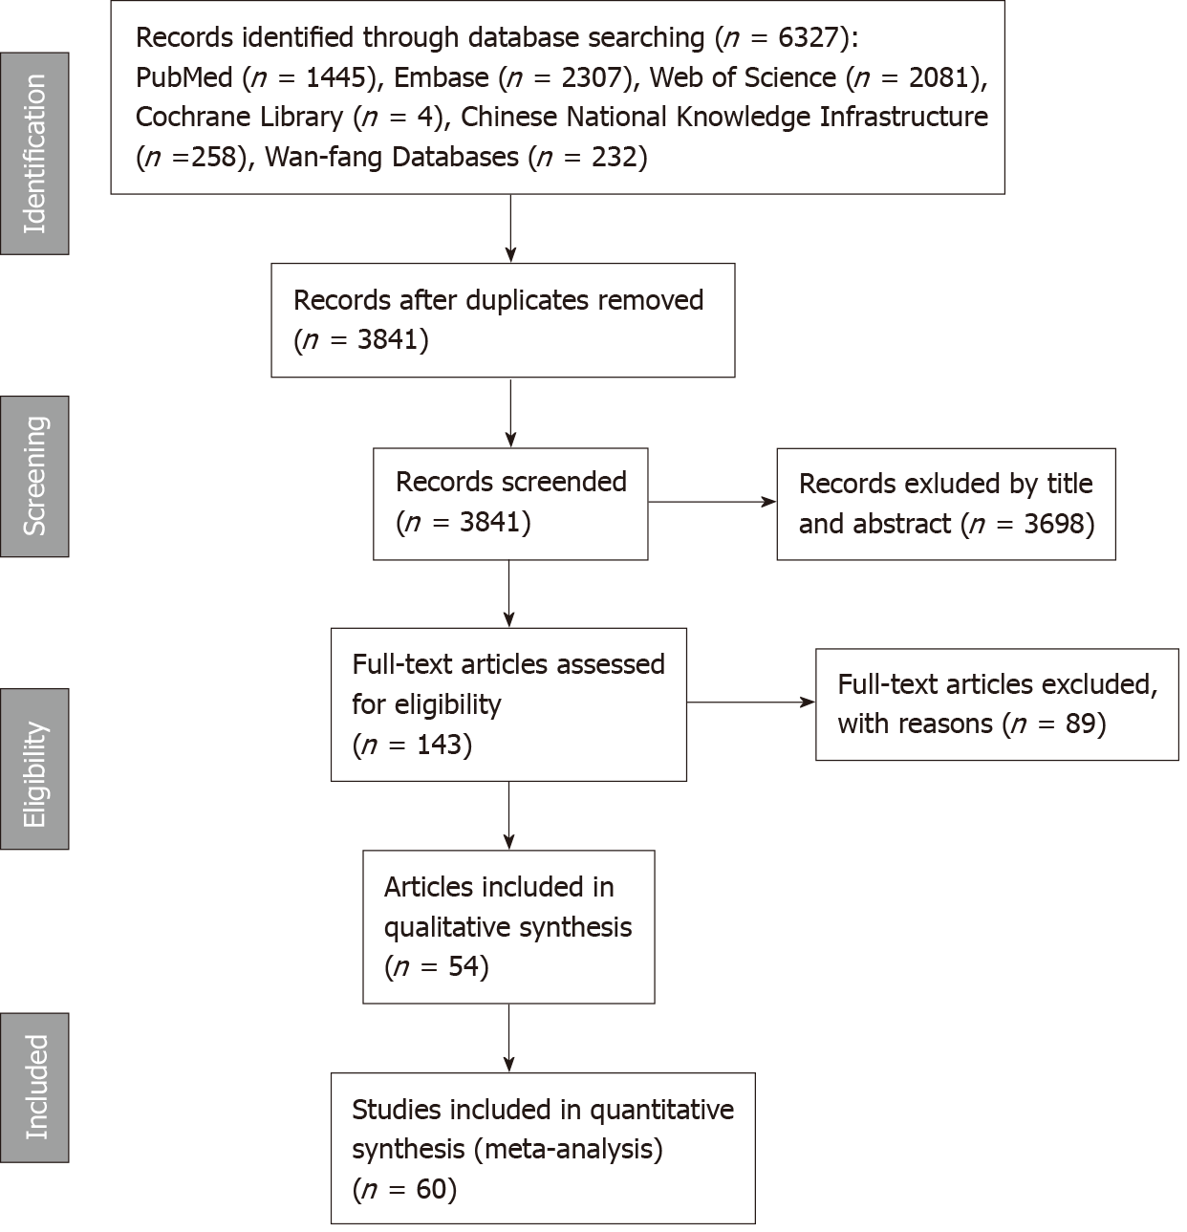
Figure 1 The flow chart of this meta-analysis to identify inclusion studies.

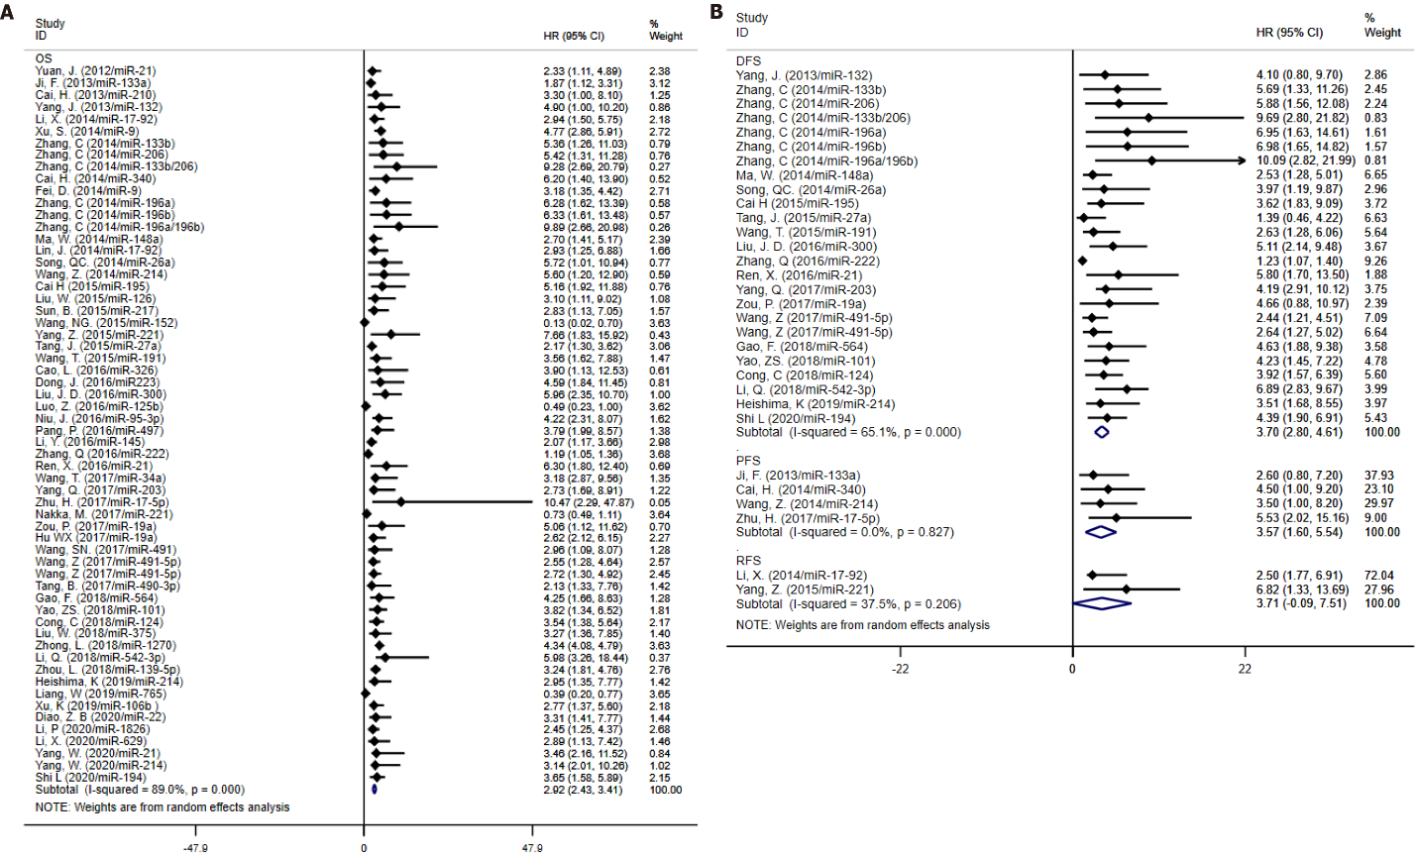
Figure 2 Forest plots for the microRNAs associated with clinical outcome. A: Forest plots for the microRNA (miRNA) associated with overall survival; B: Forest plots for the miRNAs associated with disease-free survival, progression-free survival and recurrence-free survival.

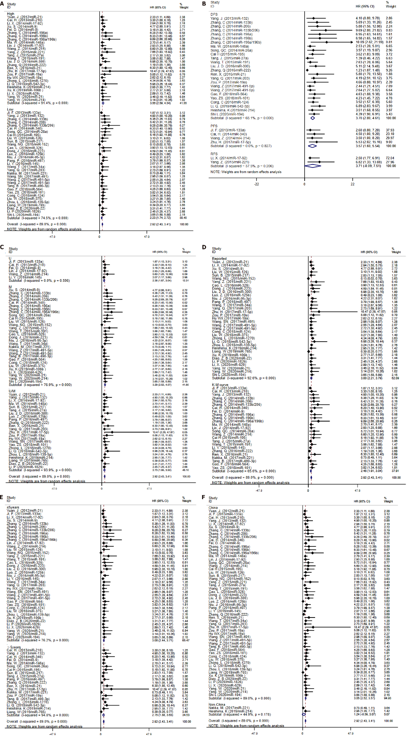
Figure 3 Forest plot of subgroup analysis. A: Subgroup analysis based on microRNA expression; B: Subgroup analysis based on specimen type; C: Subgroup analysis based on survival analysis; D: Subgroup analysis based on source of hazard ratio; E: Subgroup analysis based on follow-up; F: Subgroup analysis based on country of publication.

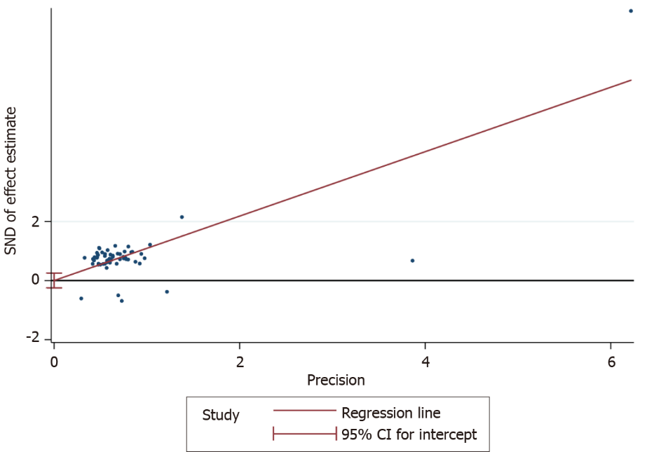
Figure 4 Egger’s test of publication bias.

Table 1 Characteristics of eligible studies in this meta-analysis
Ref. | Country | MicroRNA | MicroRNA expression¹ | Sample size |  |  | Specimen | Cut off value | Follow-up (mo) | Outcome | Detection method | Survival analysis | Source of HR | NOS score
 |  |  |  | Total | Low | High
Yuan et al^{[20]}, 2012 | China | miR-21 | High | 65 | NR | NR | Serum | Median | 46 | OS | RT-PCR | U/M | Reported | 6
Ji et al^{[21]}, 2013 | China | miR-133a | Low | 92 | 46 | 46 | Tissue | Median | 60 | OS | RT-PCR | U | K-M curve | 6
Cai et al^{[22]}, 2013 | China | miR-210 | High | 92 | 44 | 48 | Tissue | Median | 100 | OS/PFS | RT-PCR | U | K-M curve | 6
Yang et al^{[23]}, 2013 | China | miR-132 | Low | 166 | 90 | 76 | Tissue | Median | 100 | OS/DFS | RT-PCR | U/M | K-M curve | 6
Li et al^{[24]}, 2014 | China | miR-17-92 | High | 117 | 45 | 72 | Tissue | Median | 60 | OS/RFS | RT-PCR | U/M | Reported | 6
Xu et al^{[25]}, 2014 | China | miR-9 | High | 79 | 39 | 40 | Tissue | Median | 60 | OS | RT-PCR | M | Reported | 6
Zhang et al^{[26]}, 2014 | China | miR-133b/ 206 | Low | 100 | NR | NR | Serum | 2.7/2.8 | 40 | OS/DFS | RT-PCR | M | K-M curve | 8
Cai et al^{[27]}, 2014 | China | miR-340 | Low | 92 | NR | NR | Tissue | Median | 100 | OS/PFS | RT-PCR | M | K-M curve | 7
Fei et al^{[28]}, 2014 | China | miR-9 | High | 118 | NR | NR | Serum | Median | 80 | OS | RT-PCR | U | K-M curve | 6
Zhang et al^{[13]}, 2014 | China | miR-196a/b | High | 100 | NR | NR | Serum | 4.9/5.5 | 40 | OS/DFS | RT-PCR | M | K-M curve | 8
Ma et al^{[29]}, 2014 | China | miR-148a | High | 148 | NR | NR | Plasma | Median | 100 | OS/DFS | RT-PCR | U/M | K-M curve | 7
Lin et al^{[30]}, 2014 | China | miR-17-92 | High | 63 | 25 | 38 | Tissue | Median | 60 | OS | RT-PCR | U | K-M curve | 6
Song et al^{[31]}, 2014 | China | miR-26a | Low | 144 | 63 | 81 | Tissue | Median | 150 | OS/DFS | RT-PCR | M | K-M curve | 7
Wang et al^{[32]}, 2014 | China | miR-214 | High | 82 | 33 | 49 | Tissue | Median | 60 | OS/FFS | RT-PCR | U | K-M curve | 7
Cai et al^{[33]}, 2015 | China | miR-195 | Low | 166 | 88 | 78 | Serum | 1.44 | 100 | OS/DFS | RT-PCR | M | K-M curve | 8
Liu et al^{[34]}, 2015 | China | miR-126 | Low | 122 | 60 | 62 | Tissue | Median | 60 | OS | RT-PCR | M | Reported | 7
Sun et al^{[35]}, 2015 | China | miR-217 | Low | 168 | 84 | 84 | Tissue | Median | 80 | OS | RT-PCR | U/M | Reported | 6
Wang, et al^{[36]}, 2015 | China | miR-152 | Low | 80 | 42 | 38 | Serum | Median | 60 | OS | RT-PCR | M | Reported | 6
Yang et al^{[37]}, 2015 | China | miR-221 | High | 108 | 55 | 53 | Serum | Median | 60 | OS/RFS | RT-PCR | M | Reported | 7
Tang et al^{[38]}, 2015 | China | miR-27a | High | 166 | 80 | 86 | Serum | Median | 100 | OS/DFS | RT-PCR | U/M | K-M curve | 8
Wang et al^{[39]}, 2015 | China | miR-191 | High | 100 | 42 | 58 | Serum | 3.56 | 60 | OS/DFS | RT-PCR | M | K-M curve | 8
Cao et al^{[40]}, 2016 | China | miR-326 | Low | 60 | 25 | 35 | Serum | Median | 60 | OS | RT-PCR | M | Reported | 6
Dong et al^{[41]}, 2016 | China | miR-223 | Low | 112 | 53 | 59 | Serum | Median | 60 | OS | RT-PCR | M | Reported | 6
Liu et al^{[42]}, 2016 | China | miR-300 | High | 114 | 46 | 68 | Serum | Median | 60 | OS/DFS | RT-PCR | U/M | Reported | 6
Luo et al^{[14]}, 2016 | China | miR-125b | Low | 56 | NR | NR | Plasma | Median | 30 | OS | RT-PCR | U/M | Reported | 7
Niu et al^{[43]}, 2016 | China | miR-95-3p | Low | 133 | 97 | 36 | Serum | Median | 60 | OS | RT-PCR | M | Reported | 7
Pang et al^{[44]}, 2016 | China | miR-497 | Low | 185 | 91 | 94 | Serum | Median | 70 | OS | RT-PCR | U/M | Reported | 7
Li et al^{[45]}, 2016 | China | miR-145 | low | 39 | 19 | 20 | Tissue | Median | 60 | OS | RT-PCR | U | K-M curve | 7
Zhang and Wang^{[46]}, 2016 | China | miR-222 | High | 57 | 28 | 29 | Serum | Median | 80 | OS/DFS | RT-PCR | U/M | K-M curve | 7
Ren et al^{[47]}, 2016 | China | miR-21 | High | 84 | 33 | 51 | Tissue | Median | 100 | OS/DFS | RT-PCR | U/M | K-M curve | 6
Wang et al^{[48]}, 2017 | China | miR-34a | low | 120 | NR | NR | Serum | 4.16 | 60 | OS | RT-PCR | M | Reported | 7
Yang et al^{[49]}, 2017 | China | miR-203 | Low | 103 | 52 | 51 | Tissue | Median | 60 | OS/DFS | RT-PCR | U/M | Reported | 7
Zhu et al^{[11]}, 2017 | China | miR-17-5p | High | 62 | NR | NR | Plasma | Median | 70 | OS/PFS | RT-PCR | U/M | Reported | 6
Nakka et al^{[50]}, 2017 | United States | miR-221 | Low | 32 | NR | NR | Plasma | Median | 150 | OS | RT-PCR | M | K-M curve | 6
Zou et al^{[51]}, 2017 | China | miR-19a | High | 166 | 80 | 86 | Tissue | Median | 100 | OS/DFS | RT-PCR | U/M | Reported | 7
Hu et al^{[52]}, 2017 | China | miR-19a | High | 32 | NR | NR | Tissue | Median | 50 | OS | RT-PCR | U/M | Reported | 6
Wang et al^{[53]}, 2017 | China | miR-491 | Low | 102 | 58 | 44 | Serum | Median | 60 | OS | RT-PCR | U/M | Reported | 7
Wang et al^{[54]}, 2017 | China | miR-491-5p | Low | 72 | 36 | 36 | Tissue/ Serum | Median | 60 | OS/DFS | RT-PCR | M | Reported | 6
Tang et al^{[55]}, 2017 | China | miR-490-3p | Low | 148 | 76 | 72 | Tissue | Median | 70 | OS | RT-PCR | M | K-M curve | 6
Gao et al^{[56]}, 2018 | China | miR-564 | Low | 217 | 107 | 110 | Tissue | Median | 60 | OS/DFS | RT-PCR | M | K-M curve | 7
Yao et al^{[57]}, 2018 | China | miR-101 | Low | 152 | 82 | 70 | Serum | Median | 60 | OS/RFS | RT-PCR | U/M | K-M curve | 6
Cong et al^{[58]}, 2018 | China | miR-124 | Low | 114 | NR | NR | Serum | Median | 60 | OS/DFS | RT-PCR | M | Reported | 6
Liu et al^{[59]}, 2018 | China | miR-375 | Low | 95 | 47 | 48 | Serum | Median | 60 | OS | RT-PCR | M | Reported | 6
Zhong et al^{[60]}, 2018 | China | miR-1270 | High | 143 | 69 | 74 | Tissue | Median | 70 | OS | RT-PCR | U/M | Reported | 7
Li et al^{[61]}, 2018 | China | miR-542-3p | High | 76 | NR | NR | Serum | 0.87 | 70 | OS/DFS | RT-PCR | U/M | Reported | 8
Zhou et al^{[62]}, 2018 | China | miR-139-5p | Low | 98 | 53 | 45 | Serum | Median | 60 | OS | RT-PCR | U/M | Reported | 7
Heishima et al^{[63]}, 2019 | Japan | miR-214 | High | 106 | NR | NR | Plasma | Median | 72 | OS/DFS | RT-PCR | U/M | Reported | 7
Liang et al^{[12]}, 2019 | China | miR-765 | Low | 33 | NR | NR | Tissue | Median | 72 | OS | RT-PCR | U/M | Reported | 6
Xu, et al^{[64]}, 2019 | China | miR-106b | High | 134 | 64 | 70 | Tissue | Median | 60 | OS | RT-PCR | M | Reported | 7
Diao et al^{[65]}, 2020 | China | miR-22 | Low | 120 | 60 | 60 | Plasma | Median | 60 | OS | RT-PCR | U/M | Reported | 6
Li et al^{[66]}, 2020 | China | miR-1826 | Low | 122 | 69 | 53 | Tissue | Median | 60 | OS | RT-PCR | U/M | Reported | 7
Li et al^{[67]}, 2020 | China | miR-629 | High | 110 | 45 | 65 | Tissue | Median | 60 | OS | RT-PCR | M | Reported | 7
Yang et al^{[68]}, 2020 | China | miR-21/ 214 | High | 63 | NR | NR | Tissue | Median | 60 | OS | RT-PCR | M | Reported | 7
Shi et al^{[69]}, 2020 | China | miR-194 | Low | 124 | 69 | 55 | Serum | Median | 60 | OS/DFS | RT-PCR | M | Reported | 7

¹MicroRNA expression with poor prognosis.

High: High expression; Low: Low expression; OS: Overall survival; PFS: Progression-free survival; DFS: Disease-free survival; RFS: Recurrence-free survival; NR: Not reported; M: Multivariate analysis; U: Univariate analysis; NOS: Newcastle-Ottawa scale; RT-PCR: Real-time reverse transcription-PCR.

Table 2 Hazard ratios and 95% confidence intervals of survival outcome extracted from included studies
Ref. | MicroRNA | OS |  | PFS |  | DFS |  | RFS | P
 |  | HR (95%CI) | P | HR (95%CI) | P | HR (95%CI) | P | HR (95%CI)
Yuan et al^{[20]}, 2012 | miR-21 | 2.33 (1.11-4.89) | 0.026
Ji et al^{[21]}, 2013 | miR-133a | 1.87 (1.12–3.31) | 0.015 | 2.6 (0.8–7.2) | 0.02
Cai et al^{[22]}, 2013 | miR-210 | 3.3 (1.0–8.1) | 0.01
Yang et al^{[23]}, 2013 | miR-132 | 4.9 (1.0–10.2) | 0.001 |  |  | 4.1 (0.8–9.7) | 0.006
Li et al^{[24]}, 2014 | miR-17-92 | 2.94 (1.51-5.75) | 0.002 |  |  |  |  | 2.50 (1.77-6.92) | 0.001
Xu et al^{[25]}, 2014 | miR-9 | 4.77 (2.86–5.91) | 0.002
Zhang et al^{[26]}, 2014 | miR-133b | 5.36 (1.26-11.03) | 0.02 |  |  | 5.69 (1.33-11.26) | 0.02
Zhang et al^{[26]}, 2014 | miR-206 | 5.42 (1.31-11.28) | 0.02 |  |  | 5.88 (1.56-12.08) | 0.02
Zhang et al^{[26]}, 2014 | miR-133b/206 | 9.28 (2.69-20.79) | 0.001 |  |  | 9.69 (2.80-21.82) | 0.001
Cai et al^{[27]}, 2014 | miR-340 | 6.2 (1.4–13.9) | 0.006 | 4.5 (1.0–9.2) | 0.01
Fei et al^{[28]}, 2014 | miR-9 | 3.18 (1.35-4.42) | 0.002
Zhang et al^{[13]}, 2014 | miR-196a | 6.28 (1.62–13.39) | 0.01 |  |  | 6.95 (1.63–14.61) | 0.01
Zhang et al^{[13]}, 2014 | miR-196b | 6.33 (1.61–13.48) | 0.01 |  |  | 6.98 (1.65–14.82) | 0.01
Zhang et al^{[13]}, 2014 | miR-196a/196b | 9.89 (2.66–20.98) | 0.001 |  |  | 10.09 (2.82–21.99) | 0.001
Ma et al^{[29]}, 2014 | miR-148a | 2.70 (1.41-5.17) | 0.003 |  |  | 2.53 (1.28-5.01) | 0.008
Lin et al^{[30]}, 2014 | miR-17-92 | 2.93 (1.25-6.88) | 0.007
Song et al^{[31]}, 2014 | miR-26a | 5.72(1.01-10.94) | 0.007 |  |  | 3.97 (1.19-9.87) | 0.014
Wang et al^{[32]}, 2014 | miR-214 | 5.6 (1.2–12.9) | 0.008 | 3.5 (1.0–8.2) | 0.01
Cai et al^{[33]}, 2015 | miR-195 | 5.16 (1.92-11.88) | 0.002 |  |  | 3.62 (1.83-9.09) | 0.01
Liu et al^{[34]}, 2015 | miR-126 | 3.10 (1.11–9.02) | 0.018
Sun et al^{[35]}, 2015 | miR-217 | 2.83 (1.13–7.05) | 0.026
Wang et al^{[36]}, 2015 | miR-152 | 0.13 (0.02–0.70) | 0.004
Yang et al^{[37]}, 2015 | miR-221 | 7.66 (1.83–15.92) | 0. 01 |  |  |  |  | 6.82(1.33–13.69) | 0.01
Tang et al^{[38]}, 2015 | miR-27a | 2.17 (1.30-3.62) | 0. 01 |  |  | 1.39 (0.46-4.22) | 0. 01
Wang, et al^{[39]}, 2015 | miR-191 | 3.56 (1.62–7.88) | 0.01 |  |  | 2.63 (1.28–6.06) | 0.02
Cao et al^{[40]}, 2016 | miR-326 | 3.90 (1.13-12.53) | 0.001
Dong et al^{[41]}, 2016 | miR-223 | 4.59 (1.84–11.45) | 0.001
Liu et al^{[41]}, 2016 | miR-300 | 5.96 (2.35-10.70) | 0.009 |  |  | 5.11 (2.14-9.48) | 0.019
Luo et al^{[14]}, 2016 | miR-125b | 0.49 (0.24-0.10) | 0.049
Niu et al^{[43]}, 2016 | miR-95-3p | 4.22 (2.31–8.07) | 0.014
Pang et al^{[44]}, 2016 | miR-497 | 3.79 (1.99-8.57) | 0.004
Li et al^{[45]}, 2016 | miR-145 | 2.07 (1.17-3.66) | 0.0124
Zhang and Wang^{[46]}, 2016 | miR-222 | 1.19 (1.05-1.36) | 0.008 |  |  | 1.23 (1.07-1.40) | 0.003
Ren et al^{[47]}, 2016 | miR-21 | 6.3 (1.8–12.4) | 0.001 |  |  | 5.8 (1.7–13.5) | 0.001
Wang et al^{[48]}, 2017 | miR-34a | 3.18 (2.87-9.56) | 0.001
Yang et al^{[49]}, 2017 | miR-203 | 2.73 (1.69-8.91) | 0.01 |  |  | 4.19 (2.91-10.12) | 0.005
Zhu et al^{[11]}, 2017 | miR-17-5p | 10.47 (2.29-47.87) | 0.002 | 5.53 (2.02-15.16) | 0.001
Nakka et al^{[50]}, 2017 | miR-221 | 0.73 (0.49-1.11) | 0.139
Zou et al^{[51]}, 2017 | miR-19a | 5.06 (1.12–11.62) | 0.001 |  |  | 4.66 (0.88–10.97) | 0.006
Hu et al^{[52]}, 2017 | miR-19a | 2.62 (2.12-6.15) | 0.037
Wang et al^{[53]}, 2017 | miR-491 | 2.96 (1.09-8.07) | 0.03
Wang et al^{[54]}, 2017 | miR-491-5p | 2.55 (1.28-4.64) | 0.039 |  |  | 2.44 (1.21-4.51) | 0.03
Wang et al^{[54]}, 2017 | miR-491-5p | 2.72 (1.30-4.92) | 0.028 |  |  | 2.64 (1.27-5.02) | 0.022
Tang et al^{[55]}, 2017 | miR-490-3p | 2.13 (1.33-7.76) | 0.001
Gao et al^{[56]}, 2018 | miR-564 | 4.25 (1.66-8.63) | 0.001 |  |  | 4.63 (1.88-9.38) | 0.001
Yao et al^{[57]}, 2018 | miR-101 | 3.82 (1.34-6.52) | 0.014 |  |  | 4.23 (1.45-7.22) | 0.008
Cong et al^{[58]}, 2018 | miR-124 | 3.54 (1.38–5.64) | 0.019 |  |  | 3.92 (1.57–6.39) | 0.012
Liu et al^{[59]}, 2018 | miR-375 | 3.27 (1.36-7.85) | 0.008
Zhong et al^{[60]}, 2018 | miR-1270 | 4.34 (4.08–4.79) | 0.018
Li et al^{[61]}, 2018 | miR-542-3p | 5.98 (3.26–18.44) | 0.01 |  |  | 6.89 (2.83–9.67) | 0.018
Zhou et al^{[62]}, 2018 | miR-139-5p | 3.24 (1.81–4.76) | 0.007
Heishima et al^{[63]}, 2019 | miR-214 | 2.95 (1.35-7.77) | 0.005 |  |  | 3.51 (1.68-8.55) | 0.0004
Liang et al^{[12]}, 2019 | miR-765 | 0.39 (0.20-0.77) | 0.007
Xu, et al^{[64]}, 2019 | miR-106b | 2.77 (1.37-5.60) | 0.005
Diao et al^{[65]}, 2020 | miR-22 | 3.31 (1.41-7.77) | 0.006
Li et al^{[66]}, 2020 | miR-1826 | 2.45 (1.25-4.37) | 0.014
Li et al^{[67]}, 2020 | miR-629 | 2.89 (1.13-7.42) | 0.027
Yang et al^{[68]}, 2020 | miR-21 | 3.46 (2.17-11.52) | 0.013
Yang et al^{[68]}, 2020 | miR-214 | 3.14 (2.01-10.26) | 0.017
Shi et al^{[69]}, 2020 | miR-194 | 3.65 (1.58-5.89) | 0.014 |  |  | 4.39 (1.90-6.91) | 0.005

HR: Hazard ratio; CI: Confidence interval; OS: Overall survival; PFS: Progression-free survival; DFS: Disease-free survival; RFS: Recurrence-free survival.

Table 3 Subgroup analyses of the relationship between microRNA expression and overall survival.
Subgroup | Number of datasets | Heterogeneity |  | Pooled HR (95%CI) | P value
 |  | I² (%) | P value
Overall | 60 | 89.0% | 0.000 | 2.92 (2.43–3.41) | 0.000
Expression
High | 27 | 91.4% | 0.000 | 3.56 (2. 59–4.54) | 0.000
Low | 33 | 74.5% | 0.000 | 2.23 (1. 74–2.72) | 0.000
Specimen
Tissue | 26 | 92.1% | 0.000 | 3.20 (2.16–4.23) | 0.000
Serum | 28 | 77.1% | 0.000 | 3.04 (2.37–3.71) | 0.000
Plasma | 6 | 53.7% | 0.055 | 0.94 (0.36–1.51) | 0.001
Survival analysis
U | 6 | 0.0% | 0.569 | 2.36 (1.67–3.04) | 0.000
M | 30 | 76.9% | 0.000 | 3.29 (2.52–4.07) | 0.000
U/M | 24 | 93.9% | 0.000 | 2.73 (1.95–3.50) | 0.000
Source of HR
Reported | 35 | 92.6% | 0.000 | 3.00 (2.21–3.79) | 0.000
K-M curve | 25 | 65.6% | 0.000 | 2.48 (1.92–3.04) | 0.000
Follow-up
≤ 5 years | 40 | 76.2% | 0.000 | 3.08 (2.44–3.71) | 0.000
＞5 years | 20 | 94.8% | 0.000 | 2.75 (1.88–3.63) | 0.000
Country
China | 58 | 89.0% | 0.000 | 3.05 (2.52–3.57) | 0.000
Non-China | 2 | 44.9% | 0.178 | 1.24 (0.59–3.07) | 0.183

OS: Overall survival; M: Multivariate analysis; U: Univariate analysis; HR: Hazard ratio; CI: Confidence interval.

Published by Baishideng Publishing Group Inc
7041 Koll Center Parkway, Suite 160, Pleasanton, CA 94566, USA
Telephone: +1-925-3991568
E-mail: bpgoffice@wjgnet.com
Help Desk: https://www.f6publishing.com/helpdesk
https://www.wjgnet.com

© 2021 Baishideng Publishing Group Inc. All rights reserved.

