Name of journal: World Journal of Orthopedics
ESPS Manuscript NO: 18247
Columns: EDITORIAL
Arthroscopic approach to the posterior compartment of the knee using a posterior transseptal portal

Ohishi T et al. Arthroscopic approach to the posterior compartment of the knee

Tsuyoshi Ohishi, Masaaki Takahashi, Daisuke Suzuki, Yukihiro Matsuyama

Tsuyoshi Ohishi, Daisuke Suzuki, Department of Orthopedic Surgery, Enshu Hospital, Hamamatsu, Shizuoka 430-0929, Japan

Masaaki Takahashi, Joint Center, Jyuzen Memorial Hospital, Hamamatsu, Shizuoka 434-0042, Japan

Yukihiro Matsuyama, Department of Orthopedic Surgery, Hamamatsu University School of Medicine, Hamamatsu, Shizuoka 431-3192, Japan

Author contributions: Ohishi T wrote the paper; Ohishi T and Suzuki D operated on patients; Takahashi M and Matsuyama Y reviewed the manuscript and provided useful comments.

Conflict-of-interest: The authors declare no conflicting interests.

Open-Access: This article is an open-access article which was selected by an in-house editor and fully peer-reviewed by external reviewers. It is distributed in accordance with the Creative Commons Attribution Non Commercial (CC BY-NC 4.0) license, which permits others to distribute, remix, adapt, build upon this work non-commercially, and license their derivative works on different terms, provided the original work is properly cited and the use is non-commercial. See: http://creativecommons.org/licenses/by-nc/4.0/

Correspondence to: Tsuyoshi Ohishi, MD, PhD, Department of Orthopedic Surgery, Enshu Hospital, 1-1-1 Chuo, Naka-ku, Hamamatsu, Shizuoka 430-0929, Japan. t-ohishi@ken.ja-shizuoka.or.jp
Telephone: +81-53-4531111
Fax: +81-53-4010081

Received: April 13, 2015
Peer-review started: April 24, 2015
First decision: May 13, 2015
Revised: May 27, 2015
Accepted: June 18, 2015
Article in press:
Published online:

Abstract
Arthroscopic surgery of the posterior compartment of the knee is difficult when only two anterior portals are used for access because of the inaccessibility of the back of the knee. Since its introduction, the posterior transseptal portal has been widely employed to access lesions in the posterior compartment. However, special care should be taken to avoid neurovascular injuries around the posteromedial, posterolateral, and transseptal portals. Most importantly, popliteal vessel injury should be avoided when creating and using the transseptal portal during surgery. Purpose of the present study is to describe how to avoid the neurovascular injuries during establishing the posterior three portals and to introduce our safer technique to create the transseptal portal. To date, we have performed arthroscopic surgeries via the transseptal portal in the posterior compartments of 161 knees and have not encountered nerve or vascular injury. In our procedure, the posterior septum is perforated with a 1.5-3.0-mm Kirschner wire that is protected by a sheath inserted from the posterolateral portal and monitored from the posteromedial portal to avoid popliteal vessel injury.

Key words: Arthroscopic surgery; Knee; Posterolateral portal; Posteromedial portal; Transseptal portal

© The Author(s) 2015. Published by Baishideng Publishing Group Inc. All rights reserved.

Core tip: Arthroscopic surgery in posterior compartment of the knee via the transseptal portal is less invasive to the patient compared to open surgery for access to the back of the knee. However, special care should be taken to avoid neurovascular injury when creating the three posterior portals. We have not encountered neurovascular injury with our procedure for creating a posterior transseptal portal in 161 treated knees, and conclude that it is safe and reliable.

Ohishi T, Takahashi M, Suzuki D, Matsuyama Y. Arthroscopic approach to the posterior compartment of the knee using a posterior transseptal portal. World J Orthop 2015; In press

INTRODUCTION
Prior to introduction of the posterior transseptal portal, arthroscopic surgery for lesions located in the posterior compartment of the knee was difficult because both the cruciate ligaments and curvature of the femoral condyles obstructed the advance of the arthroscope or other instruments to the back of the knee. Additionally, posterior lesions such as a posterior periphery or posterior horn of the medial meniscus might be missed when using an anterior approach alone^{[1,2]}. Trans-notch views from anterior portals have allowed us to obtain clear views of the posterior compartment^{[1-3]}. However, a particular “blind zone” on the medial meniscus that could not be viewed remained even with a 70-degree arthroscope^{[4,5]}. The treatment of lesions located in the posterior compartment introduces further difficulty. The addition of posteromedial and posterolateral portals together with a 70-degree arthroscope facilitated treatment procedures for posterior lesions^{[2,6-9]}. Nevertheless, the cruciate ligaments, femoral condyles, and prominence of the tibial spine limited the maneuverability of the arthroscope or other instruments advanced through the intercondylar notch from the anterior portals^{[1,3]}. Ideally, either the posteromedial or posterolateral portal would be used as a viewing portal, while the other would be used as a working portal. However, the posterior compartment of the knee is divided into two compartments by a posterior septum comprising a thin synovial membrane between the posterior cruciate ligament (PCL) and the posterior capsule. In 1997, Kim first reported arthroscopic surgery in the posterior compartment of the knee through two posterior portals created after perforating the posterior septum^{[10]}. Since then, many authors have demonstrated their techniques for transseptal portal creation^{[10-12]}. However, important neurovascular or tendon structures lie just posterior to the posteromedial, posterolateral, and transseptal portals. Special care must be taken to avoid injuries to those structures^{[13,14]}. To date, arthroscopic surgeries via transseptal portal have been employed more frequently along with broadening indications for arthroscopic surgery for posterior lesions of the knee, including synovectomy^{[15]}, meniscectomy^{[16]}, repair of the posterior horn of the medial meniscus^{[17-20]}, Posterior cruciate ligament (PCL) reconstruction^{[21]}, PCL avulsion fracture fixation^{[22]}, loose body removal^{[23-26]}, cystic lesion removal^{[27-29]}, posterior capsular release^{[30]}, repair of posterior capsular tears^{[31]}, and synovectomy of a prosthetic knee^{[32]}. We have also performed arthroscopic surgery via the transseptal portal to approach lesions located in the posterior compartment of the knee since 2006. In this paper, we present the techniques for creating posteromedial, posterolateral, and transseptal portals and for avoiding neurovascular injuries around the portal site reported by several authors as well as those performed at our institute.

ANATOMY AND CLINICAL RELEVANCE
The triangular posterior septum borders the dorsal aspect of the PCL anteriorly, femoral intercondylar notch superiorly, and posterior capsule posteriorly and divides the posterior compartment into the posteromedial and posterolateral compartments^{[11,12]} (Figure 1). The septum comprises adipose tissue surrounded by a synovial membrane that contains blood vessels and nerve endings^{[33]}. The medial genicular artery, which originates from the popliteal artery, enters the proximal portion of the septum, which accordingly features a richer vasculature than the distal portion. Mechanoreceptors are also abundant in the proximal septum^{[33]}. Therefore, recommendations regarding limited resection or penetration of the septum indicate that this procedure should be performed at the distal portion, just behind the PCL, rather than at the proximal or femoral side to reduce bleeding while creating the transseptal portal. Immediately behind the septum, the popliteal artery lies outside of the posterior capsule^{[34-36]}. The popliteal artery lies approximately 10 mm laterally to the septum^{[15,37]}. Regarding the posteromedial portal, a sartorial branch of the saphenous nerve is located immediately inferoposteriorly to the portal site (Figure 2A). The common peroneal nerve and long head of the biceps femoris are immediately posterior to the posterolateral portal site, whereas the lateral collateral ligament and popliteal tendon are immediately anterior to this site^{[36,38-41]} (Figure 2B).

ESTABLISHMENT OF THE TRANSSEPTAL PORTAL
In 1997, Kim first introduced an arthroscopic approach to lesions located in posterior compartment of the knee via the transseptal portal. According to Kim’s technique, the posterior septum was perforated via the posteromedial portal using a blunt obturator with a sheath^{[10]}. Ahn et al. described a limited resection of the septum using a shaver introduced from the anteromedial portal through the intercondylar notch, which was viewed from the posteromedial portal^{[11]}. Louisia et al^{[12]} penetrated the septum from the medial to lateral direction using a blunt obturator, which was followed by a skin incision to create a posterolateral portal. These authors demonstrated a “back and forth” technique in which each posterior portal is used alternately for the arthroscope and other instruments placed through the transseptal portal. Kim et al^{[15]} penetrated the septum in the posterolateral to posteromedial direction to create a transseptal portal for complete synovectomy in a patient with rheumatoid arthritis.

RISKS INVOLVING NERVES AND VESSELS
Special care should be taken to avoid popliteal neurovascular injuries during transseptal portal creation and subsequent arthroscopic surgery via this portal. The posterior compartment, which is enlarged upon knee flexion, is enlarged to an even greater extent during arthroscopic surgery under irrigation pressure^{[34]}. The distances between the PCL and popliteal artery at different knee positions were measured in cadavers^{[34,35,38,41]}. A flexion of 90 degrees resulted a greater distance (17-29 mm) between the PCL and popliteal artery than that observed at 30 degrees of flexion. As the popliteal neurovascular bundle lies laterally to the septum, posterolateral capsule injuries should be avoided during surgery^{[12,37]}. Perforation of the septum in the posterolateral to the posteromedial direction, as described by Kim et al^{[15]}, is a safer technique. Arthroscopic procedures in the posteromedial compartment are easier than those in the posterolateral compartment because the former is 1.5 times larger and bulges a bit more posteriorly under irrigation pressure during surgery relative to the latter ^{[15,37]} (Figure 1). Fortunately, popliteal vessel injuries during arthroscopic surgery via the transseptal portal have not yet been reported in the literature.
Care should be taken not only to avoid popliteal vessel injury when creating the transseptal portal, but also to avoid neurovascular injury when creating the posteromedial and posterolateral portals^{[35-38,40,41]}. Oglivie-Harris et al^{[13]} reported five complications related to the posteromedial portal that involved the saphenous nerve and vein. McGinnis et al^{[40]} reported a so-called “anatomical soft spot”, which is surrounded by the posterior edge of the medial condyle of the femur, hamstrings, and medial tibial plateau, as a safe area in which to place the posteromedial portal. The posteromedial portal could be created more safely with the knee at a flexion of 90 degrees than in an extended position because the saphenous nerve and vessels move more posteriorly in the former position^{[36,38,41]}. The mean distance between the posteromedial portal site and saphenous nerve is 22-26 mm at a 90-degree flexion^{[36,38,41]}. The distance between the posterolateral portal site and common peroneal nerve at a 90-degree knee flexion is relatively wide: 40 mm as reported by Pace et al^{[41]}, and 25.4 mm according to Ahn et al^{[21]}. When creating a posterolateral portal, palpation of the fibular head as an identifiable landmark is recommended if the posterolateral capsule is not visible in the intercondylar posterior view^{[38]}. However, excess knee flexion (e.g., > 120°) is not acceptable because this reduces the distance between the common peroneal nerve and posterolateral portal to a greater extent^{[36]}.

OUR TECHNIQUE
In our method, the patient is placed under spinal or general anesthesia and the knee is flexed beyond 90 degrees on the operating table using a footrest and lateral post. As a precaution, a tourniquet is applied but not inflated. No arthropump is used. The procedure begins with the creation of the posteromedial and posterolateral portals through the anterior two portals according to the approach reported by Schreiber^{[9]}, although our method uses a 30-degree rather than 70-degree arthroscope. The arthroscope is introduced into the posteromedial compartment through the intercondylar notch from the anterolateral portal. If osteophytes block the advance of the arthroscope through the intercondylar notch, knee extension facilitates the advance to the posteromedial compartment. A 23-gauge spinal needle is subsequently inserted just behind the posterior medial condyle and 5 mm above the tibial articular surface under guidance from a cutaneous trans-illumination arthroscopic light, as described by Schreiber^{[9]} (Figure 3A). If a condition such as obesity prevents identification of the posterior edge of the medial femoral condyle, a 23-gauge spinal needle is first inserted to the medial aspect of the femoral condyle first, and the needle insertion site is then moved posteriorly to identify the posterior edge of the medial femoral condyle. The cutaneous trans-illumination arthroscopic guide helps to avoid injuries of the saphenous nerve and adjacent vein^{[9]}. The entry point skin and capsule are incised with a No. 11 knife just anterior to and along with the 23-gauge needle. The posteromedial portal opening is subsequently maintained with a hemostat. Next, an arthroscope is introduced into the posterolateral compartment through the intercondylar notch from the anteromedial portal. A posterolateral portal is then created in the same manner as the posteromedial portal, using a 23-gauge spinal needle to determine the posterolateral portal site (Figure 3B). Palpation of the common peroneal nerve and fibular head may help to avoid common peroneal nerve injuries. Next, a switching rod with a sheath is inserted through the posterolateral portal to the septum. The camera head of the 30-degree arthroscope is turned to the septum so the operator can confirm that the tip of the rod is attached to the septum (Figure 4). The rod is then removed while the sheath is kept in place. The sheath is pushed into the septum, and the arthroscope is inserted into the posteromedial portal. While maintaining a view of the medial side of the septum using the arthroscope introduced through the posteromedial portal, 1.5-mm (Figure 5A) and 3.0-mm Kirschner wires (Figure 5B) are sequentially pushed to the septum from the posterolateral portal through the sheath while in close contact with the posterior femoral condyle, after which the septum is perforated. The sheath is expected to protect the posterolateral capsule. The Kirschner wires are pushed several times into the septum to enlarge the initial hole and allow the switching rod to pass easily through the septum (Figure 5C). The switching rod is then inserted from the posterolateral portal to the posteromedial portal via the transseptal portal. Once the transseptal portal has been created, the arthroscope and instruments can be easily interchanged through the two posterior portals using the posterior “back and forth” approach described by Louisia et al^{[12]} (Figure 6). It is not necessary to remove the septum with a motorized shaver.

OUR EXPERIENCE OF THR TECHNIQUE
Using our procedure, we performed arthroscopic surgery for lesions in the posterior compartments of 161 knees between December 2006 and March 2015 (Figure 7). Some of these cases were reported elsewhere to demonstrate the use of the transseptal portal^{[42-47]}. The arthroscopic procedures conducted using our established transseptal portal technique are listed in Table 1. Postoperative complications were encountered in four knees (2.5%), including superficial infection of the posteromedial portal in two knees, subcutaneous hematoma in one knee, and deep infection of the posterolateral portal in one knee. Treatment for the latter case required open debridement of the affected knee. No popliteal neurovascular, peroneal nerve, or saphenous nerve injuries or postoperative deep vein thromboses occurred in any knee during these operations.

ADVANTAGES OF OUR TECHNIQUE
We have modified the procedures reported in previous papers^{[10-12,15]} as follows. First, the knee is flexed beyond 90 degrees on the operating table, with a footrest placed at the heel, so that the popliteal vessels move posteriorly. Flexion beyond 90° is better achieved when the lower leg is not suspended from the side of the table. Moreover, the operator can work freely when the lower leg is on the operating table, as this provides more available space for working around the knee (Figure 6). Second, we perforated the septum while protecting the posterolateral capsule with a sheath to avoid popliteal vessel injury, as a popliteal neurovascular bundle is located just lateral to the septum (Figure 4). Finally, septum perforation using only a rod or blunt obturator might be difficult and could confer the risk of posterior rod or blunt obturator slippage, as the septum is very elastic and easily stretched. It is therefore safer to perforate the septum initially with a 1.5-mm Kirschner wire to determine the proper placement, followed by a 3.0 mm Kirschner wire to enlarge the hole and subsequent switching rod placement, rather than rod placement alone (Figure 5). However, the operator should ensure that the tip of the Kirschner wire is properly positioned just behind the PCL and is not directed towards the posterior capsule. It is essential that the operators use an arthroscope introduced through the opposite portal to maintain direct visibility of the tip of the Kirschner wire or the switching rod as it passes through the perforated septum.

CONCLUSION
An arthroscopic approach via a transseptal portal for posterior lesions of the knee confers several advantages upon patients and operators, including less invasive technique compared to the open surgery for access to the back of the knee. However, the risk of neurovascular injuries should be considered. It is important for operators to understand the anatomy around the posterior three portals.

REFERENCES
1 Boytim MJ, Smith JP, Fischer DA, Quick DC. Arthroscopic posteromedial visualization of the knee. Clin Orthop Relat Res 1995; (310): 82-86 [PMID: 7641464 DOI: 10.1097/00003086-199501000-00015]
2 Gillquist J, Hagberg G, Oretorp N. Arthroscopic visualization of the posteromedial compartment of the knee joint. Orthop Clin North Am 1979; 10: 545-547 [PMID: 460830 DOI: 10.1007/BF00266321]
3 Lubowitz JH, Rossi MJ, Baker BS, Guttmann D. Arthroscopic visualization of the posterior compartments of the knee. Arthroscopy 2004; 20: 675-680 [PMID: 15346107 DOI: 10.1016/S0749-8063(04)00547-X]
4 Morin WD, Steadman JR. Arthroscopic assessment of the posterior compartments of the knee via the intercondylar notch: the arthroscopist's field of view. Arthroscopy 1993; 9: 284-290 [PMID: 8323613 DOI: 10.1016/S0749-8063(05)80423-2]
5 Tolin BS, Sapega AA. Arthroscopic visual field mapping at the periphery of the medial meniscus: a comparison of different portal approaches. Arthroscopy 1993; 9: 265-271 [PMID: 8323610 DOI: 10.1016/S0749-8063(05)80420-7]
6 Gold DL, Schaner PJ, Sapega AA. The posteromedial portal in knee arthroscopy: an analysis of diagnostic and surgical utility. Arthroscopy 1995; 11: 139-145 [PMID: 7794424 DOI: 10.1016/0749-8063(95)90058-6]
7 Mariani PP, Gillquist J. The blind spots in arthroscopic approaches. Int Orthop 1981; 5: 257-264 [PMID: 7341511 DOI: 10.1007/BF00271080]
8 Ochi M, Adachi N, Sumen Y, Uchio Y, Iwasa J. A new guide system for posteromedial portal in arthroscopic knee surgery. Arch Orthop Trauma Surg 1998; 118: 25-28 [PMID: 9833100 DOI: 10.1007/s004020050304]
9 Schreiber SN. Arthroscopy update #9. Posterior compartment observation and instrumentation in the knee using anteromedial and anterolateral portals and an interchangeable cannula system. Orthop Rev 1991; 20: 67-8, 73, 76-80 [PMID: 1997957]
10 Kim JM. Direct posterior-posterior triangulation of the knee joint. Arthroscopy 1997; 13: 262-264 [PMID: 9127090 DOI: 10.1016/S0749-8063(97)90167-5]
11 Ahn JH, Ha CW. Posterior trans-septal portal for arthroscopic surgery of the knee joint. Arthroscopy 2000; 16: 774-779 [PMID: 11027767 DOI: 10.1053/jars.2000.7681]
12 Louisia S, Charrois O, Beaufils P. Posterior "back and forth" approach in arthroscopic surgery on the posterior knee compartments. Arthroscopy 2003; 19: 321-325 [PMID: 12627160 DOI: 10.1053/jars.2003.50082]
13 Ogilvie-Harris DJ, Weisleder L. Arthroscopic synovectomy of the knee: is it helpful? Arthroscopy 1995; 11: 91-95 [PMID: 7727018 DOI: 10.1016/0749-8063(95)90094-2]
14 Tawes RL, Etheredge SN, Webb RL, Enloe LJ, Stallone RJ. Popliteal artery injury complicating arthroscopic menisectomy. Am J Surg 1988; 156: 136-138 [PMID: 3400813 DOI: 10.1016/S0002-9610(88)80374-X]
15 Kim SJ, Jung KA, Kwun JD, Kim JM. Arthroscopic synovectomy of the knee joint in rheumatoid arthritis: surgical steps for complete synovectomy. Arthroscopy 2006; 22: 461.e1-461.e4 [PMID: 16581463 DOI: 10.1016/j.arthro.2005.06.025]
16 Jang KM, Ahn JH, Wang JH. Arthroscopic partial meniscectomy of a posteriorly flipped superior leaflet in a horizontal medial meniscus tear using a posterior transseptal portal. Orthopedics 2012; 35: e430-e433 [PMID: 22385458 DOI: 10.3928/01477447-20120222-37]
17 Ahn JH, Wang JH, Yoo JC, Noh HK, Park JH. A pull out suture for transection of the posterior horn of the medial meniscus: using a posterior trans-septal portal. Knee Surg Sports Traumatol Arthrosc 2007; 15: 1510-1513 [PMID: 17370062 DOI: 10.1007/s00167-007-0310-3]
18 Ahn JH, Wang JH, Lim HC, Bae JH, Park JS, Yoo JC, Shyam AK. Double transosseous pull out suture technique for transection of posterior horn of medial meniscus. Arch Orthop Trauma Surg 2009; 129: 387-392 [PMID: 18542975 DOI: 10.1007/s00402-008-0639-1]
19 Kim JH, Shin DE, Dan JM, Nam KS, Ahn TK, Lee DH. Arthroscopic suture anchor repair of posterior root attachment injury in medial meniscus: technical note. Arch Orthop Trauma Surg 2009; 129: 1085-1088 [PMID: 19142649 DOI: 10.1007/s00402-008-0810-8]
20 Wang KH, Hwang DH, Cho JH, Changale SD, Woo SJ, Nha KW. Arthroscopic direct repair for a complete radial tear of the posterior root of the medial meniscus. Clin Orthop Surg 2011; 3: 332-335 [PMID: 22162797 DOI: 10.4055/cios.2011.3.4.332]
21 Ahn JH, Chung YS, Oh I. Arthroscopic posterior cruciate ligament reconstruction using the posterior trans-septal portal. Arthroscopy 2003; 19: 101-107 [PMID: 12522410 DOI: 10.1016/S0749-8063(03)00600-5]
22 Kwon OS, Park MJ, Kelly JD. Arthroscopic treatment of a PCL avulsion fracture in a skeletally immature patient. Orthopedics 2011; 34: 137 [PMID: 21323274 DOI: 10.3928/01477447-20101221-34]
23 Ahn JH, Yoo JC, Lee SH. Arthroscopic loose-body removal in posterior compartment of the knee joint: a technical note. Knee Surg Sports Traumatol Arthrosc 2007; 15: 100-106 [PMID: 16972108 DOI: 10.1007/s00167-006-0098-6]
24 Kyung BS, Lee SH, Han SB, Park JH, Kim CH, Lee DH. Arthroscopic treatment of synovial chondromatosis at the knee posterior septum using a trans-septal approach: report of two cases. Knee 2012; 19: 732-735 [PMID: 22104391 DOI: 10.1016/j.knee.2011.10.10.003]
25 Lee YS, Ahn JH, Min BH, Nha KW. Arthroscopic loose body removal and cyst decompression using a posterior trans-septal portal in the blind spot during knee arthroscopy--technical report. Knee 2011; 18: 55-58 [PMID: 20163965 DOI: 10.1016/j.knee.2010.01.008]
26 Pengatteeri YH, Park SE, Lee HK, Lee YS, Gopinathan P, Han CW. Synovial chondromatosis of the posterior cruciate ligament managed by a posterior-posterior triangulation technique. Knee Surg Sports Traumatol Arthrosc 2007; 15: 1121-1124 [PMID: 17333121 DOI: 10.1007/s00167-007-0292-1]
27 Lakdawala A, El-Zebdeh M, Ireland J. Excision of a ganglion cyst from within the posterior septum of the knee--an arthroscopic technique. Knee 2005; 12: 245-247 [PMID: 15911302 DOI: 10.1016/j.knee.2004.06.013]
28 Tsai TY, Yang YS, Tseng FJ, Lin KY, Liu CW, Shen HC, Lee CH, Lin LC, Pan RY. Arthroscopic excision of ganglion cysts of the posterior cruciate ligaments using posterior trans-septal portal. Arthroscopy 2012; 28: 95-99 [PMID: 22019231 DOI: 10.1016/j.arthro.2011.07.013]
29 Yoo JH, Kim EH, Min KD, Lee BI. Arthroscopic excision of the ganglion in the posterior septum by posterior trans-septal portal: report of two cases. Arch Orthop Trauma Surg 2009; 129: 1047-1051 [PMID: 18654790 DOI: 10.1007/s00402-008-0703-x]
30 Mariani PP. Arthroscopic release of the posterior compartments in the treatment of extension deficit of knee. Knee Surg Sports Traumatol Arthrosc 2010; 18: 736-741 [PMID: 19784629 DOI: 101007/s00167-009-0920-z]
31 Ahn JH, Lee YS, Ha HC. Arthroscopic management of the postero-medial or postero-lateral capsule tear in the knee joint: technical note. Knee Surg Sports Traumatol Arthrosc 2008; 16: 24-28 [PMID: 17684728 DOI: 10.1007/s00167-007-0392-y]
32 Landsiedl F, Aigner N, Hexel M, Krasny C, Schenk S, Steinböck G. A new arthroscopic technique for revision of the posterior compartment in symptomatic total knee arthroplasty. Arthroscopy 2005; 21: 506-510 [PMID: 15800534 DOI: 10.1016/j.arthro.2004.11.009]
33 Ramos LA, Astur D, Novaretti JV, Ribeiro LM, Carvalho RT, Cohen M, Ingham SJ, Abdalla RJ. An anatomic study of the posterior septum of the knee. Arthroscopy 2012; 28: 100-104 [PMID: 21982388 DOI: 10.1016/j.arthro.2011.06.037]
34 Ahn JH, Wang JH, Lee SH, Yoo JC, Jeon WJ. Increasing the distance between the posterior cruciate ligament and the popliteal neurovascular bundle by a limited posterior capsular release during arthroscopic transtibial posterior cruciate ligament reconstruction: a cadaveric angiographic study. Am J Sports Med 2007; 35: 787-792 [PMID: 17293460 DOI: 10.1177/0363546506297908]
35 Cosgarea AJ, Kramer DE, Bahk MS, Totty WG, Matava MJ. Proximity of the popliteal artery to the PCL during simulated knee arthroscopy: implications for establishing the posterior trans-septal portal. J Knee Surg 2006; 19: 181-185 [PMID: 16893156]
36 Makridis KG, Wajsfisz A, Agrawal N, Basdekis G, Djian P. Neurovascular anatomic relationships to arthroscopic posterior and transseptal portals in different knee positions. Am J Sports Med 2013; 41: 1559-1564 [PMID: 23818438 DOI: 10.1177/0363546513492704]
37 Kim SJ, Song HT, Moon HK, Chun YM, Chang WH. The safe establishment of a transseptal portal in the posterior knee. Knee Surg Sports Traumatol Arthrosc 2011; 19: 1320-1325 [PMID: 21311859 DOI: 10.1007/s00167-011-1429-9]
38 Ahn JH, Lee SH, Jung HJ, Koo KH, Kim SH. The relationship of neural structures to arthroscopic posterior portals according to knee positioning. Knee Surg Sports Traumatol Arthrosc 2011; 19: 646-652 [PMID: 21153546 DOI: 10.1007/s00167-010-1326-7]
39 Dickens JF, Kilcoyne K, Kluk M, Rue JP. The posterolateral corner: surgical approach and technique overview. J Knee Surg 2011; 24: 151-158 [PMID: 21980874 DOI: 10.1055/s-0031-1284727]
40 McGinnis MD, Gonzalez R, Nyland J, Caborn DN. The posteromedial knee arthroscopy portal: a cadaveric study defining a safety zone for portal placement. Arthroscopy 2011; 27: 1090-1095 [PMID: 21620634 DOI: 10.1016/j.arthro.2011.02.031]
41 Pace JL, Wahl CJ. Arthroscopy of the posterior knee compartments: neurovascular anatomic relationships during arthroscopic transverse capsulotomy. Arthroscopy 2010; 26: 637-642 [PMID: 20434661 DOI: 10.1016/j.arthro.2009.09.009]
42 Ohishi T, Fujita T, Suzuki D, Yamamoto K, Ushirozako H, Matsuyama Y. Arthroscopic debridement of the posterior compartment of the knee after total knee arthroplasty. Case Rep Orthop 2014; 2014: 568417 [PMID: 25202462 DOI: 10.1155/2014/568417]
43 Ohishi T, Ichikawa T, Miyagi M, Irisawa H, Nagano A. Gouty synovitis of the knee with partial hypoxanthine-guanine phosphoribosyl transferase deficiency (Kelley-Seegmiller syndrome): A case report. J Rural Med 2009; 4: 80-83 [DOI: 10.2185/jrm.4.80]
44 Ohishi T, Suzuki D, Yamamoto K, Banno T, Shimizu Y, Ohmura A, Matsuyama Y. Meniscal pullout repair following meniscal ossicle resection: a case report. Knee 2013; 20: 52-57 [PMID: 22781211 DOI: 10.1016/j.knee.2012.06.006]
45 Ohishi T, Takahashi M, Matsuyama Y. Osteochondritis dissecans with a large osteochondral free body in the posterolateral compartment of the knee: a case report. Knee 2014; 21: 620-623 [PMID: 24331030 DOI: 10.1016/j.knee.2013.11.005]
46 Ohishi T, Takahashi M, Suzuki D, Fujita T, Yamamoto K, Ushirozako H, Banno T, Matsuyama Y. Treatment of popliteal cysts via arthroscopic enlargement of unidirectional valvular slits. Mod Rheumatol 2015; 1-7 [PMID: 25661740 DOI: 10.3109/14397595.2015.1008779]
47 Ohishi T, Torikai E, Suzuki D, Banno T, Honda Y. Arthroscopic treatment of a medial meniscal cyst using a posterior trans-septal approach: a case report. Sports Med Arthrosc Rehabil Ther Technol 2010; 2: 25 [PMID: 20939883 DOI: 10.1186/1758-2555-2-25]
P-Reviewer: Angoules A, Camera A, Robertson GA, von Heideken J
S-Editor: Tian YL L-Editor: E-Editor:

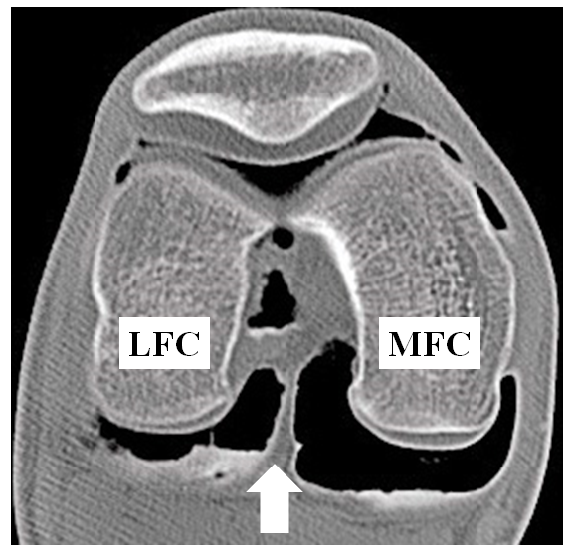
Figure 1 Axial image of double contrast arthrography of the knee. The white arrow indicates a posterior septum that borders the posterior cruciate ligament anteriorly and posterior capsule posteriorly. Note that posteromedial compartment is larger than posterolateral compartment. LFC: Lateral femoral condyle; MFC: Medial femoral condyle.
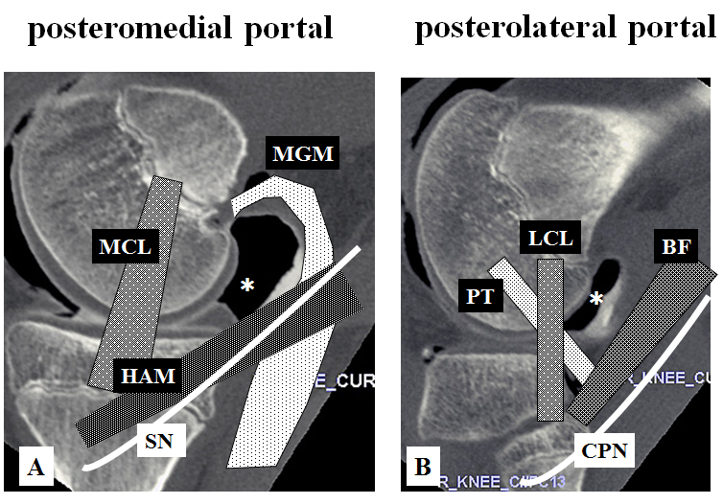
Figure 2 Sagittal images of double contrast arthrography at the levels of the medial (A) and lateral (B) femoral condyle of the knee. Posteromedial (A) and posterolateral (B) sites are indicated by asterisks (*). The portal site is surrounded by important structures. MCL: Medial collateral ligament; MGM: Medial head of the gastrocnemius muscle; HAM: Hamstrings; SN: Saphenous nerve; LCL: Lateral collateral ligament; PT: Popliteus tendon; BF: Biceps femoris; CPN: Common peroneal nerve.
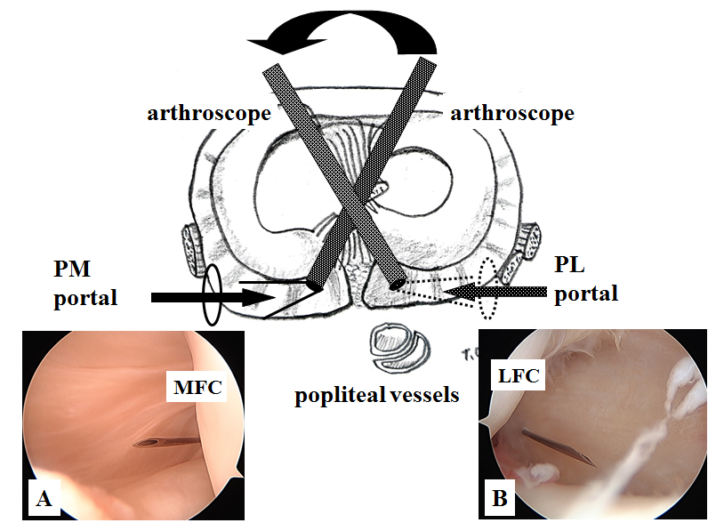
Figure 3 Arthroscopic view of the posteromedial (A) and posterolateral (B) compartment through the intercondylar notch from the anterolateral (A) and anteromedial (B) portals. A 23-gauge spinal needle is inserted just posterior to the medial (A) and lateral (B) femoral condyle at 5 mm above the tibial articular surface. PM: Posteromedial; PL: Posterolateral; MFC: Medial femoral condyle; LFC: Lateral femoral condyle. (Permission for reproduction was obtained from Nankodo Co., Ltd.).
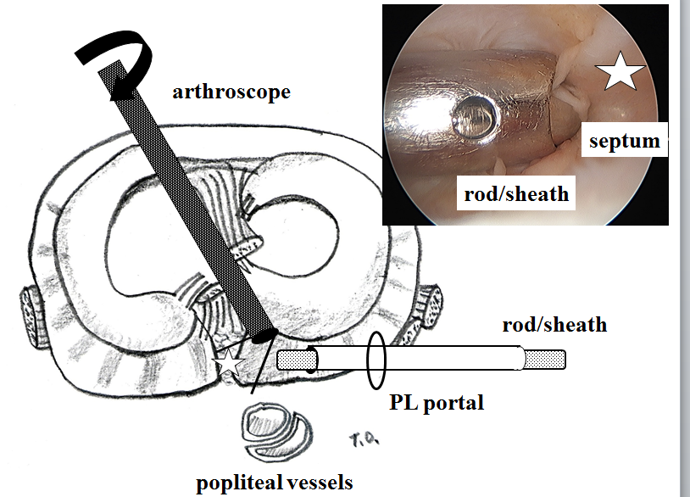
Figure 4 Rod with a sheath is inserted from the posterolateral portal. The camera head of the 30-degree arthroscope is turned toward the septum so that the operator can confirm attachment of the tip of the rod to the septum (white star). PL: Posterolateral. (Permission for reproduction was obtained from Nankodo Co., Ltd.).
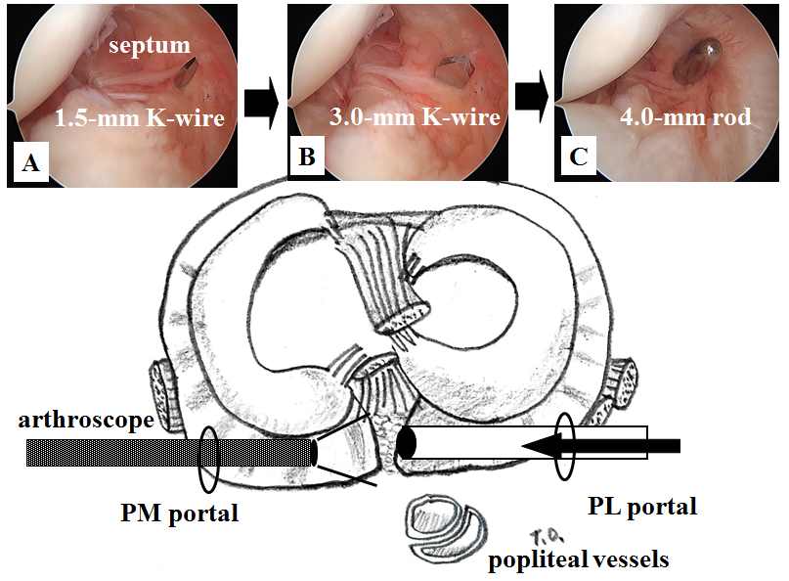
Figure 5 Arthroscopic views from the posteromedial portal. While maintaining a view of the medial side of the septum using an arthroscope introduced through the posteromedial portal, 1.5-mm (A) and 3.0-mm Kirschner wires (B) are pushed sequentially to the septum through the sheath from the posterolateral portal, finally, a 4.0-mm switching rod is passed through the septum (C). PM: Posteromedial; PL: Posterolateral. (Permission for reproduction was obtained from Nankodo Co., Ltd.).
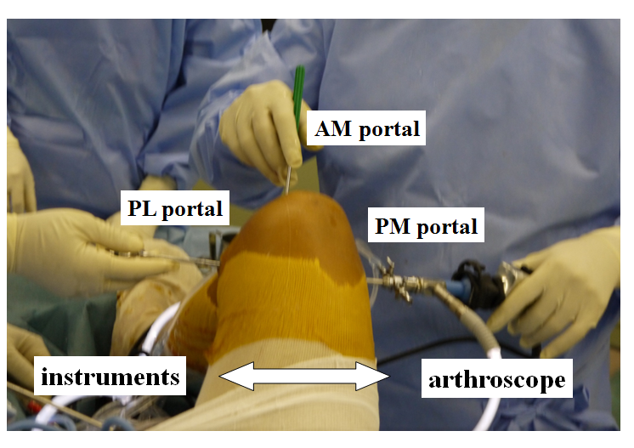
Figure 6 Image taken during an operation involving the posterior transseptal portal. One of the posterior two portals is used as a viewing portal; the other is used as a working portal. Anterior portals can be also used as working portals. PM: Posteromedial; PL: Posterolateral; AM: Anteromedial.
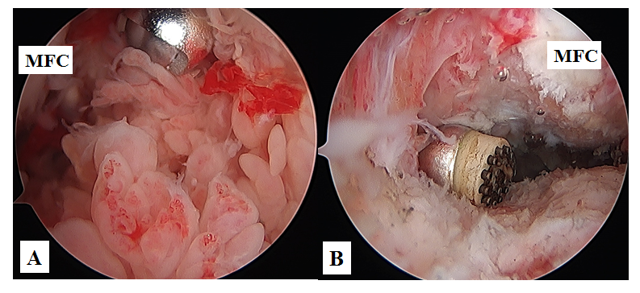
Figure 7 Arthroscopic views of the posterior compartment of the knee in a patient with rheumatoid arthritis. The posteromedial compartment was filled with synovial villi prior to synovectomy. A shaver is introduced from the posterolateral portal through the transseptal portal (A). An arthroscopic view from the posterolateral portal through the transseptal portal after synovectomy (B). A radiofrequency device is introduced from the posteromedial portal. MFC: Medial femoral condyle.

Table 1 List of procedures using our transseptal portal technique
Procedure | n
Synovectomy | 57
Meniscal resection | 20
Thermal shrinkage | 1
Resection of PCL ganglion | 1
Meniscal cyst decompression | 1
Popliteal cyst decompression | 53
Repair of PCL avulsion fracture | 5
Free body resection | 5
Repair of the posterior horn of the medial meniscus | 5
PCL reconstruction | 2
Probing only | 11
PCL: Posterior cruciate ligament.

