Name of Journal: World Journal of Gastroenterology
Manuscript NO: 81184
Manuscript Type: REVIEW

Functional constipation in children: What physicians should know

Tran DL et al. Constipation in children

Duc Long Tran, Palittiya Sintusek

Duc Long Tran, Thailand and Department of Pediatrics, Faculty of Medicine, Chulalongkorn University, Bangkok 10330, Bangkok, Thailand

Duc Long Tran, Faculty of Medicine, Can Tho University of Medicine and Pharmacy, Can Tho City 9000, Viet Nam

Palittiya Sintusek, Thai Pediatric Gastroenterology, Hepatology and Immunology Research Unit, Division of Gastroenterology, Department of Pediatrics, King Chulalongkorn Memorial Hospital and Thai Red Cross, Faculty of Medicine, Chulalongkorn University, Bangkok 10330, Thailand

Author contributions: Sintusek P and Tran DL contributed to conception of the study; Tran DL drafted the manuscript; Sintusek P and Tran DL wrote the manuscript; Sintusek P made critical revisions related to the intellectual content of the manuscript; and all authors read and approved the final version of the manuscript.

Supported by Thailand and Thailand Science Research and Innovation Fund Chulalongkorn University, No. HEA663000047.

Corresponding author: Palittiya Sintusek, MD, PhD, Doctor, Lecturer, Thai Pediatric Gastroenterology, Hepatology and Immunology Research Unit, Division of Gastroenterology, Department of Pediatrics, King Chulalongkorn Memorial Hospital and Thai Red Cross, Faculty of Medicine, Chulalongkorn University, 1873 Rama IV Road, Pathumwan Subdistrict, Bangkok 10330, Thailand. palittiya.s@chula.ac.th

Received: October 28, 2022
Revised: December 5, 2022
Accepted: February 16, 2023
Published online:

Abstract
Functional constipation (FC) is considered the most common functional gastrointestinal disorder in children with a pooled global prevalence of 14.4% (95% confidence interval: 11.2-17.6) when diagnosed based on the Rome IV criteria. Its pathophysiological mechanisms are thought be multifactorial and complicated, resulting in difficult management. Currently, the most effective medication, when used in parallel with toilet training, is osmotic laxatives. Children’s adherence to medication and parental concern regarding long-term laxative use are the main contributors to treatment failure. Recently, novel therapies with a high safety profile have been developed, such as probiotics, synbiotics, serotonin 5-hydroxytryptamine 4 receptor agonists, chloride channel activators, and herbal and transitional medicines; nonetheless, well-designed research to support the use of these therapies is needed. This review aims to focus on multiple aspects of FC in children, including global prevalence, pathogenesis, diagnostic criteria, tools, as well as conventional and novel treatment options, such as non-pharmacological management, including adequate fiber and fluid intake, physiotherapy, or neuromodulators. We also report that in very difficult cases, surgical intervention may be required.

Key Words: Constipation; Children; Laxative; Treatment; Toilet training; Herbal

Tran DL, Sintusek P. Functional constipation in children: What physicians should know. World J Gastroenterol 2023; In press

Core Tip: Functional constipation (FC) is a typical symptom of functional gastrointestinal disorders in children and its prevalence is high worldwide. Since the pathophysiology of FC in children is associated with stool withholding behavior, successful toilet training in combination with osmotic laxatives is crucial for the treatment childhood FC. Additionally, promising and innovative drugs can also aid in treatment success.

INTRODUCTION
Functional constipation (FC) is considered a great disease burden in children that needs early screening and detection. The prognosis of FC is better in children with prompt and proper management. General physicians and pediatricians are usually the first person who take care these children hence understanding the pathophysiology of FC can lead to the proper management and satisfied outcome. In this chapter, the content will be covered all aspect the physician should know about FC for better patient care.

EPIDEMIOLOGY
Globally, up to 25% of visits to pediatric gastroenterologists and 3% of all general pediatric outpatient visits are due to FC^{[1]}. It is difficult to determine the true prevalence of FC in children due to the heterogeneity of the studies in terms of target population sampling, diagnostic criteria, participant ethnicity and environment, method of data acquisition, and life style and psychological factors among others^{[2]}. The primary reasons for the global diversity in prevalence among published studied may be due to the lack of agreement on diagnostic standards and cultural differences^{[3]}. A systematic review and meta-analysis published by Koppen et al^{[4]} reported that the worldwide prevalence of FC according to the Rome III criteria was 9.5% [95% confidence interval (CI): 7.5%-12.1%], with significantly more American and European children being affected than Asian ones. Additionally, geographical region, diet, and exposure to traumatic life events were linked to FC in children.
We determined that the pool global prevalence of FC in children was 14.4% (95%CI: 11.2-17.6) using the Rome IV criteria. According to continent, Africa had a highest prevalence of constipation (31.4%), followed by America (12.1%, 95%CI: 9.1%-15.1%), Europe (8.3%, 95%CI: 3.7%-12.9%), and Asia (6.2%, 95%CI: 1.3%-11%). Moreover, the factors significantly associated with FC from these studies are summarized in Figure 1 and Table 1.

NORMAL DEFECATION AND FC
Frequency of toileting habits in infants and children varies with age. To reduce parental worry and prevent needless testing and treatment, knowing the typical toilet routines for all age groups is important^{[5]}. The frequency of stool passage per day gradually decreases from more than four times per day during the first week of life to three times per day at 4-6 wk of life and one to two times per day by the age of 4 years^{[6,7]}. Healthy infants who are exclusively breastfed will have infrequent stool passage at 1-2 mo of life, with a mean duration of 6 days per stool passage (2-28 d per stool passage) without any abnormalities^{[8]}. This condition will normalize at a mean age of 3.9 mo (range 1-7 mo)^{[9]}. Hence, if the stool is soft, the infrequent stool passage in this age group requires neither intervention nor treatment. From the age of five, the majority of children pass stools daily or every other day without straining or withholding^{[3]}. In early newborns, the average intestinal transit time is around 8.5 h, whereas intestinal transit times after puberty range from 30 to 48 h^{[5]}.
FC in adults had been first defined in 1999 according to the Rome II criteria and was mostly based on expert opinion. The diagnostic criteria of FC in children was subsequently established and integrated in Rome III criteria by Rome foundation in 2006. In 2016, the Rome III criteria had been replaced by the Rome IV criteria, with only minor changes being made as shown in Table 2^{[10]}. Children who are not yet toilet trained do not need to include fecal incontinence (FI) and clogged toilet in the diagnostic criteria. In addition, the duration of symptoms in children had been changed from 2 mo in the previous Rome III criteria to 1 mo in the current Rome IV criteria^{[10,11]} to promote early recognition and timely treatment. Although there are some changes of the diagnostic criteria in Rome IV, the prevalence of FC in children was similar using either the Rome IV or Rome III criteria.
FI in children is defined as the involuntary passage of stool into the underwear either as unintentional seepage of small amounts of liquid stools (generally referred to as “soiling” or “leakage”) in a child older than 4 years of age or in a toilet-trained child^{[12,13]}. Irrespective of the amount of stool, this is one of the most unpleasant and embarrassing things for a growing child apart from being an upsetting and mentally distressing issue that has a negative impact on children’s quality of life. FI was divided into 2 types; retentive and nonretentive FI. It is critical to distinguish between retentive and nonretentive FI given their different etiologies and approaches to treatment^{[14]}. Hospital and community studies have shown retentive FI occurs in constipated children with fecal impaction^{[1,15,16]}, whereas the nonretentive type could be found in children with psychological problems^{[3]}.

PHYSIOLOGY OF DEFECATION AND PATHOGENESIS
The act of defecation is a process related to the pelvic floor muscles, anal sphincter complex, enteric nervous system, and central nervous system (Figure 2). Normally, children over 18 mo old can initially control defecation through this complicated process, with nearly all of them succeeding in controlling defecation by the age of 4.
The etiology of constipation can be classified into functional and organic causes, which account for 90% and 10% of the cases, respectively^{[12]}. Regarding FC, the pathophysiological mechanism might be multifactorial, including stool withholding behavior, anorectal dysfunctions, diet, physical activity, genetic predisposition, and psychological issues. Stool withholding behavior is the main pathophysiological mechanism especially in toddlers and young children. Faulty toilet training, painful defecation from hard stool and frequent rectal enema contribute to fear and bad experiences related to defecation, which can cause purposeful or subconscious stool withholding behavior. Instead of relaxing the pelvic floor muscle when feeling the urge to defecate, children will defecate in the standing position and contract the pelvic floor and gluteal muscles, a phenomenon called “retentive posture or defecation in standing position”. This behavior promotes the retention of stool in rectum and causes the stool to become lumpier and harder, making it quite difficult to evacuate, due to water absorption by rectal mucosa. This phenomenon leads to a vicious cycle of difficult defecation. Once large stools are retained in the rectum, the rectal wall stretches and develops into a megarectum^{[17]} with decreased sensation to defecate^{[12]}. Moreover, liquid stool can penetrate the hard stool and leak out of the anus, causing fecal soiling (Figure 3). According to pathophysiology, withholding behavior, palpable fecal mass on abdominal examination, and fecal soiling were reported in 37%-91%, 33%-68%, and 33%-77% of in children with FC, respectively^{[18-21]}. Hence, two of the three characteristics were integrated into the Rome IV criteria.

CLINICAL MANIFESTATIONS OF AND EXAMINATIONS FOR FUNCTIONAL AND ORGANIC CONSTIPATION
FC is diagnosed based on symptoms detailed in the Rome IV criteria. However, some examinations may help pediatricians in cases with uncertain symptoms and signs^{[22]}. Moreover, in cases that are difficult to treat or have alarm features (Table 3), examinations to exclude organic cause are necessary. Here we will review the clinical manifestations and examinations that can helpful general pediatricians and specialists diagnose functional and organic constipation (Table 4).

Patient history
When obtaining the medical history of children, it is important to inquire about when the child had their first bowel movement after delivery. Normally, during the first 24 h of life, more than 90% of term newborns pass meconium^{[23,24]}. This period may be longer in preterm infants due to the delayed maturation of the intestinal motor function^{[25]}. If the passage of meconium is delayed after birth, worrisome diseases, such as Hirschsprung’s disease (HD) and cystic fibrosis, should be excluded^{[6,26]}. Age of onset, frequency, consistency and size of the stool, painful or difficult defecation, and presence of blood coating the stool are all crucial details to note when recording a patient’s history. In addition, frequent clogging of the toilet might reflect a large fecal mass in rectum. Anal fissures should be examined in children with a history of difficult defecation (Figure 4A) and those with blood coating the stool (Figure 4B) or the toilet paper. It is necessary to gather information regarding incontinence or soiling during the day and night. FI can be mistaken for diarrhea by their guardians^{[1,6]} (Figure 4C). Evidence of fecal impaction in children suspected of FI is crucial, and physicians could obtain this information through abdominal palpation of a fecal mass, digital rectal examination, or rarely through plain abdominal radiography in noncooperative children. Importantly, physicians must define how a child defecates. Withholding behaviors are considered the main pathogenesis of FC and have been defined by guardians as defecation in the “standing position”. This can also be described as stiffening up, buttock clenching, walking on tip toes, crossing one leg over the other, bracing against furniture, being in the all-fours position or curling up in a ball, and sitting with legs straight out (Figure 4D)^{[27,28]}. Withholding behaviors also help clinicians determine that the constipation should be of functional etiology without any organic problems. Other factors, such as significant life events like a family member’s death, the birth of a sibling, difficulties in school, sexual abuse, and others, can contribute to retentive behaviors and FC and should be evaluated in detail^{[1,6]}.
Although the abdominal pain caused by FC is typically nonspecific and poorly localized, constipation was the cause of acute abdominal pain in 50% of children who presented for a primary care visit and should be considered in this context^{[1]}. Physicians should identify alarm features (Table 4) and other signs and symptoms, including appetite loss, fever, nausea, vomiting, reduced weight gain, issues with neuromuscular development, and behavioral or psychological problems^{[6,26,29]}. Poddar et al^{[18]} reported that children with symptoms such as delayed passage of meconium, growth failure, lack of retentive posturing, and absence of fecal impaction may likely have organic FC. Furthermore, urinary tract infections have been reported in a significant number of children suffering from constipation and FI^{[30,31]}. Dietary and constipation treatment history should be investigated to predict the long-term outcomes of FC in affected children^{[1,6,32]}.

Physical examination
Assessing children’s physical development through weight and height measurements should be the first step^{[6]}. Abdominal examination should obtain information on the rectal fecal mass, particularly its height above the pelvic brim, through bimanual palpation on either side of the rectus sheath^{[7]}. With careful abdominal and digital rectal examination, fecal masses can be detected in 30%-75% of children with FC^{[1,18]}. The perineum should be examined given that it can reveal important details regarding the anal position, evidence of FI, skin irritation, eczema, fissures, and signs of possible sexual abuse^{[6]}.
Measuring the anogenital index (Figure 5) is important given that it might be considered a factor associated with FC. The anogenital index can be calculated using the formula presented below^{[33-36]}. The normal anogenital index in males and females is 0.54 ± 0.03 and 0.40 ± 0.04, respectively^{[35]}. Anogenital index = [vagino/scroto to anal distance (cm) ÷ vagino/scroto to coccygeal distance (cm)]^{[35]}.
When the child’s history suggests the presence of FC, a digital rectal examination may not be necessary^{[7,37]}. Digital rectal examination should be conducted when children present with red flags, a history of delayed meconium passage after birth, intractable constipation, an uncertain diagnosis according to the Rome IV criteria, suspicion of an anatomic problem, and assessment of fecal impaction after disimpaction. Although neurological disease causing organic constipation is very rare, dedicated neurological examination still has merit (Figure 6).

Laboratory examinations
It is necessary to emphasize that FC is a clinical diagnosis based on a detailed medical history and physical examination. The goal of laboratory testing is to determine the presence of a rare organic etiology in children with constipation showing alarm features^{[37]} (Table 3) or confirm the diagnosis of FC in complicated or unclear cases. Hence, further diagnostic interventions are sometimes warranted. Investigations that might be useful for determining organic causes of constipation are described below.

Laboratory testing: Thyroid function and serum calcium tests can be used in children with intractable constipation or chronic constipation who are quite difficult to treat. In countries with a high prevalence of celiac disease and cystic fibrosis, specific tests for these diseases might be considered. Although the prevalence of food allergies in children presenting to tertiary clinics with chronic constipation who are unresponsive to traditional treatment vary from 28% to 78%^{[38]}, conflicting data support the use of allergy testing to identify cow’s milk protein allergy (CMPA) in constipated children^{[39-41]}. Therefore, according to the recommendations of the European Society of Paediatric Gastroenterology, Hepatology and Nutrition (ESPGHAN) and North American Society of Pediatric Gastroenterology, Hepatology and Nutrition (NAPSGHAN), routine allergy testing is not recommended in constipated children suspected for CMPA^{[37]}. Oral food avoidance and rechallenge is the gold standard for diagnosing CMPA that manifests with intractable constipation.

Abdominal radiography: Abdominal radiography can be help pediatricians determine the presence fecal masses in some cases where physical examination is limited (Figure 7), such as obese children, patient refusal, or noncooperation, or exclude some causes of acute abdominal pain.
According to systematic reviews, abdominal radiography can identify constipation with a sensitivity and specificity of 60%-80% and 43%-99%, respectively^{[42,43]}. There was inconsistent evidence to support the diagnostic relationship between constipation symptoms and fecal loading in abdominal radiographs from children; hence, the results should be interpreted with caution. In line with this, three scoring systems have been developed, namely the Barr score^{[44]}, Leech score^{[45]}, and Blethyn score^{[46]}. However, further validation is needed before they can be widely used in clinical practice.

Abdominal ultrasonography: Abdominal ultrasonography can assess stool retention and estimate the size of the rectum and colon based on the supposition that fecal retention is one of the primary characteristics of constipation in both children and adult^{[6,47]}. Given that ultrasound scanning is noninvasive and radiation-free, it is usually used for assessment in primary and secondary clinical care^{[1,6]}. Rectal diameter measurements were correlated with the results of digital rectal examination and therefore seems to accurately assess fecal impaction^{[43]}. Evidence suggests that digital rectal examination might be replaced by ultrasound scanning given that the latter is less unpleasant^{[48]}. Even though there was a good correlation of transverse rectal diameter with FI and long-term constipation^{[49]}, the transverse diameter cannot be used to predict fecal impaction or constipation^{[37]}. Furthermore, the results are largely operator dependent, and patient cooperation is also needed.

Radiopaque marker for colonic transit study: Based on the distribution of markers throughout the colon, the radiopaque marker (ROM) for colonic transit time (CTT) study is one method for distinguishing between different types of colonic function, including normal colonic transit, slow-transit constipation, and obstruction of the rectal outlet. Given its accessibility and strong concordance with scintigraphic methods, the ROM for CTT study has become the most popular method for determining both total and segmental CTT^{[50]}. The sensitivity and specificity of the ROM for CTT study were 71% (95%CI: 57%-83%) and 95% (95%CI: 82%-99%), respectively^{[51]}. The mean transit time in healthy persons has been reported to range from 15.6 to 37.7 h, with a review by Southwell et al^{[52]} revealing that the normal CTT was < 32 h (upper 95th centile: 54 h).
The ESPGHAN and NAPSGHAN recommend that these tests only used to distinguish FC from functional non-retentive fecal incontinence or, where the diagnosis is unclear, provide clarity and allow the selection of alternative diagnostic procedures due to the widespread use of the Rome criteria for the diagnosis of FC and the potential risks caused from repeated radiation exposure from abdominal radiography^{[37,50]}.

Colonic manometry: To determine the neuromuscular function of the colon in children with intractable constipation, colonic manometry is regarded as the gold standard^{[50]}. Evidence suggests that colonic manometry is most useful in providing subsequent guidance for further therapy, including pharmacological and surgical management, in intractable constipation. According to a review by the ESGHAN motility group, high amplitude propagating contractions are the most easily recognizable and reliable motor pattern (Figure 8). They are initiated usually in the proximal colon and expected to stop at the recto-sigmoid junction. However, colonic manometry can be difficult for children given its invasive nature and necessity for general anesthesia. Moreover, age can be a potential limiting factor depending on the size of the catheter and endoscope. Additionally, only a few specialist centers globally offer this test.

Wireless motility capsule: The wireless motility capsule (WMC) is a novel, nonradioactive, and minimally invasive tool for the assessment of colonic motor function. Several investigations have reported on the safety and tolerability of WMC. In recent years, an increasing number of studies have used WMC to diagnose children with functional gastrointestinal diseases (FGIDs)^{[53,54]}. This test could provide information on gastrointestinal motility that is similar to information obtained via nuclear medicine gastric emptying time and/or ROM. Moreover, WMC can provide additional information on regional and entire-gut transit^{[53]}, which can not only add to our knowledge of colon physiology but also be used as a parameter to tailor treatment^{[54]}. Considering its safety and low invasiveness, the ESPGHAN motility working group recommended that more research be done to assess the effectiveness of the WMC in predicting outcomes among children with intractable constipation^{[50]}.

Magnetic resonance imaging: Cine magnetic resonance imaging (cMRI) is a noninvasive tool that uses a high-resolution spatiotemporal approach to facilitate dynamic MRI, which would allow the observation of the gut lumen diameter. The assessment of stomach accommodation and emptying, terminal ileum motility, and the small bowel using cMRI has been documented in the literature^{[43]}.
In both adults and children, cMRI can be used to assess colonic motility for various gastrointestinal disorders^{[55]}. However, data on the application of this method in children with intractable FC are currently scarce.
Vriesman et al^{[56]} published the first pediatric study comparing the identification of colonic motility patterns on cMRI with that on colonic manometry, proving potential evidence regarding the feasibility of the technique. cMRI has the advantage of being noninvasive, precluding the need for general anesthesia; however, given that this is still a research-based modality, additional studies are required to establish objective and systematic measurements.

Barium enema and others: A barium enema is used to coat the lining of the colon and rectum in order to create clearer images of the colon (Figure 9A). A contrast enema is often used in the diagnostic workup of HD, in which a transition zone between the aganglionic and ganglionic bowel may be observed in histopathology study^{[6]} (Figure 9B). A 24-h delayed barium enema film could offer comprehensive data on colon transit function in young children, especially those under 4 years old who often cannot undergo CTT study^{[57]}. Moreover, delayed retention of contrast at 48 h provides the strongest negative predictive value to exclude HD. Nonetheless, a limitation of barium enema is that it cannot be used to diagnose ultrashort HD; instead, anorectal manometry is required wherein absence of the anorectal inhibitory reflex is pathognomonic for HD (Figure 9C).

TREATMENT OPTIONS
The goals of treatment include establishing regular defecation (ideally once a day, passing soft stools and without difficulties) and preventing relapses^{[1,6,58]}. Oral laxatives and structured toilet training are the main tools of a successful treatment. FC in children is typically managed across four important phases: (1) Education; (2) Fecal disimpaction; (3) Preventing fecal reaccumulation; and (4) Follow-up.

Education
Education is an important initial step of treatment^{[59]} given its association with adherence and the successful of management of constipated children. In fact, studies by Steiner et al^{[60]} and Koppen et al^{[61]} reported that 38% and 37% of patients adhered to therapy, respectively. Inconvenience, dissatisfaction with treatment, and emotional impact of symptoms were linked to low adherence, all of which require attention^{[61]}.
Therefore, education should include an explanation of the physiological dynamics of defecation; associated factors of constipation; and the related shame, embarrassment, and social issues to the guardians and their children. In particular, the doctor needs to make it clear to the family that withholding behavior is crucial to the pathophysiology of FC. Furthermore, physicians should create a thorough plan to eliminate the frustration of guardians and children and increase cooperation required for prolonged treatment. Moreover, the timing of a successful treatment is frequently unpredictable, and guardians must understand that there is no quick fix for this problem. Recovery is only feasible with a sufficient, frequent, and prolonged care^{[1,6,59]}. In some complex cases, such as in children with intractable constipation or in those suffering from other comorbidities such as urinary problems, it is necessary to involve a multidisciplinary team that includes pediatric specialist nurses, pediatric research nurses, psychiatrists, urotherapists, and urologists for long-term follow-ups. Hence, such children require customized care.

Fecal disimpaction
Fecal disimpaction is crucial before the start of maintenance therapy in order to maximize the success of treatment. If fecal impaction is not eliminated beforehand, maintenance therapy can lead to worsening FI^{[1,6,59]}. Oral drugs, rectal enema, or a combination of both can effectively treat fecal impaction. Two randomized controlled trials (RCTs) showed that polyethylene glycol (PEG) and enemas are equally effective for fecal disimpaction^{[62,63]}. The use of 1-1.5 g/kg/d of PEG with or without electrolytes orally for 3-6 d is recommended as the first-line treatment for constipated children with fecal impaction^{[37]}. However, a RCT study reported that both lactulose and PEG treatment successfully promoted disimpaction and were safe and well tolerated, although PEG achieved disimpaction significantly faster at day 2 (P = 0.001)^{[64]}. Lactulose may be a useful PEG substitution for treating fecal impaction, particularly in areas wherein the availability of PEG is limited.
The oral route is typically less intrusive, better tolerated, and provides children with a better sense of control than rectal enema; however, successful disimpaction can take a few days, with compliance also being an issue. In contrast, the rectal approach (enema) is faster (effect occurs within minutes) but more invasive and traumatic. It may be useful for removing fecal impaction in patients with severe abdominal pain or large fecal mass on abdominal examination. Common side effects of enema include anorectal discomfort and abdominal pain; hence, it should be avoided in scared and resistant children to avoid anal fissures^{[58]}. Recently, a study on the efficacy of olive oil enemas for childhood constipation showed that 79.6% and 66.7% of FC cases in the olive oil and lubricant groups were effectively treated for fecal impaction, respectively^{[65]} (Table 5).

Maintenance therapy
Following disimpaction, maintenance therapy should be started immediately. The goals of maintenance therapy are to produce soft and painless stools, avoid stool reimpaction, and stop the reemergence of stool withholding behavior. This can be accomplished by combining pharmacological and nonpharmacological interventions.

Pharmacological management
Osmotic laxatives: Osmotic laxatives, including PEG, lactulose, and milk of magnesium hydroxide (MOM), are a type of osmotically active ions or molecules that are rarely absorbed in the small intestine. As such, they stimulate water retention in the colon, consequently softening stools.
PEG has been demonstrated to be more effective at increasing bowel movement frequency than lactulose, making it the first option for maintenance therapy in constipated children^{[66-68]} or MOM^{[69]}. However, limited evidence of its the utilization and safety has been available in infants, especially for long-term usage^{[66,70]}. Moreover, data from a 10-year survey revealed that 645 children using PEG 3350 between the ages of 0-21 reported 1564 adverse symptoms. Among these adverse symptoms, 58.75% were neurological or neuropsychiatric, such as anxiety, anger, abnormal behaviors, and others^{[71]}. However, the data source from this survey had significant limitations, including sampling bias, lack of verification, inability to seek clarifications, and lack of follow-up data. Comparing the efficacy of lactulose and MOM, one study found a significant difference in the frequency of stool passage per week, favoring MOM over lactulose (MD: 1.51, 95%CI: -2.63 to -0.39, 50 patients) (89). Besides PEG, lactulose and MOM have been used as second-line drugs, with MOM being very cheap and widely available in some Asian countries such as Thailand^{[72]}. However, the main limitation of MOM is its terrible palatability as opposed to lactulose. The concerning adverse effect of MOM is just only awareness of hypermagnesemia, especially with long-term usage in children with chronic renal disease. Conversely, lactulose can used safely even among preterm infants^{[73]}, with the only common adverse effect being abdominal distension. Though PEG is the most effective osmotic laxative for the treatment of function constipation in children, in areas or situations where availability is limited, MOM or lactulose might be used as the standard medication for FC instead of PEG^{[6,37]}.

Stimulant laxatives: Stimulant laxatives, such as senna and bisacodyl, increase intestinal motility and interfere with water and electrolyte transport across the epithelial layer. Therefore, stimulant laxatives might result in cramping and abdominal discomfort^{[1,6,74]}. When osmotic laxatives alone are ineffective in treating chronic constipation, stimulant laxatives are often considered. Although stimulant laxatives are thought to be safe and beneficial for treating childhood constipation, limited high-quality RCTs have evaluated their use^{[66,74,75]}. Based on expert opinion, the use of stimulant laxatives may be considered as an additional or second-line treatment^{[37]}.

Lubricants: The most popular lubricant laxative is mineral oil, often known as liquid paraffin. Mineral oil works by coating and lubricating stools, lowering fecal water absorption in the colon, and making it easier to pass feces. Given that mineral oil has no chemical activity, severe negative impacts are rarely common. The effectiveness of mineral oil and oral laxatives in treating childhood constipation has been compared in a few low-quality trials. Accordingly, mineral oil promoted significantly greater bowel movement frequency compared to lactulose^{[66,76,77]}, but no significant difference in treatment response was observed when compared to PEG^{[78]}. Moreover, liquid paraffin was found to induce significantly better defecation frequency and FI episodes compared to senna; however, the evidence was of low quality^{[79]}. Given the risk of aspiration and severe lipoid pneumonitis, mineral oil is not recommended for infants under the age of 1 year^{[80]}.

Promising pharmacological therapies
Probiotics/prebiotics: Probiotics are live microorganisms that, when administered in adequate amounts, confer health benefits to the host. Probiotics have been used in the treatment of FC based on the hypothesis that they alter the intestinal microbiota and colonic pH, thereby improving gastrointestinal motility. Studies reported that constipated children have higher amounts of Lactobacillus spp.^{[81, 82]} and lower amounts of Bacteroides^{[83]} compared to healthy children, implying that gut dysbiosis in the pathogenesis of constipation. So far, however, strong evidence to support the benefits of probiotics in the treatment or prevention of constipation has been limited^{[84-87]}. However, some studies have demonstrated significantly increased stool frequency or softer stools after receiving probiotics. These findings might imply the significant impact of the pathogenesis of stool withholding in constipated children and that probiotics cannot be expected to overcome withholding behaviors. Therefore, future well-designed studies are needed.

5-HT₄ receptor agonists: Serotonin controls gut motility, visceral sensitivity, and intestinal secretion through serotonin 5-HT₄ receptors, which are primarily expressed by enteric nervous system interneurons^{[6]}.
5-HT₄ receptor agonists cisapride and tegaserod, which showed similar benefits for treating childhood constipation, were discontinued due to their increased risk for cardiovascular accidents and prolonged QT interval (6, 113). Prucalopride is a new generation of selective, high-affinity 5-HT₄ receptor agonists that stimulate gastrointestinal motility and act primarily on parts of the lower gastrointestinal tract^{[6,74,88]}. Current research on the benefit of prucalopride for constipated children has been contradictory. In an open-label pilot study, prucalopride had favorable effects on stool frequency, stool consistency, and frequency of FI in children with FC^{[89]}. However, a recent multicenter RCT in 213 constipated children found no significant improvement of symptoms compared to placebo^{[90]}. Common side effects include headache, nausea, abdominal pain, and diarrhea.

Chloride channel activators: Lubiprostone is a prostaglandin E₁ derivative that activates the chloride channel, thereby stimulating intestinal fluid secretion without increasing serum electrolyte levels^{[6,74,88]}. A study on 127 children (3-17 years old) with constipation showed that lubiprostone was effective and well tolerated, with only minimal side effects like nausea and vomiting^{[91]}. Another study evaluating the safety and tolerability of oral lubiprostone over the course of 24 wk for the treatment of childhood FC in patients aged 6-17 years old showed that lubiprostone was well tolerated and the frequency of treatment-emergent adverse events was similar to that seen in previous clinical trials and adults^{[92]}. However, a double-blind, placebo-controlled, multicenter study on 606 children aged 6-17 years old (202 placebo; 404 Lubiprostone) with FC who satisfied the Rome IV criteria showed no significant difference in the total spontaneous bowel movements response rate between the lubiprostone and placebo groups. Frequently reported side effects include nausea, vomiting, diarrhea, and stomach pain^{[93]}.
Linaclotide and plecanatide bind to and act as an agonist of guanylate cyclase-C receptors, causing an increase in the production of chloride and bicarbonate the intestinal lumen. This increase in intestinal fluid causes an acceleration of the gastrointestinal transit while simultaneously decreasing visceral pain by reducing pain sensation^{[6,74]}. Although no pediatric trials have been conducted, studies in adults showed that plecanatide treatment significantly improved constipation. The use of linaclotide in children with FC (0-18 years old) was only reported in a retrospective study, which showed that 45% patients with FC had a positive clinical response and approximately one-third of children experienced negative side effect, such as diarrhea, abdominal pain nausea, and bloating. Eventually, 27% patients stopped using linaclotid due to adverse events^{[94]}.

Herbal and traditional medicine: Stool withholding behavior is the main pathogenesis of FC in children. Given that successful toilet training takes time, normally more than 3-6 mo, osmotic laxatives have been the mainstay of treatment during toilet training. However, the majority of guardians and children wanted to withdraw the medication due to their concerns, sometimes with the taste or the amount of osmotic laxatives, which worsened the constipation. In several countries such as Iran, China, Vietnam, and Thailand, herbal medicine is usually integrated into some parts of the treatment as the main or additional therapy. Furthermore, while developing a new drug is a time-consuming and costly process, traditional drugs can be used to treat FC in children instead.
Several herbal and traditional medicines have been used for managing constipation in children, such as glucomannan^{[95,96]}, cocoa husk^{[97]}, AFPFF (combined acacia fiber, psyllium and fructose)^{[98]}, cassia fistula emulsion^{[99]}, inulin^{[100]}, black stap molasses^{[101]}, XiaojiDaozhi Decoction^{[102]}, darmark roses^{[103,104]}, and other herbal medicines^{[105]}. However, only a small number of herbal remedies for FC have been well supported by RCTs in children (Table 6).
Most studies have reported that herbal and traditional medicine had significant effects on childhood constipation without significant adverse effects. Nonetheless, more high-quality studies are needed. This also suggests the need for studies that identify the active ingredients of herbal and traditional medicine responsible for their beneficial effects against FC in children. With more evidence, herbal or traditional medicine therapies can be integrated into standard treatments for childhood.

Nonpharmacological management
Diet (fiber and water): A low dietary fiber intake has been considered a risk factor for the development of FC^{[1,6,106]}. The recommended adequate dietary fiber intake in children older than 2 years of age is equivalent to age (in years) plus 5-10 g/d^{[1,107]}. However, there is still insufficient evidence from RCTs to support the routine use of fiber supplements to reduce constipation in children^{[108]}. While some studies have shown that constipated children have lower fiber intake compared to healthy controls^{[96,109]}, other studies do not support this^{[95,110]}. Regarding to fluid intake, lower water intake has been associated with a higher risk for intestinal constipation^{[111-113]}. Hence, adequate water intake may be beneficial for the prevention of FC. The recommended water intake for children is based on the National Institute for Health and Care Excellence Guideline (Table 7).

Physiotherapy: FC in children is thought to be influenced by dysynergic defecation, which refers to pelvic floor dysfunction^{[88]}. Studies have shown the effectiveness of pelvic muscle exercises as part of a combined treatment intervention^{[59,88]}. A multicenter RCT comparing standard medical care (SMC), which includes education, toilet training, and laxatives, with pelvic physiotherapy (PPT) + SMC in constipated children aged 5-16 years old showed that PPT and PPT + SMC were effective in 63% and 92.3% of the children, respectively. Treatment success (based on the global perceived effect) were achieved in 88.5% and 33.3% of subjects receiving PPT + SMC and SMC, respectively (P < 0.001)^{[114]}. A significant study in a primary care environment, however, found no additional benefits of PPT in 134 children aged 4-18^{[115]} and that adding physiotherapy to SMA as a first-line treatment for all children with FC offered no cost benefits compared to SMA alone^{[116]}.

Toilet training: Toilet training aims to reduce symptoms, the child’s defecation anxiety, and toileting avoidance^{[1,6]}. There are four main methods for toilet training, including the child-oriented toilet training method, Azrin and Foxx method, Dr. Spock’s toilet training method, and early elimination toilet training method^{[117-119]}. The most friendly, accepted, and practical methods recommended by the American Academy of Pediatrics and Canadian Pediatric Society is the child-oriented toilet training method, in which the proper age for toilet training is between 18 and 24 mo^{[120,121]}. Parents should be encouraged to be positive and supportive throughout the toilet training. Children should be encouraged to participate in toilet training, which consists of five sequential steps: know, dare, can, will, and do^{[122]}. The child is taught to sit on the toilet for up to 5 min, one to three times a day, following meals to take advantage of the gastrocolic reflex^{[6]}. The position of defecation is necessary to open the anorectal angle (the angle between the longitudinal axis of anal canal and the posterior rectal line, parallel to the longitudinal axis of rectum) and facilitate stool expulsion (Figure 10). To track improvement and compliance, keeping a daily journal of bowel movement, fecal and urine incontinence, and medication is beneficial. Providing stickers or small gifts as positive reinforcement for good behavior might further motivate children^{[6,122]}. Through this process, children gain the ability to perceive their urge to defecate, consequently developing the habit of using the toilet instead of holding it in^{[59]}.

Biofeedback: Biofeedback training is a technique for teaching children how to control their perianal muscles for more efficient bowel movements. This technique involves bringing a typically unfamiliar physiological process to the patient’s attention and allowing them to measure it^{[1,6]}. In line with this, a recent meta-analysis incorporated three studies contrasting conventional treatment with add-on biofeedback treatment. Accordingly, two studies showed that treatment success rates were higher in the biofeedback group, whereas one study found no difference. In addition, one study found that the addition of biofeedback training at home offered no benefit in terms of defecation frequency compared to biofeedback at the laboratory^{[106]}. Accordingly, biofeedback therapy is not advised for the regular treatment of children with FC based on the most recent research^{[59,106]}.

Abdominal massage: The mechanisms by which abdominal massages reduce constipation are most likely a combination of local stimulation and relaxation, as well as stimulation of the parasympathetic nervous system. Direct pressure over the abdominal wall alternately compresses and releases sections of the digestive tract, briefly distorting the lumen size and activating stretch receptors that can reinforce the gastrocolic reflex and trigger intestinal and rectal contraction^{[106,123,124]}. A meta-analysis including a total of 23 RCTs and 2005 children showed that traditional Chinese medicine (TCM) infant massage had a superior effect on infant FC than drug therapy alone. Moreover, a clinical investigation found that children with FC may defecate more frequently and experience less constipation symptoms when receiving TCM infant massage^{[123]}. There is little evidence to support the idea that using Chinese herbs in combination with other therapies might be beneficial^{[106,123]}. Abdominal massage might be a promising additional therapy to manage FC.

Retrograde enemas: There is insufficient evidence to support the role of retrograde enemas in the maintenance phase of FC in children. Hence, this procedure is reserved for intractable constipation, especially in cases with slow-transit constipation or megarectum. An RCT comparing to the clinical efficacy of supplemental treatment with rectal enemas against conventional treatment alone in 100 children between the ages of 8 and 18 who had symptoms of constipation for at least 2 years revealed that defecation frequency normalized after 1 year of treatment in both groups but was significantly higher in the intervention group compared to controls at 26 and 52 wk (5.6/wk vs 3.9/wk, P = 0.02, and 5.3/wk vs. 3.9/wk, P = 0.02, respectively). Enemas as maintenance therapy for severely constipated children had no substantial side effects compared to oral laxatives alone^{[125]}.

Transanal irrigation: Transanal irrigation (Figure 11A) can be an option for children with FC who do not respond to pharmacological treatment^{[126,127]}. It involves inserting a catheter or cone into the rectum to inject water into the colon, cleaning it completely^{[126]}. This treatment has been previously well established for patients with neurogenic bowel disorders and anorectal malformations^{[127]}. Moreover, evidence has suggested its safety and effectiveness, with an average success rate of 78% for both FI and constipation^{[127,128]}. In addition, 86% of the parents were satisfied with the results of transanal irrigation, and 67% reported that they would continue using transanal irrigation for the treatment of their child’s symptoms^{[129]}. Therefore, transanal irrigation can be considered an effective therapeutic option for severely constipated children with FI who do not respond to conventional therapy^{[6,127,128]}.

Botulinum toxin A injection: Botulinum toxin A (Botox) injections into the anal sphincter can be considered in cases suspected of anorectal dysfunction or functional outlet obstruction^{[59]}. Botox injections, which temporarily reduce anal sphincter muscle contraction, serves as both a diagnostic test, indicating whether the obstructive symptoms are being caused by internal anal sphincter hypertonia, and treatment for intractable constipation. Children who exhibit significant withholding behavior or anal sphincter dysfunction may benefit from Botox injections^{[6,59]}. A RCT and systematic review found that Botox injections were as equally effective as internal sphincter myectomy on short-term follow-up^{[130,131]}. However, a retrospective study on 164 children over 7 years old with intractable constipation showed that Botox injections into the internal anal sphincter of children had an overall response rate of 70%. Moreover, anorectal manometry studies in children with normal and abnormal sphincter dynamics observed similar response rates to this therapy^{[132]}.

Neuromodulation: Sacral neuromodulation (SNM) is a promising option for the treatment intractable constipation. SNM involves percutaneous placement of an electrode into the third sacral foramen and implantation of a stimulating device under the skin covering the buttocks^{[6]}. The exact working mechanism of SNM remains largely unknown, although evidence has suggested that SNM stimulates anorectal function at a more central level. SNS can affect multiple physiological functions of the pelvis and lower abdomen and supports the propulsive peristalsis of the intestine, which is of special interest in slow-transit constipation^{[133]}. One study in 30 constipated children reported a significant improvement in defecation frequency and abdominal pain after 3 wk of SNM treatment, with the effects being sustained over 22 mo of follow-up in 42% of children. Another study on the treatment of intractable constipation with SNM for over 2 years found that defecation frequency did not change after SNS; however, patients reported that FI decreased from 72% to 20% (P < 0.01) and urinary incontinence decreased from 56% to 28% (P = 0.04). Minor complications include pain after implantation, displacements of the leads, and infection^{[134,135]}. A recent pilot study that assessed noninvasive SNS in 17 constipated children also found it effective in improving symptoms of constipation^{[136]}. Additionally, abdominal transcutaneous electrical stimulation and posterior tibial nerve stimulation, two skin stimulation techniques, have been used to neuromodulate the bowel to treat constipation with promising outcomes^{[6]}.

Surgery: Although almost all patients with FC are successfully treated with conventional therapy, a few continue to have intractable symptoms without any organic problems. In such cases, surgical interventions may be beneficial.
Apart from transanal irrigation, there are also surgical treatment options to achieve stool expulsion, such as antegrade colonic irrigation or antegrade continence enemas (ACEs)^{[59]}. When maximal conventional therapy fails, ACEs have been considered a successful therapeutic option for constipated children^{[1,6]}. ACEs allow fluid to be flushed through the entire colon via an external opening into the colonic lumen, which is usually located at the cecum. The most well-established ACE procedures are percutaneous cecostomy and Malone appendicocecostomy (Figures 11B and 11C). The success rate of ACEs for the management of FC varies from 15% to 100% among studies^{[130,137,138]}. Various enema solutions can be used, including saline and PEG. Complications include skin abrasion, stoma stenosis, granulation tissue, enema fluid leaks, and tube dislodging^{[137,138]}. Regarding other surgical management, there are no clear guidelines on surgical colonic resections and ostomies for children with FC, with such surgical management only reserved for severely constipated children who do not respond to conventional therapy and surgical ACE. These surgical procedures are performed in specialized centers by a multidisciplinary team due to their complexity and potential for problems^{[6,59]}.

CONCLUSION
FC is the most common FGID in children and it affects the quality of life and psychological health of both the child and the family. Stool withholding behavior is the main etiological agent of FC and successful toilet training is the most effective treatment measure as it also prevents FC recurrence in the long term. Nonetheless, osmotic laxatives and lifestyle modifications, along with adequate fiber and fluid intake, are also crucial as first line therapy during toilet training. Even though extensive history taking and physical examination might enable a diagnosis of FC according to Rome IV criteria, children with intractable constipation may require multiple investigations to confirm the diagnosis or to exclude organic causes. Apart from osmotic laxatives, other promising herbal and alternative therapies have been reported to yield satisfactory outcomes in FC with minimal short-term adverse effects; nevertheless, more evidence is needed before these strategies can be adopted worldwide. Children with intractable constipation typically requires a multidisciplinary team approach and the physician should refer the child to a pediatric specialist for re-evaluation and further management (Figure 12).

ACKNOWLEDGEMENTS
The authors are grateful to Miss Alisara Pittiyayon at Electricity Generating Authority of Thailand for the image in figures 2, 3, 5, 9C, 10 and 11, and Assistant Professor Anapat Sanpavat, Division of Pathology, Chulalongkorn University, for providing figures 8C.

REFERENCES
1 Benninga MA, Voskuijl WP, Taminiau JA. Childhood constipation: is there new light in the tunnel? J Pediatr Gastroenterol Nutr 2004; 39: 448-464 [PMID: 15572881 DOI: 10.1097/00005176-200411000-00002]
2 Boronat AC, Ferreira-Maia AP, Matijasevich A, Wang YP. Epidemiology of functional gastrointestinal disorders in children and adolescents: A systematic review. World J Gastroenterol 2017; 23: 3915-3927 [PMID: 28638232 DOI: 10.3748/wjg.v23.i21.3915]
3 Vriesman MH, Benninga MA. Functionl constipation and fecal incontience. In: Wyllie R. Pediatric gastrointestinal and liver diseases. Philadelphia: Elsevier, 2021: 106-118
4 Koppen IJN, Vriesman MH, Saps M, Rajindrajith S, Shi X, van Etten-Jamaludin FS, Di Lorenzo C, Benninga MA, Tabbers MM. Prevalence of Functional Defecation Disorders in Children: A Systematic Review and Meta-Analysis. J Pediatr 2018; 198: 121-130.e6 [PMID: 29656863 DOI: 10.1016/j.jpeds.2018.02.029]
5 Rial R, Uc A. Functional constipation. In: Kleinman RE, Goulet O-J, Mieli-Vergani G, Sanderson IR, Sherman PM, Shneider BL, editors. Walker’s peadiatric gastrointestinal disease. United States: People’s medical publishing house, 2018: 991-1005
6 Weaver LT. Bowel habit from birth to old age. J Pediatr Gastroenterol Nutr 1988; 7: 637-640 [PMID: 3054038 DOI: 10.1097/00005176-198809000-00002]
7 Osatakul S, Yossuk P, Mo-suwan L. Bowel habits of normal Thai children. J Pediatr Gastroenterol Nutr 1995; 20: 339-342 [PMID: 7608830 DOI: 10.1097/00005176-199504000-00013]
8 Courdent M, Beghin L, Akré J, Turck D. Infrequent stools in exclusively breastfed infants. Breastfeed Med 2014; 9: 442-445 [PMID: 25243969 DOI: 10.1089/bfm.2014.0050]
9 Choe YH, Lee JE, Moon KB, Hwang JH, Seo JM. The infrequent bowel movements in young infants who are exclusively breast-fed. Eur J Pediatr 2004; 163: 630-1; discussion 632-3 [PMID: 15290268 DOI: 10.1007/s00431-004-1514-x]
10 Benninga MA, Faure C, Hyman PE, St James Roberts I, Schechter NL, Nurko S. Childhood Functional Gastrointestinal Disorders: Neonate/Toddler. Gastroenterology 2016 [PMID: 27144631 DOI: 10.1053/j.gastro.2016.02.016]
11 Koppen IJ, Nurko S, Saps M, Di Lorenzo C, Benninga MA. The pediatric Rome IV criteria: what's new? Expert Rev Gastroenterol Hepatol 2017; 11: 193-201 [PMID: 28092724 DOI: 10.1080/17474124.2017.1282820]
12 Hyams JS, Di Lorenzo C, Saps M, Shulman RJ, Staiano A, van Tilburg M. Functional Disorders: Children and Adolescents. Gastroenterology 2016 [PMID: 27144632 DOI: 10.1053/j.gastro.2016.02.015]
13 Rajindrajith S, Devanarayana NM, Thapar N, Benninga MA. Functional Fecal Incontinence in Children: Epidemiology, Pathophysiology, Evaluation, and Management. J Pediatr Gastroenterol Nutr 2021; 72: 794-801 [PMID: 33534361 DOI: 10.1097/MPG.0000000000003056]
14 Rajindrajith S, Devanarayana NM, Benninga MA. Review article: faecal incontinence in children: epidemiology, pathophysiology, clinical evaluation and management. Aliment Pharmacol Ther 2013; 37: 37-48 [PMID: 23106105 DOI: 10.1111/apt.12103]
15 Rajindrajith S, Devanarayana NM, Benninga MA. Constipation-associated and nonretentive fecal incontinence in children and adolescents: an epidemiological survey in Sri Lanka. J Pediatr Gastroenterol Nutr 2010; 51: 472-476 [PMID: 20562725 DOI: 10.1097/MPG.0b013e3181d33b7d]
16 Voskuijl WP, Heijmans J, Heijmans HS, Taminiau JA, Benninga MA. Use of Rome II criteria in childhood defecation disorders: applicability in clinical and research practice. J Pediatr 2004; 145: 213-217 [PMID: 15289770 DOI: 10.1016/j.jpeds.2004.04.050]
17 Scott SM, van den Berg MM, Benninga MA. Rectal sensorimotor dysfunction in constipation. Best Pract Res Clin Gastroenterol 2011; 25: 103-118 [PMID: 21382582 DOI: 10.1016/j.bpg.2011.01.001]
18 Poddar U, Singh S, Pawaria A, Srivastava A, Yachha SK. Aetiological spectrum, clinical differentiation and efficacy of polyethylene glycol over lactulose in children with constipation: Experience of 316 cases. J Paediatr Child Health 2019; 55: 162-167 [PMID: 29943871 DOI: 10.1111/jpc.14099]
19 Jang HJ, Chung JY, Seo JH, Moon JS, Choe BH, Shim JO. Nationwide Survey for Application of ROME IV Criteria and Clinical Practice for Functional Constipation in Children. J Korean Med Sci 2019; 34: e183 [PMID: 31269544 DOI: 10.3346/jkms.2019.34.e183]
20 Dehghani SM, Kulouee N, Honar N, Imanieh MH, Haghighat M, Javaherizadeh H. Clinical Manifestations among Children with Chronic Functional Constipation. Middle East J Dig Dis 2015; 7: 31-35 [PMID: 25628851]
21 Russo M, Strisciuglio C, Scarpato E, Bruzzese D, Casertano M, Staiano A. Functional Chronic Constipation: Rome III Criteria Versus Rome IV Criteria. J Neurogastroenterol Motil 2019; 25: 123-128 [PMID: 30646483 DOI: 10.5056/jnm18035]
22 Alshehri DB, Sindi HH, AlMusalami IM, Rozi IH, Shagrani M, Kamal NM, Alahmadi NS, Alfuraikh SS, Vandenplas Y. Saudi Experts Consensus on Diagnosis and Management of Pediatric Functional Constipation. Pediatr Gastroenterol Hepatol Nutr 2022; 25: 163-179 [PMID: 35611377 DOI: 10.5223/pghn.2022.25.3.163]
23 Ezomike UO, Ugwu EO, Ezomike NE, Eke CB, Ekenze SO. Evaluation of Impact of Perinatal Factors on Time to First Meconium Passage in Nigerian Neonates. Malawi Med J 2019; 31: 150-154 [PMID: 31452849 DOI: 10.4314/mmj.v31i2.8]
24 Tunc VT, Camurdan AD, Ilhan MN, Sahin F, Beyazova U. Factors associated with defecation patterns in 0-24-month-old children. Eur J Pediatr 2008; 167: 1357-1362 [PMID: 18264719 DOI: 10.1007/s00431-008-0669-2]
25 Bekkali N, Hamers SL, Schipperus MR, Reitsma JB, Valerio PG, Van Toledo L, Benninga MA. Duration of meconium passage in preterm and term infants. Arch Dis Child Fetal Neonatal Ed 2008; 93: F376-F379 [PMID: 18285377 DOI: 10.1136/adc.2008.138024]
26 Xinias I, Mavroudi A. Constipation in Childhood. An update on evaluation and management. Hippokratia 2015; 19: 11-19 [PMID: 26435640]
27 Dos Santos IR, de Abreu GE, Dourado ER, Martinelli Braga AAN, Lobo VA, de Carvalho IWB, Bastos Netto JM, Barroso U Jr. Emotional and behavioural problems in children and adolescents: The role of constipation. J Paediatr Child Health 2021; 57: 1003-1008 [PMID: 33565678 DOI: 10.1111/jpc.15368]
28 Singh H, Connor F. Paediatric constipation: An approach and evidence-based treatment regimen. Aust J Gen Pract 2018; 47: 273-277 [PMID: 29779292 DOI: 10.31128/AFP-06-17-4246]
29 Benzamin M, Karim AB, Rukunuzzaman M, Mazumder MW, Rana M, Alam R, Islam MM, Alam MS, Hossen K, Yasmin A, Fathema K, Khadga M, Aishy AS. Functional constipation in Bangladeshi school aged children: A hidden misty at community. World J Clin Pediatr 2022; 11: 160-172 [PMID: 35433302 DOI: 10.5409/wjcp.v11.i2.160]
30 Ataee P, Taleshi B, Eskandarifar A, Nuri B, Naghshizadian R, Malekian Taghi A, Eftekhari K. Association between duration of constipation and frequency of urinary tract infection in children. J Comprehensive Pediatrics 2020; 11 [DOI: 10.5812/compreped.104402]
31 Giramonti KM, Kogan BA, Agboola OO, Ribons L, Dangman B. The association of constipation with childhood urinary tract infections. J Pediatr Urol 2005; 1: 273-278 [PMID: 18947551 DOI: 10.1016/j.jpurol.2005.01.011]
32 Strisciuglio C, Cenni S, Serra MR, Dolce P, Kolacek S, Sila S, Trivic I, Bar Lev MR, Shamir R, Kostovski A, Papadopoulou A, Roma E, Katsagoni C, Jojkic-Pavkov D, Campanozzi A, Scarpato E, Miele E, Staiano A. Diet and Pediatric Functional Gastrointestinal Disorders in Mediterranean Countries. Nutrients 2022; 14 [PMID: 35684135 DOI: 10.3390/nu14112335]
33 Chan WT, Lee HC, Wang WN, Yeung CY, Jiang CB. Determination of the normal position of the anus in Taiwanese infants. Pediatr Neonatol 2009; 50: 158-161 [PMID: 19750890 DOI: 10.1016/S1875-9572(09)60055-3]
34 Merlob P, Reisner SH. Determination of the normal position of the anus (with reference to idiopathic constipation). J Pediatr Gastroenterol Nutr 1988; 7: 630 [PMID: 3397855]
35 Núñez-Ramos R, Fabbro MA, González-Velasco M, Núñez Núñez R, Romanato B, Vecchiato L, D'Agostino S, Blesa Sánchez E. Determination of the anal position in newborns and in children with chronic constipation: comparative study in two European healthcare centres. Pediatr Surg Int 2011; 27: 1111-1115 [PMID: 21553273 DOI: 10.1007/s00383-011-2914-4]
36 Bar-Maor JA, Eitan A. Determination of the normal position of the anus (with reference to idiopathic constipation). J Pediatr Gastroenterol Nutr 1987; 6: 559-561 [PMID: 3430264 DOI: 10.1097/00005176-198707000-00012]
37 Tabbers MM, DiLorenzo C, Berger MY, Faure C, Langendam MW, Nurko S, Staiano A, Vandenplas Y, Benninga MA; European Society for Pediatric Gastroenterology, Hepatology, and Nutrition; North American Society for Pediatric Gastroenterology. Evaluation and treatment of functional constipation in infants and children: evidence-based recommendations from ESPGHAN and NASPGHAN. J Pediatr Gastroenterol Nutr 2014; 58: 258-274 [PMID: 24345831 DOI: 10.1097/MPG.0000000000000266]
38 Gelsomino M, Vescovo ED, Bersani G, Sopo SM. Functional constipation related to cow's milk allergy in children: A management proposal. Allergol Immunopathol (Madr) 2021; 49: 17-20 [PMID: 33938184 DOI: 10.15586/aei.v49i3.72]
39 Iacono G, Cavataio F, Montalto G, Florena A, Tumminello M, Soresi M, Notarbartolo A, Carroccio A. Intolerance of cow's milk and chronic constipation in children. N Engl J Med 1998; 339: 1100-1104 [PMID: 9770556 DOI: 10.1056/NEJM199810153391602]
40 Simeone D, Miele E, Boccia G, Marino A, Troncone R, Staiano A. Prevalence of atopy in children with chronic constipation. Arch Dis Child 2008; 93: 1044-1047 [PMID: 18562455 DOI: 10.1136/adc.2007.133512]
41 Mohammadi Bourkheili A, Mehrabani S, Esmaeili Dooki M, Haji Ahmadi M, Moslemi L. Effect of Cow's-milk-free diet on chronic constipation in children; A randomized clinical trial. Caspian J Intern Med 2021; 12: 91-96 [PMID: 33680404 DOI: 10.22088/cjim.12.1.91]
42 Reuchlin-Vroklage LM, Bierma-Zeinstra S, Benninga MA, Berger MY. Diagnostic value of abdominal radiography in constipated children: a systematic review. Arch Pediatr Adolesc Med 2005; 159: 671-678 [PMID: 15997002 DOI: 10.1001/archpedi.159.7.671]
43 Berger MY, Tabbers MM, Kurver MJ, Boluyt N, Benninga MA. Value of abdominal radiography, colonic transit time, and rectal ultrasound scanning in the diagnosis of idiopathic constipation in children: a systematic review. J Pediatr 2012; 161: 44-50.e1-2 [PMID: 22341242 DOI: 10.1016/j.jpeds.2011.12.045]
44 Barr RG, Levine MD, Wilkinson RH, Mulvihill D. Chronic and occult stool retention: a clinical tool for its evaluation in school-aged children. Clin Pediatr (Phila) 1979; 18: 674, 676, 677-679, passim [PMID: 498690 DOI: 10.1177/000992287901801103]
45 Leech SC, McHugh K, Sullivan PB. Evaluation of a method of assessing faecal loading on plain abdominal radiographs in children. Pediatr Radiol 1999; 29: 255-258 [PMID: 10199902 DOI: 10.1007/s002470050583]
46 Blethyn AJ, Jenkins HR, Roberts R, Verrier Jones K. Radiological evidence of constipation in urinary tract infection. Arch Dis Child 1995; 73: 534-535 [PMID: 8546513 DOI: 10.1136/adc.73.6.534]
47 Matsumoto M, Misawa N, Tsuda M, Manabe N, Kessoku T, Tamai N, Kawamoto A, Sugama J, Tanaka H, Kato M, Haruma K, Sanada H, Nakajima A. Expert Consensus Document: Diagnosis for Chronic Constipation with Faecal Retention in the Rectum Using Ultrasonography. Diagnostics (Basel) 2022; 12 [PMID: 35204390 DOI: 10.3390/diagnostics12020300]
48 Burgers R, de Jong TP, Benninga MA. Rectal examination in children: digital vs transabdominal ultrasound. J Urol 2013; 190: 667-672 [PMID: 23473901 DOI: 10.1016/j.juro.2013.02.3201]
49 Pop D, Tătar S, Fufezan O, Farcău D. Rectum sizes: Assessment by ultrasonography in children with functional constipation. J Paediatr Child Health 2021; 57: 1244-1249 [PMID: 33665902 DOI: 10.1111/jpc.15435]
50 Rybak A, Martinelli M, Thapar N, Van Wijk MP, Vandenplas Y, Salvatore S, Staiano A, Benninga MA, Borrelli O. Colonic Function Investigations in Children: Review by the ESPGHAN Motility Working Group. J Pediatr Gastroenterol Nutr 2022; 74: 681-692 [PMID: 35262513 DOI: 10.1097/MPG.0000000000003429]
51 Popescu M, Mutalib M. Bowel transit studies in children: evidence base, role and practicalities. Frontline Gastroenterol 2022; 13: 152-159 [PMID: 35300467 DOI: 10.1136/flgastro-2020-101719]
52 Southwell BR, Clarke MC, Sutcliffe J, Hutson JM. Colonic transit studies: normal values for adults and children with comparison of radiological and scintigraphic methods. Pediatr Surg Int 2009; 25: 559-572 [PMID: 19488763 DOI: 10.1007/s00383-009-2387-x]
53 Rodriguez L, Heinz N, Colliard K, Amicangelo M, Nurko S. Diagnostic and clinical utility of the wireless motility capsule in children: A study in patients with functional gastrointestinal disorders. Neurogastroenterol Motil 2021; 33: e14032 [PMID: 33184926 DOI: 10.1111/nmo.14032]
54 Fritz T, Hünseler C, Broekaert I. Assessment of whole gut motility in adolescents using the wireless motility capsule test. Eur J Pediatr 2022; 181: 1197-1204 [PMID: 34786599 DOI: 10.1007/s00431-021-04295-6]
55 Menys A, Saliakellis E, Borrelli O, Thapar N, Taylor SA, Watson T. The evolution of magnetic resonance enterography in the assessment of motility disorders in children. Eur J Radiol 2018; 107: 105-110 [PMID: 30292253 DOI: 10.1016/j.ejrad.2018.08.017]
56 Vriesman MH, de Jonge CS, Kuizenga-Wessel S, Adler B, Menys A, Nederveen AJ, Stoker J, Benninga MA, Di Lorenzo C. Simultaneous assessment of colon motility in children with functional constipation by cine-MRI and colonic manometry: a feasibility study. Eur Radiol Exp 2021; 5: 8 [PMID: 33565002 DOI: 10.1186/s41747-021-00205-5]
57 Yoo HY, Son JS, Park HW, Kwak BO, Kim HS, Bae SH. Value of 24-hour Delayed Film of Barium Enema for Evaluation of Colon Transit Function in Young Children with Constipation. J Neurogastroenterol Motil 2016; 22: 483-489 [PMID: 26979249 DOI: 10.5056/jnm15128]
58 Leung AK, Hon KL. Paediatrics: how to manage functional constipation. Drugs Context 2021; 10 [PMID: 33828605 DOI: 10.7573/dic.2020-11-2]
59 Koppen IJN, Benninga MA. Functional Constipation and Dyssynergic Defecation in Children. Front Pediatr 2022; 10: 832877 [PMID: 35252068 DOI: 10.3389/fped.2022.832877]
60 Steiner SA, Torres MR, Penna FJ, Gazzinelli BF, Corradi CG, Costa AS, Ribeiro IG, de Andrade EG, do Carmo Barros de Melo M. Chronic functional constipation in children: adherence and factors associated with drug treatment. J Pediatr Gastroenterol Nutr 2014; 58: 598-602 [PMID: 24345842 DOI: 10.1097/MPG.0000000000000255]
61 Koppen IJN, van Wassenaer EA, Barendsen RW, Brand PL, Benninga MA. Adherence to Polyethylene Glycol Treatment in Children with Functional Constipation Is Associated with Parental Illness Perceptions, Satisfaction with Treatment, and Perceived Treatment Convenience. J Pediatr 2018; 199: 132-139.e1 [PMID: 29754864 DOI: 10.1016/j.jpeds.2018.03.066]
62 Miller MK, Dowd MD, Friesen CA, Walsh-Kelly CM. A randomized trial of enema versus polyethylene glycol 3350 for fecal disimpaction in children presenting to an emergency department. Pediatr Emerg Care 2012; 28: 115-119 [PMID: 22270500 DOI: 10.1097/PEC.0b013e3182442c0a]
63 Bekkali NL, van den Berg MM, Dijkgraaf MG, van Wijk MP, Bongers ME, Liem O, Benninga MA. Rectal fecal impaction treatment in childhood constipation: enemas versus high doses oral PEG. Pediatrics 2009; 124: e1108-e1115 [PMID: 19948614 DOI: 10.1542/peds.2009-0022]
64 Shatnawi MS, Alrwalah MM, Ghanma AM, Alqura'an ML, Zreiqat EN, Alzu'bi MM. Lactulose versus polyethylene glycol for disimpaction therapy in constipated children, a randomized controlled study. Sudan J Paediatr 2019; 19: 31-36 [PMID: 31384086 DOI: 10.24911/SJP.106-1546805996]
65 Yokoi A, Kamata N. The usefulness of olive oil enema in children with severe chronic constipation. J Pediatr Surg 2021; 56: 1141-1144 [PMID: 33812657 DOI: 10.1016/j.jpedsurg.2021.03.024]
66 Gordon M, MacDonald JK, Parker CE, Akobeng AK, Thomas AG. Osmotic and stimulant laxatives for the management of childhood constipation. Cochrane Database Syst Rev 2016; 2016: CD009118 [PMID: 27531591 DOI: 10.1002/14651858.CD009118.pub3]
67 Jarzebicka D, Sieczkowska-Golub J, Kierkus J, Czubkowski P, Kowalczuk-Kryston M, Pelc M, Lebensztejn D, Korczowski B, Socha P, Oracz G. PEG 3350 Versus Lactulose for Treatment of Functional Constipation in Children: Randomized Study. J Pediatr Gastroenterol Nutr 2019; 68: 318-324 [PMID: 30383579 DOI: 10.1097/MPG.0000000000002192]
68 Treepongkaruna S, Simakachorn N, Pienvichit P, Varavithya W, Tongpenyai Y, Garnier P, Mathiex-Fortunet H. A randomised, double-blind study of polyethylene glycol 4000 and lactulose in the treatment of constipation in children. BMC Pediatr 2014; 14: 153 [PMID: 24943105 DOI: 10.1186/1471-2431-14-153]
69 Loening-Baucke V, Pashankar DS. A randomized, prospective, comparison study of polyethylene glycol 3350 without electrolytes and milk of magnesia for children with constipation and fecal incontinence. Pediatrics 2006; 118: 528-535 [PMID: 16882804 DOI: 10.1542/peds.2006-0220]
70 Roy D, Akriche F, Amlani B, Shakir S. Utilisation and Safety of Polyethylene Glycol 3350 With Electrolytes in Children Under 2 Years: A Retrospective Cohort. J Pediatr Gastroenterol Nutr 2021; 72: 683-689 [PMID: 33587408 DOI: 10.1097/MPG.0000000000003074]
71 Hussaun SZ, Belkind-Gerson J, Chogle A, Bhuiyan MAN, Hicks T, Misra S. Probable neuropsychiatric toxicity of polyethylene glycol roles of media internet and the caregivers. GastroHep 2019; 1: 118-123 [DOI: 10.1002/ygh2.336]
72 Chen SL, Cai SR, Deng L, Zhang XH, Luo TD, Peng JJ, Xu JB, Li WF, Chen CQ, Ma JP, He YL. Efficacy and complications of polyethylene glycols for treatment of constipation in children: a meta-analysis. Medicine (Baltimore) 2014; 93: e65 [PMID: 25310742 DOI: 10.1097/MD.0000000000000065]
73 Riskin A, Hochwald O, Bader D, Srugo I, Naftali G, Kugelman A, Cohen E, Mor F, Kaufman B, Shaoul R. The effects of lactulose supplementation to enteral feedings in premature infants: a pilot study. J Pediatr 2010; 156: 209-214 [PMID: 19879595 DOI: 10.1016/j.jpeds.2009.09.006]
74 Medina-Centeno R. Medications for constipation in 2020. Curr Opin Pediatr 2020; 32: 668-673 [PMID: 32833797 DOI: 10.1097/MOP.0000000000000938]
75 Vilanova-Sanchez A, Gasior AC, Toocheck N, Weaver L, Wood RJ, Reck CA, Wagner A, Hoover E, Gagnon R, Jaggers J, Maloof T, Nash O, Williams C, Levitt MA. Are Senna based laxatives safe when used as long term treatment for constipation in children? J Pediatr Surg 2018; 53: 722-727 [PMID: 29429768 DOI: 10.1016/j.jpedsurg.2018.01.002]
76 Urganci N, Akyildiz B, Polat TB. A comparative study: the efficacy of liquid paraffin and lactulose in management of chronic functional constipation. Pediatr Int 2005; 47: 15-19 [PMID: 15693860 DOI: 10.1111/j.1442-200x.2004.02001.x]
77 Farahmand F. A randomised trial of liquid paraffin versus lactulose in the treatment of chronic functional constipation in children. Acta Medica Iranica 2006; 45: 183-188
78 Rafati M, Karami H, Salehifar E, Karimzadeh A. Clinical efficacy and safety of polyethylene glycol 3350 versus liquid paraffin in the treatment of pediatric functional constipation. Daru 2011; 19: 154-158 [PMID: 22615652]
79 Sondheimer JM, Gervaise EP. Lubricant versus laxative in the treatment of chronic functional constipation of children: a comparative study. J Pediatr Gastroenterol Nutr 1982; 1: 223-226 [PMID: 6310075 DOI: 10.1097/00005176-198201020-00012]
80 Sharif F, Crushell E, O'Driscoll K, Bourke B. Liquid paraffin: a reappraisal of its role in the treatment of constipation. Arch Dis Child 2001; 85: 121-124 [PMID: 11466186 DOI: 10.1136/adc.85.2.121]
81 Jomehzadeh N, Javaherizadeh H, Amin M, Rashno M, Teimoori A. Quantification of Intestinal Lactobacillus Species in Children with Functional Constipation by Quantitative Real-Time PCR. Clin Exp Gastroenterol 2020; 13: 141-150 [PMID: 32440191 DOI: 10.2147/CEG.S250755]
82 de Moraes JG, Motta ME, Beltrão MF, Salviano TL, da Silva GA. Fecal Microbiota and Diet of Children with Chronic Constipation. Int J Pediatr 2016; 2016: 6787269 [PMID: 27418934 DOI: 10.1155/2016/6787269]
83 de Meij TG, de Groot EF, Eck A, Budding AE, Kneepkens CM, Benninga MA, van Bodegraven AA, Savelkoul PH. Characterization of Microbiota in Children with Chronic Functional Constipation. PLoS One 2016; 11: e0164731 [PMID: 27760208 DOI: 10.1371/journal.pone.0164731]
84 Wojtyniak K, Szajewska H. Systematic review: probiotics for functional constipation in children. Eur J Pediatr 2017; 176: 1155-1162 [PMID: 28762070 DOI: 10.1007/s00431-017-2972-2]
85 Wegner A, Banaszkiewicz A, Kierkus J, Landowski P, Korlatowicz-Bilar A, Wiecek S, Kwiecien J, Gawronska A, Dembinski L, Czaja-Bulsa G, Socha P. The effectiveness of Lactobacillus reuteri DSM 17938 as an adjunct to macrogol in the treatment of functional constipation in children. A randomized, double-blind, placebo-controlled, multicentre trial. Clin Res Hepatol Gastroenterol 2018; 42: 494-500 [PMID: 29650440 DOI: 10.1016/j.clinre.2018.03.008]
86 Jadrešin O, Sila S, Trivić I, Mišak Z, Hojsak I, Kolaček S. Lack of Benefit of Lactobacillus reuteri DSM 17938 as an Addition to the Treatment of Functional Constipation. J Pediatr Gastroenterol Nutr 2018; 67: 763-766 [PMID: 30134331 DOI: 10.1097/MPG.0000000000002134]
87 Lee KJ, Ryoo E, Lee YM, Yoon JM, Jang HJ, Choi SY, Choi YJ, Kim HJ, Chung JY, Shim JO. Saccharomyces boulardii and Lactulose for Childhood Functional Constipation: A Multicenter Randomized Controlled Trial. J Neurogastroenterol Motil 2022; 28: 454-462 [PMID: 35799239 DOI: 10.5056/jnm²1130]
88 van Mill MJ, Koppen IJN, Benninga MA. Controversies in the Management of Functional Constipation in Children. Curr Gastroenterol Rep 2019; 21: 23 [PMID: 31025225 DOI: 10.1007/s11894-019-0690-9]
89 Winter HS, Di Lorenzo C, Benninga MA, Gilger MA, Kearns GL, Hyman PE, Vandeplassche L, Ausma J, Hoppenbrouwers M. Oral prucalopride in children with functional constipation. J Pediatr Gastroenterol Nutr 2013; 57: 197-203 [PMID: 23535761 DOI: 10.1097/MPG.0b013e318292f9ea]
90 Mugie SM, Korczowski B, Bodi P, Green A, Kerstens R, Ausma J, Ruth M, Levine A, Benninga MA. Prucalopride is no more effective than placebo for children with functional constipation. Gastroenterology 2014; 147: 1285-95.e1 [PMID: 25239590 DOI: 10.1053/j.gastro.2014.09.005]
91 Hyman PE, Di Lorenzo C, Prestridge LL, Youssef NN, Ueno R. Lubiprostone for the treatment of functional constipation in children. J Pediatr Gastroenterol Nutr 2014; 58: 283-291 [PMID: 24048162 DOI: 10.1097/MPG.0000000000000176]
92 Hussain SZ, Labrum B, Mareya S, Stripling S, Clifford R. Safety of Lubiprostone in Pediatric Patients With Functional Constipation: A Nonrandomized, Open-Label Trial. J Pediatr Gastroenterol Nutr 2021; 73: 572-578 [PMID: 34387619 DOI: 10.1097/MPG.0000000000003280]
93 Benninga MA, Hussain SZ, Sood MR, Nurko S, Hyman P, Clifford RA, O'Gorman M, Losch-Beridon T, Mareya S, Lichtlen P, Di Lorenzo C. Lubiprostone for Pediatric Functional Constipation: Randomized, Controlled, Double-Blind Study With Long-term Extension. Clin Gastroenterol Hepatol 2022; 20: 602-610.e5 [PMID: 33838349 DOI: 10.1016/j.cgh.2021.04.005]
94 Baaleman DF, Gupta S, Benninga MA, Bali N, Vaz KH, Yacob D, Di Lorenzo C, Lu PL. The Use of Linaclotide in Children with Functional Constipation or Irritable Bowel Syndrome: A Retrospective Chart Review. Paediatr Drugs 2021; 23: 307-314 [PMID: 33876403 DOI: 10.1007/s40272-021-00444-4]
95 Chmielewska A, Horvath A, Dziechciarz P, Szajewska H. Glucomannan is not effective for the treatment of functional constipation in children: a double-blind, placebo-controlled, randomized trial. Clin Nutr 2011; 30: 462-468 [PMID: 21320737 DOI: 10.1016/j.clnu.2011.01.012]
96 Loening-Baucke V, Miele E, Staiano A. Fiber (glucomannan) is beneficial in the treatment of childhood constipation. Pediatrics 2004; 113: e259-e264 [PMID: 14993586 DOI: 10.1542/peds.113.3.e259]
97 Castillejo G, Bulló M, Anguera A, Escribano J, Salas-Salvadó J. A controlled, randomized, double-blind trial to evaluate the effect of a supplement of cocoa husk that is rich in dietary fiber on colonic transit in constipated pediatric patients. Pediatrics 2006; 118: e641-e648 [PMID: 16950955 DOI: 10.1542/peds.2006-0090]
98 Quitadamo P, Coccorullo P, Giannetti E, Romano C, Chiaro A, Campanozzi A, Poli E, Cucchiara S, Di Nardo G, Staiano A. A randomized, prospective, comparison study of a mixture of acacia fiber, psyllium fiber, and fructose vs polyethylene glycol 3350 with electrolytes for the treatment of chronic functional constipation in childhood. J Pediatr 2012; 161: 710-5.e1 [PMID: 22677568 DOI: 10.1016/j.jpeds.2012.04.043]
99 Esmaeilidooki MR, Mozaffarpur SA, Mirzapour M, Shirafkan H, Kamalinejad M, Bijani A. Comparison Between the Cassia Fistula`s Emulsion With Polyethylene Glycol (PEG4000) in the Pediatric Functional Constipation: A Randomized Clinical Trial. Iran Red Crescent Med J 2016; 18: e33998 [PMID: 27660721 DOI: 10.5812/ircmj.33998]
100 Closa-Monasterolo R, Ferré N, Castillejo-DeVillasante G, Luque V, Gispert-Llaurado M, Zaragoza-Jordana M, Theis S, Escribano J. The use of inulin-type fructans improves stool consistency in constipated children. A randomised clinical trial: pilot study. Int J Food Sci Nutr 2017; 68: 587-594 [PMID: 27931142 DOI: 10.1080/09637486.2016.1263605]
101 Dehghani SM, Bahroloolomifard MS, Yousefi G, Pasdaran A, Hamedi A. A randomized controlled double blinded trial to evaluate efficacy of oral administration of black strap molasses (sugarcane extract) in comparison with polyethylene glycol on pediatric functional constipation. J Ethnopharmacol 2019; 238: 111845 [PMID: 30946967 DOI: 10.1016/j.jep.2019.111845]
102 Qiao L, Wang LJ, Wang Y, Chen Y, Zhang HL, Zhang SC. A Randomized, Double-Blind, and Placebo-Controlled Trial of Chinese Herbal Medicine in the Treatment of Childhood Constipation. Clin Transl Gastroenterol 2021; 12: e00345 [PMID: 33938874 DOI: 10.14309/ctg.0000000000000345]
103 Saneian H, Ghaedi S, Famouri F, Khademian M, Ahmadi N, Memarzadeh M, Sadeghi S, Nasri P. Comparing the Effect of a Herbal-based Laxative (Goleghand®) and Polyethylene Glycol on Functional Constipation among Children: A Randomized Controlled Trial. J Res Pharm Pract 2021; 10: 43-49 [PMID: 34295852 DOI: 10.4103/jrpp.JRPP_20_133]
104 Imanieh MH, Honar N, Mohagheghzadeh A, Haghighat M, Dehghani SM, Mosleh G, Ataollahi M, Safarpour H, Darban B, Karbasian F, Safarpour AR, Hassani AH, Avazpour A. Rosa damascena together with brown sugar mitigate functional constipation in children over 12 months old: A double-blind randomized controlled trial. J Ethnopharmacol 2022; 298: 115582 [PMID: 35963416 DOI: 10.1016/j.jep.2022.115582]
105 Paknejad MS, Motaharifard MS, Barimani S, Kabiri P, Karimi M. Traditional, complementary and alternative medicine in children constipation: a systematic review. Daru 2019; 27: 811-826 [PMID: 31734825 DOI: 10.1007/s40199-019-00297-w]
106 Wegh CAM, Baaleman DF, Tabbers MM, Smidt H, Benninga MA. Nonpharmacologic Treatment for Children with Functional Constipation: A Systematic Review and Meta-analysis. J Pediatr 2022; 240: 136-149.e5 [PMID: 34536492 DOI: 10.1016/j.jpeds.2021.09.010]
107 McClung HJ, Boyne L, Heitlinger L. Constipation and dietary fiber intake in children. Pediatrics 1995; 96: 999-1000 [PMID: 7494681]
108 Tabbers MM, Benninga MA. Constipation in children: fibre and probiotics. BMJ Clin Evid 2015; 2015 [PMID: 25758093]
109 Souza DDS, Tahan S, Weber TK, Araujo-Filho HB, de Morais MB. Randomized, Double-Blind, Placebo-Controlled Parallel Clinical Trial Assessing the Effect of Fructooligosaccharides in Infants with Constipation. Nutrients 2018; 10 [PMID: 30388751 DOI: 10.3390/nu10111602]
110 Weber TK, Toporovski MS, Tahan S, Neufeld CB, de Morais MB. Dietary fiber mixture in pediatric patients with controlled chronic constipation. J Pediatr Gastroenterol Nutr 2014; 58: 297-302 [PMID: 24157445 DOI: 10.1097/MPG.0000000000000224]
111 Comas Vives A, Polanco Allué I; Grupo de Trabajo Español para el Estudio del Estreñimiento en la Población Infantil. [Case-control study of risk factors associated with constipation. The FREI Study]. An Pediatr (Barc) 2005; 62: 340-345 [PMID: 15826563 DOI: 10.1157/13073247]
112 Chien LY, Liou YM, Chang P. Low defaecation frequency in Taiwanese adolescents: association with dietary intake, physical activity and sedentary behaviour. J Paediatr Child Health 2011; 47: 381-386 [PMID: 21309885 DOI: 10.1111/j.1440-1754.2010.01990.x]
113 Park M, Bang YG, Cho KY. Risk Factors for Functional Constipation in Young Children Attending Daycare Centers. J Korean Med Sci 2016; 31: 1262-1265 [PMID: 27478337 DOI: 10.3346/jkms.2016.31.8.1262]
114 van Engelenburg-van Lonkhuyzen ML, Bols EM, Benninga MA, Verwijs WA, de Bie RA. Effectiveness of Pelvic Physiotherapy in Children With Functional Constipation Compared With Standard Medical Care. Gastroenterology 2017; 152: 82-91 [PMID: 27650174 DOI: 10.1053/j.gastro.2016.09.015]
115 van Summeren JJGT, Holtman GA, Kollen BJ, Lisman-van Leeuwen Y, van Ulsen-Rust AHC, Tabbers MM, Dekker JH, Berger MY. Physiotherapy for Children with Functional Constipation: A Pragmatic Randomized Controlled Trial in Primary Care. J Pediatr 2020; 216: 25-31.e2 [PMID: 31732133 DOI: 10.1016/j.jpeds.2019.09.048]
116 van Summeren JJGT, Holtman GA, Lisman-van Leeuwen Y, van Ulsen-Rust AHC, Vermeulen KM, Tabbers MM, Kollen BJ, Dekker JH, Berger MY. Cost-effectiveness of physiotherapy in childhood functional constipation: a randomized controlled trial in primary care. Fam Pract 2022; 39: 662-668 [PMID: 35018413 DOI: 10.1093/fampra/cmab147]
117 Klassen TP, Kiddoo D, Lang ME, Friesen C, Russell K, Spooner C, Vandermeer B. The effectiveness of different methods of toilet training for bowel and bladder control. Evid Rep Technol Assess (Full Rep) 2006: 1-57 [PMID: 17764212]
118 Blum NJ, Taubman B, Nemeth N. Relationship between age at initiation of toilet training and duration of training: a prospective study. Pediatrics 2003; 111: 810-814 [PMID: 12671117 DOI: 10.1542/peds.111.4.810]
119 Choby BA, George S. Toilet training. Am Fam Physician 2008; 78: 1059-1064 [PMID: 19007052]
120 Stadtler AC, Gorski PA, Brazelton TB. Toilet training methods, clinical interventions, and recommendations. American Academy of Pediatrics. Pediatrics 1999; 103: 1359-1368 [PMID: 10353954]
121 Toilet learning: Anticipatory guidance with a child-oriented approach. Paediatr Child Health 2000; 5: 333-344 [PMID: 20177551 DOI: 10.1093/pch/5.6.333]
122 van Dijk M, Benninga MA, Grootenhuis MA, Nieuwenhuizen AM, Last BF. Chronic childhood constipation: a review of the literature and the introduction of a protocolized behavioral intervention program. Patient Educ Couns 2007; 67: 63-77 [PMID: 17374472 DOI: 10.1016/j.pec.2007.02.002]
123 Liu Z, Gang L, Yunwei M, Lin L. Clinical Efficacy of Infantile Massage in the Treatment of Infant Functional Constipation: A Meta-Analysis. Front Public Health 2021; 9: 663581 [PMID: 34178921 DOI: 10.3389/fpubh.2021.663581]
124 Sinclair M. The use of abdominal massage to treat chronic constipation. J Bodyw Mov Ther 2011; 15: 436-445 [PMID: 21943617 DOI: 10.1016/j.jbmt.2010.07.007]
125 Bongers ME, van den Berg MM, Reitsma JB, Voskuijl WP, Benninga MA. A randomized controlled trial of enemas in combination with oral laxative therapy for children with chronic constipation. Clin Gastroenterol Hepatol 2009; 7: 1069-1074 [PMID: 19576297 DOI: 10.1016/j.cgh.2009.06.018]
126 Vriesman MH, Koppen IJN, Camilleri M, Di Lorenzo C, Benninga MA. Management of functional constipation in children and adults. Nat Rev Gastroenterol Hepatol 2020; 17: 21-39 [PMID: 31690829 DOI: 10.1038/s41575-019-0222-y]
127 Mosiello G, Marshall D, Rolle U, Crétolle C, Santacruz BG, Frischer J, Benninga MA. Consensus Review of Best Practice of Transanal Irrigation in Children. J Pediatr Gastroenterol Nutr 2017; 64: 343-352 [PMID: 27977546 DOI: 10.1097/MPG.0000000000001483]
128 Patel S, Hopson P, Bornstein J, Safder S. Impact of Transanal Irrigation Device in the Management of Children With Fecal Incontinence and Constipation. J Pediatr Gastroenterol Nutr 2020; 71: 292-297 [PMID: 32404764 DOI: 10.1097/MPG.0000000000002785]
129 Koppen IJ, Kuizenga-Wessel S, Voogt HW, Voskeuil ME, Benninga MA. Transanal Irrigation in the Treatment of Children With Intractable Functional Constipation. J Pediatr Gastroenterol Nutr 2017; 64: 225-229 [PMID: 27082102 DOI: 10.1097/MPG.0000000000001236]
130 Siminas S, Losty PD. Current Surgical Management of Pediatric Idiopathic Constipation: A Systematic Review of Published Studies. Ann Surg 2015; 262: 925-933 [PMID: 25775070 DOI: 10.1097/SLA.0000000000001191]
131 Keshtgar AS, Ward HC, Sanei A, Clayden GS. Botulinum toxin, a new treatment modality for chronic idiopathic constipation in children: long-term follow-up of a double-blind randomized trial. J Pediatr Surg 2007; 42: 672-680 [PMID: 17448764 DOI: 10.1016/j.jpedsurg.2006.12.045]
132 Zar-Kessler C, Kuo B, Belkind-Gerson J. Botulinum toxin injection for childhood constipation is safe and can be effective regardless of anal sphincter dynamics. J Pediatr Surg 2018; 53: 693-697 [PMID: 29395154 DOI: 10.1016/j.jpedsurg.2017.12.007]
133 Maeda Y, O'Connell PR, Lehur PA, Matzel KE, Laurberg S; European SNS Bowel Study Group. Sacral nerve stimulation for faecal incontinence and constipation: a European consensus statement. Colorectal Dis 2015; 17: O74-O87 [PMID: 25603960 DOI: 10.1111/codi.12905]
134 Lu PL, Koppen IJN, Orsagh-Yentis DK, Leonhart K, Ambeba EJ, Deans KJ, Minneci PC, Teich S, Diefenbach KA, Alpert SA, Benninga MA, Yacob D, Di Lorenzo C. Sacral nerve stimulation for constipation and fecal incontinence in children: Long-term outcomes, patient benefit, and parent satisfaction. Neurogastroenterol Motil 2018; 30 [PMID: 28799195 DOI: 10.1111/nmo.13184]
135 van der Wilt AA, van Wunnik BP, Sturkenboom R, Han-Geurts IJ, Melenhorst J, Benninga MA, Baeten CG, Breukink SO. Sacral neuromodulation in children and adolescents with chronic constipation refractory to conservative treatment. Int J Colorectal Dis 2016; 31: 1459-1466 [PMID: 27294660 DOI: 10.1007/s00384-016-2604-8]
136 Besendörfer M, Kohl M, Schellerer V, Carbon R, Diez S. A Pilot Study of Non-invasive Sacral Nerve Stimulation in Treatment of Constipation in Childhood and Adolescence. Front Pediatr 2020; 8: 169 [PMID: 32373563 DOI: 10.3389/fped.2020.00169]
137 Reppucci ML, Nolan MM, Cooper E, Wehrli LA, Schletker J, Ketzer J, Peña A, Bischoff A, De la Torre L. The success rate of antegrade enemas for the management of idiopathic constipation. Pediatr Surg Int 2022; 38: 1729-1736 [PMID: 36107238 DOI: 10.1007/s00383-022-05214-y]
138 Kuizenga-Wessel S, Mousa HM, Benninga MA, Di Lorenzo C. Lack of Agreement on How to Use Antegrade Enemas in Children. J Pediatr Gastroenterol Nutr 2016; 62: 71-79 [PMID: 26192697 DOI: 10.1097/MPG.0000000000000899]
139 Huang Y, Tan SY, Parikh P, Buthmanaban V, Rajindrajith S, Benninga MA. Prevalence of functional gastrointestinal disorders in infants and young children in China. BMC Pediatr 2021; 21: 131 [PMID: 33731059 DOI: 10.1186/s12887-021-02610-6]
140 Chew KS, Em JM, Koay ZL, Jalaludin MY, Ng RT, Lum LCS, Lee WS. Low prevalence of infantile functional gastrointestinal disorders (FGIDs) in a multi-ethnic Asian population. Pediatr Neonatol 2021; 62: 49-54 [PMID: 32891528 DOI: 10.1016/j.pedneo.2020.08.009]
141 Ibrahim ATA, Hamdy AM, Elhodhod MA. Prevalence of Functional Gastrointestinal Disorders among School-aged Children and adolescents, A Multicenter Study. QJM 2020; 113 [DOI: 10.1093/qjmed/hcaa063.029]
142 Khayat A, Algethami G, Baik S, Alhajori M, Banjar D. The Effect of Using Rome IV Criteria on the Prevalence of Functional Abdominal Pain Disorders and Functional Constipation among Children of the Western Region of Saudi Arabia. Glob Pediatr Health 2021; 8: 2333794X211022265 [PMID: 34104704 DOI: 10.1177/2333794X211022265]
143 Siajunboriboon S, Tanpowpong P, Empremsilapa S, Lertudomphonwanit C, Nuntnarumit P, Treepongkaruna S. Prevalence of functional abdominal pain disorders and functional constipation in adolescents. J Paediatr Child Health 2022; 58: 1209-1214 [PMID: 35348253 DOI: 10.1111/jpc.15950]
144 Chia LW, Nguyen TVH, Phan VN, Luu TTN, Nguyen GK, Tan SY, Rajindrajith S, Benninga MA. Prevalence and risk factors of functional gastrointestinal disorders in Vietnamese infants and young children. BMC Pediatr 2022; 22: 315 [PMID: 35624448 DOI: 10.1186/s12887-022-03378-z]
145 Zwiener R, Keller C, Robin S, Hyman PE, Palsson OS, Saps M, Lorenzo CD, Shulman RJ, Hyams J, Nurko S, Tilburg MALV. Prevalence of Rome IV functional gastrointestinal disorders in children and adolescents in the United States. Gastroenterology 2017; 152: S649 [DOI: 10.1016/S0016-5085(17)32291-6]
146 Saps M, Velasco-Benitez CA, Langshaw AH, Ramírez-Hernández CR. Prevalence of Functional Gastrointestinal Disorders in Children and Adolescents: Comparison Between Rome III and Rome IV Criteria. J Pediatr 2018; 199: 212-216 [PMID: 29747935 DOI: 10.1016/j.jpeds.2018.03.037]
147 Robin SG, Keller C, Zwiener R, Hyman PE, Nurko S, Saps M, Di Lorenzo C, Shulman RJ, Hyams JS, Palsson O, van Tilburg MAL. Prevalence of Pediatric Functional Gastrointestinal Disorders Utilizing the Rome IV Criteria. J Pediatr 2018; 195: 134-139 [PMID: 29398057 DOI: 10.1016/j.jpeds.2017.12.012]
148 Játiva-Mariño E, Rivera-Valenzuela MG, Velasco-Benitez CA, Saps M. The prevalence of functional constipation in children was unchanged after the Rome IV criteria halved the diagnosis period in Rome III. Acta Paediatr 2019; 108: 2274-2277 [PMID: 31140192 DOI: 10.1111/apa.14880]
149 Saps M, Velasco-Benitez CA, Fernandez Valdes L, Mejia J, Villamarin E, Moreno J, Ramirez C, González MJ, Vallenilla I, Falcon AC, Axelrod C. The impact of incorporating toilet-training status in the pediatric Rome IV criteria for functional constipation in infant and toddlers. Neurogastroenterol Motil 2020; 32: e13912 [PMID: 32510778 DOI: 10.1111/nmo.13912]
150 Velasco-Benitez CA, Axelrod CH, Gutierrez S, Saps M. The Relationship Between Prematurity, Method of Delivery, and Functional Gastrointestinal Disorders in Children. J Pediatr Gastroenterol Nutr 2020; 70: e37-e40 [PMID: 31978026 DOI: 10.1097/MPG.0000000000002543]
151 Baaleman DF, Velasco-Benítez CA, Méndez-Guzmán LM, Benninga MA, Saps M. Can We Rely on the Rome IV Questionnaire to Diagnose Children With Functional Gastrointestinal Disorders? J Neurogastroenterol Motil 2021; 27: 626-631 [PMID: 34642283 DOI: 10.5056/jnm²0179]
152 Velasco-Benítez CA, Gómez-Oliveros LF, Rubio-Molina LM, Tovar-Cuevas JR, Saps M. Diagnostic Accuracy of the Rome IV Criteria for the Diagnosis of Functional Gastrointestinal Disorders in Children. J Pediatr Gastroenterol Nutr 2021; 72: 538-541 [PMID: 33394887 DOI: 10.1097/MPG.0000000000003030]
153 de Morais MB, Toporovski MS, Tofoli MHC, Barros KV, Silva LR, Ferreira CHT. Prevalence of Functional Gastrointestinal Disorders in Brazilian Infants Seen in Private Pediatric Practices and Their Associated Factors. J Pediatr Gastroenterol Nutr 2022; 75: 17-23 [PMID: 35622063 DOI: 10.1097/MPG.0000000000003469]
154 Vladimir C, Iienkova N. Prevalence of functional gastrointestinal disorders in Russian children [abstract]. Turkey J Gastroenterol 2019; 30: S279
155 Steutel NF, Zeevenhooven J, Scarpato E, Vandenplas Y, Tabbers MM, Staiano A, Benninga MA. Prevalence of Functional Gastrointestinal Disorders in European Infants and Toddlers. J Pediatr 2020; 221: 107-114 [PMID: 32446468 DOI: 10.1016/j.jpeds.2020.02.076]
156 Campeotto F, Barbaza MO, Hospital V. Functional Gastrointestinal Disorders in Outpatients Aged up to 12 Months: A French Non-Interventional Study. Int J Environ Res Public Health 2020; 17 [PMID: 32517046 DOI: 10.3390/ijerph17114031]
157 Alonso-Bermejo C, Barrio J, Fernández B, García-Ochoa E, Santos A, Herreros M, Pérez C. Functional gastrointestinal disorders frequency by Rome IV criteria. An Pediatr (Engl Ed) 2022; 96: 441-447 [PMID: 35534416 DOI: 10.1016/j.anpede.2021.05.013]
158 Beser OF, Cullu Cokugras F, Dogan G, Akgun O, Elevli M, Yilmazbas P, Ocal M, Bayrak NA, Sezer Yamanel RG, Bozaykut A, Celtik C, Polat E, Gerenli N, Bozlak S, Ayyildiz Civan H, Ozkul Saglam N, Hatipoglu SS, Özgürhan G, Sunnetci Silistre E, Solmaz B, Kutluk G, Genc HS, Onal H, Usta AM, Urganci N, Sahin A, Cam S, Yildirim S, Yildirim A, Vandenplas Y. The frequency of and factors affecting functional gastrointestinal disorders in infants that presented to tertiary care hospitals. Eur J Pediatr 2021; 180: 2443-2452 [PMID: 33811535 DOI: 10.1007/s00431-021-04059-2]
159 Strisciuglio C, Cenni S, Serra MR, Dolce P, Kolacek S, Sila S, Trivic I, Lev MRB, Shamir R, Kostovski A, Papadopoulou A, Roma E, Katsagoni C, Jojkic-Pavkov D, Salvatore S, Pensabene L, Scarpato E, Miele E, Staiano A; Collaborators: Angelo Campanozzi, and Maria Fotoulaki. Functional Gastrointestinal Disorders in Mediterranean Countries According to Rome IV Criteria. J Pediatr Gastroenterol Nutr 2022; 74: 361-367 [PMID: 35226645 DOI: 10.1097/MPG.0000000000003358]
160 Bellaiche M, Ategbo S, Krumholz F, Ludwig T, Miqdady M, Abkari A, Vandenplas Y. A large-scale study to describe the prevalence, characteristics and management of functional gastrointestinal disorders in African infants. Acta Paediatr 2020; 109: 2366-2373 [PMID: 32150302 DOI: 10.1111/apa.15248]
161 Cai QH, Ma R, Hu SY, Li XM, Xiang XX, Ding Y, He P, Han XM, Chang K, Zhang W, Xue Z, Wang XF, Zhong CL, Yang N. A Randomized Controlled Trial of Chinese Patent Medicine Xiao'er Biantong Granules in the Treatment of Functional Constipation in Children. Evid Based Complement Alternat Med 2018; 2018: 4941505 [PMID: 29849708 DOI: 10.1155/2018/4941505]
162 Tavassoli S, Eftekhari K, Karimi M, Ghobadi A, Shati M, Naddaf A, Abbassian A. Effectiveness of Viola Flower Syrup Compared with Polyethylene Glycol in Children with Functional Constipation: A Randomized, Active-Controlled Clinical Trial. Evid Based Complement Alternat Med 2021; 2021: 9915289 [PMID: 34552657 DOI: 10.1155/2021/9915289]
163 Nasri P, Saeidi S, Saneian H, Famouri F, Sadeghi S, Kashani LMT, Khademian M. Comparative Evaluation between the LaxaPlus Barij(®) and Polyethylene Glycol (4000) in the Pediatric Functional Constipation in Children 2-15 Years Old. J Res Pharm Pract 2021; 10: 180-184 [PMID: 35769841 DOI: 10.4103/jrpp.jrpp_57_21]
164 Constipation in children and young people: diagnosis and management. London: NICE clinical guidelines, 2017. [cited 15 August 2022]. Available from https://www.nice.org.uk/guidance/cg99/resources/constipation-in-children-and-young-people-diagnosis-and-management-pdf-975757753285
Footnotes
Conflict-of-interest statement: All the authors report no relevant conflicts of interest for this article.

Open-Access: This article is an open-access article that was selected by an in-house editor and fully peer-reviewed by external reviewers. It is distributed in accordance with the Creative Commons Attribution NonCommercial (CC BY-NC 4.0) license, which permits others to distribute, remix, adapt, build upon this work non-commercially, and license their derivative works on different terms, provided the original work is properly cited and the use is non-commercial. See: https://creativecommons.org/Licenses/by-nc/4.0/

Provenance and peer review: Invited article; Externally peer reviewed
Peer-review model: Single blind

Peer-review started: October 28, 2022
First decision: November 14, 2022
Article in press:

Specialty type: Gastroenterology and hepatology
Country/Territory of origin: Thailand
Peer-review report’s scientific quality classification
Grade A (Excellent): 0
Grade B (Very good): B
Grade C (Good): C, C, C
Grade D (Fair): 0
Grade E (Poor): 0

P-Reviewer: Bredt LC, Brazil; Patel MV, India; Skogman BH, Sweden S-Editor: Wang JJ L-Editor: A P-Editor:
Figure Legends
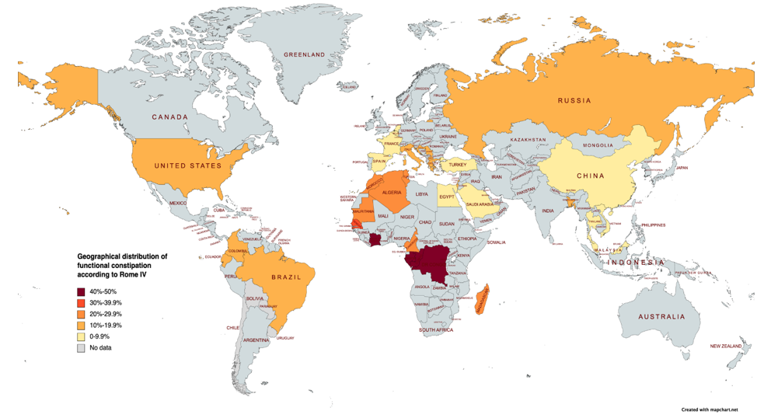
Figure 1 Geographical distribution of functional constipation in children worldwide, according to Rome IV.

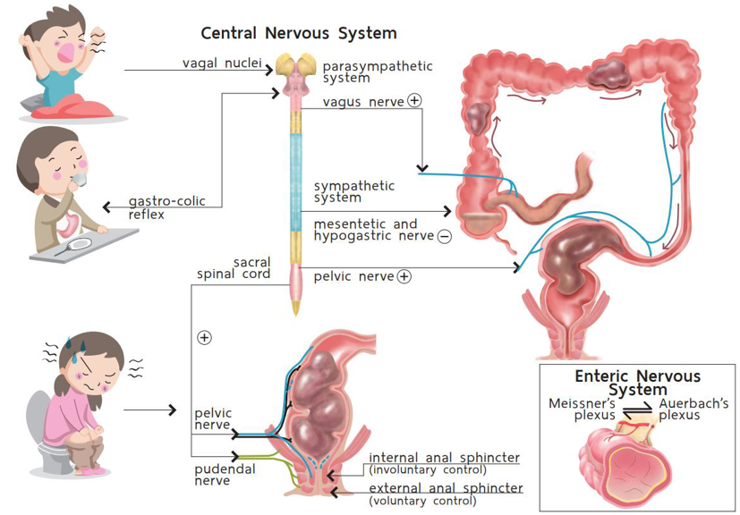
Figure 2 Normal defecation dynamics. Citation: Palittiya Sintusek. Pediatric lower gastrointestinal motility disorders. In: Werawatganon D, editor. Practical Neurogastroenterology and motility: Basic, testing, and treatment. Bangkok: Printable Inc, 2021: 417. Copyright© The Authors 2021. Published by Thai Neurogastroenterology and Motility Society. The authors have obtained the permission for figure using from Thai Neurogastroenterology and Motility Society (Supplementary material).

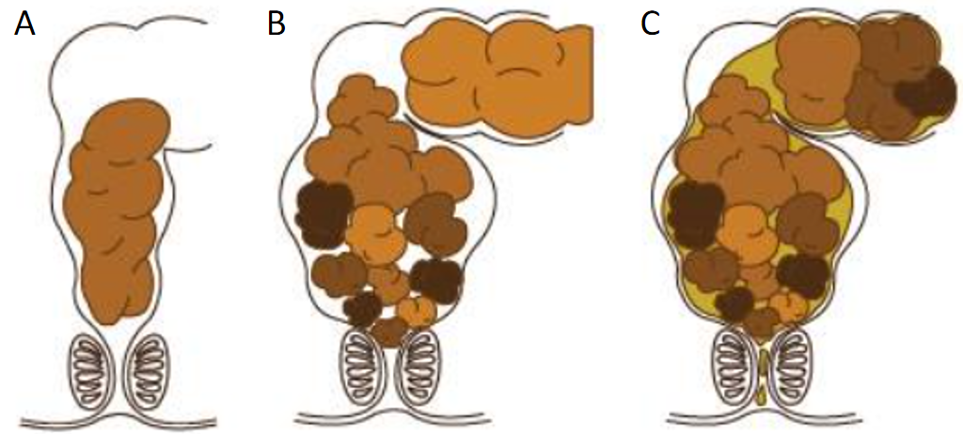
Figure 3 Accumulation of fecal mass in the rectum causes rectal wall distension and fecal soiling. A: Normal stool; B: Massive stool are retained in the rectum from withholding behavior; C: Liquid stool can leak out the anus or fecal soiling. A-C: Citation: Palittiya Sintusek. Chronic constipation. In: Supapitiporn K, editor. Pediatric practice: simple&applicable. Bangkok: Chulalongkorn University, 2021: 96. Copyright© The Authors 2017. Published by Department of Pediatrics, Chulalongkorn University. The authors have obtained the permission for figure using from Department of Pediatrics, Chulalongkorn University (Supplementary material).

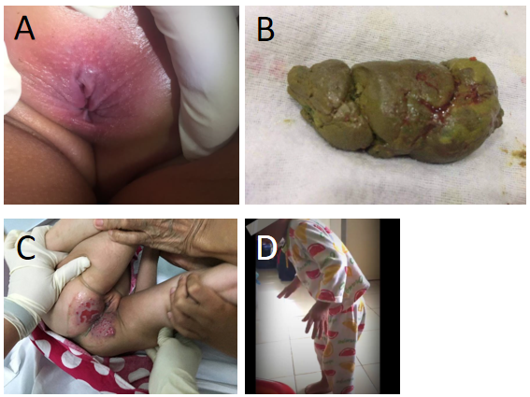
Figure 4 Clinical manifestations in constipated children. A: Anal fissure usually at the 6 o’clock or posterior parts; B: Blood coated, hard, and lumpy stool; C: Rectal abrasion from fecal incontinence that was misdiagnosed as chronic diarrhea; D: Retentive posture. A-D: Citation: Palittiya Sintusek. Chronic constipation. In: Supapitiporn K, editor. Pediatric practice: simple&applicable. Bangkok: Chulalongkorn University, 2021: 96. Copyright© The Authors 2017. Published by Department of Pediatrics, Chulalongkorn University. The authors have obtained the permission for figure using from Department of Pediatrics, Chulalongkorn University (Supplementary material).

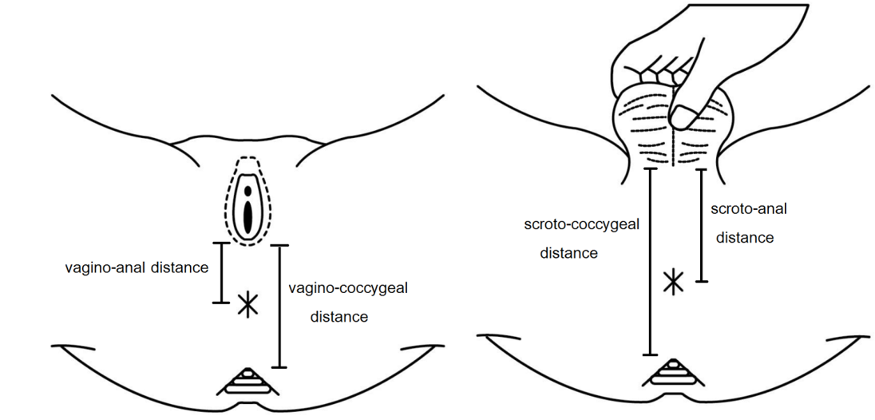
Figure 5 Landmarks for the measurement of the anogenital index. Citation: Palittiya Sintusek. Chronic constipation. In: Supapitiporn K, editor. Pediatric practice: simple&applicable. Bangkok: Chulalongkorn University, 2021: 96. Copyright© The Authors 2017. Published by Department of Pediatrics, Chulalongkorn University. The authors have obtained the permission for figure using from Department of Pediatrics, Chulalongkorn University (Supplementary material).

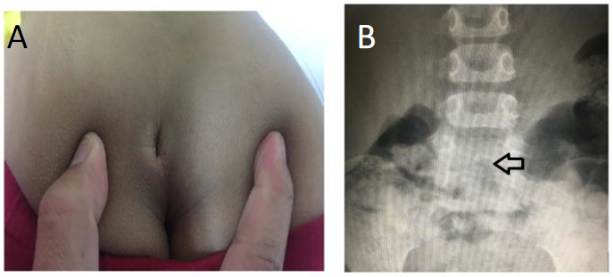
Figure 6 Sacral dimple and spinal dysraphism on spinal radiography (arrow) in a 5-year-old boy with intractable constipation. A: Sacral dimple; B: Spinal dysraphism.

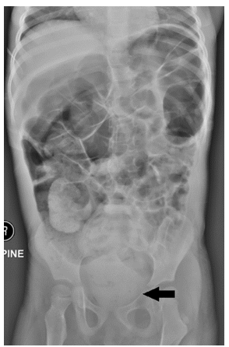
Figure 7 Abdominal radiography of a 3-year-old girl with a chief complaint of chronic diarrhea for 4 mo shows fecal impaction in the rectum. Citation: Palittiya Sintusek. Chronic constipation. In: Supapitiporn K, editor. Pediatric practice: simple&applicable. Bangkok: Chulalongkorn University, 2021: 96. Copyright© The Authors 2017. Published by Department of Pediatrics, Chulalongkorn University. The authors have obtained the permission for figure using from Department of Pediatrics, Chulalongkorn University (Supplementary material).
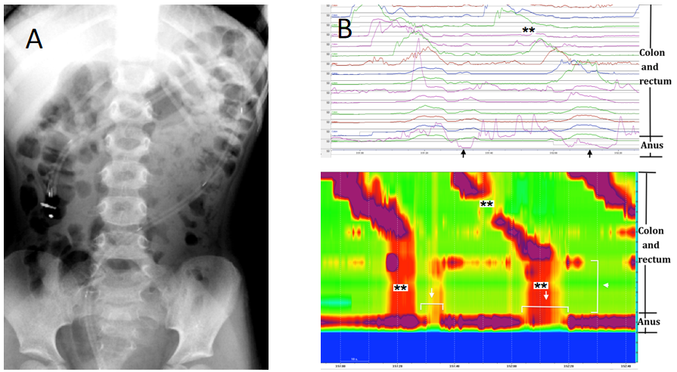
Figure 8 High amplitude propagating contractions. A: Proper position of the colonic catheter; B: graphical demonstration of abnormal high amplitude propagating contractions (HAPCs) with absent HAPCs at the sigmoid region (**) but preserved colo-anal reflex (arrow). A and B: Citation: Palittiya Sintusek. Chronic constipation. In: Supapitiporn K, editor. Pediatric practice: simple&applicable. Bangkok: Chulalongkorn University, 2021: 96. Copyright© The Authors 2017. Published by Department of Pediatrics, Chulalongkorn University. The authors have obtained the permission for figure using from Department of Pediatrics, Chulalongkorn University (Supplementary material).

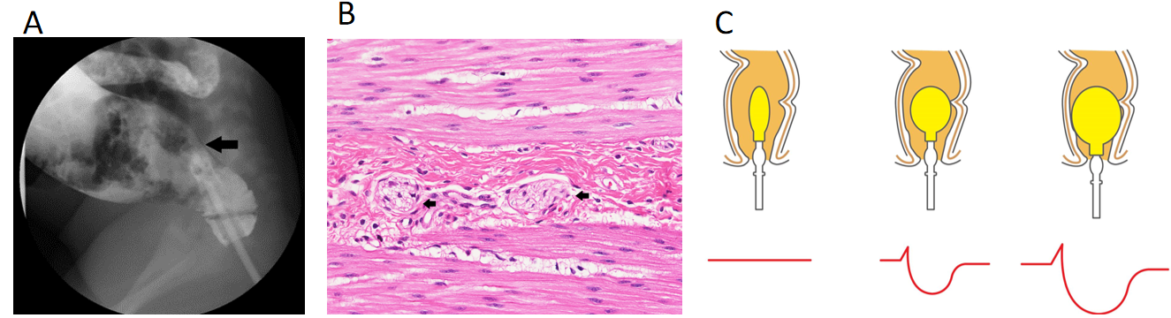
Figure 9 Investigations for organic constipation. A: Transition zone after barium enema in a child diagnosed with Hirschsprung’s disease; B: Anorectal manometry showing rectoanal inhibitory reflex; C and D: Histopathology revealing no ganglion cells in the nerve plexuses (myenteric plexus) of the muscular propria layer. Arrow shows thick nerve trunk but without ganglion cells. A-C: Citation: Palittiya Sintusek. Pediatric lower gastrointestinal motility disorders. In: Werawatganon D, editor. Practical Neurogastroenterology and motility: Basic, testing, and treatment. Bangkok: Printable Inc, 2021: 417. Copyright© The Authors 2021. Published by Thai Neurogastroenterology and Motility Society. The authors have obtained the permission for figure using from Thai Neurogastroenterology and Motility Society (Supplementary material).

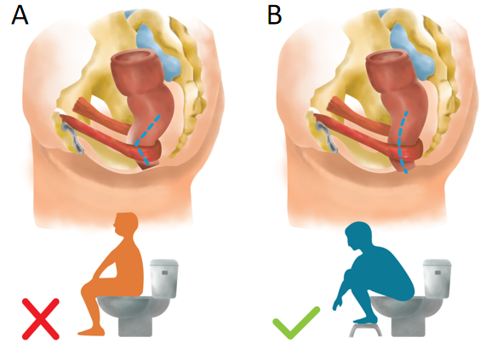
Figure 10 Position during defecation. A: Improper position during defecation; B: Proper position to open the rectoanal angle and facilitate stool expulsion during defecation.

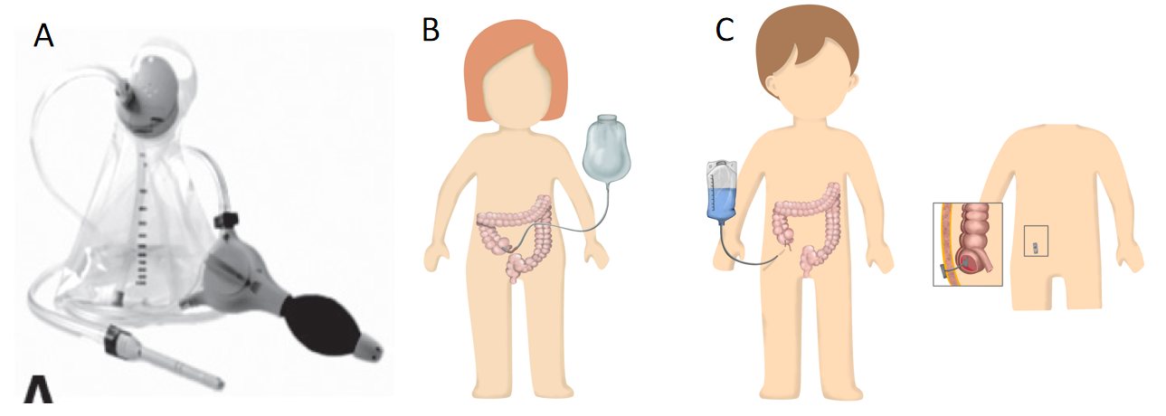
Figure 11 Rectal irrigation method. A: Transanal irrigation; B and C: Antegrade continence enema. A-C: Citation: Palittiya Sintusek. Pediatric lower gastrointestinal motility disorders. In: Werawatganon D, editor. Practical Neurogastroenterology and motility: Basic, testing, and treatment. Bangkok: Printable Inc, 2021: 423-424. Copyright© The Authors 2021. Published by Thai Neurogastroenterology and Motility Society. The authors have obtained the permission for figure using from Thai Neurogastroenterology and Motility Society (Supplementary material).

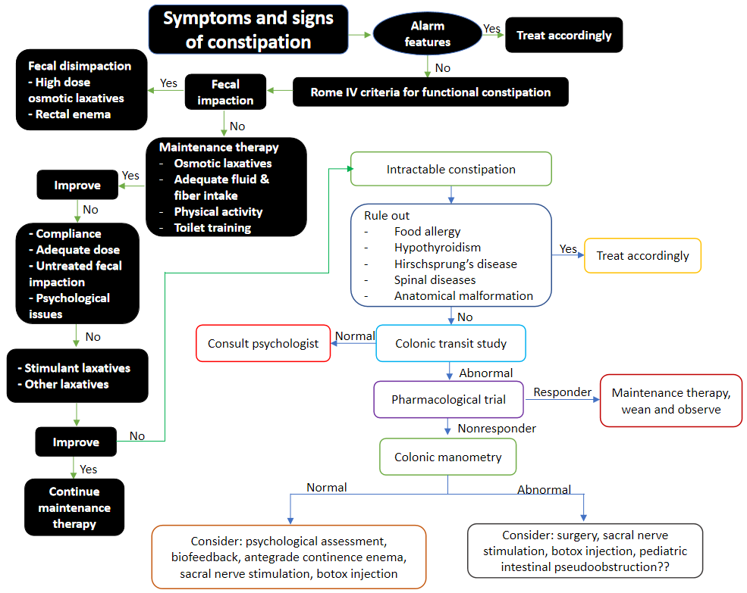
Figure 12 Algorithm for the management of children presenting with signs and symptoms of constipation.

Table 1 Prevalence of functional constipation in children according to Rome IV and factors associated with functional constipation
Ref. | Country | Population | Sample size | Age | Method of data collection | Prevalence of FC, n | Factors associated with FC
Huang et al^{[139]}, 2021 | China | 4 community hospitals in Jinhua and Shanghai | 2604 | 0-4 yr | Guardian interview | 92 (3.5%) | Vaginal delivery (OR = 0.01, 95%CI: 0.00-0.17), forceps delivery (OR: > 999, 95%CI: 154 to > 999)
Chew et al^{[140]}, 2021 | Malaysia | A well child clinic, University Malaya medical center | 534 | 1-12 mo | Guardian interview | 6 (1.1%) | NA
Ibrahim et al^{[141]}, 2020 | Egypt | Randomly schools in Cairo | 1082 | 4-18 yr | NA | 91 (8.4%) | NA
Khayat et al^{[142]}, 2021 | Saudi Arabia | Public survey (random) from Western | 317 | 3-18 yr | Questionnaire by Google form/links share on social apps | 15 (4.7%) | Guardian characteristics, family income, gender, age, development, previous covid ìnfection (P > 0.05)
Benzamin et al^{[29]}, 2022 | Bangladesh | Schools of Dhaka division | 707 | 5-16 yr | Child interview and examination (face to face) | 134 (19%) | Female (P = 0.003), age (P = 0.001), history of FC in siblings/parents (P = 0.001), fibers intake (P = 0.002), fluid intake (P = 0.001), electronic screen time (P = 0.001)
Siajunboriboon et al^{[143]}, 2022 | Thailand | 2 high schools | 1700 | 14-18 yr | Child interview | 138 (8.1%) | Guardian characteristics, BMI, history of allergic diseases (P > 0.05)
Chia et al^{[144]}, 2022 | Vietnam | A government hospital and a government kindergarten | 1511 | 0-48 mo | Guardian interview and examination (face to face) | 46 (3%) | Male (OR = 3.6, 95%CI: 1.5-8.5), bottle feeding (OR = 18.5, 95%CI: 1.5-219.4), low income (OR = 5.8, 95%CI: 1.7-19.3)
 |  |  | 8455 |  |  | 522 (6.2%)
Zwiener et al^{[145]}, 2017 | United States | Online survey | 1075 | 4-18 yr | Guardian interview | 144 (13.4%) | NA
Saps et al^{[146]}, 2018 | Colombia | 12 schools in 6 cities | 3567 | 8-18 yr | Child interview | 382 (10.7%) | NA
Robin et al^{[147]}, 2018 | United States | Online survey panels by CINT, United States | 1255 | 0-18 yr | Guardian interview | 186 (14.8%) | NA
Játiva-Mariño E et al^{[148]}, 2019 | Ecuador | 1 public and 1 private school | 951 | 8-15 yr | Child interview | 137 (14.4%) | NA
Saps et al^{[149]}, 2020 | Colombia | 6 outpatient clinics | 1334 | 1-48 mo | Guardian interview (face to face) | 281 (15.1%) | NA
Velasco-Benitez et al^{[150]}, 2020 | Colombia | 4 public schools | 1497 | 10-18 yr | Guardians interview | 194 (13%) | NA
Baaleman et al^{[151]}, 2021 | Colombia | A public school | 118 | 11-18 yr | Child interview | 16 (13.6%) | NA
Velasco-Benítez et al^{[152]}, 2021 | Colombia | 5 to 8 grade students in Cali | 465 | 10-18 yr | Children interview | 52 (28.7%) | NA
Dos Santos et al^{[27]}, 2021 | Brazil | Public parks and school areas | 799 | 5-14 yr | Guardian interview | 163 (20.4%) | Sex, type of school (P > 0.05)
de Morais et al^{[153]}, 2022 | Brazil | Pediatric private clinics in 5 regions | 4560 | 0-12 mo | Guardian interview | 341 (7.6%) | Age 162-248 d (OR = 1.41, 95%CI: 1.01-1.95), prematurity (OR = 1.44, 95%CI: 1.02-2.02)
 |  |  | 15621 |  |  | 1896 (12.1%)
Russo et al^{[21]}, 2019 | Italy | General clinics | 214 | 1 mo-17 yr | Guardian/child interview  (face to face) | 39 (18.2%) | NA
Vladimir et al^{[154]}, 2019 | Russia | University clinic | 300 | 0-48 mo | Guardian interview | 45 (15%) | NA
Steutel et al^{[155]}, 2020 | Belgium, Italy, Netherland | General pediatrics hospital (Belgium, Italy) and well-baby clinic (the Netherlands) | 2751 | 0-48 mo | Guardian interview and examination (face to face) | 151 (5.4%) | NA
Campeotto et al^{[156]}, 2020 | France | Private out-patient pediatricians and general practitioner | 1570 | 0-12 mo | Guardian interview and examination (face to face) | 141 (9%) | NA
Alonso-Bermejo et al^{[157]}, 2022 | Spain | A pediatric gastroenterology clinic | 574 | 0-16 yr | Guardian/child interview and examination (face to face) | 41 (7.1%) | NA
Beser et al^{[158]}, 2021 | Turkey | 9 tertiary Hospital | 2383 | 1-12 mo | Child interview and examination (face to face) | 112 (4.7%) | NA
Strisciuglio et al^{[159]}, 2022 | 6 Mediterranean countries¹ | Nursery schools, primary schools and secondary schools, randomly | 4353 | 4-18 yr | Guardian interview | 475 (10.9%) | NA
 |  |  | 12145 |  |  | 1004 (8.3%)
Bellaiche et al^{[160]}, 2020 | 10 countries in Africa² | Children with gastrointestinal symptoms | 10458 | 0-12 mo | Guardians interview and examination (face to face) | 3283 (31.4%) | NA
 |  |  | 10458 |  |  | 3283 (3.4%)
 |  |  | 46679 |  |  | 6704 (14.4%)
¹6 Mediterranean countries: Croatia, Greece, Israel, Italy, Macedonia, Serbia.
²10 countries: Algeria, Cameroon, Congo, Gabon, Madagascar, Morocco, Mauritius, Ivory Coast, Senegal, Tunisia.
CINT: A global software in digital insight and research technology; FC: Functional constipation; CI: Confidence interval; OR: Odds ratio; apps: Applications; NA: Not available; BMI: Body mass index.

Table 2 Rome IV criteria for pediatric functional constipation^{[6,7,9]}
Child’s age | Diagnostic criteria
< 4 years old | Two or more criteria for at least 1 mo¹: (1) Two or fewer defecations per week; (2) History of excessive stool retention; (3) History of painful or hard bowel movements; (4) History of large diameter stools; (5) Presence of a large fecal mass in the rectum; (6) At least one episode of fecal incontinence per week after the acquisition of toileting skills; and (7) History of large-diameter stools that may obstruct the toilet in toilet trained children
≥ 4 years old | Two or more symptoms for at least 1 mo in children at least 4 yr²: (1) Two or fewer defecations per week; (2) At least one episode of fecal incontinence per week; (3) History of retentive posturing or excessive stool retention; (4) History of painful or hard bowel movements; (5) Presence of a large fecal mass in the rectum; (6) History of large-diameter stool that may obstruct the toilet; and (7) Additional criteria: Without fulfilling irritable bowel syndrome criteria
¹After appropriate evaluation, the symptoms cannot be fully explained by another medical condition.
²After appropriate evaluation, the symptoms cannot be fully explained by another medical condition.

Table 3 Alarm signs and symptoms of constipation^{[37]}
Alarm signs | Symptoms of constipation
History | Constipation starting in neonatal period, delay pass meconium (> 48 h of life), family history of Hirschsprung’s disease
Stool characteristics | Ribbon stools, blood in the stools in the absence of anal fissures
Gastrointestinal features | Bilious vomiting, severe abdominal distension
Back | Sacral dimple, tuft of hair on spine, gluteal cleft deviation
Anus | Perianal fistula, abnormal position of anus, anal scar, absent anal/cremasteric reflex
Neurological features | Decreased lower extremity strength/tone/reflex
Others | Abnormal thyroid gland, fever, faltering of growth

Table 4 Organic causes of constipation^{[1]}
Organic causes
Abnormalities of colon and rectum | Anal or colonic stenosis. Imperforate anus. Anteriorly displaced or ectopic anus. Cloacal malformations. Chronic intestinal pseudo-obstruction
Systemic disorders | Hypothyroidism. Hypercalcemia. Hypocalcemia. Diabetes mellitus. Panhypopituitarism. Cerebral palsy. Myotonia congenita. Scleroderma. Amyloidosis. Mixed connective tissue disease. Myotonic dystrophy. Progressive systemic sclerosis
Others | Cystic fibrosis. Celiac disease. Heavy metal ingestion (lead, mercury)
Spinal cord abnormalities | Meningomyelocele. Spinal cord tumor. Sacral agenesis. Tethered cord
Neuropathic intestinal disorders | Hirschsprung’s disease. Intestinal neuronal dysplasia. Chagas disease. Abnormal muscle of abdomen. Prune belly syndrome. Gastroschisis
Drugs | Opiates. Anticholinergics. Antacids. Antihypertensives. Antimotility agents. Cholestyramine. Psychotropics. Diuretics

Table 5 Laxatives used for functional constipation in children^{[1,6,37,58]}
Agent | Child’s age | Dosage | Side effects
Osmotic laxatives
PEG | Any age | 0.4-0.8g/kg per day (max 17 g per day) for maintenance; 1-1.5g/kg per day for fecal disimpaction | Diarrhea, bloating, flatulence, nausea, vomiting, abdominal cramps
Lactulose (70% solution) | Any age | 1 mL/kg once or twice daily (max 120 mL per day) | Bloating, flatulence, abdominal cramps, fecal, incontinence
Sorbitol (70% solution) | 1-11 yr | 1 mL/kg once or twice daily (max 30 mL per day) | Bloating, abdominal cramps
 | > 12 yr | 15-30 mL once or twice daily
Milk of magnesium | > 2 yr | 1-3 mL/kg per day once or twice daily | Abdominal pain, fecal incontinence, Hypermagnesaemia, hypocalcaemia, hypophosphataemia (with excess use in children with renal disease)
Stimulant laxatives
Senna (antraquinone) | > 2 yr | 7.5-15 mg/kg per day once daily | Abdominal cramps, idiosyncratic hepatitis, melanosis coli in prolong used, nephropathy, neuropathy, hypertrophic osteoarthropathy
Bisacodyl | > 2 yr | 5-10 mg per day once daily | Diarrhoea, abdominal cramps
Sodium picosulphate | 4-5 yr | 3 mg per day | Nausea, vomiting, bloating, abdominal cramps, diarrhea, headache, taste impairment
 | > 6 yr | 4-6 mg per day
Glycerine suppository | < 1 yr | Half a pediatric suppository once daily | Rectal irritation, bloating, abdominal cramps, diarrhea
Rectal laxatives/enemas
Sodium phosphate | > 1 yr | 2.5 mg/kg (max 133 mL/dose) | Rectal discomfort, diarrhea, abdominal cramps, electrolyte imbalance
Bisacodyl | 2-12 yr | 5 mg/dose once daily | Rectal discomfort, diarrhea, abdominal cramps, hypokalemia
 | > 12 yr | 5-10 mg/dose once daily
Saline enema | Neonate | < 1 kg: 5 mL, > 1 kg: 10 mL | Rectal discomfort, bloating
 | > 1 yr | 6 mL/kg once or twice daily
Lubricant
Mineral oil | > 1 yr | 1-2 mL/kg daily (max 90 mL per day) | Rectal discomfort, lipoid pneumonitis
PEG: Polyethylene glycol.

Table 6 Characteristics of randomized controlled trials assessing the effects of herbal medications in children with constipation
Ref. | Country | Age (yr) | Study design | No. case (intervention/control) | Intervention protocol | Probably pharmacological effect of herbal medicine | Duration of treatment/follow-up/end point and outcome measurement | Treatment effect
Esmaeilidooki et al^{[99]}, 2016 | Iran | 2-15 | Open label, RCT, single center | 109 (52/57) | CFE 1 mL/kg per day in three-divided doses (equivalent to 0.1 g of dried pulp of fruits of Cassia fistula). PEG 0.7-0.8g/kg per day | Phenolic antioxidants such as flavonoids, flavan-3-ol derivatives and anthraquinones: Stimulant laxative | Treatment for 4 wk. Primary outcome: Frequencies of defecation, severity of pain, consistency of stool, fecal incontinence and retentive posturing. Secondary: The safety and compliance of therapy | After 4 wk: 86.5% of children in CFE group and 77.1% in PEG group exited from the criteria of FC (RR = 1.121, CI95%: 0.939-1.338). Frequency of defecation that in CFE group (10.96 ± 5.7 stools per week) was significantly more than PEG group (6.9 ± 3.5 stools per week) (P < 0.001). No serious adverse effects in both groups (25% diarrhea and 3.8% abdominal pain)
Cai et al^{[161]}, 2018 | China | 1-14 | Double-bline RCT, multicenter | 480 (120/360) | XEBT: (1) 1-3 years old: 2.5 g, 3 times a day; (2) 4-6 years old: 5 g, 2 times a day; and (3) > 7 years old: 5 g, 3 times a day. Placebo | Seven herbs (Houpo contains magnolol, JueMingZi contain anthraquinones, LuHui contains reactive Aloe-emodin, BaiZhu contains Atractylodes japonica, LaiFuZi, XingRen, ZhiQiao): Promote small bowel peristalsis and work against atropine-induced small intestine suppression in mice | Treatment for 14 days  Primary outcome: Frequency of SBM for 14 d. Secondary outcomes: Effectual time of defecation, mean symptom scores, disappearance rate of symptoms, recurrence rate and safety outcomes | The mean value of SBM for 14 d were 8.89 and 5.63 in the XEBT and placebo group (P < 0.05). The median effectual time of defecation, main symptom score and disappearance rate of symptoms were significant improved in XEBT group without the significant minor adverse effects between groups
Dehghani et al^{[101]}, 2019 | Iran | 4-12 | Double-blind RCT, single center | 92 (45/47) | BSM (sugarcane extract) 1 mL/kg per day. PEG 1 g/kg per day | The BSM naturally contained polyphenols (960 μg/mL), potassium (12430 μg/mL), iron (10 μg/mL), calcium (3320 μg/mL), zinc (22 μg/mL), sucrose (296000 μg/mL), triterpenoids (11230 μg/mL), phytosterols (7 μg/mL), flavonoids (2 μg/mL and polysaccharides (1250 μg/mL): Polysaccharide act as bulk forming agent, flavonoids/phytosterols and polyphenolic compounds act as natural antioxidants and anti-inflammatory agents | Treatment for 4 wk: Primary outcome: Response rate improvement in frequency of defecations per week, absence of lumpy or hard stools, abdominal pain and retention, soiling and blood-stained stool, sensation of anorectal obstruction/blockage. Secondary outcome: Patients’ body weigh was measured in every visit and serological parameters (count blood cells, BUN, creatinine, calcium, phosphorus, sodium and potassium) | Defecation per week was significantly improved in both groups. Symptoms including volitional stool retention, large diameter stool, painful or hard stool and large fecal mass in the rectum decreased significantly two and four weeks after intervention (P < 0.05). No significant difference between the groups. No adverse effects were observed
Qiao et al^{[102]}, 2021 | China | 4-14 | Double-blind RCT, multicenter study | 200 (100/100) | Mixture of 12 herbs¹ (XiaojiDaozhi Decoction) and placebo (5% drug ingredients and 95% dextrin). All received fiber 20 g per day and toilet training) | 12.5% Raphanus sativus L. (facilitating intestinal motility), 8.33% Areca catechu L. (stimulating gastrointestinal cholinergic receptor), 6.67% Fructus aurantll immaturus (stimulate gastrointestinal smooth muscle), Citrus aurantium L. (stimulate gastrointestinal smooth muscle), 6.67% Crataegus pinnatifida (stimulate gastrointestinal smooth muscle), Magnolia officinalis Rehd (stimulate gastrointestinal smooth muscle), Cannabis sativa L. (moistening the bowel and purging the stools), Atractylodesmacrocephala Koidz. (stimulate gastrointestinal smooth muscle), Semen armeniacae amarum (purgative effect), Paeonia lactiflora Pall, Radix et rhizoma rhei, (purgative stool)0 and honey (moistening the bowel and purgative effect) | Treatment for 8 wk and follow-up for 12 wk. Primary outcome: Complete SBM (≥ 3 per week) and satisfaction with bowel function. Secondary outcome: Safety and adverse effect (blood measurement of liver and kidney function and lead level) | After 8 wk: 56% of CHM group and 25% of placebo satified with bowel movement (P < 0.05). 40% of CHM group and 19% of placebo had complete spontaneous bowel movement (P < 0.05). No serious adverse effects in both groups
Tavassoli et al^{[162]}, 2021 | Iran | 4-10 | Open label RCT, single center | 133 (66/67) | Viola flower syrups 5 mL, 3 times a day. PEG 4000 1 g/kg per day | Viola flower contains crude methanolic extract, butanolic and aqueous extracts the stimulate gastrointestinal motility | Treatment 4 wk. Primary outcome: Response off treatment (ROME III criteria). Secondary outcome: Stool consistency, defecation frequency, hard stools, painful defecation, fecal retention, and fecal soiling | Both groups demonstrated significant improvement in stool consistency, number off defecation, hard stool, painful defecation, fecal retention and fecal soiling at the end of the study compared to baseline (P < 0.001). No significant difference was observed between the two groups at baseline or at the end of the study (P > 0.05)
Nasri et al^{[163]}, 2021 | Iran | 2-15 | Open-lable RCT | 120 (60/60) | LaxaPlus Barij Syrup 1 mL/kg divided into 3 doses. PEG 0.7 g/kg | NA | Treatment and follow-up 8 wk. Primary outcome: Stool consistency, number of defecations, intensity of pain, fecal incontinence. Secondary outcome: Satisfaction rate | After 8 wk follow-up: Bowel movements in the intervention group was significantly higher than in the control group (P < 0.05). Pain intensity, and abdominal pain in the group LaxaPlus Barij® decreased significant than control group. No different about satisfaction rate between 2 group
Saneian et al^{[103]}, 2021 | Iran | 2-15 | Double-blind RCT | 60 (30/30) | Goleghand (including honey and Rosa damascene) 0.5 g/kg in three divided dose. PEG: 0.7 g/kg | NA | Treatment and follow-up 8 wk. Primary outcome: The number and consistency of stools per day, painful defecation, abdominal pain, and fecal incontinence. Secondary outcome: Adverse effects and parental satisfaction | After 8 wk: The number of fecal defecations in Goleghand group was higher than PEG (P < 0.05). The decrease of defecations after following was more significant in the PEG group than in the Goleghand® group (P = 0.001). Parental satisfaction scores did not change in either group (P > 0.05)
Imanieh et al^{[104]}, 2022 | Iran | 1-18 | Double-blind RCT | 100 (50/50) | Rosa damascena + brown sugar 1-2 mL/kg (1 mL composed of 0.1 g damask rose and 0.85 g brown sugar). PEG 1-2 mL/kg. All received high fiber diet and hydration | Damask rose: Osmotic laxatives and prokinetic effect. Brown sugar: Osmotic laxatives effect. Possible active ingredients might be phenolic compounds and aqueous fraction (terpenes, glucosides, flavonoids, anthocyanins, kaempferol and quercetin) | Treatment and follow-up 4 wk. Primary outcome: the effective of herbs with PEG. Secondary outcome: Adverse effects | After 4 wk: The cure rate was 100% in the R. damascena group and 91.7% in the control group. Adverse effect of intervention group was the taste which was too sweet
¹LaxaPlus Barij® Syrup- an herbal medicine that includes jujube, rose, asparagus, violet flower, borage, quince seeds, and Cordia myxa fruit.
CFE: Cassia fistula emulsion; PEG: Polyethylene glycol; FC: Functional constipation; RR: Risk ratio; RCT: Randomized controlled trial; XEBT: Xiao’er Biantong granules; SBM: Spontaneous bowel movements; BSM: Black strap molasses; BUN: Blood urea nitrogen; CHM: Chinese herbal medicine.
Table 7 Recommend water intake per day^{[164]}
 | Total water intake per day, including water contained in food (mL)
Infants 0-6 mo | 700 (water is assumed to be from breast) milk
7-12 mo | 800 (milk and complementary foods and beverages)
1-3 yr | 1300
4-8 yr | 1700
Boys 9-13 yr | 2400
Girls 9-13 yr | 2100
Boys 14-18 yr | 3300
Girls 14-18 yr | 2300

