Name of Journal: World Journal of Clinical Cases
Manuscript NO: 72288
Manuscript Type: CASE REPORT

Relationship between treatment types and blood–brain barrier disruption in patients with acute ischemic stroke: Two case reports

Seo Y et al. Blood-brain barrier disruption in patients

Youngbeom Seo, Jonghoon Kim, Min Cheol Chang, Hyungkyu Huh, Eun-Hee Lee

Youngbeom Seo, Jonghoon Kim, Department of Neurosurgery, College of Medicine, Yeungnam University, Daegu 42415, South Korea

Min Cheol Chang, Department of Rehabilitation Medicine, College of Medicine, Yeungnam University, Daegu 42415, South Korea

Hyungkyu Huh, Eun-Hee Lee, Medical Interdisciplinary Team, Medical Device Development Center, Daegu-Gyeongbuk Medical Innovation Foundation, Daegu 41061, South Korea

Author contributions: Kim J contributed to conception and design of the study; Huh H and Lee EH organized the database; Kim J and Seo Y wrote the first draft of the manuscript; Huh H, Kim J, Chang MC, and Seo J wrote sections of the manuscript; all authors contributed to manuscript revision, read, and approved the submitted version.

Supported by the National Research Foundation of Korea grant, No. 2019M3E5D1A02069399.
Corresponding author: Jonghoon Kim, MD, PhD, Doctor, Neurosurgeon, Professor, Department of Neurosurgery, College of Medicine, Yeungnam University, 170, Hyeonchung Street, Nam-Gu, Daegu 42415, South Korea. kjhns@yu.ac.kr

Received: October 12, 2021
Revised: October 26, 2021
Accepted: January 17, 2022
Published online:

Abstract
BACKGROUND
Blood-brain barrier (BBB) disruption plays an important role in the development of neurological dysfunction in ischemic stroke. However, diagnostic modalities that can clearly diagnose the degree of BBB disruption in ischemic stroke are limited. Here, we describe two cases in which the usefulness of dynamic contrast-enhanced magnetic resonance imaging (DCE-MRI) in detecting BBB disruption was evaluated after treatment of acute ischemic stroke using two different methods.

CASE SUMMARY
The two patients of similar age and relatively similar cerebral infarction locations were treated conservatively or with thrombectomy, although their sex was different. As a result of analysis by performing DCE-MRI, it was confirmed that BBB disruption was significantly less severe in the patient who underwent thrombectomy (P = 3.3 × 10⁻⁷), whereas the average K_{trans} of the contralateral hemisphere in both patients was similar (2.4 × 10⁻⁵ min⁻¹ and 2.0 × 10⁻⁵ min⁻¹). If reperfusion is achieved through thrombectomy, it may indicate that the penumbra can be saved and BBB recovery can be promoted.

CONCLUSION
Our cases suggest that BBB disruption could be important if BBB permeability is used to guide clinical treatment.

Key Words: Blood–brain barrier; Ischemic stroke; Dynamic contrast-enhanced magnetic resonance imaging; Thrombectomy; Penumbra; Case report

Seo Y, Kim J, Chang MC, Huh H, Lee EH. Relationship between treatment types and blood–brain barrier disruption in patients with acute ischemic stroke: A case report. World J Clin Cases 2022; In press

Core Tip: We describe two cases in which the usefulness of dynamic contrast-enhanced magnetic resonance imaging in detecting blood–brain barrier (BBB) disruption was evaluated after treatment of acute ischemic stroke using two different methods. Our cases suggest that BBB disruption could be important if BBB permeability is used to guide clinical treatment.

INTRODUCTION
Acute ischemic stroke (AIS) is defined as a sudden dysfunction of the central nervous system due to cerebral ischemia and is associated with high mortality and disability rates^{[1]}. Minutes after ischemic stroke, dramatic cerebral pathological changes occur at the genomic, molecular, and cellular levels. One of the major pathological changes is the disruption of the blood–brain barrier (BBB)^{[2]}. Under pathological conditions, such as ischemic stroke, the BBB can be disrupted, followed by extravasation of blood components into the brain, thereby compromising the normal neuronal function. BBB disruption plays an important role in the development of neurological dysfunction in ischemic stroke^{[3]}. However, diagnostic modalities that can clearly diagnose the degree of BBB disruption in ischemic stroke are limited. Dynamic contrast-enhanced magnetic resonance imaging (DCE-MRI) is a noninvasive perfusion MRI technique that enables the evaluation of damage to the microcirculatory structure and pathological BBB dysfunction^{[4]}. Here, we describe two cases in which the usefulness of DCE-MRI in detecting BBB disruption was evaluated after treatment of AIS using two different methods.

CASE PRESENTATION
Chief complaints
DCE-MRI was performed after two patients were diagnosed with AIS at the Yeungnam University Medical Center. The BBB permeability (K_{trans}) was calculated in each patient using the Patlak model^{[5]}.
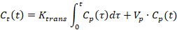
where τ, V_{p}, and C_{t}(t) and C_{p}(t) indicate the variable of integration, plasma volume, and temporal variation of the contrast agent of the tissue and plasma, respectively. C_{p}(t) was measured in the internal carotid artery with the capillary hematocrit level set at 45%. The average K_{trans} values were manually segmented and compared.

Case 1: A 58-year-old man with a chief complaint of motor aphasia was admitted to our emergency department.

Case 2: A 59-year-old woman with a chief complaint of right hemiparesis and motor aphasia arrived at our emergency department.

History of present illness
Case 1: The patient developed symptoms 9 h before arrival at the hospital.

Case 2: The patient developed symptoms 10 h before arrival at the hospital.

History of past illness
Case 1: The only notable medical history was hypertension.

Case 2: There was no specific medical history.

Physical examination
Case 1: His National Institute of Health Stroke Scale (NIHSS) score was 3.

Case 2: The NIHSS score was 4.

Imaging examinations
Case 1: Diffusion-weighted imaging (DWI) and perfusion-weighted imaging (PWI) showed acute infarctions in the left temporal and insular lobes with no significant DWI–PWI mismatch in the left middle cerebral artery (MCA) territory (Figure 1A and B).

Case 2: DWI and PWI showed acute infarctions in the left parietal and insular lobes with significant DWI–PWI mismatch in the left MCA territory (Figure 1D and E).

FINAL DIAGNOSIS
Case 1
Magnetic resonance angiography confirmed occlusion of the M2 inferior trunk of the MCA (Figure 1C).

Case 2
Digital subtraction angiography confirmed the occlusion of the M2 inferior trunk (Figure 2F).

TREATMENT
Case 1
Since there was no definite DWI–PWI mismatch, we decided to perform treatment with dual antiplatelet medication without endovascular treatment (EVT). The patient was discharged 1 wk later with no new acute infarction and slight improvement in motor aphasia.

Case 2
EVT: Considering definite DWI–PWI mismatch, we decided to perform EVT. EVT was performed under local anesthesia. A balloon guide catheter (Optimo, Tokai Medical) was placed in the proximal internal carotid artery through the femoral artery. The balloon of the balloon guide catheter was inflated, and the target vessel was navigated using a 0.014-inch micro-guidewire (Asahi Chikai 10, Asahi Intecc) through the occlusion. A microcatheter (Rebar 18, Medtronic) was then advanced over the wire distal to the occlusion. Selective microcatheter angiography was performed to confirm the occlusion site and distal blood flow. The microcatheter was exchanged for a Solitaire FR (4 × 40). Further, stent-retriever thrombectomy using a Solitaire FR was performed. Finally, reperfusion and good antegrade blood flow were confirmed (Figure 1G). The patient was discharged 1 wk later with no definite neurologic deficits, except mild dysarthria.

OUTCOME AND FOLLOW-UP
Case 1 and Case 2
BBB disruption: DCE-MRI was performed after 1 week, the average K_{trans} of the entire ischemic region after the treatment was 0.067 ± 0.026 min⁻¹, whereas that of the contralateral hemisphere was 2.4 × 10⁻⁵ min⁻¹ (Figure 2A). DCE-MRI was performed after 1 wk, the average K_{trans} of the entire ischemic region after the treatment was 0.0097 ± 0.0024 min⁻¹, and that of the contralateral hemisphere was 2.0 × 10⁻⁵ min⁻¹ (Figure 2B).

DISCUSSION
BBB disruption begins at the onset of ischemic stroke and increases with sustained hypoperfusion. Maintenance of the BBB immediately after stroke onset might be expected to stop the downstream progression of ischemic brain injury and improve clinical outcomes^{[2]}.
BBB disruption is an important component of the pathological progression of AIS and is a potential therapeutic target. Thrombectomy is an interventional means to dislodge and remove the blood clot, and the recent American Heart Association recommendations approve its use up to 24 h after symptoms appear^{[6,7]}. The two patients of similar age and relatively similar cerebral infarction locations were treated conservatively or with thrombectomy, although their sex was different. As a result of analysis by performing DCE-MRI, it was confirmed that BBB disruption was significantly less severe in the patient who underwent thrombectomy (P = 3.3 × 10⁻⁷), whereas the average K_{trans} of the contralateral hemisphere in both patients was similar (2.4 × 10⁻⁵ min⁻¹ and 2.0 × 10⁻⁵ min⁻¹). If reperfusion is achieved through thrombectomy, it may indicate that the penumbra can be saved and BBB recovery can be promoted. The reversible BBB disruption may be associated with rapid reperfusion, which is associated with shorter periods of cerebral ischemia.
However, it should be noted that studies have found BBB hyperpermeability 3-4 weeks after ischemia onset, indicating that there can be long-term derangement in barrier function^{[8]}. Indeed, in patients with stroke, there is evidence that there may be low-level BBB dysfunction at 1 mo^{[9]}. Rapid reperfusion after mechanical thrombectomy can result in brain tissue injury^{[10]}. Efforts to decrease the duration of BBB disruption could improve clinical outcomes in patients with successful reperfusion.
The impact of BBB disruption after EVT and outcomes in patients with AIS should be investigated in a larger prospective study. For patients with AIS, BBB protective agents could play an important role and should be investigated in the future. The examination of BBB disruption in the management of AIS is an emerging field of research. With the advancement of DCE-MRI, future research on the BBB is likely to reveal potential therapeutic targets for protecting the BBB and improving outcomes in patients with AIS.

CONCLUSION
Our cases suggest that BBB disruption could be important if BBB permeability is used to guide clinical treatment.

REFERENCES
1 Benjamin EJ, Virani SS, Callaway CW, Chamberlain AM, Chang AR, Cheng S, Chiuve SE, Cushman M, Delling FN, Deo R, de Ferranti SD, Ferguson JF, Fornage M, Gillespie C, Isasi CR, Jiménez MC, Jordan LC, Judd SE, Lackland D, Lichtman JH, Lisabeth L, Liu S, Longenecker CT, Lutsey PL, Mackey JS, Matchar DB, Matsushita K, Mussolino ME, Nasir K, O'Flaherty M, Palaniappan LP, Pandey A, Pandey DK, Reeves MJ, Ritchey MD, Rodriguez CJ, Roth GA, Rosamond WD, Sampson UKA, Satou GM, Shah SH, Spartano NL, Tirschwell DL, Tsao CW, Voeks JH, Willey JZ, Wilkins JT, Wu JH, Alger HM, Wong SS, Muntner P; American Heart Association Council on Epidemiology and Prevention Statistics Committee and Stroke Statistics Subcommittee. Heart Disease and Stroke Statistics-2018 Update: A Report From the American Heart Association. Circulation 2018; 137: e67-e492 [PMID: 29386200 DOI: 10.1161/CIR.0000000000000558]
2 Liu C, Yan S, Zhang R, Chen Z, Shi F, Zhou Y, Zhang M, Lou M. Increased blood-brain barrier permeability in contralateral hemisphere predicts worse outcome in acute ischemic stroke after reperfusion therapy. J Neurointerv Surg 2018; 10: 937-941 [PMID: 29352054 DOI: 10.1136/neurintsurg-2017-013663]
3 Jiang X, Andjelkovic AV, Zhu L, Yang T, Bennett MVL, Chen J, Keep RF, Shi Y. Blood-brain barrier dysfunction and recovery after ischemic stroke. Prog Neurobiol 2018; 163-164: 144-171 [PMID: 28987927 DOI: 10.1016/j.pneurobio.2017.10.001]
4 Oh SS, Lee EH, Kim JH, Seo YB, Choo YJ, Park J, Chang MC. The Use of Dynamic Contrast-Enhanced Magnetic Resonance Imaging for the Evaluation of Blood-Brain Barrier Disruption in Traumatic Brain Injury: What Is the Evidence? Brain Sci 2021; 11 [PMID: 34208047 DOI: 10.3390/brainsci11060775]
5 Patlak CS, Blasberg RG, Fenstermacher JD. Graphical evaluation of blood-to-brain transfer constants from multiple-time uptake data. J Cereb Blood Flow Metab 1983; 3: 1-7 [PMID: 6822610 DOI: 10.1038/jcbfm.1983.1]
6 Jovin TG, Nogueira RG, Investigators D. Thrombectomy 6 to 24 Hours after Stroke. N Engl J Med 2018; 378: 1161-1162 [PMID: 29562149 doi: 10.1056/NEJMc1801530]
7 Nogueira RG, Jadhav AP, Haussen DC, Bonafe A, Budzik RF, Bhuva P, Yavagal DR, Ribo M, Cognard C, Hanel RA, Sila CA, Hassan AE, Millan M, Levy EI, Mitchell P, Chen M, English JD, Shah QA, Silver FL, Pereira VM, Mehta BP, Baxter BW, Abraham MG, Cardona P, Veznedaroglu E, Hellinger FR, Feng L, Kirmani JF, Lopes DK, Jankowitz BT, Frankel MR, Costalat V, Vora NA, Yoo AJ, Malik AM, Furlan AJ, Rubiera M, Aghaebrahim A, Olivot JM, Tekle WG, Shields R, Graves T, Lewis RJ, Smith WS, Liebeskind DS, Saver JL, Jovin TG; DAWN Trial Investigators. Thrombectomy 6 to 24 Hours after Stroke with a Mismatch between Deficit and Infarct. N Engl J Med 2018; 378: 11-21 [PMID: 29129157 DOI: 10.1056/NEJMoa1706442]
8 Lin CY, Chang C, Cheung WM, Lin MH, Chen JJ, Hsu CY, Chen JH, Lin TN. Dynamic changes in vascular permeability, cerebral blood volume, vascular density, and size after transient focal cerebral ischemia in rats: evaluation with contrast-enhanced magnetic resonance imaging. J Cereb Blood Flow Metab 2008; 28: 1491-1501 [PMID: 18478021 DOI: 10.1038/jcbfm.2008.42]
9 Liu HS, Chung HW, Chou MC, Liou M, Wang CY, Kao HW, Chiang SW, Juan CJ, Huang GS, Chen CY. Effects of microvascular permeability changes on contrast-enhanced T1 and pharmacokinetic MR imagings after ischemia. Stroke 2013; 44: 1872-1877 [PMID: 23743977 DOI: 10.1161/STROKEAHA.113.001558]
10 Shi ZS, Duckwiler GR, Jahan R, Tateshima S, Szeder V, Saver JL, Kim D, Sharma LK, Vespa PM, Salamon N, Villablanca JP, Viñuela F, Feng L, Loh Y, Liebeskind DS. Early Blood-Brain Barrier Disruption after Mechanical Thrombectomy in Acute Ischemic Stroke. J Neuroimaging 2018; 28: 283-288 [PMID: 29484769 DOI: 10.1111/jon.12504]

Footnotes
Informed consent statement: Written informed consent was obtained from the patient for publication of this report and any accompanying images.

Conflict-of-interest statement: The authors declare that the research was conducted in the absence of any commercial or financial relationships that could be construed as a potential conflict of interest.

CARE Checklist (2016) statement: The authors have read the CARE Checklist (2016), and the manuscript was prepared and revised according to the CARE Checklist (2016).

Open-Access: This article is an open-access article that was selected by an in-house editor and fully peer-reviewed by external reviewers. It is distributed in accordance with the Creative Commons Attribution NonCommercial (CC BY-NC 4.0) license, which permits others to distribute, remix, adapt, build upon this work non-commercially, and license their derivative works on different terms, provided the original work is properly cited and the use is non-commercial. See: http://creativecommons.org/Licenses/by-nc/4.0/

Provenance and peer review: Unsolicited article; Externally peer reviewed.
Peer-review model: Single blind

Peer-review started: October 12, 2021
First decision: October 22, 2021
Article in press:

Specialty type: Neuroimaging
Country/Territory of origin: South Korea
Peer-review report’s scientific quality classification
Grade A (Excellent): 0
Grade B (Very good): B
Grade C (Good): 0
Grade D (Fair): D
Grade E (Poor): 0

P-Reviewer: Cao X, Shamseldeen AA S-Editor: Ma YJ L-Editor: A P-Editor: Ma YJ
Figure Legends
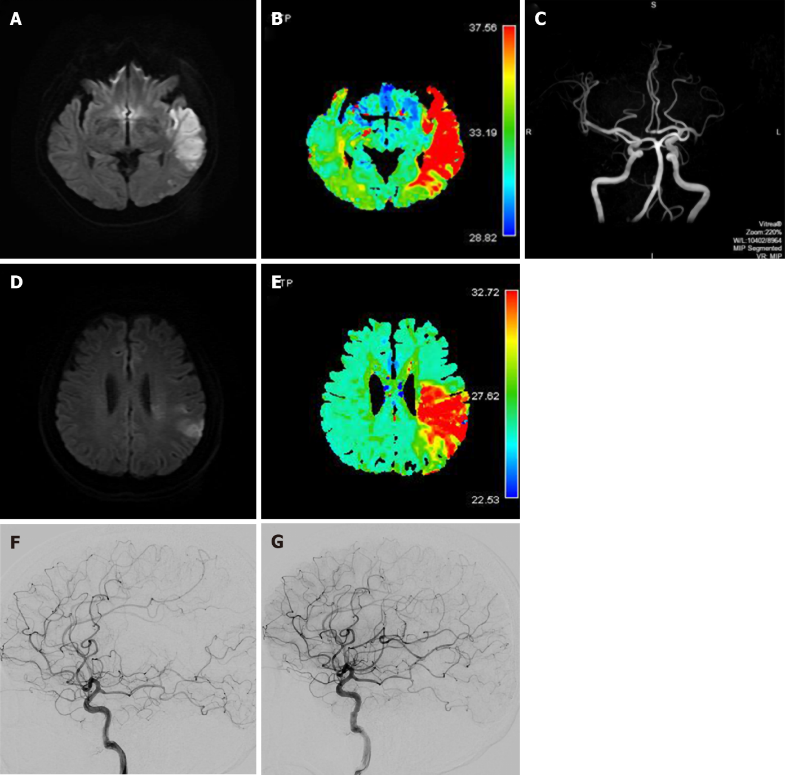

Figure 1 Diffusion-weighted imaging. Case 1, A and B: Diffusion-weighted imaging and perfusion-weighted imagingshow acute infarctions in the left temporal and insular lobes with no significant diffusion-weighted imaging-perfusion-weighted imaging mismatch, C: Magnetic resonance angiography shows occlusion of the M2 inferior trunk. Case 2, D and E: Diffusion-weighted imaging and perfusion-weighted imaging show acute infarctions in the left parietal and insular lobes with significant DWI-PWI mismatch; F: Digital subtraction angiography confirmed the occlusion of the M2 inferior trunk; G: After thrombectomy, reperfusion and good antegrade blood flow was confirmed.

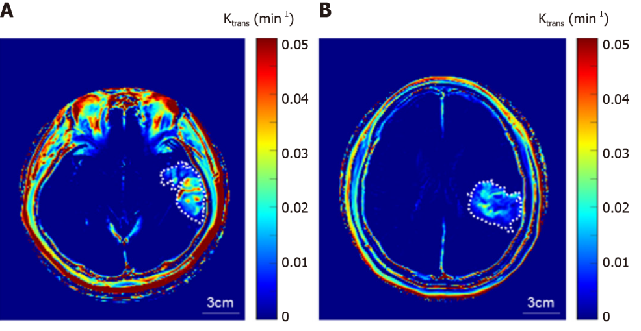
Figure 2 Dynamic contrast-enhanced magnetic resonance imaging. A representative blood-brain barrier permeability (K_{trans}) map of the patients without (A) and with (B) thrombectomy. The dashed line indicates the manually segmented stroke region with enhanced K_{trans}.

