Name of Journal: World Journal of Diabetes
Manuscript NO: 57884
Manuscript Type: ORIGINAL ARTICLE

Observational Study
Exenatide once weekly combined with metformin reduced glycemic variability in type 2 diabetes by using flash glucose monitoring system

Li Y et al. Exenatide once weekly reduced glycemic variability

Yang Li, Min-Min Han, Qiong He, Zi-Ang Liu, Dong Liang, Jing-Tian Hou, Yi Zhang, Yun-Feng Liu

Yang Li, Min-Min Han, Qiong He, Dong Liang, Jing-Tian Hou, Yun-Feng Liu, Department of Endocrinology, First Hospital of Shanxi Medical University, Taiyuan 030001, Shanxi Province, China

Zi-Ang Liu, Department of First Medical College, Shanxi Medical University, Taiyuan 030001, Shanxi Province, China

Yi Zhang, Department of Pharmacology, Basic Medical College, Shanxi Medical University, Taiyuan 030001, Shanxi Province, China

Author contributions: Liu YF and Zhang Y designed the study and revised the manuscript; Li Y and Han MM drafted the initial manuscript; Li Y, Han MM and He Q analyzed and interpretated the data; Liu ZA, Liang D, Hou JT, Li Y, Han MM and He Q conducted the study and collected the data. All authors read and approved the final manuscript for publication.

Supported by National Natural Science Foundation of China, No. 81770776 and No. 81973378; Cultivate Scientific Research Excellence Programs of Higher Education Institutions in Shanxi, No. 2019KJ022; and Special project for transformation and guidance of scientific and technological achievements in Shanxi Province, No. 201804D131044.

Corresponding author: Yun-Feng Liu, PhD, Chief Physician, Professor, Department of Endocrinology, First Hospital of Shanxi Medical University, No. 85 Jiefang South Road, Yingze District, Taiyuan 030001, Shanxi Province, China. nectarliu@163.com

Received: June 27, 2020
Revised: October 9, 2020
Accepted: October 26, 2020
Published online:

Abstract
BACKGROUND
Multiple studies demonstrate that fluctuating blood glucose level produce greater damage compared with sustained hyperglycemia. Flash glucose monitoring system is an effective method in documenting blood glucose variability, contributing to better glucose management and reduced hypoglycemic event occurrence.

AIM
To investigate the improvement in glycemic variability (GV), blood glucose level and metabolic index of patients with type 2 diabetes mellitus after exenatide once weekly (EXQW) and metformin combination treatment.

METHODS
Twenty-five patients with type 2 diabetes mellitus suffering from poor blood glucose control under metformin treatment were recruited. The recruited patients were prescribed with oral metformin only (maintaining a dosage of metformin at ≥ 1500 mg/day) for two weeks (screening period), and then, taken EXQW (2 mg, subcutaneous injection) for 12 wk (experimental period). The flash glucose monitoring system was used to document blood glucose values during the screening period and the last two weeks of the experimental period.

RESULTS
Four patients were excluded for various reasons, yielding a total of 21 patients, 17 males and 4 females, with an average age of 48.8 years, completed this study. The estimated HbA1c, mean blood glucose, fasting and postprandial blood glucose levels, and percentage of blood glucose above 7.8 mmol/L decreased compared to that at baseline (P = 0.003, 0.003, 0.008, 0.010, 0.014, 0.017, and 0.005, respectively), while the percentage of blood glucose between 3.9 and 7.8 mmol/L significantly increased (P = 0.005). Parameters of GV including standard deviation of blood glucose, mean amplitude of glycemic excursions, mean of daily difference, area under the curve difference between 25 and 75 percentile, and area under the carve difference between 10 and 90 percentile were significantly lower compared to that of baseline (P = 0.017, 0.006, 0.000, 0.024, 0.036, respectively). The durations of blood glucose below 3.9 mmol/L during the day and at nocturnal period significantly increased after treatment (P = 0.041, 0.028, respectively), though, there was no significant increase in severe hypoglycemia (< 3.0 mmol/L) compared with that at baseline (P = 0.207). In addition, some metabolic indicators improved after EXQW treatment.

CONCLUSION
EXQW combined with metformin can effectively improve blood glucose levels, reduce GV, and improve metabolic indicators. However, there is still a risk of nocturnal hypoglycemia, and careful attention should be paid to patients with EXQW treatment.

Key Words: Flash glucose monitoring; Glycemic variability; Type 2 diabetes mellitus; Exenatide once weekly

Li Y, Han MM, He Q, Liu ZA, Liang D, Hou JT, Zhang Y, Liu YF. Exenatide once weekly combined with metformin reduced glycemic variability in type 2 diabetes by using flash glucose monitoring system. World J Diabetes 2020; In press

Core Tip: In this study, flash glucose monitoring system was used not only to observe the hypoglycemic effect and the improvement of glycemic variability of exenatide once weekly combination with metformin, but also to accurately assess the specific time period for the improvement of blood glucose and the time when the occurrence of hypoglycemia was concentrated. The results indicated that the combination of drugs had significant improvement in fasting blood glucose, but the risk of increasing hypoglycemia, especially at night, should be warned.

INTRODUCTION
Achieving and maintaining blood glucose levels within normal range is an integral part of diabetes mellitus (DM) management, in which the blood glucose monitoring plays an indispensable role. Glycated hemoglobin (HbA1c) is long-term blood glucose indicator, providing useful information about most recent 2-3 mo blood glucose levels. However, patients with similar or identical HbA1c results may have different glucose variability (GV) profiles. GV conditions in patients with DM has gained wide attention in recent years, because it is a more reliable indicator for a wide range of acute or chronic diabetes-related complications^{[1,2]}. Current researches have demonstrated that compared to persistent hyperglycemia, fluctuating hyperglycemia can cause greater damage to the blood vessels and endothelium tissue.
Flash glucose monitoring system (FGMS) can be used to continuously measure interstitial blood glucose level over a period of 10 to 14 d. Compared to the continuous glucose monitoring system, the FGMS is factory calibrated without the alert function for the risk of hyperglycemia and hypoglycemia^{[3]}, and available data revealed that the FGMS is an effective method in documenting blood glucose variability, contributing to better glucose management and reduced hypoglycemic event occurrence^{[4,5]}.
Glucagon-like peptide 1 receptor agonists (GLP-1RA) has been demonstrated to significantly improve blood glucose level, blood lipid profile, and weight in patients with DM, which is a safe and effective hypoglycemic medication due to its glucose-dependent hypoglycemic property without increasing risk of hypoglycemia. In addition, the safety of GLP-1RA on the cardiovascular system has been verified, specifically, the LEADER study^{[6]} has also shown that liraglutide, as a kind of GLP-1RA, has a significant protective effect on the cardiovascular system. Exenatide once-weekly (EXQW), a long-acting GLP-1RA, can significantly improve metabolic disorders in vivo. Considering the reduced frequency of injections and discomfort experience, EXQW has become an effective and convenient therapy which can improve patients’ quality of life and compliance^{[7]}. Therefore, we hypothesized that the combination of EXQW and metformin can bring significant clinical benefits for DM management.
As the aims of this study, the clinical and therapeutic effect of combined EXQW and metformin treatment in type 2 diabetes patients are evaluated by using dynamic glucose monitoring and metabolic indicators. Based on the FGMS data, we analyzed and compared the GV-related indices, and hypoglycemic incidence between baseline and end points.

MATERIALS AND METHODS
This is a pre-post study involving the same group of patients, conducted at the First Hospital of Shanxi Medical University from June 2018 to March 2019. This research project has been approved by the Ethics Committee of the First Hospital of Shanxi Medical University (2018K007). All patients were informed of the objective of the study and signed consent forms.

Study population
Twenty-five patients with type 2 DM (T2DM), whose blood glucose was poorly controlled by metformin monotherapy, were recruited. These patients were selected according to the following criteria: (1) patients were diagnosed with T2DM for two to ten years, based on the DM diagnosis standards published by the World Health Organization in 1999, and their ages ranged from 18 to 70 years old; (2) the measured HbA1C results of ≥ 7.0 % but < 11.0%; (3) patients receiving monotherapy of metformin for at least three months (the daily metformin dosage ≥ 1500 mg) with unsatisfactory blood glucose control; and (4) patients with estimated values of glomerular filtration rate of > 60 mL/min/1.73 m².
The exclusion criteria were as follows: (1) patients with contraindications according to the instructions on EXQW, or who had a history of allergy to any other excipients; (2) patients received insulin therapy for more than seven days consecutively within one year before the screening (excluding those taking insulin therapy for acute diseases or operations); (3) patients with a medical record of acute or chronic pancreatitis; (4) patients with a personal or family medical record of medullary thyroid carcinoma or multiple endocrine neoplasia type 2; (5) patients suffering from serious gastrointestinal diseases; and (6) patients who could not cooperate with the researcher because of poor compliance or mental disorders, unwilling to communicate, or having difficulty in expressing thoughts.

Study intervention
This study comprised of two periods, namely, a 2-wk screening period and a 12-wk experiment period. During the screening period, recruited patients’ profiles comprising height, weight, waist circumference, and other basic information were compiled. Thereafter, all patients were provided with the standard diabetes health education and relevant training on the FGMS. It is recommended that all subjects have meals at 8:00, 13:00 and 18:00 each day. According to the Dietary Guidelines for Type 2 diabetes in China and Guidelines for the prevention and control of type 2 diabetes in China, patients were instructed to eat 50%-65% carbohydrate, 20%-30% fat and 15%-20% protein every day, and they were given 150min of moderate-intensity aerobic exercise every week.
During the 2-wk screening period, patients were prescribed with oral metformin only (maintaining a dosage of metformin at ≥ 1500 mg/day). At the end of the screening period, EXQW was prescribed at 2 mg via subcutaneous injection, administered at a fixed time every week. The combined drug therapy continued for the 12 wk.
FGMS was used in the screening period and the last two weeks of experimental period. The sensor of an FGMS device was placed under the skin of patient’s upper arm with the help of professional medical staff. Patients were asked to avoid strenuous exercise, long hours of bathing or swimming to prevent the sensor from detaching. Additionally, patients were required to obtain complete blood glucose data at least once every 8 h using the separate touchscreen reader device.

Endpoint
The primary endpoint of this study was to evaluate the change of GV in the baseline and after 12-wk treatment by using an FGMS, and the secondary end point was to assess blood glucose control and the occurrence of hypoglycemia. In addition, changes in some biochemical indicators were also observed. Pancreatic islets function and insulin resistance (IR) were assessed using homeostasis model assessment (HOMA)^{[8]}: HOAM-β = 20*FINS/(FBG-3.5), and HOMA-IR = FBG*FINS/22.5, respectively.

Flash glucose monitoring system data
The FGMS records blood glucose values every 15 min, and the information has to be scanned at least once every 8 h for data compilation. Therefore, 96 continuous blood glucose level values could be obtained for every 24 h. After wearing the FGMS for 10 to 14 d, the patients’ baseline blood glucose data and automatically-generated ambulatory glucose profile (AGP) were captured by the commercial software in the FGMS devices. Should there be missing values in the baseline blood glucose data, they will be replaced by the average blood glucose value nearing the missing value.
Based on the FGMS data, we calculated some parameters of GV, including mean amplitude of glycemic excursion (MAGE), mean of daily difference (MODD), coefficient of variation (CV), standard deviation of blood glucose (SDBG), large amplitude of glycemic excursion, area under the carve (AUC) difference between 25-75 percentile (area of IQR), and AUC difference between 10-90 percentile (area of IDR). The automatically generated AGP profiles were used as parameters for blood glucose control, including estimated HbA1c, mean blood glucose (MBG), time in range (TIR) (3.9-7.8 mmol/L), time out of range (TOR), percentage of time below 3.9 mmol/L, percentage of time between 3.9-7.8 mmol/L, and percentage of time above 7.8 mmol/L. At the same time, blood glucose levels at fasting (6:00-8:00) and postprandial periods (8:00-10:00, 13:00-15:00, and 18:00-20:00) were extracted for specific analysis. The means of blood glucose in each time period was plotted into a line graph and the AUCs were calculated accordingly. In addition, two different hypoglycemic cutoffs, less than 3.9 mmol/L and 3.0 mmol/L, were used during the day (6:00-24:00) and at nocturnal period (0:00-6:00). The parameters of GV and blood glucose levels were obtained by SigmaPlot 12.5 version for Windows and SPSS version 23.0 software, except that some of them were provided by AGP.

Statistical analysis
SPSS version 23.0 software was used for statistical analysis. Data were reported as mean ± SD for normally distributed continuous variables and median (inter-quartile range) for the non-normally distributed continuous variables. Paired-sample t-tests or Wilcoxon signed rank test were performed to compare between start and the end of this intervention study. P < 0.05 was considered to be statistically significant.

RESULTS
Baseline characteristics of the patients
Twenty-five subjects were recruited for this study, of which two failed to complete the study and two failed to obtain FGMS data. Finally, a total of 21 subjects were involved in this study, 17 males and 4 females. The mean age of participant was 48.8 ± 8.4 years (range of 33–66 years). The mean duration of diabetes was 5.3 ± 2.1 years (range of 2–10 years). All patients wore the FGMS devices for a total of 284 d for baseline period and 309 d after 12-wk treatment. Baseline characteristics of the participants are shown in Table 1.

Effectiveness of exenatide once weekly on glycemic control
Overall, after 12 wk of combined drug therapy, blood glucose levels improved significantly compared with that of baseline, as shown in Table 2. The estimated HbA1c, MBG, and TOR decreased after treatment (P = 0.003, 0.003, 0.005, respectively), while TIR increased (P = 0.005).

Percentage of time in different target ranges
As shown in Figure 1, percentage of time below 3.9 mmol/L and percentage of time above 7.8 mmol/L significantly decreased (P = 0.035, 0.005, respectively), while percentage of time between 3.9-7.8 mmol/L significantly increased (P = 0.005) after 12 wk of combination therapy compared with that at baseline.

Glycemic variability alterations
After intervention treatment, GV improved significantly compared to that of baseline. Parameters representing within-day GV (SDBG and MAGE), and day-to-day GV (MODD) decreased significantly (P = 0.017, 0.006, 0.000, respectively). Further extraction and analysis of GV parameters for daytime and night showed that the values of MAGE and MODD reduced during the daytime as well as at night (P = 0.010, 0.020, 0.001, 0.007, respectively). Moreover, AUC difference between 25 and 75 percentile (area of IQR) and AUC difference between 10 and 90 percentile (area of IDR) narrowed (P = 0.024, 0.036, respectively). However, there was no significant difference in CV and large amplitude of glycemic excursion. Detailed information is shown in Table 3.

Area under the curve of fasting and postprandial blood glucose
The results are shown in Figure 2. The blood glucose levels at fasting and postprandial periods significantly decreased after treatment compared with those at baseline (P = 0.008, 0.010, 0.014, 0.017, respectively).

Duration of hypoglycemia
As shown in Table 4, when the interstitial fluid blood glucose less than 3.9 mmol/L were considered as hypoglycemia, the durations of hypoglycemia during the whole day and the nocturnal period (0:00-6:00) increased significantly compared with those at baseline (P = 0.041, 0.028, respectively), while the duration of hypoglycemia during the daytime (6:00-24:00) showed no significant difference (P = 0.157). For the hypoglycemic cutoff point was 3.0 mmol/L, the durations of hypoglycemia did not increase throughout the day, during the daytime (6:00-24:00) or at nocturnal period (0:00-6:00).

Comparison of metabolic indicators
After 12-wk combined therapy, mean weight of patients decreased from 78.1 ± 8.3 to 77.3 ± 8.5 kg (P = 0.008), and mean waist circumference of patients decreased from 100.8 ± 9.2 to 99.5 ± 8.5 cm (P = 0.021). Besides, the significantly decreased HOMA-IR and significant increased HOMA-β than those at baseline indicated an improvement in insulin resistance and pancreatic islets function. Results are shown in Table 5.

DISCUSSION
This study explored the effects of EXQW combined with metformin treatment on GV, blood glucose levels, hypoglycemia, and some metabolic indicators in patients with T2DM. A recent study has revealed that exenatide twice daily and metformin could jointly improve GV profile^{[9]}. This present study has extended this prior research by demonstrating that the combination of EXQW and metformin could significantly improve GV and blood glucose control. Additionally, the therapeutic effects on weight loss, waist circumference reduction, and improvement of islet function were also evident.
In this research, an FGMS was used to acquire continuous blood glucose levels in 10 to 14 d to assess GV, blood glucose control, and duration of hypoglycemia in T2DM patients with combined EXQW and metformin treatment. This new-type glucose monitoring system consists of a subcutaneous sensor and an independent reader. It is easy to wear and is almost pain free. Besides, its invisibility and portability have provided much convenience for patients who have trouble in monitoring blood glucose levels consistently. A prospective study applied FGMS in adults with T2DM suggested that FGMS usage could improve blood glucose control, reduce incidence of hypoglycemia, and improve patients’ quality of life^{[10]}. Besides, FGMS has high user satisfaction and is a convenient option for patients requiring intensive glucose monitoring.
EXQW is a long-acting GLP-1RA, which is usually injected subcutaneously at 2 mg per week. A prospective study observed the therapeutic effect of EXQW combined with a standard dosage of metformin, suggesting that this treatment can effectively decrease HbA1c and fasting blood glucose levels, and improve carotid intima-media thickness^{[11]}.
According to this study, after 12-wk EXQW and metformin combination treatment, estimated HbA1c, MBG, and TOR significantly decreased, while TIR significantly increased, indicating that the overall blood glucose control was better compared to that at baseline. TIR is an important index for the effectiveness in blood glucose control. When TIR is lowered, it suggests the existence of hypoglycemia or hyperglycemia. The relationship between TIR and macro and microvascular complications has been confirmed by previous researchers^{[12,13]}; hence, the reduction of TIR helps to delay the progression of diabetes.
In recent years, evidence-based medicine has achieved significant progress; there are new findings suggesting that unstable GV is more dangerous than the mere hyperglycemia^{[14,15]}. GV is considered unstable when the blood glucose levels fluctuate between peaks and troughs, increasing the risks in inflammation, oxidative stress, and damage of the endothelial cells^{[16]}. Therefore, GV is closely related to multiple complications in diabetes and is also a risk factor independent of blood glucose level. Our study revealed that the combination of EXQW and metformin for 12 wk of treatment could improve the general GV (MBG, CV), within-day GV (SDBG and MAGE) and day-to-day GV (MODD). Besides, the AUC difference between 25 and 75 percentile (area of IQR) and AUC difference between 10 and 90 percentile (area of IDR) narrowed. By comparing the changes in MAGE and MODD at daytime and at night to those at baseline, we found that these indicators improved significantly. A random placebo control research using continuous glucose monitoring system to assess GV found that EXQW could not only improve blood glucose level but reduce GV^{[17]}, which is consistent with the results of this study.
Researchers have demonstrated that GV is a powerful independent predicting factor for patients with T2DM and acute coronary syndrome^{[18]}. Another study has also found that long-term follow-up of GV is probably a more reliable index compared to HbA1c in assessing the future risk of macro and microvascular complications in patients with T2DM^{[19]}. Owing to the relatively short period of this study, follow-up on the occurrence of relevant complications could not be carried out. However, it can be inferred that EXQW in combination with metformin slows down the progression of diabetes-related complications by improving GV.
Regarding the results of specifically analyzed the blood glucose levels and AUCs at four different time periods. It revealed that EXQW can significantly reduce fasting blood glucose and achieve satisfactory blood glucose after breakfast, lunch, and dinner. Therefore, as a long-acting GLP-1RA, EXQW has a significant effect on the control of fasting blood glucose and exerts a certain effect on the control of postprandial blood glucose.
In this research, we calculated the durations of hypoglycemia below 3.9 mmol/L and 3.0 mmol/L, respectively. Results show that EXQW combined with metformin increased the durations of hypoglycemia (< 3.9 mmol/L) throughout the day and during the night (0:00-6:00), without any obvious increase of hypoglycemia at daytime (6:00-24:00). Further analysis of the duration of blood glucose below 3.0 mmol/L showed that severe hypoglycemia did not increase for the day, at daytime or night. Hypoglycemia causes anxiety and fear in patients, and severe hypoglycemia tends to occur at night. However, nocturnal hypoglycemia is usually asymptomatic and difficult to monitor, which often results in patients not getting timely and appropriate severe hypoglycemia management. GLP-1RA promotes insulin secretion in a glucose-dependent manner and inhibits glucagon secretion, contributing to low risk of hypoglycemia. However, we should still be vigilant against the occurrence of nocturnal hypoglycemia, though, the risk of hypoglycemia due to GLP-1RA is relatively low.
In addition to lowering blood glucose, we also found that HOMA-IR decreased after treatment, while HOMA-β increased. This indicates that EXQW not only could lower blood glucose, but also contribute to the repair of damaged pancreatic islet function and reduce the resistance of peripheral tissues to insulin, which is consistent with the findings of Bunck et al^{[20]}.
In this study, changes in the body weight and waist circumference of patients were recorded. After 12 wk of treatment, both body weight and waist circumference were reduced compared to that at baseline, which is consistent with previous findings on using EXQW to improve body weight and waist circumference^{[12,21,22]}. We are informed that EXQW reduces body weight and waist circumference mainly through inhibition of the appetite, extended digestion in the stomach, and reduction in calorie intake.
Nevertheless, this study has its limitations，one of which is the lack of a control group. Moreover, it was a single-center study involving a small number of patients and a short observation period which limited the evaluation of certain essential treatment indicators. Meanwhile, the poor compliance of some patients or force majeure resulted in some missing data on blood glucose level. To overcome these study limitations, a multi-center study could be carried out, with higher number of subjects, extended period of observation, and enhanced education to improve patient compliance.

CONCLUSION
In summary, EXQW in combination with metformin could effectively improve blood glucose levels and reduce GV. It has a remarkable effect on the control of fasting blood glucose and also exerts certain effect on the blood glucose levels after three meals in a day. While GV is more stable throughout the day, we also found that the GV parameters of day and night times were reduced. Although the risk of severe hypoglycemia in EXQW is relatively low, there is still a risk of nocturnal hypoglycemia, which requires careful attention. In addition, EXQW has a variety of effects other than lowering blood glucose, such as alleviating insulin resistance, improving islet function, and reducing body weight and waist circumference. Therefore, it has a good clinical application prospect for the treatment of patients with T2DM.

ARTICLE HIGHLIGHTS
Research background
Multiple studies demonstrate that fluctuating blood glucose level produce greater damage compared with sustained hyperglycemia. Flash glucose monitoring system (FGMS) is an effective method in documenting blood glucose variability, contributing to better glucose management and reduced hypoglycemic event occurrence.

Research motivation
A dynamic blood glucose monitoring system was used to observe the blood glucose characteristics of type 2 diabetes patients during the use of exenatide once weekly (EXQW) combined with metformin.

Research objectives
As the aims of this study, the clinical and therapeutic effect of combined EXQW and metformin treatment in type 2 diabetes patients are evaluated by using FGMS and metabolic indicators. Based on the FGMS data, we analyzed and compared the glycemic variability-related indices, and hypoglycemic incidence between baseline and end points.

Research methods
This study is a pre-post study involving the same group of patients. Patients wore FGMS twice during the screening period (oral metformin monotherapy) and the experimental period (EXQW combined with metformin), respectively, and the changes of blood glucose characteristics and related metabolic indexes at baseline and endpoint were observed.

Research results
After 12 wk of combined treatment, hyperglycemia was controlled, especially fasting blood glucose, and postprandial blood glucose levels were also reduced. The percentage of time in range (3.9-7.8 mmol/L) increased and the percentage of time out of range decreased. The fluctuation of blood glucose was more stable than baseline, and there were statistically significant differences among standard deviation of blood glucose, mean amplitude of glycemic excursion, mean of daily difference, area under the carve of IQR and area under the carve of IDR. After EXQW combined with metformin, the duration of hypoglycemia (< 3.9 mmol/L) increased, mainly at night, but the duration of severe hypoglycemia (< 3.0 mmol/L) did not increase. In addition, metabolic indexes such as body weight and waist circumference were improved.

Research conclusions
The combination of EXQW and metformin can effectively control hyperglycemia, reduce glycemic variability and improve metabolic indexes. By analyzing FGMS data at different time periods, EXQW was found to significantly improve fasting and postprandial glucose without increasing the incidence of severe hypoglycemia (< 3.0 mmol/L) events, but still with an increased risk of nocturnal hypoglycemia.

Research perspectives
This study has its limitations, and we expect that the multi-center, large-sample study should be carried out.

ACKNOWLEDGEMENTS
We are grateful to all the study subjects for their participation.

REFERENCES
1 Prázný M, Škrha J, Šoupal J, Škrha J Jr. [Glycemic variability and microvascular complications of diabetes]. Cas Lek Cesk Winter; 156: 308-313 [PMID: 29212335]
2 Nusca A, Tuccinardi D, Albano M, Cavallaro C, Ricottini E, Manfrini S, Pozzilli P, Di Sciascio G. Glycemic variability in the development of cardiovascular complications in diabetes. Diabetes Metab Res Rev 2018; 34: e3047 [PMID: 30028067 DOI: 10.1002/dmrr.3047]
3 Heinemann L, Freckmann G. CGM Versus FGM; or, Continuous Glucose Monitoring Is Not Flash Glucose Monitoring. J Diabetes Sci Technol 2015; 9: 947-950 [PMID: 26330484 DOI: 10.1177/1932296815603528]
4 Rouhard S, Buysschaert M, Alexopoulou O, Preumont V. Impact of flash glucose monitoring on glycaemic control and quality of life in patients with type 1 diabetes: A 18-month follow-up in real life. Diabetes Metab Syndr 2020; 14: 65-69 [PMID: 31991294 DOI: 10.1016/j.dsx.2019.12.007]
5 Kublin O, Stępień M. Effect of Using Additional Readers for Flash Glucose Monitoring System on Metabolic Control, Safety, and the Incidence of Complications in Patients With Diabetes Mellitus. J Diabetes Sci Technol 2020; 1932296819900257 [PMID: 31948275 DOI: 10.1177/1932296819900257]
6 Marso SP, Daniels GH, Brown-Frandsen K, Kristensen P, Mann JF, Nauck MA, Nissen SE, Pocock S, Poulter NR, Ravn LS, Steinberg WM, Stockner M, Zinman B, Bergenstal RM, Buse JB; LEADER Steering Committee; LEADER Trial Investigators. Liraglutide and Cardiovascular Outcomes in Type 2 Diabetes. N Engl J Med 2016; 375: 311-322 [PMID: 27295427 DOI: 10.1056/NEJMoa1603827]
7 Fifer S, Rose J, Hamrosi KK, Swain D. Valuing injection frequency and other attributes of type 2 diabetes treatments in Australia: a discrete choice experiment. BMC Health Serv Res 2018; 18: 675 [PMID: 30165844 DOI: 10.1186/s12913-018-3484-0]
8 Wallace TM, Levy JC, Matthews DR. Use and abuse of HOMA modeling. Diabetes Care 2004; 27: 1487-1495 [PMID: 15161807 DOI: 10.2337/diacare.27.6.1487]
9 Xu S, Liu X, Ming J, Ji Q. Comparison of exenatide with biphasic insulin aspart 30 on glucose variability in type 2 diabetes: study protocol for a randomized controlled trial. Trials 2016; 17: 160 [PMID: 27009108 DOI: 10.1186/s13063-016-1258-8]
10 Dover AR, Stimson RH, Zammitt NN, Gibb FW. Flash Glucose Monitoring Improves Outcomes in a Type 1 Diabetes Clinic. J Diabetes Sci Technol 2017; 11: 442-443 [PMID: 27464754 DOI: 10.1177/1932296816661560]
11 Patti AM, Nikolic D, Magan-Fernandez A, Giglio RV, Castellino G, Chianetta R, Citarrella R, Corrado E, Provenzano F, Provenzano V, Montalto G, Rizvi AA, Rizzo M. Exenatide once-weekly improves metabolic parameters, endothelial dysfunction and carotid intima-media thickness in patients with type-2 diabetes: An 8-month prospective study. Diabetes Res Clin Pract 2019; 149: 163-169 [PMID: 30759365 DOI: 10.1016/j.diabres.2019.02.006]
12 Lu J, Ma X, Shen Y, Wu Q, Wang R, Zhang L, Mo Y, Lu W, Zhu W, Bao Y, Vigersky RA, Jia W, Zhou J. Time in Range Is Associated with Carotid Intima-Media Thickness in Type 2 Diabetes. Diabetes Technol Ther 2020; 22: 72-78 [PMID: 31524497 DOI: 10.1089/dia.2019.0251]
13 Lu J, Ma X, Zhou J, Zhang L, Mo Y, Ying L, Lu W, Zhu W, Bao Y, Vigersky RA, Jia W. Association of Time in Range, as Assessed by Continuous Glucose Monitoring, With Diabetic Retinopathy in Type 2 Diabetes. Diabetes Care 2018; 41: 2370-2376 [PMID: 30201847 DOI: 10.2337/dc18-1131]
14 Kilpatrick ES, Rigby AS, Atkin SL. A1C variability and the risk of microvascular complications in type 1 diabetes: data from the Diabetes Control and Complications Trial. Diabetes Care 2008; 31: 2198-2202 [PMID: 18650371 DOI: 10.2337/dc08-0864]
15 Šoupal J, Škrha J Jr, Fajmon M, Horová E, Mráz M, Škrha J, Prázný M. Glycemic variability is higher in type 1 diabetes patients with microvascular complications irrespective of glycemic control. Diabetes Technol Ther 2014; 16: 198-203 [PMID: 24401008 DOI: 10.1089/dia.2013.0205]
16 Saisho Y. Glycemic variability and oxidative stress: a link between diabetes and cardiovascular disease? Int J Mol Sci 2014; 15: 18381-18406 [PMID: 25314300 DOI: 10.3390/ijms151018381]
17 Frías JP, Nakhle S, Ruggles JA, Zhuplatov S, Klein E, Zhou R, Strange P. Exenatide once weekly improved 24-hour glucose control and reduced glycaemic variability in metformin-treated participants with type 2 diabetes: a randomized, placebo-controlled trial. Diabetes Obes Metab 2017; 19: 40-48 [PMID: 27527911 DOI: 10.1111/dom.12763]
18 Gerbaud E, Darier R, Montaudon M, Beauvieux MC, Coffin-Boutreux C, Coste P, Douard H, Ouattara A, Catargi B. Glycemic Variability Is a Powerful Independent Predictive Factor of Midterm Major Adverse Cardiac Events in Patients With Diabetes With Acute Coronary Syndrome. Diabetes Care 2019; 42: 674-681 [PMID: 30728222 DOI: 10.2337/dc18-2047]
19 Cardoso CRL, Leite NC, Moram CBM, Salles GF. Long-term visit-to-visit glycemic variability as predictor of micro- and macrovascular complications in patients with type 2 diabetes: The Rio de Janeiro Type 2 Diabetes Cohort Study. Cardiovasc Diabetol 2018; 17: 33 [PMID: 29477146 DOI: 10.1186/s12933-018-0677-0]
20 Bunck MC, Diamant M, Cornér A, Eliasson B, Malloy JL, Shaginian RM, Deng W, Kendall DM, Taskinen MR, Smith U, Yki-Järvinen H, Heine RJ. One-year treatment with exenatide improves beta-cell function, compared with insulin glargine, in metformin-treated type 2 diabetic patients: a randomized, controlled trial. Diabetes Care 2009; 32: 762-768 [PMID: 19196887 DOI: 10.2337/dc08-1797]
21 Gorgojo-Martínez JJ, Gargallo-Fernández MA, Brito-Sanfiel M, Lisbona-Catalán A. Real-world clinical outcomes and predictors of glycaemic and weight response to exenatide once weekly in patients with type 2 diabetes: The CIBELES project. Int J Clin Pract 2018; 72: e13055 [PMID: 29341370 DOI: 10.1111/ijcp.13055]
22 Jones KL, Huynh LQ, Hatzinikolas S, Rigda RS, Phillips LK, Pham HT, Marathe CS, Wu T, Malbert CH, Stevens JE, Lange K, Rayner CK, Horowitz M. Exenatide once weekly slows gastric emptying of solids and liquids in healthy, overweight people at steady-state concentrations. Diabetes Obes Metab 2020; 22: 788-797 [PMID: 31903712 DOI: 10.1111/dom.13956]

Footnotes
Institutional review board statement: The study was reviewed and approved by the Ethics Committee of the First Hospital of Shanxi Medical University.

Informed consent statement: All study participants, or their legal guardian, provided informed written consent prior to study enrollment.

Conflict-of-interest statement: There are no conflicts of interest to report.

Data sharing statement: No additional data are available.

STROBE statement: The authors have read the STROBE Statement—checklist of items, and the manuscript was prepared and revised according to the STROBE Statement—checklist of items.

Open-Access: This article is an open-access article that was selected by an in-house editor and fully peer-reviewed by external reviewers. It is distributed in accordance with the Creative Commons Attribution NonCommercial (CC BY-NC 4.0) license, which permits others to distribute, remix, adapt, build upon this work non-commercially, and license their derivative works on different terms, provided the original work is properly cited and the use is non-commercial. See: http://creativecommons.org/Licenses/by-nc/4.0/

Manuscript source: Unsolicited manuscript

Peer-review started: June 27, 2020
First decision: September 18, 2020
Article in press:

Specialty type: Endocrinology and metabolism
Country/Territory of origin: China
Peer-review report’s scientific quality classification
Grade A (Excellent): 0
Grade B (Very good): B, B
Grade C (Good): C, C
Grade D (Fair): 0
Grade E (Poor): 0

P-Reviewer: Athyros VG, Koch T, Nakajima K S-Editor: Zhang H L-Editor: P-Editor:

Figure Legends
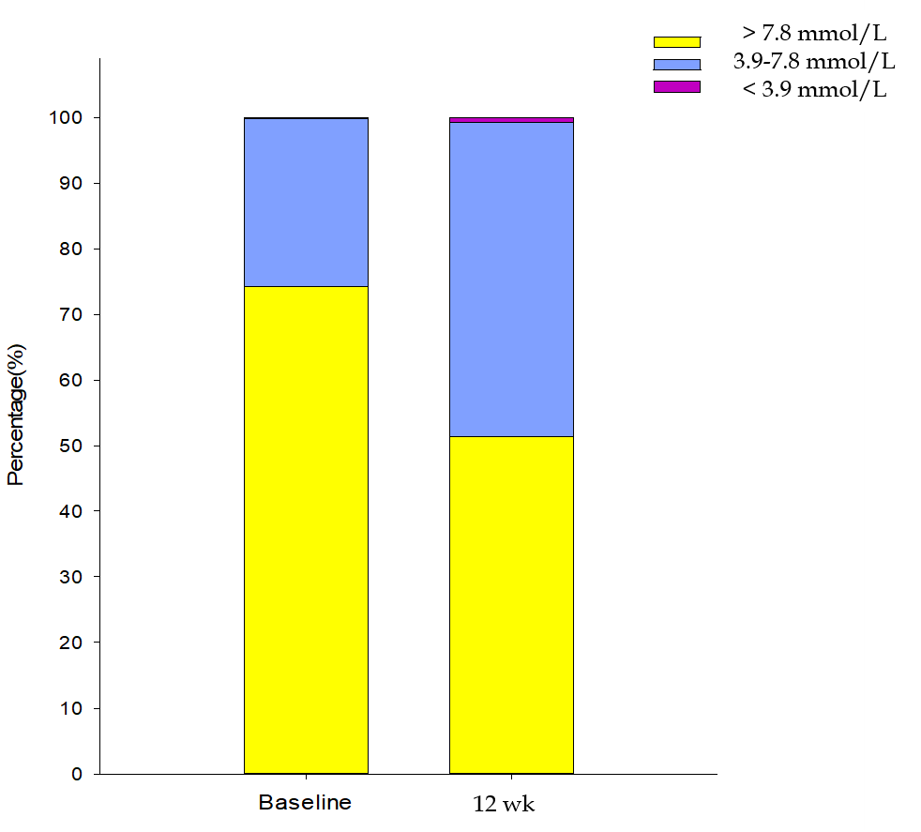
Figure 1 PT1, PT2, PT3 at baseline and 12 wk. PT1: Percentage of time below 3.9 mmol/L; PT2: Percentage of time between 3.9-7.8 mmol/L; PT3: Percentage of time above 7.8 mmol/L. P = 0.035, 0.005, 0.005, respectively, after 12-wk treatment vs baseline.

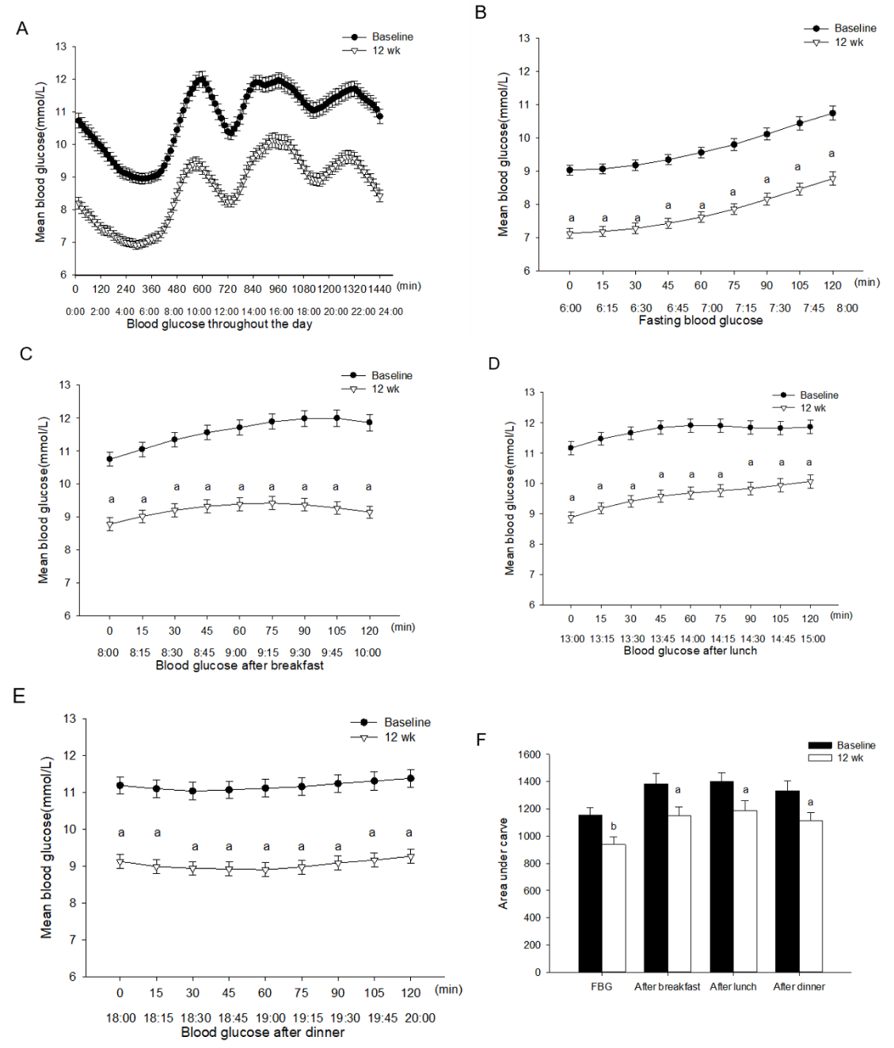
Figure 2 Comparison of mean blood glucose and the area under carve of fasting and postprandial blood glucose at baseline and after treatment. A: Mean blood glucose from 0:00 to 24:00; B: Mean blood glucose from 6:00 to 8:00; C: Mean blood glucose from 8:00 to 10:00; D: Mean blood glucose from 13:00 to 15:00; E: Mean blood glucose from 18:00 to 20:00; F: Area under the curves of each time period. The data are denoted as mean ± SD. ªP < 0.05, ^{b}P < 0.01, after 12-wk treatment vs baseline.

Table 1 The baseline characteristics of patients [mean ± SD]
Variables | Total (21)
Age(yr) | 48.8 ± 8.4
Duration of diabetes (yr) | 5.3 ± 2.1
Gender (female/male) | 4/17
BMI (kg/m²) | 26.7 ± 1.6
Smoking (%) | 71.4
Hypertension (%) | 66.7
Macrovascular complication (%) | 19.0
Microvascular complications (%) | 38.1
BMI: Body mass index.

Table 2 Blood glucose level and time in range at baseline and 12 wk [mean ± SD or median (interquartile range)]
Variables | Baseline | 12 wk | P value
eHbA1c (%) | 8.4 ± 1.4 | 7.0 ± 1.3 | 0.003
MBG (mmol/L) | 10.8 ± 2.3 | 8.6 ± 2.0 | 0.003
TIR (h) | 6.1 ± 5.9 | 11.5 ± 5.8 | 0.005
TOR (h) | 17.9 ± 5.9 | 12.5 ± 5.8 | 0.005
eHbA1c: Estimated glycated hemoglobin; MBG: Mean blood glucose; TIR: Time in range; TOR: Time out of range.

Table 3 Parameters of glycemic variability at baseline and 12 wk [mean ± SD or median (interquartile range)]
Variables |  | Baseline | 12 wk | P value
SDBG (mmol/L) |  | 2.8 ± 0.8 | 2.3 ± 0.6 | 0.017
CV (%) |  | 26.3 ± 5.4 | 26.3 ± 3.5 | 0.997
MAGE (mmol/L) | Overall | 5.7 ± 1.3 | 4.5 ± 1.1 | 0.006
 | During day | 5.8 ± 1.2 | 4.6 ± 1.3 | 0.010
 | At night | 4.7 ± 1.8 | 3.6 ± 1.2 | 0.020
MODD (mmol/L) | Overall | 2.8 ± 1.2 | 1.6 ± 0.4 | 0.000
 | During day | 2.9 ± 1.1 | 1.8 ± 0.5 | 0.001
 | At night | 1.8 (1.1-3.9 ) | 1.0 (0.6-1.5 ) | 0.007
LAGE (mmol/L) | Overall | 15.2 ± 2.6 | 13.5 ± 3.2 | 0.092
 | During day | 14.8 ± 2.8 | 13.1 ± 3.3 | 0.127
 | At night | 9.7 ± 3.6 | 8.5 ± 2.4 | 0.258
AUC of IQR |  | 5017.5 ± 1932.8 | 3877.1 ± 1001.1 | 0.024
AUC of IDR |  | 9713.2 ± 2782.2 | 8015.9 ± 2208.2 | 0.036
AUC of IDR: Area under the curve between 10-90 percentile; AUC of IQR: Area under the curve between 25-75 percentile; CV: Coefficient of variation; LAGE: Large amplitude of glycemic excursion; MAGE: Mean amplitude of glycemic excursion; MODD: Mean of daily difference; SDBG: Standard deviation of blood glucose.

Table 4 Duration of hypoglycemia at baseline and after treatment [median (interquartile range)]
Variables | Before trial | After trial | P value
Hypoglycemia cutoff: 3.9 mmol/L
Throughout the day (min) | 0 (0-2.3) | 1.1 (0-22.0) | 0.041
During day (min) | 0 (0-1.3) | 0 (0-3.0) | 0.157
At night (min) | 0 (0-0) | 1.1 (0-10.0) | 0.028
Hypoglycemia cutoff: 3.0 mmol/L
Throughout the day (min) | 0 (0,0) | 0 (0, 0) | 0.207
During day (min) | 0 (0,0) | 0 (0, 0) | 0.197
At night (min) | 0 (0-0) | 0 (0, 0) | 0.465

Table 5 Comparison of metabolic indicators before and after treatment (mean ± SD)
Variables | Baseline | 12 wk | P value
Weight (kg) | 78.1 ± 8.3 | 77.3 ± 8.5 | 0.008
Waist circumference (cm) | 100.8 ± 9.2 | 99.5 ± 8.5 | 0.021
HOMA-IR | 4.8 ± 2.2 | 4.0 ± 1.9 | 0.033
HOMA-β | 41.2 ± 24.1 | 64.4 ± 51.6 | 0.046
HOMA-IR: Homeostasis model assessment insulin resistance; HOMA-β: Homeostasis model assessment beta cell.

