Name of journal: World Journal of Gastroenterology
ESPS Manuscript NO: 331
Columns: CASE REPORT

Anal canal gastrointestinal stromal tumours: Case report and literature review

Carvalho N et al. Local excision for anal canal GIST

Nuno Carvalho, Diogo Albergaria, Rui Lebre, João Giria, Vitor Fernandes, Helena Vidal, Maria José Brito

Nuno Carvalho, Diogo Albergaria, Rui Lebre, João Gíria, Department of General Surgery, Garcia de Orta Hospital, 2801-951 Almada, Portugal

Victor Fernandes, Department of Gastroenterology, Garcia de Orta Hospital, 2801-951 Almada, Portugal

Helena Vidal, Department of Radiology, Garcia de Orta Hospital, 2801-951 Almada, Portugal

Maria José Brito, Department of Pathology, Garcia de Orta Hospital, 2801-951 Almada, Portugal

Author contributions: Carvalho N, Albergaria D and Lebre R contributed equally to this work; Fernandes V, Vidal H and Brito MJ contributed new reagents/analytic tools; Gíria J reviewed this work; Carvalho N wrote the paper.

Correspondence to: Diogo Albergaria, MD, Department of General Surgery, Garcia de Orta Hospital, Av. Torrado da Silva, 2801-951 Almada, Portugal. diogo.albergaria@gmail.com
Telephone: +351-21-2727114 Fax: +351-21-2727114

Received: August 29, 2012 Revised: March 28, 2013
Accepted: April 9, 2013
Published online:

Abstract
Gastrointestinal stromal tumours (GIST) are an uncommon group of tumours of mesenchymal origin. GIST of the anal canal is extremely rare. At the present, only ten cases of c-kit positive anal GIST have been reported in the literature. There is no widely accepted treatment approach for this neoplasia. Literature is sparse for imaging evaluation of anal canal GIST, usually described as a lesion in the intersphincteric space. Herein we described the case of a 73-year-old man with a mass in the anal canal, with no other symptoms. Endoanal ultrasound and magnetic resonance imaging showed a well circumscribed solid nodule in the intersphincteric space. The patient was treated by local excision. Gross pathological examination showed a 7 cm × 3.5 cm × 3 cm mass and histological examination showed a proliferation of spindle cells, with prominent nuclear palisading. The mitotic count was of 12 mitosis / 50HPF. The tumour was positive for KIT protein, CD34 and vimentine in the majority of cells and negative for desmin and S100. A diagnosis of GIST, with high risk aggressive behaviour was made. An abdomino-perineal resection was discussed, but refused. The follow-up has been made with clinical evaluation and anal ultrasound. After 5 years the patient is well, with maintained continence and no evidence of local recurrence.

© 2013 Baishideng. All rights reserved.

Key words: Gastrointestinal stromal tumours; Anal canal; Endoanal ultrasound; Magnetic resonance imaging; C-Kit receptor; Local excision

Core tip: Gastrointestinal stromal tumours (GIST) are an uncommon group of tumours of mesenchymal origin. GIST of the anal canal is extremely rare. Herein the authors described the case of a 73-year-old man with a mass in the anal canal, with no other symptoms. The patient was treated by local excision.
An abdomino-perineal resection was discussed, but refused. The follow-up has been made with clinical evaluation and anal ultrasound. After 5 years the patient is well, with maintained continence and no evidence of local recurrence.

Carvalho N, Albergaria D, Lebre R, Giria J, Fernandes V, Vidal H, Brito MJ. Anal canal gastrointestinal stromal tumours: Case report and literature review

Available from:
DOI:

INTRODUCTION
Gastrointestinal stromal tumours (GIST) are specific KIT-positive mesenchymal tumours that are most commonly found in the stomach and small bowel. Anorectal GIST is rare and comprises approximately 5% of all GIST^{[1]}. Although surgical resection is the mainstay of treatment, it is still uncertain whether local or radical excision should be appropriate for anorectal GIST^{[1]}.

CASE REPORT
A 73-year-old man was referred for evaluation of an anal mass. The patient did note an anal mass for the past 4 mo, without changes in size, pain or rectal discharge. Traumas to the area, rectal bleeding and fecal incontinence were denied. There was no weight loss or changes in appetite. His past history was irrelevant.
On examination there was a 4 cm × 2 cm left lateral anal mass, extending till the pubo-rectalis muscle, firm and mobile over surrounding planes. No inguinal lymph nodes were found. Laboratory blood tests were normal. Endoanal ultrasound showed a left lateral isoechoide lump, with central calcification, extending from the inferior anal canal to the pubo-rectalis muscle. The lump was well circumscribed in the intersphincteric plane, pushing the external anal sphincter, with no evidence of invasion or infiltration of the surrounding tissues. There was no local lymphadenopathy (Figure 1).
Magnetic resonance imaging confirmed a well circumscribed, solid lump in the intersphincteric plane, without adenophaty (Figure 2A and B). The patient was brought to the operating theatre and through a radial incision a local excision was performed. Just a small amount of fibbers of the internal anal sphincter was also removed. The mass was capsulated and not adherent to the surrounding structures.
Gross pathological examination showed a 7 cm × 3.5 cm × 3 cm fibrous-elastic mass and histological examination showed a proliferation of spindle cells, with prominent nuclear palisading (Figure 3). A Complete margin-free (R0 resection) was shown; the mitotic count was of 12 mitosis / 50HPF. The tumour was positive for KIT protein (CD 117), CD34 and vimentine in the majority of cells and negative for desmin and S100 (Figure 4).
A diagnosis of GIST, with high risk aggressive behaviour was made. An abdomino-perineal resection was discussed, but refused. The follow-up was made by clinical examination and endo-anal ultrasound. After 5 years the patient is well, and there is no clinical or imagiologic evidence of recurrence. Faecal continence remained unchanged after surgery.

DISCUSSION
GIST is the most common nonepithelial tumours of the gastrointestinal tract^{[2]}. The term was first used in 1983 to describe an unusual type of nonepithelial tumour of the gastrointestinal tract that lacked the traditional features of smooth muscle or Schwann cells^{[2]}. These tumours have a histological and immunohistochemical structure similar to Cajal interstitial cells. GIST and Cajal cells both express in a very high percentage of cases (85%-100%) the c-kit receptor, which is the protein produced by the c-kit proto-oncogene.
DNA study of the tumours cells demonstrated a high frequency of mutation that leads to constitutive activation of the Kit-tyrosine-kinase in the absence of stimulation by its physiologic ligand. This causes an uncontrolled stimulation of downstream signalling cascades with aberrant cellular proliferation and resistance to apoptosis^{[3]}.
GIST cells are characterized by CD117 antibody, which identifies c-Kit, a membrane receptor protein with tyrosine-kinase activity. GIST express CD117 up to 95% of cases, but also CD34 (70%), smooth muscle actine (40%), protein S100 and desmine (2%)^{[4]}. Our patient had a c-kit positive anal GIST, and to our knowledge could be the twelve case described in the literature^{[5]}. Inhibitor of tyrosine-kinase receptor as imatinib mesylate, represents the target therapy for local and distant recurrence after surgical resection^{[5]}. GIST are found more often in the stomach (60%-70%) and less frequently in the small intestine (30%), while the rectum and anus are extremely rare locations with an incidence of 5% of all gastrointestinal stromal tumours. Anal GIST is even rarer representing only 3% of all anorectal mesenchymal tumours^{[5]}.
The vast majority of anorectal GIST afflicts males in the fifth to seventh decades of life. About half are incidental findings on colonoscopy or barium enema. The symptomatic group presents with either bleeding per rectum, pain, change of bowel habit, signs of obstruction or urinary symptoms akin to prostatitis^{[6]}. Literature is sparse for imaging evaluation of anal canal GIST, usually described as a lesion in the intersphincteric space^{[2,5-7]}. Calcification of a GIST has been reported in microscopic evaluation^{[8]}.
The best indicator of malignancy is the presence of invasion of adjacent organs or obvious metastatic disease seen on imaging or surgery^{[7]}. The widely accepted criteria to predict malignancy of GIST are the mitotic activity (> 5 mitotic figures per 50 × high power field) and the tumour size (> 5 cm)^{[5]}. No lesion can be definitely labelled as benign^{[5]}. The treatment of choice for GIST is excision. High grade tumours are usually larger and need wider excision^{[5]}.
There are presently few published data on the outcomes of anorectal GIST treated by local excision versus radical clearance. Local recurrence frequently precedes late spread to liver, lungs and bone, and has been attributed to inadequate surgical clearance^{[6]}.
Some authors recommend abdominoperineal resection for GIST larger than 2 cm^{[6]}. Local excision can be an acceptable treatment option in selected patients, with tumours < 2 cm and < 5 mitoses per 50 HPF (frozen section)^{[1]}. Extensive lymph nodes dissection is unnecessary because GIST rarely metastize to the regional lymph nodes^{[3]}.
In a series of 18 anorectal GIST, 6 out of 10 tumours treated by local excision recurred, whereas none of 8 tumours treated by abdominoperineal resection recurred. However, the method of resection did not significantly affect the development of metastasis or survival, as the number of metastases and deaths were similar with both surgical methods^{[9]}.
Local excision has the advantage of minimal morbidity and sphincter preservation, while radical excision may offer a better oncological cure^{[1]}. The role of adjuvant therapy is still uncertain. Although inhibitors of tyrosine-kinase receptor needs further studies before using them routinely as adjuvant therapy, their role in case of distant or local recurrence has been accepted^{[5]}. Neither radiotherapy nor conventional chemotherapy has any proven efficacy as adjuvant therapy^{[1,3]}.
Patients close follow up is mandatory to disclose as soon as possible local recurrence or metastases^{[6]}. A long latency period is common between primary operation and recurrences and metastases^{[8]}. Recurrence 10 years after resection the primary tumour is not rare. Therefore, all patients with anorectal GIST should be regularly followed up for an infinite period. If recurrent disease is detected, further excision can be attempted, for cure or palliation. For unresectable primary or recurrent GIST, the use of imatinib has been shown to be effective in reducing tumour volume and controlling disease progression^{[1]}. The natural history and prognostic features of GIST needs further researc ^{[7]}.

REFERENCES
1 Li JC, Ng SS, Lo AW, Lee JF, Yiu RY, Leung KL. Outcome of radical excision of anorectal gastrointestinal stromal tumors in Hong Kong Chinese patients. Indian J Gastroenterol 2007; 26: 33-35 [PMID: 17401234]
2 Hong X, Choi H, Loyer EM, Benjamin RS, Trent JC, Charnsangavej C. Gastrointestinal stromal tumor: role of CT in diagnosis and in response evaluation and surveillance after treatment with imatinib. Radiographics 2006; 26: 481-495 [PMID: 16549611 DOI:10.1148/rg.262055097]
3 De Marco G, Roviello F, Marrelli D, De Stefano A, Neri A, Rossi S, Corso G, Rampone B, Nastri G, Pinto E. A clinical case of duodenal gastrointestinal stromal tumor with a peculiarity in the surgical approach. Tumori 2005; 91: 261-263 [PMID: 16206652]
4 Lopes JM, Gouveia A, Pimenta A. O papel da anatomia patológica no diagnóstico e prognóstico dos GISTs. Revista Portuguesa de Cirurgia Junho 2007, 2ª Série, N º 1, 35-38
5 Nigri GR, Dente M, Valabrega S, Aurello P, D'Angelo F, Montrone G, Ercolani G, Ramacciato G. Gastrointestinal stromal tumor of the anal canal: an unusual presentation. World J Surg Oncol 2007; 5: 20 [PMID: 17306018 DOI:10.1186/1477-7819-5-20]
6 Tan GY, Chong CK, Eu KW, Tan PH. Gastrointestinal stromal tumor of the anus. Tech Coloproctol 2003; 7: 169-172 [PMID: 14628161 DOI:10.1007/s10151-003-0030-8]
7 Huilgol RL, Young CJ, Solomon MJ. The gist of it: Case reports of a gastrointestinal stromal tumour and a leiomyoma of the anorectum. ANZ J Surg 2003; 73: 167-169 [PMID: 12608988 DOI:10.1046/j.1445-2197.2003.02643.x]
8 Miettinen M, Furlong M, Sarlomo-Rikala M, Burke A, Sobin LH, Lasota J. Gastrointestinal stromal tumors, intramural leiomyomas, and leiomyosarcomas in the rectum and anus: a clinicopathologic, immunohistochemical, and molecular genetic study of 144 cases. Am J Surg Pathol 2001; 25: 1121-1133 [PMID: 11688571 DOI:10.1097/00000478-200109000-00002]
9 Tworek JA, Goldblum JR, Weiss SW, Greenson JK, Appelman HD. Stromal tumors of the anorectum: a clinicopathologic study of 22 cases. Am J Surg Pathol 1999; 23: 946-954 [PMID: 10435565 DOI:10.1097/00000478-199908000-00013]

P-Reviewers El Nakeeb A, Regadas FSP S-Editor Song XX L-Editor E-Editor

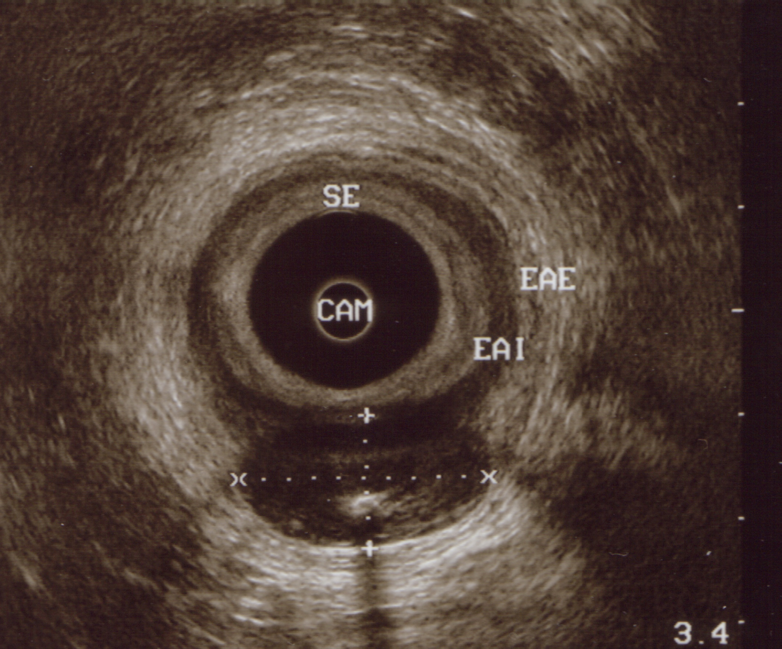

Figure 1 Endoanal ultrasound. Posterior hipoecoid nodule, well circumscribed, between internal and external anal sphincter, with posterior enhancement and central calcification. CAM: Middle anal canal; EAI: Internal anal sphincter; EAE: External anal sphincter; SE-Subepitelium.
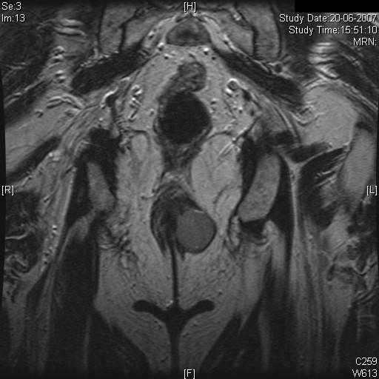
A
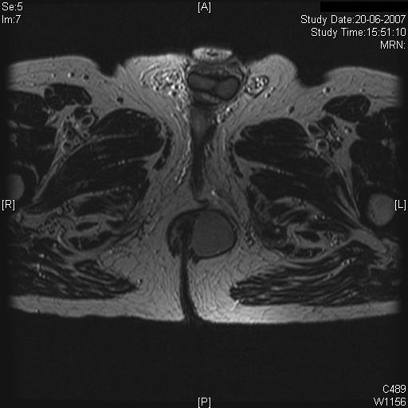
B
Figure 2 Anal canal magnetic resonance imaging. A: T2 coronal ponderation. Anal canal left lateral wall, well circumscribed nodule, solid component. No evidence of adenophaty; B: T2 axial ponderation.

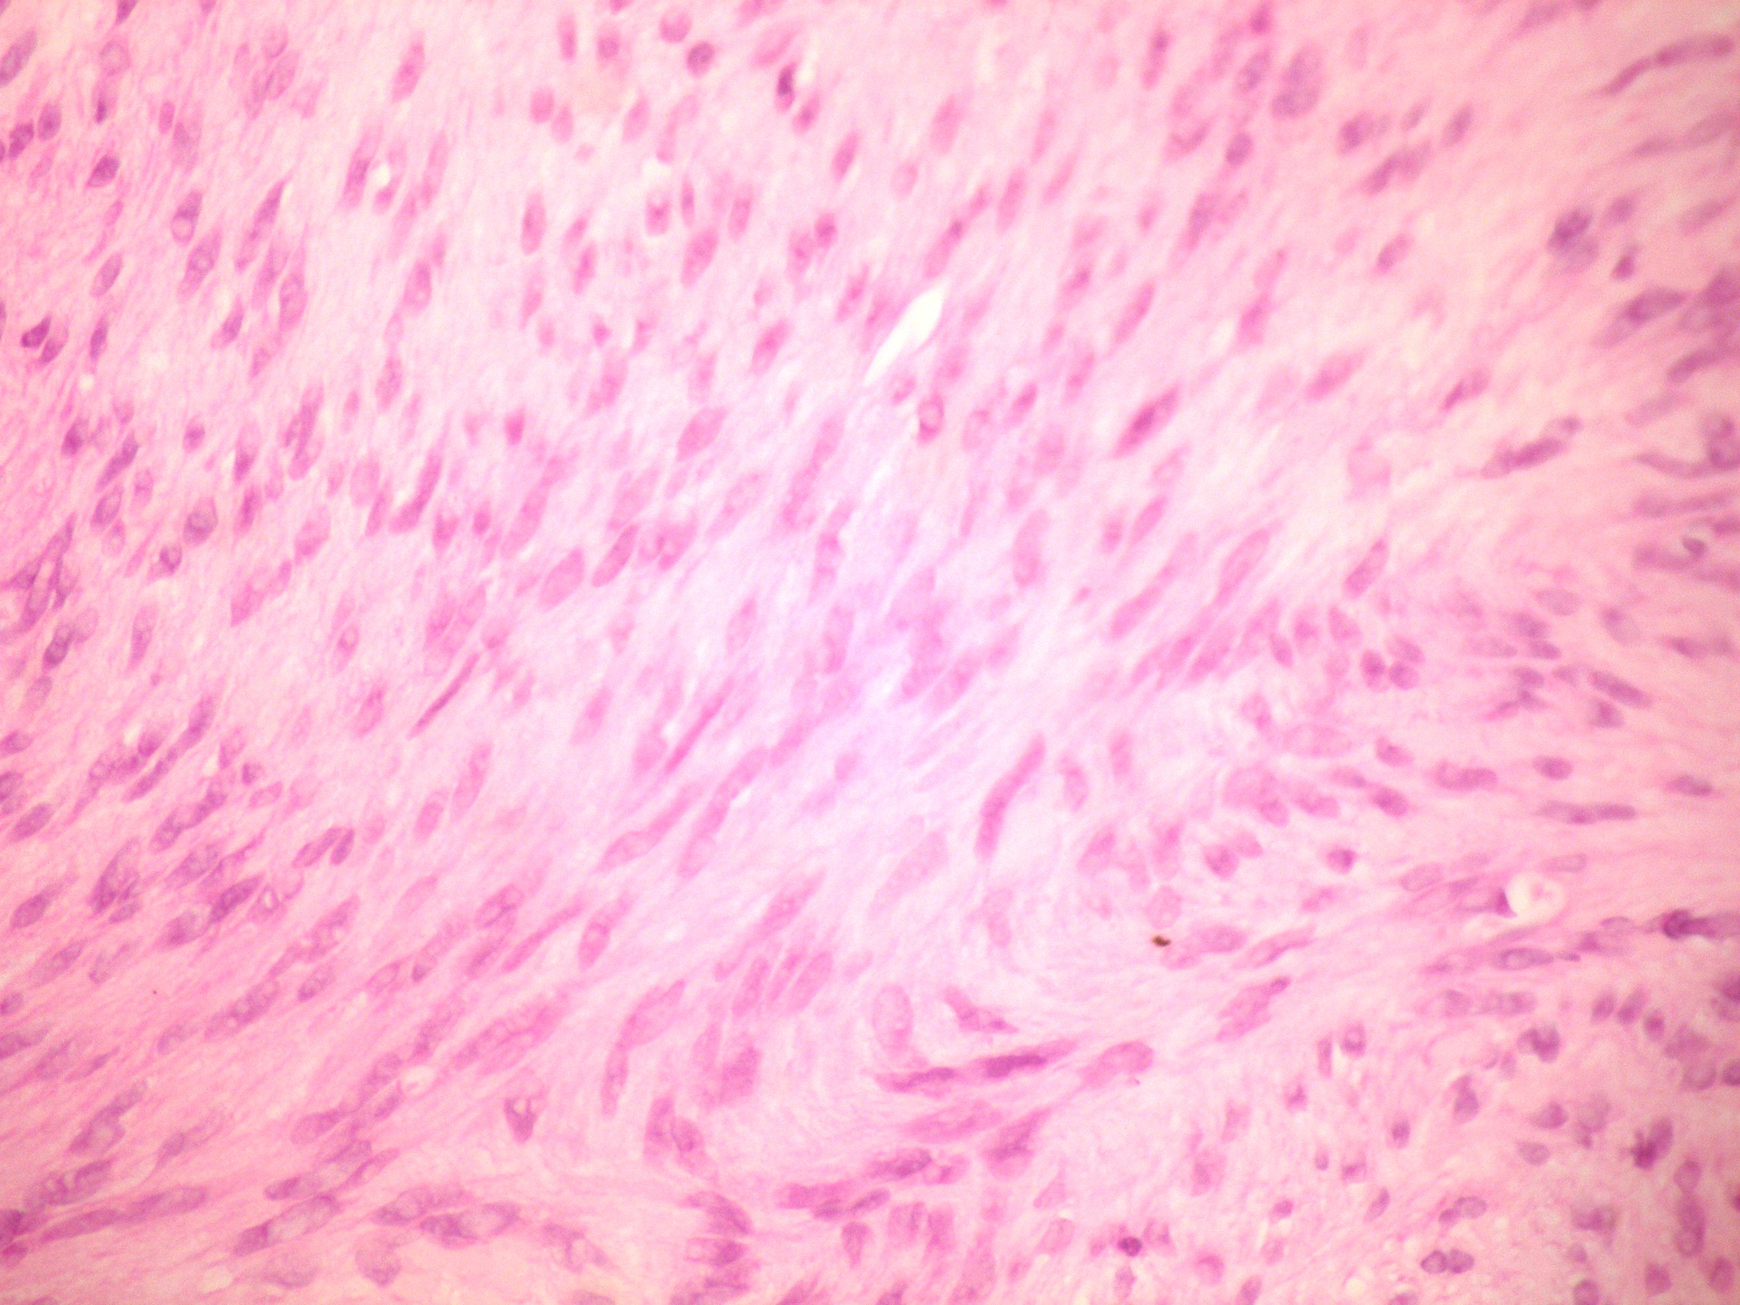
Figure 3 HE (× 400), eosinophlic, fusiform cells with elongated nuclei.

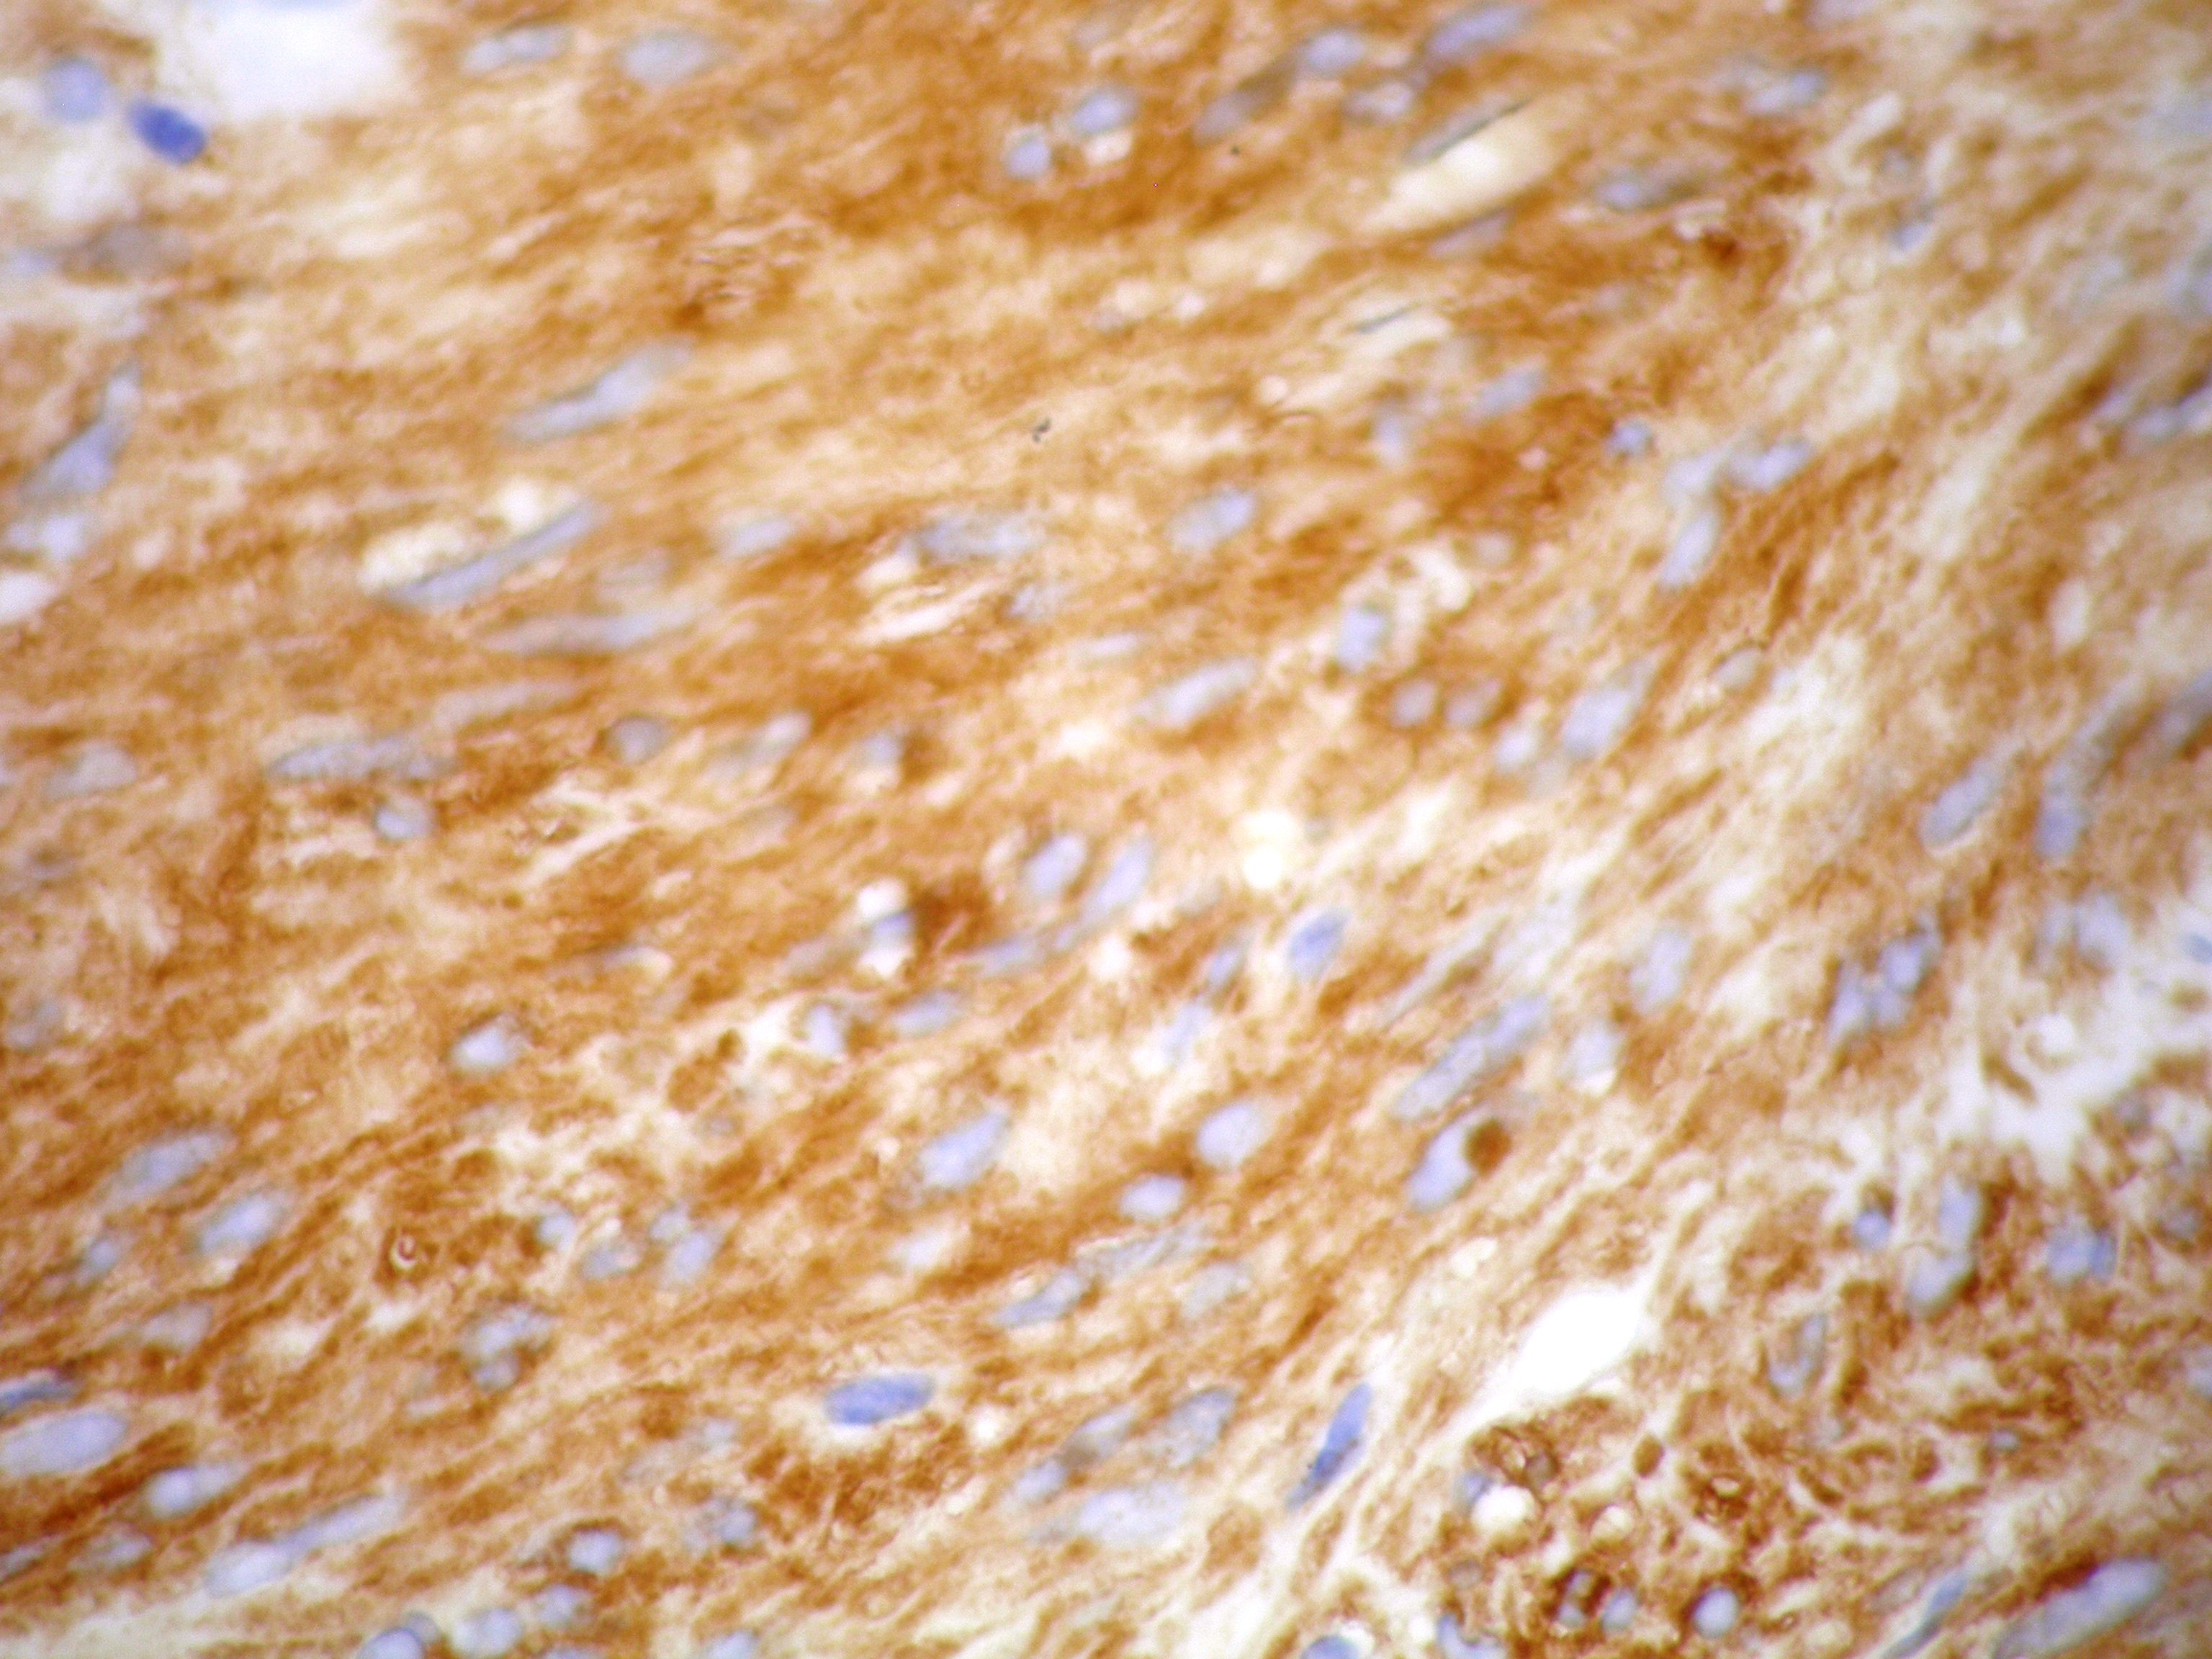
Figure 4 Positive immunostaining for CD117.

