Name of Journal: World Journal of Psychiatry
Manuscript NO: 85580
Manuscript Type: ORIGINAL ARTICLE

Observational Study
Effects of sports on school adaptability, resilience and cell phone addiction tendency of high school students

Zhang LQ et al. Effects of sports on high school students

Li-Qiang Zhang, Hui-Na Gao

Li-Qiang Zhang, School of Physical Education, Xizang Minzu University, Xianyang 712082, Shaanxi Province, China

Hui-Na Gao, The PE Department, Shaanxi Institute of International Trade & Commerce, Xi’an 712046, Shaanxi Province, China

Author contributions: Zhang LQ and Gao HN designed the research; Zhang LQ performed the research and wrote the paper; both the authors reviewed the paper.

Supported by the General Project for Humanities and Social Sciences Research, Ministry of Education of China, No. 19XZJC890001.

Corresponding author: Hui-Na Gao, MA, Associate Professor, The PE Department, Shaanxi Institute of International Trade & Commerce, No. 35 West Unification Road, Fengxi New Town University Park, Xi’an New District, Xi’an 712046, Shaanxi Province, China. gaohn927@126.com

Received: May 31, 2023
Revised: June 29, 2023
Accepted: July 19, 2023
Published online:

Abstract
BACKGROUND
Sport help promote healthy physical and mental development of high school students. To date, there have been few studies on the effect of sport on school adaptability, resilience and cell phone addiction tendency of high school students.

AIM
To explore the effects of sports on school adaptability, resilience and cell phone addiction of high school students.

METHODS
A stratified random sampling method was used to select 600 students from two high schools in Lhasa, and Physical Activity Rating Scale, School Adjustment Scale for High School Students, Chinese Adolescents Resilience Scale, and Mobile Phone Addiction Index were used for field questionnaire survey.

RESULTS
Sport was positively correlated with school adaptability and resilience (P < 0.01), school adaptability was positively correlated with resilience (P < 0.01) and cell phone addiction was negatively correlated with sports, school adaptability and resilience (P < 0.01). The direct effect of sport on cell phone addiction was significant (P < 0.001), accounting for 20.51% of the total effect. The mediating effect of school adaptability on sport and cell phone addiction was significant (P < 0.001), accounting for 17.38% and 35.36% of the total effect value, respectively. School adjustment and resilience had a significant chain-mediated effect on sport and cell phone addiction (P < 0.001), accounting for 26.75% of the total effect.

CONCLUSION
Sport affected the cell phone addiction tendency of senior high school students through the mediating effect of school adaptability and resilience, and through the chain mediation effect of both.

Key Words: Sport; High school students; School adaptability; Resilience; Cell phone addiction

Zhang LQ, Gao HN. Effects of sports on school adaptability, resilience and cell phone addiction tendency of high school students. World J Psychiatry 2023; In press

Core Tip: Sport is beneficial to the development of heart and lung function and motor system, and can develop physical strength and promote mental health. This study analyzed the questionnaire data of 560 high school students’ sporting activity, school adaptability, resilience and cell phone addiction tendency. By constructing a chain mediation model, the relationship between sport and school adaptability, resilience and cell phone addiction tendency was obtained, providing a theoretical basis for the physical and mental health development of high school students.

INTRODUCTION
High school students are in a stage of growth and development, and sport plays a particularly important role in promoting their physical and mental health^{[1]}. However, many high school students neglect sport because they study all day under academic pressure or are addicted to their cell phones^{[2,3]}. The decline in sport could have a negative effect on physical and mental health of high school students^{[4]}. Sport can improve high school students’ adaptability to school, which can promote interpersonal relations and enthusiasm for learning^{[5]}. Sport can enhance the resilience of high school students, and help them to face the pressure and difficulties brought by school life with a more positive and optimistic attitude^{[6]}. Sport is also linked to lower levels of cell phone addiction among senior high school students^{[7]}. Although many studies have shown that sport has an impact on school adaptability, resilience and cell phone addiction of adolescent students^{[8-11]}, few studies have combined sport with these other aspects in high school students.Therefore, by establishing the amount of sport of high school students, we analyzed the relationship between sport and senior high school students’ school adaptability, resilience and cell phone addiction tendency. We also discussed the influence of sport on high school students’ school adaptability, resilience and cell phone addiction tendency.

MATERIALS AND METHODS
Research object
From March to June 2022, a questionnaire survey was conducted among students from two high schools in Lhasa using stratified random sampling. A total of 600 students were selected according to different grades, and 200 in each grade were selected. The mean age was 16.56 years ± 1.01 years. There were 320 male students (53.33%) with an average age of 16.58 years ± 1.0 years. There were 280 female students (46.67%) with an average age of 16.53 years ± 1.04 years. We included senior grade one, two and three students, and students gave informed consent to complete the questionnaire. We excluded students with poor physical and mental health, and those who were unable to cooperate with the questionnaire. This study is in accordance with the Declaration of Helsinki.

Questionnaire
The questionnaire was conducted with the consent of the students, their parents and the school. Before the test, a mental health professional instructed the students to fill in the questionnaire according to their own situation. After filling in the questionnaire, it was recovered immediately. Six hundred questionnaires were sent out, and 560 (93.33%) were collected.

Research tools
Physical activity rating scale: The Physical Activity scale modified by Liang et al^{[12]} was adopted, which measured sport from three dimensions of participation; namely time, intensity and frequency. Score = sport intensity score “(sport time score-1)” sport frequency score. Each dimension was divided into five grades, scoring 1-5 points. Scores ranged from 0 to 100: Low level of sport ≤ 19 points; level 20-42 points, and high level ≥ 43 points. Cronbach’s α was 0.82.

School adjustment scale: We used Hou et al^{[13]} School Adjustment Scale for Senior High School Students. The scale consisted of 82 items, including seven dimensions of academic adjustment, peer relationship, school attitude, class activity adjustment, emotional adjustment, conflict in teacher-student relationship, and intimacy of teacher-student relationship. A 5-point Likert 5 scale was used. Scores ranged from 1 to 5. All dimensions were added together to obtain the School Adaptation Score. A higher total score indicated better school adaptability. Cronbach’s α was 0.964.

Resilience scale for Chinese adolescents: Hu et al^{[14]} compiled the Resilience Scale for Chinese adolescents. The scale consisted of 27 items, including five dimensions: goal focus, positive cognition, emotional control, family support, and interpersonal assistance. The scale used a 5-point Likert scoring method. Scores ranged from 1 to 5, and a higher total score indicated greater resilience. Cronbach’s α was 0.86.

Mobile phone addiction index: The Mobile Phone Addiction Index was compiled by Leung^{[15]}. There were 17 items, including four dimensions: Loss of control, withdrawal, inefficiency and escape. A 5-point Likert scoring method was used. Scores ranged from 1 to 5, and a score < 34 was considered to show no cell phone addiction, 34-51 mild addiction, 52-68 addiction, and 68-85 severe addiction. Cronbach’s α was 0.90.

Statistical analysis
SPSS 26.0 statistical software was used for data analysis. Descriptive statistics, t test, analysis of variance, and correlation analysis were conducted on the collected data, and PROCESS was used to test the mediating effect. The statistical significance was P < 0.05.

RESULTS
Essential features of senior high school sport
The total score for level of sport in high school students was 16 (6, 30) points (Table 1). The level of sport of high school students was mostly in the low sport level, accounting for 59.29% of the total number.
The level of sport among high school students was significantly higher in male than female students (P < 0.05) (Table 2). Sport intensity, time and frequency and total score were also significantly higher in male students (P < 0.05), indicating that male students had a greater need of sport.
There were no significant differences in sport intensity, time and frequency in senior grade one, two and three students (P > 0.05) (Figure 1).
Among the 560 high school students participating in the survey 332 (59.29%) had a low level of sport, 144 (25.71%) had a medium level, and 84 (15%) had a high level (Table 1). Among the 300 male students, 157 (52.33%) had a low level of sport, 82 (27.33%) had a medium level, and 61 (20.34%) had a high level. Among the 260 female students, 175 (67.31%) had a low level of sport, 62 (23.85%) had a medium level, and 23 (8.84%) had a high level. Among the 184 senior grade 1 high school students, 107 (58.15%) had a low level of sport, 53 (24.81%) had a medium level, and 24 (13.04%) had a high level. Among the 192 senior grade two students, 115 (59.90%) had a low level of sport, 46 (23.96%) had a medium level, and 31 (16.14%) had a high level. Among the 184 senior grade 3 students, 110 (59.78%) had a low level of sport, 45 (24.46%) had a medium level, and 29 (15.76%) had a high level.

Specific analysis of different levels of sports in senior high school sports
As shown in Tables 3-5, there was no significant difference in gender and grade among high school students of low, medium and high sports levels (P > 0.05), indicating that there was no gender and grade difference between high school students at the same sports level. Therefore, the following analysis was performed in three groups of high school students at low, medium and high sports levels to analyze resilience, school adaptability and cell phone addiction tendency.

Effect of level of sport on school adaptability of high school students
There were significant differences in the scores for academic adjustment, peer relationship, school attitude, class activity adjustment, emotional adjustment, conflict in teacher-student relationship, intimacy of teacher-student relationship when comparing low, medium and high levels of sport (P < 0.05) (Figure 2A). There were significant differences in the seven dimensions of school adaptability between students with low and medium levels of sport, low and high levels of sport, and medium and high levels of sport (P < 0.05).

Effect of level of sport on resilience of high school students
The total scores for goal focus, positive cognition, emotional control, family support, and interpersonal assistance were significantly different between students with low, medium and high levels of sport (P < 0.05) (Figure 2B). There were significant differences between these five dimensions when comparing students with low and medium levels of sport, low and high levels of sport, and medium and high levels of sport (P < 0.05).

Effect of level of sport on cell phone addiction tendency of high school students
There were significant differences in loss of control, withdrawal, escape, and inefficiency among students with low, medium and high levels of sport (P < 0.05) (Figure 2C). There were significant differences in these four dimensions of cell phone addiction tendency between students with low and medium levels of sport, low and high levels of sport, and medium and high levels of sport (P < 0.05).

Correlation analysis of level of sport with school adaptability, resilience and cell phone addiction tendency among high school students
Level of sport was positively correlated with school adaptability and resilience (P < 0.01); school adaptability was positively correlated with resilience (P < 0.01); and cell phone addiction was negatively correlated with sports, school adaptability and resilience (P < 0.01) (Table 6).

Analysis of the mediating effects of sport and school adaptability, resilience and cell phone addiction among senior high school students
The Bootstrap method was used to test for mediation effect, so as to prove the degree of influence among dependent, independent and mediating variables. The direct effect of sport on cell phone addiction was significant (P < 0.001), accounting for 20.51% of the total effect (Figure 3; Table 7). The mediating effect of school adaptability on sport and cell phone addiction was significant (P < 0.001), accounting for 17.38% and 35.36% of the total effect value, respectively. School adjustment and resilience had a significant chain-mediated effect between sport and cell phone addiction (P < 0.001), accounting for 26.75% of the total effect.

DISCUSSION
We used a field questionnaire survey to collect data on the level of sport, school adaptability, resilience and cell phone addiction tendency of senior high school students. Through correlation analysis, a chain mediation effect model was constructed to deeply analyze the influence of sports on school adaptability, resilience and cell phone addiction tendency of senior high school students.
The overall level of sport of high school students reached the medium level, and the level of sport differed significantly by gender, but not by grade. In terms of school adaptability, resilience and cell phone addiction tendency, there were significant differences among low, medium and high levels of sport. There was a positive correlation between level of sport, school adaptability and resilience, and a negative correlation between cell phone addiction and level of sport, school adaptability and resilience. Level of sport had a significant direct effect on cell phone addiction, and school adaptability had a significant mediating effect on level of sport and cell phone addiction. There was a significant mediating effect of resilience between level of sport and cell phone addiction. School adjustment and resilience had significant chain-mediated effects between level of sport and cell phone addiction. Previous studies have shown a significant positive correlation between level of sport and school adaptability^{[16]}. This shows that sports can enhance high school students’ adaptability to school, help them establish good interpersonal relationships in school, promote their physical and mental health, and better adapt to the school environment. Similarly, other results show that there is a significant positive correlation between sport and resilience^{[17]}, indicating that increasing level of sport is the key to improving the resilience of senior high school students^{[18]}. There was also a significant positive correlation between school adaptability and resilience, indicating that high school students with stronger school adaptability had greater resilience. This is conducive for high school students to cope with various difficulties and setbacks encountered in school or life, and to better complete their studies and develop their social ability in the future^{[19]}. A previous study has shown that sports have a significant negative correlation with cell phone addiction tendency of college students^{[20]}, and the results of this study show that sports have a significant negative correlation with cell phone addiction tendency of high school students, which is similar to the results of the present study, indicating that sports can indeed improve the extent of cell phone addiction of senior high school students^{[21]}. Sport can enhance the interpersonal interaction between high school students and their peers, teachers and parents, thus enriching their emotional and social needs, so as to reduce the need to use cell phones for social interaction, thereby preventing cell phone addiction^{[22]}. Analysis of the chain mediation effect model of sport, school adaptability, resilience and cell phone addiction showed that the increase in level of sport improved school adaptability of high school students, and their level of resilience, and reduced their cell phone addiction tendency. Increased level of sport also improved high school students’ adaptability or resilience, and reduced their cell phone addiction tendency. Improvement of school adaptability is accompanied by improvement of resilience, which can ultimately reduce cell phone addiction tendency of high school students. Therefore, in order to better develop the mental and physical health of high school students, schools should raise awareness of the importance of sport. Schools should strengthen sports facilities, provide professional guidance and management of sporting activities, and formulate relevant policies to ensure participation in sport, to help high school students participate in school life in a positive manner, eliminate negative emotions, and enhance ability to withstand pressure. Meanwhile, high school students can reduce their dependence on cell phones and improve their physical and mental development^{[23]}.
This study had some limitations. The study sample was not comprehensive enough to represent all high school students, so the results have some limitations. The questionnaire survey was a cross-sectional study, which lacked longitudinal data and follow-up survey. The longitudinal data and follow-up survey can be combined to further study the relationship between high school students’ level of sport, school adaptability, resilience and cell phone addiction tendency, so as to research on the influence of enriching sports on high school students’ school adaptability, resilience and cell phone addiction tendency^{[24,25]}.

CONCLUSION
Sport can directly affect school adaptability, resilience and cell phone addiction tendency of senior high school students. Sport can affect cell phone addiction tendency through the mediating effect of school adaptability and resilience, and through the chain mediation effect of both.

ARTICLE HIGHLIGHTS
Research background
High school students are in an important stage of physical development. Sport can promote the healthy physical and mental development of high school students, help them adapt to the school environment, relieve study pressure, reduce the level of stress, and reduce cell phone addiction, which are important for healthy physical and mental development.

Research motivation
This study investigated the influence of sport on school adaptability, resilience and cell phone addiction, to establish whether their relationship had a positive impact on the physical and mental development of high school students.

Research objectives
We investigated the relationship between sport and school adaptability, resilience and cell phone addiction tendency in high school students, and the mediating effect of sport was tested. We hope that this study can strengthen high school students’ participation in sport, and indicate new ways for improving school adaptability and resilience and reducing cell phone addiction tendency.

Research methods
We collected data using a field questionnaire survey and SPSS was used to analyze the collected data on the effect of sport, school adaptability, resilience and cell phone addiction tendency in senior high school students. Through correlation analysis, a chain mediation effect model was constructed to analyze the influence of sport on school adaptability, resilience and cell phone addiction tendency of high school students.

Research results
Sport, school adaptability and resilience were positively correlated, while cell phone addiction was negatively correlated with sport, school adaptability and resilience, and sport affected the other three through the chain mediation model. The results provide a theoretical basis for further research combined with longitudinal research.

Research conclusions
We conclude that sport has an impact on school adaptability, cell phone addiction tendency and resilience of high school students.

Research perspectives
We analyzed the effect of sport on school adaptability, resilience and cell phone addiction tendency in high school students. In future research, longitudinal research and follow-up can be combined to analyze the relationship among level of sport, school adaptability, resilience and cell phone addiction tendency.

REFERENCES
1 Carlisle CC, Weaver RG, Stodden DF, Cattuzzo MT. Contribution of Organized Sport Participation to Health-Related Fitness in Adolescents. Glob Pediatr Health 2019; 6: 2333794X19884191 [PMID: 31696145 DOI: 10.1177/2333794X19884191]
2 Biddle SJ, Asare M. Physical activity and mental health in children and adolescents: a review of reviews. Br J Sports Med 2011; 45: 886-895 [PMID: 21807669 DOI: 10.1136/bjsports-2011-090185]
3 An X, Chen S, Zhu L, Jiang C. The mobile phone addiction index: Cross gender measurement invariance in adolescents. Front Psychol 2022; 13: 894121 [PMID: 35923732 DOI: 10.3389/fpsyg.2022.894121]
4 Ho FK, Louie LH, Chow CB, Wong WH, Ip P. Physical activity improves mental health through resilience in Hong Kong Chinese adolescents. BMC Pediatr 2015; 15: 48 [PMID: 25898349 DOI: 10.1186/s12887-015-0365-0]
5 Lin H, Wang B, Hu Y, Song X, Zhang D. Physical Activity and Interpersonal Adaptation in Chinese Adolescents After COVID-19: The Mediating Roles of Self-Esteem and Psychological Resilience. Psychol Rep 2022: 332941221137233 [PMID: 36314269 DOI: 10.1177/00332941221137233]
6 Qiu C, Qi Y, Yin Y. Multiple Intermediary Model Test of Adolescent Physical Exercise and Internet Addiction. Int J Environ Res Public Health 2023; 20 [PMID: 36901042 DOI: 10.3390/ijerph20054030]
7 Li Y, Sun Q, Sun M, Sun P, Sun Q, Xia X. Physical Exercise and Psychological Distress: The Mediating Roles of Problematic Mobile Phone Use and Learning Burnout among Adolescents. Int J Environ Res Public Health 2021; 18 [PMID: 34501851 DOI: 10.3390/ijerph18179261]
8 Alexandru MA, Jürgen B, Arash M, Guillaume M, Lorand B. Influence of Organized vs Non Organized Physical Activity on School Adaptation Behavior. Front Psychol 2020; 11: 550952 [PMID: 33329181 DOI: 10.3389/fpsyg.2020.550952]
9 Guddal MH, Stensland SØ, Småstuen MC, Johnsen MB, Zwart JA, Storheim K. Physical activity and sport participation among adolescents: associations with mental health in different age groups. Results from the Young-HUNT study: a cross-sectional survey. BMJ Open 2019; 9: e028555 [PMID: 31488476 DOI: 10.1136/bmjopen-2018-028555]
10 Xiao W, Wu J, Yip J, Shi Q, Peng L, Lei QE, Ren Z. The Relationship Between Physical Activity and Mobile Phone Addiction Among Adolescents and Young Adults: Systematic Review and Meta-analysis of Observational Studies. JMIR Public Health Surveill 2022; 8: e41606 [PMID: 36515994 DOI: 10.2196/41606]
11 Vaquero-Solís M, Tapia-Serrano MA, Hortigüela-Alcalá D, Sierra-Díaz MJ, Sánchez-Miguel PA. Physical Activity and Quality of Life in High School Students: Proposals for Improving the Self-Concept in Physical Education. Int J Environ Res Public Health 2021; 18 [PMID: 34281121 DOI: 10.3390/ijerph18137185]
12 Liang DQ. Stress level of college students and their relationship with physical exercise. Chin Ment Health J 1994; 8: 5-6
13 Hou J. The Development of the Questionnaire of School Adjustment for High School Students. Zhongguo Linchuang Xinlixue Zazhi 2013; 21: 367, 385-388 [DOI: 10.16128/j.cnki.1005-3611.2013.03.006]
14 Hu YQ, Gan Y. Development and psychometric validity of the resilience scale for Chinese adolescents. Acta Psychol Sin 2008; 40: 902-912 [DOI: 10.3724/SP.J.1041.2008.00902]
15 Leung L. Linking psychological attributes to addiction and improper use of the mobile phone among adolescents in Hong Kong. Journal of Children and Media 2008; 2: 93-113 [DOI: 10.1080/17482790802078565]
16 Bai MZ, Yao SJ, Ma QS, Wang XL, Liu C, Guo KL. The relationship between physical exercise and school adaptation of junior students: A chain mediating model. Front Psychol 2022; 13: 977663 [PMID: 36186376 DOI: 10.3389/fpsyg.2022.977663]
17 Xu S, Liu Z, Tian S, Ma Z, Jia C, Sun G. Physical Activity and Resilience among College Students: The Mediating Effects of Basic Psychological Needs. Int J Environ Res Public Health 2021; 18 [PMID: 33918303 DOI: 10.3390/ijerph18073722]
18 Zhao Z, Zhao S, Wang Q, Zhang Y, Chen C. Effects of Physical Exercise on Mobile Phone Addiction in College Students: The Chain Mediation Effect of Psychological Resilience and Perceived Stress. Int J Environ Res Public Health 2022; 19 [PMID: 36497752 DOI: 10.3390/ijerph192315679]
19 Zhang X, Huang PF, Li BQ, Xu WJ, Li W, Zhou B. The influence of interpersonal relationships on school adaptation among Chinese university students during COVID-19 control period: Multiple mediating roles of social support and resilience. J Affect Disord 2021; 285: 97-104 [PMID: 33640862 DOI: 10.1016/j.jad.2021.02.040]
20 Yang G, Li Y, Liu S, Liu C, Jia C, Wang S. Physical activity influences the mobile phone addiction among Chinese undergraduates: The moderating effect of exercise type. J Behav Addict 2021; 10: 799-810 [PMID: 34546969 DOI: 10.1556/2006.2021.00059]
21 Guo KL, Ma QS, Yao SJ, Liu C, Hui Z, Jiang J, Lin X. The Relationship Between Physical Exercise and Mobile Phone Addiction Tendency of University Students in China: A Moderated Mediation Model. Front Psychol 2022; 13: 730886 [PMID: 35237204 DOI: 10.3389/fpsyg.2022.730886]
22 Penglee N, Christiana RW, Battista RA, Rosenberg E. Smartphone Use and Physical Activity among College Students in Health Science-Related Majors in the United States and Thailand. Int J Environ Res Public Health 2019; 16 [PMID: 31013703 DOI: 10.3390/ijerph16081315]
23 Guo Z, Zhang Y. Study on the Interactive Factors between Physical Exercise and Mental Health Promotion of Teenagers. J Healthc Eng 2022; 2022: 4750133 [PMID: 35126925 DOI: 10.1155/2022/4750133]
24 Tang S, Chen H, Wang L, Lu T, Yan J. The Relationship between Physical Exercise and Negative Emotions in College Students in the Post-Epidemic Era: The Mediating Role of Emotion Regulation Self-Efficacy. Int J Environ Res Public Health 2022; 19 [PMID: 36231469 DOI: 10.3390/ijerph191912166]
25 Lee SM, Jeong HC, So WY, Youn HS. Mediating Effect of Sports Participation on the Relationship between Health Perceptions and Health Promoting Behavior in Adolescents. Int J Environ Res Public Health 2020; 17 [PMID: 32947940 DOI: 10.3390/ijerph17186744]

Footnotes
Institutional review board statement: The study was reviewed and approved by the East China Normal University (Approval No. HR 222-2019).

Informed consent statement: All study participants, or their legal guardian, provided informed written consent prior to study enrollment.

Conflict-of-interest statement: There are no conflicts of interest to report.

Data sharing statement: Data for this study can be obtained from the corresponding author upon request.

STROBE statement: The authors have read the STROBE Statement—checklist of items, and the manuscript was prepared and revised according to the STROBE Statement—checklist of items.

Open-Access: This article is an open-access article that was selected by an in-house editor and fully peer-reviewed by external reviewers. It is distributed in accordance with the Creative Commons Attribution NonCommercial (CC BY-NC 4.0) license, which permits others to distribute, remix, adapt, build upon this work non-commercially, and license their derivative works on different terms, provided the original work is properly cited and the use is non-commercial. See: https://creativecommons.org/Licenses/by-nc/4.0/

Provenance and peer review: Unsolicited article; Externally peer reviewed.
Peer-review model: Single blind

Peer-review started: May 31, 2023
First decision: June 14, 2023
Article in press:

Specialty type: Psychiatry
Country/Territory of origin: China
Peer-review report’s scientific quality classification
Grade A (Excellent): 0
Grade B (Very good): 0
Grade C (Good): C, C
Grade D (Fair): 0
Grade E (Poor): 0

P-Reviewer: Bressington D, China; Mends-Brew E, Ghana S-Editor: Chen YL L-Editor: A P-Editor:
Figure Legends
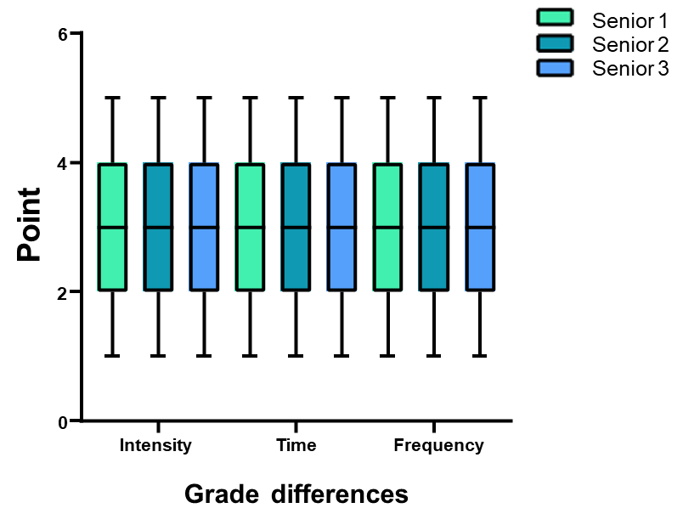
Figure 1 Differences in level of sport of high school students according to grade.

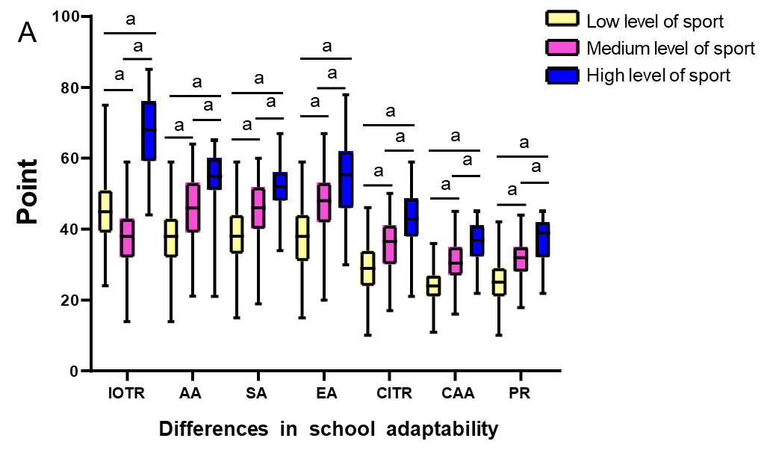
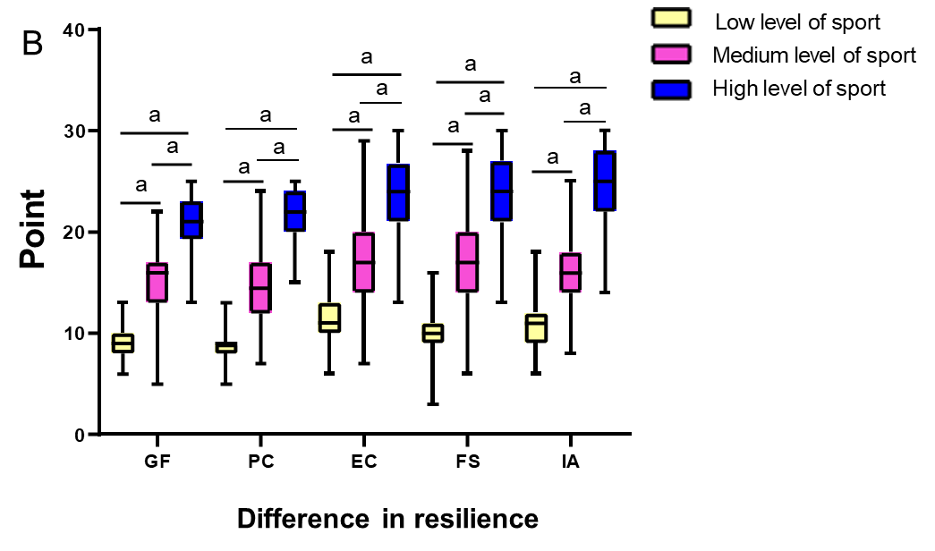
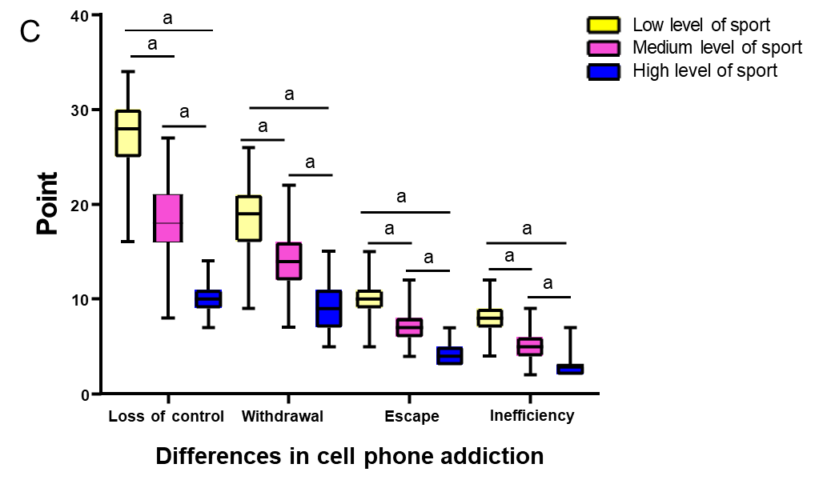
Figure 2 Effect of low, medium and high levels of sport. A: On school adaptability of high school students; B: On resilience of high school students; C: On cell phone addiction tendency of high school students. ªP < 0.05. IOTR: Intimacy of teacher-student relationship; AA: Academic adjustment; SA: School attitude; EA: Emotional adjustment; CITR: Conflict in teacher-student relationship; CAA: Class activity adjustment; PR: Peer relationship; GF: Goal focus; PC: Positive cognition; EC: Emotional control; FS: Family support; IA: Interpersonal assistance.

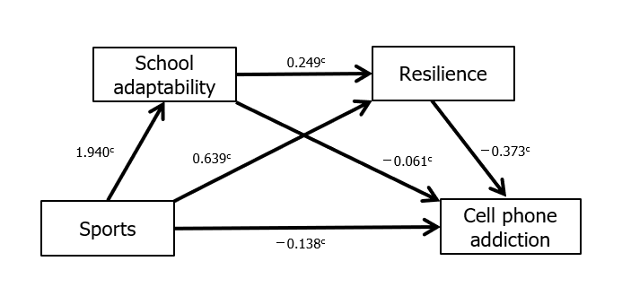
Figure 3 Chain mediation effect model. ^{c}P < 0.001.

Table 1 Analysis of characteristics of different levels of sport
 | Low level (≤ 19 points) | Medium level (20-42 points) | High level (≥ 43 points) | Total
Score (point)
Intensity | 3 (2, 3) | 3 (3, 4) | 4 (3, 5) | 3 (2, 4)
Time | 2 (1, 3) | 4.0 (3.0, 4.5) | 5 (4, 5) | 3 (2, 4)
Frequency | 3 (2, 4) | 3 (3, 4) | 4 (4, 5) | 3 (2, 4)
Total score | 6.0 (0, 13.5) | 27 (24, 34) | 49 (48, 62) | 16 (6, 30)
Gender, n (%)
Male | 157 (52.33) | 82 (27.33) | 61 (20.34) | 300 (100.00)
Female | 175 (67.31) | 62 (23.85) | 23 (8.84) | 260 (100.00)
Total | 332 (59.29) | 144 (25.71) | 84 (15.00) | 560 (100.00)
Grade, n (%)
Senior 1 | 107 (58.15) | 53 (24.81) | 24 (13.04) | 184 (100.00)
Senior 2 | 115 (59.90) | 46 (23.96) | 31 (16.14) | 192 (100.00)
Senior 3 | 110 (59.78) | 45 (24.46) | 29 (15.76) | 184 (100.00)
Total | 332 (56.29) | 144 (25.71) | 84 (15.00) | 560 (100.00)

Table 2 Gender differences in sports of high school students
 | Male (n = 300) | Female (n = 260) | Z | P
Intensity | 3 (2, 4) | 3 (2, 4) | 3.522 | < 0.001
Time | 3 (2, 4) | 3 (2, 4) | 3.002 | 0.003
Frequency | 3 (2, 4) | 3 (2, 4) | 2.438 | 0.015
Total score | 18 (6, 36) | 12 (4, 24) | 3.520 | < 0.001

Table 3 Effect of gender and grade in high school students with low level of sport
 | Intensity | Time | Frequency | Total score
Male | 3 (2, 4) | 2 (1, 3) | 3 (2, 4) | 6 (0, 12)
Female | 2 (2, 3) | 2 (2, 3) | 3 (2, 3) | 6.0 (2.0, 13.5)
Z | 1.709 | 0.656 | 1.107 | 0.323
P | 0.087 | 0.512 | 0.268 | 0.747
Senior 1 | 3.0 (2.0, 3.5) | 3 (2, 3) | 2 (1, 3) | 8 (2.5, 15.0)
Senior 2 | 2 (2, 4) | 2 (1, 3) | 3 (2, 4) | 6 (0, 12)
Senior 3 | 3 (2, 3) | 2 (1, 3) | 3 (2, 4) | 6 (0, 12)
H | 0039 | 3.391 | 4.462 | 1.434
P | 0.981 | 0.183 | 0.107 | 0.488

Table 4 Effect of gender and grade among high school students with medium level of sport
 | Intensity | Time | Frequency | Total score
Male | 3 (3, 5) | 4 (3, 5) | 3 (3, 4) | 30 (24, 32)
Female | 3 (2, 4) | 3 (3, 4) | 3.5 (3, 4) | 24 (24, 36)
Z | 0.873 | 1.144 | 0.917 | 0.450
P | 0.382 | 0.253 | 0.359 | 0.653
Senior 1 | 3 (3, 4) | 4 (3, 4) | 4 (3, 4) | 30 (24, 36)
Senior 2 | 3 (2, 5) | 4 (3, 5) | 3 (3, 4) | 24 (24, 32)
Senior 3 | 3 (3, 4) | 4 (3, 5) | 3 (3, 4) | 27 (24, 32)
H | 0.009 | 0.436 | 1.904 | 2.875
P | 0.996 | 0.804 | 0.386 | 0.238

Table 5 Effect of gender and grade among high school students with high level of sport
 | Intensity | Time | Frequency | Total score
Male | 4 (3, 5) | 5 (4, 5) | 4 (4, 5) | 60 (45, 64)
Female | 4 (3, 5) | 4 (4, 5) | 4 (4, 5) | 48 (48, 60)
Z | 0.155 | 0.949 | 0.268 | 0.862
P | 0.877 | 0.343 | 0.788 | 0.389
Senior 1 | 4.0 (3.0, 4.5) | 5 (4, 5) | 4 (3, 5) | 48 (45, 60)
Senior 2 | 4 (3, 5) | 5 (4, 5) | 4 (4, 5) | 50 (48, 62)
Senior 3 | 4 (3, 5) | 5 (4, 5) | 4 (4, 5) | 60 (48, 64)
H | 1.202 | 0.145 | 0.095 | 3.084
P | 0.548 | 0.930 | 0.954 | 0.214

Table 6 Correlation analysis of high school students’ sports with school adaptability, resilience and cell phone addiction tendency
 | Sports | School adaptability | Resilience | Cell phone addiction
Sports | 1.000
School adaptability | 0.761^{b} | 1.000
Resilience | 0.765^{b} | 0.743 ^{b} | 1.000
Cell phone addiction | -0.747 ^{b} | -0.766 ^{b} | -0.786^{b} | 1.000
^{b}P < 0.01 (two-tailed).
Table 7 Test results of mediating effect
Paths |  | Coeff | S.E. | LLCI | ULCI
Direct effect | Sports→cell phone addiction | -0.138 | 0.027 | -0.190 | -0.085
Indirect effect | (1) Sports→school adaptability→cell phone addiction | -0.117 | 0.0224 | -0.162 | -0.0742
 | (2) Sports→resilience→cell phone addiction | -0.238 | 0.025 | -0.290 | -0.193
 | (3) Sports→school adaptability→resilience→cell phone addiction | -0.180 | 0.017 | -0.214 | -0.148
 | Total indirect effect | -0.536 | 0.030 | -0.598 | -0.480
Total effect |  | -0.673 | 0.021 | -0.714 | -0.633
LLCI: Lower limit of 95% confidence interval; ULCI: Upper limit of 95% confidence interval.

