Name of Journal: World Journal of Radiology
ESPS Manuscript NO: 23753
Manuscript Type: Case Report

Unusual presentation of Erdheim-Chester disease in a child with acute lymphoblastic leukemia

Vallonthaiel AG et al. Erdheim-Chester disease in a child

Archana George Vallonthaiel, Asit Ranjan Mridha, Shivanand Gamanagatti, Manisha Jana, Mehar Chand Sharma, Shah Alam Khan, Sameer Bakhshi

Archana George Vallonthaiel, Asit Ranjan Mridha, Mehar Chand Sharma, Department of Pathology, All India Institute of Medical Sciences, New Delhi 110029, India

Shivanand Gamanagatti, Manisha Jana, Department of Radiodiagnosis, All India Institute of Medical Sciences, New Delhi 110029, India

Shah Alam Khan, Department of Orthopaedics, All India Institute of Medical Sciences, New Delhi 110029, India

Sameer Bakhshi, Medical Oncology, All India Institute of Medical Sciences, New Delhi 110029, India

Author contributions: Vallonthaiel AG, Mridha AR and Sharma MC designed the report; Manisha Jana M, Gamanagatti S, Khan SA, Bakhshi S provided the patient’s clinical data; Vallonthaiel AG and Mridha AR analyzed the data and wrote the paper.

Institutional review board statement: This case report was exempt from the Institutional Ethics Board standards at All India Institute of Medical Sciences, New Delhi, India.

Informed consent statement: The patient involved in this case report gave her written informed consent authorizing use and disclosure of her protected health information.

Conflict-of-interest statement: None of the authors have any conflicts of interest.

Open-Access: This article is an open-access article which was selected by an in-house editor and fully peer-reviewed by external reviewers. It is distributed in accordance with the Creative Commons Attribution Non Commercial (CC BY-NC 4.0) license, which permits others to distribute, remix, adapt, build upon this work non-commercially, and license their derivative works on different terms, provided the original work is properly cited and the use is non-commercial. See: http://creativecommons.org/licenses/by-nc/4.0/

Manuscript source: Unsolicited manuscript

Correspondence to: Asit Ranjan Mridha, MD, Assistant Professor, Department of Pathology, All India Institute of Medical Sciences, Ansari Nagar, New Delhi 110029, India. asit_aiims@yahoo.co.in
Telephone: +91-11-26593227
Fax: +91-11-26588641

Received: December 15, 2015
Peer-review started: December 18, 2015
First decision: February 29, 2016
Revised: May 14, 2016
Accepted: June 14, 2016
Article in press:
Published online:

Abstract
Erdheim-Chester disease (ECD) is an uncommon, non-familial, non-Langerhans cell histiocytosis, which involves skeletal system and soft tissue usually in middle aged and elderly patients. The characteristic radiologic features include bilateral, symmetric cortical osteosclerosis of the diaphyseal and metaphyseal parts of the long bones, or bilateral symmetrically abnormally intense ^{99m}Technetium labelling of the metaphyseal-diaphyseal region of the long bones, and computed tomography scan findings of “coated aorta” or “hairy kidneys”. ECD in childhood with osteolytic lesion is extremely rare. We describe an unusual case with an expansile lytic bone lesion at presentation in a case of acute lymphoblastic leukemia.

Key words: Erdheim-Chester disease; Osteolytic lesion; Bone; Acute lymphoblastic leukemia

© The Author(s) 2016. Published by Baishideng Publishing Group Inc. All rights reserved.

Core tip: Erdheim-Chester disease (ECD) is characterised by bilateral, symmetric cortical osteosclerosis of the diaphyseal and metaphyseal parts of the long bones. Occurrence of osteolytic lesions and presentation in childhood are extremely rare. We describe an unusual case of ECD with an expansile lytic bone lesion in a case of acute lymphoblastic leukemia.

Vallonthaiel AG, Mridha AR, Gamanagatti S, Jana M, Sharma MC, Khan SA, Bakhshi S. Unusual presentation of Erdheim-Chester disease in a child with acute lymphoblastic leukemia. World J Radiol 2016; In press

INTRODUCTION
Erdheim-Chester disease (ECD) results from excessive proliferation of CD68-positive and CD1a-negative foamy histiocytes and “lipid-laden” macrophages in different organs and tissues. It was first described in 1930 as ‘lipid granulomatosis’ by Erdheim and Chester^{[1]}. More than 550 cases have been described^{[2]} and most are in middle aged and elderly patients. Bone is most commonly affected. The pathogonomonic radiologic features are bilateral, symmetric cortical osteosclerosis of the diaphyseal and metaphyseal regions of the long bones, symmetric bilateral abnormally intense ^{99m}Technetium (Tc) labelling of the distal ends of the long bones, and, “coated aorta” and “hairy kidneys” which are seen on computed tomography (CT) scan due to soft-tissue sheathing of aorta and infiltration of the perirenal fat by the histiocytic infiltrate respectively^{[3,4]}. Occurrence in childhood and presence of osteolytic lesions are uncommon^{[5,6]}. Only a single case with multiple osteolytic lesions in a child with acute lymphoblastic lymphoma (ALL) has been reported^{[5]}. But an expansile osteolytic lesion as the presenting clinical feature is unique to our case and has not been reported in the literature.

CASE REPORT
A 6-year-old female was diagnosed with B-cell ALL and treated as per INCTR (International Network for Cancer Treatment and Research programs) protocol. Complete clinical and haematological remission was achieved after induction therapy. Two years later, during maintenance therapy, she complained of pain in the right arm. Physical examination revealed a tender swelling in the right upper arm; while other systems were unremarkable. An X-ray of right arm revealed a multiseptated, expansile, lytic lesion with narrow zone of transition in the metaphysis of upper end of the right humerus with cortical discontinuity on medial aspect (arrow). No specific matrix mineralization or periosteal reaction was noted (Figure 1). Magnetic resonance imaging (MRI) images of the right shoulder showed a solid expansile intramedullary mass replacing the normal marrow fat. It was hypointense on T1WI, and hyperintense on T2WI. There was a cortical break in medial upper humeral diaphysis with extension into soft tissue. A skip lesion in the humeral shaft with similar signal characteristics was also noted (red arrows) (Figure 2). A biopsy from the lesion showed fragmented bony trabeculae with widening of intertrabecular spaces by an infiltrate comprised of foamy histiocytic cells, lipid laden histiocytes, a few multinucleated giant cells, lymphocytes and fibroblastic cells (Figure 3A). No emperipolesis, mitosis or necrosis was seen. Histiocytic cells and giant cells were immunopostive with CD68 (1:50) (Novocastra, United Kingdom) (Figure 3B) and negative for CD1a (1:100) (Thermo Scientific, United States), Langerin (1:200) (Novocastra, United Kingdom), S100 (1:800) (Dako, United States), and CD23 (1:100) (Spring Bioscience, United States). Microscopic features were those of ECD. Subsequent skeletal survey revealed symmetric bilateral osteosclerosis of the metaphysis and diaphysis of both the long bones of the forearms and legs (arrows) (Figure 4) as well as patchy osteosclerosis involving pelvic bones and proximal femoral shafts (arrows) (Figure 5). Whole body MRI was performed in a 1.5 T MRI scanner (Acheiva 1.5 T, Philips, The Netherlands) and coronal whole body soft tissue inversion recovery sequence was acquired, followed by detailed evaluation of the foci of abnormality, using axial and coronal T2W and T2WTSE FS sequences. Coronal whole body diffusion weighted imaging with background suppression imaging were performed using b-value of 0 and 400. The whole body MRI showed presence of bilateral ethmoid and maxillary sinusitis along with replacement of normal marrow by focal lesions involving maxilla (Figure 6), mandible, right humerus (involving epi-meta and proximal diaphysis), left scapula, head of left humerus, dorsal vertebra, sacrum, bilateral femoral and tibial diaphyses (Figure 7). Positron emission tomography-computed tomography (PET-CT) acquisition was done 45 to 60 min after injection of 10 mCi ¹⁸fludeoxyglucose (¹⁸FDG) by intravenous route from level of orbits to mid-thigh. PET-CT revealed increased tracer uptake in bilateral maxilla, head of the right humerus, and bilateral pubic and iliac bones along with ground glass appearance in bilateral lungs. MR and PET-CT scans of the brain were normal. Besides mild pain and swelling in the right shoulder, the patient is otherwise doing well. She has been given conservative treatment with anti-inflammatory drug and kept under close follow up.

DISCUSSION
ECD is a primary histiocytic disorder with unknown aetiology and usually occurs during fifth to seventh decades of life with a slight male predominance^{[7]}. It can involve multiple organ systems or any tissue of the body; however, bone is most frequently (96%) affected with a predilection for the femur, tibia and fibula^{[8]}. Involvement of the humerus and axial skeleton is uncommon^{[9]}. Soft tissue lesions are generally seen in the heart with endocardial, myocardial and pericardial involvement, coronaries, large vessels, lung parenchyma, pleura, retroperitoneum with or without ureteral obstruction and hydronephrosis, adrenal glands, retro-orbital region, maxillary sinus, central nervous system including intra- and extra-axial compartments, skin, etc.^{[2]}. At least one soft tissue involvement is present in more than 50% of patients^{[8,10]}. The clinical presentation depends upon the organ of involvement and the common manifestations are bone pain (in 50% of cases)^{[3]} diabetes insipidus, proptosis, renal, cardiovascular, central nervous system and retroperitoneal involvement^{[7,10]}. The classic triad of ECD includes bone pain, diabetes insipidus and painless bilateral exophthalmos. The commonest cutaneous manifestation is xanthelasma. Some authors have categorized ECD as CNS, cardiac, vascular, endocrine, retroperitoneal, pulmonary dominant and multisystem type depending on the organ/tissue involvement^{[2]}. ECD is rare in children and only seven cases have been reported^{[3]}. Though clinical features are like that of adult patients; no cardiovascular involvement has been reported in children^{[5,6]}. Localized pain and swelling in the right shoulder were the clinical presentation in our case.
Bone is most frequently (96% of cases) affected in ECD and the typical radiographic features include bilateral symmetric osteosclerosis of the metadiaphyseal region of long bones. Lytic lesions are infrequent and occur in < 10% of cases^{[5,7]}. An expansive lytic lesion involving the epi-, meta- and proximal diaphysis of humerus, which was the presenting clinical feature in our case, has not been described earlier. Even though the exact pathogenesis needs to be elucidated, the lytic lesions may be due to localised increase in osteoclastic activity or reduced host bone response to the lesion. However, subsequent skeletal survey revealed typical features of ECD in the bilateral long bones of upper and lower extremities as well as osteosclerotic lesions in the pelvic bones and the femur. Epiphyseal and subperiosteal lesions are rare^{[9]} and better visualized by MRI than plain radiograph or CT^{[3,8]}. The classical CT scan findings of ECD are “coated aorta” and “hairy kidneys” which are seen in 23% and 68% cases respectively^{[3]}. In the present case besides right humerus lesions, MRI also revealed focal lesions in the maxilla, mandible, left scapula, head of the left humerus, dorsal vertebrae, sacrum, bilateral femoral and tibial diaphysis, and right maxilla.
^{99m}Tc bone scintigraphy demonstrates bilateral, symmetric, abnormal labelling in the metaphyseal-diaphyseal parts of long bones especially in the lower limbs^{[8]}. FDG PET-CT scan can assess extent of involvement including extraskeletal components, activity and progression of disease, and help monitoring of therapy^{[11]} (Table 1). In addition to above bone and soft tissue lesions, the PET-CT scan in our case also showed mild bilateral lung parenchymal involvement which was also described by Wittenberg et al^{[12]}. Lung lesions mainly affect the interlobular septae and are not associated with a significant prognostic factor for ECD^{[3]}.
Radiologic differential diagnoses of ECD are renal osteodystrophy, Pagets disease, myelofibrosis, osteoblastic metastases, chronic osteomyelitis, metabolic bone disorders^{[8,13]} and in children with lytic lesion differentials include Langerhans cell histiocytosis (LCH), infection and metastatic neuroblastoma^{[5]}. Imaging findings are typical and pathognomonic for ECD in most of the cases. However, histopathologic examination is required to confirm the diagnosis and exclude the other possibilities and coexisting diseases such as LCH and Rosai-Dorfman disease (RDD).
Microscopic features of ECD include foamy histiocytic infiltrate with lipid laden macrophages/histiocytes, fibroblastic proliferation, lymphocytic infiltrate, granuloma formation with or without Touton giant cells and fibrosis^{[8]}. LCH and RDD can rarely coexist either alone or in combination with ECD. Histiocytes of ECD are immunoreactive to CD68, CD163 and Factor XIIIa; while, negative for CD1a and langerin, which are positive in LCH. In our case, histiocytes were negative for S100, CD1a and langerin. Absence of emperipolesis in our case also ruled out the possibility of RDD (Table 2). The association of ALL and ECD, similar to our case, has been reported only in a single child; but she had osteolytic lesions in multiple long bones and skull bones without any osteosclerosis^{[5]}.
ECD was considered as non-clonal condition associated with abnormal Th1 immune response producing several proinflammatory cytokines like interferon-α, interleukin (IL)-1/IL1-RA, IL-6, IL-12 and monocyte chemotactic protein-1^{[2,8,14]}. The recent studies however have demonstrated BRAFV600E mutations in more than 50% cases, suggesting the clonal origin^{[2,3]}. The origin of ECD is thought to be from CD34(+) myeloid stem cells, which also give rise to various haematolymphoid malignancies^{[8]}. The association between ECD with other histiocytic disorders like Langerhans cell histiocytosis, Rosai-Dorfmann disease and rare cases of haematologic malignancies like Hodgkin lymphoma^{[15]} and ALL could be due to the origin from common precursor cells.
Current recommendations for evaluation of ECD are imaging studies including skeletal survey, CT scan of chest, abdomen, and pelvis, FDG-PET of the entire body including brain and distal extremities, MRI of the brain and the heart with gadolinium, histopathological examination and BRAF mutation analysis^{[2]}. Immunohistochemistry using the BRAFV600E mutant specific antibody (VE1) has high sensitivity and specificity^{[16]}. However, it was negative in our case.
Corticosteroids, cytotoxic chemotherapies, radiotherapy and surgery were the treatment modalities prior to the discovery of IFN-α^{[2]}. Currently, IFN-α and pegylated IFN-α are preferred for the treatment and are associated with improved survival^{[17]}. Treatment should be continued indefinitely if tolerated. An attempt at treatment cessation may be done for individual cases with minimal disease burden^{[2]}. Anakinra (recombinant IL1R antagonist) and infliximab (anti-TNF-α antibody) reduce the inflammatory mediators and may be used for second-line treatment. A pilot study using vemurafenib, an inhibitor of BRAF harbouring the V600E mutation, has shown dramatic clinical improvement in a few patients^{[18]}. Treatment with LCH-protocol therapies in children with ECD has proved to be unsuccessful. FDG-PET scan is recommended for monitoring and assessing treatment response, every 3 to 6 mo for all patients following the initiation of treatment, and the frequency can be reduced once the disease has stabilized^{[2,19]}. No specific therapy has been given to our patient and she has been kept under close follow-up.
Prognosis of patients with ECD has been reported to be dismal^{[14]} and is generally worse with cardiovascular and central nervous system involvement. Overall mean survival is 32 mo and majority of patients die within 3 years from renal, cardiovascular, pulmonary or central neurological complications^{[7]}. Arnaud et al^{[17]} have reported 1-year and 5-year survival rates to be 96% and 68% respectively. ECD is a rare disease and may occur in association with other neoplastic and non-neoplastic diseases with atypical clinical presentation. High degree of suspicion and proper evaluation are required for the diagnosis of the disease, proper management and prediction of prognosis.

COMMENTS
Case characteristics
A 6-year-old female who had achieved remission after treatment for B-cell acute lymphoblastic lymphoma (ALL), presented with pain in the right upper arm.

Clinical diagnosis
Physical examination revealed a tender swelling in the right upper arm, suspicious of primary bone neoplasm.

Differential diagnosis
Langerhans cell histiocytosis.

Laboratory diagnosis
All labs were within normal limits including bone marrow aspirate for blasts.

Imaging diagnosis
An X-ray of right arm revealed a multiseptated, expansile, lytic lesion with narrow zone of transition in the metaphysis of upper end of the right humerus with cortical discontinuity without specific matrix mineralization or periosteal reaction while MRI images of the right shoulder showed a solid expansile intramedullary mass replacing the normal marrow fat, suggestive of Langerhan cell histiocytosis (LCH).

Pathological diagnosis
Polymorphic population with foamy and lipid laden histiocytes, which are immunopositive with CD68, but negative for CD1a and Langerin, compatible with Erdheim-Chester disease (ECD).

Treatment
Patient is kept on symptomatic treatment and a close follow-up.

Related reports
ECD presenting in childhood, especially after ALL and with osteolytic lesions is extremely rare. Only one case with multiple pure osteolytic lesions after ALL has been reported in the literature.

Term explanation
ECD is a non-LCH characterised by bilateral symmetrical osteosclerosis of diaphyseal and metaphyseal region of long bones.

Experiences and lessons
ECD may be mistaken for LCH which is the most common differential diagnosis of osteolytic lesions in childhood. High degree of suspicion and proper evaluation are required for an accurate diagnosis.

Peer-review
It is an excellent, well-written and documented work.

REFERENCES
- Chester W. Uber lipoidgranulomatose. Virchows Arch A Pathol Anat Histol 1930; 279: 561-602 [DOI: 10.1007/BF01942684]
- Diamond EL, Dagna L, Hyman DM, Cavalli G, Janku F, Estrada-Veras J, Ferrarini M, Abdel-Wahab O, Heaney ML, Scheel PJ, Feeley NK, Ferrero E, McClain KL, Vaglio A, Colby T, Arnaud L, Haroche J. Consensus guidelines for the diagnosis and clinical management of Erdheim-Chester disease. Blood 2014; 124: 483-492 [PMID: 24850756 DOI: 10.1182/blood-2014-03-561381]
- Haroche J, Arnaud L, Amoura Z. Erdheim-Chester disease. Curr Opin Rheumatol 2012; 24: 53-59 [PMID: 22089098 DOI: 10.1097/BOR.0b013e32834d861d]
- Serratrice J, Granel B, De Roux C, Pellissier JF, Swiader L, Bartoli JM, Disdier P, Weiller PJ. "Coated aorta": a new sign of Erdheim-Chester disease. J Rheumatol 2000; 27: 1550-1553 [PMID: 10852289]
- Krishna VV, James TE, Chang KT, Yen SS. Erdheim-Chester disease with rare radiological features in a 14-year old girl with pre-B Acute Lymphocytic Leukemia and Diabetes Mellitus. J Radiol Case Rep 2014; 8: 7-15 [PMID: 25426240 DOI: 10.3941/jrcr.v8i8.1899]
- Song SY, Lee SW, Ryu KH, Sung SH. Erdheim-Chester disease with multisystem involvement in a 4-year-old. Pediatr Radiol 2012; 42: 632-635 [PMID: 21879308 DOI: 10.1007/s00247-011-2235-8]
- Veyssier-Belot C, Cacoub P, Caparros-Lefebvre D, Wechsler J, Brun B, Remy M, Wallaert B, Petit H, Grimaldi A, Wechsler B, Godeau P. Erdheim-Chester disease. Clinical and radiologic characteristics of 59 cases. Medicine (Baltimore) 1996; 75: 157-169 [PMID: 8965684]
- Mazor RD, Manevich-Mazor M, Shoenfeld Y. Erdheim-Chester Disease: a comprehensive review of the literature. Orphanet J Rare Dis 2013; 8: 137 [PMID: 24011030 DOI: 10.1186/1750-1172-8-137]
- Dion E, Graef C, Miquel A, Haroche J, Wechsler B, Amoura Z, Zeitoun D, Grenier PA, Piette JC, Laredo JD. Bone involvement in Erdheim-Chester disease: imaging findings including periostitis and partial epiphyseal involvement. Radiology 2006; 238: 632-639 [PMID: 16371583 DOI: 10.1148/radiol.2382041525]
- Antunes C, Graça B, Donato P. Thoracic, abdominal and musculoskeletal involvement in Erdheim-Chester disease: CT, MR and PET imaging findings. Insights Imaging 2014; 5: 473-482 [PMID: 25017251 DOI: 10.1007/s13244-014-0331-7]
- Arnaud L, Malek Z, Archambaud F, Kas A, Toledano D, Drier A, Zeitoun D, Cluzel P, Grenier PA, Chiras J, Piette JC, Amoura Z, Haroche J. 18F-fluorodeoxyglucose-positron emission tomography scanning is more useful in followup than in the initial assessment of patients with Erdheim-Chester disease. Arthritis Rheum 2009; 60: 3128-3138 [PMID: 19790052 DOI: 10.1002/art.24848]
- Wittenberg KH, Swensen SJ, Myers JL. Pulmonary involvement with Erdheim-Chester disease: radiographic and CT findings. AJR Am J Roentgenol 2000; 174: 1327-1331 [PMID: 10789787]
- Ihde LL, Forrester DM, Gottsegen CJ, Masih S, Patel DB, Vachon LA, White EA, Matcuk GR. Sclerosing bone dysplasias: review and differentiation from other causes of osteosclerosis. Radiographics 2011; 31: 1865-1882 [PMID: 22084176 DOI: 10.1148/rg.317115093]
- Al-Quran S, Reith J, Bradley J, Rimsza L. Erdheim-Chester disease: case report, PCR-based analysis of clonality, and review of literature. Mod Pathol 2002; 15: 666-672 [PMID: 12065781]
- Bulycheva EN, Baykov VV, Zaraĭskiĭ MI, Salogub GN. Rare form of erdheim-chester disease presenting with isolated central skeletal lesions treated with a combination of alfa-interferon and zoledronic Acid. Case Rep Hematol 2015; 2015: 876752 [PMID: 25949835 DOI: 10.1155/2015/876752]
- Long GV, Wilmott JS, Capper D, Preusser M, Zhang YE, Thompson JF, Kefford RF, von Deimling A, Scolyer RA. Immunohistochemistry is highly sensitive and specific for the detection of V600E BRAF mutation in melanoma. Am J Surg Pathol 2013; 37: 61-65 [PMID: 23026937 DOI: 10.1097/PAS.0b013e31826485c0]
- Arnaud L, Pierre I, Beigelman-Aubry C, Capron F, Brun AL, Rigolet A, Girerd X, Weber N, Piette JC, Grenier PA, Amoura Z, Haroche J. Pulmonary involvement in Erdheim-Chester disease: a single-center study of thirty-four patients and a review of the literature. Arthritis Rheum 2010; 62: 3504-3512 [PMID: 20662053 DOI: 10.1002/art.27672]
- Haroche J, Cohen-Aubart F, Emile JF, Arnaud L, Maksud P, Charlotte F, Cluzel P, Drier A, Hervier B, Benameur N, Besnard S, Donadieu J, Amoura Z. Dramatic efficacy of vemurafenib in both multisystemic and refractory Erdheim-Chester disease and Langerhans cell histiocytosis harboring the BRAF V600E mutation. Blood 2013; 121: 1495-1500 [PMID: 23258922 DOI: 10.1182/blood-2012-07-446286]
- García-Gómez FJ, Acevedo-Báñez I, Martínez-Castillo R, Tirado-Hospital JL, Cuenca-Cuenca JI, Pachón-Garrudo VM, Álvarez-Pérez RM, García-Jiménez R, Rivas-Infante E, García-Morillo JS, Borrego-Dorado I. The role of 18FDG, 18FDOPA PET/CT and 99mTc bone scintigraphy imaging in Erdheim-Chester disease. Eur J Radiol 2015; 84: 1586-1592 [PMID: 25975897 DOI: 10.1016/j.ejrad.2015.04.022]

P-Reviewer: Garcia-Gomez FJ, Matsushita K, Monti L S-Editor: Kong JX
L-Editor: E-Editor:

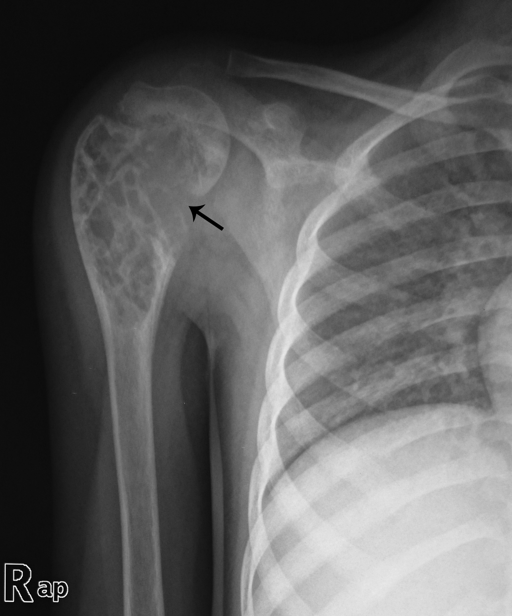
Figure 1 Anteroposterior radiograph of right shoulder showing multiseptated expansile lytic lesion with narrow zone of transition involving metaphysis of upper end of right humerus with cortical discontinuity on medial aspect (arrow). No specific matrix mineralization or periosteal reaction noted.

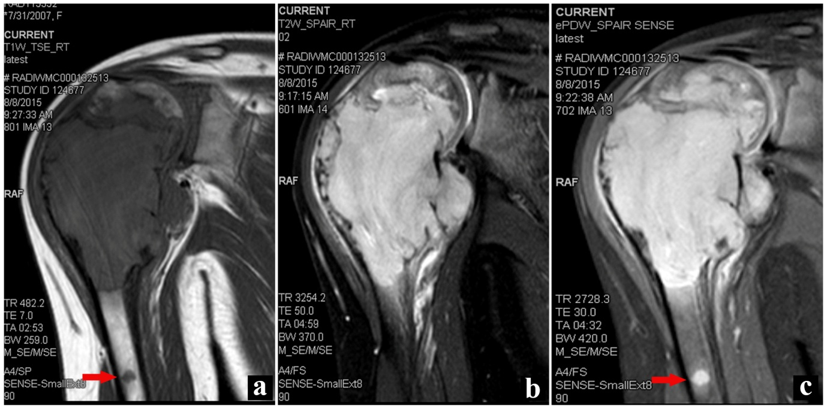
Figure 2 Oblique coronal TSE T1W (A), TSE T2WFS (B) and PDWFS (C) magnetic resonance imaging images of the right shoulder showing a solid expansile intramedullary mass replacing the normal marrow fat; hypointense on T1WI, hyperintense on T2WI. A cortical break in medial upper humeral diaphysis with extension into soft tissue noted. Note another skip lesion in the humeral shaft with similar signal characteristics (red arrow).

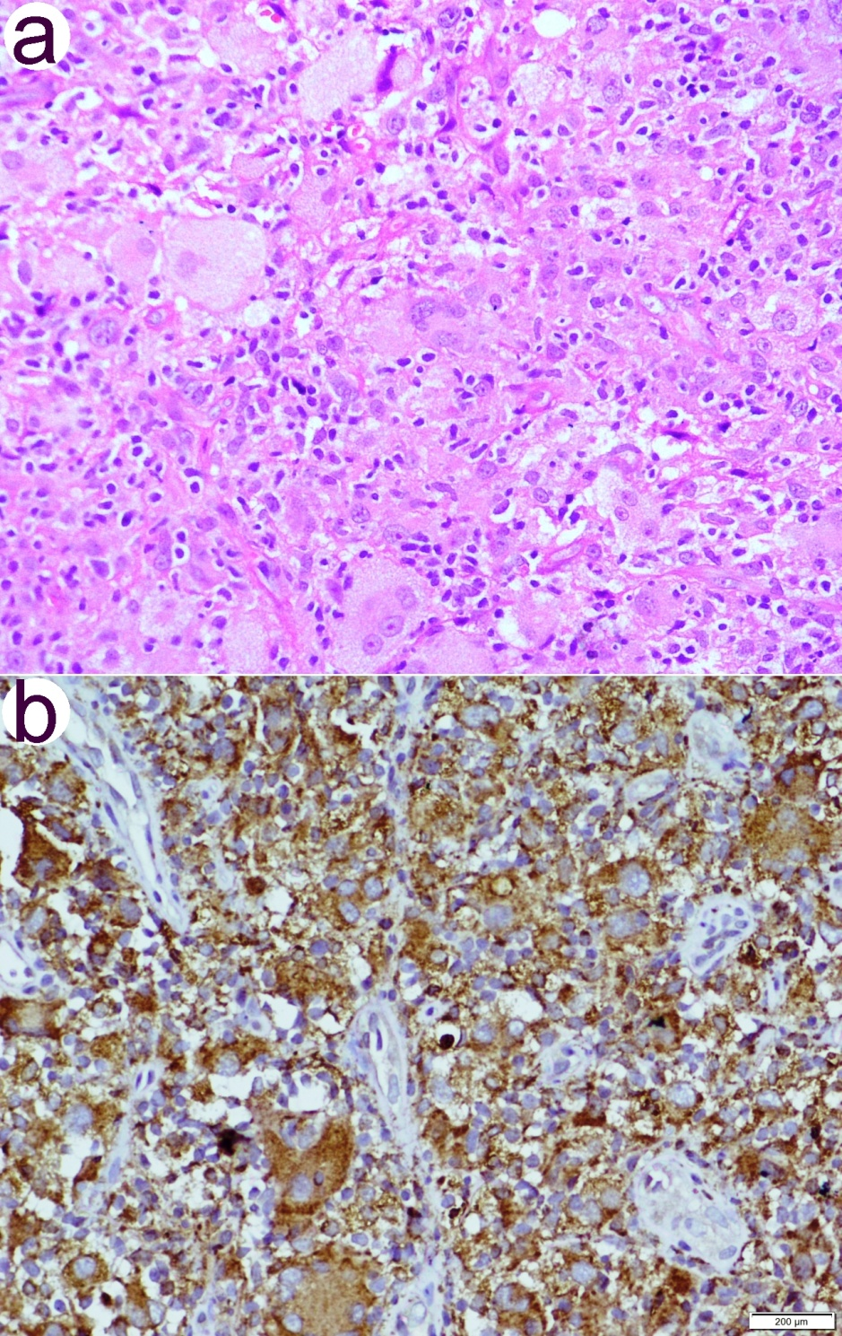
Figure 3 A biopsy from the lesion. A: Hematoxylin and eosin stained section showing an infiltrate comprised of foamy and lipid laden histiocytes, multinucleated giant cells, lymphocytes and fibroblastic cells (200 ×); B: Immunohistochemistry with CD68 showing positivity in histiocytic cells and giant cells (200 ×).

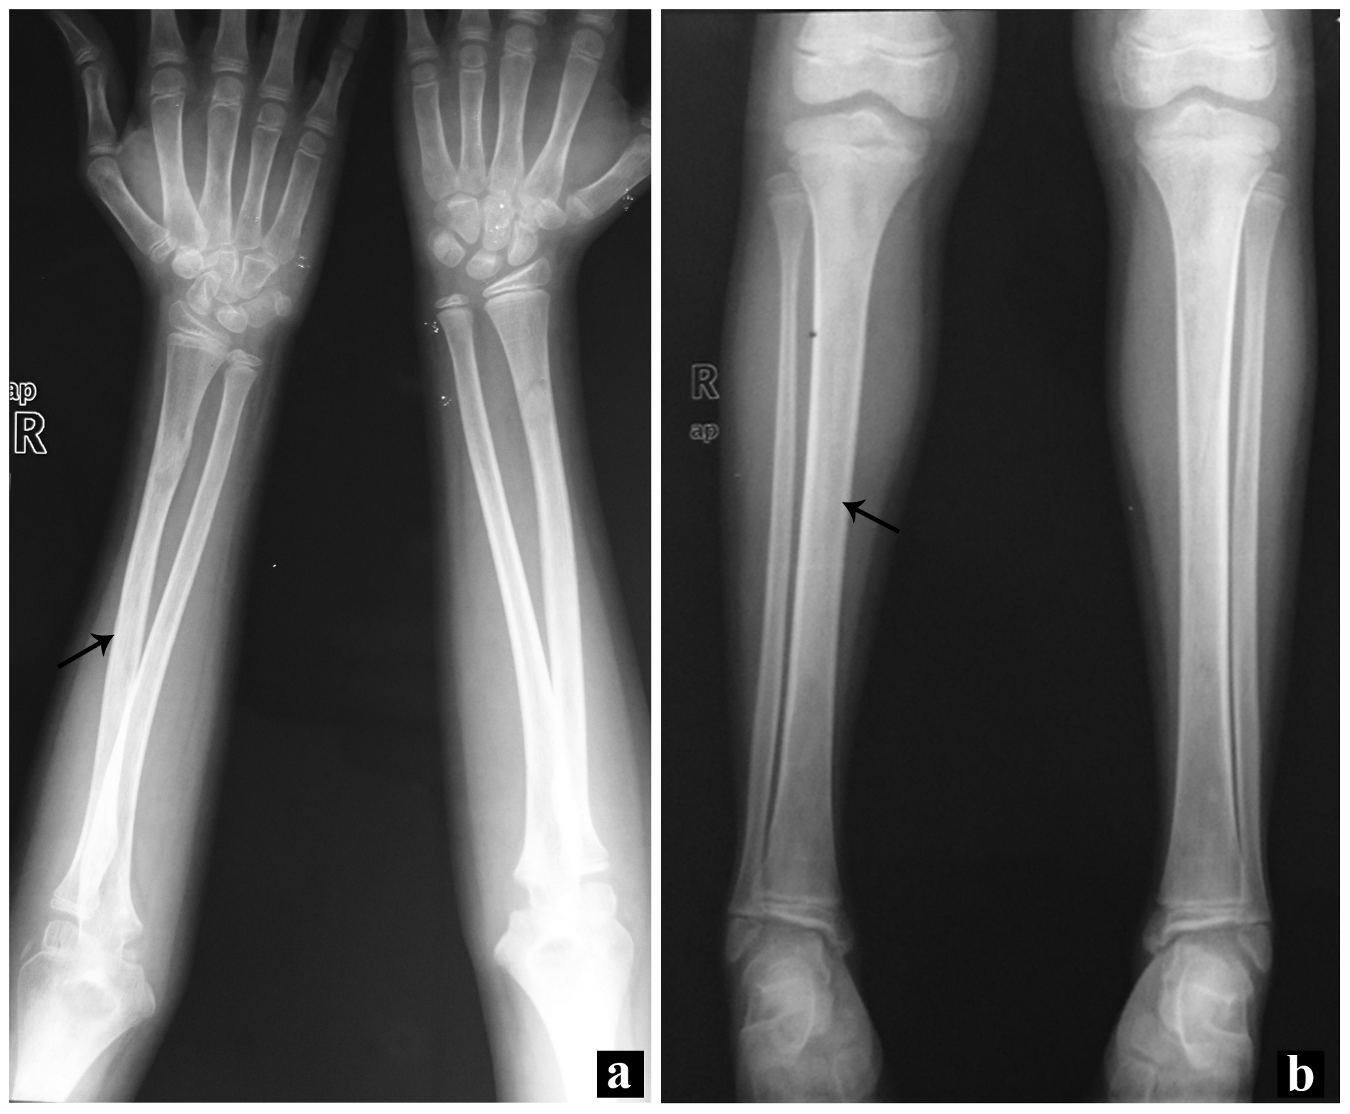
Figure 4 Anteroposterior radiographs of both forearms (A) and both legs (B) showing symmetric bilateral osteosclerosis of the metaphysis and diaphysis of the long bones (arrows).

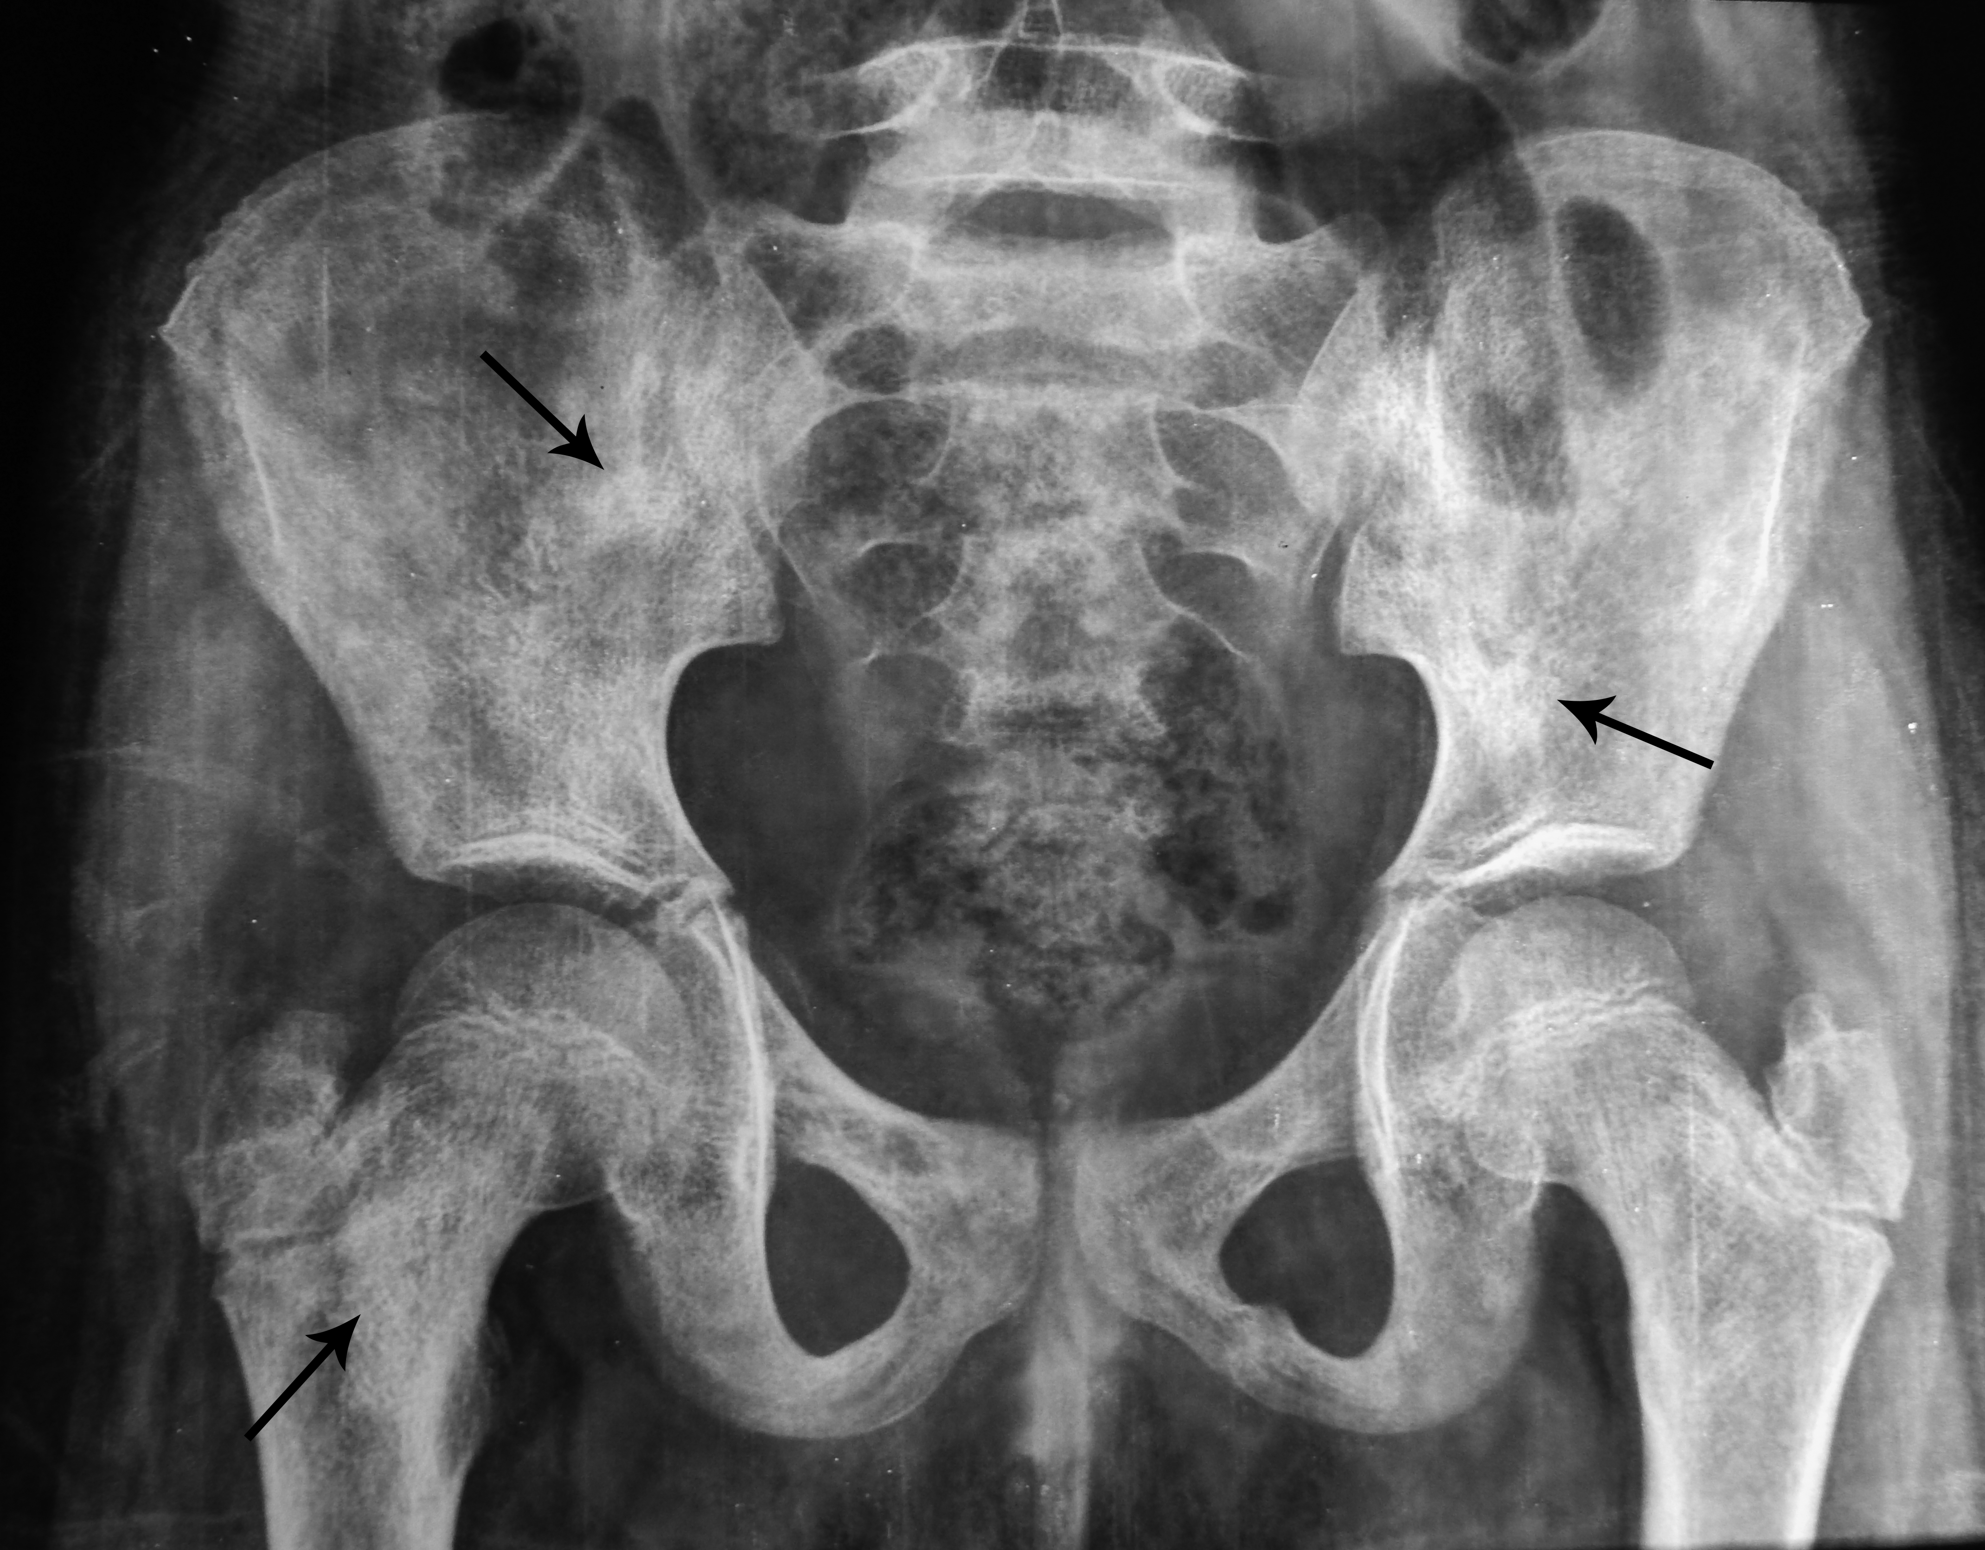
Figure 5 Anteroposterior radiograph of pelvis showing patchy osteosclerosis involving pelvic bones and proximal shafts of the femur (arrows).

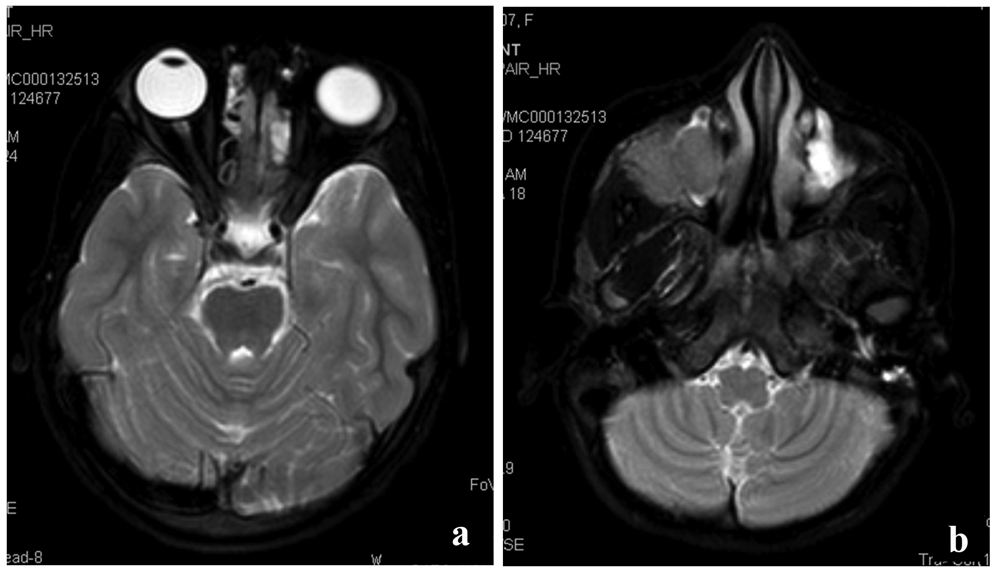
Figure 6 The whole body magnetic resonance imaging showed presence of bilateral ethmoid and maxillary sinusitis along with replacement of normal marrow by focal lesions involving maxilla. A: Axial TSE T2W fat suppressed image of normal orbits; B: T2WFS axial image of the face showing isointense soft tissue filling the right maxillary sinus with extension into the infratemporal fossa.

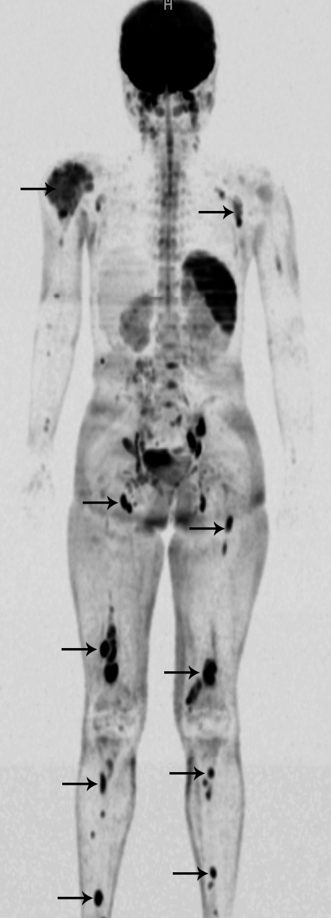
Figure 7 Whole body diffusion weighted imaging with background suppression imaging showing multiple skeletal lesions in right humerus, left scapula, bilateral femur and tibia (arrows).

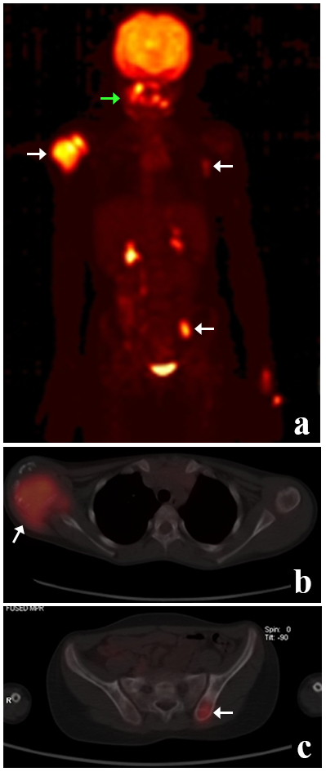

Figure 8 Positron emission tomography-computed tomography whole body maximum intensity projection image (A), axial fused images of chest (B) and pelvis (C) reveal areas of increased fluorodeoxyglucose uptake in right humeral head (arrow), the paranasal sinuses (green arrow), left thoracic wall (arrow) and left iliac bone (arrow). Note the physiological uptake and excretion in the kidneys and urinary bladder.

Table 1 Summary of Erdheim-Chester disease
Age | Middle aged and elderly patients predominantly affected
Site | Any tissue or organ can be affected and clinical manifestations depend upon the organ of involvement. Bone is most frequently affected (> 90%), however, at least one soft tissue component is seen in more than 50% of patients
Pathophysiology | Shows polyclonal proliferation of histiocytes associated with abnormal Th1 immune response. The recent studies however have suggested a clonal origin by demonstrating BRAFV600E mutations in more than 50% cases
Diagnostic criteria (Radiologic)  (Histopathologic) | Bilateral, symmetric cortical osteosclerosis of the diaphyseal and metaphyseal regions of the long bones;  Symmetric bilateral abnormally intense Tc labelling of the distal ends of the long bones;  Characteristic “coated aorta” or “hairy kidneys” on CT scan; Xanthogranulomatosis or polymorphic granuloma with foamy/lipid laden histiocytes with immunoreactivity to CD68, but negative for CD1a and Langerin
Treatment | IFN-α and pegylated IFN-α are preferred for the treatment;  Anakinra (recombinant IL1R antagonist) and infliximab (anti-TFN-α antibody) may be used for second-line treatment;  Vemurafenib (an inhibitor of BRAF) especially for the patients with severe and refractory BRAF^{V600E} histiocytoses
Follow-up (with PET-CT) | Useful for assessing extent of involvement both skeletal and extraskeletal components, activity and progression of disease, and monitoring of therapy
PET-CT: Positron emission tomography-computed tomography; Tc: ^{99m}Technetium; CT: Computed tomography; FDG: Fludeoxyglucose.

Table 2 Differential diagnoses of Erdheim-Chester disease
Radiologic differential diagnoses
With osteosclerotic lesions | Renal osteodystrophy, Pagets disease, myelofibrosis, osteoblastic metastases, chronic osteomyelitis, metabolic bone disorders
With osteolytic lesions in children | Langerhans cell histiocytosis, infection, metastatic neuroblastoma
Histologic
Langerhans cell histiocytosis | Positive for S100, CD1a, and Langerin
Rosai-Dorfman disease | Histiocytes show emperipolesis; positive for S100 and CD68; negative for CD1a, and Langerin
Juvenile xanthogranuloma | Lack characteristic radiologic features of ECD; positive for factor XIIIa, CD68, CD163, fascin, and CD14, negative for CD1a, S100, and Langerin
Solitary/ multicentric reticulohistiocytoma | Lack characteristic radiologic features of ECD; positive for factor XIIIa, CD68, CD163, fascin, and CD14; negative for CD1a, S100, and Langerin

