Name of Journal: World Journal of Gastroenterology
Manuscript NO: 40474
Manuscript Type: ORIGINAL ARTICLE

Observational Study
Fungal dysbiosis predicts the diagnosis of pediatric Crohn’s disease

El Mouzan MI et al. Fungal dysbiosis predicts CD

Mohammad I El Mouzan, Kirill S Korolev, Mohammad A Al Mofarreh, Rajita Menon, Harland S Winter, Ahmad A Al Sarkhy, Scot E Dowd, Ahmad M Al Barrag, Asaad A Assiri

Mohammad I El Mouzan, Ahmad A Al Sarkhy, Asaad A Assiri, Department of Pediatrics, King Saud University, Riyadh 11461, Saudi Arabia

Kirill S Korolev, Rajita Menon, Bioinformatics Program, Boston University, Boston, MA 02215, United States

Mohammad A Al Mofarreh, Al Mofarreh PolyClinic, Riyadh 11423, Saudi Arabia

Harland S Winter, MassGeneral Hospital for Children, Boston, MA 02114, United States

Scot E Dowd, MRDNA, Shallowater, TX 79363, United States

Ahmad M Al Barrag, Department of Microbiology, King Saud University, Riyadh 11461, Saudi Arabia

ORCID number: Mohammad I El Mouzan (0000-0001-8699-3143); Kirill S Korolev (0000-0003-1988-0645); Mohammad A Al Mofarreh (0000-0001-5426-9425); Rajita Menon (0000-0002-4767-0971); Harland S Winter (0000-0003-1122-4811); Ahmad A Al Sarkhy (0000-0002-1424-5784 ); Scot E Dowd (0000-0002-6296-1427); Ahmad M Al Barrag ( 0000-0002-8829-9371); Asaad A Assiri ( 0000-0003-3357-5794).

Author contributions: El Mouzan MI and Winter HS contributed to the concept and design of the study; Al Mofarreh MA, Al Sarkhy AA, Assiri AA and Al Barrag AM contributed to data acquisition and samples storage; Dowd SE performed DNA extraction and fungal sequencing; Korolev KS and Menon R performed Biostatistics and Bioinformatics; El Mouzan MI drafted the manuscript and all co-authors contributed to review, editing and approval of the final manuscript.

Institution review board statement: The manuscript is part of the study of the characteristics of inflammatory bowel disease in Saudi children approved by the IRB of the College of Medicine, King Saud University No:10/2647/IRB dated 29/6/2010.

Informed consent statement: Parents and/or children gave consent and/or assent to participate in the study before enrollment.

Conflict-of-interest statement: All authors declare no conflict of interest related to this study.

STROBE Statement: The authors have read the STROBE Statement—checklist of items, and the manuscript was prepared and revised according to the STROBE Statement – checklist items

Open-Access: This article is an open-access article which was selected by an in-house editor and fully peer-reviewed by external reviewers. It is distributed in accordance with the Creative Commons Attribution Non Commercial (CC BY-NC 4.0) license, which permits others to distribute, remix, adapt, build upon this work non-commercially, and license their derivative works on different terms, provided the original work is properly cited and the use is non-commercial. See: http://creativecommons.org/licenses/by-nc/4.0/

Manuscript source: Unsolicited manuscript

Correspondence to: Mohammad El Mouzan, MD, Professor and Consultant Pediatrician, Department of Pediatrics, Gastroenterology Unit, College of Medicine, King Saud University, Riyadh 11461, Saudi Arabia. drmouzan@gmail.com
Telephone: +966-555479281
Fax: +966-114679364

Received: June 29, 2018
Peer-review started: July 2, 2018
First decision: July 12, 2018
Revised: September 3, 2018
Accepted: October 5, 2018
Article in press:
Published online:

Abstract
AIM
To investigate the accuracy of fungal dysbiosis in mucosa and stool in predicting the diagnosis of Crohn’s disease (CD).

METHODS
The children were prospectively enrolled in two medical centers; one university hospital and one private gastroenterology clinic in the city of Riyadh, Kingdom of Saudi Arabia. The children with confirmed diagnosis of CD by standard guidelines were considered cases the others were considered non-IBD controls. Mucosal and stool samples were sequenced utilizing Illumina MiSeq chemistry following the manufacturer’s protocols, and abundance and diversity of fungal taxa in mucosa and stool were analyzed. Sparse logistic regression was used to predict the diagnosis of CD. The accuracy of the classifier was tested by computing the receiver operating characteristic curves with 5-fold stratified cross validation under 100 permutations of the training data partition and the mean area under the curve (AUC) was calculated.

RESULTS
All the children were Saudi nationals. There were 15 children with CD and 20 controls. The mean age was 13.9 (range 6.7-17.8) years for CD children and 13.9 (3.25–18.6) years for controls, and 10/15 (67%) of the CD and 13/20 (65%) of the control subjects were boys. CD locations at diagnosis were ileal (L1) in 4 and colonic (L3) in 11 children while CD behavior was non-stricturing and non-penetrating (B1) in 12 and stricturing (B2) in 3 children. The mean AUC for the fungal dysbiosis classifier was significantly higher in stools (AUC = 0.85 ± 0.057) than in mucosa (AUC = 0.71 ± 0.067) (P < 0.001). Most fungal species were significantly more depleted in stools than mucosal samples except for Saccharomyces cerevisiae and S. bayanus, which were significantly more abundant. Diversity was significantly more reduced in stools than in mucosa.

CONCLUSION
We find high AUC of fungal dysbiosis in fecal samples of children with CD, suggesting high accuracy in predicting the diagnosis of CD.

Key words: Fungiome; Mycobiome; Crohn’s disease; Inflammation; Saudi children

© The Author(s) 2018. Published by Baishideng Publishing Group Inc. All rights reserved.

Core tip: We find high accuracy of fungal dysbiosis in predicting the diagnosis of Crohn’s disease (CD), a finding similar to bacterial dysbiosis. However, the higher area under the curve for the fungal dysbiosis classifier in in stool (0.85 ± 0.057) than in mucosa (0.71 ± 0.067) (P < 0.001) contrasts with bacterial studies, suggesting higher accuracy of stool samples. Although the clinical application of this finding is limited at present by the high cost of fungal analysis, such information is important from a scientific viewpoint, to increase the understanding of the role of fungal flora in CD and to stimulate further studies.

El Mouzan MI, Korolev KS, Al Mofarreh MA, Menon R, Winter HS, Al Sarkhy AA, Dowd SE, Al Barrag AM, Assiri AA. Fungal dysbiosis predicts the diagnosis of pediatric Crohn’s disease. World J Gastroenterol 2018; In press

INTRODUCTION
Inflammatory bowel diseases (IBD) including Crohn’s disease (CD) and ulcerative colitis are chronic conditions. Their incidence is highest with an increasing trend in Western populations^{[1,2]}. However, their incidence is increasing in non-Western populations as well^{[3,4]}. The cause of CD remains unknown despite extensive research and a multifactorial etiology has been suggested. In genetically-susceptible individuals, environmental triggering factors play a major role and diet and microbiota are the most relevant causative factors for children^{[5]}. Dietary components may act directly or through alteration of gut microbiota to initiate and maintain inflammation in susceptible subjects^{[6,7]}. Significant fungal dysbiosis has been demonstrated in adults and children with CD^{[8-10]}. Recent reports found high accuracy of bacterial dysbiosis in predicting the diagnosis of IBD in general and CD in particular^{[11-13]}.
Despite the demonstration of fungal dysbiosis in adults and children with CD, there are no similar reports on the potential role of fungal dysbiosis in the diagnosis of CD. The objective of this report was, therefore, to evaluate the accuracy of fungal dysbiosis in stool and mucosal samples, for the diagnosis of CD in a cohort of non-Western children with new onset disease.

MATERIALS AND METHODS
Ethical considerations
This report is a portion of the main study project entitled “ characteristics of inflammatory bowel disease in Saudi children” . The study was reviewed and approved by the Institutional Review Board of the College of Medicine, King Saud University. Riyadh, Kingdom of Saudi Arabia. Approval number: 10/2647/IRB.

Study population, sample collection, storage, and processing
The children were prospectively enrolled in two medical centers; one university hospital and one private gastroenterology clinic in the same city of Riyadh, Kingdom of Saudi Arabia (KSA). The children were referred to these clinics for investigation of suspected IBD. The children with confirmed diagnosis of CD by standard guidelines ^{[14]}, were considered cases and those in whom the diagnosis of CD was excluded were considered non-IBD controls. The most common final diagnoses in non-IBD controls were functional abdominal pain and polyps. Mucosal and fecal samples were collected from 15 children with confirmed CD and 20 controls without inflammation or infection. A total of 78 samples (58 from CD children and 20 from non-IBD controls) were obtained. Stool samples were collected before bowel preparation, and none afterward. Mucosal forceps biopsies were taken from various parts of the colon and ileum. All samples were put into cryovials without preservatives and transported immediately in ice to the laboratory and stored at –80°C. At the end of the study, all samples were shipped by express mail in dry ice to MRDNA laboratories, Texas, United States for microbiome analysis.

Fungal DNA extraction and sequencing
Fungal DNA was extracted using the Mobio Powersoil kit as per the manufacturer’s instructions (MOBIO, Carlsbad, CA, United States). Amplicon sequencing service (bTEFAP®) was performed at MR DNA (Shallowater, TX, United States) and used for fungal analysis ^{[15]}. The internal transcribed spacer primers ITS1F CTTGGTCATTTAGAGGAAGTAA and ITS2R GCTGCGTTCTTCATCGATGC were used. A single-step 30-cycle polymerase chain reaction (PCR) with HotStarTaq Plus Master Mix Kit (Qiagen, Valencia, CA, United States) was employed. Samples were sequenced utilizing Illumina MiSeq chemistry following the manufacturer’s protocols.
The Q25 sequence data derived from the sequencing process was processed using the MR DNA ribosomal and functional gene analysis pipeline (www.mrdnalab.com , MR DNA, Shallowater, TX, United States). Sequences are depleted of barcodes and primers and short sequences < 150 bp are removed and sequences with ambiguous base calls removed. Operational taxonomic units were defined clustering at 3% divergence (97% similarity) followed by removal of singleton sequences and chimeras. Final OTUs were taxonomically classified using BLASTn top hit analysis against a curated database derived from RDPII and NCBI (www.ncbi.nlm.nih.gov, http://rdp.cme.msu.edu) and compiled into each taxonomic level into both “counts” and “percentage” files.

Statistical analysis
All analyses were performed using Python and scikit-learn^{[16]}. Custom functions implementing the permutation test were written to detect the taxa whose abundances are significantly different between CD and control samples. When more than one sample was available from the same patient for analysis, the log relative abundances from these samples were averaged.
It has been shown that variations in species abundance are better captured by a log-transform than a linear scale, improving the statistical power^{[13]}. Therefore, we followed this approach. In addition, rare taxa (< 1% abundance or absent from > 50% of the samples) were removed to improve the statistical power. Statistical significance was assessed via a permutation test (Fisher’s exact test), which yielded raw, uncorrected p-values. These were transformed into q-values (corrected p-value) that measure the probability of false discovery following the Benjamini Hochberg procedure ^{[17]}. We considered associations statistically significant only when the corrected p-values were less than 0.05.
A linear logistic regression classifier (linearmodel.LogisticRegression) in scikit-learn, Machine Learning in Python^{[16]}, was used to predict CD based on the subject’s microbiota. The accuracy of the classifier was tested by computing the receiver operating characteristic (ROC) curve with 5-fold stratified cross-validation under 100 permutations of the training data partition. We partitioned the data into randomly assigned training and test sets 100 times; in each case the classifier was trained on 4/5 of the data and tested on 1/5 of the data i.e., 5-fold cross-validation.
Alpha diversity, a measure of genera richness (number of genera), was evaluated using the Shannon index. We used Fisher’s t-test to determine P-values for alpha diversity.
The difference in community composition (Beta diversity) was quantified by the Bray-Curtis distance, which accounts for both patterns of presence-absence of taxa and changes in their relative abundances. Non-parametric multi-dimensional scaling (NMDS) was applied to visualize the distance between mucosa and stool samples taken from CD and control subjects. NMDS quantifies the dissimilarity in community composition between samples via a combination of presence-absence and absolute abundance of taxa. For the data shown, the separations were analyzed by the ANOSIM or analysis of (dis)similarity. The ANOSIM statistic compares the mean of ranked dissimilarities between groups to the mean of ranked dissimilarities within groups.
The statistics in this article was performed and reviewed by the coauthors Kirill S Korolev, PhD and Rajita Menon, PhD from the Bioinformatics Program, Boston University, Boston, MA 02215, United States.

RESULTS
Demographic data
All children were Saudi nationals. There were 15 CD children and 20 controls; mean age was 13.9 (range 6.7-17.8) years for CD children and 13.9 (3.25–18.6) years for controls, and 10/15 (67%) of the CD and 13/20 (65%) of the control subjects were boys. At diagnosis, CD locations were ileal (L1) in 4 and ileo-colonic (L3) in 11 children, while CD behavior was non-stricturing and non-penetrating (B1) in 12 and stricturing (B2) in 3 children. Controls included all patients with no evidence of IBD or other causes of inflammation. The final diagnoses in control subjects were juvenile polyps, recurrent abdominal pain, recurrent cyclic vomiting or other functional gastrointestinal disorders.

Fungal dysbiosis
In a previous report, description of fungal community structure in mucosa and stool in children with CD relative to controls indicated significantly-abundant CD-associated taxa included Psathyrellaceae (P = 0.01), Cortinariaceae (P = 0.04), Psathyrella (P = 0.003), and Gymnopilus (P = 0.03). Monilinia was significantly depleted (P = 0.03), whereas other depleted taxa, although not statistically significant, included Leotiomycetes (P = 0.06), Helotiales (P = 0.08), and Sclerotiniaceae (P = 0.07)^{[10]}.

Prediction analysis
The mean area under the ROC curve (AUC) for the fungal dysbiosis classifier is illustrated in figure 1, indicating a significantly-higher AUC in stools (0.85 ± 0.057) than in mucosa (0.71 ± 0.067) (P < 0.001).
This analysis was further expanded to demonstrate the difference in abundance and diversity between mucosa and stool in controls and children with CD separately. Table 1 shows a comparison of fungal abundance between mucosa and stools in controls, indicating that only two species, Volvariella dunensis (P = 0.03) and Lepraria humida (P = 0.04), were significantly less abundant in stool than in mucosal samples. In contrast, about 50 species were significantly less abundant in stools of children with CD (P < 0.05) and only two species, Saccharomyces cerevisiae (P = 0.02) and S. bayanus (P = 0.001), were significantly more abundant in stools than in mucosal samples (Table 2). Alpha diversity, as measured by the Shannon Index and illustrated in figure 2, was different in mucosa and stool. The stool community for children with CD was more than 5 times less diverse than that of mucosa (P = 0.0001), whereas in controls the reduction in stool diversity was statistically not significant (P = 0.35). Beta diversity as measured by the Bray-Curtis distance and visualized by the NMDS in figure 3, shows a significant difference in fungal community separation between mucosal and stool samples (P = 0.005).

DISCUSSION
Microbial dysbiosis in the form of depletion of beneficial organisms, expansion of harmful organisms, and reduced microbial diversity may occur independently or concurrently and result in significant effects on immune responses^{[18]}. Fungal dysbiosis demonstrated in Saudi children with CD is in line with previous studies^{[19,20]}.

Key findings
This is the first report on the accuracy of fungal dysbiosis in mucosa and stools in predicting the diagnosis of CD in children. The main finding in this study is the high AUC for the fungal dysbiosis classifier, suggesting high accuracy in predicting the diagnosis of CD, which is in line with the high AUC for bacterial dysbiosis^{[11-13]}. However, the higher AUC for the fungal dysbiosis classifier in in stool (0.85 ± 0.057) than in mucosa (0.71 ± 0.067) (P < 0.001) contrast with the higher AUC for bacterial dysbiosis in mucosal samples^{[12-13]}. Since this is the first report on fungal dysbiosis accuracy in predicting the diagnosis of CD, further studies are needed to clarify this result.
The finding of significant differences in a large number of species between stool and mucosa in CD children compared to much smaller numbers of species in controls reflects the degree of disturbance of the fungal community in children with CD. In this study, except for S. cerevisiae and S. bayanus, which were significantly more abundant in stool samples (P = 0.02 and P = 0.003, respectively), the significantly lower abundance of most fungal species in stool than in mucosal samples indicates variation in dysbiosis between stools and mucosa and support the variable accuracy in predicting the diagnosis of CD.
It has been suggested that the presence of some fungi in the gut may reflect environmental exposure rather than colonization of the mucosa^{[21]}. However, reports indicate that many fungi such as Candida, Cryptococcus, Malassezia, Saccharomyces and Trichosporon spp have been isolated from the stool of humans^{[22,23]}. Furthermore, the role of fungi in the pathogenesis of IBD has been suggested based on animal models of colitis. Pattern recognition receptors in the innate immune system cells include dectin-1, dectin-2, DC-SIGN, mannose receptor, and mannose receptor lecithin^{[24]}, and mice lacking dectin-1 had increased susceptibility to experimental colitis^{[25]}. In addition, treatment with antifungal drugs may reduce the inflammation^{[26]}.

Strength and weaknesses of this study
The strengths of this study comprise the fact that it is the first report on the subject and inclusion of newly-diagnosed, treatment naïve children with CD and controls from a well-defined population. Weaknesses include the relatively small number of cases which may be adequate for a first report. The controls were not completely healthy. Obviously, performing endoscopy and biopsies to exclude IBD in healthy children is unethical. Therefore, children who are free of IBD, infection and inflammation have been considered appropriate non-IBD controls.
In conclusion, the most important finding in this study is the high AUC in fecal samples of children with CD, suggesting high accuracy in predicting the diagnosis. Although, the clinical application of this finding is limited at present by the high cost of fungal analysis, such information is important from a scientific viewpoint, to increase the understanding of the role of fungal flora in CD and to stimulate further research, possibly leading to a “dysbiosis test” as a non-invasive screening tool for CD.

Article Highlights
Research background
Bacterial dysbiosis has been reported to predict the diagnosis of Crohn’s disease (CD), no similar reports for fungal dysbiosis. The study is of scientific significance to stimulate further research important for further clarification of the role of fungi in CD.

Research motivation
The role microbiota in CD, bacterial or fungal, is of worldwide research interest. However, a key problem to be solved is whether the dysbiosis the cause or the result of inflammation. Solving this problem may facilitate discovery of new microbiota -based treatment options. Regarding the accuracy of fungal dysbiosis in predicting the diagnosis, the main problem would be the current high cost of fungal analysis. Solving this problem could lead to development of a dysbiosis screaning test for Crohn disease.

Research objectives
The objective of this study was to evaluate the accuracy of intestinal fungal dysbiosis as predictor of CD. A high accuracy was found. Future research is needed to confirm this finding and to develop low cost fungal dysbiosis tests.

Research methods
Mucosal and stool samples were collected from children with Crohn’ disease at presentation and controls. Fungal DNA were extracted from theses samples and sequencing was performed. Fungal abundance and diversities were determined. Fungal dysbiosis in children with CD was demonstrated. This is the first study of the accuracy of fungal dysbiosis in predicting the diagnosis of CD in children.

Research results
The main finding was the high accuracy of fungal dysbiosis in predicting the diagnosis of CD. This should stimulate further research to confirm our findings and to develop a low cost dysbiosis test.

Research conclusions
The high accuracy of fungal dysbiosis in predicting the diagnosis of CD is a new finding. The finding could lead to further research in the role of fungal dysbiosis in CD. A new theory suggesting the possibility of design of a noninvasive fungal dysbiosis screening test for CD.

Research perspectives
The role of microbiota in CD may include development of a noninvasive screening test. Further research is needed to confirm the findings and to develop low cost fungal analysis.

REFERENCES
1 Kappelman MD, Moore KR, Allen JK, Cook SF. Recent trends in the prevalence of Crohn's disease and ulcerative colitis in a commercially insured US population. Dig Dis Sci 2013; 58: 519-525 [PMID: 22926499 DOI: 10.1007/s10620-012-2371-5]
2 Burisch J, Pedersen N, Čuković-Čavka S, Brinar M, Kaimakliotis I, Duricova D, Shonová O, Vind I, Avnstrøm S, Thorsgaard N, Andersen V, Krabbe S, Dahlerup JF, Salupere R, Nielsen KR, Olsen J, Manninen P, Collin P, Tsianos EV, Katsanos KH, Ladefoged K, Lakatos L, Björnsson E, Ragnarsson G, Bailey Y, Odes S, Schwartz D, Martinato M, Lupinacci G, Milla M, De Padova A, D'Incà R, Beltrami M, Kupcinskas L, Kiudelis G, Turcan S, Tighineanu O, Mihu I, Magro F, Barros LF, Goldis A, Lazar D, Belousova E, Nikulina I, Hernandez V, Martinez-Ares D, Almer S, Zhulina Y, Halfvarson J, Arebi N, Sebastian S, Lakatos PL, Langholz E, Munkholm P; EpiCom-group. East-West gradient in the incidence of inflammatory bowel disease in Europe: the ECCO-EpiCom inception cohort. Gut 2014; 63: 588-597 [PMID: 23604131]
3 Benchimol EI, Fortinsky KJ, Gozdyra P, Van den Heuvel M, Van Limbergen J, Griffiths AM. Epidemiology of pediatric inflammatory bowel disease: a systematic review of international trends. Inflamm Bowel Dis 2011; 17: 423-439 [PMID: 20564651 DOI: 10.1002/ibd.21349]
4 El Mouzan MI, Saadah O, Al-Saleem K, Al Edreesi M, Hasosah M, Alanazi A, Al Mofarreh M, Asery A, Al Qourain A, Nouli K, Al Hussaini A, Telmesani A, AlReheili K, Alghamdi S, Alrobiaa N, Alzaben A, Mehmadi A, Al Hebbi H, Al Sarkhy A, Al Mehaidib A, Al Saleem B, Assiri A, Wali S. Incidence of pediatric inflammatory bowel disease in Saudi Arabia: a multicenter national study. Inflamm Bowel Dis 2014; 20: 1085-1090 [PMID: 24788219 DOI: 10.1097/MIB.0000000000000048]
5 Leone V, Chang EB, Devkota S. Diet, microbes, and host genetics: the perfect storm in inflammatory bowel diseases. J Gastroenterol 2013; 48: 315-321 [PMID: 23475322 DOI: 10.1007/s00535-013-0777-2]
6 Chapman-Kiddell CA, Davies PS, Gillen L, Radford-Smith GL. Role of diet in the development of inflammatory bowel disease. Inflamm Bowel Dis 2010; 16: 137-151 [PMID: 19462428 DOI: 10.1002/ibd.20968]
7 Wu GD, Chen J, Hoffmann C, Bittinger K, Chen YY, Keilbaugh SA, Bewtra M, Knights D, Walters WA, Knight R, Sinha R, Gilroy E, Gupta K, Baldassano R, Nessel L, Li H, Bushman FD, Lewis JD. Linking long-term dietary patterns with gut microbial enterotypes. Science 2011; 334: 105-108 [PMID: 21885731 DOI: 10.1126/science.1208344]
8 Sokol H, Leducq V, Aschard H, Pham HP, Jegou S, Landman C, Cohen D, Liguori G, Bourrier A, Nion-Larmurier I, Cosnes J, Seksik P, Langella P, Skurnik D, Richard ML, Beaugerie L. Fungal microbiota dysbiosis in IBD. Gut 2017; 66: 1039-1048 [PMID: 26843508 DOI: 10.1136/gutjnl-2015-310746]
9 Liguori G, Lamas B, Richard ML, Brandi G, da Costa G, Hoffmann TW, Di Simone MP, Calabrese C, Poggioli G, Langella P, Campieri M, Sokol H. Fungal Dysbiosis in Mucosa-associated Microbiota of Crohn's Disease Patients. J Crohns Colitis 2016; 10: 296-305 [PMID: 26574491 DOI: 10.1093/ecco-jcc/jjv209]
10 El Mouzan M, Wang F, Al Mofarreh M, Menon R, Al Barrag A, Korolev KS, Al Sarkhy A, Al Asmi M, Hamed Y, Saeed A, Dowd SE, Assiri A, Winter H. Fungal Microbiota Profile in Newly Diagnosed Treatment-naïve Children with Crohn's Disease. J Crohns Colitis 2017; 11: 586-592 [PMID: 27811291 DOI: 10.1093/ecco-jcc/jjw197]
11 Papa E, Docktor M, Smillie C, Weber S, Preheim SP, Gevers D, Giannoukos G, Ciulla D, Tabbaa D, Ingram J, Schauer DB, Ward DV, Korzenik JR, Xavier RJ, Bousvaros A, Alm EJ. Non-invasive mapping of the gastrointestinal microbiota identifies children with inflammatory bowel disease. PLoS One 2012; 7: e39242 [PMID: 22768065 DOI: 10.1371/journal.pone.0039242]
12 Gevers D, Kugathasan S, Denson LA, Vázquez-Baeza Y, Van Treuren W, Ren B, Schwager E, Knights D, Song SJ, Yassour M, Morgan XC, Kostic AD, Luo C, González A, McDonald D, Haberman Y, Walters T, Baker S, Rosh J, Stephens M, Heyman M, Markowitz J, Baldassano R, Griffiths A, Sylvester F, Mack D, Kim S, Crandall W, Hyams J, Huttenhower C, Knight R, Xavier RJ. The treatment-naive microbiome in new-onset Crohn's disease. Cell Host Microbe 2014; 15: 382-392 [PMID: 24629344 DOI: 10.1016/j.chom.2014.02.005]
13 Wang F, Kaplan JL, Gold BD, Bhasin MK, Ward NL, Kellermayer R, Kirschner BS, Heyman MB, Dowd SE, Cox SB, Dogan H, Steven B, Ferry GD, Cohen SA, Baldassano RN, Moran CJ, Garnett EA, Drake L, Otu HH, Mirny LA, Libermann TA, Winter HS, Korolev KS. Detecting Microbial Dysbiosis Associated with Pediatric Crohn Disease Despite the High Variability of the Gut Microbiota. Cell Rep 2016; 14: 945-955 [PMID: 26804920 DOI: 10.1016/j.celrep.2015.12.088]
14 Levine A, Koletzko S, Turner D, Escher JC, Cucchiara S, de Ridder L, Kolho KL, Veres G, Russell RK, Paerregaard A, Buderus S, Greer ML, Dias JA, Veereman-Wauters G, Lionetti P, Sladek M, Martin de Carpi J, Staiano A, Ruemmele FM, Wilson DC; European Society of Pediatric Gastroenterology, Hepatology, and Nutrition. ESPGHAN revised porto criteria for the diagnosis of inflammatory bowel disease in children and adolescents. J Pediatr Gastroenterol Nutr 2014; 58: 795-806 [PMID: 24231644 DOI: 10.1097/MPG.0000000000000239]
15 Dowd SE, Callaway TR, Wolcott RD, Sun Y, McKeehan T, Hagevoort RG, Edrington TS. Evaluation of the bacterial diversity in the feces of cattle using 16S rDNA bacterial tag-encoded FLX amplicon pyrosequencing (bTEFAP). BMC Microbiol 2008; 8: 125 [PMID: 18652685 DOI: 10.1186/1471-2180-8-125]
16 Pedregosa F, Varoquaux G, Gramfort A, Michel V, Thirion B. Scikit-learn: Machine Learning in Python. J Mach Learn Res 2011; 12: 2825-2830
17 Benjamini Y, Hochberg Y. Controlling the False Discovery Rate: A Practical and Powerful Approach to Multiple Testing. J Roy Stat Soc B 1995; 57: 289-300
18 Petersen C, Round JL. Defining dysbiosis and its influence on host immunity and disease. Cell Microbiol 2014; 16: 1024-1033 [PMID: 24798552 DOI: 10.1111/cmi.12308]
19 Mukhopadhya I, Hansen R, Meharg C, Thomson JM, Russell RK, Berry SH, El-Omar EM, Hold GL. The fungal microbiota of de-novo paediatric inflammatory bowel disease. Microbes Infect 2015; 17: 304-310 [PMID: 25522934 DOI: 10.1016/j.micinf.2014.12.001]
20 Chehoud C, Albenberg LG, Judge C, Hoffmann C, Grunberg S, Bittinger K, Baldassano RN, Lewis JD, Bushman FD, Wu GD. Fungal Signature in the Gut Microbiota of Pediatric Patients With Inflammatory Bowel Disease. Inflamm Bowel Dis 2015; 21: 1948-1956 [PMID: 26083617 DOI: 10.1097/MIB.0000000000000454]
21 Suhr MJ, Hallen-Adams HE. The human gut mycobiome: pitfalls and potentials--a mycologist's perspective. Mycologia 2015; 107: 1057-1073 [PMID: 26354806 DOI: 10.3852/15-147]
22 Hallen-Adams HE, Kachman SD, Kim J, Legg RM, Martinez I. Fungi inhabiting the healthy human gastrointestinal tract: A diverse and dynamic community. Fungal Ecol 2015; 15: 9-17 [DOI: 10.1016/j.funeco.2015.01.006]
23 Nash AK, Auchtung TA, Wong MC, Smith DP, Gesell JR, Ross MC, Stewart CJ, Metcalf GA, Muzny DM, Gibbs RA, Ajami NJ, Petrosino JF. The gut mycobiome of the Human Microbiome Project healthy cohort. Microbiome 2017; 5: 153 [PMID: 29178920 DOI: 10.1186/s40168-017-0373-4]
24 Wang ZK, Yang YS, Stefka AT, Sun G, Peng LH. Review article: fungal microbiota and digestive diseases. Aliment Pharmacol Ther 2014; 39: 751-766 [PMID: 24612332 DOI: 10.1111/apt.12665]
25 Iliev ID, Funari VA, Taylor KD, Nguyen Q, Reyes CN, Strom SP, Brown J, Becker CA, Fleshner PR, Dubinsky M, Rotter JI, Wang HL, McGovern DP, Brown GD, Underhill DM. Interactions between commensal fungi and the C-type lectin receptor Dectin-1 influence colitis. Science 2012; 336: 1314-1317 [PMID: 22674328 DOI: 10.1126/science.1221789]
26 Zwolinska-Wcislo M, Brzozowski T, Budak A, Kwiecien S, Sliwowski Z, Drozdowicz D, Trojanowska D, Rudnicka-Sosin L, Mach T, Konturek SJ, Pawlik WW. Effect of Candida colonization on human ulcerative colitis and the healing of inflammatory changes of the colon in the experimental model of colitis ulcerosa. J Physiol Pharmacol 2009; 60: 107-118 [PMID: 19439813]
P-Reviewer: Day AS, Gazouli M S-Editor: Gong ZM
L-Editor: E-Editor:
Specialty type: Gastroenterology and hepatology
Country of origin: Saudi Arabia
Peer-review report classification
Grade A (Excellent): A, A
Grade B (Very good): 0
Grade C (Good): 0
Grade D (Fair): 0
Grade E (Poor): 0

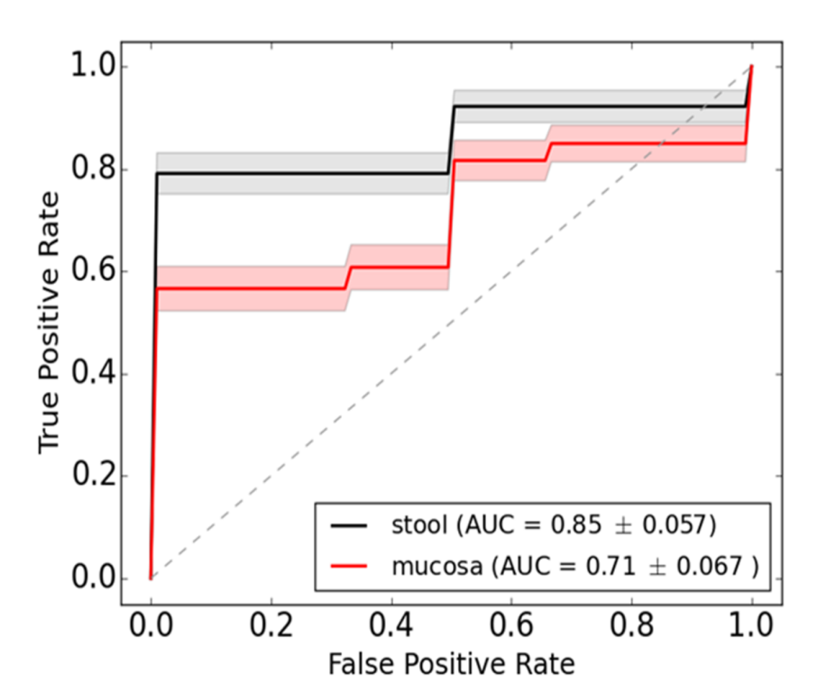
Figure 1 Dysbiosis score classification curve to distinguish between children with Crohn’s disease and controls. The receiver operating characteristic (ROC) curve for the logistic regression dysbiosis classifier. The mean ROC curve for stool (solid black line) and mucosal (solid red line) dysbiosis scores in fungi cohorts is shown. The standard deviation from 100 permutations is shown in gray and light red shading. The AUC for stool dysbiosis is significantly higher than in mucosal dysbiosis, using a Fisher t-test computed p < 0.001.

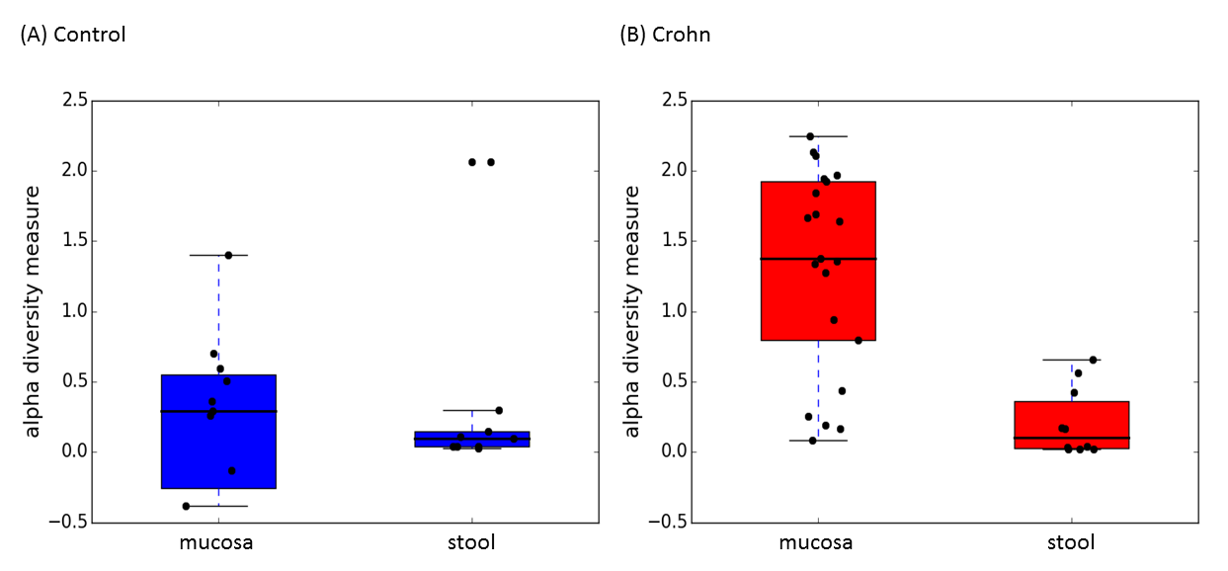
Figure 2 Alpha diversity evaluated by Shannon Index. Comparison between mucosa and stool in children with Crohn’s disease (CD) and controls. Alpha diversity is significantly lower in stool than in mucosa in CD samples (P = 0.0001), while the difference is not significant in control samples (P = 0.35).

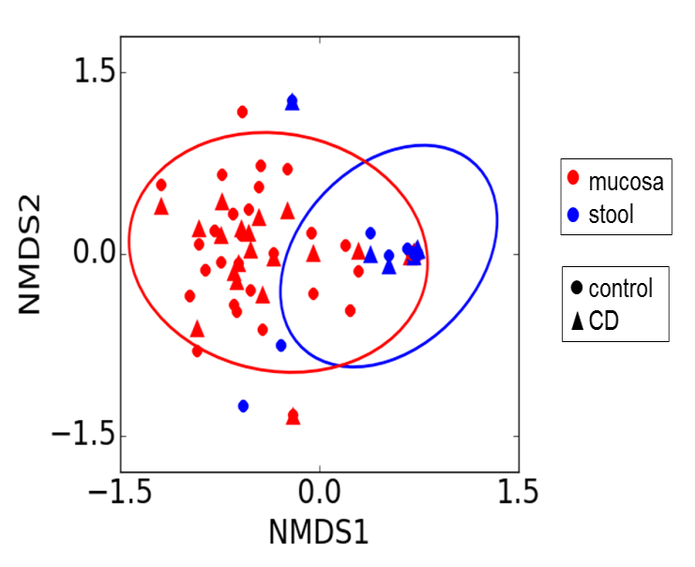
Figure 3 Beta diversity evaluated by Bray-Curtis distance and illustrated by the NMDS plot based on. This is a measure of beta diversity, and quantifies the similarity in abundance of taxa between samples. The ovals contain 95% of the probabilities for mucosa and stool. This plot shows a clear separation of mucosa and stool samples (P = 0.005).

Table 1 Fungal species abundance in mucosa and stool of controls
Fungal species | Abundance mucosa, % | Abundance stool, % | Ratio | P value
Volvariella dunensis | 0.027 | 0.0013 | 0.047 | 0.036
Lepraria humida | 0.015 | 0.0010 | 0.063 | 0.042

Table 2 Fungal species abundance in mucosa and stool of children with Crohn’s disease
Fungal species | Abundance mucosa, % | Abundance stool, % | Ratio | P value
Volvariella dunensis | 0.06 | 0.0014 | 0.025 | <0.001
Malassezia restricta | 0.09 | 0.0044 | 0.049 | < 0.001
Ceriporia lacerate | 0.03 | 0.0022 | 0.065 | < 0.001
Cl. Cladosporioides | 0.11 | 0.004 | 0.035 | < 0.001
Trametes hirsute | 0.048 | 0.0043 | 0.089 | < 0.001
Psathyrella artemisiae | 0.44 | 0.028 | 0.065 | < 0.001
Amyloporia sp. | 0.027 | 0.0012 | 0.046 | < 0.001
Irpex sp. | 0.095 | 0.0019 | 0.02 | < 0.001
Bjerkandera adusta | 0.022 | 0.0011 | 0.049 | < 0.001
Lepista sordida | 0.041 | 0.0015 | 0.037 | < 0.001
Cerrena sp. | 0.022 | 0.0011 | 0.05 | < 0.001
Coprinellus radians | 0.034 | 0.0011 | 0.032 | < 0.001
Phlebia acanthocystis | 0.022 | 0.0011 | 0.048 | < 0.001
Leptosphaerulina sp. | 0.037 | 0.0013 | 0.036 | < 0.001
Coprinus sp. | 0.085 | 0.0019 | 0.022 | < 0.001
Malassezia globose | 0.028 | 0.0026 | 0.095 | < 0.001
Alternaria alternate | 0.054 | 0.0037 | 0.069 | < 0.001
Ramalinopsis mannii | 0.066 | 0.0018 | 0.027 | < 0.001
Saccharomyces bayanus | 2.5 | 53 | 21 | < 0.001
Trichoderma hypocrea | 0.022 | 0.0014 | 0.067 | < 0.001
Aspergillus penicillioides | 0.11 | 0.0066 | 0.062 | < 0.001
Psathyrella candolleana | 0.063 | 0.0059 | 0.093 | < 0.001
Cladosporium sp. | 0.072 | 0.0053 | 0.074 | < 0.001
Aspergillus sp. | 0.064 | 0.0049 | 0.076 | < 0.001
Galactomyces geotrichum | 0.079 | 0.0063 | 0.08 | < 0.001
Peniophora incarnate | 0.011 | 0.0027 | 0.25 | < 0.001
Eutypella sp. | 0.038 | 0.0044 | 0.12 | < 0.001
Ophiocordyceps sinensis | 0.059 | 0.004 | 0.068 | < 0.001
Nakaseomyces candida | 0.12 | 0.0058 | 0.049 | 0.019
Hypocrea ceramic | 0.02 | 0.0037 | 0.18 | 0.019
Saccharomyces cerevisiae | 0.043 | 0.23 | 5.3 | 0.024

