Name of Journal: World Journal of Diabetes
Manuscript NO: 83989
Manuscript Type: ORIGINAL ARTICLE

Basic Study
Alteration of intestinal microbiota is associated with diabetic retinopathy and its severity: Samples collected from southeast coast Chinese

Gu XM et al. Intestinal microbiota prompt diabetic retinopathy

Xue-Mei Gu, Chao-Yin Lu, Jian Pan, Jian-Zhong Ye, Qi-Han Zhu

Xue-Mei Gu, Qi-Han Zhu, Department of Endocrinology, The First Affiliated Hospital of Wenzhou Medical University, Wenzhou 325000, Zhejiang Province, China

Xue-Mei Gu, Qi-Han Zhu, Wenzhou Key Laboratory of Diabetes Research, The First Affiliated Hospital of Wenzhou Medical University, Wenzhou 325000, Zhejiang Province, China

Chao-Yin Lu, Department of Endocrinology, Taizhou Central Hospital (Taizhou University Hospital), Taizhou 318000, Zhejiang Province, China

Jian Pan, Department of Ophthalmology, The First Affiliated Hospital of Wenzhou Medical University, Wenzhou 325000, Zhejiang Province, China

Jian-Zhong Ye, Department of Clinical Laboratory, The First Affiliated Hospital of Wenzhou Medical University, Wenzhou 325000, Zhejiang Province, China

Author contributions: Gu XM and Lu CY have contributed equally to this work and share first authorship; Gu XM performed data analysis and co-wrote the first draft of the manuscript; Lu CY performed data analysis, specimen collection, and co-wrote the first draft of the manuscript; Pan J performed specimen collection and data collection; Ye JZ performed data analysis, experimental design, co-chief investigator of the study, and co-guarantor of this work; Zhu QH performed data analysis, experimental design, essay modification, co-chief investigator of the study, and co-guarantor of this work; all authors have provided substantial intellectual input and approved the final version for publication.

Supported by Wenzhou Science and Technology Bureau, No. Y20190129 and No. Y2020263.

Corresponding author: Qi-Han Zhu, MM, Attending Doctor, Department of Endocrinology, The First Affiliated Hospital of Wenzhou Medical University, The South of Shangcai Village, Nanbaixiang Town, Ouhai District, Wenzhou 325000, Zhejiang Province, China. dr_zhuqihan@163.com

Received: March 9, 2023
Revised: April 9, 2023
Accepted: April 27, 2023
Published online: June 15, 2023

Abstract
BACKGROUND
Current approaches for the therapy of diabetic retinopathy (DR), which was one of leading causes of visual impairment, have their limitations. Animal experiments revealed that restructuring of intestinal microbiota can prevent retinopathy.

AIM
To explore the relationship between intestinal microbiota and DR among patients in the southeast coast of China, and provide clues for novel ways to prevention and treatment methods of DR.

METHODS
The fecal samples of non-diabetics (Group C, n = 15) and diabetics (Group DM, n = 30), including 15 samples with DR (Group DR) and 15 samples without DR (Group D), were analyzed by 16S rRNA sequencing. Intestinal microbiota compositions were compared between Group C and Group DM, Group DR and Group D, as well as patients with proliferative diabetic retinopathy (PDR) (Group PDR, n = 8) and patients without PDR (Group NPDR, n = 7). Spearman correlation analyses were performed to explore the associations between intestinal microbiota and clinical indicators.

RESULTS
The alpha and beta diversity did not differ significantly between Group DR and Group D as well as Group PDR and Group NPDR. At the family level, Fusobacteriaceae, Desulfovibrionaceae and Pseudomonadaceae were significantly increased in Group DR than in Group D (P < 0.05, respectively). At the genera level, Fusobacterium, Pseudomonas, and Adlercreutzia were increased in Group DR than Group D while Senegalimassilia was decreased (P < 0.05, respectively). Pseudomonas was negatively correlated with NK cell count (r = -0.39, P = 0.03). Further, the abundance of genera Eubacterium (P < 0.01), Peptococcus, Desulfovibrio, Acetanaerobacterium and Negativibacillus (P < 0.05, respectively) were higher in Group PDR compared to Group NPDR, while Pseudomonas, Alloprevotella and Tyzzerella (P < 0.05, respectively) were lower. Acetanaerobacterium and Desulfovibrio were positively correlated with fasting insulin (r = 0.53 and 0.61, respectively, P < 0.05), when Negativibacillus was negatively correlated with B cell count (r = −0.67, P < 0.01).

CONCLUSION
Our findings indicated that the alteration of gut microbiota was associated with DR and its severity among patients in the southeast coast of China, probably by multiple mechanisms such as producing short-chain fatty acids, influencing permeability of blood vessels, affecting levels of vascular cell adhesion molecule-1, hypoxia-inducible factor-1, B cell and insulin. Modulating gut microbiota composition might be a novel strategy for prevention of DR, particularly PDR in population above.

Key Words: Intestinal microbiota; Diabetic retinopathy; Occurrence; Progression; Southeast coast of China

©The Author(s) 2023. Published by Baishideng Publishing Group Inc. All rights reserved.

Citation: Gu XM, Lu CY, Pan J, Ye JZ, Zhu QH. Alteration of intestinal microbiota is associated with diabetic retinopathy and its severity: Samples collected from southeast coast Chinese. World J Diabetes 2023; 14(6): 862-882
URL: https://www.wjgnet.com/1948-9358/full/v14/i6/862.htm
DOI: https://dx.doi.org/10.4239/wjd.v14.i6.862

Core Tip: Current approaches for the therapy of diabetic retinopathy (DR) have their limitations. Our study revealed that alteration of gut microbiota was associated with DR and its progression, and further, this association was mediated by multiple mechanisms including producing short-chain fatty acids, influencing permeability of blood vessels, affecting levels of vascular cell adhesion molecule-1, hypoxia-inducible factor-1, B cell and insulin. Hence, reconstruction of gut microbiota might be a promising strategy for prevention of DR.

INTRODUCTION
For the moment, diabetes is one of the fastest developing and worldwide metabolic diseases, with multiple complications such as diabetic retinopathy (DR). Global pool analysis of DR in 2010 revealed the proportion of DR, and vision-threatening DR in diabetics was 34.6%, 10.2% respectively^{[1]}. DR will cause visual impairment and even blindness in adults aged 20 to 74 years old, and is considered as one of the primary causes^{[2]}. DR is subdivided into non-proliferative diabetic retinopathy (NPDR) and proliferative diabetic retinopathy (PDR). PDR is less common in patients but more threatening to vision compared with NPDR^{[3]}. The treatment of PDR and visually threatening diabetic macular edema (DME) is a main research topic on DR. Laser therapy, anti-angiogenic therapy, anti-inflammatory therapy and surgery are major treatments for PDR. Laser therapy is a classic tool for severe NPDR and PDR, aiming to preserve visual acuity^{[4]}. However, laser would impair the central vision and night vision^{[5]}. As a main anti-angiogenic therapy, anti-vascular endothelial growth factor (VEGF) is a recommended therapy of DR refractory to laser treatment and DME. Contrast to laser monotherapy, anti-VEGF therapy can improve visual acuity in inpatients with DME or PDR^{[6,7]}. However, considering limited half-life time of anti-VEGF agents, the repetitive injections of anti-VEGF are required at one or two months intervals, causing increased financial burden, increased occurrence of endophthalmitis and elevated intraocular pressure^{[8]}. Besides, the long-term therapy of anti-VEGF would reduce patient compliance, increase the incidence of treatment interruption, and result in deterioration finally^{[9]}. Almost nearly 50% patients are insensitive or even non-responsive to anti-VEGF therapy, but new approved anti-angiogenic therapies as well as effective and evidence-based replacement treatments are absent^{[10,11]}. Although glucocorticoids can be used in patients who failed to respond to anti-VEGF, the role in treating PDR still need further confirmation and the side effect of elevating blood glucose constrains its application in diabetics^{[9]}. Other treatments including anti-protein kinase C, angiotensin receptor blockers, fenofibrate have their own flaws^{[12-16]}.
Chronic low-grade inflammations are already recognized as pivotal players in the development of diabetes and its complications including DR. Besides the anti-inflammatory effect via generating short chain fatty acid such as butyrate^{[17]}, intestinal microbiota also plays a pro-inflammatory role by increasing intestinal permeability, releasing lipopolysaccharide (LPS) which was relevant with distant inflammatory response and impacted cytokines such as TNF-α and IL-6^{[18,19]}. The roles of microbiota on inflammation may explain its possible contribution on occurrence and development of DR. An animal experiments showed that intermittent fasting can prevent the occurrence of DR^{[10]}. Only four studies aiming at the relationship between human intestinal microbiota and DR have been found^{[20-23]}. Jayasudha et al^{[21]} performed Illumina sequencing of the internal transcribed spacer 2 region which mainly detects fungus. Three other studies performed 16S rRNA sequencing to distinguish the microbiota between diabetics with DR and without DR^{[20,22,23]}. Moubayed et al^{[20]} only analyzed fecal genus Bacteroides among healthy volunteers, diabetic patients with DR and without DR, lack of analysis of the other microbial community types. As for the other two studiers, one of their limits was that diabetics enrolled are always treated with metformin^{[22,23]}. Metformin can reduce the severity of DR and incidence of NPDR independently and the mechanisms might be anti-angiogenesis and anti-inflammation^{[24-27]}. Notwithstanding no studies have demonstrated that intestinal microbiota involves in the effect of metformin on DR, metformin should also be considered as a confounding factor which may affect the accuracy of the conclusion about relationship between intestinal microbiota and DR stated by Huang et al^{[22]}. Moreover, the effect of metformin on different microbiota were inconsistent in type 2 diabetes mellitus (T2DM) patients, which possibly be impacted by duration of diabetes, gender and race^{[28]}. Thus, metformin taken by whole T2DM subjects still probably complicate the analysis of gut microbiota^{[24]}. The abundance of intestinal microbiota was obviously affected by diet and geographic proximity^{[29,30]}. Different intestinal microbiota may be relevant to same diseases among different persons from different areas and with different dietary habits. Our study is focus on exploring the differential bacteria between diabetic patients with DR and without DR, as well as diabetic patients with PDR and NPDR in south Zhejiang and north Fujian in China, aiming to unravel the link between intestinal microflora and DR, and find a new therapeutic target for DR, especially PDR.

MATERIALS AND METHODS
Study population and sample collection
For this study, 45 samples were obtained from patients who are hospitalized in the department of endocrinology in the 1st Affiliated Hospital of Wenzhou medical university from August, 2018 to September, 2020. Patients were divided into non-diabetics (Group C, n = 15) and T2DM patients (Group DM, n = 30), which was further divided into patients with DR (Group DR, n = 15) and patients without DR (Group D, n = 15). Further, Group DR was divided into patients with PDR (Group PDR, n = 8) and patients without PDR (Group NPDR, n = 7). The enrolled patients are aged between 30-80 years old without conditions as pregnant, lactation, current smoker, current drinker, BMI ≥ 27, prescribed for metformin, alpha glycosidase inhibitor, antibiotics, probiotics, glucocorticoids, cathartics or PPI within 3 mo, rheumatoid arthritis, inflammatory bowel disease, or gastrointestinal tract operation. After admitted into our department, demographic, medical history, physical examination data were collected and several biochemical tests were performed. Participants self-collected a fecal sample, which were collected by patients, and stored at -80 ℃ later in less than 24 h. This study was approved by the Ethics Committee of the 1st Affiliated Hospital of Wenzhou medical university. All participants gave their informed consent. The trial register number is 2018-129.

DNA extraction and amplification
Fecal samples were snap frozen and stored at -80 ℃ after collection. Bacterial DNA was isolated from the fecal samples using MagPure Soil DNA LQ Kit (Magen, United States) following the manufacturer’s instructions. DNA concentration and integrity were measured by Nano Drop 2000 spectrophotometer (Thermo Fisher Scientific, Waltham, MA, United States) and agarose gel electrophoresis, respectively. Polymerase chain reaction (PCR) amplification of the V3-V4 hypervariable regions of the bacterial 16S rRNA gene was carried out in a 25 μL reaction using universal primer pairs (343F: 5′-TACGGRAGGCAGCAG-3′; 798R: 5′-AGGGTATCTAATCCT-3′). The reverse primer contained a sample barcode and both primers were connected with an Illumina sequencing adapter.

Library construction and sequencing
The amplicon quality was visualized using gel electrophoresis. The PCR products were purified with Agencourt AMPure XP beads (Beckman Coulter Co., United States) and quantified using Qubit dsDNA assay kit. The concentrations were then adjusted for sequencing. 16S rDNA sequencing were performed using Illumina MiSeq platform at Shanghai OE Biotech Co., Ltd.

Bioinformatic analysis
Paired-end reads were preprocessed using Trimmomatic software to detect and cut off ambiguous bases(N)^{[31]}. It also cut off low quality sequences with average quality score below 20 using sliding window trimming approach. After trimming, paired-end reads were assembled using FLASH software^{[32]}. Parameters of assembly were: 10 bp of minimal overlapping, 200 bp of maximum overlapping and 20% of maximum mismatch rate. Sequences were performed further denoising as follows: Reads with ambiguous, homologous sequences or below 200 bp were abandoned. Reads with 75% of bases above Q20 were retained using QIIME software (version 1.8.0)^{[33]}. Then, reads with chimera were detected and removed using VSEARCH^{[34]}. Clean reads were subjected to primer sequences removal and clustering to generate operational taxonomic units (OTUs) using VSEARCH software with 97% similarity cutoff^{[34]}. The representative read of each OTU was selected using QIIME package. All representative reads were annotated and blasted against Silva database (Version 123) using Ribosomal Database Project classifier (confidence threshold was 70%)^{[35]}. The microbial diversity in fecal samples was estimated using the alpha diversity that include Chao1 index, Shannon index and Simpson index. The Unifrac distance matrix performed by QIIME software was used for weighted Unifrac principal coordinates analysis (PCoA) construction. The 16S rRNA gene amplicon sequencing and analysis were conducted by OE Biotech Co., Ltd. (Shanghai, China).

Statistical analysis
Data with normal distribution and homogeneity of variance were compared using independant samples t test, otherwise, were compared using Wilcoxon test. Comparisons between groups were performed with the clinical characteristics. For associations between clinical characteristics and gut microbial, Spearman correlation analysis were performed using R version 3.6.1. Correction for multiple testing was performed using false discovery rate with the Benjamini–Hochberg. False discovery rate values < 0.05 were considered statistically significant.

RESULTS
Clinical and biochemical characteristics
The clinical and biochemical characteristics were compared between Group DM and C as well as Group D and DR, Group PDR and NPDR (Tables 1 and 2). The age, sex proportion and BMI did not differ between the three pairs mentioned above. Further, the other indexes were comparable between Group DM and C except for fasting blood glucose, glycated hemoglobin A1c (Tables 1 and 2). Compared to Group D, neutrophil to lymphocyte ratio, CD4⁺ T cell count were significantly increased in Group DR (P < 0.05, P < 0.05), whereas, B cell count, CD8⁺ T cell count, NK cell count, percentage of NK cell were decreased (P < 0.01, P < 0.05, P < 0.01, P < 0.05, Table 2). Patients in Group PDR had a significantly lower level of estimated glomerular filtration rate (eGFR) and B cell count (P < 0.05, P < 0.01), and a higher level of fasting insulin compared with NPDR (P < 0.05, Table 2).

Sequencing summary
Total 890469 sequences read with an average of 19788.2 reads per sample were obtained among the 45 samples. 46551 OTUs were observed totally, with a mean of 1034.467 OTUs. The phyla Bacteroidete was the dominant intestinal microbiota with approximately 40% (Figure 1). The other three phyla dominated in microbiota were Firmicutes, Proteobacteria and Actinobacteria, with average relative abundances of 29.1%, 19.6% and 5.2% respectively (Figure 1).

Fecal microbiota diversity
The Chao1, Shannon, simpson indexes were significantly higher in Group C compared with Group DM (P < 0.001, P < 0.001, P < 0.001, Figure 2A-C). However, they did not differ significantly between Group D and Group DR as well as between Group PDR and Group NPDR (P > 0.05, Figure 2D-I).
Weighted and unweighted PCoA showed a distinct distance between Group C and Group DM (Adonis, P < 0.01, P < 0.01, Figure 3A and B), whereas Group D and Group DR had no distinction (P > 0.05, P > 0.05, P > 0.05, P > 0.05, Figure 3C and D). However, the microbiota community in Group PDR was not differed from Group NPDR (P > 0.05, P > 0.05, Figure 3E and F).

The composition of fecal microbiota
At the phylum level, Proteobacteria was the most abundant in Group C followed by Bacteroidetes (Figure 4A). The abundance of Firmicutes, Bacteroidetes, Proteobacteria and Actinobacteria varied between Group DM and Group C (Figure 4A). The Firmicutes to Bacteroidetes ratio was slightly higher in Group DM compared with Group C, however, there was no significant difference (r = 0.86 vs r = 0.81, P = 0.53).
At the phylum level, the majority composition of microbiome in Group D and DR were Bacteroidetes and Firmicutes (Figure 4B). The relative mean abundance of phylum Bacteroidetes and Firmicutes as well as Firmicutes to Bacteroidetes ratio between Group D and Group DR were similar (P = 0.33, P = 0.37, P = 0.52, Figure 4B). The relative mean abundance of phylum Bacteroidetes, Firmicutes and Firmicutes to Bacteroidetes ratio showed a similarity between Group PDR and NPDR (P = 0.71, P = 0.33, P = 0.54, Figure 4C).
The linear discriminant analysis effect size revealed that Fusob Cteriaceae, Fusobacteriales, Fusobacteriia, Fusobacteriaceae, Desulfovibrionales, Delta Proteobacteria, Burkholderiaceae and Beta Proteobacteriales were dominant in Group DR (Figure 5A). Meanwhile, Eubacteriaceae and Pseudomonadaceae were dominant in PDR and Group NPDR respectively (Figure 5B).
At the phylum level, Fusobacteria was significant higher in Group DR than in Group D (P < 0.05, Figure 6A). In addition, at the family level, Fusobacteriaceae, Burkholderiaceae, Desulfovibrionaceae and Pseudomonadaceae were significantly increased in Group DR than in Group D (P < 0.05, P < 0.05, P < 0.05, P < 0.05, Figure 6B). At the genus level, the abundance of Senegalimassilia, S5-A14a and Lachnospiraceae_UCG-008 were significantly decreased in Group DR than in Group D (P < 0.05, P < 0.05, P < 0.05), whereas, Fusobacterium, Pseudomonas, Lachnospiraceae_UCG-010 and Adlercreutzia were significantly increased (P < 0.05, P < 0.05, P < 0.05, P < 0.05, Figure 6C). Further, Eubacterium, Peptococcus, Desulfovibrio, Acetanaerobacterium, Negativibacillus and Family_XIII_UCG-001 were significantly increased in Group PDR compared with Group NPDR (P < 0.01, P < 0.05, P < 0.05, P < 0.05, P < 0.05, P < 0.05), wherereas, Pseudomonas, Alloprevotella, Tyzzerella and Tyzzerella-3 had a reduction (P < 0.05, P < 0.05, P < 0.05, P < 0.05, Figure 6D).
Spearman’s correlations between the relative abundance of bacterial families, clinical indices and biochemical characteristics were performed between Group DR and Group D as well as Group PDR and NPDR. In Group D and Group DR, Pseudomonas had a negative correlation with NK cell count (r = -0.39, P < 0.05, Figure 7A). However, Senegalimassilia had a positive correlation with NK cell% (r = 0.42, P < 0.05, Figure 7A). Meanwhile, in Group PDR and Group NPDR, Acetanaerobacterium (r = 0.53, P < 0.05) and Desulfovibrio were positively correlated with fasting insulin (r = 0.61, P < 0.05, Figure 7B), when Negativibacillus was negatively correlated with B cell count (r = -0.67, P < 0.01) and eGFR (r = -0.66, P < 0.01, Figure 7C).

DISCUSSION
Disorder in intestinal microbiota composition has been implicated in occurrence and development of diabetes mellitus (DM)^{[36,37]}. Intestinal microbiota dysbiosis induces oxidative stress, inflammation, insulin resistance and vascular permeability, which probably involves in progression of diabetic complication including DR^{[37,38]}. However, the association between intestinal microbiota and DR remains unclear. Moubayed et al^{[20]} found diabetic patients have higher relative abundance of Bacteroides than non-diabetic patients, however microbiota differences between patients with DR and without DR were not detected. A study presented microbiota biomarkers to help diagnosing DR, but not analyze the relation between them and clinical markers^{[22]}. Considering existing mature examination to make a definite diagnosis of DR, microbiota biomarkers did not contribute much to the diagnosis. Besides, there was no evidence to prove that the relationship between biomarkers and DR was not accidental. The primary aim of the current study was to assess the gut flora differences of persons with DM and healthy controls, of diabetic patients with DR and without DR separately, applying 16S rRNA gene sequencing. In addition, the analysis of the correlation between the gut flora differences and clinical indexes was taken.
PCOA analysis revealed that the α diversity was decreased significantly in Group DM compared those in Group C, which was in line with previous study^{[22]}. Lower bacterial richness was associated with several common metabolic markers including overall adiposity, insulin resistance and dyslipidaemia coexisted in T2DM^{[39]}. Maintenance of gut nomobiosis played a protective role in glycolipid metabolism^{[40]}, on the contrary, gut dysbiosis characteristed with reduced microbiota diversity induced expansion of pathogenic bacteria, gut inflammation and deterioration of diabetes^{[41,42]}. Signifificant variations of gut microbiota between T2DM patients and nondiabetic controls revealed in PCoA was showed by a previous report^{[43]}, which was accordant with ours. In addition, in accordance with previous study, α diversity indexes did not differ significantly between Group DR and Group D^{[22,23]}. The α and β diversity did not significantly change between Group DR and Group D as well as between Group NPDR and PDR in our study.
At phylum level, Bacteroidota, Firmicutes, Proteobacteria and Actinobacteriota occupied more than 80% of community abundance were regarded as the most dominant phyla in each group. A study found that the abundance of Firmicutes and Bacteroidetes increased in Group DM compared with Group C, with slightly higher Firmicutes/Bacteroidetes ratio in Group DM, consistent to our study^{[43]}. Further, the investigation performed by Li et al^{[44]} got the similar results in Han population. Of interests, we found that Firmicutes were more abundant in Group DR than Group D, while Bacteroidetes were less abundant in Group DR via Wilcoxon test. However, Huang et al^{[22]} got an opposite result. Although the result in our study was lack of statistical difference, this distinction also got our attention. Metformin may influence Firmicutes abundance^{[45]}. We guessed that metformin received by most diabetic patients without DR stated by Huang et al^{[22]} might led to lower abundance of Firmicutes in Group DM without DR. Compared with Group D, there was a significant increase abundance of Fusobacteria in Group DR. However, the study performed by Sisinthy Shivaji was discordant with ours^{[23]}, which possibly due to the inconsistent effect of metformin on Fusobacteria^{[28]}.
Our results indicated that Fusobacteriacee, Desulfovibrionaceae, Burkholderiaceae and Pseudomonadaceae at the family level increased in Group DR compared with Group D. Further, Eubacteriaceae and Pseudomonadaceae were predominant in Group PDR and Group NPDR respectively. Fusobacteria and Fusobacteriaceae produced short-chain fatty acids including acetate and propionate and their abundance increased in non-alcoholic steatohepatitis (NASH) subjects compared to nonalcoholic fatty liver and healthy controls^{[46]}. Elevated and propionate in faeces of human NASH subjects were relevant to the increase of Th17 in peripheral blood^{[46]}. An study in animal model showed that blocking the IL-23-Th17-IL-17A pathway would help alleviating DR in mice^{[47]}. Therefore, our results suggested that increased Fusobacteria and Fusobacteriaceae may contribute to producing acetate and propionate, increasing Th17 and causing DR. Fusobacteriaceae is a gram-negative bacterium producing endotoxin, LPS^{[48]}. A study found that Fusobacteriaceae increased and induced LPS in pigs with NASH^{[48]}. And, in hyperglycaemic mice, elevation of systemic LPS contributed to the occurrence of DR^{[49]}. Thus, higher abundance of Fusobacteriaceae possibly produce LPS and cause DR in our study. Eubacteriaceae is one of the bacteria that can metabolize aromatic amino acids to produce p-Cresy lsulfate (a prototype protein-bound uremic toxin)^{[50]}. P-Cresy lsulfate induced renal cell carcinoma to overexpress hypoxia-inducible factor (HIF)-1α^{[51]}. In our study, eGFR was lower in Group PDR than NPDR. P-Cresy lsulfate which was one of metabolites of great uremic solutes produced by Eubacteriaceae may deteriorate DR by elevate the level of HIF-1α in retina in our study.
Compared to Group D, the genera Fusobacterium, Pseudomonas, Adlercreutzia and Lachnospiraceae_UCG-010 were increased, but Senegalimassilia, Lachnospiraceae_UCG-008 and S5-A14a were decreased in Group DR. Huang et al^{[22]} found that compared with patients with diabetic patients without DR , Group DR had decreased Blautia and Lactobacillus and less of them took metformin. Besides preventing the occurrence of DR, metformin also increase Blautia and Lactobacillus^{[27,52]}. Accordingly, despite lack of statistical differences in the numbers of patients using metformin between the two groups stated by Huang et al^{[22]}, we speculated that increased Blautia and Lactobacillus and lower incidence of DR were relevant to metformin, and the causal relationship between Blautia, Lactobacillus and DR remained uncertain. Patients in Group DR had a larger proportion of Fusobacterium, suggesting a possible larger proportion of Fusobacterium Nucleatum (Fn) than in Group D. As a most frequent Fusobacterium Specie, FN secreted adhesins recognized vascular endothelial cell receptors and increased the vascular permeability contributing to the development of retinopathy possibly^{[53,54]}. This may explain why diabetic patients with higher Fusobacterium are more likely to develop DR. Pseudomonas aeruginosa was one of Pseudomonas species which was a common pathogen in human body^{[55]}. Pseudomonas aeruginosa could help secreting exotoxin to induce hyperpermeability and thrombosis of pulmonary vessels^{[56]}. Besides, our study found that Pseudomonas was negatively correlated with absolute value of NK cells, consistent to other studies^{[57,58]}. We presumed that Pseudomonas increased the permeability of retinal blood vessels and decreased NK cells, resulting in the occurrence of DR. Further experiments were needed to confirm the supposition. Adlercreutzia was positively correlated with leptin level which was positively correlated with the severity of DR^{[59,60]}. Therefore, Adlercreutzia may promote the occurrence of DR by influencing leptin. Senegalimassilia had the genome that produced enterolactone, which was one of the two kinds of lignans in mammals and negatively correlated with white blood cells and C-reactive protein^{[50,61,62]}. Increased Senegalimassilia would inhibit inflammatory response by producing enterolactone, and prevent DR consequently. The relationship between Lachnospiraceae_UCG-010, Lachnospiraceae_UCG-008, S5-A14a and diabetic complications had not been reported.
Eubacterium, Peptococcus, Desulfovibrio, Acetanaerobacterium, Negativibacillus and Family_XIII_UCG-001 were higher in Group PDR compared to Group NPDR, while Pseudomonas, Alloprevotella and Tyzzerella were lower. Eubacterium is known as a butyrate producer^{[63]}. Sodium butyrate in low concentration can promote angiogenesis whereas high concentration sodium butyrate has anti-angiogenic effect^{[64,65]}. However, whether Eubacterium in our study promotes DR by generating low concentration sodium butyrate needs to be further clarified. Diabetes had a close relationship with cognitive impairment^{[66-68]}. Diabetics with DR were more likely to suffer cognitive impairment (CI) and patients with higher severity of DR were more likely to have higher incidence of CI^{[69]}. In addition, retinal vessel and cerebral small vessel had similar embryological origin, size and structure, suggesting that DR and CI may have similar pathophysiological basis^{[69]}. A study showed patients with T2DM who had CI had higher level of Peptococcus and our study showed patients in Group PDR had a higher level of Peptococcus than Group NPDR^{[70]}. Peptococcus may inspire both CI and DR progression in diabetic patients. Desulfovibrio desulfuricans was one of three species isolated from human faeces and could induce endothelial cell to produce vascular cell adhesion molecule-1 (VCAM-1) relating to the severity of DR^{[71,72]}. Elevated level of Desulfovibrio desulfuricans may involve in the progression of PDR. The conclusion needs to be further explored due to the lack of analyzing species levels in genera Desulfovibrio.Desulfovibrio and Acetanaerobacterium were positively correlated with fasting insulin level and their abundance were higher in Group PDR than Group NPDR in our study. Insulin could induce HIF and neovascularization by PI3K and MAPK pathway^{[73]}. Hyperinsulinemia may be the mechanism of Desulfovibrio and Acetanaerobacterium promoting PDR. Our study showed that Negativibacillus was negatively correlated with B lymphocyte. Considering immune cells including B lymphocyte inhibited the formation of pulmonary neovascularization by ischemi, Negativibacillus may promote retinal neovascularization by decreasing B lymphocyte^{[74]}. As stated earlier, Pseudomonas aeruginosa increased the incidence of DR by promoting increased vascular permeability. However, Pseudomonas aeruginosa decreased in Group PDR than Group NPDR. Pseudomonas aeruginosa inhibited HIF, a key molecule of developing PDR^{[75]}. Reason for the phenomenon that Pseudomonas aeruginosa was related higher incidence of DR but lower incidence of PDR needed further exploration. Butyric acid exhibited anti-angiogenic effect by inhibit expression of VEGF/KDR gene, and the higher abundance of Alloprevotella in the Group NPDR may suppress angiogenesis via butyric acids, thus delay the onset of PDR^{[76]}. Tyzzerella produced much propionate which was capable of reducing the expression of VCAM-1 and intercellular adhesion molecule-1 (ICAM-1) induced by cytokine^{[77,78]}. The levels of VCAM-1 and ICAM-1 in serum and eyes of patients in Group PDR were elevated compared with Group NPDR^{[79]}. Hence, Tyzzerella may have slowed the progression of DR by reducing VCAM-1 and ICAM-1. The effect of Family XIII UCG-001 on DR was still unknown.

CONCLUSION
Our study explored the differences of intestinal microbiota between group DR and group D, as well as group PDR and group NPDR in the Chinese population of the southeast coastal region, rid of the interference of metformin. At the family level and genus level, much different microbiota was found between group DR and group D, and they may promote the occurrence of DR by affecting immune cells mediated by short-chain fatty acids, pro-inflammation response or anti-inflammation, inducing HIF and influencing permeability of blood vessels in the fundus. On the genus level, we found that besides Pseudomonas, the variation of microbiota composition between group PDR and group NPDR was completely different from that between group DR and group D. Some differential bacteria between group PDR and group NPDR may affect the level of butyrate or butyric acid, participate in the production of VCAM-1, decrease the level of HIF, affect the brain-eye barrier, promote insulin secretion and reduce B lymphocytes to promote or postpone the progress of DR. Accordingly, we speculated that the disorder of intestinal microbiota may be involved in the occurrence and development of DR, providing a possible novel therapeutic target for DR. However, our study lacked the detection at species level, as well as the measurement of microbial metabolites and related clinical indicators. The causal relationship between intestinal microbiota and the occurrence and development of DR remained unclear. Consider the limitation mentioned above, further investigation was required.

ARTICLE HIGHLIGHTS
Research background
For the therapy of diabetic retinopathy (DR), current approaches showed their own limitations. Modulation of gut flora was capable of preventing DR, which was revealed by animal experiment.

Research motivation
To provide clues for novel ways to prevention and treatment methods of DR.

Research objectives
This study aims to explore the relationship between intestinal microbiota and DR among patients in the southeast coast of China.

Research methods
By 16S rRNA sequencing, fecal samples of non-diabetics (Group C, n = 15) and diabetics (Group DM, n = 30) were analyzed. Spearman correlation analyses were performed to explore the associations between intestinal microbiota and clinical indicators.

Research results
The alpha and beta diversity did not differ significantly between Group DR and Group D as well as Group PDR and Group NPDR. At the genera level, Pseudomonas, Fusobacterium and Adlercreutzia were increased in Group DR than Group D while Senegalimassilia was decreased (P < 0.05, respectively). At the family level, Pseudomonadaceae, Desulfovibrionaceae and Fusobacteriaceae were significantly increased in Group DR than in Group D (P < 0.05, respectively). Pseudomonas was negatively correlated with NK cell count (r = -0.39, P = 0.03). In addition, the abundance of Pseudomonas, Alloprevotella and Tyzzerella (P < 0.05, respectively) were lower in Group PDR compared to Group NPDR, while genera Eubacterium (P < 0.01), Peptococcus, Desulfovibrio, Acetanaerobacterium and Negativibacillus (P < 0.05, respectively) were higher. Desulfovibrio and Acetanaerobacterium were positively associated with fasting insulin (r = 0.53 and 0.61, respectively, P < 0.05), when Negativibacillus was negatively associated with B cell count (r = −0.67, P < 0.01).

Research conclusions
Our research revealed that dysbiosis of gut flora was correlated with DR and its progression among diabetics in the southeast coast of China, probably via several mechanisms including producing influencing permeability of blood vessels, short-chain fatty acids, affecting levels of vascular cell adhesion molecule-1, hypoxia-inducible factor-1, B cell and insulin. Manipulating gut microbiota might be a novel way for prevention of DR, particularly PDR in population above.

Research perspectives
This research perspectives are as fellow: (1) Current treatments for DR did not acquire satisfied effect; (2) Animal experiment revealed that reconstruction of gut microbiota could prevent DR; and (3) Does alteration of gut microbiota has connection with DR in human?

ACKNOWLEDGEMENTS
We would like to appreciate all the participating patients.

REFERENCES
1 Yau JW, Rogers SL, Kawasaki R, Lamoureux EL, Kowalski JW, Bek T, Chen SJ, Dekker JM, Fletcher A, Grauslund J, Haffner S, Hamman RF, Ikram MK, Kayama T, Klein BE, Klein R, Krishnaiah S, Mayurasakorn K, O'Hare JP, Orchard TJ, Porta M, Rema M, Roy MS, Sharma T, Shaw J, Taylor H, Tielsch JM, Varma R, Wang JJ, Wang N, West S, Xu L, Yasuda M, Zhang X, Mitchell P, Wong TY; Meta-Analysis for Eye Disease (META-EYE) Study Group. Global prevalence and major risk factors of diabetic retinopathy. Diabetes Care 2012; 35: 556-564 [PMID: 22301125 DOI: 10.2337/dc11-1909]
2 Cheung N, Mitchell P, Wong TY. Diabetic retinopathy. Lancet 2010; 376: 124-136 [PMID: 20580421 DOI: 10.1016/S0140-6736(09)62124-3]
3 Sivaprasad S, Gupta B, Crosby-Nwaobi R, Evans J. Prevalence of diabetic retinopathy in various ethnic groups: a worldwide perspective. Surv Ophthalmol 2012; 57: 347-370 [PMID: 22542913 DOI: 10.1016/j.survophthal.2012.01.004]
4 Wang W, Lo ACY. Diabetic Retinopathy: Pathophysiology and Treatments. Int J Mol Sci 2018; 19 [PMID: 29925789 DOI: 10.3390/ijms19061816]
5 Fong DS, Girach A, Boney A. Visual side effects of successful scatter laser photocoagulation surgery for proliferative diabetic retinopathy: a literature review. Retina 2007; 27: 816-824 [PMID: 17891003 DOI: 10.1097/IAE.0b013e318042d32c]
6 Writing Committee for the Diabetic Retinopathy Clinical Research Network, Gross JG, Glassman AR, Jampol LM, Inusah S, Aiello LP, Antoszyk AN, Baker CW, Berger BB, Bressler NM, Browning D, Elman MJ, Ferris FL 3rd, Friedman SM, Marcus DM, Melia M, Stockdale CR, Sun JK, Beck RW. Panretinal Photocoagulation vs Intravitreous Ranibizumab for Proliferative Diabetic Retinopathy: A Randomized Clinical Trial. JAMA 2015; 314: 2137-2146 [PMID: 26565927 DOI: 10.1001/jama.2015.15217]
7 Mitchell P, Bandello F, Schmidt-Erfurth U, Lang GE, Massin P, Schlingemann RO, Sutter F, Simader C, Burian G, Gerstner O, Weichselberger A; RESTORE study group. The RESTORE study: ranibizumab monotherapy or combined with laser versus laser monotherapy for diabetic macular edema. Ophthalmology 2011; 118: 615-625 [PMID: 21459215 DOI: 10.1016/j.ophtha.2011.01.031]
8 Jorge R, Costa RA, Calucci D, Cintra LP, Scott IU. Intravitreal bevacizumab (Avastin) for persistent new vessels in diabetic retinopathy (IBEPE study). Retina 2006; 26: 1006-1013 [PMID: 17151487 DOI: 10.1097/01.iae.0000246884.76018.63]
9 Villegas VM, Schwartz SG. Current and Future Pharmacologic Therapies for Diabetic Retinopathy. Curr Pharm Des 2018; 24: 4903-4910 [PMID: 30706803 DOI: 10.2174/1381612825666190130140717]
10 Beli E, Yan Y, Moldovan L, Vieira CP, Gao R, Duan Y, Prasad R, Bhatwadekar A, White FA, Townsend SD, Chan L, Ryan CN, Morton D, Moldovan EG, Chu FI, Oudit GY, Derendorf H, Adorini L, Wang XX, Evans-Molina C, Mirmira RG, Boulton ME, Yoder MC, Li Q, Levi M, Busik JV, Grant MB. Restructuring of the Gut Microbiome by Intermittent Fasting Prevents Retinopathy and Prolongs Survival in db/db Mice. Diabetes 2018; 67: 1867-1879 [PMID: 29712667 DOI: 10.2337/db18-0158]
11 Ferris FL 3rd, Maguire MG, Glassman AR, Ying GS, Martin DF. Evaluating Effects of Switching Anti-Vascular Endothelial Growth Factor Drugs for Age-Related Macular Degeneration and Diabetic Macular Edema. JAMA Ophthalmol 2017; 135: 145-149 [PMID: 28006042 DOI: 10.1001/jamaophthalmol.2016.4820]
12 He Y, Qin MZ, Chen YW. Liver injury caused by fenofibrate within 48 h after first administration: a case report. BMC Gastroenterol 2021; 21: 298 [PMID: 34325660 DOI: 10.1186/s12876-021-01874-7]
13 Dohmen K, Wen CY, Nagaoka S, Yano K, Abiru S, Ueki T, Komori A, Daikoku M, Yatsuhashi H, Ishibashi H. Fenofibrate-induced liver injury. World J Gastroenterol 2005; 11: 7702-7703 [PMID: 16437706 DOI: 10.3748/wjg.v11.i48.7702]
14 Sjølie AK, Klein R, Porta M, Orchard T, Fuller J, Parving HH, Bilous R, Chaturvedi N; DIRECT Programme Study Group. Effect of candesartan on progression and regression of retinopathy in type 2 diabetes (DIRECT-Protect 2): a randomised placebo-controlled trial. Lancet 2008; 372: 1385-1393 [PMID: 18823658 DOI: 10.1016/S0140-6736(08)61411-7]
15 Antonetti DA, Klein R, Gardner TW. Diabetic retinopathy. N Engl J Med 2012; 366: 1227-1239 [PMID: 22455417 DOI: 10.1056/NEJMra1005073]
16 Kawata R, Yokoi T. Analysis of a Skeletal Muscle Injury and Drug Interactions in Lovastatin- and Fenofibrate-Coadministered Dogs. Int J Toxicol 2019; 38: 192-201 [PMID: 31113311 DOI: 10.1177/1091581819844793]
17 Segain JP, Raingeard de la Blétière D, Bourreille A, Leray V, Gervois N, Rosales C, Ferrier L, Bonnet C, Blottière HM, Galmiche JP. Butyrate inhibits inflammatory responses through NFkappaB inhibition: implications for Crohn's disease. Gut 2000; 47: 397-403 [PMID: 10940278 DOI: 10.1136/gut.47.3.397]
18 Janssen AW, Kersten S. Potential mediators linking gut bacteria to metabolic health: a critical view. J Physiol 2017; 595: 477-487 [PMID: 27418465 DOI: 10.1113/JP272476]
19 Allam-Ndoul B, Castonguay-Paradis S, Veilleux A. Gut Microbiota and Intestinal Trans-Epithelial Permeability. Int J Mol Sci 2020; 21 [PMID: 32899147 DOI: 10.3390/ijms21176402]
20 Moubayed NM, Bhat RS, Al Farraj D, Dihani NA, El Ansary A, Fahmy RM. Screening and identification of gut anaerobes (Bacteroidetes) from human diabetic stool samples with and without retinopathy in comparison to control subjects. Microb Pathog 2019; 129: 88-92 [PMID: 30708043 DOI: 10.1016/j.micpath.2019.01.025]
21 Jayasudha R, Das T, Kalyana Chakravarthy S, Sai Prashanthi G, Bhargava A, Tyagi M, Rani PK, Pappuru RR, Shivaji S. Gut mycobiomes are altered in people with type 2 Diabetes Mellitus and Diabetic Retinopathy. PLoS One 2020; 15: e0243077 [PMID: 33259537 DOI: 10.1371/journal.pone.0243077]
22 Huang Y, Wang Z, Ma H, Ji S, Chen Z, Cui Z, Chen J, Tang S. Dysbiosis and Implication of the Gut Microbiota in Diabetic Retinopathy. Front Cell Infect Microbiol 2021; 11: 646348 [PMID: 33816351 DOI: 10.3389/fcimb.2021.646348]
23 Das T, Jayasudha R, Chakravarthy S, Prashanthi GS, Bhargava A, Tyagi M, Rani PK, Pappuru RR, Sharma S, Shivaji S. Alterations in the gut bacterial microbiome in people with type 2 diabetes mellitus and diabetic retinopathy. Sci Rep 2021; 11: 2738 [PMID: 33531650 DOI: 10.1038/s41598-021-82538-0]
24 Li Y, Ryu C, Munie M, Noorulla S, Rana S, Edwards P, Gao H, Qiao X. Association of Metformin Treatment with Reduced Severity of Diabetic Retinopathy in Type 2 Diabetic Patients. J Diabetes Res 2018; 2018: 2801450 [PMID: 29854819 DOI: 10.1155/2018/2801450]
25 Esfahanian N, Shakiba Y, Nikbin B, Soraya H, Maleki-Dizaji N, Ghazi-Khansari M, Garjani A. Effect of metformin on the proliferation, migration, and MMP-2 and -9 expression of human umbilical vein endothelial cells. Mol Med Rep 2012; 5: 1068-1074 [PMID: 22246099 DOI: 10.3892/mmr.2012.753]
26 Xavier DO, Amaral LS, Gomes MA, Rocha MA, Campos PR, Cota BD, Tafuri LS, Paiva AM, Silva JH, Andrade SP, Belo AV. Metformin inhibits inflammatory angiogenesis in a murine sponge model. Biomed Pharmacother 2010; 64: 220-225 [PMID: 20053525 DOI: 10.1016/j.biopha.2009.08.004]
27 Fan YP, Wu CT, Lin JL, Hsiung CA, Liu HY, Lai JN, Yang CC. Metformin Treatment Is Associated with a Decreased Risk of Nonproliferative Diabetic Retinopathy in Patients with Type 2 Diabetes Mellitus: A Population-Based Cohort Study. J Diabetes Res 2020; 2020: 9161039 [PMID: 32377525 DOI: 10.1155/2020/9161039]
28 Zhang Q, Hu N. Effects of Metformin on the Gut Microbiota in Obesity and Type 2 Diabetes Mellitus. Diabetes Metab Syndr Obes 2020; 13: 5003-5014 [PMID: 33364804 DOI: 10.2147/DMSO.S286430]
29 García-Vega ÁS, Corrales-Agudelo V, Reyes A, Escobar JS. Diet Quality, Food Groups and Nutrients Associated with the Gut Microbiota in a Nonwestern Population. Nutrients 2020; 12 [PMID: 32992776 DOI: 10.3390/nu12102938]
30 Hansen MEB, Rubel MA, Bailey AG, Ranciaro A, Thompson SR, Campbell MC, Beggs W, Dave JR, Mokone GG, Mpoloka SW, Nyambo T, Abnet C, Chanock SJ, Bushman FD, Tishkoff SA. Population structure of human gut bacteria in a diverse cohort from rural Tanzania and Botswana. Genome Biol 2019; 20: 16 [PMID: 30665461 DOI: 10.1186/s13059-018-1616-9]
31 Bolger AM, Lohse M, Usadel B. Trimmomatic: a flexible trimmer for Illumina sequence data. Bioinformatics 2014; 30: 2114-2120 [PMID: 24695404 DOI: 10.1093/bioinformatics/btu170]
32 Reyon D, Tsai SQ, Khayter C, Foden JA, Sander JD, Joung JK. FLASH assembly of TALENs for high-throughput genome editing. Nat Biotechnol 2012; 30: 460-465 [PMID: 22484455 DOI: 10.1038/nbt.2170]
33 Caporaso JG, Kuczynski J, Stombaugh J, Bittinger K, Bushman FD, Costello EK, Fierer N, Peña AG, Goodrich JK, Gordon JI, Huttley GA, Kelley ST, Knights D, Koenig JE, Ley RE, Lozupone CA, McDonald D, Muegge BD, Pirrung M, Reeder J, Sevinsky JR, Turnbaugh PJ, Walters WA, Widmann J, Yatsunenko T, Zaneveld J, Knight R. QIIME allows analysis of high-throughput community sequencing data. Nat Methods 2010; 7: 335-336 [PMID: 20383131 DOI: 10.1038/nmeth.f.303]
34 Rognes T, Flouri T, Nichols B, Quince C, Mahé F. VSEARCH: a versatile open source tool for metagenomics. PeerJ 2016; 4: e2584 [PMID: 27781170 DOI: 10.7717/peerj.2584]
35 Wang Q, Garrity GM, Tiedje JM, Cole JR. Naive Bayesian classifier for rapid assignment of rRNA sequences into the new bacterial taxonomy. Appl Environ Microbiol 2007; 73: 5261-5267 [PMID: 17586664 DOI: 10.1128/aem.00062-07]
36 Qin J, Li Y, Cai Z, Li S, Zhu J, Zhang F, Liang S, Zhang W, Guan Y, Shen D, Peng Y, Zhang D, Jie Z, Wu W, Qin Y, Xue W, Li J, Han L, Lu D, Wu P, Dai Y, Sun X, Li Z, Tang A, Zhong S, Li X, Chen W, Xu R, Wang M, Feng Q, Gong M, Yu J, Zhang Y, Zhang M, Hansen T, Sanchez G, Raes J, Falony G, Okuda S, Almeida M, LeChatelier E, Renault P, Pons N, Batto JM, Zhang Z, Chen H, Yang R, Zheng W, Li S, Yang H, Wang J, Ehrlich SD, Nielsen R, Pedersen O, Kristiansen K, Wang J. A metagenome-wide association study of gut microbiota in type 2 diabetes. Nature 2012; 490: 55-60 [PMID: 23023125 DOI: 10.1038/nature11450]
37 Karlsson FH, Tremaroli V, Nookaew I, Bergström G, Behre CJ, Fagerberg B, Nielsen J, Bäckhed F. Gut metagenome in European women with normal, impaired and diabetic glucose control. Nature 2013; 498: 99-103 [PMID: 23719380 DOI: 10.1038/nature12198]
38 Allin KH, Nielsen T, Pedersen O. Mechanisms in endocrinology: Gut microbiota in patients with type 2 diabetes mellitus. Eur J Endocrinol 2015; 172: R167-R177 [PMID: 25416725 DOI: 10.1530/EJE-14-0874]
39 Le Chatelier E, Nielsen T, Qin J, Prifti E, Hildebrand F, Falony G, Almeida M, Arumugam M, Batto JM, Kennedy S, Leonard P, Li J, Burgdorf K, Grarup N, Jørgensen T, Brandslund I, Nielsen HB, Juncker AS, Bertalan M, Levenez F, Pons N, Rasmussen S, Sunagawa S, Tap J, Tims S, Zoetendal EG, Brunak S, Clément K, Doré J, Kleerebezem M, Kristiansen K, Renault P, Sicheritz-Ponten T, de Vos WM, Zucker JD, Raes J, Hansen T; MetaHIT consortium, Bork P, Wang J, Ehrlich SD, Pedersen O. Richness of human gut microbiome correlates with metabolic markers. Nature 2013; 500: 541-546 [PMID: 23985870 DOI: 10.1038/nature12506]
40 Prakash S, Rodes L, Coussa-Charley M, Tomaro-Duchesneau C. Gut microbiota: next frontier in understanding human health and development of biotherapeutics. Biologics 2011; 5: 71-86 [PMID: 21847343 DOI: 10.2147/BTT.S19099]
41 Weiss GA, Hennet T. Mechanisms and consequences of intestinal dysbiosis. Cell Mol Life Sci 2017; 74: 2959-2977 [PMID: 28352996 DOI: 10.1007/s00018-017-2509-x]
42 Sharma S, Tripathi P. Gut microbiome and type 2 diabetes: where we are and where to go? J Nutr Biochem 2019; 63: 101-108 [PMID: 30366260 DOI: 10.1016/j.jnutbio.2018.10.003]
43 Wang J, Li W, Wang C, Wang L, He T, Hu H, Song J, Cui C, Qiao J, Qing L, Li L, Zang N, Wang K, Wu C, Qi L, Ma A, Zheng H, Hou X, Liu F, Chen L. Enterotype Bacteroides Is Associated with a High Risk in Patients with Diabetes: A Pilot Study. J Diabetes Res 2020; 2020: 6047145 [PMID: 32064276 DOI: 10.1155/2020/6047145]
44 Li SC, Xiao Y, Wu RT, Xie D, Zhao HH, Shen GY, Wu EQ. Comparative analysis of type 2 diabetes-associated gut microbiota between Han and Mongolian people. J Microbiol 2021; 59: 693-701 [PMID: 33990912 DOI: 10.1007/s12275-021-0454-8]
45 Wu H, Esteve E, Tremaroli V, Khan MT, Caesar R, Mannerås-Holm L, Ståhlman M, Olsson LM, Serino M, Planas-Fèlix M, Xifra G, Mercader JM, Torrents D, Burcelin R, Ricart W, Perkins R, Fernàndez-Real JM, Bäckhed F. Metformin alters the gut microbiome of individuals with treatment-naive type 2 diabetes, contributing to the therapeutic effects of the drug. Nat Med 2017; 23: 850-858 [PMID: 28530702 DOI: 10.1038/nm.4345]
46 Rau M, Rehman A, Dittrich M, Groen AK, Hermanns HM, Seyfried F, Beyersdorf N, Dandekar T, Rosenstiel P, Geier A. Fecal SCFAs and SCFA-producing bacteria in gut microbiome of human NAFLD as a putative link to systemic T-cell activation and advanced disease. United European Gastroenterol J 2018; 6: 1496-1507 [PMID: 30574320 DOI: 10.1177/2050640618804444]
47 Xu H, Cai M, Zhang X. Effect of the blockade of the IL-23-Th17-IL-17A pathway on streptozotocin-induced diabetic retinopathy in rats. Graefes Arch Clin Exp Ophthalmol 2015; 253: 1485-1492 [PMID: 25371107 DOI: 10.1007/s00417-014-2842-9]
48 Panasevich MR, Meers GM, Linden MA, Booth FW, Perfield JW 2nd, Fritsche KL, Wankhade UD, Chintapalli SV, Shankar K, Ibdah JA, Rector RS. High-fat, high-fructose, high-cholesterol feeding causes severe NASH and cecal microbiota dysbiosis in juvenile Ossabaw swine. Am J Physiol Endocrinol Metab 2018; 314: E78-E92 [PMID: 28899857 DOI: 10.1152/ajpendo.00015.2017]
49 Vagaja NN, Binz N, McLenachan S, Rakoczy EP, McMenamin PG. Influence of endotoxin-mediated retinal inflammation on phenotype of diabetic retinopathy in Ins2 Akita mice. Br J Ophthalmol 2013; 97: 1343-1350 [PMID: 23913246 DOI: 10.1136/bjophthalmol-2013-303201]
50 McCann SE, Hullar MAJ, Tritchler DL, Cortes-Gomez E, Yao S, Davis W, O'Connor T, Erwin D, Thompson LU, Yan L, Lampe JW. Enterolignan Production in a Flaxseed Intervention Study in Postmenopausal US Women of African Ancestry and European Ancestry. Nutrients 2021; 13 [PMID: 33809130 DOI: 10.3390/nu13030919]
51 Wu TK, Wei CW, Pan YR, Hsu RJ, Wu CY, Yu YL. The uremic toxin p-cresyl sulfate induces proliferation and migration of clear cell renal cell carcinoma via microRNA-21/ HIF-1α axis signals. Sci Rep 2019; 9: 3207 [PMID: 30824757 DOI: 10.1038/s41598-019-39646-9]
52 Zhang X, Zhao Y, Xu J, Xue Z, Zhang M, Pang X, Zhang X, Zhao L. Modulation of gut microbiota by berberine and metformin during the treatment of high-fat diet-induced obesity in rats. Sci Rep 2015; 5: 14405 [PMID: 26396057 DOI: 10.1038/srep14405]
53 Afra K, Laupland K, Leal J, Lloyd T, Gregson D. Incidence, risk factors, and outcomes of Fusobacterium species bacteremia. BMC Infect Dis 2013; 13: 264 [PMID: 23734900 DOI: 10.1186/1471-2334-13-264]
54 Fardini Y, Wang X, Témoin S, Nithianantham S, Lee D, Shoham M, Han YW. Fusobacterium nucleatum adhesin FadA binds vascular endothelial cadherin and alters endothelial integrity. Mol Microbiol 2011; 82: 1468-1480 [PMID: 22040113 DOI: 10.1111/j.1365-2958.2011.07905.x]
55 Silby MW, Winstanley C, Godfrey SA, Levy SB, Jackson RW. Pseudomonas genomes: diverse and adaptable. FEMS Microbiol Rev 2011; 35: 652-680 [PMID: 21361996 DOI: 10.1111/j.1574-6976.2011.00269.x]
56 Machado GB, de Assis MC, Leão R, Saliba AM, Silva MC, Suassuna JH, de Oliveira AV, Plotkowski MC. ExoU-induced vascular hyperpermeability and platelet activation in the course of experimental Pseudomonas aeruginosa pneumosepsis. Shock 2010; 33: 315-321 [PMID: 19543153 DOI: 10.1097/SHK.0b013e3181b2b0f4]
57 Chung JW, Piao ZH, Yoon SR, Kim MS, Jeong M, Lee SH, Min JK, Kim JW, Cho YH, Kim JC, Ahn JK, Kim KE, Choi I. Pseudomonas aeruginosa eliminates natural killer cells via phagocytosis-induced apoptosis. PLoS Pathog 2009; 5: e1000561 [PMID: 19714221 DOI: 10.1371/journal.ppat.1000561]
58 Broquet A, Roquilly A, Jacqueline C, Potel G, Caillon J, Asehnoune K. Depletion of natural killer cells increases mice susceptibility in a Pseudomonas aeruginosa pneumonia model. Crit Care Med 2014; 42: e441-e450 [PMID: 24732238 DOI: 10.1097/CCM.0000000000000311]
59 Afarid M, Attarzadeh A, Farvardin M, Ashraf H. The Association of Serum Leptin Level and Anthropometric Measures With the Severity of Diabetic Retinopathy in Type 2 Diabetes Mellitus. Med Hypothesis Discov Innov Ophthalmol 2018; 7: 156-162 [PMID: 30505866]
60 Dekker Nitert M, Mousa A, Barrett HL, Naderpoor N, de Courten B. Altered Gut Microbiota Composition Is Associated With Back Pain in Overweight and Obese Individuals. Front Endocrinol (Lausanne) 2020; 11: 605 [PMID: 32982987 DOI: 10.3389/fendo.2020.00605]
61 Adlercreutz H. Lignans and human health. Crit Rev Clin Lab Sci 2007; 44: 483-525 [PMID: 17943494 DOI: 10.1080/10408360701612942]
62 Eichholzer M, Richard A, Nicastro HL, Platz EA, Linseisen J, Rohrmann S. Urinary lignans and inflammatory markers in the US National Health and Nutrition Examination Survey (NHANES) 1999-2004 and 2005-2008. Cancer Causes Control 2014; 25: 395-403 [PMID: 24463788 DOI: 10.1007/s10552-014-0340-3]
63 Takada T, Watanabe K, Makino H, Kushiro A. Reclassification of Eubacterium desmolans as Butyricicoccus desmolans comb. nov., and description of Butyricicoccus faecihominis sp. nov., a butyrate-producing bacterium from human faeces. Int J Syst Evol Microbiol 2016; 66: 4125-4131 [PMID: 27453394 DOI: 10.1099/ijsem.0.001323]
64 Tracy SC, Tasto JP, Oshima Y, Murata R, Garcia J, Amiel D. The effect of butyric acid on normal tendons: a potential stimulus for extracellular matrix expression. Am J Orthop (Belle Mead NJ) 2011; 40: 142-147 [PMID: 21720603]
65 Jahani S, Moslemi HR, Dehghan MM, Sedaghat R, Mazaheri Nezhad R, Rezaee Moghaddam D. The effect of butyric acid with autogenous omental graft on healing of experimental Achilles tendon injury in rabbits. Iran J Vet Res 2015; 16: 100-104 [PMID: 27175160]
66 Wong RH, Scholey A, Howe PR. Assessing premorbid cognitive ability in adults with type 2 diabetes mellitus--a review with implications for future intervention studies. Curr Diab Rep 2014; 14: 547 [PMID: 25273482 DOI: 10.1007/s11892-014-0547-4]
67 Grünblatt E, Bartl J, Riederer P. The link between iron, metabolic syndrome, and Alzheimer's disease. J Neural Transm (Vienna) 2011; 118: 371-379 [PMID: 20556444 DOI: 10.1007/s00702-010-0426-3]
68 Biessels GJ, Staekenborg S, Brunner E, Brayne C, Scheltens P. Risk of dementia in diabetes mellitus: a systematic review. Lancet Neurol 2006; 5: 64-74 [PMID: 16361024 DOI: 10.1016/s1474-4422(05)70284-2]
69 Gupta P, Gan ATL, Man REK, Fenwick EK, Sabanayagam C, Mitchell P, Cheung CY, Cheung N, Wong TY, Cheng CY, Lamoureux EL. Association between diabetic retinopathy and incident cognitive impairment. Br J Ophthalmol 2019; 103: 1605-1609 [PMID: 31645330 DOI: 10.1136/bjophthalmol-2018-312807]
70 Zhang Y, Lu S, Yang Y, Wang Z, Wang B, Zhang B, Yu J, Lu W, Pan M, Zhao J, Guo S, Cheng J, Chen X, Hong K, Li G, Yu Z. The diversity of gut microbiota in type 2 diabetes with or without cognitive impairment. Aging Clin Exp Res 2021; 33: 589-601 [PMID: 32301029 DOI: 10.1007/s40520-020-01553-9]
71 Weglarz L, Dzierzewicz Z, Skop B, Orchel A, Parfiniewicz B, Wiśniowska B, Swiatkowska L, Wilczok T. Desulfovibrio desulfuricans lipopolysaccharides induce endothelial cell IL-6 and IL-8 secretion and E-selectin and VCAM-1 expression. Cell Mol Biol Lett 2003; 8: 991-1003 [PMID: 14668922]
72 Chen YR, Zhou LZ, Fang ST, Long HY, Chen JY, Zhang GX. Isolation of Desulfovibrio spp. from human gut microbiota using a next-generation sequencing directed culture method. Lett Appl Microbiol 2019; 68: 553-561 [PMID: 30835854 DOI: 10.1111/lam.13149]
73 Zeng Y, Zhang L, Hu Z. Cerebral insulin, insulin signaling pathway, and brain angiogenesis. Neurol Sci 2016; 37: 9-16 [PMID: 26442674 DOI: 10.1007/s10072-015-2386-8]
74 Wagner EM, Sánchez J, McClintock JY, Jenkins J, Moldobaeva A. Inflammation and ischemia-induced lung angiogenesis. Am J Physiol Lung Cell Mol Physiol 2008; 294: L351-L357 [PMID: 18156440 DOI: 10.1152/ajplung.00369.2007]
75 Legendre C, Reen FJ, Mooij MJ, McGlacken GP, Adams C, O'Gara F. Pseudomonas aeruginosa Alkyl quinolones repress hypoxia-inducible factor 1 (HIF-1) signaling through HIF-1α degradation. Infect Immun 2012; 80: 3985-3992 [PMID: 22949552 DOI: 10.1128/IAI.00554-12]
76 Gururaj AE, Belakavadi M, Salimath BP. Antiangiogenic effects of butyric acid involve inhibition of VEGF/KDR gene expression and endothelial cell proliferation. Mol Cell Biochem 2003; 243: 107-112 [PMID: 12619895 DOI: 10.1023/a:1021647726366]
77 Isipato M, Dessì P, Sánchez C, Mills S, Ijaz UZ, Asunis F, Spiga D, De Gioannis G, Mascia M, Collins G, Muntoni A, Lens PNL. Propionate Production by Bioelectrochemically-Assisted Lactate Fermentation and Simultaneous CO(2) Recycling. Front Microbiol 2020; 11: 599438 [PMID: 33384675 DOI: 10.3389/fmicb.2020.599438]
78 Zapolska-Downar D, Naruszewicz M. Propionate reduces the cytokine-induced VCAM-1 and ICAM-1 expression by inhibiting nuclear factor-kappa B (NF-kappaB) activation. J Physiol Pharmacol 2009; 60: 123-131 [PMID: 19617655]
79 Adamiec-Mroczek J, Oficjalska-Młyńczak J, Misiuk-Hojło M. Proliferative diabetic retinopathy-The influence of diabetes control on the activation of the intraocular molecule system. Diabetes Res Clin Pract 2009; 84: 46-50 [PMID: 19237221 DOI: 10.1016/j.diabres.2009.01.012]

Footnotes
Institutional review board statement: The studies involving human participants were reviewed and approved by Research Ethics Committee of the First Affiliated Hospital of Wenzhou Medical University.

Conflict-of-interest statement: All the authors report no relevant conflicts of interest for this article.

Data sharing statement: The datasets presented in this study can be found in online repositories: https://www.ncbi.nlm.nih.gov/bioproject/PRJNA786292. The names of the repository/repositories and accession number(s) can be found below: NCBI SRA (accession: SRP349289).

Open-Access: This article is an open-access article that was selected by an in-house editor and fully peer-reviewed by external reviewers. It is distributed in accordance with the Creative Commons Attribution NonCommercial (CC BY-NC 4.0) license, which permits others to distribute, remix, adapt, build upon this work non-commercially, and license their derivative works on different terms, provided the original work is properly cited and the use is non-commercial. See: https://creativecommons.org/Licenses/by-nc/4.0/

Provenance and peer review: Unsolicited article; Externally peer reviewed.

Peer-review model: Single blind

Peer-review started: March 9, 2023
First decision: March 23, 2023
Article in press: April 27, 2023

Specialty type: Endocrinology and metabolism
Country/Territory of origin: China
Peer-review report’s scientific quality classification
Grade A (Excellent): 0
Grade B (Very good): B
Grade C (Good): C
Grade D (Fair): 0
Grade E (Poor): 0

P-Reviewer: Baraka B, United States; Millman JR, United States S-Editor: Gong ZM L-Editor: A P-Editor: Fan JR

Figure Legends
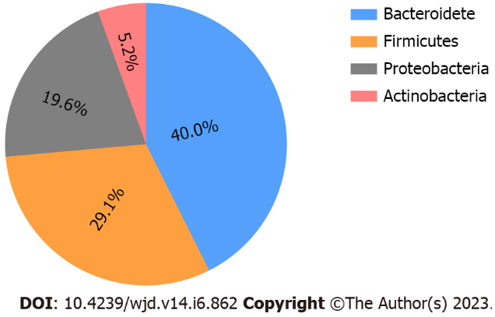
Figure 1 The pie shows average relative abundances of the most four dominated phyla. Relative abundances are presented as percentage.
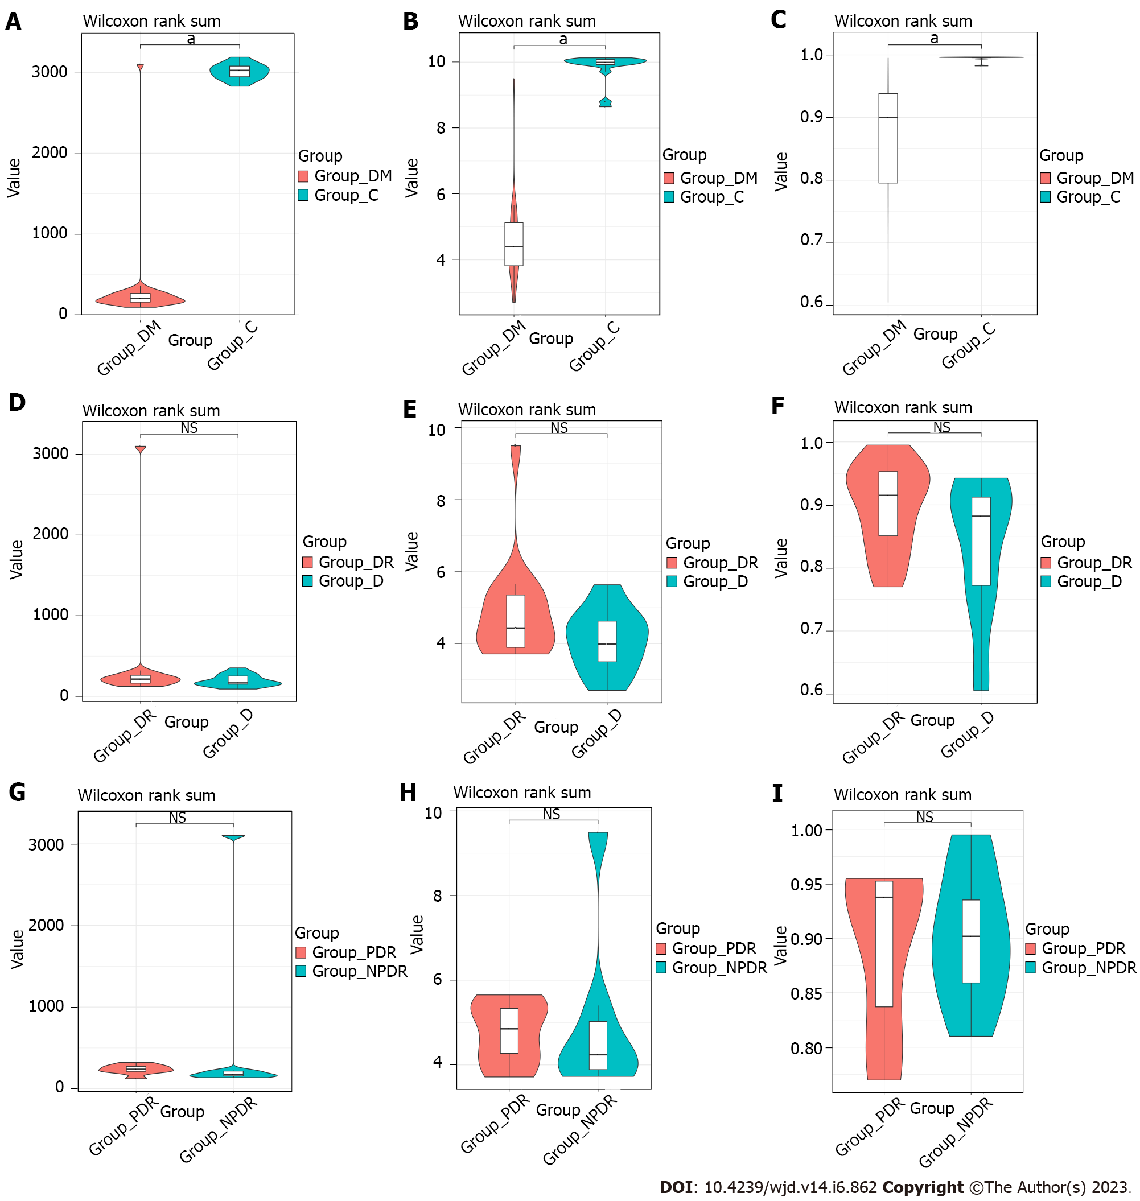
Figure 2 Alpha diversity analysis of microbiota in the six groups. A: The Chao1 index between Group DM and Group C; B: The Shannon index between Group DM and Group C; C: The simpson index between Group DM and Group C; D: The Chao1 index between Group DR and Group D; E: The Shannon index between Group DR and Group D; F: The simpson index between Group DR and Group D; G: The Chao1 index between Group PDR and Group NPDR; H: The Shannon index between Group PDR and Group NPDR; I: The simpson index between Group PDR and Group NPDR. ªP < 0.05. NS: Not significant. Group C: Samples with non-diabetics; Group DM: Samples with diabetics; Group DR: Samples with diabetic retinopathy; Group D: Samples without diabetic retinopathy; Group PDR: Patients with proliferative diabetic retinopathy; Group NPDR: Patients without proliferative diabetic retinopathy.

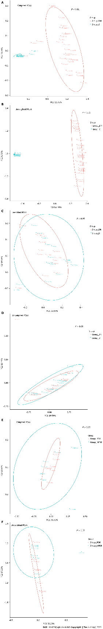
Figure 3 Beta diversity analysis of microbiota in the six groups. A and B: Weighted and unweighted PCoA between between Group DM and Group C; C and D: Weighted and unweighted PCoA between between Group DR and Group D; E and F: Weighted and unweighted PCoA between between Group PDR and Group NPDR. Differences were assessed by Adonis. Group C: Samples with non-diabetics; Group DM: Samples with diabetics; Group DR: Samples with diabetic retinopathy; Group D: Samples without diabetic retinopathy; Group PDR: Patients with proliferative diabetic retinopathy; Group NPDR: Patients without proliferative diabetic retinopathy.
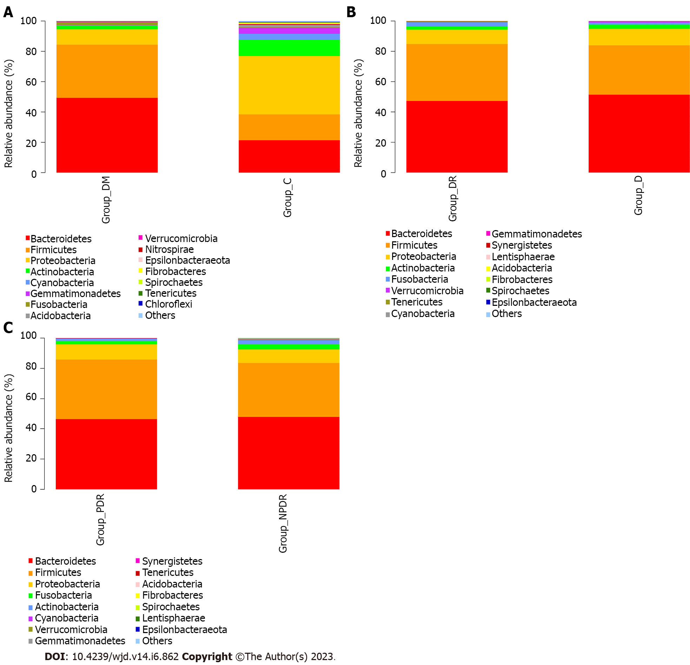
Figure 4 The composition at phylum level in the six groups. A: The composition at phylum level in Group DM and Group C. The abundance of Firmicutes, Bacteroidetes, Proteobacteria and Actinobacteria varied between the two groups; B: The composition at phylum level in Group DR and Group D. The relative mean abundance of phylum Bacteroidetes and Firmicutes between Group D and Group DR were similar (P = 0.33, P = 0.37); C: The composition at phylum level in Group PDR and Group NPDR. The relative mean abundance of phylum Bacteroidetes, Firmicutes and showed a similarity between Group PDR and NPDR (P = 0.71, P = 0.33). Group C: Samples with non-diabetics; Group DM: Samples with diabetics; Group DR: Samples with diabetic retinopathy; Group D: Samples without diabetic retinopathy; Group PDR: Patients with proliferative diabetic retinopathy; Group NPDR: Patients without proliferative diabetic retinopathy.

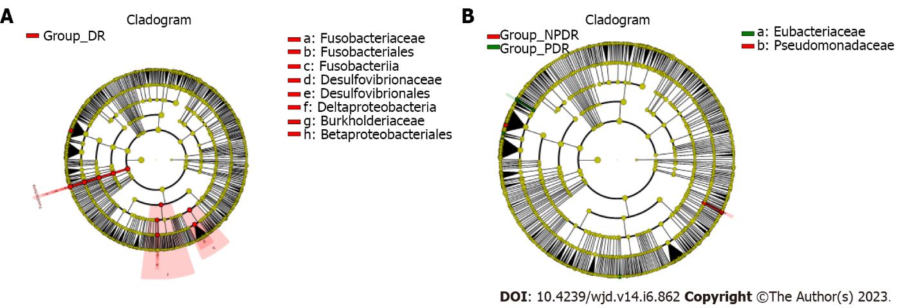
Figure 5 Results of linear discriminant analysis effect size in the six groups. Wilcoxon signed rank test was used for statistical analyzing. The threshold of linear discriminant analysis score was set to 2.0. A and B: Red nodes designated microorganism that only been detected in Group DR. The regions marked with yellow indicated no significant difference between Group DR and Group D as well as Group PDR and NPDR. Group DR: Samples with diabetic retinopathy; Group D: Samples without diabetic retinopathy; Group PDR: Patients with proliferative diabetic retinopathy; Group NPDR: Patients without proliferative diabetic retinopathy.
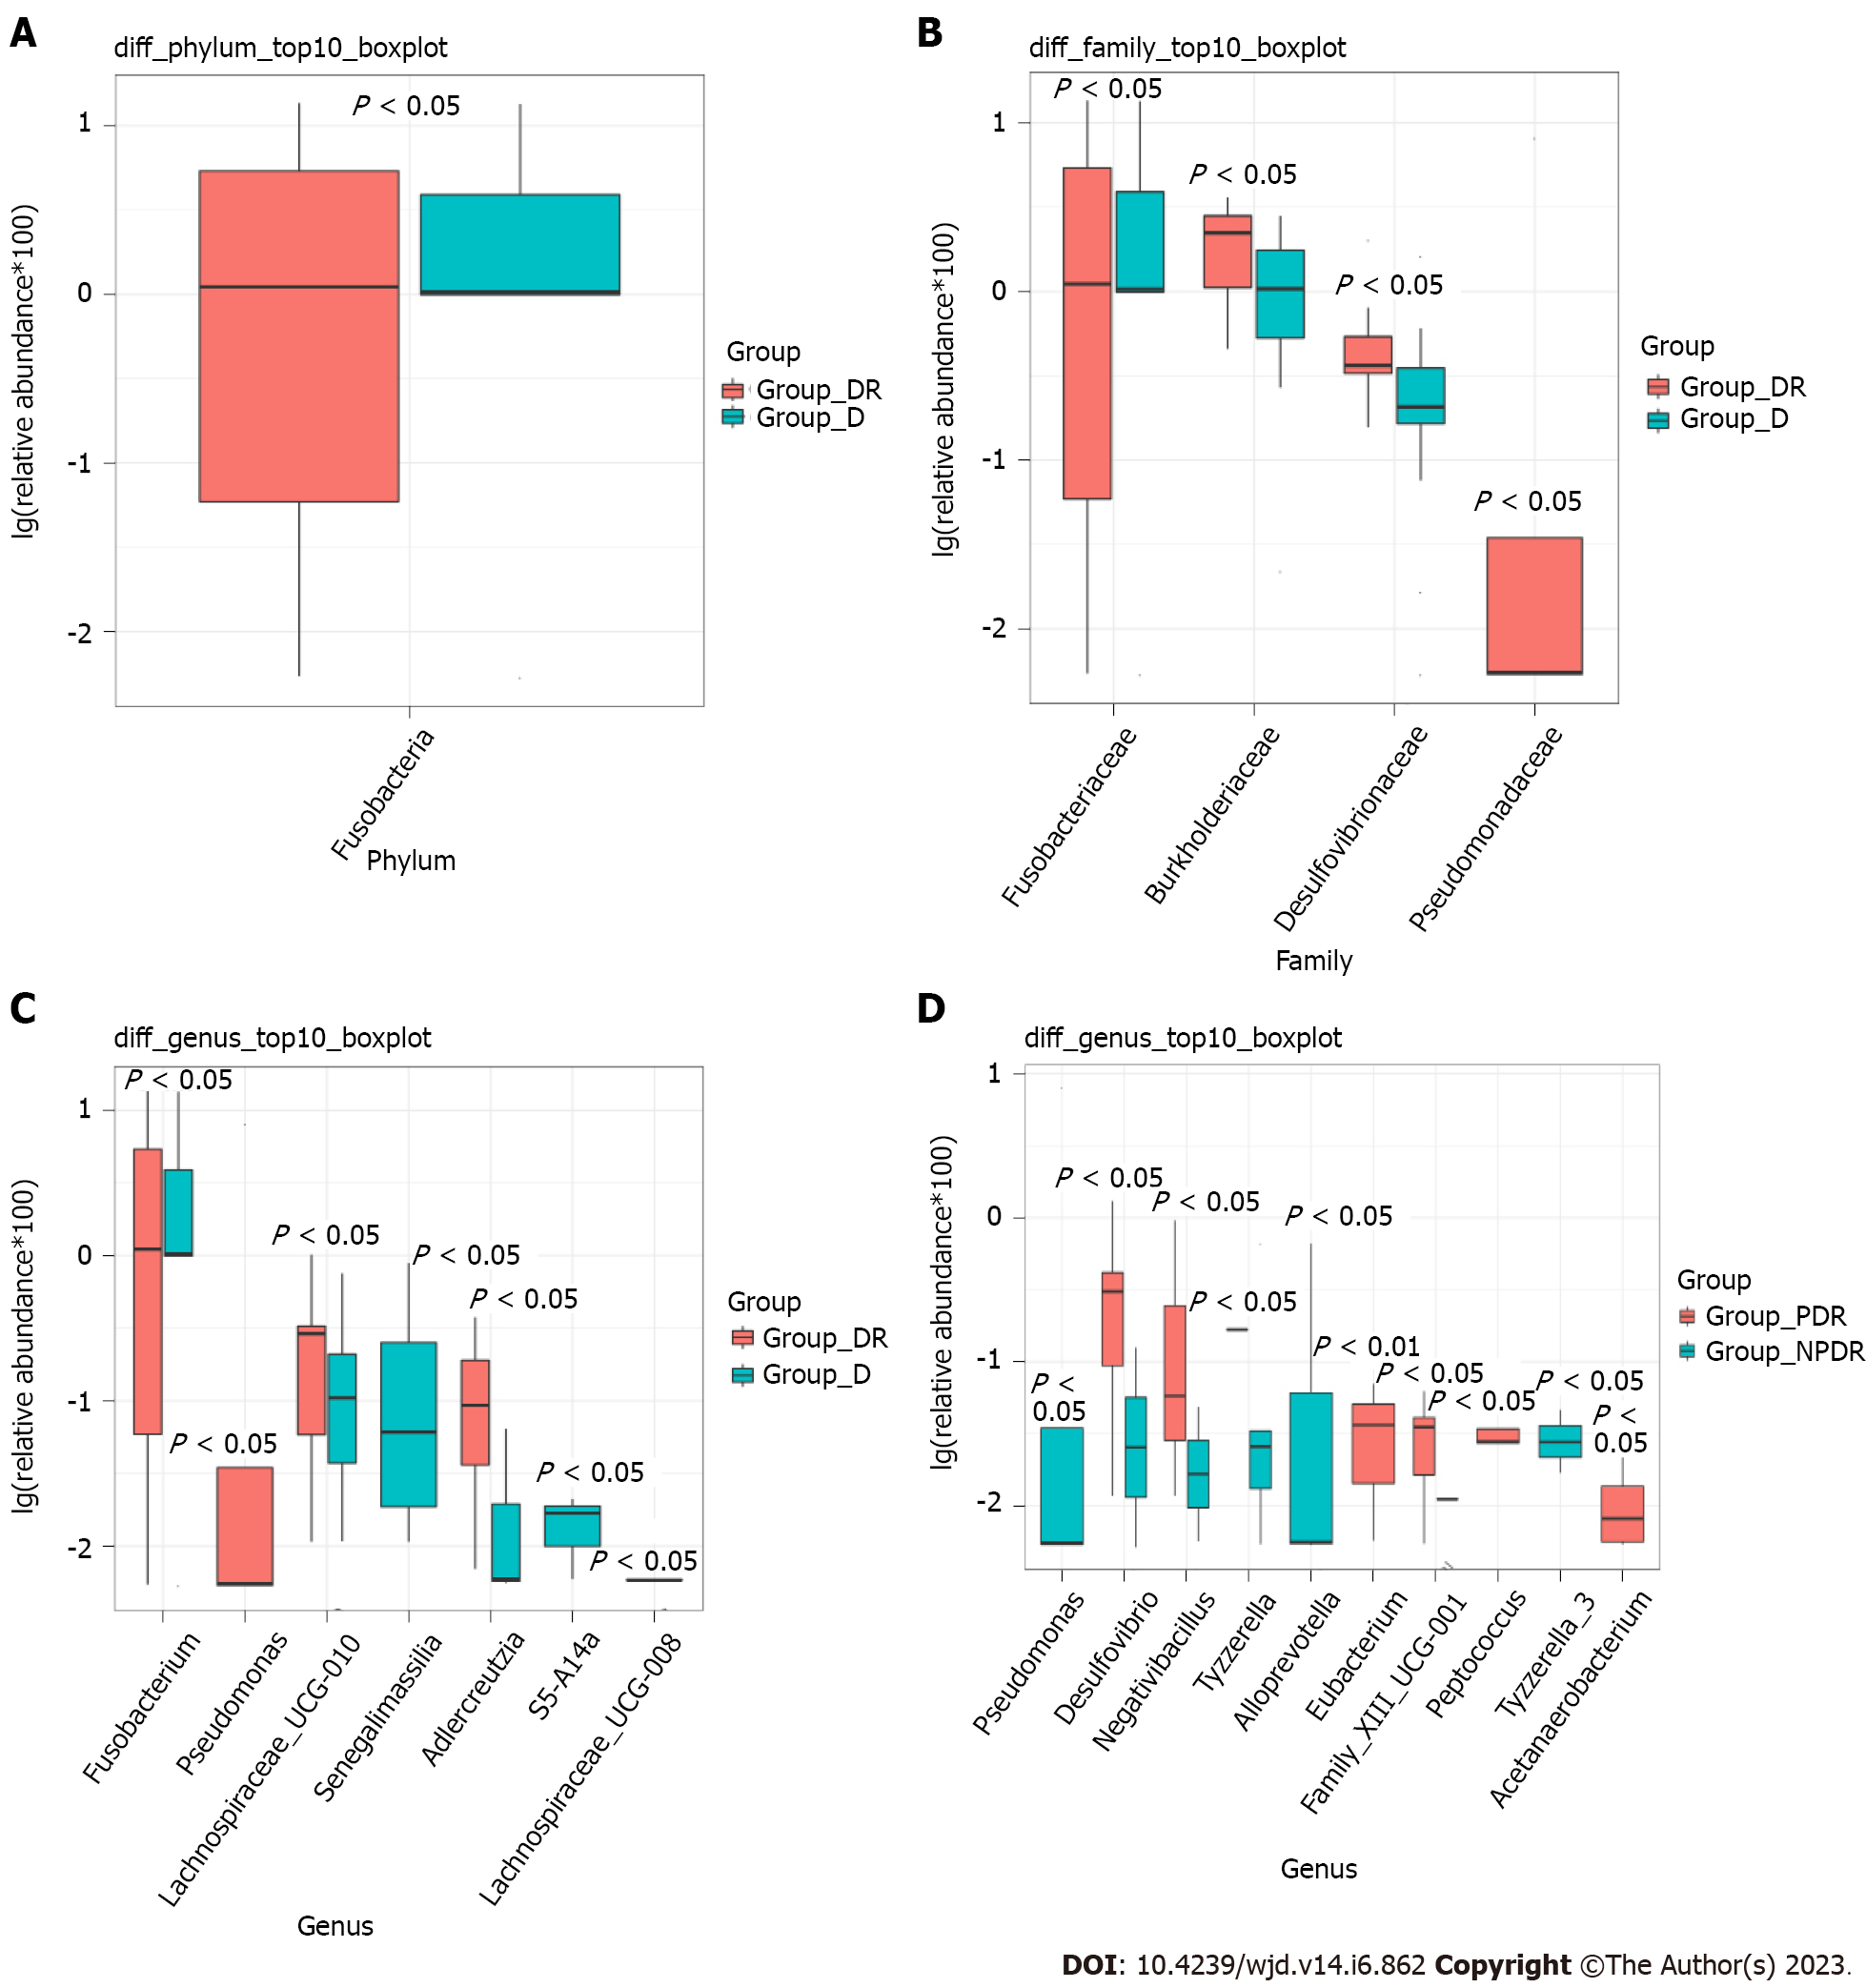
Figure 6 Relative abundance of microbiota displayed by Box and whiskers plots. A-C: Box and whiskers plots display relative abundance of microbiota in different level between Group DR and Group D; D: Box and whiskers plots display relative abundance of genera between Group PDR and NPDR. Group DR: Samples with diabetic retinopathy; Group D: Samples without diabetic retinopathy; Group PDR: Patients with proliferative diabetic retinopathy; Group NPDR: Patients without proliferative diabetic retinopathy.
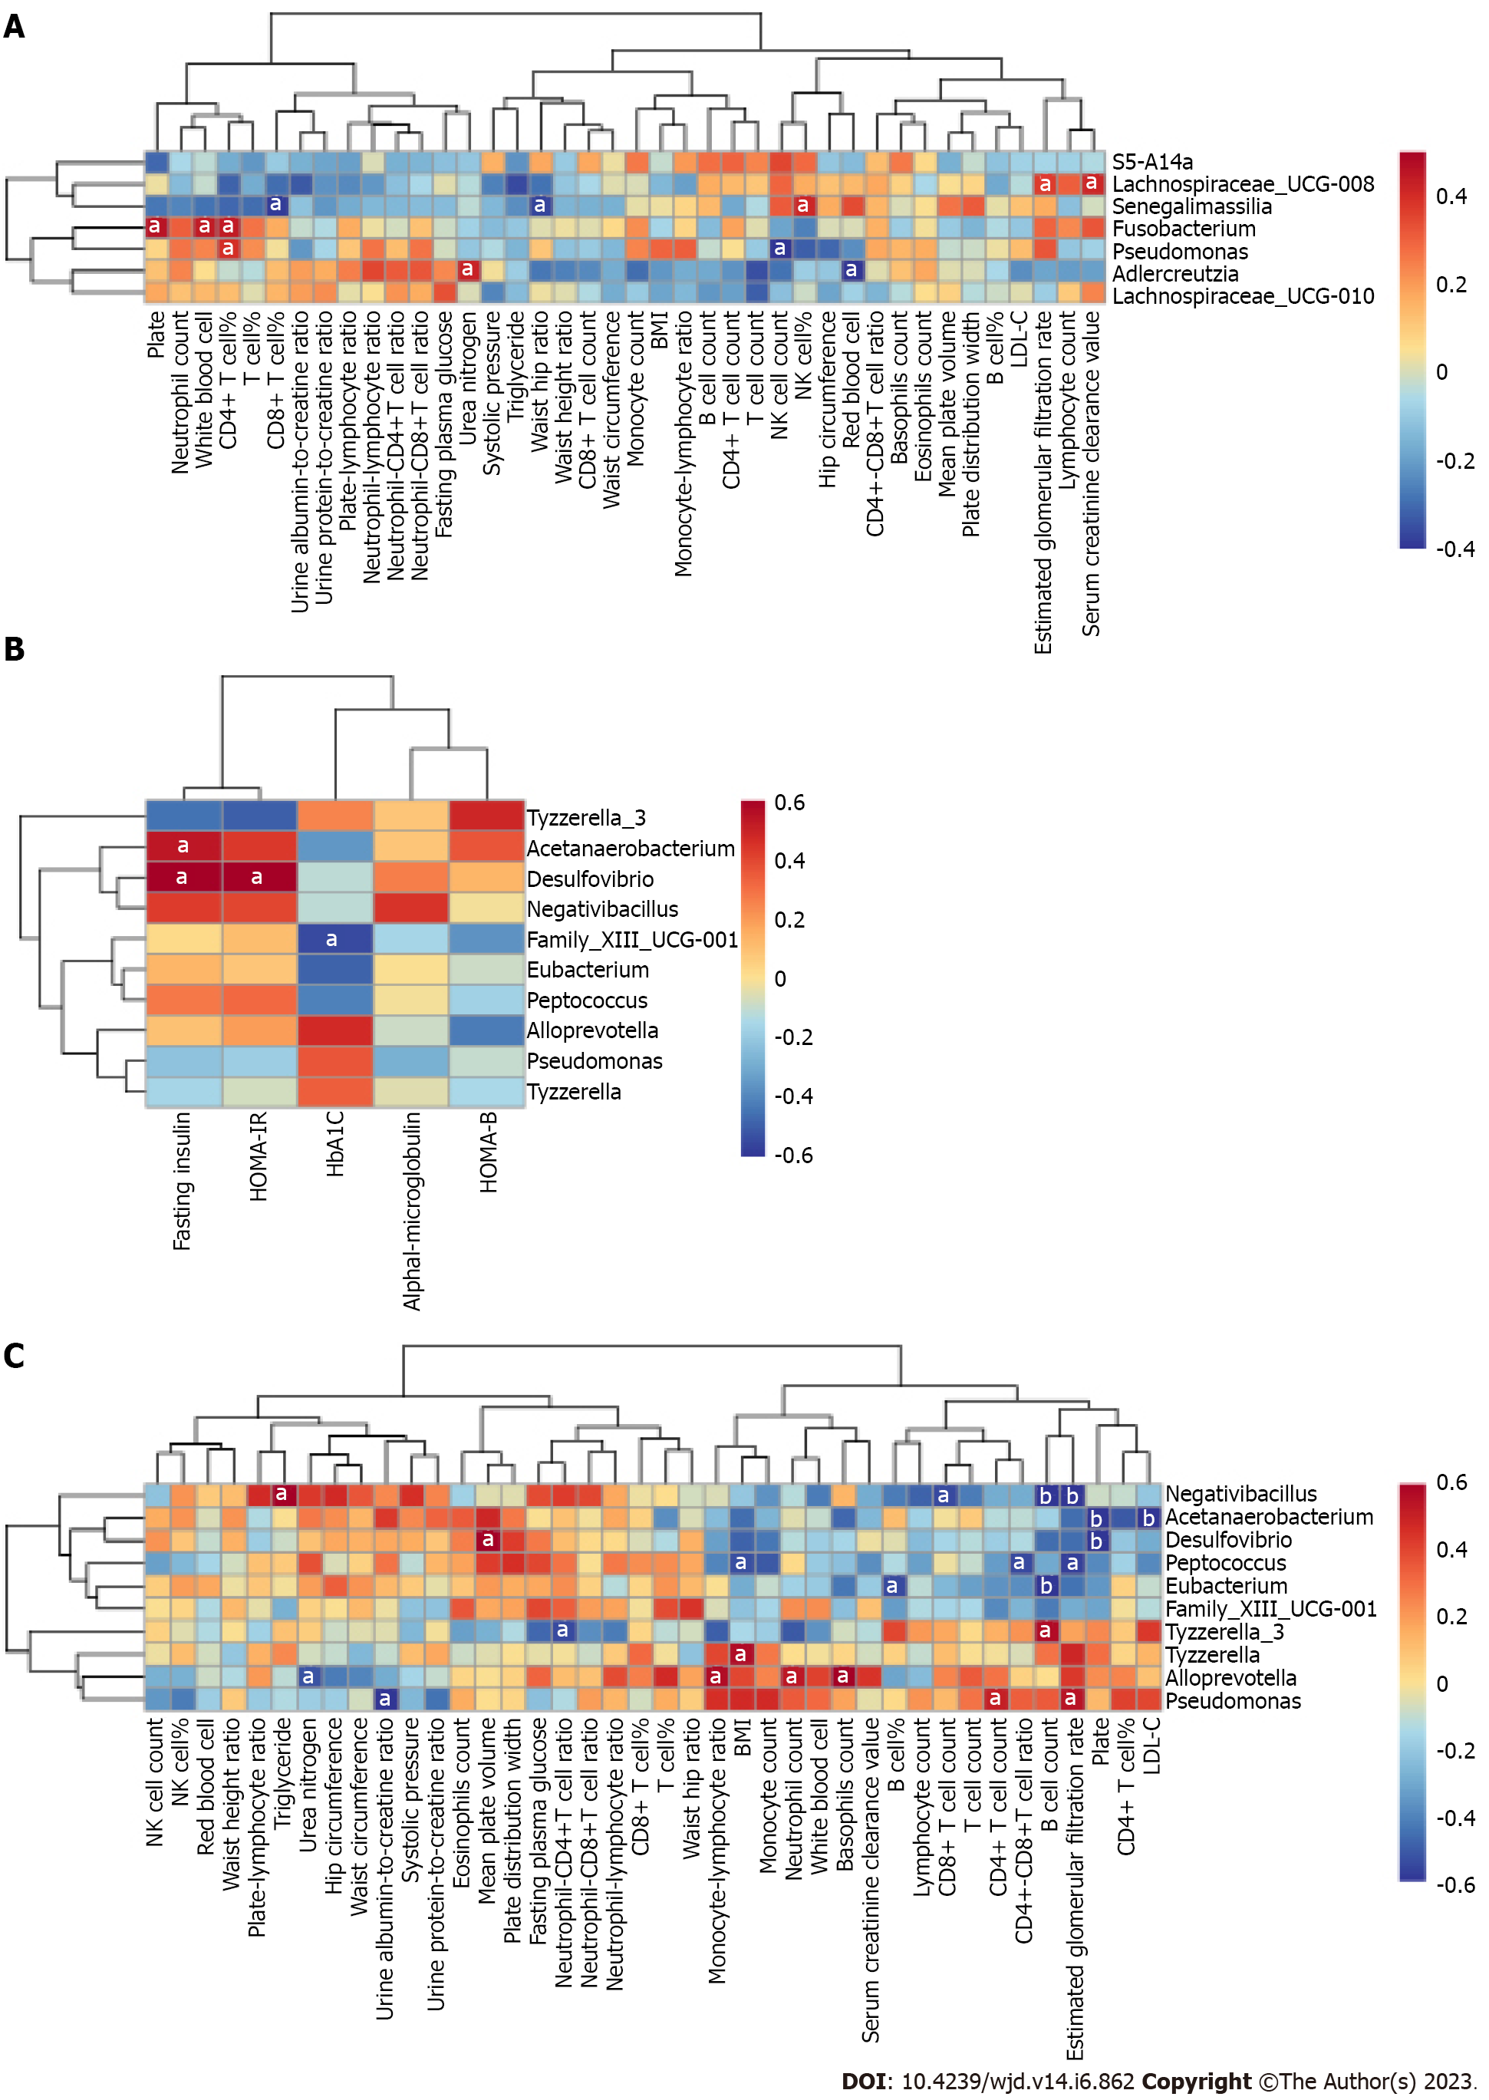
Figure 7 Correlation heatmap between gut microbiota and clinical indices. A: Correlation heatmap between gut microbiota and clinical indices in Group DM (Group DR vs Group D); B and C: Correlation heatmap between gut microbiota and clinical indices in Group DR (Group PDR vs Group NPDR). Different colors represent correlation level. Different colors represent correlation level (blue represents for negative correlation, red represents for positive correlation). ªP < 0.05; ^{b}P < 0.01. Group C: Samples with non-diabetics; Group DM: Samples with diabetics; Group DR: Samples with diabetic retinopathy; Group D: Samples without diabetic retinopathy; Group PDR: Patients with proliferative diabetic retinopathy; Group NPDR: Patients without proliferative diabetic retinopathy.
Table 1 Basic characteristics compared between Group DM and Group C
Characteristic | Group DM vs Group C
 | Group DM (n = 30) | Group C (n = 15) | P value
Age | 55.93 ± 9.58 | 59.73 ± 16.46 | NS
Gender, male/female | 19/11 | 9/6 | NS
Height | 165.70 ± 8.07 | 162.20 ± 7.78 | NS
Weight | 64.75 ± 7.67 | 62.53 ± 8.29 | NS
Body mass index | 23.47 ± 2.21 | 23.73 ± 2.27 | NS
Waist circumference | 84.75 ± 7.78 | 84.67 ± 8.36 | NS
Hip circumference | 91.42 ± 7.32 | 92.07 ± 7.29 | NS
Waist hip ratio | 0.93 ± 0.05 | 0.92 ± 0.08 | NS
Waist height ratio | 0.51 ± 0.05 | 0.52 ± 0.05 | NS
Systolic blood pressure | 128.43 ± 11.98 | 127.80 ± 14.03 | NS
Fasting glucose | 8.29 ± 2.79 | 5.34 ± 0.95 | < 0.01
HbA1c | 9.94 ± 1.96 | 5.63 ± 0.31 | < 0.01
Triglycerides | 1.81 ± 1.82 | 1.72 ± 0.77 | NS
LDL-C | 3.00 ± 0.97 | 2.94 ± 0.88 | NS
eGFR | 92.29 ± 27.65 | 87.21 ± 30.00 | NS
Data are presented as mean ± SD. HbA1c: Glycosylated hemoglobin A1c; LDL-C: Low-density lipoprotein cholesterol; eGFR: Estimated glomerular filtration rate. Group C: Samples with non-diabetics; Group DM: Samples with diabetics.

Table 2 Basic characteristics compared between samples with diabetic retinopathy and samples without diabetic retinopathy, as well as patients with proliferative diabetic retinopathy vs patients without proliferative diabetic retinopathy
Characteristic | Group DR vs Group D |  |  | Group PDR vs Group NPDR
 | Group DR (n = 15) | Group D (n = 15) | P value | Group PDR (n = 8) | Group NPDR (n = 7) | P value
Age | 55.87 ± 10.54 | 56.00 ± 8.90 | NS | 58.75 ± 11.85 | 52.57 ± 8.44 | NS
Gender, male/female | 9/6 | 10/5 | NS | 3/5 | 3/4 | NS
Diabetes duration | 14.27 ± 7.27 | 4.045 ± 4.67 | NS | 15.50 ± 4.99 | 12.87 ± 9.49 | < 0.01
height | 165.13 ± 9.26 | 166.27 ± 6.97 | NS | 165.75 ± 10.12 | 164.43 ± 8.90 | NS
Weight | 64.83 ± 9.11 | 64.67 ± 6.24 | NS | 65.19 ± 9.64 | 64.43 ± 9.22 | NS
Body mass index | 23.49 ± 1.99 | 23.45 ± 2.48 | NS | 23.07 ± 1.24 | 23.97 ± 2.62 | NS
Waist circumference | 83.47 ± 8.40 | 86.03 ± 7.17 | NS | 85.75 ± 9.77 | 80.86 ± 6.20 | NS
Hip circumference | 89.53 ± 8.83 | 93.30 ± 5.03 | NS | 92.88 ± 8.17 | 85.71 ± 8.50 | NS
Waist hip ratio | 0.93 ± 0.06 | 0.92 ± 0.05 | NS | 0.92 ± 0.07 | 0.95 ± 0.03 | NS
Waist height ratio | 0.51 ± 0.05 | 0.52 ± 0.05 | NS | 0.52 ± 0.07 | 0.49 ± 0.02 | NS
Systolic blood pressure | 131.93 ± 13.27 | 124.93 ± 9.74 | NS | 135.75 ± 13.79 | 127.57 ± 12.15 | NS
Fasting glucose | 9.24 ± 2.95 | 7.34 ± 2.35 | NS | 9.61 ± 1.83 | 8.81 ± 4.00 | NS
HbA1c | 10.01 ± 1.63 | 9.87 ± 2.31 | NS | 9.26 ± 1.62 | 10.87 ± 1.24 | NS
Triglycerides | 2.18 ± 2.50 | 1.44 ± 0.57 | NS | 2.42 ± 2.90 | 1.90 ± 2.14 | NS
LDL-C | 2.78 ± 0.90 | 3.22 ± 1.02 | NS | 2.51 ± 1.16 | 3.09 ± 0.34 | NS
eGFR | 88.08 ± 32.09 | 96.51 ± 22.72 | NS | 69.33 ± 33.84 | 109.51 ± 7.88 | < 0.05
Urine albumin creatine ratio | 527.22 ± 1055.30 | 30.90 ± 52.89 | NS | 508.40 ± 731.68 | 548.74 ± 1404.61 | NS
Serum creatinine clearance value | 97.59 ± 52.53 | 114.66 ± 41.75 | NS | 94.24 ± 60.68 | 101.41 ± 45.96 | NS
Urea nitrogen | 7.65 ± 5.66 | 5.87 ± 2.24 | NS | 9.60 ± 7.24 | 5.41 ± 1.58 | NS
Fasting insulin | 61.34 ± 24.06 | 70.91 ± 57.40 | NS | 73.31 ± 19.84 | 47.66 ± 21.96 | < 0.05
HOMA-IR | 3.82 ± 2.13 | 3.10 ± 2.00 | NS | 4.53 ± 1.62 | 23.00 ± 2.46 | NS
HOMA-B | 0.40 ± 0.25 | 0.80 ± 1.02 | NS | 0.36 ± 0.13 | 0.45 ± 0.36 | NS
Platelet | 217.60 ± 55.49 | 203.67 ± 63.63 | NS | 196.63 ± 43.45 | 241.57 ± 61.04 | NS
Mean platelet volume | 11.13 ± 0.85 | 10.99 ± 0.79 | NS | 11.40 ± 0.88 | 10.83 ± 0.76 | NS
Platelet distribution width | 13.79 ± 1.58 | 13.95 ± 1.55 | NS | 14.05 ± 1.55 | 13.49 ± 1.67 | NS
Neutrophil to lymphocyte ratio | 2.85 ± 0.99 | 2.10 ± 0.86 | < 0.05 | 2.75 ± 0.90 | 2.97 ± 1.15 | NS
T cell count | 1165.87 ± 373.69 | 1518.00 ± 335.85 | NS | 1092.75 ± 504.02 | 1249.43 ± 119.08 | NS
B cell count | 249.67 ± 82.72 | 378.87 ± 124.49 | < 0.01 | 198.00 ± 57.65 | 308.71 ± 66.81 | < 0.01
CD4⁺ T cell count | 733.87 ± 299.45 | 953.2 ± 226.40 | < 0.05 | 684.13 ± 413.77 | 790.72 ± 49.25 | NS
CD8⁺ T cell count | 389.40 ± 116.23 | 490.47 ± 137.90 | < 0.05 | 371.88 ± 145.83 | 409.43 ± 76.37 | NS
CD4⁺ to CD8⁺ T cell ratio | 1.91 ± 0.60 | 2.01 ± 0.42 | NS | 1.85 ± 0.79 | 1.98 ± 0.31 | NS
NK cell count | 220.20 ± 85.18 | 462.27 ± 250.54 | < 0.01 | 240.00 ± 114.91 | 197.57 ± 20.12 | NS
NK cell percent | 12.66 ± 3.65 | 19.41 ± 9.48 | < 0.05 | 14.05 ± 4.52 | 11.07 ± 1.33 | NS
Data are presented as mean ± SD. HbA1c: Glycosylated hemoglobin A1c; LDL-C: Low-density lipoprotein cholesterol; eGFR: Estimated glomerular filtration rate; HOMA-IR: Homeostasis model assessment of insulin resistance; HOMA-B: Homeostasis model assessment of beta-cell function; NS: No significance; Group DR: Samples with diabetic retinopathy; Group D: Samples without diabetic retinopathy; Group PDR: Patients with proliferative diabetic retinopathy; Group NPDR: Patients without proliferative diabetic retinopathy.

Published by Baishideng Publishing Group Inc
7041 Koll Center Parkway, Suite 160, Pleasanton, CA 94566, USA
Telephone: +19253991568
Email: bpgoffice@wjgnet.com
Help Desk: https://www.f6publishing.com/helpdesk
https://www.wjgnet.com

© 2023 Baishideng Publishing Group Inc. All rights reserved.

