Name of Journal: World Journal of Clinical Cases
Manuscript NO: 65604
Manuscript Type: CASE REPORT

Diverse microbiota in palatal radicular groove analyzed by Illumina sequencing: Four case reports

Tan XL et al. Microbiota in palatal radicular groove

Xue-Lian Tan, Xuan Chen, Yu-Jie Fu, Ling Ye, Lan Zhang, Ding-Ming Huang

Xue-Lian Tan, Xuan Chen, Yu-Jie Fu, Ling Ye, Lan Zhang, Ding-Ming Huang, State Key Laboratory of Oral Diseases & National Clinical Research Center for Oral Diseases & Department of Operative Dentistry and Endodontics West China Hospital of Stomatology, Sichuan University, Chengdu 610041, Sichuan Province, China

Author contributions: Tan XL designed and carried out the experiments, analyzed the results, and wrote the manuscript; Chen X analyzed the results and wrote the manuscript; Fu YJ helped carry out the experiments and analyzed the results; Ye L, and Zhang L revised this manuscript; Huang DM designed the experiments and critically revised this manuscript; All authors approved the manuscript and are responsible for all aspects of the work.

Supported by National Natural Science Foundation of China, No. 82001037; and the Research and Develop Program, West China Hospital of Stomatology, Sichuan University, No. RD-02-202007.

Corresponding author: Ding-Ming Huang, PhD, Professor, State Key Laboratory of Oral Diseases & National Clinical Research Center for Oral Diseases & Department of Operative Dentistry and Endodontics West China Hospital of Stomatology, Sichuan University, No. 14 3rd Section, Renmin South Road, Chengdu 610041, Sichuan Province, China. dingminghuang@163.com

Received: April 14, 2021
Revised: May 24, 2021
Accepted: June 4, 2021
Published online: August 16, 2021

Abstract
BACKGROUND
A palatal radicular groove is an unusual developmental deformity of the tooth, which may serve as a channel linking the periodontal and periapical inflammation, and yet no literature could be obtained analyzing microbiota within the palatal radicular grooves.

CASE SUMMARY
Four patients diagnosed with palatal radicular groove and concomitant periodontal-endodontic deformity in permanent maxillary lateral incisors were enrolled in this work. Twelve bacterial samples from 4 patients were collected from different parts of the palatal radicular groove during intentional replantation surgery. Illumina sequencing was performed to analyze the taxonomical composition and microbiome structure inside the palatal grooves, and 1162 operational taxonomic units were obtained. The phyla of Firmicutes and Proteobacteria predominated in most of the samples. An unknown genus from the Bacillaceae family, Lactococcus, and Porphyromonas were the most abundant genera identified. There was no difference in the microbiota richness and diversity in three sections of the groove.

CONCLUSION
The unique ecological niches inside the palatal grooves harbored bacterial communities that shared some component features of both the endodontic and periodontal infections. The existence of palatal groove may play an interaction bridge between the root apex and tooth cervix and thus impair the outcome of traditional therapeutic methods such as root canal treatment and periodontal management.

Key Words: Palatal radicular groove; High-throughput sequencing; Microbiota composition; Taxonomy; Endodontic-periodontal infection; Case report

©The Author(s) 2021. Published by Baishideng Publishing Group Inc. All rights reserved.

Citation: Tan XL, Chen X, Fu YJ, Ye L, Zhang L, Huang DM. Diverse microbiota in palatal radicular groove analyzed by Illumina sequencing: Four case reports. World J Clin Cases 2021; 9(23): 6846-6857
URL: https://www.wjgnet.com/2307-8960/full/v9/i23/6846.htm
DOI: https://dx.doi.org/10.12998/wjcc.v9.i23.6846

Core Tip: Microbial communities dwelling in the palatal grooves are as complex as those related to endodontic and periodontal infections. The existence of palatal groove may bridge interactions between the root apex and dental cervix and thus impair the outcome of traditional therapeutic methods such as root canal treatment and periodontal management.

INTRODUCTION
A palatal radicular groove is an unusual developmental deformity of the tooth, with the groove usually starting near the cingulum of the incisor, running apically, and terminating at various lengths along the root^{[1]}. The existence of palatal grooves is rare, with a prevalence ranging from 2.8%-8.5%^{[2]}. According to previous studies, palatal grooves can be classified into three types based on the depths of grooves generated via cone-beam computed tomographic scanning^{[3,4]}. Type I represents the shallowest grooves, while types II and III of palatal grooves can extrude and affect the relevant shape of the root canal, thus increasing the difficulty of root canal therapy as well as providing extra ecological niches for potential oral pathogens. When encountering beneficial dysbiosis environment in the local area, bacterial inhabitants in these niches tend to invade alongside the groove^{[5]}, which may damage the periodontal tissues, generate localized and deep periodontal pocket extending along the palatal groove and consequently cause root surface and root canal infections including pulp necrosis and/or apical periodontitis, and finally present the concomitant periodontal-endodontic deformity.
Due to the close relationship between the microbiota existing on the root surface and the local inflammation around the palatal groove, a comprehensive understanding of the etiology and pathogenesis of the bacterial community composition inside the palatal grooves may be helpful in developing effective prevention and successful treatment strategies for palatal grooves concomitant to periodontal-endodontic deformity^{[6,7]}. Studies on apex microbiome have shown that the apical region of the root canal system drives a more diverse and obligated anaerobe community than the coronal region due to the complex anatomic structures on the apical end and the sharp reduction of oxygen and nutrient gradients from fresh to protein-rich regions^{[6,8]}. It has also been reported that the microbial community presenting in combined endodontic–periodontal lesions is complex and more diverse than previously thought^{[9]}. It is also the case with palatal radicular grooves in terms of structural complexity such as the depths of the groove and periodontal pocket are highly variable in different clinical cases^{[3,5]}. Thus, it is reasonable to extrapolate that the microbial community may be subject to various changes of the palatal grooves. However, the exact etiology of palatal radicular grooves and the difference of microbiota composition between the apex zone and palatal groove are not fully understood yet^{[10,11]}.
Recently, emerging molecular genetic techniques, such as high-throughput sequencing technologies, gradually became the optimal methods to comprehensively characterize microbiota from human ecological niches. This will aid in better understanding of the role of prokaryotes in the pathogenesis of infectious diseases in the oral cavity^{[9,12]}.
In this case report, we uncovered the highly polymicrobial communities in the palatal radicular groove samples associated with periodontal-endodontic lesions utilizing the Illumina MiSeq sequencing technology to analyze the microbial compositions inside the palatal grooves to initially provide evidence for unveiling the potential etiology and pathogenesis of these polymicrobial communities as well as reference for optional therapeutic strategy for this kind of disease.

CASE PRESENTATION
Chief complaints
All patients reported to our department with chief complaints of pus discharge in their maxillary incisor regions.

History of present illness
All patients found pus discharge in their maxillary incisor regions 1-4 wk ago.

History of past illness
There was no history of trauma, and all the patients were systemically healthy.

Personal and family history
The personal and family history was noncontributory.

Physical examination
Patient information, such as age, sex, probing depth, etc. were accurately recorded in Table 1.

Laboratory examinations
Tooth extraction and sample collection: Intentional replantation was applied to treat these cases after root canal treatment. The tooth and the operating field were carefully decontaminated and disinfected with 1% povidone-iodine followed by 0.1% chlorhexidine solution. After the tooth was minimally invasively extracted from the alveolar bone, the palatal groove was observed directly (Figure 1A and 1B). We trisected the palatal groove region into three equal segments namely the apical 1/3 (GJ), medium 1/3 (GZ), and cervical 1/3 (GG). Twelve bacteria samples were collected from the three regions of the 4 teeth under strict aseptic conditions. Briefly, the root surface was gently washed with sterile saline to remove possible contamination during extraction, then sterile microsurgery curettes were used to scrape debris from the surface of the groove. The obtained debris was then transferred into cryotubes containing TE buffer (10 mmol/L Tris-HCl, 0.1 mmol/L EDTA, pH 7.6) and immediately frozen at −20 °C before further extraction and sequencing procedures.

DNA extraction and sequencing: Genomic DNA of the collected samples was extracted with the Power Soil DNA Kit (MoBio Laboratories, Carlsbad, CA, United States) according to the manufacturer’s instructions. Concentration of the generated DNA was examined by a NanoDrop ND-1000 spectrophotometer (Thermo Scientific, United States). For high-throughput sequencing, the V4 variable regions of the 16S rRNA gene were amplified using primers^{[13]} according to the Illumina 16S Metagenomic Sequencing Library Preparation instructions. The Illumina MiSeq was performed by Personalbio Biomedical Technology Co. Ltd. (Shanghai, China) as described elsewhere^{[14]}.
Scanning electron microscope examination: The teeth apexes were then cut during the intentional replantation procedure, immersed into 2.5% glutaraldehyde solution, and stored overnight at 4 °C, followed by gradient dehydration using alcohol at consecutive concentrations of 30%, 50%, 80%, 85%, 90%, 95%, and 100%. Then, the samples were rinsed in phosphate-buffer solution twice, followed by dehydration in a critical point device (Denton Vacuum DCP-1; Denton Vacuum, Moorestown, NJ) and gold sputter coating (Denton Vacuum Desk II; Denton Vacuum). The surface of the root tip was then examined under a scanning electron microscope (SEM) operated at 15 kV (Jeol JSM–5600 LV, Akishima, Tokyo, Japan).

Imaging examinations
Three-dimensional reconstruction for each case was conducted after cone-beam computed tomographic scanning using Mimics 17.0 software (Materialise Company, Belgium) using a 0.13 mm interval thickness with voxel sizes of 60 mm × 60 mm × 60 mm as described elsewhere^{[3]}.

Three-dimensional reconstruction and tooth apex morphology
Three-dimensional reconstruction of the infected teeth based on cone-beam computed tomographic scanning revealed that the 4 cases enrolled in this study could be classified into either type I or type II. Both type I (Figure 1C) and type II (Figure 1D) had a palatal groove that started from the cingulum and extended to the apex along the root surface, which was in agreement with the intraoperative awareness during intentional replantation (Figure 1A and 1B), but the groove depth of type II (Figure 1E) was deeper than that of type I (Figure 1F), and the type II groove extruded into the root canal to form a “C” shape. Simultaneously, the shape of the pulp cavity (Figure 1G and 1H) and its relationship with teeth (Figure 1I and 1J) were correspondingly changed.
SEM results suggested that there were highly polymicrobial communities dwelling in the apexes of the infected teeth. Analyses of the SEM photo captures revealed a rugged radicular surface and bacterial biofilms that mainly consisted of kinds of long bacillus, short bacillus, and coccus surrounded and covered the apical foramen and the external radicular surface (Figure 1K-M).

Sequencing results
A total of 1162 operational taxonomic units (OTUs) were obtained via the MiSeq, and these OTUs could be taxonomically assigned into 24 bacterial phyla, 51 classes, 91 orders, 185 families, and 339 genera. The numbers of OTUs and subsequently assigned taxa were not statistically different in the three parts of the root (P > 0.05) (Table 2). Of the OTUs, 67% were ubiquitously distributed in the full length of the palatal groove. There were 38 OTUs that could only be located on the apical portion of the root, followed by 33 OTUs exclusive to the cervical segment, and only 4 OTUs uniquely distributed in the middle third of the root.

Microbiota taxonomical composition
Regarding the phyla division, Firmicutes (average 40.7% ± 15.2%) and Proteobacteria (average 32.2% ± 9.0%) predominated in most of the samples, followed by Bacteroidetes (average 12.2% ± 8.8%) and Fusobacteria (average 5.6 ± 10.8%), while there were also some exceptions that one of the middle 1/3 samples (GZ1) was predominated by Fusobacteria and Proteobacteria, and one of the cervical samples (GG1) harbored mostly the Bacteroidetes and Fusobacteria (Figure 2A). Viewing spatially, cervical portion of the roots harbored 40% of the Proteobacteria detected, much more than the other two parts (Figure 2B). However, Firmicutes was more frequently detected in the middle third samples (GZ). Some phyla including Synergistetes, Spirochaetes and TM7, though less abundant, were mostly exhibited at the apical end (Figure 2B).
Among the identified 339 genera, an unknown genus from the Bacillaceae family (15.2%), genera of Lactococcus (9.5%), Porphyromonas (8.7%), Rhodanobacter (6.4%), and Sediminibacterium (6.2%) were the only five genera that exhibited an abundance above 5%. Lactococcus was the most abundant genus in the apical samples (GJ, average 12.4 ± 3.6%), while the genus from the Bacillaceae family was the most abundant in both middle (GZ) and cervical (GG) samples (average 22.8 ± 22.7% and 11.2 ± 12.4%, respectively) (Figure 2C and 2D). Three genera, namely Peptococcus, Acholeplasma, and Brooklawnia, were found exclusively in the apical samples (GJ) with an incredibly low abundance (< 0.1%). Some genera that are frequently associated with endodontic infections were found below the top 30 abundance: Prevotella ranked number 30 (0.7%), Sphingomonas ranked number 31 (0.6%), Actinomyces ranked number 32 (0.5%), Tannerella ranked number 42 (0.3%), Acinetobacter ranked number 43 (0.3%), Capnocytophaga ranked number 57 (0.1%), and Enterococcus ranked number 181 (below 0.1%).

Richness and diversity
All 690 taxa (final taxon to genus level) were used to perform alpha diversity analyses. Chao1 and angiotensin converting enzyme richness estimates were not significantly different (P > 0.05) among the three segments (Figure 3A and 3B). Likewise, comparison of the Shannon and Simpson indexes indicated that there were no significant differences (P > 0.05) in bacterial community diversity in the cervical, middle, and apical parts of the palatal groove (Figure 3C and 3D).

Bacterial community structure
Bacterial community structures in the collected samples were compared using UniFrac based on the phylogenetic relationships of representative reads from different samples, and the weighted UniFrac distances were utilized to conduct a principal coordinate analysis. The results suggested that samples originating from the same root had similar UniFrac distance (0.176 ± 0.110) to the average distance calculated from all samples (0.227 ± 0.090; P > 0.05), meaning that microbial communities distributed in a ubiquitous pattern in all the tested samples regardless of whether the samples were collected from the same tooth or not. However, the data contained a few strong outliers (samples GG4, GG1, and GZ1), which exhibited significantly longer distances to the other samples. Visualization of the UniFrac analysis on phylogenetic distances amongst the different samples showed that patients 2 and 3 tooth samples clustered together, while the apical part of patient 1 (GJ1) and the cervical portion of patient 4 (GG4) were way too far from their counterparts derived from the same root (Figure 4A). Similar results could also be obtained from the gradient heatmap describing abundances of the top 50 abundant genera in different samples (Figure 4B). Samples GJ2, GG2, GJ1, and GZ2 were clustered together as their microbial communities were all rich in genera such as Streptococcus, Anoxybacillus, Sphingomonas, and Lactococcus. Adjacent to the aforementioned four samples, GJ3, GG3, GZ3, GJ4, and GZ4 also grouped together, exhibiting higher contents of Rhodanobacter and Burkholderia. On the other hand, the three outliners, GG4, GZ1, and GG1, were found to be dominated by periodontal infection-related genera including Porphyromonas, Tannerella, Fusobacterium, Treponema, and Prevotella.

FINAL DIAGNOSIS
Four patients were diagnosed with palatal radicular grooves in permanent maxillary lateral incisors.

TREATMENT
Four patients were treated with nonsurgical root canal therapy in combination with intentional replantation in the Department of Conservative Dentistry and Endodontics of the West China Hospital of Stomatology at Sichuan University.

OUTCOME AND FOLLOW-UP
All patients could achieve a soundness prognosis at 1 year follow-up with excellent periradicular healing.

DISCUSSION
In this study for the first time, we reported the microbial composition and structure inside the niches of palatal grooves. Our results suggested that the ecological niches inside the palatal grooves harbored a distinct and highly polymicrobial community. Palatal radicular grooves are always found to be involved in periodontal-endodontic deformity. Like several other human endogenous infections including endodontic infections and periodontitis^{[15-17]}, palatal grooves accommodating a set of highly organized bacterial communities can serve as a favorable channel for the invasion and progression of periodontal-endodontic lesions. But unfortunately, traditional therapeutic measures such as root canal treatment and periodontal management lack effectiveness in treating this kind of disease.
Recently, cases were reported to handle this condition with innovative strategies including root canal treatment followed by intentional replantation^{[3,18]} and enamel matrix augmented periodontal regeneration^{[19]}, but the long-term follow-ups are necessary to illustrate the effectiveness of these cases. In this case report, under the intentional replantation procedure, the clinician could clean a vast amount of bacterial plaque, granulation tissues, and caries that were often noted on the surface of the grooves. Thus, intentional replantation is likely to be a sufficient treatment for clearing the apical- and periodontal-infected tissues. However, a long-time follow-up is still needed concerning the possible complications such as alternative absorption under intentional replantation. In this context, the exploration and identification of community profiles involved in palatal radicular grooves may represent an important step towards a better understanding of the pathogenesis of the disease as well as the establishment of more effective therapeutic protocols^{[20]}.
With the aid of high-throughput sequencing techniques, researchers are able to characterize the apical periodontitis associated microbiota in a more accurate and effective way, and majority of the results suggested that the most frequently detected bacterial populations during apical inflammations were classified within the phyla of Firmicutes, Bacteroidetes, Proteobacteria, Actinobacteria, and Fusobacteria, where Proteobacteria, Firmicutes, and Bacteroidetes were always prevalent^{[12,21]}. Our results partially concurred with this consensus that Firmicutes and Proteobacteria were the most abundant phyla detected, followed by Bacteroidetes and Fusobacteria. The total abundances of these four phyla accounted for 89% of the phyla detected, while Actinobacteria was merely 3.6%. This consistency indicated that the microbial community within the palatal grooves shared some common features with those of the periradicular lesions, and partially explained why palatal groove related deformity could cause pulp infection and necrosis.
Intriguingly, in a study conducted by Vengerfeldt et al^{[20]} Proteobacteria was the most abundant phyla in the root sample of an apical abscess patient, and the high proportion of Proteobacteria detected in our case might be part of the reason why all the patients enrolled in this experiment suffered from pus discharge in their maxillary incisor regions. Fusobacterium, which occupied 93% of the bacterial population within the phylum of Fusobacteria detected in our current research, has regularly been associated with periodontal disease and has also been related to polymicrobial infections due to bacterial synergism^{[17,22]}. More specifically, high abundance of Fusobacterium was detected in the cervical portion of patient 1 and 4 and the middle portion of patient 1, while Porphyromonas, another periodontal pathogenic genus and the third abundant genus detected in all the samples, was also enriched in the cervical part of patient 4. The relatively high dominance of genera related to periodontal infection in the region of palatal groove might indicate its microbiological resemblance with the subgingival niches, implying the community shift between these niches, and the potential related polymicrobial synergy might also add difficulties to the control and treatment of the palatal groove deformity associated periodontal-endodontic infections.
The top two most abundant genera were unknown members of the Bacillaceae family and the genus Lactococcus. Bacillus pumilus from the Bacillaceae family has been isolated from endodontic and periodontal lesions, which shows elastin and collagen dissolution activities, and is deemed as a potential virulence pathogen contributing to apical and periodontal tissue damage during inflammation^{[23]}. Another well-known Bacillus species Bacillus subtilis is widely used as the standard strain in the construction of endodontic infection models^{[24,25]}. Lactcoccus lactis has been isolated from endodontic biofilms associated with apical periodontitis and cellulitis and exhibited multidrug resistance^{[26]}. This evidence implies that members isolated from the family of Bacillaceae and the genus of Lactococcus in this case might possess some endodontic and periodontal pathogenic potential as well and are worthy of further investigation.
While most of the genera obtained via MiSeq were endodontic associated bacteria, most of these taxa were at low abundances. Taxa from the genera Rhodanobacter and Sediminibacterium, however, turned out to be the third and fifth most abundant genus in our analysis, respectively. Rhodanobacter and Sediminibacterium have always been isolated from the soil and sediment microbiota^{[27,28]}, and we were the first to detect these two genera in endodontic-periodontal infection. Considering the relatively high dominance of these genera in our samples, it is urgent to elaborate the involvements and pathogenesis of Rhodanobacter and Sediminibacterium in endodontic inflammations. Some genera frequently associated with endodontic infections, such as Enterococcus^{[6]}, was found in low abundance (0.02%) in the full length of the palatal grooves, which may suggest that the apical bacteria composition has changed in the palatal radicular groove context and indicated potential apical-cervical communication and substance shift by means of the palatal grooves.
It is well known that the more apical the root is, the more complex the networks of canals are, and this phenomenon would result in a sharp decrease of fresh nutrients and oxygen in the apical area of root canals compared to their coronal counterparts^{[8,12]}, and thus more obligate anaerobes and fastidious bacteria can be detected in the apical region^{[29]}. However, though SEM examination revealed highly complex biofilms forming on the apical end of the root, we have not found significant differences of bacterial distribution among the apical, middle, and cervical samples in our current research. This might be attributable to the limit of our sample capacity. Meanwhile, another possible explanation could be that the existence of palatal groove serves as a bypath for the apex and periodontal tissue, and this in turn reduces the nutrition and oxygen gradient between the apical and cervical segments, which end up with a similar distribution of microbial communities through the palatal grooves.

CONCLUSION
Within the limitation of this study, we demonstrated some features of the microbiota in palatal radicular groove with concomitant periodontal-endodontic deformity. The unique ecological niches inside the palatal grooves harbored bacterial communities that shared the composition of both the endodontic and periodontal infection related microbiota and indicated the potential communication between the apical and cervical parts of the groove, which may impair the outcome of traditional therapeutic methods such as root canal treatment and periodontal management. Some taxa such as Firmicutes, Proteobacteria, Fusobacterium, and Rhodanobacter were highlighted for their relatively high abundance, and their accurate functions in the initiation and progression of palatal groove associated endodontic-periodontal infections still needs further exploration.

REFERENCES
1 Lara VS, Consolaro A, Bruce RS. Macroscopic and microscopic analysis of the palato-gingival groove. J Endod 2000; 26: 345-350 [PMID: 11199752 DOI: 10.1097/00004770-200006000-00009]
2 Cho YD, Lee JE, Chung Y, Lee WC, Seol YJ, Lee YM, Rhyu IC, Ku Y. Collaborative Management of Combined Periodontal-endodontic Lesions with a Palatogingival Groove: A Case Series. J Endod 2017; 43: 332-337 [PMID: 27989583 DOI: 10.1016/j.joen.2016.10.003]
3 Tan X, Zhang L, Zhou W, Li Y, Ning J, Chen X, Song D, Zhou X, Huang D. Palatal Radicular Groove Morphology of the Maxillary Incisors: A Case Series Report. J Endod 2017; 43: 827-833 [PMID: 28343927 DOI: 10.1016/j.joen.2016.12.025]
4 Castelo-Baz P, Ramos-Barbosa I, Martín-Biedma B, Dablanca-Blanco AB, Varela-Patiño P, Blanco-Carrión J. Combined Endodontic-Periodontal Treatment of a Palatogingival Groove. J Endod 2015; 41: 1918-1922 [PMID: 26395912 DOI: 10.1016/j.joen.2015.08.008]
5 Marsh PD, Zaura E. Dental biofilm: ecological interactions in health and disease. J Clin Periodontol 2017; 44 Suppl 18: S12-S22 [PMID: 28266111 DOI: 10.1111/jcpe.12679]
6 Ozok AR, Persoon IF, Huse SM, Keijser BJ, Wesselink PR, Crielaard W, Zaura E. Ecology of the microbiome of the infected root canal system: a comparison between apical and coronal root segments. Int Endod J 2012; 45: 530-541 [PMID: 22251411 DOI: 10.1111/j.1365-2591.2011.02006.x]
7 Takahama A, Rocas IN, Faustino ISP, Alves FRF, Azevedo RS, Gomes CC, Araujo-Filho WR, Siqueira JF. Association between bacteria occurring in the apical canal system and expression of bone-resorbing mediators and matrix metalloproteinases in apical periodontitis. Int Endod J 2018; 51: 738-746 [DOI: 10.1111/iej.12895]
8 Pham LC, van Spanning RJ, Röling WF, Prosperi AC, Terefework Z, Ten Cate JM, Crielaard W, Zaura E. Effects of probiotic Lactobacillus salivarius W24 on the compositional stability of oral microbial communities. Arch Oral Biol 2009; 54: 132-137 [PMID: 18976742 DOI: 10.1016/j.archoralbio.2008.09.007]
9 Sánchez-Sanhueza G, Bello-Toledo H, González-Rocha G, Gonçalves AT, Valenzuela V, Gallardo-Escárate C. Metagenomic study of bacterial microbiota in persistent endodontic infections using Next-generation sequencing. Int Endod J 2018; 51: 1336-1348 [PMID: 29786880 DOI: 10.1111/iej.12953]
10 Simon JH, Dogan H, Ceresa LM, Silver GK. The radicular groove: its potential clinical significance. J Endod 2000; 26: 295-298 [PMID: 11199740 DOI: 10.1097/00004770-200005000-00012]
11 Kishan KV, Hegde V, Ponnappa KC, Girish TN, Ponappa MC. Management of palato radicular groove in a maxillary lateral incisor. J Nat Sci Biol Med 2014; 5: 178-181 [PMID: 24678222 DOI: 10.4103/0976-9668.127322]
12 Manoil D, Al-Manei K, Belibasakis GN. A Systematic Review of the Root Canal Microbiota Associated with Apical Periodontitis: Lessons from Next-Generation Sequencing. Proteomics Clin Appl 2020; e1900060 [DOI: 10.1002/prca.201900060]
13 Chen H, Hu HY, Chen QQ, Shi ML, Jin RC. Successful start-up of the anammox process: Influence of the seeding strategy on performance and granule properties. Bioresour Technol 2016; 211: 594-602 [PMID: 27043054 DOI: 10.1016/j.biortech.2016.03.139]
14 Ji L, Zhang Q, Fu X, Zheng L, Dong J, Wang J, Guo S. Feedback of airborne bacterial consortia to haze pollution with different PM_{2.5} levels in typical mountainous terrain of Jinan, China. Sci Total Environ 2019; 695: 133912 [PMID: 31425993 DOI: 10.1016/j.scitotenv.2019.133912]
15 Montagner F, Jacinto RC, Signoretti FG, Sanches PF, Gomes BP. Clustering behavior in microbial communities from acute endodontic infections. J Endod 2012; 38: 158-162 [PMID: 22244629 DOI: 10.1016/j.joen.2011.09.029]
16 Gomes BP, Berber VB, Kokaras AS, Chen T, Paster BJ. Microbiomes of Endodontic-Periodontal Lesions before and after Chemomechanical Preparation. J Endod 2015; 41: 1975-1984 [PMID: 26521147 DOI: 10.1016/j.joen.2015.08.022]
17 Mombelli A. Microbial colonization of the periodontal pocket and its significance for periodontal therapy. Periodontol 2000 2018; 76: 85-96 [PMID: 29193304 DOI: 10.1111/prd.12147]
18 Yan H, Xu N, Wang H, Yu Q. Intentional Replantation with a 2-segment Restoration Method to Treat Severe Palatogingival Grooves in the Maxillary Lateral Incisor: A Report of 3 Cases. J Endod 2019; 45: 1543-1549 [PMID: 31676043 DOI: 10.1016/j.joen.2019.09.007]
19 Corbella S, Alberti A, Zotti B, Francetti L. Periodontal Regenerative Treatment of Intrabony Defects Associated with Palatal Grooves: A Report of Two Cases. Case Rep Dent 2019; 2019: 8093192 [PMID: 31281682 DOI: 10.1155/2019/8093192]
20 Vengerfeldt V, Špilka K, Saag M, Preem JK, Oopkaup K, Truu J, Mändar R. Highly diverse microbiota in dental root canals in cases of apical periodontitis (data of illumina sequencing). J Endod 2014; 40: 1778-1783 [PMID: 25227214 DOI: 10.1016/j.joen.2014.06.017]
21 Qian W, Ma T, Ye M, Li Z, Liu Y, Hao P. Microbiota in the apical root canal system of tooth with apical periodontitis. BMC Genomics 2019; 20: 189 [PMID: 30967114 DOI: 10.1186/s12864-019-5474-y]
22 Yun KH, Lee HS, Nam OH, Moon CY, Lee JH, Choi SC. Analysis of bacterial community profiles of endodontically infected primary teeth using pyrosequencing. Int J Paediatr Dent 2017; 27: 56-65 [PMID: 26872127 DOI: 10.1111/ipd.12226]
23 Johnson BT, Shaw LN, Nelson DC, Mayo JA. Extracellular proteolytic activities expressed by Bacillus pumilus isolated from endodontic and periodontal lesions. J Med Microbiol 2008; 57: 643-651 [PMID: 18436599 DOI: 10.1099/jmm.0.47754-0]
24 Böhm AL, Koch M, Rosiwal S, Burkovski A, Karl M, Grobecker-Karl T. Electrochemical Disinfection of Experimentally Infected Teeth by Boron-Doped Diamond Electrode Treatment. J Clin Med 2019; 8 [PMID: 31766433 DOI: 10.3390/jcm8122037]
25 Subha N, Prabhakar V, Koshy M, Abinaya K, Prabu M, Thangavelu L. Efficacy of peracetic acid in rapid disinfection of Resilon and gutta-percha cones compared with sodium hypochlorite, chlorhexidine, and povidone-iodine. J Endod 2013; 39: 1261-1264 [PMID: 24041388 DOI: 10.1016/j.joen.2013.06.022]
26 Kaboré WAD, Dembélé R, Bagré TS, Konaté A, Boisramé S, Chevalier V, Konsem T, Traoré AS, Barro N. Characterization and Antimicrobial Susceptibility of Lactococcus lactis Isolated from Endodontic Infections in Ouagadougou, Burkina Faso. Dent J (Basel) 2018; 6 [PMID: 30544668 DOI: 10.3390/dj6040069]
27 Dahal RH, Chaudhary DK, Kim J. Rhodanobacter hydrolyticus sp. nov., a novel DNA- and tyrosine-hydrolysing gammaproteobacterium isolated from forest soil. Int J Syst Evol Microbiol 2018; 68: 2580-2586 [PMID: 29952746 DOI: 10.1099/ijsem.0.002881]
28 Song Y, Jia J, Liu D, Choi L, Wang G, Li M. Sediminibacterium roseum sp. nov., isolated from sewage sediment. Int J Syst Evol Microbiol 2017; 67: 4674-4679 [PMID: 28984225 DOI: 10.1099/ijsem.0.002355]
29 Kreft JU. Biofilms promote altruism. Microbiology (Reading) 2004; 150: 2751-2760 [PMID: 15289571 DOI: 10.1099/mic.0.26829-0]

Footnotes
Informed consent statement: Informed written consent was obtained from the patients for publication of this report and any accompanying images.

Conflict-of-interest statement: The authors declare that they have no conflict of interest.

CARE Checklist (2016) statement: The authors have read the CARE Checklist (2016), and the manuscript was prepared and revised according to the CARE Checklist (2016).

Open-Access: This article is an open-access article that was selected by an in-house editor and fully peer-reviewed by external reviewers. It is distributed in accordance with the Creative Commons Attribution NonCommercial (CC BY-NC 4.0) license, which permits others to distribute, remix, adapt, build upon this work non-commercially, and license their derivative works on different terms, provided the original work is properly cited and the use is non-commercial. See: http://creativecommons.org/Licenses/by-nc/4.0/

Manuscript source: Unsolicited manuscript

Peer-review started: April 14, 2021
First decision: May 11, 2021
Article in press: June 4, 2021

Specialty type: Medicine, research and experimental
Country/Territory of origin: China
Peer-review report’s scientific quality classification
Grade A (Excellent): 0
Grade B (Very good): B, B
Grade C (Good): 0
Grade D (Fair): 0
Grade E (Poor): 0

P-Reviewer: Ferreira GSA, Liakina V S-Editor: Fan JR L-Editor: Filipodia P-Editor: Zhang YL

Figure Legends
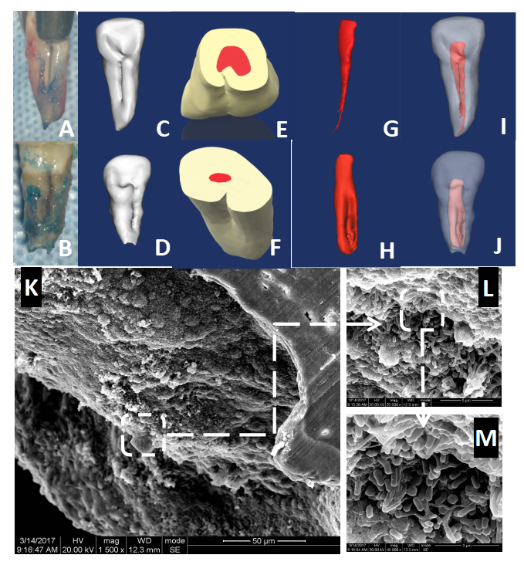
Figure 1 Three-dimensional reconstruction of the teeth with palatal radicular groove and representative scanning electron microscope images for resected root apex. A and B: Intraoperative awareness of palatal groove during intentional replantation; C and D: Lingual view of the three-dimensional reconstruction models of type I and type II palatal grooves; E-J: Shapes of the pulp cavity associated with type I and II palatal grooves and their spatial and configurational relationship with the root; K-M: Gradually magnified scanning electron microscope photograph series of the biofilm covering the root apex of tooth with palatal radicular groove associated infection (K: × 1500; L: × 20000; M: × 40000).
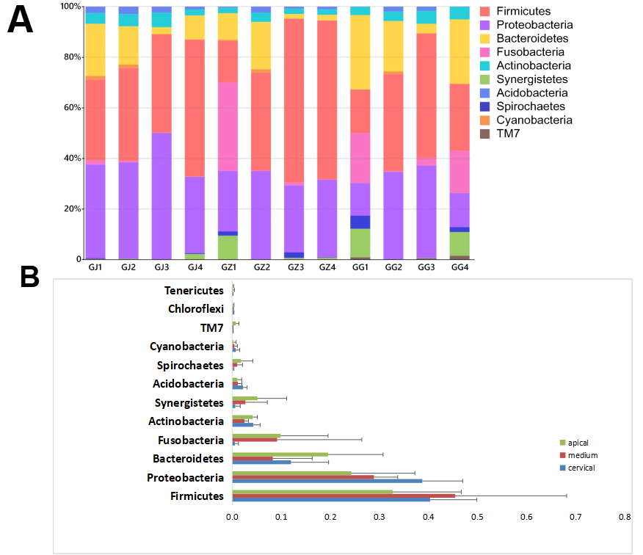
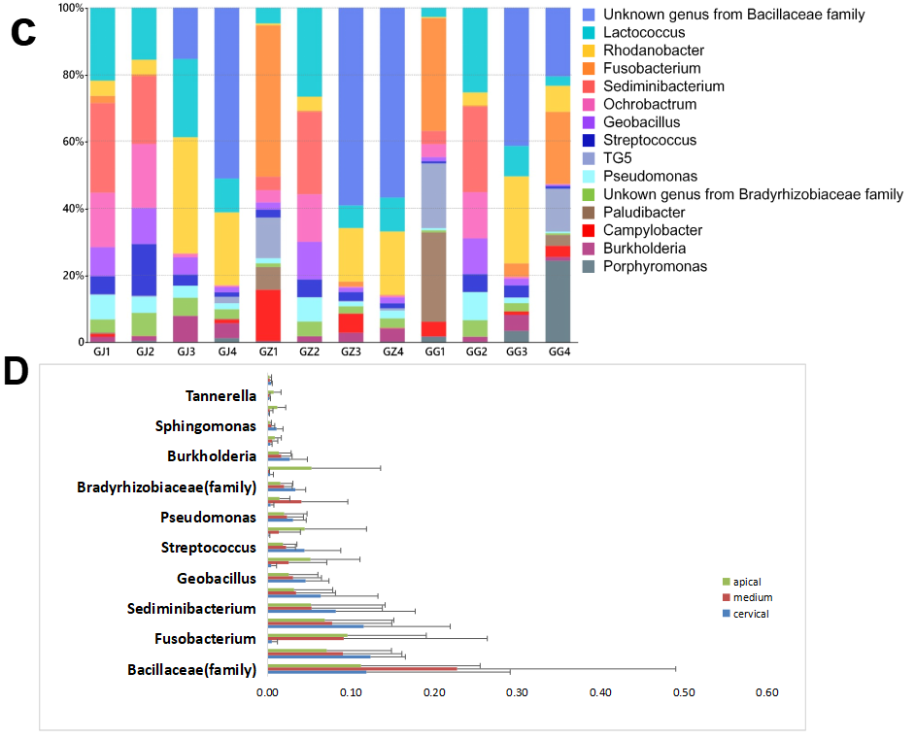
Figure 2 Distribution and abundance of phyla and genera. A and B: Distribution and abundance of phyla (relative abundances > 0.2%) in the microbiota derived from various sections of palatal grooves accompanied with endodontic-periodontal diseases; C and D: Distribution and abundance of genera (relative abundances > 1.5%) in the microbiota derived from various sections of palatal grooves accompanied with endodontic-periodontal diseases. GG: Cervical samples; GJ: Apical samples; GZ: Middle samples.
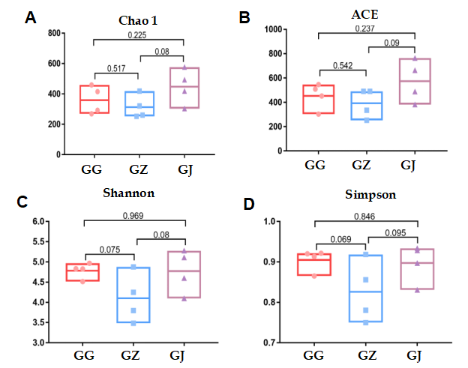
Figure 3 Alpha diversity analyses of bacterial communities in various sections of palatal grooves diagnosed with endodontic-periodontal infections. A: The Chao1 richness estimator; B: The angiotensin converting enzyme richness estimator; C: The Shannon diversity index; D: The Simpson diversity index. Boxes and dots represent the values generated from each group. Line in the middle of the column indicates the average value of each part. P values were shown above the connection lines, and no significant differences were detected among groups. ACE: Angiotensin converting enzyme; GG: Cervical samples; GJ: Apical samples; GZ: Middle samples.
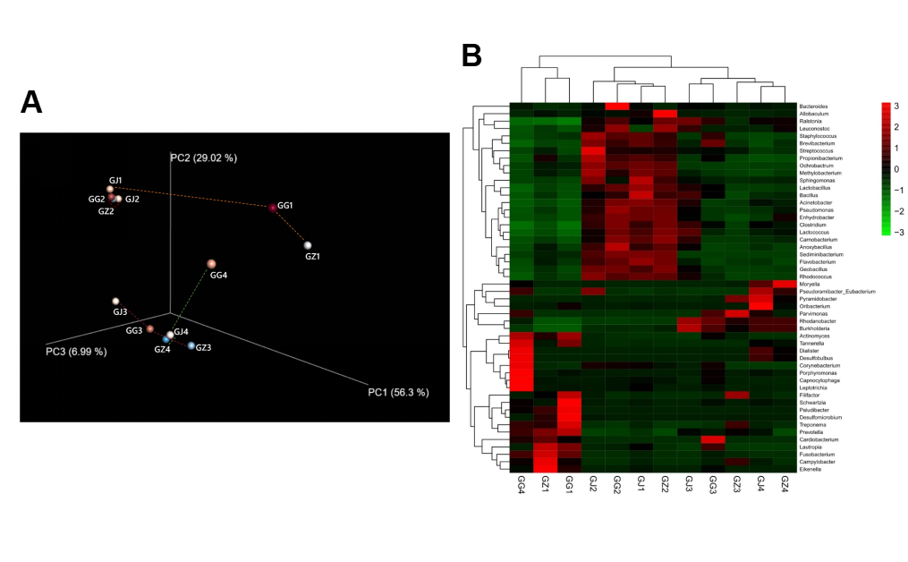
Figure 4 Bacterial community structures. A: Principal coordinates analysis plot of the phylogenetic distances (Weighted UniFrac) among the segments from 4 infected roots with palatal grooves. Principal coordinates PC1, PC2, and PC3 explained 56.30%, 29.02%, and 6.99% of the overall variance among the samples, respectively. Segments (GJ, GZ, and GG) from the same root (labeled with the same number) are connected with dashed lines. Segment groups differ in their phylogenetic relatedness from being very adjacent or similar (root 2 and 3) to very distant or phylogenetically different (GJ1 and GG4 from root 1 and 4, respectively); B: Cluster and comparison of the samples at the genus level using a gradient heat map (microbiota with the top 50 abundance). GJ: Apical samples; GZ: Middle samples; GG: Cervical samples.
Table 1 Demographic and clinical information of the participants
Patient ID | Age in yr | Sex | Tooth number¹ | Groove  type | Location of  the groove | Probing depth of the localized periodontal pocket in mm | Groove’s stop, examined during intentional replantation
1 | 28 | Male | 7 | II | Mesial | 8 | Junction of the medium and apical thirds of the root
2 | 33 | Male | 7 | I | Distal | 10 | Junction of the medium and apical thirds of the root
3 | 36 | Male | 7 | II | Distal | 12 | Root apex
4 | 44 | Female | 7 | I | Distal | 12 | Approaching the root apex (about 3 mm above the apex)
¹Applied with the universal numbering system.
Table 2 Taxonomic and spatial distribution of the identified operational taxonomic unit
Sample ID | Phylum | Class | Order | Family | Genus | Species
GJ1 | 686¹ | 686 | 679 | 598 | 391 | 92
GZ1 | 513 | 513 | 501 | 452 | 327 | 75
GG1 | 477 | 477 | 465 | 422 | 308 | 56
GJ2 | 622 | 622 | 610 | 531 | 362 | 84
GZ2 | 543 | 543 | 534 | 460 | 313 | 74
GG2 | 583 | 583 | 567 | 500 | 340 | 75
GJ3 | 573 | 573 | 560 | 479 | 287 | 70
GZ3 | 428 | 428 | 419 | 374 | 244 | 52
GG3 | 635 | 635 | 620 | 548 | 348 | 79
GJ4 | 480 | 480 | 469 | 420 | 281 | 60
GZ4 | 444 | 444 | 434 | 377 | 240 | 48
GG4 | 402 | 402 | 391 | 367 | 258 | 41
¹Data represents numbers of operational taxonomic units identified in this sample categorized into this taxonomic level. GG: Cervical samples; GJ: Apical samples; GZ: Medium samples.

Published by Baishideng Publishing Group Inc
7041 Koll Center Parkway, Suite 160, Pleasanton, CA 94566, USA
Telephone: +1-925-3991568
E-mail: bpgoffice@wjgnet.com
Help Desk: https://www.f6publishing.com/helpdesk
https://www.wjgnet.com

© 2021 Baishideng Publishing Group Inc. All rights reserved.

