Name of Journal: World Journal of Clinical Cases
Manuscript NO: 89410
Manuscript Type: CASE REPORT

Addison's disease caused by adrenal tuberculosis may lead to misdiagnosis of major depressive disorder: A case report

Zhang et al. Misdiagnosis of Addison's disease

Tian-Xiang Zhang, Hong-Yan Xu, Wei Ma, Jian-Bao Zheng

Tian-Xiang Zhang, Hong-Yan Xu, Wei Ma, Jian-Bao Zheng, Department of Tuberculosis, The Tuberculosis Hospital of Shaanxi Province, Xi’an 710100, Shaanxi Province, China

Jian-Bao Zheng, Department of General Surgery, First Affiliated Hospital of Xi’an Jiaotong University, Xi’an 710100, Shaanxi Province, China

Co-first authors: Tian-Xiang Zhang and Hong-Yan Xu.

Author contributions: Xu HY and Zhang TX discussed the patient and formulated the treatment plan; Zhang TX provided patient information and wrote the manuscript; Ma W contributed to the data analysis; Zheng JB contributed to conceptualization and supervision; all authors have read and agreed to the published version of the manuscript. Zhang TX and Xu HY contributed equally to this work as co-first authors. This article is the result of the joint efforts of researchers, and designating a collaborative work represents recognition of authors who have made similar contributions to this study, acknowledging the spirit of teamwork in this study. During patient diagnosis, treatment, and follow-up, different fields of knowledge enrich the discussion section of the article, improve the quality of the manuscript, and take the research to a deeper level, allowing readers to understand more disease-related knowledge while reading. In the process of writing an article, different writing techniques such as creating charts and photographs can help improve the content and make the article more comprehensive. We believe that Zhang TX and Xu HY are suitable as co-first authors of our manuscript, providing deeper content, making the article more comprehensive, and reflecting the equal contribution and importance of teamwork.

Corresponding author: Jian-Bao Zheng, PhD, Professor, Department of Tuberculosis, The Tuberculosis Hospital of Shaanxi Province, No. 1 Jiazi, Shangwan Village, Taiyigong Town, Xi’an 710100, Shaanxi Province, China. jacke6071@163.com

Received: October 30, 2023
Revised: November 30, 2023
Accepted: December 19, 2023
Published online:

Abstract
BACKGROUND
Addison’s disease (AD) is a rare but potentially fatal disease in Western countries, which can easily be misdiagnosed at an early stage. Severe adrenal tuberculosis (TB) may lead to depression in patients.

CASE SUMMARY
We report a case of primary adrenal insufficiency secondary to adrenal TB with TB in the lungs and skin in a 48-year-old woman. The patient was misdiagnosed with depression because of her depressed mood. She had hyperpigmentation of the skin, nails, mouth, and lips. The final diagnosis was adrenal TB that resulted in the insufficient secretion of adrenocortical hormone. Adrenocortical hormone test, skin biopsy, T cell spot test of TB, and adrenal computed tomography scan were used to confirm the diagnosis. The patient’s condition improved after hormone replacement therapy and TB treatment.

CONCLUSION
Given the current status of TB in high-burden countries, outpatient doctors should be aware of and pay attention to TB and understand the early symptoms of AD.

Key Words: Primary adrenal insufficiency; Adrenal tuberculosis; Fatigue; Hypotension; Hyperkalemia; Hyponatremia; Depression; Case report

Zhang TX, Xu HY, Ma W, Zheng JB. Addison's disease caused by adrenal tuberculosis may lead to misdiagnosis of major depressive disorder: A case report. World J Clin Cases 2023; In press

Core Tip: Symptoms of early-onset depressed mood and skin pigmentation in developing countries warrant consideration for Addison’s disease (AD) induced by adrenal tuberculosis (TB) Diagnostic anti-TB therapy with rifampicin is not recommended because of the risk of adrenal crisis; T cell spot test of TB negativity cannot be used as a criterion to exclude TB, especially in immunocompromised patients or those with hematogenous disseminated pulmonary TB; In AD caused by adrenal TB, recovering adrenal function is difficult, with most cases requiring lifelong hormone replacement therapy.

INTRODUCTION
Primary adrenal insufficiency or Addison’s disease (AD) is characterized by damage to the adrenal gland, resulting in the insufficient production of cortisol, aldosterone, and sex hormones. AD is a rare disease with an incidence of 4:1000000 cases per year in Western countries and has fatal consequences^{[1]}. This disorder can lead to depressed mood and depression^{[2]}.
Autoimmune adrenalitis is the leading cause of AD in developed countries, whereas in developing countries, adrenal tuberculosis (TB) remains an important cause of morbidity. The nonspecific symptoms of AD and the low frequency of non-TB epidemic countries often lead to neglect or delay in diagnosing the disease. Less experience in diagnosis has been noted for nonrelated professional doctors, resulting in a higher frequency of misdiagnosis in recent years^{[3]}.

CASE PRESENTATION
Chief complaints
A 48-year-old woman was admitted to Shaanxi TB Hospital with the chief complaint of skin pigmentation for 1 year.

History of present illness
The patient experienced depressed mood, fatigue, decreased appetite, and hyperpigmentation of the skin, nails, mouth, and mucous membranes of the lips (Figure 1), which started 1 year prior to the consultation.

History of past illness
The patient experienced skin pigmentation for 1 year. She was also diagnosed with depression according to ICD-10 at other hospitals and was prescribed duloxetine hydrochloride 60 mg once daily and clonazepam 0.25 mg once daily. However, her depressive symptoms did not improve after 1 mo of treatment. She presented with a skin ulcer on her back, and pathological biopsy of the dorsal skin lesions showed hyperkeratosis and tuberculoid granulomatous inflammation (Figure 2A and B).

Personal and family history
The patient denied having any genetic and she did not have a history of smoking or pulmonary TB.

Physical examination
On physical examination, the vital signs were as follows: Body temperature of 37.4 ℃, blood pressure of 63/40 mmHg, heart rate of 114 bpm, and respiratory rate of 21 breaths per min. There was hyperpigmentation of the skin, nails, mouth, and mucous membranes of the lips, which persisted after pressing and wiping. Two skin lesions were found on the left back, with no secretions (Figure 2C).

Laboratory examinations
Laboratory tests showed elevated inflammatory parameters (erythrocyte sedimentation rate: 42 mm/h, C-reactive protein: 52.2 mg/L, and procalcitonin: 0.65 ng/mL). The patient also had hyperkalemia (5.6 mmol/L), hyponatremia (111.8 mmol/L), and hypochloremia (81.1 mmol/L). Persistent hypotension (80/40 mmHg) was observed. T cell spot test of TB (T-SPOT.TB) was positive.

Imaging examinations
Chest computed tomography (CT) revealed infectious lesions in both lungs (Figure 3). Fiberoptic bronchoscopy was recommended, but the patient did not consent.

Further diagnostic workup
Refractory hyperkalemia and hyponatremia alongside persistent hypotension of 80/40 mmHg were observed. The patient’s condition did not improve despite electrolyte correction, rehydration, and use of vasoactive drugs. Thus, adrenal hormone secretion deficiency was considered based on her symptoms and laboratory tests. Further workup revealed cortisol < 1.31 μg/dL and adrenocorticotropic hormone (ACTH) > 2000 pg/mL. Adrenal CT revealed bilateral calcification and giant masses in the adrenal glands (Figure 4).

FINAL DIAGNOSIS
The final diagnosis was AD secondary to adrenal TB.

TREATMENT
The treatment protocol was as follows: Prednisone (PAT) 5 mg once daily at 8 am, isoniazid 0.3 g once daily, rifampicin 0.6 g once daily, pyrazinamide 0.5 g thrice daily, and ethambutol hydrochloride 1.0 g once daily. During the combined treatment of PAT plus anti-TB therapy, the patient had no adverse drug reactions.

OUTCOME AND FOLLOW-UP
After 2 wk of combined treatment, there was significant improvement in depressive symptoms, and her blood pressure and serum electrolyte levels normalized (Figure 5). After 1 mo of combined treatment, chest CT showed improvement in inflammation (Figure 6), and after 6 mo, the patient’s pigmentation improved (Figure 7).

DISCUSSION
At present, the prevention and treatment of TB remains grim. In 2020, approximately 1.5 million deaths worldwide were attributable to TB, with a TB case fatality rate of 15% (up from 14% in 2019). The number of TB deaths among human immunodeficiency virus-negative patients increased from 1.21 million to 1.28 million in 2019^{[4]}. Primary adrenal insufficiency was discovered by Addison et al^{[5]} in 1855. When he first described adrenocortical insufficiency in his patients, 6 of 11 cases were caused by the destruction of the adrenal cortex by Mycobacterium tuberculosis^{[6]}. In 1930, Guttman et al^{[7]} reported 566 patients with AD, of whom 70% had AD caused by tuberculous adrenalitis. By 1956, the number decreased to 25%. A meta-analysis performed by Italian scholars in 2011 showed a decrease in the incidence of adrenal failure secondary to tuberculous in 615 patients with AD. Only 9% of the cases were caused by TB^{[8]}. TB is no longer the most common cause of AD in developed countries. Recent data suggest that this trend continues, with an increasing prevalence of AD, particularly in women^{[9]}. Today, in Western societies, 80% of AD cases are caused by autoimmune adrenalitis, followed by TB or other infectious and malignant diseases in approximately 10% the cases. However, the most common cause of AD in developing countries remains infection with M. tuberculosis, which spreads to the adrenal glands via the bloodstream^{[6]}. The current treatment is hormone therapy, with most patients requiring lifelong replacement therapy. Hydrocortisone is the drug of choice for glucocorticoid replacement, but 3-5 mg/dL prednisolone as a single dose or in two divided oral doses is an alternative.
Many patients have no obvious early symptoms. Alterations in sleep habits, mood, and behavior can sometimes be the first symptoms. Severely ill patients seek medical attention owing to fatal adrenal crisis. AD becomes apparent only when > 90% of the adrenal glands are destroyed by TB. Most active or recently active (< 2 years) patients with TB have bilateral adrenal enlargement, calcifications, and atrophy that is typical of longstanding infections caused by TB^{[10]}.
In our case, AD was misdiagnosed as depression in the outpatient clinic of the patient due to long-term skin pigmentation. At the time of admission to our hospital, her chest CT showed manifestations of a pulmonary infection, and skin biopsy revealed a pathological diagnosis of TB granuloma. The adrenal gland CT showed enlargement and calcification. Given the signs and symptoms of this patient and the high suspicion for tuberculous adrenalitis, cortisol and ACTH were tested, which resulted in the diagnosis of AD secondary to adrenal TB. After 1 mo of anti-TB and hormone replacement therapy, chest CT showed improvement in inflammation. After 6 mo, the pigmentation was partially reversed.
This report aimed to show our experience in the diagnosis and treatment of AD. First, it was important that the physician made the correct diagnosis in the outpatient clinic at an early stage. AD involves multiple organs, including the brain. This patient was diagnosed with depression at another hospital, and the signs of skin hyperpigmentation, hypotension, and electrolyte disorder were ignored. Thus, AD should be considered when multiple mucosal hyperpigmentation and depression are observed in countries with a high burden of TB. Second, reversal of hormone secretion changes in AD induced by adrenal TB is extremely difficult even after long-term anti-TB treatment. Most patients require lifelong hormone replacement therapy. Additionally, we do not recommend diagnostic anti-TB therapy as a diagnostic measure because it is also worth noting that rifampicin has the potential to cause adrenal crisis. This can interfere with the diagnosis of AD and should be carefully differentiated^{[11]}. Third, T-SPOT.TB positivity can be used as a reference indicator for TB infection, but T-SPOT.TB negativity cannot be used as a basis for excluding the infection, especially in immunocompromised patients or those with hematogenous disseminated pulmonary TB^{[12]}. In terms of treatment, once AD induced by adrenal TB is diagnosed, lifelong hormone replacement therapy and a course of anti-TB treatment are required. In summary, AD symptoms caused by TB are insidious and easily misdiagnosed in the early stage.

CONCLUSION
Given the current status of TB in high-burden countries, outpatient doctors should pay attention to the early symptoms of AD and consider the possibility of TB infection. In addition, recovery of adrenal function after AD caused by adrenal TB is difficult, and most cases require lifelong hormone replacement therapy.

REFERENCES
1 Puar TH, Stikkelbroeck NM, Smans LC, Zelissen PM, Hermus AR. Adrenal Crisis: Still a Deadly Event in the 21st Century. Am J Med 2016; 129: 339.e1-339.e9 [PMID: 26363354 DOI: 10.1016/j.amjmed.2015.08.021]
2 van Haren Noman S, Visser H, Muller AF, Limonard GJ. Addison's Disease Caused by Tuberculosis: Diagnostic and Therapeutic Difficulties. Eur J Case Rep Intern Med 2018; 5: 000911 [PMID: 30756059 DOI: 10.12890/2018_000911]
3 Rowińska-Zakrzewska E, Szopiński J, Remiszewski P, Szymańska D, Miller M, Pawlicka L, Zwolska-Kwiek Z. Tuberculosis in the autopsy material: analysis of 1500 autopsies performed between 1972 and 1991 in the Institute of Tuberculosis and Chest Diseases, Warsaw, Poland. Tuber Lung Dis 1995; 76: 349-354 [PMID: 7579318 DOI: 10.1016/s0962-8479(05)80035-8]
4 World Health Organization. Global tuberculosis report 2021. Oct 14, 2021. [cited 31 January 2022]. Available from: https://www.who.int/publications/i/item/9789240037021
5 . On the Constitutional and Local Effects of Disease of the Supra-Renal Capsules. Br Foreign Med Chir Rev 1856; 18: 404-413 [PMID: 30164929]
6 Jacob JJ, Paul PAM. Infections in Endocrinology: Tuberculosis. 2021 Mar 14. In: Endotext [Internet]. South Dartmouth (MA): MDText.com, Inc.; 2000– [PMID: 33734657]
7 Guttman P, Guttman PH, Guttman P. Addison's disease-a statistical analysis of 566 cases and a study of the pathology. Arch Pathol 1930; 10: 742-935
8 Betterle C, Morlin L. Autoimmune Addison's disease. Endocr Dev 2011; 20: 161-172 [PMID: 21164269 DOI: 10.1159/000321239]
9 Meyer G, Neumann K, Badenhoop K, Linder R. Increasing prevalence of Addison's disease in German females: health insurance data 2008-2012. Eur J Endocrinol 2014; 170: 367-373 [PMID: 24322183 DOI: 10.1530/EJE-13-0756]
10 Gupta S, Ansari MAM, Gupta AK, Chaudhary P, Bansal LK. Current Approach for Diagnosis and Treatment of Adrenal Tuberculosis-Our Experience and Review of Literature. Surg J (N Y) 2022; 8: e92-e97 [PMID: 35252566 DOI: 10.1055/s-0042-1743523]
11 Yokoyama T, Toda R, Kimura Y, Mikagi M, Aizawa H. Addison's disease induced by miliary tuberculosis and the administration of rifampicin. Intern Med 2009; 48: 1297-1300 [PMID: 19652434 DOI: 10.2169/internalmedicine.48.1974]
12 Whitworth HS, Badhan A, Boakye AA, Takwoingi Y, Rees-Roberts M, Partlett C, Lambie H, Innes J, Cooke G, Lipman M, Conlon C, Macallan D, Chua F, Post FA, Wiselka M, Woltmann G, Deeks JJ, Kon OM, Lalvani A; Interferon-γ Release Assays for Diagnostic Evaluation of Active Tuberculosis study group. Clinical utility of existing and second-generation interferon-γ release assays for diagnostic evaluation of tuberculosis: an observational cohort study. Lancet Infect Dis 2019; 19: 193-202 [PMID: 30655049 DOI: 10.1016/S1473-3099(18)30613-3]

Footnotes
Informed consent statement: Informed written consent was obtained from the patient for publication of this report and any accompanying images.

Conflict-of-interest statement: The authors declare that they have no conflict of interest.

CARE Checklist (2016) statement: The authors have read the CARE Checklist (2016), and the manuscript was prepared and revised according to the CARE Checklist (2016).

Open-Access: This article is an open-access article that was selected by an in-house editor and fully peer-reviewed by external reviewers. It is distributed in accordance with the Creative Commons Attribution NonCommercial (CC BY-NC 4.0) license, which permits others to distribute, remix, adapt, build upon this work non-commercially, and license their derivative works on different terms, provided the original work is properly cited and the use is non-commercial. See: https://creativecommons.org/Licenses/by-nc/4.0/

Provenance and peer review: Unsolicited article; Externally peer reviewed.

Peer-review model: Single blind

Peer-review started: October 30, 2023
First decision: November 21, 2023
Article in press:

Specialty type: Medicine, research and experimental
Country/Territory of origin: China
Peer-review report’s scientific quality classification
Grade A (Excellent): 0
Grade B (Very good): B
Grade C (Good): 0
Grade D (Fair): 0
Grade E (Poor): 0

P-Reviewer: Pavón L, Mexico S-Editor: Qu XL L-Editor: A P-Editor:
Figure Legends
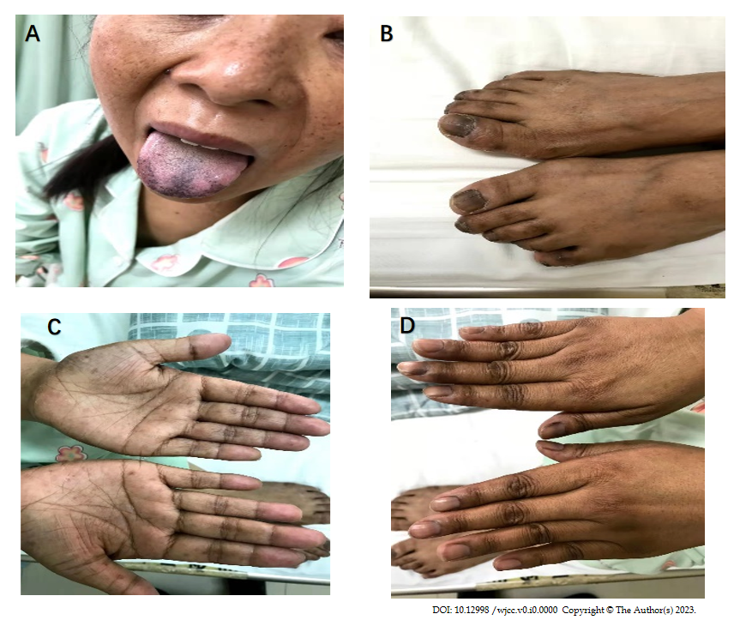
Figure 1 Multiple skin pigmentation. A: Hyperpigmentation on the skin of face, mouth, tongue and mucous membranes of the lips; B-D: Hyperpigmentation on nails, hands and feet.

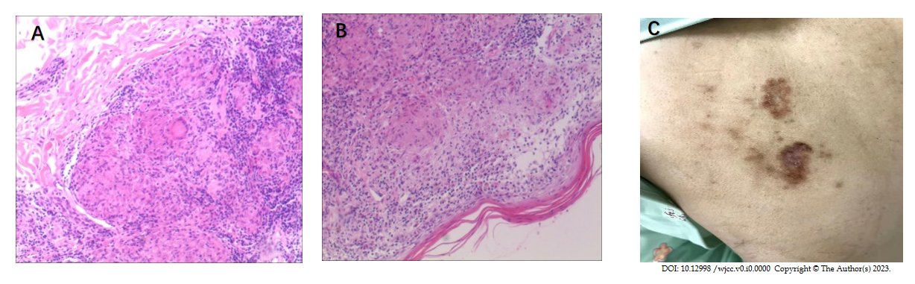
Figure 2 Histopathological analysis of the resected specimen. A and B: Haematoxylin and eosin staining (× 40). Pathology of cutaneous tuberculosis; C: Skin ulcers on the back.

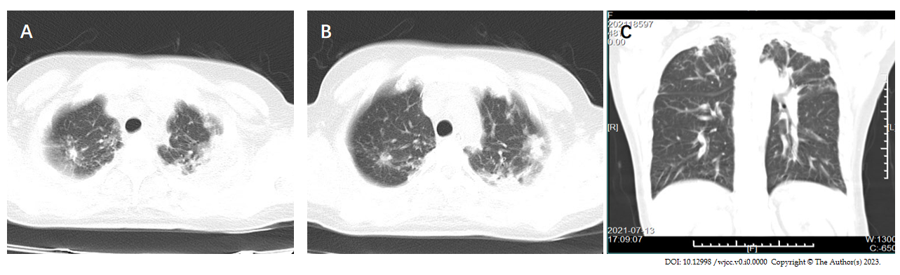
Figure 3 Computed tomography scan of pulmonary tuberculosis before treatment. A and B: Upper field infection of both lungs; C: Computed tomography chest lung window coronal view shows bilateral lung infection.
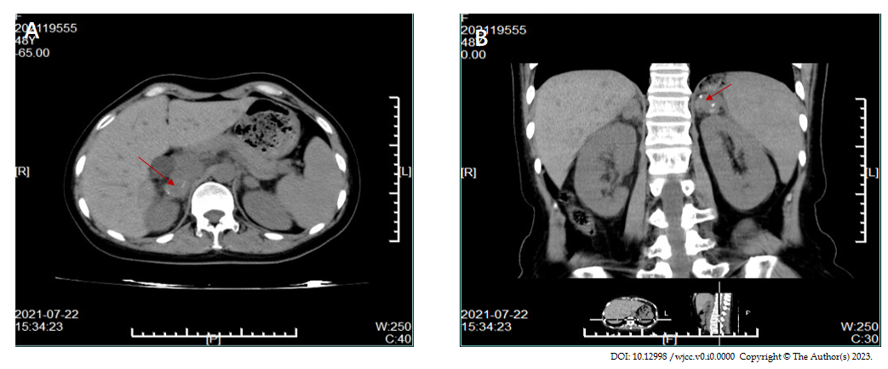
Figure 4 Adrenal computed tomography scan of adrenal enlargement and calcification (red arrow). A: Right adrenal gland enlargement and calcification at the red arrow; B: Abdominal computed tomography coronal view shows enlargement and calcification of the right adrenal gland at the red arrow.

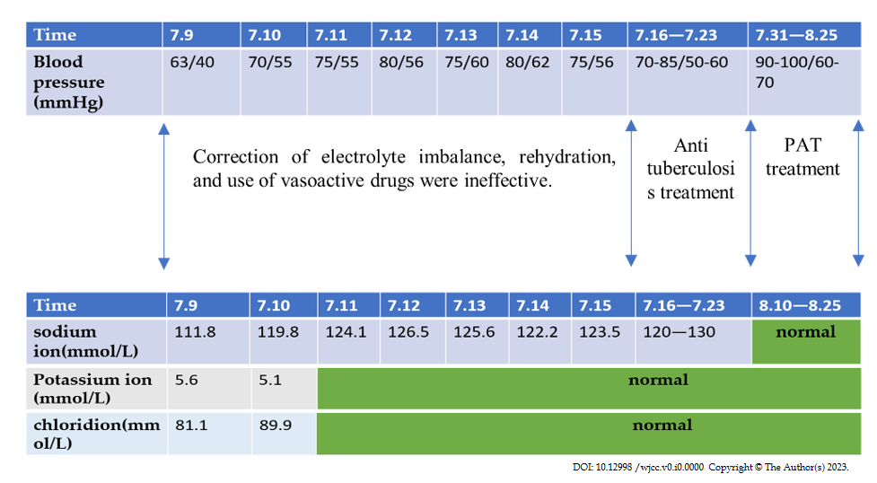
Figure 5 Time line table of the patient. PAT: Prednisone.

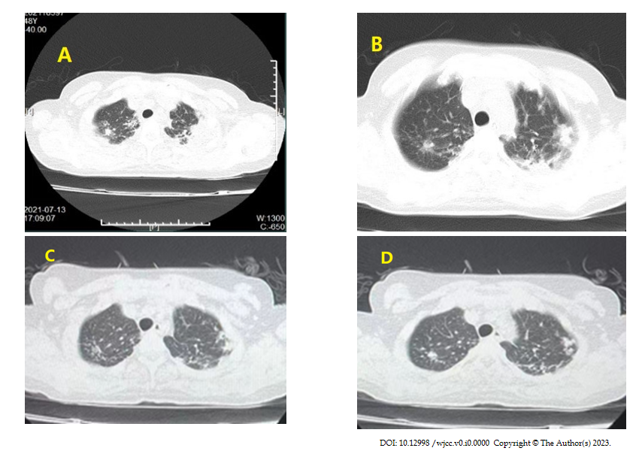
Figure 6 Chest computed tomography scans before and after treatment. A and B: Before anti tuberculosis treatment; C and D: After 1 mo of treatment, chest computed tomography showed improvement in inflammation.
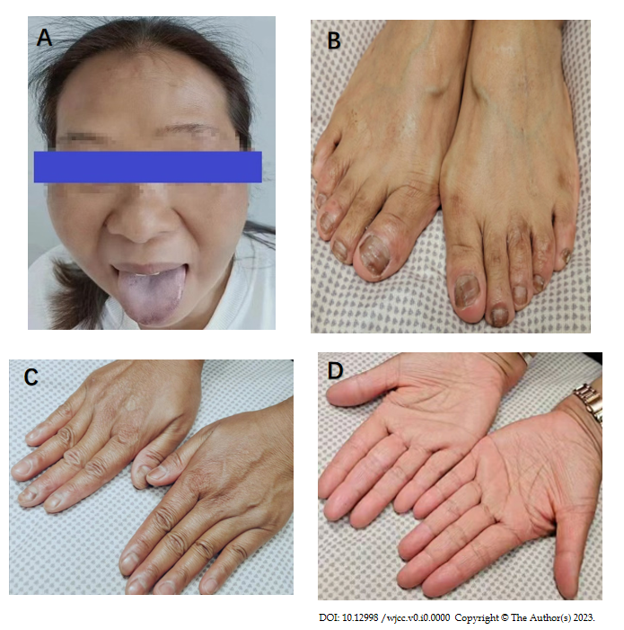
Figure 7 After 6 mo of treatment, the pigmentation was partially reversed. A: Hyperpigmentation on the skin of face, mouth, tongue and mucous membranes of the lips; B-D: Hyperpigmentation on nails, hands and feet.

