Name of Journal: World Journal of Gastroenterology
Manuscript NO: 75751
Manuscript Type: MINIREVIEWS

Endoscopic salvage therapy after failed biliary cannulation using advanced techniques: A concise review

Tsou YK et al. Endoscopic salvage for failed ERCP

Yung-Kuan Tsou, Kuang-Tse Pan, Mu Hsien Lee, Cheng-Hui Lin

Yung-Kuan Tsou, Mu Hsien Lee, Cheng-Hui Lin, Department of Gastroenterology and Hepatology, Chang Gung Memorial Hospital, Taoyuan 333, Taiwan

Yung-Kuan Tsou, Kuang-Tse Pan, Mu Hsien Lee, Cheng-Hui Lin, Department of Medicine, Chang Gung University, Taoyuan 333, Taiwan

Kuang-Tse Pan, Department of Medical Imaging and Intervention, Chang Gung Memorial Hospital, Taoyuan 333, Taiwan

Author contributions: Tsou YK conceptualized and designed the review and wrote the manuscript; Pan KT was responsible for the data acquisition/analysis of the percutaneous-transhepatic-endoscopic rendezvous procedures; Lee MH was responsible for the data acquisition/analysis of the endoscopic ultrasound-assisted or guided procedures; Lin CH contributed to revising and validating the manuscript.

Corresponding author: Cheng-Hui Lin, MD, Doctor, Department of Gastroenterology and Hepatology, Chang Gung Memorial Hospital, No. 5 Fu-Shin Street, Kweishan, Taoyuan 333, Taiwan. linchehui@adm.cgmh.org.tw

Received: February 13, 2022
Revised: April 15, 2022
Accepted: July 5, 2022
Published online: August 7, 2022

Abstract
Therapeutic endoscopic retrograde cholangiopancreatography (ERCP) begins with successful biliary cannulation. However, it is not always be successful. The failure of the initial ERCP is attributed to two main aspects: the papilla/biliary orifice is endoscopically accessible, or it is inaccessible. When the papilla/biliary orifice is accessible, bile duct cannulation failure can occur even with advanced cannulation techniques, including double guidewire techniques, transpancreatic sphincterotomy, needle-knife precut papillotomy, or fistulotomy. There is currently no consensus on the next steps of treatment in this setting. Therefore, this review aims to propose and discuss potential endoscopic options for patients who have failed ERCP due to difficult bile duct cannulation. These options include interval ERCP, percutaneous-transhepatic-endoscopic rendezvous procedures (PTE-RV), and endoscopic ultrasound-assisted rendezvous procedures (EUS-RV). The overall success rate for interval ERCP was 76.3% (68%-79% between studies), and the overall adverse event rate was 7.5% (0-15.9% between studies). The overall success rate for PTE-RV was 88.7% (80.4%-100% between studies), and the overall adverse event rate was 13.2% (4.9%-19.2% between studies). For EUS-RV, the overall success rate was 82%-86.1%, and the overall adverse event rate was 13%-15.6%. Because interval ERCP has an acceptably high success rate and lower adverse event rate and does not require additional expertise, facilities, or other specialists, it can be considered the first choice for salvage therapy. EUS-RV can also be considered if local experts are available. For patients in urgent need of biliary drainage, PTE-RV should be considered.

Key Words: Difficult biliary cannulation; Endoscopic ultrasound; Rendezvous; Endoscopic retrograde cholangiopancreatography; Percutaneous transhepatic biliary drainage; Interval

©The Author(s) 2022. Published by Baishideng Publishing Group Inc. All rights reserved.

Citation: Tsou YK, Pan KT, Lee MH, Lin CH. Endoscopic salvage therapy after failed biliary cannulation using advanced techniques: A concise review. World J Gastroenterol 2022; 28(29): 3803-3813
URL: https://www.wjgnet.com/1007-9327/full/v28/i29/3803.htm
DOI: https://dx.doi.org/10.3748/wjg.v28.i29.3803

Core Tip: Three endoscopic salvage therapies are available for endoscopic retrograde cholangiopancreatography (ERCP) cannulation failure, but consensus is lacking. This review found that interval ERCP had an overall success rate of 76.3% and an adverse event rate of 7.5%. Percutaneous-transhepatic-endoscopic rendezvous procedure (PTE-RV) had an overall success rate of 88.7% and an adverse event rate of 13.2%. Endoscopic ultrasound-assisted rendezvous procedures (EUS-RV) had an overall success rate of 82%-86.1% and an adverse event rate of 13%-15.6%. Interval ERCP may be preferred, but EUS-RV may also be considered if a local expert is available. PTE-RV is reserved for patients requiring urgent biliary drainage.

INTRODUCTION
Endoscopic retrograde cholangiopancreatography (ERCP) has become the treatment of choice for biliary tract diseases in recent decades. Selective biliary cannulation (SBC) is a critical step in the success of therapeutic ERCP; however, it is not always successful, even for experienced endoscopists^{[1]}. The failure to achieve SBC during the initial ERCP can be attributed to two main aspects: an endoscopically inaccessible papilla/biliary orifice; and an endoscopically accessible papilla/biliary orifice but failed SBC with available cannulation methods. Management of initial ERCP failure constitutes a major clinical challenge for endoscopists. This review focuses on the endoscopic management of initial SBC failure in patients with an accessible papilla/biliary orifice.
When the major papilla is accessible, SBC typically begins with standard cannulation methods through a cannula or sphincterotome using either guidewire-assisted or contrast-guided techniques^{[2]}. Using standard cannulation techniques, SBC fails in approximately 5% to 15% of cases^{[3]}. This condition is often referred to as difficult biliary cannulation, although definitions have varied widely between endoscopists or studies^{[4,5]}. In this case, depending on the experience or preference of the endoscopist, a variety of advanced techniques can be applied as a means of rescue. In general, when unintentional pancreatic guidewire insertion has been achieved, a double guidewire cannulation approach can be attempted^{[1]}. Alternately or sequentially, transpancreatic sphincterotomy can be performed^{[6]}. However, some endoscopists might prefer to perform needle-knife precut papillotomy (NKP) or needle-knife fistulotomy (NKF), especially after the placement of a pancreatic stent^{[2,7]}. If the pancreatic duct is not cannulated, however, only NKP or NKF can be applied^{[4]}. The application of these advanced technologies does not require additional facilities. Today, most qualified ERCP endoscopists can master at least some of these advanced cannulation techniques, so these procedures can often be performed by the same endoscopist during the same endoscopic session^{[8]}. Despite these rescue techniques, failed biliary cannulation can occur^{[9]}. Therefore, in this review, difficult biliary cannulation was defined as failure to achieve SBC using the advanced techniques described above^{[10,11]}. In the setting of difficult bile duct cannulation, there is currently no consensus on the next steps in treatment^{[9]}. Because endoscopic therapy has the advantage of a broader range of treatment options and no need for external drainage, this review aims to propose and discuss potential endoscopic options, alone or in combination with the percutaneous procedure, for patients who have failed initial ERCP due to difficult bile duct cannulation. These endoscopic options include interval ERCP, percutaneous-transhepatic-endoscopic rendezvous procedures (PTE-RV), and endoscopic ultrasound (EUS)-guided procedures. We also propose a potential treatment algorithm to provide practical advice.

Interval ERCP
In a literature search in early 2022, we were only able to find 7 studies (371 patients in total) reporting interval ERCP^{[9,12-17]}. All of these studies were retrospective. There were no review/meta-analysis articles on this topic. However, when SBC cannot be achieved by advanced cannulation techniques, such as NKP or NKF, these studies have shown that interval ERCP is a viable treatment option (Table 1)^{[9,12-17]}. The overall success rate of interval ERCP was 76.3% (68%-79% between studies). The time interval between the initial ERCP and the interval ERCP varies greatly from study to study (median, 3-8 d)^{[9,12,13,15-17]}. Three studies reported that 0%, 16%, and 28% of patients required a second precut procedure during the interval ERCP, respectively^{[9,12,14]}.
Interestingly, the timing to perform interval ERCP appeared to affect the success rate of interval ERCP^{[9,13,14,16]}. The edema, tissue necrosis, and even bleeding of the major papilla caused by cannulation and/or NKP/F improved over time, resulting in an open and easily accessible papilla (Figures 1 and 2). Therefore, the success rate of interval ERCP could increase if it could be delayed for a couple of days. Donnellan et al^{[13]} reported a significantly longer median time interval between initial and interval ERCP in the successful cannulation group compared to the failed cannulation group (6.0, 1-28 d vs 3.0, 1-8 d; P = 0.02). Kim et al^{[14]} studied only patients who received interval ERCP within 3 d^{[14]}. They reported that the success rate of interval ERCP after one day was significantly lower than after 2-3 d (65.7% vs 88.2%, P = 0.027). Except for the time interval, no other factor was significantly associated with the success of interval ERCP in their study. Colan-Hernandez et al^{[16]} performed univariate and multivariate analyses of factors associated with interval ERCP cannulation failure. They found that the ERCP interval within 4 d after the initial precut was the only significant factor (cannulation success rate of 44.4% vs 79.4%, P = 0.024 for univariate and 0.026 for multivariate analysis). However, in our study, we did not find any factors associated with interval ERCP failure in either the univariate or multivariate analysis^{[9]}.
Adverse events of interval ERCP were reported in five studies involving a total of 254 patients^{[9,12-14,16]}. These adverse events included pancreatitis, bleeding, perforation, and cholangitis. The overall adverse event rate was 7.5% (0-15.9% between studies). Pancreatitis occurred in 1.6% (0-2.9%); all cases were mild. The bleeding rate was 2.8% (0-5.8%). Approximately half of the bleeding was mild, and the other half was moderate. The perforation rate was 1.2% (0-2.9%); all cases were mild. The cholangitis rate was 2.0% (0-4.7%). Two studies compared adverse event rates for initial and interval ERCP and found no significant difference^{[14,15]}.
In these studies, only 38%-82% of patients received interval ERCP when initial NKP/F failed to achieve SBC^{[9,12-17]}. This result could reflect that some other salvage treatments, such as percutaneous or EUS-guided drainage, are still applicable in this situation^{[18]}.

Percutaneous-transhepatic-endoscopic rendezvous procedures
Percutaneous transhepatic biliary drainage (PTBD) remains possibly the most widely used salvage therapy in the setting of initial ERCP failure^{[19]}. However, PTBD has some drawbacks, including a high rate of adverse events, decreased patient quality of life, and most importantly, providing of somewhat limited options for therapeutic maneuvers^{[3]}. In addition, external drainage can cause discomfort and pain and often requires reintervention^{[20]}. Therefore, an improved technique combining percutaneous and endoscopic approaches, known as percutaneous-transhepatic-endoscopic rendezvous procedures (PTE-RV), seems preferable to PTBD^{[21]}. PTE-RV have been around for more than three decades^{[22]}. They have several advantages over PTBD alone: (1) PTE-RV allow for transhepatic puncture using only small-caliber catheters, thereby reducing complications. Bokemeyer et al^{[21]} reported significantly fewer complications with PTE-RV than in PTBD (16.6% vs 26.4%; P = 0.037); (2) PTE-RV allow endoscopists to perform therapeutic ERCP in the usual manner through rendezvous access; and (3) Although PTBD is part of PTE-RV, once the biliary obstruction is resolved, the percutaneous access is closed^{[23]}.
PTE-RV can be executed as a one-stage procedure or a two-stage procedure^{[23]}. The advantage of the one-stage procedure is that there is no need to insert a PTBD catheter. The two-stage procedure includes PTBD during the first session and internalization of the drain using an endoscope during the second session. These two steps are usually separated by a few hours to a few days^{[24]}. Wayman et al^{[25]} compared one-stage (n = 19) and two-stage PTE-RV (n = 22) and found that the technical success rates were comparable (94.7% vs 95.5%), but adverse events were more common in the two-stage group (37% vs 73%, P < 0.05), mainly due to complications related to external drainage.
For the following purposes, we recommend the insertion of a percutaneously placed hydrophilic-coated catheter (e.g., angiocatheter) before the endoscopic rendezvous procedure (Figure 3A). First, the hepatic capsule and parenchyma, which could be damaged by the antegrade-introduced guidewire (AGW), were protected. Second, to ensure percutaneous access, once the AGW is lost incidentally during PTE-RV, it can be reintroduced into the biliary tree. Third, to facilitate the movements of AGW. After the AGW is introduced into the duodenum, there are several ways to achieve SBC^{[23,26]}. The first and most classic technique is to grasp the distal end of the AGW with a snare and then pull the wire through the working channel of the endoscope. Retrograde bile duct cannulation can then be achieved over the wire (Figure 3B). This technique is particularly useful for patients with tight biliary strictures since the guidewire can be secured at both sides of percutaneous and endoscopic routes to facilitate retrograde passage of a catheter or stent through the stricture (push-pull technique). However, this technique might be limited by the difficult capture of the AGW and laborious guidewire manipulation, the potential for kinking or accidental loss of the AGW during withdrawal, and the risk of hepatic capsule/parenchymal tearing during AGW manipulation. The second and parallel technique is to use a standard ERCP cannulation method alongside the AGW or the percutaneously introduced catheter (Figure 3C). The advantage of this technique is that it is simple and perhaps time saving while avoiding the limitations of classical techniques. However, in some cases, it can be difficult. In such cases, retrograde biliary cannulation can be performed after antegrade balloon dilation of the biliary orifice. The other adjunctive maneuvers include insertion of a retrograde guidewire into a percutaneously placed catheter exiting the ampulla or insertion of a sphincterotome into the AGW exiting the ampulla^{[26]}.
PTE-RV has been relatively less investigated. In a literature search in early 2022, we found no review/meta-analysis articles on this topic. We were only able to find six studies (441 patients in total) over the past decade; all of them were retrospective (Table 2)^{[21,23,24,26-28]}. The reason for PTE-RV in the searched studies was the failure of the initial ERCP. All but one study on the management of biliary strictures after living-donor liver transplantation included patients with malignant biliary strictures^{[28]}, ranging from 38% to 100% of study patients. PTE-RV is effective, with a technical success rate of 88.7% (80.4%-100% between studies). PTE-RV is also safe, with an overall adverse event rate of 13.2% (4.9%-19.2% between studies). Most studies reported no deaths from procedure-related mortality, except for one study that reported a 3.5% mortality rate possibly related to the PTE-RV procedure^{[23,24,27,28]}.

EUS-assisted or guided biliary drainage
EUS-assisted or guided biliary drainage (EUS-BD) includes the EUS-assisted rendezvous technique (EUS-RV), EUS-guided choledochoduodenostomy (EUS-CDS), EUS-guided hepaticogastrostomy (EUS-HGS) and other procedures^{[29]}. EUS-RV is designed to facilitate ERCP and does not involve tract dilation or stent placement and is therefore more physiologically and minimally invasive among the existing EUS-guided procedures^{[30]}. Indications for EUS-RV include benign or potentially resectable malignant cases and unresectable malignant cases not suitable for other EUS-BD methods^{[31,32]}. EUS-CDS and EUS-HGS involve direct transmural biliary drainage, so there could be some serious adverse events^{[33]}. Therefore, both techniques are currently indicated for unresectable malignant cases^{[29-31,33]}. EUS-HGS and EUS-CDS are mainly used in patients in whom access to the papilla is not possible, such as in cases of duodenal obstruction or surgically altered anatomy. Therefore, they are beyond the scope of this review and are not included. However, indications for EUS-BD might change over time as technology advances, and improvements in devices/stents could increase technical success rates and reduce adverse event rates^{[34-37]}.

EUS-assisted rendezvous technique
In EUS-RV, the bile duct is punctured under EUS guidance, followed by the introduction of an AGW into the duodenum (Figure 4). The EUS endoscope is then switched to a duodenoscope, with eventual ERCP (SBC is achieved over the AGW or in parallel to the AGW). There are three puncture routes for EUS-RV^{[11,31,38]}: (1) The intrahepatic bile duct (IHBD) route: Either transesophageal puncture of B2 or transgastric puncture of B2 or B3 can be performed. If the target is the right IHBD, it can be punctured from the duodenal bulb (D1). Transgastric puncture of B2 is most frequently performed; (2) The extrahepatic bile duct (EHBD)/D1 route, with puncture from D1: In this route, the endoscope is usually in the push position (long position), and the proximal EHBD is punctured; and (3) The EHBD/second portion of the duodenum (D2) route, with puncture from D2. In this route, the endoscope is usually in a short position, and the distal EHBD is punctured.
Two studies proposing treatment algorithms suggested using the EHBD/D2 route as a first-line approach^{[10,31]}. They reported that the EHBD/D2 route was feasible in 50%-62.5% of patients, with EUS-RV success rates of 100% in both studies. Iwashita et al^{[10]} found that the EUS-RV success rate via the EHBD/D1 and IHBD routes was only 66.7%. Matsubara et al^{[31]} found that the time between puncture and guidewire placement with the DEHBD/D2 route was significantly shorter than that with other methods (3.5 min vs 14.0 min, P = 0.014). Therefore, EUS-RV via the EHBD/D2 route can be considered a first-line approach when feasible, although the route of access should be chosen on a patient-by-patient basis^{[10,31,32]}. In the case of the IHBD approach, Iwashita et al^{[39]} reported a hybrid rendezvous technique, in which a 6-French dilator was inserted into the biliary system for better guidewire manipulation, which could improve the technical success rate.
EUS-RV has been increasingly used in patients with SBC failure in initial ERCP^{[11,30]}. A review by Tsuchiya et al^{[11]} in 2016 (15 studies, 382 patients) reported that EUS-RV had an overall success rate of 82% (50%-100% between studies) and a complication rate of 13% (0-23% between studies). They also found that the IHBD puncture route had a lower success rate than the EHBD route (76% vs 85%). Therefore, in this review, we performed a literature search in Medline and included studies published after 2015 (7 studies, 177 patients; Table 3)^{[10,31,32,40-43]}. The proportion of patients with malignant biliary obstruction was 43.5% (0-68.8% between studies). The results showed an overall EUS-RV success rate of 84.4% (78.6%-100% between studies) and a complication rate of 15.6% (6.3%-23.3% between studies) for EUS-RV. These results are similar to those in the aforementioned review article. Furthermore, we found that the IHBD puncture route also had a lower success rate than the EHBD route (74.2% vs 84.9%). The associated complications included pancreatitis (6.7%), cholangitis (1.7%), bile leak/peritonitis (3.3%), hematoma (0.6%), perforation (0.6%), pneumomediastinum (1.7%), aspiration pneumonia (0.6%), and gastric mucosal laceration (0.6%). In a recent meta-analysis (12 studies, 342 patients), Klair et al^{[30]} further reported that, if only patients with normal anatomy (without surgical alterations) were included in the analysis, the technical success rate would have improved from 86.1% to 88.3%. The pooled clinical success rate was 80.8% (95%CI: 64.1-90.8). The pooled overall adverse event rate was 14% (95%CI: 10.5-18.4), including pancreatitis (7.2%), cholangitis (2.3%), bile leak (3.3%), bleeding (2.1%), perforation (2.7%), and peritonitis (2.3%). However, all of the studies included in this meta-analysis were retrospective.
Some unanswered questions remain; for example, does early switching to EUS-RV without spending too much time on advanced cannulation techniques improve technical success rates and reduce complication rates^{[44]}? Further studies are required to clarify this issue.

CONCLUSION
Based on this review, interval ERCP appears to have the lowest technical success rate and overall complication rate of the three endoscopic salvage methods. Given the acceptably high success rates and low complication rates, and without the need for additional expertise, facilities (e.g., EUS), or other specialists (e.g., radiologists), interval ERCP can be considered the first choice when SBC is not feasible with advanced cannulation techniques^{[4]}. In this way, more invasive alternative interventions can be avoided in approximately three-quarters of patients. However, the main limitation of interval ERCP is that it must be delayed by a few days to improve the success rate. Therefore, patients in urgent need of biliary drainage (e.g., uncontrolled cholangitis) should undergo other, more invasive therapies. In this setting, since percutaneous biliary puncture is a more widespread technique than EUS-BD, and most ERCP endoscopists can perform rendezvous procedures, two-stage PTE-RV can be considered because PTBD can achieve early bile drainage. Of course, if both interventional radiologists and endoscopists are available, one-stage PTE-RV is welcome because it reduces complication rates. Another situation in which PTE-RV can be considered a first choice is when the patient has a PTBD drainage tube before the initial ERCP. EUS-BD is a relatively new technique and requires additional technical expertise/facilities, and as such, its use has been limited to some ERCP endoscopists at some advanced endoscopy centers. When local experts are available, EUS-BD could serve as a first-line salvage technique before considering PTBD, as recommended by recently issued ESGE guidelines^{[29]}. If not, it might be performed in a second endoscopic session by another endoscopist with dual endoscopic techniques. Based on the current review, we propose a treatment algorithm to provide practical recommendations, as shown in Figure 5. Since there have been no comparative studies between treatments, the suggested practice should be validated by further studies.

REFERENCES
1 Berry R, Han JY, Tabibian JH. Difficult biliary cannulation: Historical perspective, practical updates, and guide for the endoscopist. World J Gastrointest Endosc 2019; 11: 5-21 [PMID: 30705728 DOI: 10.4253/wjge.v11.i1.5]
2 Reddy DN, Nabi Z, Lakhtakia S. How to Improve Cannulation Rates During Endoscopic Retrograde Cholangiopancreatography. Gastroenterology 2017; 152: 1275-1279 [PMID: 28366733 DOI: 10.1053/j.gastro.2017.03.041]
3 Chen Q, Jin P, Ji X, Du H, Lu J. Management of difficult or failed biliary access in initial ERCP: A review of current literature. Clin Res Hepatol Gastroenterol 2019; 43: 365-372 [PMID: 30314736 DOI: 10.1016/j.clinre.2018.09.004]
4 Testoni PA, Mariani A, Aabakken L, Arvanitakis M, Bories E, Costamagna G, Devière J, Dinis-Ribeiro M, Dumonceau JM, Giovannini M, Gyokeres T, Hafner M, Halttunen J, Hassan C, Lopes L, Papanikolaou IS, Tham TC, Tringali A, van Hooft J, Williams EJ. Papillary cannulation and sphincterotomy techniques at ERCP: European Society of Gastrointestinal Endoscopy (ESGE) Clinical Guideline. Endoscopy 2016; 48: 657-683 [PMID: 27299638 DOI: 10.1055/s-0042-108641]
5 Liao WC, Angsuwatcharakon P, Isayama H, Dhir V, Devereaux B, Khor CJ, Ponnudurai R, Lakhtakia S, Lee DK, Ratanachu-Ek T, Yasuda I, Dy FT, Ho SH, Makmun D, Liang HL, Draganov PV, Rerknimitr R, Wang HP. International consensus recommendations for difficult biliary access. Gastrointest Endosc 2017; 85: 295-304 [PMID: 27720741 DOI: 10.1016/j.gie.2016.09.037]
6 Zou XP, Leung JW, Li YH, Yao YL, Pei QS, Wu YL, He QB, Cao J, Ding XW. Comparison of sequential pancreatic duct guidewire placement technique and needle knife precut sphincterotomy for difficult biliary cannulation. J Dig Dis 2015; 16: 741-746 [PMID: 26562073 DOI: 10.1111/1751-2980.12300]
7 Kubota K, Sato T, Kato S, Watanabe S, Hosono K, Kobayashi N, Hisatomi K, Matsuhashi N, Nakajima A. Needle-knife precut papillotomy with a small incision over a pancreatic stent improves the success rate and reduces the complication rate in difficult biliary cannulations. J Hepatobiliary Pancreat Sci 2013; 20: 382-388 [PMID: 22993078 DOI: 10.1007/s00534-012-0552-4]
8 Barakat MT, Girotra M, Thosani N, Kothari S, Banerjee S. Escalating complexity of endoscopic retrograde cholangiopancreatography over the last decade with increasing reliance on advanced cannulation techniques. World J Gastroenterol 2020; 26: 6391-6401 [PMID: 33244200 DOI: 10.3748/wjg.v26.i41.6391]
9 Lo MH, Lin CH, Wu CH, Tsou YK, Lee MH, Sung KF, Liu NJ. Management of biliary diseases after the failure of initial needle knife precut sphincterotomy for biliary cannulation. Sci Rep 2021; 11: 14968 [PMID: 34294788 DOI: 10.1038/s41598-021-94361-8]
10 Iwashita T, Yasuda I, Mukai T, Iwata K, Ando N, Doi S, Nakashima M, Uemura S, Mabuchi M, Shimizu M. EUS-guided rendezvous for difficult biliary cannulation using a standardized algorithm: a multicenter prospective pilot study (with videos). Gastrointest Endosc 2016; 83: 394-400 [PMID: 26089103 DOI: 10.1016/j.gie.2015.04.043]
11 Tsuchiya T, Itoi T, Sofuni A, Tonozuka R, Mukai S. Endoscopic ultrasonography-guided rendezvous technique. Dig Endosc 2016; 28 Suppl 1: 96-101 [PMID: 26786389 DOI: 10.1111/den.12611]
12 Kevans D, Zeb F, Donnellan F, Courtney G, Aftab AR. Failed biliary access following needle knife fistulotomy: is repeat interval ERCP worthwhile? Scand J Gastroenterol 2010; 45: 1238-1241 [PMID: 20553113 DOI: 10.3109/00365521.2010.495418]
13 Donnellan F, Enns R, Kim E, Lam E, Amar J, Telford J, Byrne MF. Outcome of repeat ERCP after initial failed use of a needle knife for biliary access. Dig Dis Sci 2012; 57: 1069-1071 [PMID: 22147249 DOI: 10.1007/s10620-011-1982-6]
14 Kim J, Ryu JK, Ahn DW, Park JK, Yoon WJ, Kim YT, Yoon YB. Results of repeat endoscopic retrograde cholangiopancreatography after initial biliary cannulation failure following needle-knife sphincterotomy. J Gastroenterol Hepatol 2012; 27: 516-520 [PMID: 21913986 DOI: 10.1111/j.1440-1746.2011.06914.x]
15 Pavlides M, Barnabas A, Fernandopulle N, Bailey AA, Collier J, Phillips-Hughes J, Ellis A, Chapman R, Braden B. Repeat endoscopic retrograde cholangiopancreaticography after failed initial precut sphincterotomy for biliary cannulation. World J Gastroenterol 2014; 20: 13153-13158 [PMID: 25278710 DOI: 10.3748/wjg.v20.i36.13153]
16 Colan-Hernandez J, Aldana A, Concepción M, Chavez K, Gómez C, Mendez-Bocanegra A, Martínez-Guillen M, Sendino O, Villanueva C, Llach J, Guarner-Argente C, Cárdenas A, Guarner C. Optimal timing for a second ERCP after failure of initial biliary cannulation following precut sphincterotomy: an analysis of experience at two tertiary centers. Surg Endosc 2017; 31: 3711-3717 [PMID: 28127713 DOI: 10.1007/s00464-016-5410-z]
17 Narayan KS, Gupta GK, Nijhawan S, Pandey S, Dhandhu BS, Puri S, Kumar A, Sharma D. Is it Worth to Repeat Endoscopic Retrograde Cholangiopancreaticography after Failed Precut? Short Report from a Tertiary Care Hospital in North India. J Digest Endosc 2017; 8: 129-131
18 Téllez-Ávila FI, Herrera-Mora D, Duarte-Medrano G, Lopez-Arce G, Lindoro-Barraza D, Casanova I, Elizondo-Rivera J, Ramírez-Luna M, Valdovinos-Andraca F. Biliary Drainage in Patients With Failed ERCP: Percutaneous Versus EUS-guided Drainage. Surg Laparosc Endosc Percutan Tech 2018; 28: 183-187 [PMID: 29683996 DOI: 10.1097/SLE.0000000000000528]
19 Gupta K, Mallery S, Hunter D, Freeman ML. Endoscopic ultrasound and percutaneous access for endoscopic biliary and pancreatic drainage after initially failed ERCP. Rev Gastroenterol Disord 2007; 7: 22-37 [PMID: 17392627 DOI: 10.1111/j.1365-2982.2007.00981.x]
20 Nennstiel S, Weber A, Frick G, Haller B, Meining A, Schmid RM, Neu B. Drainage-related Complications in Percutaneous Transhepatic Biliary Drainage: An Analysis Over 10 Years. J Clin Gastroenterol 2015; 49: 764-770 [PMID: 25518004 DOI: 10.1097/MCG.0000000000000275]
21 Bokemeyer A, Müller F, Niesert H, Brückner M, Bettenworth D, Nowacki T, Beyna T, Ullerich H, Lenze F. Percutaneous-transhepatic-endoscopic rendezvous procedures are effective and safe in patients with refractory bile duct obstruction. United European Gastroenterol J 2019; 7: 397-404 [PMID: 31019708 DOI: 10.1177/2050640619825949]
22 Robertson DA, Ayres R, Hacking CN, Shepherd H, Birch S, Wright R. Experience with a combined percutaneous and endoscopic approach to stent insertion in malignant obstructive jaundice. Lancet 1987; 2: 1449-1452 [PMID: 2447457 DOI: 10.1016/s0140-6736(87)91141-x]
23 Chivot C, Yzet C, Bouzerar R, Brazier F, Hakim S, Le Mouel JP, Nguyen-Khac E, Delcenserie R, Yzet T. Safety and efficacy of percutaneous transhepatic-endoscopic rendezvous procedure in a single session. Surg Endosc 2021; 35: 3534-3539 [PMID: 32710212 DOI: 10.1007/s00464-020-07812-0]
24 Tomizawa Y, Di Giorgio J, Santos E, McCluskey KM, Gelrud A. Combined interventional radiology followed by endoscopic therapy as a single procedure for patients with failed initial endoscopic biliary access. Dig Dis Sci 2014; 59: 451-458 [PMID: 24271117 DOI: 10.1007/s10620-013-2913-5]
25 Wayman J, Mansfield JC, Matthewson K, Richardson DL, Griffin SM. Combined percutaneous and endoscopic procedures for bile duct obstruction: simultaneous and delayed techniques compared. Hepatogastroenterology 2003; 50: 915-918 [PMID: 12845949 DOI: 10.5172/rsj.351.15.2.119]
26 Yang MJ, Kim JH, Hwang JC, Yoo BM, Kim SS, Lim SG, Won JH. Usefulness of combined percutaneous-endoscopic rendezvous techniques after failed therapeutic endoscopic retrograde cholangiography in the era of endoscopic ultrasound guided rendezvous. Medicine (Baltimore) 2017; 96: e8991 [PMID: 29310413 DOI: 10.1097/MD.0000000000008991]
27 Neal CP, Thomasset SC, Bools D, Sutton CD, Garcea G, Mann CD, Rees Y, Newland C, Robinson RJ, Dennison AR, Berry DP. Combined percutaneous-endoscopic stenting of malignant biliary obstruction: results from 106 consecutive procedures and identification of factors associated with adverse outcome. Surg Endosc 2010; 24: 423-431 [PMID: 19565296 DOI: 10.1007/s00464-009-0586-0]
28 Chang JH, Lee IS, Chun HJ, Choi JY, Yoon SK, Kim DG, You YK, Choi MG, Choi KY, Chung IS. Usefulness of the rendezvous technique for biliary stricture after adult right-lobe living-donor liver transplantation with duct-to-duct anastomosis. Gut Liver 2010; 4: 68-75 [PMID: 20479915 DOI: 10.5009/gnl.2010.4.1.68]
29 van der Merwe SW, van Wanrooij RLJ, Bronswijk M, Everett S, Lakhtakia S, Rimbas M, Hucl T, Kunda R, Badaoui A, Law R, Arcidiacono PG, Larghi A, Giovannini M, Khashab MA, Binmoeller KF, Barthet M, Perez-Miranda M, van Hooft JE. Therapeutic endoscopic ultrasound: European Society of Gastrointestinal Endoscopy (ESGE) Guideline. Endoscopy 2022; 54: 185-205 [PMID: 34937098 DOI: 10.1055/a-1717-1391]
30 Klair JS, Zafar Y, Ashat M, Bomman S, Murali AR, Jayaraj M, Law J, Larsen M, Singh DP, Rustagi T, Irani S, Ross A, Kozarek R, Krishnamoorthi R. Effectiveness and Safety of EUS Rendezvous After Failed Biliary Cannulation With ERCP: A Systematic Review and Proportion Meta-analysis. J Clin Gastroenterol 2021 [PMID: 34009843 DOI: 10.1097/MCG.0000000000001543]
31 Matsubara S, Nakagawa K, Suda K, Otsuka T, Isayama H, Nakai Y, Oka M, Nagoshi S. A Proposed Algorithm for Endoscopic Ultrasound-Guided Rendezvous Technique in Failed Biliary Cannulation. J Clin Med 2020; 9 [PMID: 33260305 DOI: 10.3390/jcm9123879]
32 Okuno N, Hara K, Mizuno N, Hijioka S, Tajika M, Tanaka T, Ishihara M, Hirayama Y, Onishi S, Niwa Y, Yamao K. Endoscopic Ultrasound-guided Rendezvous Technique after Failed Endoscopic Retrograde Cholangiopancreatography: Which Approach Route Is the Best? Intern Med 2017; 56: 3135-3143 [PMID: 28943555 DOI: 10.2169/internalmedicine.8677-16]
33 Ogura T, Higuchi K. Technical Review of Developments in Endoscopic Ultrasound-Guided Hepaticogastrostomy. Clin Endosc 2021; 54: 651-659 [PMID: 33896154 DOI: 10.5946/ce.2021.020-KDDW]
34 Nakai Y, Kogure H, Isayama H, Koike K. Endoscopic Ultrasound-Guided Biliary Drainage for Benign Biliary Diseases. Clin Endosc 2019; 52: 212-219 [PMID: 30866611 DOI: 10.5946/ce.2018.188]
35 Han SY, Kim SO, So H, Shin E, Kim DU, Park DH. EUS-guided biliary drainage versus ERCP for first-line palliation of malignant distal biliary obstruction: A systematic review and meta-analysis. Sci Rep 2019; 9: 16551 [PMID: 31719562 DOI: 10.1038/s41598-019-52993-x]
36 Ginestet C, Sanglier F, Hummel V, Rouchaud A, Legros R, Lepetit H, Dahan M, Carrier P, Loustaud-Ratti V, Sautereau D, Albouys J, Jacques J, Geyl S. EUS-guided biliary drainage with electrocautery-enhanced lumen-apposing metal stent placement should replace PTBD after ERCP failure in patients with distal tumoral biliary obstruction: a large real-life study. Surg Endosc 2022; 36: 3365-3373 [PMID: 34606007 DOI: 10.1007/s00464-021-08653-1]
37 Karagyozov PI, Tishkov I, Boeva I, Draganov K. Endoscopic ultrasound-guided biliary drainage-current status and future perspectives. World J Gastrointest Endosc 2021; 13: 607-618 [PMID: 35070022 DOI: 10.4253/wjge.v13.i12.607]
38 Dhir V, Artifon EL, Gupta K, Vila JJ, Maselli R, Frazao M, Maydeo A. Multicenter study on endoscopic ultrasound-guided expandable biliary metal stent placement: choice of access route, direction of stent insertion, and drainage route. Dig Endosc 2014; 26: 430-435 [PMID: 23941261 DOI: 10.1111/den.12153]
39 Iwashita T, Uemura S, Yoshida K, Mita N, Tezuka R, Yasuda I, Shimizu M. EUS-guided hybrid rendezvous technique as salvage for standard rendezvous with intra-hepatic bile duct approach. PLoS One 2018; 13: e0202445 [PMID: 30133542 DOI: 10.1371/journal.pone.0202445]
40 Tang Z, Igbinomwanhia E, Elhanafi S, Othman MO. Endoscopic Ultrasound Guided Rendezvous Drainage of Biliary Obstruction Using a New Flexible 19-Gauge Fine Needle Aspiration Needle. Diagn Ther Endosc 2016; 2016: 3125962 [PMID: 27822005 DOI: 10.1155/2016/3125962]
41 Nakai Y, Isayama H, Matsubara S, Kogure H, Mizuno S, Hamada T, Takahara N, Nakamura T, Sato T, Takeda T, Hakuta R, Ishigaki K, Saito K, Tada M, Koike K. A novel "hitch-and-ride" deep biliary cannulation method during rendezvous endoscopic ultrasound-guided ERCP technique. Endoscopy 2017; 49: 983-988 [PMID: 28732390 DOI: 10.1055/s-0043-113444]
42 Shiomi H, Yamao K, Hoki N, Hisa T, Ogura T, Minaga K, Masuda A, Matsumoto K, Kato H, Kamada H, Goto D, Imai H, Takenaka M, Noguchi C, Nishikiori H, Chiba Y, Kutsumi H, Kitano M. Endoscopic Ultrasound-Guided Rendezvous Technique for Failed Biliary Cannulation in Benign and Resectable Malignant Biliary Disorders. Dig Dis Sci 2018; 63: 787-796 [PMID: 29349694 DOI: 10.1007/s10620-018-4908-8]
43 Martínez B, Martínez J, Casellas JA, Aparicio JR. Endoscopic ultrasound-guided rendezvous in benign biliary or pancreatic disorders with a 22-gauge needle and a 0.018-inch guidewire. Endosc Int Open 2019; 7: E1038-E1043 [PMID: 31404452 DOI: 10.1055/a-0918-5931]
44 Yoon WJ, Brugge WR. EUS-guided biliary rendezvous: EUS to the rescue. Gastrointest Endosc 2012; 75: 360-361 [PMID: 22248604 DOI: 10.1016/j.gie.2011.09.024]

Footnotes
Conflict-of-interest statement: There is no conflict of interest associated with any of the authors contributing their efforts to this manuscript.

Open-Access: This article is an open-access article that was selected by an in-house editor and fully peer-reviewed by external reviewers. It is distributed in accordance with the Creative Commons Attribution NonCommercial (CC BY-NC 4.0) license, which permits others to distribute, remix, adapt, build upon this work non-commercially, and license their derivative works on different terms, provided the original work is properly cited and the use is non-commercial. See: https://creativecommons.org/Licenses/by-nc/4.0/

Provenance and peer review: Invited article; Externally peer reviewed.
Peer-review model: Single blind

Peer-review started: February 13, 2022
First decision: April 5, 2022
Article in press: July 5, 2022

Specialty type: Gastroenterology and hepatology
Country/Territory of origin: Taiwan
Peer-review report’s scientific quality classification
Grade A (Excellent): 0
Grade B (Very good): B
Grade C (Good): C
Grade D (Fair): 0
Grade E (Poor): 0

P-Reviewer: Hou XH, China; Martino A, Italy S-Editor: Yan JP L-Editor: A P-Editor: Yan JP

Figure Legends
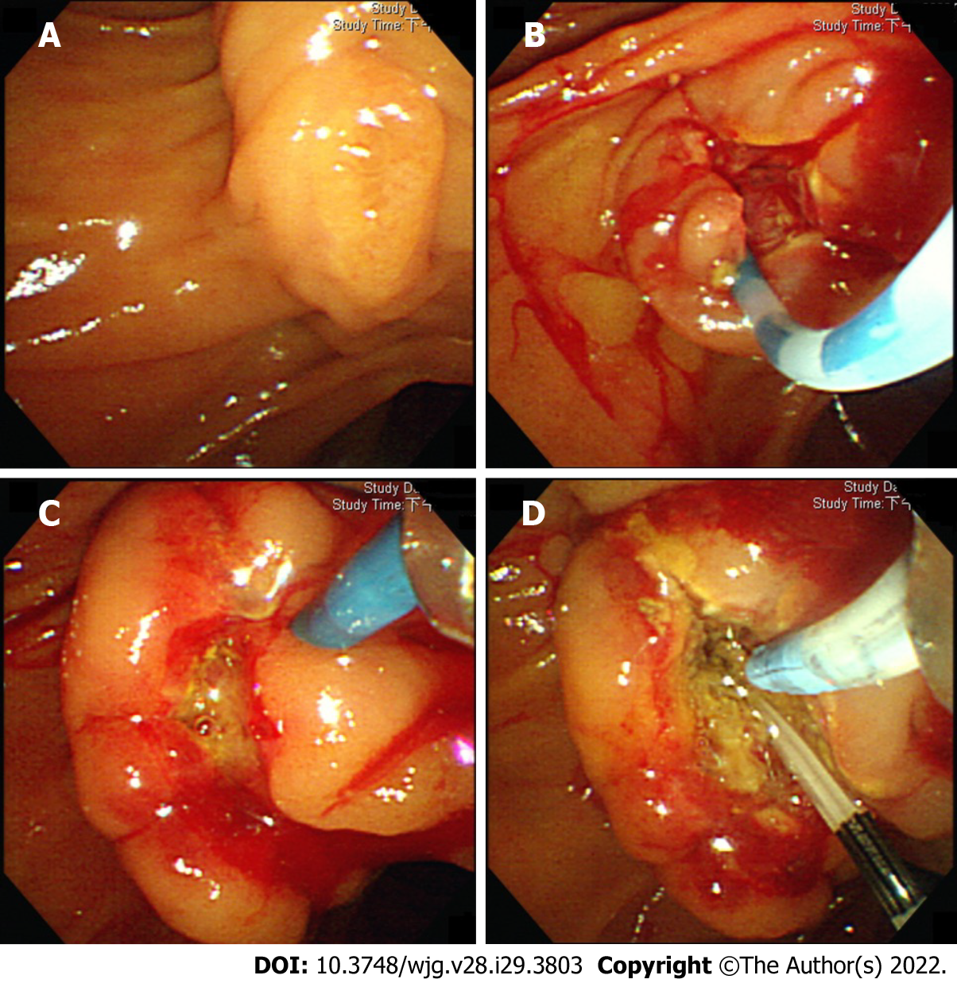
Figure 1 Interval endoscopic retrograde cholangiopancreatography, 1 d after the initial procedure. A: The original papilla in the initial endoscopic retrograde cholangiopancreatography (ERCP); B: Post-precut papilla, at the end of initial ERCP; C: post-precut papilla, at the beginning of interval ERCP. The papilla is swollen, edematous, and with mild oozing; D: Deep bile duct cannulation is unsuccessful during the interval ERCP, even after the placement of a pancreatic stent.

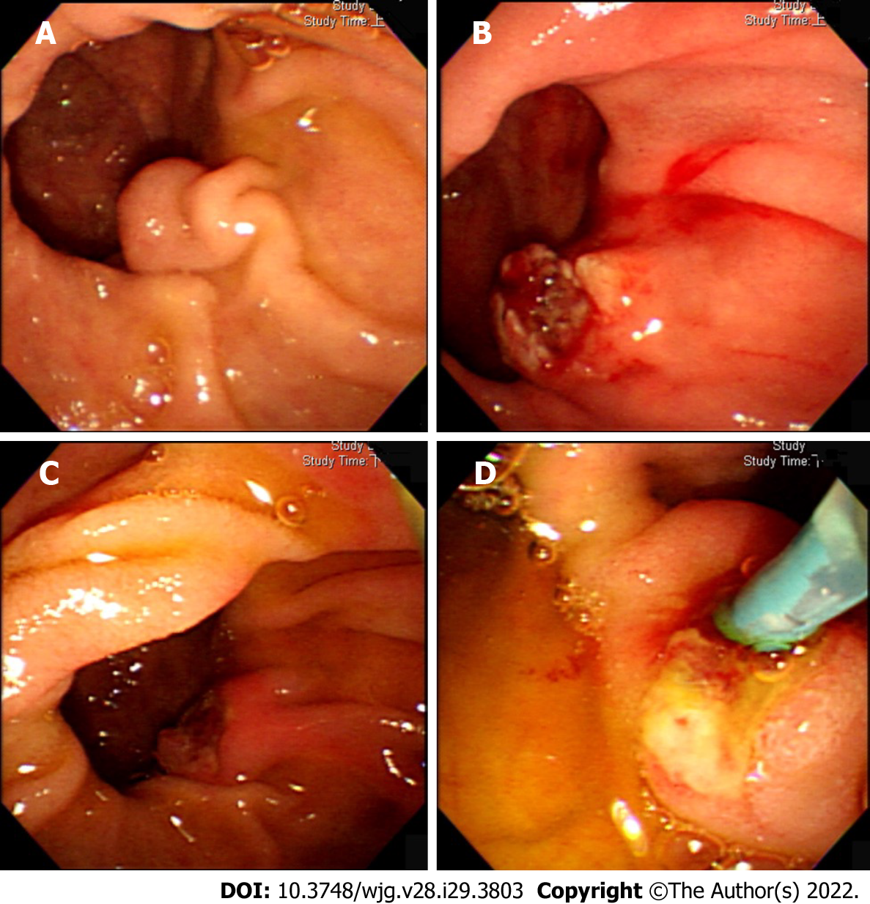
Figure 2 Interval endoscopic retrograde cholangiopancreatography, 3 d after the initial procedure. A: The original papilla in the initial endoscopic retrograde cholangiopancreatography (ERCP); B: Post-precut papilla, at the end of initial ERCP; C: post-precut papilla, at the beginning of interval ERCP. Papillary edema due to pre-cut has disappeared; D: Deep bile duct cannulation is successful during the interval ERCP.

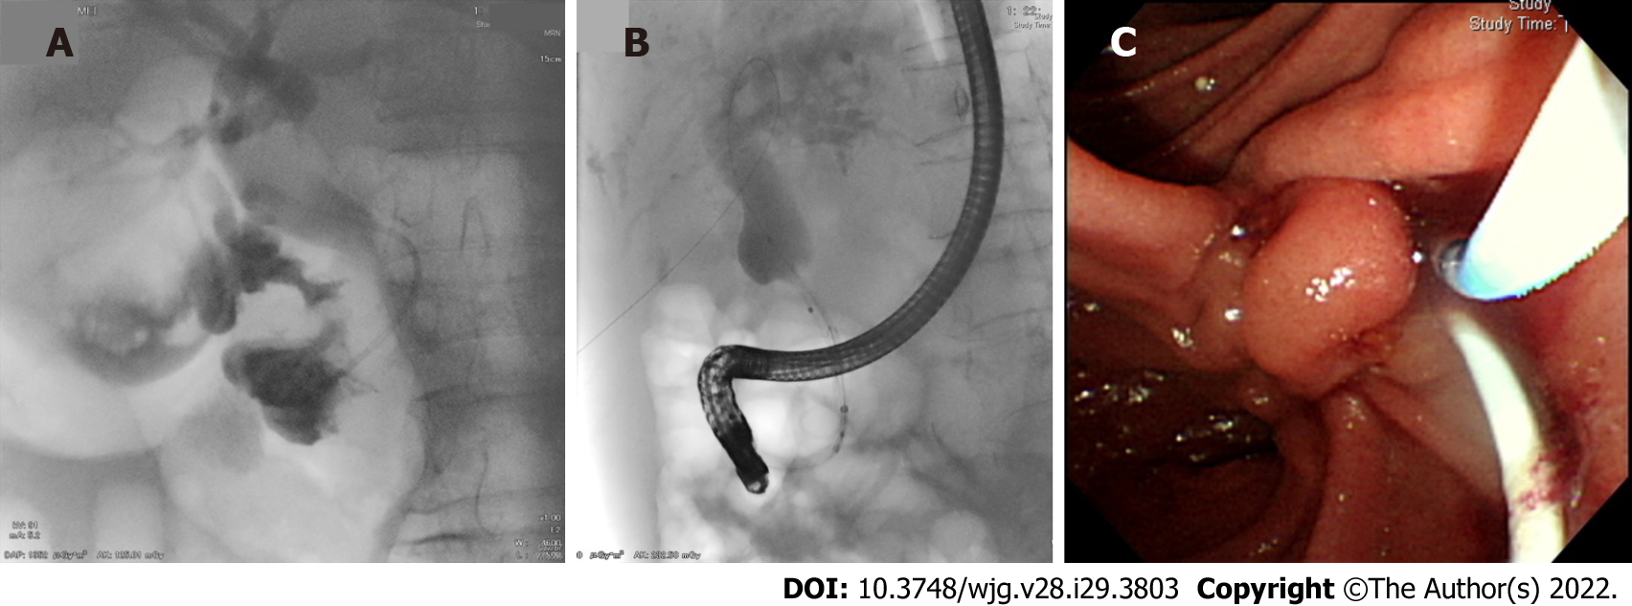
Figure 3 Percutaneous-transhepatic-endoscopic rendezvous procedures. A: Placement of an angiocatheter to protect the liver capsule and parenchyma from guidewire damage; B: A metal stent is passed through the distal biliary stricture over the antegrade-introduced guidewire; C: Cannulation alongside the antegrade-introduced angiocatheter.

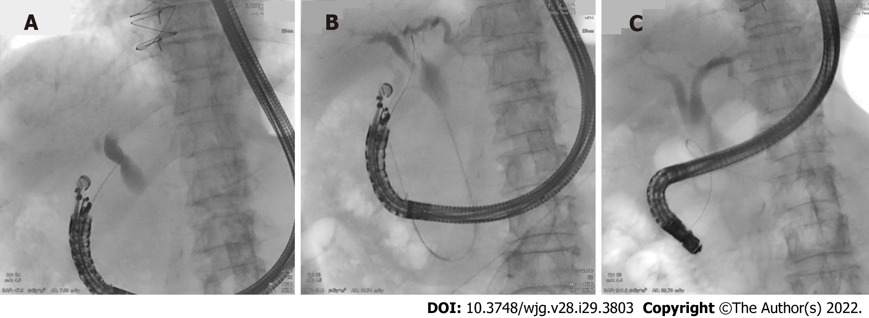
Figure 4 Endoscopic ultrasound-assisted rendezvous procedures. A: Under endoscopic ultrasound, the proximal extrahepatic bile duct is punctured through the duodenal bulb. The sonoendoscope is in a long position; B: The guidewire is delivered antegradely to the duodenum through the puncture route; C: Switch to a duodenoscope to grasp the antegradely introduced guidewire.

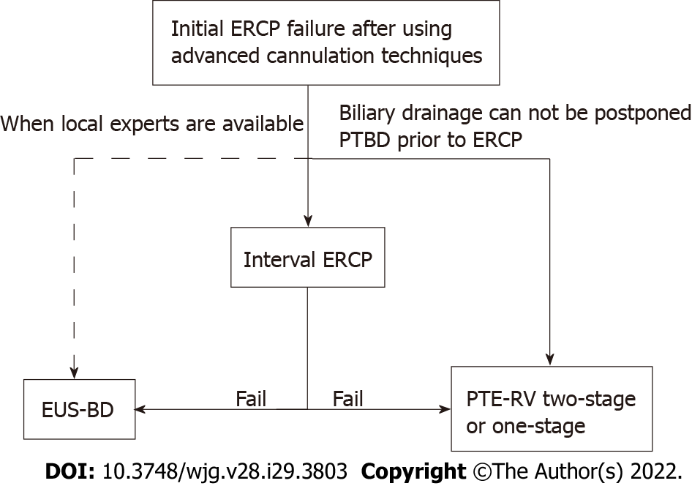
Figure 5 The proposed treatment algorithm. ERCP: Endoscopic retrograde cholangiopancreatography; PTBD: Percutaneous transhepatic biliary drainage; PTE-RV: Percutaneous-transhepatic-endoscopic rendezvous procedure; EUS-BD: Endoscopic ultrasound-assisted or guided biliary drainage.

Table 1 Summary of studies on reporting interval endoscopic retrograde cholangiopancreatography
Ref. | Study design (patient number) | Percentage¹ | Median time interval² (range) | Pre-cut during interval ERCP | Technical success rate | Factors associated with success | Overall complication rate
Kevans et al^{[12]} (2010) | Retrospective (n = 19) | 53% (19/36) | 6 d (1-21 d) | 0% | 68% (13/19) | NA | 0
Donnellan et al^{[13]} (2012) | Retrospective (n = 51) | 68% (51/75) | 8 d (1-28 d) | NA | 75% (38/51) | 3 d vs 6 d (failure vs success) | 3.9% (2/51)
Kim et al^{[14]} (2012) | Retrospective (n = 69) | 76% (69/91) | NA (1-3 d) | 16% (11/69) | 77% (53/69) | 1 d vs 2-3 d (66% vs 88%) | 15.9% (11/69)
Pavlides et al^{[15]} (2014) | Retrospective (n = 89) | 82% (89/108) | 4 d (IQR 3-6 d) | NA | 78% (69/89) | NA | -
Colan-Hernandez et al^{[16]} (2017) | Retrospective (n = 72) | 64% (72/112) | 7 d (IQR 5-11 d) | NA | 75% (54/72) | ≤ 4 d vs > 4 d (44% vs 79%) | 4.2% (3/72)
Narayan et al^{[17]} (2017) | Retrospective (n = 28) | 76% (28/37) | 3 d (3-4 d) | NA | 79% (22/28) | NA | -
Lo et al^{[9]} (2021) | Retrospective (n = 43) | 38% (43/114) | 4 d (1-20 d) | 28% (12/43) | 79% (34/43) | None | 7.0% (3/43)
Overall | n = 371 | - | - | - | 76.3% (281/371) | - | 7.5% (19/254)
¹Number of study cases as a percentage of initial endoscopic retrograde cholangiopancreatography (ERCP) failures.
²Time interval between initial and interval ERCP.
ERCP: Endoscopic retrograde cholangiopancreatography; NA: Not available; IQR: Interquartile range.

Table 2 Summary of studies on reporting percutaneous-transhepatic-endoscopic rendezvous procedures
Ref. | Study design (patient number) | Malignant biliary obstruction | One-stage vs two-stage | Technical success rate | Adverse events | PTE-RV related mortality
Chivot et al^{[23]} (2021) | Retrospective (n = 84) | 78.5% | One-stage | 95.2% (80/84) | 19% (16/84); Cholangitis: 9.5%; Pancreatitis: 3.5%; Hemorrhage: 2.3%; Pneumoperitoneum: 3.5% | 3.5%
Bokemeyer et al^{[21]} (2019) | Retrospective (n = 163) | 71.3% | NA | 80.4% (131/163) | 16.6% (27/163); Procedure-related complications: 8.6%; Drainage-related complications: 8% | NA
Yang et al^{[26]} (2017) | Retrospective (n = 42) | 38% | Two-stage | 92.9% (39/42) | 7.1% (3/42) | NA
Tomizawa et al^{[24]} (2014) | Retrospective (n = 26) | 91% | One-stage (73%) or two-stage | 88% (23/26) | 19.2% (5/26) | 0
Neal et al^{[27]} (2010) | Retrospective (n = 106) | 100% | Two-stage | 92.5% (98/106) | 4.9% (5/106) | 0
Chang et al^{[28]} (2010) | Retrospective (n = 20) | 0 | Two-stage | 100% (20/20) | 10% (2/20); Pancreatitis: 5%; Cholangitis: 5% | 0
Overall | 441 | - | - | 88.7% (391/441) | 13.2% (58/441) | -
PTE-RV: Percutaneous-transhepatic-endoscopic rendezvous procedures; NA: Not available.

Table 3 Summary of studies on reporting endoscopic ultrasound-guided rendezvous procedures
Ref. | Study design (patient number) | Malignant biliary obstruction | Success rate via EHBD | Success rate via IHBD | Overall technical success rate | Overall complication rate
Iwashita et al^{[10]} (2016) | Prospective (n = 20) | 60% (12/20) | 86.7% (13/15) | 75% (3/4) | 80% (16/20) | 15% (3/20); Hematoma (5%); Pancreatitis (10%)
Tang et al^{[40]} (2016) | Retrospective (n = 25) | 52% (13/25) | 83.3% (20/24) | 0 (0/1) | 80% (20/25) | 16% (4/25); Pancreatitis (12%); Cholangitis (4%)
Okuno et al^{[32]} (2017) | Retrospective (n = 39) | 62.5% (24/39) | 84.6% (22/26) | 68.8% (11/16) | 78.6% (33/42) | 16.7% (7/42); Pneumomediastinum (4.8%); Retroperitoneal perforation (2.4%); Cholangitis (2.4%); Peritonitis (4.8%); Pancreatitis (2.4%)
Nakai et al^{[41]} (2017) | Retrospective (n = 30) | 30% (9/30) | NA | NA | 93.3% (28/30) | 23.3% (7/30); Pancreatitis (10.0 %); Bile peritonitis (3.3 %); Cholangitis (3.3 %); Aspiration pneumonia (3.3 %); Gastric mucosa laceration (3.3 %)
Shiomi et al^{[42]} (2018) | Prospective (n = 20) | 40% (8/20) | 83.3% (10/12) | 87.5% (7/8) | 85% (17/20) | 15% (3/20); Biliary peritonitis (10%); Pancreatitis (5%)
Martínez et al^{[43]} (2019) | Retrospective (n = 27) | 0 | 81.5 % (22/27) | - | 81.5 % (22/27) | 11.1% (3/27); Pneumomediastinum (3.7%); Bile leak (3.7%); Pancreatitis (3.7%)
Matsubara et al^{[31]} (2020) | Retrospective (n = 16) | 68.8% (11/16) | 93.3% (14/15) | 100% (2/2¹) | 100% (16/16) | 6.3% (1/16); Pancreatitis (6.3%)
Overall | n = 177 | 43.5% (77/177) | 84.9% (101/119) | 74.2% (23/31) | 84.4% (152/180) | 15.6% (28/180); Pancreatitis (6.7%); Bile leak/peritonitis (3.3%); Cholangitis (1.7%); Pneumomediastinum (1.7%); Retroperitoneal perforation (0.6%); Hematoma (0.6%); Aspiration pneumonia (0.6%); Gastric mucosa laceration (0.6%)
¹Including one patient had initial extrahepatic bile duct approach attempt.
NA: Not available; IHBD: Intrahepatic bile duct; EHBD: Extrahepatic bile duct.

Published by Baishideng Publishing Group Inc
7041 Koll Center Parkway, Suite 160, Pleasanton, CA 94566, USA
Telephone: +1-925-3991568
E-mail: bpgoffice@wjgnet.com
Help Desk: https://www.f6publishing.com/helpdesk
https://www.wjgnet.com

© 2022 Baishideng Publishing Group Inc. All rights reserved.

