Name of Journal: World Journal of Diabetes
Manuscript NO: 88549
Manuscript Type: ORIGINAL ARTICLE

Case Control Study
Comparative study of type 2 diabetes mellitus-associated gut microbiota between the Dai and Han populations

Tang LT et al. Gut microbiota in Han and Dai

Ling-Tong Tang, Lei Feng, Hui-Ying Cao, Rui Shi, Bei-Bei Luo, Yan-Bi Zhang, Yan-Mei Liu, Jian Zhang, Shuang-Yue Li

Ling-Tong Tang, Lei Feng, Hui-Ying Cao, Yan-Mei Liu, Jian Zhang, Shuang-Yue Li, Department of Clinical Laboratory, Yan’an Hospital Affiliated to Kunming Medical University, Kunming 650051, Yunnan Province, China

Rui Shi, Bei-Bei Luo, Yan-Bi Zhang, Department of Clinical Laboratory, Sixth Affiliated Hospital of Kunming Medical University, Kunming 650051, Yunnan Province, China

Author contributions: Tang LT and Feng L contributed equally to this work; Tang LT and Feng L drafted the manuscript; Shi R contributed to recruiting patients; Tang LT, Cao HY, and Li SY collected the data; Zhang YB and Zhang J analyzed and interpreted the data; Liu YM contributed to conception and design; Luo BB contributed to administrative support; and all authors read and approved the final manuscript.

Supported by the National Natural Science Foundation of China, No. 82160402; Special Fund for Training Leading Medical Talents in Yunnan Province, China, No. L-2019022.

Corresponding author: Lei Feng, PhD, Chief Doctor, Full Professor, Department of Clinical Laboratory, Yan’an Hospital Affiliated to Kunming Medical University, No. 245 Renmin East Road, Kunming 650051, Yunnan Province, China. fngj2004@163.com

Received: October 7, 2023
Revised: October 24, 2023
Accepted: November 17, 2023
Published online:

Abstract
BACKGROUND
The global prevalence of type 2 diabetes mellitus (T2DM) is increasing. T2DM is associated with alterations of the gut microbiota, which can be affected by age, illness, and genetics. Previous studies revealed that there are discriminating microbiota compositions between the Dai and the Han populations. However, the specific gut microbiota differences between the two populations have not been elucidated.

AIM
To compare the gut microbiota differences in subjects with and without T2DM in the Dai and Han populations.

METHODS
A total of 35 subjects of the Han population (including 15 healthy children, 8 adult healthy controls, and 12 adult T2DM patients) and 32 subjects of the Dai population (including 10 healthy children, 10 adult healthy controls, and 12 adult T2DM patients) were enrolled in this study. Fasting venous blood samples were collected from all the subjects for biochemical analysis. Fecal samples were collected from all the subjects for DNA extraction and 16S rRNA sequencing, which was followed by analyses of the gut microbiota composition.

RESULTS
No significant difference in alpha diversity was observed between healthy children and adults. The diversity of gut microbiota was decreased in T2DM patients compared to the healthy adults in both the Dai and Han populations. There was a significant difference in gut microbiota between healthy children and healthy adults in the Han population with an increased abundance of Bacteroidetes and decreased Firmicutes in children. However, this difference was less in the Dai population. Significant increases in Bacteroidetes in the Han population and Proteobacteria in the Dai population and decreases in Firmicutes in both the Han and Dai population were observed in T2DM patients compared to healthy adults. Linear discriminant analysis Effect Size analysis also showed that the gut microbiota was different between the Han and Dai populations in heathy children, adults, and T2DM patients. Four bacteria were consistently increased and two consistently decreased in the Han population compared to the Dai population.

CONCLUSION
Differences in gut microbiota were found between the Han and Dai populations. A significant increase in Bacteroidetes was related to the occurrence of T2DM in the Han population, while a significant increase in Proteobacteria was related to the occurrence of T2DM in the Dai population.

Key Words: Gut microbiota; Type 2 diabetes mellitus; Dai population; Han population; Genetics; Ethnic

Tang LT, Feng L, Cao HY, Shi R, Luo BB, Zhang YB, Liu YM, Zhang J, Li SY. Comparative study of type 2 diabetes mellitus-associated gut microbiota between the Dai and Han populations. World J Diabetes 2023; In press

Core Tip: This study revealed that gut microbiota in the Han population is significantly different from the Dai population in healthy children, healthy adults, and patients with type 2 diabetes mellitus (T2DM). There was a significant difference in gut microbiota between healthy children and healthy adults in the Han population, but the difference was less in the Dai population. A significant increase in Bacteroidetes was observed in T2DM patients in the Han population, while a significant increase in Proteobacteria was observed in T2DM patients in the Dai population when compared to healthy controls.

INTRODUCTION
As the world population and the proportion of elderly people increases, type 2 diabetes mellitus (T2DM), a prevalent metabolic disorder, has become a major global public health problem^{[1]}. It is clinically characterized by hyperinsulinemia, insulin resistance, and islet cell damage, which can reach 50% at the time of diagnosis^{[2]}. Individuals with T2DM are highly susceptible to vascular and neurological consequences in addition to life, psychological, and financial stress^{[3]}. In 2021, 537 million people were diagnosed with diabetes, which is expected to increase to 643 million by 2030 and to 783 million by 2045^{[4]}. Although the etiology and pathogenesis of T2DM are still unclear, recent studies have shown that gut microbiota may play key roles^{[5-8]}. Identifying the features of gut microbiota associated with T2DM could help to better understand the pathogenesis of T2DM and prevent or delay the onset of the disease.
The gut microbiota is a complex microecological community composed of more than 100 trillion microorganisms^{[9-11]}. However, it can be affected by various factors, such as age, diet, illness, environment, and genetics^{[12-14]}. Different ethnic groups have a wide variety of dietary patterns, lifestyles, and geographical environments, which can lead to different presentations of gut microbiota and T2DM^{[15]}. Previous studies revealed that there are discriminating microbiota compositions between the Dai and Han populations^{[16-18]}. However, due to the heterogeneity among different ethnic groups, the results of these studies are difficult to replicate. Therefore, it is necessary to carry out analyses of gut microbiota in various ethnic groups with different genetic backgrounds in China.
The Dai ethnic group is a unique minority in Yunnan, China. They have lived in the valley area for generations and generally have endogamous marriages^{[19]}. Due to the different genetic backgrounds, unique lifestyles, and geographical environments^{[19-22]} of the Dai and Han populations, we hypothesized that there may be some underlying differences in the gut microbiota of the two populations. This study was designed to compare the gut microbiota in subjects with and without T2DM in the Dai and Han populations in Yunnan, China. The results of this investigation will help elucidate the underlying differences of gut microbiota between the Dai and Han populations and determine the association between gut microbiota and T2DM prevalence.

MATERIALS AND METHODS
Subjects recruitment
Healthy children, adult T2DM patients, and ethnically matched healthy adults from the Han and Dai populations living in the same area were recruited and enrolled in this study. Patients with T2DM met the following diagnostic criteria^{[23]}: (1) Fasting blood glucose ≥ 7.0 mmol/L; or (2) Hemoglobin A1c ≥ 6.5%. The enrolled T2DM patients were newly diagnosed and drug-naïve. Subjects who had been treated with antibiotics in the previous 3 mo, were pregnant or lactating, or had inflammatory bowel disease were excluded from the study. The T2DM patients and healthy adults in each population were age-matched (P > 0.05). The enrolled subjects have completed the Study Questionnaires to provide personal details and information about health, diet, smoking activity and lifestyle at the time of sample collection. The study was approved by the ethics committee of the Sixth Affiliated Hospital of Kunming Medical University (approval no. 2023-kmykdx6f-66). All participants provided written informed consent.

Sample collection
Fasting venous blood samples were collected from all participants in the morning. After centrifugation (3000 rpm) at 4 °C for 10 min, the serum was immediately extracted and aliquoted. All blood and serum samples were stored at -80 °C until further biochemical analysis was performed. Stool samples were collected into 5-mL disposable sterile tubes within 30 min of discharge and kept at -80 °C until further processing was conducted.

Genomic DNA extraction and 16S rRNA gene sequencing
Total genomic DNA samples were extracted using the OMEGA Soil DNA Kit (M5635-02) (Omega Bio-Tek, Norcross, GA, United States) according to the manufacturer’s instructions. The quantity and quality of extracted DNA were measured using a NanoDrop NC2000 spectrophotometer (Thermo Fisher Scientiﬁc, Waltham, MA, United States) and agarose gel electrophoresis, respectively. Prepared DNA samples were stored at -20 °C.
The V3-V4 region of 16S rRNA was amplified by polymerase chain reaction (PCR) with the primers 338F (5’-ACTCCTACGGGAGGCAGCA-3’) and 806R (5’-GGACTACHVGGGTWTCTAAT-3’). The following thermal cycling conditions were utilized: initial denaturation at 98 °C for 5 min; 25 cycles consisting of denaturation at 98 °C for 30 s, annealing at 53 °C for 30 s, and extension at 72 °C for 45 s; and a final extension of 5 min at 72 °C. PCR amplicons were puriﬁed with Vazyme VAHTSTM DNA Clean Beads (Vazyme, Nanjing, China) and quantiﬁed using the Quant-iT PicoGreen dsDNA Assay Kit (Invitrogen, Carlsbad, CA, United States). After the individual quantification step, amplicons were pooled in equal amounts, and pair-end 2 × 250 bp sequencing was performed using the Illlumina NovaSeq platform with NovaSeq 6000 SP Reagent Kit (500 cycles) at Shanghai Personal Biotechnology Co., Ltd (Shanghai, China).

Sequence and bioinformatics analyses
Microbiome bioinformatics were performed with QIIME2 2019.4 with slight modifications according to the official tutorials (https://docs.qiime2.org/2019.4/tutorials/). Briefly, raw sequence data were demultiplexed using the demux plugin followed by primer cutting with cutadapt plugin. Sequences were then quality filtered, denoised, merged, and chimera removed using the DADA2 plugin. Non-singleton amplicon sequence variants were aligned with mafft and used to construct a phylogeny with fasttree2. Taxonomy was assigned to amplicon sequence variants using the classify-sklearn naïve Bayes taxonomy classifier in feature-classifier plugin. Microbiota comparisons were performed using principal coordinate analysis (PCoA), principal component analysis (PCA), and permutational multivariate analysis of variance (PERMANOVA), diversity index estimate and composition of microbiome analysis.

Biochemical data analysis
Data were analyzed with SPSS Software (Version 29.0; IBM Corp., Armonk, NY, United States). Continuous data were expressed as mean ± SD. Comparisons between groups were performed using one-way analysis of variance and Student’s t test. Cases with missing data for analysis were omitted, and the remaining data were analyzed. P < 0.05 was considered statistically significant.

RESULTS
Subject characteristics
A total of 35 subjects from the Han population (including 15 healthy children, 8 adult healthy controls, and 12 T2DM patients) and 32 subjects from the Dai population (including 10 healthy children, 10 adult healthy controls, and 12 T2DM patients) were enrolled in this study. The main demographics and blood biochemical indexes of the subjects are presented in Table 1. The levels of total bilirubin, direct bilirubin, indirect bilirubin, total cholesterol, hemoglobin A1c, gamma glutamyl transferase, and hypersensitive C-reactive protein were significantly higher in the T2DM patients in the Han population compared to the T2DM patients in the Dai population. Low density lipoprotein cholesterol and apolipoprotein A1 were significantly lower in T2DM patients in the Han population compared to T2DM patients in the Dai population. The levels of triglycerides, total bilirubin, indirect bilirubin, and gamma glutamyl transferase were significantly higher in healthy adults in the Dai population compared to healthy adults in the Han population.

Overall gut microbiota distribution in the Han and Dai populations
The total amount of data comprised 4505369 reads, with an average of 68736 reads per sample. For the 35 Han individuals, the total amount of data included 2132603 reads, with an average of 60931 reads per sample. For the 32 Dai individuals, the total amount of data included 2472766 reads, with an average of 77274 reads per sample. By clustering analysis at a 97% similarity, 22890 operational taxonomic units were identified.

Analysis of alpha diversity in gut microbiota
Six indices (Chao1, abundance-based coverage estimator, Good’s coverage, Shannon, Simpson, and Pielou) were compared between all the population groups to evaluate the alpha diversity in gut microbiota. No significant difference in alpha diversity was observed between healthy children and adults. However, the diversity of the gut microbiota was decreased in T2DM patients compared to healthy adults in both the Dai and Han populations (Figure 1).

Comparison of gut microbiota between healthy children and healthy adults in the Han and Dai populations
PCA scores plot showed that there’s differences among groups (Supplementary Figure 1). Further PCoA and PERMANOVA (P < 0.05) showed a clear distinction in the gut microbiota between healthy children and healthy adults in the Han population (Figure 2A). The gut microbiota composition of healthy children and healthy adults in the Han population was compared by the Linear discriminant analysis Effect Size (LEfSe) analysis (Figure 2B). The Bacteroidetes phylum was more abundant in the children of the Han population. In the Dai population, there was no clear distinction in the gut microbiota between healthy children and healthy adults after the PCoA (Figure 2C) and the LEfSe analysis (Figure 2D).
These data indicated that the difference in the gut microbiota between healthy children and healthy adults was greater in the Han population than in the Dai population and suggest that the influence of age, diet, or lifestyle on the gut microbiota is greater in the Han population than the Dai population.

Comparison of gut microbiota between healthy adults and adult T2DM patients in the Han and Dai populations
An obvious distinction between healthy adults and T2DM patients in the Han population was observed on the PCoA plot (Figure 3A). The gut microbiota composition of healthy adults and T2DM patients in the Han population was presented in a cladogram (Figure 3B). Compared with healthy adults, the T2DM patients from the Han population had an increased abundance of Bacteroidetes, Bacteroidales, Megamonas, and Bacteroidia within the Bacteroidetes phylum (Table 2).
There were no observable differences in the gut microbiota between healthy adults and T2DM patients in the Dai population after the PCoA (Figure 3C) and LEfSe analysis (Figure 3D). Compared with healthy adults, the T2DM patients from the Dai population had an increased abundance of Deltaproteobacteria, Shigella, and Acinetobacter within the Proteobacteria phylum (Table 3).
There were several bacterial types with a decreased abundance in T2DM patients in the Han population (63 total types) and in the Dai population (40 total types). Five of these bacteria, including Dorea, Peptostreptococcaceae, Blautia, Ruminococcus, and Coprococcus, were decreased in both populations (Figure 4).

Differences of gut microbiota between the Han and Dai populations during the transition from healthy children to healthy adults and T2DM
To investigate the differences of gut microbiota between the Han and Dai populations during the transition from healthy children to healthy adults and T2DM, the LEfSe analysis was performed (Figures 5-7). Compared to the Dai population, the abundances of Coprococcus, Streptococcus, and Lactococcus within the phylum Firmicutes were consistently higher in the Han population. We also observed that the abundances of Rhizobiales within the phylum Proteobacteria and Veillonellaceae within the phylum Firmicutes were significantly lower in the Han population (Table 4).

DISCUSSION
The relationship between gut microbiota and T2DM is becoming increasingly important. In the past decade, studies have supported the role of gut microbiota in the pathogenesis of T2DM^{[24-28]}. Some researchers have reported that there are discriminating microbiota compositions between the Han and the Tibetans populations^{[16-18]} and also different among the different ethnicities: Han, Zang, Bai, Hani, Dai, and Miao (including both healthy urban and rural residents of each ethnicity)^{[29]}. However, the underlying differences of the gut microbiota between the Han and Dai populations have not been elucidated. Here, we performed a comparative analysis of the gut microbiota in subjects with and without T2DM from the Dai and Han populations in Yunnan Province, China. To the best of our knowledge, this is the first time to compare the T2DM-associated gut microbiota between Han and Dai populations.
The alpha diversity of the gut microbiota, which reflects the abundance, evenness, and richness^{[30]}, might vary between ethnic groups in part due to the varied prevalence of T2DM among ethnic groups^{[31]}. Interestingly, our study showed that there was no significant difference in alpha diversity between the Han and Dai populations, suggesting that the abundance, evenness, and richness of the gut microbiota were not significantly different between the Han and Dai populations. However, the diversity of gut microbiota was decreased in T2DM patients compared to healthy adults in both the Han and Dai populations (Figure 1), which is consistent with the previous results in different populations of the world, including other populations in China^{[32-34]}.
The gut microbiota is associated with the age of host^{[35]}. Despite being matched for age (significance less than 0.05), there was a large deviation from the mean value of the age of healthy adults with diabetes in Dai who were actually enrolled in the analysis. We also selected some of these samples with matched age means for subset analysis, and the results were consistent with the existing result. To determine the influence of age on gut microbiota, we also conducted a comparison of gut microbiota between healthy children and healthy adults in the Han and Dai populations. These findings suggested that the difference in the gut microbiota between healthy children and healthy adults was greater in the Han population than the Dai population. The observed higher relative abundances of genus Bacteroides in children and higher relative abundances of genus Blautia in adults were consistent with the previous studies^{[36]}.
Many researchers have reported that the gut microbiota diversity is affected by T2DM^{[26,37]}. After comparing the gut microbiota between healthy adults and T2DM patients in the Han population, we observed a significant difference in the gut microbiota. However, there was no clear distinction between healthy adults and T2DM patients in the Dai population. The underlying reason behind this warrant further investigation. Moreover, our data showed that the T2DM patients of the Dai population possessed a distinctive microbiota composition characterized by a high abundance of Proteobacteria, which is consistent with the previous results^{[38]}. Recent evidence has also shown that Proteobacteria in gut microbial dysbiosis is essential for metabolic disorders^{[39]}. Interestingly, we found that T2DM patients from the Han population had an increase in Bacteroidetes, Bacteroidales, Megamonas and Bacteroidia within the phylum Bacteroidetes. This discovery conflicted with the results of some earlier studies^{[32,40]}. The possible reason might be that the proportion of Bacteroidales abundance can be altered by high-calorie diets^{[41]}, which is also a possible cause of T2DM.
Although we have identified that both age and T2DM influence the gut microbiota, it is unknown which has a greater effect. We explored the differences in bacteria between healthy children to healthy adults and healthy adults to T2DM in both ethnic groups. The results showed that the differences of healthy children between the Han and Dai population were still significant in healthy adults. However, these changes in T2DM patients were not statistically significant. These results demonstrated that the differences were influenced more by age than T2DM during the transition from healthy children to healthy adults and T2DM patients in both the Han and Dai populations.
Several limitations of this study should be taken into account. First, the sample size was relatively small, which limits the generalizability of the findings. It should be confirmed in a larger scale of samples in the future. Second, the effect of gender, food, and smoking activity were not investigated in the study. Third, the metabolic profile requires further investigation to confirm the relationship between the imbalance of metabolism and gut microbiota alterations.

CONCLUSION
Through the comparative analysis, this study found significant differences in the gut microbiota in the Han and Dai populations, and these differences were influenced to a greater degree by age than by T2DM. Our findings may provide additional insight for further study of gut microbiota dysbiosis-related diseases in the Han and Dai populations.

ARTICLE HIGHLIGHTS
Research background
Previous studies revealed that there are discriminating microbiota compositions between the Han and Dai populations. However, the underlying differences in the gut microbiota between the Han and Dai populations have not yet been elucidated.

Research motivation
We compared the differences in the gut microbiota in subjects with and without type 2 diabetes mellitus (T2DM) in the Han and Dai populations to explore the pathogenic mechanism of T2DM.

Research objectives
To identify the differences in the gut microbiota related to the occurrence of T2DM in the Han and Dai populations.

Research methods
A total of 35 subjects of the Han population (15 healthy children, 8 adult healthy controls, and 12 adult T2DM patients) and 32 subjects of the Dai population (10 healthy children, 10 adult healthy controls, and 12 adult T2DM patients) were enrolled in this study. Fasting venous blood samples were collected from all the subjects for biochemical analysis. Fecal samples were collected from all the subjects for DNA extraction and 16S rRNA sequencing, which was followed by analyses of the gut microbiota composition.

Research results
Fasting plasma glucose levels and hemoglobin A1c were significantly increased in the T2DM patients. The gut microbiota of the Han population was significantly different from the Dai population in healthy children, healthy adults, and T2DM patients. Significant increases in Bacteroidetes were observed in T2DM patients from the Han population, while significant increases in Proteobacteria were observed in T2DM patients in the Dai population.

Research conclusions
We observed significant differences in the gut microbiota in the Han and Dai populations, and these differences were influenced to a greater degree by age than by T2DM.

Research perspectives
Our findings may provide additional insight for further study of the gut microbiota dysbiosis-related diseases in the Han and Dai populations. Future research should include a larger scale of samples and an investigation of the metabolic profile in order to confirm the relationship between an imbalance of the metabolism and gut microbiota alterations.

ACKNOWLEDGEMENTS
The authors would like to thank all the collaborators for their efforts and also thank parents for allowing participation of their children in this study.

REFERENCES
1 Soares Andrade CA, Shahin B, Dede O, Akpeji AO, Ajene CL, Albano Israel FE, Varga O. The burden of type 2 diabetes mellitus in states of the European Union and United Kingdom at the national and subnational levels: A systematic review. Obes Rev 2023; 24: e13593 [PMID: 37401729 DOI: 10.1111/obr.13593]
2 Holman RR, Paul SK, Bethel MA, Matthews DR, Neil HA. 10-year follow-up of intensive glucose control in type 2 diabetes. N Engl J Med 2008; 359: 1577-1589 [PMID: 18784090 DOI: 10.1056/NEJMoa0806470]
3 Papatheodorou K, Banach M, Bekiari E, Rizzo M, Edmonds M. Complications of Diabetes 2017. J Diabetes Res 2018; 2018: 3086167 [PMID: 29713648 DOI: 10.1155/2018/3086167]
4 Su J, Luo Y, Hu S, Tang L, Ouyang S. Advances in Research on Type 2 Diabetes Mellitus Targets and Therapeutic Agents. Int J Mol Sci 2023; 24 [PMID: 37686185 DOI: 10.3390/ijms241713381]
5 Hamjane N, Mechita MB, Nourouti NG, Barakat A. Gut microbiota dysbiosis -associated obesity and its involvement in cardiovascular diseases and type 2 diabetes. A systematic review. Microvasc Res 2023; 151: 104601 [PMID: 37690507 DOI: 10.1016/j.mvr.2023.104601]
6 Ma Q, Li Y, Li P, Wang M, Wang J, Tang Z, Wang T, Luo L, Wang C, Wang T, Zhao B. Research progress in the relationship between type 2 diabetes mellitus and intestinal flora. Biomed Pharmacother 2019; 117: 109138 [PMID: 31247468 DOI: 10.1016/j.biopha.2019.109138]
7 Wu J, Yang K, Fan H, Wei M, Xiong Q. Targeting the gut microbiota and its metabolites for type 2 diabetes mellitus. Front Endocrinol (Lausanne) 2023; 14: 1114424 [PMID: 37229456 DOI: 10.3389/fendo.2023.1114424]
8 Zhou Z, Sun B, Yu D, Zhu C. Gut Microbiota: An Important Player in Type 2 Diabetes Mellitus. Front Cell Infect Microbiol 2022; 12: 834485 [PMID: 35242721 DOI: 10.3389/fcimb.2022.834485]
9 Zhou YD, Liang FX, Tian HR, Luo D, Wang YY, Yang SR. Mechanisms of gut microbiota-immune-host interaction on glucose regulation in type 2 diabetes. Front Microbiol 2023; 14: 1121695 [PMID: 36891383 DOI: 10.3389/fmicb.2023.1121695]
10 Bajinka O, Tan Y, Darboe A, Ighaede-Edwards IG, Abdelhalim KA. The gut microbiota pathway mechanisms of diabetes. AMB Express 2023; 13: 16 [PMID: 36754883 DOI: 10.1186/s13568-023-01520-3]
11 Gill SR, Pop M, Deboy RT, Eckburg PB, Turnbaugh PJ, Samuel BS, Gordon JI, Relman DA, Fraser-Liggett CM, Nelson KE. Metagenomic analysis of the human distal gut microbiome. Science 2006; 312: 1355-1359 [PMID: 16741115 DOI: 10.1126/science.1124234]
12 Brooks AW, Priya S, Blekhman R, Bordenstein SR. Gut microbiota diversity across ethnicities in the United States. PLoS Biol 2018; 16: e2006842 [PMID: 30513082 DOI: 10.1371/journal.pbio.2006842]
13 Deschasaux M, Bouter KE, Prodan A, Levin E, Groen AK, Herrema H, Tremaroli V, Bakker GJ, Attaye I, Pinto-Sietsma SJ, van Raalte DH, Snijder MB, Nicolaou M, Peters R, Zwinderman AH, Bäckhed F, Nieuwdorp M. Depicting the composition of gut microbiota in a population with varied ethnic origins but shared geography. Nat Med 2018; 24: 1526-1531 [PMID: 30150717 DOI: 10.1038/s41591-018-0160-1]
14 Wu GD, Chen J, Hoffmann C, Bittinger K, Chen YY, Keilbaugh SA, Bewtra M, Knights D, Walters WA, Knight R, Sinha R, Gilroy E, Gupta K, Baldassano R, Nessel L, Li H, Bushman FD, Lewis JD. Linking long-term dietary patterns with gut microbial enterotypes. Science 2011; 334: 105-108 [PMID: 21885731 DOI: 10.1126/science.1208344]
15 Alvarez-Silva C, Kashani A, Hansen TH, Pinna NK, Anjana RM, Dutta A, Saxena S, Støy J, Kampmann U, Nielsen T, Jørgensen T, Gnanaprakash V, Gnanavadivel R, Sukumaran A, Rani CSS, Færch K, Radha V, Balasubramanyam M, Nair GB, Das B, Vestergaard H, Hansen T, Mande SS, Mohan V, Arumugam M, Pedersen O. Trans-ethnic gut microbiota signatures of type 2 diabetes in Denmark and India. Genome Med 2021; 13: 37 [PMID: 33658058 DOI: 10.1186/s13073-021-00856-4]
16 Huan H, Ren T, Xu L, Hu H, Liu C. Compositional distinction of gut microbiota between Han Chinese and Tibetan populations with liver cirrhosis. PeerJ 2021; 9: e12142 [PMID: 34616612 DOI: 10.7717/peerj.12142]
17 Li K, Dan Z, Gesang L, Wang H, Zhou Y, Du Y, Ren Y, Shi Y, Nie Y. Comparative Analysis of Gut Microbiota of Native Tibetan and Han Populations Living at Different Altitudes. PLoS One 2016; 11: e0155863 [PMID: 27232599 DOI: 10.1371/journal.pone.0155863]
18 Zhu LL, Ma ZJ, Ren M, Wei YM, Liao YH, Shen YL, Fan SM, Li L, Wu QX, Gao ZS, Song JF, Ma YL. Distinct Features of Gut Microbiota in High-Altitude Tibetan and Middle-Altitude Han Hypertensive Patients. Cardiol Res Pract 2020; 2020: 1957843 [PMID: 33294219 DOI: 10.1155/2020/1957843]
19 Zhang L, Sun Y, Zhang X, Shan X, Li J, Yao Y, Shu Y, Lin K, Huang X, Yang Z, Chu J, Huang L, Sun H. Three Novel Genetic Variants in the FAM110D, CACNA1A, and NLRP12 Genes Are Associated With Susceptibility to Hypertension Among Dai People. Am J Hypertens 2021; 34: 874-879 [PMID: 33621312 DOI: 10.1093/ajh/hpab040]
20 Zhang F, Amat G, Tang Y, Chen R, Tian X, Hu W, Chen C, Shen S, Xie Y. NUDT15 Genetic Variants in Chinese Han, Uighur, Kirghiz, and Dai Nationalities. Front Pediatr 2022; 10: 832363 [PMID: 35498806 DOI: 10.3389/fped.2022.832363]
21 He M, Lin K, Huang Y, Zhou L, Yang Q, Li S, Jiang W. Prevalence and Molecular Study of G6PD Deficiency in the Dai and Jingpo Ethnic Groups in the Dehong Prefecture of the Yunnan Province. Hum Hered 2018; 83: 55-64 [PMID: 29860254 DOI: 10.1159/000489009]
22 Yang J, Li W, Zhang Z, Shen J, Zhang N, Yang M, Yang M, Yu Y. PSCArs2294008 T polymorphism increases the risk of bladder cancer in Bai, Dai, and Han ethnicity in China and a potential mechanism. Genes Genomics 2018; 40: 531-541 [PMID: 29892961 DOI: 10.1007/s13258-018-0653-9]
23 Chinese Elderly Type 2 Diabetes Prevention and Treatment of Clinical Guidelines Writing Group; Geriatric Endocrinology and Metabolism Branch of Chinese Geriatric Society; Geriatric Endocrinology and Metabolism Branch of Chinese Geriatric Health Care Society; Geriatric Professional Committee of Beijing Medical Award Foundation; National Clinical Medical Research Center for Geriatric Diseases (PLA General Hospital). [Clinical guidelines for prevention and treatment of type 2 diabetes mellitus in the elderly in China (2022 edition)]. Zhonghua Nei Ke Za Zhi 2022; 61: 12-50 [PMID: 34979769 DOI: 10.3760/cma.j.cn112138-20211027-00751]
24 Brunkwall L, Orho-Melander M. The gut microbiome as a target for prevention and treatment of hyperglycaemia in type 2 diabetes: from current human evidence to future possibilities. Diabetologia 2017; 60: 943-951 [PMID: 28434033 DOI: 10.1007/s00125-017-4278-3]
25 Chen L, Guo L, Feng S, Wang C, Cui Z, Wang S, Lu Q, Chang H, Hang B, Snijders AM, Mao JH, Lu Y, Ding D. Fecal microbiota transplantation ameliorates type 2 diabetes via metabolic remodeling of the gut microbiota in db/db mice. BMJ Open Diabetes Res Care 2023; 11 [PMID: 37253485 DOI: 10.1136/bmjdrc-2022-003282]
26 Carrizales-Sánchez AK, Tamez-Rivera O, Rodríguez-Gutiérrez NA, Elizondo-Montemayor L, Gradilla-Hernández MS, García-Rivas G, Pacheco A, Senés-Guerrero C. Characterization of gut microbiota associated with metabolic syndrome and type-2 diabetes mellitus in Mexican pediatric subjects. BMC Pediatr 2023; 23: 210 [PMID: 37138212 DOI: 10.1186/s12887-023-03983-6]
27 Huang X, Qiu Y, Gao Y, Zhou R, Hu Q, He Z, Lv Y, Wang X, Chen W, Deng Y, An Z, Zhang H, Mo Z, Lin R. Gut microbiota mediate melatonin signalling in association with type 2 diabetes. Diabetologia 2022; 65: 1627-1641 [PMID: 35768541 DOI: 10.1007/s00125-022-05747-w]
28 Xia F, Wen LP, Ge BC, Li YX, Li FP, Zhou BJ. Gut microbiota as a target for prevention and treatment of type 2 diabetes: Mechanisms and dietary natural products. World J Diabetes 2021; 12: 1146-1163 [PMID: 34512884 DOI: 10.4239/wjd.v12.i8.1146]
29 Sun Y, Zuo T, Cheung CP, Gu W, Wan Y, Zhang F, Chen N, Zhan H, Yeoh YK, Niu J, Du Y, Zhang F, Wen Y, Yu J, Sung JJY, Chan PKS, Chan FKL, Wang K, Ng SC, Miao Y. Population-Level Configurations of Gut Mycobiome Across 6 Ethnicities in Urban and Rural China. Gastroenterology 2021; 160: 272-286.e11 [PMID: 32956679 DOI: 10.1053/j.gastro.2020.09.014]
30 Wei T, Jia Y, Xue W, Ma M, Wu W. Nutritional Effects of the Enteral Nutritional Formula on Regulation of Gut Microbiota and Metabolic Level in Type 2 Diabetes Mellitus Mice. Diabetes Metab Syndr Obes 2021; 14: 1855-1869 [PMID: 33953585 DOI: 10.2147/DMSO.S301454]
31 Pham TM, Carpenter JR, Morris TP, Sharma M, Petersen I. Ethnic Differences in the Prevalence of Type 2 Diabetes Diagnoses in the UK: Cross-Sectional Analysis of the Health Improvement Network Primary Care Database. Clin Epidemiol 2019; 11: 1081-1088 [PMID: 32021464 DOI: 10.2147/CLEP.S227621]
32 Larsen N, Vogensen FK, van den Berg FW, Nielsen DS, Andreasen AS, Pedersen BK, Al-Soud WA, Sørensen SJ, Hansen LH, Jakobsen M. Gut microbiota in human adults with type 2 diabetes differs from non-diabetic adults. PLoS One 2010; 5: e9085 [PMID: 20140211 DOI: 10.1371/journal.pone.0009085]
33 Wang Y, Luo X, Mao X, Tao Y, Ran X, Zhao H, Xiong J, Li L. Gut microbiome analysis of type 2 diabetic patients from the Chinese minority ethnic groups the Uygurs and Kazaks. PLoS One 2017; 12: e0172774 [PMID: 28328990 DOI: 10.1371/journal.pone.0172774]
34 Li Q, Chang Y, Zhang K, Chen H, Tao S, Zhang Z. Implication of the gut microbiome composition of type 2 diabetic patients from northern China. Sci Rep 2020; 10: 5450 [PMID: 32214153 DOI: 10.1038/s41598-020-62224-3]
35 Li Y, Chen T, Li Y, Tang Y, Huang Z. Gut microbiota are associated with sex and age of host: Evidence from semi-provisioned rhesus macaques in southwest Guangxi, China. Ecol Evol 2021; 11: 8096-8122 [PMID: 34188874 DOI: 10.1002/ece3.7643]
36 Radjabzadeh D, Boer CG, Beth SA, van der Wal P, Kiefte-De Jong JC, Jansen MAE, Konstantinov SR, Peppelenbosch MP, Hays JP, Jaddoe VWV, Ikram MA, Rivadeneira F, van Meurs JBJ, Uitterlinden AG, Medina-Gomez C, Moll HA, Kraaij R. Diversity, compositional and functional differences between gut microbiota of children and adults. Sci Rep 2020; 10: 1040 [PMID: 31974429 DOI: 10.1038/s41598-020-57734-z]
37 Takagi T, Naito Y, Kashiwagi S, Uchiyama K, Mizushima K, Kamada K, Ishikawa T, Inoue R, Okuda K, Tsujimoto Y, Ohnogi H, Itoh Y. Changes in the Gut Microbiota are Associated with Hypertension, Hyperlipidemia, and Type 2 Diabetes Mellitus in Japanese Subjects. Nutrients 2020; 12 [PMID: 33007825 DOI: 10.3390/nu12102996]
38 Shin NR, Whon TW, Bae JW. Proteobacteria: microbial signature of dysbiosis in gut microbiota. Trends Biotechnol 2015; 33: 496-503 [PMID: 26210164 DOI: 10.1016/j.tibtech.2015.06.011]
39 Kwan SY, Sabotta CM, Joon A, Wei P, Petty LE, Below JE, Wu X, Zhang J, Jenq RR, Hawk ET, McCormick JB, Fisher-Hoch SP, Beretta L. Gut Microbiome Alterations Associated with Diabetes in Mexican Americans in South Texas. mSystems 2022; 7: e0003322 [PMID: 35477306 DOI: 10.1128/msystems.00033-22]
40 Zhang X, Shen D, Fang Z, Jie Z, Qiu X, Zhang C, Chen Y, Ji L. Human gut microbiota changes reveal the progression of glucose intolerance. PLoS One 2013; 8: e71108 [PMID: 24013136 DOI: 10.1371/journal.pone.0071108]
41 Daniel H, Gholami AM, Berry D, Desmarchelier C, Hahne H, Loh G, Mondot S, Lepage P, Rothballer M, Walker A, Böhm C, Wenning M, Wagner M, Blaut M, Schmitt-Kopplin P, Kuster B, Haller D, Clavel T. High-fat diet alters gut microbiota physiology in mice. ISME J 2014; 8: 295-308 [PMID: 24030595 DOI: 10.1038/ismej.2013.155]

Footnotes
Institutional review board statement: This study was reviewed and approved by the Ethics Committee of the Sixth Affiliated Hospital of Kunming Medical University (2023-kmykdx6f-66).

Informed consent statement: All study participants, or their legal guardians, provided informed written consent prior to study enrollment.

Conflict-of-interest statement: All the authors report no relevant conflicts of interest for this article.

Data sharing statement: No additional data are available.

STROBE statement: The authors have read the STROBE Statement-checklist of items, and the manuscript was prepared and revised according to the STROBE Statement-checklist of items.

Open-Access: This article is an open-access article that was selected by an in-house editor and fully peer-reviewed by external reviewers. It is distributed in accordance with the Creative Commons Attribution NonCommercial (CC BY-NC 4.0) license, which permits others to distribute, remix, adapt, build upon this work non-commercially, and license their derivative works on different terms, provided the original work is properly cited and the use is non-commercial. See: https://creativecommons.org/Licenses/by-nc/4.0/

Provenance and peer review: Unsolicited article; Externally peer reviewed.
Peer-review model: Single blind

Peer-review started: October 7, 2023
First decision: October 17, 2023
Article in press:

Specialty type: Endocrinology and metabolism
Country/Territory of origin: China
Peer-review report’s scientific quality classification
Grade A (Excellent): 0
Grade B (Very good): 0
Grade C (Good): C, C, C, C
Grade D (Fair): 0
Grade E (Poor): 0

P-Reviewer: Joda BA, Iraq; Popovic DS, Serbia; Horowitz M, Australia S-Editor: Wang JJ L-Editor: A P-Editor:

Figure Legends
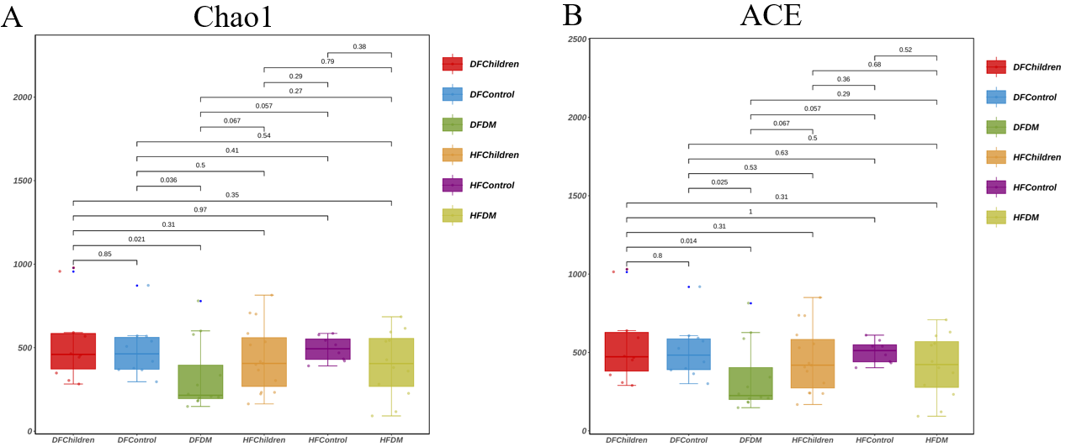
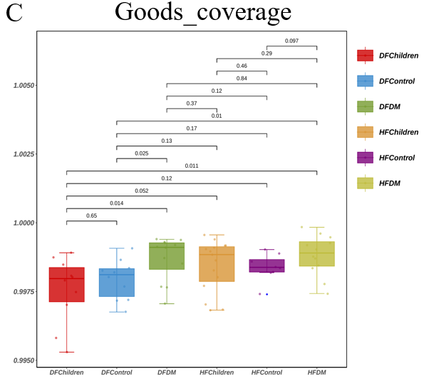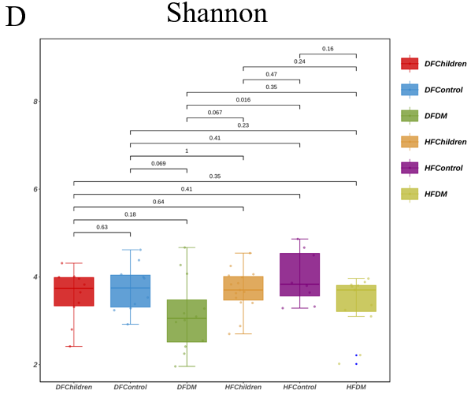
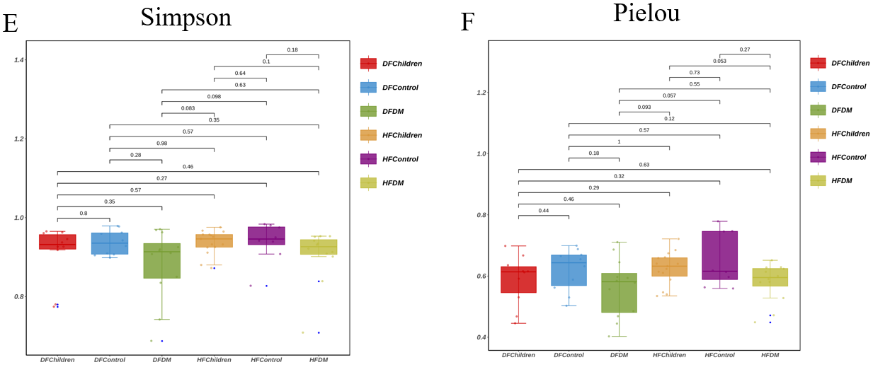
Figure 1 Analysis of alpha diversity in the gut microbiota. We evaluated and compared six indices of alpha diversity. A: Chao1 index; B: Abundance-based coverage estimator index; C: Good’s coverage index; D: Shannon index; E: Simpson index; F: Pielou index. There were no significant differences observed in the population groups among the six indices (P > 0.05). ACE: Abundance-based coverage estimator; DFChildren: Healthy children from the Dai population; DFControl: Healthy adults from the Dai population; DFDM: Adult type 2 diabetes mellitus patients from the Dai population; HFChildren: Healthy children from the Han population; HFControl: Healthy adults from the Han population; HFDM: Adult type 2 diabetes mellitus patients from the Han population.

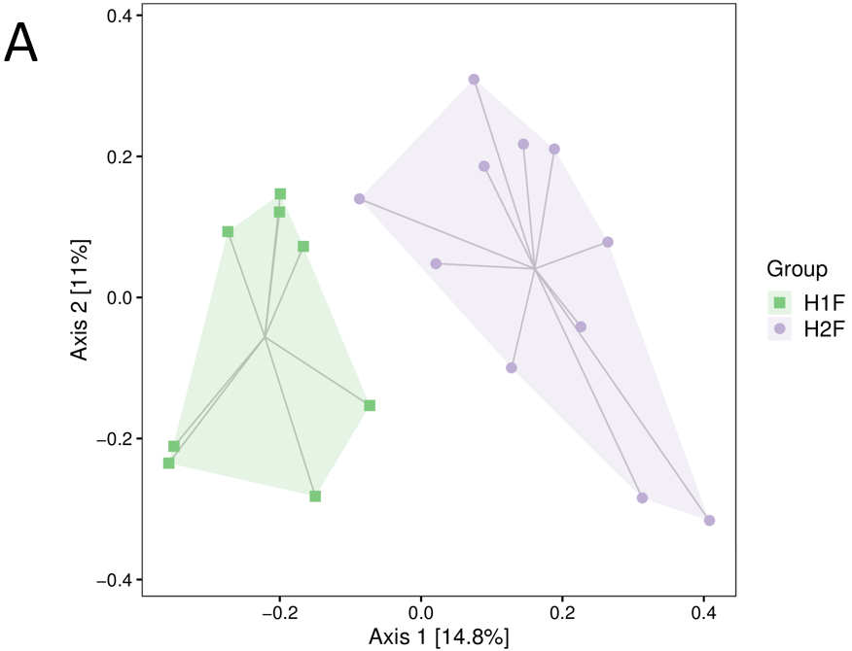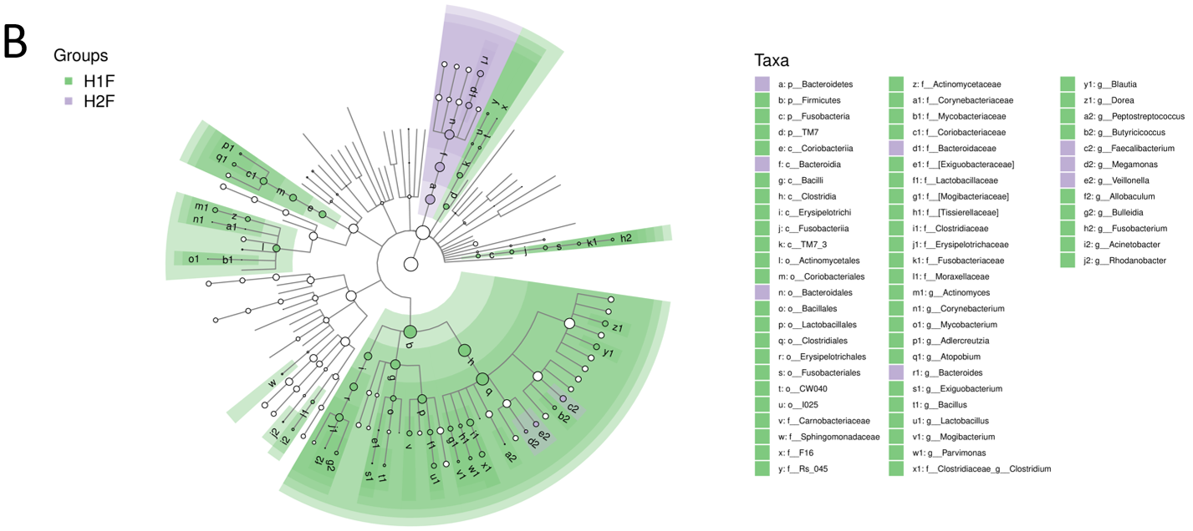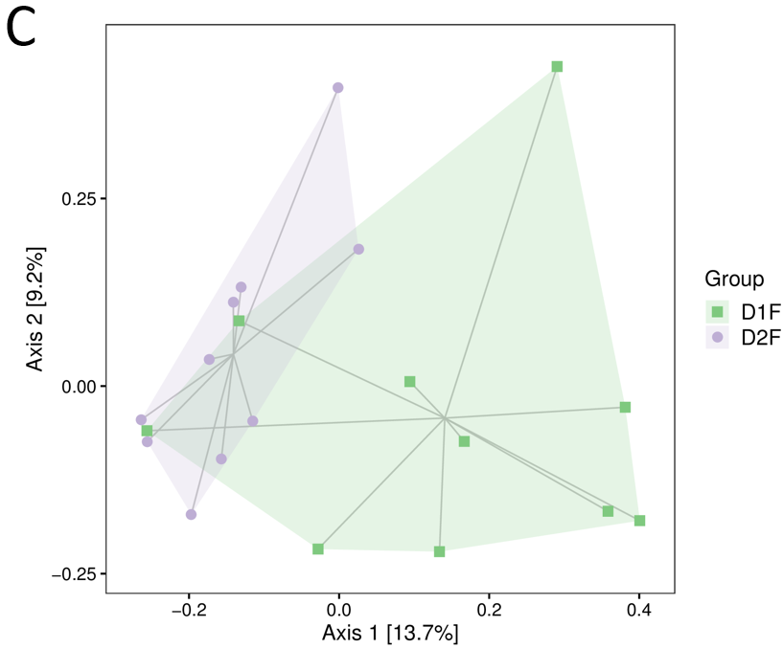
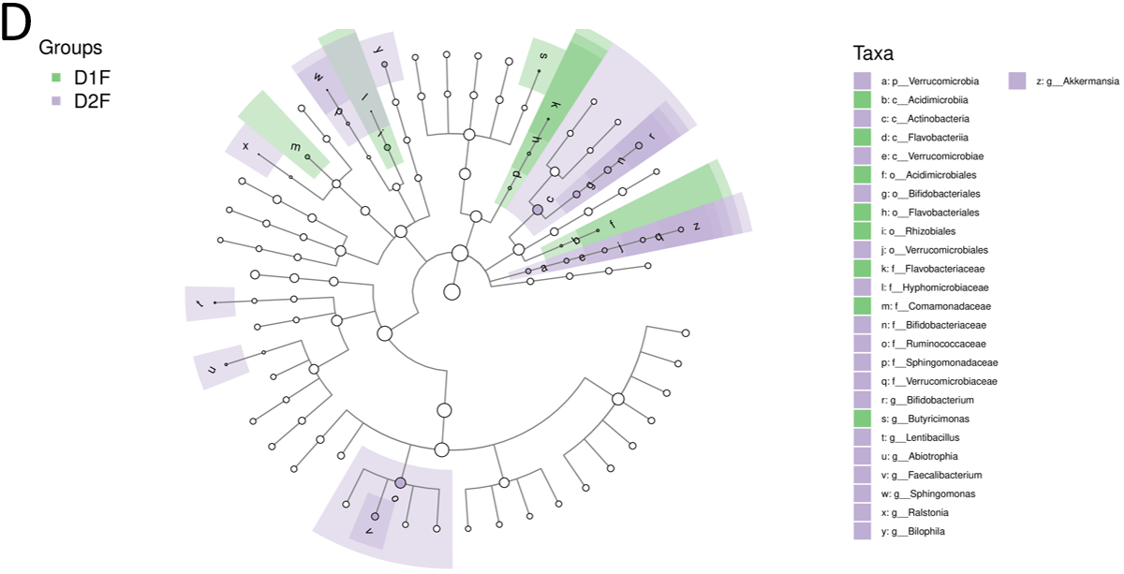
Figure 2 Comparison of gut microbiota between healthy children and healthy adults in the Han and Dai populations. A: Clustering of gut microbiota composition between the healthy children and healthy adults in the Han population. There was a significant difference and clear distinction between the groups (P < 0.05); B: Gut microbiota composition analysis between healthy children and healthy adults in the Han population; C: Clustering of gut microbiota composition between healthy children and adults in the Dai population. There was no significant difference between the groups (P > 0.05); D: Gut microbiota composition analysis between healthy children and healthy adults in the Dai population. H1F: Healthy adults in the Han population; H2F: Healthy children in the Han population; D1F: Healthy adults in the Dai population; D2F: Healthy children in the Dai population.

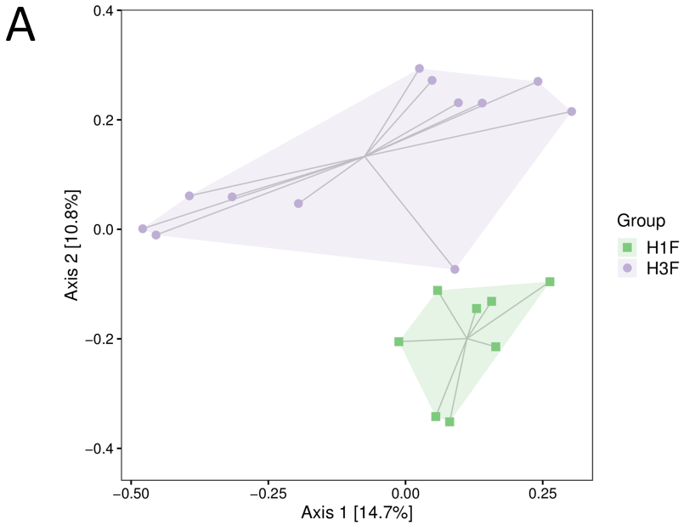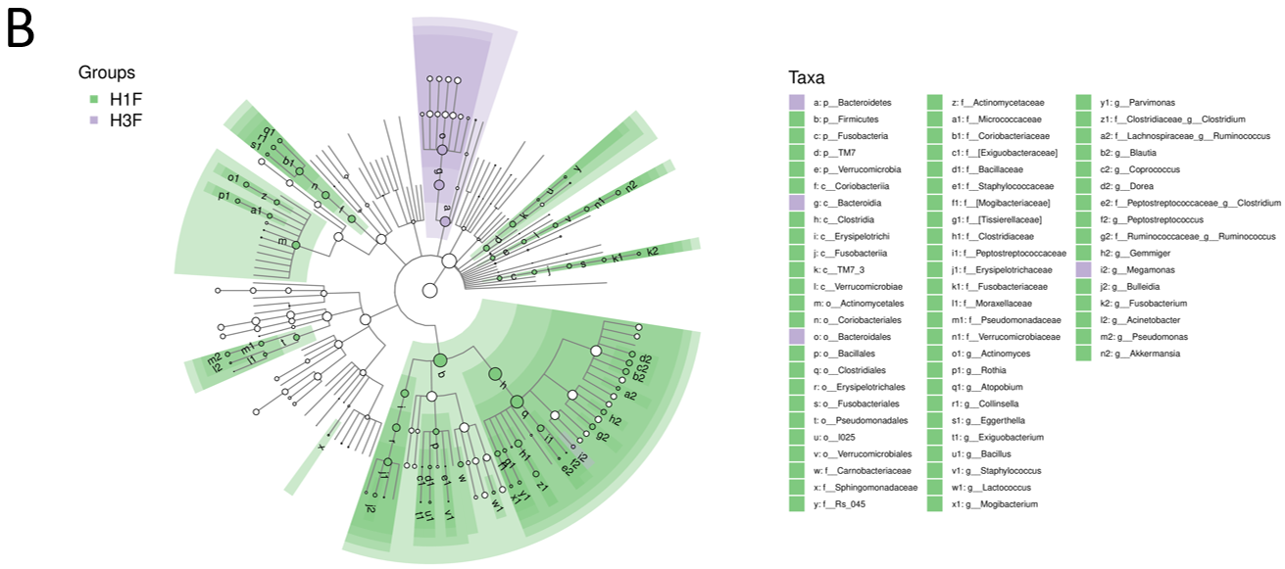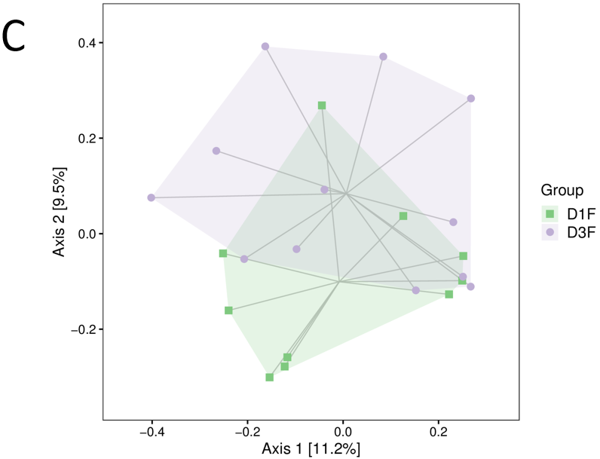
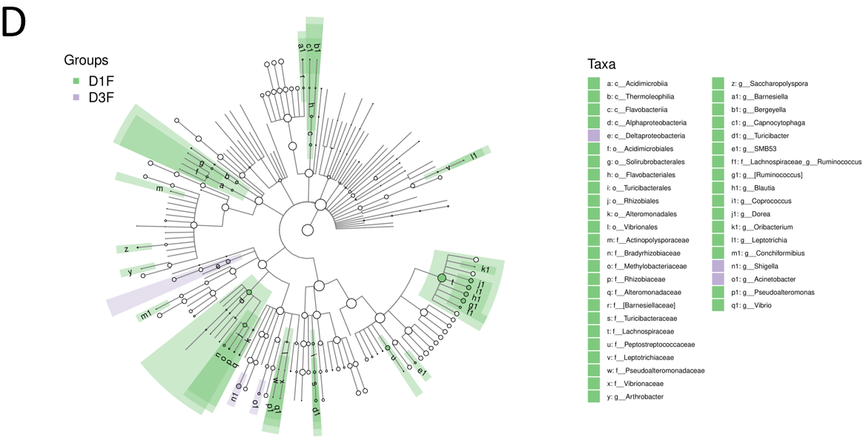
Figure 3 Comparison of gut microbiota between healthy adults and type 2 diabetes mellitus patients in the Han and Dai populations. A: Clustering of gut microbiota composition between the healthy adults and type 2 diabetes mellitus (T2DM) patients in the Han population. There was a significant difference between the two groups (P < 0.05); B: Gut microbiota composition analysis between the healthy adults and T2DM patients in the Han population. There was an increased abundance of Bacteroidetes, Bacteroidales, Megamonas and Bacteroidia in the T2DM patients (P < 0.05); C: Clustering of gut microbiota composition between the healthy adults and T2DM patients in the Dai population. There were no significant differences between two groups (P > 0.05); D: Gut microbiota composition analysis between the healthy adults and T2DM patients in the Dai population. There was an increased abundance of Deltaproteobacteria, Shigella, and Acinetobacter (P < 0.05). D1F: Healthy adults in the Dai population; D3F: Type 2 diabetes mellitus patients in the Dai population; H1F: Healthy adults in the Han population; H3F: Type 2 diabetes mellitus patients in the Han population.

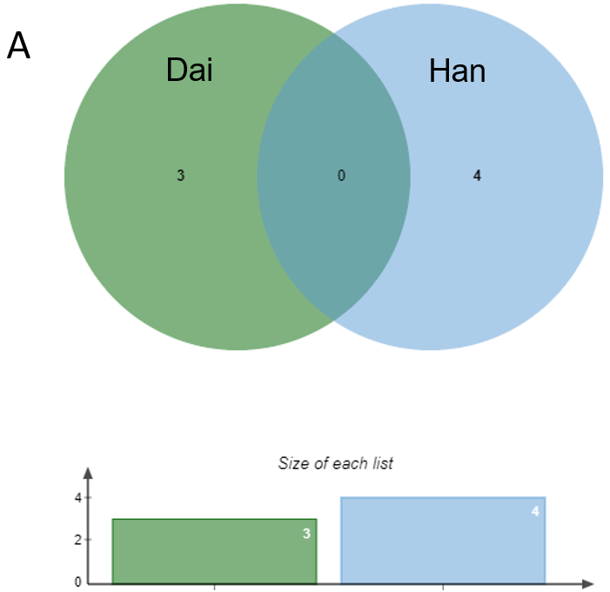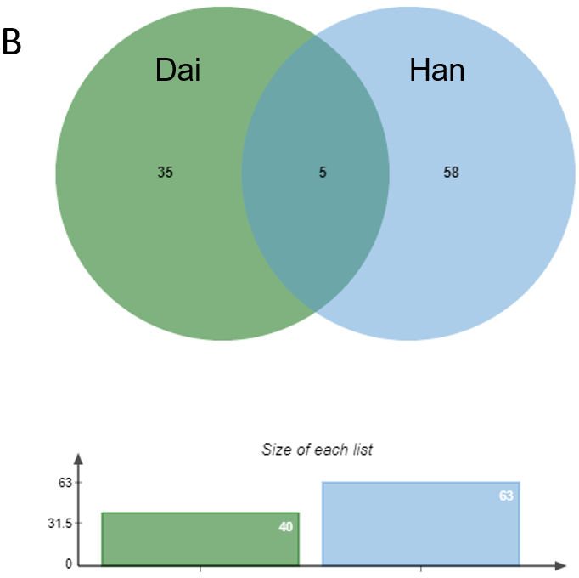
Figure 4 Venn diagram of the unique and shared bacteria in type 2 diabetes mellitus patients in the Han and Dai populations. A: Bacteria with increased abundance; B: Bacteria with decreased abundance. The five bacteria that were decreased in both the Han and Dai populations were Dorea, Peptostreptococcaceae, Blautia, Ruminococcus, and Coprococcus.

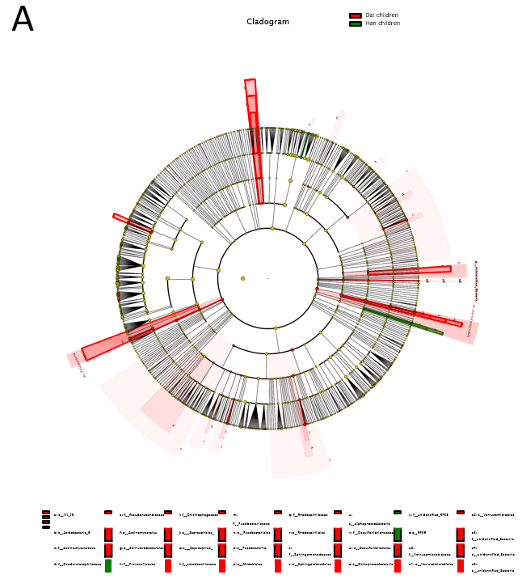
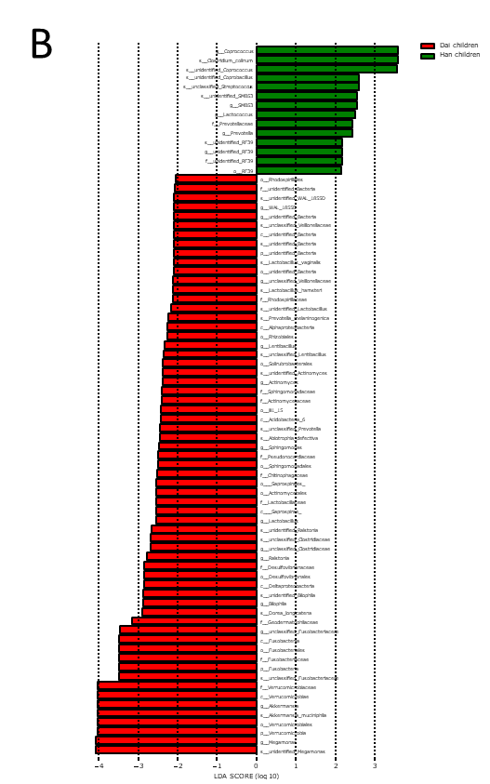
Figure 5 Cladogram of the Linear discriminant analysis Effect Size analysis in healthy children. A: Taxonomic representation of statistically and biologically consistent differences between the healthy children in the Han and Dai populations. Differences are represented in the color of the most abundant class (red indicates the Dai population, and green indicates the Han population). The diameter of each circle is proportional to the abundance of the taxon; B The Linear discriminant analysis Effect Size analysis provided a list of features that were statistically and biologically different (ranked by the effect size). T2DM: Type 2 diabetes mellitus.

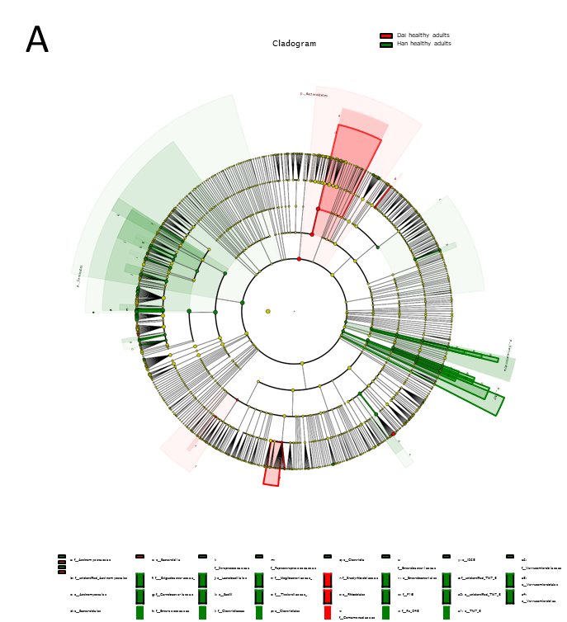
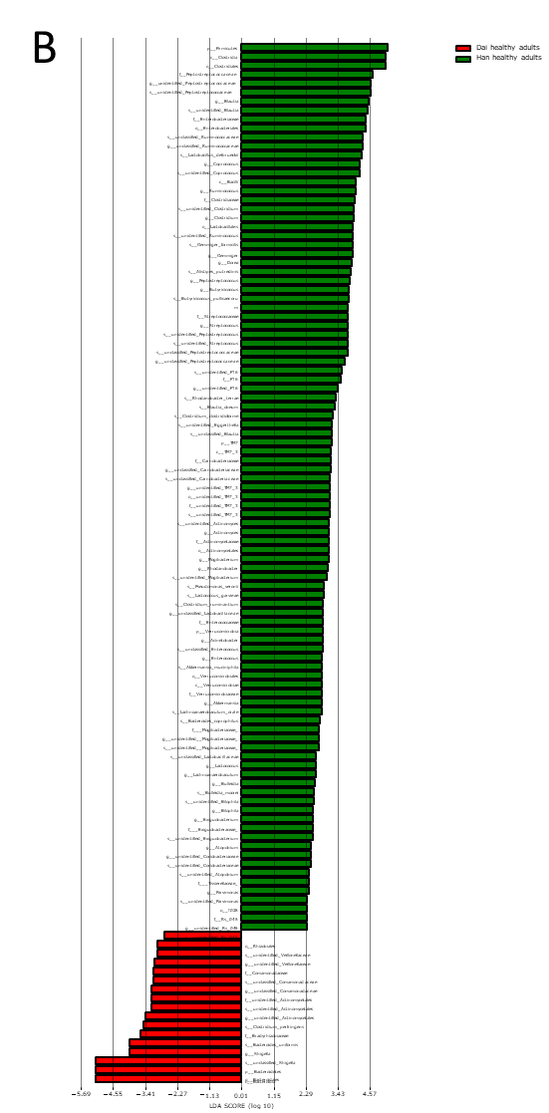
Figure 6 Cladogram of the Linear discriminant analysis Effect Size analysis in healthy adults. A: Taxonomic representation of statistically and biologically consistent differences between the healthy adults in the Han and Dai populations. Differences are represented in the color of the most abundant class (red indicates the Dai population, and green indicates the Han population). The diameter of each circle is proportional to the abundance of the taxon; B The Linear discriminant analysis Effect Size analysis provided a list of features that were statistically and biologically different (ranked by the effect size). T2DM: Type 2 diabetes mellitus.

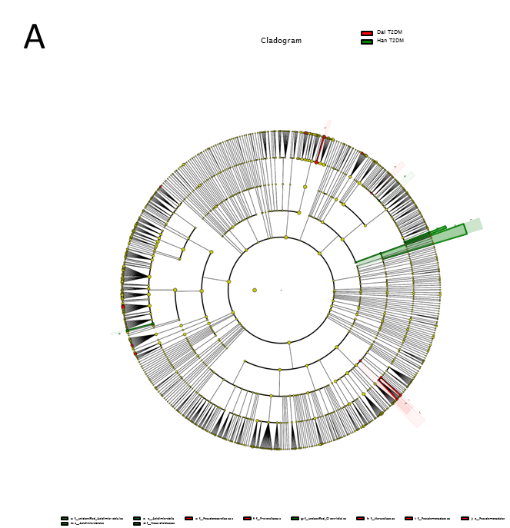
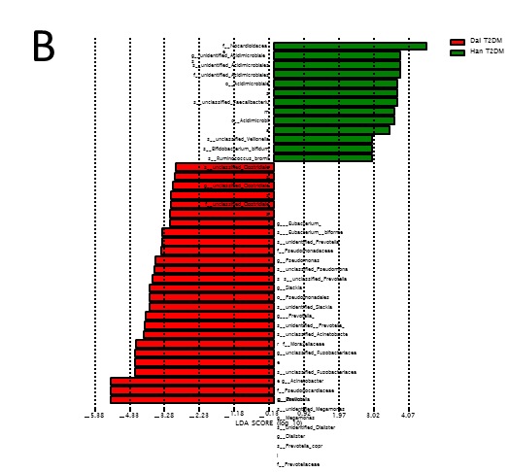
Figure 7 Cladogram of the Linear discriminant analysis Effect Size analysis in type 2 diabetes mellitus patients. A: Taxonomic representation of statistically and biologically consistent differences between the type 2 diabetes mellitus patients in the Han and Dai populations. Differences are represented in the color of the most abundant class (red indicates the Dai population, and green indicates the Han population). The diameter of each circle is proportional to the abundance of the taxon; B The Linear discriminant analysis Effect Size analysis provided a list of features that were statistically and biologically different (ranked by the effect size). T2DM: Type 2 diabetes mellitus.

Table 1 Subject demographics and biochemical blood indices
Parameter | Han population |  |  | Dai population
 | Healthy adults, n = 8 | T2DM patients, n = 12 | Healthy children, n = 15 | Healthy adults, n = 10 | T2DM patients, n = 12 | Healthy children, n = 10
Sex as male/female | 3/5 | 8/4 | 7/8 | 5/5 | 9/3 | 4/6
Age in yr | 50.63 ± 5.85 | 55.27 ± 11.76 | 5.00 ± 2.10¹ | 45.70 ± 14.66² | 55.92 ± 9.07 | 5.50 ± 1.18³
FBG in mmol/L | 4.85 ± 0.38 | 9.98 ± 5.89¹ | 3.23 ± 0.99 | 5.62 ± 1.36 | 7.74 ± 2.39³ | 4.52 ± 0.29
HbA1c as % | 5.55 ± 0.24 | 8.55 ± 2.59¹ | 5.23 ± 0.15 | 5.58 ± 0.19 | 7.24 ± 0.77^{3,4} | 5.19 ± 0.35
TG in mmol/L | 1.90 ± 0.63 | 2.22 ± 1.54 | 0.97 ± 0.24¹ | 3.90 ± 4.10² | 2.48 ± 1.91 | 1.12 ± 0.45³
TC in mmol/L | 5.15 ± 0.61 | 3.76 ± 1.45¹ | 4.01 ± 0.88 | 5.51 ± 1.04 | 4.85 ± 1.26⁴ | 3.91 ± 0.57³
HDL-C in mmol/L | 1.28 ± 0.28 | 0.97 ± 0.22¹ | 1.48 ± 0.34 | 1.23 ± 0.28 | 1.26 ± 0.40 | 1.39 ± 0.42
LDL-C in mmol/L | 3.12 ± 0.64 | 1.82 ± 0.71¹ | 2.16 ± 0.63¹ | 2.98 ± 1.23 | 2.75 ± 1.05⁴ | 2.16 ± 0.38
APO-A1 in g/L | 1.75 ± 0.27 | 1.30 ± 0.30¹ | 1.75 ± 0.36 | 1.83 ± 0.23 | 1.74 ± 0.37⁴ | 1.61 ± 0.36
APO-B in g/L | 1.04 ± 0.15 | 0.68 ± 0.18¹ | 0.72 ± 0.19¹ | 0.98 ± 0.24 | 0.94 ± 0.29 | 0.66 ± 0.09³
WBC as 10⁹/L | 6.06 ± 1.44 | 6.41 ± 1.87 | 6.95 ± 1.11 | 6.79 ± 1.43 | 7.07 ± 2.09 | 8.32 ± 2.38
RBC as 10¹²/L | 5.19 ± 0.66 | 4.82 ± 0.57 | 4.89 ± 0.27 | 5.09 ± 0.65 | 5.05 ± 0.57 | 4.90 ± 0.42
TBil in μmol/L | 6.84 ± 1.59 | 14.19 ± 9.35¹ | 6.07 ± 4.48 | 8.71 ± 5.08² | 6.19 ± 1.98⁴ | 5.74 ± 2.38
DBil in μmol/L | 3.84 ± 0.79 | 6.31 ± 2.92¹ | 2.92 ± 2.34 | 3.96 ± 2.05 | 3.35 ± 1.02⁴ | 3.13 ± 1.40
IBil in μmol/L | 3.00 ± 0.85 | 7.88 ± 6.51¹ | 3.15 ± 2.28 | 4.75 ± 3.05² | 2.84 ± 1.34⁴ | 2.61 ± 1.41³
ALT in U/L | 22.50 ± 11.33 | 31.36 ± 26.34 | 15.80 ± 14.85 | 25.50 ± 15.68 | 26.10 ± 17.22 | 13.70 ± 14.96
AST in U/L | 21.13 ± 4.58 | 27.36 ± 25.61 | 31.50 ± 7.18¹ | 23.26 ± 8.71 | 23.14 ± 8.64 | 27.40 ± 6.45
GGT in U/L | 34.75 ± 24.40 | 51.82 ± 90.65 | 9.67 ± 2.94¹ | 70.40 ± 66.34² | 38.67 ± 22.80⁴ | 13.50 ± 8.15³
BUN in mmol/L | 5.63 ± 1.40 | 4.59 ± 1.70 | 3.68 ± 0.82¹ | 5.12 ± 1.51 | 5.23 ± 2.18 | 3.75 ± 0.91
Cr in μmol/L | 70.38 ± 8.75 | 69.55 ± 20.92 | 32.17 ± 7.60¹ | 68.20 ± 17.69 | 85.50 ± 30.21 | 32.00 ± 4.00³
Hcy in μmol/L | 15.63 ± 3.45 | 12.35 ± 1.55¹ | 14.20 ± 3.12 | 13.59 ± 3.57 | 16.69 ± 3.47⁴ | 11.55 ± 1.53⁵
hs-CRP in mg/L | 1.85 ± 3.35 | 3.46 ± 5.23 | 2.84 ± 6.66⁵ | 1.84 ± 1.57 | 1.83 ± 1.47⁴ | 0.47 ± 0.50³
¹P < 0.05 vs healthy adults in the Han population.
²P < 0.05, healthy adults in the Han population vs healthy adults in the Dai population.
³P < 0.05 vs healthy adults in the Dai population.
⁴P < 0.05, adult type 2 diabetes mellitus patients in the Han population vs adult type 2 diabetes mellitus patients in the Dai population.
⁵P < 0.05, healthy children in the Han population vs healthy children in the Dai population.
ALT: Alanine transaminase; APO: Apolipoprotein; AST: Aspartate aminotransferase; BUN: Blood urea nitrogen; Cr: Creatinine; DBil: Direct bilirubin; FBG: Fasting blood glucose; GGT: Gamma glutamyl transferase; HbA1c: Hemoglobin A1c; Hcy: Homocysteine; HDL-C: High density lipoprotein cholesterol; hs-CRP: Hypersensitive C-reactive protein; IBil: Indirect bilirubin; LDL-C: Low density lipoprotein cholesterol; RBC: Red blood cell; T2DM: Type 2 diabetes mellitus; TBil: Total bilirubin; TC: Total cholesterol; TG: Triglyceride; WBC: White blood cell.

Table 2 Significantly increased bacteria in type 2 diabetes mellitus patients in the Han population
Taxa | Abundance, T2DM patients vs healthy adults | LDA score | P value
Bacteria. Bacteroidetes | 5.353 | 4.939 | 0.037
Bacteria. Bacteroidetes. Bacteroidia. Bacteroidales | 5.353 | 4.939 | 0.037
Bacteria. Firmicutes. Clostridia. Clostridiales. Veillonellaceae. Megamonas | 4.347 | 3.760 | 0.045
Bacteria. Bacteroidetes. Bacteroidia | 5.353 | 4.939 | 0.037
LDA: Linear discriminant analysis; T2DM: Type 2 diabetes mellitus.

Table 3 Significantly increased gut microbiota in type 2 diabetes mellitus patients in the Dai population
Taxa | Abundance, T2DM patients vs healthy adults | LDA score | P value
Bacteria. Proteobacteria. Gammaproteobacteria. Pseudomonadales. Moraxellaceae. Acinetobacter | 2.047 | 2.754 | 0.004
Bacteria. Proteobacteria. Gammaproteobacteria. Enterobacteriales. Enterobacteriaceae. Shigella | 4.711 | 4.288 | 0.021
Bacteria. Proteobacteria. Deltaproteobacteria | 3.199 | 2.764 | 0.044
LDA: Linear discriminant analysis; T2DM: Type 2 diabetes mellitus.

Table 4 Differential gut microbiota observed in the Han population vs Dai population
Differential gut microbiota | Healthy children | Healthy adults | T2DM patients
Han population
d__Bacteria.p__Firmicutes.c__Clostridia.o__Clostridiales.f__Lachnospiraceae.g__Coprococcus.s__unidentified_Coprococcus | 0.542¹ | 0.259ª | 0.461
d__Bacteria.p__Firmicutes.c__Bacilli.o__Lactobacillales.f__Streptococcaceae.g__Streptococcus.s__unclassified_Streptococcus | 0.000¹ | 0.800ª | 1.000
d__Bacteria.p__Firmicutes.c__Clostridia.o__Clostridiales.f__Lachnospiraceae.g__Coprococcus | 0.521¹ | 0.286ª | 0.475
d__Bacteria.p__Firmicutes.c__Bacilli.o__Lactobacillales.f__Streptococcaceae.g__Lactococcus | 0.009¹ | 0.019ª | 0.083
Dai population
d__Bacteria.p__Proteobacteria.c__Alphaproteobacteria.o__Rhizobiales | 4.840¹ | 1.159ª | 1.636
d__Bacteria.p__Firmicutes.c__Clostridia.o__Clostridiales.f__Veillonellaceae.g__unclassified_Veillonellaceae | 8.800¹ | 12.000ª | 1.688
ªP < 0.05 Han population vs Dai population.
T2DM: Type 2 diabetes mellitus.

