Name of Journal: World Journal of Methodology
Manuscript NO: 86258
Manuscript Type: SCIENTOMETRICS

Mapping research trends of transarterial chemoembolization for hepatocellular carcinoma from 2012 to 2021: A bibliometric analysis

Zhang N et al. Bibliometric analysis for TACE

Na Zhang, Xiao-Feng He, Xiang-Ke Niu

Na Zhang, Department of General Practice, Affiliated Hospital of Chengdu University, Chengdu 610081, Sichuan Province, China

Xiao-Feng He, Department of Interventional Radiology, Nanfang Hospital, Southern Medical University, Guangzhou 510515, Guangdong Province, China

Xiang-Ke Niu, Department of Interventional Radiology, Affiliated Hospital of Chengdu University, Chengdu 610081, Sichuan Province, China

Xiang-Ke Niu, Department of Interventional Radiology, Sichuan Cancer Hospital & Research Institute, School of Medicine, University of Electronic Science and Technology of China, Chengdu 610041, Sichuan Province, China

Author contributions: Zhang N and He XF contributed equally to this work; Niu XK designed the research study; Zhang N performed the research; He XF contributed analytic tools; Zhang N and Niu XK analyzed the data and wrote the manuscript; all authors have read and approve the final manuscript.

Supported by The Medical Association Project of Sichuan Province, No. 2021HR04 and No. Q20050; Innovation Team Foundation of Affiliated Hospital of Chengdu University, No. CDFYCX202204.

Corresponding author: Xiang-Ke Niu, MD, PhD, Chief Physician, Professor, Department of Interventional Radiology, Affiliated Hospital of Chengdu University, No. 82 North Second Section of Second Ring Road, Chengdu 610081, Sichuan Province, China. niu19850519@163.com

Received: June 8, 2023
Revised: July 20, 2023
Accepted: August 21, 2023
Published online: September 20, 2023

Abstract
BACKGROUND
Hepatocellular carcinoma (HCC) is the fifth most common cancer worldwide and the second leading cause of cancer-related deaths. Transcatheter arterial chemoembolization (TACE) is a therapy where drugs aimed to slow or halt tumor development are injected into the artery supplying for HCC tissues. A comprehensive analysis of all the articles on TACE for HCC can give us a general understanding of the progress in this field and provide guidance for future research.

AIM
To analyze and visualize scientific results and research trends in TACE treatment for HCC.

METHODS
The “Web of Science” database was used to identify articles regarding TACE for the treatment of HCC from 2012 to 2021. VOSviewer and CiteSpace were used to analyze the publications trends, collaboration between countries/institutions/authors, and the co-occurrence of keywords, keyword bursts, and references.

RESULTS
A total of 5728 original articles on TACE for HCC were retrieved. Regarding the volume of publications, the total number of yearly publications showed a generally increasing trend. China had the highest number of articles, while the United States achieved the highest Hirsch index and highest number of citations. The Sun Yat-sen University in China was most prolific institution. The most active author was Park, J.W from South Korea. The Journal of Vascular and Interventional Radiology (234 articles) was the most productive journal. There is a growing trend toward international collaboration in TACE for HCC. Cluster networks of co-cited references suggested that practice guidelines and targeted therapies are an essential theme in this field. In addition, cluster analysis based on keyword co-occurrence identified the research topic "prediction of TACE treatment" as a hotspot, and propensity score matching can be used to help investigators conduct innovative studies in the future.

CONCLUSION
The results of our bibliometric analysis provide the latest trends and hot topics in TACE therapy for HCC.

Key Words: Transarterial chemoembolization; Hepatocellular carcinoma; VOSviewer; CiteSpace; Bibliometrics

©The Author(s) 2023. Published by Baishideng Publishing Group Inc. All rights reserved.

Citation: Zhang N, He XF, Niu XK. Mapping research trends of transarterial chemoembolization for hepatocellular carcinoma from 2012 to 2021: A bibliometric analysis. World J Methodol 2023; 13(4): 345-358
URL: https://www.wjgnet.com/2222-0682/full/v13/i4/345.htm
DOI: https://dx.doi.org/10.5662/wjm.v13.i4.345

Core Tip: Transarterial chemoembolization (TACE) has been considered the standard of care for intermediate stage hepatocellular carcinoma (HCC). Bibliometric analysis assesses the scientific activity in a given field. Based on the assessment of database and literature characteristics, bibliometrics can estimate developing trends in a scientific manner and expose research frontiers to researchers. Knowledge of the literature in TACE treatment for HCC can lead to a better understanding of the research trends in the field. The results of this bibliometric analysis provided the updated trends and hot topics in TACE treatment of HCC.

INTRODUCTION
Hepatocellular carcinoma (HCC) is the fifth most common cancer worldwide and the second leading cause of cancer-related deaths^{[1]}. Approximately 70% of patients with HCC are diagnosed at an intermediate to advanced stage, when curative treatment is no longer feasible^{[2]}. Conventional transarterial chemoembolization (cTACE) is performed by injecting chemotherapeutic agents and lipiodol emulsion through a catheter into the tumor supply artery under the guidance of medical imaging, followed by the injection of gelatin sponge particles to embolize the tumor vessel^{[3]}. According to the current guidelines^{[4,5]}, TACE is the recommended first-line treatment for patients with Barcelona Clinic Liver Cancer stage B (BCLC-B) disease, defined as a multinodal tumor burden, preserved liver function and good performance status.
Recent advances in TACE techniques, such as the well-known drug-eluting bead TACE (DEB-TACE), have demonstrated the potential to improve the overall survival of patients with intermediate to advanced HCC^{[6,7]}. Studies on the combination of TACE with other treatment modalities, such as thermal ablation^{[8]}, radiotherapy^{[9]} or systemic therapy^{[10]}, have been actively conducted and have achieved encouraging results. A comprehensive analysis of all the articles on TACE for HCC can give us a general understanding of the progress in this field and provide guidance for future research.
Bibliometric analysis assesses the scientific activity in a given field^{[11]}. Based on the assessment of database and literature characteristics, bibliometrics can estimate developing trends in a scientific manner and expose research frontiers to researchers^{[12]}. In recent decades, a large number of bibliometric analyses have been utilized in the medical field^{[13]}. However, comprehensive bibliometric studies on TACE for HCC are still lacking. Therefore, the aim of this study was to systematically analyze studies on TACE for HCC to determine its current status and assess future trends.

MATERIALS AND METHODS
Data sources and search strategies
Ethics Committee approval was not required for this study as it did not involve intervention or data collection in animal or clinical trials. Articles were obtained from the Web of Science (WoS) with a time limit of January 1, 2012 to December 30, 2021, using the following search terms: TS = (Hepatocellular Carcinoma OR HCC OR Liver Cancer OR Liver Neoplasms OR Hepatic Neoplasms OR Cancer of Liver) AND TS = (Chemoembolization OR Chemoembolisation OR Transcatheter Embolization OR Transcatheter Chemoembolization OR TACE OR Transarterial chemoembolization). Inclusion criteria included: articles from peer-review journals; written in English. We also excluded reports, books or book chapters, conference proceedings, dissertations, theses, expert opinion, commentaries, editorials, and letters. We excluded 102 studies from the list after removing duplicates because they failed all inclusion criteria or met at least one exclusion criterion. The complete screening process is shown in Table 1.

Data collection
Two reviewers selected the articles independently, and any discrepancy was solved through discussion. We used the bibliometric method, VOSviewer 1.6.13 and CiteSpace 5.8.R2 to identify the data, including authors, affiliations, countries/regions, journals, number of papers and citations, year of publication, Hirsch index (H index), keywords, and references. The H index is used to quantify an individual’s scientific research output and measure the impact of his or her research^{[14]}. In this study, journal impact factors (IFs) were collected from journal citation reports for 2021.

Data analysis
In this study, the following network graphs were constructed and visualized using VOSviewer: A network graph of co-cited authors and journals, and a co-occurrence analysis of keywords. According to the frequency of items appearing together, co-citation and co-occurrence analysis can reflect the relationship of the items^{[15]}. Additionally, in the network visualization, each node represents a different item, such as author, journal, country/region, or keyword, and the different colors of the nodes indicate different classification criteria or frequency of occurrence. The size of the node represents the number of citations or occurrences, and larger nodes represent higher-level citations or occurrences^{[16]}. The links between nodes demonstrate the relevance of the items' co-citation or co-occurrence, and the thickness of the lines represents the strength of the links.
In addition, another bibliometric software called CiteSpace is used to show new trends and developments in the scientific literature. It is multidimensional, time-shared, dynamic visual analysis software. Burst detection is used to detect abrupt changes in nodes (including authors, countries, keywords, etc.). In this study, we use CiteSpace 5.8.R2 to identify highly cited references and keywords with the strongest citation burst during a certain period.

RESULTS
An overview of publications
From 2012 to 2021, a total of 5728 articles from the last decade were retrieved from WoS, including 72,403 citations for the retrieved articles, with an average number of citations (Nc) per article of 20.67. The H-index for all publications was 111. Supplementary Figure 1 shows the geographical distribution of the total number of papers on TACE for HCC.

Annual trend of paper publication quantity
Figure 1 demonstrates the annual number of papers (Np) related to TACE for HCC. Overall, despite fluctuations over the decade, the number of annual papers increased from 440 in 2012 to 733 in 2021, while Np increased to a peak in 2021.

Analysis of the active countries, institutions and co-authors
The included studies were published in 77 countries and regions in the last decade. We ranked the 10 high-output countries for all authors according to Np (Table 2). China had the highest number of publications (2109), followed by the United States (USA) (1100) and Japan (746). According to the citation analysis, the USA had 31045 citations, followed by China (22453) and Japan (10739). In addition, the USA achieved the highest H-index (71), followed by China (61) and South Korea (49). Overall, 201 institutions contributed to this area. Table 3 displays the five most productive institutions, all of them from Asian countries. Sun Yat-sen University (from China) was the most productive institution, followed by Fudan University (from China) and Seoul National University (from South Korea). Figure 2A shows the trend of global collaboration. There is extensive collaboration among active countries. China has the closest cooperation with the USA and the United Kingdom. Three countries– China, the USA and the United Kingdom–have shown more active cooperation with each other. Figure 2B shows that the organizations are also interacting very closely. Sun Yat-sen University (China) and Johns Hopkins University (USA) are the principal institutions leading collaborative research. The co-author network knowledge map provides relevant links between authors to help researchers access potential collaboration opportunities. As shown in Figure 3, the top three prominent nodes include llovet, J. M., Lencioni R. and Kudo M.

Analysis of highly cited articles
Figure 4 Lists the number of the highest local citation score (LCS) per year for the top 20 articles. The paper is written by Park, J.W in 2015 had the highest LCS of 465 and was ranked first. This is a large multicenter, multinational collaborative retrospective study published in Liver International. The study concluded that TACE was the commonly usedin North America, Europe, China and Korea, regardless of disease stage. Most of the articles with high LCS were conducted in multicenter and international studies and focused on major issues in TACE for HCC. Supplementary Table 1 shows the study characteristics of the top 10 highly cited articles. When the threshold is set at 3, most studies focused on the clinical perspective and conventional TACE-based combination therapies.

Productive journals
A total of 1247 journals published articles in the field. Furthermore, we list the 10 most productive journals with their impact factors in Table 4, and provide a map of the most productive journal in Figure 5. According to statistics from the WoS, Journal of Vascular and Interventional Radiology ranked first with 234 publications in the last decade. Cardiovascular and Interventional Radiology ranks second (220 publications), followed by World Journal of Gastroenterology (143 publications), Medicine (118 publications), and PLoS One (113 publications).

Analysis of co-cited references
Unlike local citation analysis, co-citation networks emphasize research topics that are closely linked to a specific field. The reference co-citation relationship changes over time, and its study can explore the development and evolutionary dynamics of a particular study. Figure 6A shows the mapping of co-cited references based on TACE treatment. Figure 6B depicts the top 20 references with the strongest citation explosion. The most cited references and the highest concentration of TACE treatment for HCC are “practice guidelines” and “targeted therapy”.

Keywords co-occurrence analysis
The high frequency and centrality of keywords allows exploration of core issues and research hotspots of broad interest in the field. A total of 192 terms that appeared more than 20 times were grouped into five clusters. The top three clusters are as follows: Cluster 1 (red) mainly represented the prediction of TACE treatment, as shown in Supplementary Figure 2A. Cluster 2 (green) is focused on vascular endothelial growth factor (VEGF) expression and tumor angiogenesis. Cluster 3 (blue) was the drug-delivery method. The top frequent occurrences of keywords were “HCC”, “survival”, “management” and “prognosis”, indicating that the main focus of research is placed on the prognosis of TACE treatment. Additionally, “drug-delivery method”, “targeted therapy” and “response assessment” have long been a focus of research in the field, as shown in Supplementary Figure 2B. Additionally, we found that the propensity score matching was increasingly used to assess TACE safety/efficiency (Supplementary Figure 2C).

DISCUSSION
To the best of our knowledge, this is not the first but comprehensive bibliometric analysis of TACE management in HCC. A unique database was created, duplicate articles were removed and then selected articles were analyzed along different dimensions: Bibliometrics, demographics, authors, and research trends. The overall increasing trend in the number of papers from 2011 to 2021 reflects a relatively promising research future for TACE in the coming years.
Among the most prolific countries/regions, China ranked first in Np, indicating that China is a highly productive country in this field. Two Chinese institutions and three South Korean institutions came in the top 5 affiliations in Np. According to the GLOBOCAN database, Asia accounts for nearly 72.5% of newly diagnosed cases and 72.4% of deaths from HCC^{[17]}. The BRIDGE study in 2015 concluded that the survival times in South Korea and China were significantly less than that in Japan, which to some extent suggests that these two countries have invested significant resources in recent years. However, compared with China, the USA had a relatively high Nc and H-index. This is because the USA is undoubtedly the most impactful in scientific research fields. The USA has been at the center of academic publishing and has been supported by significant investments in academic research and technological innovation. In recent years, China has also invested heavily in innovative embolic materials for TACE. CalliSpheres® Beads are the first drug eluting beads (DEB) product available for HCC treatment in China, and studies have shown that HCC patients treated with CalliSpheres DEB-TACE have a better treatment response and safety than those treated with cTACE^{[18,19]}. Notably, according to the global network of major research institutions and national collaboration, China could have a major impact on research in this area, and despite being a developing country, it has the strongest global collaboration. Large co-authorship nodes in the network diagram show llovet, J. M. occupying the central area, which is not surprising, as he has made significant contributions to this research. In terms of scientific influence a given field, co-authorship and researchers with a high H-index should be comparable, which helps researchers to understand the most influential authors and to seek potential collaboration opportunities with them.
Regarding the top 10 most productive journals, 7 journals have a relatively high IF score of more than 3. This shows that it is not hard to publish studies on TACE in high-quality journals. All of the top 10 high LCS articles were published in these journals with high IFs (IF > 5), including top journals in oncology and liver disease research, such as the Journal of Clinical Oncology and Hepatology. This implies that these journals have published potentially groundbreaking results in the field, which reminds researchers interested in the topic to pay more attention to these journals. We further analyzed the characteristics of the top 10 highly cited articles. In summary, these studies introduce the positive results of recent randomized clinical trials, and describe targeted therapy combination regimens for patients with intermediate stage HCC. Futhermore, we found that all of the studies were clinical studies, suggesting that the researchers in this field have a strong focus on the clinical perspective; however, basic/experimental research leading to major breakthroughs may have a good chance of being published in the top journals in the future.
Co-cited references show that the hotspots that have been of common interest are “practice guideline” and “targeted therapy”. TACE is the only guideline-recommended standard of care for intermediate-stage HCC worldwide^{[20]}. Therefore, relevant clinical guidelines are expected to be released every few years in both Western and Asian countries. Researchers have paid more attention to these clinical guidelines when conducting their studies. The explanation is that it is more standardized to conduct studies under clinical guidelines and that the guidelines provide us with possible next research hotspots. For example, the European Association for the Study of the Liver (EASL)-2018 clinical practice guideline sets the goal of treatment for HCC: Linking molecular subclasses in clinical trials to predict the treatment response and overall survival. Targeted therapy [tyrosine kinase inhibitor (TKI)] has been the main treatment for patients with advanced stage HCC for more than 10 years^{[21]}. However, in 2019, lenvatinib was approved as an alternative to sorafenib for first-line targeted therapy for HCC^{[22]}. Currently, studies have mainly focused on the molecular mechanisms responsible for tumor progression and treatment resistance, the sequences and timing of drug administration, and which TKI drugs are most beneficial to patient survival from combination therapy^{[23,24]}.
Some emerging research on TACE is gradually becoming a research topic. Cluster 1 (red) primarily represented the prediction of TACE treatment. TACE benefits patients survival; however, repeated TACE therapy progressively impairs liver function. Careful evaluation of the risks and benefits of repeated TACE is needed to improve the long-term outcomes of TACE for HCC. Appropriate decision support has been established during TACE treatment, including the HAP (hepatocellular artery embolization prognosis) score and its modifications (mHAP-II and -III)^{[25]}. A recent study by Wang et al^{[26]} developed an easy-to-use model, referred to as the "six-and twelve" score, which stratifies ideal TACE candidates based on the sum of tumor size and number of lesions. Unfortunately, the results of some external validation studies suggested that the model only has a modest predictive ability^{[27,28]}. More recently, Han et al^{[29]} developed a survival prediction model that assesses patients prior to initial TACE. Although good results were obtained in the preliminary study, the utility of this model needs to be evaluated in future studies. Novel artificial intelligence approaches based on imaging data clearly hold great promise for the future. A study by Niu et al^{[30]} demonstrated the feasibility of a CT-based radiomics model to predict the outcome of sequential TACE treatment.
Cluster 2 is involved in VEGF expression and angiogenesis in HCC. It has been demonstrated that both tumor progression and metastasis are closely related to tumor neoangiogenesis. VEGF is one of the most important angiogenic factors and is highly expressed in HCC tumors; it is associated with tumor angiogenesis, growth, recurrence, and metastasis^{[31]}. Thus, studies on VEGF expression and angiogenesis may lead to novel therapeutic targets for HCC, particularly, in combination with TACE for HCC. Unfortunately, the ideal candidate for molecularly targeted drugs in combination with TACE remains uncertain. Currently, there are more than 1000 clinical trials enrolling patients, demonstrating a dedication to finding novel effective systemic therapeutics or targeting immune checkpoints for the treatment of HCC^{[32]}.
In terms of the "delivery method", conventional TACE using iodine oil loaded with anticancer drugs is less effective, and although DEB, including HepaSphere, CalliSpheres and TANDEM, are used, there are still problems of low response rates, as well as chemotherapeutic drug escape and tumor resistance^{[33]}. Currently, the combination of nanodelivery systems with TACE is of interest. Due to the method of medication, the targeting effect of TKIs is poor, while nanodelivery systems can provide an opportunity to overcome the drawbacks and achieve good results^{[34]}. Ding et al^{[35]} developed peptide nanogels with a stimulatory response for the delivery of lenvatinib with good tumor suppression and few side effects. Although some nanoparticles (NPs) have been approved by the FDA for clinical use, the safety of NPs has been an unavoidable issue during human applications. Therefore, more in-depth experimental studies and clinical trials on various combinations of TACE and nanospheres are needed to explore the correlation between NP size and optimal drug loading and their impact on drug delivery properties.
In the last decade, technical improvements, mainly include: (1) The treatment should involve a water-in-oil emulsion, which maximize the propensity to target the tumor feeding arteries^{[36]}; (2) improvement of imaging quality during fluoroscopy or digital subtracted angiography: Angio Cone-Beam Computed Tomography should be used to detect enhancing tumors, tumor feeders and guide tumor targeting^{[37,38]}; and (3) whenever cTACE is proposed, it should aim at being supraselective-TACE. Regarding the most suitable and appropriate microcatheter for the procedures, 2.4 French (F) was recognized as the upper caliber limit accepted to perform supraselective-TACE. However, all experts agree that a lower microcatheter diameter, 1.5-2.0 F, should be preferred and recommended whenever possible. Recently, balloon occluded TACE (B-TACE), due to its ability to redistribute flow towards lower resistance vascular territories and allowing a pressure-gradient driven embolization, has been shown to improvedrug delivery to target lesion^{[39,40]}.The top co-cited reference with the most citation burstiness is “propensity score matching”. Propensity score matching (PSM) is one of the most popular statistical methods used to process data from observational studies. In observational studies, there are various bias and confounding variables for some reasons, and the propensity score matching method is designed to reduce the effects of these bias and confounding variables to make a more reasonable comparison between control and experimental groups. PSM has been shown to be comparable to Randomized control trials in producing unbiased estimates of efficacy; however, the cost and research time are significantly reduced^{[41,42]}. A recent study conducted by Marinelli et al^{[43]} used propensity score matching and found that TACE can be safely combined with programmed cell death 1 blockers and may lead to HCC downstaging in selected patients.
TACE may also be used as a downstaging therapy prior to hepatectomy or as a bridging therapy prior to liver transplantation in patients with advanced tumors. However, before considering TACE as a treatment option for patients with unresectable HCC, the patient's risk profile, comorbidities, treatment prognosis, and benefits should be taken into account in order to improve overall survival and minimize the occurrence of adverse events. Notably, in addition to the traditional TACE monotherapy, some researchsrs are now focusing on TACE-based combination therapies, such as the combination of TACE and tumor thermal ablation, the combination of TACE and radiotherapy, and the combination of TACE and systemic therapeutic agents. However, further research is needed to determine which combination therapy is more cost-effective in prolonging patient survival.
The present study also has some limitations. First, we only included articles published in English in WoS; therefore, not all publications were considered and the number of citations may have been underestimated. Second, CiteSpace only analyzed the main findings of the studies rather than reviewing the full text; As a result, some important information may have been overlooked. Finally, our results reflect only the current status of TACE for HCC, as data usually change over time.

CONCLUSION
In conclusion, the results of our bibliometric analysis provide the latest trends and hot topics in TACE therapy for HCC. Based on the results found by CiteSpace and VOSviewer, we can conclude that current research in this field is focused on survival prediction and TACE-based combined therapies. These results can also help researchers in the field find relevant literature and stay informed about hot topics.

ARTICLE HIGHLIGHTS
Research background
Hepatocellular carcinoma (HCC) is the fifth most common cancer worldwide and the second leading cause of cancer-related deaths. Transcatheter arterial chemoembolization (TACE) is a therapy where drugs aimed to slow or halt tumor development are injected into the artery supplying for HCC tissues. A comprehensive analysis of all the articles on TACE for HCC can give us a general understanding of the progress in this field and provide guidance for future research.

Research motivation
The bibliometric analysis can be an important tool to help quantify and evaluate productivity within a scientifc feld, while also providing a comprehensive overview of the literature for students, trainees and experts in addition to identifying potential future research directions.

Research objectives
The aim of this study was to systematically analyze studies on TACE for HCC to determine its current status and assess future trends.

Research methods
The “Web of Science” database was used to identify articles regarding TACE for the treatment of hepatocellular carcinoma (HCC) from 2012 to 2021. VOSviewer and CiteSpace were used to analyze the publications trends, collaboration between countries/institutions/authors, and the co-occurrence of keywords, keyword bursts, and references.

Research results
A total of 5728 original articles on TACE for HCC were retrieved. Regarding the volume of publications, the total number of yearly publications showed a generally increasing trend. China had the highest number of articles, while the United States achieved the highest Hirsch index and highest number of citations. The Sun Yat-sen University in China was most prolific institution. The most active author was Park JW from South Korea. The Journal of Vascular and Interventional Radiology (234 articles) was the most productive journal. There is a growing trend toward international collaboration in TACE for HCC. Cluster networks of co-cited references suggested that practice guidelines and targeted therapies are an essential theme in this field. In addition, cluster analysis based on keyword co-occurrence identified the research topic "prediction of TACE treatment" as a hotspot, and propensity score matching can be used to help investigators conduct innovative studies in the future.

Research conclusions
We found that current research in this field focuses on survival prediction and TACE-based combined therapies. These results can also help researchers in the field find relevant literature and stay informed about hot topics.

Research perspectives
High-quality international multicenter studies are needed to confirm how TACE-based combination therapies better improve patient survival.

REFERENCES
1 Bray F, Ferlay J, Soerjomataram I, Siegel RL, Torre LA, Jemal A. Global cancer statistics 2018: GLOBOCAN estimates of incidence and mortality worldwide for 36 cancers in 185 countries. CA Cancer J Clin 2018; 68: 394-424 [PMID: 30207593 DOI: 10.3322/caac.21492]
2 Bruix J, Sherman M; American Association for the Study of Liver Diseases. Management of hepatocellular carcinoma: an update. Hepatology 2011; 53: 1020-1022 [PMID: 21374666 DOI: 10.1002/hep.24199]
3 Yang Z, Zou R, Zheng Y, Qiu J, Shen J, Liao Y, Zhang Y, Wang C, Wang Y, Yuan Y, Li K, Zuo D, He W, Liu W, Li B, Yuan Y. Lipiodol deposition in portal vein tumour thrombus predicts treatment outcome in HCC patients after transarterial chemoembolisation. Eur Radiol 2019; 29: 5752-5762 [PMID: 30993438 DOI: 10.1007/s00330-019-06157-0]
4 European Association for the Study of the Liver. Electronic address: easloffice@easloffice.eu. EASL Clinical Practice Guidelines: Management of hepatocellular carcinoma. J Hepatol 2018; 69: 182-236 [PMID: 29628281 DOI: 10.1016/j.jhep.2018.03.019]
5 Xie DY, Ren ZG, Zhou J, Fan J, Gao Q. 2019 Chinese clinical guidelines for the management of hepatocellular carcinoma: updates and insights. Hepatobiliary Surg Nutr 2020; 9: 452-463 [PMID: 32832496 DOI: 10.21037/hbsn-20-480]
6 Zane KE, Makary MS. Locoregional Therapies for Hepatocellular Carcinoma with Portal Vein Tumor Thrombosis. Cancers (Basel) 2021; 13 [PMID: 34771593 DOI: 10.3390/cancers13215430]
7 Ji K, Zhu H, Wu W, Li X, Zhan P, Shi Y, Sun J, Li Z. Tumor Response and Nomogram-Based Prognostic Stratification for Hepatocellular Carcinoma After Drug-Eluting Beads Transarterial Chemoembolization. J Hepatocell Carcinoma 2022; 9: 537-551 [PMID: 35698645 DOI: 10.2147/JHC.S360421]
8 Lee HJ, Kim JW, Hur YH, Shin SS, Heo SH, Cho SB, Kang YJ, Lim HS, Seon HJ, Jeong YY. Combined Therapy of Transcatheter Arterial Chemoembolization and Radiofrequency Ablation vs Surgical Resection for Single 2-3 cm Hepatocellular Carcinoma: A Propensity-Score Matching Analysis. J Vasc Interv Radiol 2017; 28: 1240-1247.e3 [PMID: 28688816 DOI: 10.1016/j.jvir.2017.05.015]
9 Yoon SM, Ryoo BY, Lee SJ, Kim JH, Shin JH, An JH, Lee HC, Lim YS. Efficacy and Safety of Transarterial Chemoembolization Plus External Beam Radiotherapy vs Sorafenib in Hepatocellular Carcinoma With Macroscopic Vascular Invasion: A Randomized Clinical Trial. JAMA Oncol 2018; 4: 661-669 [PMID: 29543938 DOI: 10.1001/jamaoncol.2017.5847]
10 Meyer T, Fox R, Ma YT, Ross PJ, James MW, Sturgess R, Stubbs C, Stocken DD, Wall L, Watkinson A, Hacking N, Evans TRJ, Collins P, Hubner RA, Cunningham D, Primrose JN, Johnson PJ, Palmer DH. Sorafenib in combination with transarterial chemoembolisation in patients with unresectable hepatocellular carcinoma (TACE 2): a randomised placebo-controlled, double-blind, phase 3 trial. Lancet Gastroenterol Hepatol 2017; 2: 565-575 [PMID: 28648803 DOI: 10.1016/S2468-1253(17)30156-5]
11 Oelrich B, Peters R, Jung K. A bibliometric evaluation of publications in urological journals among European Union countries between 2000-2005. Eur Urol 2007; 52: 1238-1248 [PMID: 17673361 DOI: 10.1016/j.eururo.2007.06.050]
12 Miao L, Zhang J, Zhang Z, Wang S, Tang F, Teng M, Li Y. A Bibliometric and Knowledge-Map Analysis of CAR-T Cells From 2009 to 2021. Front Immunol 2022; 13: 840956 [PMID: 35371087 DOI: 10.3389/fimmu.2022.840956]
13 Zou LX, Sun L. Global diabetic kidney disease research from 2000 to 2017: A bibliometric analysis. Medicine (Baltimore) 2019; 98: e14394 [PMID: 30732183 DOI: 10.1097/MD.0000000000014394]
14 Hirsch JE. An index to quantify an individual's scientific research output. Proc Natl Acad Sci U S A 2005; 102: 16569-16572 [PMID: 16275915 DOI: 10.1073/pnas.0507655102]
15 Wu H, Tong L, Wang Y, Yan H, Sun Z. Bibliometric Analysis of Global Research Trends on Ultrasound Microbubble: A Quickly Developing Field. Front Pharmacol 2021; 12: 646626 [PMID: 33967783 DOI: 10.3389/fphar.2021.646626]
16 Wu H, Li Y, Tong L, Wang Y, Sun Z. Worldwide research tendency and hotspots on hip fracture: a 20-year bibliometric analysis. Arch Osteoporos 2021; 16: 73 [PMID: 33866438 DOI: 10.1007/s11657-021-00929-2]
17 Arnold M, Abnet CC, Neale RE, Vignat J, Giovannucci EL, McGlynn KA, Bray F. Global Burden of 5 Major Types of Gastrointestinal Cancer. Gastroenterology 2020; 159: 335-349.e15 [PMID: 32247694 DOI: 10.1053/j.gastro.2020.02.068]
18 Duan X, Liu J, Han X, Ren J, Li H, Li F, Ju S. Comparison of Treatment Response, Survival Profiles, as Well as Safety Profiles Between CalliSpheres(®) Microsphere Transarterial Chemoembolization and Conventional Transarterial Chemoembolization in Huge Hepatocellular Carcinoma. Front Oncol 2021; 11: 793581 [PMID: 35127501 DOI: 10.3389/fonc.2021.793581]
19 Wang Z, Mu K, Lv Y, Zhao L, Li B, Hao Y, Wang N. Efficacy, safety, and prognostic factors of drug-eluting beads transarterial chemoembolization using CalliSpheres in treating huge hepatocellular carcinoma patients. Ir J Med Sci 2022; 191: 2493-2499 [PMID: 35064533 DOI: 10.1007/s11845-021-02851-5]
20 Bruix J, Reig M, Sherman M. Evidence-Based Diagnosis, Staging, and Treatment of Patients With Hepatocellular Carcinoma. Gastroenterology 2016; 150: 835-853 [PMID: 26795574 DOI: 10.1053/j.gastro.2015.12.041]
21 Forner A, Reig M, Bruix J. Hepatocellular carcinoma. Lancet 2018; 391: 1301-1314 [PMID: 29307467 DOI: 10.1016/S0140-6736(18)30010-2]
22 Kudo M, Finn RS, Qin S, Han KH, Ikeda K, Piscaglia F, Baron A, Park JW, Han G, Jassem J, Blanc JF, Vogel A, Komov D, Evans TRJ, Lopez C, Dutcus C, Guo M, Saito K, Kraljevic S, Tamai T, Ren M, Cheng AL. Lenvatinib vs sorafenib in first-line treatment of patients with unresectable hepatocellular carcinoma: a randomised phase 3 non-inferiority trial. Lancet 2018; 391: 1163-1173 [PMID: 29433850 DOI: 10.1016/S0140-6736(18)30207-1]
23 Fan W, Zhu B, Zheng X, Yue S, Lu M, Fan H, Qiao L, Li F, Yuan G, Wu Y, Zou X, Wang H, Xue M, Li J. Sorafenib plus drug-eluting bead transarterial chemoembolization for early intrahepatic stage-progressed advanced hepatocellular carcinoma refractory to conventional transarterial chemoembolization. J Cancer Res Clin Oncol 2023; 149: 1873-1882 [PMID: 35788728 DOI: 10.1007/s00432-022-04107-w]
24 Zhang JX, Chen YX, Zhou CG, Liu J, Liu S, Shi HB, Zu QQ. Transarterial chemoembolization combined with lenvatinib vs transarterial chemoembolization combined with sorafenib for unresectable hepatocellular carcinoma: A comparative retrospective study. Hepatol Res 2022; 52: 794-803 [PMID: 35698267 DOI: 10.1111/hepr.13801]
25 Müller L, Stoehr F, Mähringer-Kunz A, Hahn F, Weinmann A, Kloeckner R. Current Strategies to Identify Patients That Will Benefit from TACE Treatment and Future Directions a Practical Step-by-Step Guide. J Hepatocell Carcinoma 2021; 8: 403-419 [PMID: 34012930 DOI: 10.2147/JHC.S285735]
26 Wang Q, Xia D, Bai W, Wang E, Sun J, Huang M, Mu W, Yin G, Li H, Zhao H, Li J, Zhang C, Zhu X, Wu J, Li J, Gong W, Li Z, Lin Z, Pan X, Shi H, Shao G, Liu J, Yang S, Zheng Y, Xu J, Song J, Wang W, Wang Z, Zhang Y, Ding R, Zhang H, Yu H, Zheng L, Gu W, You N, Wang G, Zhang S, Feng L, Liu L, Zhang P, Li X, Chen J, Xu T, Zhou W, Zeng H, Zhang Y, Huang W, Jiang W, Zhang W, Shao W, Li L, Niu J, Yuan J, Li X, Lv Y, Li K, Yin Z, Xia J, Fan D, Han G; China HCC-TACE Study Group. Development of a prognostic score for recommended TACE candidates with hepatocellular carcinoma: A multicentre observational study. J Hepatol 2019; 70: 893-903 [PMID: 30660709 DOI: 10.1016/j.jhep.2019.01.013]
27 Bourlière M, Pénaranda G, Adhoute X, Bronowicki JP. The "six-and-twelve score" for TACE treatment: Does it really help us? J Hepatol 2019; 71: 1051-1052 [PMID: 31515044 DOI: 10.1016/j.jhep.2019.06.014]
28 Adhoute X, Larrey E, Anty R, Chevallier P, Penaranda G, Tran A, Bronowicki JP, Raoul JL, Castellani P, Perrier H, Bayle O, Monnet O, Pol B, Bourliere M. Expected outcomes and patients' selection before chemoembolization-"Six-and-Twelve or Pre-TACE-Predict" scores may help clinicians: Real-life French cohorts results. World J Clin Cases 2021; 9: 4559-4572 [PMID: 34222423 DOI: 10.12998/wjcc.v9.i18.4559]
29 Han G, Berhane S, Toyoda H, Bettinger D, Elshaarawy O, Chan AWH, Kirstein M, Mosconi C, Hucke F, Palmer D, Pinato DJ, Sharma R, Ottaviani D, Jang JW, Labeur TA, van Delden OM, Pirisi M, Stern N, Sangro B, Meyer T, Fateen W, García-Fiñana M, Gomaa A, Waked I, Rewisha E, Aithal GP, Travis S, Kudo M, Cucchetti A, Peck-Radosavljevic M, Takkenberg RB, Chan SL, Vogel A, Johnson PJ. Prediction of Survival Among Patients Receiving Transarterial Chemoembolization for Hepatocellular Carcinoma: A Response-Based Approach. Hepatology 2020; 72: 198-212 [PMID: 31698504 DOI: 10.1002/hep.31022]
30 Niu XK, He XF. Development of a computed tomography-based radiomics nomogram for prediction of transarterial chemoembolization refractoriness in hepatocellular carcinoma. World J Gastroenterol 2021; 27: 189-207 [PMID: 33510559 DOI: 10.3748/wjg.v27.i2.189]
31 Marzi L, Mega A, Gitto S, Pelizzaro F, Seeber A, Spizzo G. Impact and Novel Perspective of Immune Checkpoint Inhibitors in Patients with Early and Intermediate Stage HCC. Cancers (Basel) 2022; 14 [PMID: 35884392 DOI: 10.3390/cancers14143332]
32 Luo XY, Wu KM, He XX. Advances in drug development for hepatocellular carcinoma: clinical trials and potential therapeutic targets. J Exp Clin Cancer Res 2021; 40: 172 [PMID: 34006331 DOI: 10.1186/s13046-021-01968-w]
33 Facciorusso A. Drug-eluting beads transarterial chemoembolization for hepatocellular carcinoma: Current state of the art. World J Gastroenterol 2018; 24: 161-169 [PMID: 29375202 DOI: 10.3748/wjg.v24.i2.161]
34 Su D. The transcatheter arterial chemoembolization combined with targeted nanoparticle delivering sorafenib system for the treatment of microvascular invasion of hepatocellular carcinoma. Bioengineered 2021; 12: 11124-11135 [PMID: 34923912 DOI: 10.1080/21655979.2021.2001239]
35 Ding L, Zhang P, Huang X, Yang K, Liu X, Yu Z. Intracellular Reduction-Responsive Molecular Targeted Nanomedicine for Hepatocellular Carcinoma Therapy. Front Pharmacol 2021; 12: 809125 [PMID: 35082681 DOI: 10.3389/fphar.2021.809125]
36 de Baere T, Ronot M, Chung JW, Golfieri R, Kloeckner R, Park JW, Gebauer B, Kibriya N, Ananthakrishnan G, Miyayama S. Initiative on Superselective Conventional Transarterial Chemoembolization Results (INSPIRE). Cardiovasc Intervent Radiol 2022; 45: 1430-1440 [PMID: 35978174 DOI: 10.1007/s00270-022-03233-9]
37 Angle JF. Cone-beam CT: vascular applications. Tech Vasc Interv Radiol 2013; 16: 144-149 [PMID: 23993076 DOI: 10.1053/j.tvir.2013.02.009]
38 Beaton L, Daly M, Tregidgo HF, Grimes H, Moinuddin S, Stacey C, Znati S, Hague J, Bascal ZA, Wilde PE, Cooper S, Bandula S, Lewis AL, Clarkson MJ, Sharma RA. Radiopaque drug-eluting embolisation beads as fiducial markers for stereotactic liver radiotherapy. Br J Radiol 2022; 95: 20210594 [PMID: 34762499 DOI: 10.1259/bjr.20210594]
39 Lucatelli P, De Rubeis G, Rocco B, Basilico F, Cannavale A, Abbatecola A, Nardis PG, Corona M, Brozzetti S, Catalano C, Bezzi M. Balloon occluded TACE (B-TACE) vs DEM-TACE for HCC: a single center retrospective case control study. BMC Gastroenterol 2021; 21: 51 [PMID: 33535972 DOI: 10.1186/s12876-021-01631-w]
40 Ikeda K. Recent advances in medical management of hepatocellular carcinoma. Hepatol Res 2019; 49: 14-32 [PMID: 30308081 DOI: 10.1111/hepr.13259]
41 Austin PC. The use of propensity score methods with survival or time-to-event outcomes: reporting measures of effect similar to those used in randomized experiments. Stat Med 2014; 33: 1242-1258 [PMID: 24122911 DOI: 10.1002/sim.5984]
42 Lonjon G, Boutron I, Trinquart L, Ahmad N, Aim F, Nizard R, Ravaud P. Comparison of treatment effect estimates from prospective nonrandomized studies with propensity score analysis and randomized controlled trials of surgical procedures. Ann Surg 2014; 259: 18-25 [PMID: 24096758 DOI: 10.1097/SLA.0000000000000256]
43 Marinelli B, Kim E, D'Alessio A, Cedillo M, Sinha I, Debnath N, Kudo M, Nishida N, Saeed A, Hildebrand H, Kaseb AO, Abugabal YI, Pillai A, Huang YH, Khan U, Muzaffar M, Naqash AR, Patel R, Fischman A, Bishay V, Bettinger D, Sung M, Ang C, Schwartz M, Pinato DJ, Marron T. Integrated use of PD-1 inhibition and transarterial chemoembolization for hepatocellular carcinoma: evaluation of safety and efficacy in a retrospective, propensity score-matched study. J Immunother Cancer 2022; 10 [PMID: 35710293 DOI: 10.1136/jitc-2021-004205]

Footnotes
Conflict-of-interest statement: There is no conflict of interest associated with any of the senior author or other coauthors contributed their efforts in this manuscript.

PRISMA 2009 Checklist statement: The authors have read the PRISMA 2009 Checklist, and the manuscript was prepared and revised according to the PRISMA 2009 Checklist.

Open-Access: This article is an open-access article that was selected by an in-house editor and fully peer-reviewed by external reviewers. It is distributed in accordance with the Creative Commons Attribution NonCommercial (CC BY-NC 4.0) license, which permits others to distribute, remix, adapt, build upon this work non-commercially, and license their derivative works on different terms, provided the original work is properly cited and the use is non-commercial. See: https://creativecommons.org/Licenses/by-nc/4.0/

Provenance and peer review: Unsolicited article; Externally peer reviewed.
Peer-review model: Single blind

Peer-review started: June 8, 2023
First decision: July 10, 2023
Article in press: August 21, 2023

Specialty type: Hematology
Country/Territory of origin: China
Peer-review report’s scientific quality classification
Grade A (Excellent): 0
Grade B (Very good): 0
Grade C (Good): C, C, C
Grade D (Fair): 0
Grade E (Poor): 0

P-Reviewer: Nath L, India; Toti L, Italy; Tustumi F, Brazil S-Editor: Liu JH L-Editor: A P-Editor: Chen YX
Figure Legends

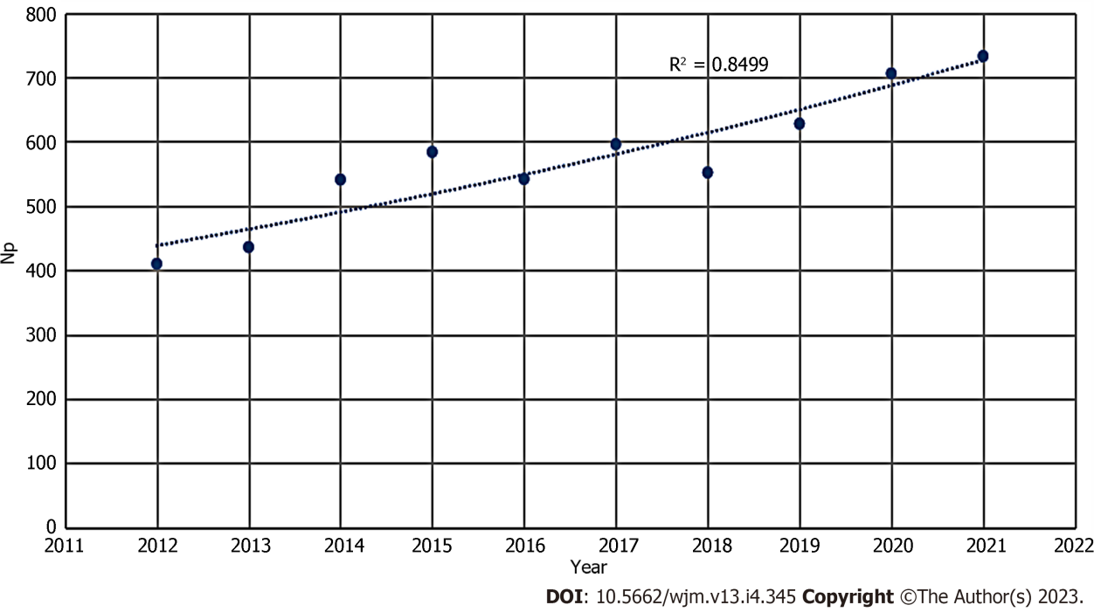

Figure 1 Curve fitting of publications’ overall yearly growth trend. Np: Number of papers.

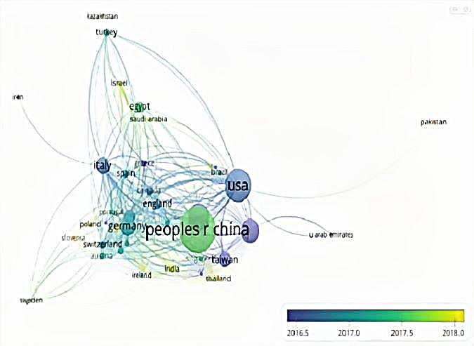
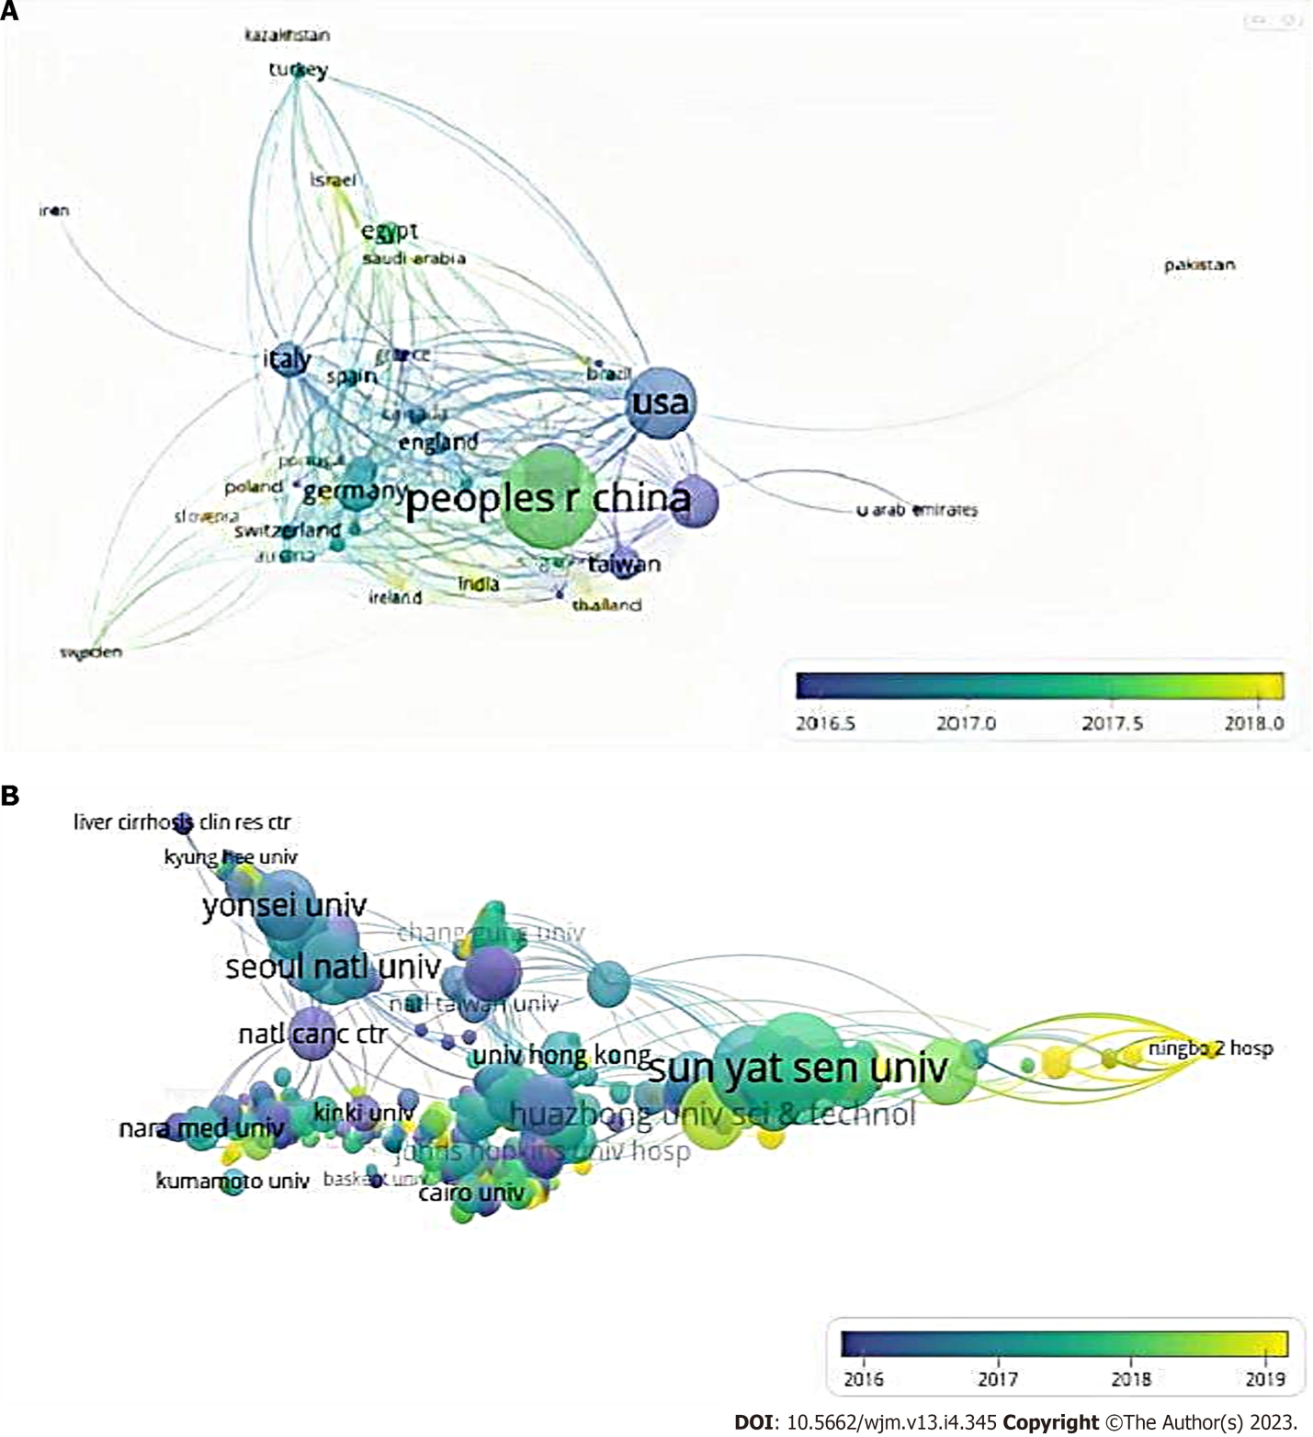
A
Figure 2 Shows the trend of global collaboration, the organizations are also interacting very closely. A: Mapping of the main research countries in transarterial chemoembolization (TACE) for hepatocellular carcinoma (HCC). The minimum number of documents of a country was set at 5. Of the 80 countries that were involved in this field, 42 countries met the threshold; B: Mapping of the collaboration network of the main research organizations in TACE for HCC. The minimum number of documents of an organization was set at 15. Of the 2146 organizations that were involved in this field, 74 organizations met the threshold.

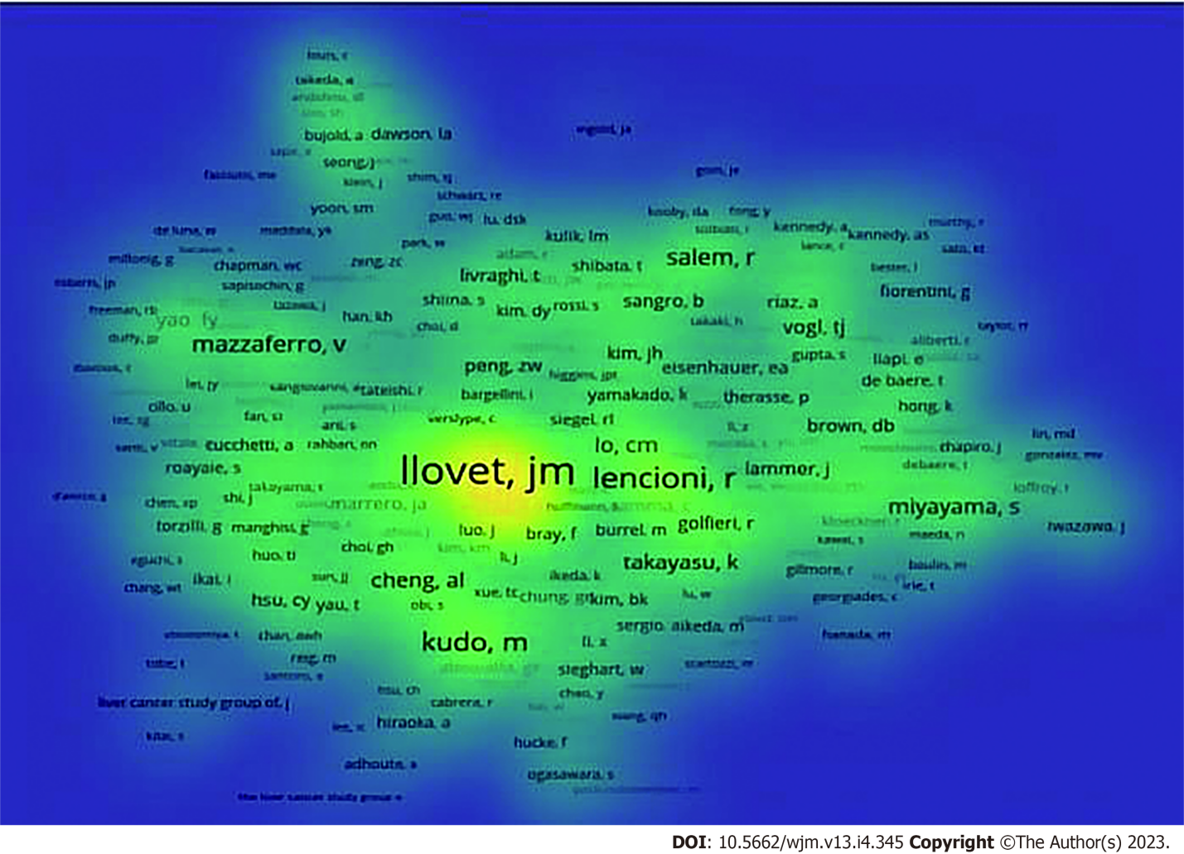
Figure 3 Co-authorship network of productive authors conducting transarterial chemoembolization research. The minimum number of documents of an author was set at 5. Of the 8975 authors that were involved in the research field, 73 authors met the threshold. Yellow means appearing more frequently, while green means appearing less frequently.

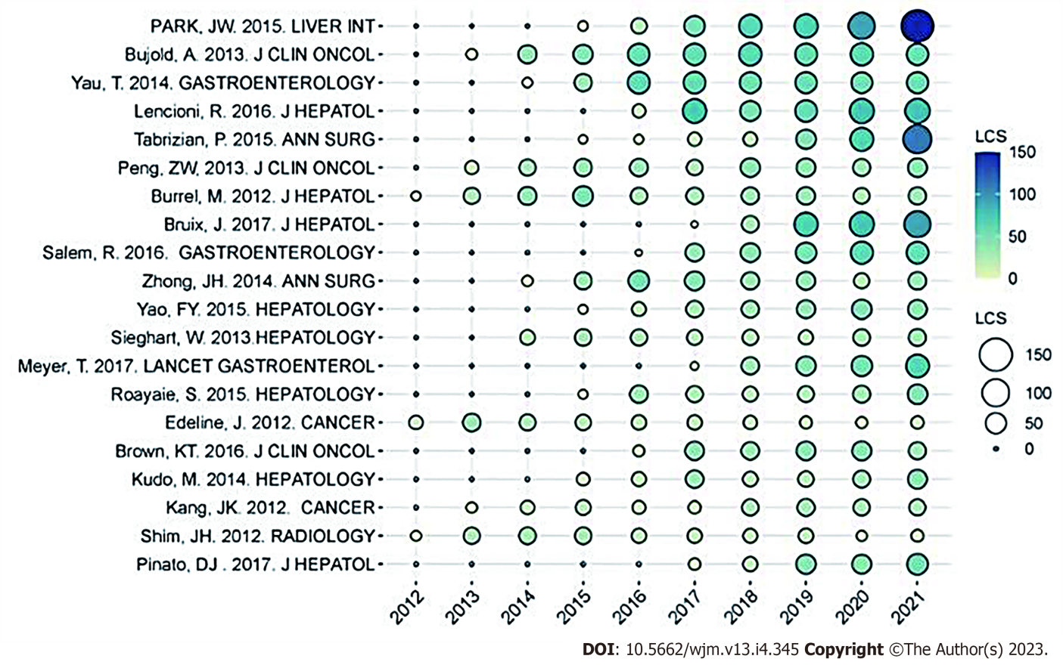
Figure 4 The yearly number of local citations of papers with high local citations. The size and colors of the circle represent the high local citations of papers. LCS: High local citations.

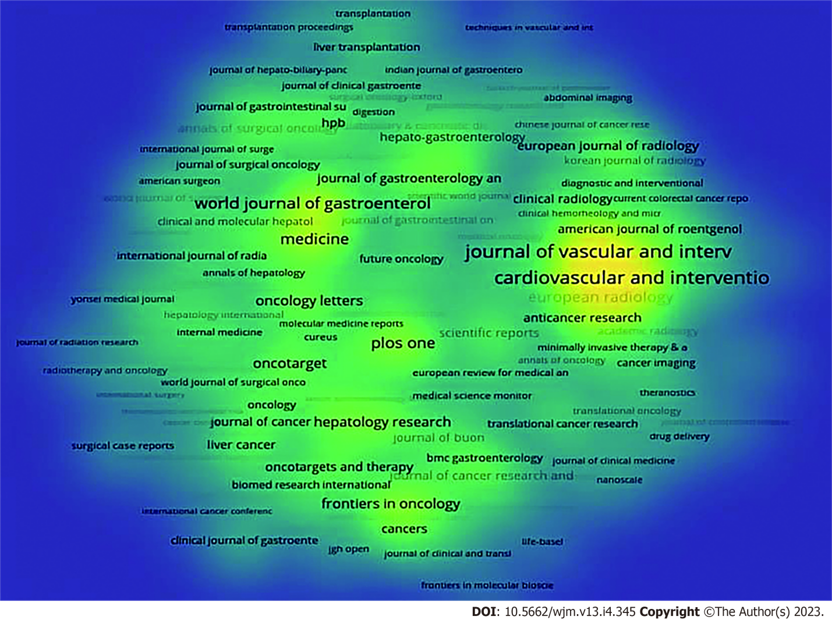
Figure 5 Density visualization for the most prolific journals. The minimum number of documents of an organization was set at 5. Of the 857 journals that were involved in this field, 232 journals met the threshold. Yellow means appearing more frequently, while green means appearing less frequently.

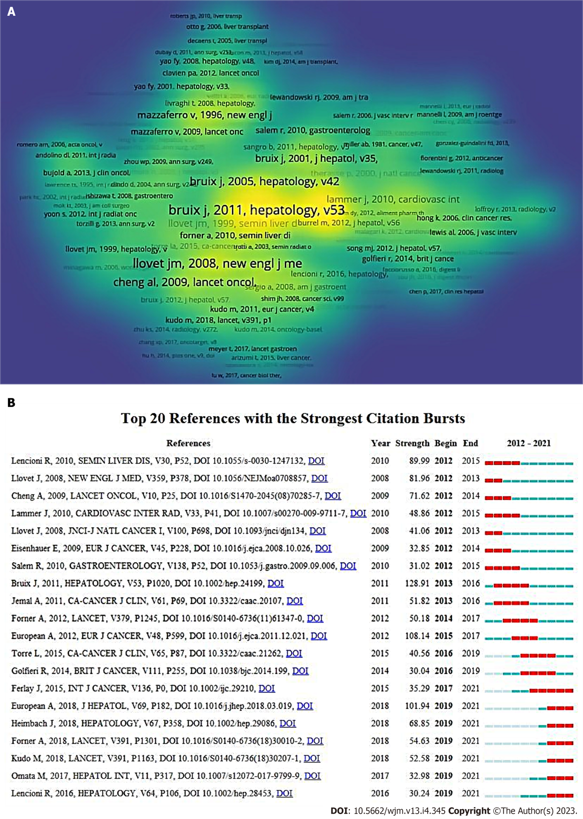
Figure 6 Shows the mapping of co-cited references based on transarterial chemoembolization treatment, depicts the top 20 references with the strongest citation explosion. A: Density visualization of co-cited references. Of the 68527 references, 1159 (divided into six clusters) were cited at least 20 times. Yellow means appearing more frequently, while green means appearing less frequently; B: The top 20 co-cited references with the most citation burstiness. Years between “Begin” and “End” represent the period when the reference was more influential. Years in light green mean that the reference has not yet appeared, years in dark green mean that the reference is less influential, and years in red mean that the reference is more influential.
Table 1 Topic search quires and refinement procedure
Step | Results | Refinement
1 | 13393 | TS = (Hepatocellular Carcinoma OR HCC OR Liver Cancer OR Liver Neoplasms OR Hepatic Neoplasms OR Cancer of Liver) AND TS = (Chemoembolization OR Chemoembolisation OR Transcatheter Embolization OR Transcatheter Chemoembolization OR TACE OR Transarterial chemoembolization)
2 | 8530 | Refined by publication years: (2012 OR 2013 OR 2014 OR 2015 OR 2016 OR 2017 OR 2018 OR 2019 OR 2020 OR 2021)
3 | 5830 | Refined by document types: Articles
4 | 5728 | Refined by languages: English
TS: Topic; HCC: Hepatocellular carcinoma; TACE: Transarterial chemoembolization.

Table 2 The top ten countries/regions with the highest productivity
Rank | Country/Region | Np | Nc | Average per item | H-index
1 | China | 2109 | 22453 | 13.17 | 61
2 | United States | 1100 | 31045 | 30.41 | 71
3 | Japan | 746 | 10739 | 16.03 | 46
4 | South Korea | 595 | 10605 | 19.92 | 49
5 | Germany | 371 | 5529 | 16.04 | 37
6 | Italy | 279 | 9252 | 34.27 | 45
7 | China Taiwan | 244 | 5330 | 22.84 | 34
8 | France | 190 | 6609 | 35.97 | 35
9 | Egypt | 120 | 969 | 8.72 | 18
10 | England | 106 | 3554 | 34.74 | 29
H-index: Hirsch index; Np: Number of papers; Nc: Number of citations.

Table 3 The top five most productive affiliations
Rank | Affiliations | Country | Np | Nc | Average per item | H-index
1 | Sun Yat-senUniversity | China | 228 | 4360 | 20.53 | 34
2 | Fudan University | China | 146 | 2991 | 21.15 | 27
3 | Seoul national University | South korea | 112 | 1497 | 14.23 | 23
4 | Ulsan University | South korea | 111 | 2033 | 19.51 | 25
5 | Yonsei University | South korea | 109 | 2126 | 20.35 | 25
H-index: Hirsch index; Np: Number of papers; Nc: Number of citations.

Table 4 The top 10 most active journals
Rank | Journal | Np | Nc | Average per item | H-index | IF (2021)
1 | Journal of Vascular and Interventional Radiology | 234 | 3858 | 17.41 | 33 | 3.682
2 | Cardiovascular and Interventional Radiology | 220 | 2845 | 13.86 | 26 | 2.797
3 | World Journal of Gastroenterology | 143 | 3423 | 24.25 | 33 | 5.374
4 | Medicine | 118 | 1057 | 9.16 | 18 | 1.817
5 | PLoS One | 113 | 2108 | 18.94 | 26 | 3.752
6 | European Radiology | 108 | 1441 | 14.13 | 21 | 7.034
7 | Hepatology Research | 81 | 1434 | 18.32 | 21 | 4.942
8 | Frontiers in Oncology | 77 | 278 | 3.83 | 9 | 5.738
9 | Oncotarget | 75 | 1119 | 15.17 | 19 | /
10 | BMC Cancer | 74 | 1487 | 20.18 | 23 | 4.638
H-index: Hirsch index; Np: Number of papers; Nc: Number of citations; IF: Impact factors.

Published by Baishideng Publishing Group Inc
7041 Koll Center Parkway, Suite 160, Pleasanton, CA 94566, USA
Telephone: +1-925-3991568
E-mail: bpgoffice@wjgnet.com
Help Desk: https://www.f6publishing.com/helpdesk
https://www.wjgnet.com

© 2023 Baishideng Publishing Group Inc. All rights reserved.

