Name of Journal: World Journal of Gastrointestinal Endoscopy
ESPS Manuscript NO: 20909
Manuscript Type: ORIGINAL ARTICLE

Basic Study
Transgastric endoscopic gastrojejunostomy using holing followed by interrupted suture technique in a porcine model

Chen SY et al. NOTES gastrojejunostomy in a non-survival porcine model

Su-Yu Chen, Hong Shi, Sheng-Jun Jiang, Yong-Guang Wang, Kai Lin, Zhao-Fei Xie, Xiao-Jing Liu

Su-Yu Chen, Hong Shi, Zhao-Fei Xie, Department of Gastrointestinal Endoscopy, Fujian Provincial Tumor Hospital, Teaching Hospital of Fujian Medical University, Fuzhou 350014, Fujian Province, China

Sheng-Jun Jiang, Yong-Guang Wang, Xiao-Jing Liu, Department of Minimally Invasive Surgery, Beijing Chuiyangliu Hospital, Institute of Minimally Invasive Medicine of Tongji University, Beijing 100022, China

Kai Lin, Department of General Surgery, Fuzhou Seventh Hospital, Fuzhou 350014, Fujian Province, China

Author contributions: Chen SY and Shi H were responsible for the study’s conception and design, endoscopic procedures; all authors preformed the endoscopic procedures together; Chen SY drafted the manuscript; Shi H and Wang YG revised and finalized the manuscript.

supported by Medical Innovation Project of Fujian Provincial Health Bureau (2012-C*B-8).

Institutional review board statement: The study was reviewed and approved by the Institutional Review Board of Fujian Provincial Tumor Hospital, Teaching Hospital of Fujian Medical University.

Institutional animal care and use committee statement: All procedures involving animals were reviewed and approved by the Institutional Animal Care and Use Committee of Fujian Provincial Tumor Hospital, Teaching Hospital of Fujian Medical University( protocol number: 2012-C*B-8).

Conflict-of-interest statement: To the best of our knowledge, no conflicts of interest exist regarding the publication of this manuscript.

Data sharing statement: No additional data are available.

Open-Access: This article is an open-access article which was selected by an in-house editor and fully peer-reviewed by external reviewers. It is distributed in accordance with the Creative Commons Attribution Non Commercial (CC BY-NC 4.0) license, which permits others to distribute, remix, adapt, build upon this work non-commercially, and license their derivative works on different terms, provided the original work is properly cited and the use is non-commercial. See: http://creativecommons.org/licenses/by-nc/4.0/

Corresponding author: Hong Shi, MD, Department of Gastrointestinal Endoscopy, Fujian Provincial Tumor Hospital, Teaching Hospital of Fujian Medical University, No. 91 FuMalu Fengban Road, Fuzhou 350014, Fujian Province, China. endoshihong@hotmail.com
Telephone: +86-591-83660063
Fax: +86-591-83660063

Received: June 25, 2015
Peer-review started: June 27, 2015
First decision: July 10, 2015
Revised: July 26, 2015
Accepted: September 13, 2015

Article in press:
Published online:

Abstract
Aim: To demonstrate the feasibility and reproducibility of a pure natural orifice transluminal endoscopic surgery (NOTES) gastrojejunostomy using holing followed by a single endoloop matched with a pair of clips interrupted suture technique in a non-survival porcine model.

Methods: NOTES gastrojejunostomy was performed on 3 female domestic pigs as follows: gastrostomy, selection and retrieval of a free-floating loop of small bowel into the stomach pouch, hold and Exposure of the loop in the gastric cavity using a submucosal inflation technique, execution of a gasto-jejunal mucosal-seromuscular layer approximation using holing followed by endoloop/clips interrupted suture technique, and full-thickness incision of the loop with a Dual Knife.

Results: Pure NOTES side-to-side gastrojejunostomy was successfully performed in all three animals. No leakage was identiﬁed via methylene blue evaluation following surgery.

Conclusion: This novel technique for preforming a gastrointestinal anastomosis exclusively by NOTES is technically feasible and reproducible in an animal model but warrants further improvement.

Key words: Natural orifice transluminal endoscopic surgery; Endoscopic gastrojejunostomy; Endoloop; Endoscopic clips; Pigs

© The Author(s) 2015. Published by Baishideng Publishing Group Inc. All rights reserved.

Core tip: A pure natural orifice transluminal endoscopic surgery gastrojejunostomy procedure may be successfully performed in a non-survival porcine model using holing followed by one endoloop matched with a pair of clips interrupted suture technique, without the need of any additional devices.

Chen SY, Shi H, Jiang SJ, Wang YG, Lin K, Xie ZF, Liu XJ. Transgastric endoscopic gastrojejunostomy using holing followed by interrupted suture technique in a porcine model. World J Gastrointest Endosc 2015; In press

Introduction
Gastro-jejunal side-to-side anastomosis is clinically designed for palliation of malignant gastric outlet obstruction (GOO)^{[1]}, performed primarily via open^{[2]} and laparoscopic surgery^{[3]}. Natural orifice transluminal endoscopic surgery may represent an alternative for the execution of gastro-jejunostomy procedures^{[4-10]} due to less invasiveness and postoperative pain compared with the above-mentioned two procedures. To date, dozens of successful gastric bypass procedures by pure or hybrid natural orifice transluminal endoscopic surgery (NOTES) have been reported, however, these methods are associated with some limitations, including being time-consuming, technically demanding and requiring specialized suturing devices.
Our experimental study aimed to demonstrate the feasibility and reproducibility of a pure NOTES gastrojejunostomy procedure using holing^{[11]} followed by a single endoloop matched with a pair of clips^{[12]} interrupted suture technique in a non-survival porcine model.

Materials and methods
Animal model
Our study involved three healthy female domestic pigs weighing between 15 and 20 kg. All animals were fasted for 24 h prior to surgery. Induction of anesthesia was achieved via an intramuscular injection of 100 mg ketamine, 10 mg droperidol and 1 mg atropine, and maintenance of anesthesia by intravenous drip of propofol at a dose of 10 mL/h with endotracheal intubation. Heart rate and oxygen saturation were monitored during the operation. Animals were kept in a supine position to allow for the best access and optimal peritoneal exploration. This study was approved by the Institutional Animal Use and Care Committee of Fujian Provincial Tumor Hospital, Teaching Hospital of Fujian Medical University, Fuzhou China.

NOTES gastrojejunostomy
Gastrostomy: A small incision was created in the horizontal portion of the anterior pre-antral zone, which was determined via finger indentations of the abdominal wall, away from the small and large curvature, using a Dual knife (KD650L Olympus), followed by dilation using an 18-mm CRE balloon. The dual-channel therapeutic endoscope (GIF2TQ260M, Olympus Tokyo Japan) was subsequently advanced into the peritoneal cavity through the gastrostomy site.
Selection and retrieval of a free-floating loop of small bowel into the stomach pouch: Loop selection was guided by loop proximity to the gastrostomy site to minimize the risk of tension and possible ischemia. An appropriate segment of the upper small intestine (SI) on its anti-mesenteric side was grasped by an endoscopic alligator forceps (FQ-46L-1, Olympus) through one channel of the endoscope and dragged through the incision into the stomach for the intra-gastric anastomosis, taking care not to include the mesenteric vascular supply to avoid unexpected incarceration.
Hold and Exposure of the loop in the gastric cavity via submucosal inflation: An endoscopic injector (NM-400L-0423 Olympus) was passed through the other channel of the endoscope. 5-10 ml of saline solution mixed with 0.1 ml of 2% methylene blue was immediately injected into the submucosal layer circumferentially along the periphery of the gastrostomy site. Submucosal inflation temporarily decreased the size of the orifice of the gastrostomy to prevent the loop from falling back to the peritoneal cavity.
Execution of a gasto-jejunal mucosal-seromuscular layer approximation using holing followed by endoloop/clips interrupted suture technique: First, a total of five to seven holes were made circumferentially along the periphery of the gastrostomy by using the Dual knife. An endoloop followed by an endoclip delivery system was inserted into the gastric cavity through the double-channel endoscope and placed at the side of one hole. One prong of the clip was then inserted in the hole of the stomach wall and clipped to anchor the endoloop. The second clip was used to anchor the same endoloop to the serosal surface of the small intestine. The gastric mucosal layer and the intestinal serosal layer were approximated by tightening of the endoloop. Briefly, gasto-jejunal mucosal-seromuscular layer anastomosis was created in pairs through the mucosa of the stomach and the serosa of small intestine to join the tissues based on the cooperation between one loop and a pair of clips. Five to seven pairs of interrupted sutures were placed to secure the anastomosis.
Full-thickness incision of the loop with the Dual Knife: Jejunal loop incision was made longitudinally on its anti-mesenteric aspect to turn the inside mucosa out.

Euthanasia and necropsy
Euthanasia was performed immediately after the procedure. Necropsy results including injuries to adjacent organs, vascular bleeding, anastomotic patency and leakage evaluation were recorded.

Results
Detailed data of pure NOTES side-to-side gastrojejunostomy performed on the three animals were shown in Table 1 (Figure 1). The procedure was technically successful in all cases. The duration of the procedure ranged from 1.0 to 1.5 h. Minor bleeding occurred from the right gastroepiploic artery during gastrostomy in 2 pigs and treated efficiently with the endoscopic hemostatic forceps (FD-410LR, Olympus) (80 W/soft-coagulation). On the postmortem examination, the immediate patency of the anastomosis was satisfactory, and no evidence of anastomotic leakage was identiﬁed via methylene blue evaluation^{[13]} (Figure 2).

Discussion
The advent of NOTES has made a minimally invasive endoscopic technique possible for creation of gastrojejunal anastomosis, no doubt, being faced with opportunities and challenges at the same time.
Previous studies^{[4,7,8-10]} have reported three full-thickness suturing methods summarized as the small intestine being pulled into the stomach lumen and then sutured to the stomach wall using newly designed endoscopic suturing devices as follows: (1) a prototype endoscopic suturing device (Eagle Claw; Olympus)^{[7]}; (2) a prototype “T-tag” suture system(BraceBar; Olympus)^{[4,9,10]}; and (3) an EndoGIA stapler(Covidien)^{[8]}. Here we reported for the first time, the use of one endoloop matched with a pair of clips interrupted suture technique in a non-survival porcine model. This new technique resembles T-tag suture system, one of the aforementioned three methods, with its own unique characteristics as follows: First, submucosal saline solution injection around the gastrostomy site made a slight cushion that prevented unexpected perforation by electric knives and allowed space to create holes deep enough to insert the prongs of the clip and to facilitate the subsequent secure clipping. Furthermore, submucosal inflation temporarily decreased the size of the orifice, and the smaller orifice allowed us to manipulate the loop of the small intestine in place more easily. Second, creating several holes at the edge of gastrostomy provided strong anchoring points for one prong of a clip in order to avoid clip slippage during grasping gastric thick mucosal surface. Third, one endoloop matched with a pair of clips interrupted suture method was derived from the principle of “sewing” using a pair of T-tags with a single puncture needle, which may be done successfully by using only endoscopes and common endoscopic accessories, without the need of any extra devices.
In particular, if the small intestine was inadvertently dropped during the procedure, no leakage of small bowel contents occurred because the bowel wall was not incised until the anastomosis was complete.
Our pilot study had several limitations, however. First, endoscopic selection of an appropriate loop of the small bowel and secure fixation of the small bowel to the gastric wall without intra-peritoneal manipulation remains challenging^{[14]}. In our current study, the appropriate portion of the small bowel was identified based on its proximity to the gastrostomy site and the left upper abdominal anatomical landmarks such as the spleen. For clinical studies, EUS guidance could be used to direct the targeted jejunal segment near the ligament of Treitz in non-altered anatomy patients^{[1,15]}. Second, both of the endoscopic endoloop/clips utilized in our study, as well as the sewing devices (such as T-bar sutures) predominantly approximate the mucosa, and the reliability and durability of the anastomosis under gastric pressure should be estimated in the porcine model of gastric outlet obstruction (GOO). Thompson et al^{[16]} demonstrated that gastric mucosal closure with endoscopic clips may result in significant air and fluid leakage via the line of clips, however, this was not observed in our study.
In conclusion, this novel technique of performing gastrointestinal anastomosis exclusively by NOTES is technically feasible and reproducible in an animal model, although further improvement is warranted.

Comments
Background
Gastro-jejunal side-to-side anastomosis is clinically designed for palliation of malignant gastric outlet obstruction (GOO), mostly performed via open and laparoscopic surgery. Natural orifice transluminal endoscopic surgery may represent an alternative method of performing gastro-jejunostomy procedures due to its less invasiveness and lower incidence of postoperative pain compared with the above-mentioned two methods.

Research frontiers
To date, dozens of successful gastric bypass procedures via either pure or hybrid natural orifice transluminal endoscopic surgery (NOTES) have been desctibed, however, these methods are associated with some limitations, as they are time-consuming, technically demanding and require specialized suturing devices.

Innovations and breakthroughs
A pure NOTES gastrojejunostomy procedure may be successfully performed in a non-survival porcine model using holing followed by one endoloop matched with a pair of clips interrupted suture technique, without the need of any additional devices.

Applications
This study demonstrates the potential application of pure NOTES gastrojejunostomy using holing followed by one endoloop matched with a pair of clips interrupted suture technique for palliation of malignant gastric outlet obstruction.

Terminology
A NOTES gastrojejunostomy using a single endoloop matched with a pair of clips interrupted suture technique resembles the technical principle of T-tag suture system, without the need of any additional devices.

Peer-review
The advent of NOTES has made a minimally invasive endoscopic technique possible for creation of gastrojejunal anastomosis, being faced with opportunities and challenges at the same time. A pure NOTES gastrojejunostomy procedure may be successfully performed in a non-survival porcine model using holing followed by one endoloop matched with a pair of clips interrupted suture technique.

References
1 Khashab MA, Baron TH, Binmoeller KF, Itoi T. EUS-guided gastroenterostomy: a new promising technique in evolution. Gastrointest Endosc 2015; 81: 1234-1236 [PMID: 25864896 DOI: 10.1016/j.gie.2014.12.053]
2 Chandrasegaram MD, Eslick GD, Mansfield CO, Liem H, Richardson M, Ahmed S, Cox MR. Endoscopic stenting versus operative gastrojejunostomy for malignant gastric outlet obstruction. Surg Endosc 2012; 26: 323-329 [PMID: 21898024 DOI: 10.1007/s00464-011-1870-3]
3 Mehta S, Hindmarsh A, Cheong E, Cockburn J, Saada J, Tighe R, Lewis MP, Rhodes M. Prospective randomized trial of laparoscopic gastrojejunostomy versus duodenal stenting for malignant gastric outflow obstruction. Surg Endosc 2006; 20: 239-242 [PMID: 16362479]
4 Bergström M, Ikeda K, Swain P, Park PO. Transgastric anastomosis by using flexible endoscopy in a porcine model (with video). Gastrointest Endosc 2006; 63: 307-312 [PMID: 16427940]
5 Yi SW, Chung MJ, Jo JH, Lee KJ, Park JY, Bang S, Park SW, Song SY. Gastrojejunostomy by pure natural orifice transluminal endoscopic surgery using a newly designed anastomosing metal stent in a porcine model. Surg Endosc 2014; 28: 1439-1446 [PMID: 24380992 DOI: 10.1007/s00464-013-3371-z]
6 Barthet M, Binmoeller KF, Vanbiervliet G, Gonzalez JM, Baron TH, Berdah S. Natural orifice transluminal endoscopic surgery gastroenterostomy with a biflanged lumen-apposing stent: first clinical experience (with videos). Gastrointest Endosc 2015; 81: 215-218 [PMID: 25527056]
7 Kantsevoy SV, Jagannath SB, Niiyama H, Chung SS, Cotton PB, Gostout CJ, Hawes RH, Pasricha PJ, Magee CA, Vaughn CA, Barlow D, Shimonaka H, Kalloo AN. Endoscopic gastrojejunostomy with survival in a porcine model. Gastrointest Endosc 2005; 62: 287-292 [PMID: 16046997]
8 Chiu PW, Wai Ng EK, Teoh AY, Lam CC, Lau JY, Sung JJ. Transgastric endoluminal gastrojejunostomy: technical development from bench to animal study (with video). Gastrointest Endosc 2010; 71: 390-393 [PMID: 20004893 DOI: 10.1016/j.gie.2009.09.019]
9 Vanbiervliet G, Gonzalez JM, Bonin EA, Garnier E, Giusiano S, Saint Paul MC, Berdah S, Barthet M. Gastrojejunal Anastomosis Exclusively Using the "NOTES" Technique in Live Pigs: A Feasibility and Reliability Study. Surg Innov 2014; 21: 409-418 [PMID: 24253256]
10 Song TJ, Seo DW, Kim SH, Park do H, Lee SS, Lee SK, Kim MH. Endoscopic gastrojejunostomy with a natural orifice transluminal endoscopic surgery technique. World J Gastroenterol 2013; 19: 3447-3452 [PMID: 23801837 DOI: 10.3748/wjg.v19.i22.3447]
11 Kim HH, Park SJ, Park MI, Moon W. Endoscopic hole and clipping technique: a novel technique for closing the wide orifice of a postoperative fistula. Gastrointest Endosc 2012; 75: 1250-1252 [PMID: 22459662 DOI: 10.1016/j.gie.2012.02.005]
12 Zhang Y, Wang X, Xiong G, Qian Y, Wang H, Liu L, Miao L, Fan Z. Complete defect closure of gastric submucosal tumors with purse-string sutures. Surg Endosc 2014; 28: 1844-1851 [PMID: 24442680 DOI: 10.1007/s00464-013-3404-7]
13 Vegunta RK, Rawlings AL, Jeziorczak PM. Methylene blue: a simple marker for intraoperative detection of gastroduodenal perforations during laparoscopic pyloromyotomy. Surg Innov 2010; 17: 11-13 [PMID: 20038507 DOI: 10.1177/1553350609357055]
14 Luo H, Pan Y, Min L, Zhao L, Li J, Leung J, Xue L, Yin Z, Liu X, Liu Z, Sun A, Li C, Wu K, Guo X, Fan D. Transgastric endoscopic gastroenterostomy using a partially covered occluder: a canine feasibility study. Endoscopy 2012; 44: 493-498 [PMID: 22531984 DOI: 10.1055/s-0031-1291689]
15 Itoi T, Ishii K, Tanaka R, Umeda J, Tonozuka R. Current status and perspective of endoscopic ultrasonography-guided gastrojejunostomy: endoscopic ultrasonography-guided double-balloon-occluded gastrojejunostomy (with videos). J Hepatobiliary Pancreat Sci 2015; 22: 3-11 [PMID: 25155270 DOI: 10.1002/jhbp.148]
16 Ryou M, Pai RD, Sauer JS, Rattner DW, Thompson CC. Evaluating an optimal gastric closure method for transgastric surgery. Surg Endosc 2007; 21: 677-680 [PMID: 17160493]

P-Reviewer: Tomizawa m S-Editor: Ma YJ L-Editor: E-Editor:

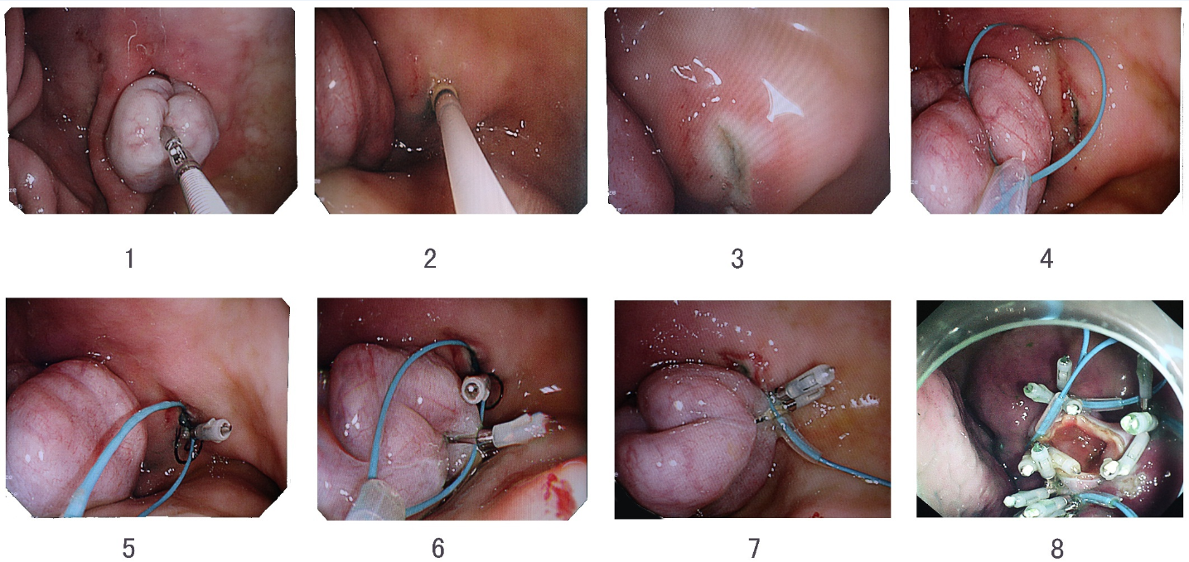
Figure 1 Step-by-step procedure of pure natural orifice transluminal endoscopic surgery side-to-side gastrojejunostomy. 1: Endoscopic view of a loop of small bowel in the stomach grasped by an endoscopic alligator forceps on its anti-mesenteric side; 2: Image taken during submucosal injection around the loop; 3: Endoscopic view of one hole made on gastric mucosal surface; 4: Endoscopic view of an endoloop placed around the hole; 5: Endoscopic view of one clip clipped to anchor the endoloop on the side of the stomach after the prong of the clip was inserted in the hole of the stomach wall; 6: Endoscopic view of the second clip clipped to anchor the endoloop on the side of the small intestine; 7: Endoscopic view of the endoloop tightened to approximate the gastric mucosal layer and the intestinal serosal layer; 8: Endoscopic view of gasto-jejunal mucosal-seromuscular layer anastomosis followed by the loop full-thickness incision.

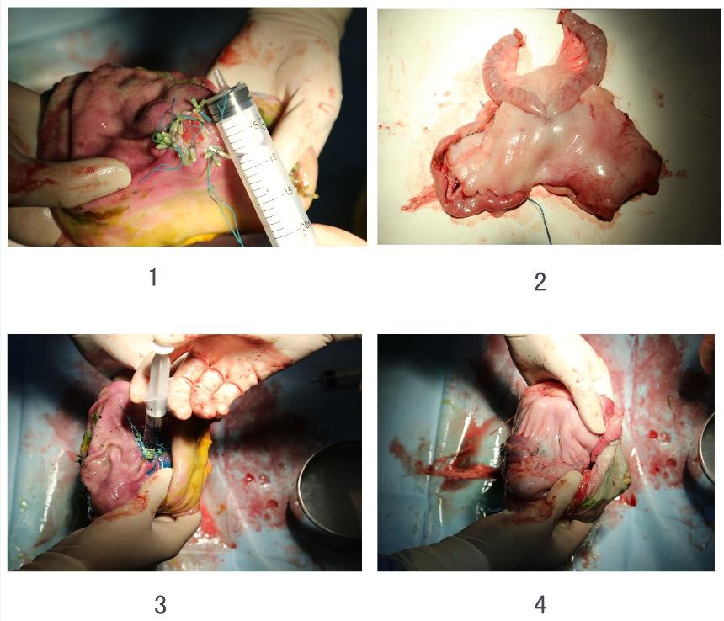
Figure 2 Postmortem appearances of anastomosis. 1: Macroscopic appearance showing that the intestinal wall had been joined to the stomach wall; 2: Macroscopic appearance of gastrointestinal side-to-side anastomosis; 3: Methylene blue instilled into the anastomotic lumen; 4: No methylene blue observed on the surface of gastric serosa around the anastomosis.

Table 1 Summary of the procedures and outcomes following creation of pure natural orifice transluminal endoscopic surgery side-to-side gastrojejunostomy in three female pigs
Observation parameters | Pig 1 | Pig 2 | Pig 3
Time required to enter the peritoneal cavity and pull the loop intro the stomach (min) | 35 | 19 | 18
Time required to suture the anastomosis (min) | 58 | 44 | 47
Number of the stitched pairs | 5 | 6 | 7
complications
Minor bleeding | + | + | -
Anastomotic leak | - | - | -

