Name of Journal: World Journal of Clinical Cases
Manuscript NO: 61239
Manuscript Type: CASE REPORT

Infiltrating ductal breast carcinoma with monoclonal gammopathy of undetermined significance: A case report

Ma Y et al. Infiltrating ductal breast carcinoma with MGUS

Yi Ma, Sen Cui, Yu-Juan Yin

Yi Ma, Sen Cui, Yu-Juan Yin, Department of Hematology, Qinghai University Affiliated Hospital, Xining 810000, Qinghai Province, China

Author contributions: Ma Y researched the literature and drafted the manuscript; Cui S reviewed the literature and edited the manuscript; Yin YJ edited the paper and suggested clinical information.

Supported by The Second Batch of Qinghai Province “Thousand talents Plan for High-end Innovative Talents,” No. [2017] 5.

Corresponding author: Yu-Juan Yin, MD, Chief Doctor, Department of Hematology, Qinghai University Affiliated Hospital, No. 29 Shengli Road, Chengxi District, Xining 810000, Qinghai Province, China. 442844625@qq.com

Received: November 30, 2020
Revised: March 3, 2021
Accepted: March 23, 2021
Published online: May 26, 2021

Abstract
BACKGROUND
Infiltrating ductal breast carcinoma with monoclonal gammopathy of undetermined significance (MGUS) is rare and easily misdiagnosed. Most patients are first diagnosed with MGUS. We report a rare case of MGUS secondary to infiltrating ductal breast carcinoma. We also review the literature to analyze the clinical characteristics and diagnostic methods.

CASE SUMMARY
A 51-year-old woman underwent modified radical mastectomy for infiltrating ductal carcinoma of the right breast and was then treated with radiation and chemotherapy. A decreased platelet count was found on routine blood examination, and MGUS was subsequently diagnosed. This is the first report of the occurrence of MGUS after breast cancer surgery.

CONCLUSION
Vigilance is required to distinguish this rare comorbidity from breast plasmacytoma.

Key Words: Infiltrating ductal breast carcinoma; Monoclonal gammopathy of undetermined significance; Breast plasmacytoma; Plasmacytoma; Case report

©The Author(s) 2021. Published by Baishideng Publishing Group Inc. All rights reserved.

Citation: Ma Y, Cui S, Yin YJ. Infiltrating ductal breast carcinoma with monoclonal gammopathy of undetermined significance: A case report. World J Clin Cases 2021; 9(15): 3675-3679
URL: https://www.wjgnet.com/2307-8960/full/v9/i15/3675.htm
DOI: https://dx.doi.org/10.12998/wjcc.v9.i15.3675

Core Tip: With age, the risk of monoclonal gammopathy of undetermined significance increases, ranging from 2% to 3% over the age of 50 and approximately 5% over the age of 70. In addition, obesity increases the risk relatively. The cause is unclear. Genetic factors, environmental factors, radiation and chemicals (such as pesticides, herbicides) may have a certain impact on the occurrence of this disease. The risk of infection is higher than normal, the risk of osteoporosis and fractures is increased, and the risk of thrombosis is increased. Tumors with monoclonal gammopathy of undetermined significance should be given more attention.
INTRODUCTION
Plasma cell tumors account for 3% of all plasma cell diseases and can be characterized by single or multiple lesions. The most common manifestation is bone marrow-based disseminated tumors. But in rare cases, they can migrate to soft tissue with the help of adhesion molecules, resulting in extra medullary plasmacytoma^{[1,2]}. Polyneuropathy, organomegaly, endocrinopathy, monoclonal protein, skin changes, adenopathy and extensive skin patch overlying a plasmacytoma are paraneoplastic syndromes associated with plasma cell neoplasms^{[3]}. To date, extramedullary plasmacytoma located on both sides of the breast have been reported, and pathological examination confirmed the existence of plasma cell infiltration in the breast^{[4]}.
However, there are no reports of infiltrating ductal breast carcinoma (not breast plasmacytoma) complicated by monoclonal gammopathy of undetermined significance (MGUS). We report the first case of infiltrating ductal breast carcinoma with MGUS.

CASE PRESENTATION
Chief complaints
A 51-year-old woman had undergone breast cancer surgery 18 mo ago, and she had a decrease in platelets for more than 9 mo.

History of present illness
The patient attended our hospital on September 9, 2020. She had a right breast tumor as the initial diagnosis, and pathology after modified radical mastectomy showed infiltrating ductal carcinoma stage I, pT1N1M0, IIA of the right breast. From April to July 2020, the patient received six cycles of docetaxel and Adriamycin chemotherapy followed by radiation therapy and finally two cycles of docetaxel and Adriamycin chemotherapy. On September 8, 2020, she had a routine blood examination that showed a platelet count of 4 × 10⁹/L. She denied any uncomfortable symptoms.

History of past illness
She had type 2 diabetes.

Personal and family history
The patient did not have any special history.

Physical examination
Hemorrhage was observed over the body, mainly on both lower limbs. The right breast was absent. A surgical scar approximately 15 cm in length was present. The left breast was normal without a palpable mass.

Laboratory examinations
Liver fibrosis index showed type III procollagen peptide 88.75 ng/mL, type IV collagen IV-C 63.01 ng/mL and hyaluronic acid 208.90 ng/mL. Liver biopsy showed liver parietal hepatocyte dysplasia, reticular fiber disorder; negative Epstein-Barr virus DNA and, negative hepatitis C virus core antigen and antibody. Bone marrow cytology showed few platelets and megakaryocytes. Hypersplenism was also observed. Serum and urine protein electrophoresis showed M protein 8.6%, immunoglobulin (Ig)G-kappa M proteinemia and positive Bence-Jones protein in urine, which was 0.37 g/L (Figure 1). The serum-free light chain assay showed κ chain 233 mg/L, λ chain 27 mg/L and κ/λ 8.630, considering monoclonal gamma globulin disorder. The urine-free light chain assay showed κ chain 1170 mg/L, λ chain 92 mg/L, and κ/λ 12.717. The L265P mutation of MYD88 gene was negative. Tumor immunophenotyping showed that lymphocytes accounted for approximately 20% of nuclear cells, of which B lymphocytes accounted for a large proportion of the lymphocytes and no obvious light chain restriction (Figure 2). Bone marrow biopsy showed active hematopoietic tissue proliferation, scattered granulocytes and thrombocytosis and an increased proportion of erythroblasts. Scattered or small clusters of plasma cells accounted for approximately 5%-10% and were CD3 (+), CD20 (+), CD56 (-) and CD13 (+) (Figure 3).

FINAL DIAGNOSIS
The patient was diagnosed with infiltrating ductal breast carcinoma and MGUS.

TREATMENT
The patient’s condition was stable after chemotherapy, radiotherapy and breast cancer surgery. The treatment principle for MGUS was observation, long-term close follow-up and no special treatment because MGUS showed no clinical manifestations of malignant plasma cell disease and did not reach the indications for monoclonal immunoglobulin therapy. The patient received a platelet transfusion and thrombopoietin for symptomatic treatment.

OUTCOME AND FOLLOW-UP
The patient was discharged from hospital when her platelet count was normal and was contacted by phone 1 mo after discharge. She had no skin or mucous membrane bleeding.

DISCUSSION
MGUS is an asymptomatic precancerous plasma cell disease, which is essentially a precancerous lesion and does not always progress to an obvious malignant tumor. It is characterized by a serum M protein lower than 30 g/L, bone marrow clonal plasma cells less than 10%, no plasma cell myeloma-related terminal organ damage, including hypercalcemia, renal insufficiency, anemia and bone lesions and no B-cell lymphoma or other diseases known to produce M protein. About 3% of people aged over 50 years have MGUS, and these individuals are more likely to have recurrent infections, ischemic heart disease, peripheral neuropathy and kidney disease^{[5]}. Serum protein electrophoresis can be used to diagnose MGUS. The prevalence of MGUS in the general population tends to increase with age, with a higher proportion in males and Black races^{[6]}.
There are three different types of MGUS: (1) non-IgM MGUS, which accounts for the majority of MGUS and can progress to multiple myeloma; (2) IgM-MGUS is characterized by monoclonal plasma cells. Non-IgM-MGUS can develop into IgM-MGUS and usually develops into lymphocytic lymphoma, Waldenstrom macroglobulinemia, and other lymphoproliferative diseases. The probability of malignant transformation of IgM-MGUS is significantly higher than that of non-IgM-MGUS; and (3) light chain MGUS involves a monoclonal protein lacking immunoglobulin heavy chain components. Light chain MGUS can progress to light chain multiple myeloma (risk 0.3%) and immunoglobulin light chain amyloidosis^{[7,8]}.
In a previous case report, multiple myeloma involved the breast, which was characterized by a solitary plasma cell tumor^{[9]}. Patients with MGUS have a higher risk of developing nonhematological malignancies, including nonmelanoma skin cancer, endocrine cancer, breast cancer, renal and urinary cancer, respiratory cancer, male reproductive system cancer and gastrointestinal cancer. The most common malignant tumor is colorectal cancer followed by prostate cancer and thyroid cancer. Breast cancer is relatively rare^{[10]}.
However, in this case, the patient was diagnosed with IgG-MGUS and infiltrating ductal breast carcinoma. The initial consideration of thrombocytopenia was because of radiation and chemotherapy for infiltrating ductal breast carcinoma. However, after admission, relevant laboratory tests and examinations confirmed secondary thrombocytopenia caused by MGUS. The patient also had liver cirrhosis and hepatocyte dysplasia but refused abdominal contrast-enhanced computed tomography; therefore, the possibility of infiltrating ductal breast carcinoma liver metastasis cannot be ruled out.
There may be two reasons for the patient’s splenomegaly: (1) liver cirrhosis can lead to splenomegaly and hypersplenism, aggravating the destruction of platelets; and (2) it is possible that abnormal plasma cells can infiltrate the spleen. In more than 30% of patients with IgG-MGUS or IgA-MGUS, the initial cause may be viral infection, including chronic antigen stimulation caused by Epstein-Barr virus, hepatitis C virus. Compared with IgG-MGUS, IgA-MGUS is relatively rare, and patients with IgA myeloma are more likely to develop bone destruction and extra medullary diseases. Therefore, survival time is shorter, and prognosis is worse^{[11]}. However, Epstein-Barr virus DNA and the core antigen and antibody of hepatitis C virus in this patient were negative, suggesting that there was no potential chronic infection, and MGUS was unlikely to progress.

CONCLUSION
Vigilance is required to distinguish this rare comorbidity from breast plasmacytoma.

REFERENCES
1 Ghiassi-Nejad Z, Ru M, Moshier E, Chang S, Jagannath S, Dharmarajan K. Overall Survival Trends and Clinical Characteristics of Plasmacytoma in the United States: A National Cancer Database Analysis. Clin Lymphoma Myeloma Leuk 2019; 19: 310-319 [PMID: 30878315 DOI: 10.1016/j.clml.2019.01.004]
2 Wang J, Li J, Zhang F, Zhang P. Retroperitoneal extramedullary plasmacytoma: A case report and review of the literature. Medicine (Baltimore) 2018; 97: e13281 [PMID: 30431616 DOI: 10.1097/MD.0000000000013281]
3 Cardenas-de la Garza JA, Esquivel-Valerio JA, Arvizu-Rivera RI, Colunga-Pedraza PR, Galarza-Delgado DA. Flushing out a plasmacytoma in a patient with POEMS and AESOP syndromes. Lancet 2020; 396: e21 [PMID: 32861309 DOI: 10.1016/S0140-6736(20)31756-6]
4 Curtis Martínez C, Oller Navarro I, Porras A, Cansado P, Arroyo Sebastian A. Extramedullary plasmacytoma of the breast: An unusual diagnosis. Breast J 2020; 26: 1841-1842 [PMID: 32772461 DOI: 10.1111/tbj.13990]
5 Lomas OC, Mouhieddine TH, Tahri S, Ghobrial IM. Monoclonal Gammopathy of Undetermined Significance (MGUS)-Not So Asymptomatic after All. Cancers (Basel) 2020; 12 [PMID: 32545521 DOI: 10.3390/cancers12061554]
6 Taino G, Bordini L, Sarto C, Porro S, Chirico F, Oddone E, Imbriani M. [Monoclonal gammopathy of uncertain significance (MGUS) and occupational risk factors: criteria to carry out the health surveillance]. G Ital Med Lav Ergon 2019; 41: 202-207 [PMID: 31242349]
7 Kaseb H, Annamaraju P, Babiker HM. Monoclonal Gammopathy Of Undetermined Significance 2021 [PMID: 29939657]
8 Goldschmidt H, Nitschmann S. [Long-term follow-up of monoclonal gammopathies of undetermined significance (MGUS)]. Internist (Berl) 2018; 59: 639-640 [PMID: 29696302 DOI: 10.1007/s00108-018-0425-2]
9 Ali HOE, Nasir Z, Marzouk AMSM. Multiple Myeloma Breast Involvement: A Case Report. Case Rep Radiol 2019; 2019: 2079439 [PMID: 31687247 DOI: 10.1155/2019/2079439]
10 Sandecka V, Adam Z, Krejci M, Stork M, Rehak Z, Koukalova R, Sevcikova S, Brozova L, Kral Z, Mayer J, Pour L. Diagnostic relevance of 18F-FDG PET/CT in newly diagnosed patients with monoclonal gammopathy of undetermined significance (MGUS): Single-center experience. Neoplasma 2020; 67: 939-945 [PMID: 32567936 DOI: 10.4149/neo_2020_191104N1137]
11 Bosseboeuf A, Seillier C, Mennesson N, Allain-Maillet S, Fourny M, Tallet A, Piver E, Lehours P, Mégraud F, Berthelot L, Harb J, Bigot-Corbel E, Hermouet S. Analysis of the Targets and Glycosylation of Monoclonal IgAs From MGUS and Myeloma Patients. Front Immunol 2020; 11: 854 [PMID: 32536913 DOI: 10.3389/fimmu.2020.00854]

Footnotes
Informed consent statement: Informed statement consent was obtained in a routine manner.

Conflict-of-interest statement: The authors declare that they have no conflicts of interest.

CARE Checklist (2016) statement: The authors have read the CARE Checklist (2016), and the manuscript was prepared and revised according to the CARE Checklist (2016).

Open-Access: This article is an open-access article that was selected by an in-house editor and fully peer-reviewed by external reviewers. It is distributed in accordance with the Creative Commons Attribution NonCommercial (CC BY-NC 4.0) license, which permits others to distribute, remix, adapt, build upon this work non-commercially, and license their derivative works on different terms, provided the original work is properly cited and the use is non-commercial. See: http://creativecommons.org/Licenses/by-nc/4.0/

Manuscript source: Unsolicited manuscript

Peer-review started: November 30, 2020
First decision: February 28, 2021
Article in press: March 23, 2021

Specialty type: Medicine, research and experimental
Country/Territory of origin: China
Peer-review report’s scientific quality classification
Grade A (Excellent): 0
Grade B (Very good): B, B
Grade C (Good): C
Grade D (Fair): 0
Grade E (Poor): 0

P-Reviewer: Fakhr I, Murdaca G S-Editor: Gao CC L-Editor: Filipodia P-Editor: Ma YJ

Figure Legends
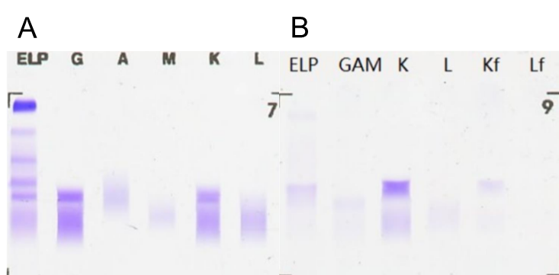
Figure 1 Protein electrophoresis. A: Serum; B: Urine. ELP: Serum protein electrophoresis; G: Immunoglobulin G; A: Immunoglobulin A; M: Immunoglobulin M; K: Kappa light chain; L: Lambda light chain; Kf: Kappa free light chain; Lf: Lambda free light chain.
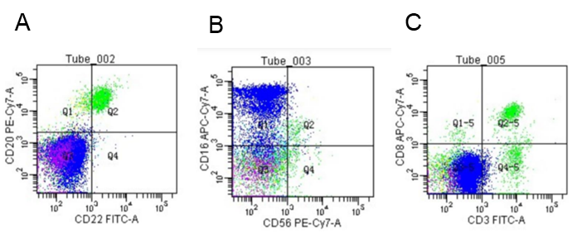
Figure 2 Hematological tumor immunophenotype. A: CD22 (+) and CD20 (+); B: CD56 (+) and CD16 (+); C: CD3 (+) and CD8 (+).
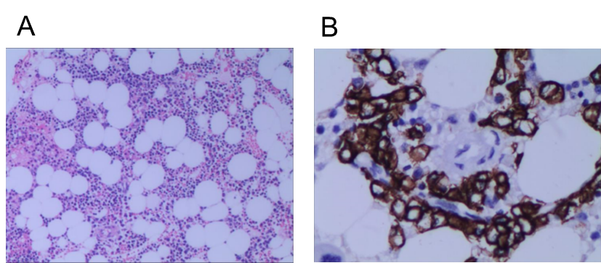
Figure 3 Bone marrow biopsy immunohistochemistry. Bone marrow biopsy showed active hematopoietic tissue proliferation, scattered granulocytes and thrombocytosis, an increased proportion of erythroblasts, and scattered or small clusters of plasma cells accounted for approximately 5%-10%. It was CD3 (+), CD20 (+), CD56 (-) and CD13 (+). A: Hematoxylin-eosin, 100 ×; B: Immunohistochemistry, 400 ×.

Published by Baishideng Publishing Group Inc
7041 Koll Center Parkway, Suite 160, Pleasanton, CA 94566, USA
Telephone: +1-925-3991568
E-mail: bpgoffice@wjgnet.com
Help Desk: https://www.f6publishing.com/helpdesk
https://www.wjgnet.com

© 2021 Baishideng Publishing Group Inc. All rights reserved.

