Name of Journal: World Journal of Gastroenterology
Manuscript NO: 79334
Manuscript Type: STANDARD AND CONSENSUS

Baishideng’s Reference Citation Analysis database announces the first Journal Article Influence Index of 101 core journals and a list of high-quality academic journals in gastroenterology and hepatology

Wang JL et al. RCA announces the 2022 JAII of 101 journals in gastroenterology and hepatology

Jin-Lei Wang, Yu-Jie Ma, Li Ma, Na Ma, Diao-Mei Guo, Lian-Sheng Ma

Jin-Lei Wang, Yu-Jie Ma, Li Ma, Na Ma, Diao-Mei Guo, Lian-Sheng Ma, Baishideng Publishing Group Inc, Pleasanton, CA 94566, United States

Author contributions: Wang JL analyzed the data and drafted the manuscript; Ma YJ participated in the data collection; Ma LS revised the manuscript for important intellectual content; and all authors participated in manuscript revision.

Corresponding author: Lian-Sheng Ma, Doctor, Founder and CEO, Baishideng Publishing Group Inc, 7041 Koll Center Parkway, Suite 160, Pleasanton, CA 94566, United States. l.s.ma@baishideng.com

Received: August 16, 2022
Revised: September 6, 2022
Accepted: September 21, 2022
Published online:

Abstract
After three rounds of rigorous evaluation of core journals in gastroenterology and hepatology conducted by the Reference Citation Analysis (RCA) editorial team of Baishideng Publishing Group (Baishideng), the RCA database of Baishideng officially released the 2022 Journal Article Influence Index (2022 JAII) of 101 core journals in gastroenterology and hepatology, for the first time. The list of 101 core journals can be found at: https://www.referencecitationanalysis.com/SearchJournal. Among them, the highest 2022 JAII is 48.014 and the lowest is 3.900. This article highlights the top 20 journals, describes the calculation method for the 2022 JAII, the evaluation process, and the inclusion principles for journals in the RCA. These steps are the underpinning of the RCA’s empirical journal academic evaluation service by which the digital platform addresses the needs of authors to select reliable journals for submission, readers to select high-quality literature for reading, and editors to track their own journal citation performance. As such, the RCA core journal list will serve as a useful Find-a-Journal tool. Any interested party is welcome to use this journal list and recommend it to their peers.

Key Words: Reference Citation Analysis; Journal Article Influence Index; Gastroenterology and hepatology; Journal list; Find a journal; Announcement

Wang JL, Ma YJ, Ma L, Ma N, Guo DM, Ma LS. Baishideng’s Reference Citation Analysis database announces the first Journal Article Influence Index of 101 core journals and a list of high-quality academic journals in gastroenterology and hepatology. World J Gastroenterol 2022; In press

Core Tip: The Reference Citation Analysis (RCA) database of Baishideng Publishing Group officially released the 2022 Journal Article Influence Index (2022 JAII) of 101 core journals in gastroenterology and hepatology, for the first time. This article highlights the top 20 journals, describes the calculation method for the 2022 JAII, evaluation process and inclusion principles. The RCA journal academic evaluation service platform addresses the needs of authors to select reliable journals for submission, readers to select high-quality literature for reading, and editors to track their own journal citation performance, effectively serving as a useful Find-a-Journal tool. You are welcome to use this journal list and recommend it to your peers.

INTRODUCTION
We are very pleased to announce that the Reference Citation Analysis (RCA) database of Baishideng Publishing Group (Baishideng) has, for the first time, officially released the 2022 Journal Article Influence Index (2022 JAII) of 101 core journals in the field of gastroenterology and hepatology on August 8, 2022. A total of 101 core journals in gastroenterology and hepatology can be found at: https://www.referencecitationanalysis.com/SearchJournal.
RCA is an artificial intelligence technology-based open multidisciplinary citation analysis database. It was carefully designed to lead the development of wisdom, knowledge innovation, and emerging disciplines^{[1]}. As such, the functions of RCA include: Find an Article (54753299), Find a Category (254), Find a Journal (14087), Find a Scholar (631), and Find an Academic Assistant (15). RCA updates its list of journals daily, according to relevant data including total number of articles, total citations, and the JAII. RCA acquires newly released abstracts and references from Crossref and adds them to the RCA database weekly. RCA also acquires abstracts and references released within the calendar year from Crossref and adds them to the RCA database monthly, and then updates the total number of articles, citations, and JAII accordingly. Herein, we introduce the top 20 2022 JAII from the total 101 core journals in the field of gastroenterology and hepatology included in RCA, the calculation method for the 2022 JAII, and the evaluation process and the inclusion principles of RCA journals.

TOP 20 2022 JAII JOURNALS IN THE FIELD OF GASTROENTEROLOGY AND HEPATOLOGY INCLUDED IN THE RCA
The RCA classifies academic journals with a JAII of 20.0 or above as high quality academic journals, which will be highly recommended to authors and readers. There are 101 core journals in the field of gastroenterology and hepatology in the RCA, of which 20 were identified to be high quality academic journals, accounting for 19.8%. These 20 journals are listed below.

2022 JAII and rankings of Seminars in Liver Disease
In the RCA database, the 2022 JAII for Seminars in Liver Disease is 48.014, ranking 1st among 101 core journals in the field of gastroenterology and hepatology included in the RCA, with a total of 83641 citations (28/101) and a total of 1742 articles (50/101) (Figure 1). For more information on Seminars in Liver Disease, please visit: https://www.referencecitationanalysis.com/SearchJournal.

2022 JAII and rankings of Hepatology
In the RCA database, the 2022 JAII for Hepatology is 43.054, ranking 2nd among 101 core journals in the field of gastroenterology and hepatology included in the RCA, with a total of 1169100 citations (2/101) and a total of 27154 articles (2/101) (Figure 2). For more information on Hepatology, please visit: https://www.referencecitationanalysis.com/SearchJournal.

2022 JAII and rankings of Gastroenterology
In the RCA database, the 2022 JAII for Gastroenterology is 37.170, ranking 3rd among 101 core journals in the field of gastroenterology and hepatology included in the RCA, with a total of 1711173 citations (1/101) and a total of 46037 articles (1/101) (Figure 3). For more information on Gastroenterology, please visit: https://www.referencecitationanalysis.com/SearchJournal.

2022 JAII and rankings of Gut
In the RCA database, the 2022 JAII for Gut is 36.751, ranking 4th among 101 core journals in the field of gastroenterology and hepatology included in the RCA, with a total of 914769 citations (3/101) and a total of 24891 articles (3/101) (Figure 4). For more information on Gut, please visit: https://www.referencecitationanalysis.com/SearchJournal.

2022 JAII and rankings of Nature Reviews Gastroenterology & Hepatology
In the RCA database, the 2022 JAII for Nature Reviews Gastroenterology & Hepatology is 35.473, ranking 5th among 101 core journals in the field of gastroenterology and hepatology included in the RCA, with a total of 100601 citations (24/101) and a total of 2836 articles (40/101) (Figure 5). For more information on Nature Reviews Gastroenterology & Hepatology, please visit: https://www.referencecitationanalysis.com/SearchJournal.

2022 JAII and rankings of Gut Microbes
In the RCA database, the 2022 JAII for Gut Microbes is 31.557, ranking 6th among 101 core journals in the field of gastroenterology and hepatology included in the RCA, with a total of 38720 citations (41/101) and a total of 1227 articles (64/101) (Figure 6). For more information on Gut Microbes, please visit: https://www.referencecitationanalysis.com/SearchJournal.

2022 JAII and rankings of Alimentary Pharmacology & Therapeutics
In the RCA database, the 2022 JAII for Alimentary Pharmacology & Therapeutics is 28.725, ranking 7th among 101 core journals in the field of gastroenterology and hepatology included in the RCA, with a total of 323707 citations (10/101) and a total of 11269 articles (13/101) (Figure 7). For more information on Alimentary Pharmacology & Therapeutics, please visit: https://www.referencecitationanalysis.com/SearchJournal.

2022 JAII and rankings of Journal of Hepatology
In the RCA database, the 2022 JAII for Journal of Hepatology is 28.725, ranking 8th among 101 core journals in the field of gastroenterology and hepatology included in the RCA, with a total of 556699 citations (4/101) and a total of 19575 articles (7/101) (Figure 8). For more information on Journal of Hepatology, please visit: https://www.referencecitationanalysis.com/SearchJournal.

2022 JAII and rankings of Best Practice & Research Clinical Gastroenterology
In the RCA database, the 2022 JAII for Best Practice & Research Clinical Gastroenterology is 28.428, ranking 9th among 101 core journals in the field of gastroenterology and hepatology included in the RCA, with a total of 44917 citations (36/101) and a total of 1580 articles (54/101) (Figure 9). For more information on Best Practice & Research Clinical Gastroenterology, please visit: https://www.referencecitationanalysis.com/SearchJournal.

2022 JAII and rankings of Diseases of the Colon & Rectum
In the RCA database, the 2022 JAII for Diseases of the Colon & Rectum is 26.946, ranking 10th among 101 core journals in the field of gastroenterology and hepatology included in the RCA, with a total of 344714 citations (9/101) and a total of 12793 articles (10/101) (Figure 10). For more information on Diseases of the Colon & Rectum, please visit: https://www.referencecitationanalysis.com/SearchJournal.

2022 JAII and rankings of Liver Transplantation
In the RCA database, the 2022 JAII for Liver Transplantation is 26.872, ranking 11th among 101 core journals in the field of gastroenterology and hepatology included in the RCA, with a total of 159891 citations (18/101) and a total of 5950 articles (25/101) (Figure 11). For more information on Liver Transplantation, please visit: https://www.referencecitationanalysis.com/SearchJournal.

2022 JAII and rankings of Gastric Cancer
In the RCA database, the 2022 JAII for Gastric Cancer is 24.105, ranking 12th among 101 core journals in the field of gastroenterology and hepatology included in the RCA, with a total of 45558 citations (35/101) and a total of 1890 articles (49/101) (Figure 12). For more information on Gastric Cancer, please visit: https://www.referencecitationanalysis.com/SearchJournal.

2022 JAII and rankings of The American Journal of Gastroenterology
In the RCA database, the 2022 JAII for The American Journal of Gastroenterology is 23.563, ranking 13th among 101 core journals in the field of gastroenterology and hepatology included in the RCA, with a total of 476726 citations (5/101) and a total of 20232 articles (6/101) (Figure 13). For more information on The American Journal of Gastroenterology, please visit: https://www.referencecitationanalysis.com/SearchJournal.

2022 JAII and rankings of Lancet Gastroenterology & Hepatology
In the RCA database, the 2022 JAII for Lancet Gastroenterology & Hepatology is 23.470, ranking 14th among 101 core journals in the field of gastroenterology and hepatology included in the RCA, with a total of 30276 citations (48/101) and a total of 1290 articles (63/101) (Figure 14). For more information on Lancet Gastroenterology & Hepatology, please visit: https://www.referencecitationanalysis.com/SearchJournal.

2022 JAII and rankings of Journal of Gastroenterology
In the RCA database, the 2022 JAII for Journal of Gastroenterology is 22.837, ranking 15th among 101 core journals in the field of gastroenterology and hepatology included in the RCA, with a total of 110941 citations (22/101) and a total of 4858 articles (28/101) (Figure 15). For more information on Journal of Gastroenterology, please visit: https://www.referencecitationanalysis.com/SearchJournal.

2022 JAII and rankings of Neurogastroenterology and Motility
In the RCA database, the 2022 JAII for Neurogastroenterology and Motility is 22.335, ranking 16th among 101 core journals in the field of gastroenterology and hepatology included in the RCA, with a total of 93695 citations (26/101) and a total of 4195 articles (30/101) (Figure 16). For more information on Neurogastroenterology and Motility, please visit: https://www.referencecitationanalysis.com/SearchJournal.

2022 JAII and rankings of Clinical Gastroenterology and Hepatology
In the RCA database, the 2022 JAII for Clinical Gastroenterology and Hepatology is 22.295, ranking 17th among 101 core journals in the field of gastroenterology and hepatology included in the RCA, with a total of 223108 citations (13/101) and a total of 10007 articles (17/101) (Figure 17). For more information on Clinical Gastroenterology and Hepatology, please visit: https://www.referencecitationanalysis.com/SearchJournal.

2022 JAII and rankings of World Journal of Gastroenterology
In the RCA database, the 2022 JAII for World Journal of Gastroenterology is 21.914, ranking 18th among 101 core journals in the field of gastroenterology and hepatology included in the RCA, with a total of 471463 citations (4/101) and a total of 21514 articles (5/101) (Figure 18). For more information on World Journal of Gastroenterology, please visit: https://www.referencecitationanalysis.com/00000009.

2022 JAII and rankings of American Journal of Physiology-Gastrointestinal and Liver Physiology
In the RCA database, the 2022 JAII for American Journal of Physiology-Gastrointestinal and Liver Physiology is 21.406, ranking 19th among 101 core journals in the field of gastroenterology and hepatology included in the RCA, with a total of 230179 citations (11/101) and a total of 10753 articles (14/101) (Figure 19). For more information on American Journal of Physiology-Gastrointestinal and Liver Physiology, please visit: https://www.referencecitationanalysis.com/SearchJournal.

2022 JAII and rankings of Journal of Gastrointestinal Surgery
In the RCA database, the 2022 JAII for Journal of Gastrointestinal Surgery is 20.714, ranking 20th among 101 core journals in the field of gastroenterology and hepatology included in the RCA, with a total of 138742 citations (20/101) and a total of 6698 articles (22/101) (Figure 20). For more information on Journal of Gastrointestinal Surgery, please visit: https://www.referencecitationanalysis.com/SearchJournal.

RCA’S MISSION
The mission of RCA is to provide a high quality academic article evaluation service platform for various categories. At present, there are many evaluation methods for academic articles, but their calculation methods are complicated. The RCA is a new method of evaluating the quality of academic articles, which allows academic evaluation of journals, scholars, institutions, drugs, medical devices, and publishers based on the JAII of each article in the citation analysis database, thus greatly enriching the academic evaluation systems across different disciplines and guiding the healthy development of the academic community^{[2]}.

OPENNESS AND TRANSPARENCY OF RCA EVALUATION
RCA is unique in its objective, impartial, fair, and transparent release of citation analysis data of important academic journals to authors and readers, including evaluation data, evaluation indices, evaluation methods, and evaluation results, in order to ensure the reliability of academic evaluation^{[2]}.

CALCULATION METHOD FOR 2022 JAII
The 2022 JAII, calculated as Total citations/Total articles, is not a 2-year or 5-year average of citations, but is an average of citations for all articles since the journal was assigned its DOI number. Article types are not only limited to original articles and review articles, but for all types of articles. In this way, it is a more objective, fair, and transparent calculation of the academic influence index of an academic journal. Furthermore, the journal list itself is evaluated dynamically, its bibliographic metrics being updated daily, including total number of articles, total citations, and JAII^{[2]}.

EVALUATION PROCESS OF RCA JOURNALS
The journals included in the RCA core journal list need to undergo three rounds of strict evaluation. The evaluation process is as follows^{[2]}:

First-round evaluation: Verify the basic information on the journal, including Journal Name, Abbreviated Title, Print ISSN, Online ISSN, Language, Category, Peer-Reviewed Journal, Ownership, Publisher, Journal Website, Editorial Board Members, Submit a Manuscript, and Indexed by.

Second-round evaluation: Verify the activity of the journal, including Total Articles, Total Citations, Cited by in F6Publishing, and the JAII.

Third-round evaluation: Based on the reliability of journal information, the activity of publication data, whether the journal is a peer-reviewed journal or not, and JAII, the editorial team evaluates every journal, makes the decision to accept or reject the journal, and creates a list of core journals by discipline. The function of the list of core academic journals is to classify journals according to categories and rank them according to various bibliometrics, including Total Views, JAII, Total Citations, Cited by in F6Publishing, Total Articles, and Number of Years.

INCLUSION PRINCIPLES OF RCA JOURNAL
The RCA editorial team of Baishideng conducted three rounds of rigorous evaluation on core journals in gastroenterology and hepatology. The resultant RCA core journal list for the field of gastroenterology and hepatology includes a total of 101 journals, among which the highest 2022 JAII is 48.014 and the lowest JAII is 3.900, the highest total number of citations is 1711173 and the lowest is 698, and the highest total number of articles is 46037 and the lowest is 133. The RCA core journal list does not include any journals with a JAII lower than 3.0. We implement dynamic evaluation inclusively for the RCA core journal list. Evaluation is initiated once an RCA-nonincluded journal receives a JAII over 3.0. Similarly, if a journal included in the RCA core journal list receives a JAII lower than 3.0, it will be excluded^{[2]}. The RCA core journal list is designed by publishers, scientific editors, and engineers for use by readers, authors, and editorial offices, and is free-of-charge to users.
Upon completion of the three rounds of rigorous evaluation on core journals in gastroenterology and hepatology by the RCA editorial team, all data in each journal are organized for public consumption according to category rank, including the 2022 JAII, total citations, cited by in F6Publishing, total articles, and the 2021 Journal Impact Factor™. All information in each journal, including Journal Name, Print ISSN, Online ISSN, Language, Free Access, Peer-Reviewed Journal, Ownership, Publisher, Journal Website, Editorial Board Members, Submit a Manuscript, and Indexed by are made available in RCA. Moreover, the citations of each journal can be then ranked in RCA by the Impact Index Per Article, Cited by in Crossref, and Cited by in F6Publishing parameters. Results analysis available for each journal includes Year Published Analysis, Article Type Analysis, Journal Title Analysis, and Category Analysis. The references of each journal are also refined by Year Published and Article Type. Each reference’s citation information is displayed, including PMID, DOI, Cited by in Crossref, Impact Index Per Article, RCA, and Track Full Text^{[2]}.

CONCLUSION
The ultimate purpose of RCA is to provide an open, objective, fair, and reliable academic evaluation service platform for readers, authors, and journal editors. The RCA journal academic evaluation service platform is designed and actively maintained to address the needs of authors to select reliable journals for submission, readers to select high-quality literature for reading, and editors to track their own journal citation performance. The RCA core journal list itself will serve as a useful Find-a-Journal tool. Any interested party is welcome to use this journal list and recommend it to their peers.

REFERENCES
1 Baishideng Publishing Group Inc. Welcome to the Reference Citation Analysis. Available from: https://www.referencecitationanalysis.com
2 Baishideng Publishing Group Inc. Reference Citation Analysis’s evaluation process for inclusion of academic journals. [cited 19 August 2022]. Available from: https://www.wjgnet.com/bpg/GerInfo/303

Footnotes
Conflict-of-interest statement: The authors are employees of the Baishideng Publishing Group Inc, and declare that they have no other real or potential conflicts of interest to disclose.

Open-Access: This article is an open-access article that was selected by an in-house editor and fully peer-reviewed by external reviewers. It is distributed in accordance with the Creative Commons Attribution NonCommercial (CC BY-NC 4.0) license, which permits others to distribute, remix, adapt, build upon this work non-commercially, and license their derivative works on different terms, provided the original work is properly cited and the use is non-commercial. See: https://creativecommons.org/Licenses/by-nc/4.0/

Provenance and peer review: Unsolicited article; Externally peer reviewed
Peer-review model: Single blind

Peer-review started: August 16, 2022
First decision: August 25, 2022
Article in press:

Specialty type: Gastroenterology and hepatology
Country/Territory of origin: United States
Peer-review report’s scientific quality classification
Grade A (Excellent): 0
Grade B (Very good): B
Grade C (Good): 0
Grade D (Fair): 0
Grade E (Poor): 0

P-Reviewer: Morozov S, Russia S-Editor: Wang JJ L-Editor: Webster JR P-Editor:

Figure Legends
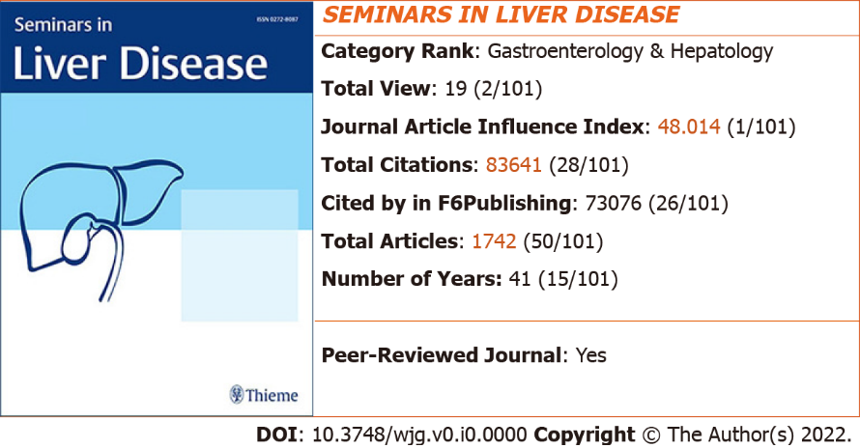
Figure 1 2022 Journal Article Influence Index and rankings of Seminars in Liver Disease. The image of the journal cover is originally from the home page of the journal: https://www.thieme.in/seminars-in-liver-disease.

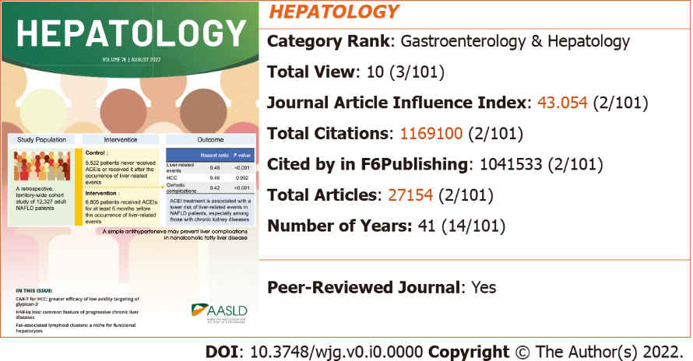
Figure 2 2022 Journal Article Influence Index and rankings of Hepatology. The image of the journal cover is originally from the home page of the journal: https://aasldpubs.onlinelibrary.wiley.com/journal/15273350.
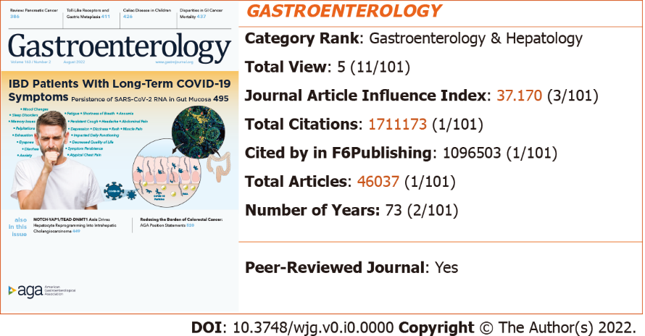
Figure 3 2022 Journal Article Influence Index and rankings of Gastroenterology. The image of the journal cover is originally from the home page of the journal: https://www.gastrojournal.org/.

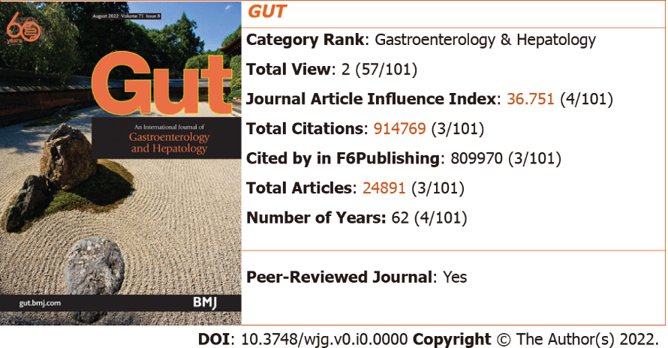
Figure 4 2022 Journal Article Influence Index and rankings of Gut. The image of the journal cover is originally from the home page of the journal: http://gut.bmj.com/.

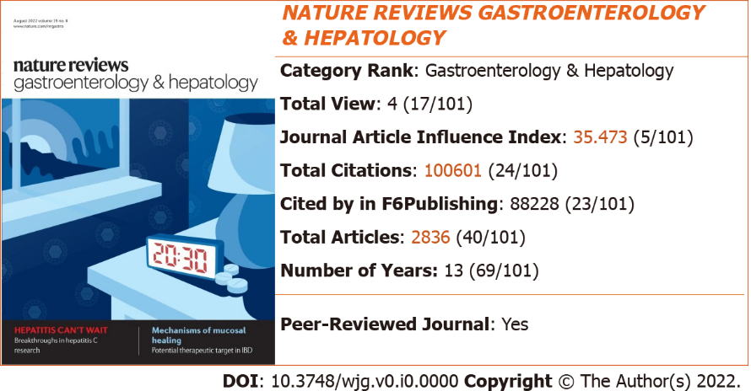
Figure 5 2022 Journal Article Influence Index and rankings of Nature Reviews Gastroenterology & Hepatology. The image of the journal cover is originally from the home page of the journal: https://www.nature.com/nrgastro/.

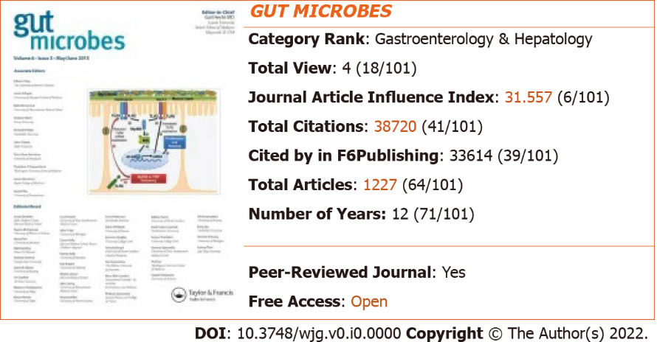
Figure 6 2022 Journal Article Influence Index and rankings of Gut Microbes. The image of the journal cover is originally from the home page of the journal: http://www.tandfonline.com/kgmi.

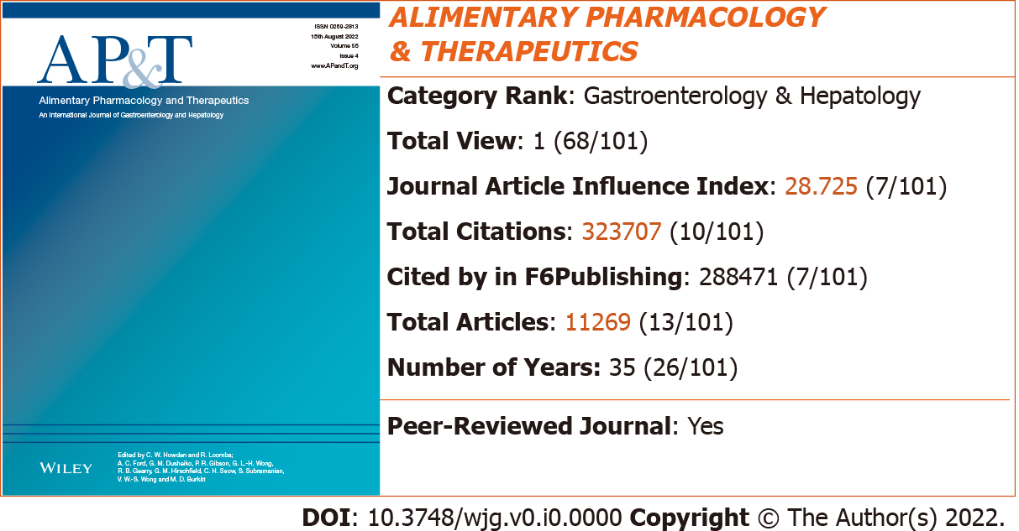
Figure 7 2022 Journal Article Influence Index and rankings of Alimentary Pharmacology & Therapeutics. The image of the journal cover is originally from the home page of the journal: https://onlinelibrary.wiley.com/journal/13652036.
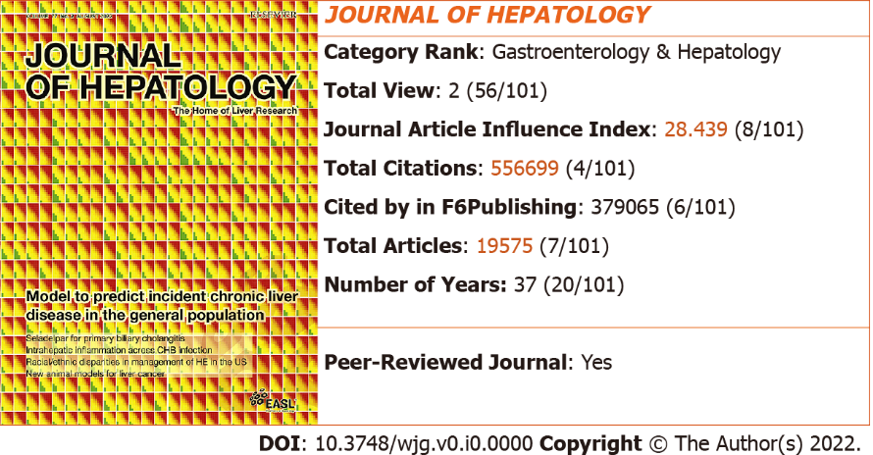
Figure 8 2022 Journal Article Influence Index and rankings of Journal of Hepatology. The image of the journal cover is originally from the home page of the journal: https://www.sciencedirect.com/journal/journal-of-hepatology.

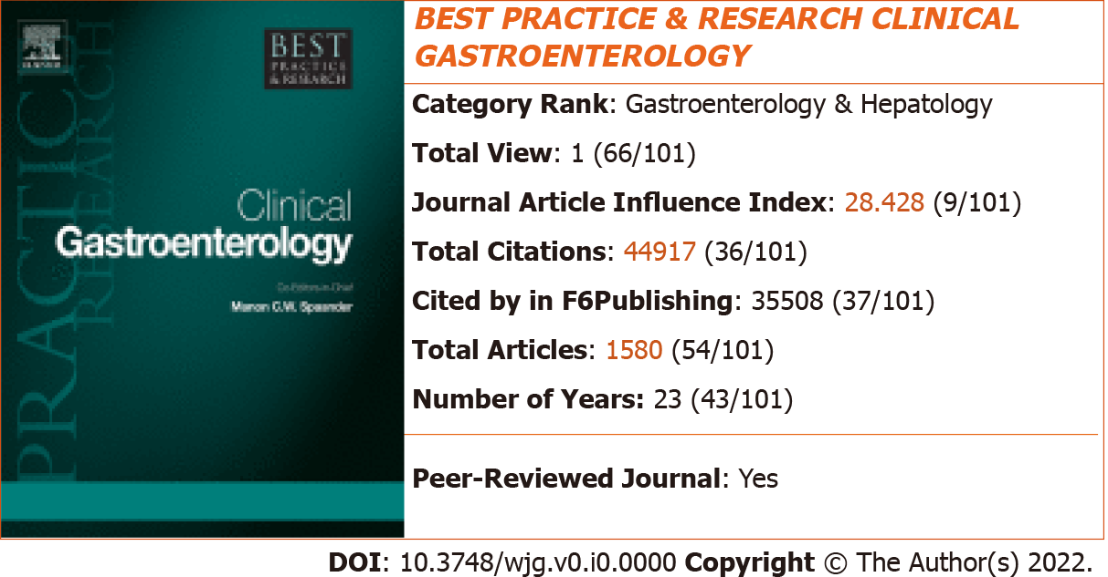
Figure 9 2022 Journal Article Influence Index and rankings of Best Practice & Research Clinical Gastroenterology. The image of the journal cover is originally from the home page of the journal: http://www.sciencedirect.com/science/journal/15216918.

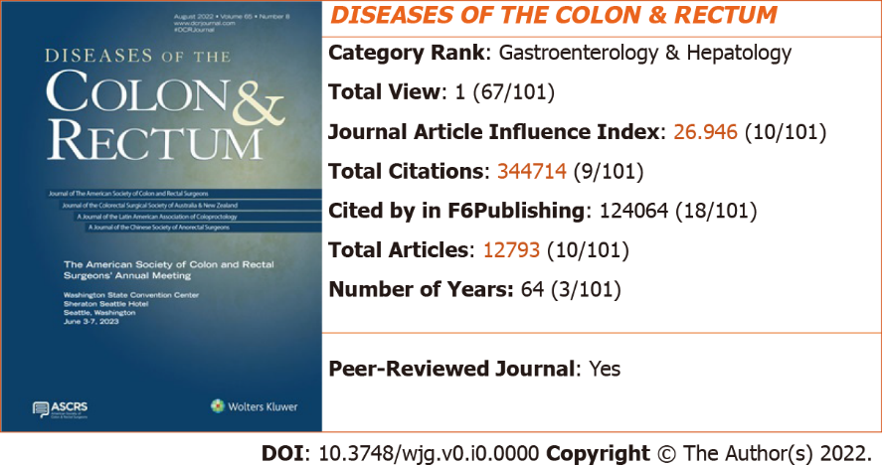
Figure 10 2022 Journal Article Influence Index and rankings of Diseases of the Colon & Rectum. The image of the journal cover is originally from the home page of the journal: https://journals.lww.com/dcrjournal/pages/default.aspx.

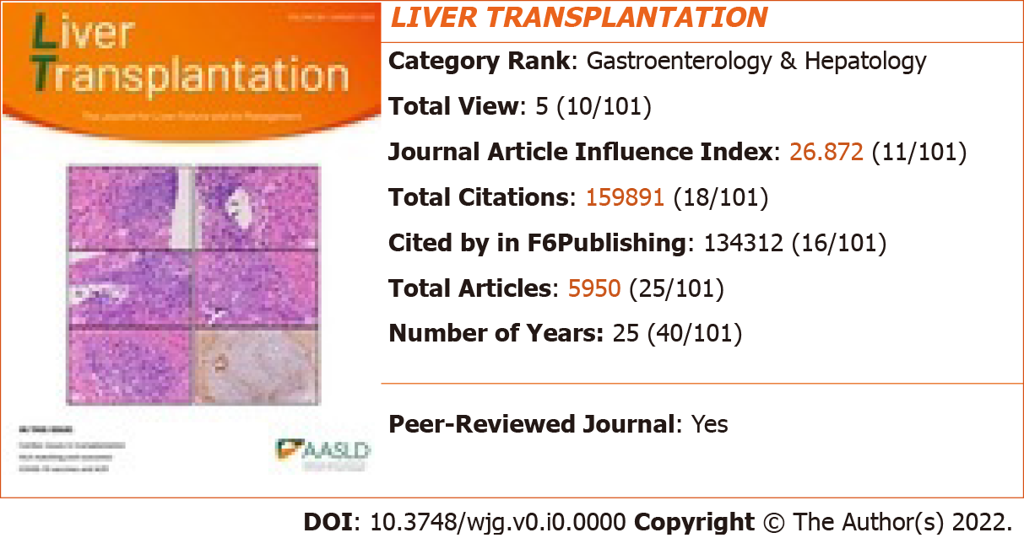
Figure 11 2022 Journal Article Influence Index and rankings of Liver Transplantation. The image of the journal cover is originally from the home page of the journal: https://aasldpubs.onlinelibrary.wiley.com/journal/15276473.

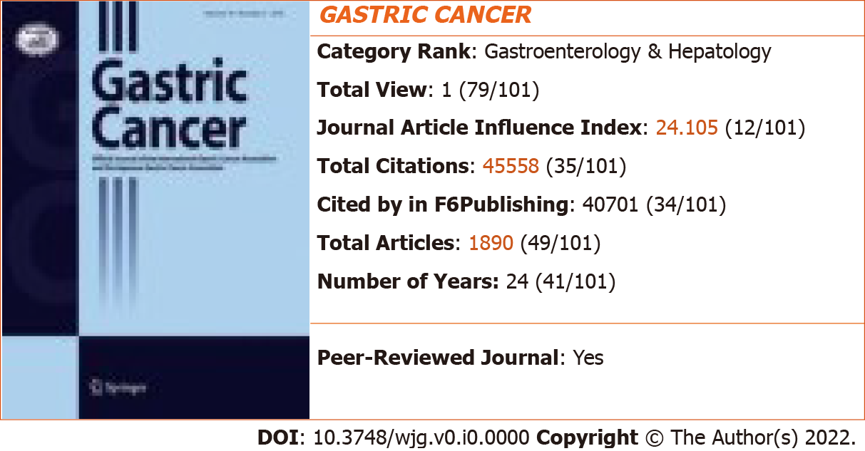
Figure 12 2022 Journal Article Influence Index and rankings of Gastric Cancer. The image of the journal cover is originally from the home page of the journal: https://link.springer.com/journal/10120.
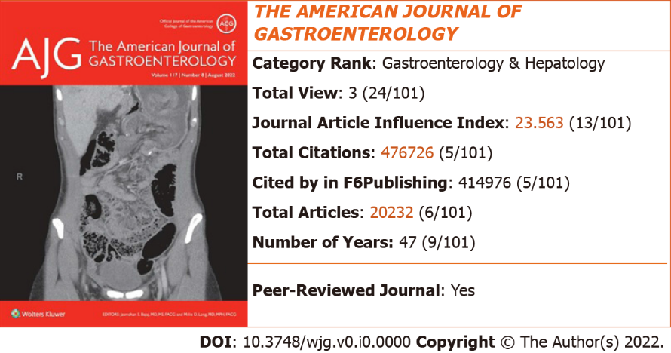
Figure 13 2022 Journal Article Influence Index and rankings of The American Journal of Gastroenterology. The image of the journal cover is originally from the home page of the journal: https://journals.lww.com/ajg/pages/default.aspx.

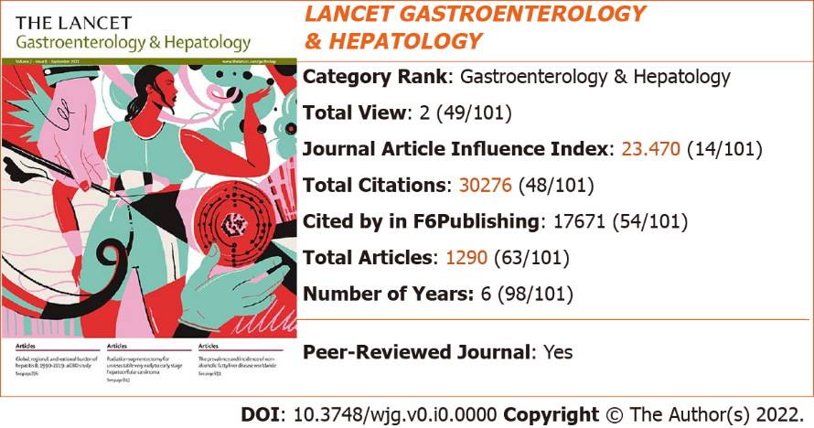
Figure 14 2022 Journal Article Influence Index and rankings of Lancet Gastroenterology & Hepatology. The image of the journal cover is originally from the home page of the journal: https://www.thelancet.com/journals/langas/home.

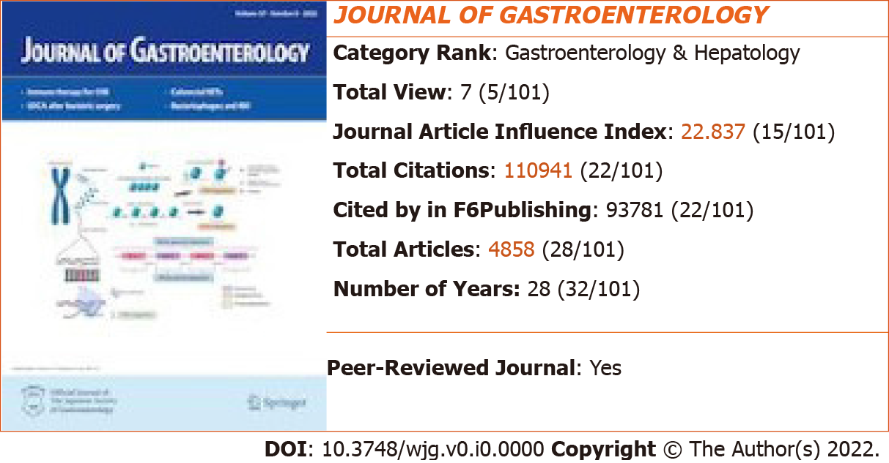
Figure 15 2022 Journal Article Influence Index and rankings of Journal of Gastroenterology. The image of the journal cover is originally from the home page of the journal: https://link.springer.com/journal/535.

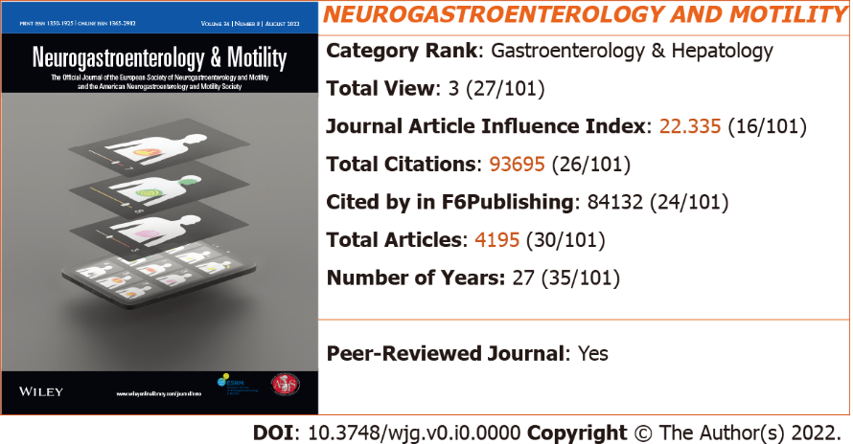
Figure 16 2022 Journal Article Influence Index and rankings of Neurogastroenterology and Motility. The image of the journal cover is originally from the home page of the journal: https://onlinelibrary.wiley.com/journal/13652982.

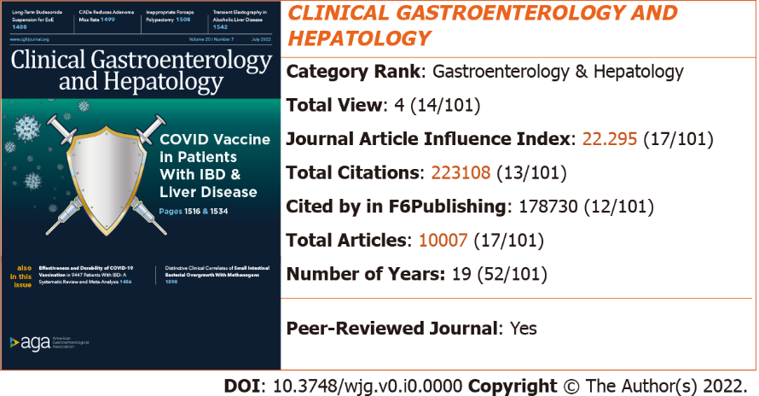
Figure 17 2022 Journal Article Influence Index and rankings of Clinical Gastroenterology and Hepatology. The image of the journal cover is originally from the home page of the journal: http://www.sciencedirect.com/science/journal/15423565.

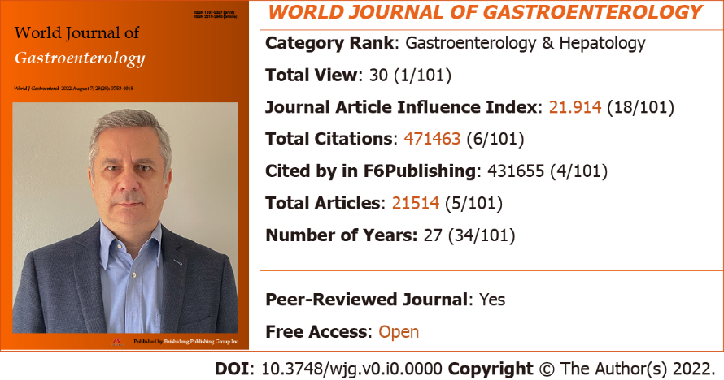
Figure 18 2022 Journal Article Influence Index and rankings of World Journal of Gastroenterology. The image of the journal cover is originally from the home page of the journal: http://www.wjgnet.com/1007-9327/index.htm.

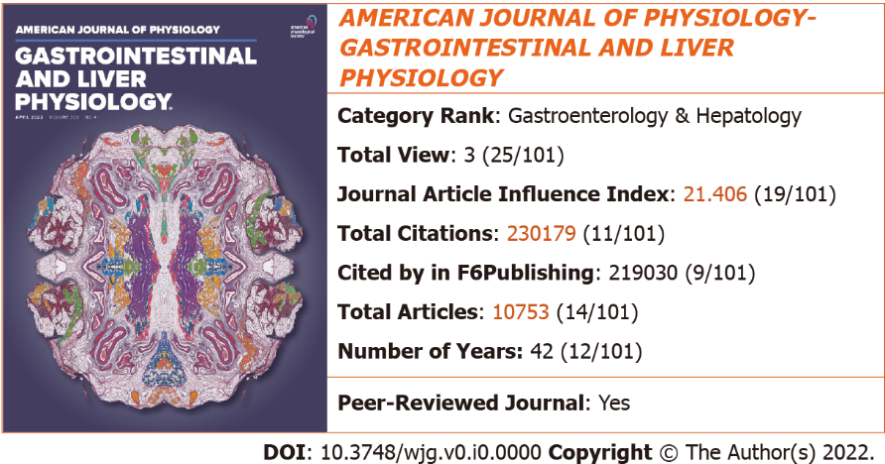
Figure 19 2022 Journal Article Influence Index and rankings of American Journal of Physiology-Gastrointestinal and Liver Physiology. The image of the journal cover is originally from the home page of the journal: https://journals.physiology.org/journal/ajpgi.
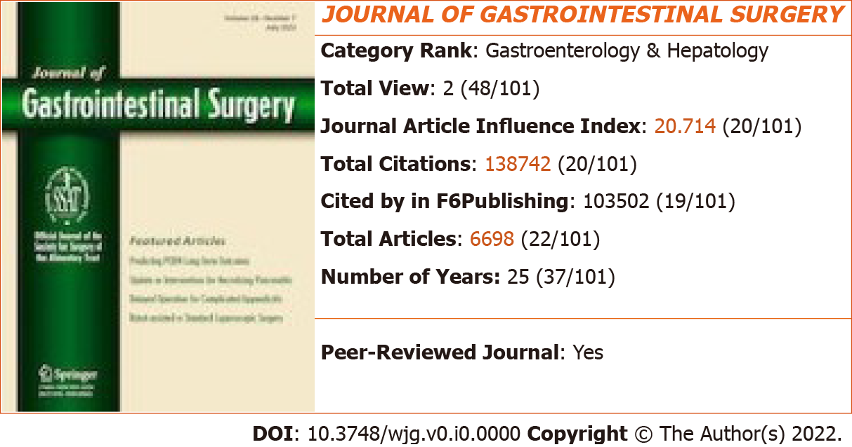
Figure 20 2022 Journal Article Influence Index and rankings of Journal of Gastrointestinal Surgery. The image of the journal cover is originally from the home page of the journal: https://link.springer.com/journal/11605.

