Name of Journal: World Journal of Transplantation
ESPS Manuscript NO: 24204
Manuscript Type: Case Report

Cavitary lung lesion 6 years after renal transplantation

Subbiah et al. Cavitary lung lesion in a renal transplant recipient

Arun Kumar Subbiah, Sudheer Arava, Soumita Bagchi, Karan Madan, Chandan J Das, Sanjay Kumar Agarwal

Arun Kumar Subbiah, Department of Nephrology, All India Institute of Medical Sciences, New Delhi 110029, India

Sudheer Arava, Department of Pathology, All India Institute of Medical Sciences, New Delhi 110029, India

Soumita Bagchi, Department of Nephrology, All India Institute of Medical Sciences, New Delhi 110029, India

Karan Madan, Department of Pulmonary medicine and sleep disorders, All India Institute of Medical Sciences, New Delhi 110029, India

Chandan J Das, Department of Radiology, All India Institute of Medical Sciences, New Delhi 110029, India

Sanjay Kumar Agarwal, Department of Nephrology, All India Institute of Medical Sciences, New Delhi 110029, India

Author contributions: All authors contributed to the management of the patient, conceptualizing, writing and revising the manuscript.

Institutional review board statement: The case report was exempt ethic approval by the Institute Ethics Committee, AIIMS.

Informed consent statement: The patients involved in this study gave his informed consent authorizing use and disclose of his anonymized health information.

Conflict-of-interest statement: All authors have no conflicts of interests to declare.

Open-Access: This article is an open-access article which was selected by an in-house editor and fully peer-reviewed by external reviewers. It is distributed in accordance with the Creative Commons Attribution Non Commercial (CC BY-NC 4.0) license, which permits others to distribute, remix, adapt, build upon this work non-commercially, and license their derivative works on different terms, provided the original work is properly cited and the use is non-commercial. See: http://creativecommons.org/licenses/by-nc/4.0/

Manuscript source: Unsolicited manuscript

Correspondence to: Soumita Bagchi, Assistant Professor, Department of Nephrology, All India Institute of Medical Sciences, Virbhadra Road, New Delhi 110029, India. soumita_bagchi@yahoo.co.in
Telephone: +91-987-1911744

Received: January 13, 2016
Peer-review started: January 15, 2016
First decision: March 1, 2016
Revised: March 29, 2016
Accepted: May 10, 2016
Article in press:

Abstract
The differential diagnoses of a cavitary lung lesion in renal transplant recipients would include infection, malignancy and less commonly inflammatory diseases. Bacterial infection, Tuberculosis, nocardiosis, fungal infections like aspergillosis and cryptococcosis need to be considered in these patients. Pulmonary cryptococcosis usually presents 16-21 mo after transplantation, more frequently in patients who have a high level of cumulative immunosuppression. Here we discuss an interesting patient who never received any induction/anti-rejection therapy but developed both bk virus bk nephropathy as well as severe pulmonary cryptococcal infection after remaining stable for 6 years after transplantation. This case highlights the risk of serious opportunistic infections even in apparently low immunologic risk transplant recipients many years after transplantation.

Key words: Renal transplantation; Lung cavity; Immunosuppression

© The Author(s) 2016. Published by Baishideng Publishing Group Inc. All rights reserved.

Core tip: Here we discuss an interesting patient who never received any induction/anti-rejection therapy but developed both bk virus bk nephropathy as well as severe pulmonary cryptococcal infection after remaining stable for 6 years after transplantation. This case highlights the risk of serious opportunistic infections even in apparently low immunologic risk transplant recipients many years after transplantation.

Subbiah AK, Arava S, Bagchi S, Madan K, Das CJ, Agarwal SK. Cavitary lung lesion 6 years after renal transplantation. World J Transplant 2016; In press

INTRODUCTION
Fungal infections causing cavitary lung lesions usually manifest in transplant recipients who have received a high level of cumulative immunosuppression. We describe an unusual case, where a low risk transplant recipient who has been stable for 6 years developed severe pulmonary cryptococcal disease and bk virus bk nephropathy.

CASE REPORT
A 40-year-old Indian man was admitted with low grade fever and dry cough for one month. He had end stage renal disease (ESRD) due to unclassified primary disease and had a live related renal transplantation with his sister as the donor in 2009. He was detected HBsAg positive before transplantation and has been on tenofovir since then. He received no induction and was initially maintained on Tacrolimus, Mycophenolate Mofetil (MMF) and steroids. After a year, MMF was changed to Azathioprine due to financial constraints. He received trimethoprim-sulfamethoxazole for 6 mo after transplantation but no primary prophylaxis for CMV, TB or fungal infection. His postoperative course was uneventful and he maintained serum creatinine of 1.1-1.2 mg/dL. He is a non smoker.
Clinically, the patient was febrile, hemodynamically stable and hypoxemic (SPO₂ 92% on room air) requiring oxygen by mask. Investigations revealed pancytopenia (Hb-7.4 g/dL, total leucocyte count -3400/cu mm, platelet count -87000/cu mm) and high serum creatinine - 2.5 mg%. Azathioprine was stopped. Tacrolimus trough level was 3.7 ng/mL. Urinalysis was unremarkable. Graft biopsy showed BKV nephropathy and serum BKV PCR was more than 10⁴ copies/mL.
He was started empirically on broad spectrum antibiotics. Blood and urine cultures and quantitative CMV PCR assay were non-contributory. A non-contrast CT thorax showed bilateral, multiple, diffuse centrilobular and perbronchovascular cavitating nodules coalescing to form areas of consolidation with a larger cavity in apico posterior segment of upper lobe of left lung (Figure 1). Bronchoscopy with bronchoalveolar lavage (BAL) fluid cultures was unrevealing. Serum cryptococcal antigen was negative. Serum and BAL fluid galactomannan were negative.
Since patient continued to be febrile, CT guided biopsy of the cavitary lesion in the left lung was done and the histopathology (Figure 2) showed cryptococcal infection. He was treated with liposomal Amphotericin for 6 wk and given fluconazole prophylaxis. Flucytosine was not available at that time. Patient showed clinical as well as radiologic improvement and was discharged on oral fluconazole. His pulmonary infection has subsequently recurred and now he is being treated with a combination of Amphotericin and Flucytosine

DISCUSSION
A renal transplant recipient may present with a cavitary lung lesion due to infection, malignancy (post-transplant lymphoproliferative disorder) and inflammatory disease, though infections are the predominant causative factor^{[1-3]}. TB is the commonest cause of cavitary lung lesions in endemic areas like India and patients may receive empiric anti-TB therapy if the index of suspicion for rarer infections is not high and investigations are non-contributory. Aspergillosis (either angioinvasive or chronic necrotizing form) is the most common fungal infection associated with cavitation. Other causes are nocardiosis, cryptococcosis, actinomycosis and rarely legionella pneumophila. In a sick patient, the possibility of septic emboli has to be kept in mind^{[1,2]}.
Cryptococcosis is the third most common fungal infection seen in transplant recipients^{[4,5]}. It typically occurs late with median time to onset being 16 to 21 mo after renal transplantation. However our patient presented very late - 6 years after transplantation. So besides TB and fungal infection, post-transplant lymphoproliferative disease was an important differential diagnosis considered. All factors which increased the cumulative immunosuppression in patients increase the risk of disseminated cryptococcal disease. Presence of chronic liver disease and use of steroids, T cell depleting antibodies and Alemtuzumab are specifically associated with increased risk of cryptococcosis. CNI based regimens are believed to be protective, being associated more commonly with cryptococcosis limited to lungs with less likelihood of dissemination^{[5,6]}.
Our patient is HBsAg positive. But he had not received induction, had no history of rejection requiring pulse steroid therapy and has not been on MMF for 5 years. Though the apparent dose of immunosuppressive drugs given seems to be low, his cumulative immunosuppression level is definitely high as is suggested by the onset of late BKV associated nephropathy.
Cryptococcal infection commonly presents with neurologic disease (meningitis) or pneumonia. But it may also involve the skin and soft tissue, bones, joints and other organs like the liver and the kidney. Isolated pulmonary disease is uncommon seen in only 33% patients. Serum cryptococcal antigen has 90% sensitivity in disseminated disease but may be negative in immunosuppressed patients especially with isolated pulmonary disease^{[5]} as seen in our patient. The final diagnosis is by tissue biopsy and/or culture. The organism can be recognized by its oval shape, and narrow-based budding on histopathology. With the use of mucicarmine staining, the cryptococcal capsule will stain rose to burgundy in color and help differentiate C neoformans from other yeasts, especially Blastomyces dermatiditis and Histoplasma capsulatum^{[5]}.
Choice of antifungal therapy depends on the severity and extent of the disease. In patients with severe pulmonary infection, CNS involvement and disseminated disease, combination of liposomal Amphotericin with flucytosine for 2 wk followed by Fluconazole for 12 mo is recommended. If Flucytosine is not available, which was the case initially in our patient, Amphotericin should be given for a minimum of 4-6 wk^{[5]}.
Cryptococcal infection has an overall mortality of 14% in solid organ transplant recipients^{[6]}. Early diagnosis and initiation of treatment is the key to survival. A high index of suspicion and step-wise approach to diagnosis including a lung biopsy is required as the duration of therapy differs significantly from other fungal infections.

COMMENTS
Case characteristics
A 40-year-old male renal transplant recipient presented with low grade fever and dry cough for one month.

Clinical diagnosis
A febrile patient with respiratory symptoms.

Differential diagnosis
Chest infection-bacterial/ tuberculosis /fungal.

Laboratory diagnosis
Pancytopenia with high serum creatinine.

Imaging diagnosis
Non contrast CT scan of chest showed bilateral, multiple, diffuse centrilobular and perbronchovascular cavitating nodules coalescing to form areas of consolidation with a larger cavity in apico posterior segment of upper lobe of left lung.

Pathological diagnosis
Biopsy from the lung lesion showed Cryptococcal infection and graft kidney biopsy showed BKV associated nephropathy.

Treatment
He was treated with liposomal Amphotericin and Flucytosine.

Related reports
A renal transplant recipient may present with a cavitary lung lesion due to infection, malignancy (post-transplant lymphoproliferative disorder) and inflammatory disease, though infections are the predominant causative factor.

Term explanation
Cryptococcal infection is the third most common fungal infection seen in transplant recipients. It commonly presents with neurologic disease (meningitis) or pneumonia, but may also involve the skin and soft tissue, bones, joints and other organs like the liver and the kidney.

Experiences and lessons
Tissue biopsy or culture is required to diagnosed isolated pulmonary cryptococcosis. Early diagnosis and initiation of treatment is essential for survival.

Peer-review
The case discusses an important issue in patients with kidney transplantation.

REFERENCES
1 Gadkowski LB, Stout JE. Cavitary pulmonary disease. Clin Microbiol Rev 2008; 21: 305-333, table of contents [PMID: 18400799 DOI: 10.1128/CMR.00060-07]
2 Küpeli E, Eyüboğlu FÖ, Haberal M. Pulmonary infections in transplant recipients. Curr Opin Pulm Med 2012; 18: 202-212 [PMID: 22388586 DOI: 10.1097/MCP.0b013e328352104f]
3 Chen M, Wang X, Yu X, Dai C, Chen D, Yu C, Xu X, Yao D, Yang L, Li Y, Wang L, Huang X. Pleural effusion as the initial clinical presentation in disseminated cryptococcosis and fungaemia: an unusual manifestation and a literature review. BMC Infect Dis 2015; 15: 385 [PMID: 26395579 DOI: 10.1016/j.jrid.2014.10.001]
4 Silveira FP, Husain S. Fungal infections in solid organ transplantation. Med Mycol 2007; 45: 305-320 [PMID: 17510855]
5 Baddley JW, Forrest GN. Cryptococcosis in solid organ transplantation. Am J Transplant 2013; 13 Suppl 4: 242-249 [PMID: 23465017 DOI: 10.1111/ajt.12116]
6 Singh N, Alexander BD, Lortholary O, Dromer F, Gupta KL, John GT, del Busto R, Klintmalm GB, Somani J, Lyon GM, Pursell K, Stosor V, Munoz P, Limaye AP, Kalil AC, Pruett TL, Garcia-Diaz J, Humar A, Houston S, House AA, Wray D, Orloff S, Dowdy LA, Fisher RA, Heitman J, Wagener MM, Husain S. Cryptococcus neoformans in organ transplant recipients: impact of calcineurin-inhibitor agents on mortality. J Infect Dis 2007; 195: 756-764 [PMID: 17262720 DOI: 10.1086/511438]

P-Reviewer: Ali-El-Dein B, Mahmoud KM, Sheashaa HA
S-Editor: Qiu S L-Editor: E-Editor:

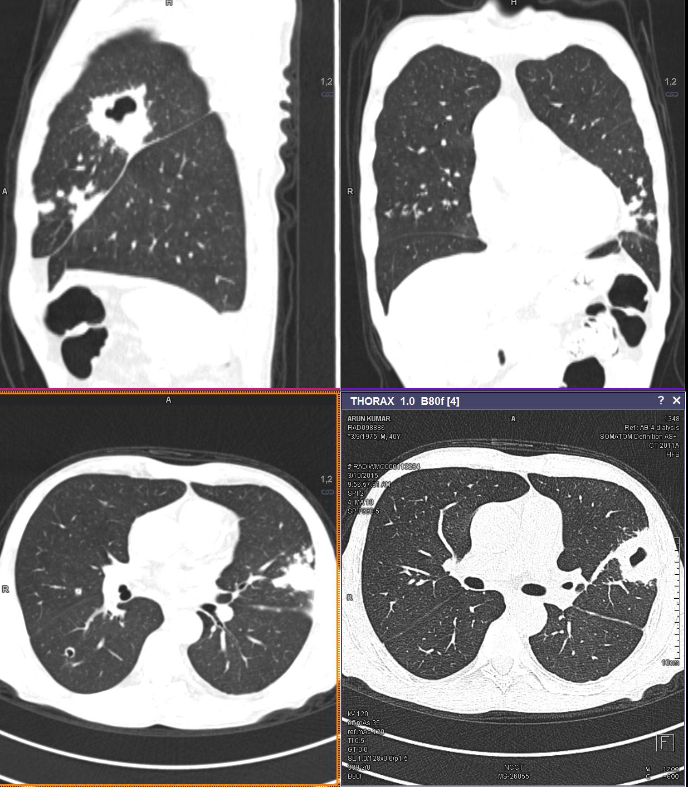
Figure 1 Multiple diffuse bilateral centrilobular and perbronchovascular cavitating nodules coalescing to form areas of consolidation with larger cavity in apico posterior segment of upper lobe of left lung.

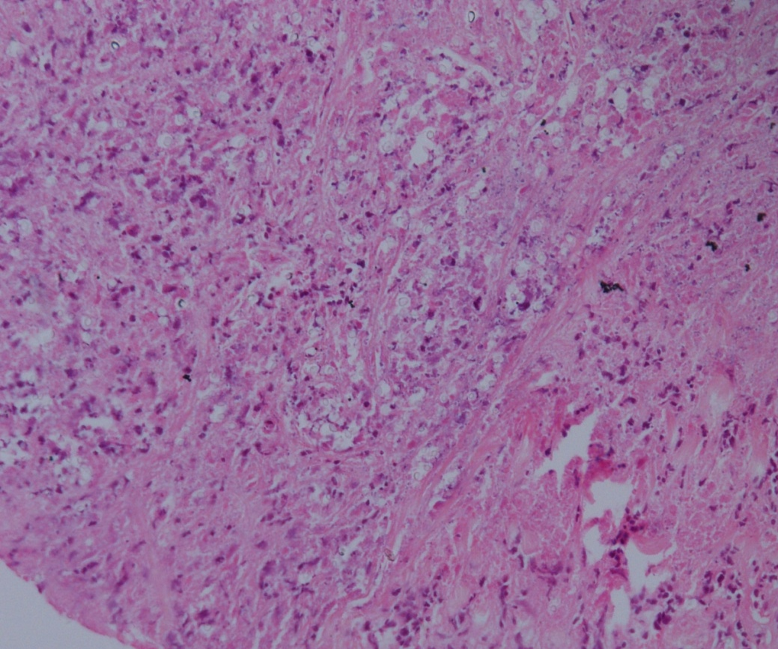
A
H&E, X 20

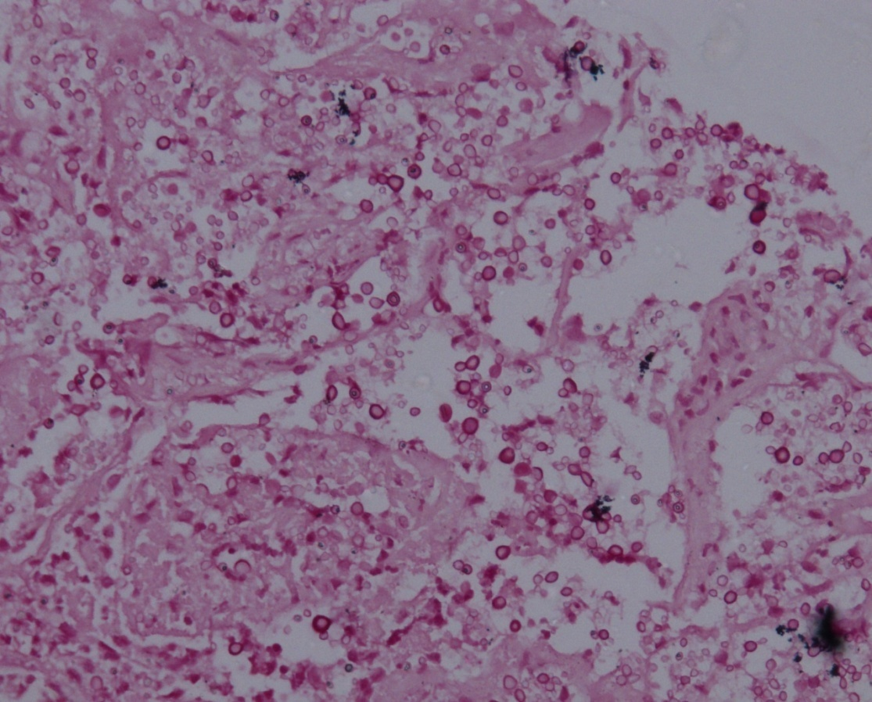
B
Mucicarmine, X 20

Figure 2 The histopathology showed cryptococcal infection. Histopathology of the lung lesion shows (A) large area of necrosis with a numerous capsulated yeast forms of fungi (arrow) morphologically resembling Cryptococcus; (B) Special histochemical stain (Mucicarmine) highlights its polysaccharide capsule.

