Name of journal: World Journal of Gastroenterology
Manuscript NO: 36839
Manuscript Type: ORIGINAL ARTICLE

Retrospective Study
Short-term and long-term outcomes following laparoscopic vs open surgery for pathological T4 colorectal cancer: 10 years of experience in a single center

Yang ZF et al. Laparoscopy in pT4 CRC

Zi-Feng Yang, De-Qing Wu, Jun-Jiang Wang, Ze-Jian Lv, Yong Li

Zi-Feng Yang, De-Qing Wu, Jun-Jiang Wang, Ze-Jian Lv, Yong Li, Department of General Surgery, Guangdong General Hospital, Guangdong Academy of Medical Science, Guangzhou510080, Guangdong Province, China

ORCID number: Zi-Feng Yang (0000-0001-9523-603X); De-Qing Wu (0000-0001-6972-3192); Jun-Jiang Wang (0000-0002-2682-2104); Ze-Jian Lv (0000-0003-1119-4544); Yong Li (0000-0002-2643-4697).

Author contributions: Yang ZF and Wu DQ contributed equally to this work and designed research; Wang JJ and Lv ZJ acquired the data; Yang ZF and Wu DQ analyzed and interpreted data; Lv ZJ drafted the manuscript; all authors made critical revisions related to important intellectual content of the manuscript; all authors have read and approved the final version to be published.

Supported by Natural Science Foundation of Guangdong Province, No. 2016A030310328 2016A030313762.

Institutional review board statement: This study was evaluated and approved by the ethics committee at our institution.

Informed consent statement: All study participants, or their legal guardian, provided informed written consent prior to study enrollment.

Conflict-of-interest statement: All authors declare no conflict of interest.

Data sharing statement: No additional data are available.

Open-Access: This article is an open-access article which was selected by an in-house editor and fully peer-reviewed by external reviewers. It is distributed in accordance with the Creative Commons Attribution Non Commercial (CC BY-NC 4.0) license, which permits others to distribute, remix, adapt, build upon this work non-commercially, and license their derivative works on different terms, provided the original work is properly cited and the use is non-commercial. See: http://creativecommons.org/licenses/by-nc/4.0/

Manuscript source: Unsolicited manuscript

Correspondence to: Yong Li, MD, PhD, Chief Doctor, Professor, Department of General Surgery, Guangdong General Hospital, Guangdong Academy of Medical Science, No 106, Zhongshan 2nd road, Guangzhou 510080, Guangdong Province, China. s_09zfyang@163.com.
Telephone: +86-20-83827812-60910
Fax: +86-20-83827812

Received: October 26, 2017
Peer-review started: October 27, 2017
First decision: November 8, 2017
Revised: November 17, 2017
Accepted: November 22, 2017
Article in press:
Published online:

Abstract
AIM
To evaluate the short-term and long-term outcomes following laparoscopic vs open surgery for pathological T4 (pT4) colorectal cancer.

METHODS
We retrospectively analyzed the short- and long-term outcomes of proven pT4 colorectal cancer patients from 2006 to 2015 in Guangdong General Hospital, where all patients were treated with complete resection by laparoscopic or open surgery.

RESULTS
There were 211 cases of pT4 colorectal cancer patients in this analysis including 101 cases in the laparoscopy (LAP) group and 110 cases in the open (OPEN) group, and the conversion to open surgery concerned 15 patients (12.9%). Clinical information (age, gender, BMI, comorbidities, ASA score, etc.) did not differ between the two groups. In terms of blood loss, postoperative complications and rate of recovery, the LAP group performed more favorably, and these differences were significant between the two groups (P < 0.05). In pT4a/b and combined-organ resection, there were more cases in the OPEN group, and there was a significant difference between the two groups (p < 0.05). The 3- and 5-year overall survival rates were 74.9% and 60.5%, respectively, for the LAP group and 62.4% and 46.5%, respectively, for The OPEN group (P = 0.060). The 3- and 5-year diseases-free survival rates were 68.0% and 57.3%, respectively, for the LAP group and 55.8% and 39.8%, respectively, for The OPEN group (P = 0.053). Multivariate analyses showed that the IIIB/IIIC stage, lymph node status, and CA19-9 were significant predictors of overall survival. PT4a/b, the IIIC stage, histological subtypes, CA19-9 and adjuvant chemotherapy were independent factors affecting disease-free survival.

CONCLUSIONS
Laparoscopy is safely used in the treatment of pT4 colorectal cancer while offering advantages of minimal invasiveness and faster recovery. Laparoscopy is able to achieve good oncologic outcomes similar to those of open surgery. We recommend that it can be carried out in experienced centers. We need to screen the appropriate cases for laparoscopic surgery, optimize the preoperative diagnosis process, and reduce the conversion rate. Multi-center, prospective, and large-sample studies are required to assess these issues.

Key words: pT4 colorectal cancer; Laparoscopy; Open surgery

© The Author(s) 2017. Published by Baishideng Publishing Group Inc. All rights reserved.

Core tip: Laparoscopy has been widely used in the treatment of colorectal cancer and has achieved a good radical effect in oncology. However, current clinical association guidelines do not recommend laparoscopic surgery for T4 colorectal cancer. This study retrospectively collected data of pathological T4 (pT4) colorectal cancer patients in Guangdong General Hospital from 2006 to 2015, aiming to compare laparoscopic and open surgery outcomes. And the conclusion is that laparoscopy is safely used in the treatment of pT4 colorectal cancer while offering advantages of faster recovery. Laparoscopy is able to achieve good oncologic outcomes similar to those of open surgery.

Yang ZF, Wu DQ, Wang JJ, Lv ZJ, Li Y. Short-term and long-term outcomes following laparoscopic vs open surgery for pathological T4 colorectal cancer: 10 years of experience in a single center. World J Gastroenterol 2017; In press
INTRODUCTION
Colorectal cancer is a common malignant tumor. It is the 3rd most diagnosed cancer and the 4th leading cause of cancer-related deaths worldwide^{[1]}. In China, the incidence and mortality of colorectal cancer are ranked among the top five of all cancers; thus, colorectal cancer is a very serious public health problem^{[2]}. In promoting comprehensive, individualized, and precise treatments to date, surgical treatment is still the only way to cure colorectal cancer. Since 1991, when Jacobs first reported the technical feasibility of the laparoscopic colectomy^{[3]}, a number of successful RCT studies have been conducted around the world to compare laparoscopy and laparotomy, with encouraging results. The laparoscopic treatment of colorectal cancer can not only achieve similar short- and long-term outcomes comparable to laparotomy, but its advantage of minimal invasiveness has gradually been recognized and promoted^{[4-7]}. The American Joint Committee on Cancer (AJCC) classifies T4 colorectal cancers as those that invade into other organs and structures and/or perforate the visceral peritoneum; laparoscopic surgery at this tumor stage is difficult as it is hard to reach and violates the “no touch” principle. Therefore, the AJCC and European Association of Endoscopic Surgery do not recommend laparoscopic treatment of pathological T4 (pT4) colorectal cancer^{[8]}. This study retrospectively collected data of pT4 colorectal cancer patients in Guangdong General Hospital from 2006 to 2015, aiming to compare laparoscopic and open surgery outcomes.

MATERIALS AND METHODS
Patients
All pT4 colorectal cancer patients in Guangdong General Hospital from 2006 to 2015 were enrolled in this study. All patients were staged according to the AJCC 7th edition manual for colorectal cancer. The inclusion criteria included the following: (1) an age of 18-75 years; (2) proven T4 pathology; and (3) radical surgery (D3 lymph node dissection). The exclusion criteria included the following: (1) low rectal cancer (peritoneal reflection as the boundary); (2) preoperative neoadjuvant treatment; (3) non-neoplastic deaths; and (4) palliative resection.

Surgical procedure
Preoperative CT and MRI were used to determine the preoperative clinical stage. The decision to proceed with laparoscopy or open surgery was made for all subjects on a patient-by-patient basis following multidisciplinary discussions and meetings. All cases entailed surgical resection according to the Japanese Society for Cancer of the Colon and Rectum (JSCCR) Guidelines^{[9]}, which have the following requirements: D3 lymph node dissection (Figure 1) to ensure the appropriate resection length, and ensuring that the integrity of the mesorectum and intraoperative operations follow the principle of "no touch" (sharp separation, blood vessels first, tumor isolation, etc.). According to the different locations of the tumor, the method of resection included the following: total colectomy, right colectomy, extended right colectomy, transverse colectomy, left colectomy, sigmoid colectomy, mid/upper anterior resection and combined-organ resection. Laparoscopic incision should not exceed 6 cm. The conversion cases were analyzed in the open (OPEN) group.

Observation index
The preoperative index included age, gender, BMI (kg/m²), comorbidity, ASA score, tumor location, hemoglobin, tumor markers (CA19-9 and CEA), etc. The intraoperative index included surgical and pathological outcomes. Surgical outcomes included the conversion rate (conversion was defined as an open performed during the laparoscopy in order to ensure complete resection, reconstruction or hemostasis and not just for the extraction of specimens), tumor size, resection length, operative time, blood loss, intraoperative complications, combined-organ resection, postoperative complications and mortality. Pathological outcomes included the number of lymph nodes dissected, lymph nodes status, margin, pT stage, pN stage, pTNM stage, Dukes stage, histological subtypes, and differentiation. The postoperative faster recovery index included time to flatus, diet, walk and hospital stays.

Follow-up
All patients were postoperatively referred to the 7th AJCC/UICC TNM stage for adjuvant chemotherapy. All patients were followed up through outpatient visits. According to NCCN guidelines, patients were subjected to a 5-year surveillance program consisting of physical examinations and tumor marker (CEA and CA 19-9) analysis every 3 mo up to 2 years. Every 6 mo, patients had complete colonoscopies at one and three years after surgery. Thoracic and abdominal CT scans were planned every year for five years of surveillance.

Statistical Analysis
Statistical analysis was performed using SPSS 19.0. Quantitative data are reported as the mean, median, SD. Categorical data were compared by χ² tests or Fisher’s exact test. Survival curves (overall survival and disease-free survival) were derived from Kaplan–Meier estimates, and the curves were compared by the log-rank test. Prognostic factors were identified by univariate analysis and further tested by multivariate analysis. The results are reported as a Hazard Ratio (HR) (95%CI). A P-value < 0.05 was considered statistically significant.

RESULTS
During the period from 2006 to 2015, we collected a total of 211 pT4a/bN0-2M0 cases according to enrollment criteria from 2308 cases of colorectal cancer in the general surgery department of Guangdong General Hospital. There were 101 cases in the laparoscopy (LAP) group and 111 cases in OPEN group (Figure 2).
There were no significant differences in age, gender, BMI, ASA score, tumor location, hemoglobin, CA19-9 and CEA in the LAP group compared with the OPEN group (P > 0.05) (Table 1).
For surgical outcome, conversion to open surgery concerned 15 patients (12.9%), and all conversion cases were analyzed in the OPEN group. There was no significant difference between the two groups in terms of intraoperative complications and postoperative complications within 30 d (P > 0.05). Laparoscopic surgery was slightly slower than open surgery (210.8 ± 88.9 vs 173.5 ± 72.7 min, P = 0.028); there was less blood loss (155.0 ± 75.9 vs 235.1 ± 120.5 mL, P = 0.033) in laparoscopic surgery, whereas open surgery showed better resection lengths (15.5 ± 7.3 vs 19.5 ± 10.4 cm, P = 0.046). In the case of combined-organ resection, there were 21 patients (19.1%) in the OPEN group, including 3 cases of abdominal wall resection, 5 cases of small bowel (except duodenum) resection, 3 cases of duodenum resection, 2 cases of urinary organ resection, 1 case of stomach resection, 4 cases of gynecologic organ resection and 3 cases of liver resection; in contrast, there were only 5 cases in the LAP group, which was a significant difference between the two groups (P = 0.001). For postoperative complications within 30 d, there were 5 cases (5.0%) in the LAP group, and there was a statistically significant difference between the two groups, as there was a higher incidence in the OPEN group (31.8% vs 12.9%, P = 0.006) cases reporting infection (incision and abdomen) (15 cases), disruption of incision (5 cases), leakage (4 cases), gastroplegia (4 cases), anastomotic hemorrhage (2 cases), intraabdominal bleeding (2 cases), obstruction (2 cases) and urinary injury (1 case) (Table 2).
Among pathologic outcomes, no significant differences in the number of lymph nodes dissected, lymph nodes status, margin, pN stage, pTNM stage, Dukes stage, histological subtypes, differentiation and HER2 were detected when comparing the two groups (P > 0.05). There were 21 pT4b cases in the OPEN group but only 5 cases in LAP group; a comparison between the two groups in the pT stage revealed a statistically significant difference (P = 0.021) (Table 3).
In the postoperative faster recovery index, the LAP group was significantly better than the OPEN group (P < 0.05) in time to flatus, diet and walk. The median hospital stay was 7 (5-21) d for the LAP group and 15 (7-31) d for the OPEN group, which was a statistically significant difference between the two groups (P = 0.004) (Table 4).
The mean overall follow-up time was 36 mo (range, 2-24 mo); there was no difference between the LAP and OPEN groups in terms of OS and DFS. The 3- and 5-year OS were 74.9%, and 60.5%, respectively, for the LAP group and 62.4%, and 46.5%, respectively, for the OPEN group (P = 0.60) (Figure 3). The 3- and 5-year DFS were 68.0%, and 57.3%, respectively, for the LAP group and 55.8, and 39.8%, respectively, for the OPEN group (P = 0.053) (Figure 4). Disease recurrence over the entire follow-up period was observed in 21.8% of patients (n = 22) in the LAP group and 22.7% of patients (n = 25) in the OPEN group (P = 0.711) (Table 1) without differences between the LAP and OPEN groups (P = 0.711). In the multivariate regression analysis, TNM stage (IIIB, IIIC), lymph nodes status (pN+), and CA19-9 were significant predictors of overall survival. Then, TNM stage (IIIC), Histological subtypes, CA19-9 and chemotherapy were predictive of disease-free survival (Table 5/6).

DISCUSSION
Since the first report of laparoscopic colorectal resection in 1991, some prospective clinical studies of laparoscopic resection for colorectal cancer have confirmed that laparoscopic techniques not only achieve minimally invasive and cosmetic effects but also achieve a good earlier faster recovery and similar oncologic outcomes compared with open surgery making it worthy of clinical promotion^{[10-12]}. However, due to the large tumor size of T4 colorectal cancer and more frequent invasion of peripheral tissues or nearby organs, laparoscopic complete resection is difficult and has high risks; the majority of clinical studies have fewer cases of T4 colorectal cancer^{[13,14]}, and some studies do not enroll any such cases^{[15,16]}. Therefore, the evidence-based data that supports the laparoscopic resection in T4 colorectal cancer is limited. Laparoscopic resection of T4 colorectal cancer is regarded a technique that demands precision, and its efficacy remains controversial. The relevant guidelines do not recommend laparoscopy in this kind of colorectal cancer^{[8]}. However, due to the maturity and progress of the laparoscopic platform, coupled with the popularity of and improvements in laparoscopic techniques, some surgeons in certain experienced centers have tried to use laparoscopic techniques in T4 colorectal cancer, achieving similar short- and long-term outcomes as open surgery^{[17-20]}.
This study decided whether laparoscopic or open surgery should be performed based on the results of preoperative imaging examination and the patient’s condition; the main referenced indicators included the following: tumor location, tumor size, the scope of invasive organ, etc^{[21]}. We found a statistically significant difference in the postoperative pT stage (P = 0.021), with 21 cases of pT4b in the OPEN group. An examination of postoperative surgical outcomes (Table 2) revealed 21 cases of combined-organ resection with the most common invasive organs including the small intestine, gynecological organs and duodenum; in contrast, the LAP group had only 5 cases, and the number of combined-organ resection was thus significantly different for these two groups (P = 0.001), which is consistent with the results of a previous study^{[22, 23]}. These data also demonstrate that the T4b stage may be an important consideration for surgeons to select laparoscopic or open surgery because it is very difficult to achieve the goal of complete resection using the “no touch” principle; therefore, guidelines do not recommend laparoscopic resection in T4 colorectal cancer^{[8]}. However, such considerations lead to selective bias in the study, which is one of the limitations in both this study and a retrospective study.
Because of the larger tumor, a wide scope of invasion, combined with resection of other organs, especially with the lack of laparoscopic experience in some centers, may lead to a high conversion rate. Previous studies of laparoscopic surgery in colorectal cancer (stage II-III)^{[11, 15,24]} reported that the conversion rate from the CLASSIC trial was 25% (for colon cancer), the COLOR trial was 17% and the COSTSG trial was 21%, whereas a retrospective study of pT4 colorectal cancer showed that the conversion rate was 5.6%-24.7% ^{[17,19,22,25-29]}; this study showed a conversion rate of 12.9%, which was consistent with reports in the literature. The conversion rates reported by some studies of pT4 colorectal cancer in South Korea and Singapore were 5.6%, 7.7% and 8.6% ^{[22,29,30]}, which are significantly lower than those from the US and Europe ^{[17,18,25,27]} (Table 7); we explain these differences as follows: (1) Laparoscopic technology and experience may differ between Asian and Western countries; (2) the conversion standard was different; (3) there is a lack of preoperative imaging assessments to select appropriate laparoscopic surgery cases in Western countries; (4) European populations had a higher BMI. All these factors increase the difficulty of surgery^{[17-25]}. Thus, surgeons should choose the appropriate pT4 colorectal cases to perform laparoscopic surgery in order to reduce the conversion rate and ensure operation safety. We recommend laparoscopic surgery as an option in experienced centers and for T4a cases with tumor sizes <5 cm and when only a single organ has been invaded by T4 colorectal cancer.
In this study, the LAP group had a longer operative time (210.8±88.9 vs 173.5 ± 72.7 min, P = 0.028), which may be related to lack of experience and the difficulty of this surgery^{[19]}. The resection length (19.5 ± 10.4 cm) obtained in the OPEN group was significantly better (P = 0.046). The literature shows that incidence of postoperative complications in the LAP group was clearly lower than the OPEN group^{[31]}. In this study, the rate of postoperative complication within 30 d in the LAP group was 12.9% (12/101), which is lower than the 31.8% (35/110) found in OPEN group, and the most common complications of OPEN group were infection (incision and abdomen) and disruption of incision, similar to a previous report in the literature^{[32]}; therefore, we should pay attention to intraoperative sterile principles in clinicals and the suture of incision.
With its faster postoperative recovery outcomes, the LAP group had clear advantages in time to flatus (P = 0.037), message (P = 0.003) and walk (P = 0.027) and hospital stays (P = 0.004) compared with the OPEN group (Table 4). Laparoscopy embodied the advantage of minimally invasive and fast recovery, which is in agreement with many earlier clinical studies^{[12,15,16]}.
In colorectal cancer surgery, lymph node dissection and R0 resection are important factors affecting long-term survival^{[33]}. We performed D3 lymphadenectomy (parenteral lymph node -middle lymph node-central lymph node)^{[34]} according to the guidelines recommended by the Japanese Society for the Colon and Rectum (JSCCR) surgery. Previous studies have shown that laparoscopic treatment of colorectal cancer achieved an R0 resection rate between 80.8% and 98%^{[11,16,18]}. In this study, the number of lymph node dissected that greater than 12 in the LAP group was 75.2% (76/101) and 65.5% (72/110) in the OPEN group, and this difference was not significantly different (P = 0.134). Concurrently, the R0 resection rate in the LAP group was 98% (99/101), whereas in the OPEN group, it was 97.3% (107/110), which was not significantly different (P = 0.779). Thus, we believe that laparoscopic treatment in pT4 colorectal cancer can achieve similar oncological outcomes as open surgery. Finally, no differences in the 3- and 5-year overall survival rates (P = 0.060) and in 3- and 5-year disease-free survival rates (P = 0.053) were observed when comparing the two groups, suggesting that laparoscopy may be a valid and effective tool to treat pT4 colorectal cancer without jeopardizing oncologic results, in accordance with the previous reported series. Cox multivariate analyses in our series detected the IIIB/IIIC stage, lymph node status, CA19-9 as independent predictors of overall survival and pT4a/b, IIIC stage, CA19-9 and adjuvant chemotherapy as independent predictors of disease-free survival.
In conclusion, laparoscopic surgery may be safe and acceptable in the treatment of pathologic T4 colorectal cancer patients with fast recovery outcomes and oncologic outcomes compared with open surgery. Thus, laparoscopy should not be regarded as an absolute contraindication in the management of pT4 colorectal cancer. Finally, as this study is only a retrospective study in a single center with a small sample, the results need to be confirmed by prospective, multi-center and large sample clinical studies.

ARTICLE HIGHLIGHTS
Research background
Laparoscopy has been widely used in the treatment of colorectal cancer and it has achieved a good radical effect in oncology. However, for the current clinical guidelines, laparoscopic surgery is not recommended in T4 colorectal cancer.

Research motivation
Due to the character of T4 colorectal cancer, laparoscopic complete resection is difficult for the resection of this kind of tumor. The current colorectal studies about laparoscopy have fewer cases of T4 colorectal cancer, and some studies do not enroll any such cases. We tried to collect and analyze the data about laparoscopy in T4 colorectal cancer in order to add evidence-based clinical evidence.

Research objectives
We aim to analyze the short- and long-term outcomes of proven pathological T4 colorectal cancer patients who were treated with complete resection by laparoscopic or open surgery.

Research methods
We collected and analyzed the data about pT4 colorectal cancer cases in Guangdong General Hospital from 2006 to 2015. All patients were staged according to the AJCC 7th edition manual for colorectal cancer. We compared laparoscopy (LAP) group and open (OPEN) group in clinical information, surgical and pathological outcomes, postoperative recovery outcomes and survival. Statistical analysis contains Quantitative data, Categorical data, Survival curves, Univariate and Multivariate analysis. A P-value <0.05 was considered statistically significant.

Research results
101 cases in the LAP group and 110 cases in the open (OPEN) group, and the conversion to open surgery concerned 15 patients (12.9%). Clinical information did not differ between the two groups. In terms of blood loss, postoperative complications and rate of recovery, the LAP group performed more favorably, and these differences were significant between the two groups (P < 0.05). In pT4a/b and combined-organ resection, there were more cases in the OPEN group, and there was a significant difference between the two groups (p < 0.05). The 3- and 5-year overall survival rates were 74.9% and 60.5%, respectively, for the LAP group and 62.4% and 46.5%, respectively, for The OPEN group (P = 0.060). The 3- and 5-year diseases-free survival rates were 68.0% and 57.3%, respectively, for the LAP group and 55.8% and 39.8%, respectively, for The OPEN group (P = 0.053). Multivariate analyses showed that the IIIB/IIIC stage, lymph node status, and CA19-9 were significant predictors of overall survival. PT4a/b, the IIIC stage, histological subtypes, CA19-9 and adjuvant chemotherapy were independent factors affecting disease-free survival.

Research conclusions
Laparoscopic surgery may be safe and acceptable in the treatment of pathologic T4 colorectal cancer patients with fast recovery outcomes and oncologic outcomes compared with open surgery. We recommend that it can be carried out in experienced centers. We need to screen the appropriate cases for laparoscopic surgery, optimize the preoperative diagnosis process, and reduce the conversion rate.

Research perspectives
Although our study shows that laparoscopy is able to achieve good clinicopathological and oncologic outcomes similar to those of open surgery. This study is only a retrospective study in a single center with a small sample, the results need to be confirmed by prospective, multi-center and large sample clinical studies.

REFERENCE
1 Arnold M, Sierra MS, Laversanne M, Soerjomataram I, Jemal A, Bray F. Global patterns and trends in colorectal cancer incidence and mortality. Gut 2017; 66: 683-691 [PMID: 26818619 DOI: 10.1136/gutjnl-2015-310912]
2 Chen W, Zheng R, Baade PD, Zhang S, Zeng H, Bray F, Jemal A, Yu XQ, He J. Cancer statistics in China, 2015. CA Cancer J Clin 2016; 66: 115-132 [PMID: 26808342 DOI: 10.3322/caac.21338]
3 Jacobs M, Verdeja JC, Goldstein HS. Minimally invasive colon resection (laparoscopic colectomy). Surg Laparosc Endosc 1991; 1: 144-150 [PMID: 1688289]
4 Veldkamp R, Kuhry E, Hop WC, Jeekel J, Kazemier G, Bonjer HJ, Haglind E, Påhlman L, Cuesta MA, Msika S, Morino M, Lacy AM; COlon cancer Laparoscopic or Open Resection Study Group (COLOR). Laparoscopic surgery vs open surgery for colon cancer: short-term outcomes of a randomised trial. Lancet Oncol 2005; 6: 477-484 [PMID: 15992696 DOI: 10.1016/S1470-2045(05)70221-7]
5 Colon Cancer Laparoscopic or Open Resection Study Group., Buunen M, Veldkamp R, Hop WC, Kuhry E, Jeekel J, Haglind E, Påhlman L, Cuesta MA, Msika S, Morino M, Lacy A, Bonjer HJ. Survival after laparoscopic surgery vs open surgery for colon cancer: long-term outcome of a randomised clinical trial. Lancet Oncol 2009; 10: 44-52 [PMID: 19071061 DOI: 10.1016/S1470-2045(08)70310-3]
6 Di B, Li Y, Wei K, Xiao X, Shi J, Zhang Y, Yang X, Gao P, Zhang K, Yuan Y, Zhang D, Wei X, Liu S, Wang J, Wang X, Zhang Y, Cai H. Laparoscopic vs open surgery for colon cancer: a meta-analysis of 5-year follow-up outcomes. Surg Oncol 2013; 22: e39-e43 [PMID: 23643698 DOI: 10.1016/j.suronc.2013.03.002]
7 Deijen CL, Vasmel JE, de Lange-de Klerk ESM, Cuesta MA, Coene PLO, Lange JF, Meijerink WJHJ, Jakimowicz JJ, Jeekel J, Kazemier G, Janssen IMC, Påhlman L, Haglind E, Bonjer HJ; COLOR (COlon cancer Laparoscopic or Open Resection) study group. Ten-year outcomes of a randomised trial of laparoscopic vs open surgery for colon cancer. Surg Endosc 2017; 31: 2607-2615 [PMID: 27734203 DOI: 10.1007/s00464-016-5270-6]
8 Mathis KL, Nelson H. Controversies in laparoscopy for colon and rectal cancer. Surg Oncol Clin N Am 2014; 23: 35-47 [PMID: 24267164 DOI: 10.1016/j.soc.2013.09.006]
9 Muro K. Systemic chemotherapy for metastatic colorectal cancer -Japanese Society for Cancer of the Colon and Rectum (JSCCR) Guidelines 2016 for treatment of colorectal cancer. Nihon Shokakibyo Gakkai Zasshi 2017; 114: 1217-1223 [PMID: 28679979 DOI: 10.11405/nisshoshi.114.1217]
10 Kim RH, Kavanaugh MM, Caldito GC. Laparoscopic colectomy for cancer: Improved compliance with guidelines for chemotherapy and survival. Surgery 2017; 161: 1633-1641 [PMID: 28027818 DOI: 10.1016/j.surg.2016.11.024]
11 Bonjer HJ, Deijen CL, Abis GA, Cuesta MA, van der Pas MH, de Lange-de Klerk ES, Lacy AM, Bemelman WA, Andersson J, Angenete E, Rosenberg J, Fuerst A, Haglind E; COLOR II Study Group. A randomized trial of laparoscopic vs open surgery for rectal cancer. N Engl J Med 2015; 372: 1324-1332 [PMID: 25830422 DOI: 10.1056/NEJMoa1414882]
12 Kang SB, Park JW, Jeong SY, Nam BH, Choi HS, Kim DW, Lim SB, Lee TG, Kim DY, Kim JS, Chang HJ, Lee HS, Kim SY, Jung KH, Hong YS, Kim JH, Sohn DK, Kim DH, Oh JH. Open vs laparoscopic surgery for mid or low rectal cancer after neoadjuvant chemoradiotherapy (COREAN trial): short-term outcomes of an open-label randomised controlled trial. Lancet Oncol 2010; 11: 637-645 [PMID: 20610322 DOI: 10.1016/S1470-2045(10)70131-5]
13 Stevenson AR, Solomon MJ, Lumley JW, Hewett P, Clouston AD, Gebski VJ, Davies L, Wilson K, Hague W, Simes J; ALaCaRT Investigators. Effect of Laparoscopic-Assisted Resection vs Open Resection on Pathological Outcomes in Rectal Cancer: The ALaCaRT Randomized Clinical Trial. JAMA 2015; 314: 1356-1363 [PMID: 26441180 DOI: 10.1001/jama.2015.12009]
14 Jeong SY, Park JW, Nam BH, Kim S, Kang SB, Lim SB, Choi HS, Kim DW, Chang HJ, Kim DY, Jung KH, Kim TY, Kang GH, Chie EK, Kim SY, Sohn DK, Kim DH, Kim JS, Lee HS, Kim JH, Oh JH. Open vs laparoscopic surgery for mid-rectal or low-rectal cancer after neoadjuvant chemoradiotherapy (COREAN trial): survival outcomes of an open-label, non-inferiority, randomised controlled trial. Lancet Oncol 2014; 15: 767-774 [PMID: 24837215 DOI: 10.1016/S1470-2045(14)70205-0]
15 Guillou PJ, Quirke P, Thorpe H, Walker J, Jayne DG, Smith AM, Heath RM, Brown JM; MRC CLASICC trial group. Short-term endpoints of conventional vs laparoscopic-assisted surgery in patients with colorectal cancer (MRC CLASICC trial): multicentre, randomised controlled trial. Lancet 2005; 365: 1718-1726 [PMID: 15894098 DOI: 10.1016/S0140-6736(05)66545-2]
16 Fleshman J, Branda M, Sargent DJ, Boller AM, George V, Abbas M, Peters WR Jr, Maun D, Chang G, Herline A, Fichera A, Mutch M, Wexner S, Whiteford M, Marks J, Birnbaum E, Margolin D, Larson D, Marcello P, Posner M, Read T, Monson J, Wren SM, Pisters PW, Nelson H. Effect of Laparoscopic-Assisted Resection vs Open Resection of Stage II or III Rectal Cancer on Pathologic Outcomes: The ACOSOG Z6051 Randomized Clinical Trial. JAMA 2015; 314: 1346-1355 [PMID: 26441179 DOI: 10.1001/jama.2015.10529]
17 de'Angelis N, Landi F, Vitali GC, Memeo R, Martínez-Pérez A, Solis A, Assalino M, Vallribera F, Mercoli HA, Marescaux J, Mutter D, Ris F, Espin E, Brunetti F. Multicentre propensity score-matched analysis of laparoscopic vs open surgery for T4 rectal cancer. Surg Endosc 2017; 31: 3106-3121 [PMID: 27826780 DOI: 10.1007/s00464-016-5332-9]
18 de'Angelis N, Vitali GC, Brunetti F, Wassmer CH, Gagniere C, Puppa G, Tournigand C, Ris F. Laparoscopic vs. open surgery for T4 colon cancer: A propensity score analysis. Int J Colorectal Dis 2016; 31: 1785-1797 [PMID: 27627964 DOI: 10.1007/s00384-016-2646-y]
19 Ng DC, Co CS, Cheung HY, Chung CC, Li MK. The outcome of laparoscopic colorectal resection in T4 cancer. Colorectal Dis 2011; 13: e349-e352 [PMID: 21689365 DOI: 10.1111/j.1463-1318.2011.02698.x]
20 Shukla PJ, Trencheva K, Merchant C, Maggiori L, Michelassi F, Sonoda T, Lee SW, Milsom JW. Laparoscopic resection of t4 colon cancers: is it feasible? Dis Colon Rectum 2015; 58: 25-31 [PMID: 25489691 DOI: 10.1097/DCR.0000000000000220]
21 Vignali A, Ghirardelli L, Di Palo S, Orsenigo E, Staudacher C. Laparoscopic treatment of advanced colonic cancer: a case-matched control with open surgery. Colorectal Dis 2013; 15: 944-948 [PMID: 23398664 DOI: 10.1111/codi.12170]
22 Park JS, Huh JW, Park YA, Cho YB, Yun SH, Kim HC, Lee WY, Chun HK. Clinically suspected T4 colorectal cancer may be resected using a laparoscopic approach. BMC Cancer 2016; 16: 714 [PMID: 27595851 DOI: 10.1186/s12885-016-2753-8]
23 Huh JW, Kim HR. The feasibility of laparoscopic resection compared to open surgery in clinically suspected T4 colorectal cancer. J Laparoendosc Adv Surg Tech A 2012; 22: 463-467 [PMID: 22393927 DOI: 10.1089/lap.2011.0425]
24 Clinical Outcomes of Surgical Therapy Study Group, Nelson H, Sargent DJ, Wieand HS, Fleshman J, Anvari M, Stryker SJ, Beart RW Jr, Hellinger M, Flanagan R Jr, Peters W, Ota D. A comparison of laparoscopically assisted and open colectomy for colon cancer. N Engl J Med 2004; 350: 2050-2059 [PMID: 15141043 DOI: 10.1056/NEJMoa032651]
25 Elnahas A, Sunil S, Jackson TD, Okrainec A, Quereshy FA. Laparoscopic vs open surgery for T4 colon cancer: evaluation of margin status. Surg Endosc 2016; 30: 1491-1496 [PMID: 26123344 DOI: 10.1007/s00464-015-4360-1]
26 Kim IY, Kim BR, Kim YW. The short-term and oncologic outcomes of laparoscopic vs open surgery for T4 colon cancer. Surg Endosc 2016; 30: 1508-1518 [PMID: 26123346 DOI: 10.1007/s00464-015-4364-x]
27 Leon P, Iovino MG, Giudici F, Sciuto A, de Manzini N, Cuccurullo D, Corcione F. Oncologic outcomes following laparoscopic colon cancer resection for T4 lesions: a case-control analysis of 7-years' experience. Surg Endosc 2017 [PMID: 28842796 DOI: 10.1007/s00464-017-5784-6]
28 Kim KY, Hwang DW, Park YK, Lee HS. A single surgeon's experience with 54 consecutive cases of multivisceral resection for locally advanced primary colorectal cancer: can the laparoscopic approach be performed safely? Surg Endosc 2012; 26: 493-500 [PMID: 22011939 DOI: 10.1007/s00464-011-1907-7]
29 Kang J, Baik SH, Lee KY, Sohn SK. Outcomes of laparoscopic surgery in pathologic T4 colon cancers compared to those of open surgery. Int J Colorectal Dis 2017; 32: 531-538 [PMID: 27882405 DOI: 10.1007/s00384-016-2720-5]
30 Chan DK, Tan KK. Laparoscopic surgery should be considered in T4 colon cancer. Int J Colorectal Dis 2017; 32: 517-520 [PMID: 27838816 DOI: 10.1007/s00384-016-2702-7]
31 Ohtani H, Tamamori Y, Arimoto Y, Nishiguchi Y, Maeda K, Hirakawa K. A meta-analysis of the short- and long-term results of randomized controlled trials that compared laparoscopy-assisted and open colectomy for colon cancer. J Cancer 2012; 3: 49-57 [PMID: 22315650 DOI: 10.7150/jca.3621]
32 Liao CH, Tan EC, Chen CC, Yang MC. Real-world cost-effectiveness of laparoscopy vs open colectomy for colon cancer: a nationwide population-based study. Surg Endosc 2017; 31: 1796-1805 [PMID: 27538935 DOI: 10.1007/s00464-016-5176-3]
33 Yamamoto S, Inomata M, Katayama H, Mizusawa J, Etoh T, Konishi F, Sugihara K, Watanabe M, Moriya Y, Kitano S; Japan Clinical Oncology Group Colorectal Cancer Study Group. Short-term surgical outcomes from a randomized controlled trial to evaluate laparoscopic and open D3 dissection for stage II/III colon cancer: Japan Clinical Oncology Group Study JCOG 0404. Ann Surg 2014; 260: 23-30 [PMID: 24509190 DOI: 10.1097/SLA.0000000000000499]
34 Watanabe T, Muro K, Ajioka Y, Hashiguchi Y, Ito Y, Saito Y, Hamaguchi T, Ishida H, Ishiguro M, Ishihara S, Kanemitsu Y, Kawano H, Kinugasa Y, Kokudo N, Murofushi K, Nakajima T, Oka S, Sakai Y, Tsuji A, Uehara K, Ueno H, Yamazaki K, Yoshida M, Yoshino T, Boku N, Fujimori T, Itabashi M, Koinuma N, Morita T, Nishimura G, Sakata Y, Shimada Y, Takahashi K, Tanaka S, Tsuruta O, Yamaguchi T, Yamaguchi N, Tanaka T, Kotake K, Sugihara K; Japanese Society for Cancer of the Colon and Rectum. Japanese Society for Cancer of the Colon and Rectum (JSCCR) guidelines 2016 for the treatment of colorectal cancer. Int J Clin Oncol 2017 [PMID: 28349281 DOI: 10.1007/s10147-017-1101-6]

P-Reviewer: Kim SM, Sterpetti AV, Yokoyama S S-Editor: Chen K L-Editor: E-Editor:
Specialty type: Gastroenterology and hepatology
Country of origin: China
Peer-review report classification
Grade A (Excellent): 0
Grade B (Very good): B, B
Grade C (Good): 0
Grade D (Fair): 0
Grade E (Poor): E

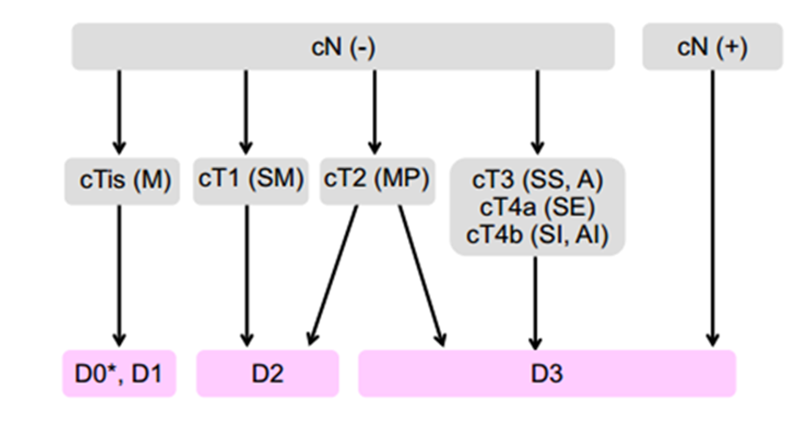
Figure 1 Flowchart for selection of the extent of lymph node dissection (from reference 9).

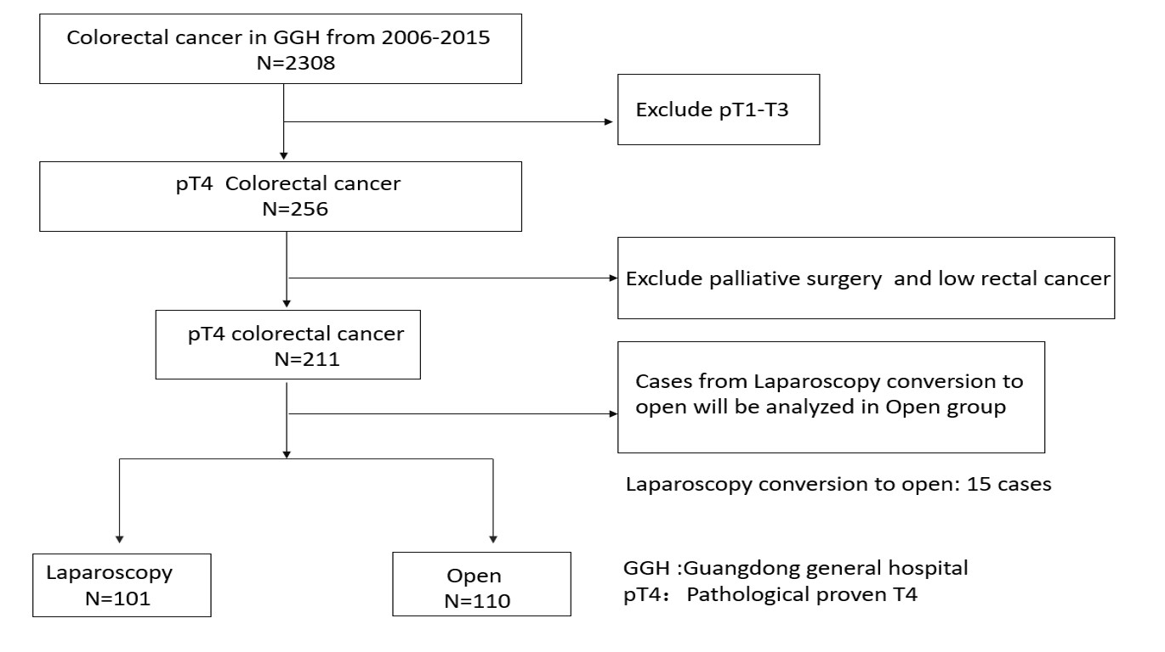Figure 2 Study flowchart showing patient selection.

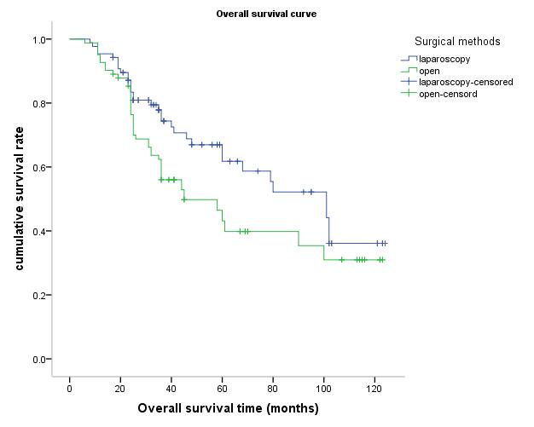
Figure 3 The overall survival curve shows that 3- and 5-year overall survival rates were 74.9% and 60.5%, respectively, in the LAP group and 62.4% and 46.5%, respectively, in the OPEN group. There was no significant difference between the LAP and OPEN groups (P = 0.060).

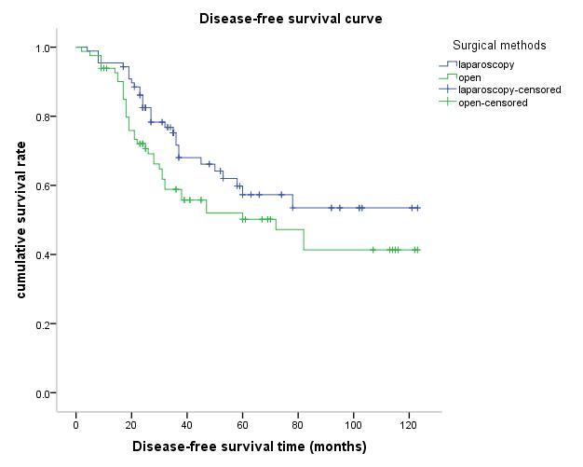
Figure 4 The disease-free survival curve shows that the 3- and 5-year disease-free survival rates were 68.0% and 57.3%, respectively, in the LAP group and 55.8% and 39.8%, respectively, in the OPEN group. There was no significant difference between the LAP and OPEN groups (P = 0.053).

Table 1 Clinical information of 211 colorectal cancer cases
Clinical information |  | LAP  n = 101 | OPEN  n = 110 | P-value
Age | > 60 yr | 55 | 58 | 0.270
 | ≤ 60 yr | 46 | 52
Gender | Male | 67 | 66 | 0.392
 | Female | 34 | 44
BMI(kg/m²) | < 24 | 67 | 73 | 0.348
 | ≥ 24 | 34 | 37
Comorbidities | Yes | 39 | 42 | 1.000
 | No | 62 | 68
ASA score | I | 8 | 9 | 0.715
 | II | 63 | 72
 | III | 30 | 29
Tumor  location | Mid/upper Rectum | 33 | 35 | 0.989
 | Left colon | 43 | 47
 | Right colon | 25 | 28
HBG (g/L) | Mean ± SD | 124.0 ± 27.1 | 120.7 ± 22.9 | 0.263
CA19-9 (U/mL) | < 27 | 78 | 75 | 0.163
 | ≥ 27 | 23 | 35
CEA (ng/mL) | < 5 | 60 | 64 | 0.666
 | ≥ 5 | 41 | 46
Postoperative Adjuvant chemotherapy | Yes | 49 | 46 | 0.332
 | No | 52 | 64
Recurrence | Yes | 22 | 25 | 0.711
 | No | 79 | 85
CRC: Colorectal cancer; LAP: Laparoscopy group; OPEN: Open group; BMI: Body mass index; ASA: American Society of Anesthesiology; HGB: Hemoglobin; CA19-9: Carbohydrate antigen 19-9; CEA: Caicinoembryonic antigen; SD: Standard deviation. The LAP and OPEN groups were comparable.

Table 2 Surgical outcomes of 211 colorectal cancer cases
Surgical outcome |  |  | LAP  n = 101 | OPEN  n = 110 | P-value
Conversion to open (n/%) |  |  | 15 (12.9%) | NR | /
Tumor size (cm) |  | Mean ± SD | 5.4 ± 1.9 | 5.2 ± 2.5 | 0.765
Resection length (cm) |  | Mean ± SD | 15.5 ± 7.3 | 19.5 ± 10.4 | 0.046
Operative time (min) |  | Mean ± SD | 210.8 ± 88.9 | 173.5 ± 72.7 | 0.028
Blood loss (mL) |  | Mean ± SD | 155.0 ± 75.9 | 235.1 ± 120.5 | 0.033
Intraoperative complication |  |  | 3 | 8 | 0.117
Combined-organ resection |  | Total (%) | 5 (5.0%) | 21 (19.1%) | 0.001
 |  | Abdominal wall | 2 | 3
 |  | Small bowel (except duodenum) | 1 | 5
 |  | Duodenum | 0 | 3
 |  | Urinary organs | 0 | 2
 |  | Stomach | 1 | 1
 |  | Gynecologic organs | 1 | 4
 |  | Liver | 0 | 3
Postoperative complication within 30 d | Total (%) |  | 12 (12.9%) | 35 (31.8%) | 0.006
 | Anastomotic Hemorrhage |  | 1 | 2
 | Urinary injury |  | 0 | 1
 | Intraabdominal bleeding |  | 1 | 2
 | Leakage |  | 1 | 4
 | Gastroplegia |  | 2 | 4
 | Infection  (incision and abdomen) |  | 6 | 15
 | Disruption of incision |  | 0 | 5
 | Obstruction |  | 1 | 2
Postoperative morbidity within 30 d |  |  | 0 | 1 | 0.667
CRC: Colorectal cancer; LAP: Laparoscopy group; OPEN: Open group; N: Number of patients; SD: Standard deviation.

Table 3 Pathologic outcomes of 211 colorectal cancer cases
Pathologic outcome |  | LAP  n = 101 | OPEN  n = 110 | P-value
Number of lymph nodes dissected | < 12 | 25 | 38 | 0.134
 | ≥ 12 | 76 | 72
Lymph nodes status | + | 67 | 74 | 1.000
 | - | 34 | 36
Margin | R1 | 2 | 3 | 0.779
 | R0 | 99 | 107
pT stage | T4a | 96 | 89 | 0.021
 | T4b | 5 | 21
pN stage | N0 | 36 | 35 | 0.841
 | N1 | 28 | 32
 | N2 | 37 | 43
 | IIB + IIC | 34 | 35 | 0.282
pTNM stage | IIIB | 30 | 24
 | IIIC | 37 | 51
Dukes | B | 34 | 35 | 0.883
 | C | 67 | 75
Histological subtypes | Adenocarcinoma | 87 | 94 | 1.000
 | Myxoadenocarcinoma | 14 | 16
Differentiation | Poor | 20 | 25 | 0.719
 | Median/high | 81 | 85
HER2 | −/+ | 86 | 96 | 0.871
 | ++ | 10 | 10
 | +++ | 5 | 4
CRC: Colorectal cancer; LAP: Laparoscopy group; OPEN: Open group; N: number of patients; SD: Standard deviation; p: Pathological.

Table 4 Postoperative recovery outcomes of 211 colorectal cancer cases
Recovery outcome |  | LAP  n = 101 | OPEN  n = 110 | P-value
Time to flatus (d) | Median (range) | 2 (1-9) | 4 (3-15) | 0.037
Time to diet (d) | Median (range) | 3 (2-18) | 7 (5-27) | 0.003
Time to walk (d) | Median (range) | 2 (1-5) | 5 (3-9) | 0.027
Hospital stays | Median (range) | 7 (5-21) | 15 (7-31) | 0.004
LAP: Laparoscopy group; OPEN: Open group.

Table 5 Univariate and multivariate analyses of 211 pathological T4 colorectal cancer patients for overall survival
 | Univariate analysis |  | Multivariate analysis
Variables | HR (95%CI) | P-value | HR(95%CI) | P-value
Age | 1.217 (0.784-1.888) | 0.381
Gender | 0.807 (0.508-1.281) | 0.363
Surgical method  (LAP and OPEN) | 1.528 (0.982-2.377) | 0.060
Tumor location
Mid/upper rectum | Reference group | -
Left colon | 1.303 (0.813-2.091) | 0.272
Right colon | 0.792 (0.409-1.533) | 0.489
Comorbidities | 1.603 (1.007-2.552) | 0.047 | 2.519 (1.436-4.419) | 0.142
pT4a/b | 0.790 (0.692-1.236) | 0.445
N stage
N0 | Reference group | -
N1 | 1.328 (0.701-2.517) | 0.384
N2 | 2.079 (1.170-3.697) | 0.013
TNM stage
IIB+IIC | Reference group | - | Reference group | -
IIIB | 1.229 (0.564-2.679) | 0.604 | 1.324 (0.785-1.753) | 0.019
IIIC | 3.092 (1.617-5.913) | 0.001 | 1.104 (0.333-3.662) | 0.001
Lymph nodes status | 0.560 (0.324-0.968) | 0.038 | 0.307 (0.103-0.919) | 0.035
No. of lymphadenectomy | 0.593 (0.385-0.915) | 0.018 | 0.432 (0.264-0.708) | 0.123
Histological subtypes | 0.369 (0.212-0.640) | 0.000 | 0.433 (0.218-0.859) | 0.247
Differentiation | 0.326(0.204-0.519) | 0.000 | 0.460 (0.273-0.775) | 0.087
CA19-9 | 1.868 (1.195-2.922) | 0.006 | 1.662 (1.212-2.280) | 0.002
CEA | 1.089 (0.706-1.680) | 0.013 | 0.608 (0.356-1.038) | 0.068
Chemotherapy | 1.611 (1.040-2.494) | 0.033 | 2.225 (1.394-3.552) | 0.181
CRC: Colorectal cancer; LAP: Laparoscopy surgery; OPEN: Open surgery; p: Pathological; CA19-9: Carbohydrate antigen 19-9; CEA: Carcinoembryonic antigen; HR: Hazards ratio.

Table 6 Univariate and multivariate analyses of 211 pathological T4 colorectal cancer patients for disease-free survival
 | Univariate analysis |  | Multivariate analysis
Variables | HR (95%CI) | P-value | HR (95%CI) | P-value
Age | 1.621(1.010-2.601) | 0.045 | 1.892 (1.111-3.223) | 0.419
Gender | 1.328 (0.824-2.141) | 0.243
Surgical method  (LAP and OPEN) | 1.503 (0.933-2.422) | 0.094
Tumor location
Mid/upper rectum | Reference group | -
Left colon | 1.010 (0.601-10697) | 0.969
Right colon | 0.818 (0.411-1.629) | 0.568
Comorbidities | 1.787 (1.058-3.019) | 0.030 | 2.261 (1.235-4.139) | 0.080
pT4a/b | 0.818 (0.618-1.725) | 0.013 | 1.214 (0.784-1.974) | 0.001
N stage
N0 | Reference group | -
N1 | 1.134 (0.594-2.167) | 0.703
N2 | 1.553 (0.861-2.801) | 0.144
TNM stage
IIB+IIC | Reference group | - | Reference group | -
IIIB | 1.034 (0.471-2.269) | 0.933 | 0.884 (0.393-1.989) | 0.765
IIIC | 2.284 (1.202-4.337) | 0.012 | 1.831 (0.935-3.584) | 0.018
Lymph nodes status | 0.710 (0.411-1.229) | 0.221
No. of lymphadenectomy | 0.661 (0.411-1.061) | 0.087
Histological subtypes | 0.456 (0.243-0.854) | 0.014 | 0.469 (0.225-0.974) | 0.042
Differentiation | 0.439(0.266-0.725) | 0.001 | 0.662 (0.374-1.170) | 0.156
CA19-9 | 2.458 (1.526-3.960) | 0.000 | 3.372 (1.968-5.778) | 0.000
CEA | 1.268 (0.790-2.036) | 0.326 | 0.608 (0.356-1.038) | 0.072
Chemotherapy | 2.157 (1.323-3.514) | 0.002 | 3.817 (2.194-6.639) | 0.000
CRC: colorectal cancer; LAP: Laparoscopy surgery; OPEN: Open surgery; p-Pathological; CA19-9: Carbohydrate antigen 19-9; CEA: Arcinoembryonic antigen; HR: Hazards ratio.

Table 7 Studies about laparoscopic surgery for pathological T4 colorectal cancer
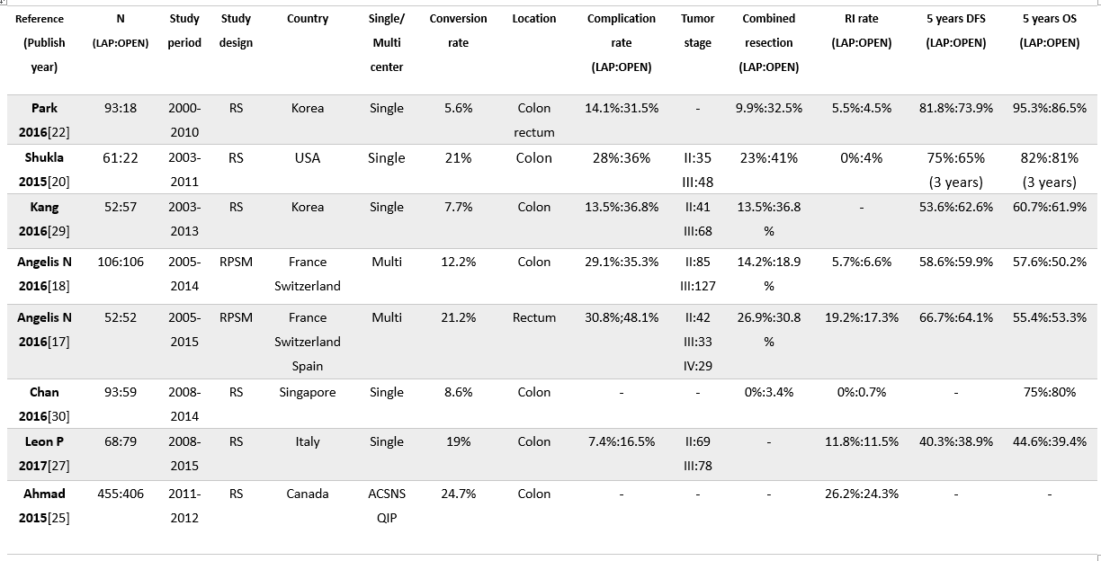
N: Number of patients; LAP: Laparoscopy; RS: Retrospective study; RPSM: Retrospective propensity score matching; ACSNS: American College of Surgeons National Surgical Quality Improvement Program; OS: Overall survival; DFS: Disease-free survival.

