Name of Journal: World Journal of Clinical Cases
Manuscript NO: 63738
Manuscript Type: OPINION REVIEW

Regulating monocyte infiltration and differentiation: Providing new therapies for colorectal cancer patients with COVID-19

Bai L et al. Role of monocyte-macrophage in COVID-19

Ling Bai, Wang Yang, Lei Qian, Jiu-Wei Cui

Ling Bai, Wang Yang, Lei Qian, Jiu-Wei Cui, Cancer Center, The First Hospital of Jilin University, Changchun 130021, Jilin Province, China

Author contributions: Bai L and Yang W contributed equally to this work; Bai L and Yang W carried out the primary literature search, processed the data, drafted and revised the manuscript, and participated in discussions; Qian L carried out the primary literature search, revised the manuscript, and participated in discussions; Cui JW designed the research, performed literature analysis, drafted and revised the manuscript, and participated in discussions; All authors read and approved the final manuscript.

Supported by the National Key Research and Development Program of New Coronary Pneumonia and Other Infectious Diseases Prevention Basic Research Orientation Project of China, No. 2020YFA0707704 (to Qian L); the Ministry of Science and Technology of the People’s Republic of China, No. 2016YFC1303800 (to Cui JW); the Interdisciplinary Research Funding Program of Jilin University, No. 101832020DJX083 (to Bai L); and the Outstanding Talent Cultivation Program for Doctoral Students in Norman Bethune Health Science Center of Jilin University (to Bai L).

Corresponding author: Jiu-Wei Cui, MD, PhD, Chief Doctor, Professor, Cancer Center, The First Hospital of Jilin University, No. 71 Xinmin Street, Changchun 130021, Jilin Province, China. cuijw@jlu.edu.cn

Received: February 1, 2021
Revised: March 10, 2021
Accepted: August 4, 2021
Published online: December 6, 2021

Abstract
The outbreak of coronavirus disease 2019 (COVID-19) is a significant challenge for clinicians, especially for immunocompromised cancer patients. By analyzing the impact of COVID-19 on the immune microenvironment of colorectal cancer (CRC) patients at the tissue level and single-cell level, we found that CRC patients are more easily infected by severe acute respiratory syndrome coronavirus-2 (SARS-CoV-2), but promotion of infiltration and differentiation of monocytes makes them more likely to develop severe COVID-19. Because of the continuing activation of nuclear factor (NF)-κB and C-C chemokine receptor type 5 (CCR5) signaling pathways in monocytes, imbalance of macrophage polarization can aggravate the cytokine release syndrome. Therefore, regulating the infiltration and differentiation of monocytes is helpful for the treatment of COVID-19 in CRC patients.

Key Words: COVID-19; SARS-CoV-2; Monocyte; Macrophage; Colorectal cancer

©The Author(s) 2021. Published by Baishideng Publishing Group Inc. All rights reserved.

Citation: Bai L, Yang W, Qian L, Cui JW. Regulating monocyte infiltration and differentiation: Providing new therapies for colorectal cancer patients with COVID-19. World J Clin Cases 2021; 9(34): 10392-10399
URL: https://www.wjgnet.com/2307-8960/full/v9/i34/10392.htm
DOI: https://dx.doi.org/10.12998/wjcc.v9.i34.10392

Core Tip: Not only are colorectal cancer (CRC) patients susceptible to severe acute respiratory syndrome coronavirus 2 (SARS-CoV-2) but their infiltrating monocytes are also affected by SARS-CoV-2. Promotion of infiltration and differentiation of monocytes after infection CRC patients are more likely to develop severe coronavirus disease 2019 (COVID-19). In severe COVID-19, because of activation of the nuclear factor (NF)-κB and C-C chemokine receptor type 5 (CCR5) signaling pathways, the imbalance of macrophage polarization can cause further aggravation of the cytokine release syndrome.
INTRODUCTION
As a public health emergency of international concern, there are nearly 150 million coronavirus disease 2019 (COVID-19) cases worldwide. In particular, cancer patients are more vulnerable to virus infection because of their suppressed immune microenvironment. Severe acute respiratory syndrome coronavirus 2 (SARS-CoV-2) enters cells by recognizing angiotensin I converting enzyme 2 (ACE2), transmembrane serine protease 2 (TMPRSS2)^{[1]}, and other proteases, such as cathepsin B (CTSB) and cathepsin L (CTSL)^{[2]}, in the host cell. Clarifying the expression of those proteins unique to various human pathologies may be helpful in identifying susceptible populations.
Studies have shown that cancer patients not only have a 2.31 times higher risk of infection with SARS-CoV-2 than the general population^{[3]} but also have a higher risk of developing severe COVID-19^{[3,4]}. Compared with patients without cancer, those with cancer have a 3.56-fold increased risk of severe disease following COVID-19 infection^{[5]}. However, the mechanism of the exacerbation of COVID-19 is not clear. Therefore, revealing the effects of COVID-19 infection on the human body may provide new ideas for preventing the deterioration of COVID-19 patients.
The leading cause of COVID-19 aggravation is multiorgan dysfunction caused by the cytokine release syndrome (CRS). By comparing the differences in proteomics and metabolomics of severe and nonsevere COVID-19 cases with healthy controls, it was found that the severe cases were associated with abnormal macrophage regulation^{[6,7]}. The results of meta-analysis and bioinformatics analysis have shown that colorectal cancer (CRC) patients are more susceptible to SARS-CoV-2 than cancer patients with other tumors^{[8]}. Studies have also shown that COVID-19 patients with CRC are more likely to have clinical characteristics with a poor COVID-19 prognosis than matched patients with COVID-19 but without cancer^{[9]}. We used CRC as an example to elucidate the effect of SARS-CoV-2 on the cancer immune microenvironment, especially the impact on monocytes, with the goal of finding treatments to delay the progression of COVID-19.

SARS-CoV-2 RECOGNITION PROTEINS ARE HIGHLY EXPRESSED IN THE TUMOR TISSUES OF CRC PATIENTS
After SARS-CoV-2 infection, viral envelope spike proteins bind to ACE2 and promote cellular recognition of the virus^{[2]}. If transmembrane serine protease 2 (TMPRSS2) is present, it promotes the cleavage and activation of S proteins by host cells. SARS-CoV-2 usually enters cells through the endosomal pathway, but in the absence of TMPRSS2, it enters by cathepsin L (CTSL) and cathepsin B (CTSB) proteolysis and activation of S protein^{[10-12]}.
Data on mRNA expression in colorectal cancer tissue in the Cancer Genome Atlas (https://cancergenome.nih.gov/) and the Genotype-Tissue Expression project (https://www.gtexportal.org/home/) databases, we found that the expression of ACE2 and TMPRSS2 was higher in CRC than in healthy tissue (Figure 1A). In addition, single-cell sequencing data from 27,414 cells from six CRC patients in the National Center for Biotechnology Information Gene Expression Omnibus (GEO) database (GSE144735), we found that ACE2, TMPRSS2, CTSL, and CTSB were primarily expressed in stromal and epithelial cells of CRC tissue (Figure 1B, C). Therefore, the susceptibility of CRC patients to COVID-19 may be associated with the high expression of SARS-CoV-2 recognition proteins.

INFILTRATING MONOCYTES IN COLORECTAL CANCER TISSUES ARE SENSITIVE TO SARS-COV-2 INFECTION
Analysis of GEO single-cell sequencing data (GSE144735) revealed that expression of the CTSL and CTSB SARS-CoV-2 recognition proteins was higher in monocytes compared with other immune cells in the tumor microenvironment (Figure 2). Consequently, SARS-CoV-2 infection may affect the function of monocytes. The analysis also showed that the expression of CTSL and CTSB mRNA was higher in infiltrated monocytes in cells from tumor than it was in cells from healthy tissue (Figure 2). Thus, when infected by COVID-19, monocytes in the tumor microenvironment may induce a stronger inflammatory effect.

COVID-19 PROMOTES INFILTRATION AND DIFFERENTIATION OF MONOCYTES
Monocytes constitute a pool of dendritic cells and macrophages, and differentiate into type 1 macrophages (M1) and type 2 macrophages (M2). M1 are proinflammatory macrophages and have an anti-tumor effect. M2 are anti-inflammatory macrophages that mediate tumor immune escape. The effects of monocyte cytokines produced following SARS-CoV-2 infection on macrophage polarization was investigated using GEO data (GSE145926). Cluster-based processing of cells from three healthy, three mild, and six severe COVID-19 patient using Harmony (https://www.harmony-alliance.eu/covid19/covid-19-news/open-call-for-data-partners-to-join-the-harmony-covid-19-data-platform) was used to remove batch effects and select 20 principal components. Differential expression analysis with Seurat (https://satijalab.org/seurat/archive/v3.2/de_vignette.html) identified CD14⁺ monocytes in the patient samples for subsequent analysis. The proportions of M1 and M2 in the samples were determined by counting the CD80- and CD86-positive M1 and MRC1- and CD163-positive M2 cells. Differences were compared with GraphPad Prism 7.0a for Mac OS X (GraphPad Inc., La Jolla, CA, United States) and the unpaired two-tailed Student’s t-test. Numeric data are reported as means ± SD. The gene set variation analysis (GSVA) for microarray and RNA-seq data (https://www.bioconductor.org/packages/release/bioc/html/GSVA.html) R statistics package was used to score gene set enrichment analysis data from 31,557 monocytes (c2.cp.v7.1.symbols.gmt: https://data.broadinstitute.org/gsea-msigdb/msigdb/release/7.1/).
Analysis of the cytokines expressed by monocytes in alveolar lavage fluid (GEO: GSE145926, https://www.ncbi.nlm.nih.gov/geo/query/acc.cgi?acc=GSE145926) showed that COVID-19 induced the differentiation of M1 and M2 by affecting the cytokines TGF-β1 and TNF-α (Figure 3A). Therefore, SARS-CoV-2 promotes macrophage polarization and enhances macrophage infiltration by stimulating cytokine production. By comparing the correlation between the proportion of macrophages and the degree of infection, it was found that patients with COVID-19 had higher macrophage infiltration than healthy people (Figure 3B). However, after developing into severe COVID-19, the M1/M2 ratio increased (Figure 3B), which may further aggravate the CRS.

REGULATION OF MONOCYTE INFILTRATION AND DIFFERENTIATION MAY CONTRIBUTE TO THE TREATMENT OF COVID-19
We use the Linear Models for Microarray (limma) R package (https://bioconductor.org/packages/release/bioc/html/limma.html) to distinguish signaling pathways (DEGenesets) in patients with severe and nonsevere COVID-19 infection and healthy controls and cutoffs of the average absolute between-group differences. We identified nine signaling pathways that were statistically different (≥ 0.35 false discovery rate-adjusted P < 0.001, Figure 4). The results suggest that COVID-19 infection promotes the activation of NF-κB and CCR5 signaling pathways in monocytes. Multiple metabolic pathways in monocytes are involved (Figure 4). Inhibiting the activation of the NF-κB or CCR5 signaling pathway is expected to maintain the balance of M1 and M2 monocytes and thus prevent progression to severe COVID-19 infection.

CONCLUSION
COVID-19 has many implications for the diagnosis and treatment of cancer. With the increasing understanding of the SARS-CoV-2 infection-related signaling pathway, a growing number of studies have described the association between tumors and the risk of CDVID-19 infection. Clinical studies and meta-analyses have also preliminarily confirmed the susceptibility of Chinese CRC patients to COVID-19^{[13,14]}, but reason needs further study. This study briefly described the expression of SARS-CoV-2 recognition proteins in the cells and tissues of COVID-19 patients, providing a reference for subsequent studies on the susceptibility of CRC patients to COVID-19.
Because SARS-CoV-2 recognition proteins are not only expressed in tumor cells but also immune cells, we analyzed the expression of essential proteins related to COVID-19 infection in various immune cells by the single-cell sequencing analysis of cells in CRC patients. We found that SARS-CoV-2 infection may affect the function of monocytes and that SARS-CoV-2 infection can promote the activation of NF-κB and CCR5 signaling pathways in monocytes. Suppressing the activation of NF-κB and CCR5 signaling pathways may reshape the balance of macrophage polarization, which can be helpful for the treatment of COVID-19.
Because of the relationship between monocyte-macrophage activation and the severity of COVID-19, the cytokines released by epithelial cells and fibroblasts following SARS-CoV-2 infection promote the recruitment of monocytes and the activation of macrophages, which promotes the CRS^{[15]}. We also uncovered evidence that monocyte-macrophage infiltration was associated with COVID-19 severity and that M1/M2 ratio was higher in severe than in nonsevere COVID-19, which promotes disease progression. We believe that the high expression of SARS-CoV-2 recognition protein in monocytes affects monocytes function in direct or indirect ways.
Statins are inhibitors of cholesterol synthesis. They are also helpful in the treatment of COVID-19^{[16]}, although it is not clear how they do that. Statins can not only directly inhibit the growth and development of tumors, but also inhibit the release of pro-differentiation cytokines by M1 macrophages. They also cause a reduction of the M1/M2 ratio and inhibit macrophage infiltration by inhibiting TLR4/MYD88/NF-κB signaling^{[17,18]}. Furthermore, lipids promote the upregulation of CCR5 in monocytes and enhance their proinflammatory phenotype^{[19]}. Inhibitors of NF-κB and CCR5, such as statins, may offer a novel treatment for CRC patients with COVID-19 by regulating the changes in the M1/M2 ratio. Because lipopolysaccharides are a TLR4 agonist, active prevention and treatment of combined bacterial infections may be effective to prevent CRS occurrence. Leronlimab, a CCR5-specific antibody, has also been reported as a potential treatment of COVID-19. It inhibits macrophage polarization and CRS occurrence by blocking CCR5^{[20,21]}. We believe that other drugs that block NF-κB or CCR5 may also be effective in treating COVID-19.

REFERENCES
1 Sungnak W, Huang N, Bécavin C, Berg M, Queen R, Litvinukova M, Talavera-López C, Maatz H, Reichart D, Sampaziotis F, Worlock KB, Yoshida M, Barnes JL; HCA Lung Biological Network. SARS-CoV-2 entry factors are highly expressed in nasal epithelial cells together with innate immune genes. Nat Med 2020; 26: 681-687 [PMID: 32327758 DOI: 10.1038/s41591-020-0868-6]
2 Gkogkou E, Barnasas G, Vougas K, Trougakos IP. Expression profiling meta-analysis of ACE2 and TMPRSS2, the putative anti-inflammatory receptor and priming protease of SARS-CoV-2 in human cells, and identification of putative modulators. Redox Biol 2020; 36: 101615 [PMID: 32863223 DOI: 10.1016/j.redox.2020.101615]
3 Yu J, Ouyang W, Chua MLK, Xie C. SARS-CoV-2 Transmission in Patients With Cancer at a Tertiary Care Hospital in Wuhan, China. JAMA Oncol 2020; 6: 1108-1110 [PMID: 32211820 DOI: 10.1001/jamaoncol.2020.0980]
4 Dai M, Liu D, Liu M, Zhou F, Li G, Chen Z, Zhang Z, You H, Wu M, Zheng Q, Xiong Y, Xiong H, Wang C, Chen C, Xiong F, Zhang Y, Peng Y, Ge S, Zhen B, Yu T, Wang L, Wang H, Liu Y, Chen Y, Mei J, Gao X, Li Z, Gan L, He C, Li Z, Shi Y, Qi Y, Yang J, Tenen DG, Chai L, Mucci LA, Santillana M, Cai H. Patients with Cancer Appear More Vulnerable to SARS-CoV-2: A Multicenter Study during the COVID-19 Outbreak. Cancer Discov 2020; 10: 783-791 [PMID: 32345594 DOI: 10.1158/2159-8290.CD-20-0422]
5 Liang W, Guan W, Chen R, Wang W, Li J, Xu K, Li C, Ai Q, Lu W, Liang H, Li S, He J. Cancer patients in SARS-CoV-2 infection: a nationwide analysis in China. Lancet Oncol 2020; 21: 335-337 [PMID: 32066541 DOI: 10.1016/S1470-2045(20)30096-6]
6 Shen B, Yi X, Sun Y, Bi X, Du J, Zhang C, Quan S, Zhang F, Sun R, Qian L, Ge W, Liu W, Liang S, Chen H, Zhang Y, Li J, Xu J, He Z, Chen B, Wang J, Yan H, Zheng Y, Wang D, Zhu J, Kong Z, Kang Z, Liang X, Ding X, Ruan G, Xiang N, Cai X, Gao H, Li L, Li S, Xiao Q, Lu T, Zhu Y, Liu H, Chen H, Guo T. Proteomic and Metabolomic Characterization of COVID-19 Patient Sera. Cell 2020; 182: 59-72.e15 [PMID: 32492406 DOI: 10.1016/j.cell.2020.05.032]
7 Liao M, Liu Y, Yuan J, Wen Y, Xu G, Zhao J, Cheng L, Li J, Wang X, Wang F, Liu L, Amit I, Zhang S, Zhang Z. Single-cell landscape of bronchoalveolar immune cells in patients with COVID-19. Nat Med 2020; 26: 842-844 [PMID: 32398875 DOI: 10.1038/s41591-020-0901-9]
8 Wang B, Huang Y. Which type of cancer patients are more susceptible to the SARS-COX-2: Evidence from a meta-analysis and bioinformatics analysis. Crit Rev Oncol Hematol 2020; 153: 103032 [PMID: 32599375 DOI: 10.1016/j.critrevonc.2020.103032]
9 Liu C, Wang K, Zhang M, Hu X, Hu T, Liu Y, Hu Q, Wu S, Yue J. High expression of ACE2 and TMPRSS2 and clinical characteristics of COVID-19 in colorectal cancer patients. NPJ Precis Oncol 2021; 5: 1 [PMID: 33479506 DOI: 10.1038/s41698-020-00139-y]
10 Bittmann S, Weissenstein A, Villalon G, Moschuring-Alieva E, Luchter E. Simultaneous Treatment of COVID-19 With Serine Protease Inhibitor Camostat and/or Cathepsin L Inhibitor? J Clin Med Res 2020; 12: 320-322 [PMID: 32489508 DOI: 10.14740/jocmr4161]
11 Hoffmann M, Kleine-Weber H, Schroeder S, Krüger N, Herrler T, Erichsen S, Schiergens TS, Herrler G, Wu NH, Nitsche A, Müller MA, Drosten C, Pöhlmann S. SARS-CoV-2 Cell Entry Depends on ACE2 and TMPRSS2 and Is Blocked by a Clinically Proven Protease Inhibitor. Cell 2020; 181: 271-280.e8 [PMID: 32142651 DOI: 10.1016/j.cell.2020.02.052]
12 Zhao MM, Yang WL, Yang FY, Zhang L, Huang WJ, Hou W, Fan CF, Jin RH, Feng YM, Wang YC, Yang JK. Cathepsin L plays a key role in SARS-CoV-2 infection in humans and humanized mice and is a promising target for new drug development. Signal Transduct Target Ther 2021; 6: 134 [PMID: 33774649 DOI: 10.1038/s41392-021-00558-8]
13 Antikchi MH, Neamatzadeh H, Ghelmani Y, Jafari-Nedooshan J, Dastgheib SA, Kargar S, Noorishadkam M, Bahrami R, Jarahzadeh MH. The Risk and Prevalence of COVID-19 Infection in Colorectal Cancer Patients: a Systematic Review and Meta-analysis. J Gastrointest Cancer 2021; 52: 73-79 [PMID: 32997314 DOI: 10.1007/s12029-020-00528-3]
14 Xiao F, Tang M, Zheng X, Liu Y, Li X, Shan H. Evidence for Gastrointestinal Infection of SARS-CoV-2. Gastroenterology 2020; 158: 1831-1833.e3 [PMID: 32142773 DOI: 10.1053/j.gastro.2020.02.055]
15 Gómez-Rial J, Rivero-Calle I, Salas A, Martinón-Torres F. Role of Monocytes/Macrophages in Covid-19 Pathogenesis: Implications for Therapy. Infect Drug Resist 2020; 13: 2485-2493 [PMID: 32801787 DOI: 10.2147/IDR.S258639]
16 Zhang XJ, Qin JJ, Cheng X, Shen L, Zhao YC, Yuan Y, Lei F, Chen MM, Yang H, Bai L, Song X, Lin L, Xia M, Zhou F, Zhou J, She ZG, Zhu L, Ma X, Xu Q, Ye P, Chen G, Liu L, Mao W, Yan Y, Xiao B, Lu Z, Peng G, Liu M, Yang J, Yang L, Zhang C, Lu H, Xia X, Wang D, Liao X, Wei X, Zhang BH, Zhang X, Yang J, Zhao GN, Zhang P, Liu PP, Loomba R, Ji YX, Xia J, Wang Y, Cai J, Guo J, Li H. In-Hospital Use of Statins Is Associated with a Reduced Risk of Mortality among Individuals with COVID-19. Cell Metab 2020; 32: 176-187.e4 [PMID: 32592657 DOI: 10.1016/j.cmet.2020.06.015]
17 Methe H, Kim JO, Kofler S, Nabauer M, Weis M. Statins decrease Toll-like receptor 4 expression and downstream signaling in human CD14+ monocytes. Arterioscler Thromb Vasc Biol 2005; 25: 1439-1445 [PMID: 15860745 DOI: 10.1161/01.ATV.0000168410.44722.86]
18 Koushki K, Shahbaz SK, Mashayekhi K, Sadeghi M, Zayeri ZD, Taba MY, Banach M, Al-Rasadi K, Johnston TP, Sahebkar A. Anti-inflammatory Action of Statins in Cardiovascular Disease: the Role of Inflammasome and Toll-Like Receptor Pathways. Clin Rev Allergy Immunol 2021; 60: 175-199 [PMID: 32378144 DOI: 10.1007/s12016-020-08791-9]
19 Renovato-Martins M, Matheus ME, de Andrade IR, Moraes JA, da Silva SV, Citelli Dos Reis M, de Souza AA, da Silva CC, Bouskela E, Barja-Fidalgo C. Microparticles derived from obese adipose tissue elicit a pro-inflammatory phenotype of CD16⁺, CCR5⁺ and TLR8⁺ monocytes. Biochim Biophys Acta Mol Basis Dis 2017; 1863: 139-151 [PMID: 27677832 DOI: 10.1016/j.bbadis.2016.09.016]
20 Patterson BK, Seethamraju H, Dhody K, Corley MJ, Kazempour K, Lalezari J, Pang APS, Sugai C, Mahyari E, Francisco EB, Pise A, Rodrigues H, Wu HL, Webb GM, Park BS, Kelly S, Pourhassan N, Lelic A, Kdouh L, Herrera M, Hall E, Bimber BN, Plassmeyer M, Gupta R, Alpan O, O'Halloran JA, Mudd PA, Akalin E, Ndhlovu LC, Sacha JB. CCR5 inhibition in critical COVID-19 patients decreases inflammatory cytokines, increases CD8 T-cells, and decreases SARS-CoV2 RNA in plasma by day 14. Int J Infect Dis 2021; 103: 25-32 [PMID: 33186704 DOI: 10.1016/j.ijid.2020.10.101]
21 Chua RL, Lukassen S, Trump S, Hennig BP, Wendisch D, Pott F, Debnath O, Thürmann L, Kurth F, Völker MT, Kazmierski J, Timmermann B, Twardziok S, Schneider S, Machleidt F, Müller-Redetzky H, Maier M, Krannich A, Schmidt S, Balzer F, Liebig J, Loske J, Suttorp N, Eils J, Ishaque N, Liebert UG, von Kalle C, Hocke A, Witzenrath M, Goffinet C, Drosten C, Laudi S, Lehmann I, Conrad C, Sander LE, Eils R. COVID-19 severity correlates with airway epithelium-immune cell interactions identified by single-cell analysis. Nat Biotechnol 2020; 38: 970-979 [PMID: 32591762 DOI: 10.1038/s41587-020-0602-4]
Footnotes
Conflict-of-interest statement: The authors declare that they have no competing interests.

Open-Access: This article is an open-access article that was selected by an in-house editor and fully peer-reviewed by external reviewers. It is distributed in accordance with the Creative Commons Attribution NonCommercial (CC BY-NC 4.0) license, which permits others to distribute, remix, adapt, build upon this work non-commercially, and license their derivative works on different terms, provided the original work is properly cited and the use is non-commercial. See: http://creativecommons.org/Licenses/by-nc/4.0/

Provenance and peer review: Invited article; Externally peer reviewed

Peer-review started: February 1, 2021
First decision: March 29, 2021
Article in press: August 4, 2021

Specialty type: Immunology
Country/Territory of origin: China
Peer-review report’s scientific quality classification
Grade A (Excellent): 0
Grade B (Very good): 0
Grade C (Good): C
Grade D (Fair): 0
Grade E (Poor): 0

P-Reviewer: Trabelsi M S-Editor: Wu YXJ L-Editor: Filipodia P-Editor: Wang LYT

Figure Legends
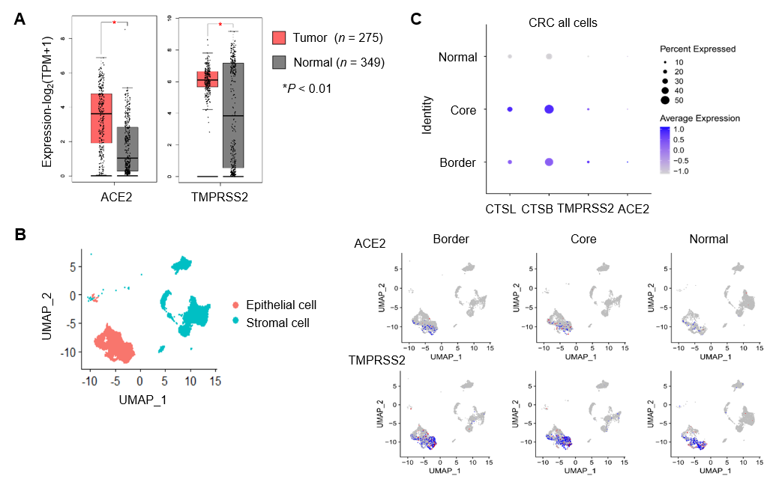
Figure 1 Severe acute respiratory syndrome coronavirus 2 recognition proteins are highly expressed in the tumor tissues of patients with colorectal cancer. A: In the TCGA and GTEx databases, expression of angiotensin I converting enzyme 2 (ACE2) and transmembrane serine protease 2 (TMPRSS2) was significantly higher in in colorectal cancer (CRC) tumors than in healthy tissues (P < 0.01); B: single-cell sequencing analysis of 27,414 cells from six CRC patients found that ACE2 and TMPRSS2 expression was higher in CRC than in healthy tissue, and was mainly expressed in epithelial cells; C: Expression of ACE2, TMRPSS2, cathepsin B, and cathepsin L was higher in CRC than in normal tissue in both stromal and epithelial cells analysis of single-cell sequencing (Gene Expression Omnibus: GSE144735). ACE2: Angiotensin I converting enzyme 2; CRC: Colorectal cancer; CTSB: Cathepsin B; CTSL: Cathepsin L; GTEx: Genotype-tissue expression; TCGA: The Cancer Genome Atlas; TMPRSS2: Transmembrane serine protease 2; UMAP: Uniform manifold approximation and projection.
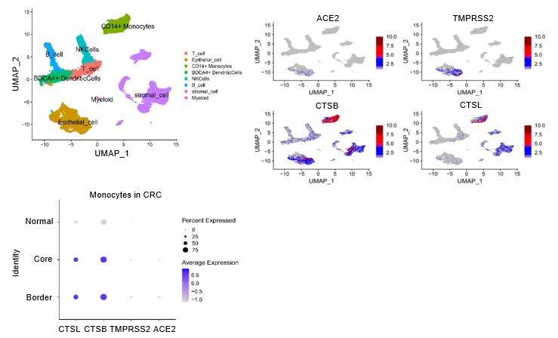
Figure 2 Infiltrating monocytes in colorectal cancer tissues express high levels of severe acute respiratory syndrome coronavirus 2 recognition proteins. Analysis of single-cell sequencing of 27,414 cells in six colorectal cancer patients identified genes that were expressed in at least three cells and at least 200 genes were identified in each cell. Harmony was used to remove batch effects. The first 20 principal components were selected in Seurat to cluster the patients, and the enriched pathways in marker gene sets were found with enrichR (https://amp.pharm.mssm.edu/Enrichr/) and the expression of coronavirus disease 2019-related genes in dendritic, natural killer, myeloid, stromal, and epithelial cells; monocytes, and B cells was screened. Severe acute respiratory syndrome coronavirus 2 recognition proteins were mainly expressed on monocytes. The expression of angiotensin I converting enzyme 2, transmembrane serine protease 2, cathepsin B, and cathepsin L in tissue-infiltrated monocytes was higher in colorectal cancer than in normal tissue. ACE2: Angiotensin I converting enzyme 2; CRC: Colorectal cancer; CTSB: Cathepsin B; CTCL: Cathepsin L; TMPRSS2: Transmembrane serine protease; UMAP: Uniform manifold approximation and projection.
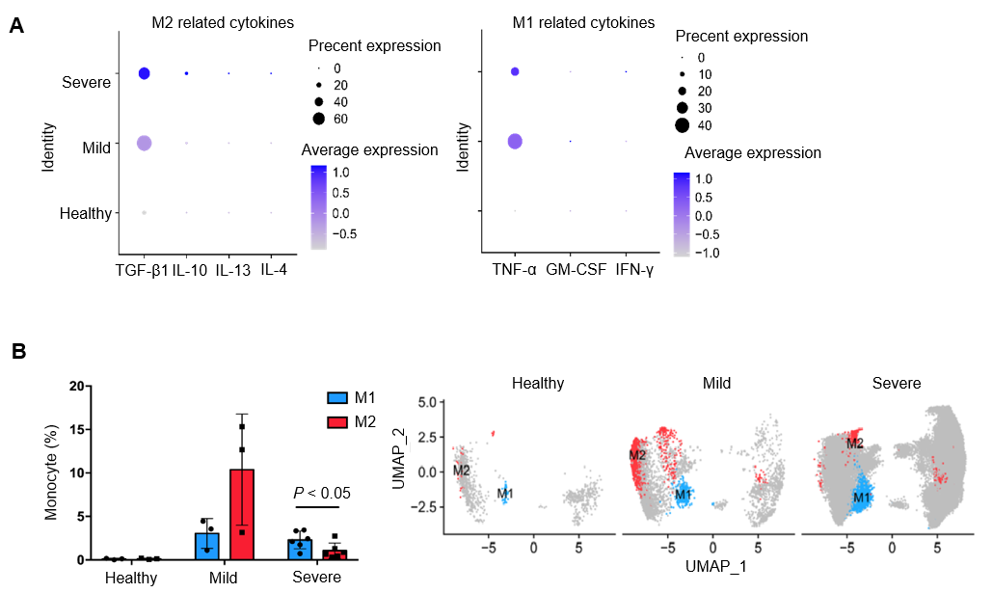
Figure 3 Impact of coronavirus disease 2019 on monocytes. A: Coronavirus disease 2019 (COVID-19) induces the differentiation of M1 and M2 macrophages by affecting cytokines, especially TGF-β1 and TNF-α; B: COVID-19 patients had higher macrophage infiltration than healthy people. In severe COVID-19, the M1/M2 ratio increased. GM-CSF: Granulocyte-macrophage colony-stimulating factor; IFN-γ: Interferon-γ; IL: Interleukin; M1: Type 1 macrophage; M2: Type 2 macrophage.
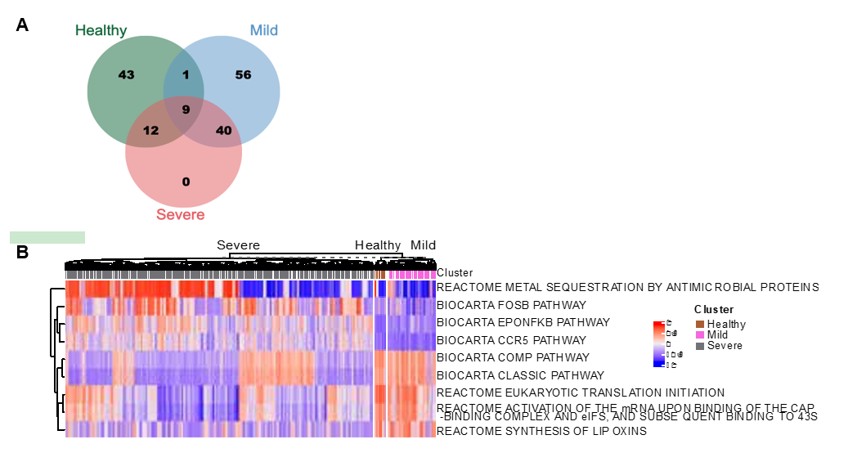
Figure 4 Coronavirus disease 2019 infection promotes the activation of NF-κB and CCR5 signaling pathways in monocytes. The limma R package was used to identify differentially expressed pathways (DEGeneset) in severe and nonsevere Coronavirus disease 2019 (COVID-19) patients, and healthy controls with an absolute value score > 0.35 and a false discovery rate < 0.001. Nine differential pathways were found. COVID-19 infection promoted the activation of NF-κB and CCR5 signaling pathways in monocytes. Multiple metabolic pathways were also involved.

Published by Baishideng Publishing Group Inc
7041 Koll Center Parkway, Suite 160, Pleasanton, CA 94566, USA
Telephone: +1-925-3991568
E-mail: bpgoffice@wjgnet.com
Help Desk: https://www.f6publishing.com/helpdesk
https://www.wjgnet.com

© 2021 Baishideng Publishing Group Inc. All rights reserved.

