Rockville M. Topic I: Hepatitis E Virus (HEV) and Blood Transfusion Safety BLOOD PRODUCTS ADVISORY COMMITTEE,104th Meeting, September 20, 2012. FDA Fishers Lane Building 5630 Fishers Lane, Room 1066 2012: 1-24
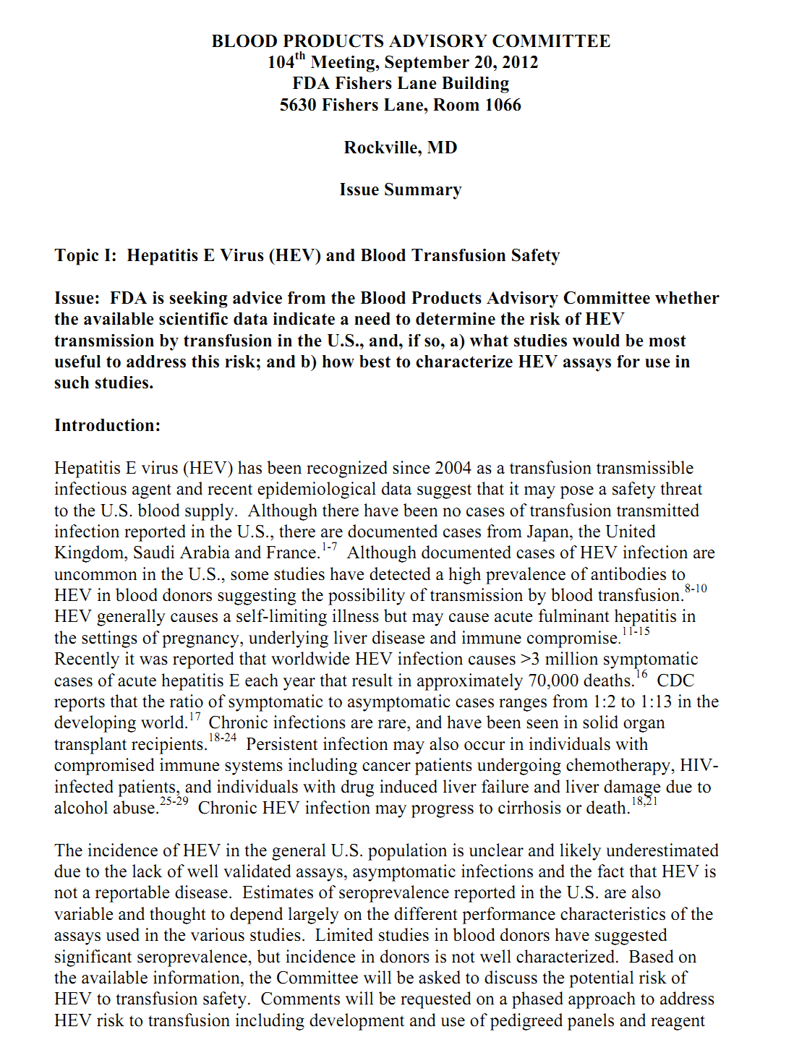

Taherkhani R, Farshadpour F. A new strategy for development of hepatitis E vaccine: Epitope-based vaccines. Pathog Infect Dis 2015; 1(1): e933 [DOI: 10.14800/pid.933]
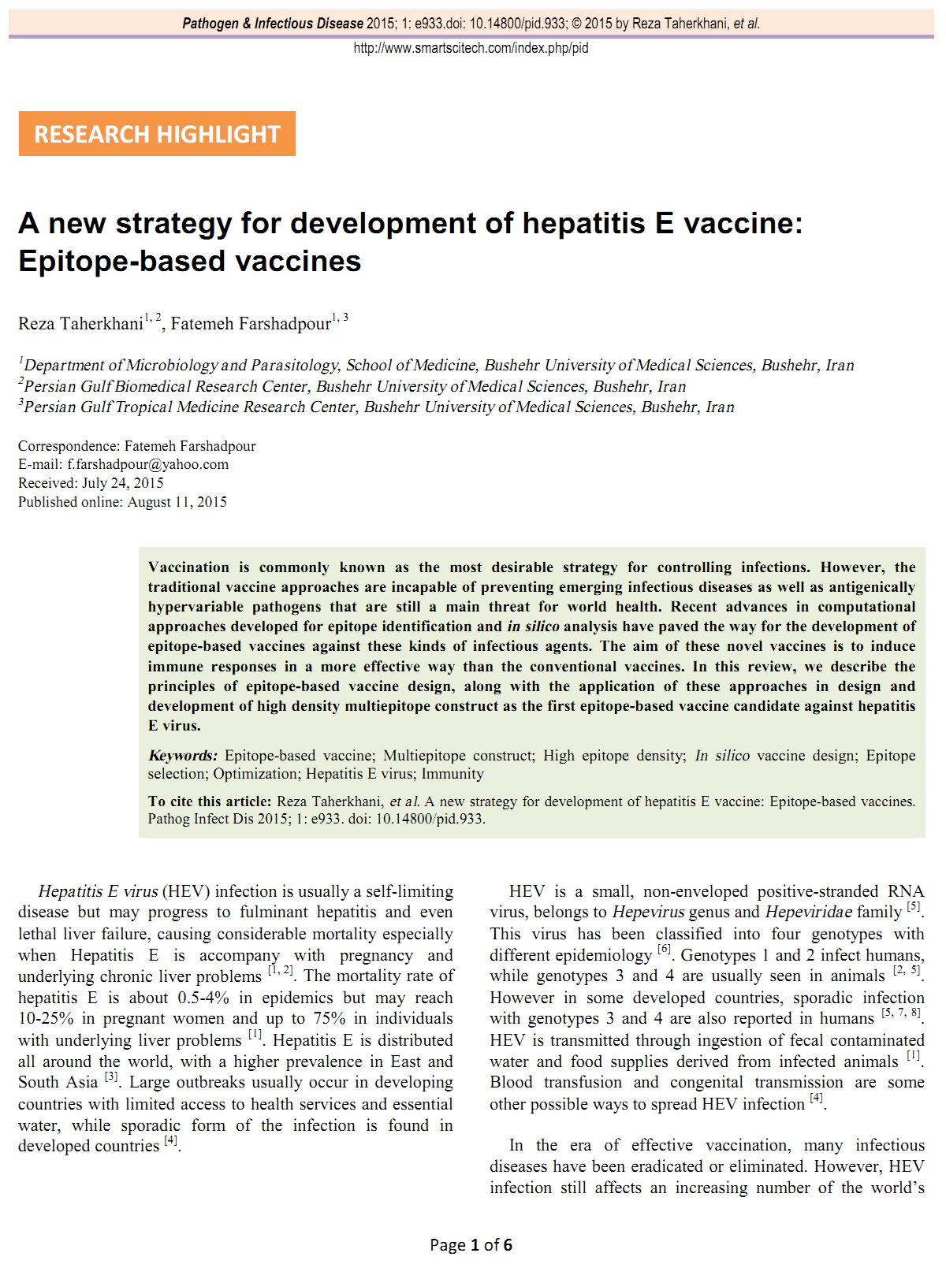

WHO. Hepatitis E, WHO fact sheet; No. 280, updated July 2015. Available at: http://www.who.int/mediacentre/factsheets/fs280/en/.
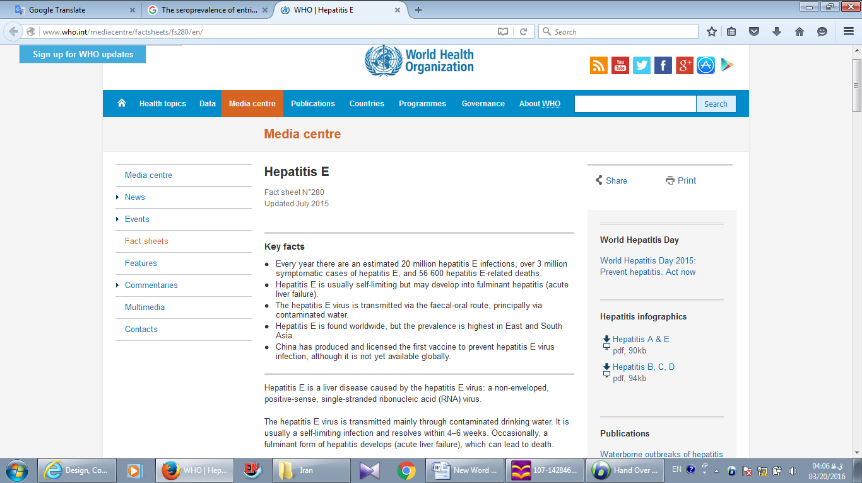

Jamali R. Epidemiologic Studies on Viral Hepatitis: A Short Review. Thrita 2014; 3(1): e15376 [DOI: 10.5812/thrita.15376 ]
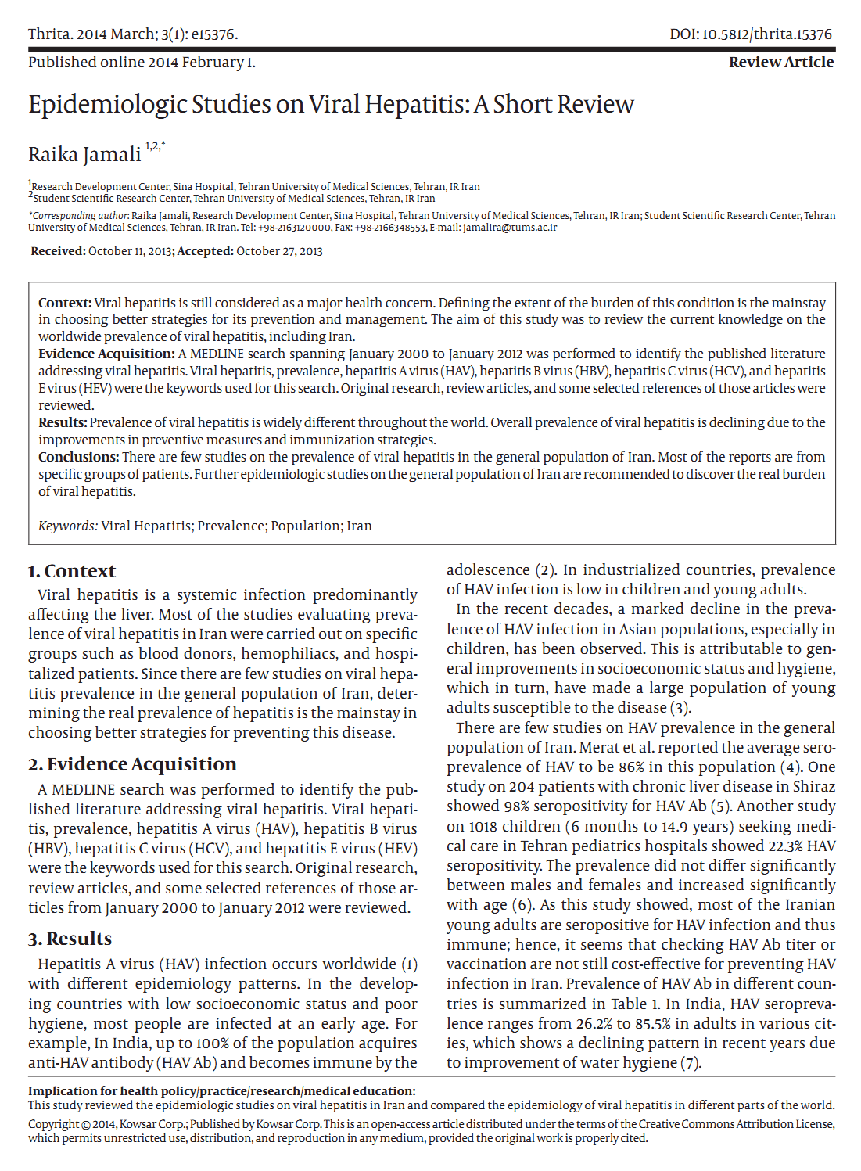

Ghorbani GA, Alavian S-M, Esfahani AA, Assari S. Seroepidemiology of hepatitis E virus in Iranian soldiers. Hepat Mon 2007; 7(3): 123-126
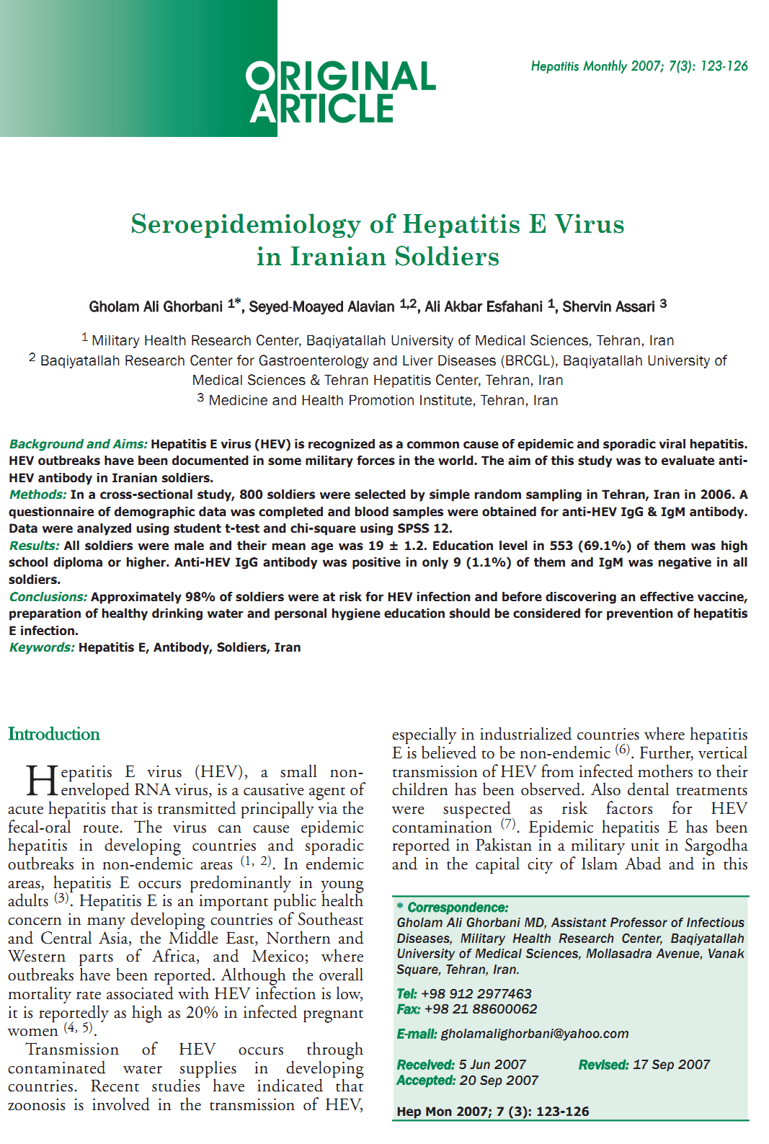

Alavian S-M, Fallahian F, Lankarani KB. Epidemiology of hepatitis E in Iran and Pakistan. Hepat Mon 2009; 9(1): 60-65
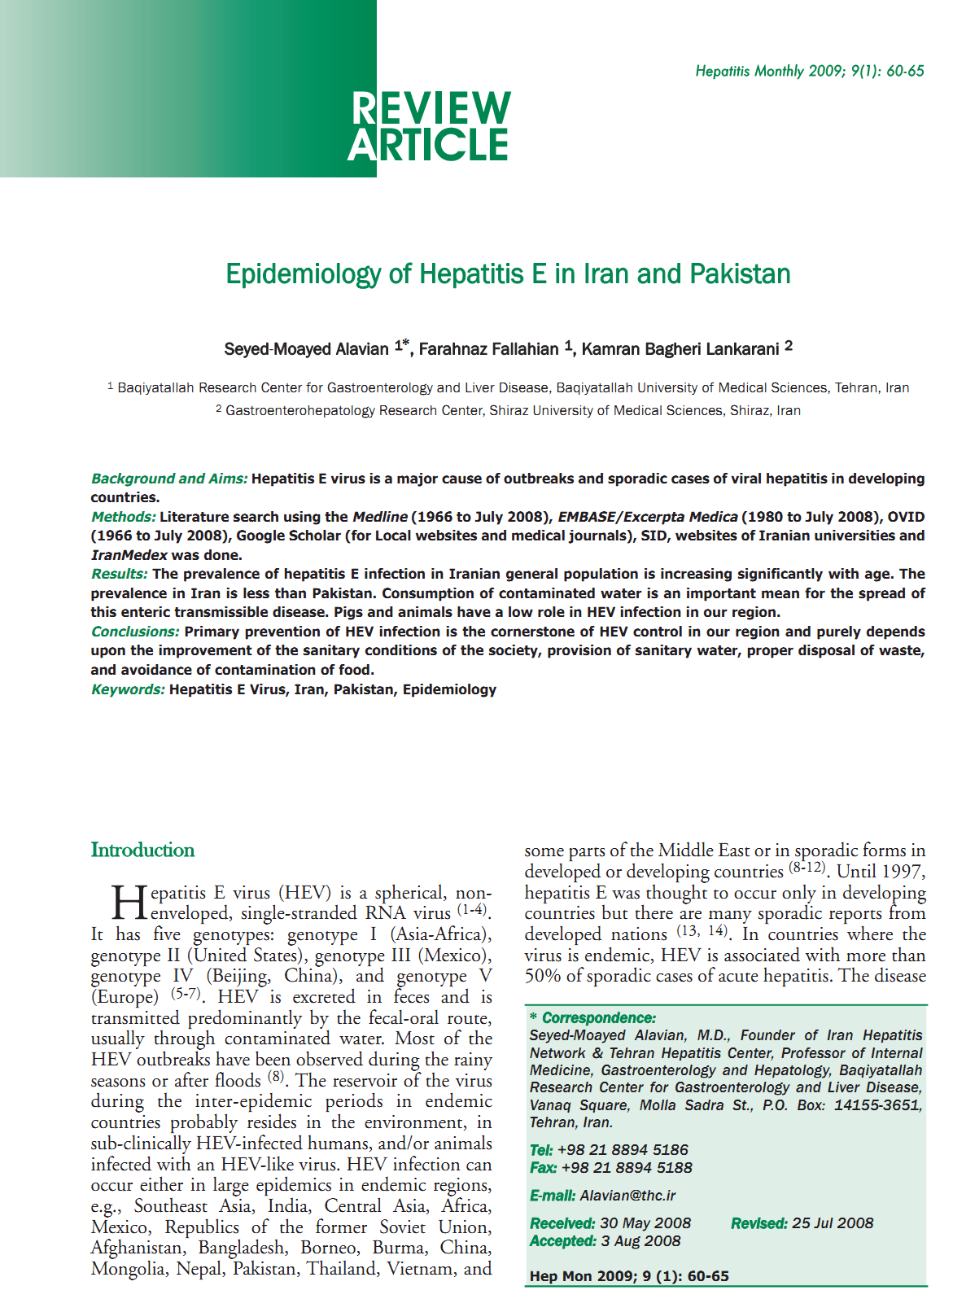

Alavian S-M. Hepatitis E Virus Infection: A Neglected Problem in Our Region. Hepat Mon 2007; 7(3): 119-121
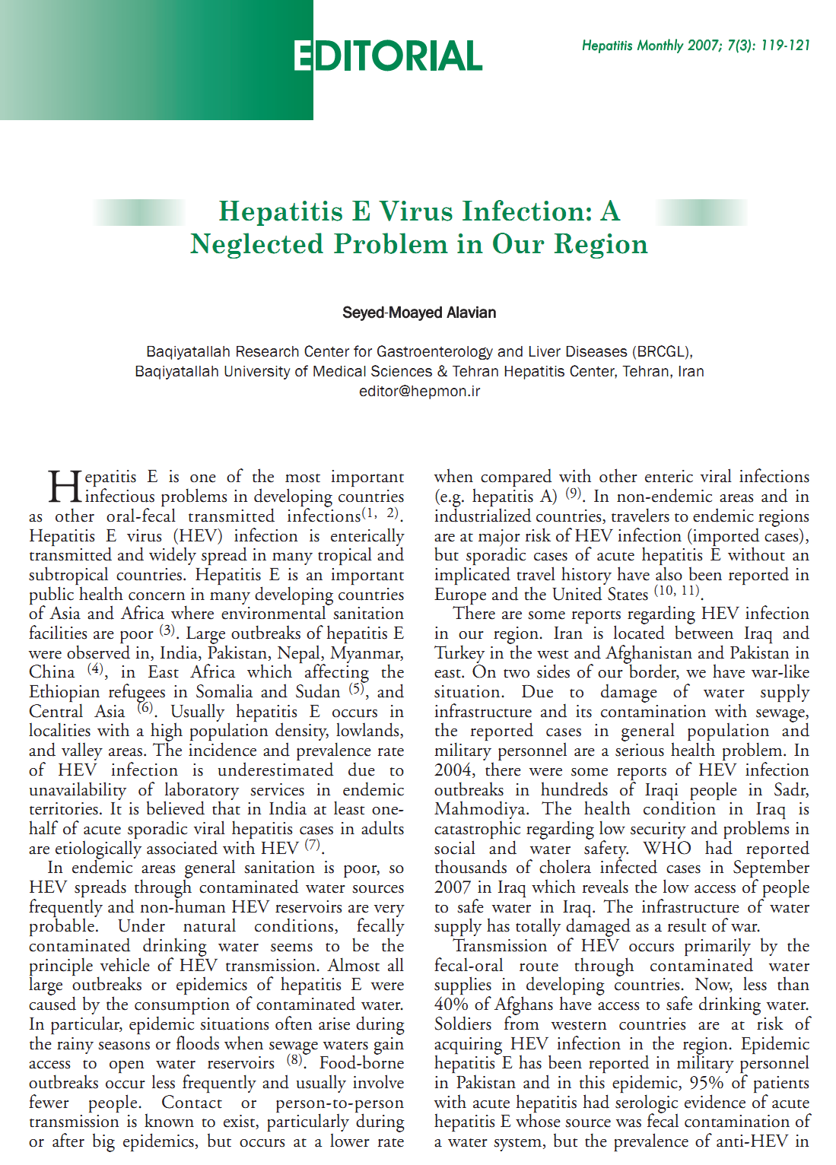

Hesamizadeh K, Sharafi H, Keyvani H, Alavian SM, Shabankareh AN-T, Olyaie RS, Keshvari M. Hepatitis A Virus and Hepatitis E Virus Seroprevalence Among Blood Donors in Tehran, Iran. Hepat Mon 2016; 16(1): e32215 [DOI: 10.5812/hepatmon.32215]
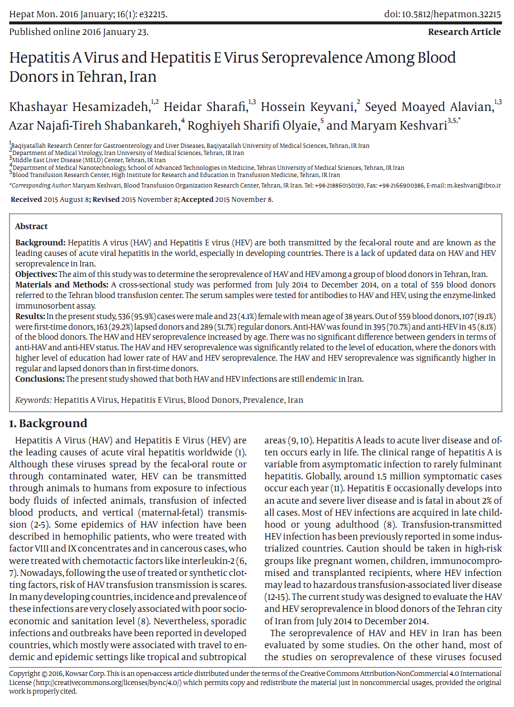

Keyvani H, Shamsi Shahrabadi M, Najafifard S, Hajibeigi B, Fallahian F, Alavian S. Seroprevalence of anti-HEV and HEV RNA among volunteer blood donors and patients with Hepatitis B and C in Iran. Bangladesh Liver Journal 2009; 1(1): 34-37
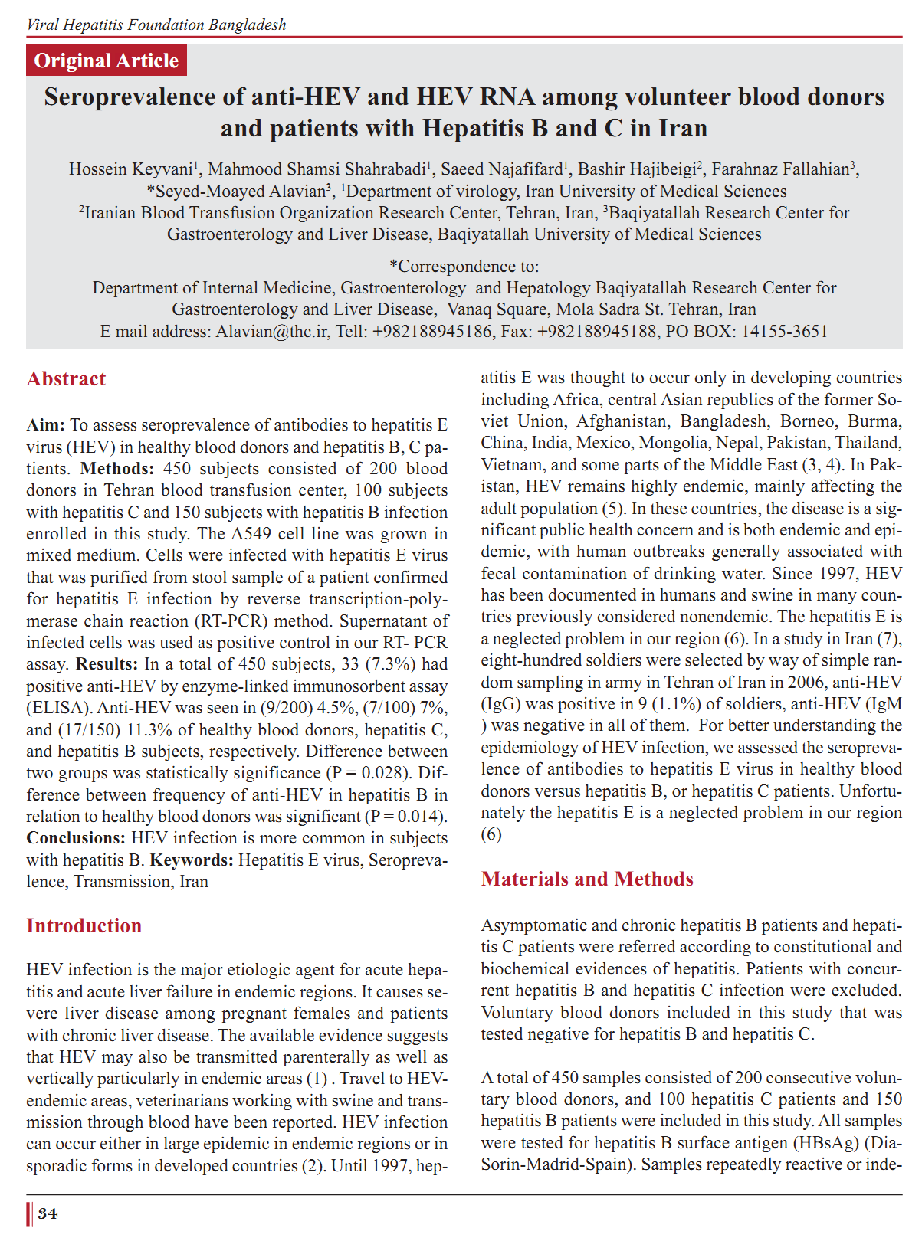

Arabzadeh S, Zahedi M, Mollaei H, Aghaie-Afshar A. Seroepidemiology of Anti-HEV IgG in Healthy Men Blood Donors in Kerman, 2007-2008. Iran J virol 2009; 3(1): 33-35
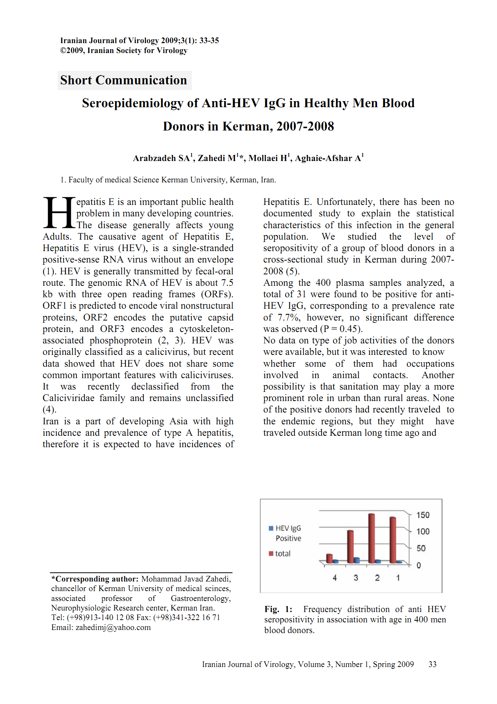

Aminiafshar S, Alimagham M, Gachkar L, Yousefi F, Attarchi Z. Anti hepatitis E virus seropositivity in a group of blood donors. Iranian J Publ Health 2004; 33(4): 53-56
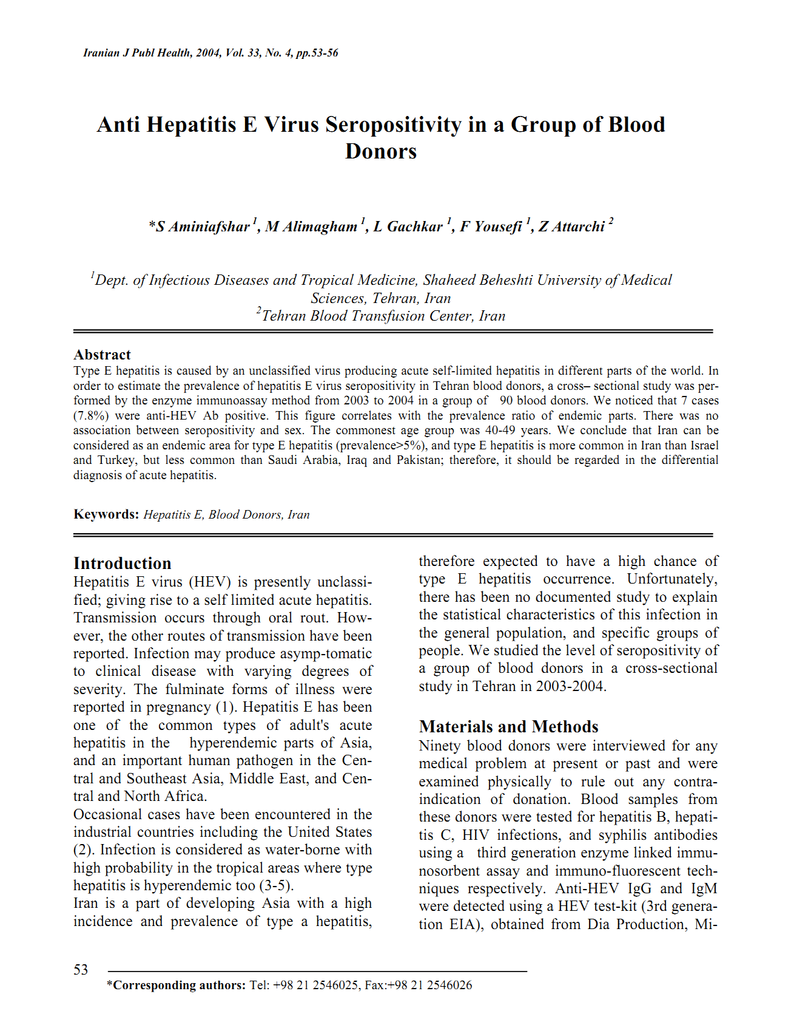

Karimi Elizee P, Alavian SM, Miri SM, Behnava B, Alavian SH, Keshvari M, Gholami Fesharaki M, Salimi S, Mehrnoush L, Shafiei M. The seroprevalence of entrically transmitted viral hepatitis in HCV infected thalassemia and hemophilia patients in Iran. Jundishapur J Microbiol 2013; 6(7): e9091 [DOI: 10.5812/ijem.9091 ]
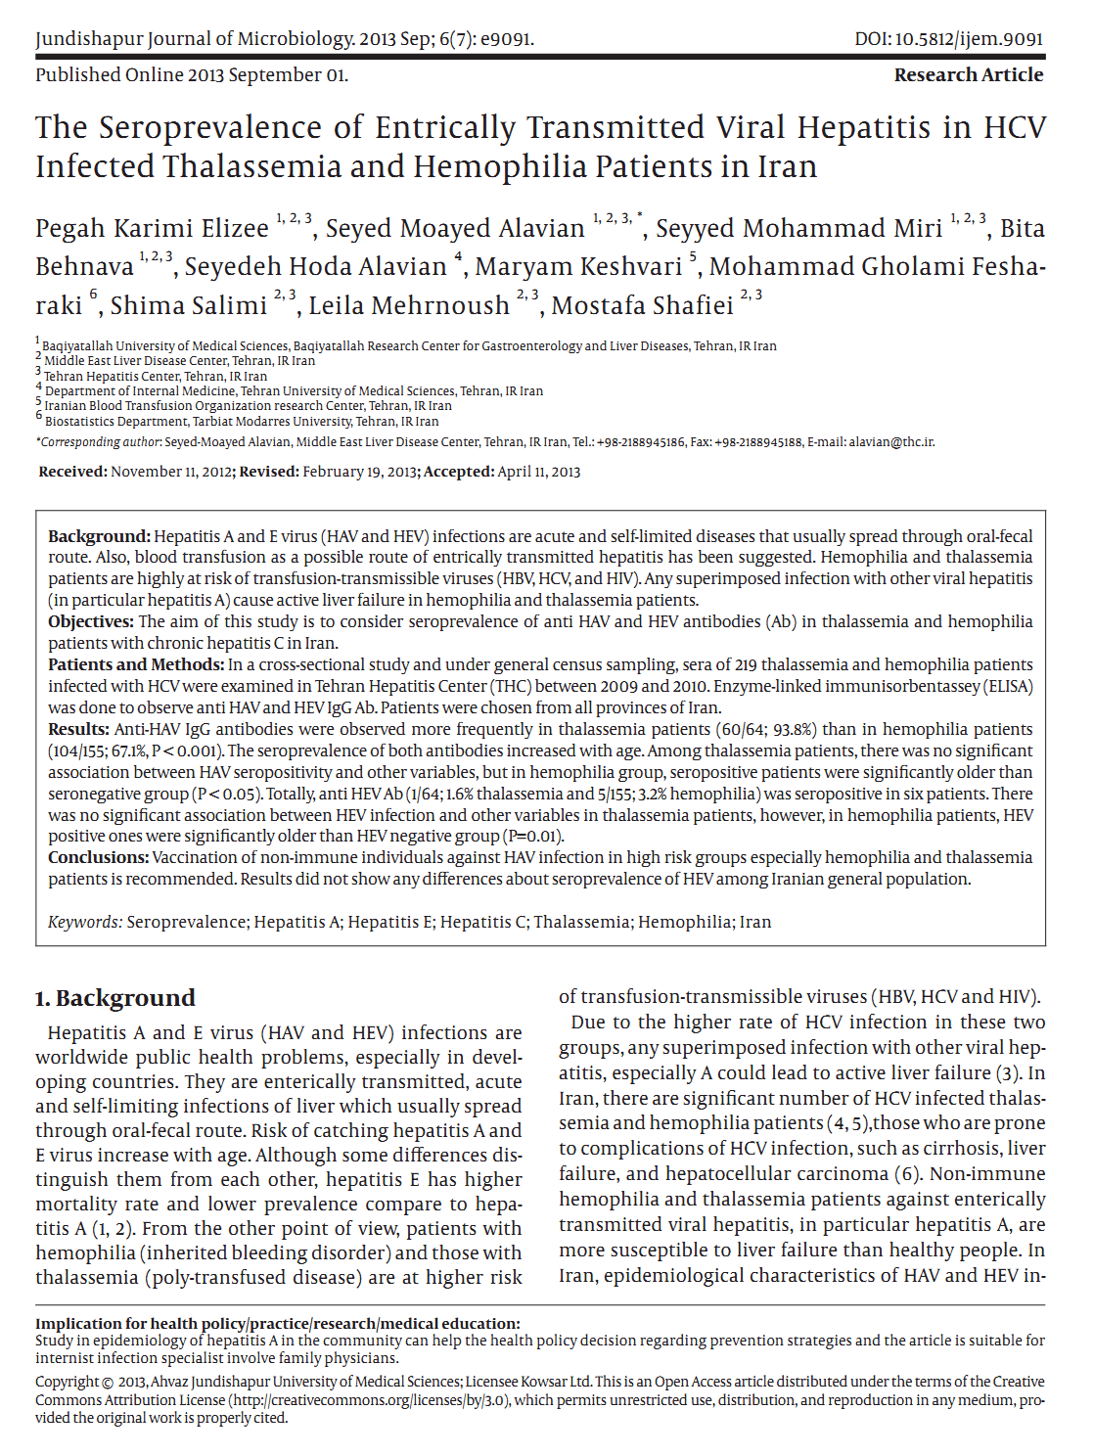
Alavi SM, Ahmadi F, Ghasemirad MR. Seroepidemiological study of hepatitis E virus in drug addicts in Ahvaz, Southern Iran: 2005-2006. Hepat Mon 2008; 8(4): 263-266
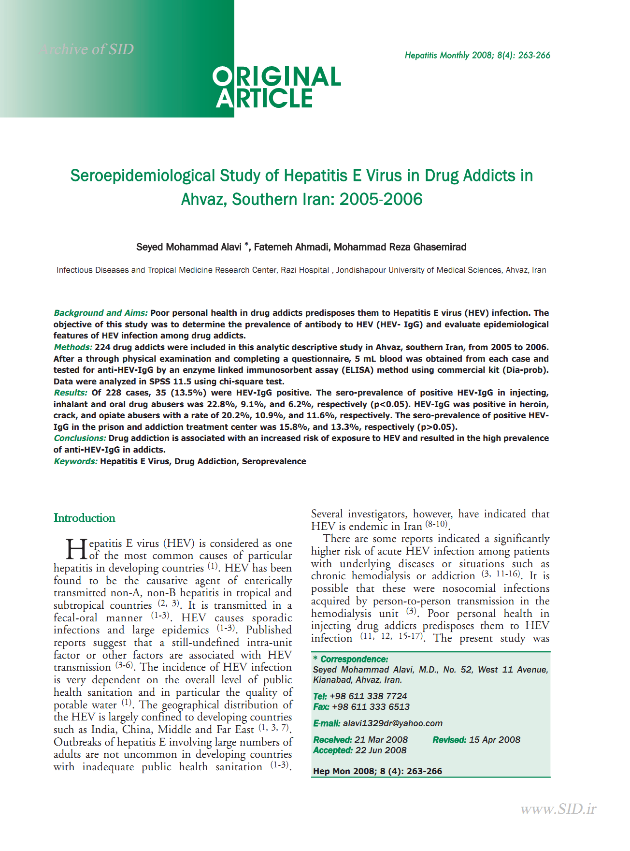
Keramat F, Mamani M, Samadi M, Mohammadnezhad S, Eini P, Moradi A. Seroprevalence of Hepatitis E Virus Among Injection Drug Users and Non-Injection Drug Users in Hamadan, West of Iran. Avicenna J Clin Microb Infec 2014; 1(3): e22343 [DOI: 10.17795/ajcmi-22343]
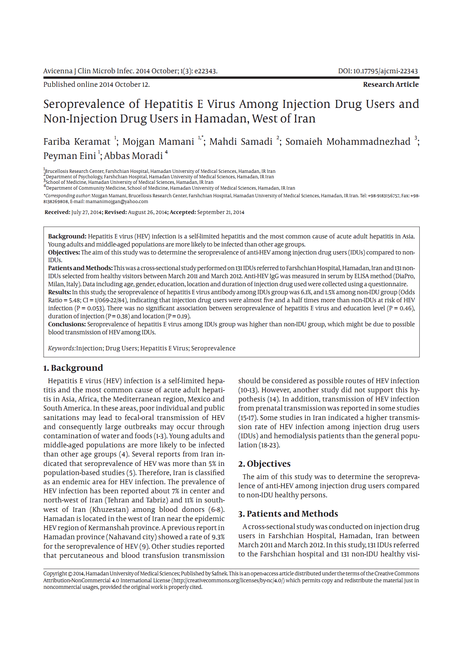
Pourahmad M, Sotoodeh AR, Nasiri H. Hepatitis E virus infection in hemodialysis patients: a seroepidemiological survey in Jahrom, Southern Iran. Hepat Month 2009; 9(3): 232-235
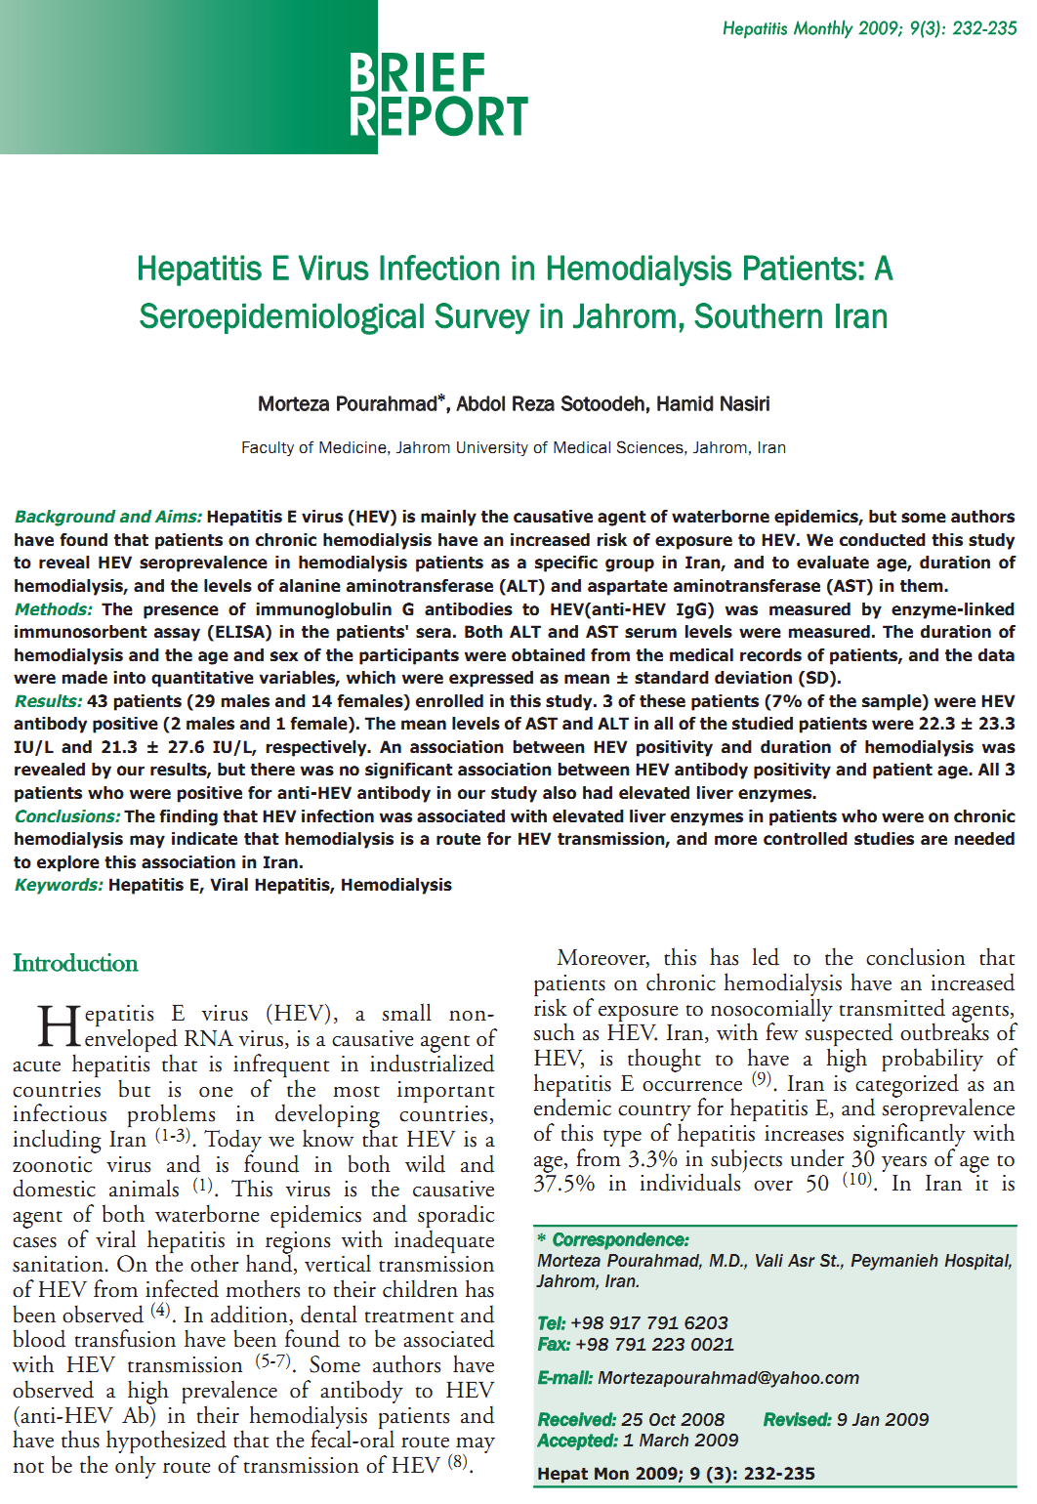

Zaki MES, Abdelsalam M, Anbar NH, El-deek BS. Prevalence of Hepatitis E Virus among Hemodialysis Patients: One Egyptian Center Study. IJHSR 2015; 5(4): 65-72
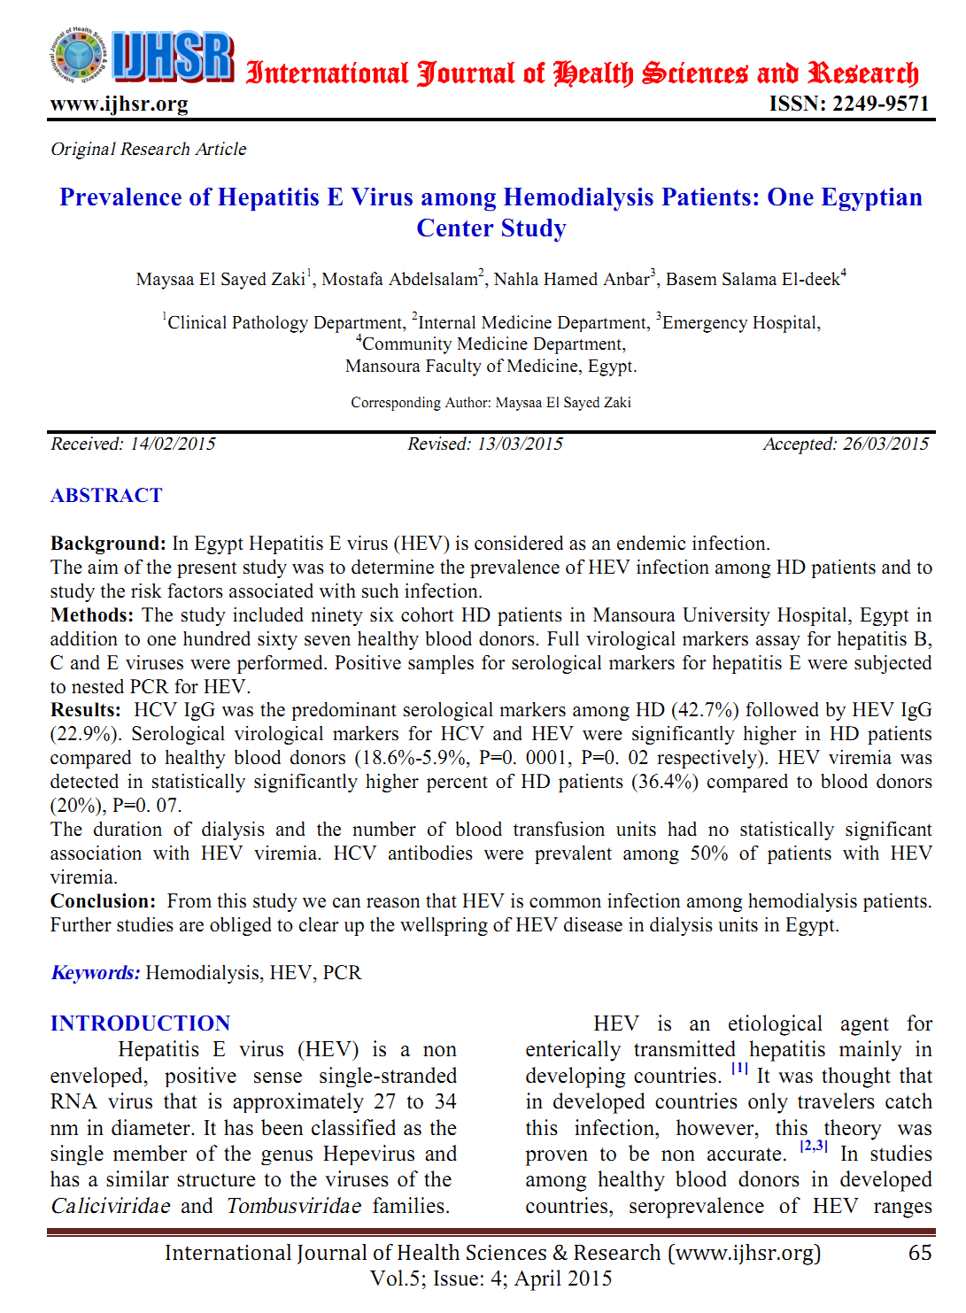

Somi MH, Farhang S, Majidi G, Shavakhi A, Pouri A-A. Seroprevalence of hepatitis E in patients with chronic liver disease from East Azerbaijan, Iran. Hep Mon 2007; 7(3): 127-130
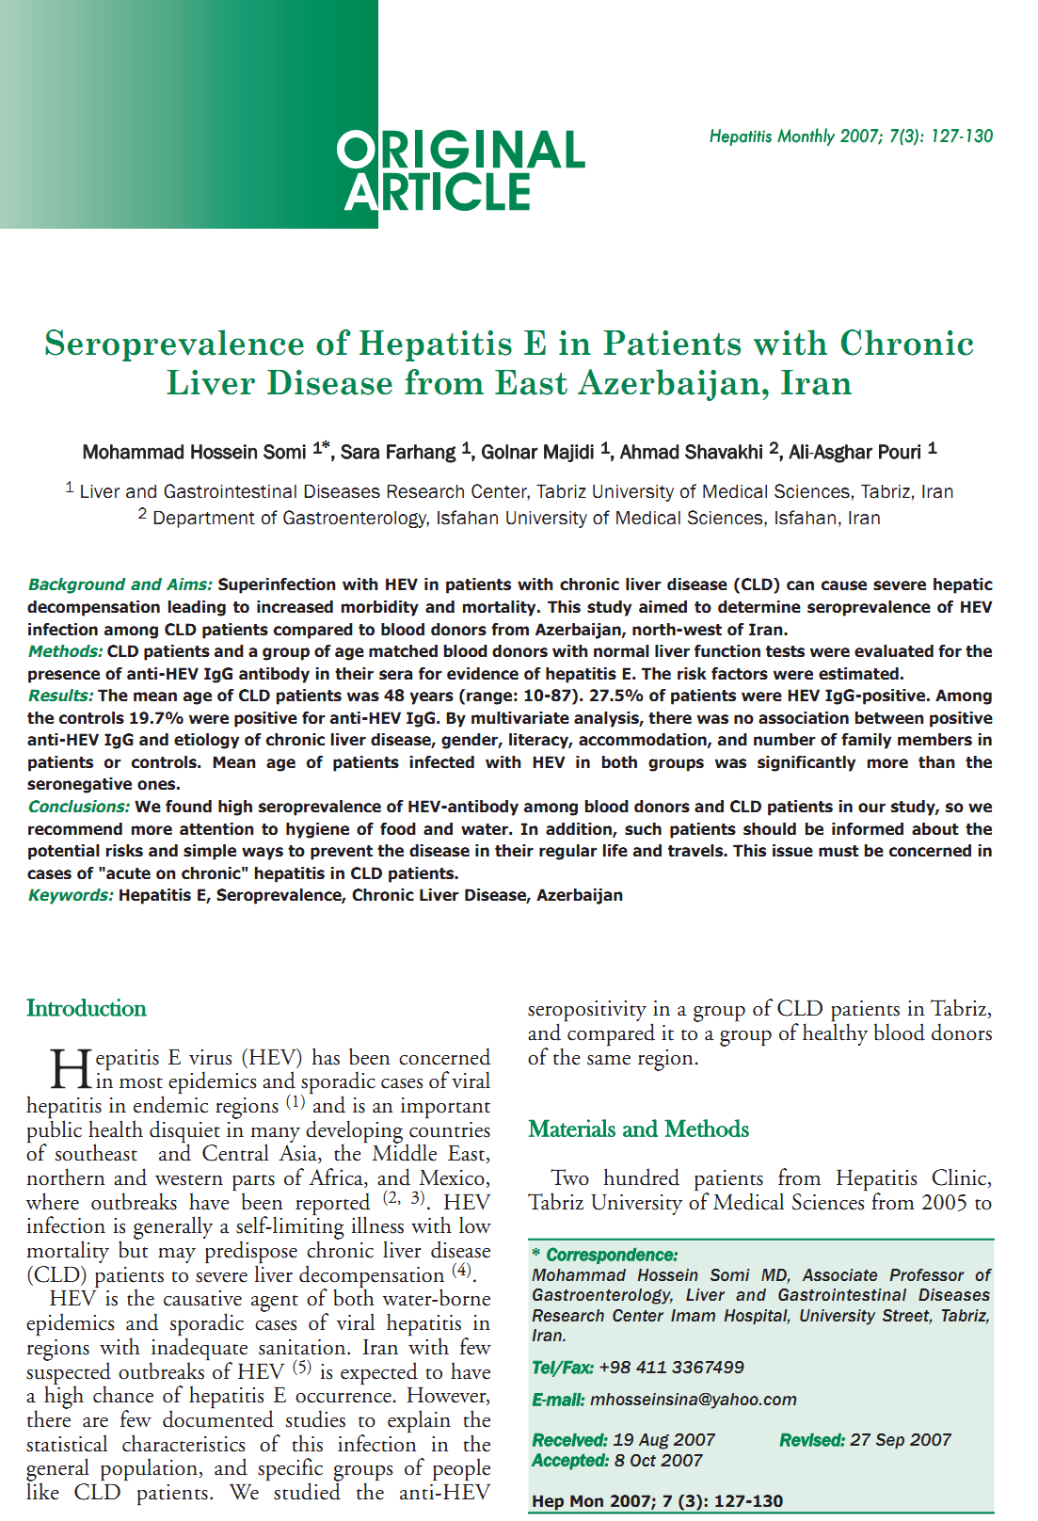

Singh A, Singh S, Ansari MA, Irshad M. Co-infectivity of hepatitis B virus and hepatitis E virus. BMC Infect Dis 2012; 12(Suppl 1): P1 [DOI: 10.1097/INF.0b013e318273599c]
