Name of Journal: World Journal of Clinical Cases
Manuscript NO: 61187
Manuscript Type: CASE REPORT

Restenosis of a drug eluting stent on the previous bioresorbable vascular scaffold successfully treated with a drug-coated balloon: A case report

Jang HG. et al. Restenosis of DES on the BVS

Hyun Gyung Jang, Kyehwan Kim, Hyun Woong Park, Jin-Sin Koh, Young-Hoon Jeong, Jeong Rang Park, Min Gyu Kang

Hyun Gyung Jang, Kyehwan Kim, Hyun Woong Park, Jin-Sin Koh, Jeong Rang Park, Min Gyu Kang, Department of Internal Medicine, Gyeongsang National University of Medicine and Gyeongsang National University Hospital, Jinju KS011, South Korea

Young-Hoon Jeong, Department of Internal Medicine, Gyeongsang National University School of Medicine, CHangwon 51472, Gyeongsangnam-do, South Korea

Young-Hoon Jeong, Cardiovascular Center, Gyeongsang National University Changwon Hospital, CHangwon 51472, Gyeongsangnam-do, South Korea

Author contributions: Kang MG were the patient’s interventional cardiologist, reviewed the literature and contributed to manuscript drafting; Jang HG reviewed the literature and contributed to manuscript drafting; Kim K and Park HW performed the interpretation of coronary imaging modality and contributed to manuscript drafting; Koh JS and Park JR analyzed and interpreted the imaging findings; Jeong YH performed the pharmacologic strategy for coronary artery diseases consultation, reviewed the literature and drafted the manuscript; Kang MG and Jang HG were responsible for the revision of the manuscript for important intellectual content; all authors issued final approval for the version to be submitted.

Corresponding author: Min Gyu Kang, PhD, Associate Professor, Department of Internal Medicine, Gyeongsang National University of Medicine and Gyeongsang National University Hospital, 11 Samjeongja-ro, Jinju KS011, South Korea. med2floyd@naver.com

Received: November 27, 2020
Revised: December 22, 2020
Accepted: December 30, 2020
Published online: January 26, 2021

Abstract
BACKGROUND
The in-stent restenosis (ISR) rates are reportedly inconsistent despite the increased use of second-generation drug eluting stent (DES). Although bioresorbable vascular scaffold (BVS) have substantial advantages with respect to vascular restoration, the rate of scaffold thrombosis is higher with BVS than with DES. Optimal treatment strategies have not been established for DES-ISR to date.

CASE SUMMARY
We report on a case of a 60-year-old man patient with acute coronary syndrome. He had a history of ST-segment elevation myocardial infarction associated with very late scaffold thrombosis and treated with a DES. Coronary angiography revealed significant stenosis, suggesting DES-ISR on the previous BVS. Optical coherence tomography (OCT) identified a plaque rupture and a disrupted scaffold strut in the neointimal proliferation of DES. To treat the DES-ISR on the previous BVS, we opted for a drug-coated balloon (DCB) after a balloon angioplasty using a semi-compliant and non-compliant balloon. The patient did not experience adverse cardiovascular events on using a DCB following the use of intensive dual antiplatelet therapy and statin for 24 mo.

CONCLUSION
This case highlights the importance of OCT as an imaging modality for characterizing the mechanism of target lesion failure. The use of a DCB following the administration of optimal pharmacologic therapy may be an optimal strategy for the treatment and prevention of recurrent BVS thrombosis and DES-ISR.

Key Words: Bioresorbable vascular scaffold thrombosis; In-stent restenosis; Drug-coated balloon; Optical coherence tomography; Intensive dual antiplatelet therapy; Case report

©The Author(s) 2021. Published by Baishideng Publishing Group Inc. All rights reserved.

Citation: Jang HG, Kim K, Park HW, Koh JS, Jeong YH, Park JR, Kang MG. Restenosis of a drug eluting stent on the previous bioresorbable vascular scaffold successfully treated with a drug-coated balloon: A case report. World J Clin Cases 2021; 9(3): 758-763
URL: https://www.wjgnet.com/2307-8960/full/v9/i3/758.htm
DOI: https://dx.doi.org/10.12998/wjcc.v9.i3.758

Core Tip: In-stent restenosis still poses a limitation of percutaneous coronary intervention and bioresorbable vascular scaffold are associated with a high rate of target lesion revascularization We present herein, a rare case of restenosis of a drug eluting stent on the previous bioresorbable vascular scaffold. Optical coherence tomography is an instrumental imaging modality for identifying the mechanisms underlying target lesion failure. Drug-coated balloon following the administration of optimal pharmacologic therapy may be an optimal strategy for the treatment and prevention of recurrent target lesion failure.

INTRODUCTION
Although percutaneous coronary intervention (PCI) with drug eluting stent (DES) is the standard of care for the treatment of coronary artery stenosis, in-stent restenosis (ISR) still poses a limitation^{[1]}. Optimal treatment strategies for DES-ISR have not been established to date^{[2]}. Bioresorbable vascular scaffold (BVS) have substantial advantages with respect to vascular restoration^{[3,4]}. However, BVS are associated with a high rate of target lesion revascularization (TLR)^{[5]} .Optical coherence tomography (OCT) is an instrumental imaging modality for identifying the mechanisms underlying target lesion failure (TLF), especially in cases involving BVS. Here, we present a case of acute coronary syndrome (ACS) caused due to DES-ISR on the previous BVS. To the best our knowledge, this is the first report on ACS caused by restenosis of a second-generation DES on the previous BVS. Patient has provided informed consent for publication of the case.

CASE PRESENTATION
Chief complaints
A 60-year-old man was referred to the emergency room with a complaint of chest pain.

History of present illness
Patient’s symptoms started a 3 d ago with recurrent episodes during exertion, which had been worsened the last 1 h.

History of past illness
He had a history of unstable angina treated with a BVS (3.5 mm × 18 mm Absorb GT1 everolimus-eluting bioresorbable scaffold, Abbott Vascular, Santa Clara, CA, United States) in the proximal left anterior descending artery (LAD) 36 mo prior to the current presentation (Figure 1). Twenty months ago, he was diagnosed with ST-segment elevation myocardial infarction associated with very late scaffold thrombosis (Figure 2A). A red thrombus associated with disruption of the scaffold strut was identified on OCT (Dragonfly, St. Jude Medical, St. Paul, MN, United States; (Figure 2B). We treated the patient with a DES (3.5 mm × 33 mm XIENCE everolimus-eluting stent, Abbott Vascular, Santa Clara, CA, United States), covering the whole segment of the previous scaffold (Figure 2C and D).

Physical examination
The patient’s blood pressure was 130/80 mmHg, heart rate was 66 bpm, respiratory rate was 14 breaths per minute, temperature was 36.8 °C, and oxygen saturation in room air was 98%.

Laboratory examinations
Baseline electrocardiography showed Q waves in precordial leads and blood test including cardiac enzymes were normal.

Imaging examinations
Coronary angiography (CAG) revealed tight stenosis (diameter > 90%) of the proximal LAD, suggesting DES-ISR on the previous BVS (Figure 3A). OCT indicated plaque rupture and a disrupted scaffold strut in the neointimal proliferation of DES (Figure 3B).

FINAL DIAGNOSIS
The final diagnosis of the presented case is unstable angina associated with restenosis of a DES on the previous BVS.

TREATMENT
We performed a balloon angioplasty using a 2.5 mm × 20 mm semi-compliant balloon and a 3.0 mm × 12 mm non-compliant balloon to treat the DES-ISR on the previous BVS. We opted for a drug-coated balloon (DCB) rather than a DES. After placement of the DCB (3.5 mm × 26 mm SeQuent Please paclitaxel-eluting balloon, B. Braun, Melsungen, Germany) at 16 atm (up to diameter 4.0 mm, for 60 min), CAG revealed an acceptable residual stenosis of < 10% (Figure 3C). OCT showed achievement of optimal luminal gain (minimal/mean lumen diameter, 3.25/3.45 mm, minimal lumen area, 9.45 mm², Figure 3D). He was discharged on the day after the procedure and was prescribed 90 mg ticagrelor twice daily, 100 mg aspirin daily, and 20 mg rosuvastatin daily.

OUTCOME AND FOLLOW-UP
The patient had an uneventful clinical course for 24 mo. At 12 mo follow-up, we deescalated to 60 mg ticagrelor twice daily.

DISCUSSION
We report a case of ACS caused by restenosis of a second-generation DES on the previous BVS. The patient did not experience adverse cardiovascular events on using a DCB following the use of intensive dual antiplatelet therapy (DAPT) and statin for 12 mo.
In patients with coronary artery stenosis who receive a metallic DES, adverse events, such as late TLF may be related, in part, to the persistent presence of the metallic stent frame in the coronary vessel wall^{[3]} .Theoretically, the use of a BVS was considered a promising treatment for coronary artery disease associated with a favorable tissue response^{[4]}. However, the cumulative 5-year adverse event rates were higher in patients with a BVS than in those with DESs; thus, restricted use of BVSs was noted in current clinical practice^{[5]}.
Recent real-world long-term data reported that lesion complexity and more pronounced cardiovascular risk factors were the determinants of TLF of BVS^{[6]}. In this case, very late scaffold thrombosis was associated with peri-strut low-intensity area and strut discontinuity^{[7]}. We used the DES to cover the entire segment of the previous scaffold, following the administration of continuous intensive DAPT with ticagrelor and aspirin. Unfortunately, the patient experienced an emergent revascularization after the procedure, and we performed OCT-guided PCI using a DCB.
In contemporary clinical practice, the management of ISR remains challenging. When selecting a treatment strategy for ISR, the specific advantages and disadvantages of DESs and DCBs should be carefully weighed. Although the use of a DES resulted in superior late angiographic findings in the treatment of ISR^{[8]}, repeat implantation of a DES remains, arguably, the most widely used treatment strategy. The use of a DCB for ISR is an effective treatment option; additional stent implantation is hence, not required and the outcomes are similar with those noted with TLR^{[9]}. Thus, the use of a DCB can be an attractive treatment option for patients with recurrent stent or scaffold failure.
To best our knowledge, this case report of ACS by restenosis of second-generation DES on the prior BVS is the earliest in the literature. In this case, the structural deformities associated with the previous BVS such as, disruption of the scaffold strut, were identified as a risk factor for TLF. Hence, tailored strategies involving imaging-guided PCI following intensive medical treatment are necessary to prevent thrombosis and neo-atherosclerosis after the implantation of a BVS and DES^{[10-12]}. To the best of our knowledge, the presented case is the first in the literature describing the evolution of ACS associated with restenosis of a DES on the previous BVS.

CONCLUSION
This case highlights the importance of OCT as an imaging modality for characterizing the mechanism of target lesion failure. The use of a DCB following the administration of optimal pharmacologic therapy may be an optimal strategy for the treatment and prevention of recurrent BVS thrombosis and DES-ISR.

REFERENCES
1 Dangas GD, Claessen BE, Caixeta A, Sanidas EA, Mintz GS, Mehran R. In-stent restenosis in the drug-eluting stent era. J Am Coll Cardiol 2010; 56: 1897-1907 [PMID: 21109112 DOI: 10.1016/j.jacc.2010.07.028]
2 Siontis GC, Stefanini GG, Mavridis D, Siontis KC, Alfonso F, Pérez-Vizcayno MJ, Byrne RA, Kastrati A, Meier B, Salanti G, Jüni P, Windecker S. Percutaneous coronary interventional strategies for treatment of in-stent restenosis: a network meta-analysis. Lancet 2015; 386: 655-664 [PMID: 26334160 DOI: 10.1016/S0140-6736(15)60657-2]
3 Ellis SG, Kereiakes DJ, Metzger DC, Caputo RP, Rizik DG, Teirstein PS, Litt MR, Kini A, Kabour A, Marx SO, Popma JJ, McGreevy R, Zhang Z, Simonton C, Stone GW; ABSORB III Investigators. Everolimus-Eluting Bioresorbable Scaffolds for Coronary Artery Disease. N Engl J Med 2015; 373: 1905-1915 [PMID: 26457558 DOI: 10.1056/NEJMoa1509038]
4 Karanasos A, Simsek C, Gnanadesigan M, van Ditzhuijzen NS, Freire R, Dijkstra J, Tu S, Van Mieghem N, van Soest G, de Jaegere P, Serruys PW, Zijlstra F, van Geuns RJ, Regar E. OCT assessment of the long-term vascular healing response 5 years after everolimus-eluting bioresorbable vascular scaffold. J Am Coll Cardiol 2014; 64: 2343-2356 [PMID: 25465421 DOI: 10.1016/j.jacc.2014.09.029]
5 Kereiakes DJ, Ellis SG, Metzger DC, Caputo RP, Rizik DG, Teirstein PS, Litt MR, Kini A, Kabour A, Marx SO, Popma JJ, Tan SH, Ediebah DE, Simonton C, Stone GW; ABSORB III Investigators. Clinical Outcomes Before and After Complete Everolimus-Eluting Bioresorbable Scaffold Resorption: Five-Year Follow-Up From the ABSORB III Trial. Circulation 2019; 140: 1895-1903 [PMID: 31553222 DOI: 10.1161/CIRCULATIONAHA.119.042584]
6 Wiebe J, Baquet M, Dörr O, Hoppmann P, Jochheim D, Rheude T, Boeder N, Grundman D, Blachutzik F, Theiss H, Cassese S, Hofmann FJ, Gschwendtner S, Elsässer A, Massberg S, Hamm C, Laugwitz KL, Byrne RA, Mehilli J, Kastrati A, Nef H. Long-term follow-up and predictors of target lesion failure after implantation of everolimus-eluting bioresorbable scaffolds in real-world practice. Int J Cardiol 2020; 312: 42-47 [PMID: 32151443 DOI: 10.1016/j.ijcard.2020.02.062]
7 Cuculi F, Puricel S, Jamshidi P, Valentin J, Kallinikou Z, Toggweiler S, Weissner M, Münzel T, Cook S, Gori T. Optical Coherence Tomography Findings in Bioresorbable Vascular Scaffolds Thrombosis. Circ Cardiovasc Interv 2015; 8: e002518 [PMID: 26399265 DOI: 10.1161/CIRCINTERVENTIONS.114.002518]
8 Alfonso F, Pérez-Vizcayno MJ, Cárdenas A, García del Blanco B, García-Touchard A, López-Minguéz JR, Benedicto A, Masotti M, Zueco J, Iñiguez A, Velázquez M, Moreno R, Mainar V, Domínguez A, Pomar F, Melgares R, Rivero F, Jiménez-Quevedo P, Gonzalo N, Fernández C, Macaya C; RIBS IV Study Investigators (under auspices of Interventional Cardiology Working Group of Spanish Society of Cardiology). A Prospective Randomized Trial of Drug-Eluting Balloons Versus Everolimus-Eluting Stents in Patients With In-Stent Restenosis of Drug-Eluting Stents: The RIBS IV Randomized Clinical Trial. J Am Coll Cardiol 2015; 66: 23-33 [PMID: 26139054 DOI: 10.1016/j.jacc.2015.04.063]
9 Baan J Jr, Claessen BE, Dijk KB, Vendrik J, van der Schaaf RJ, Meuwissen M, van Royen N, Gosselink ATM, van Wely MH, Dirkali A, Arkenbout EK, de Winter RJ, Koch KT, Sjauw KD, Beijk MA, Vis MM, Wykrzykowska JJ, Piek JJ, Tijssen JGP, Henriques JPS. A Randomized Comparison of Paclitaxel-Eluting Balloon Versus Everolimus-Eluting Stent for the Treatment of Any In-Stent Restenosis: The DARE Trial. JACC Cardiovasc Interv 2018; 11: 275-283 [PMID: 29413242 DOI: 10.1016/j.jcin.2017.10.024]
10 Moriyama N, Shishido K, Tanaka Y, Yokota S, Hayashi T, Miyashita H, Koike T, Yokoyama H, Takada T, Nishimoto T, Ochiai T, Tobita K, Yamanaka F, Mizuno S, Murakami M, Takahashi S, Saito S. Neoatherosclerosis 5 Years After Bioresorbable Vascular Scaffold Implantation. J Am Coll Cardiol 2018; 71: 1882-1893 [PMID: 29699614 DOI: 10.1016/j.jacc.2018.02.051]
11 Wallentin L, Becker RC, Budaj A, Cannon CP, Emanuelsson H, Held C, Horrow J, Husted S, James S, Katus H, Mahaffey KW, Scirica BM, Skene A, Steg PG, Storey RF, Harrington RA; PLATO Investigators, Freij A, Thorsén M. Ticagrelor versus clopidogrel in patients with acute coronary syndromes. N Engl J Med 2009; 361: 1045-1057 [PMID: 19717846 DOI: 10.1056/NEJMoa0904327]
12 Gili S, Iannaccone M, Colombo F, Montefusco A, Amabile N, Calcagno S, Capodanno D, Scalone G, Rognoni A, Omedè P, Ugo F, Cavallo E, Mancone M, Mangiameli A, Boccuzzi G, Hiansen J, Motreff P, Toutouzas K, Garbo R, Sardella G, Tamburino C, D'Amico M, Moretti C, Templin C, Gaita F, Souteyrand G, Niccoli G, D'Ascenzo F. Effects of statins on plaque rupture assessed by optical coherence tomography in patients presenting with acute coronary syndromes: insights from the optical coherence tomography (OCT)-FORMIDABLE registry. Eur Heart J Cardiovasc Imaging 2018; 19: 524-531 [PMID: 28605473 DOI: 10.1093/ehjci/jex102]

Footnotes
Informed consent statement: Informed written consent was obtained from the patient for publication of this report and any accompanying images.

Conflict-of-interest statement: The authors declare that they have no conflict of interest.

CARE Checklist (2016) statement: The authors have read the CARE Checklist (2016), and the manuscript was prepared and revised according to the CARE Checklist (2016).

Open-Access: This article is an open-access article that was selected by an in-house editor and fully peer-reviewed by external reviewers. It is distributed in accordance with the Creative Commons Attribution NonCommercial (CC BY-NC 4.0) license, which permits others to distribute, remix, adapt, build upon this work non-commercially, and license their derivative works on different terms, provided the original work is properly cited and the use is non-commercial. See: http://creativecommons.org/Licenses/by-nc/4.0/

Manuscript source: Unsolicited manuscript

Peer-review started: November 27, 2020
First decision: December 21, 2020
Article in press: December 30, 2020

Specialty type: Medicine, research and experimental
Country/Territory of origin: South Korea
Peer-review report’s scientific quality classification
Grade A (Excellent): 0
Grade B (Very good): B
Grade C (Good): 0
Grade D (Fair): 0
Grade E (Poor): 0

P-Reviewer: Hussein A S-Editor: Fan JR L-Editor: A P-Editor: Li JH

Figure Legends
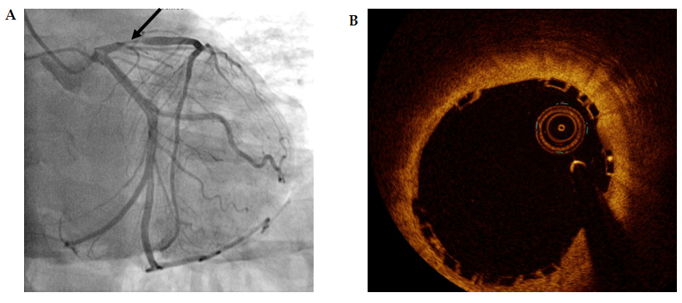
Figure 1 Index percutaneous coronary intervention performed 36 mo ago. A: Coronary angiography image showing significant stenosis in the proximal left anterior descending artery; B: Optical coherence tomography image showing optimal implantation of the bioresorbable vascular scaffold.

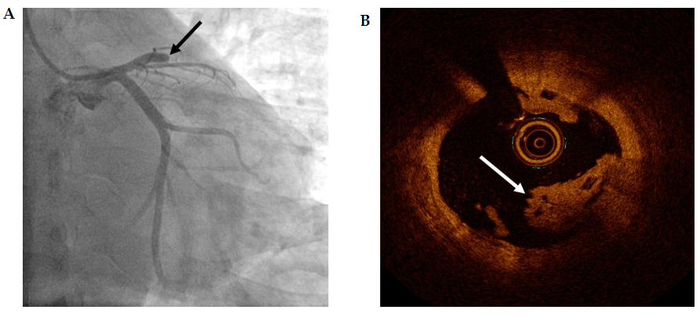
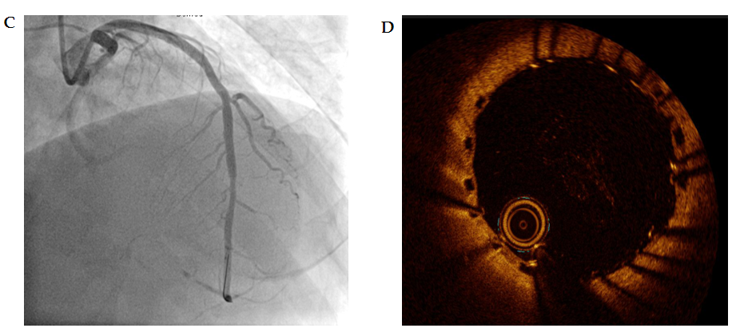
Figure 2 Very late scaffold thrombosis noted 20 mo ago. A: Coronary angiography image showing total occlusion of the proximal left anterior descending artery; B: Optical coherence tomography image showing a red thrombus associated with disruption of the scaffold strut; C: Revascularization was successfully performed with the drug eluting stent (DES) covering the whole segment of the previous scaffold; D: Optical coherence tomography image showing optimal implantation of the DES on the previous bioresorbable vascular scaffold.
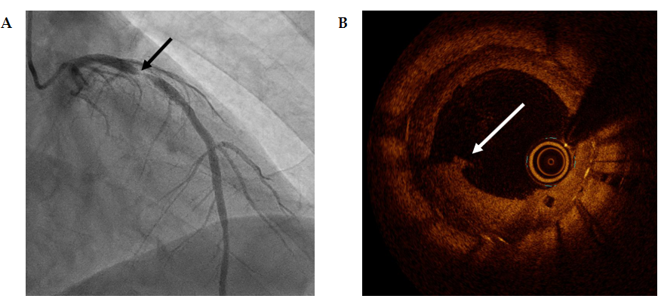
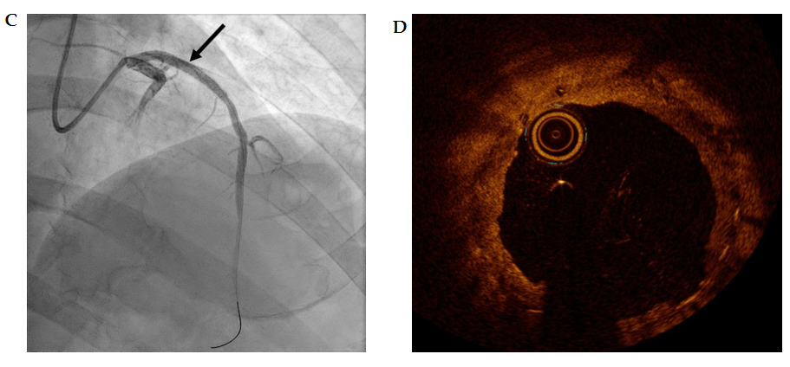
Figure 3 Restenosis of the drug eluting stent on the previous bioresorbable vascular Scaffold. A: Coronary angiography image showing significant stenosis in the proximal left anterior descending artery; B: Optical coherence tomography image showing plaque rupture and a disrupted scaffold strut in the neointimal proliferation of drug eluting stent; C: Angiography image showing optimal diameter gain by the drug-coated balloon; D: Optical coherence tomography image showing achievement of optimal luminal gain.

Published by Baishideng Publishing Group Inc
7041 Koll Center Parkway, Suite 160, Pleasanton, CA 94566, USA
Telephone: +1-925-3991568
E-mail: bpgoffice@wjgnet.com
Help Desk: https://www.f6publishing.com/helpdesk
https://www.wjgnet.com

© 2021 Baishideng Publishing Group Inc. All rights reserved.

