Name of Journal: World Journal of Orthopedics
Manuscript NO: 68673
Manuscript Type: MINIREVIEWS

Diagnosis, treatment and complications of radial head and neck fractures in the pediatric patient

Macken AA et al. Proximal radius fractures in children

Arno A Macken, Denise Eygendaal, Christiaan JA van Bergen

Arno A Macken, Christiaan JA van Bergen, Department of Orthopedic Surgery, Amphia Hospital, Breda 4818 CK, Noord-Brabant, Netherlands

Arno A Macken, Denise Eygendaal, Department of Orthopedic Surgery and Sports medicine, Erasmus Medical Centre, Rotterdam 3015 GD, South-Holland, Netherlands

Author contributions: van Bergen CJ coordinated the paper; Macken AA performed the literature search, wrote the initial manuscript, and prepared the tables and figures; All authors contributed to the conception and outline of the paper, and provided substantial contribution to writing, reviewing, editing, and approved the final manuscript.

Corresponding author: Christiaan JA van Bergen, MD, PhD, Surgeon, Department of Orthopedic Surgery, Amphia Hospital, Molengracht 21, Breda 4818 CK, Noord-Brabant, Netherlands. cvanbergen@amphia.nl

Received: May 30, 2021
Revised: August 11, 2021
Accepted: February 12, 2022
Published online: March 18, 2022

Abstract
Radial head and neck fractures represent up to 14% of all pediatric elbow fractures and can be a difficult challenge in the pediatric patient. In up to 39% of proximal radius fractures, there is a concomitant fracture, which can easily be overlooked on the initial standard radiographs. The treatment options for proximal radius fractures in children range from non-surgical treatment, such as immobilization alone and closed reduction followed by immobilization, to more invasive options, including closed reduction with percutaneous pinning and open reduction with internal fixation. The choice of treatment depends on the degree of angulation and displacement of the fracture and the age of the patient; an angulation of less than 30 degrees and translation of less than 50% is generally accepted, whereas a higher degree of displacement is considered an indication for surgical intervention. Fractures with limited displacement and non-surgical treatment generally result in superior outcomes in terms of patient-reported outcome measures, range of motion and complications compared to severely displaced fractures requiring surgical intervention. With proper management, good to excellent results are achieved in most cases, and long-term sequelae are rare. However, severe complications do occur, including radio-ulnar synostosis, osteonecrosis, rotational impairment, and premature physeal closure with a malformation of the radial head as a result, especially after more invasive procedures. Adequate follow-up is therefore warranted.

Key Words: Radial head; Proximal radius; Fracture; Pediatrics; Closed fracture reduction; Open reduction fracture; Fracture fixation; Synostosis; Osteonecrosis

©The Author(s) 2022. Published by Baishideng Publishing Group Inc. All rights reserved.

Citation: Macken AA, Eygendaal D, van Bergen CJ. Diagnosis, treatment and complications of radial head and neck fractures in the pediatric patient. World J Orthop 2022; 13(3): 238-249
URL: https://www.wjgnet.com/2218-5836/full/v13/i3/238.htm
DOI: https://dx.doi.org/10.5312/wjo.v13.i3.238

Core Tip: This article presents the latest evidence-based insights in pediatric proximal radius fractures. A stepwise progression of treatment is warranted, starting with closed reduction and immobilization, and progressing to more invasive measures in case of unsuccessful reduction. Open reduction with internal fixation is left as the last option due to the high risk of complications and inferior functional results.

INTRODUCTION
Radial head or neck fractures can be a difficult challenge in the pediatric patient. Limited data are published on the subject, and there is controversy surrounding the optimal treatment and expected results^{[1,2]}. This article aims to provide an overview of the currently available literature on the diagnosis, classification, treatment, outcomes and complications of proximal radius fractures in the pediatric patient.

Development and anatomy of the radial head and neck
Ossification of the radial head occurs between the ages of 3 years and 5 years, and the radial head fuses with the radial shaft between the ages of 14 years and 17 years^{[2,3]}. The epiphysis of the radial head is covered by the annular ligament, which lies in continuity with the joint capsule. The capsule extends to the proximal metaphysis. Therefore, part of the radial neck is localized outside of the joint capsule. The blood supply to the radial head enters through the metaphysis to retrogradely perfuse the radial head. The posterior interosseous nerve, which provides innervation to the digital extensor muscles, runs directly over the radial neck. The anatomic angle of the radial neck relative to the radial shaft is up to 15 degrees valgus and 10 degrees apex posterior^{[2]}. Knowledge of this anatomy is essential when evaluating a fracture and indicating the appropriate treatment.

Epidemiology of proximal radius fractures
Elbow fractures represent 10% of all fractures occurring in the pediatric population^{[4]}. Unlike in adults, proximal radius fractures are relatively rare, representing up to 14% of all pediatric elbow fractures^{[4,5]}. Radial head and neck fractures occur most frequently in children aged 7 years to 12 years^{[3,6]}. The majority of proximal radius fractures are radial neck fractures (89%), and these fractures occur more frequently in younger patients compared to radial head fractures^{[7]}. A concomitant fracture occurs in up to 39% of radial head or neck fractures, and can easily be missed on the initial interpretation of the radiographs^{[5,7]}.

Trauma mechanism
The most common trauma mechanism for radial head and neck fractures is valgus loading with the elbow in extension, such as a fall on an outstretched hand. The force through the lateral capitellum compresses the radial head, causing it to break at the weakest point, which is often the radial neck at the metaphysis. A second injury mechanism is a radial head dislocation, which is most commonly seen in relation to radial head fractures^{[4]}.

Clinical presentation
Children with a proximal radius fracture present with symptoms of pain and limited range of motion after a fall or other type of trauma. Patients generally refuse to move the affected elbow. In some cases, pain may be referred to the wrist. Physical examination shows swelling, and pain exacerbated by motion, particularly with attempted pronation and supination. There is tenderness on palpation of the proximal radius^{[2,8,9]}. Neurovascular examination should be performed, with specific consideration to the posterior interosseous nerve^{[10,11]}. Attention should also be paid to soft-tissue swelling to assess the rare risk of forearm compartment syndrome^{[12]}.

Concomitant injuries
A concomitant fracture is seen in up to 39% of cases^{[5,7]}. A retrospective study of 494 proximal radius fractures showed that 25% of the concomitant fractures were missed on the initial analysis of radiographs. In retrospect, 56% were visible, and 44% radiographically occult^{[7]}. A high index of suspicion of additional fractures is therefore required.
The most common concomitant injury is a fracture of the olecranon. Less common are ulnar metadiaphyseal fractures, ulnar fractures as part of a Monteggia fracture-dislocation and medial epicondyle fractures. Risk factors for concomitant fractures include joint effusion, young children, and complete or displaced proximal radius fractures^{[5,7]}. In addition to concomitant fractures, other injury patterns can accompany a proximal radius fracture, such as elbow dislocation or acute longitudinal radioulnar disruption (ALRUD or Essex-Lopresti injury). In general, fractures in the pediatric patient can be easily missed due to the unique characteristics of the pediatric bone and varying clinical presentation, with patients not always being able to clearly communicate their symptoms^{[13]}. Therefore, when assessing a child with a suspected fracture of the proximal radius, thorough examination of the wrist, shoulder and contralateral arm should be performed to exclude associated injuries.

Imaging
Conventional radiographs are used for the diagnosis and grading of radial head and neck fractures in the pediatric patient. Anteroposterior and lateral views are made. In case of a high clinical suspicion of a fracture, such as a positive fat pad sign, but no fracture on standard radiographical views, an additional radial head-capitellum (Greenspan) view can be made to allow for easier visualization of the radial head^{[14]}. Some studies have shown the effectiveness of the Greenspan view in identifying fractures which were occult on regular views, providing additional information in up to 21% of patients^{[14,15]}. However, other studies dispute the added value of this view reporting only one additionally identified fracture in 32 and 125 patients^{[16,17]}.
A bilateral radiograph of the wrist can be made to exclude additional injuries such as an ALRUD injury. Nondisplaced radial neck fractures can be difficult to detect and are often occult on the initial radiograph. Fat pad signs may aid in diagnosing a nondisplaced fracture in combination with high clinical suspicion (Figure 1)^{[18]}. However, since a part of the radial neck lies outside the joint capsule, joint effusion and fat pad signs may be absent in radial neck fractures. In these cases, a nondisplaced radial neck fracture is easily missed^{[7]}.
Imaging modalities other than plain radiographs play a less prominent role in the assessment of proximal radius fractures in children. Magnetic resonance imaging may be used to visualize the pre-ossified elbow in young children but is not routinely indicated. In addition, magnetic resonance imaging may be useful in assessment of ligamentous integrity in case of elbow instability, dislocation, or secondary instability after successful treatment of the fracture^{[2,19]}. Computed tomography may be used in planning operative fixation, specifically in cases of comminuted radial head fractures in older children and adolescents^{[2]}. However, in the majority of cases plain radiographs are sufficient.

Determining fracture displacement
Angulation and translation of the proximal radius fracture are essential in the choice of treatment. There are several ways to determine these two measures. A simple way to determine angulation is to draw a line perpendicular to the articular surface of the radial head and a line through the center of the radial shaft, the angle is measured at the intersection of the lines (Figure 2A). Angulation should be measured using the radiograph that shows the greatest abnormality^{[2]}. For the translation of the fracture, the percentage of the uncovered radial metaphysis is divided by the total width of the metaphysis. Alternatively, the distance in millimeters from the center of the proximal part to the center of the distal part of the radius can be measured (Figure 2B)^{[2]}.

Classification
Several classification systems of proximal radius fractures using conventional radiographs are available. Commonly used are the Judet classification, Metaizeau's modification of the Judet classification, and the O'Brien classification (Table 1, Figure 3)^{[20-22]}. These classifications are useful for the choice of treatment.

Treatment and outcome
The treatment options for proximal radius fractures in the pediatric patient range from conservative measures, such as immobilization alone and closed reduction followed by immobilization, to more invasive options, including closed reduction and percutaneous pinning and open reduction with internal fixation. The choice of treatment depends on the degree of angulation and displacement of the fracture. Generally, an angulation of fewer than 30 degrees (O'Brien type I or Judet grade I or II) and translation of less than 50% or 3 millimeters (Metaizeau grade I or II) is accepted^{[2,3,23]}. A higher degree of displacement is usually an indication for surgical treatment^{[3,23,24]}. Studies comparing immobilization with percutaneous intervention and percutaneous with open treatment have shown that a conservative approach leads to better outcomes in terms of patient-reported outcome scores, range of motion and fewer complications^{[3,4,25]}. However, these results may be confounded by the fact that more severely displaced fractures are often treated more aggressively. Nonetheless, it is advised to initially attempt a conservative approach and follow a stepwise progression to more invasive options if the former fails to achieve an adequate and stable reduction (Figure 4).

Immobilization
The indication for non-surgical treatment is an isolated fracture with less than 30 degrees angulation and less than 50% translation, on the initial presentation or after closed reduction. In addition, some studies have shown superior results of non-surgical treatment in children younger than 10 years of age, suggesting that non-surgical treatment should be more liberally indicated for younger children^{[22,26-28]}. The affected arm is splinted in a long-arm cast or pressure bandage for 1 wk, followed by range of motion exercises without loading. If reduction is required, the arm is immobilized for 2 wk to 4 wk depending on patient age and injury severity^{[29,30]}. If there is no concomitant injury, the patient may return to full usage of the elbow after 4 wk^{[2,3]}. Immobilization, with or without closed reduction, results in good to excellent outcomes in terms of range of motion and Mayo Elbow Performance Index in the majority of patients^{[3]}.

Closed reduction
In case fractures do not meet the criteria for direct immobilization, closed reduction under anesthesia is attempted. Various techniques have been described to reduce the proximal radius fracture^{[29,30]}. (1) Patterson maneuver: With the elbow in extension and the forearm supinated, distal traction and varus force is applied while pressing directly over the radial head; (2) Israeli technique: With the elbow in flexion and the forearm supinated, pressure is applied directly over the radial head while pronating the forearm; (3) Neher-Torch technique: With the elbow in extension and the forearm supinated, two thumbs stabilize the radial head while distal traction, varus force and lateral pressure are applied. This technique requires at least two persons; and (4) Elastic bandage technique: An elastic bandage is tightly wrapped around the forearm starting at the wrist progressing proximally over the elbow. This may lead to a spontaneous reduction.
Overall success rate of closed reduction is approximately 25%, with higher success rates in lower Judet grade fractures^{[31]}. A recent retrospective study of 70 children found that a longer time from injury to presentation and larger degree of angulation was associated with unsuccessful closed reduction; in only one of the 14 patients presenting more than 24 h after injury and none of the 10 patients with an angulation larger than 60 degrees the fracture could be successfully reduced^{[31]}.
If the fracture is successfully reduced, non-surgical treatment is sufficient. Otherwise, percutaneous pinning is the next step in the treatment ladder.

Percutaneous pinning
Besides the above-mentioned reduction maneuvers, the fracture can be reduced percutaneously in several ways. Kirschner wires can be used to position the fragment, either by placing the wire into the fragment and levering it into position (joystick technique) or by pushing the fragment with the blunt end of the wire. Kirschner wires can then be used to fixate the fragment (Figure 5A and B).
Alternatively, an elastic, flexible intramedullary nail can be used (Metaizeau technique). The nail is pre-bent and inserted at the distal radius through a standard radial styloid approach or a dorsal approach over Lister's tubercle. The nail is advanced in a retrograde fashion across the fracture site into the proximal fragment. The nail can be rotated to reduce the fragment and is left in place for permanent fixation (Figure 5C)^{[32]}. Previous studies found no difference in functional and radiographic results between the two percutaneous techniques^{[28,33,34]}. However, fluoroscopy and operating times are greater when using the Metaizeau technique^{[34]}.
Percutaneous fixation is generally performed under guidance of radiographic fluoroscopy. However, a recent retrospective study of 50 children showed the feasibility of percutaneous pinning under ultrasound guidance, reporting comparable outcomes between the two types of imaging guidance^{[35]}. Using ultrasound may reduce the amount of radiation exposure in children with proximal radius fractures.
Following percutaneous fixation of a proximal radius fracture, the patient is placed into a long-arm cast for 4 wk, after which the Kirschner wires are removed and elbow range of motion exercises can be started. In case an intramedullary nail is used, it is removed after 3 mo to 6 mo^{[2,3,24]}. If initial percutaneous fixation fails, there is controversy surrounding the choice for a second attempt at percutaneous fixation before continuing onto internal fixation. It is thought that multiple attempts may damage the blood supply to the radial head and increase the risk of complications. However, only one study has assessed this problem and found no association between multiple attempts and worse outcomes^{[28]}. It is generally accepted to continue to the next step in the treatment ladder if a single attempt at percutaneous fixation is unsuccessful.

Open reduction and internal fixation
The indication for open reduction and internal fixation is a fracture with more than 30 degrees angulation or more than 50% translation, which is unstable and cannot be reduced adequately with the previously mentioned methods. In addition, in case of concomitant injuries that may result in instability, internal fixation can be indicated. A lateral approach through the Kocher or Kaplan interval is used. The forearm should be pronated to avoid the posterior interosseous nerve. The method of fixation varies greatly. Kirschner wires can be placed through the fracture to fixate the proximal fragment; titanium elastic nails can be placed in the radial shaft; or in some cases, screws are used to reattach the radial head^{[3,24]}. If deemed necessary, the annular ligament can be repaired. Transcapitellar pin fixation has been used in the past but is no longer advised due to the tendency of these pins to break inside the joint, which may result in chondral damage of the capitellum. Fixation may not always be necessary after open reduction, and in rare cases, a stable situation is achieved with open reduction leaving the joint capsule intact. However, two studies have reported cases of non-union, synostosis and avascular necrosis after open reduction without fixation, arguing that open reduction should always be accompanied by adequate fixation^{[3,19]}.
Open reduction and internal fixation have been associated with a greater loss in range of motion and increased rates of osteonecrosis and synostosis compared to closed reduction techniques^{[3,25,36]}. However, these results are controversial due to open reduction being more frequently used in fractures with a higher degree of displacement and more concomitant injuries. Worse outcomes have also been reported with increasing age, and better outcomes are achieved in children of 10 years or younger^{[3,8,27,28]}. However, older children have been reported to sustain more severe fractures. Nonetheless, two studies have shown worse outcomes with increasing age while statistically correcting for the degree of fracture displacement^{[8,28]}. Long-term results of pediatric proximal radius fractures are positive; a study of 24 patients treated conservatively or with open reduction and internal fixation with a mean follow-up of 19 years reported no complaints in 86% of patients, a mean decrease in flexion arc of 3 degrees compared to the uninjured population, and no osteoarthritis^{[37]}.

Intra-articular fractures
Intra-articular fractures are less common in skeletally immature children compared to skeletally mature adolescents (52 vs 7 per cent) and may be missed on radiographic imaging^{[38]}. Recent case series have reported rapid radiocapitellar degeneration and progressive radial head subluxation in pediatric patients with an intra-articular radial head fracture^{[39,40]}. This type of fracture should not be underestimated and should, in contrast to extra-articular fractures, be treated more aggressively.

Complications
Various complications have been reported after radial head or neck fractures in children. Overall, the complication rate increases with increasingly invasive treatment and is highest after open articular surgery^{[3]}. General complications related to surgery or anesthesia, such as infection or postoperative bleeding, are not mentioned here. Common complications or complications with severe consequences that are specific to radial head or neck fractures are discussed in descending order of severity.

Radio-ulnar synostosis
Radio-ulnar synostosis is a complication involving a bony or soft-tissue connection that is formed between the proximal radius and ulna during post-traumatic remodeling. It has a reported incidence of approximately 1% after radial head or neck fractures in children and occurs predominantly after open reduction or delayed treatment^{[3]}. Synostosis is the most severe complication in terms of functional results and typically presents as an inability to rotate the forearm with an intact flexion arc. The diagnosis is confirmed on conventional radiographs or computed tomography. Treatment is surgical and involves excision of the synostosis. A common problem is the recurrence of the synostosis after excision, and a wide variety of additional techniques have been proposed to prevent this problem, including rotation osteotomy, the interposition of a silicone spacer, interposition of a free fat graft, interposition of a pedicled or free muscle flap, or nonsteroidal anti-inflammatory drugs. Due to the low incidence of post-traumatic radio-ulnar synostosis, the available evidence for all techniques is based on a handful of cases^{[41-47]}. No conclusion can be drawn as to which technique is superior. Although pronation and supination motion is partly restored in most cases, the functional results of these procedures vary greatly, and a large proportion of patients have poor long-term outcomes^{[41-47]}. Radio-ulnar synostosis is associated with open treatment of proximal radius fractures. Therefore, the incidence of synostosis is most effectively reduced by using minimally invasive techniques when possible^{[3,25,36]}. Furthermore, it is the senior authors’ practice to remove bone dust using gel or water and avoid interfering with the radio-ulnar space.

Avascular necrosis
Due to the main blood supply to the radial head entering through the metaphysis and running retrogradely to the radial head, it is vulnerable to disruption in the case of a radial neck fracture. This may result in osteonecrosis of the radial head. The reported incidence of avascular necrosis after proximal radius fractures in children is approximately 1%^{[3]}. The occurrence of avascular necrosis is associated with a higher degree of fracture displacement and open treatment^{[3,48]}. Patients with avascular necrosis present with a new and increasing pain at the elbow and restriction of movement. In addition, swelling is seen in some cases. Symptoms of post-traumatic necrosis can first occur several years after the initial injury^{[49]}. The diagnosis is confirmed using conventional radiographs. Initial treatment is conservative with range of motion exercises and may provide relief in some cases. If severe symptoms persist, avascular necrosis can be treated surgically using bone grafting or radial head resection^{[3,49]}. However, these interventions often do not provide sufficient pain relief or restore range of motion entirely and are associated with poor outcomes in the pediatric population^{[3,49]}. Overall, the presence of avascular necrosis is associated with worse functional outcomes and restricted elbow motion at long-term follow-up^{[48,49]}.

Posterior interosseous nerve injury
The posterior interosseous nerve may be injured during the initial trauma or during surgery, resulting in transient or permanent nerve palsy. Iatrogenic injury of the posterior interosseous nerve is rare; a recent systematic review including 751 cases reported no cases of permanent iatrogenic nerve injury^{[3]}. Risk of injury to the posterior interosseous nerve can be reduced by pronating the forearm during the (lateral) surgical approach. Transient neurological deficits in both the radial and ulnar nerves after treatment of proximal radius fractures are reported in approximately 1% of pediatric patients^{[3]}. The typical clinical presentation of posterior interosseous nerve palsy includes limitations in finger and thumb extension together with radial deviation when extending the wrist, due to preserved function of the extensor carpi radialis longus and brevis. The posterior interosseous nerve does not have cutaneous branches, and there will be no loss of sensory function. Available follow-up data of proximal radius fracture-related posterior interosseous nerve palsies in children are limited. Case reports of adults generally show spontaneous recovery between 2 mo and 6 mo after injury, and operative intervention is rarely required^{[10,11,50,51]}.

Non-union
After treatment of a proximal radius fracture, non-union can occur. However, the incidence of non-union is low, with two studies reporting 0% and 0.7% non-union in children with a proximal radius fracture, respectively^{[27,28]}. Patients may present with a decreased range of motion, mostly affecting supination. In addition, intermittent pain or functional complaints are reported in some cases, as well as valgus deformity^{[52]}. The diagnosis is confirmed using conventional radiographs. The time between fracture and presentation for non-union varies greatly and is reported up to 8.5 years in rare cases^{[19]}. Depending on the severity of the symptoms, a non-union can be treated conservatively with range of motion exercises. In case of severe symptoms, a non-union can be treated surgically with open reduction and internal fixation, with the option of bone grafting. In some cases, radial head resection is required^{[52]}. Results of both conservative and operative treatment vary greatly. In general, improvement in complaints and range of motion is seen, but various remaining abnormalities are seen on follow-up radiographs^{[19,52]}. In case of radial head resection, improvement in range of motion often comes with complaints of instability^{[52]}. However, the available evidence is limited and relies on a small case series.

Mal-union
If the fracture consolidates in a non-anatomical position, it is considered a mal-union. The reported incidence of mal-union is equally low, ranging from 0% to 4%^{[3,27,28]}. Patients may present with elbow pain and restricted motion, which can occur up to decades after the initial injury in rare cases^{[53,54]}. The diagnosis is made using conventional radiographs. Depending on the severity of the symptoms, a mal-union of the radial neck or head can be treated with corrective osteotomy or radial head resection^{[55]}. Limited data are available on the results of surgical interventions in these patients. Case series have shown overall pain reduction after osteotomy, but contrasting results with regards to restoring range of motion^{[53,54,56]}. Mal-union of the proximal radius should be distinguished from partial growth arrest or injury of the growth plate of the radius, resulting in a posttraumatic malformation of the radial head, most commonly an enlargement of the radial head and an incongruent proximal radioulnar joint^{[8,26]}.

Heterotopic ossification
Heterotopic ossification may occur in the soft-tissue surrounding the elbow after a proximal radius fracture. The incidence is approximately 2% after a proximal radius fracture in children^{[3]}. Patients with heterotopic ossification may present with restricted motion, swelling of the joint, joint and muscle pain, or in some cases fever^{[57-59]}. The severity of heterotopic ossification ranges from mild symptoms that resolve spontaneously to complete ankylosis. The presence of heterotopic ossification is confirmed on radiographs or computed tomography. The use of medications such as vitamin-K antagonists or nonsteroidal anti-inflammatory drugs have been suggested to prevent heterotopic ossification but are not routinely advised in children^{[60,61]}. Treatment options for heterotopic ossification include range of motion exercises and excision of the ossification through arthroscopic or open surgery^{[57-59]}. Limited data on the results of surgical excision of heterotopic ossification around the elbow in children are available, but the few reported cases show good results and no recurrence^{[57-59]}.

Physeal arrest or premature physeal closure
The damage caused to the growth plate by the fracture or consequential treatment may result in an arrest or premature closure of the physis, but it may also be the result of avascular necrosis. The incidence of premature physeal closure after a proximal radius fracture in children is approximately 1.5% but is not always reported, and a physeal arrest may be missed in the absence of symptoms^{[3]}. Symptoms can include mild restriction of motion, pain, a clicking sensation, or a visible deformity such as cubitus valgus, but growth arrest can also be asymptomatic^{[62]}. Closure of the physis or physeal arrest, with malformation of the radial head as a result, may be seen on conventional radiographs. Approximately 25% of growth in the radius occurs in the proximal physis^{[63]}. Therefore, there is less remodeling potential than distally, but a lower chance of symptoms due to longitudinal deficiency. In most cases, physeal arrest or premature closure can be treated conservatively, with range of motion exercises. In case of severe symptoms, surgical treatment can be attempted using corrective osteotomy or bone lengthening procedures^{[64]}. Limited data are available on the results of these interventions, and conflicting results are reported, with most treated children showing an improved range of motion, but worsened outcomes in a selection of cases^{[64]}.

Decreased range of motion
Elbow stiffness is the most common complication, reported in up to 31% of patients^{[27]}. It is often caused by soft-tissue contraction and fibrous tissue formation, but can also be caused by bone overgrowth. It has been associated with injury severity, concomitant fractures and multiple attempts at closed and open reduction and has been correlated with a worse functional outcome^{[48]}. Elbow stiffness is best prevented by early mobilization and adequate guidance during rehabilitation, preferably by a physiotherapist. If conservative treatment, including static progressive splinting, is unsuccessful and elbow motion is severely limited, the stiff elbow can be released arthroscopically or with open surgery. This generally results in improved range of motion, but rarely to the extent that it matches the unaffected side^{[65]}.

Radial head overgrowth
Post-traumatic osseous overgrowth of the radial head or neck is a common radiographic finding after fracture of the pediatric proximal radius, reported to occur in 18% to 37% of patients^{[66]}. It is often asymptomatic but may result in restricted motion.

CONCLUSION
Radial head and neck fractures remain challenging injuries in the pediatric patient. Fractures are classified based on the initial angulation and translation, which determine the type of treatment. With proper management, generally good to excellent results are achieved, and long-term sequelae are rare. However, severe complications such as synostosis, osteonecrosis or (partial) growth arrest do occur, especially after more invasive procedures. Complications such as stiffness and radial head overgrowth are more common but can generally be treated successfully with conservative measures. There is controversy in the literature regarding the treatment of older pediatric patients nearing skeletal maturity and whether they should be approached in a similar fashion as adult patients. Furthermore, apart from striving to use the least invasive treatment options, there is limited data available on prevention of specific complications. In addition, the rate of missed fractures and missed concomitant injuries is relatively high. Future research should focus on more accurate diagnosis, expanding the closed and percutaneous treatment options, and prevention of complications.

ACKNOWLEDGEMENTS
We would like to thank Steemers N for her aid in English language editing of the manuscript.

REFERENCES
1 Radomisli TE, Rosen AL. Controversies regarding radial neck fractures in children. Clin Orthop Relat Res 1998: 30-39 [PMID: 9728157 DOI: 10.1097/00003086-199808000-00005]
2 Nicholson LT, Skaggs DL. Proximal Radius Fractures in Children. J Am Acad Orthop Surg 2019; 27: e876-e886 [PMID: 30865025 DOI: 10.5435/JAAOS-D-18-00204]
3 Kumar S, Mishra A, Odak S, Dwyer J. Treatment principles, prognostic factors and controversies in radial neck fractures in children: A systematic review. J Clin Orthop Trauma 2020; 11: S456-S463 [PMID: 32774012 DOI: 10.1016/j.jcot.2020.04.022]
4 Landin LA. Fracture patterns in children. Analysis of 8,682 fractures with special reference to incidence, etiology and secular changes in a Swedish urban population 1950-1979. Acta Orthop Scand Suppl 1983; 202: 1-109 [PMID: 6574687 DOI: 10.3109/17453678309155630]
5 DeFroda SF, Hansen H, Gil JA, Hawari AH, Cruz AI Jr. Radiographic Evaluation of Common Pediatric Elbow Injuries. Orthop Rev (Pavia) 2017; 9: 7030 [PMID: 28286625 DOI: 10.4081/or.2017.7030]
6 Jacoby SM, Herman MJ, Morrison WB, Osterman AL. Pediatric elbow trauma: an orthopaedic perspective on the importance of radiographic interpretation. Semin Musculoskelet Radiol 2007; 11: 48-56 [PMID: 17665350 DOI: 10.1055/s-2007-984412]
7 Degnan AJ, Ho-Fung VM, Nguyen JC, Barrera CA, Lawrence JTR, Kaplan SL. Proximal radius fractures in children: evaluation of associated elbow fractures. Pediatr Radiol 2019; 49: 1177-1184 [PMID: 31177320 DOI: 10.1007/s00247-019-04445-x]
8 Tan BH, Mahadev A. Radial neck fractures in children. J Orthop Surg (Hong Kong) 2011; 19: 209-212 [PMID: 21857047 DOI: 10.1177/230949901101900216]
9 Kim HH, Gauguet JM. Pediatric Elbow Injuries. Semin Ultrasound CT MR 2018; 39: 384-396 [PMID: 30070231 DOI: 10.1053/j.sult.2018.03.005]
10 Stepanovich MT, Hogan CJ. Posterior interosseous and ulnar nerve motor palsies after a minimally displaced radial neck fracture. J Hand Surg Am 2012; 37: 1630-1633 [PMID: 22835587 DOI: 10.1016/j.jhsa.2012.05.028]
11 Terra BB, Sassine TJ, Lima GF, Rodrigues LM, Padua DV, Nadai A. Radial head fracture associated with posterior interosseous nerve injury. Rev Bras Ortop 2016; 51: 725-729 [PMID: 28050547 DOI: 10.1016/j.rboe.2016.10.002]
12 Lin JS, Samora JB. Pediatric acute compartment syndrome: a systematic review and meta-analysis. J Pediatr Orthop B 2020; 29: 90-96 [PMID: 30688754 DOI: 10.1097/BPB.0000000000000593]
13 George MP, Bixby S. Frequently Missed Fractures in Pediatric Trauma: A Pictorial Review of Plain Film Radiography. Radiol Clin North Am 2019; 57: 843-855 [PMID: 31076036 DOI: 10.1016/j.rcl.2019.02.009]
14 Greenspan A, Norman A, Rosen H. Radial head-capitellum view in elbow trauma: clinical application and radiographic-anatomic correlation. AJR Am J Roentgenol 1984; 143: 355-359 [PMID: 6611066 DOI: 10.2214/ajr.143.2.355]
15 Grundy A, Murphy G, Barker A, Guest P, Jack L. The value of the Radial Head-Capitellum view in radial head trauma. Br J Radiol 1985; 58: 965-967 [PMID: 3916075 DOI: 10.1259/0007-1285-58-694-965]
16 Manns RA, Lee JR. Critical evaluation of the radial head-capitellum view in acute elbow with an effusion. Clin Radiol 1990; 42: 433-436 [PMID: 2261724 DOI: 10.1016/S0009-9260(05)80901-8]
17 Hall-Craggs MA, Shorvon PJ, Chapman M. Assessment of the radial head-capitellum view and the dorsal fat-pad sign in acute elbow trauma. AJR Am J Roentgenol 1985; 145: 607-609 [PMID: 3875263 DOI: 10.2214/ajr.145.3.607]
18 Skaggs DL, Mirzayan R. The posterior fat pad sign in association with occult fracture of the elbow in children. J Bone Joint Surg Am 1999; 81: 1429-1433 [PMID: 10535592 DOI: 10.2106/00004623-199910000-00007]
19 Waters PM, Stewart SL. Radial neck fracture nonunion in children. J Pediatr Orthop 2001; 21: 570-576 [PMID: 11521020 DOI: 10.1097/01241398-200109000-00003]
20 Judet R. Treatment of fractures of the femur neck by pedicled graft. Acta Orthop Scand 1962; 32: 421-427 [PMID: 13957963 DOI: 10.3109/17453676208989601]
21 O'Brien PI. Injuries involving the proximal radial epiphysis. Clin Orthop Relat Res 1965; 41: 51-58 [PMID: 5832738 DOI: 10.1097/00003086-196500410-00006]
22 Metaizeau JP, Lascombes P, Lemelle JL, Finlayson D, Prevot J. Reduction and fixation of displaced radial neck fractures by closed intramedullary pinning. J Pediatr Orthop 1993; 13: 355-360 [PMID: 8496371 DOI: 10.1097/01241398-199305000-00015]
23 Pring ME. Pediatric radial neck fractures: when and how to fix. J Pediatr Orthop 2012; 32 Suppl 1: S14-S21 [PMID: 22588098 DOI: 10.1097/BPO.0B013e31824b251d]
24 Watkins CJ, Yeung CM, Rademacher E, Kramer DE. Percutaneous leverage technique for reduction of radial neck fractures in children: technical tips. J Child Orthop 2020; 14: 118-124 [PMID: 32351624 DOI: 10.1302/1863-2548.14.190130]
25 Dietzel M, Scherer S, Esser M, Kirschner HJ, Fuchs J, Lieber J. Fractures of the proximal radius in children: management and results of 100 consecutive cases. Arch Orthop Trauma Surg 2021 [PMID: 33974141 DOI: 10.1007/s00402-021-03917-w]
26 Vocke AK, Von Laer L. Displaced fractures of the radial neck in children: long-term results and prognosis of conservative treatment. J Pediatr Orthop B 1998; 7: 217-222 [PMID: 9702672 DOI: 10.1097/01202412-199807000-00007]
27 Basmajian HG, Choi PD, Huh K, Sankar WN, Wells L, Arkader A. Radial neck fractures in children: experience from two level-1 trauma centers. J Pediatr Orthop B 2014; 23: 369-374 [PMID: 24811086 DOI: 10.1097/BPB.0000000000000057]
28 Zimmerman RM, Kalish LA, Hresko MT, Waters PM, Bae DS. Surgical management of pediatric radial neck fractures. J Bone Joint Surg Am 2013; 95: 1825-1832 [PMID: 24132355 DOI: 10.2106/JBJS.L.01130]
29 Augustithis GA, Huntley JS. Closed reduction of paediatric radial neck fractures. Ann R Coll Surg Engl 2015; 97: 316-317 [PMID: 26263944 DOI: 10.1308/rcsann.2015.97.4.316]
30 Patterson R. Treatment of displaced transverse fractures of the neck of the radius in children. J Bone Jt Surg - Am Vol 1934; 16: 695-698
31 Kong J, Lewallen L, Elliott M, Jo C, McIntosh AL, Ho CA. Pediatric Radial Neck Fractures: Which Ones Can Be Successfully Closed Reduced in the Emergency Department? J Pediatr Orthop 2021; 41: 17-22 [PMID: 33044259 DOI: 10.1097/BPO.0000000000001699]
32 Métaizeau JP. Reduction and osteosynthesis of radial neck fractures in children by centromedullary pinning. Injury 2005; 36 Suppl 1: A75-A77 [PMID: 15652940 DOI: 10.1016/j.injury.2004.12.016]
33 Tarallo L, Mugnai R, Fiacchi F, Capra F, Catani F. Management of displaced radial neck fractures in children: percutaneous pinning vs. elastic stable intramedullary nailing. J Orthop Traumatol 2013; 14: 291-297 [PMID: 23843093 DOI: 10.1007/s10195-013-0252-0]
34 Kalem M, Şahin E, Kocaoğlu H, Başarır K, Kınık H. Comparison of two closed surgical techniques at isolated pediatric radial neck fractures. Injury 2018; 49: 618-623 [PMID: 29395220 DOI: 10.1016/j.injury.2018.01.012]
35 Su Y, Jin C, Duan X, Wang J, Li K. Treatment of displaced radial neck fractures under ultrasonographic guidance in children. Int Orthop 2020; 44: 2337-2342 [PMID: 32430548 DOI: 10.1007/s00264-020-04630-w]
36 Hemmer J, Happiette A, Muller F, Barbier D, Journeau P. Prognostic factors for intramedullary nailing in radial neck fracture in children. Orthop Traumatol Surg Res 2020; 106: 1287-1291 [PMID: 32988780 DOI: 10.1016/j.otsr.2020.05.014]
37 Malmvik J, Herbertsson P, Olof Josefsson P, Hasserius R, Besjakov J, Karlsson MK. Fracture of the radial head and neck of Mason types II and III during growth: A 14-25 year follow-up. J Pediatr Orthop Part B 2003; 12: 63-68 [DOI: 10.1097/01202412-200301000-00012]
38 Leung AG, Peterson HA. Fractures of the proximal radial head and neck in children with emphasis on those that involve the articular cartilage. J Pediatr Orthop 2000; 20: 7-14 [PMID: 10641680 DOI: 10.1097/01241398-200001000-00003]
39 Ekdahl M, Baar A, Larraín C, López S, Flores S. Severe joint cartilage degeneration after minimally displaced fracture of proximal radius in children: a report of 2 cases. JSES Int 2020; 4: 1006-1010 [PMID: 33345248 DOI: 10.1016/j.jseint.2020.08.017]
40 Xu L, Ye W. Radial neck fracture or Monteggia equivalent lesion: delayed radial head subluxation in an adolescent and review of literature. BMC Musculoskelet Disord 2020; 21: 282 [PMID: 32375718 DOI: 10.1186/s12891-020-03315-0]
41 Jones ME, Rider MA, Hughes J, Tonkin MA. The use of a proximally based posterior interosseous adipofascial flap to prevent recurrence of synostosis of the elbow joint and forearm. J Hand Surg Eur Vol 2007; 32: 143-147 [PMID: 17134798 DOI: 10.1016/J.JHSB.2006.09.004]
42 Green WT, Mital MA. Congenital radio-ulnar synostosis: Surgical treatment. J Bone Jt Surg - Ser A 1979; 61: 738-743 [DOI: 10.2106/00004623-197961050-00015]
43 Proubasta IR, Lluch A. Proximal radio-ulnar synostosis treated by interpositional silicone arthroplasty. A case report. Int Orthop 1995; 19: 242-244 [PMID: 8557422 DOI: 10.1007/BF00185231]
44 Yong-Hing K, Tchang SP. Traumatic radio-ulnar synostosis treated by excision and a free fat transplant. A report of two cases. J Bone Joint Surg Br 1983; 65: 433-435 [PMID: 6874714 DOI: 10.1302/0301-620X.65B4.6874714]
45 Sugimoto M, Masada K, Ohno H, Hosoya T. Treatment of traumatic radioulnar synostosis by excision, with interposition of a posterior interosseous island forearm flap. J Hand Surg (British Eur Vol 1996; 21: 393-395 [DOI: 10.1016/S0266-7681(05)80213-X]
46 Kanaya F, Ibaraki K. Mobilization of a congenital proximal radioulnar synostosis with use of a free vascularized fascio-fat graft. J Bone Joint Surg Am 1998; 80: 1186-1192 [PMID: 9730128 DOI: 10.2106/00004623-199808000-00012]
47 Thurston AJ, Spry NA. Post-traumatic radio-ulnar synostosis treated by surgical excision and adjunctive radiotherapy. Aust N Z J Surg 1993; 63: 976-980 [PMID: 8285910 DOI: 10.1111/j.1445-2197.1993.tb01728.x]
48 Falciglia F, Giordano M, Aulisa AG, Di Lazzaro A, Guzzanti V. Radial neck fractures in children: results when open reduction is indicated. J Pediatr Orthop 2014; 34: 756-762 [PMID: 25171679 DOI: 10.1097/BPO.0000000000000299]
49 Young S, Letts M, Jarvis J. Avascular necrosis of the radial head in children. J Pediatr Orthop 2000; 20: 15-18 [PMID: 10641681 DOI: 10.1097/01241398-200001000-00004]
50 Bulstra LF, Schep NWL, van der Vlies CH. Posterior interosseous nerve palsy after closed proximal forearm fractures. Trauma Case Rep 2019; 23: 100240 [PMID: 31497636 DOI: 10.1016/j.tcr.2019.100240]
51 Daurka J, Chen A, Akhtar K, Kamineni S. Tardy posterior interosseous nerve palsy associated with radial head fracture: a case report. Cases J 2009; 2: 22 [PMID: 19128490 DOI: 10.1186/1757-1626-2-22]
52 Fernandez Fernandez F, Weiß B, Zwingmann J, Wirth T, Eberhardt O. Nonunion of the radial neck in children: a rare but severe complication after fractures of the radial neck. Eur J Trauma Emerg Surg 2021; 47: 283-292 [PMID: 33660010 DOI: 10.1007/s00068-021-01604-4]
53 Vandergugten S, Troussel S, Lefebvre B. Radial Neck Osteotomy for Malunion of Radial Neck Fracture in Childhood. Case Rep Orthop 2015; 2015: 871429 [PMID: 26347364 DOI: 10.1155/2015/871429]
54 Ceroni D, Campos J, Dahl-Farhoumand A, Holveck J, Kaelin A. Neck osteotomy for malunion of neglected radial neck fractures in children: a report of 2 cases. J Pediatr Orthop 2010; 30: 649-654 [PMID: 20864847 DOI: 10.1097/BPO.0b013e3181ec95e0]
55 Wegmann H, Heider S, Novak M, Sperl M, Kraus T, Singer G, Till H. Outcome following excision of the radial head in children with open physes for impaired elbow motion. J Shoulder Elbow Surg 2019; 28: 525-529 [PMID: 30502032 DOI: 10.1016/j.jse.2018.08.045]
56 Weigelt L, Fürnstahl P, Schweizer A. Computer-Assisted Corrective Osteotomy of Malunited Pediatric Radial Neck Fractures-Three-Dimensional Postoperative Accuracy and Clinical Outcome. J Orthop Trauma 2017; 31: e436-e441 [PMID: 28742788 DOI: 10.1097/BOT.0000000000000970]
57 Gaur A, Sinclair M, Caruso E, Peretti G, Zaleske D. Heterotopic ossification around the elbow following burns in children: results after excision. J Bone Joint Surg Am 2003; 85: 1538-1543 [PMID: 12925635 DOI: 10.2106/00004623-200308000-00016]
58 Susnjar T, Biocić M, Pogorelić Z. Traumatic heterotopic ossification of the elbow in children--a case report. Acta Chir Belg 2010; 110: 246-249 [PMID: 20514847 DOI: 10.1080/00015458.2010.11680611]
59 Kim BS, Song KS, Bae KC, Lee SW, Um SH, Cho CH. Total Ankylosis by Heterotopic Ossification in an Adolescent Anterior Trans-olecranon Fracture Dislocation: A Case Report. Clin Shoulder Elb 2019; 22: 154-158 [PMID: 33330213 DOI: 10.5397/cise.2019.22.3.154]
60 Guillemin F, Mainard D, Rolland H, Delagoutte JP. Antivitamin K prevents heterotopic ossification after hip arthroplasty in diffuse idiopathic skeletal hyperostosis. A retrospective study in 67 patients. Acta Orthop Scand 1995; 66: 123-126 [PMID: 7740940 DOI: 10.3109/17453679508995504]
61 Kan SL, Yang B, Ning GZ, Chen LX, Li YL, Gao SJ, Chen XY, Sun JC, Feng SQ. Nonsteroidal Anti-inflammatory Drugs as Prophylaxis for Heterotopic Ossification after Total Hip Arthroplasty: A Systematic Review and Meta-Analysis. Medicine (Baltimore) 2015; 94: e828 [PMID: 25950691 DOI: 10.1097/MD.0000000000000828]
62 Gauger EM, Casnovsky LL, Gauger EJ, Bohn DC, Van Heest AE. Acquired Upper Extremity Growth Arrest. Orthopedics 2017; 40: e95-e103 [PMID: 27684080 DOI: 10.3928/01477447-20160926-07]
63 Noonan KJ, Price CT. Forearm and distal radius fractures in children. J Am Acad Orthop Surg 1998; 6: 146-156 [PMID: 9689186 DOI: 10.5435/00124635-199805000-00002]
64 Farr S, Mindler G, Ganger R, Girsch W. Bone Lengthening in the Pediatric Upper Extremity. J Bone Joint Surg Am 2016; 98: 1490-1503 [PMID: 27605694 DOI: 10.2106/JBJS.16.00007]
65 Kodde IF, van Rijn J, van den Bekerom MP, Eygendaal D. Surgical treatment of post-traumatic elbow stiffness: a systematic review. J Shoulder Elbow Surg 2013; 22: 574-580 [PMID: 23375881 DOI: 10.1016/j.jse.2012.11.010]
66 Vahvanen V, Gripenberg L. Fracture of the radial neck in children. A long-term follow-up study of 43 cases. Acta Orthop Scand 1978; 49: 32-38 [PMID: 654893 DOI: 10.3109/17453677809005720]

Footnotes
Conflict-of-interest statement: All authors declare no conflict of interest for this article.

Open-Access: This article is an open-access article that was selected by an in-house editor and fully peer-reviewed by external reviewers. It is distributed in accordance with the Creative Commons Attribution NonCommercial (CC BY-NC 4.0) license, which permits others to distribute, remix, adapt, build upon this work non-commercially, and license their derivative works on different terms, provided the original work is properly cited and the use is non-commercial. See: http://creativecommons.org/Licenses/by-nc/4.0/

Provenance and peer review: Invited article; Externally peer reviewed.
Peer-review model: Single blind

Peer-review started: May 30, 2021
First decision: July 28, 2021
Article in press: February 12, 2022

Specialty type: Orthopedics
Country/Territory of origin: Netherlands
Peer-review report’s scientific quality classification
Grade A (Excellent): 0
Grade B (Very good): B
Grade C (Good): C
Grade D (Fair): 0
Grade E (Poor): 0

P-Reviewer: Chuaychoosakoon C, Tawonsawatruk T S-Editor: Wu YXJ L-Editor: Filipodia P-Editor: Wu YXJ
Figure Legends
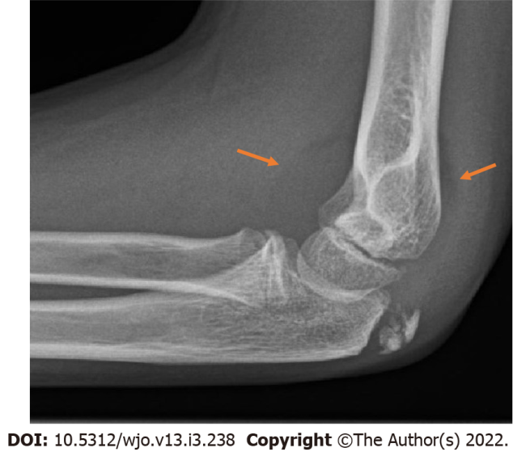
Figure 1 Fat pad sign. Lateral radiograph of a 13-year-old boy, showing an anterior and posterior fat pad sign without visible fracture. A proximal radius fracture was identified using computed tomography.

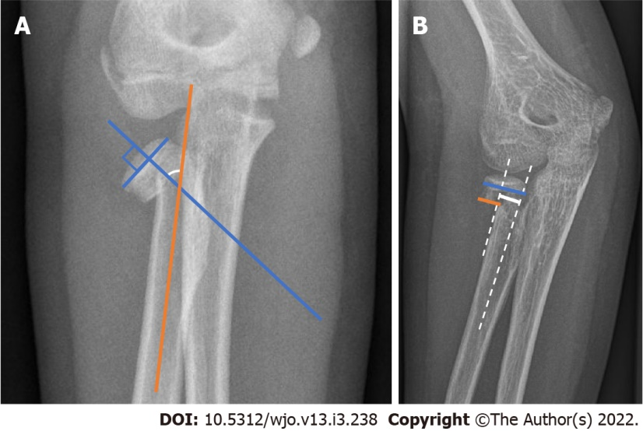
Figure 2 Measurement of angulation and translation of the proximal radius fracture. A: Angulation measurement. Angulation of a proximal radius fracture is measured by drawing a line perpendicular to the surface of the radial head (blue line) and a line through the middle of the radial shaft (orange line). The angle is measured at the intersection of the two lines (white arc); B: Translation measurement. Translation of a proximal radius fracture is calculated by dividing the length the uncovered part of the metaphysis (orange line) by the total width of the proximal radius (blue line), multiplying by one hundred provides the percentage of translation. Alternatively, the distance from the middle of the proximal part to the middle of the distal part can be measured in millimeters (continuous white line).

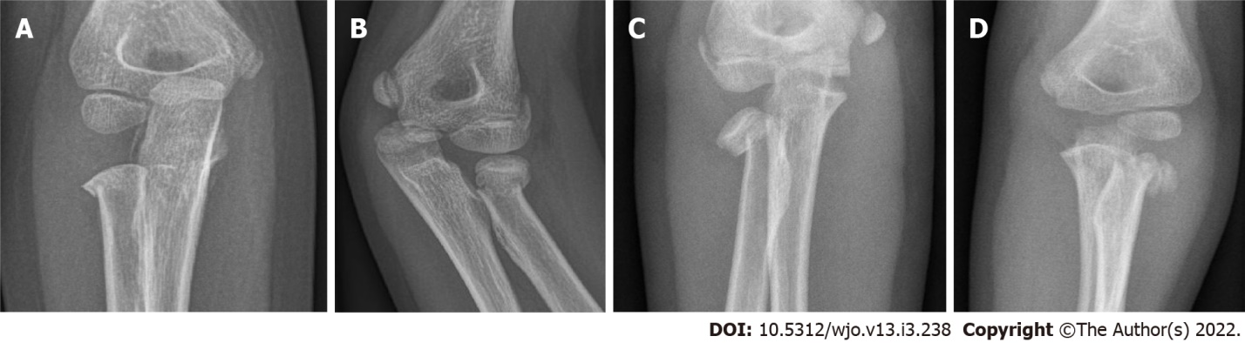
Figure 3 Anteroposterior radiograph of proximal radius fracture. A: Grade I fracture. Anteroposterior radiograph of a 5-year-old boy with a proximal radius fracture that is (nearly) nondisplaced. Judet grade I; Metaizeau grade I; O’Brien type I; B: Grade II fracture. Radiograph of a 9-year-old girl with a proximal radius fracture in 27 degrees of angulation and 17% translation. Judet grade II; Metaizeau grade II; O’Brien type I; C: Grade III fracture. Anteroposterior radiograph of a 10-year-old girl with a proximal radius fracture in 58 degrees of angulation and 55% translation. Judet grade III; Metaizeau grade III; O’Brien type II; D: Grade IV fracture. Anteroposterior radiograph of a 7-year-old girl with a proximal radius fracture in 87 degrees of angulation and 80% translation. Judet grade IVb; Metaizeau grade IVb; O’Brien type III.

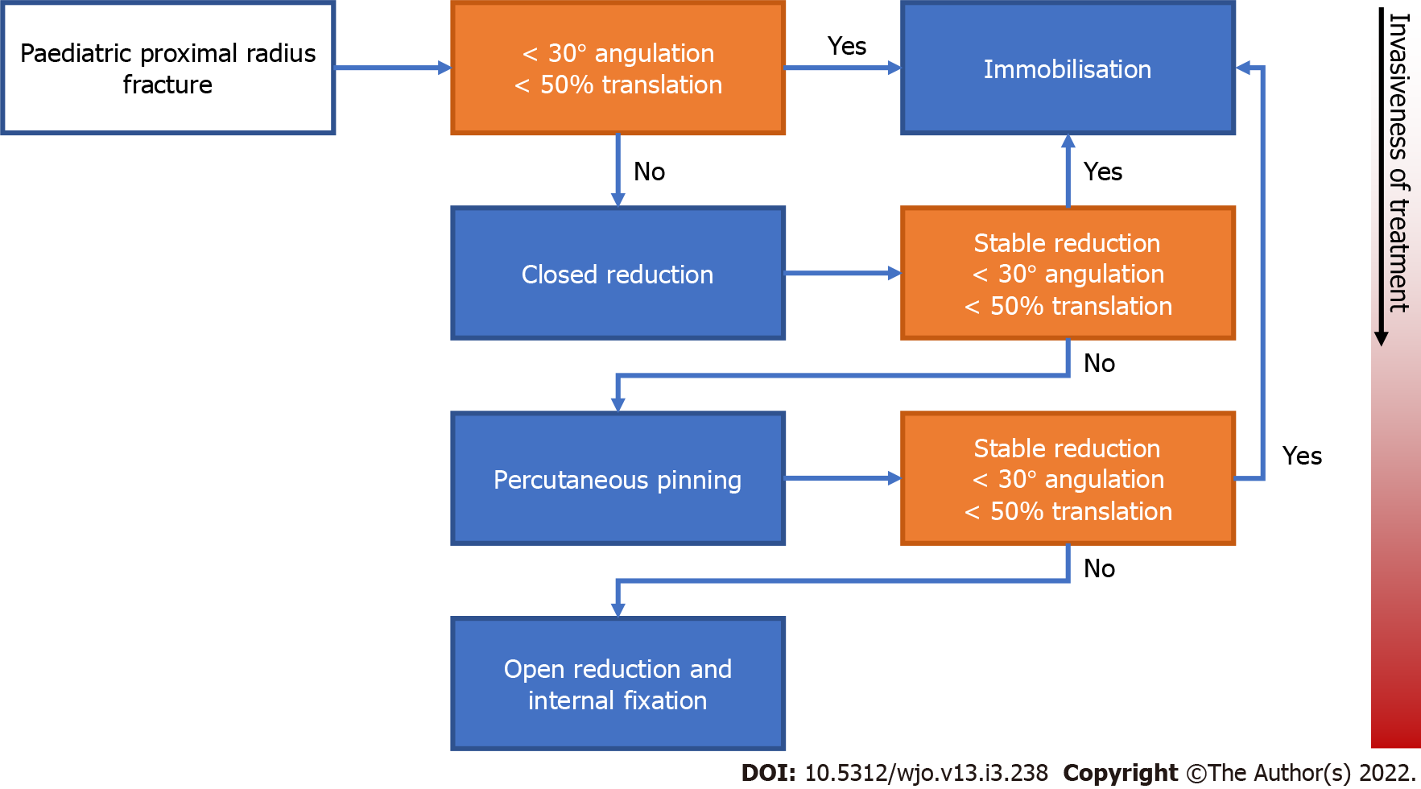
Figure 4 Treatment flowchart. Treatment flowchart that plots the stepwise progression from conservative to increasingly invasive treatment of pediatric proximal radius fractures. Starting from the left, orange boxes represent points of decision-making and blue boxes represent treatment options. Boxes placed lower in the chart represent more invasive procedures than those placed above.

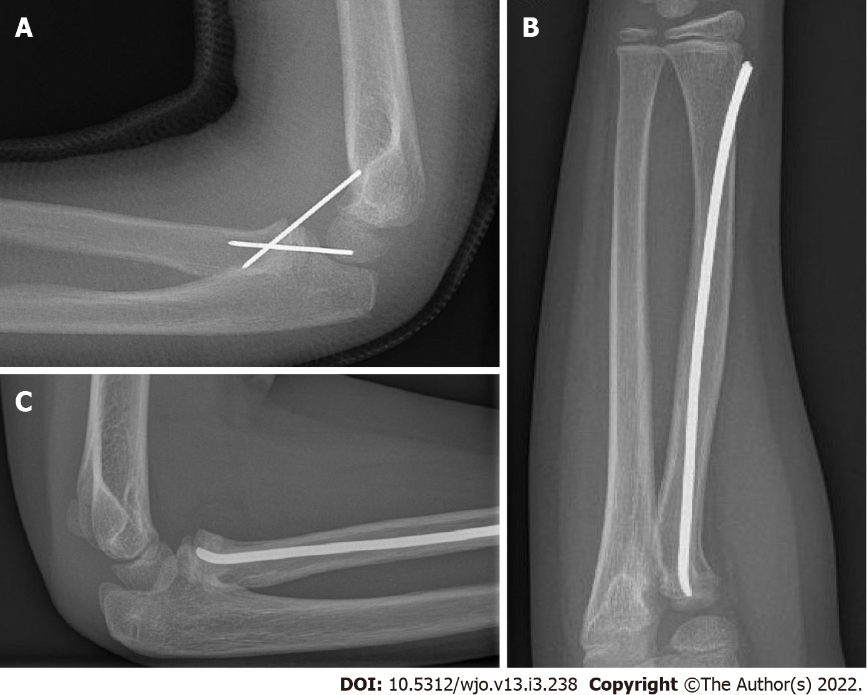
Figure 5 A fracture can be reduced percutaneously in several ways. A: Percutaneous Kirschner wire fixation. Lateral radiograph of a 7-year-old boy with a proximal radius fracture after percutaneous reduction and fixation using two Kirschner wires; B and C: Intramedullary nail: Anteroposterior radiograph of a 10-year-old girl with a proximal radius fracture that was reduced and fixated using a flexible intramedullary nail (Metaizeau technique) (B), Lateral radiograph of a 10-year-old girl with a proximal radius fracture that was reduced and fixated using a flexible intramedullary nail (Metaizeau technique) (C).

Table 1 Classification systems
 | Angulation, degrees | Translation
Judet
I | Nondisplaced or horizontal shift
II | < 30
III | 30-60
IVa | 60-80
IVb | > 80
Metaizeau's modification
I | Non-displaced or horizontal shift | < 3 mm
II | < 30 | < 50%
III | 30-60 | > 50%
IVa | 60-80 | > 100%
IVb | > 80
V | Epiphyseal separation
O'Brien
Type I | < 30
Type II | 30-60
Type III | > 60

Published by Baishideng Publishing Group Inc
7041 Koll Center Parkway, Suite 160, Pleasanton, CA 94566, USA
Telephone: +1-925-3991568
E-mail: bpgoffice@wjgnet.com
Help Desk: https://www.f6publishing.com/helpdesk
https://www.wjgnet.com

© 2022 Baishideng Publishing Group Inc. All rights reserved.

