Name of Journal: World Journal of Gastrointestinal Oncology
Manuscript NO: 88960
Manuscript Type: ORIGINAL ARTICLE

Clinical and Translational Research
Risk factors, prognostic factors, and nomograms for distant metastasis in patients with diagnosed duodenal cancer: A population-based study

Shang JR et al. Nomogram for DM in duodenal cancer

Jia-Rong Shang, Chen-Yi Xu, Xiao-Xue Zhai, Zhe Xu, Jun Qian

Jia-Rong Shang, Chen-Yi Xu, Xiao-Xue Zhai, Jun Qian, Department of Oncology, Jiangsu Province Hospital of Chinese Medicine, The Affiliated Hospital of Nanjing University of Chinese Medicine, Nanjing 210000, Jiangsu Province, China

Chen-Yi Xu, Department of Proctology, Nanjing Hospital of Chinese Medicine, Nanjing 210000, Jiangsu Province, China

Zhe Xu, Department of Digestive Cancer Surgery, Jiangsu Province Hospital of Chinese Medicine, The Affiliated Hospital of Nanjing University of Chinese Medicine, Nanjing 210000, Jiangsu Province, China

Co-first authors: Jia-Rong Shang and Chen-Yi Xu.

Co-corresponding authors: Zhe Xu and Jun Qian.

Author contributions: Shang JR and Xu CY made equal contributions to this work. They both played significant roles in the research, including study design, data collection, data analysis and interpretation, and manuscript drafting. Zhai XX collected data; Xu Z and Qian J provided guidance and support throughout the research, assisted in data collection and analysis, and actively participated in manuscript revision and editing. All authors have read and approved the final manuscript. The reason for listing them as co-first authors is based on their equal and significant contributions to the research project. This is evident in the following aspects: Research design and planning: co-first authors Shang JR and Xu CY played equally important roles in the design and planning of the research project. They jointly formulated the research framework, defined the main objectives, and determined the research methods. Data collection and analysis: Both co-first authors actively participated in data collection, organization, and analysis. They collaborated in handling a substantial amount of experimental data and conducted statistical analyses to ensure the scientific reliability of the study. Data interpretation and presentation: Shang JR and Xu CY worked together to interpret the experimental results and jointly wrote sections of the research report related to data presentation. They ensured that the data was presented to the readers in a clear and accurate manner. Manuscript drafting: Both authors contributed equally to drafting the research manuscript. They shared responsibilities in writing different sections of the research, including the introduction, methodology, results, and discussion. In summary, Shang JR and Xu CY demonstrated equal intellectual contributions throughout the entire research project, including research design, data processing, result interpretation, and manuscript writing. Therefore, they are considered qualified co-first authors. This arrangement reflects their collaborative and equal contributions to the project, ensuring fair and just authorship recognition. Xu Z and Qian J are designated as co-corresponding authors based on their equal contributions to the conception, design, and execution of the research project, illustrating their shared responsibility in the development and implementation of the study. They collaborated closely in the acquisition, analysis, and interpretation of data, ensuring a comprehensive and rigorous evaluation of the results. Both authors actively participated in drafting and critically revising the manuscript, providing intellectual input, and approving the final version for submission. They jointly supervised the research, overseeing various aspects of the project to guarantee its integrity and accuracy. Their collaborative efforts and equal contributions underscore the significance of designating them as co-corresponding authors.

Supported by State Administration of Traditional Chinese Medicine Base Construction Stomach Cancer Special Fund, No. Y2020CX57; Jiangsu Provincial Graduate Research and Practical Innovation Program Project, No. SJCX23-0799.

Corresponding author: Zhe Xu, MD, PhD, Chief Physician, Doctor, Surgeon, Surgical Oncologist, Department of Digestive Cancer Surgery, Jiangsu Province Hospital of Chinese Medicine, The Affiliated Hospital of Nanjing University of Chinese Medicine, No. 155 Hanzhong Avenue, Qinhuai District, Nanjing 210000, Jiangsu Province, China. xi.88@163.com

Received: October 16, 2023
Revised: December 24, 2023
Accepted: February 4, 2024
Published online:

Abstract
BACKGROUND
Duodenal cancer is one of the most common subtypes of small intestinal cancer, and distant metastasis (DM) in this type of cancer still leads to poor prognosis. Although nomograms have recently been used in tumor areas, no studies have focused on the diagnostic and prognostic evaluation of DM in patients with primary duodenal cancer.

AIM
To develop and evaluate nomograms for predicting the risk of DM and personalized prognosis in patients with duodenal cancer.

METHODS
Data on duodenal cancer patients diagnosed between 2010 and 2019 were extracted from the Surveillance, Epidemiology, and End Results database. Univariate and multivariate logistic regression analyses were used to identify independent risk factors for DM in patients with duodenal cancer, and univariate and multivariate Cox proportional hazards regression analyses were used to determine independent prognostic factors in duodenal cancer patients with DM. Two novel nomograms were established, and the results were evaluated by receiver operating characteristic (ROC) curves, calibration curves, and decision curve analysis (DCA).

RESULTS
A total of 2603 patients with duodenal cancer were included, of whom 457 cases (17.56%) had DM at the time of diagnosis. Logistic analysis revealed independent risk factors for DM in duodenal cancer patients, including gender, grade, tumor size, T stage, and N stage (P < 0.05). Univariate and multivariate COX analyses further identified independent prognostic factors for duodenal cancer patients with DM, including age, histological type, T stage, tumor grade, tumor size, bone metastasis, chemotherapy, and surgery (P < 0.05). The accuracy of the nomograms was validated in the training set, validation set, and expanded testing set using ROC curves, calibration curves, and DCA curves. The results of Kaplan-Meier survival curves (P < 0.001) indicated that both nomograms accurately predicted the occurrence and prognosis of DM in patients with duodenal cancer.

CONCLUSION
The two nomograms are expected as effective tools for predicting DM risk in duodenal cancer patients and offering personalized prognosis predictions for those with DM, potentially enhancing clinical decision-making.

Key Words: Duodenal cancer; Distant metastasis; Nomogram; Risk factors; Prognostic factors

Shang JR, Xu CY, Zhai XX, Xu Z, Qian J. Risk factors, prognostic factors, and nomograms for distant metastasis in patients with diagnosed duodenal cancer: A population-based study. World J Gastrointest Oncol 2024; In press

Core Tip: Developed and evaluated were two new nomograms for predicting the risk of distant metastasis (DM) and providing personalized prognosis for patients with primary duodenal cancer. The study involved a total of 2603 duodenal cancer patients, among whom 457 (17.56%) had DM at the time of diagnosis. Independent risk factors for DM in duodenal cancer patients were identified. Additionally, independent prognostic factors for duodenal cancer patients with DM were determined. The results indicated that the nomograms accurately predicted the occurrence and prognosis of DM in duodenal cancer patients.

INTRODUCTION
Duodenal cancer, classified as a rare malignancy within gastrointestinal tumors, is recognized as a distinct clinicopathological subtype of small intestinal cancer^{[1]}. The incidence rate of duodenal cancer is low, with a rate lower than 0.5 per 100000, it accounting for approximately 0.3% to 1.0% of all gastrointestinal malignancies^{[2]}. However, among malignant tumors of the small intestine, duodenal cancer represents a significant portion, accounting for 25% to 35% of cases, making it one of the high-incidence malignancies of the digestive tract^{[3]}. The incidence of malignant tumors in the small intestine has been steadily increasing, as reported by Yao et al^{[4]}. From 1976 to 2016, the incidence has risen by 130%, accompanied by a relative increase in the mortality rate by 26%^{[5]}. The duodenum, the most proximal portion of the small intestine, is frequently involved in duodenal cancer cases^{[6]}. The number of patients with duodenal cancer has been progressively rising^{[7-9]}, highlighting the importance of research in this area. Most patients with duodenal cancer remain asymptomatic until the disease reaches an advanced stage. Additionally, the difficulty in identifying duodenal cancer through imaging examinations often leads to delays in diagnosis and subsequent poor prognosis^{[10,11]}. Thus, there is a need for an enhanced understanding and improved diagnostic methods for this disease.
In patients with duodenal cancer who develop metastasis, The most common site of metastasis is the liver, occurring in 37.5% of cases. This was followed by lymph node metastasis at a rate of 12.5%) and lung metastasis occurring in 9.4% of cases. Overall, the metastasis rate in patients with duodenal cancer is 48.5%^{[12]}. Notably, patients with duodenal cancer who experience distant metastasis (DM) often present with multiple lesions^{[13]}. Hence, it is crucial to develop precise models for assessing the risk of DM in patients with duodenal cancer and evaluating their prognosis. Currently, there is a scarcity of studies offering dependable data regarding the association between clinicopathological characteristics and metastatic patterns in duodenal cancer. Furthermore, there is a lack of established predictive models for determining the likelihood of DM in duodenal cancer or for predicting the prognosis of patients with duodenal cancer and DM^{[14]}.
Recently, nomograms have gained widespread use for evaluating the prognosis of cancer patients because of their convenience and precision, making them an ideal choice for our purpose^{[15,16]}. Considering this, we conducted a study using a representative cohort from the Surveillance, Epidemiology, and End Results (SEER) database to assess the incidence, risk factors, and prognosis of DM in patients diagnosed with duodenal cancer and developed two nomograms: One for predicting the likelihood of DM in patients with duodenal cancer and another for predicting the overall survival (OS) of duodenal cancer patients with DM.

MATERIALS AND METHODS
Patient selection and data collection
The current data for this study on duodenal cancer were extracted from three SEER registry systems, SEER 8, SEER 12, and SEER 17, covering the period from 2010 to 2019. Only data from the period after 2010 were retrieved because the SEER database did not provide information on the site of DM. The inclusion criteria were as follows: (1) Cancer patients with a primary site in the duodenum retrieved using the topographical codes from the International Classification of Diseases for Oncology (ICD-O-3: C17.0); and (2) clinical pathological information, including primary tumor site, grade, histological type, tumor-node-metastasis, and tumor size. In addition, all patients without microscopic confirmation of duodenal cancer diagnosis were excluded. A total of 2603 patients diagnosed with duodenal cancer were included in the present study, of which 457 had DM. Finally, 2603 patients diagnosed with duodenal cancer, including 457 with DM, were included in the present study. All patients were used to form a diagnostic cohort to explore the risk factors for DM and develop a predictive nomogram. Additionally, out of 457 duodenal cancer patients with DM, 412 patients with a survival time of one month or more and available specific treatment information such as surgery, chemotherapy, and radiotherapy were used to form a prognostic cohort to study the prognostic factors for patients with DM and develop a novel prognostic nomogram.
In the diagnostic cohort, the patients were randomly divided into two sets: A training set consisting of 70% of the patients, and a validation set consisting of the remaining 30% of patients. Similarly, for the prognostic cohort, the training and validation sets were derived from corresponding patients with DM from the diagnostic cohort. For each cohort, patients in the training set were used to construct the nomogram and the corresponding patients in the validation set were used to validate the nomogram.

Data collection
In this study, several variables were selected to identify risk factors for DM in patients with duodenal cancer. These variables included age, sex, race, marital status, grade, income, histological type, T stage, N stage, metastasis information, and tumor size. Survival analyses were conducted to investigate prognostic factors in patients with duodenal cancer and DM. Based on these factors, three treatment variables were included: surgery, radiotherapy, and chemotherapy. OS was the primary outcome and was defined as the time interval between the day of diagnosis and the day of death for any reason.

Statistical analysis
In the present study, all statistical analysis was performed with SPSS 25.0 and R software (version 4.2.3), and at P < 0.05 (two side) was considered as statistical significance. To assess the distribution of variables between the training and validation sets, all patients with duodenal cancer were randomly divided into these sets using the R software. Chi-square test or Fisher's exact test was used to compare the distribution of variables between the two sets.
In the diagnostic cohort, the univariate logistic analysis was to identify DM-related risk factors. Variables with P < 0.05 in the univariate analysis were incorporated into the multivariate logistic analysis with “Forward LR” in SPSS 25.0, to determine independent risk factors for DM in patients with duodenal cancer. Additionally, a novel diagnostic nomogram was built using the “rms” package based on independent risk factors. The receiver operating characteristic (ROC) curves of the nomogram and all independent variables were generated, and the corresponding area under the curve (AUC) was calculated to assess discrimination. Calibration curves and decision curve analysis (DCA) were used to evaluate the performance of the nomogram.
For prognostic factors, univariate Cox regression analysis was applied to determine the OS-related factors in duodenal cancer patients with DM. Significant variables (P < 0.05) were incorporated into the multivariate Cox analysis with “Forward LR” in SPSS 25.0, to further determine independent prognostic factors. A nomogram based on independent prognostic predictors was developed to predict the OS of duodenal cancer patients with DM and the individual risk score were calculated using the nomogram formula. In addition, time-dependent ROC curves of the nomogram and all independent prognostic variables at 12, 36, and 60 months were generated, and the corresponding time-dependent AUCs were applied to show discrimination. Calibration curves and DCA values at 12, 36, and 60 months were plotted to evaluate the nomogram. According to the median risk score, all patients with duodenal cancer with DM were divided into high- and low-risk groups. Kaplan-Meier (K-M) survival curves with the log-rank test were performed to show the difference in OS status between the two groups.

RESULTS
Baseline characteristics of the study population
We performed a retrospective review of patients with duodenal cancer, based on the publicly available SEER program. A total of 2603 patients diagnosed with duodenal cancer were included in this study, with 1822 patients allocated to the training set and 781 patients to the validation set. Demographic and clinical characteristics of the duodenal cancer patients are summarized in Table 1. In the training set, the mean age was 63.73 years (range: 16-97 years), and in the validation set, it was 64.11 years (range: 25-96 years). As shown in Table 1, the most common tumor grade of differentiation was grade I (43.3 % in the training set and 45.3% in the validation set). The most common T and N stages were T1-T2 (51.8% in the training set and 52.5% in the validation set) and N0 (65.3% in the training set and 64.4% in the validation set). Regarding the histological type of duodenal cancer, adenocarcinoma (not otherwise specified), accounted for 35.8% in the training set and 36.0% in the validation set. Meanwhile, the Chi-squared test indicated that the distribution was completely random (Table 1).

Incidence and risk factors of DM in duodenal cancer patients
Among the total of 2603 cases analyzed, 457 cases (17.56%) were confirmed to have DM at the time of initial diagnosis, while 2146 cases (82.44%) did not have DM. Univariate logistic analysis of 11 potential factors revealed that five variables, namely sex, grade, T stage, N stage, and tumor size, were significantly associated with DM (Table 2). Subsequently, multivariate logistic regression analysis confirmed that male sex, higher T stage, higher N stage, higher grade, and larger tumor size were independent risk factors for the development of DM in patients with primary duodenal cancer (Table 2).

Diagnostic nomogram development and validation
A novel nomogram for predicting the risk of DM in patients with duodenal cancer was established based on five independent predictors (Figure 1A). The predictive accuracy of the nomogram was assessed using ROC curves in the training set, and the AUC of the nomogram was 0.804 (Figure 1B), indicating a strong predictive capability. To further validate the calibration of the nomogram, we generated calibration curves and DCA curves. The calibration curves demonstrated excellent consistency between the observed and predicted probabilities (Figure 1C). DCA curves (Figure 1D) further confirmed the reliability of the nomogram in providing valuable information for DM assessment. In the validation set, similar analyses were performed, verifying the predictive accuracy of the nomogram (Figure 1E-G). Additionally, ROC curves were generated for each individual predictor, revealing that the nomogram exhibited superior discriminative ability compared to individual factors in both the training and validation sets (Figure 2). Additionally, an expanded testing set was obtained from the SEER database to validate the applicability of the nomogram when external data were lacking. The AUC of the nomogram in the expanded testing set was 0.806 (Figure 3A). Additionally, the calibration, DCA, and ROC curves of all independent factors in the expanded testing set further demonstrated the good performance of the diagnostic nomogram (Figure 3B-D).

Prognostic factors for duodenal cancer patients with DM
In this study, we examined 457 eligible patients diagnosed with duodenal cancer and DM to investigate potential prognostic factors. Among these patients, 121 (26.5%) underwent surgery, 56 (12.3%) received radiotherapy, and 246 (53.8%) underwent chemotherapy, as outlined in Table 3. Statistical analysis, including the Chi-square test and Fisher's exact test, revealed no significant differences in all variables between the training and validation sets. Undergoing both univariate and multivariate Cox regression analyses, robust prognostic factors were identified. The results revealed that older age (P < 0.001), higher T stage (P = 0.018), higher grade (P < 0.001), bone metastasis (P < 0.001), absence of surgery (P < 0.001), and absence of chemotherapy (P < 0.001) were established as independent prognostic factors for patients with duodenal cancer and DM (Table 4).

Prognostic nomogram development and validation
Based on these prognostic factors, we developed a nomogram to predict OS in patients with duodenal cancer and DM (Figure 4). The calibration curves for OS probability at 12, 36, and 60 months indicate strong consistency between the predicted OS and actual outcomes in the training set (Figure 5A-C). Furthermore, DCA curves confirm the favorable clinical utility of the nomogram (Figure 5D-F). In the validation set, both calibration curves and DCA curves also demonstrate good accuracy (Figure 6). ROC analysis revealed the nomogram's strong discrimination ability for predicting OS in duodenal cancer patients with DM. The area under the AUC values for the nomogram were 0.795, 0.836, and 0.815 at 12, 36, and 60 months in the training set (Figure 7A), and 0.874, 0.920, and 0.926 in the validation set (Figure 7B), respectively, demonstrating excellent predictive accuracy. K-M curves further highlighted the significant difference in OS between the high-risk and low-risk groups (Figure 7C and D). Moreover, we compared the discriminatory power of the nomogram with each independent prognostic factor and found that the nomogram consistently outperformed all individual factors at 12, 36, and 60 months (Figure 8).

Validating the prognostic nomogram in an expanded testing set
In the expanded testing set, consisting of 468 patients with DM and comprehensive data on age, chemotherapy, and surgery from the SEER database, we observed the performance of the prognostic nomogram. The results demonstrated excellent calibration, as illustrated by the calibration plots (Figure 9A-C), signifying a strong concordance between the predicted OS and the actual outcomes for patients with DM. Additionally, DCA demonstrated that the prognostic nomogram served as an effective clinical tool (Figure 9 D-F). Furthermore, the nomogram showed better discrimination than the three independent predictors at 12, 36, and 60 months (Figures 9G-I). The AUC for OS prediction at 12, 36, and 60 months was 0.804, 0.793, and 0.782, respectively (Figure 9J). Moreover, K-M survival analysis revealed distinct survival patterns between the high- and low-risk groups of patients (Figure 9K).

DISCUSSION
Distant organ metastasis is a common occurrence in duodenal cancer, a rare and aggressive malignant tumor. Approximately 26.7% of patients are diagnosed with metastasis at the time of diagnosis, with liver metastasis being the most prevalent (15.4%), followed by lung metastasis (8.1%), bone metastasis (4.6%), and brain metastases (1.2%)^{[17,18]}. The grim prognosis associated with advanced-stage duodenal cancer is attributed to the challenges faced by patients with distant organ metastasis, who often cannot benefit from surgery, chemotherapy, and novel treatments, and are prone to experiencing various complications^{[19-22]}. To address this, it is crucial to identify effective risk and prognostic factors for duodenal cancer patients with diabetes mellitus. In this research, we formulated a diagnostic nomogram to predict the presence of DM in recently diagnosed individuals with duodenal cancer. Additionally, we created a prognostic nomogram specifically tailored for patients already diagnosed with DM. By leveraging accessible variables, these nomograms provide diagnosis-related and prognosis-related scores, offering valuable guidance for clinical evaluation and intervention.
Recently, the focus of research on DM in duodenal cancer has increased, with many studies primarily consisting of case reports and a limited emphasis on clinical and pathological characteristics. In our study, we utilized a substantial dataset with meticulous clinical information sourced from the SEER database. Our findings reveal that the likelihood of DM in duodenal cancer patients is 17.6%. We identified five significant predictors of DM: Sex, T stage, N stage, tumor size, and grade. A study by Jiang et al^{[2]} emphasized the varying rates and patterns of metastasis in patients with duodenal adenocarcinoma, particularly noting significant distinctions between males and females. Their research strongly suggests that males may be more susceptible to developing metastatic lesions in duodenal cancer, indicating a potentially more prominent role in the metastatic behavior of this malignancy. Our study aligns closely with these findings, further supporting the notion that male patients are at a greater risk of encountering duodenal cancer metastasis than their female counterparts. It's important to note that T stage encodes the depth and extent of tumor invasion, while N stage encodes the degree of lymph node involvement. In our study, we observed a positive correlation between higher T stage and the incidence of DM, as well as a positive correlation between higher N stage and the incidence of DM. These findings are consistent with previous research, indicating that cellular migration, invasion, and lymph node metastasis are crucial factors contributing to tumor progression and metastasis^{[23-25]}. The correlation between tumor size and the occurrence of metastasis is undeniable, and our study confirms this relationship^{[26,27]}.
Given the notably unfavorable prognosis in duodenal cancer patients with DM, early detection of DM is of paramount importance, enabling timely initiation of appropriate measures such as surgical resection and chemotherapy^{[28]}. Until now, many studies have only examined individual risk factors in isolation, and we have taken a step forward by developing an innovative diagnostic nomogram to predict the risk of DM in patients with duodenal cancer. This nomogram incorporated five independent predictive factors, allowing for a comprehensive assessment of DM risk. Through rigorous evaluation using calibration curves, ROC curves, and DCA, we demonstrated the exceptional performance of our nomogram. It holds the promise of significantly enhancing the current landscape of risk assessment, offering a more accurate and personalized approach to clinical decision making.
We further examined the prognostic factors of patients with duodenal cancer and DM. Age, histological type, T stage, tumor grade, tumor size, whether surgery or chemotherapy was performed, and the presence of bone or lung metastasis were identified as prognostic factors. We developed a corresponding prognostic nomogram, which suggests that patients with bone metastasis may require more aggressive treatments due to significantly lower OS than those with liver metastasis and lung metastasis^{[29]}. As the incidence of duodenal cancer continues to increase, there is an urgent need for new treatment strategies. However, current adjuvant chemotherapy continues to play a crucial role in prolonging patients’ lives, and some clinical trials are still ongoing^{[30-32]}. Surgery remains the primary choice for the treatment of early stage duodenal cancer, and it still plays a role in the management of patients with advanced-stage duodenal cancer^{[33,34]}. Remarkably, our findings demonstrated that the lack of surgical intervention and chemotherapy exerted a substantial detrimental effect on OS, consistent with the aforementioned outcomes. Furthermore, our study revealed that radiotherapy did not significantly affect the prognosis, which is consistent with a previous study^{[35]}. Patients who underwent surgical and chemotherapy interventions achieved superior outcomes compared to those who did not receive such treatments, underscoring the pivotal role of surgery and chemotherapy in the treatment of duodenal cancer. These compelling results provide clinicians with evidence to effectively persuade hesitant patients about the substantial benefits of surgery and chemotherapy. It is widely believed that older age in duodenal cancer patients with DM is associated with a poorer OS prognosis than in younger patients^{[14]}. Our study affirmed that older patients indeed had a higher likelihood of experiencing a poorer OS. Importantly, we introduced a novel prognostic nomogram for predicting the prognosis of duodenal cancer patients with DM, and its discriminative ability was demonstrated to surpass that of any individual predictor. This suggests that the nomogram may offer a new avenue for personalized assessment in clinical decision-making.
Currently, there are no nomograms available for predicting the prognosis of duodenal cancer with DM. Compared with the available prognostic models, our study offers several advantages. First, our study focused on a different population than previous studies. For instance, Wang et al^{[36]} only examined patients with small intestinal adenocarcinoma, whereas Modlin et al^{[37]} included patients with small intestinal carcinoid tumors. In contrast, we specifically investigated the common duodenal cancer subtype with a poor prognosis and limited effective treatments. This clinical specificity has not been explored previously. Second, our study incorporated a smaller number of clinical variables, while achieving equivalent or enhanced AUC values. Third, in the absence of external data, our study conducted extensive validation using the SEER database to further validate the performance of the nomogram.
Nonetheless, there are certain limitations to this study. First, the relatively small sample size of duodenal cancer patients with DM (n = 457) may have introduced potential errors. Second, while we constructed a prediction model in the training set and validated it in the validation set, the nomograms lacked sufficient external data for complete validation, potentially leading to internal bias. Third, the information collected in the SEER database was about the disease at the time of initial diagnosis, which meant that the DM that occurred in the latter stage could not be included. Fourth, potential confounding factors, such as specific surgical approaches, chemotherapy, radiotherapy, and reasons for treatment selection, were unmeasured and therefore unreported in the SEER database, which may have impacted the results. Additionally, the predictors in this study encompassed only common clinical variables such as several critical variables such as carcinoembryonic antigen and CA-199 were not recorded in the SEER database. Finally, as this was a retrospective study, we need to confirm the nomograms designed in this study with relevant prospective studies in the future.

CONCLUSION
In conclusion, our study contributes novel insights into the diagnosis, prognosis, and treatment of duodenal cancer, particularly in the context of DM and the challenging subgroup of patients with DM. The innovative nomograms developed offer valuable tools for clinicians, providing a more accurate and personalized approach to risk assessment and clinical decision-making. While our study has shed light on critical factors influencing DM and prognosis, it is not without limitations. The relatively limited number of duodenal cancer patients with DM may introduce potential errors. Additionally, the nomograms lack external data for complete validation, potentially leading to internal bias. The retrospective nature of the study and the unavailability of certain critical variables in the SEER database further impact the generalizability of our findings. Despite these limitations, our study presents a foundation for future research. Prospective studies are warranted to confirm and further validate the nomograms designed in this study. This comprehensive approach to understanding and managing duodenal cancer, especially in high-risk subgroups, holds promise for improving patient outcomes and guiding clinical practice.

ARTICLE HIGHLIGHTS
Research background
Duodenal cancer is a prevalent subtype of small intestinal cancer, and the prognosis for patients with distant metastasis (DM) in this type of cancer remains poor. However, there is a lack of studies focusing on the diagnostic and prognostic evaluation of DM in patients with primary duodenal cancer.

Research motivation

In this study, we aimed to utilize data from the Surveillance, Epidemiology, and End Results (SEER) database to investigate the risk factors for DM and identify prognostic factors in patients with duodenal cancer.

Research objectives
To develop nomogram predicting the risk of DM in patients with duodenal cancer and providing personalized prognosis predictions for those with DM, aiming to enhance clinical decision-making.

Research methods
Data from duodenal cancer patients (2010-2019) were extracted from the SEER database. Univariate and multivariate logistic regression identified independent DM risk factors, while Cox proportional hazards regression determined prognostic factors in duodenal cancer patients with DM. Novel nomograms were created and evaluated using receiver operating characteristic (ROC) curves, calibration curves, and decision curve analysis (DCA).

Research results
Among 2603 duodenal cancer patients, 17.56% had DM at diagnosis. Logistic analysis identified risk factors (gender, grade, tumor size, T stage, N stage, P < 0.05). Cox analyses revealed prognostic factors (age, histological type, T stage, tumor grade, tumor size, bone metastasis, chemotherapy, surgery, P < 0.05). Nomogram accuracy was confirmed in training, validation, and testing sets (ROC, calibration, DCA curves). Kaplan-Meier curves (P < 0.001) indicated precise prediction of DM occurrence and prognosis.

Research conclusions
This study on duodenal cancer highlights the poor prognosis linked to DM. Developed and evaluated using SEER database data, two nomograms predict DM risk and personalized prognosis. Validated for accuracy, these nomograms offer clinicians a valuable tool to enhance decision-making on DM risk and prognosis in duodenal cancer patients.

Research perspectives
Future research should prospectively validate the nomograms, integrating additional factors for enhanced predictive accuracy. External validation across diverse datasets and assessing the nomograms' impact on treatment decisions are crucial. Evaluating feasibility for routine clinical use, conducting long-term follow-up studies, and considering patient-reported outcomes aim to improve applicability and enhance decision-making for duodenal cancer patients with DM.

ACKNOWLEDGEMENTS
The authors sincerely thank the Surveillance, Epidemiology, and End Results (SEER) program for their efforts in establishing the SEER database.

REFERENCES
1 Nakagawa K, Sho M, Fujishiro M, Kakushima N, Horimatsu T, Okada KI, Iguchi M, Uraoka T, Kato M, Yamamoto Y, Aoyama T, Akahori T, Eguchi H, Kanaji S, Kanetaka K, Kuroda S, Nagakawa Y, Nunobe S, Higuchi R, Fujii T, Yamashita H, Yamada S, Narita Y, Honma Y, Muro K, Ushiku T, Ejima Y, Yamaue H, Kodera Y. Clinical practice guidelines for duodenal cancer 2021. J Gastroenterol 2022; 57: 927-941 [PMID: 36260172 DOI: 10.1007/s00535-022-01919-y]
2 Jiang QL, Huang XH, Chen YT, Zhang JW, Wang CF. Prognostic Factors and Clinical Characteristics of Patients with Primary Duodenal Adenocarcinoma: A Single-Center Experience from China. Biomed Res Int 2016; 2016: 6491049 [PMID: 28116301 DOI: 10.1155/2016/6491049]
3 Miller KD, Nogueira L, Devasia T, Mariotto AB, Yabroff KR, Jemal A, Kramer J, Siegel RL. Cancer treatment and survivorship statistics, 2022. CA Cancer J Clin 2022; 72: 409-436 [PMID: 35736631 DOI: 10.3322/caac.21731]
4 Yao H, Sokas C, Welch HG. Rising Incidence of Cancer of the Small Intestine: Overdiagnosis and Better Diagnosis of Low-lethality Disease. Gastroenterology 2022; 162: 1749-1751.e2 [PMID: 35031298 DOI: 10.1053/j.gastro.2022.01.012]
5 Anzidei M, Napoli A, Zini C, Kirchin MA, Catalano C, Passariello R. Malignant tumours of the small intestine: a review of histopathology, multidetector CT and MRI aspects. Br J Radiol 2011; 84: 677-690 [PMID: 21586504 DOI: 10.1259/bjr/20673379]
6 Aparicio T, Zaanan A, Svrcek M, Laurent-Puig P, Carrere N, Manfredi S, Locher C, Afchain P. Small bowel adenocarcinoma: epidemiology, risk factors, diagnosis and treatment. Dig Liver Dis 2014; 46: 97-104 [PMID: 23796552 DOI: 10.1016/j.dld.2013.04.013]
7 Legué LM, Bernards N, Gerritse SL, van Oudheusden TR, de Hingh IH, Creemers GM, Ten Tije AJ, Lemmens VE. Trends in incidence, treatment and survival of small bowel adenocarcinomas between 1999 and 2013: a population-based study in The Netherlands. Acta Oncol 2016; 55: 1183-1189 [PMID: 27170100 DOI: 10.1080/0284186X.2016.1182211]
8 Lu Y, Fröbom R, Lagergren J. Incidence patterns of small bowel cancer in a population-based study in Sweden: increase in duodenal adenocarcinoma. Cancer Epidemiol 2012; 36: e158-e163 [PMID: 22405637 DOI: 10.1016/j.canep.2012.01.008]
9 Bilimoria KY, Bentrem DJ, Wayne JD, Ko CY, Bennett CL, Talamonti MS. Small bowel cancer in the United States: changes in epidemiology, treatment, and survival over the last 20 years. Ann Surg 2009; 249: 63-71 [PMID: 19106677 DOI: 10.1097/SLA.0b013e31818e4641]
10 Bojesen RD, Andersson M, Riis LB, Nielsen OH, Jess T. Incidence of, phenotypes of and survival from small bowel cancer in Denmark, 1994-2010: a population-based study. J Gastroenterol 2016; 51: 891-899 [PMID: 26847562 DOI: 10.1007/s00535-016-1171-7]
11 Qubaiah O, Devesa SS, Platz CE, Huycke MM, Dores GM. Small intestinal cancer: a population-based study of incidence and survival patterns in the United States, 1992 to 2006. Cancer Epidemiol Biomarkers Prev 2010; 19: 1908-1918 [PMID: 20647399 DOI: 10.1158/1055-9965.EPI-10-0328]
12 Nappo G, Funel N, Laurenti V, Stenner E, Carrara S, Bozzarelli S, Spaggiari P, Zerbi A. Ampullary Cancer: Histological Subtypes, Markers, and Clinical Behaviour-State of the Art and Perspectives. Curr Oncol 2023; 30: 6996-7006 [PMID: 37504367 DOI: 10.3390/curroncol30070507]
13 Ohara T, Iwai N, Okuda T, Tsuji T, Hara T, Okishio S, Kubota M, Oka K, Sakai H, Komaki T, Sakagami J, Kagawa K. [A Case of Duodenal Tumor Accompanied by Liver and Lymph Node Metastases after Ten Years of Observation]. Gan To Kagaku Ryoho 2023; 50: 913-915 [PMID: 37608420]
14 Xu J, Yao Z, Liao G, OuYang X, Mao S, Cao J, Lai B. Prediction of distant metastasis and specific survival prediction of small intestine cancer patients with metastasis: A population-based study. Cancer Med 2023; 12: 15037-15053 [PMID: 37255376 DOI: 10.1002/cam4.6166]
15 Balachandran VP, Gonen M, Smith JJ, DeMatteo RP. Nomograms in oncology: more than meets the eye. Lancet Oncol 2015; 16: e173-e180 [PMID: 25846097 DOI: 10.1016/S1470-2045(14)71116-7]
16 Song C, Yu D, Wang Y, Wang Q, Guo Z, Huang J, Li S, Hu W. Dual Primary Cancer Patients With Lung Cancer as a Second Primary Malignancy: A Population-Based Study. Front Oncol 2020; 10: 515606 [PMID: 33194578 DOI: 10.3389/fonc.2020.515606]
17 Overman MJ, Pozadzides J, Kopetz S, Wen S, Abbruzzese JL, Wolff RA, Wang H. Immunophenotype and molecular characterisation of adenocarcinoma of the small intestine. Br J Cancer 2010; 102: 144-150 [PMID: 19935793 DOI: 10.1038/sj.bjc.6605449]
18 Todoroki T, Koike N, Morishita Y, Kawamoto T, Ohkohchi N, Shoda J, Fukuda Y, Takahashi H. Patterns and predictors of failure after curative resections of carcinoma of the ampulla of Vater. Ann Surg Oncol 2003; 10: 1176-1183 [PMID: 14654474 DOI: 10.1245/aso.2003.07.512]
19 Lee SY, Lee JH, Hwang DW, Kim SC, Park KM, Lee YJ. Long-term outcomes in patients with duodenal adenocarcinoma. ANZ J Surg 2014; 84: 970-975 [PMID: 23656271 DOI: 10.1111/ans.12112]
20 Gedaly R, Shoukouh-Amiri H, Shimizu A, Osama Gaber A, Sylvestre PB, Vera S. Liver transplantation for the treatment of nonresectable metastatic duodenal paraganglioma. Transpl Int 2006; 19: 848-850 [PMID: 16961778 DOI: 10.1111/j.1432-2277.2006.00353.x]
21 Liu T, Sun Q, Chen J, Wang F, Li B, Qin W, Ye Z, Hu F. A comparison of neoadjuvant chemotherapy with gemcitabine versus docetaxel plus cisplatin in locoregionally advanced nasopharyngeal carcinoma: a propensity score matching analysis. Cancer Manag Res 2018; 10: 6237-6245 [PMID: 30538570 DOI: 10.2147/CMAR.S186233]
22 Ziogas IA, Rallis KS, Tasoudis PT, Moris D, Schulick RD, Del Chiaro M. Management and outcomes of mixed adenoneuroendocrine carcinoma of the ampulla of Vater: A systematic review and pooled analysis of 56 patients. Eur J Surg Oncol 2023; 49: 682-687 [PMID: 36646615 DOI: 10.1016/j.ejso.2023.01.005]
23 Lee KF, Lok HT, Fung AKY, Kung JWC, Lo EYJ, Chong CCN, Wong J, Ng KKC, Lai PBS. The Impact of Involved Resection Margin on Recurrence and Survival After Pancreaticoduodenectomy for Periampullary Carcinoma, with Emphasis on Pancreatic Head Carcinoma. World J Surg 2023; 47: 717-728 [PMID: 36335279 DOI: 10.1007/s00268-022-06816-2]
24 Ecker BL, McMillan MT, Datta J, Dempsey DT, Karakousis GC, Fraker DL, Drebin JA, Mamtani R, Giantonio BJ, Roses RE. Lymph node evaluation and survival after curative-intent resection of duodenal adenocarcinoma: A matched cohort study. Eur J Cancer 2016; 69: 135-141 [PMID: 27821316 DOI: 10.1016/j.ejca.2016.09.027]
25 Zhou YJ, Wang QW, Zhang QW, Chen JN, Wang XY, Gao YJ, Li XB. Patterns of Lymph Node Metastasis in Patients With T1/T2 Gastroduodenal Neuroendocrine Neoplasms: Implications for Endoscopic Treatment. Front Endocrinol (Lausanne) 2021; 12: 658392 [PMID: 34122337 DOI: 10.3389/fendo.2021.658392]
26 Shi J, Liu S, Cao J, Shan S, Zhang J, Wang Y. Development and validation of lymph node ratio-based nomograms for primary duodenal adenocarcinoma after surgery. Front Oncol 2022; 12: 962381 [PMID: 36276093 DOI: 10.3389/fonc.2022.962381]
27 Wang SJ, Li YF, Liao S, Wei YZ, Zhou YM. Proposal of a new T-stage classification system for ampullary carcinoma based on Surveillance, Epidemiology and End Result (SEER) database. Hepatobiliary Pancreat Dis Int 2021; 20: 568-573 [PMID: 34417142 DOI: 10.1016/j.hbpd.2021.07.009]
28 Patel PH, Likos-Corbett M, Doyle J, Kumar S, Bhogal RH. Node negative duodenal adenocarcinoma is associated with long-term patient survival following pancreaticoduodenal resection. ANZ J Surg 2022; 92: 1105-1109 [PMID: 35403794 DOI: 10.1111/ans.17694]
29 Guo T, Ng KK, Chiang HW, Ma MF, Lin Y, Qian JM. Duodenal Neuroendocrine Carcinoma Presenting with Disseminated Liver and Bone Metastases as the Primary Manifestation: Case Report and Literature Review. Cell Biochem Biophys 2015; 72: 305-309 [PMID: 25564359 DOI: 10.1007/s12013-014-0430-6]
30 Seo D, Park BG, Jung D, Hwang HK, Kim SH, Hong SS, Kang CM. Pancreatoduodenectomy following neoadjuvant chemotherapy in duodenal adenocarcinoma. Ann Hepatobiliary Pancreat Surg 2023; 27: 114-119 [PMID: 36536505 DOI: 10.14701/ahbps.22-069]
31 Zhang Z, Lei Y, Wang D, Yang L, Lou C. Case Report: A case of advanced duodenal adenocarcinoma in complete remission after chemotherapy combined with targeted therapy and radiotherapy. Front Oncol 2022; 12: 968110 [PMID: 36353566 DOI: 10.3389/fonc.2022.968110]
32 Han L, Ding N, Li L, Wei X, Hu J, Liu B, Qian X. Hepatoid adenocarcinoma of the duodenal papilla with hepatic metastases: A case report and literature review. Front Oncol 2022; 12: 948892 [PMID: 36003790 DOI: 10.3389/fonc.2022.948892]
33 Hwang JS, So H, Oh D, Song TJ, Park DH, Seo DW, Lee SK, Kim MH, Hong SM, Yang J, Lee SS. Long-term outcomes of endoscopic papillectomy for early-stage cancer in duodenal ampullary adenoma: Comparison to surgical treatment. J Gastroenterol Hepatol 2021; 36: 2315-2323 [PMID: 33604986 DOI: 10.1111/jgh.15462]
34 Chadalavada P, Shah TU. Updates in endoscopic management of ampullary and duodenal adenomas. Curr Opin Gastroenterol 2023; 39: 496-502 [PMID: 37807962 DOI: 10.1097/MOG.0000000000000976]
35 Guo X, Bian SB, Peng Z, Wang N, Wei B, Cui JX, Wang XX, Xie TY, Xi HQ, Chen L. [Surgical selection and metastatic warning of splenic lymph node dissection in advanced gastric cancer radical surgery: a prospective, single-center, randomized controlled trial]. Zhonghua Wei Chang Wai Ke Za Zhi 2020; 23: 144-151 [PMID: 32074794 DOI: 10.3760/cma.j.issn.1671-0274.2020.02.009]
36 Wang D, Li C, Li Y, Liu W, Zhao L, Güngör C, Tan F, Zhou Y. Specific survival nomograms based on SEER database for small intestine adenocarcinoma. Ann Palliat Med 2021; 10: 7440-7457 [PMID: 34263641 DOI: 10.21037/apm-21-600]
37 Modlin IM, Gustafsson BI, Pavel M, Svejda B, Lawrence B, Kidd M. A nomogram to assess small-intestinal neuroendocrine tumor ('carcinoid') survival. Neuroendocrinology 2010; 92: 143-157 [PMID: 20733279 DOI: 10.1159/000319784]

Footnotes
Institutional review board statement: This study complied with the principles of the Declaration of Helsinki. Because all data were derived from a public database and individual information was anonymous, it was permitted to obtain the data from the SEER database. Ethical review and approval were waived for this study, due to the data being publicly available and anonymous.

Informed consent statement: As the study used anonymous and pre-existing data, the requirement for the informed consent from patients was waived.

Conflict-of-interest statement: The authors declare that the research was conducted in the absence of any commercial or financial relationships that could be construed as potential conflicts of interest.

Data sharing statement: No additional data are available.

Open-Access: This article is an open-access article that was selected by an in-house editor and fully peer-reviewed by external reviewers. It is distributed in accordance with the Creative Commons Attribution NonCommercial (CC BY-NC 4.0) license, which permits others to distribute, remix, adapt, build upon this work non-commercially, and license their derivative works on different terms, provided the original work is properly cited and the use is non-commercial. See: https://creativecommons.org/Licenses/by-nc/4.0/

Provenance and peer review: Unsolicited article; Externally peer reviewed.

Peer-review model: Single blind

Peer-review started: October 16, 2023
First decision: December 19, 2023
Article in press:

Specialty type: Oncology
Country/Territory of origin: China
Peer-review report’s scientific quality classification
Grade A (Excellent): 0
Grade B (Very good): B
Grade C (Good): 0
Grade D (Fair): 0
Grade E (Poor): 0

P-Reviewer: Njemanze P, Nigeria S-Editor: Qu XL L-Editor: A P-Editor:
Figure Legends
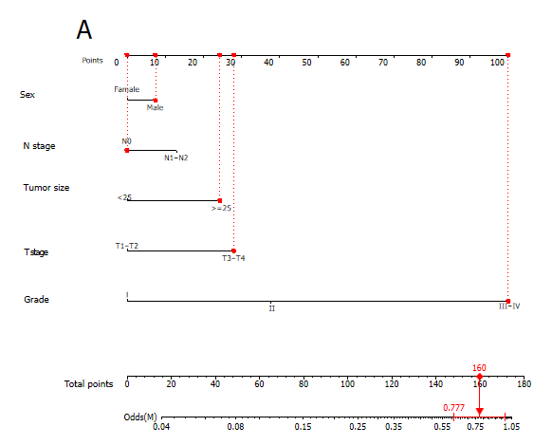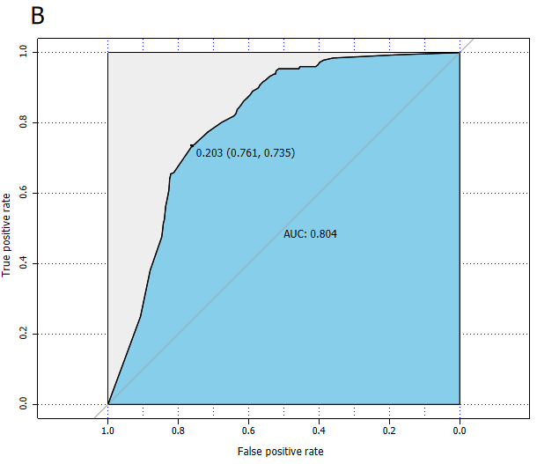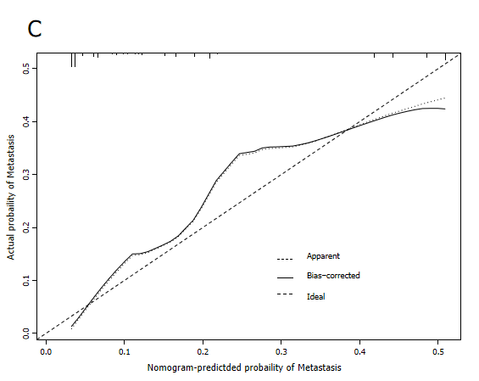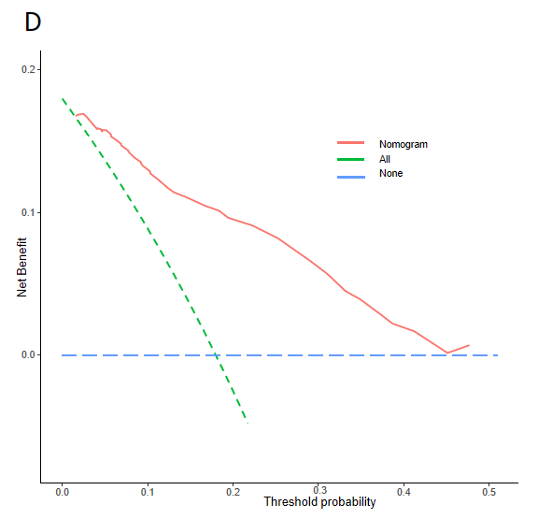
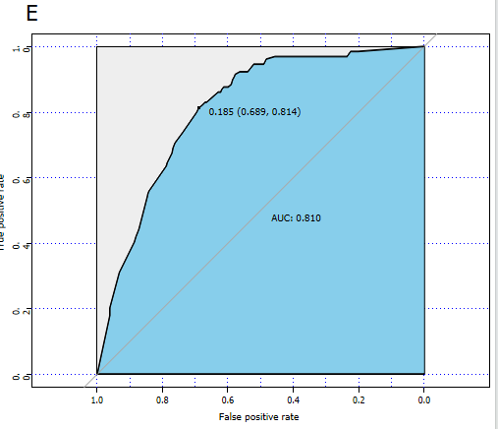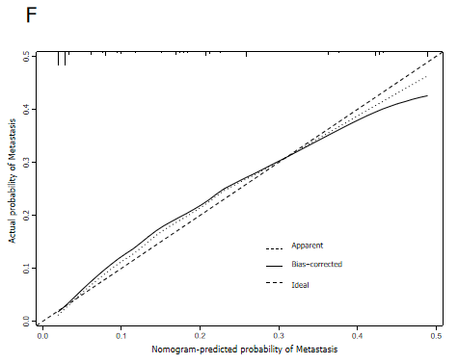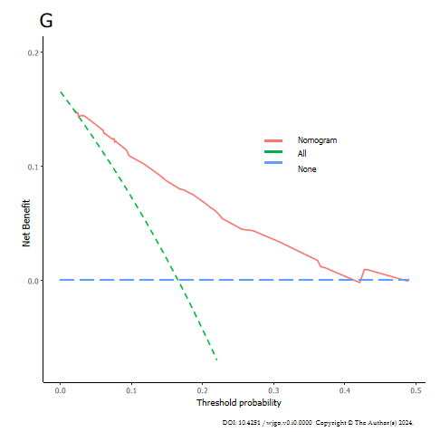
Figure 1 Construction and validation of a diagnostic nomogram. A: A nomogram to estimate the risk of distant metastasis in duodenal carcinoma patients; B: The receiver operating characteristic curve of the training set; C: The calibration curve of the training set; D: The decision curve analysis of the training set; E: The receiver operating characteristic curve of the validation set; F: The calibration curve of the validation set; G: The decision curve analysis of the validation set. AUC: Area under the curve.
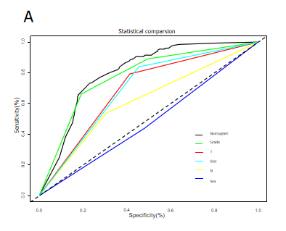 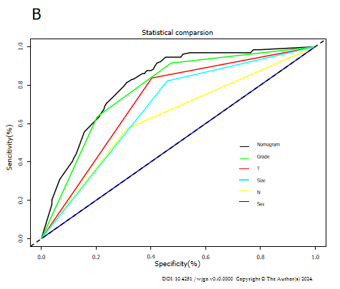
Figure 2 Comparison of area under the receiver operating characteristic curves between nomogram and all independent factors, including Grade, T stage, N stage, Size and Sex. A: In the training set; B: In the validation set.
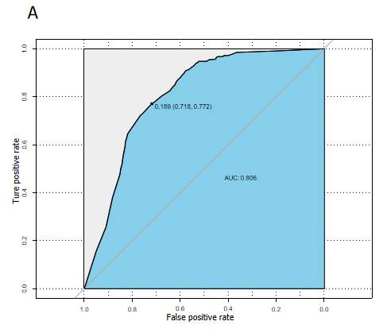 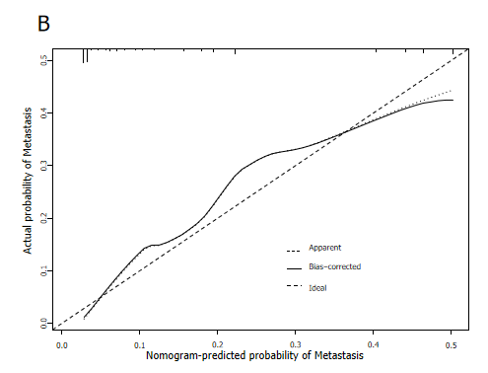 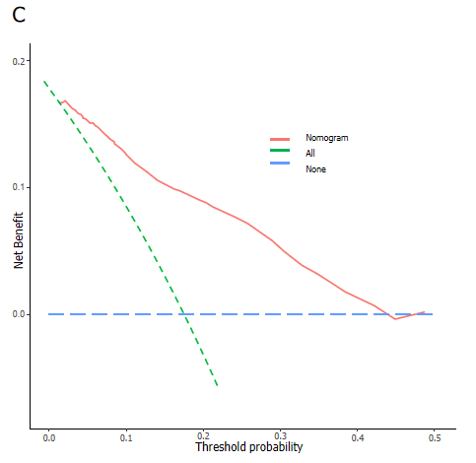 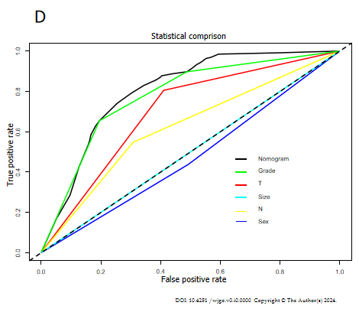
Figure 3 Validating the diagnostic nomogram in the expanded testing set. A: The receiver operating characteristic curve of the expanded testing set; B: The calibration curve of the expanded testing set; C: The decision curve analysis of the expanded testing set; D: Comparison of area under the receiver operating characteristic curves between nomogram and all independent factors, including sex, T stage, tumor size, grade stage.

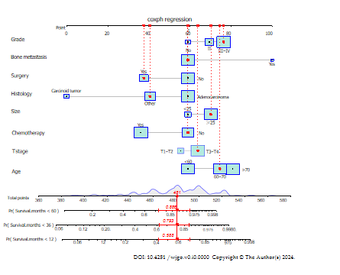
Figure 4 A prognostic nomogram for predicting the overall survival of duodenal carcinoma patients with distant metastasis for the 12, 36, and 60 months.
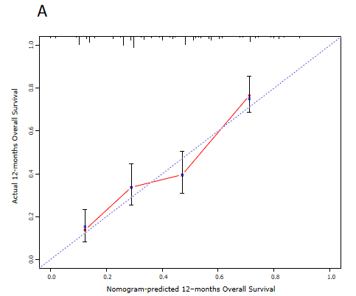 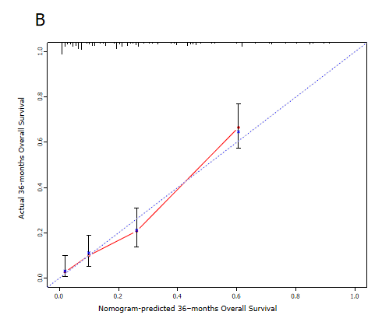 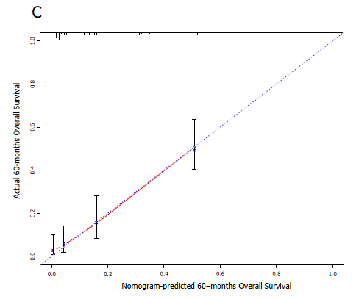 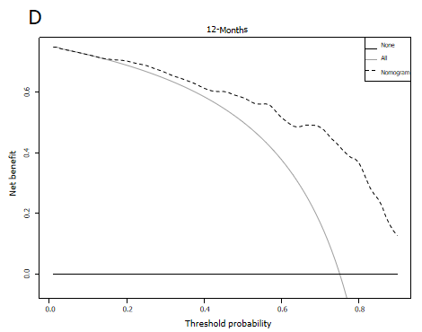 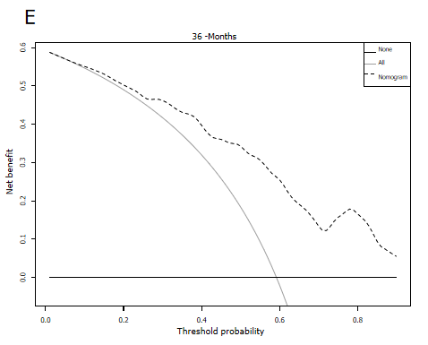 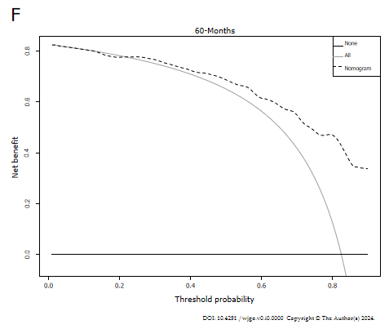
Figure 5 Calibration and decision curves for 12, 36, and 60 months in the training set. A: The calibration curves of the nomogram for the 12 months in the training set; B: The calibration curves of the nomogram for the 36 months in the training set; C: The calibration curves of the nomogram for the 60 months in the training set; D: The decision curve analysis of the nomogram for the 12 months in the training set; E: The decision curve analysis of the nomogram for the 36 months in the training set; F: The decision curve analysis of the nomogram for the 60 months in the training set.
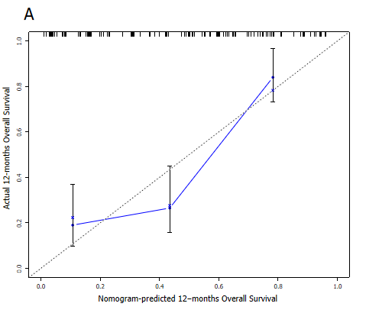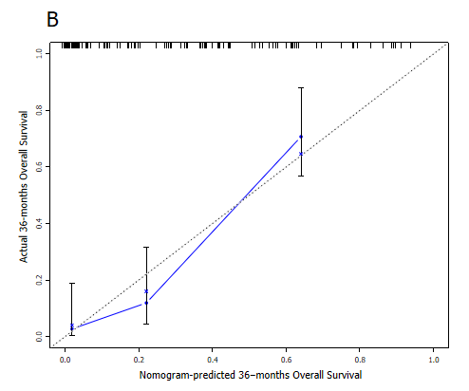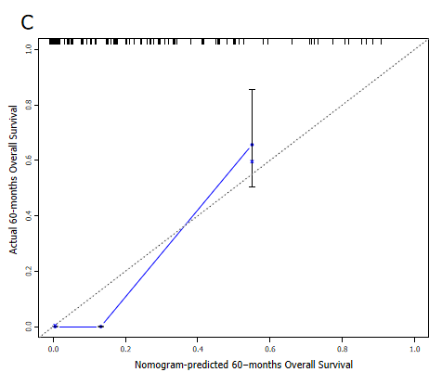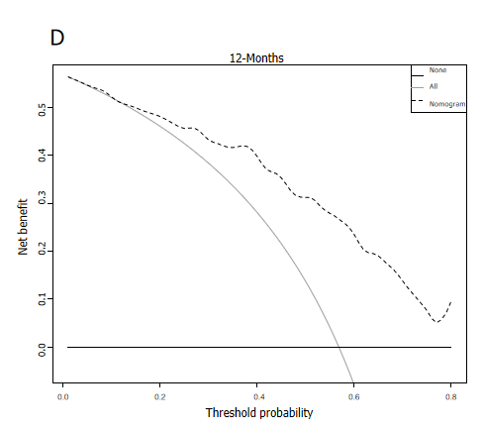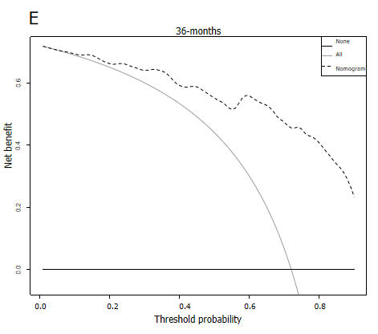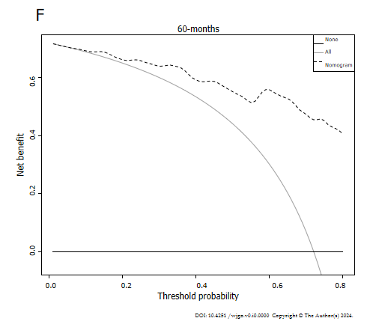
Figure 6 Calibration and decision curve analysis for nomogram at 12, 36, and 60 months in the validation set. A: The calibration curves of the nomogram for the 12 months in the validation set; B: The calibration curves of the nomogram for the 36 months in the validation set; C: The calibration curves of the nomogram for the 60 months in the validation set; D: The decision curve analysis of the nomogram for the 12 months in the validation set; E: The decision curve analysis of the nomogram for the 36 months in the validation set; F: The decision curve analysis of the nomogram for the 60 months in the validation set.

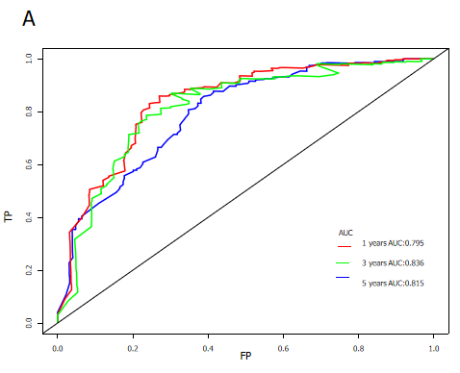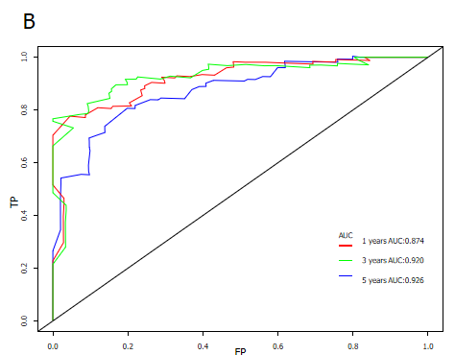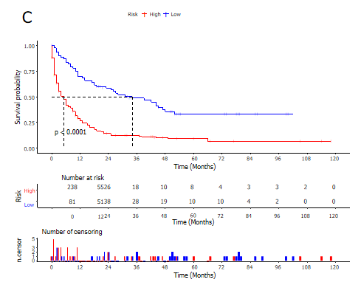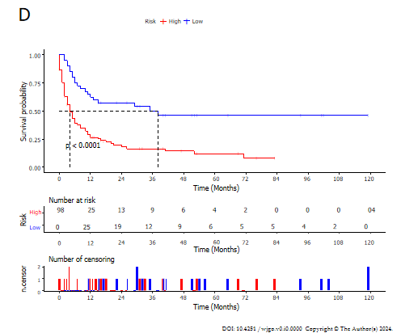
Figure 7 Time-dependent receiver operating characteristic curve analysis and kaplan-meier survival curves in the training and validation sets. A: Time-dependent receiver operating characteristic curve analysis of the nomogram for the 12, 36, and 60 months in the training set; B: Time-dependent receiver operating characteristic curve analysis of the nomogram for the 12, 36, and 60 months in the validation set; C: The Kaplan-Meier (K-M) survival curves of the patients in the training set; D: The K-M survival curves of the patients in the validation set.
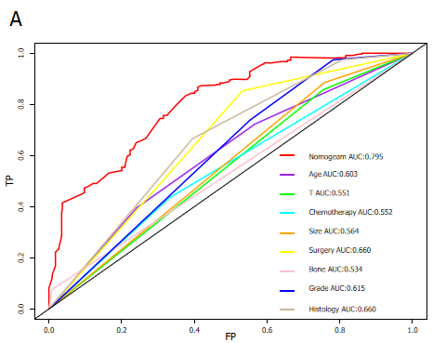 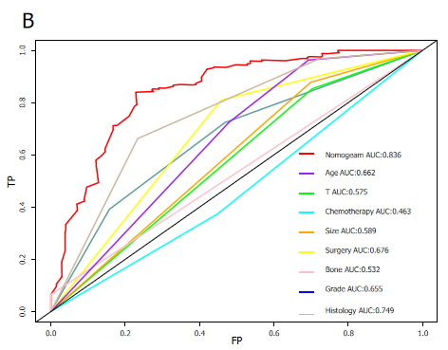 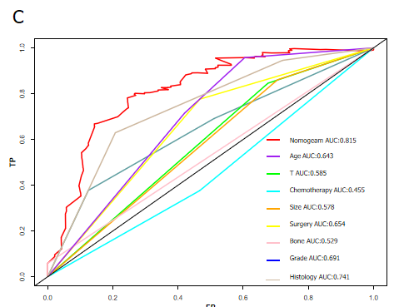 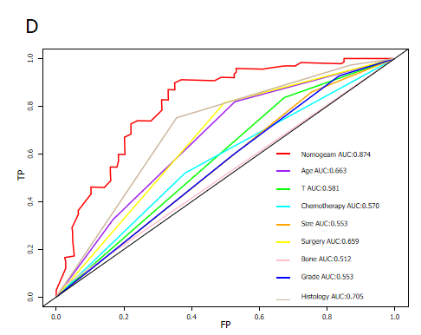 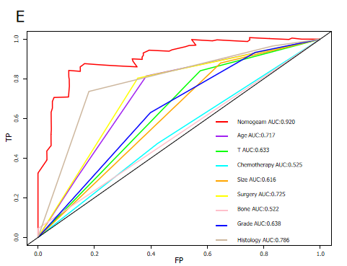 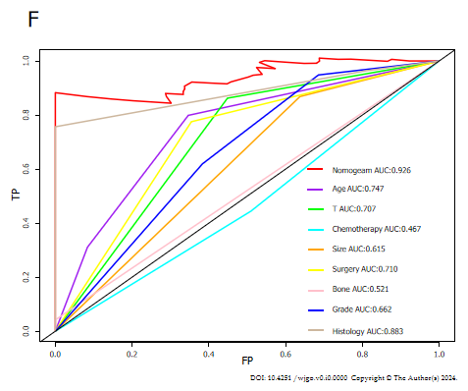
Figure 8 Comparison of area under the receiver operating characteristic curves between nomogram and all independent factors, including age, T stage, tumor size, grade stage, bone metastasis, surgery, and chemotherapy. A: 12 months in the training set; B: 36 months in the training set; C: 60 months in the training set; D: 12 months in the validation set; E: 36 months in the validation set; F: 60 months in the validation set.
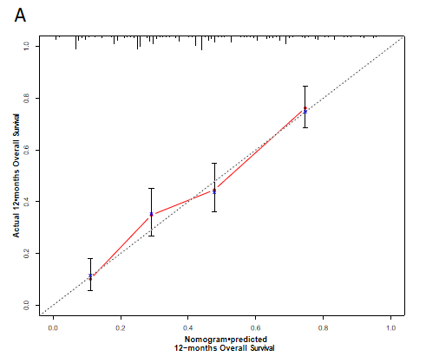
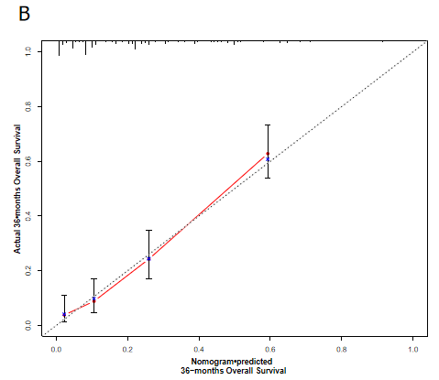
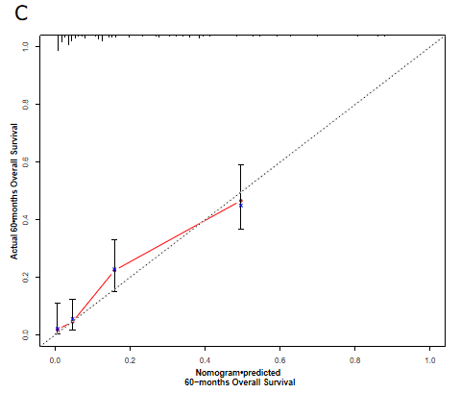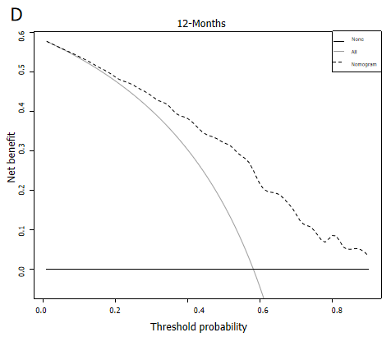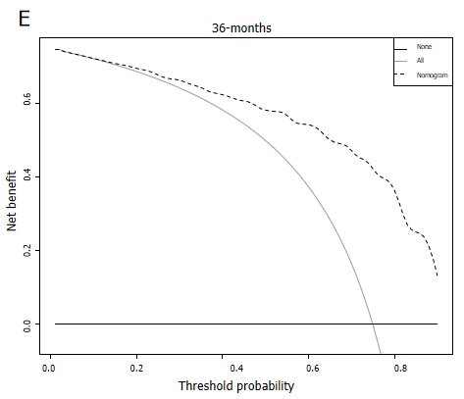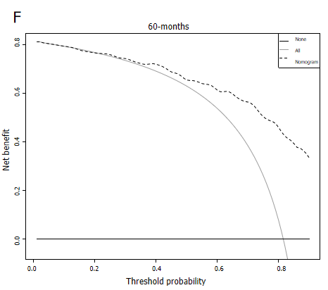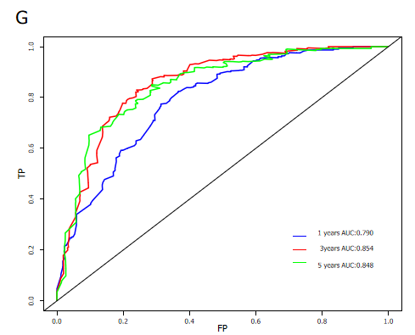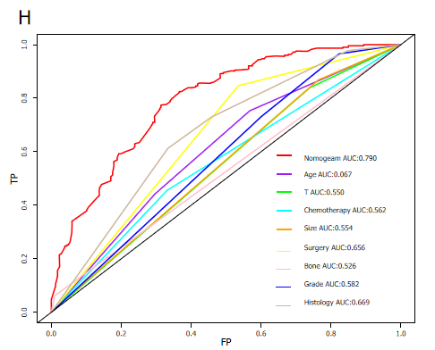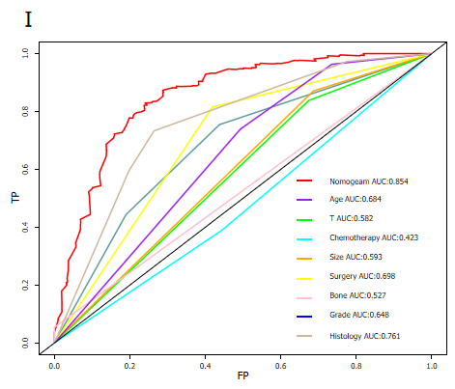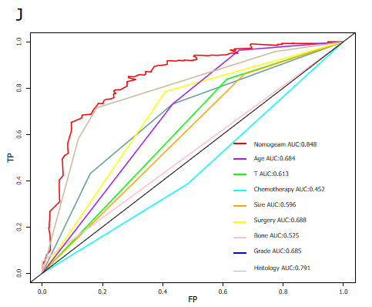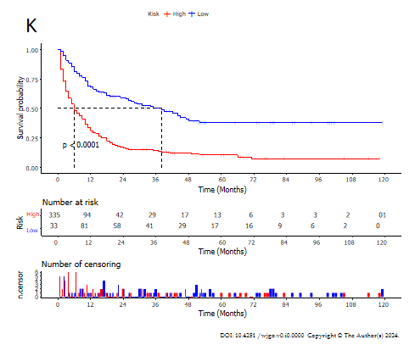
Figure 9 Validating the prognostic nomogram in the expanded testing set. A: The calibration curves of the nomogram for the 12 months in the expanded testing set; B: The calibration curves of the nomogram for the 36 months in the expanded testing set; C: The calibration curves of the nomogram for the 60 months in the expanded testing set; D: The decision curve analysis of the nomogram for the 12 months in the expanded testing set; E: The decision curve analysis of the nomogram for the 36 months in the expanded testing set; F: The decision curve analysis of the nomogram for the 60 months in the expanded testing set; G: Comparison of area under the receiver operating characteristic curves between nomogram and all independent factors for the 12 months in the expanded testing set; H: Comparison of area under the receiver operating characteristic curves between nomogram and all independent factors for the 36 months in the expanded testing set; I: Comparison of area under the receiver operating characteristic curves between nomogram and all independent factors for the 60 months in the expanded testing set; J: Time-dependent receiver operating characteristic curve analysis of the nomogram for the 12, 36, and 60 months in the expanded testing set; K: The Kapla-Meier survival curve of the patients in the expanded testing set. AUC: Area under the curve.
Table 1 Baseline clinical characteristics of duodenal cancer patients, n (%)
 | Training (%) | Validation | Overall | χ² | P value
 | (n = 1822) | (n = 781) | (n = 2603)
Age, yr |  |  |  | 0.125 | 0.939
< 60 | 625 (34.3) | 266 (34.1) | 891 (34.2)
> 70 | 645 (35.4) | 282 (36.1) | 927 (35.6)
60-70 | 552 (30.3) | 233 (29.8) | 785 (30.2)
Race |  |  |  | 2.1543 | 0.3406
Black | 358 (19.6) | 142 (18.2) | 500 (19.2)
Other | 166 (9.1) | 84 (10.8) | 250 (9.6)
White | 1298 (71.2) | 555 (71.1) | 1853 (71.2)
Sex |  |  |  | 1.795 | 0.180
Female | 863 (47.4) | 393 (50.3) | 1256 (48.3)
Male | 959 (52.6) | 388 (49.7) | 1347 (51.7)
Marital status |  |  |  | 0.003 | 0.955
Married | 1095 (60.1) | 471 (60.3) | 1566 (60.2)
Single | 727 (39.9) | 310 (39.7) | 1037 (39.8)
Income |  |  |  | 3.034 | 0.219
$50000- $70000 | 844 (46.3) | 377 (48.3) | 1221 (46.9)
< $50000 | 294 (16.1) | 138 (17.7) | 432 (16.6)
> $70000 | 684 (37.5) | 266 (34.1) | 950 (36.5)
PRCDA |  |  |  | 0.635 | 0.426
No | 1338 (73.4) | 561 (71.8) | 1899 (73.0)
Yes | 484 (26.6) | 220 (28.2) | 704 (27.0)
T |  |  |  | 0.092 | 0.761
T1-T2 | 943 (51.8) | 410 (52.5) | 1353 (52.0)
T3-T4 | 879 (48.2) | 371 (47.5) | 1250 (48.0)
N |  |  |  | 0.160 | 0.689
N0 | 1190 (65.3) | 503 (64.4) | 1693 (65.0)
N1-N2 | 632 (34.7) | 278 (35.6) | 910 (35.0)
Grade |  |  |  | 1.132 | 0.568
I | 790 (43.3) | 354 (45.3) | 1144 (43.9)
II | 528 (29.0) | 212 (27.1) | 740 (28.4)
III-IV | 504 (27.7) | 215 (27.5) | 719 (27.6)
Tumor size, mm |  |  |  | 0.018 | 0.894
< 25 | 868 (47.6) | 375 (48.0) | 1243 (47.8)
≥ 25 | 954 (52.4) | 406 (52.0) | 1360 (52.2)
Histological type |  |  |  | 0.010 | 0.995
Adenocarcinoma | 652 (35.8) | 281 (36.0) | 933 (35.8)
Carcinoid tumor | 661 (36.3) | 282 (36.1) | 943 (36.2)
Other | 509 (27.9) | 218 (27.9) | 727 (27.9
PRCDA: Purchased Referred Care Delivery Area.

Table 2 Univariate and multivariate logistic analyses of distant metastasis in duodenal cancer patients
 | Univariate analysis |  |  | Multivariate analysis
 | OR | 95%CI | P value | OR | 95%CI | P value
Age, yr
< 60 | Reference
60-70 | 1.164 | 0.939-1.445 | 0.246
> 70 | 1.266 | 1.032-1.554 | 0.058
Race
Black | Reference
White | 1.013 | 0.817-1.265 | 0.92
Other | 1.014 | 0.722-1.413 | 0.946
Sex
Female | Reference |  |  | Reference
Male | 1.245 | 1.050-1.477 | 0.035 | 1.165 | 0.965-1.408 | 0.183
Marital status
Married | Reference
Single | 1.056 | 0.888-1.254 | 0.603
Income
$50000-$70000 | Reference
< $50000 | 0.789 | 0.603-1.021 | 0.137
> $70000 | 1.279 | 1.065-1.536 | 0.027
PRCDA
No | Reference
Yes | 1.118 | 0.925-1.347 | 0.330
T
T1-T2 | Reference |  |  | Reference
T3-T4 | 5.926 | 4.832-7.316 | < 0.001 | 1.779 | 1.360-2.336 | < 0.001
N
N0 | Reference |  |  | Reference
N1-N2 | 2.719 | 2.289-3.233 | < 0.001 | 1.306 | 1.070-1.595 | 0.027
Grade
I | Reference |  |  | Reference
II | 4.119 | 3.072-5.579 | < 0.001 | 2.174 | 1.560-3.053 | < 0.001
III-IV | 16.616 | 12.710-22.039 | < 0.001 | 7.819 | 5.689-10.870 | < 0.001
Tumor size, mm
< 25 | Reference |  |  | Reference
≥ 25 | 5.976 | 4.822-7.469 | < 0.001 | 1.649 | 1.249-2.186 | 0.003
Histological type
Adenocarcinoma | Reference
Carcinoid tumor | 0.106 | 0.078-0.142 | < 0.001
Other | 0.740 | 0.612-0.894 | 0.009
PRCDA: Purchased Referred Care Delivery Area.

Table 3 Baseline clinical characteristics of patients diagnosed duodenal cancer with distant metastasis, n (%)
 | Training | Validation | Overall | χ² | P value
 | (n = 319) | (n = 138) | (n = 457)
Age, yr |  |  |  | 0.839 | 0.657
< 60 | 94 (29.5) | 46 (33.3) | 140 (30.6)
> 70 | 124 (38.9) | 53 (38.4) | 177 (38.7)
60-70 | 101 (31.7) | 39 (28.3) | 140 (30.6)
Race |  |  |  | 0.351 | 0.839
Black | 61 (19.1) | 26 (18.8) | 87 (19.0)
Other | 29 (9.1) | 15 (10.9) | 44 (9.6)
White | 229 (71.8) | 97 (70.3) | 326 (71.3)
Sex |  |  |  | 1.010 | 0.315
Female | 145 (45.5) | 55 (39.9) | 200 (43.8)
Male | 174 (54.5) | 83 (60.1) | 257 (56.2)
Marital status |  |  |  | 0.046 | 0.831
Married | 190 (59.6) | 80 (58.0) | 270 (59.1)
Single | 129 (40.4) | 58 (42.0) | 187 (40.9)
Income |  |  |  | 1.765 | 0.414
$50000-$70000 | 147 (46.1) | 57 (41.3) | 204 (44.6)
< $50000 | 43 (13.5) | 16 (11.6) | 59 (12.9)
> $70000 | 129 (40.4) | 65 (47.1) | 194 (42.5)
PRCDA |  |  |  | 2.04420 | 0.153
No | 220 (69.0) | 105 (76.1) | 325 (71.1)
Yes | 99 (31.0) | 33 (23.9) | 132 (28.9)
T |  |  |  | 0.4560 | 0.500
T1-T2 | 59 (18.5) | 30 (21.7) | 89 (19.5)
T3-T4 | 260 (81.5) | 108 (78.3) | 368 (80.5)
N |  |  |  | 0.043 | 0.837
N0 | 146 (45.8) | 61 (44.2) | 207 (45.3)
N1-N2 | 173 (54.2) | 77 (55.8) | 250 (54.7)
Surgery |  |  |  | 0.468 | 0.494
No | 238 (74.6) | 98 (71.0) | 336 (73.5)
Yes | 81 (25.4) | 40 (29.0) | 121 (26.5)
Chemotherapy |  |  |  | 0.324 | 0.569
No | 144 (45.1) | 67 (48.6) | 211 (46.2)
Yes | 175 (54.9) | 71 (51.4) | 246 (53.8)
Radiation |  |  |  | 0.192 | 0.661
No | 278 (87.1) | 123 (89.1) | 401 (87.7)
Yes | 41 (12.9) | 15 (10.9) | 56 (12.3)
Grade |  |  |  | 0.613 | 0.736
I | 35 (11.0) | 12 (8.7) | 47 (10.3)
II | 78 (24.5) | 33 (23.9) | 111 (24.3)
III-IV | 206 (64.6) | 93 (67.4) | 299 (65.4)
Tumor size, mm |  |  |  | 0.157 | 0.692
< 25 | 55 (17.2) | 21 (15.2) | 76 (16.6)
≥ 25 | 264 (82.8) | 117 (84.8) | 381 (83.4)
Histology |  |  |  | 0.506 | 0.776
Adenocarcinoma | 181 (56.7) | 78 (56.5) | 259 (56.7)
Carcinoid tumor | 24 (7.5) | 13 (9.4) | 37 (8.1)
Other | 114 (35.7) | 47 (34.1) | 161 (35.2)
Lung |  |  |  | 3.109 | 0.0779
No | 290 (90.9) | 117 (84.8) | 407 (89.1)
Yes | 29 (9.1) | 21 (15.2) | 50 (10.9)
Bone |  |  |  | 0.072 | 0.788
No | 304 (95.3) | 133 (96.4) | 437 (95.6)
Yes | 15 (4.7) | 5 (3.6) | 20 (4.4)
Brain |  |  |  | 0.588 | 2.326
No | 317 (99.4) | 136 (98.6) | 453 (99.1)
Yes | 2 (0.6) | 2 (1.4) | 4 (0.9)
Liver |  |  |  | 0.315 | 0.575
No | 56 (17.6) | 28 (20.3) | 84 (18.4)
Yes | 263 (82.4) | 110 (79.7) | 373 (81.6)
PRCDA: Purchased Referred Care Delivery Area.

Table 4 Univariate and multivariate Cox analyses in duodenal cancer patients with distant metastasis
 | Univariate analysis |  |  | Multivariate analysis
 | HR | 95%CI | P value | HR | 95%CI | P value
Age, yr
< 60 | Reference |  |  | Reference
60-70 | 1.768 | 1.379-2.265 | < 0.001 | 1.648 | 1.280-2.123 | < 0.001
> 70 | 2.276 | 1.793-2.891 | < 0.001 | 1.848 | 1.450-2.356 | 0.002
Race
Black | Reference
White | 1.042 | 0.825-1.316 | 0.771
Other | 0.702 | 0.467-1.054 | 0.152
Sex
Female | Reference
Male | 1.216 | 1.001-1.478 | 0.098
Marital status
Married | Reference
Single | 1.267 | 1.045-1.536- | 0.044
Income
$50000-$70000 | Reference
< $50000 | 1.127 | 0.851-1.493 | 0.484
> $70000 | 0.841 | 0.684-1.034 | 0.169
PRCDA
No | Reference
Yes | 0.981 | 0.796-1.210 | 0.882
T
T1-T2 | Reference |  |  | Reference
T3-T4 | 1.814 | 1.384-2.376 | < 0.001 | 1.481 | 1.126-1.947 | 0.018
N
N0 | Reference
N1-N2 | 1.078 | 0.890-1.307 | 0.519
Grade
I | Reference
II | 2.805 | 1.840-4.276 | < 0.001 | 2.833 | 1.827-4.394 | < 0.001
III-IV | 3.642 | 2.442-5.432 | < 0.001 | 3.083 | 2.030-4.682 | < 0.001
Tumor size, mm
< 25 | Reference
≥ 25 | 1.870 | 1.415-2.470 | < 0.001 | 1.410 | 1.055- 1.884 | 0.051
Histological type
Adenocarcinoma | Reference
Carcinoid tumor | 0.146 | 0.083-0.257 | < 0.001 | 0.163 | 0.088-0.300 | < 0.001
Other | 0.471 | 0.379-0.586 | < 0.001 | 0.567 | 0.450-0.713 | < 0.001
Surgery
No
Yes | 0.361 | 0.285-0.456 | < 0.001 | 0.455 | 0.357 -0.581 | < 0.001
Chemotherapy
No
Yes | 0.767 | 0.631- 0.931 | 0.024 | 0.6004 | 0.491-0.734 | < 0.001
Radiation
No
Yes | 1.232 | 0.944-1.608 | 0.197
Bone
No
Yes | 3.094 | 2.065-4.635 | < 0.001 | 3.239 | 2.138- 4.908 | < 0.001
Liver
No
Yes | 1.067 | 0.844- 1.347 | 0.650
Brain
No
Yes | 1.958 | 0.854-4.486 | 0.183
Lung
no
Yes | 1.332 | 0.987-1.797 | 0.116
HR: Hazard ratio; PRCDA: Purchased Referred Care Delivery Area.

