Name of Journal: World Journal of Gastroenterology
Manuscript NO: 88703
Manuscript Type: LETTER TO THE EDITOR

Complementary comments on metastatic liver lesions with exceptional and rare cases

Memis KB et al. Metastatic liver lesions

Kemal Bugra Memis, Sonay Aydin

Kemal Bugra Memis, Sonay Aydin, Department of Radiology, Erzincan Binali Yıldırım University, Faculty of Medicine, Erzincan 24000, Turkey

Author contributions: Memis KB and Aydin S designed and performed research; Aydin S analyzed data and added radiological images, revised the letter; Memis KB wrote the letter.

Corresponding author: Kemal Bugra Memis, MD, Doctor, Department of Radiology, Erzincan Binali Yıldırım University, Faculty of Medicine, Basbaglar, 1429 Street, Erzincan 24000, Turkey. kemalbugramemis@gmail.com

Received: October 6, 2023
Revised: January 9, 2024
Accepted: January 22, 2024
Published online:

Abstract
Liver metastases can appear in different forms in magnetic resonance imaging. Contrary to popular belief, while radiologists report hypovascular or hypervascular metastatic lesions, exceptional examples may be detected in various tumors. The aim of this article is to improve this review by presenting rare and atypical examples of liver metastasis, as well as cases that might potentially be misdiagnosed as metastases during the process of differential diagnosis.

Key Words: Hepatic lesions; Magnetic resonance imaging; Liver metastases; Echinococcus alveolaris; Prostate adenocarcinoma; Appendix neuroendocrine tumor

Memis KB, Aydin S. Complementary comments on metastatic liver lesions with exceptional and rare cases. World J Gastroenterol 2024; In press

Core Tip: Maino et al summarized the most frequent appearances of liver metastasis in detail. This letter adds to the mentioned literature with atypical examples and a potential misleading infectious cause, alveolar echinococcosis.

TO THE EDITOR
Maino et al^{[1]} recently published research suggesting the role of magnetic resonance imaging (MRI) in liver metastases. They reviewed the importance of MRI in the diagnosis and evaluation of liver metastases, as well as a description of their primary imaging characteristics. Additionally, they described MRI protocols using contrast agents to better diagnose liver metastases. Furthermore, the study emphasises the added value of the most recent imaging tools as well as the usual and atypical appearance of liver metastases, which increases their effect^{[1]}. This letter aims to contribute to this review by presenting rare and atypical examples of liver metastases.
According to the authors of this study, hypovascular lesions are the most common typical appearances of liver metastases, but some tumors will present with atypical appearances, such as hypervascular metastases. As mentioned in the literature, hypervascular liver metastases typically arise from hypervascular primary cancers such as neuroendocrine cancers, kidney cancer, melanoma, and thyroid cancer^{[1,2]}. In 73% of patients, hepatic metastases of neuroendocrine tumors displayed a characteristic hypervascular appearance. However, it should be kept in mind that hypervascular neuroendocrine tumors may cause hypovascular liver metastasis^{[3]}. As seen in Figure 1, neuroendocrine tumors should also be included in the differential diagnosis of hypovascular liver metastases.
The article by Ozaki et al^{[2]} demonstrated the prevalence of synchronous liver metastasis in primary tumors originating from various organs. They determined that the pancreas had the highest prevalence (77.6%), whereas the prostate had the lowest prevalence (4.8%). We intended to make this unusual entity memorable with our case in Figure 2, which shows the metastasis of prostate adenocarcinoma to the liver.
When describing the visible liver lesions as metastases, a differential diagnosis between primary benign or malignant liver masses and infectious diseases should be made initially. While multiple liver abscesses are the most common among these infectious lesions, alveolar echinococcosis (AE), a rare parasitic disease that we present in Figure 3, can also be misdiagnosed as metastases. The WHO classification system for PNM, based on imaging findings, also emphasises AE as a potential alternative differential diagnosis for malignant liver masses. To distinguish AE from other tumors, serology findings and multiple imaging modalities (ultrasonography and computed tomography), and most importantly, keeping the diagnosis in mind, are required^{[4-6]}.
Our objective in this letter was to make a contribution to the literature with images of exceptional and rarely occurring cases in daily practice. All authors are in complete agreement with the information stated. The content of this manuscript is our original work and has not been published, in whole or in part, before or simultaneously with this submission.

REFERENCES
1 Maino C, Vernuccio F, Cannella R, Cortese F, Franco PN, Gaetani C, Giannini V, Inchingolo R, Ippolito D, Defeudis A, Pilato G, Tore D, Faletti R, Gatti M. Liver metastases: The role of magnetic resonance imaging. World J Gastroenterol 2023; 29: 5180-5197 [PMID: 37901445 DOI: 10.3748/wjg.v29.i36.5180]
2 Ozaki K, Higuchi S, Kimura H, Gabata T. Liver Metastases: Correlation between Imaging Features and Pathomolecular Environments. Radiographics 2022; 42: 1994-2013 [PMID: 36149824 DOI: 10.1148/rg.220056]
3 Dromain C, de Baere T, Baudin E, Galline J, Ducreux M, Boige V, Duvillard P, Laplanche A, Caillet H, Lasser P, Schlumberger M, Sigal R. MR imaging of hepatic metastases caused by neuroendocrine tumors: comparing four techniques. AJR Am J Roentgenol 2003; 180: 121-128 [PMID: 12490490 DOI: 10.2214/ajr.180.1.1800121]
4 Amano T, Hayashi S, Nishida T, Matsubara T, Takahashi K, Nakamatsu D, Tomimaru Y, Yamamoto M, Nakajima S, Fukui K, Tamura H, Adachi S, Dono K, Inada M. Alveolar Echinococcosis Mimicking a Hepatic Neoplasm with Lymph Node Metastasis: A Case Report. Case Rep Gastroenterol 2018; 12: 587-596 [PMID: 30386197 DOI: 10.1159/000492461]
5 Kantarci M, Aydin S, Eren S, Ogul H, Akhan O. Imaging Aspects of Hepatic Alveolar Echinococcosis: Retrospective Findings of a Surgical Center in Turkey. Pathogens 2022; 11 [PMID: 35215218 DOI: 10.3390/pathogens11020276]
6 Eren S, Aydın S, Kantarci M, Kızılgöz V, Levent A, Şenbil DC, Akhan O. Percutaneous management in hepatic alveolar echinococcosis: A sum of single center experiences and a brief overview of the literature. World J Gastrointest Surg 2023; 15: 398-407 [PMID: 37032805 DOI: 10.4240/wjgs.v15.i3.398]

Footnotes
Conflict-of-interest statement: The authors declare no conflict of interest.

Open-Access: This article is an open-access article that was selected by an in-house editor and fully peer-reviewed by external reviewers. It is distributed in accordance with the Creative Commons Attribution NonCommercial (CC BY-NC 4.0) license, which permits others to distribute, remix, adapt, build upon this work non-commercially, and license their derivative works on different terms, provided the original work is properly cited and the use is non-commercial. See: https://creativecommons.org/Licenses/by-nc/4.0/

Provenance and peer review: Invited article; Externally peer reviewed.

Peer-review model: Single blind

Peer-review started: October 6, 2023
First decision: January 5, 2024
Article in press:

Specialty type: Gastroenterology and hepatology
Country/Territory of origin: Turkey
Peer-review report’s scientific quality classification
Grade A (Excellent): 0
Grade B (Very good): B
Grade C (Good): C
Grade D (Fair): 0
Grade E (Poor): 0

P-Reviewer: Isac S, Romania; Liu T, China S-Editor: Fan JR L-Editor: A P-Editor:
Figure Legends
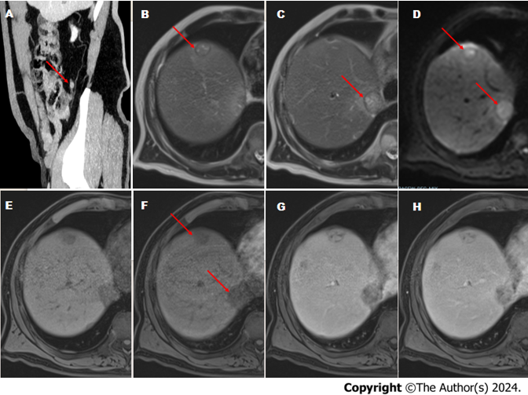
Figure 1 Liver metastases from an appendix neuroendocrine tumor. In Gd-DOTA-magnetic resonance imaging of a 60-year-old male patient. A: On sagittal MIP computed tomography images, there is an enhancing lesion located at the tip of the appendix (red arrow); B and C: On consecutive T2-weighted images, lesions appear slightly hyperintense (red arrows); D: Diffusion restriction in lesions on diffusion weighted imaging (red arrows); E: Before contrast administration, lesions are hypointense; F: During the post-contrast late hepatic arterial phase, lesions appear hypovascular (red arrows); G and H: Lesions are hyperintense on the portal-venous and delayed post-contrast phase.
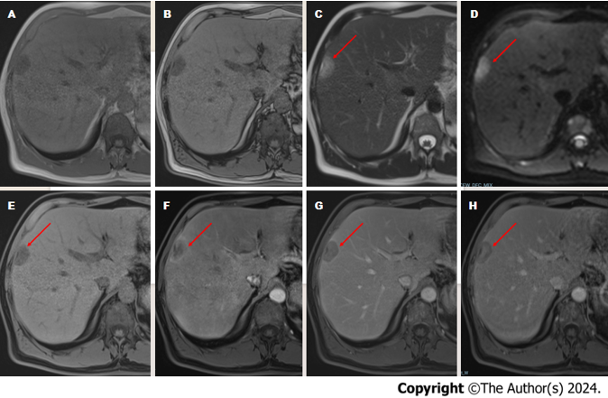
Figure 2 Liver metastases from prostate adenocarcinoma. In Gd-EOB-magnetic resonance imaging of a 52-year-old male patient. A: On in-phase images, there is a focal hypointense liver lesion; B: On out-of-phase images, the lesion persists hypointense compared to the healthy liver parenchyma; C: On T2-weighted images, the lesion appears slightly hyperintense (red arrow); D: Diffusion restriction in the lesion on diffusion-weighted imaging (red arrow); E: Before contrast administration, the lesion is hypointense (red arrow); F: The lesion appears hypervascular due to peripheral rim-like hyperenhancement during the post-contrast late hepatic arterial phase (red arrow); G: The lesion is hypointense on the portal-venous phase compared to the healthy liver parenchyma (red arrow); H: On the hepatobiliary phase, low signal intensity of the lesion due to washout is observed, especially in the peripheral areas (red arrow).
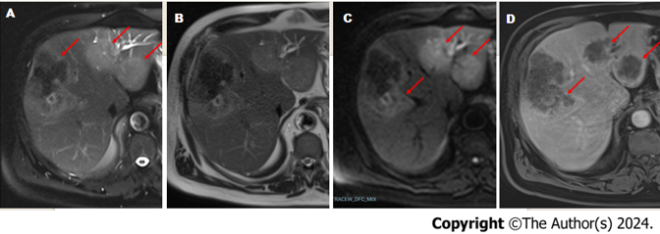
Figure 3 A case of Echinococcus alveolaris in the liver. In Gd-EOB-magnetic resonance imaging of a 69-year-old male patient. A and B: On with and without fat-suppressed T2-weighted images the lesions appear slightly hyperintense and hypointense areas in the central part of the largest lesion (red arrows); C: Diffusion-weighted imaging reveals restriction of diffusion of the lesions (red arrows); D: The lesions show peripheral rim-like enhancement on the hepatobiliary phase (red arrows).

